PLU: 4545  Bok Choy  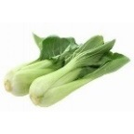 | PLU: 3163  Bok Choy Shanghai  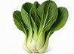
PLU: 4598  Daikon Radish | PLU: 4552  Napa Cabbage  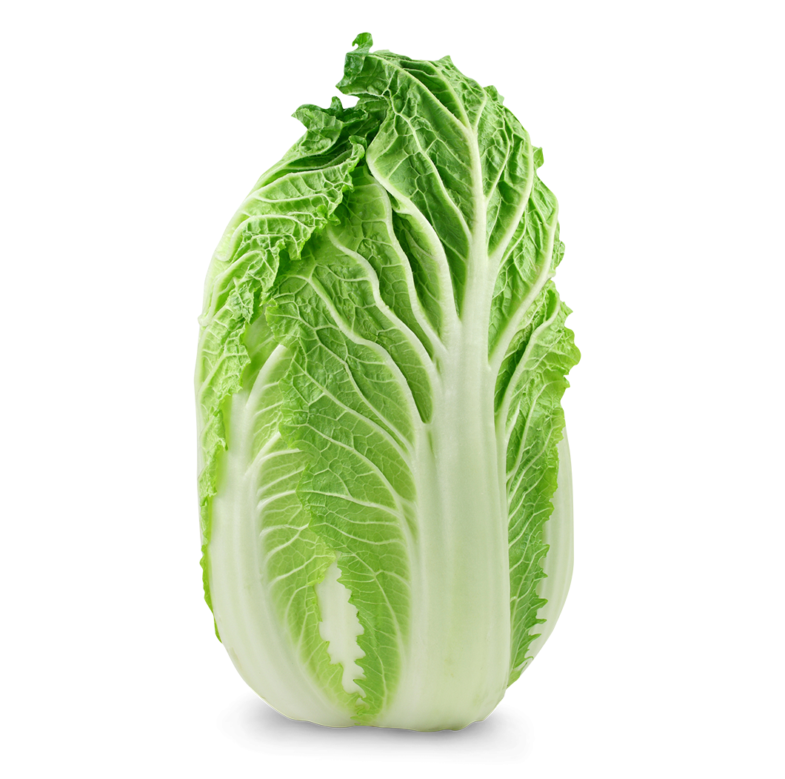
PLU: 3162  On Choy  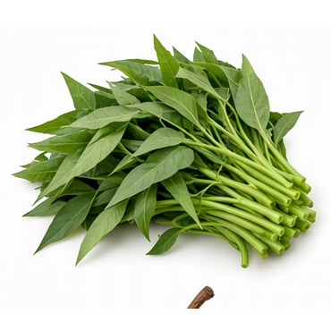 | PLU: 4544  Bok Choy Mini  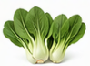

PLU: 3164  Yu Choy  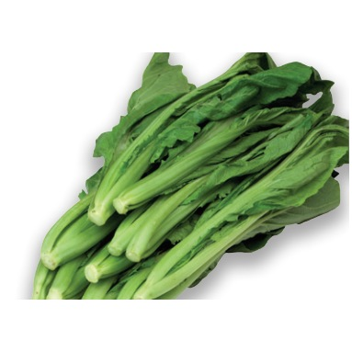 | PLU: 81905  Sher Li Hon  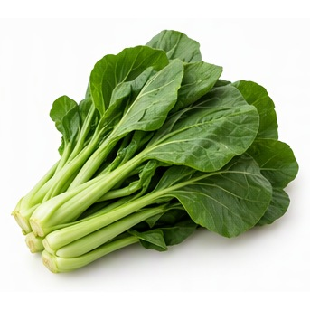
PLU: 4656  Sing Qua  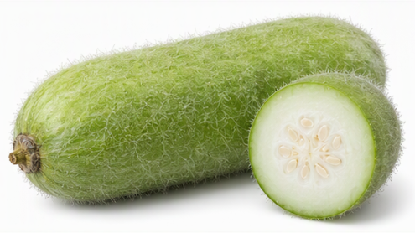 | PLU: 4834  Daikon Korean  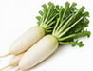
PLU: 4607  Gai Choy  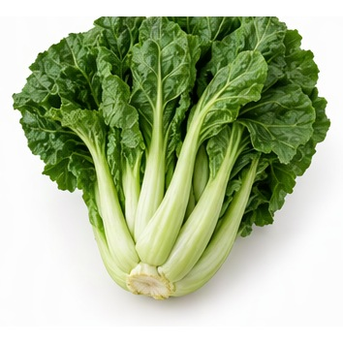 | PLU: 3160  Gai Lan  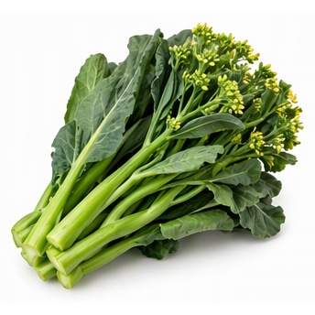

PLU: 4536  Bean Sprouts  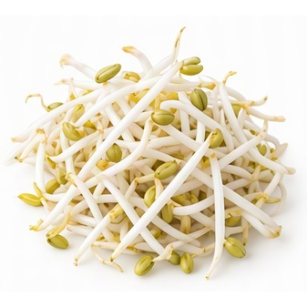 | PLU: 4989  Bok Choy Baby  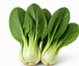
PLU: 4814  Water Chestnuts  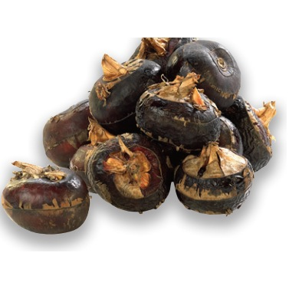 | PLU: 4060  Broccoli Bunch  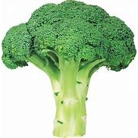
PLU: 4547  Rapini Bunch  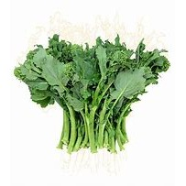 | PLU: 4548  Broccoli Florettes  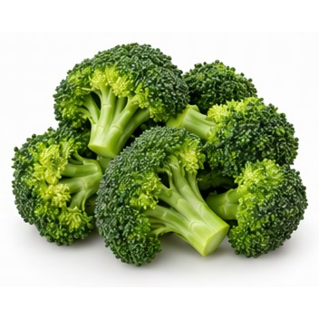

PLU: 4550  Brussel Sprouts  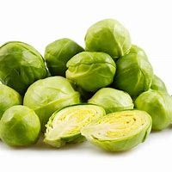 | PLU: 4069  Cabbage Green  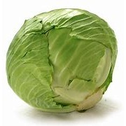
PLU: 94069  Organic Cabbage Green  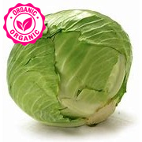 | PLU: 4554  Cabbage Red  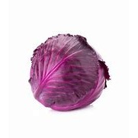
PLU: 94554  Organic Cabbage Red  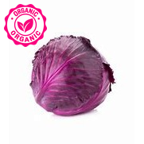 | PLU: 4555  Cabbage Savoy  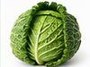

PLU: 4569  Cauliflower Orange Atl  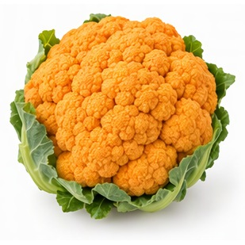 | PLU: 3436  Cauliflower Orange Ont
PLU: 4568  Cauliflower Purple  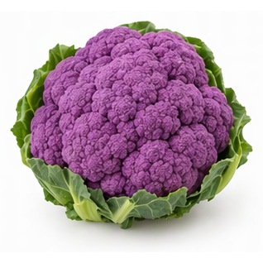 | PLU: 4079  Cauliflower Small  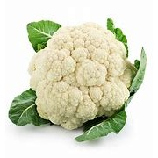
PLU: 94079  Organic Cauliflower  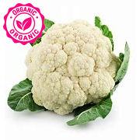 | PLU: 3214  Cabbage Sour  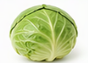

PLU: 3082  Broccoli Crowns  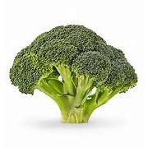 | PLU: 93320  Organic Romanesco  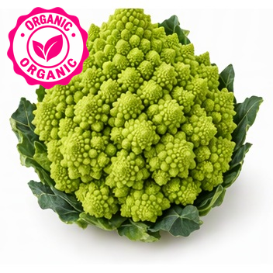
PLU: 93277  Organic Broccolini  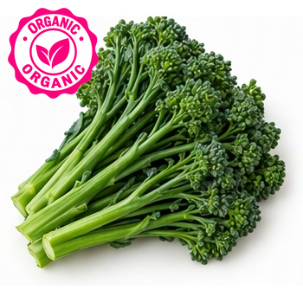 | PLU: 4596  Cucumber Pickling  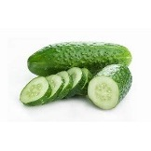
PLU: 4593  Cucumber Long English  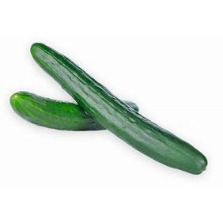 | PLU: 4062  Cucumber Green (Field)  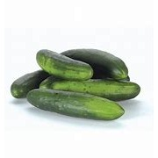

PLU: 94062  Organic Cucumber Field (Green)  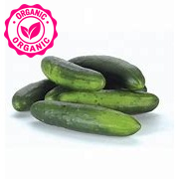 | PLU: 4999  Cucumber Mini  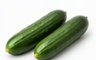
PLU: 94593  Organic Cucumber European  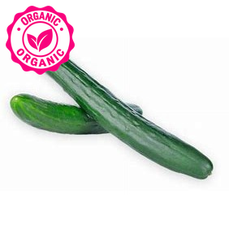 | PLU: 4903  Rosemary  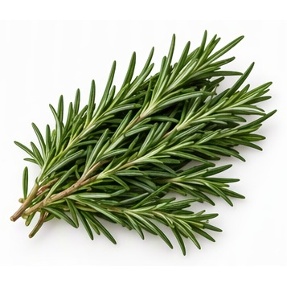
PLU: 4889  Cilantro  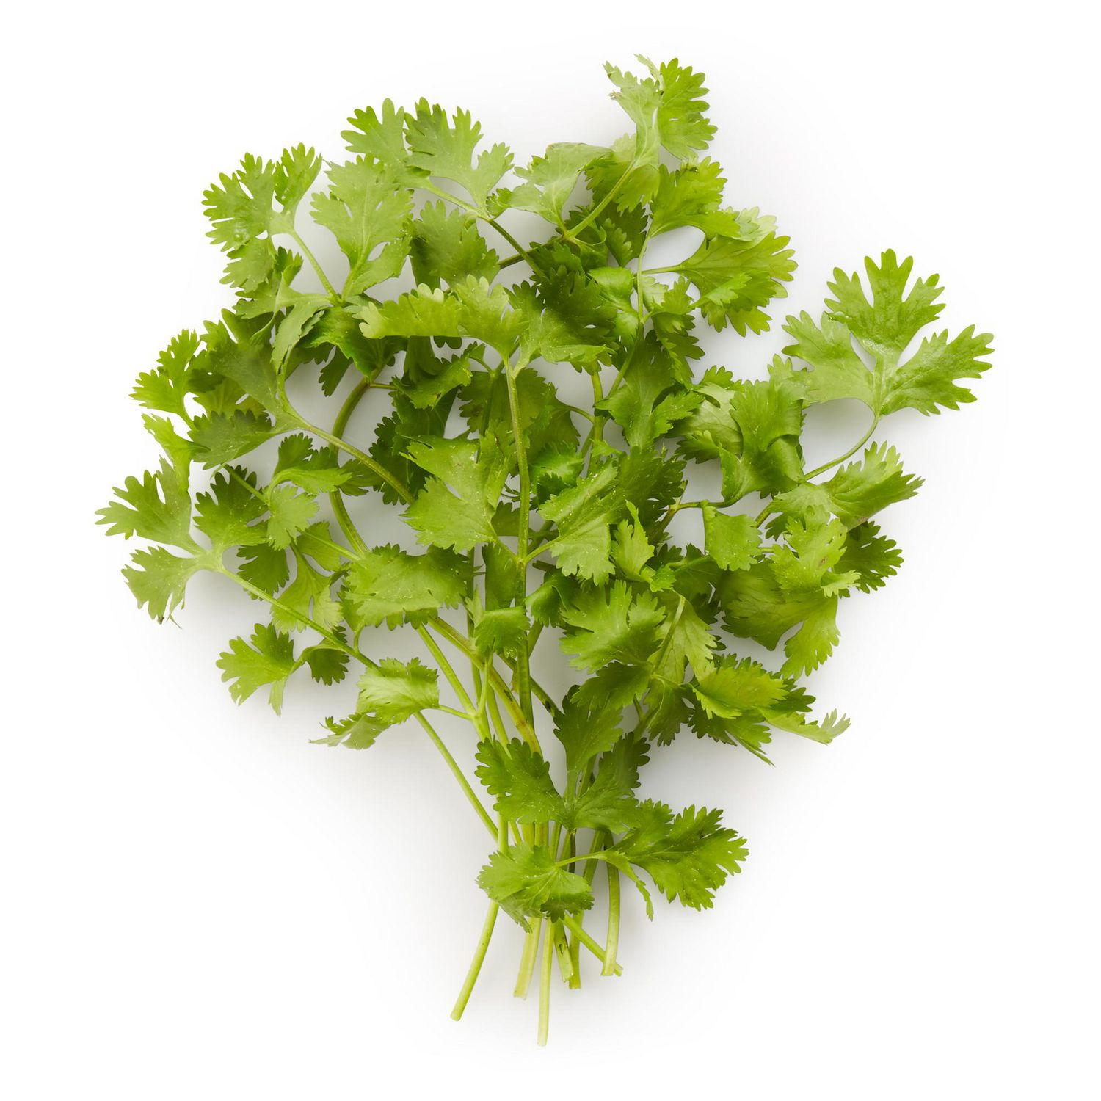 | PLU: 94889  Organic Cilantro  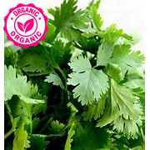

PLU: 4893  Dill | PLU: 94892  Organic Dill  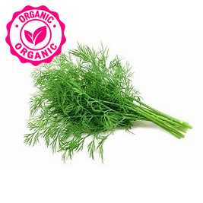
PLU: 4885  Basil  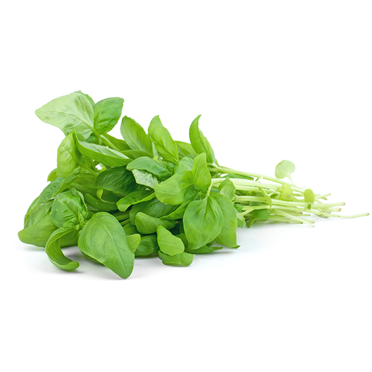 | PLU: 94885  Organic Basil  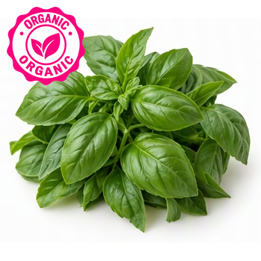
PLU: 4899  Parsley | PLU: 94901  Organic Parsley  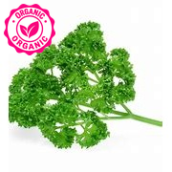

PLU: 4901  Italian Parsley | PLU: 4896  Mint  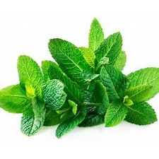
PLU: 94896  Organic Mint  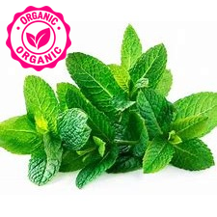 | PLU: 4894  Lemon Grass  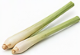
PLU: 94910  Organic Chives  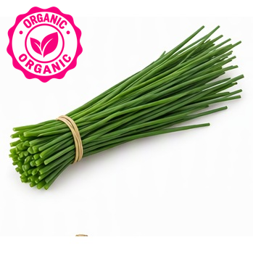 | PLU: 94900  Organic Parsley Flat  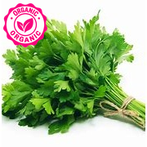

PLU: 4738  Radicchio  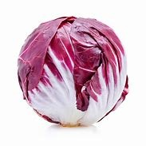 | PLU: 4623  Kale Red  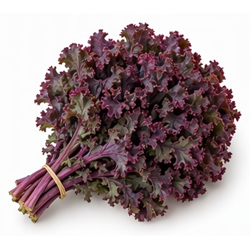
PLU: 3095  Kale Red | PLU: 9463  Organic Kale Red  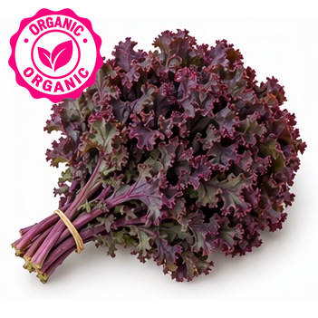
PLU: 94623  Organic Kale Red | PLU: 4543  Endive Belgian (White)  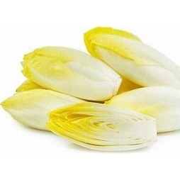

PLU: 4884  Arugula | PLU: 4614  Collard Greens  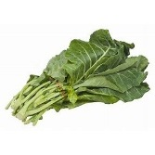
PLU: 94614  Organic Collard Greens  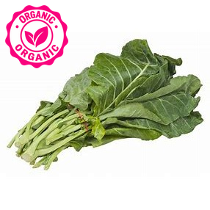 | PLU: 4627  Kale  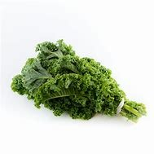
PLU: 4090  Spinach  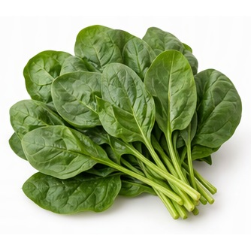 | PLU: 94090  Organic Spinach  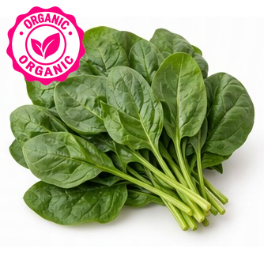

PLU: 4586  Swiss Chard Green  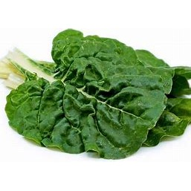 | PLU: 4587  Swiss Chard Red  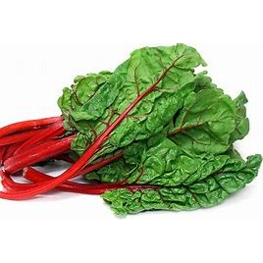
PLU: 94587  Organic Swiss Chard Red  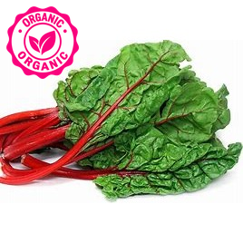 | PLU: 4619  Turnip Greens  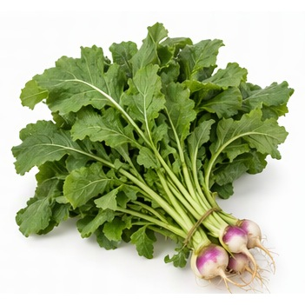
PLU: 4815  Watercress  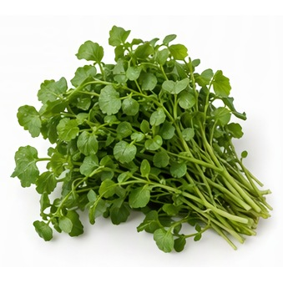 | PLU: 4624  Kale Black  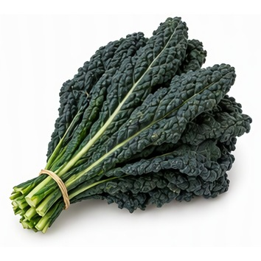

PLU: 94624  Organic Kale Black  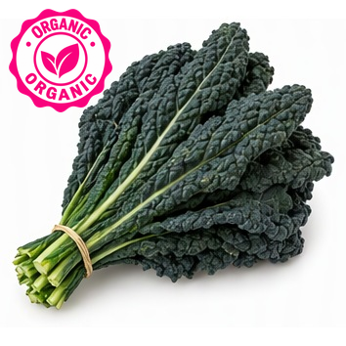 | PLU: 94621  Organic Kale Black
PLU: 4604  Endive  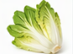 | PLU: 94588  Organic Chard Rainbow  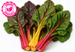
PLU: 94616  Organic Mustard Greens  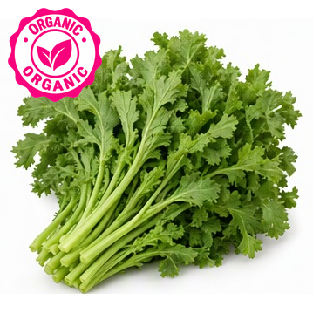 | PLU: 94586  Organic Chard Green  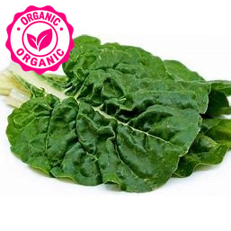

PLU: 94627  Organic Kale Greens  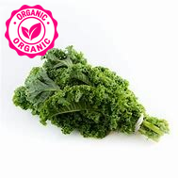 | PLU: 4640  Romaine Lettuce
PLU: 94640  Organic Lettuce Romaine  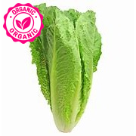 | PLU: 4061  Lettuce Iceberg  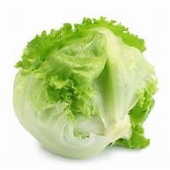
PLU: 4075  Lettuce Red Leaf  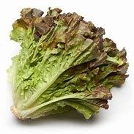 | PLU: 94075  Organic Leaf Lettuce Red  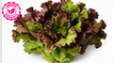

PLU: 3097  Lettuce Red Romaine  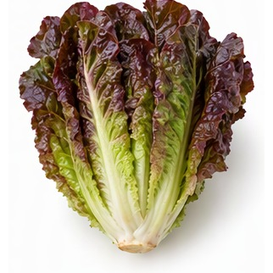 | PLU: 4076  Leaf lettuce green  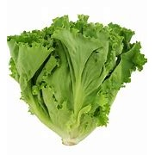
PLU: 94076  Organic Leaf Lettuce Green  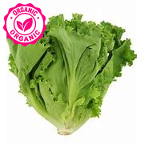 | PLU: 94061  Organic Head Lettuce (iceburg)  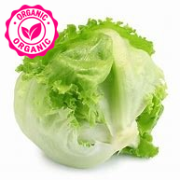
PLU: 93097  Organic Lettuc Red Romaine  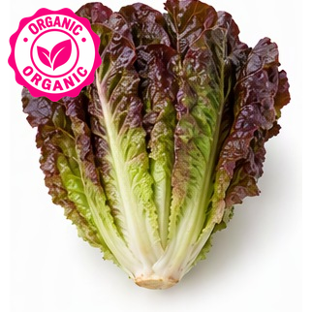 | PLU: 94632  Organic Lettuce Boston/Butter  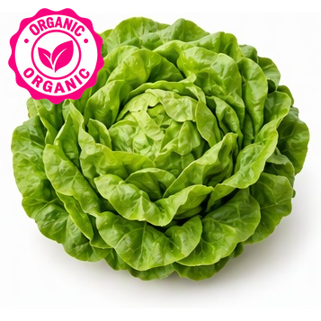

PLU: 4159  Vidalia Onions  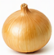 | PLU: 4662  Onion Shallots  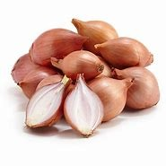
PLU: 94662  Organic Onion Shallots  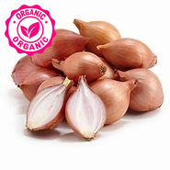 | PLU: 4659  Onions Baby Vidalia  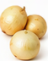
PLU: 4068  Onions Green  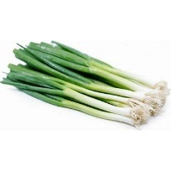 | PLU: 94068  Organic Onion Green  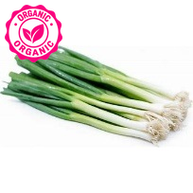

PLU: 4082  Onions Red  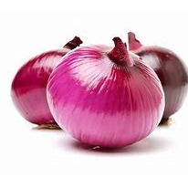 | PLU: 94082  Organic Onion Red  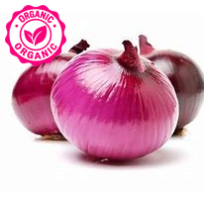
PLU: 4663  Onions White  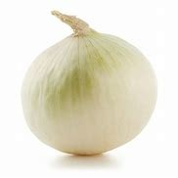 | PLU: 94666  Organic Onions White  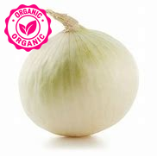
PLU: 4163  Onions Walla Walla  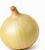 | PLU: 3400  Garlic (Large)  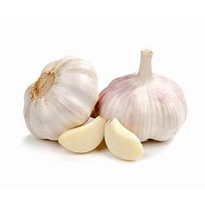

PLU: 94608  Organic Garlic  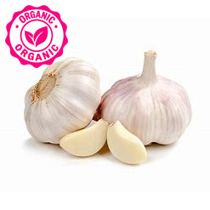 | PLU: 3339  Leeks  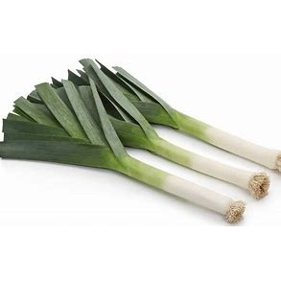
PLU: 94629  Organic Leeks  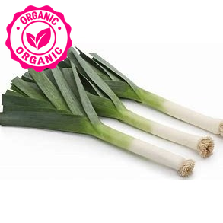 | PLU: 4093  Onion Yellow  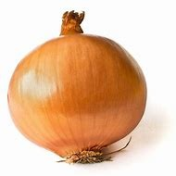
PLU: 94093  Organic Onions Yellow  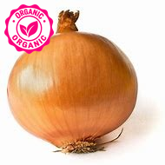 | PLU: 94665  Organic Onion Yellow

PLU: 94093  Organic Onion Spanish  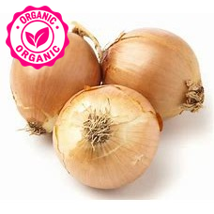 | PLU: 4677  Pepper Anaheim  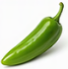
PLU: 4686  Pepper Green Chili  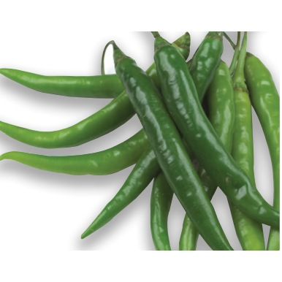 | PLU: 3125  Pepper Habanero  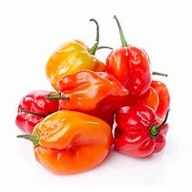
PLU: 4693  Pepper Jalapeno  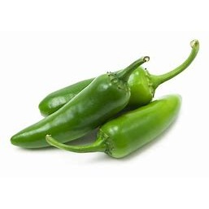 | PLU: 3121  Pepper Orange Bell  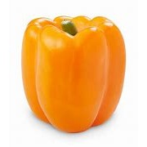

PLU: 4688  Red Sweet Bell Pepper | PLU: 4689  Pepper Yellow  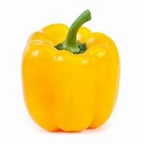
PLU: 94689  Organic Pepper Yellow  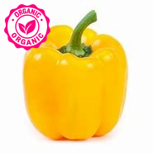 | PLU: 4705  Peppers Poblano  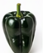
PLU: 4706  Pepper Poblano  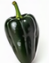 | PLU: 4772  Pepper Yellow Chili  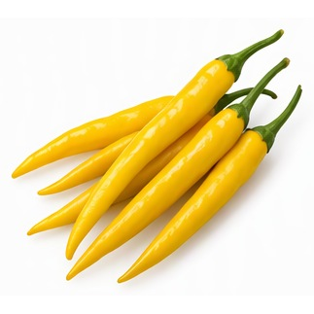

PLU: 4678  Pepper Sweet Banana  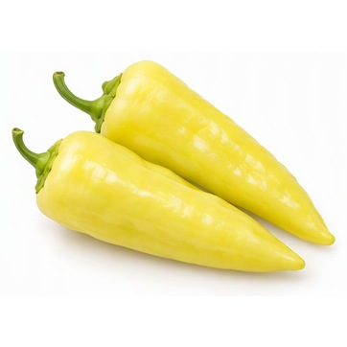 | PLU: 4709  Pepper Serrano  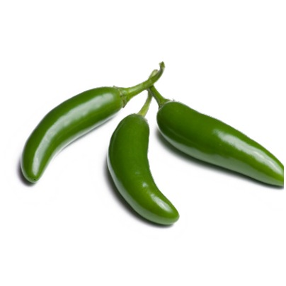
PLU: 3124  Pepper Purple Bell  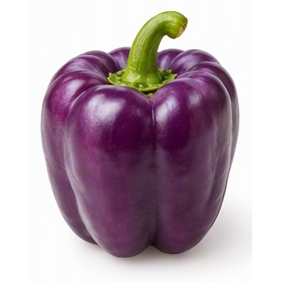 | PLU: 93124  Organic Pepper Purple Bell  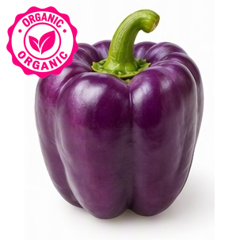
PLU: 4707  Pepper Long Red Finger  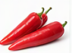 | PLU: 4692  Pepper Hungarian  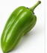

PLU: 4691  Pepper Hot Mix  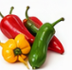 | PLU: 4696  Pepper Hot Finger  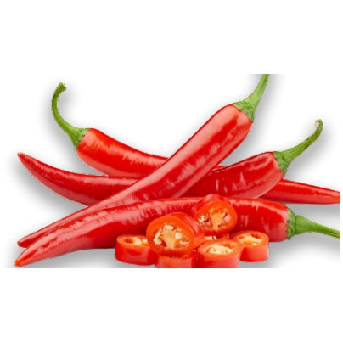
PLU: 4722  Pepper Cherry  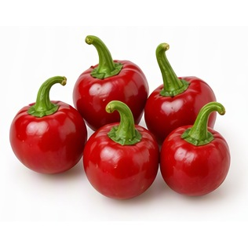 | PLU: 3123  Pepper Brown  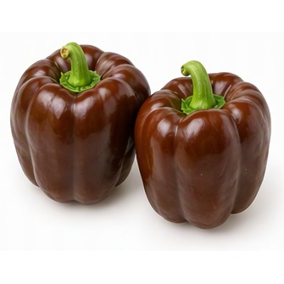
PLU: 3122  Pepper White  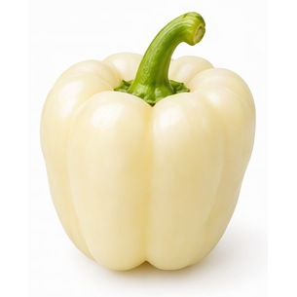 | PLU: 4065  Pepper Green Bell Large  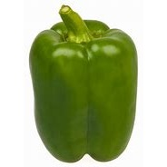

PLU: 93120  Organic Pepper Green Bell  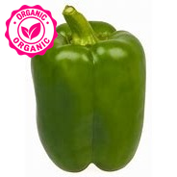 | PLU: 94323  Organic Pepper Chocolate  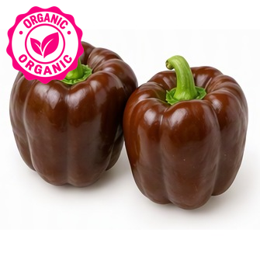
PLU: 94065  Organic Pepper Green | PLU: 93121  Organic Pepper Orange  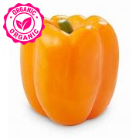
PLU: 94088  Organic Pepper Red  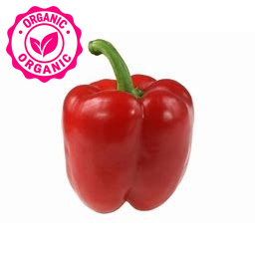 | PLU: 4724  White Creamer Potatoes  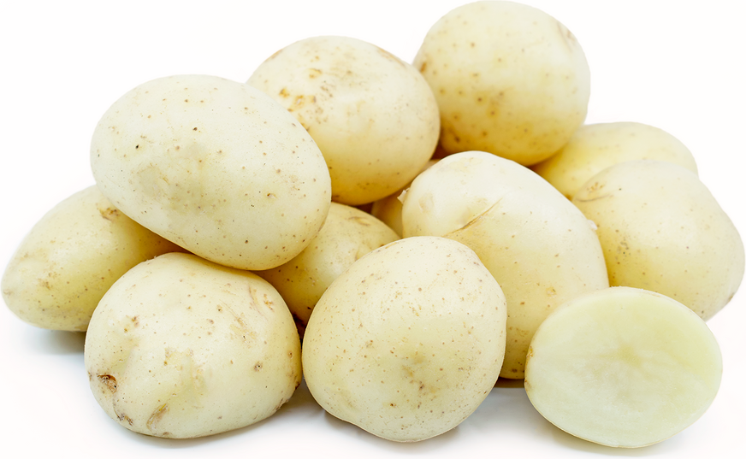

PLU: 4723  Red Creamer Potatoes  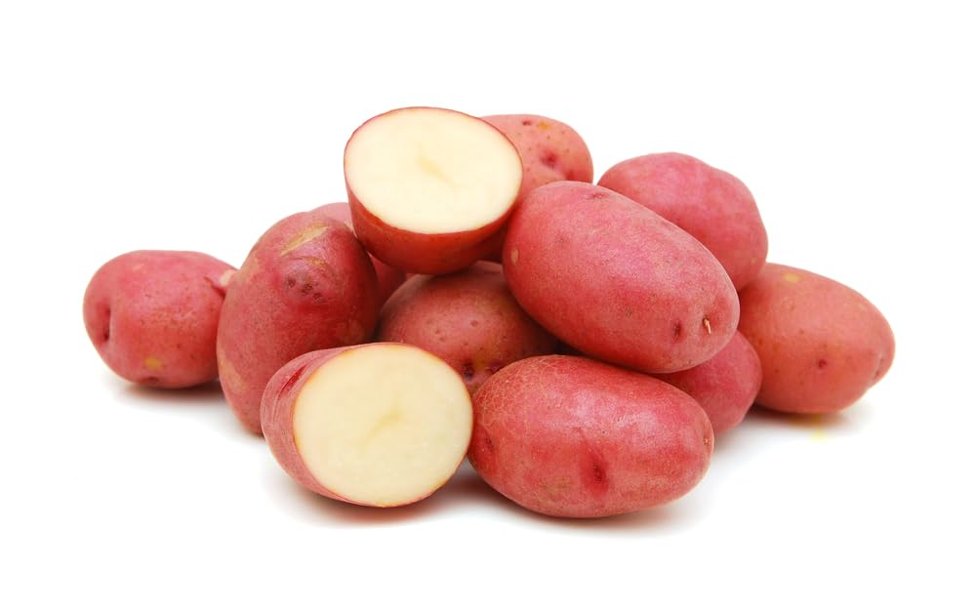 | PLU: 3128  Potato Purple  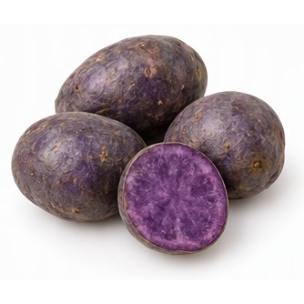
PLU: 93128  Organic Potato Purple  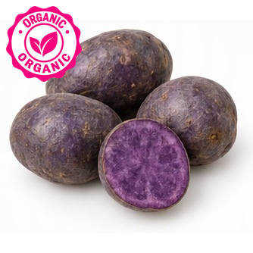 | PLU: 4073  Potato Red  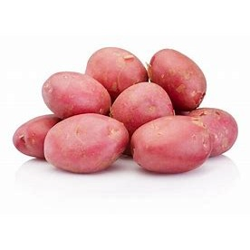
PLU: 94723  Organic Potato Red  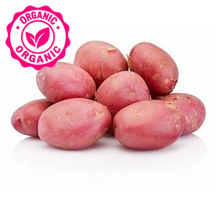 | PLU: 94073  Organic Potatoes Red

PLU: 4083  Potato White  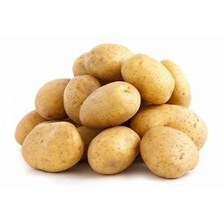 | PLU: 94823  Organic White Potatoes
PLU: 4727  Yellow Potatoes | PLU: 94829  Organic Potato Yellow  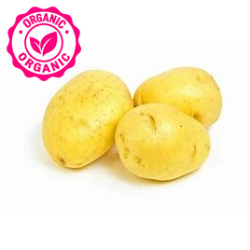
PLU: 4074  Red-Fleshed Sweet Potato  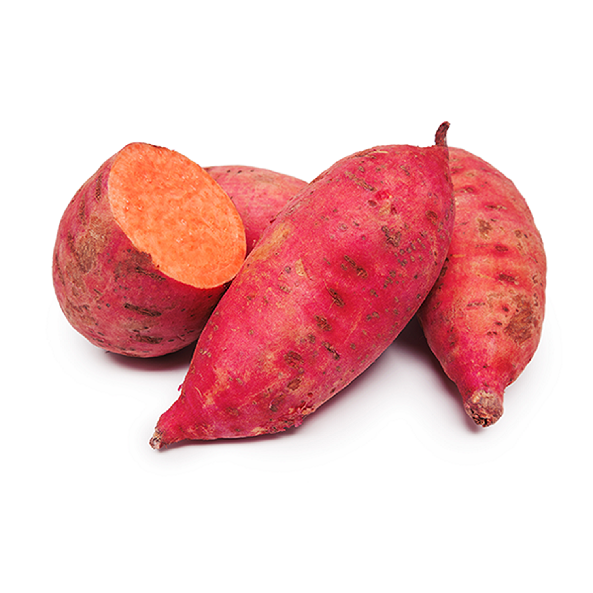 | PLU: 3209  Yam Purple  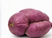

PLU: 60271  Early Nugget (Warba) Potatoes | PLU: 4730  Potato Yellow Creamer  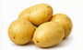
PLU: 4816  Yams  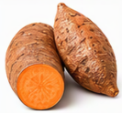 | PLU: 94816  Organic Yam  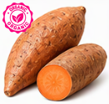
PLU: 4725  Potato Russet  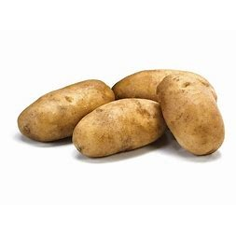 | PLU: 4091  Sweet Potato White  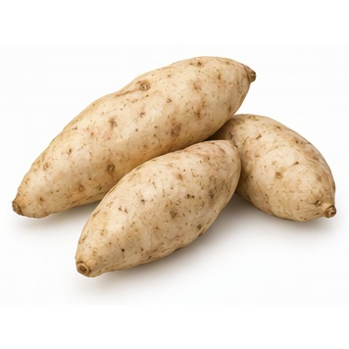

PLU: 4818  Sweet Potato japanese  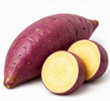 | PLU: 3474  Sweet Potato Ben Yagi Purple  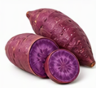
PLU: 3288  Sweet Potato Stokes Purple  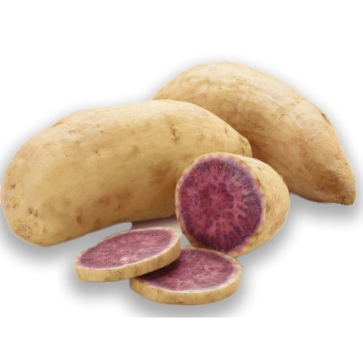 | PLU: 94072  Organic Potato Baking  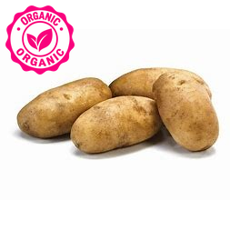
PLU: 94074  Organic Yams Red Garnet  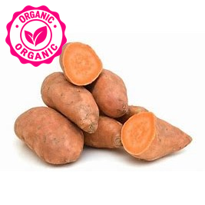 | PLU: 4747  Rutabaga  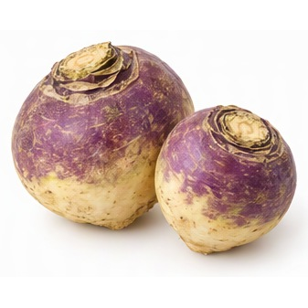

PLU: 4626  Jicama  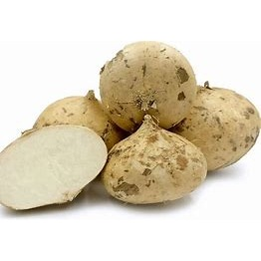 | PLU: 4560  Carrotts Baby  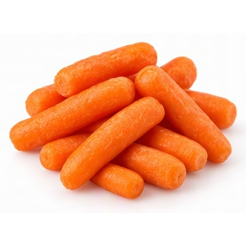
PLU: 4585  Celery Root  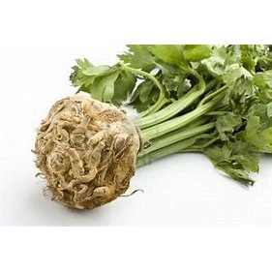 | PLU: 4612  Ginger  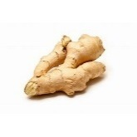
PLU: 4625  Horseradish Root  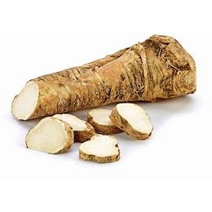 | PLU: 4672  Parsnip  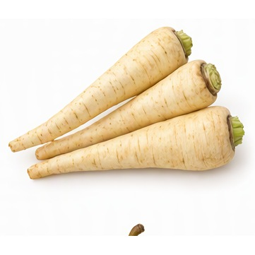

PLU: 4089  Radish Bunch Red  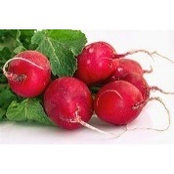 | PLU: 4811  Turnip Purple Top  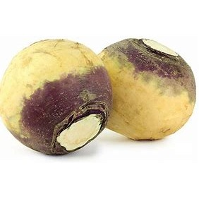
PLU: 4819  Yucca Root  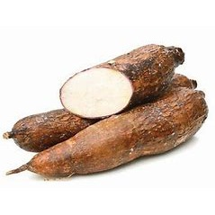 | PLU: 4539  Beets Bunch  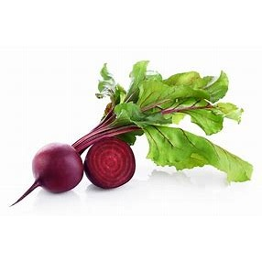
PLU: 4562  Carrots Bulk  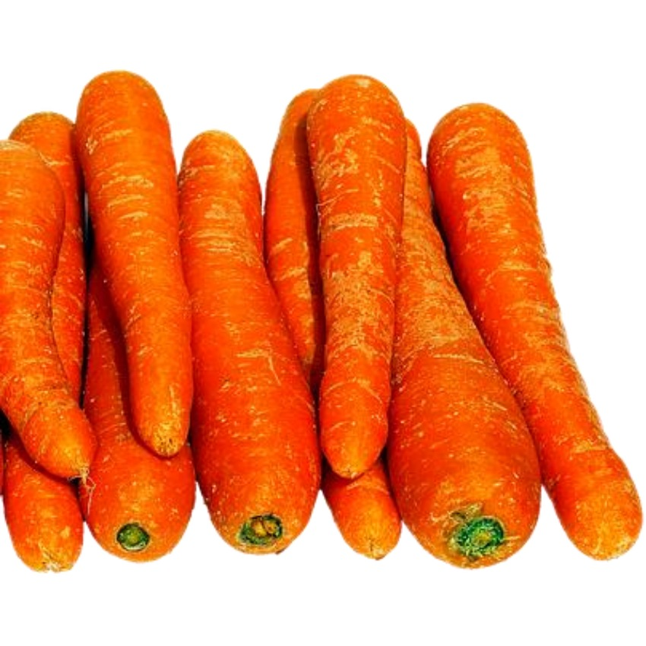 | PLU: 4540  Beets Bulk

PLU: 12882  Beets Golden  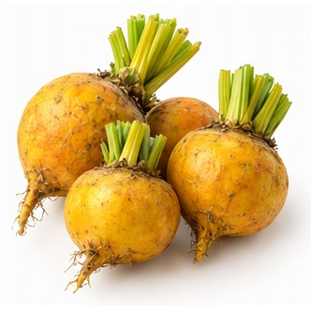 | PLU: 4094  Carrots Bunch  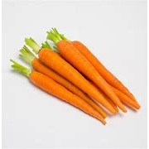
PLU: 94094  Organic Carrots Bunch  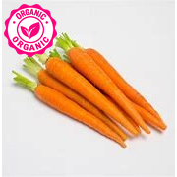 | PLU: 41519  Jumbo Carrots
PLU: 4565  Carrot - Red  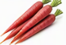 | PLU: 94096  Organic Ginger Gold  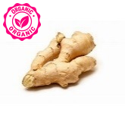

PLU: 94089  Organic Radish Bunch  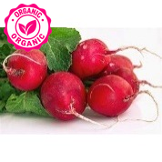 | PLU: 94539  Organic Beets  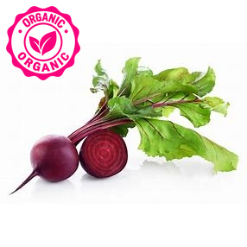
PLU: 4515  Anise Fennel  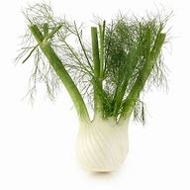 | PLU: 4762  Artichoke XL  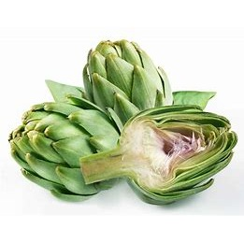
PLU: 4084  Artichokes Large | PLU: 4516  Artichokes Small

PLU: 4522  Asparagus White  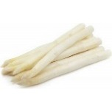 | PLU: 4533  Beans Yellow Wax  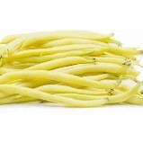
PLU: 4576  Celery Sticks  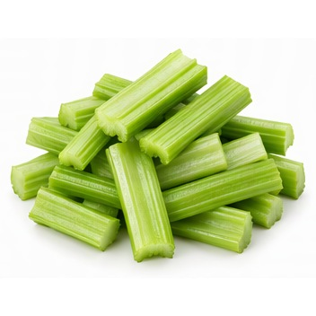 | PLU: 4078  Corn  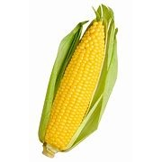
PLU: 4081  Eggplant  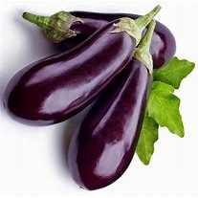 | PLU: 94081  Organic Eggplant  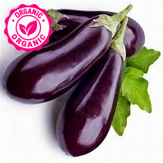

PLU: 3089  Eggplant Chinese  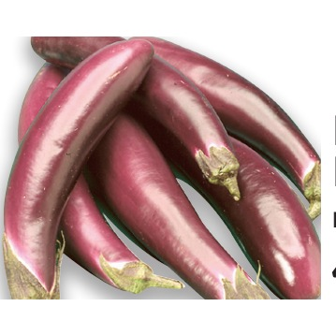 | PLU: 4599  Eggplant Italian  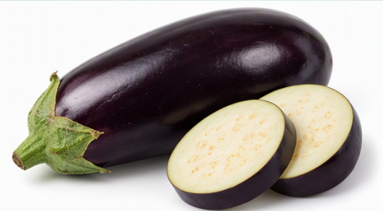
PLU: 4674  Peas Green (English)  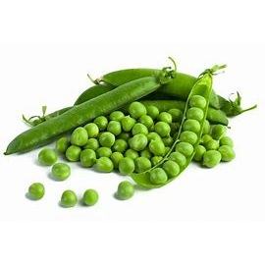 | PLU: 4092  Peas Snow  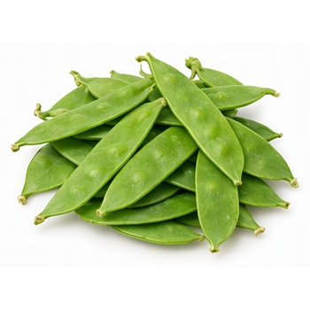
PLU: 4675  Peas Sugar Snap  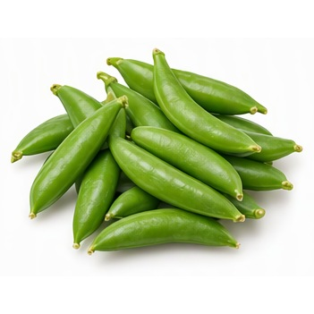 | PLU: 4676  Peas Tips  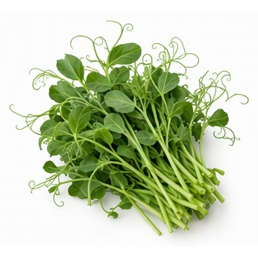

PLU: 4745  Rhubarb KG  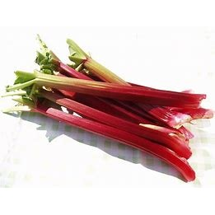 | PLU: 4080  Asparagus Green  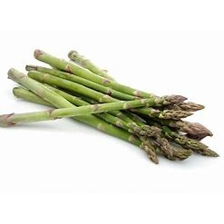
PLU: 4066  Beans Green  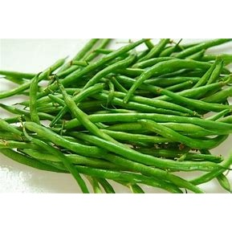 | PLU: 94066  Organic Green Beans  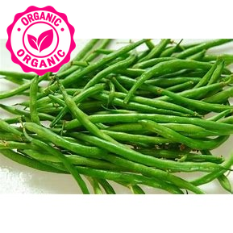
PLU: 4647  Mushroom Chantrelle  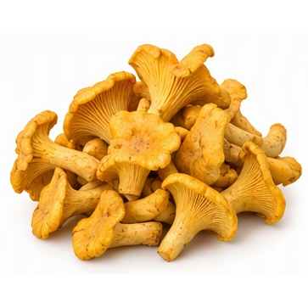 | PLU: 4582  Celery Bunch  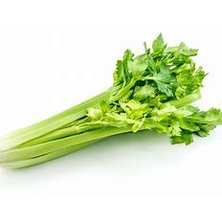

PLU: 94648  Organic Cremini Mushrooms | PLU: 94070  Organic Celery  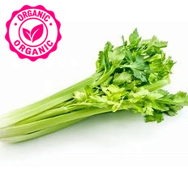
PLU: 94600  Organic Eggplant White  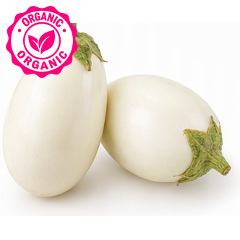 | PLU: 94649  Organic Mushroom Oyster  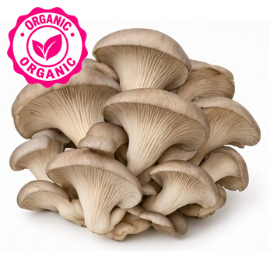
PLU: 94657  Organic Portobello Mushrooms | PLU: 94651  Organic Mushrooms Shitake  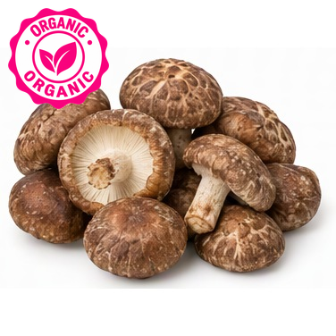

PLU: 94085  Organic Mushrooms White  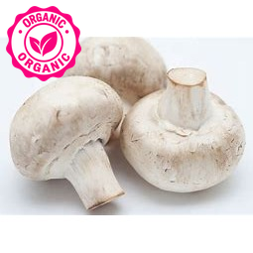 | PLU: 94655  Organic Okra  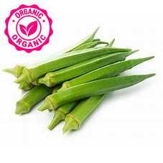
PLU: 94745  Organic Rhubarb  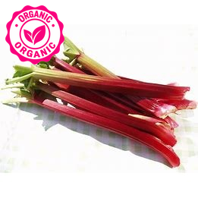 | PLU: 3130  Pumpkin  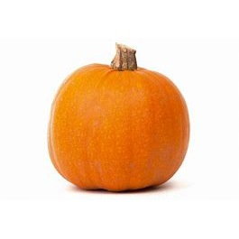
PLU: 4734  Pumpkin Mini  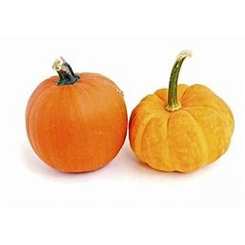 | PLU: 3132  Pumpkin White  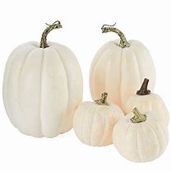

PLU: 4750  Squash Acorn/Pepper  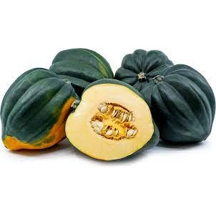 | PLU: 4758  Squash Buttercup  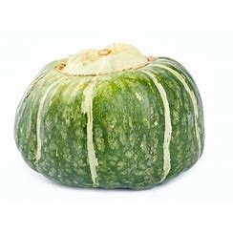
PLU: 94758  Organic Squash Buttercup  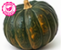 | PLU: 4759  Squash Butternut  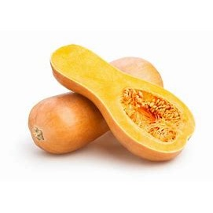
PLU: 94759  Organic Squash Butternut  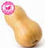 | PLU: 8180  Squash Chayote  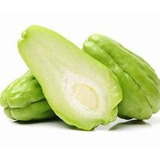

PLU: 4761  Squash Chayote | PLU: 4767  Squash Golden  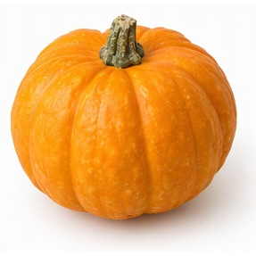
PLU: 4768  Squash Hubbard  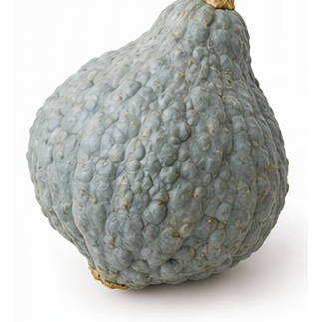 | PLU: 4780  Squash Turban  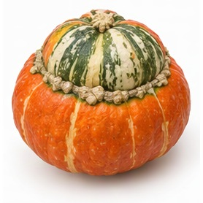
PLU: 4782  Squash Yellow  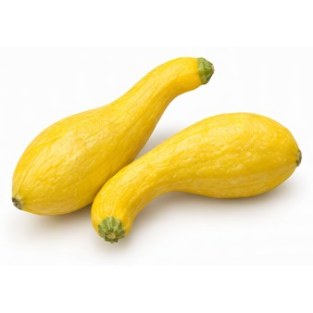 | PLU: 94782  Organic Squash Yellow  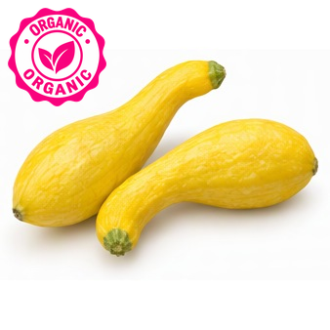

PLU: 4784  Squash Yelllow Crook | PLU: 4774  Squash Uchiki Mama  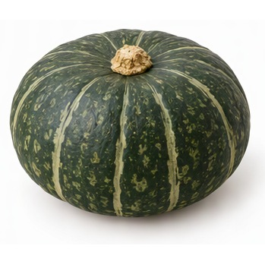
PLU: 4779  Squash Sweet Mama  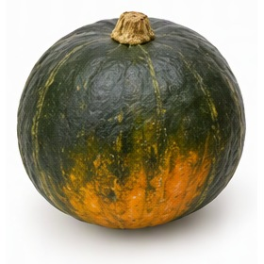 | PLU: 4764  Squash Sweet Dumpling  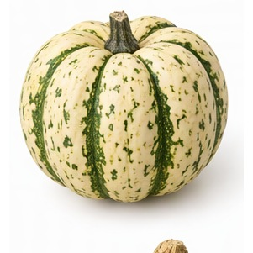
PLU: 94764  Organic Squash Dumpling Sweet  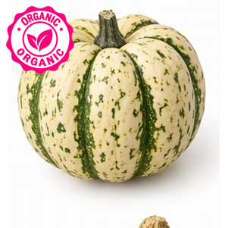 | PLU: 4777  Squash Sunburst  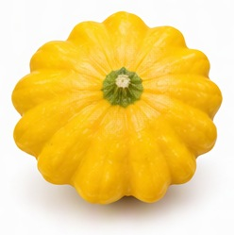

PLU: 94777  Organic Squash Sunburst  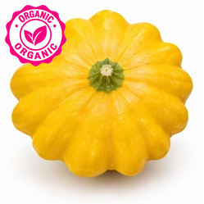 | PLU: 4968  Squash Stripetti  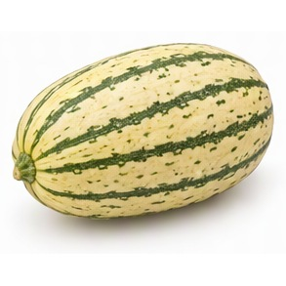
PLU: 4776  Squash Spaghetti  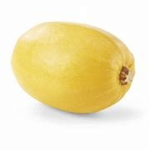 | PLU: 94776  Organic Squash Spaghetti  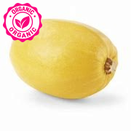
PLU: 4773  Squash Patty Pan  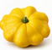 | PLU: 94773  Organic Squash Patty Pan  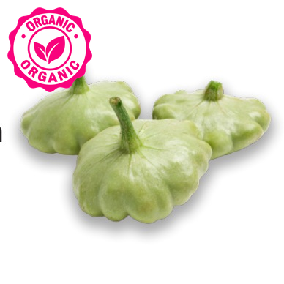

PLU: 3141  Opo Squash | PLU: 4757  Squash Banana  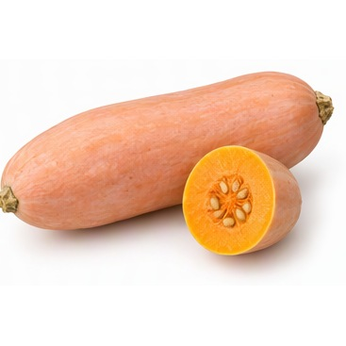
PLU: 4752  Squash Acorn White  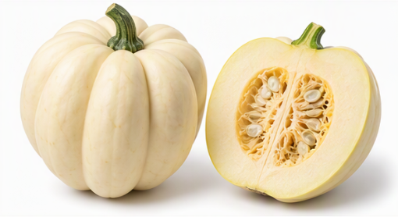 | PLU: 4751  Squash Acorn Golden  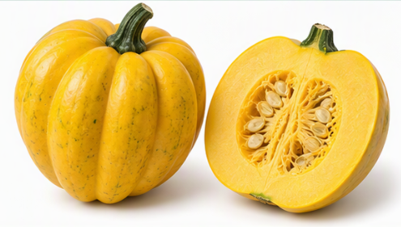
PLU: 8032  Squash Acorn Cut | PLU: 4067  Zucchini

PLU: 94067  Organic Zucchini  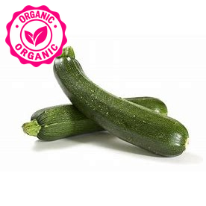 | PLU: 4086  Yellow Zucchini
PLU: 94086  Organic Zucchini Yellow  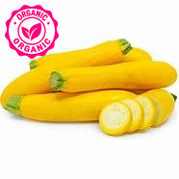 | PLU: 3135  Ornamental Gourd  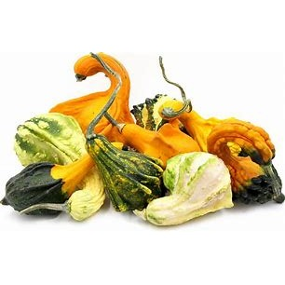
PLU: 3060  Zucchini Grey  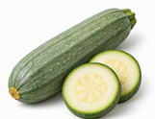 | PLU: 4769  Kabocha

PLU: 94750  Organic Squash Acorn  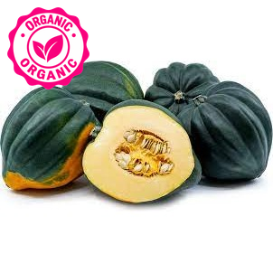 | PLU: 93142  Organic Squash Carnivale  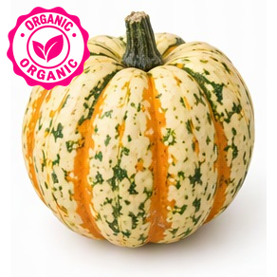
PLU: 94763  Organic Squash Delicata  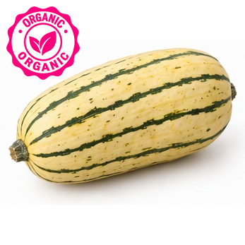 | PLU: 93418  Organic Squash Eightball  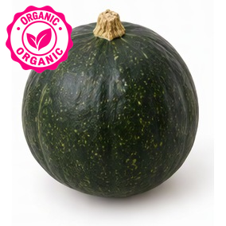
PLU: 94785  Organic Squash Festival  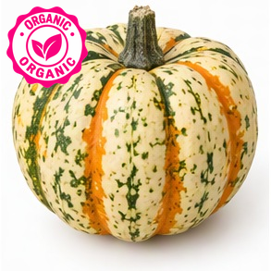 | PLU: 94774  Organic Squash Red Kurri  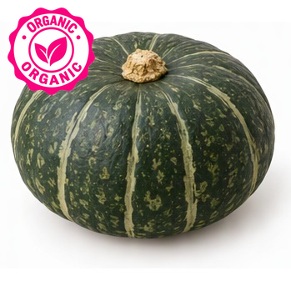

PLU: 94769  Organic Kabocha Squash | PLU: 3423  Tomato Heriloom  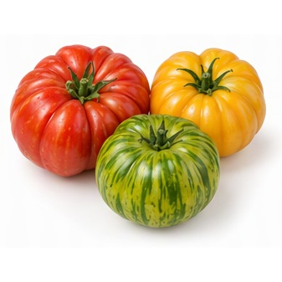
PLU: 4798  Tomato Hot House Small  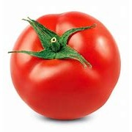 | PLU: 4799  Tomato Hot House
PLU: 4064  Tomato Vine ripe  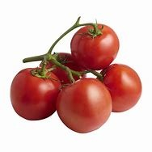 | PLU: 3146  Tomatoes Cherry Vine  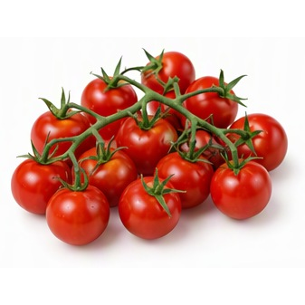

PLU: 4664  Tomato on the Vine | PLU: 4963  Tomatillos  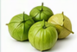
PLU: 4087  Roma Tomato  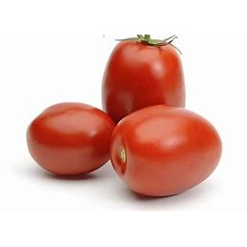 | PLU: 3061  Beef Steak Tomato  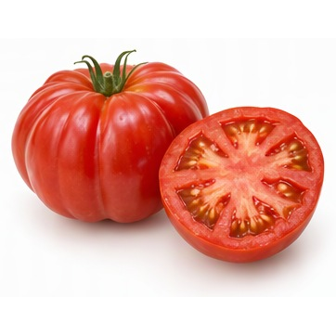
PLU: 94664  Organic Red Cluster Tomatoes (On the Vine) | PLU: 94799  Organic Hot House Tomatoe  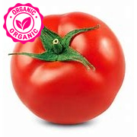

PLU: 94993  Organic Tomato Cherry  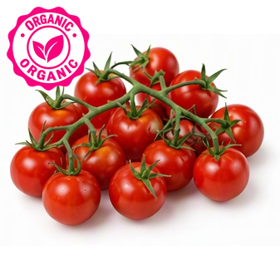 | PLU: 94860  Organic Tomato Field  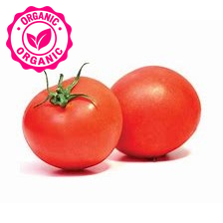
PLU: 93150  Organic Tomato Grape  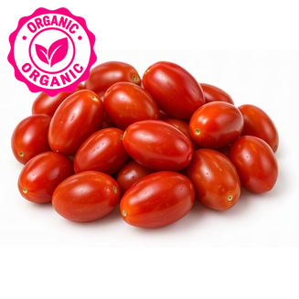 | PLU: 93423  Organic Tomato Heirloom  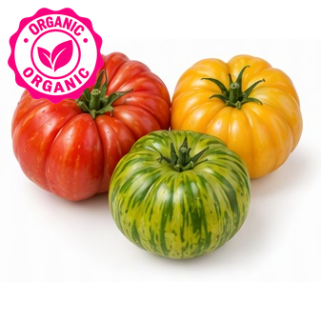
PLU: 94087  Organic Tomato Plum Roma  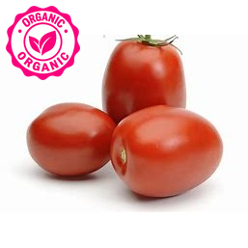 | PLU: 94063  Organic Tomato Red

PLU: 94064  Organic Tomato Red Large | PLU: 94798  Organic Tomatoes
PLU: 94031  Organic Watermelon | PLU: 94049  Organic Cantaloupe – Small
PLU: 94321
Organic Watermelon

