Fruit Visual PLU Booklet
Cashier photo reference: match the produce in front of you to the picture, then read the PLU.

How to use this booklet
1. Find the section for the type of produce (the list below shows the sections).
2. Compare the item to the photos. Use the product name, not just the colour, to confirm the match.
3. Read the PLU printed above the name. Always check the sticker on the item if it is different.
4. Entries with a red DUPLICATE PLU badge share a code with another product in the master list. Check the sticker or ask a supervisor before ringing it in.

Image source key
Code Booklet: photo taken from the supplied code booklet (document images).
Produce Guide / Produce Sheets: photo taken from the supplied produce identification PDFs.
AI Generated: realistic computer-generated picture used only where no supplied photo existed. It shows a typical example only; confirm against the real product.

Sections
Section 1 Apples (19 entries)
Section 2 Pears (22 entries)
Section 3 Citrus (30 entries)
Section 4 Grapes (7 entries)
Section 5 Berries (21 entries)
Section 6 Melons (25 entries)
Section 7 Stone Fruit (17 entries)
Section 8 Tropical Fruit (35 entries)
Section 9 Specialty Fruit (12 entries)
Section 10 Organic Fruit (105 entries)
293 PLU entries in total. Master PLU list: FINAL_FRUIT_PLU_BOOKLET.

Section 1: Apples
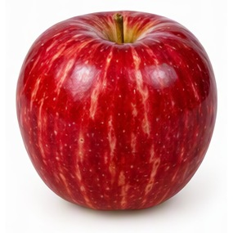  PLU: 3529  Apple Dazzle  Category: Apple  Image Source: AI Generated  Verification Status: 🤖 AI GENERATED REFERENCE IMAGE | 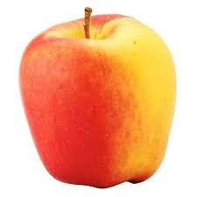  PLU: 3438  Apples Ambrosia  Category: Apple  Image Source: Code Booklet  Verification Status: ✅ VERIFIED PHOTO | 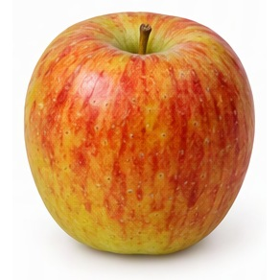  PLU: 4101  Apples Breburn Small  Category: Apple  Image Source: AI Generated  Verification Status: 🤖 AI GENERATED REFERENCE IMAGE | 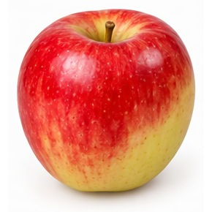  PLU: 3616  Apples Envy  Category: Apple  Image Source: AI Generated  Verification Status: 🤖 AI GENERATED REFERENCE IMAGE
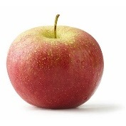  PLU: 4129  Apples Fuji Small  Category: Apple  Image Source: Code Booklet  Verification Status: ✅ VERIFIED PHOTO | 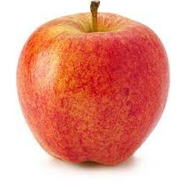  PLU: 4135  Apples Gala Large  Category: Apple  Image Source: Code Booklet  Verification Status: ✅ VERIFIED PHOTO | 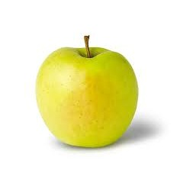  PLU: 4020  Apples Gold Delicious Large  Category: Apple  Image Source: Code Booklet  Verification Status: ✅ VERIFIED PHOTO | 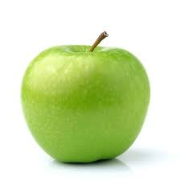  PLU: 4017  Apples Granny Smith  Category: Apple  Image Source: Code Booklet  Verification Status: ✅ VERIFIED PHOTO
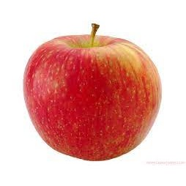  PLU: 3283  Apples Honey Crisp  Category: Apple  Image Source: Code Booklet  Verification Status: ✅ VERIFIED PHOTO | 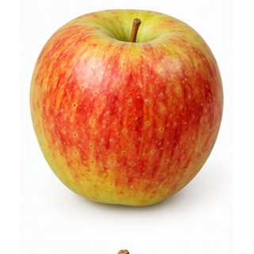  PLU: 3293  Apples Jazz Small  Category: Apple  Image Source: AI Generated  Verification Status: 🤖 AI GENERATED REFERENCE IMAGE | 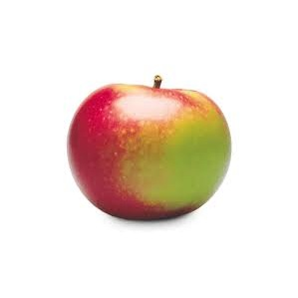  PLU: 4153  Apples MacIntosh Large  Category: Apple  Image Source: Code Booklet  Verification Status: ✅ VERIFIED PHOTO | PLU: 4152  Apples McIntosh Small  Category: Apple  Image Source: Code Booklet  Verification Status: ✅ VERIFIED PHOTO
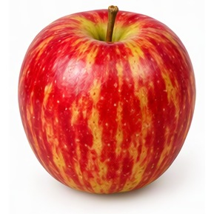  PLU: 3445  Apples Pazza  Category: Apple  Image Source: AI Generated  Verification Status: 🤖 AI GENERATED REFERENCE IMAGE | 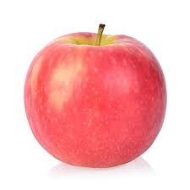  PLU: 4130  Apples Pink Lady  Category: Apple  Image Source: Code Booklet  Verification Status: ✅ VERIFIED PHOTO | 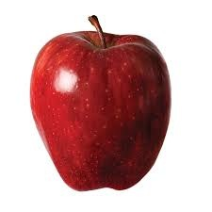  PLU: 4016  Apples Red Delicious Lrg  Category: Apple  Image Source: Code Booklet  Verification Status: ✅ VERIFIED PHOTO | 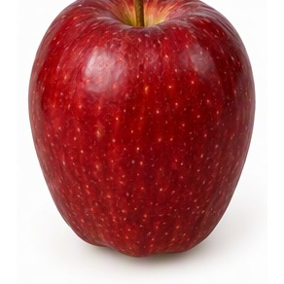  ⚠ DUPLICATE PLU  PLU: 4059  Apples Red Prince  Category: Apple  Image Source: AI Generated  Verification Status: 🤖 AI GENERATED REFERENCE IMAGE
PLU: 4174  Apples Royal Gala Large  Category: Apple  Image Source: Code Booklet  Verification Status: ✅ VERIFIED PHOTO | PLU: 4173  Apples Royal Gala Small  Category: Apple  Image Source: Code Booklet  Verification Status: ✅ VERIFIED PHOTO | 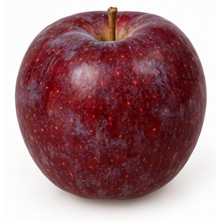  PLU: 4180  Apples Spartan Large  Category: Apple  Image Source: AI Generated  Verification Status: 🤖 AI GENERATED REFERENCE IMAGE

Section 2: Pears
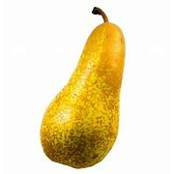  PLU: 3012  Pear Abate  Category: Pear  Image Source: Code Booklet  Verification Status: ✅ VERIFIED PHOTO | 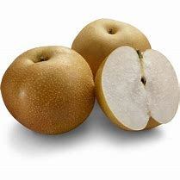  PLU: 4406  Pear Asian White  Category: Pear  Image Source: Code Booklet  Verification Status: ✅ VERIFIED PHOTO | 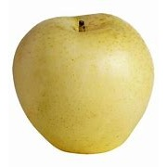  PLU: 4407  Pear Asian Yellow  Category: Pear  Image Source: Code Booklet  Verification Status: ✅ VERIFIED PHOTO | 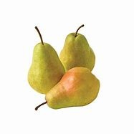  PLU: 4409  Pear Bartlett Green  Category: Pear  Image Source: Code Booklet  Verification Status: ✅ VERIFIED PHOTO
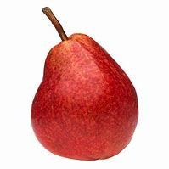  PLU: 4410  Pear Bartlett Red  Category: Pear  Image Source: Code Booklet  Verification Status: ✅ VERIFIED PHOTO | 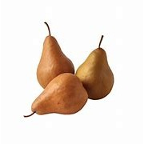  PLU: 4413  Pear Bosc Large  Category: Pear  Image Source: Code Booklet  Verification Status: ✅ VERIFIED PHOTO | 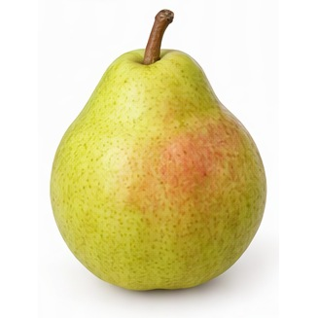  PLU: 4414  Pear Comice  Category: Pear  Image Source: AI Generated  Verification Status: 🤖 AI GENERATED REFERENCE IMAGE | 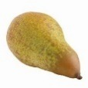  PLU: 3016  Pear Concorde  Category: Pear  Image Source: Code Booklet  Verification Status: ✅ VERIFIED PHOTO
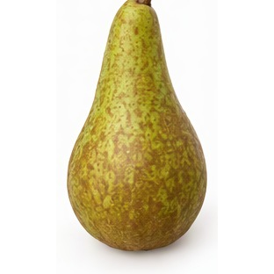  PLU: 3017  Pear Conference  Category: Pear  Image Source: AI Generated  Verification Status: 🤖 AI GENERATED REFERENCE IMAGE | 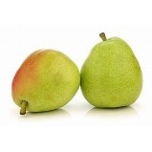  PLU: 4416  Pear D'Anjou Lrg  Category: Pear  Image Source: Code Booklet  Verification Status: ✅ VERIFIED PHOTO | 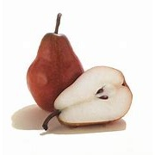  PLU: 4417  Pear D'Anjou Red  Category: Pear  Image Source: Code Booklet  Verification Status: ✅ VERIFIED PHOTO | 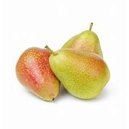  PLU: 4418  Pear Forelle  Category: Pear  Image Source: Code Booklet  Verification Status: ✅ VERIFIED PHOTO
PLU: 4415  Pear Red  Category: Pear  Image Source: Code Booklet  Verification Status: ✅ VERIFIED PHOTO | PLU: 3118  Pear Red Crimson  Category: Pear  Image Source: Code Booklet  Verification Status: ✅ VERIFIED PHOTO | 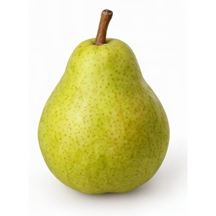  PLU: 3024  Pear Rocha  Category: Pear  Image Source: AI Generated  Verification Status: 🤖 AI GENERATED REFERENCE IMAGE | 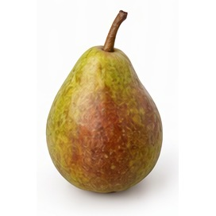  PLU: 4422  Pear Seckel  Category: Pear  Image Source: AI Generated  Verification Status: 🤖 AI GENERATED REFERENCE IMAGE
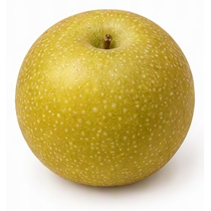  ⚠ DUPLICATE PLU  PLU: 4425  Pear Shingo  Category: Pear  Image Source: AI Generated  Verification Status: 🤖 AI GENERATED REFERENCE IMAGE | 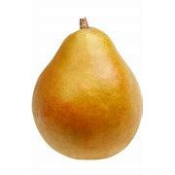  ⚠ DUPLICATE PLU  PLU: 4425  Pear Taylor Gold  Category: Pear  Image Source: Code Booklet  Verification Status: ✅ VERIFIED PHOTO | PLU: 4553  Pear Taylors Gold  Category: Pear  Image Source: Code Booklet  Verification Status: ✅ VERIFIED PHOTO  ⚠ DUPLICATE PLU | PLU: 82200  Pears Conference BC  Category: Pear  Image Source: AI Generated  Verification Status: 🤖 AI GENERATED REFERENCE IMAGE
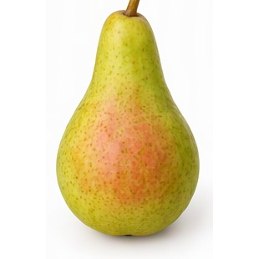  PLU: 4005  Pears Honey Belle  Category: Pear  Image Source: AI Generated  Verification Status: 🤖 AI GENERATED REFERENCE IMAGE | PLU: 4424  Pears Honey Belle Sweet Green  Category: Pear  Image Source: AI Generated  Verification Status: 🤖 AI GENERATED REFERENCE IMAGE

Section 3: Citrus
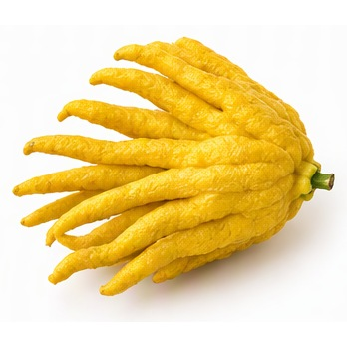  PLU: 2159  Buddha's Hand Organic  Category: Citrus  Image Source: AI Generated  Verification Status: 🤖 AI GENERATED REFERENCE IMAGE | 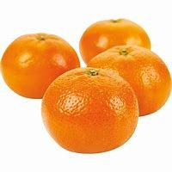  ⚠ DUPLICATE PLU  PLU: 4450  Clementine  Category: Citrus  Image Source: Code Booklet  Verification Status: ✅ VERIFIED PHOTO | ⚠ DUPLICATE PLU  PLU: 4458  Clementines Box  Category: Citrus  Image Source: Code Booklet  Verification Status: ✅ VERIFIED PHOTO | 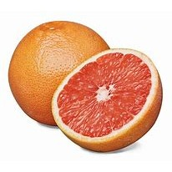  PLU: 4286  Grapefruit Deep Red  Category: Citrus  Image Source: Code Booklet  Verification Status: ✅ VERIFIED PHOTO
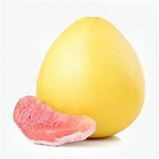  ⚠ DUPLICATE PLU  PLU: 3129  Grapefruit Pummelo  Category: Citrus  Image Source: Code Booklet  Verification Status: ✅ VERIFIED PHOTO | PLU: 4288  Grapefruit Red Large  Category: Citrus  Image Source: Code Booklet  Verification Status: ✅ VERIFIED PHOTO | PLU: 4027  Grapefruit Red Sm  Category: Citrus  Image Source: Code Booklet  Verification Status: ✅ VERIFIED PHOTO | PLU: 4280  Grapefruit Small  Category: Citrus  Image Source: Code Booklet  Verification Status: ✅ VERIFIED PHOTO
PLU: 4293  Grapefruit White Large  Category: Citrus  Image Source: Code Booklet  Verification Status: ✅ VERIFIED PHOTO | PLU: 4279  Grapefurit Pummelo  Category: Citrus  Image Source: Code Booklet  Verification Status: ✅ VERIFIED PHOTO | 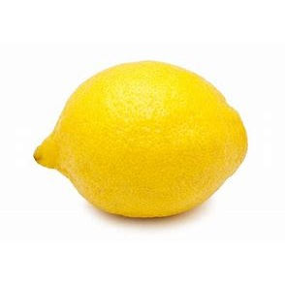  PLU: 4053  Lemons  Category: Citrus  Image Source: Code Booklet  Verification Status: ✅ VERIFIED PHOTO | 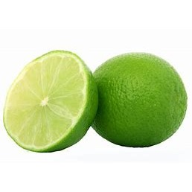  PLU: 4048  Limes  Category: Citrus  Image Source: Code Booklet  Verification Status: ✅ VERIFIED PHOTO
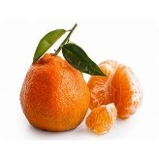  PLU: 4455  Mandarins  Category: Citrus  Image Source: Code Booklet  Verification Status: ✅ VERIFIED PHOTO | 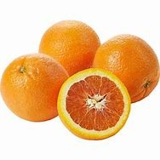  ⚠ DUPLICATE PLU  PLU: 3110  Orange Cara Cara  Category: Citrus  Image Source: Code Booklet  Verification Status: ✅ VERIFIED PHOTO | 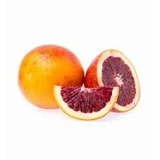  PLU: 4381  Oranges Blood  Category: Citrus  Image Source: Code Booklet  Verification Status: ✅ VERIFIED PHOTO | ⚠ DUPLICATE PLU  PLU: 4450  Oranges Clementine  Category: Citrus  Image Source: Code Booklet  Verification Status: ✅ VERIFIED PHOTO
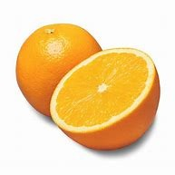  PLU: 3153  Oranges Large  Category: Citrus  Image Source: Code Booklet  Verification Status: ✅ VERIFIED PHOTO | PLU: 4477  Oranges Madarin Japanese  Category: Citrus  Image Source: Code Booklet  Verification Status: ✅ VERIFIED PHOTO | PLU: 3029  Oranges Mandarin Chinese  Category: Citrus  Image Source: Code Booklet  Verification Status: ✅ VERIFIED PHOTO | ⚠ DUPLICATE PLU  PLU: 4055  Oranges Murcott  Category: Citrus  Image Source: Code Booklet  Verification Status: ✅ VERIFIED PHOTO
PLU: 4012  Oranges Navel  Category: Citrus  Image Source: Code Booklet  Verification Status: ✅ VERIFIED PHOTO | ⚠ DUPLICATE PLU  PLU: 3110  Oranges Navel Cara  Category: Citrus  Image Source: Code Booklet  Verification Status: ✅ VERIFIED PHOTO | ⚠ DUPLICATE PLU  PLU: 3129  Pomelos  Category: Citrus  Image Source: Code Booklet  Verification Status: ✅ VERIFIED PHOTO | 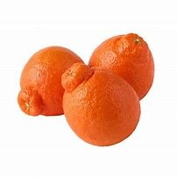  PLU: 4456  Tangelos  Category: Citrus  Image Source: Code Booklet  Verification Status: ✅ VERIFIED PHOTO
PLU: 4452  Tangerine Fairchild  Category: Citrus  Image Source: Code Booklet  Verification Status: ✅ VERIFIED PHOTO | PLU: 4454  Tangerine Murcott  Category: Citrus  Image Source: Code Booklet  Verification Status: ✅ VERIFIED PHOTO | ⚠ DUPLICATE PLU  PLU: 4458  Tangerine Seedless  Category: Citrus  Image Source: Code Booklet  Verification Status: ✅ VERIFIED PHOTO | PLU: 4449  Tangerine Sunburst  Category: Citrus  Image Source: Code Booklet  Verification Status: ✅ VERIFIED PHOTO
⚠ DUPLICATE PLU  PLU: 4055  Tangerines  Category: Citrus  Image Source: Code Booklet  Verification Status: ✅ VERIFIED PHOTO | PLU: 4453  Tangerines Honey  Category: Citrus  Image Source: Code Booklet  Verification Status: ✅ VERIFIED PHOTO

Section 4: Grapes
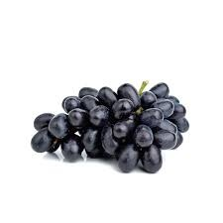  PLU: 4056  Grapes Black Seedless  Category: Grape  Image Source: Code Booklet  Verification Status: ✅ VERIFIED PHOTO | 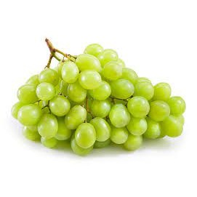  PLU: 4498  Grapes Green  Category: Grape  Image Source: Code Booklet  Verification Status: ✅ VERIFIED PHOTO | PLU: 4022  Grapes Green Seedless  Category: Grape  Image Source: Code Booklet  Verification Status: ✅ VERIFIED PHOTO | 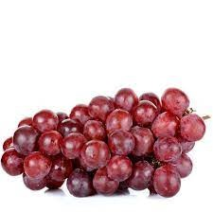  PLU: 4635  Grapes Red Seedless  Category: Grape  Image Source: Code Booklet  Verification Status: ✅ VERIFIED PHOTO
PLU: 4023  Grapes Red Seedless (Red Flame)  Category: Grape  Image Source: Code Booklet  Verification Status: ✅ VERIFIED PHOTO | PLU: 4497  Grapes Sugraone  Category: Grape  Image Source: Code Booklet  Verification Status: ✅ VERIFIED PHOTO | PLU: 4274  Grapes White Seeded  Category: Grape  Image Source: Code Booklet  Verification Status: ✅ VERIFIED PHOTO

Section 5: Berries
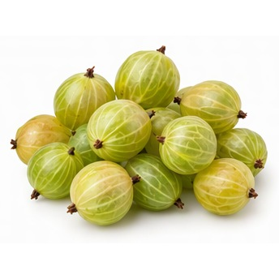  PLU: 4243  Berries - GooseBerries  Category: Berry  Image Source: AI Generated  Verification Status: 🤖 AI GENERATED REFERENCE IMAGE | 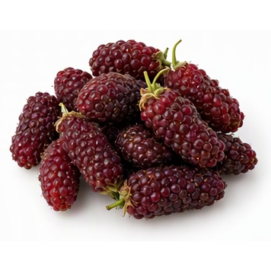  PLU: 82202  Berries - Logan Berries  Category: Berry  Image Source: AI Generated  Verification Status: 🤖 AI GENERATED REFERENCE IMAGE | 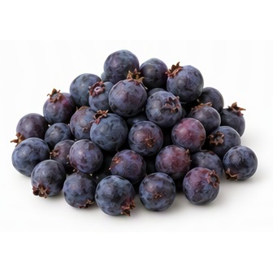  PLU: 4476  Berries Saskatoon 2 Quart  Category: Berry  Image Source: AI Generated  Verification Status: 🤖 AI GENERATED REFERENCE IMAGE | 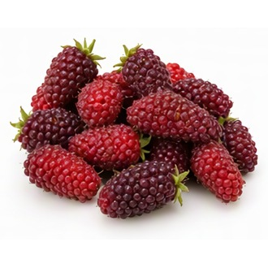  PLU: 52744  Berries Tay Berries  Category: Berry  Image Source: AI Generated  Verification Status: 🤖 AI GENERATED REFERENCE IMAGE
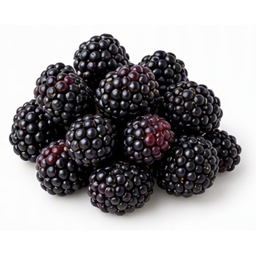  PLU: 4462  Blackberries 1 Pound  Category: Berry  Image Source: AI Generated  Verification Status: 🤖 AI GENERATED REFERENCE IMAGE | PLU: 4239  Blackberries Pint  Category: Berry  Image Source: AI Generated  Verification Status: 🤖 AI GENERATED REFERENCE IMAGE | 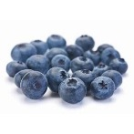  PLU: 19221  Blueberries Bulk  Category: Berry  Image Source: Code Booklet  Verification Status: ✅ VERIFIED PHOTO | PLU: 4240  Blueberries Pint  Category: Berry  Image Source: Code Booklet  Verification Status: ✅ VERIFIED PHOTO
⚠ DUPLICATE PLU  PLU: 4253  Blueberries Quart  Category: Berry  Image Source: Code Booklet  Verification Status: ✅ VERIFIED PHOTO | 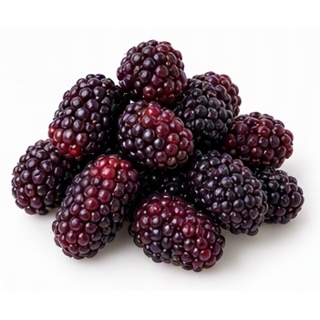  PLU: 4241  Boysenberries  Category: Berry  Image Source: AI Generated  Verification Status: 🤖 AI GENERATED REFERENCE IMAGE | 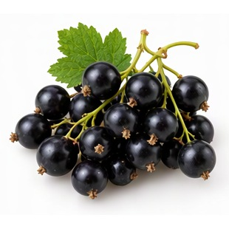  PLU: 3305  Currents - Black  Category: Berry  Image Source: AI Generated  Verification Status: 🤖 AI GENERATED REFERENCE IMAGE | 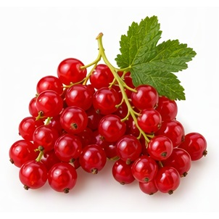  PLU: 3088  Currents - Red  Category: Berry  Image Source: AI Generated  Verification Status: 🤖 AI GENERATED REFERENCE IMAGE
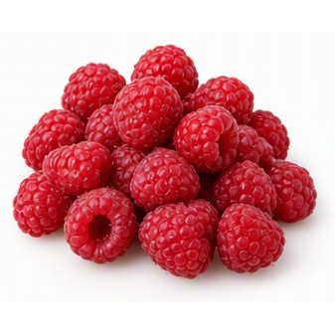  PLU: 4252  Raspberries 1 Pound  Category: Berry  Image Source: AI Generated  Verification Status: 🤖 AI GENERATED REFERENCE IMAGE | PLU: 4988  Raspberries Flat  Category: Berry  Image Source: AI Generated  Verification Status: 🤖 AI GENERATED REFERENCE IMAGE | PLU: 4054  Raspberries Half Pint  Category: Berry  Image Source: AI Generated  Verification Status: 🤖 AI GENERATED REFERENCE IMAGE | 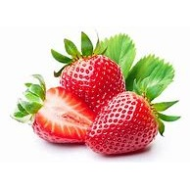  PLU: 3244  Strawberries 4 Pounds  Category: Berry  Image Source: Code Booklet  Verification Status: ✅ VERIFIED PHOTO
PLU: 3181  Strawberries BC 1 Pound  Category: Berry  Image Source: Code Booklet  Verification Status: ✅ VERIFIED PHOTO | ⚠ DUPLICATE PLU  PLU: 4253  Strawberries Flat  Category: Berry  Image Source: Code Booklet  Verification Status: ✅ VERIFIED PHOTO | PLU: 4028  Strawberries Pint  Category: Berry  Image Source: Code Booklet  Verification Status: ✅ VERIFIED PHOTO | PLU: 4248  Strawberries Quart  Category: Berry  Image Source: Code Booklet  Verification Status: ✅ VERIFIED PHOTO

PLU: 4246
Strawberry Pint
Category: Berry
Image Source: Code Booklet
Verification Status: ✅ VERIFIED PHOTO

Section 6: Melons
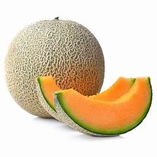  ⚠ DUPLICATE PLU  PLU: 4050  Cantaloupe Large  Category: Melon  Image Source: Code Booklet  Verification Status: ✅ VERIFIED PHOTO | 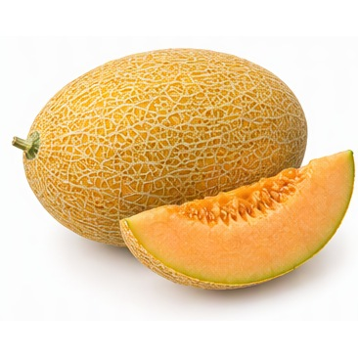  PLU: 3623  Hami Melon  Category: Melon  Image Source: AI Generated  Verification Status: 🤖 AI GENERATED REFERENCE IMAGE | 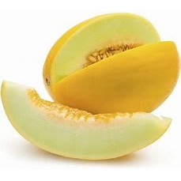  PLU: 4317  Melon Canary  Category: Melon  Image Source: Code Booklet  Verification Status: ✅ VERIFIED PHOTO | ⚠ DUPLICATE PLU  PLU: 4050  Melon Cantaloupe Jumbo  Category: Melon  Image Source: Code Booklet  Verification Status: ✅ VERIFIED PHOTO
PLU: 4319  Melon Cantaloupe Large  Category: Melon  Image Source: Code Booklet  Verification Status: ✅ VERIFIED PHOTO | PLU: 4049  Melon Cantaloupe Sm  Category: Melon  Image Source: Code Booklet  Verification Status: ✅ VERIFIED PHOTO | PLU: 4375  Melon Cantaloupe Tuscan  Category: Melon  Image Source: Code Booklet  Verification Status: ✅ VERIFIED PHOTO | 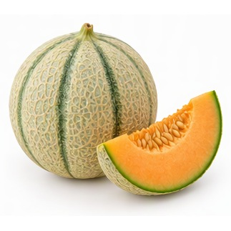  PLU: 3033  Melon Charantais  Category: Melon  Image Source: AI Generated  Verification Status: 🤖 AI GENERATED REFERENCE IMAGE
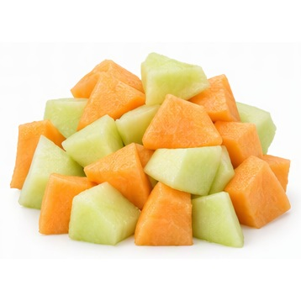  PLU: 545591  Melon Fancy Cut  Category: Melon  Image Source: AI Generated  Verification Status: 🤖 AI GENERATED REFERENCE IMAGE | PLU: 3307  Melon Golden Kiss  Category: Melon  Image Source: Code Booklet  Verification Status: ✅ VERIFIED PHOTO | PLU: 3626  Melon Hami  Category: Melon  Image Source: AI Generated  Verification Status: 🤖 AI GENERATED REFERENCE IMAGE | 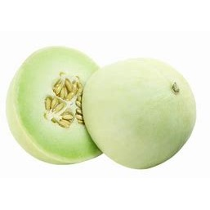  PLU: 4345  Melon Honey Kiss  Category: Melon  Image Source: Code Booklet  Verification Status: ✅ VERIFIED PHOTO
PLU: 4034  Melon Honeydew Large  Category: Melon  Image Source: Code Booklet  Verification Status: ✅ VERIFIED PHOTO | PLU: 4329  Melon Honeydew Small  Category: Melon  Image Source: Code Booklet  Verification Status: ✅ VERIFIED PHOTO | PLU: 4325  Melon Lemon Drop  Category: Melon  Image Source: Code Booklet  Verification Status: ✅ VERIFIED PHOTO | PLU: 4321  Melon Mini  Category: Melon  Image Source: Code Booklet  Verification Status: ✅ VERIFIED PHOTO
PLU: 4332  Melon Muskmelon  Category: Melon  Image Source: Code Booklet  Verification Status: ✅ VERIFIED PHOTO | 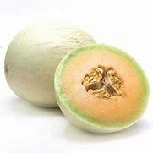  PLU: 4327  Melon Orange  Category: Melon  Image Source: Code Booklet  Verification Status: ✅ VERIFIED PHOTO | 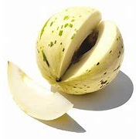  PLU: 4346  Melon Picasso/Dino  Category: Melon  Image Source: Code Booklet  Verification Status: ✅ VERIFIED PHOTO | 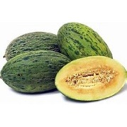  PLU: 3101  Melon Santa Claus  Category: Melon  Image Source: Code Booklet  Verification Status: ✅ VERIFIED PHOTO
⚠ DUPLICATE PLU  PLU: 4336  Melon Santa Clause  Category: Melon  Image Source: Code Booklet  Verification Status: ✅ VERIFIED PHOTO | 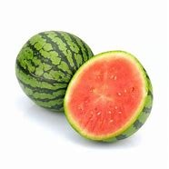  PLU: 3421  Melon Watermelon Mini  Category: Melon  Image Source: Code Booklet  Verification Status: ✅ VERIFIED PHOTO | 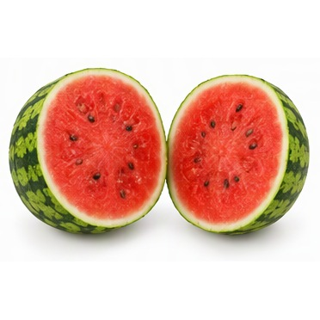  PLU: 3191  Melon Watermelon Mini Cut  Category: Melon  Image Source: AI Generated  Verification Status: 🤖 AI GENERATED REFERENCE IMAGE | ⚠ DUPLICATE PLU  PLU: 4336  Santa Claus Melon  Category: Melon  Image Source: Code Booklet  Verification Status: ✅ VERIFIED PHOTO
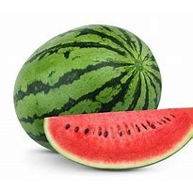

PLU: 4032
Watermelon
Category: Melon
Image Source: Code Booklet
Verification Status: ✅ VERIFIED PHOTO

Section 7: Stone Fruit
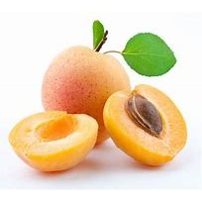  PLU: 4218  Apricots  Category: Stone Fruit  Image Source: Code Booklet  Verification Status: ✅ VERIFIED PHOTO | 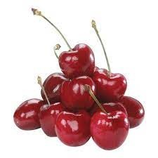  PLU: 4045  Cherries  Category: Stone Fruit  Image Source: Code Booklet  Verification Status: ✅ VERIFIED PHOTO | 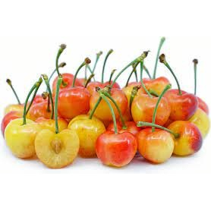  PLU: 4258  Cherries Rainier  Category: Stone Fruit  Image Source: Code Booklet  Verification Status: ✅ VERIFIED PHOTO | 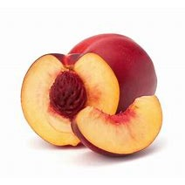  PLU: 4378  Nectarine  Category: Stone Fruit  Image Source: Code Booklet  Verification Status: ✅ VERIFIED PHOTO
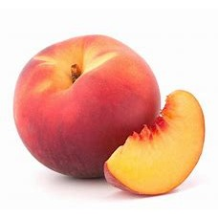  PLU: 3200  Peaches Case  Category: Stone Fruit  Image Source: Code Booklet  Verification Status: ✅ VERIFIED PHOTO | PLU: 4044  Peaches Tree Ripe  Category: Stone Fruit  Image Source: Code Booklet  Verification Status: ✅ VERIFIED PHOTO | 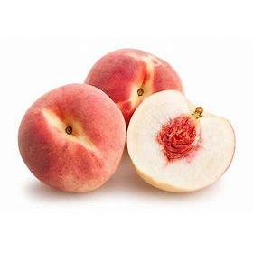  PLU: 4401  Peaches White Lrg  Category: Stone Fruit  Image Source: Code Booklet  Verification Status: ✅ VERIFIED PHOTO | 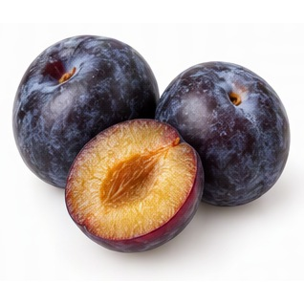  PLU: 4040  Plum Black Large  Category: Stone Fruit  Image Source: AI Generated  Verification Status: 🤖 AI GENERATED REFERENCE IMAGE
PLU: 4039  Plum Black Small  Category: Stone Fruit  Image Source: AI Generated  Verification Status: 🤖 AI GENERATED REFERENCE IMAGE | 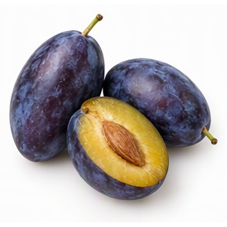  ⚠ DUPLICATE PLU  PLU: 4436  Plum Italian  Category: Stone Fruit  Image Source: AI Generated  Verification Status: 🤖 AI GENERATED REFERENCE IMAGE | ⚠ DUPLICATE PLU  PLU: 4436  Plum Italian Prune  Category: Stone Fruit  Image Source: AI Generated  Verification Status: 🤖 AI GENERATED REFERENCE IMAGE | 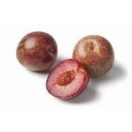  PLU: 3126  Plum Pluot  Category: Stone Fruit  Image Source: Code Booklet  Verification Status: ✅ VERIFIED PHOTO
PLU: 3611  Plum Pluots  Category: Stone Fruit  Image Source: Code Booklet  Verification Status: ✅ VERIFIED PHOTO | 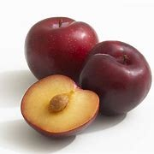  PLU: 4475  Plum Quart  Category: Stone Fruit  Image Source: Code Booklet  Verification Status: ✅ VERIFIED PHOTO | PLU: 4042  Plum Red Large  Category: Stone Fruit  Image Source: Code Booklet  Verification Status: ✅ VERIFIED PHOTO | PLU: 4439  Plum Tree Ripened  Category: Stone Fruit  Image Source: Code Booklet  Verification Status: ✅ VERIFIED PHOTO

PLU: 4865
Prunes
Category: Stone Fruit
Image Source: AI Generated
Verification Status: 🤖 AI GENERATED REFERENCE IMAGE

Section 8: Tropical Fruit
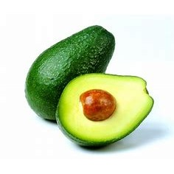  PLU: 4225  Avocado Large Hass  Category: Tropical  Image Source: Code Booklet  Verification Status: ✅ VERIFIED PHOTO | 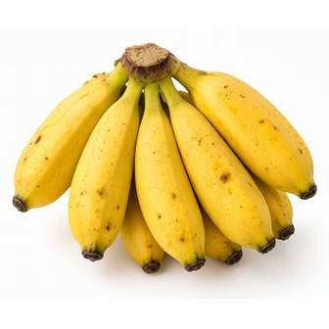  PLU: 4234  Banana Baby  Category: Tropical  Image Source: AI Generated  Verification Status: 🤖 AI GENERATED REFERENCE IMAGE | 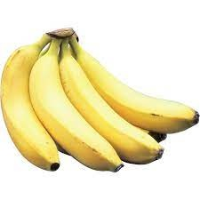  PLU: 4011  Bananas  Category: Tropical  Image Source: Code Booklet  Verification Status: ✅ VERIFIED PHOTO | 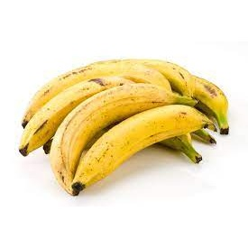  PLU: 4235  Bananas Plantains  Category: Tropical  Image Source: Code Booklet  Verification Status: ✅ VERIFIED PHOTO
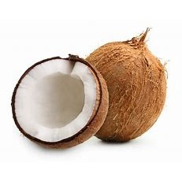  PLU: 4260  Coconut  Category: Tropical  Image Source: Code Booklet  Verification Status: ✅ VERIFIED PHOTO | 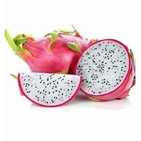  PLU: 3040  Dragon Fruit - Pitahaya  Category: Tropical  Image Source: Code Booklet  Verification Status: ✅ VERIFIED PHOTO | 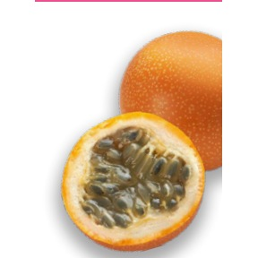  ⚠ DUPLICATE PLU  PLU: 3038  Granadilla  Category: Tropical  Image Source: Produce Guide  Verification Status: ✅ VERIFIED PHOTO | 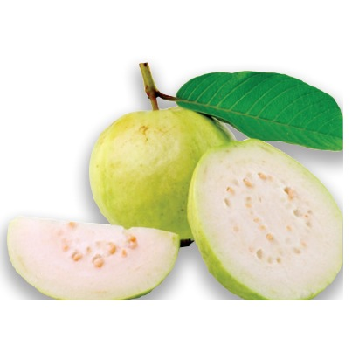  PLU: 4299  Guava  Category: Tropical  Image Source: Produce Guide  Verification Status: ✅ VERIFIED PHOTO
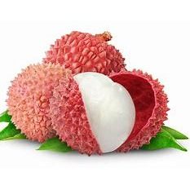  PLU: 4309  Lychees  Category: Tropical  Image Source: Code Booklet  Verification Status: ✅ VERIFIED PHOTO | 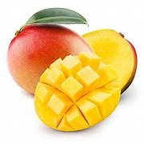  PLU: 6097  Mango  Category: Tropical  Image Source: Code Booklet  Verification Status: ✅ VERIFIED PHOTO | 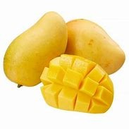  PLU: 4961  Mango Ataulfo Mexico  Category: Tropical  Image Source: Code Booklet  Verification Status: ✅ VERIFIED PHOTO | PLU: 4315  Mango Case  Category: Tropical  Image Source: Code Booklet  Verification Status: ✅ VERIFIED PHOTO
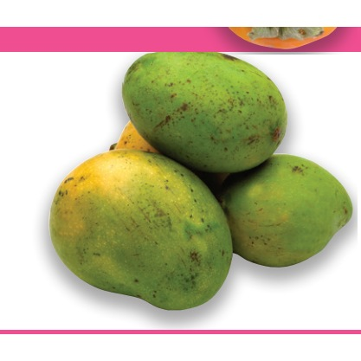  PLU: 4313  Mango Julie  Category: Tropical  Image Source: Produce Guide  Verification Status: ✅ VERIFIED PHOTO | PLU: 4959  Mango Red  Category: Tropical  Image Source: Code Booklet  Verification Status: ✅ VERIFIED PHOTO | PLU: 4051  Mango Red Small  Category: Tropical  Image Source: Code Booklet  Verification Status: ✅ VERIFIED PHOTO | PLU: 4467  Mangos Australia  Category: Tropical  Image Source: Code Booklet  Verification Status: ✅ VERIFIED PHOTO
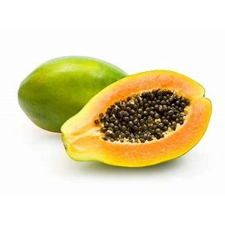  PLU: 82191  Papaya Caribbean Cut  Category: Tropical  Image Source: Code Booklet  Verification Status: ✅ VERIFIED PHOTO | PLU: 4394  Papaya Large  Category: Tropical  Image Source: Code Booklet  Verification Status: ✅ VERIFIED PHOTO | PLU: 4395  Papaya Large Cooking  Category: Tropical  Image Source: Code Booklet  Verification Status: ✅ VERIFIED PHOTO | PLU: 3112  Papaya Meridol  Category: Tropical  Image Source: Code Booklet  Verification Status: ✅ VERIFIED PHOTO
PLU: 3111  Papaya Red Flesh  Category: Tropical  Image Source: Code Booklet  Verification Status: ✅ VERIFIED PHOTO | PLU: 4052  Papaya Small  Category: Tropical  Image Source: Code Booklet  Verification Status: ✅ VERIFIED PHOTO | 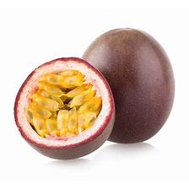  ⚠ DUPLICATE PLU  PLU: 3038  Passion Fruit  Category: Tropical  Image Source: Code Booklet  Verification Status: ✅ VERIFIED PHOTO | PLU: 4397  Passion Fruit  Category: Tropical  Image Source: Code Booklet  Verification Status: ✅ VERIFIED PHOTO
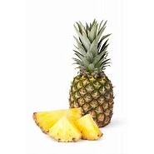  PLU: 4433  Pineapple  Category: Tropical  Image Source: Code Booklet  Verification Status: ✅ VERIFIED PHOTO | PLU: 3379  Pineapple Baby  Category: Tropical  Image Source: Code Booklet  Verification Status: ✅ VERIFIED PHOTO | 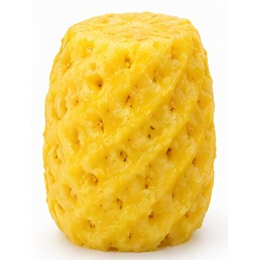  PLU: 8107  Pineapple Cored  Category: Tropical  Image Source: AI Generated  Verification Status: 🤖 AI GENERATED REFERENCE IMAGE | PLU: 4432  Pineapple Golden  Category: Tropical  Image Source: Code Booklet  Verification Status: ✅ VERIFIED PHOTO
PLU: 23406  Pineapple Golden Costa Rica  Category: Tropical  Image Source: Code Booklet  Verification Status: ✅ VERIFIED PHOTO | 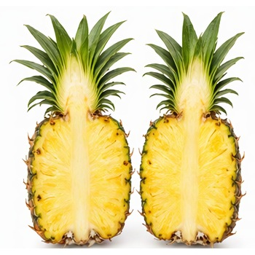  PLU: 73091  Pineapple Golden Costa Rica Cut  Category: Tropical  Image Source: AI Generated  Verification Status: 🤖 AI GENERATED REFERENCE IMAGE | PLU: 81853  Pineapple Half  Category: Tropical  Image Source: AI Generated  Verification Status: 🤖 AI GENERATED REFERENCE IMAGE | 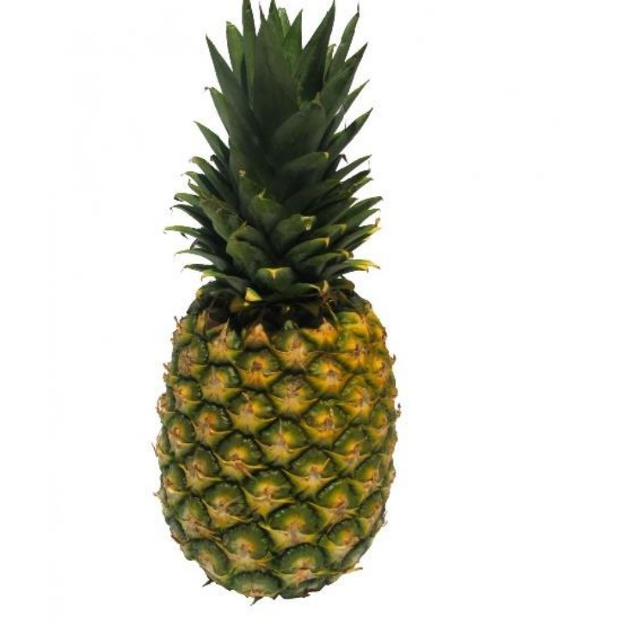  PLU: 4430  Pineapple Large  Category: Tropical  Image Source: Produce Sheets  Verification Status: ✅ VERIFIED PHOTO
PLU: 4029  Pineapple Small  Category: Tropical  Image Source: Code Booklet  Verification Status: ✅ VERIFIED PHOTO | 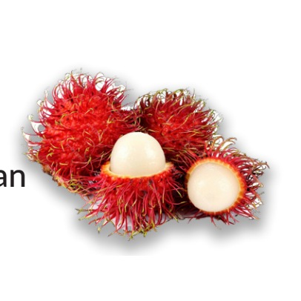  PLU: 3041  Ramboutan  Category: Tropical  Image Source: Produce Guide  Verification Status: ✅ VERIFIED PHOTO | 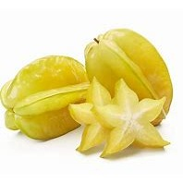  PLU: 4256  StarFruit  Category: Tropical  Image Source: Code Booklet  Verification Status: ✅ VERIFIED PHOTO

Section 9: Specialty Fruit
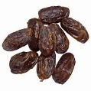  PLU: 42621  Dates  Category: Specialty  Image Source: Code Booklet  Verification Status: ✅ VERIFIED PHOTO | PLU: 3047  Dates Medjool  Category: Specialty  Image Source: Code Booklet  Verification Status: ✅ VERIFIED PHOTO | 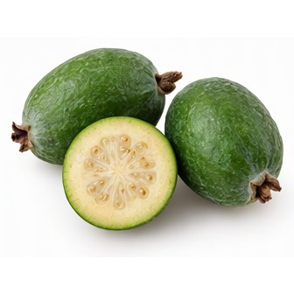  PLU: 4265  Feijoa  Category: Specialty  Image Source: AI Generated  Verification Status: 🤖 AI GENERATED REFERENCE IMAGE | 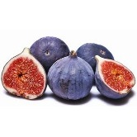  PLU: 4266  Figs Black  Category: Specialty  Image Source: Code Booklet  Verification Status: ✅ VERIFIED PHOTO
PLU: 4267  Figs Brown  Category: Specialty  Image Source: Code Booklet  Verification Status: ✅ VERIFIED PHOTO | 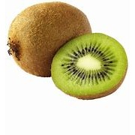  PLU: 4030  Kiwi  Category: Specialty  Image Source: Code Booklet  Verification Status: ✅ VERIFIED PHOTO | 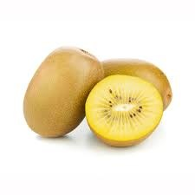  PLU: 3279  Kiwi Golden  Category: Specialty  Image Source: Code Booklet  Verification Status: ✅ VERIFIED PHOTO | ⚠ DUPLICATE PLU  PLU: 4059  Kiwi Small  Category: Specialty  Image Source: Code Booklet  Verification Status: ✅ VERIFIED PHOTO
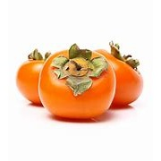  PLU: 4428  Persimmon Fuyu  Category: Specialty  Image Source: Code Booklet  Verification Status: ✅ VERIFIED PHOTO | PLU: 4429  Persimmon Large  Category: Specialty  Image Source: Code Booklet  Verification Status: ✅ VERIFIED PHOTO | 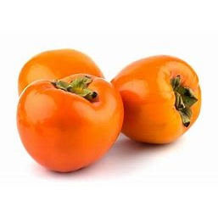  PLU: 4427  Persimmons Hachiya  Category: Specialty  Image Source: Code Booklet  Verification Status: ✅ VERIFIED PHOTO | 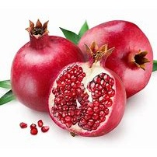  PLU: 4446  Pomegramate Large  Category: Specialty  Image Source: Code Booklet  Verification Status: ✅ VERIFIED PHOTO

Section 10: Organic Fruit
⚠ DUPLICATE PLU  PLU: 94153  Organic Aples MacIntosh  Category: Organic Apple  Image Source: Code Booklet  Verification Status: ✅ VERIFIED PHOTO | 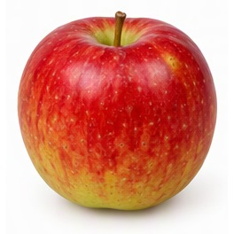  PLU: 94099  Organic Apples Akane  Category: Organic Apple  Image Source: AI Generated  Verification Status: 🤖 AI GENERATED REFERENCE IMAGE | PLU: 93438  Organic Apples Ambrosia  Category: Organic Apple  Image Source: Code Booklet  Verification Status: ✅ VERIFIED PHOTO | PLU: 94103  Organic Apples Braeburn  Category: Organic Apple  Image Source: AI Generated  Verification Status: 🤖 AI GENERATED REFERENCE IMAGE  ⚠ DUPLICATE PLU
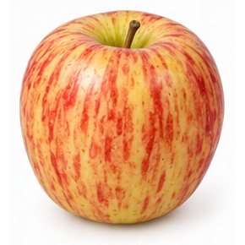  PLU: 93066  Organic Apples Cameo  Category: Organic Apple  Image Source: AI Generated  Verification Status: 🤖 AI GENERATED REFERENCE IMAGE  ⚠ DUPLICATE PLU | 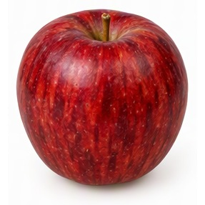  PLU: 94127  Organic Apples Empire  Category: Organic Apple  Image Source: AI Generated  Verification Status: 🤖 AI GENERATED REFERENCE IMAGE | 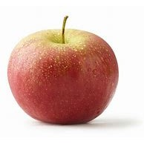  PLU: 94131  Organic Apples Fuji  Category: Organic Apple  Image Source: Code Booklet  Verification Status: ✅ VERIFIED PHOTO | PLU: 94135  Organic Apples Gala  Category: Organic Apple  Image Source: Code Booklet  Verification Status: ✅ VERIFIED PHOTO
PLU: 94174  Organic Apples Gala  Category: Organic Apple  Image Source: Code Booklet  Verification Status: ✅ VERIFIED PHOTO | PLU: 94020  Organic Apples Golden Delicious  Category: Organic Apple  Image Source: Code Booklet  Verification Status: ✅ VERIFIED PHOTO | PLU: 94097  Organic Apples Golden Delicious  Category: Organic Apple  Image Source: Code Booklet  Verification Status: ✅ VERIFIED PHOTO | PLU: 94017  Organic Apples Granny Smith  Category: Organic Apple  Image Source: Code Booklet  Verification Status: ✅ VERIFIED PHOTO
PLU: 94139  Organic Apples Granny Smith  Category: Organic Apple  Image Source: Code Booklet  Verification Status: ✅ VERIFIED PHOTO | 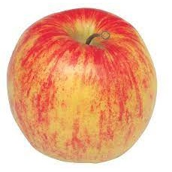  PLU: 94147  Organic Apples Jona Gold  Category: Organic Apple  Image Source: Code Booklet  Verification Status: ✅ VERIFIED PHOTO | PLU: 93072  Organic Apples Lady  Category: Organic Apple  Image Source: Code Booklet  Verification Status: ✅ VERIFIED PHOTO | ⚠ DUPLICATE PLU  PLU: 94153  Organic Apples MacIntosh  Category: Organic Apple  Image Source: Code Booklet  Verification Status: ✅ VERIFIED PHOTO
PLU: 94154  Organic Apples MacIntosh  Category: Organic Apple  Image Source: Code Booklet  Verification Status: ✅ VERIFIED PHOTO | 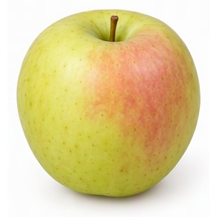  PLU: 94204  Organic Apples Orin  Category: Organic Apple  Image Source: AI Generated  Verification Status: 🤖 AI GENERATED REFERENCE IMAGE | 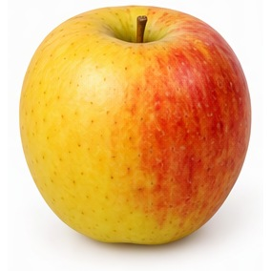  PLU: 94215  Organic Apples Pinata  Category: Organic Apple  Image Source: AI Generated  Verification Status: 🤖 AI GENERATED REFERENCE IMAGE | PLU: 94128  Organic Apples Pink Lady  Category: Organic Apple  Image Source: Code Booklet  Verification Status: ✅ VERIFIED PHOTO
PLU: 94016  Organic Apples Red Delicious  Category: Organic Apple  Image Source: Code Booklet  Verification Status: ✅ VERIFIED PHOTO | PLU: 94178  Organic Apples Spartan  Category: Organic Apple  Image Source: AI Generated  Verification Status: 🤖 AI GENERATED REFERENCE IMAGE | 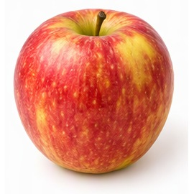  PLU: 94205  Organic Apples Su Mac  Category: Organic Apple  Image Source: AI Generated  Verification Status: 🤖 AI GENERATED REFERENCE IMAGE | 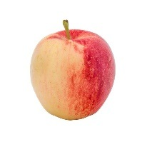  PLU: 94212  Organic Apples Sunrise  Category: Organic Apple  Image Source: Code Booklet  Verification Status: ✅ VERIFIED PHOTO
PLU: 94225  Organic Avocado Large Hass  Category: Organic Tropical  Image Source: Code Booklet  Verification Status: ✅ VERIFIED PHOTO | PLU: 94228  Organic Avocado Sharwil  Category: Organic Tropical  Image Source: Code Booklet  Verification Status: ✅ VERIFIED PHOTO | PLU: 94011  Organic Bananas  Category: Organic Tropical  Image Source: Code Booklet  Verification Status: ✅ VERIFIED PHOTO | PLU: 94249  Organic Blueberries Pint  Category: Organic Berry  Image Source: Code Booklet  Verification Status: ✅ VERIFIED PHOTO
PLU: 94045  Organic Cherries  Category: Organic Stone Fruit  Image Source: Code Booklet  Verification Status: ✅ VERIFIED PHOTO | PLU: 94025  Organic D'Anjou Pears  Category: Organic Pear  Image Source: Code Booklet  Verification Status: ✅ VERIFIED PHOTO | PLU: 94027  Organic Grapefruit  Category: Organic Citrus  Image Source: Code Booklet  Verification Status: ✅ VERIFIED PHOTO | ⚠ DUPLICATE PLU  PLU: 94281  Organic Grapefruit Pink  Category: Organic Citrus  Image Source: Code Booklet  Verification Status: ✅ VERIFIED PHOTO
⚠ DUPLICATE PLU  PLU: 94461  Organic Grapefruit Shaddock  Category: Organic Citrus  Image Source: Code Booklet  Verification Status: ✅ VERIFIED PHOTO | PLU: 93129  Organic Grapefuit Pommelo  Category: Organic Citrus  Image Source: Code Booklet  Verification Status: ✅ VERIFIED PHOTO | ⚠ DUPLICATE PLU  PLU: 94022  Organic Grapes Green Sdls  Category: Organic Grape  Image Source: Code Booklet  Verification Status: ✅ VERIFIED PHOTO | PLU: 94497  Organic Grapes Green Sdls  Category: Organic Grape  Image Source: Code Booklet  Verification Status: ✅ VERIFIED PHOTO
⚠ DUPLICATE PLU  PLU: 94023  Organic Grapes Red Seedless  Category: Organic Grape  Image Source: Code Booklet  Verification Status: ✅ VERIFIED PHOTO | ⚠ DUPLICATE PLU  PLU: 94022  Organic Green Grapes Seedless  Category: Organic Grape  Image Source: Code Booklet  Verification Status: ✅ VERIFIED PHOTO | PLU: 94034  Organic Honeydew  Category: Organic Melon  Image Source: Code Booklet  Verification Status: ✅ VERIFIED PHOTO | PLU: 94030  Organic Kiwi  Category: Organic Specialty  Image Source: Code Booklet  Verification Status: ✅ VERIFIED PHOTO
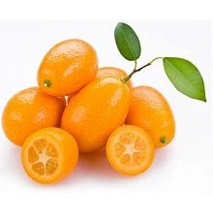  PLU: 94303  Organic KumQuat  Category: Organic Citrus  Image Source: Code Booklet  Verification Status: ✅ VERIFIED PHOTO | PLU: 94053  Organic Lemons  Category: Organic Citrus  Image Source: Code Booklet  Verification Status: ✅ VERIFIED PHOTO | 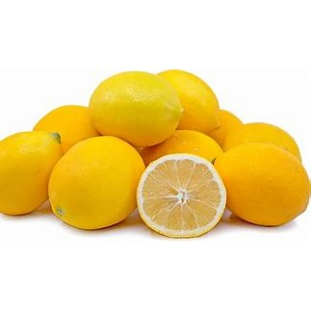  PLU: 94304  Organic Lemons Meyer-Buckbrand  Category: Organic Citrus  Image Source: Code Booklet  Verification Status: ✅ VERIFIED PHOTO | 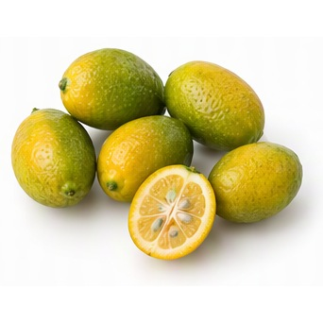  PLU: 94328  Organic Limequats  Category: Organic Citrus  Image Source: AI Generated  Verification Status: 🤖 AI GENERATED REFERENCE IMAGE
PLU: 94048  Organic Limes  Category: Organic Citrus  Image Source: Code Booklet  Verification Status: ✅ VERIFIED PHOTO | 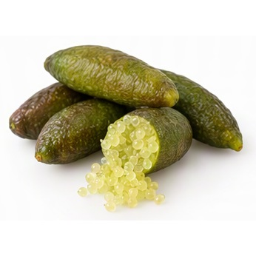  PLU: 94024  Organic Limes Finger  Category: Organic Citrus  Image Source: AI Generated  Verification Status: 🤖 AI GENERATED REFERENCE IMAGE | 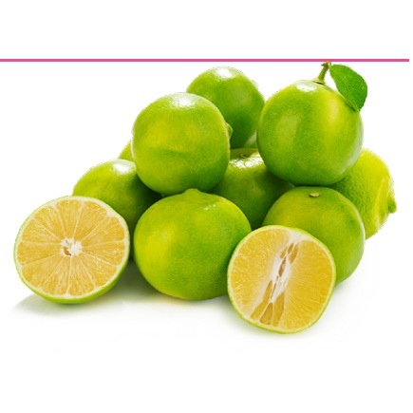  PLU: 94306  Organic Limes Sweet  Category: Organic Citrus  Image Source: Produce Guide  Verification Status: ✅ VERIFIED PHOTO | PLU: 94584  Organic Mango  Category: Organic Tropical  Image Source: Code Booklet  Verification Status: ✅ VERIFIED PHOTO
PLU: 94311  Organic Mangoes  Category: Organic Tropical  Image Source: Code Booklet  Verification Status: ✅ VERIFIED PHOTO | PLU: 94959  Organic Mangoes  Category: Organic Tropical  Image Source: Code Booklet  Verification Status: ✅ VERIFIED PHOTO | PLU: 94317  Organic Melon Canary  Category: Organic Melon  Image Source: Code Booklet  Verification Status: ✅ VERIFIED PHOTO  ⚠ DUPLICATE PLU | 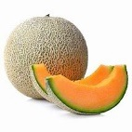  PLU: 94050  Organic Melon Cantaloupe  Category: Organic Melon  Image Source: Code Booklet  Verification Status: ✅ VERIFIED PHOTO
PLU: 94049  Organic Melon Cantaloupe Small  Category: Organic Melon  Image Source: Code Booklet  Verification Status: ✅ VERIFIED PHOTO  ⚠ DUPLICATE PLU | ⚠ DUPLICATE PLU  PLU: 94040  Organic Melon Canteloupe Small  Category: Organic Melon  Image Source: Code Booklet  Verification Status: ✅ VERIFIED PHOTO | 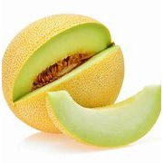  PLU: 94326  Organic Melon Galia  Category: Organic Melon  Image Source: Code Booklet  Verification Status: ✅ VERIFIED PHOTO | ⚠ DUPLICATE PLU  PLU: 94329  Organic Melon Honeydew  Category: Organic Melon  Image Source: Code Booklet  Verification Status: ✅ VERIFIED PHOTO
⚠ DUPLICATE PLU  PLU: 94329  Organic Melon Honeydew Small  Category: Organic Melon  Image Source: Code Booklet  Verification Status: ✅ VERIFIED PHOTO | PLU: 94332  Organic Melon Musk  Category: Organic Melon  Image Source: Code Booklet  Verification Status: ✅ VERIFIED PHOTO | PLU: 94031  Organic Melon Watermelon  Category: Organic Melon  Image Source: Code Booklet  Verification Status: ✅ VERIFIED PHOTO  ⚠ DUPLICATE PLU | PLU: 94032  Organic Melon Watermelon  Category: Organic Melon  Image Source: Code Booklet  Verification Status: ✅ VERIFIED PHOTO
PLU: 94321  Organic Melon Watermelon  Category: Organic Melon  Image Source: Code Booklet  Verification Status: ✅ VERIFIED PHOTO  ⚠ DUPLICATE PLU | PLU: 94340  Organic Melon Watermelon  Category: Organic Melon  Image Source: Code Booklet  Verification Status: ✅ VERIFIED PHOTO | ⚠ DUPLICATE PLU  PLU: 94342  Organic Melon Watermelon  Category: Organic Melon  Image Source: Code Booklet  Verification Status: ✅ VERIFIED PHOTO | ⚠ DUPLICATE PLU  PLU: 94342  Organic Melon Watermelon Seedless Slices  Category: Organic Melon  Image Source: Code Booklet  Verification Status: ✅ VERIFIED PHOTO
PLU: 94378  Organic Nectarines  Category: Organic Stone Fruit  Image Source: Code Booklet  Verification Status: ✅ VERIFIED PHOTO | PLU: 94036  Organic Nectarines Large  Category: Organic Stone Fruit  Image Source: Code Booklet  Verification Status: ✅ VERIFIED PHOTO | PLU: 94035  Organic Nectarines Small  Category: Organic Stone Fruit  Image Source: Code Booklet  Verification Status: ✅ VERIFIED PHOTO | PLU: 93035  Organic Nectarines White  Category: Organic Stone Fruit  Image Source: Code Booklet  Verification Status: ✅ VERIFIED PHOTO
PLU: 94381  Organic Oranges Blood  Category: Organic Citrus  Image Source: Code Booklet  Verification Status: ✅ VERIFIED PHOTO | PLU: 93110  Organic Oranges Cara Cara  Category: Organic Citrus  Image Source: Code Booklet  Verification Status: ✅ VERIFIED PHOTO | PLU: 93029  Organic Oranges Mandarin  Category: Organic Citrus  Image Source: Code Booklet  Verification Status: ✅ VERIFIED PHOTO | PLU: 94391  Organic Oranges Mango  Category: Organic Citrus  Image Source: Code Booklet  Verification Status: ✅ VERIFIED PHOTO
PLU: 94453  Organic Oranges Murcott  Category: Organic Citrus  Image Source: Code Booklet  Verification Status: ✅ VERIFIED PHOTO | PLU: 94012  Organic Oranges Navel Large  Category: Organic Citrus  Image Source: Code Booklet  Verification Status: ✅ VERIFIED PHOTO | PLU: 93107  Organic Oranges Navel Medium  Category: Organic Citrus  Image Source: Code Booklet  Verification Status: ✅ VERIFIED PHOTO | PLU: 93109  Organic Oranges Seville  Category: Organic Citrus  Image Source: Code Booklet  Verification Status: ✅ VERIFIED PHOTO
PLU: 94456  Organic Oranges Tangelos  Category: Organic Citrus  Image Source: Code Booklet  Verification Status: ✅ VERIFIED PHOTO | PLU: 94458  Organic Oranges Tangerine  Category: Organic Citrus  Image Source: Code Booklet  Verification Status: ✅ VERIFIED PHOTO | PLU: 94457  Organic Oranges TDE Tangerine  Category: Organic Citrus  Image Source: Code Booklet  Verification Status: ✅ VERIFIED PHOTO | PLU: 93227  Organic Oranges Torange  Category: Organic Citrus  Image Source: Code Booklet  Verification Status: ✅ VERIFIED PHOTO
PLU: 93108  Organic Oranges Valencia  Category: Organic Citrus  Image Source: Code Booklet  Verification Status: ✅ VERIFIED PHOTO | PLU: 94388  Organic Oranges Valencia  Category: Organic Citrus  Image Source: Code Booklet  Verification Status: ✅ VERIFIED PHOTO | PLU: 94044  Organic Peaches Tree Ripened  Category: Organic Stone Fruit  Image Source: Code Booklet  Verification Status: ✅ VERIFIED PHOTO | PLU: 94401  Organic Peaches White  Category: Organic Stone Fruit  Image Source: Code Booklet  Verification Status: ✅ VERIFIED PHOTO
PLU: 94038  Organic Peaches Yellow Lrg  Category: Organic Stone Fruit  Image Source: Code Booklet  Verification Status: ✅ VERIFIED PHOTO | PLU: 93016  Organic Pear Concord  Category: Organic Pear  Image Source: Code Booklet  Verification Status: ✅ VERIFIED PHOTO | 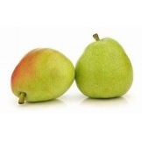  PLU: 94416  Organic Pear D'Anjou  Category: Organic Pear  Image Source: Code Booklet  Verification Status: ✅ VERIFIED PHOTO | PLU: 94116  Organic Pears Bartlett  Category: Organic Pear  Image Source: Code Booklet  Verification Status: ✅ VERIFIED PHOTO
PLU: 94409  Organic Pears Bartlett Green  Category: Organic Pear  Image Source: Code Booklet  Verification Status: ✅ VERIFIED PHOTO | PLU: 94410  Organic Pears Bartlett Red  Category: Organic Pear  Image Source: Code Booklet  Verification Status: ✅ VERIFIED PHOTO | PLU: 94413  Organic Pears Bosc  Category: Organic Pear  Image Source: Code Booklet  Verification Status: ✅ VERIFIED PHOTO | PLU: 94430  Organic Pineapple  Category: Organic Tropical  Image Source: Code Booklet  Verification Status: ✅ VERIFIED PHOTO
PLU: 94433  Organic Pineapple  Category: Organic Tropical  Image Source: Code Booklet  Verification Status: ✅ VERIFIED PHOTO | ⚠ DUPLICATE PLU  PLU: 94281  Organic Pink Grapefruit  Category: Organic Citrus  Image Source: Code Booklet  Verification Status: ✅ VERIFIED PHOTO | ⚠ DUPLICATE PLU  PLU: 94040  Organic Plum Black  Category: Organic Stone Fruit  Image Source: AI Generated  Verification Status: 🤖 AI GENERATED REFERENCE IMAGE | PLU: 94042  Organic Plum Red  Category: Organic Stone Fruit  Image Source: Code Booklet  Verification Status: ✅ VERIFIED PHOTO
PLU: 94039  Organic Plums Black Small  Category: Organic Stone Fruit  Image Source: AI Generated  Verification Status: 🤖 AI GENERATED REFERENCE IMAGE | PLU: 94041  Organic Plums Red Small  Category: Organic Stone Fruit  Image Source: Code Booklet  Verification Status: ✅ VERIFIED PHOTO | PLU: 93127  Organic Pomegrante  Category: Organic Specialty  Image Source: Code Booklet  Verification Status: ✅ VERIFIED PHOTO | 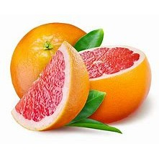  PLU: 94047  Organic Red Grapefruit  Category: Organic Citrus  Image Source: Code Booklet  Verification Status: ✅ VERIFIED PHOTO  ⚠ DUPLICATE PLU
⚠ DUPLICATE PLU  PLU: 94023  Organic Red Seedless Grapes  Category: Organic Grape  Image Source: Code Booklet  Verification Status: ✅ VERIFIED PHOTO | PLU: 94173  Organic Royal Gala Apples  Category: Organic Apple  Image Source: Code Booklet  Verification Status: ✅ VERIFIED PHOTO | ⚠ DUPLICATE PLU  PLU: 94461  Organic Shaddock  Category: Organic Citrus  Image Source: Code Booklet  Verification Status: ✅ VERIFIED PHOTO | PLU: 94252  Organic Strawberry Pint  Category: Organic Berry  Image Source: Code Booklet  Verification Status: ✅ VERIFIED PHOTO
⚠ DUPLICATE PLU
PLU: 94022
Organic White Grapes
Category: Organic Grape
Image Source: Code Booklet
Verification Status: ✅ VERIFIED PHOTO

