# Next+Koa2开发github

## 项目准备

### 安装

### 手动搭建

yarn add react react-dom next

根目录创建pages文件夹

#### Package.json文件：

{

"name": "next-github",

"version": "1.0.0",

"description": "",

"main": "index.js",

"scripts": {

"test": "echo \"Error: no test specified\" && exit 1",

"dev": "next",

"build": "next build",

"start": "next start"

},

"author": "",

"license": "ISC",

"dependencies": {

"next": "^9.0.5",

"react": "^16.9.0",

"react-dom": "^16.9.0"

}

}

增加一下代码

"scripts": {

"dev": "next",

"build": "next build",

"start": "next start"

},

yarn dev 打开开发环境

#### pages目录下新建index.js文件

import React from 'react'

export default () => <span>hello next</span>

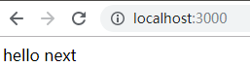

### 2. create-next-app

安装

npm i -g create-next-app

使用

npx create-next-app next-create 或者 yarn create next-app next-create 安装next项目

上面命令都创建了名为next-create的项目

### Next作为koa中间件使用

#### 安装koa

yarn add koa

根目录下创建server.js

const Koa = require('koa')

const next = require('next')

const dev = process.env.NODE_ENV !== 'production'

const app = next({ dev })

const handle = app.getRequestHandler()

app.prepare().then(() => {

const server = new Koa()

server.use(async (ctx, next) => {

await handle(ctx.req, ctx.res)

ctx.respond = false

})

})

Package.json文件修改scripts

"dev": "node server.js",

yarn dev 启动

## koa的使用

### 基础用法

#### server.js

const Koa = require('koa')

const next = require('next')

const dev = process.env.NODE_ENV !== 'production'

const app = next({ dev })

const handle = app.getRequestHandler()

const server = new Koa()

server.use(async (ctx, next) => {

const path = ctx.path

const method = ctx.method

ctx.body = `<span>Koa Render ${path} ${method}</span>`

await next()

})

server.use(async (ctx, next) => {

ctx.body = '<span>Koa Render2</span>'

})

server.listen(3000, () => {

console.log('koa server listening on 3000...')

})

### Koa-router

#### 安装koa-router

yarn add koa-router

#### koa-router简单使用

const Router = require('koa-router')

const router = new Router()

server.use(router.routes())

#### 示例：

const Koa = require('koa')

const Router = require('koa-router')

const next = require('next')

const dev = process.env.NODE_ENV !== 'production'

const app = next({ dev })

const handle = app.getRequestHandler()

const server = new Koa()

const router = new Router()

router.get('/test', async (ctx) => {

ctx.body = `<p>this is /test </p>`

})

router.get('/test/:id', async (ctx) => {

ctx.body = `<p>this is /test ${ctx.params.id}</p>`

})

router.get('/json', async (ctx) => {

ctx.body = { success: true }

// ctx.set('Content-Type', 'application/json')

})

server.use(router.routes())

server.listen(3000, () => {

console.log('koa server listening on 3000...')

})

## Redis的安装使用

### 安装redise

cnpm i koa-generic-session koa-redis --save

### * redis 远程连接方法

1、修改redis服务器的配置文件

vi redis.conf

注释以下绑定的主机地址

# bind 127.0.0.1

或

vim redis.conf

bind 0.0.0.0

protected-mode no

!!!!坑 修改配置文件启动时，记得指定配置文件

redis-server ./redis.conf

### 远程连接：

redis-cli -h 129.28.187.206 -p 6379

命令：

keys * :反馈存储的所有key值

get key值 :获取指定key的数据

hget fix name :不经过sesson读取redis

### redis的基础使用

#### 连接redis

redis-cli

#### 获取一个值

get a

#### 设置一个值

set b 111

#### 配置密码

Redis.conf文件修改一下代码

requirepass foobared 修改密码为foobared

#### 连接：

Redis-cli –p 6379

#### 认证密码

Get

#### 设置过期时间

setex c 10 1 设置一个a过期时间为10秒 值为1

#### 设置带前缀类的key

set session:sessionId 123

#### 获取

get session:sessionId

#### 查看所有key值

Keys *

#### 删除某个key

del a

## nodejs连接redis数据库

### ioredis 模块

安装 yarn add ioredis

### 使用

#### test-redis.js

async function test() {

const Redis = require('ioredis')

const redis = new Redis({

port: 6379,

host: '129.28.187.206'

// password: '123456'

})

await redis.set('c', 123)

await redis.setex('d', 10 , 2345)

const keys = await redis.keys('*')

console.log(keys, await redis.get('c'), await redis.get('d'))

setTimeout(async () => {

console.log(await redis.get('d'))

},13000)

}

test()

效果：



## 项目引入ant-design

### 安装

注意！ Nextjs 默认是不支持直接import引入css文件的， 需要第三方支持

yarn add @zeit/next-css

项目根目录新建文件

### next-config.js

const widthCss = require('@zeit/next-css')

if (typeof require !== undefined) {

require.extensions['.css'] = file => {}

}

module.exports = widthCss({})

### 安装antd

yarn add antd

yarn add babel-plugin-import

### 根目录新建文件 .babelrc

{

"presets": ["next/babel"],

"plugins": [

[

"import",

{

"libraryName": "antd"

}

]

]

}

引入以上代码后的效果是：

把

Import { Button } from ‘antd’

替换为

Import Button from ‘antd/lib/button’

这样做到按需加载

### 引入样式文件

Pages文件夹下新建一个文件_app.js用于覆盖next默认的appjs

#### _app.js

import App from 'next/app'

import 'antd/dist/antd.css'

export default App

#### .babelrc

{

"presets": ["next/babel"],

"plugins": [

[

"import",

{

"libraryName": "antd",

"style": "css" // 按需引入css目前可能会有问题（暂未发现）

}

]

]

}

## 项目构建和相关技术

### 目录结构

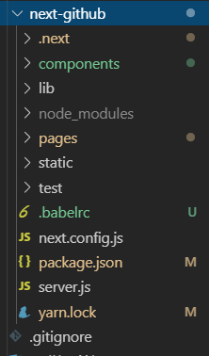

### 路由跳转

#### Link组件

1. 必须包含可渲染的节点
2. 这个节点每层必须只能有唯一节点

##### Index.js

import { Button } from 'antd'

import Link from 'next/link'

export default () => (

<Link href='test/bbb'>

<Button>index</Button>

</Link>

)

或

<Link href='test/bbb'>

<div>

<Button>index</Button>

<Button>index</Button>

</div>

</Link>

#### Router模块

import { Button } from 'antd'

import Link from 'next/link'

import Router from 'next/router'

export default () => {

function gotoTestB() {

Router.push('/test/bbb')

}

return (

<>

<Link href='test/bbb'>

<Button>index</Button>

</Link>

<Button onClick={ gotoTestB }>

test b

</Button>

</>

)

}

#### 动态路由

注意Nextjs动态路由只能通过query形式

如 localhost:3000/test/b?a=1

Router.push('/test/bbb?id=2')

// 或

Router.push({

pathname: '/test/b',

query: {

id: 2

}

})

#### 路由映射

##### Link方式

<Link href='/test/bbb?id=1' as="/test/bbb/1">

<Button>index</Button>

</Link>

##### Router方式

Router.push({

pathname: '/test/bbb',

query: {

id: 2

}

}, '/test/bbb/2')

解决刷新页面路由映射出现404的方案

在koa的server.js里面配置如下内容

const router = new Router()

router.get('/test/bbb/:id', async (ctx) => {

const id = ctx.params.id

await handle(ctx.req, ctx.res, {

pathname: '/test/bbb',

query: { id }

})

ctx.respond = false

})

server.use(router.routes())

此时在进入test/bbb/1时刷新页面则也会正常显示页面了

#### 路由变化的钩子

const event = [

'routeChageStart',

'routeChangeComplete',

'routeChangeError',

'beforeHistoryChange',

'hashChangeStart',

'hashChangeComplete '

]

function makeEvent(type) {

return (...args) => {

console.log(type, ...args)

}

}

event.forEach(event => {

Router.events.on(event, makeEvent(event))

})

### Next数据获取的方式

#### Nextjs数据获取规范

在getInitialProps里面获取数据而不是通过compontentDidMount里面

#### 渲染同步数据

import { withRouter } from 'next/router'

import Link from 'next/link'

const B = ({ router, name }) => <Link href="#aaa"><a >bbba{ router.query.id } { name } </a></Link>

B.getInitialProps = () => {

return {

name: 'jokcy'

}

}

export default withRouter(B)

效果如下

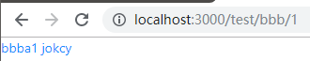

#### 渲染异步数据

B.getInitialProps = async () => {

const promise = new Promise((resolve, reject) => {

setTimeout(() => {

resolve({

name: 'jokcy'

})

}, 5000)

})

return await promise

}

### 自定义app

#### 作用：

##### 固定layout

###### Layout.jsx

import { Button } from 'antd'

import Link from 'next/link'

export default ({ children }) => (

<div>

<header>

<Link href='/test/bbb?id=1' as="/test/bbb/1">

<Button>index1</Button>

</Link>

<Link href='/test/bbb?id=2' as="/test/bbb/2">

<Button>index2</Button>

</Link>

</header>

{ children }

</div>

)

###### _app.js

import App from 'next/app'

import Layout from '../components/layout'

import 'antd/dist/antd.css'

class MyApp extends App {

static async getInitialProps ({ Component }) {

let pageProps

if (Component.getInitialProps) {

pageProps = await Component.getInitialProps()

}

return {

pageProps

}

}

render() {

const { Component, pageProps } = this.props

return (

<Layout>

<Component { ...pageProps } />

</Layout>

)

}

}

export default MyApp

###### 效果

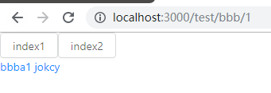

##### 保持一些公用状态

##### 给页面传入一些自定义数据

##### 自定义错误处理

### 自定义document

只有在服务器渲染的时候才会被调用

用来修改服务端渲染的文档内容

一般用来配合第三方的css-in-js方案使用

Pages下新建_document,js

import Document, { Html, Head, Main, NextScript } from 'next/document'

class MyDocument extends Document {

static async getInitialProps(ctx) { // 若要使用它需要先继承Document里面封装的getInitialProps

const props = await Document.getInitialProps(ctx)

return {

...props

}

}

render() {

return <Html>

<Head>

<title>MyApp</title> {/* 不建议 */}

<style>{`.test { font-size: 35px }`}</style>

</Head>

<body className="test">

<Main />

<NextScript />

</body>

</Html>

}

}

export default MyDocument

此时重启项目后

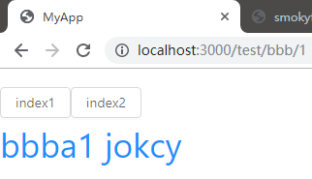

### 自定义样式

#### css-in-jsx

const colors = 'green'

const B = ({ router, name }) => (

<>

<Link href="#aaa">

<a className="link">

bb

{ router.query.id } { name }

</a>

</Link>

1. 只在当前组件生效

<style jsx>{`

a {

color: blue

}

.link {

color: ${colors}

}

`}</style>

2. 样式全局生效

<style jsx global>{` ${/* 注意这里的全局样式必须在页面渲染后才会生效 */''}

a {

color: ${colors}

}

`}</style>

</>

)

### Next集成styled-component

#### 安装

yarn add styled-components babel-plugin-styled-components

#### .babelrc

{

"presets": ["next/babel"],

"plugins": [

[

"import",

{

"libraryName": "antd",

"style": "css"

}

],

[

"styled-components", { "ssr": true }

]

]

}

#### _document,js

import Document, { Html, Head, Main, NextScript } from 'next/document'

import { ServerStyleSheet } from 'styled-components'

function withLog(Comp) {

return (props) => {

console.log(props)

return <Comp {...props} />

}

}

class MyDocument extends Document {

static async getInitialProps(ctx) { // 若要使用它需要先继承Document里面封装的getInitialProps

const sheet = new ServerStyleSheet()

const originalRenderPage = ctx.renderPage

try {

ctx.renderPage = () => originalRenderPage({

enhanceApp: App => (props) => sheet.collectStyles(<App {...props} />) // _app里面返回的MyApp

// enhanceComponent: Component => withLog(Component) // 每个页面对应的js文件

})

const props = await Document.getInitialProps(ctx)

return {

...props,

styles: <>{ props.styles }{ sheet.getStyleElement() }</>

}

} finally {

sheet.seal

}

}

render() {

return <Html>

<Head>

{/* <title>MyApp</title> 不建议 */}

{/* <style>{`.test { color: red }`}</style> */}

</Head>

<body className="test">

<Main />

<NextScript />

</body>

</Html>

}

}

export default MyDocument

#### bbb.js 相关代码

import styled from 'styled-components'

const Title = styled.h1`

color: yellow;

font-size: 40px

`

const B = ({ router, name }) => (

<div>

<Title>this is title</Title>

<Link href="#aaa">

<a className="link">

bb

{ router.query.id } { name }

</a>

</Link>

</div>

)

#### 此时渲染的页面

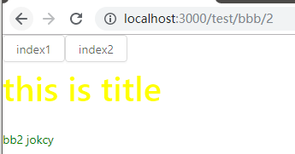

### Nextjs中异步模块和组件的加载(lazyLoading)

#### 异步加载模块

yarn add moment

##### bbb.js

当我们用到moment.js时才会被异步加载 相关代码：

B.getInitialProps = async () => {

const moment = await import ('moment')

return {

name: 'jokcy',

time: moment.default(Date.now() - 60 * 1000).fromNow()

}

}

#### 异步加载组件

##### bbb.js

import dynamic from 'next/dynamic'

// import Comp from '../../components/comp'

const Comp = dynamic(import('../../components/comp')) // 异步加载组件

const B = ({ router, name, time }) => (

<div>

<Title>this is title { time }</Title>

<Comp />

</div>

)

### Nextjs中的配置项（next.config.js）

可配置项如下

const configs = {

// 编译文件的输出目录

distDir: 'dest',

// 是否给每个路由生成Etag: 用来缓存验证

generateEtags: true,

// 页面内容缓存配置

onDemandEntries: {

// 内容在内存中缓存的时常

maxInactiveAge: 25 * 1000,

// 同时缓存多少个页面

pageBufferLength: 2,

},

// 在page目录下哪种后缀的文件会被认为是页面

pageExtensions: ['jsx', 'js'],

// 配置buildId

generateBuildId: async () => {

if (process.env.YOUR_BUILD_ID) {

return process.env.YOUR_BUILD_ID

}

// 返回null使用默认的unique id

return null

},

// 手动修改webpack config

webpack(config, options) {

return config

},

// 修改webpackDevMiddleware配置

webpackDevMiddleware: config => {

return config

},

// 可以在页面上通过process.env.customKey 获取 value

env: {

customKey: 'value',

},

// 下面两个要通过 'next/config' 来获取

// 只有服务端渲染时才会获取的配置

serverRuntimeConfig: {

mySecret: 'secret',

secondSecret: process.env.SECOND_SECRET

},

// 在服务端渲染和客户端渲染都可以获取的配置

publicRuntimeConfig: {

staticFolder: '/static',

},

}

测试使用其中的三个

module.exports = widthCss({

env: {

customKey: 'value',

},

serverRuntimeConfig: {

mySecret: 'secret',

secondSecret: process.env.SECOND_SECRET

},

// 在服务端渲染和客户端渲染都可以获取的配置

publicRuntimeConfig: {

staticFolder: '/static',

}

})

bbb.js()相关代码

import getConfig from 'next/config'

const { serverRuntimeConfig, publicRuntimeConfig } = getConfig()

const B = ({ router, name, time }) => {

console.log(serverRuntimeConfig, publicRuntimeConfig)

return (

<div>

<Title>this is title { time } { process.env.customKey }</Title>

</div>

)

}

完整代码

import { withRouter } from 'next/router'

import Head from 'next/head'

import getConfig from 'next/config'

import Link from 'next/link'

import styled from 'styled-components'

import dynamic from 'next/dynamic'

// import Comp from '../../components/comp'

const Comp = dynamic(import('../../components/comp'))

const { serverRuntimeConfig, publicRuntimeConfig } = getConfig()

const Title = styled.h1`

color: yellow;

font-size: 40px

`

const colors = 'green'

const B = ({ router, name, time }) => {

console.log(serverRuntimeConfig, publicRuntimeConfig)

return (

<div>

<Title>this is title { time } { process.env.customKey }</Title>

<Comp />

<Link href="#aaa">

<a className="link">

bb

{ router.query.id } { name }

</a>

</Link>

<style jsx>{`

a {

color: blue

}

.link {

color: ${colors}

}

`}</style>

<style jsx global>{` ${/* 注意这里的全局样式必须在页面渲染后才会生效 */''}

a {

color: ${colors}

}

`}</style>

</div>

)

}

B.getInitialProps = async () => {

const moment = await import ('moment')

return {

name: 'jokcy',

time: moment.default(Date.now() - 60 * 1000).fromNow()

}

}

export default withRouter(B)

效果如下

页面

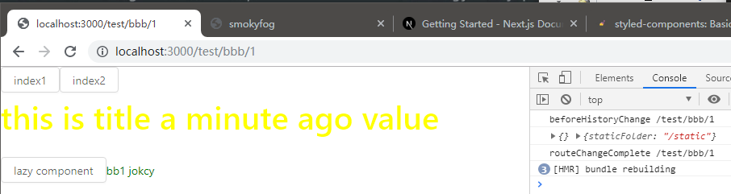

服务端

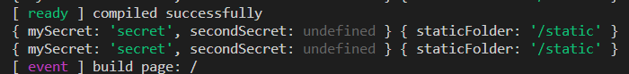

### 服务端渲染（SSR）流程

…

## HOOKS

### 基础用法

#### 常用类组件

import React from 'react'

class MyCount extends React.Component {

state = {

count: 0

}

componentDidMount() {

this.interval = setInterval(() => {

this.setState({ count: this.state.count + 1 })

}, 1000)

}

componentWillUnmount() {

if (this.interval) {

clearInterval(this.interval)

}

}

render () {

return <span>{ this.state.count }</span>

}

}

export default MyCount

#### 使用React Hooks写法

import React, { useState, useEffect } from 'react'

function MyCountFunc() {

const [ count, setCount ] = useState(0)

useEffect(() => {

const interval = setInterval(() => {

setCount(c => c + 1)

}, 1000)

return () => clearInterval(this.interval)

}, [])

return <span>{ count }</span>

}

export default MyCountFunc

这种写法的效果和上面类的方法是一致的

### State Hooks

#### useState

// setCount用法

// 1. setCount(1)

// 2. setCount((c) => c + 1 )

function MyCountFunc() {

const [ count, setCount ] = useState(0) // [a, b]

useEffect(() => {

const interval = setInterval(() => {

// setCount用法

// setCount(1)

// setCount((c) => c + 1 )

setCount(c => c + 1)

}, 1000)

return () => clearInterval(interval)

}, [])

return <span>{ count }</span>

}

export default MyCountFunc

#### useReducer

import React, { useState, useReducer, useEffect } from 'react'

function countReducer(state, action) {

switch (action.type) {

case 'add':

return state + 1

case 'minus':

return state - 1

default:

return state

}

}

function MyCountFunc() {

const [ count, dispatchCount ] = useReducer(countReducer, 0)

useEffect(() => {

const interval = setInterval(() => {

dispatchCount({ type: 'add' })

}, 1000)

return () => clearInterval(interval)

}, [])

return <span>{ count }</span>

}

export default MyCountFunc

### Effect Hooks

#### useEffect

import React, { useState, useReducer, useEffect } from 'react'

function MyCountFunc() {

const [ count, dispatchCount ] = useReducer(countReducer, 0)

const [ name, setName ] = useState('jock')

useEffect(() => {

console.log('effect invoked') // 后执行

return () => console.log('effect deteched') // 先执行

}, [count]) // 只有数组中的状态发生变化时才会先卸载return的值，在重新执行上面的部分， 若传入这个数组，则每次发生状态的变更都会执行卸载然后执行上面的内容

return (

<div>

<input value={ name } onChange={(e) => setName(e.target.value)} />

<button onClick={() => dispatchCount({type: 'add'})}>{ count }</button>

</div>

)

}

export default MyCountFunc

#### useLayoutEffect

function MyCountFunc() {

const [ count, dispatchCount ] = useReducer(countReducer, 0)

const [ name, setName ] = useState('jock')

// 会在更新dom节点树且被挂载到页面上之后执行

useEffect(() => {

console.log('effect invoked') // 后执行

return () => console.log('effect deteched') // 先执行

}, [count]) // 只有数组中的状态发生变化时才会先卸载return的值，在重新执行上面的部分， 若传入这个数组，则每次发生状态的变更都会执行卸载然后执行上面的内容

// 会在更新dom节点树而没有被挂载到页面上之前执行

useLayoutEffect(() => {

console.log('layout effect invoked') // 后执行

return () => console.log('layout effect deteched') // 先执行

}, [count])

return (

<div>

<input value={ name } onChange={(e) => setName(e.target.value)} />

<button onClick={() => dispatchCount({type: 'add'})}>{ count }</button>

</div>

)

}

export default MyCountFunc

useEffect : 会在更新dom节点树且被挂载到页面上之后执行

useLayoutEffect: 会在更新dom节点树而没有被挂载到页面上之前执行

为了用户体验 我们一般会优先使用useEffect

### Context Hook

Lib目录下新建文件

#### my-context

import React from 'react'

export default React.createContext('')

#### _app.js

import App from 'next/app'

import Layout from '../components/layout'

import MyContext from '../lib/my-context'

import { Button } from 'antd'

import 'antd/dist/antd.css'

class MyApp extends App {

state = {

context: 'value'

}

static async getInitialProps ({ Component, ctx }) {

let pageProps

if (Component.getInitialProps) {

pageProps = await Component.getInitialProps(ctx)

}

return {

pageProps

}

}

render() {

const { Component, pageProps } = this.props

return (

<Layout>

<MyContext.Provider value={ this.state.context } >

<Component { ...pageProps } />

<Button onClick={() => this.setState({context: this.state.context + '111'})}>update context</Button>

</MyContext.Provider>

</Layout>

)

}

}

export default MyApp

#### ccc.js

import

React,

{ useState, useReducer, useEffect, useLayoutEffect, useContext }

from 'react'

import MyContext from '../../lib/my-context'

function MyCountFunc() {

const [ count, dispatchCount ] = useReducer(countReducer, 0)

const [ name, setName ] = useState('jock')

const context = useContext(MyContext)

useEffect(() => {

console.log('effect invoked') // 后执行

return () => console.log('effect deteched') // 先执行

}, [count])

useLayoutEffect(() => {

console.log('layout effect invoked') // 后执行

return () => console.log('layout effect deteched') // 先执行

}, [count])

return (

<div>

<input value={ name } onChange={(e) => setName(e.target.value)} />

<button onClick={() => dispatchCount({type: 'add'})}>{ count }</button>

<p>{ context }</p>

</div>

)

}

export default MyCountFunc

#### 此时渲染页面

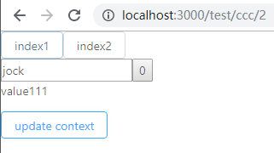

### Ref Hook

#### Class类组件的使用方法

class MyCount extends React.Component {

constructor() {

super()

this.ref = React.createRef()

}

state = {

count: 0

}

componentDidMount() {

this.refs.current

this.interval = setInterval(() => {

this.setState({ count: this.state.count + 1 })

}, 1000)

}

componentWillUnmount() {

if (this.interval) {

clearInterval(this.interval)

}

}

render () {

return <span ref={this.ref}>{ this.state.count }</span>

}

}

#### Hooks使用

import

React,

{

useState,

useReducer,

useEffect,

useLayoutEffect,

useContext,

useRef

} from 'react'

function countReducer(state, action) {

switch (action.type) {

case 'add':

return state + 1

case 'minus':

return state - 1

default:

return state

}

}

function MyCountFunc() {

// const [ count, setCount ] = useState(0) // [a, b]

const [ count, dispatchCount ] = useReducer(countReducer, 0)

const [ name, setName ] = useState('jock')

const context = useContext(MyContext)

const inputRef = useRef()

useEffect(() => {

console.log(inputRef) //此时获取的即是input的dom节点

return () => console.log('effect deteched') // 先执行

}, [count])

return (

<div>

<input ref={ inputRef } value={ name } onChange={(e) => setName(e.target.value)} />

<button onClick={() => dispatchCount({type: 'add'})}>{ count }</button>

<p >{ context }</p>

</div>

)

}

export default MyCountFunc

### 优化Hook

#### b.js

import

React,

{

useState,

useReducer,

useEffect,

useLayoutEffect,

useContext,

useRef,

memo

} from 'react'

function countReducer(state, action) {

switch (action.type) {

case 'add':

return state + 1

case 'minus':

return state - 1

default:

return state

}

}

function MyCountFunc() {

const [ count, dispatchCount ] = useReducer(countReducer, 0)

const [ name, setName ] = useState('jock')

const config = {

text: `count is ${count}`,

color: count > 3 ? 'red' : 'blue',

}

return (

<div>

<input value={ name } onChange={(e) => setName(e.target.value)} />

<Child

config={config}

onButtonClick={() => dispatchCount({ type: 'add' })}

/>

</div>

)

}

const Child = memo(function Child({ onButtonClick, config }) {

console.log('child render')

return (

<button onClick={ onButtonClick } style={{color: config.color}}>

{config.text}

</button>

)

})

export default MyCountFunc

这时无论当我点击button按钮还是在输入框里填写文字，都会触发Child组件里面console这样就影响了性能，为此我们在Child组件外层套上一层memo但此时发现当在input输入内容时child的console.log依然会被调用，原因是当input框发生改变时调用了MyCountFun函数的setName，此时MyCountFun函数会被重新执行，函数内部的config也随之重新声明，而Child组件中传入了config此时发生了更新，因此Child组件会被重新执行

我们希望在count没有发生变化的时候， config还是原来的config, 此时我们使用uesMemo这个Hook,

此时我们把config进行包装

const config = useMemo(

() => ({

text: `count is ${count}`,

color: count > 3 ? 'red' : 'blue',

}

), [count])

此时我们再次在输入框里面修改发现还是会调用child里面的console方法

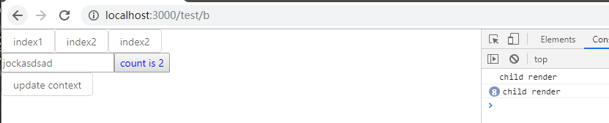

是由于

<Child

config={config}

onButtonClick={() => dispatchCount({ type: 'add' })}

/>

Child组件里面的onButtonClick调用的还是新声明的方法

此时我们又要用到一个新的hook useCallback

const handleButtonClick = useCallback(() => dispatchCount({ type: 'add' }), [])

return (

<div>

<input value={ name } onChange={(e) => setName(e.target.value)} />

<Child

config={config}

onButtonClick={handleButtonClick}

/>

</div>

)

此时我们再次输入内容时就不会再次重新调用Child了

#### b.js完整代码

import

React,

{

useState,

useReducer,

useEffect,

useLayoutEffect,

useContext,

useRef,

memo,

useMemo,

useCallback

} from 'react'

function countReducer(state, action) {

switch (action.type) {

case 'add':

return state + 1

case 'minus':

return state - 1

default:

return state

}

}

function MyCountFunc() {

const [ count, dispatchCount ] = useReducer(countReducer, 0)

const [ name, setName ] = useState('jock')

const config = useMemo(

() => ({

text: `count is ${count}`,

color: count > 3 ? 'red' : 'blue',

}

), [count])

const handleButtonClick = useCallback(

() => dispatchCount({ type: 'add' }),

[]

)

//这里我们也可以用useMemo来记忆方法,实际上useCallback就是useMemo的简化

// const handleButtonClick = useMemo(

// () => () => dispatchCount({ type: 'add' }),

// []

// )

return (

<div>

<input value={ name } onChange={(e) => setName(e.target.value)} />

<Child

config={config}

onButtonClick={handleButtonClick}

/>

</div>

)

}

const Child = memo(function Child({ onButtonClick, config }) {

console.log('child render')

return (

<button onClick={ onButtonClick } style={{color: config.color}}>

{config.text}

</button>

)

})

export default MyCountFunc

### 闭包陷阱

const handleAlertClick = function () {

setTimeout(() => {

alert(count)

}, 2000)

}

return (

<div>

<input value={ name } onChange={(e) => setName(e.target.value)} />

<Child

config={config}

onButtonClick={handleButtonClick}

/>

<button onClick ={ handleAlertClick }>AlertCount</button>

</div>

)

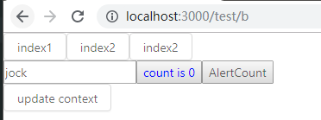

此时我们先点击AlertCount这个按钮， 然后多次点击count is 0 按钮， 会发先alert弹窗依旧会显示为0

若想要显示的值为多次点击count is 0 按钮后的count值则

const countRef = useRef() // 因为useRef生成的是同一个对象，因此规避了这一闭包现象

countRef.current = count

const handleAlertClick = function () {

setTimeout(() => {

alert(countRef.current)

}, 2000)

}

return (

<div>

<input value={ name } onChange={(e) => setName(e.target.value)} />

<Child

config={config}

onButtonClick={handleButtonClick}

/>

<button onClick ={ handleAlertClick }>AlertCount</button>

</div>

)

}

#### b.js全部代码

import

React,

{

useState,

useReducer,

useEffect,

useLayoutEffect,

useContext,

useRef,

memo,

useMemo,

useCallback

} from 'react'

function countReducer(state, action) {

switch (action.type) {

case 'add':

return state + 1

case 'minus':

return state - 1

default:

return state

}

}

function MyCountFunc() {

const [ count, dispatchCount ] = useReducer(countReducer, 0)

const [ name, setName ] = useState('jock')

const countRef = useRef()

countRef.current = count

const config = useMemo(

() => ({

text: `count is ${count}`,

color: count > 3 ? 'red' : 'blue',

}

), [count])

const handleButtonClick = useCallback(

() => dispatchCount({ type: 'add' }),

[]

)

//这里我们也可以用useMemo来记忆方法,实际上useCallback就是useMemo的简化

// const handleButtonClick = useMemo(

// () => () => dispatchCount({ type: 'add' }),

// []

// )

const handleAlertClick = function () {

setTimeout(() => {

alert(countRef.current)

}, 2000)

}

return (

<div>

<input value={ name } onChange={(e) => setName(e.target.value)} />

<Child

config={config}

onButtonClick={handleButtonClick}

/>

<button onClick ={ handleAlertClick }>AlertCount</button>

</div>

)

}

const Child = memo(function Child({ onButtonClick, config }) {

console.log('child render')

return (

<button onClick={ onButtonClick } style={{color: config.color}}>

{config.text}

</button>

)

})

export default MyCountFunc

## Redux

Redux是一个单向数据流的状态管理工具

安装redux

yarn add redux

项目根目录下新建文件夹store

新建文件

### 基础用法

#### store.js

import { createStore } from 'redux'

const initialState = {

count: 0

}

const ADD = 'ADD'

function reducer(state = initialState, action) {

console.log(state, action)

switch (action.type) {

case ADD:

return { count: state.count + 1 }

default:

return state

}

}

const store = createStore(reducer, initialState)

console.log(store)

console.log(store.getState())

store.dispatch({ type: ADD })

console.log(store.getState())

export default store

index.js

import store from '../store/store'

此时输出内容如下：

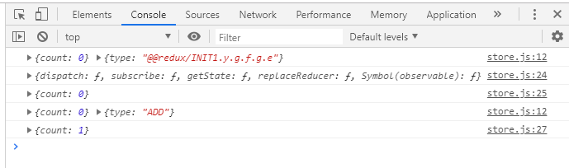

store.dispatch({ type: ADD })

store.subscribe(() => { // 在每次数据变更后调用，检测后面的变更，因此只会检测到下面的一次变更

console.log(store.getState())

})

store.dispatch({ type: ADD })

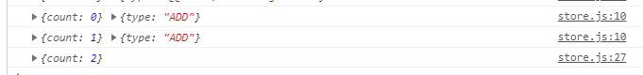

### Reducer

纯粹的方法， 不应该有任何副作用

有任何数据更新的时候返回一个新对象

可以通过combineReducer进行合并

Store.js

import { createStore, combineReducers } from 'redux'

const initialState = {

  count: 0

}

const userInitialState = {

  username: 'jack',

  age: 18

}

const ADD = 'ADD'

function countReducer(state = initialState, action) {

  switch (action.type)  {

    case ADD:

      return { count: state.count + 1 }

    default:

      return state

  }

}

const UPDATE_USERNAME = 'UPDATE_USERNAME'

function userReducer(state = userInitialState, action) {

  switch(action.type) {

    case UPDATE_USERNAME:

      return {

        ...state,

        username: action.name

      }

    default:

      return state

  }

}

const allReducers = combineReducers({ // 合并两个reducer

  counter: countReducer,

  user: userReducer

})

const store = createStore(allReducers, {

  counter: initialState,

  user: userInitialState

})

store.dispatch({ type: ADD })

store.subscribe(() => {

  console.log(store.getState())

})

store.dispatch({ type: ADD })

store.dispatch({ type: UPDATE_USERNAME, name: 'lilei' })

export default store

### action

// action creatore

function add(num) {

  return {

    type: ADD,

    num

  }

}

store.dispatch(add(3))

解决dispatch异步的方法

安装redux-thunk

yarn add redux-thunk

import { createStore, combineReducers, applyMiddleware } from 'redux'

import ReduxThunk from 'redux-thunk'

const initialState = {

  count: 0

}

const userInitialState = {

  username: 'jack',

  age: 18

}

const ADD = 'ADD'

function countReducer(state = initialState, action) {

  console.log(state, action)

  switch (action.type)  {

    case ADD:

      return { count: state.count + (action.num || 1) }

    default:

      return state

  }

}

const UPDATE_USERNAME = 'UPDATE_USERNAME'

function userReducer(state = userInitialState, action) {

  switch(action.type) {

    case UPDATE_USERNAME:

      return {

        ...state,

        username: action.name

      }

    default:

      return state

  }

}

const allReducers = combineReducers({

  counter: countReducer,

  user: userReducer

})

const store = createStore(

  allReducers,

  {

    counter: initialState,

    user: userInitialState

  },

  applyMiddleware(ReduxThunk)

)

// action creatore

// 同步的dispatch

function add(num) {

  return {

    type: ADD,

    num

  }

}

// 异步的dispatch

function addAsync(num) {

  return (dispatch) => {

    setTimeout(() => {

      dispatch(add(num))

    }, 1000)

  }

}

store.dispatch(add(3))

store.subscribe(() => { //

  console.log(store.getState())

})

store.dispatch(addAsync(5))

store.dispatch({ type: UPDATE_USERNAME, name: 'lilei' })

export default store

### react-redux

安装

Yarn add react-redux

#### _app.js

import App from 'next/app'

import Layout from '../components/layout'

import MyContext from '../lib/my-context'

import { Button } from 'antd'

import { Provider } from 'react-redux'

import store from '../store/store'

import 'antd/dist/antd.css'

class MyApp extends App {

  state = {

    context: 'value'

  }

  static async getInitialProps ({ Component, ctx }) {

    let pageProps

    if (Component.getInitialProps) {

      pageProps = await Component.getInitialProps(ctx)

    }

    return {

      pageProps

    }

  }

  render() {

    const { Component, pageProps } = this.props

    return (

      <Layout>

        <MyContext.Provider value={ this.state.context } >

          <Provider store={ store }>

            <Component { ...pageProps } />

            <Button onClick={() => this.setState({context: this.state.context + '111'})}>update context</Button>

          </Provider>

        </MyContext.Provider>

      </Layout>

    )

  }

}

export default MyApp

#### Index,js

import { Button } from 'antd'

import Link from 'next/link'

import Router from 'next/router'

import store from '../store/store'

import { connect } from 'react-redux'

const Index = ({ counter, username, rename, add }) => {

  return (

    <>

      <span>Count: { counter }</span>

      <a>username: { username }</a>

      <br />

      <input value={ username } onChange={(e) => {rename(e.target.value)}} />

      <button onClick={() => add(counter)}>do add</button>

    </>

  )

}

export default connect(function mapStateToProps(state) {

  return {

    counter: state.counter.count,

    username: state.user.username

  }

}, function mapDispatchToProps(dispatch) {

  return {

    add: (num) => dispatch({ type: 'ADD', num }),

    rename: (name) => dispatch({ type: "UPDATE_USERNAME", name })

  }

})(Index)

### Redux-devtool

安装

Yarn add redux-devtools-extension

相关代码：

import ReduxThunk from 'redux-thunk'

import { composeWithDevTools } from 'redux-devtools-extension'

const store = createStore(

  allReducers,

  {

    counter: initialState,

    user: userInitialState

  },

  composeWithDevTools(applyMiddleware(ReduxThunk))

)

Store.js

import { createStore, combineReducers, applyMiddleware } from 'redux'

import ReduxThunk from 'redux-thunk'

import { composeWithDevTools } from 'redux-devtools-extension'

const initialState = {

  count: 0

}

const userInitialState = {

  username: 'jack',

  age: 18

}

const ADD = 'ADD'

function countReducer(state = initialState, action) {

  console.log(state, action)

  switch (action.type)  {

    case ADD:

      return { count: state.count + (action.num || 1) }

    default:

      return state

  }

}

const UPDATE_USERNAME = 'UPDATE_USERNAME'

function userReducer(state = userInitialState, action) {

  switch(action.type) {

    case UPDATE_USERNAME:

      return {

        ...state,

        username: action.name

      }

    default:

      return state

  }

}

const allReducers = combineReducers({

  counter: countReducer,

  user: userReducer

})

const store = createStore(

  allReducers,

  {

    counter: initialState,

    user: userInitialState

  },

  composeWithDevTools(applyMiddleware(ReduxThunk))

)

// action creatore

// 同步的dispatch

function add(num) {

  return {

    type: ADD,

    num

  }

}

// 异步的dispatch

function addAsync(num) {

  return (dispatch) => {

    setTimeout(() => {

      dispatch(add(num))

    }, 1000)

  }

}

// console.log(store)

// console.log(store.getState())

store.dispatch(add(3))

store.subscribe(() => { //

  console.log(store.getState())

})

store.dispatch(addAsync(5))

// store.dispatch({ type: ADD })

store.dispatch({ type: UPDATE_USERNAME, name: 'lilei' })

export default store

此时打开开发者工具的Redux

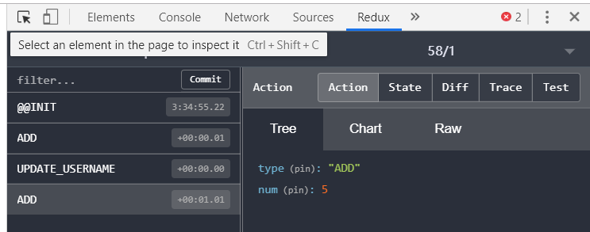

### Nextejs中的HOC

接收组件作为参数并返回新的组件

/lib/下新建test-hoc.js文件

export default Comp => {

  function TestHocComp({ Component, pageProps, ... rest }) {

    // const name = name + '123'

    console.log('Component',Component)

    console.log('PageProps',pageProps)

    if(pageProps) {

      pageProps.test = '123'

    }

    return <Comp Component={Component}  pageProps={pageProps} {...rest} />

  }

  TestHocComp.getInitialProps = Comp.getInitialProps

  return TestHocComp

}

_app.js

import App from 'next/app'

import Layout from '../components/layout'

import MyContext from '../lib/my-context'

// import { Button } from 'antd'

import { Provider } from 'react-redux'

import store from '../store/store'

import testHoc from '../lib/test-hoc'

import 'antd/dist/antd.css'

class MyApp extends App {

  state = {

    context: 'value'

  }

  static async getInitialProps ({ Component, ctx }) {

    let pageProps = {}

    if (Component.getInitialProps) {

      pageProps = await Component.getInitialProps(ctx)

    }

    return {

      pageProps

    }

  }

  render() {

    const { Component, pageProps } = this.props

    return (

      <Layout>

        <Provider store={ store }>

          <MyContext.Provider value={ this.state.context } >

            <Component { ...pageProps } />

            {/* <Button onClick={() => this.setState({context: this.state.context + '111'})}>update context</Button> */}

          </MyContext.Provider>

        </Provider>

      </Layout>

    )

  }

}

export default testHoc(MyApp)

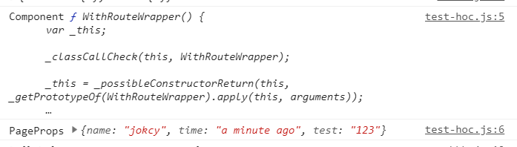

### Nextjs中集成redux

问题：

服务端如何写入数据到store

如何同步服务端的数据到客户端

Lib文件夹下新建文件

#### with-redux.js

import React from 'react'

import createSore from '../store/store'

const isServer = typeof window === 'undefined'

const __NEXT_REDUX_STORE__ = '__NEXT_REDUX_STORE__'

function getOrCreateStore(initialState) {

  if (isServer) {

    return createSore(initialState)

  }

  if (!window[__NEXT_REDUX_STORE__]) {

    window[__NEXT_REDUX_STORE__] = createSore(initialState)

  }

  return window[__NEXT_REDUX_STORE__]

}

export default Comp => {

  class WithReduxApp extends React.Component {

    constructor(props) {

      super(props)

      this.reduxStore = getOrCreateStore(props.initialReduxState)

    }

    render() {

      const { Component, pageProps, ... rest } = this.props

      if(pageProps) {

        pageProps.test = '123'

      }

      return <Comp Component={Component}  pageProps={pageProps} {...rest}  reduxStore={this.reduxStore} />

    }

  }

  WithReduxApp.getInitialProps = async ctx => {

    const reduxStore = getOrCreateStore()

    ctx.reduxStore = reduxStore

    let appProps = {}

    if (typeof Comp.getInitialProps === 'function') {

      appProps = await Comp.getInitialProps(ctx)

    }

    return {

      ...appProps,

      initialReduxState: reduxStore.getState()

    }

  }

  return WithReduxApp

}

#### _app.js

import App from 'next/app'

import Layout from '../components/layout'

import MyContext from '../lib/my-context'

import { Provider } from 'react-redux'

import store from '../store/store'

import testHoc from '../lib/with-redux'

import 'antd/dist/antd.css'

class MyApp extends App {

  state = {

    context: 'value'

  }

  static async getInitialProps ({ Component, ctx }) {

    let pageProps = {}

    if (Component.getInitialProps) {

      pageProps = await Component.getInitialProps(ctx)

    }

    return {

      pageProps

    }

  }

  render() {

    const { Component, pageProps,reduxStore } = this.props

    return (

      <Layout>

        <Provider store={ reduxStore }>

          <MyContext.Provider value={ this.state.context } >

            <Component { ...pageProps } />

          </MyContext.Provider>

        </Provider>

      </Layout>

    )

  }

}

export default testHoc(MyApp)

#### store.js

import { createStore, combineReducers, applyMiddleware } from 'redux'

import ReduxThunk from 'redux-thunk'

import { composeWithDevTools } from 'redux-devtools-extension'

const initialState = {

  count: 0

}

const userInitialState = {

  username: 'jack',

  age: 18

}

const ADD = 'ADD'

function countReducer(state = initialState, action) {

  console.log(state, action)

  switch (action.type)  {

    case ADD:

      return { count: state.count + (action.num || 1) }

    default:

      return state

  }

}

const UPDATE_USERNAME = 'UPDATE_USERNAME'

function userReducer(state = userInitialState, action) {

  switch(action.type) {

    case UPDATE_USERNAME:

      return {

        ...state,

        username: action.name

      }

    default:

      return state

  }

}

const allReducers = combineReducers({

  counter: countReducer,

  user: userReducer

})

const store = createStore(

  allReducers,

  {

    counter: initialState,

    user: userInitialState

  },

  composeWithDevTools(applyMiddleware(ReduxThunk))

)

// action creatore

// 同步的dispatch

export function add(num) {

  return {

    type: ADD,

    num

  }

}

// 异步的dispatch

function addAsync(num) {

  return (dispatch) => {

    setTimeout(() => {

      dispatch(add(num))

    }, 1000)

  }

}

store.dispatch(add(3))

store.subscribe(() => { //

  console.log(store.getState())

})

store.dispatch(addAsync(5))

store.dispatch({ type: UPDATE_USERNAME, name: 'lilei' })

export default function initializeStore(state) {

  const store = createStore(

    allReducers,

    Object.assign({}, {

      counter: initialState,

      user: userInitialState

    }, state),

    composeWithDevTools(applyMiddleware(ReduxThunk))

  )

  return store

}

#### Index.js

import { Button } from 'antd'

import Router from 'next/router'

import { connect } from 'react-redux'

import { add } from '../store/store'

const event = [

  'routeChageStart',

  'routeChangeComplete',

  'routeChangeError',

  'beforeHistoryChange',

  'hashChangeStart',

  'hashChangeComplete '

]

function makeEvent(type) {

  return (...args) => {

    console.log(type, ...args)

  }

}

event.forEach(event => {

  Router.events.on(event, makeEvent(event))

})

const Index = ({ counter, username, rename, add }) => {

  function gotoTestB() {

    // Router.push('/test/bbb?id=2')

    // 或

    Router.push({

      pathname: '/test/bbb',

      query: {

        id: 2

      }

    }, '/test/bbb/2')

  }

  return (

    <>

      <Button onClick={ gotoTestB }>

        test b

      </Button>

      <span>Count: { counter }</span>

      <a>username: { username }</a>

      <br />

      <input value={ username } onChange={(e) => {rename(e.target.value)}} />

      <button onClick={() => add(counter)}>do add</button>

    </>

  )

}

Index.getInitialProps = async ({ reduxStore }) => {

  reduxStore.dispatch(add(3))

  return {}

}

export default connect(function mapStateToProps(state) {

  return {

    counter: state.counter.count,

    username: state.user.username

  }

}, function mapDispatchToProps(dispatch) {

  return {

    add: (num) => dispatch({ type: 'ADD', num }),

    rename: (name) => dispatch({ type: "UPDATE_USERNAME", name })

  }

})(Index)

## OAuth

Oauth是一种行业标准的授权方式

### 多种授权方式

#### Authorization Code

常用，

#### Refresh Token

属于Oatuh的一种协议

#### Device Code

智能TV等

#### Password

用户名密码输入框授权登陆

一般不会为第三方提供

#### Implicit

#### Client Credentials

客户端相关

### OAuth code 授权流程

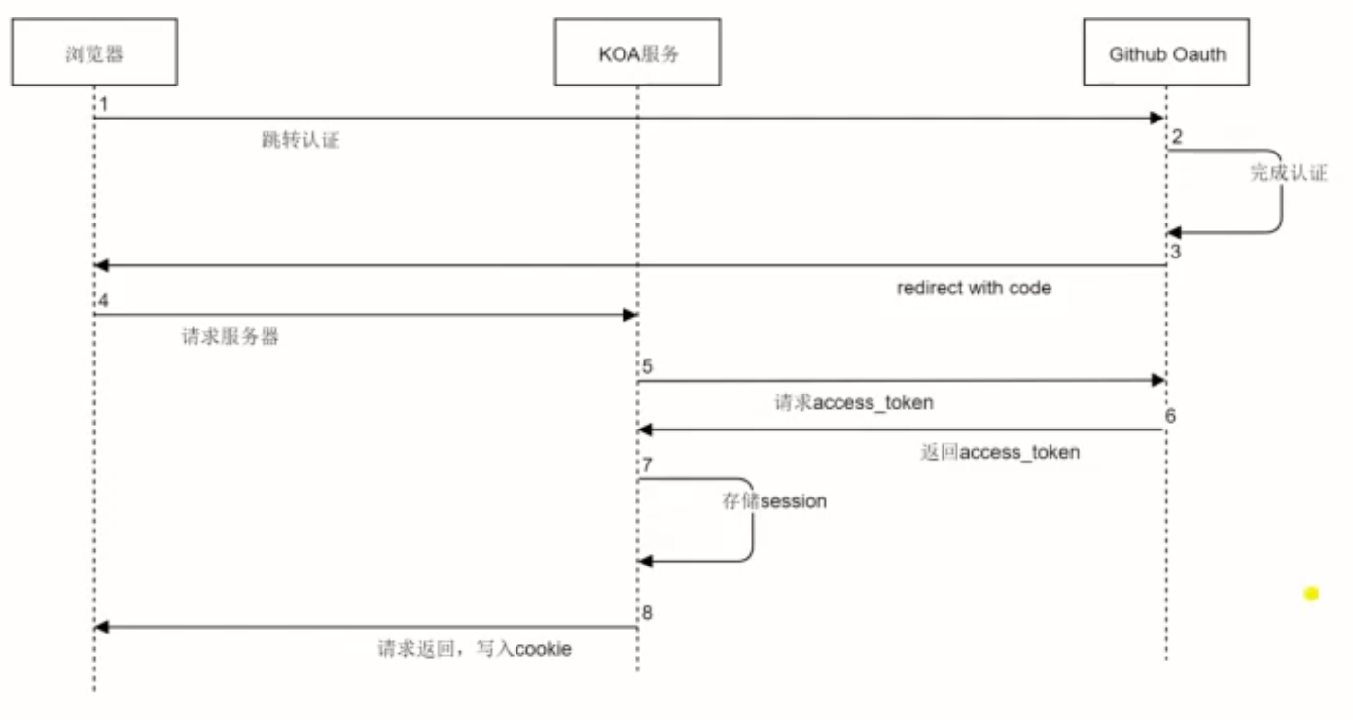

### 注册github-OAuth-App

登陆github => 点击settings => Developer settings => new GitHub App =>

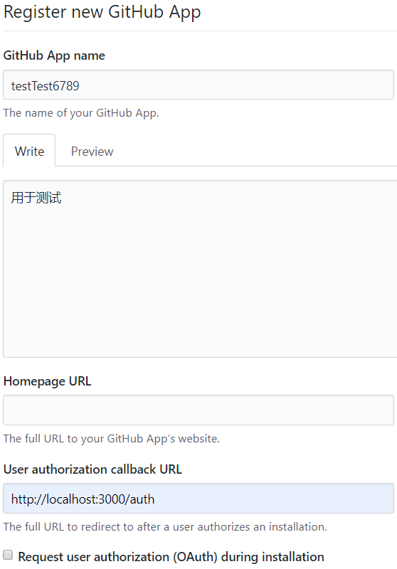

点击create GitHub App 完成

找到**Client ID和Client secret**

项目根目录新建文件config.js

module.exports = {

  github: {

    client_id: 'Iv1.848b1654fe37****',

    client_secret: 'e5d88f2aa6c231fed9026829730a7ca3aeb****'

  }

}

### OAuth的字段讲解以及流程演示

#### 跳转字段

client_id

scope 授权有哪些

可在<https://developer.github.com/apps/building-oauth-apps/authorizing-oauth-apps/>里面的<https://developer.github.com/apps/building-oauth-apps/understanding-scopes-for-oauth-apps/>里面查看

redirect_uri 必须和注册时的callback url 是一致的

login 是否允许用户登录

state 希望跳转和callback的时候带上这个state

allow_signup 是否允许用户注册

认证流程

<https://developer.github.com/apps/building-oauth-apps/authorizing-oauth-apps/>

测试授权

<https://github.com/login/oauth/authorize?client_id=Iv1.848b1654fe37f16f>(自己的client_id)

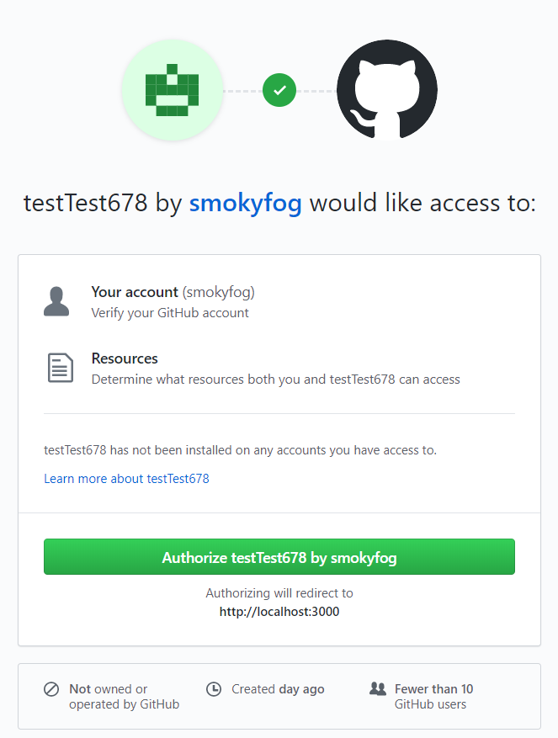

### 策略

#### 一次性code

#### Id+secret

#### Redirect_uri

### Cookie和session

#### Cookie /Session

Yarn add koa-session

##### Server.js

const Koa = require('koa')

const Router = require('koa-router')

const next = require('next')

const session = require('koa-session')

const dev = process.env.NODE_ENV !== 'production'

const app = next({ dev })

const handle = app.getRequestHandler()

app.prepare().then(() => {

  const server = new Koa()

  const router = new Router()

  server.keys = ['yqzsa yqzs']

  const SESSION_CONFIG = {

    key: 'jid'

    // store: {}

  }

  server.use(session(SESSION_CONFIG, server))

  server.use(async (ctx, next) => {

    console.log('session is', ctx.session)

    await next()

  })

  router.get('/test/bbb/:id', async (ctx) => {

    const id = ctx.params.id

    await handle(ctx.req, ctx.res, {

      pathname: '/test/bbb',

      query: { id }

    })

    ctx.respond = false

  })

  router.get('/set/user', async (ctx) => {

    ctx.session.user = {

      name: 'jocky',

      age: 18

    }

    ctx.body = 'set session success'

  })

  server.use(router.routes())

  server.use(async (ctx, next) => {

    await next()

  })

  server.use(async (ctx, next) => {

    ctx.cookies.set('id', 'userid:xxx')

    await handle(ctx.req, ctx.res)

    ctx.respond = false

  })

  server.listen(3000, () => {

    console.log('koa server listening on 3000...')

  })

})

### 实现koa-session的存储

#### Server.js

const Koa = require('koa')

const Router = require('koa-router')

const next = require('next')

const session = require('koa-session')

const Redis = require('ioredis')

const RedisSessionStore = require('./server/session-store')

const dev = process.env.NODE_ENV !== 'production'

const app = next({ dev })

const handle = app.getRequestHandler()

// 创建redis-client

const redis = new Redis({

  port: 6379,

  host: '129.28.187.206'

  // password: '123456'

})

app.prepare().then(() => {

  const server = new Koa()

  const router = new Router()

  server.keys = ['yqzsa yqzs']

  const SESSION_CONFIG = {

    key: 'jid',

    // maxAge: 10 * 1000,  //设置过期时间

    store: new RedisSessionStore(redis)

  }

  server.use(session(SESSION_CONFIG, server))

  server.use(async (ctx, next) => {

    // console.log(ctx.cookies.get('id'))

    console.log('session is', ctx.session)

    await next()

  })

  router.get('/test/bbb/:id', async (ctx) => {

    const id = ctx.params.id

    await handle(ctx.req, ctx.res, {

      pathname: '/test/bbb',

      query: { id }

    })

    ctx.respond = false

  })

  // 设置session

  router.get('/set/user', async (ctx) => {

    ctx.session.user = {

      name: 'jocky',

      age: 18

    }

    ctx.body = 'set session success'

  })

  // 删除session

  router.get('/delete/user', async (ctx) => {

    ctx.session = null

    ctx.body = 'delete session success'

  })

  server.use(router.routes())

  server.use(async (ctx, next) => {

    await next()

  })

  server.use(async (ctx, next) => {

    ctx.cookies.set('id', 'userid:xxx')

    await handle(ctx.req, ctx.res)

    ctx.respond = false

  })

  server.listen(3000, () => {

    console.log('koa server listening on 3000...')

  })

})

#### /server/session-store.js

function getRedisSessionId(sid) {

  return `ssid:${sid}`

}

class RedisSessionStore {

  constructor(client) {

    this.client = client

  }

  // 获取redis中存储的session数据

  async get(sid) {

    console.log('get session', sid)

    const id = getRedisSessionId(sid)

    const data = await this.client.get(id)

    if (!data) {

      return null

    }

    try {

      const result = JSON.parse(data)

      return result

    } catch(err) {

      console.log(err)

    }

  }

  // 用于存储session数据到redis

  async set(sid, sess, ttl) {

    console.log('set session', sid, sess, ttl)

    const id = getRedisSessionId(sid)

    if (typeof ttl === 'number') {

      ttl = Math.ceil(ttl / 1000)

    }

    try {

      const sessStr = JSON.stringify(sess)

      if (ttl) {

        await this.client.setex(id, ttl, sessStr)

      } else {

        await this.client.set(id, sessStr)

      }

    } catch (err) {

      console.log(err)

    }

  }

  // 从redis中删除某个session

  async destroy(sid) {

    console.log('destroy session', sid)

    const id = getRedisSessionId(sid)

    await this.client.del(id)

  }

}

module.exports = RedisSessionStore

### 接入github Oauth

认证流程

<https://developer.github.com/apps/building-oauth-apps/authorizing-oauth-apps/>

相应api

<https://developer.github.com/v3/>

用户相关

<https://developer.github.com/v3/users/>

#### server.js

const Koa = require('koa')

const Router = require('koa-router')

const next = require('next')

const session = require('koa-session')

const Redis = require('ioredis')

const auth = require('./server/auth')

const RedisSessionStore = require('./server/session-store')

const dev = process.env.NODE_ENV !== 'production'

const app = next({ dev })

const handle = app.getRequestHandler()

// 创建redis-client

const redis = new Redis({

  port: 6379,

  host: '129.28.187.206'

  // password: '123456'

})

app.prepare().then(() => {

  const server = new Koa()

  const router = new Router()

  server.keys = ['yqzsa yqzs']

  const SESSION_CONFIG = {

    key: 'jid',

    // maxAge: 10 * 1000,  //设置过期时间

    store: new RedisSessionStore(redis)

  }

  server.use(session(SESSION_CONFIG, server))

  // 配置处理github OAuth的登录

  auth(server)

  router.get('/test', async (ctx) => {

    ctx.redirect('/')

  })

  server.use(async (ctx, next) => {

    await next()

  })

  router.get('/api/user/info', async (ctx) => {

    const user = ctx.session.userinfo

    if (!user) {

      ctx.status = 401

      ctx.body = 'need login'

    } else {

      ctx.body = user

      ctx.set('Content-Type', 'application/json')

    }

  })

  server.use(router.routes())

  server.use(async (ctx, next) => {

    // ctx.cookies.set('id', 'userid:xxx')

    // req里获取session

    ctx.req.session = ctx.session

    await handle(ctx.req, ctx.res)

    ctx.respond = false

  })

  server.listen(3000, () => {

    console.log('koa server listening on 3000...')

  })

})

#### Auth.js

const axios = require('axios')

const config = require('../config')

const { client_id, client_secret, request_token_url  } = config.github

module.exports = (server) => {

  server.use(async (ctx, next) =>  {

    if(ctx.path === '/auth') {

      const code = ctx.query.code

      if (!code) {

        ctx.body = 'code not exist'

        return

      }

      const result = await axios({

        method: 'post',

        url: request_token_url,

        data: {

          client_id,

          client_secret,

          code

        },

        headers: {

          Accept: 'application/json'

        }

      })

      if (result.status === 200 && (result.data && !result.data.error)) {

        ctx.session.githubAuth = result.data

        const { access_token, token_type } = result.data

        const userInfoResp = await axios({

          method: 'GET',

          url: 'https://api.github.com/user',

          headers: {

            'Authorization': `${token_type} ${access_token}`

          }

        })

        ctx.session.userinfo = userInfoResp.data

        ctx.redirect('/')

      } else {

        const errorMsg = result.data && result.data.error

        ctx.body = `request token failed ${errorMsg}`

      }

    } else {

      await next()

    }

  })

}

#### Index.js

import getConfig from 'next/config'

import { useEffect } from 'react'

import axios from 'axios'

const { publicRuntimeConfig } = getConfig()

const Index = () => {

  useEffect(() => {

    axios.get('/api/user/info').then(res => {

      console.log(res)

    })

  }, [])

  return (

    <span>

    index

    <a href ={publicRuntimeConfig.OAUTH_URL}>去登陆</a>

  </span>

  )

}

export default Index

## gitHub项目开始

### 整体布局的构建

style标签里面的jsx样式显示插件

vscode-styled-jsx

#### layout

import { useState, useCallback } from 'react'

import { Button, Layout, Icon, Input, Avatar } from 'antd'

import Link from 'next/link'

import Container from './Container'

const { Header, Content, Footer } = Layout

const Comp = ({ color, children, style }) => <div style={{color, ...style}}>{children}</div>

export default ({ children }) => {

  const [search, setSearch] = useState('')

  const handleSearchChange = useCallback(

    event => {

      setSearch(event.target.value)

    },

    [setSearch]

  )

  const handleOnSearch = useCallback(

    () => {

    },

    []

  )

  const githubIconStyle = {

    color: 'white',

    fontSize: 40,

    display: 'block',

    paddingTop: 10,

    marginRight: 20

  }

  const footerStyle = {

    textAlign: 'center'

  }

  return (

    <Layout>

      <Header>

          <Container renderer={<div className="header-inner"/>}>

            <div className="header-left">

              <div className="logo">

                <Icon type="github" style={ githubIconStyle }/>

              </div>

              <div>

                <Input.Search

                  placeholder="搜索仓库"

                  value={ search }

                  onChange={ handleSearchChange }

                  onSearch={ handleOnSearch }

                />

              </div>

            </div>

            <div className="header-right">

              <div className="user">

                  <Avatar size={40} icon="user"/>

              </div>

            </div>

        </Container>

      </Header>

      <Content>

        <Container renderer={<Comp color="red" />}>

            { children }

        </Container>

      </Content>

      <Footer style={ footerStyle }>

        Develop by yq @

        <a href="mailto:yq@hotmail.com">yq@.com</a>

      </Footer>

      <style jsx>{`

        .content {

          color: red;

        }

        .header-inner {

          display: flex;

          justify-content: space-between

        }

        .header-left {

          display: flex;

          justify-content: flex-start

        }

      `}</style>

      <style jsx global>{`

        #__next {

          height: 100%;

        }

        .ant-layout {

          height: 100%

        }

        .ant-layout-header {

          padding-left: 0;

          padding-right: 0

        }

      `}</style>

    </Layout>

  )

}

#### Container.js

import { cloneElement } from 'react' //通过cloneElemet来减少标签的嵌套和保持样式的一致

const style = {

  width: '100%',

  maxWidth: 1200,

  marginLeft: 'auto',

  marginRight: 'auto',

  paddingLeft: 20,

  paddingRight: 20

}

export default ({ children, renderer=<div/> }) => {

  return cloneElement(renderer, {

    style: Object.assign({}, renderer.props.style, style),

    children

  })

  // return <Comp style={ style }>{ children }</Comp>

}

服务端端渲染同步用户信息

### 实现登录登出功能

#### Layout.jsx

import { useState, useCallback } from 'react'

import {

  Button,

  Layout,

  Icon,

  Input,

  Avatar,

  Tooltip,

  Dropdown,

  Menu

} from 'antd'

import getConfig from 'next/config'

import { connect } from 'react-redux'

import { withRouter } from 'next/router'

import Container from './Container'

import axios from 'axios'

import { logout } from '../store/store'

const { Header, Content, Footer } = Layout

const Comp = ({ color, children, style }) => <div style={{color, ...style}}>{children}</div>

const { publicRuntimeConfig } = getConfig()

const githubIconStyle = {

  color: 'white',

  fontSize: 40,

  display: 'block',

  paddingTop: 10,

  marginRight: 20

}

const footerStyle = {

  textAlign: 'center'

}

function MyLayout ({ children, user, logout, router }) {

  const [search, setSearch] = useState('')

  const handleSearchChange = useCallback(

    event => {

      setSearch(event.target.value)

    },

    [setSearch]

  )

  const handleOnSearch = useCallback(

    () => {

    },

    []

  )

  const handleLogout = useCallback(() => {

    logout()

  }, [logout])

  const handleGoToAuth = useCallback((e) => {

    e.preventDefault()

    axios.get(`/prepare-auth?url=${router.asPath}`)

      .then(res => {

        if (res.status === 200) {

          location.href = publicRuntimeConfig.OAUTH_URL

        } else {

          console.log('prepare auth faild', res)

        }

      })

      .catch(err => {

        console.log('prepare auth faild', err)

      })

  }, [])

  const userDrapDown = (

    <Menu>

      <Menu.Item>

        <a href="javascript:void(0)" onClick={handleLogout}>

          登出

        </a>

      </Menu.Item>

    </Menu>

  )

  return (

    <Layout>

      <Header>

          <Container renderer={<div className="header-inner"/>}>

            <div className="header-left">

              <div className="logo">

                <Icon type="github" style={ githubIconStyle }/>

              </div>

              <div>

                <Input.Search

                  placeholder="搜索仓库"

                  value={ search }

                  onChange={ handleSearchChange }

                  onSearch={ handleOnSearch }

                />

              </div>

            </div>

            <div className="header-right">

              <div className="user">

                {

                  user && user.id ? (

                    <Dropdown overlay={userDrapDown}>

                      <a href="/" >

                        <Avatar size={40} src={user.avatar_url} />

                      </a>

                    </Dropdown>

                  ) : (

                    <Tooltip title="点击进行登陆">

                      <a  href={`/prepare-auth?url=${router.asPath}`}>

                        <Avatar size={40} icon="user"/>

                      </a>

                    </Tooltip>

                  )

                }

              </div>

            </div>

        </Container>

      </Header>

      <Content>

        <Container renderer={<Comp color="red" />}>

            { children }

        </Container>

      </Content>

      <Footer style={ footerStyle }>

        Develop by yq @

        <a href="mailto:yq@hotmail.com">yq@.com</a>

      </Footer>

      <style jsx>{`

        .content {

          color: red;

        }

        .header-inner {

          display: flex;

          justify-content: space-between

        }

        .header-left {

          display: flex;

          justify-content: flex-start

        }

      `}</style>

      <style jsx global>{`

        #__next {

          height: 100%;

        }

        .ant-layout {

          height: 100%

        }

        .ant-layout-header {

          padding-left: 0;

          padding-right: 0

        }

      `}</style>

    </Layout>

  )

}

export default connect(function mapState(state) {

  return {

    user: state.user

  }

}, function MapReducer(dispatch) {

  return {

    logout: () => dispatch(logout())

  }

})(withRouter(MyLayout))

#### Store.js

import { createStore, combineReducers, applyMiddleware } from 'redux'

import ReduxThunk from 'redux-thunk'

import { composeWithDevTools } from 'redux-devtools-extension'

import axios from 'axios'

const userInitialState = {}

const LOGOUT = 'LOGOUT'

function userReducer(state = userInitialState, action) {

  switch(action.type) {

    case LOGOUT: {

      return {}

    }

    default:

      return state

  }

}

const allReducers = combineReducers({

  user: userReducer

})

// action creators

export function logout() {

  return dispatch => {

    axios.post('/logout')

      .then(res => {

        if (res.status === 200) {

          dispatch({

            type: LOGOUT

          })

        } else {

          console.log('logout faild', res)

        }

      }).catch(err => {

        console.log('logout faild', err)

      })

  }

}

export default function initializeStore(state) {

  const store = createStore(

    allReducers,

    Object.assign({}, {

      user: userInitialState

    }, state),

    composeWithDevTools(applyMiddleware(ReduxThunk))

  )

  return store

}

#### Auth.js

const axios = require('axios')

const config = require('../config')

const { client_id, client_secret, request_token_url  } = config.github

module.exports = (server) => {

  server.use(async (ctx, next) =>  {

    if(ctx.path === '/auth') {

      const code = ctx.query.code

      if (!code) {

        ctx.body = 'code not exist'

        return

      }

      const result = await axios({

        method: 'post',

        url: request_token_url,

        data: {

          client_id,

          client_secret,

          code

        },

        headers: {

          Accept: 'application/json'

        }

      })

      if (result.status === 200 && (result.data && !result.data.error)) {

        ctx.session.githubAuth = result.data

        const { access_token, token_type } = result.data

        const userInfoResp = await axios({

          method: 'GET',

          url: 'https://api.github.com/user',

          headers: {

            'Authorization': `${token_type} ${access_token}`

          }

        })

        ctx.session.userinfo = userInfoResp.data

         ctx.redirect((ctx.session && ctx.session.urlBeforeOAuth) || '/')

          ctx.session.urlBeforeOAuth = ''

      } else {

        const errorMsg = result.data && result.data.error

        ctx.body = `request token failed ${errorMsg}`

      }

    } else {

      await next()

    }

  })

   // 登出逻辑

   server.use(async (ctx, next) => {

    const { path, method } = ctx

    if (path === '/logout' && method === 'POST') {

      ctx.session = null

      ctx.body = 'logout success'

    } else {

      await next()

    }

  })

    // 在进行auth之前 记录请求时的页面url

  server.use(async (ctx, next) => {

    const { path, method } = ctx

    if (path === '/prepare-auth' && method === 'GET') {

      console.log('prepare-auth')

      const { url } = ctx.query

      ctx.session.urlBeforeOAuth = url

      ctx.redirect(config.OAUTH_URL)

    } else {

      await next()

    }

  })

}

#### Server.js

const Koa = require('koa')

const Router = require('koa-router')

const next = require('next')

const session = require('koa-session')

const Redis = require('ioredis')

const auth = require('./server/auth')

const RedisSessionStore = require('./server/session-store')

const dev = process.env.NODE_ENV !== 'production'

const app = next({ dev })

const handle = app.getRequestHandler()

// 创建redis-client

const redis = new Redis({

  port: 6379,

  host: '129.28.187.206'

  // password: '123456'

})

app.prepare().then(() => {

  const server = new Koa()

  const router = new Router()

  server.keys = ['yqzsa yqzs']

  const SESSION_CONFIG = {

    key: 'jid',

    // maxAge: 10 * 1000,  //设置过期时间

    store: new RedisSessionStore(redis)

  }

  server.use(session(SESSION_CONFIG, server))

  // 配置处理github OAuth的登录

  auth(server)

  router.get('/test', async (ctx) => {

    ctx.redirect('/')

  })

  server.use(async (ctx, next) => {

    await next()

  })

  router.get('/api/user/info', async (ctx) => {

    const user = ctx.session.userinfo

    if (!user) {

      ctx.status = 401

      ctx.body = 'need login'

    } else {

      ctx.body = user

      ctx.set('Content-Type', 'application/json')

    }

  })

  server.use(router.routes())

  server.use(async (ctx, next) => {

    // ctx.cookies.set('id', 'userid:xxx')

    // req里获取session

    ctx.req.session = ctx.session

    await handle(ctx.req, ctx.res)

    ctx.respond = false

  })

  server.listen(3000, () => {

    console.log('koa server listening on 3000...')

  })

})

### 全局的loading效果

#### PageLoading.jsx

import { Spin } from 'antd'

export default () => {

  return (

    <div className="root">

      <Spin />

      <style jsx>

        {`

          .root {

            position: fixed;

            left: 0;

            top: 0;

            right: 0;

            bottom: 0;

            display: flex;

            justify-content: center;

            align-items: center;

            background: rgba(255, 255, 255, 0.3);

            z-index: 10000;

          }

      `}

      </style>

    </div>

  )

}

_app.js

import App from 'next/app'

import Layout from '../components/layout'

import { Provider } from 'react-redux'

import store from '../store/store'

import testHoc from '../lib/with-redux'

import PageLoading from '../components/PageLoading'

import Router from 'next/router'

import Link from 'next/link'

import 'antd/dist/antd.css'

class MyApp extends App {

  state = {

    context: 'value',

    loading: false

  }

  startLoading = () => {

    this.setState({

      loading: true

    })

  }

  stopLoading = () => {

    this.setState({

      loading: false

    })

  }

  componentDidMount() {

    Router.events.on('routeChangeStart', this.startLoading)

    Router.events.on('routeChangeComplete', this.stopLoading)

    Router.events.on('routeChangeError', this.stopLoading)

  }

  componentWillUnmount() {

    Router.events.off('routeChangeStart', this.startLoading)

    Router.events.off('routeChangeComplete', this.stopLoading)

    Router.events.off('routeChangeError', this.stopLoading)

  }

  static async getInitialProps (ctx) {

    const { Component } = ctx

    let pageProps = {}

    if (Component.getInitialProps) {

      pageProps = await Component.getInitialProps(ctx)

    }

    return {

      pageProps

    }

  }

  render() {

    const { Component, pageProps,reduxStore } = this.props

    return (

      <Provider store={ reduxStore }>

        { this.state.loading ? <PageLoading />: null }

        <Layout>

          <Link href="/">

            <a>Index</a>

          </Link>

          <Link href="/detail">

            <a>detail</a>

          </Link>

          <Component { ...pageProps } />

        </Layout>

      </Provider>

    )

  }

}

export default testHoc(MyApp)

### 搜索功能和github接口代理

#### Layout.jsx

import { useState, useCallback } from 'react'

import {

  Button,

  Layout,

  Icon,

  Input,

  Avatar,

  Tooltip,

  Dropdown,

  Menu

} from 'antd'

import getConfig from 'next/config'

import { connect } from 'react-redux'

import { withRouter, Router } from 'next/router'

import Link from 'next/link'

import Container from './Container'

import axios from 'axios'

import { logout } from '../store/store'

const { Header, Content, Footer } = Layout

const Comp = ({ color, children, style }) => <div style={{color, ...style}}>{children}</div>

const { publicRuntimeConfig } = getConfig()

const githubIconStyle = {

  color: 'white',

  fontSize: 40,

  display: 'block',

  paddingTop: 10,

  marginRight: 20

}

const footerStyle = {

  textAlign: 'center'

}

function MyLayout ({ children, user, logout, router }) {

  const urlQuery = router.query && router.query.query

  const [search, setSearch] = useState(urlQuery || '')

  const handleSearchChange = useCallback(

    event => {

      setSearch(event.target.value)

    },

    [setSearch]

  )

  const handleOnSearch = useCallback(() => {

    router.push(`/search?query=${search}`)

  },[search])

  const handleLogout = useCallback(() => {

    logout()

  }, [logout])

  const handleGoToAuth = useCallback((e) => {

    e.preventDefault()

    axios.get(`/prepare-auth?url=${router.asPath}`)

      .then(res => {

        if (res.status === 200) {

          location.href = publicRuntimeConfig.OAUTH_URL

        } else {

          console.log('prepare auth faild', res)

        }

      })

      .catch(err => {

        console.log('prepare auth faild', err)

      })

  }, [])

  const userDrapDown = (

    <Menu>

      <Menu.Item>

        <a onClick={handleLogout}>

          登出

        </a>

      </Menu.Item>

    </Menu>

  )

  return (

    <Layout>

      <Header>

          <Container renderer={<div className="header-inner"/>}>

            <div className="header-left">

              <div className="logo">

                {/* <Link href="/"> */}

                  <Icon type="github" style={ githubIconStyle } />

                {/* </Link> */}

              </div>

              <div>

                <Input.Search

                  placeholder="搜索仓库"

                  value={ search }

                  onChange={ handleSearchChange }

                  onSearch={ handleOnSearch }

                />

              </div>

            </div>

            <div className="header-right">

              <div className="user">

                {

                  user && user.id ? (

                    <Dropdown overlay={userDrapDown}>

                      <a href="/" >

                        <Avatar size={40} src={user.avatar_url} />

                      </a>

                    </Dropdown>

                  ) : (

                    <Tooltip title="点击进行登陆">

                      <a  href={`/prepare-auth?url=${router.asPath}`}>

                        <Avatar size={40} icon="user"/>

                      </a>

                    </Tooltip>

                  )

                }

              </div>

            </div>

        </Container>

      </Header>

      <Content>

        <Container renderer={<Comp color="red" />}>

            { children }

        </Container>

      </Content>

      <Footer style={ footerStyle }>

        Develop by yq @

        <a href="mailto:yq@hotmail.com">yq@.com</a>

      </Footer>

      <style jsx>{`

        .content {

          color: #000;

        }

        .header-inner {

          display: flex;

          justify-content: space-between

        }

        .header-left {

          display: flex;

          justify-content: flex-start

        }

      `}</style>

      <style jsx global>{`

        #__next {

          height: 100%;

        }

        .ant-layout {

          min-height: 100%;

        }

        .ant-layout-header {

          padding-left: 0;

          padding-right: 0

        }

        .ant-layout-content {

          background: #fff;

        }

      `}</style>

    </Layout>

  )

}

export default connect(function mapState(state) {

  return {

    user: state.user

  }

}, function MapReducer(dispatch) {

  return {

    logout: () => dispatch(logout())

  }

})(withRouter(MyLayout))

#### Serach.js

import { withRouter } from 'next/router'

function Search({ router }) {

  return <span>{router.query.query}</span>

}

export default withRouter(Search)

#### /server/api.js

const github_base_url = 'https://api.github.com'

const axios = require('axios')

const { requestGithub } = require('../lib/api')

module.exports = server => {

  server.use(async (ctx, next) => {

    const path = ctx.path

    const method = ctx.method

    if (path.startsWith('/github/')) {

      const session = ctx.session

      const githubAuth = session && session.githubAuth || {}

      const headers = {}

      if (githubAuth && githubAuth.access_token) {

        headers['Authorization'] = `${githubAuth.token_type} ${githubAuth.access_token}`

      }

      const result = await requestGithub(

        method,

        ctx.url.replace('/github/', '/'),

        {},

        headers

      )

      ctx.status = result.status

      ctx.body = result.data

    } else {

      await next()

    }

  })

}

#### /lib/api.js

const axios = require('axios')

const github_base_url = 'https://api.github.com'

async function requestGithub(method, url, data, headers) {

  return await axios({

    method,

    url: `${github_base_url}${url}`,

    data,

    headers

  })

}

const isServer = typeof window === 'undefined'

async function request({ method = 'GET', url, data= {} }, req, res) {

  if(!url) {

    throw Error('url is provide')

  }

  if (isServer) {

    const session = req.session

    const githubAuth = session.githubAuth || {}

    const headers = {}

    if (githubAuth.access_token) {

      headers['Authorization'] = `${githubAuth.token_type} ${githubAuth.access_token}`

    }

    return await requestGithub(method, url, data, headers)

  } else {

    return await axios({

      method,

      url: `/github${url}`,

      data

    })

  }

}

module.exports = {

  request,

  requestGithub

}

！要在请求github相应的api时加上用户的token, 否则github 的安全策略限制每小时的请求次数

#### Index.js

const api = require('../lib/api')

function Index () {

  return <span>Index</span>

}

Index.getInitialProps = async ({ ctx }) => {

  const result = await api.request({

    url: '/search/repositories?q=react'

  }, ctx.req, ctx.res)

  return {

    data: result.data

  }

}

export default Index

### koa处理post请求

安装

yarn add koa-body

#### server.js

const Koa = require('koa')

const Router = require('koa-router')

const next = require('next')

const session = require('koa-session')

const koaBody = require('koa-body')

app.prepare().then(() => {

  server.use(koaBody())

  server.listen(3000, () => {

    console.log('koa server listening on 3000...')

  })

})

通过

console.log('ctx request body', ctx.request.body)

获取body里面的信息

#### Idnex.js

const api = require('../lib/api')

import { useEffect } from 'react'

import axios from 'axios'

function Index () {

  useEffect(() => {

    axios.post('/github/test', { test: 123 })

  })

  return <span>Index</span>

}

Index.getInitialProps = async ({ ctx }) => {

  const result = await api.request({

    url: '/search/repositories?q=react'

  }, ctx.req, ctx.res)

  return {

    data: result.data

  }

}

export default Index

## 主页开发

<https://developer.github.com/v3/repos/> 相关api

安装 yarn add lru-cache // 用于缓存策略

### Index.js

const api = require('../lib/api')

import { useEffect } from 'react'

import axios from 'axios'

import { Button, Icon, Tabs } from 'antd'

import { connect } from 'react-redux'

import Router, { withRouter } from 'next/router'

import Repo from '../components/Repo'

import LRU from 'lru-cache'

import getConfig from 'next/config'

const { publicRuntimeConfig } = getConfig()

const cache = new LRU({

  maxAge: 1000 * 60 * 10  // 十分钟内不会使用缓存的数据就会被删除

})

let cachedUserRepos;

let cachedUserStaredRepos;

const isServer = typeof  window === 'undefined'

function Index ({ userRepos, userStaredRepos, user, router }) {

  const tabKey = router.query.key || '1'

  useEffect(() => {

    if(!isServer) {

      // cachedUserRepos = userRepos

      // cachedUserStaredRepos = userStaredRepos

      // if(userRepos) { // 第一种缓存策略 10分钟无使用缓存则清除缓存

      //   cache.set('userRepos', userRepos)

      // }

      // if(userStaredRepos) {

      //   cache.set('userStaredRepos', userStaredRepos)

      // }

      const timeout = setTimeout(() => { // 第二种策略 固定10分钟清除一次缓存

        cachedUserRepos = null

        cachedUserStaredRepos = null

      }, 1000 * 60 * 10)

    }

  },[userRepos, userStaredRepos])

  if (!user || !user.id) {

    return (

      <div className="root">

        <p>亲，您还没有登录哦</p>

        <Button type="primary" href={publicRuntimeConfig.OAUTH_URL}>

          点击登录

        </Button>

        <style jsx>

          {`

            .root {

              height: 400px;

              display: flex;

              flex-direction: column;

              justify-content: center;

              align-items: center;

            }

          `}

        </style>

      </div>

    )

  }

  const {

    avatar_url, login, name, bio, email,

  } = user

  const handleTabChange = (activeKey) => {

    Router.push(`/?key=${activeKey}`)

  }

  return (

    <div className="root">

      <div className="user-info">

        <img src={avatar_url} alt="" className="avatar" />

        <span className="login">{login}</span>

        <span className="name">{name}</span>

        <span className="bio">{bio}</span>

        <p className="email">

          <Icon type="mail" className="icon-email" />

          <a href={`mailto:${email}`}>{email}</a>

        </p>

      </div>

      <div className="user-repos">

        <Tabs activeKey={tabKey} onChange={handleTabChange} animated={false}>

          <Tabs.TabPane tab="你的仓库" key="1">

            {userRepos.map((repo) => (

              <Repo key={repo.id} repo={repo} />

            ))}

          </Tabs.TabPane>

          <Tabs.TabPane tab="你关注的仓库" key="2">

            {userStaredRepos.map((repo) => (

              <Repo key={repo.id} repo={repo} />

            ))}

          </Tabs.TabPane>

        </Tabs>

      </div>

      <style jsx>

        {`

          .root {

            display: flex;

            align-items: flex-start;

            padding: 20px 0;

          }

          .user-info {

            flex-shrink: 0;

            display: flex;

            flex-direction: column;

            width: 200px;

            margin-right: 40px;

          }

          .login {

            font-weight: 800;

            font-size: 20px;

            margin-top: 20px;

          }

          .name {

            font-size: 16px;

            color: #777;

          }

          .bio {

            margin-top: 20px;

            color: #333;

          }

          .avatar {

            width: 100%;

            border-radius: 5px;

          }

          .user-repos {

            flex: 1;

          }

          :global(.icon-email) {

            margin-right: 10px;

          }

        `}

      </style>

    </div>

  )

}

Index.getInitialProps = async ({ ctx, reduxStore }) => {

  const user = reduxStore.getState().user

  if (!user || !user.id) {

    return {

      isLogin: false

    }

  }

  if(!isServer) {

    // if (cache.get('userRepos') && cache.get('userStaredRepos') ) {

    //   return {

    //     userRepos: cache.get('userRepos'),

    //     userStaredRepos: cache.get('userStaredRepos')

    //   }

    // }

    if (cachedUserRepos && cachedUserStaredRepos) {

      return {

        userRepos: cachedUserRepos,

        userStaredRepos: cachedUserStaredRepos

      }

    }

  }

  const userRepos = await api.request(

  {

    url: '/user/repos',

  },

  ctx.req,

  ctx.res

  )

  const userStaredRepos = await api.request(

    {

      url: '/user/starred',

    },

    ctx.req,

    ctx.res

    )

  return {

    isLogin: true,

    userRepos: userRepos.data,

    userStaredRepos: userStaredRepos.data

  }

}

export default withRouter(connect(function mapState(state) {

  return {

    user: state.user

  }

})(Index))

### Repo.js

import Link from 'next/link'

import { Icon } from 'antd'

import { getTimeFromNow } from '../lib/util'

function getLicense(license) {

  return license ? `${license.spdx_id} license` : ''

}

export default ({ repo }) => {

  return (

    <div className="root">

      <div className="basic-info">

        <h3 className="repo-title">

          <Link href={`/detail?owner=${repo.owner.login}&name=${repo.name}`}>

            <a>{repo.full_name}</a>

          </Link>

        </h3>

        <p className="repo-desc">

          {repo.description}

        </p>

        <p className="other-info">

          {repo.license ? (

            <span className="license">{getLicense(repo.license)}</span>

          ) : null}

          <span className="last-updated">{getTimeFromNow(repo.updated_at)}</span>

          <span className="open-issues">{repo.open_issues_count} open issues</span>

        </p>

      </div>

      <div className="lang-star">

        <span className="lang">

          {repo.language}

        </span>

        <span className="stars">

          {repo.stargazers_count} <Icon type="star" theme="filled" />

        </span>

      </div>

      <style jsx>{`

        .root {

          display: flex;

          justify-content: space-between;

        }

        .root + .root {

          border-top: 1px solid #eee;

          padding-top: 20px;

        }

        .other-info > span + span {

          margin-left: 10px;

        }

        .repo-title {

          font-size: 20px;

        }

        .lang-star {

          display: flex;

        }

        .lang-star > span {

          width: 120px;

          text-align: right;

        }

        .repo-desc {

          width: 400px;

        }

      `}

      </style>

    </div>

  )

}

### Api.js

const axios = require('axios')

const github_base_url = 'https://api.github.com'

async function requestGithub(method, url, data, headers) {

  return await axios({

    method,

    url: `${github_base_url}${url}`,

    data,

    headers

  })

}

const isServer = typeof window === 'undefined'

async function request({ method = 'GET', url, data= {} }, req, res) {

  if(!url) {

    throw Error('url is provide')

  }

  if (isServer) {

    const session = req.session

    const githubAuth = session.githubAuth || {}

    const headers = {}

    if (githubAuth.access_token) {

      headers['Authorization'] = `${githubAuth.token_type} ${githubAuth.access_token}`

    }

    return await requestGithub(method, url, data, headers)

  } else {

    return await axios({

      method,

      url: `/github${url}`,

      data

    })

  }

}

module.exports = {

  request,

  requestGithub

}

搜索页

安装

yarn add classnames