**A Web-based Tool for Monitoring Regional Research Activities to Support Planning and Decision Making.**

MIRC AMIL M. AMPOLOQUIO

CCIS, Caraga State University

OSCAR KIM T. OCA

CCIS, Caraga State University

Research and development (R&D) play a crucial role in driving long-term economic growth and social progress. Recognizing the importance of R&D for development and economic growth, the National Economic and Development Authority (NEDA) has identified critical challenges in the regional research sector in the Philippines. These challenges include low knowledge creation outputs, insufficient spending on R&D, and limited awareness and dissemination of research findings. The Department of Science and Technology (DOST) serves as the primary agency responsible for R&D monitoring activities. Regional development and innovation ecosystems also play a vital role in fostering collaboration, knowledge exchange, and the development of new technologies and businesses. By capturing and consolidating research data and providing data visualizations, the tool will support planning and decision-making, aid in the development of tailored policies and interventions, and offer data-driven insights into the impact of research investments. Descriptive analytics and visualization techniques will be utilized to analyze large datasets, identify trends and patterns, and provide a comprehensive understanding of the research landscape. The system leverages the MERN (MongoDB, Express.js, React.js, Node.js) stack, a popular and efficient technology stack for building modern web applications. By utilizing the MERN stack, the tool enables the capture and consolidation of research data, provides data visualizations, and supports planning and decision-making.

**Additional Keywords:** Planning, Data Visualization, MERN Stack, Decision-Making, Web-Based Tool

**ACM Referencxe Format:**

Mirc Amil M. Ampoloquio, Oscar Kim T. Oca, 2023. A Web-based Tool for Monitoring Regional Research Activities to Support Planning and Decision Making.

1. Introduction

**1.1 Background of the Study**

Research and Development (R&D) is recognized as a crucial driver of long-term economic growth and social progress by the National Economic and Development Authority (NEDA) in the Philippines. NEDA's strategic plan emphasizes the need to address challenges in the regional research sector, including low knowledge creation outputs and insufficient spending on R&D. These challenges are compounded by limited awareness and dissemination of research findings, hindering the translation of research into tangible economic and social outcomes. To promote sustainable and inclusive economic growth and development, NEDA aims to leverage research to inform policy and program development.

R&D performs multiple functions that contribute to economic growth, innovation, and societal progress. It fosters knowledge creation by pushing the boundaries of scientific understanding and exploring innovative ideas. R&D also drives technological innovation by developing new technologies or improving existing ones, leading to the creation of innovative products, services, and processes. Additionally, R&D plays a vital role in process improvement by enhancing production methods and operational processes, resulting in increased efficiency, cost reduction, and quality enhancement. It is also essential for problem-solving, addressing complex challenges across sectors by applying scientific methods and interdisciplinary approaches.

Effective R&D monitoring is crucial in the Caraga region to support evidence-based decision-making and program development. The Department of Science and Technology (DOST) serves as the primary agency responsible for R&D monitoring activities. By developing a web-based tool for monitoring regional research activities, the DOST can track ongoing initiatives, allocate resources effectively, and set research priorities aligned with regional needs and development goals. The tool will centralize data from various sources, including research publications, funding agencies, and innovation centers, eliminating the need for manual data gathering and providing efficient and effective data analysis.

The web-based tool for R&D monitoring will offer data-driven insights into the impact of research investments, enabling policymakers to understand the return on investment of different interventions and adjust strategies accordingly. By capturing and consolidating research data, the tool will provide data visualizations that reveal the strengths and weaknesses of the research ecosystem, supporting the development of tailored policies and interventions to address specific regional needs. Ultimately, this research initiative aims to contribute to the growth of a sustainable regional innovation ecosystem in the Caraga region, which will have broader implications for national development in the Philippines.

1. RESEARCH METHODOLOGY

This chapter examines the methodologies in developing a Web-based Tool for Monitoring Regional Research Activities to Support Planning and Decision Making and utilize inductive approaches in creating the system, which involves gathering data through observation and analysis of specific examples to arrive at general principles. This approach will enable the researchers to understand the needs and preferences of the users in terms of gathering data sources

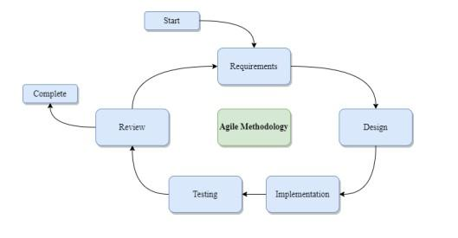

***Figure 1.*** *Agile Methodology*

A commonly used SDLC methodology for software development projects is the agile methodology, which emphasizes flexibility, collaboration, and iterative development. The agile methodology is well-suited to software development projects that require frequent updates and changes, and can be particularly useful in a project like this where the development of a monitoring tool may require ongoing feedback and adjustments based on user needs and changing data availability. Under the agile methodology, the project would be broken down into smaller development cycles, with each cycle consisting of planning, development, testing, and evaluation. The cycles would be repeated until the final monitoring tool is developed to meet the project objectives and requirements.

* 1. Conceptual Framework

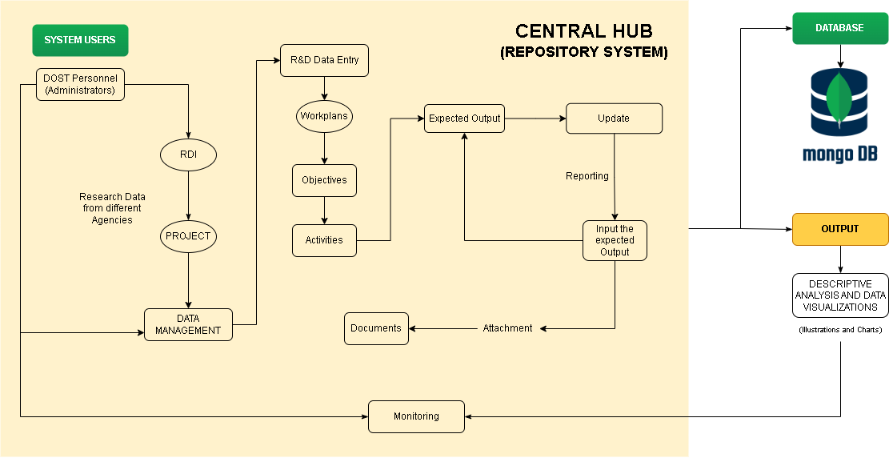The researchers have created this conceptual model to comprehensively illustrate the whole function of the system.

**Figure 2.** Conceptual Framework

The research monitoring tool is designed with the Department of Science and Technology (DOST) as the system user and administrator. DOST can create accounts for Research and Development Institutes (RDIs), Vice President for Research and Innovation (VPRIE), and individual projects. Each project is responsible for managing activities, costs, and expected outputs, which are categorized based on predefined categories. The tool allows for regular updates and monitoring of projects by VPRIE, RDIs from different sectors, and the DOST. This facilitates effective project management, evaluation, and collaboration among stakeholders, ensuring that projects are on track and aligned with the organization's goal.

**2.2 Activity Diagram**

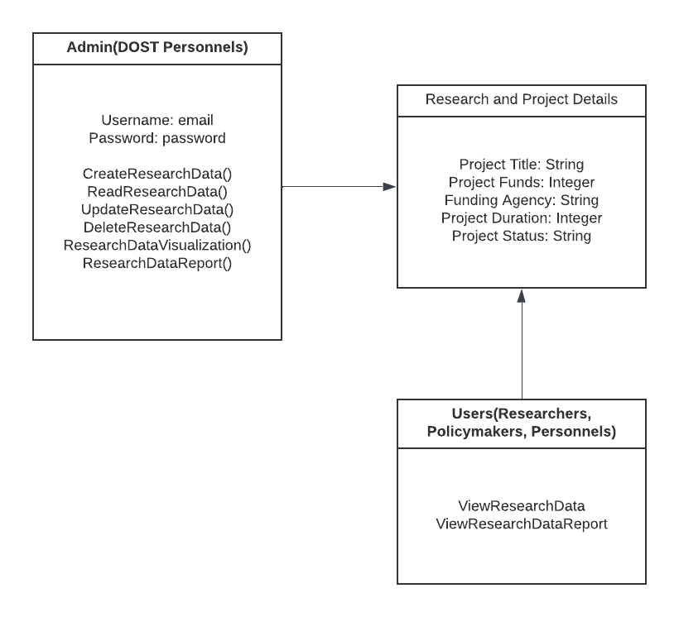

**Figure 3.** Activity Diagram of the Repository System

The researchers utilized the use of the class diagram to illustrate the structure of the system. The figure shows the system’s three (3) classes, their corresponding attributes, operations, and relationships.

1. RESULTS AND DISCUSSION

3.1 User interface of the System

In this section, the researchers provide the user interface of the system, where the users can log in and concurrently access the overview of data of R&D projects which visually presents the project's timeline, activities, and resource allocation, providing a comprehensive overview of the project's objectives and implementation plan.

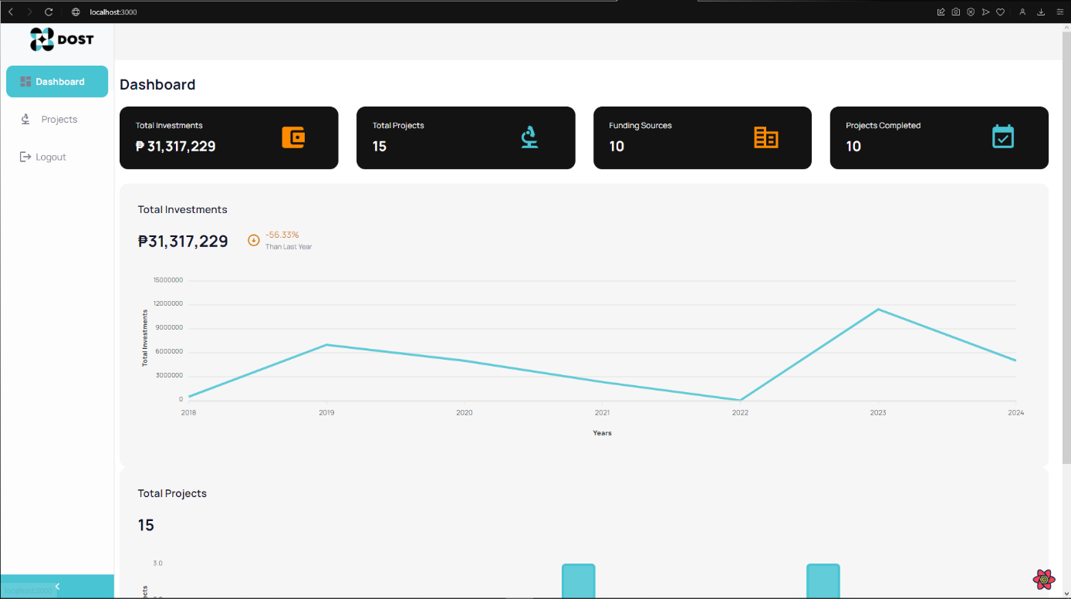

**Figure 4.** System Dashboard

Figure 4 shows the dashboard interface that serves as the landing page for administrators upon logging in to their accounts. This user interface provides visual representation of the total value of investments, number of projects and project status.

**3.2 Back-end Code**

The researchers provide a snippet view of the backend of the web-based system employed in the study.

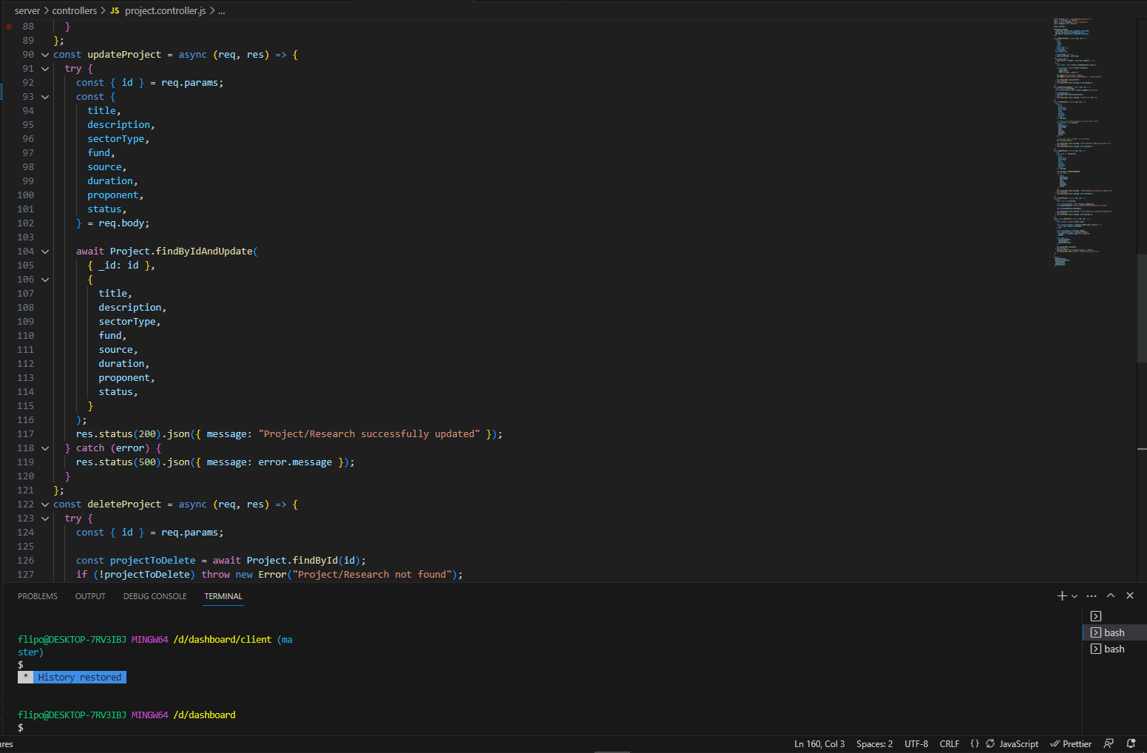

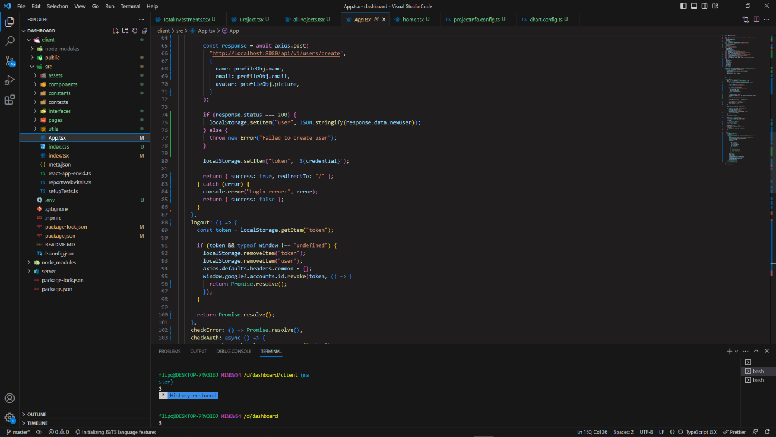

**Figure 5.** Backend of the Web-Based System

Figure 5. The figure displays a Django project version 4.1.7, with the directories visible on the left side. In the figure, only the base file is open, as it serves as the configuration file containing information about installed applications, middleware, and the database. The Django project is running locally on the server http://127.0.0.1, using port 8000.

**3.3 System Users**

The web-based tracking tool developed for the Department of Science and Technology (DOST) is designed to meet the needs of DOST personnel in monitoring and managing Research and Development (R&D) activities. It provides a centralized platform for tracking project details, milestones, resource allocation, and overall performance evaluation. The tool aims to streamline the tracking process, enhance transparency, and support informed decision-making within the realm of R&D. By adopting this monitoring tool, the DOST improves efficiency, transparency, accountability, and data-driven decision-making in managing and overseeing R&D activities. Ultimately, this tool contributes to the advancement of scientific research and technological innovation in the Philippines.

1. CONCLUSION AND RECOMMENDATION

**4.1 Conclusion**

The development of a web-based monitoring tool for regional research activities in the Caraga region is a significant step towards promoting planning and decision-making in R&D. The study has highlighted the critical role of research and development in driving economic growth and social progress, as recognized by the National Economic and Development Authority (NEDA) and the Department of Science and Technology (DOST). By leveraging data-driven insights and innovative technologies, such as data analytics, data visualization, and research repositories, the monitoring tool aims to address the challenges identified by NEDA, including limited awareness and dissemination of research findings, low knowledge creation outputs, and insufficient spending on R&D.

The study's conceptual framework, which places DOST personnel as system users and the central hub as the repository for research data, provides a solid foundation for the development of the monitoring tool. The tool's features, such as data management, planning and design, testing, and data analysis, will empower regional development practitioners to make informed decisions, allocate resources effectively, and track the impact of research investments. The integration of descriptive analysis techniques and data visualization will provide meaningful and comprehensible insights into the research landscape. The study draws inspiration from successful R&D monitoring systems in other countries and aims to adapt and implement similar advancements in the Caraga region.

**4.2 Recommendations**

* Future researchers or system developers may create dynamic forms projects.
* The web-based system should be integrated with existing personnel accounts at Caraga State University to simplify login and project monitoring for personnel.
* The next version of the system should allow dynamic types for all items in the monitoring tool, enabling modification of functionalities and expanding user access beyond regular personnel.
* Further research is recommended to evaluate the system's usability, accuracy, and efficiency in future versions.
* Extending the study to include data analytics and a predictive model can offer valuable insights and benefits to the educational institution and its stakeholders.

**REFERENCES**

1. Curry, J., Hamouda, M., & Abdullah, A. (2021). Building Innovation Ecosystems for the Future: An Empirical Examination of the Role of Collaboration and Knowledge Exchange. Journal of Business Research, 132, 548-560.
2. Etzkowitz, H., & Leydesdorff, L. (2019). The Triple Helix model of innovation: From practice to theory and back. Routledge
3. Bloom, N., Jones, C. I., Van Reenen, J., & Webb, M. (2020). Are ideas getting harder to find? American Economic Review, 110(4), 1104-1144.
4. European Commission. (2021). Regional Innovation Scoreboard 2021. https://ec.europa.eu/info/publications/regional-innovation-scoreboard-2021_en.
5. Daraio, C., Bonaccorsi, A., & Simar, L. (2021). Monitoring research systems in the European Union: Best practices and future directions. Journal of Informetrics, 15(1), 101094.
6. Kim, Y., Lee, J., & Lee, Y. (2019). Monitoring system for national R&D programs in South Korea: Process and outcomes. Science and Public Policy, 46(3), 361-371.
7. Mitra, S., Kuschel, K., & Bandyopadhyay, S. (2021). A regional innovation dashboard: Development and application in a regional innovation system. Technological Forecasting and Social Change, 165, 120552.
8. Xu, J., Zhang, Y., & Zhang, Y. (2020). A bibliometric analysis of research collaboration networks in regional innovation systems. Journal of Informetrics, 14(1), 101007.
9. Zeng, S., Xue, L., & Ma, H. (2019). Monitoring regional innovation ecosystems using social network analysis: A case study of the Zhongguancun Science Park. Journal of Cleaner Production, 239, 118028.
10. Gobithaasan, R. U., & Kaliannan, M. (2020). Text mining for research trends in healthcare: A systematic literature review. Health Information Science and Systems, 8(1), 1-17.
11. Kaur, M., & Singh, S. (2021). Bibliometric analysis of research trends in information systems. Journal of Information Technology Management, 32(1), 46-63.
12. Bao, Y., He, X., Chen, Y., & Han, X. (2019). Exploring research fronts in cross-border electronic commerce: A visualization analysis based on co-occurrence and citation network. Sustainability, 11(5), 1315.
13. Mitra, S., Datta, S., & Roy, S. (2021). Data visualization using dashboards for project monitoring and decision-making. In J. Padhye, S. Pattnaik, & N. Das (Eds.), Advanced data analytics for project management (pp. 79-97). Springer.
14. Rammer, C., & Reinkowski, J. (2019). Impact measurement of public research funding: A review of international approaches. Research Evaluation, 28(1), 1-14.
15. Lee, S., Kang, J., Park, H., & Kim, K. (2021). Monitoring the research performance of a national research institute: A case study of KISTEP in Korea. Science and Public Policy, 48(1), 97-106.
16. Yang, Y., Wan, J., Li, H., Guo, Y., & Li, Y. (2021). Monitoring and evaluation of innovation policy: A review of international practices. Technological Forecasting and Social Change, 171, 120950.
17. National Economic and Development Authority. (2022). Philippine Development Plan 2023-2028. Retrieved from https://pdp.neda.gov.ph/philippine-development-plan-2023-2028/
18. Onditi, V. M., & Magutu, P. O. (2020). Sound Planning and Decision-Making Framework in Research and Development: A Case of Kenya Agricultural and Livestock Research Organization. International Journal of Innovation and Scientific Research, 50(1), 113-122.
19. Kanwar, Y. P. S., & Sharma, N. (2018). Strategic Planning and Decision-Making in Research and Development: A Study of Indian Pharmaceutical Industry. Journal of Management Research, 18(4), 202-223.
20. Unger, S., Gemünden, H. G., & Leifer, R. (2014). Relational Decision-Making in Incremental and Radical Innovation Projects. R&D Management, 44(1), 60-78.
21. Fink, R., & Podoynitsyna, K. (2012). The Effect of Decision Environment on Strategic Planning Formalization and Decision Making Quality. Journal of Product Innovation Management, 29(3), 446-460.
22. Marimon, F., & Micheli, P. (2010). The Interplay between Organizational and Decision Making Factors in Dynamic Environments: A Conceptual Framework for R&D Intensive Firms. R&D Management, 40(2), 132-141.
23. Albert, J. R. (2016). An analysis of research planning and decision making processes in the Philippine National Research System. Philippine Journal of Science, 145(3), 293-306.
24. Morillo, F. R., & Miguel, E. L. (2015). Analysis of the planning and decision-making processes in Philippine research and development. Philippine Journal of Science, 144(2), 221-231.