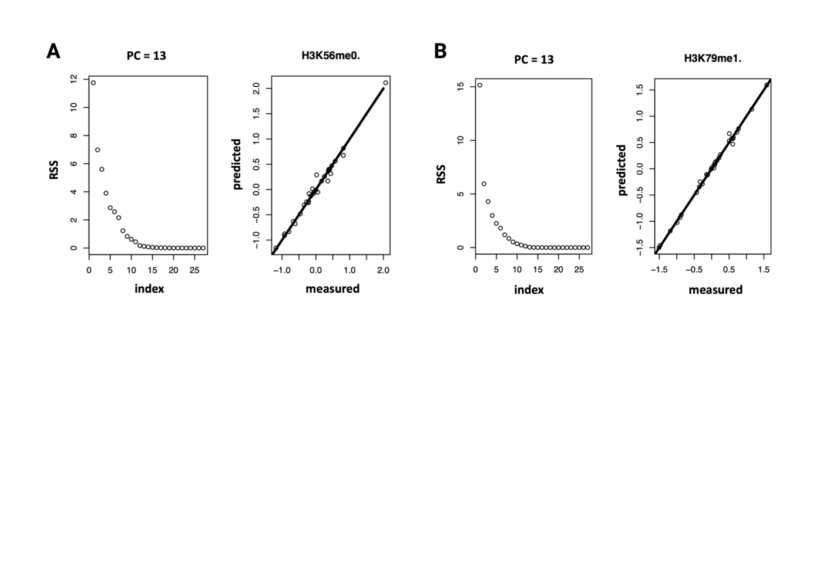

Fig S1. PLSR model performance. The prediction quality of the PLSR model is shown with the optimal number of principal components (PC) for the two histone codes of interest: (A) H3K56me0 and (B) H3K79me1. The optimal number of components for prediction is identified using residual square sum (RSS) value < 0.05.