Requirements Analysis Document
for
WeatherAlertRSS

Team: NERD Inc.
Project: WeatherAlertRSS
Team Members:
Sandra Mondragon
Drew Warner

Last Updated: 3/24/2016

Table of Contents

Table of Contents 2
Document Revision History 3
List of Figures 4
List of Tables 5
1. Introduction 6
1.1 Purpose of the System 6
1.2 Audiences and Goals 6
1.3 Scope 6
1.4 Definitions and References 6
2. Proposed System 8
2.1 Overview 8
2.2 System Models 8

Document Revision History
Revision Number | Revision Date | Description | Rationale
0.1 | 3/20/2016 | Section 1 | First draft
0.2 | 3/21/2016 | Section 2 | First draft
0.3 | 3/24/2016 | Section 2 | Needed diagrams
0.4 | 4/6/2016 | Section 2 | Apply revisions

List of Figures
Figure # Title Page #
2-2 Class Diagram 10
2-3 Sequence Diagram 1: Changing a Setting 11
2-4 Sequence Diagram 2: Fetching URL of Feeds 11
2-5 Sequence Diagram 3: Fetching Feed From a Specific Region 11
2-6 Activity Diagram 1: Changing a Setting 11
2-7 Activity Diagram 2: Fetching Feed URL 12
2-8 State Diagram 1: GUI 13
2-9 State Diagram 2: Feeds 13

List of Tables
Figure # Title Page #
2-1 Class Descriptions #

1. Introduction

1.1 Purpose of the System
The purpose of the WeatherAlertRSS system is to provide a map-based RSS reader for weather alerts to users who wish to track weather anomalies in regions of the United States.

1.2 Audiences and Goals
The goal of this document is to show the classes and relations between the classes of the WeatherRSS project. It will inform the reader of the different major use cases and how they are handled by the system.
Intended readers of this document include developers and financial backers. Developers would find this document useful to help their implementation of the system, while financial backers may wish to review the document in order to make sure that all parts of the system and how different use cases are resolved are in accordance to requirements set by them.

1.3 Scope
Section 1 includes the introduction to this document. It describes the purposes of the system, the audience of the document, the goals of the document, and the definitions and references needed to understand terms contained herein.
Section 2 includes system models for the WeatherAlertRSS system. It includes class diagrams, sequence diagrams, and use case diagrams for some of the more crucial tasks in the system.

1.4 Definitions and References
Definitions
Feed: A feed is a data format that is used in order to give users information on content that is regularly updated. In this case, it will refer to the weather alert feeds from alerts.weather.gov.
RSS: Rich Site Summary. Uses feeds to publish regularly updated content.

Class: A category of things that have common attributes or properties. In the case of this document, they also describe methods in which to interact with certain data objects.
Use case: A use case is a series of actions taken between a user and the system to achieve some sort of goal.
Object model: An object model is a diagram that shows the interaction between classes.
Sequence diagram: A sequence diagram is a diagram that shows a time-based series of events, and how processes interact with each other over a given period of time.
Activity diagram: An activity diagram is a diagram that shows a series of events unrelated to time, but with the added functionality of having branching states to symbolize choices, iteration, and concurrency.
State machine diagram: A state machine diagram is a diagram that shows the behavior of a system during certain states, unrelated to time.

References
alerts.weather.gov: Website for obtaining the weather alert RSS feeds.

2. Proposed System

2.1 Overview
The system of the WeatherAlertRSS is subdivided into numerous, interconnected classes. The classes include the Interface class, which shows the graphical region of the map and lights up areas with selected weather alerts, the Feed class, which takes alerts and displays them in feeds, and controls the ability to modify feeds, the Alert class, which downloads alerts from alerts.weather.gov and sends them to the alert vector in the Feed class, the Region class, which controls the information on certain regions, as well as returning and obtaining information on regions when certain areas of the map are click, and the Configuration class, which allows the user to view and modify the settings related to the displaying of feeds and alerts.
The dynamic models (sequence diagrams, state machine diagrams, and activity diagrams) show specific use cases in the system. The sequence diagram shows use cases as they happen in a temporal sense. The activity diagrams show use cases as a series of events, but with the added benefit of including choices and activities that occur concurrently. The state diagrams show use cases as they relate specifically to the states of the system, and how the states change as certain actions are taken.

2.2 System Models

2.2.1 Object Model
Class | Description | Attributes | Operations
Interface | Displays alerts on weather map based on importing previously saved user settings. | mapImage  regions | importSettings  importAlerts  lightAlertedRegions
FeedList | Displays feeds with URL based on user preferences | URL feedURL | deleteFeed  addFeed  editFeed  getURL  setRefreshRate
Region | Reads the information of the region that the user selects on the weather map | name  location | clickGetRegion  returnRegion  getAlert  returnAlert
Settings | Reads and processes user settings | timeFilter  updateFrequency  alertTypeFilter | getTimeFilter  getUpdateFrequency  getAlertTypeFilter  setTimeFilter  setUpdateFrequency  setAlertTypeFilter  exportToFile  loadFile
Alert | Collects alert information | Title  Summary  URL | exportToFeed
WeatherChannel | Reads in RSS feeds | FeedList rssFeeds | addRSSFeeds
Table 2-1 Class Descriptions

2.2.2 Dynamic Model
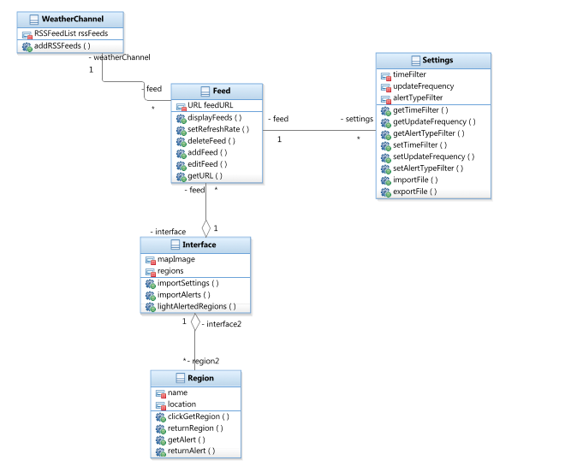
Figure 2-2 Class Diagram

2.2.3 Activity Diagram
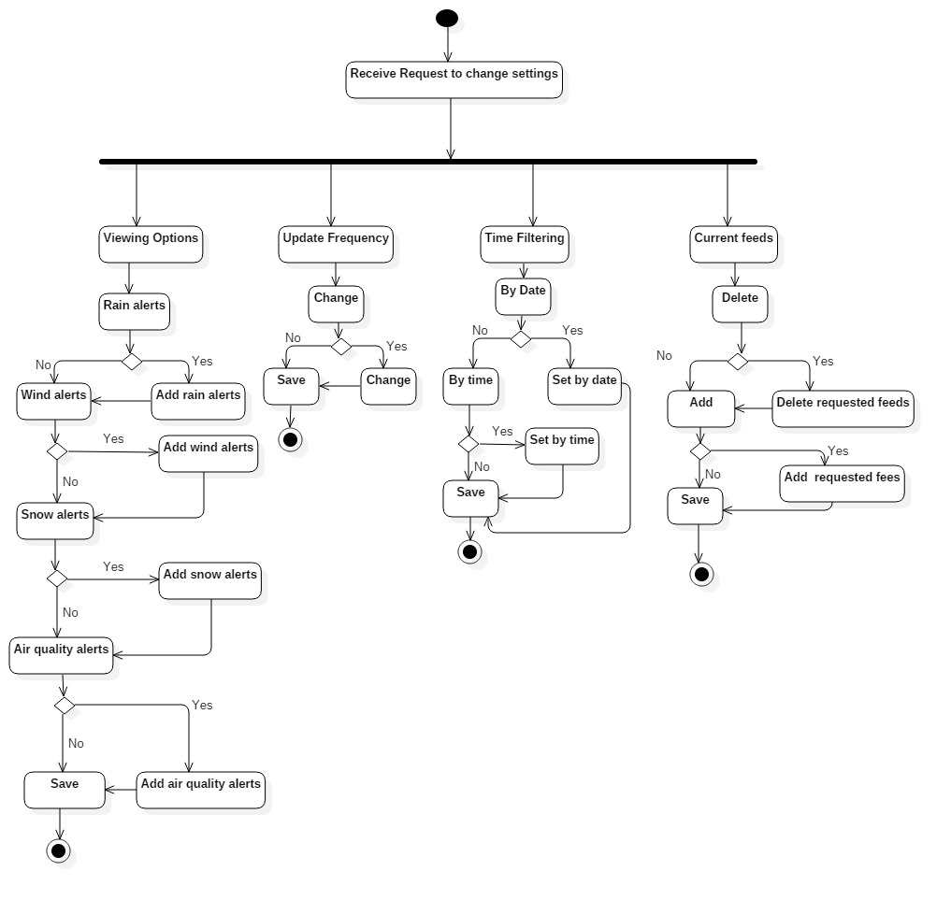
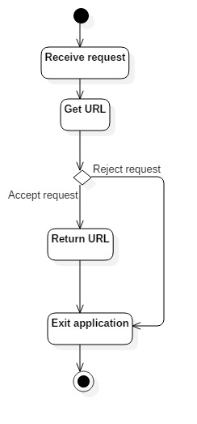
2.2.4 State chart Diagram
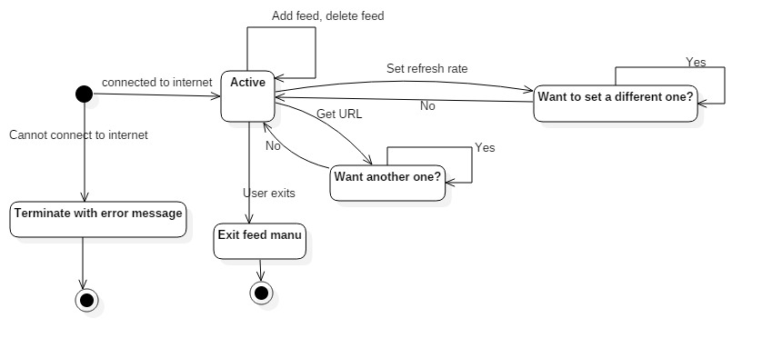

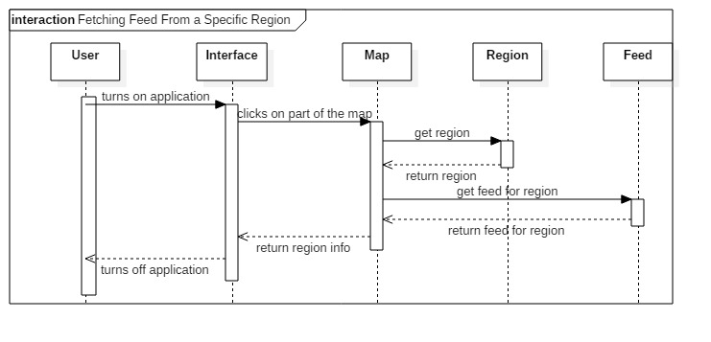
2.2.5 Sequence Diagram
