Software Requirements Specification
for
WeatherRSS: A map based RSS reader for weather alerts

Team: NERDS Inc.
Project: WeatherRSS
Team Members:
Drew Warner
Sandra Mondragon

Last Updated: March 30th 2016

Table of Contents
1. Product Concept 6
1.1 Purpose and Use 6
1.2 Intended Audience 6
2. Product Description and Functional Overview 8
2.1 Stakeholders 8
2.2 Functional Features 9
2.3 Product Interfaces 10
3. Performance Requirements 13
4. Maintenance and Support Requirements 15
5. Use Cases 16
5.1 Managing Weather RSS Alerts 16

Document Revision History
Revision Number | Revision Date | Description | Rationale
0.1 | 3/5/16 | Sections 2, 5 | 1st draft
0.2 | 3/9/16 | Sections 1, 3, 4 | 1st draft
0.3 | 3/30/16 | All sections | 2nd draft
0.4 | 3/31/16 | Revisions | 3rd draft

List of Figures
Figure # Title Page #
1-1 Key components of Weather RSS 7
2-2-1 Weather Map 9
5-1 User managing system alert settings 16

List of Tables
Figure # Title Page #
2-1 Table of stakeholders 8
2-2 Weather RSS feed example 9

1. Product Concept
This section describes the purpose, use, and intended user audience of the WeatherRSS product. WeatherRSS is a map-based RSS reader for weather alerts that performs searches and returns weather alerts in selected areas in the United States. Users of WeatherRSS will be able to search for specific areas in the United States and have weather alerts in the area returned to them. They will be able to view alerts based on time criteria, all at the frequency they so choose. Finally, the user may also select the types of alerts they wish to be shown.

Purpose and Use
WeatherRSS will download weather alerts from RSS feeds and display them. The alerts will be organized into feeds and given to the user when prompted. The user will be able to search for specific alerts, alerts in specific areas, or alerts based on the time they were issued. Alerts will be shown via a map on the user interface. WeatherRSS will be used largely to track and keep users updated on extreme weather conditions anywhere in the world.

Intended Audience
The intended audiences for WeatherRSS are mostly meteorologists, so that they may track and predict weather more accurately. Travelers may also wish to use WeatherRSS for its ability to inform them of weather conditions in locations they intend to travel to. WeatherRSS only shows regions in the United States, so the intended audience is mostly users in or studying the United States.

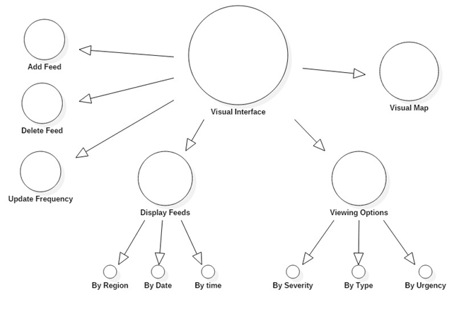
Figure 1-1: Key components of Weather RSS

2. Product Description and Functional Overview
This section provides the reader with an overview of the primary operational aspects of the Weather RSS alert system. Users of the Weather RSS alert system will have the capability to select weather alerts for regions of their choosing, that are issued in the United States. Users will also have the option to set alert frequency, organize alerts by time or severity, and add or delete alerts.

2.1 Stakeholders
The stakeholders, identified in Table 2-1, are the individuals actively involved in the WeatherRSS project, are affected by its outcome, and can influence the final outcome of the product.
Stakeholder | Major Value | Major Interests
Development Team | Medium | Implements product features to meet client and end user’s demands
Project Supervisor | Medium | Monitors the product’s progress to ensure its completeness for the client by the specified time frame
Client | High | Sets the project requirements and standards
End User/Customer | High | Depends on functionality of end product and accurate data
Table 2-1: Table of stakeholders

2.2 Functional Features
The WeatherRSS provides weather alerts to clients through live feeds. Each feed contains an event name, severity and URL that the customer can select to be directed to a web page with further weather alert information, such as, location and effective time. The customer has additional features to choose from as described below.

Event | Thunder Storm
Severity | Severe
URL | www.worldwindalert/thunderstorm.org
Table 2-2: Weather RSS feed example

2.2.1 Mapping
Description: Displays pins with Weather RSS feeds for all regions in the United States

Source: Customer
Constraints: May be unavailable depending on user’s Internet connection.
Priority: High.

2.2.2 WeatherRSS Feeds
Description: Allows user to reset or include the default feed, as well as, add new regional feeds
Source: Customer
Constraints: May be unavailable to add new regional feeds depending on user’s Internet connection.
Priority: High

2.2.3 Time Filtering
Description: Allows the user to view alerts posted within certain dates and/or time. By default, the user is able to view alerts posted within the last hour.

Source: Customer
Constraints: May be unavailable if user’s device time isn’t synchronized with the WeatherRSS application’s time.
Priority: High

2.2.4 Update Frequency
Description: Allows the user to set the update frequency of every feed.
Source: Customer
Constraints: May be unavailable if user’s device time isn’t synchronized with the WeatherRSS application’s time.
Priority: High

2.2.5 Viewing options
Description: Allows the user to select the type of alerts they want to view. The weather alert lists are based on severity, urgency, and event type.
Source: Customer
Constraints: May be unavailable depending on user’s internet connection.
Priority: High

2.2.6 Set Alerts
Description: The user is able to set an alert notifications for any feed added to their feed list.
Source: Customer
Constraints: May be unavailable depending on user’s internet connection.
Priority: High

2.3 Product Interfaces
The user interface will display pins on all United State regions that have active weather alerts. Contained in the pins will be information regarding the weather alert event type, severity, and a URL. When the user hoovers over the pin, the weather alert type and region will be displayed. The user also has the option to be notified when a region is issued a weather alert. The user can choose to be notified about more than one region. If at any time the user decides they do not want to receive a notification about a weather alert, they have the option to delete it. There is also an alert frequency setting that the user can enable. A user can choose to be notified every hour, specific day of the week, or every week about a weather alert. The user also has the capability to sort the alerts by severity, event type, or time issued.

3. Performance Requirements
3.1 Start-Up
Description: This describes the initialization of the WeatherRSS software until the user is able to interact with it. WeatherRSS should start-up and relinquish control to the user within a period exceeding no more than 30 seconds.
Source: Stakeholders.
Constraints: Sub-par user hardware could prevent this requirement from occurring.
Standards: None.
Priority: Medium.

3.2 Installation Time
Description: This describes the amount of time required to install the WeatherRSS software. WeatherRSS installation time should be initialized and completed within a period exceeding no more than 5 minutes.
Source: Stakeholders.
Constraints: Sub-par user hardware could prevent this requirement from occurring.
Standards: None.
Priority: Low.

3.3 Search Time
Description: This requirement describes any search performed by the user, whether it be by time, location, or type. Searches must be returned to the user within a timely manner, assuming no server-side complications, in no less than 10 seconds.
Source: Stakeholders.
Constraints: Server-side complications could prevent this requirement from occurring.
Standards: None.
Priority: High.

3.4 RSS Feed Download Time
Description: This describes the amount of time that WeatherRSS takes to download RSS feeds from the server. Downloads should take no less than 2 minutes.
Source: Stakeholders.
Constraints: Server-side complications could prevent this requirement from occurring.
Standards: None.
Priority: High.

4. Maintenance and Support Requirements
4.1 Hardware Failure
Description: This describes the support that must be given if a user's hardware malfunctions. Unfortunately, in this case, there is nothing we can do but recommend the user consult a hardware specialist to repair their broken hardware.
Source: Developers.
Constraints: None.
Standards: None.
Priority: Low.

4.2 Software Failure
Description: This describes what occurs if there is a malfunction in the WeatherRSS software. If such an error occurs, the software must give an error code. The troubleshooting manual provided with the software can be consulted by the user in order to fix the error, or the user may contact support. Support must have their own copy of the troubleshooting manual and must be able to walk the user through the steps required to repair the software.
Source: Stakeholders.
Constraints: Software must give a valid error code. User must have been provided a troubleshooting manual, or be able to contact a support staff member who has one.
Standards: None.
Priority: High.

4.3 Patches and Software Updates
Description: This describes what must occur when the software is patched and has updates. When these events occur, the user must be prompted to download the latest patch or update upon start-up, but does not need to update, if they choose not to.
Source: Developers.
Constraints: None (if the user cannot connect to the internet in order to download the update, then they will not be able to use the software at all).
Standards: None.
Priority: High.

5. Use Cases
The following use case diagram demonstrates a Weather RSS user configuring the Weather RSS system settings. As previously mentioned, a user has the option to set alerts in whichever regions of the United States they choose, set the alert frequency, add alerts, sort alerts by time or severity, and delete alerts.

5.1 Managing Weather RSS alerts
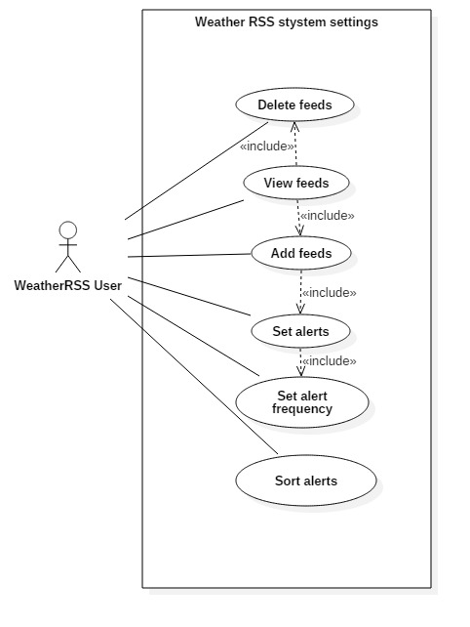 Figure 5-1 Use Case: User managing system alert settings

5.1.1 View Feeds
Use Case ID ( UC – 1.0.0 ) |  | Use Case Name | View Feeds
Created by | Sandra M | Last Updated by | Sandra M
Date Created | 3/30/16 | Date Last Updated | 3/31/16
Actor |  | Weather Alert User
Description |  | Add, delete, and view weather feeds
Preconditions |  | None
Post conditions |  | None
Priority: (low/medium/high) |  | High
Frequency of Use |  | Very often (5/5)
Normal Course |  | UC-1.0.0: View Feeds
 |  | Actor Actions  1. Indicate desire to view available feeds  3. Modify feeds |  | System Responses  2. Retrieve all available feeds  4. Delete or add new feeds  5. Save settings to file
Alternative Course
 |  | Actor Actions |  | System Responses
Exceptions
 |  | Actor Actions |  | System Responses  E1 A feed cannot be read  E2 Display error message to user  E3 Prompt user to check internet connection
Includes (another use case id) |  | UC-5.1.2; UC-5.1.3
Special requirements |  | N/A
Assumptions |  | Valid internet connection
Notes and issues |  | N/A

5.1.2 Add Feeds
Use Case ID ( UC – 2.0.0 ) |  | Use Case Name | Add Feeds
Created by | Sandra M | Last Updated by | Sandra M
Date Created | 3/30/16 | Date Last Updated | 3/31/16
Actor |  | Weather Alert User
Description |  | Add a feed for a specified region
Preconditions |  | None
Post conditions |  | None
Priority: (low/medium/high) |  | High
Frequency of Use |  | Very often (5/5)
Normal Course |  | UC-2.0.0: Add feeds
 |  | Actor Actions  1. Selects feed to be added to list |  | System Responses  2. Retrieve feed information  3. Add feed to list  4. Save settings to file
Alternative Course
 |  | Actor Actions  E1 User selects a feed to set alert notification  E4 Select notification frequency |  | System Responses  E2 Collect region information  E3 Prompt user to set notification frequency  E5 Save settings to file
Exceptions
 |  | Actor Actions |  | System Responses  E1 Feed cannot be read  E2 Display error message to user  E3 Prompt user to check internet connection
Includes (another use case id) |  | UC 5.1.4
Special requirements |  | N/A
Assumptions |  | Valid internet connection
Notes and issues |  | N/A

5.1.3 Delete Feeds
Use Case ID ( UC – 3.0.0 ) |  | Use Case Name | Delete Feeds
Created by | Sandra M | Last Updated by | Sandra M
Date Created | 3/30/16 | Date Last Updated | 3/31/16
Actor |  | Weather Alert User
Description |  | Delete weather alert region feed
Preconditions |  | Feed list is not empty
Post conditions |  | None
Priority: (low/medium/high) |  | High
Frequency of Use |  | Very often (5/5)
Normal Course |  | UC-3.0.0: Delete feeds
 |  | Actor Actions  1. Selects a feed to be deleted from the list |  | System Responses  2. Delete feed from list  3. Save settings to file
Alternative Course
 |  | Actor Actions |  | System Responses
Exceptions
 |  | Actor Actions |  | System Responses
Includes (another use case id) |  | None
Special requirements |  | N/A
Assumptions |  | None
Notes and issues |  | N/A

5.1.4 Set Alerts
Use Case ID ( UC – 4.0.0 ) |  | Use Case Name | Set Alerts
Created by | Sandra M | Last Updated by | Sandra M
Date Created | 3/30/16 | Date Last Updated | 3/31/16
Actor |  | Weather Alert User
Description |  | Set a weather alert for a specified region
Preconditions |  | Region has an issued weather alert, Feed list is not empty
Post conditions |  | None
Priority: (low/medium/high) |  | High
Frequency of Use |  | Very often (5/5)
Normal Course |  | UC-4.0.0: Set Alerts
 |  | Actor Actions  1. Selects to be notified for a specified feed |  | System Responses  2. Add feed to notification list  3. Save settings to file
Alternative Course
 |  | Actor Actions  1. User opts to set a notification frequency |  | System Responses  2. Prompt user to set alert notification by time, day or week  3. Set notification frequency  4. Save settings to file
Exceptions
 |  | Actor Actions |  | System Responses  E1 Feed cannot be read  E2 Display error message to user  E3 Prompt user to check internet connection
Includes (another use case id) |  | UC 5.1.6
Special requirements |  | N/A
Assumptions |  | Valid internet connection
Notes and issues |  | N/A
5.1.5 Sort Alerts
Use Case ID ( UC – 5.0.0 ) |  | Use Case Name | Sort Alerts
Created by | Sandra M | Last Updated by | Sandra M
Date Created | 3/30/16 | Date Last Updated | 3/31/16
Actor |  | Weather Alert User
Description |  | Sort weather alerts by region, severity, or event type
Preconditions |  | More than 1 feed has been added to the user’s alert list
Post conditions |  | None
Priority: (low/medium/high) |  | High
Frequency of Use |  | Very often (5/5)
Normal Course |  | UC-5.0.0: Sort Alerts
 |  | Actor Actions  3. Selects alerts to sorted by available options |  | System Responses  1. Collect region information  1. Prompt user to set alert notification by time, day or week
Alternative Course
 |  | Actor Actions |  | System Responses
Exceptions
 |  | Actor Actions |  | System Responses  E1 Feeds for any one alert cannot be read  E2 Display error message to user  E3 Prompt user to check internet connection
Includes (another use case id) |  | None
Special requirements |  | N/A
Assumptions |  | Valid internet connection
Notes and issues |  | N/A

5.1.6 Set Alert Frequency
Use Case ID ( UC – 6.0.0 ) |  | Use Case Name | Set Alert Frequency
Created by | Sandra M | Last Updated by | Sandra M
Date Created | 3/30/16 | Date Last Updated | 3/31/16
Actor |  | Weather Alert User
Description |  | Set alert frequency by time, day or week
Preconditions |  | More than 1 alert has been added to the user’s alert list
Post conditions |  | None
Priority: (low/medium/high) |  | High
Frequency of Use |  | Very often (5/5)
Normal Course |  | UC-6.0.0: Set Alert Frequency
 |  | Actor Actions  1. Selects alerts to set notification frequency  4. Choose alert frequency |  | System Responses  2. Collect region information  3. Prompt user to set alert notification by time, day or week  5. Save settings to file
Alternative Course
 |  | Actor Actions |  | System Responses
Exceptions
 |  | Actor Actions |  | System Responses  E1 Feeds for any one alert cannot be read  E2 Display error message to user  E3 Prompt user to check internet connection
Includes (another use case id) |  | None
Special requirements |  | N/A
Assumptions |  | Valid internet connection
Notes and issues |  | N/A

