**Highlands County Black Bear scat sample collection protocol***Modified from UC Davis Mammalian Ecology and Conservation Unit (3/18/2023)*

Project PI: Sofany Montoya, U. of Miami Department of Biology

Email: [smontoya@miami.edu](mailto:smontoya@miami.edu)

Phone: (786) 510-4053

Archbold Host: Joseph M. Guthrie, Predator Prey Program Director

Email: [jguthrie@archbold-station.org](mailto:jguthrie@archbold-station.org)

Phone: (863) 465-2571 ext 255; (502) 609-6536 (cell)

**Safety:** Animal feces ideally should not be handled by pregnant women to reduce risk of exposure to *Toxoplasma gondii*. Scats also can contain various parasites including *Echinococcus multilocularis* (or *E.granulosis*) which are rare but potentially very dangerous if ingested or inhaled, so please either wear gloves or use a plastic bag to handle scats. Wash hands with soap and water after collecting.

<https://arcg.is/1SDG0q1> 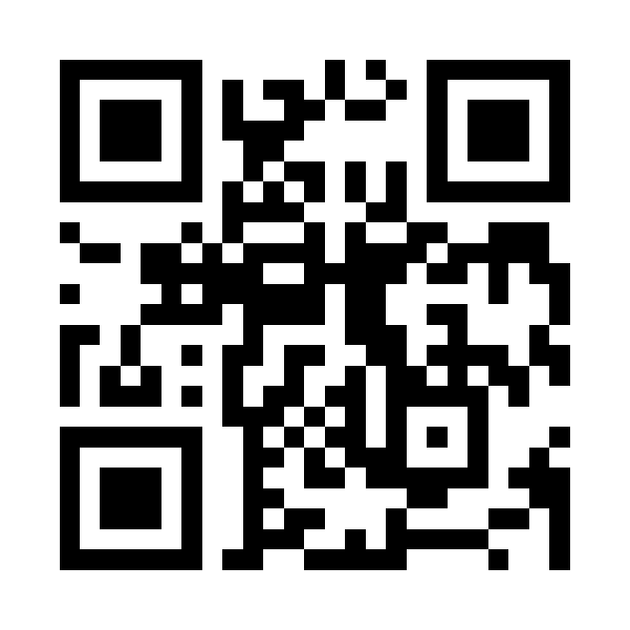

**Supplies**

Latex (or similar) gloves or inverted plastic bag

Fine-point permanent marker

Gallon-sized zip lock bags

**Sampling procedure:**

1. When you find a scat, complete the Survey123 data collection form (***see link/ QR code above***)
2. Avoid physical contact with scat (use stick or gloved hand, new for every scat)
3. In field, collect scat in gallon-sized zip lock bag labeled as follows:
   1. General location description (e.g., Archbold, Lake Placid Scrub, etc.)
   2. GPS decimal degree coordinates (from Survey123 map, *See example below*)
   3. Date in format: YYYYMMDD (e.g., 20230906)
   4. Unique number (can restart at ‘1’ every day as date will be unique   
      e.g. 20230906-1)
   5. Your initials
   6. “fresh” (if wet or known to be <2 days old), “not fresh” otherwise
4. Drop off at Predator-Prey office at Archbold Biological Station.

**Drop off Procedure**

Drop off the same day at the Predator-Prey office.

**During work hours**: Turn in the sample to Joe Guthrie or a member of the Predator-Prey office.

**After hours:**

1. Open the ziplock bag containing the sample so that it is exposed to air (pinch open the sides to expose scat surface).
2. Place opened bag in the bin located next to the Predator-Prey office door labeled **“Bear Project”**
3. Place lid on bin.
4. Email Sofy Montoya ([smontoya@miami.edu](mailto:smontoya@miami.edu)) and copy Joe Guthrie ([jguthrie@archbold-station.org](mailto:jguthrie@archbold-station.org)) notification of the sample in the bin.

**Survey 123 instructions**

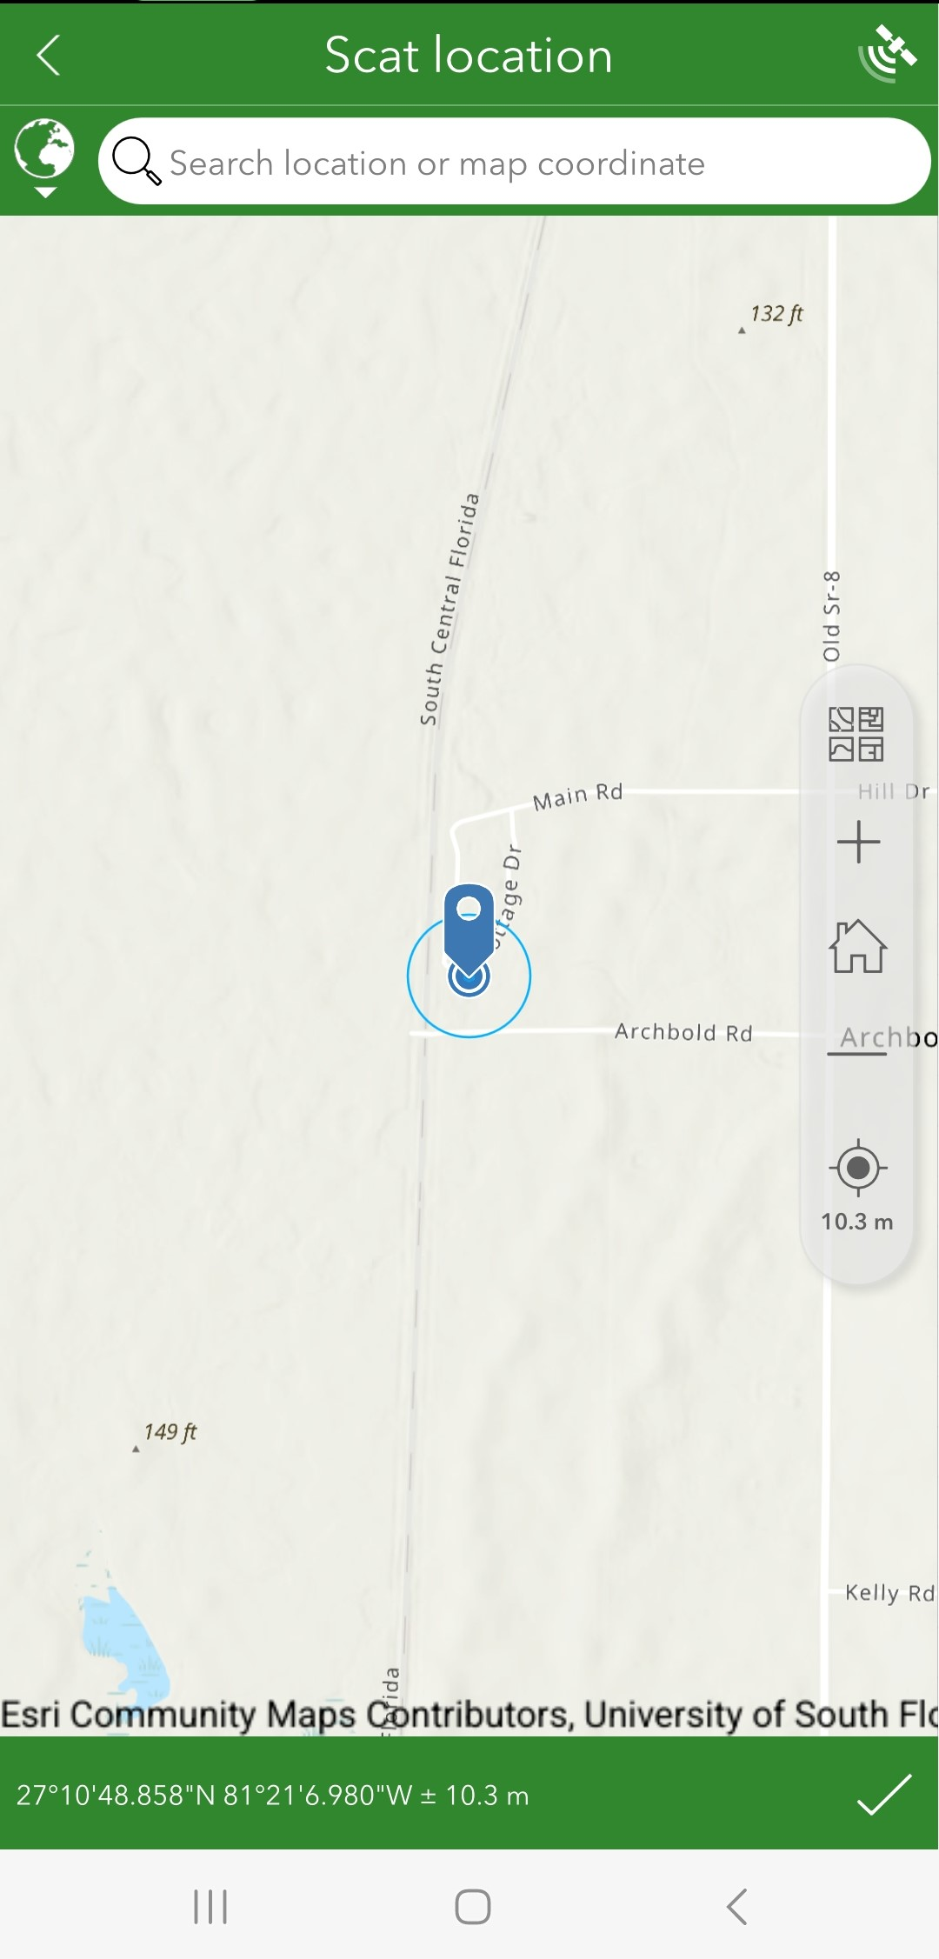

**Click to   
update position**

**Write these coordinates   
on ziplock bag**

**Click the checkmark to confirm**

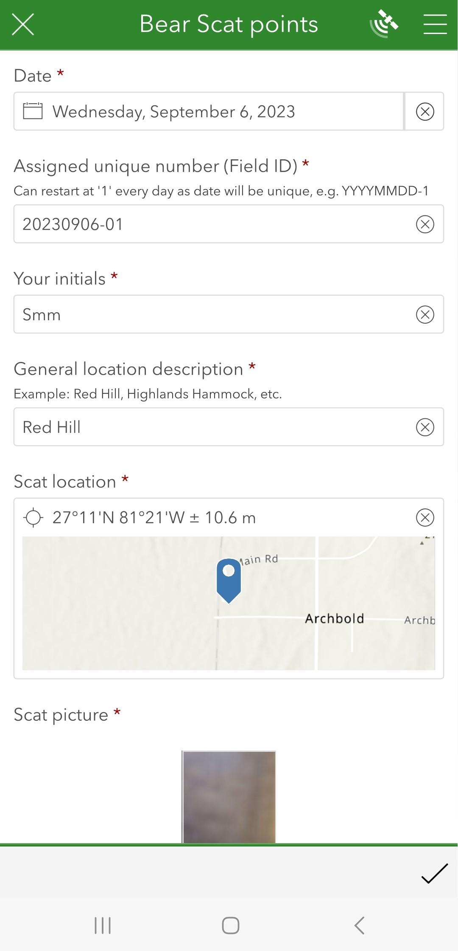

Click to open map

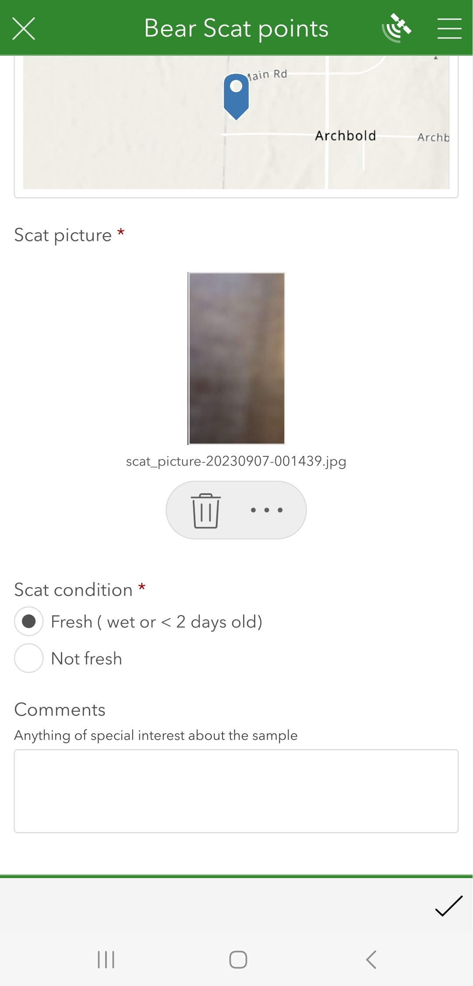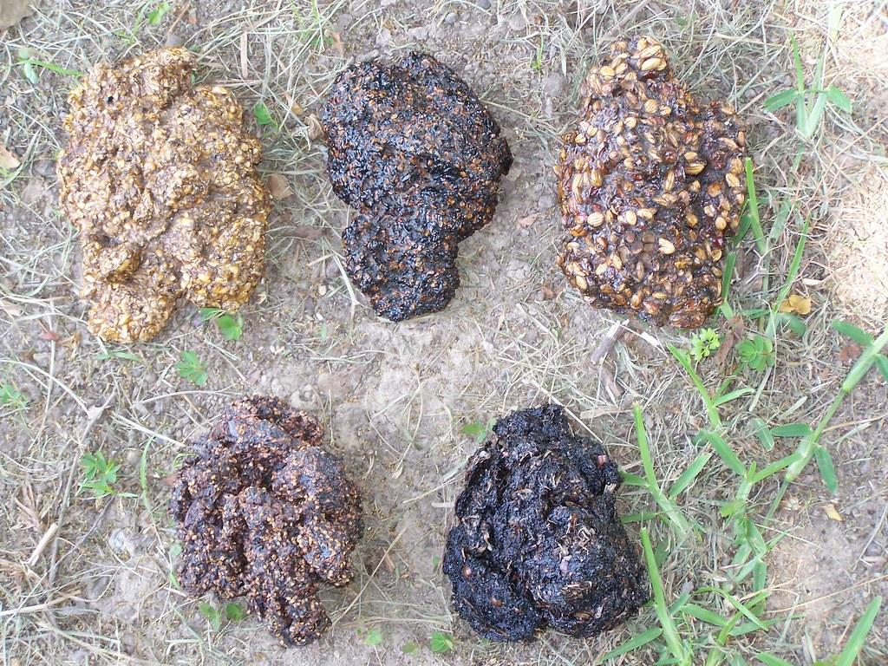

**Take a picture**

**Click to submit**

**Labeled zip lock bag example**

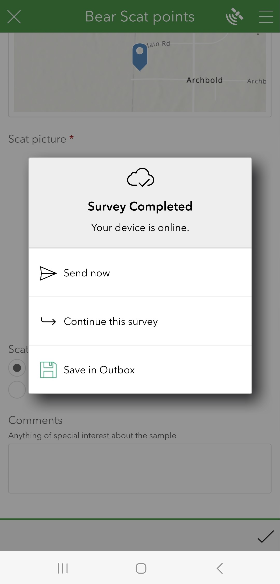

**If there is no cell service, click “Save in Outbox” to send at a later time**

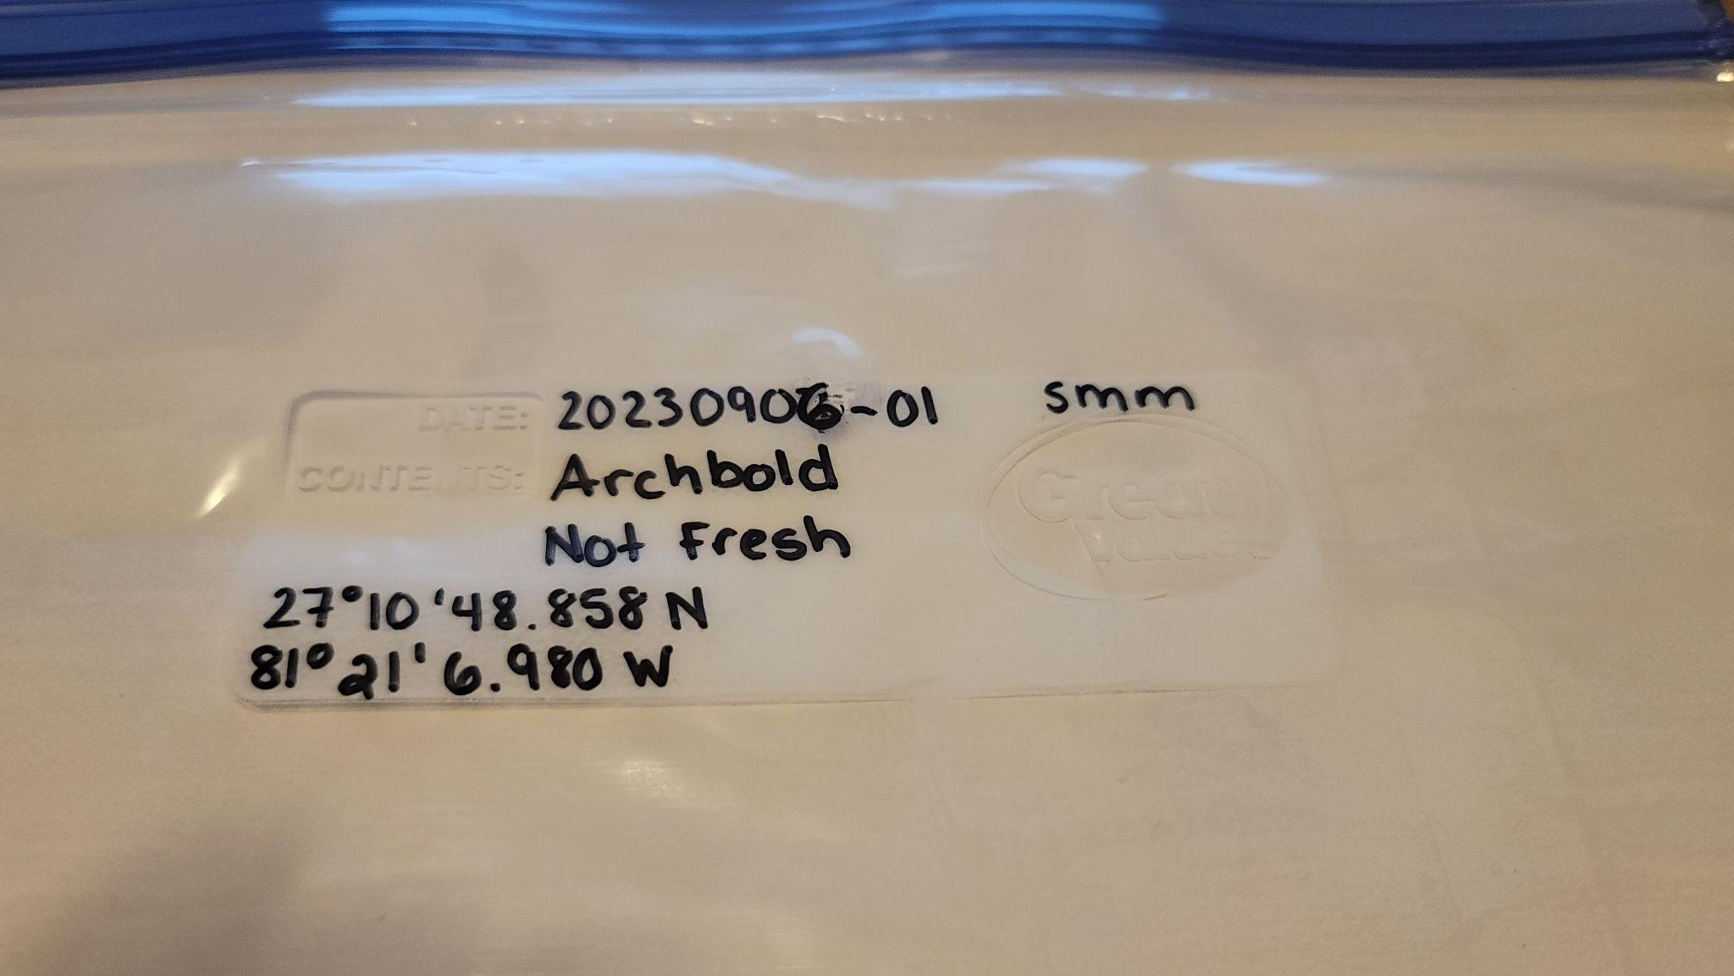

**Bear scat examples**



Picture from FWC

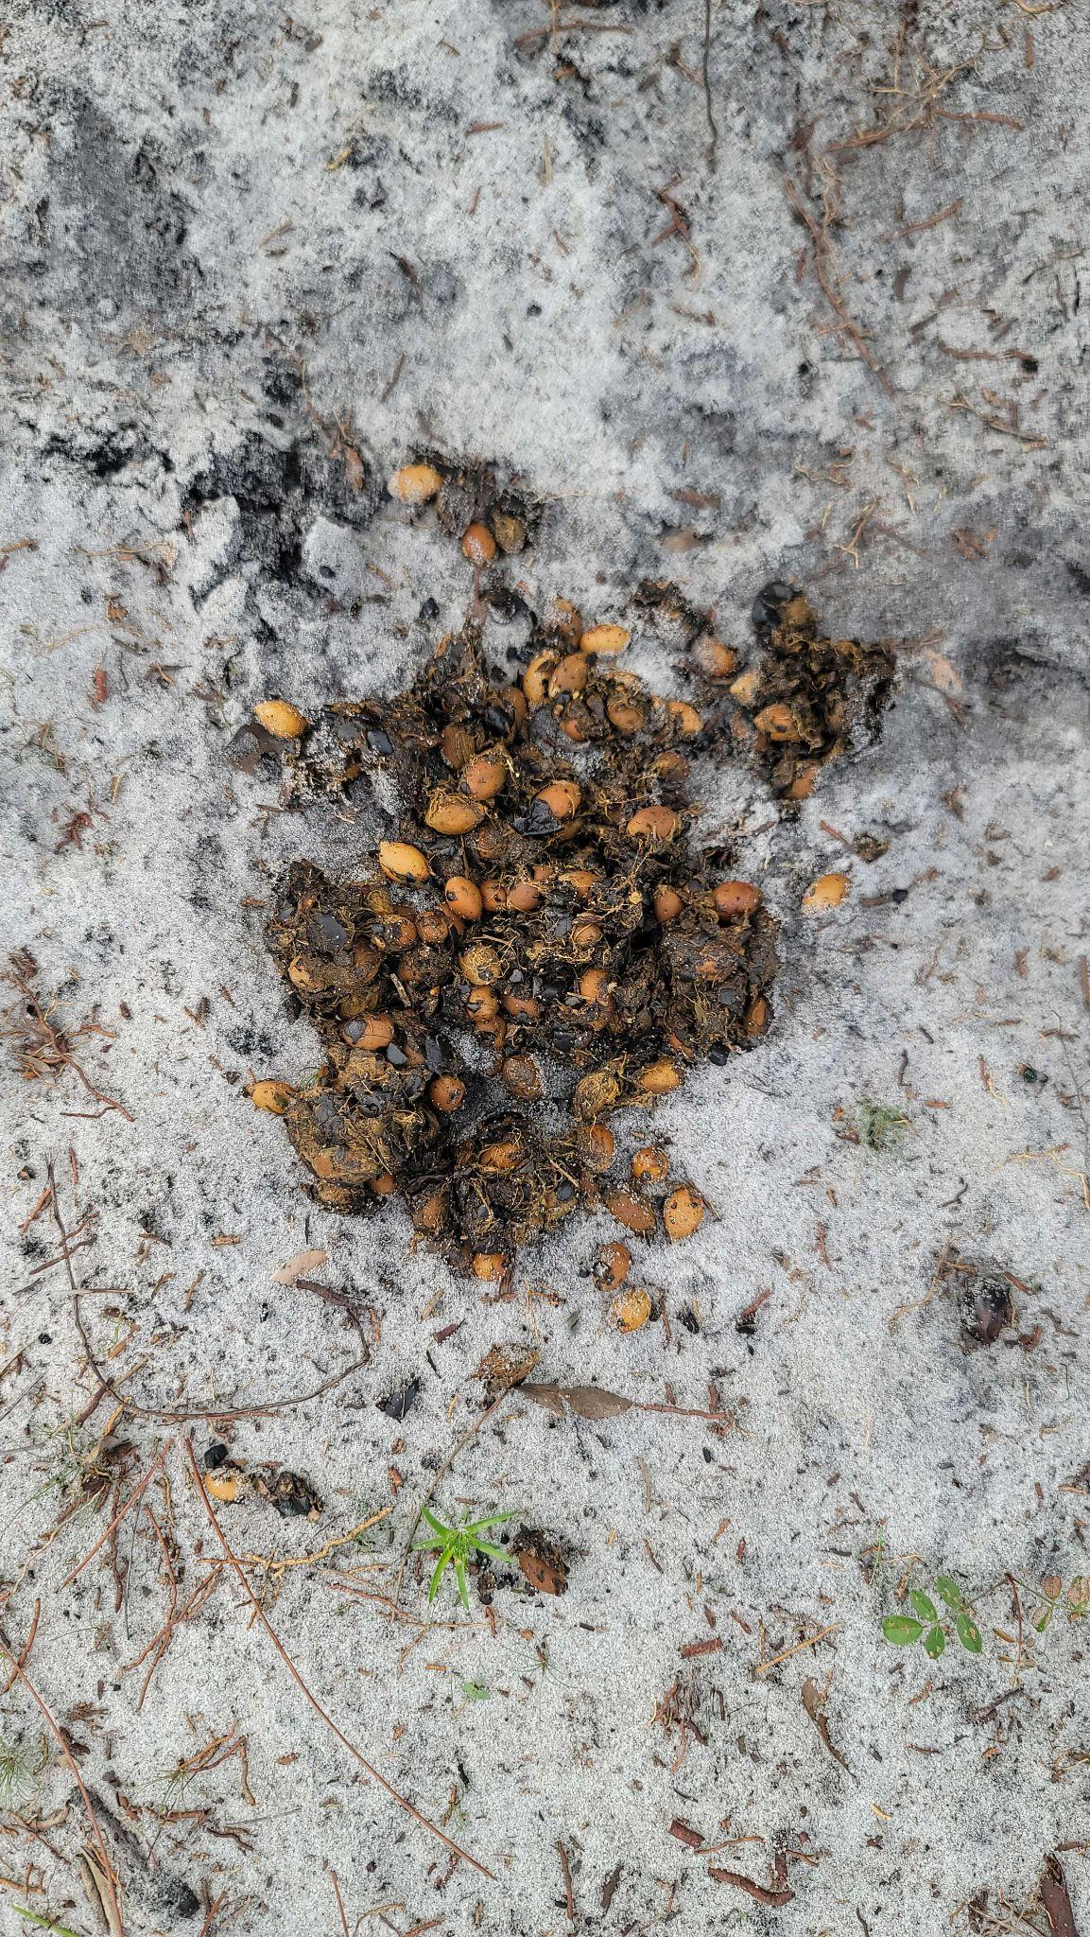

Bear scat found in LWR Lake Placid Scrub on 09/04/2023