Angular: Getting Started

Why Angular?

Expressive HTML: embed features such as if, for, local variables

Powerful Data Binding: can connect data directly to our UI

Modular by Design: app is set of building blocks so we can reuse content

Built-in Back-end Integration: GET/POST data or execute logic

JavaScript

-standard is called ECMAScript or ES

-a new version of specification is released each year (?)

Transpiled

-Newer JS features in our code must be compiled by a tool that converts newer JS syntax to older before the browser executes it

TypeScript

-strong typed, Object Oriented (classes, interfaces, inheritance), open source, Superset of JS

-transpiles to JS (meaning code developed with TS must be compiled and converted to JS)

npm

-Node package manager is an open source repo of libraries and packages

-npm is also a command line utility interacting with the repo

-npm install (inside project folder) will install it in local machine in node_modules

-npm install -g @angular/cli

-can also executes scripts

package.json

-devDependencies (only required for development) and dependencies (required for development and deployment)

-npm install to ensure that everyone has the same packages and versions

ng new apm-new --prefix pm

Component

-Template + Class + Metadata

Boostraping

-Directive is custom element

Service

-doesn’t need to be defined in an Angular Module, just Injector

-HTTP get returns an observable

-must subscribe to emit notifications (next, error, complete), does nothing until we subscribe

-subscribe to start the Observable, then GET request is sent

1. SUBSCRIBE starts the observable
2. Pipe emitted items through operators
3. Process notifications (next, error, complete)
4. Stop by unsubscribing

Pipe then subscribe?

ng g c products/product-detail --flat //means do not make a new folder

Guard

-ActivatedRouteSnapshot: to provide current route information

-RouteStateSnaoshot: to provide state information

If we don’t add services to declarations array, where do we declare it if any? Loosk like the injetctor takes care of it

Node.JS

-provides access to your file system

-node packages are installable JS librarbies and they managed by npm

-needed for Angular because it installs Angular CLI

Module 3

Prefix

-should be unique to your app

-prevents collisions with other component names

Can change it in angular.json file



CSS



Angular.json

-only reason we can access the assets folder, just leave out the src like above

-In order

-most used are changes, init and destroy

-use init to fetch data for our components



-Can bind an attribute to a functions with property binding



-Can use a function



-bind to events to execute statements



-bind to expressions and data from component with brackets





-Two ways two hide stuff, [hidden] is useful when the content you are showing and hiding is complex or expensive to render because the content is actually not added or removed from DOM, it is just hidden



-a way to add a class if the condition is true



OR



To add multiple classes

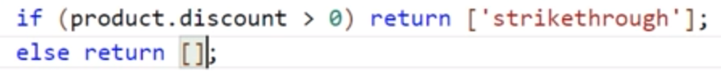





-style must be object



-another way to inject

Module 8

History

-first did callbacks but promises were better because they allowed the callback to fail in case the server throws an error

-next method is like a callback