**HW4 Problem 1** Equilibrium model of transport (16 points).

Remember the model of the translocation of (many molecules of) a protein from the Membrane to the Cytoplasm to the Nucleus? Here’s another variation of it. Now the K’s are equilibrium constants, because the translocation reactions are reversible.

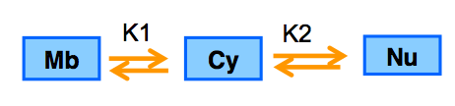

A. Using “pencil and brain”, derive a set of three equations that express the fraction of the protein that is in each compartment at equilibrium. You should be thinking “partition function” and “detailed balance”.

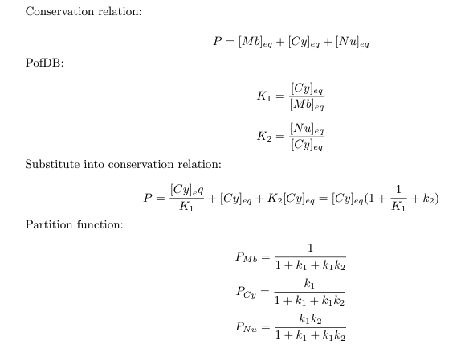

B. Make a dynamic model* of this system in *Mathematica*. Start the time course with all the protein on the membrane. For some set of parameters where K1 ≠ K2, show that the long term behavior of the system approaches that which your equations in part A predicted (ideally by plotting GridLines that are equal to your predicted steady state values).

(* That is, construct a system of differential equations, then solve, and plot the time course. You will use rate coefficients f1, f2, r1, r2, rather than equil. constants K1 and K2.)

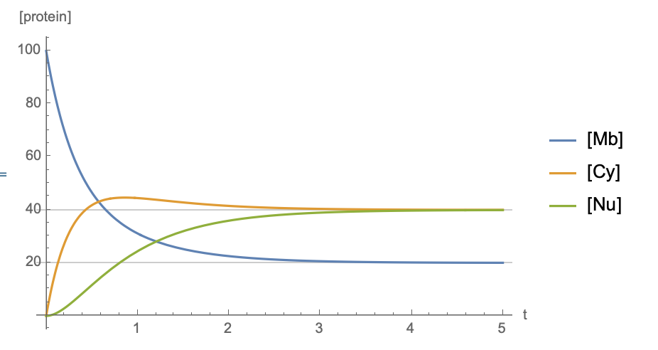

C. Find two sets of parameters which reach the same equilibrium, but where one set does this quickly, while the other set does it much more slowly. Show this with a time-course plot using your *Mathematica* model.

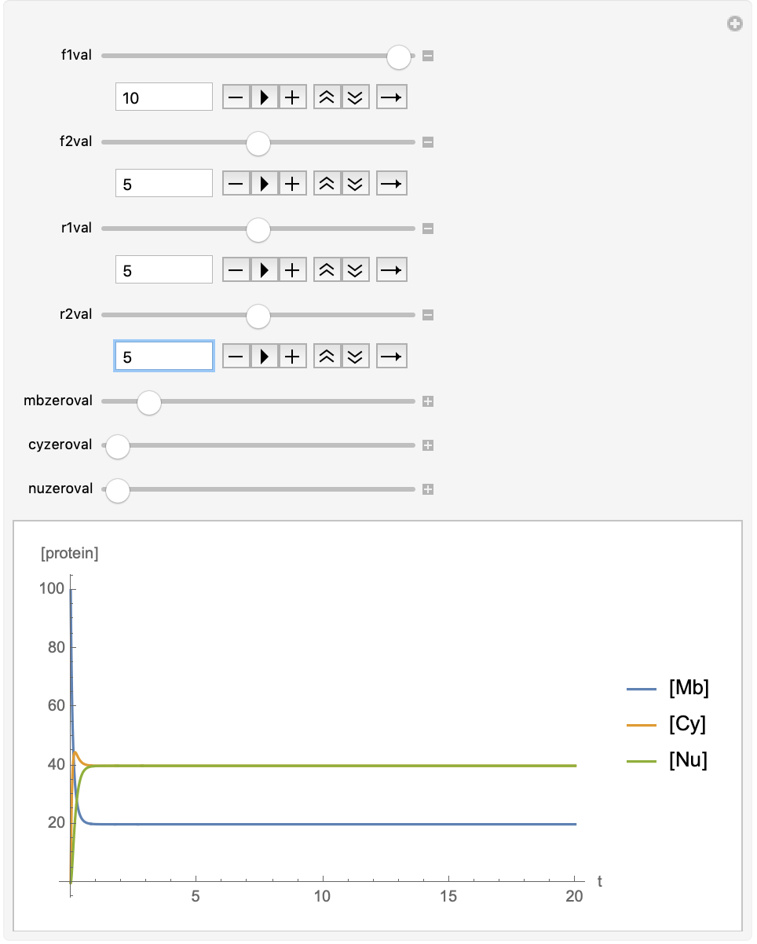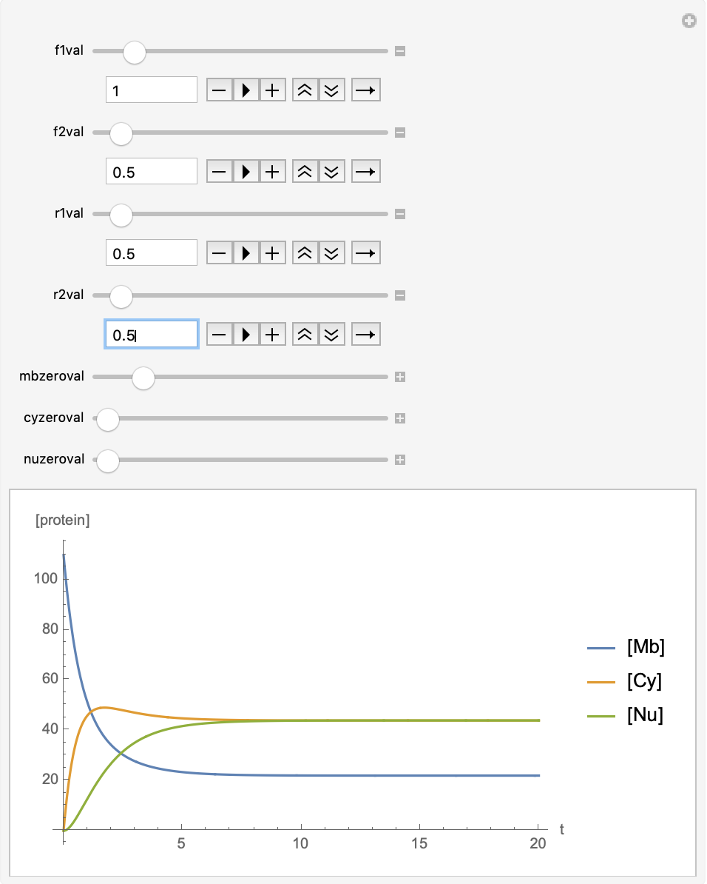

**HW4 Problem 2** Simple negative feedback motif (8 points).

1. In Mathematica, design the following a two node system that shows simple negative feedback regulation.

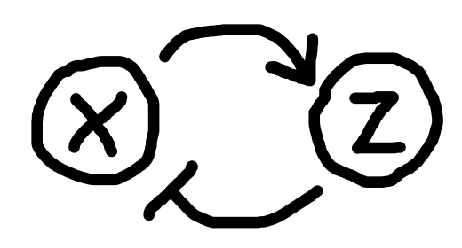

Treat X as a gene that is regulated by Z, e.g.:

where

* *pX* is a standard gene regulation-type Hill function with fixed parameters *Xmax, n,* and *kd*, and variable parameter *Z*
* *dx* is a fixed parameter that you will most likely set = 1

If you wish, Z regulation by X can be very simple. For example, your differential equation for Z could be as simple as:

where *Zmax* and *dz* are fixed parameters (and you will most likely set *dz* = 1). If you do it this way, then you can imagine that *X* is the transcript and *Z* is the protein.

If *X* was regulated by simple gene regulation, then we know the steady-state level of *X* would be directly and linearly proportional to *Xmax*. In contrast, the negative feedback system, if properly tuned, can make it so that steady-state *X* is largely independent of *Xmax*. In fact, this is your goal: make a Manipulatable time course that demonstrates:

* Tunable negative feedback
* Good control of steady-state *X* (and *Z*) in the face of variable *Xmax*
* Damped oscillations
* (see NegativeFeedback.mov for an example of what I’m looking for)

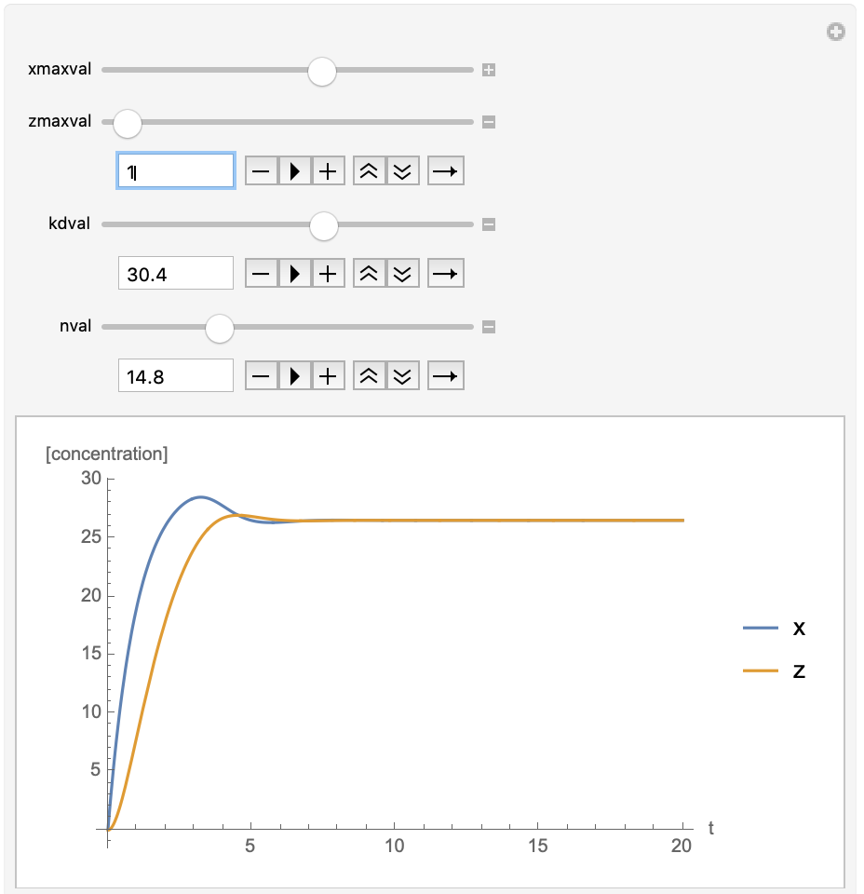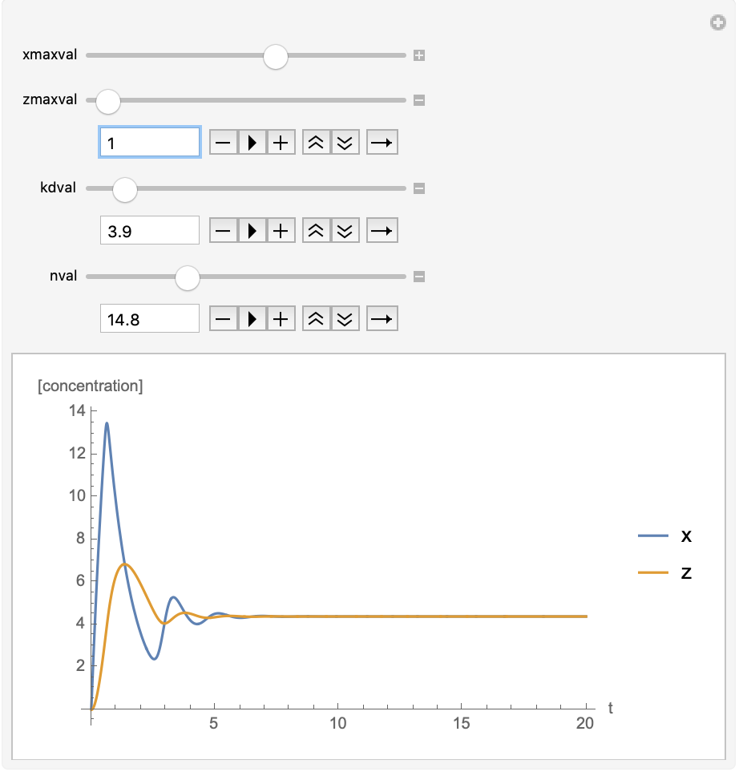

**HW4 Problem 3** Oscillating Network (6 points).

Now modify your system from Problem 2, adding a *Y*, in between *X* and *Z*, as shown:

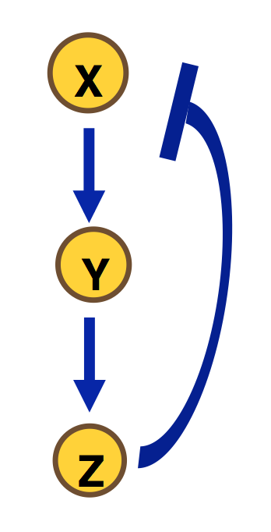

When you do this, you will now have constructed a system with the potential to behave like a Goodwin Oscillator1. Thus you should be able to demonstrate **sustained oscillations**.

Your differential equation for *Y* could be as simple as:

where *Ymax* and *dy* are fixed parameters (and you will most likely set *rY*🡪1).

In order to see sustained oscillations, you need at least 1 of the 3 regulations to be characterized by a high Hill number (at least 8). Thus, for example, two simple schemes plus one gene regulation scheme with a Hill function would be one way to obtain sustained oscillations (with certain parameters).

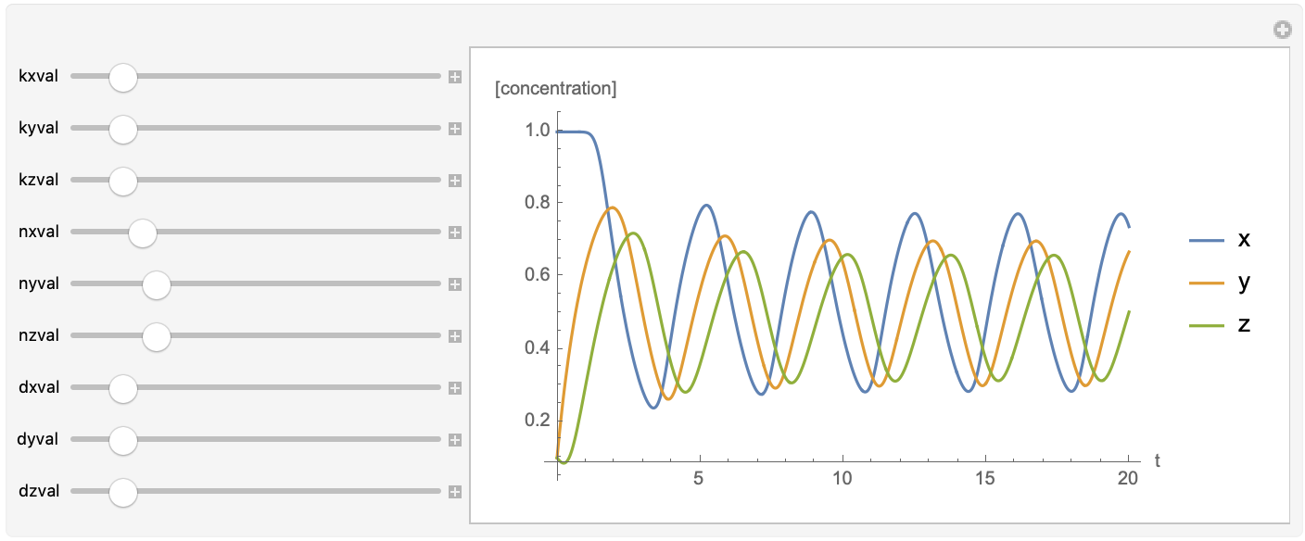

1Goodwin BC (1965) Oscillatory behavior in enzymatic control processes. In Advances in Enzyme Regulation, Vol. 3, G Weber , Ed., pp 425-438.

O’Brien EL *et al*. (2012) Modeling synthetic gene oscillators. Mathematical Biosciences, Vol. 236, pp. 1-15

Gonze (2013) The Goodwin Model: Behind the Hill Function <https://doi.org/10.1371/journal.pone.0069573>