Mathematica notebooks that may be useful for the first parts of this homework:
“Basic Chemical Reactions.nb”, “Simple_DSolve_Example.nb”, “DSolveTemplate.nb”, “Simple_NDSolve_Example.nb”, “NDSolveTemplate.nb”

Problem 1 – Simple Production Destruction Model (10 points):
To start our in-class discussion of differential equations, we considered a situation where some molecule A is created or produced at a constant rate, as symbolized by the following chemical equation or scheme:
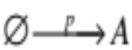

The rate equation for this reaction is:
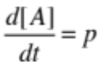

We also considered the situation where A is degraded at a rate proportional to its own concentration
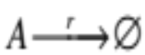

This reaction had the rate equation:

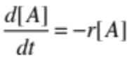

For your homework you are going to put these two elementary reactions into a series to make the system:
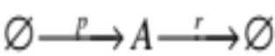
This system could describe the synthesis and degradation of an mRNA or protein, for instance.

The differential equation that describes this system is:
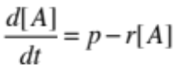

A. Using pencil and paper (and brain), what is the steady state solution for this system?

[A]_{ss} = ? (write or type on answer sheet found at end of this document)

B. Using Mathematica, obtain an exact solution for this system.
Use as your initial condition [A](0) = 0. (Note: you must use A, not Y, as your state variable)

C. Use one of the other techniques to Manipulate a solution that are detailed in “Simple_DSolve_Example.nb”, and make your solution from 1B Manipulate-able. Make is so that both p and r can be Manipulated.

(1C con’d): Paste your Manipulate statement plus graph into the “Answer Sheet”.

D. Describe the shape of the curve in your answer to part C.

E. Which parameter(s) seems to determine the time it takes to get half-way to steady state?:
p r both p and r

(Circle on answer sheet found at end of this document)

Problem 2 – Simple Transport Model (10 points):
A. Combine 2 first-order reactions to model the translocation of (many molecules of) a protein from the Membrane to the Cytoplasm to the Nucleus. Solve your system of differential equations using DSolve. Can you simplify the solutions at all?
Note: Make initial conditions so that all of the protein starts at the membrane.
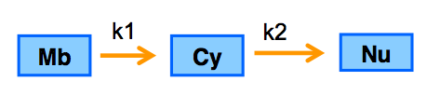
B. Plot all three time courses* on the same graph, starting with 100% of the protein at the membrane.
*use different colors for each time course, and use thick lines.
Try to imagine what this plot might look like before you actually plot it
Note: You will find that k1 cannot be set equal to k2 or you will get a zero in the denominator of your exact solution.

C. Put your exact solutions from part A into a “Manipulate” statement so that the plot in part B becomes Manipulate-able. (Or use one of the other techniques to Manipulate a solution that are detailed in “Simple_DSolve_Example.nb”)

Paste your manipulate statement plus graph into the “Answer Sheet”.

D. Solve your system of differential equations from part A using NDSolve, rather than DSolve. Plot the results (but don’t try to put into a Manipulate statement)

Problem 3 – Gene Networks – Homeostasis (10 points)
Problem 3 can be found in the Mathematica notebook entitled "Gene_Networks_Homeostasis". See the notebook for a full description of the problem. Ideally, you should wait until after the “Gene Regulation 1” lecture to start this problem.

How to turn in your homework:
1. Fill out the four page ‘Answer Sheet’ as specified (remember to paste in your Manipulate statements plus graphs for parts 1C and 2C).
2. (a) Make a single notebook for Problems 1 and 2. (b) Modify the “Gene Networks: Homeostasis” notebook with your own input function and parameters. (c) Turn both notebooks to the EEE Dropbox.
ANSWER SHEET PAGE 1 Your Name_______________________________

Problem 1A [A]_{ss} =

Problem 1C – Delete the example below and paste your Manipulate Statement plus graph into the space.

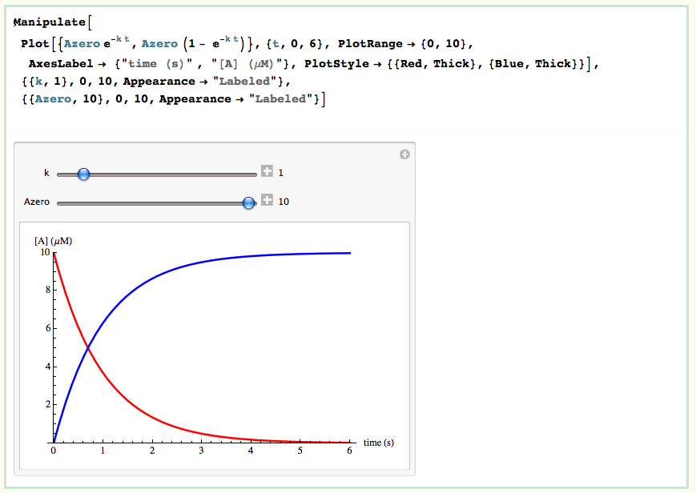

Problem 1D (Describe shape of curve):

Problem 1E – Which parameter(s) seems to determine the time it takes to get half-way to steady state? (circle one):
p r both p and r

ANSWER SHEET PAGE 2

Problem 2C – Delete the example below and paste your Manipulate Statement plus graph into the space.

ANSWER SHEET PAGE 3

Problem 3
3A. What is your biologically realistic input function? Type, write or paste it below in easy-to-read format – please do NOT use carets ^ to indicate exponents, etc.

3B. Show your parameters for part 3B.
Show the “Total Trp vs. time” graph.
Indicate what your average penalty was.
You can delete what I have pasted in below and put your solution in its place.

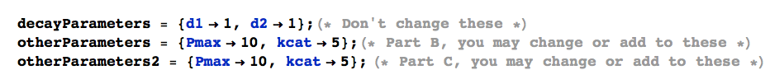

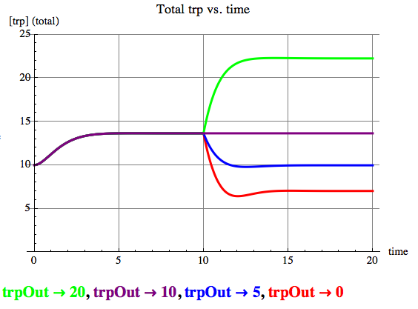

Average Penalty: 2.22

ANSWER SHEET PAGE4

Problem 3 continued
3C. (i) Show your parameters for part 3C.
Show the “Total Trp vs. time” graph.
Indicate what your average penalty was.
(Note: I will show some of the best/most interesting answers in class)

(ii) Is there any striking difference in the dynamics when you compare the time courses for 3B to the time courses for 3C?

