# Mobile Applications Development 3 Project

## Intro

## Author: Shane Moran

## 2D Unity Platform Game

The design document was made out to develop a platformer game. The main concept’s will be to move an avatar or character through an ever-changing world and in doing so, you will have to jump over obstacles, defeat enemies and collect bonuses. The overall aim is to collect as many of these bonuses, which will accumulate to overall score before finishing.

## Research

### From … Hudson’s Adventure Island (NES)

I picked this as it was this first video game I’d ever played, a simple side-scrolling platform game produced over 30 years ago.

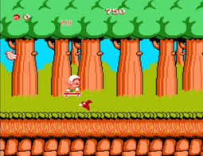

### To … Super Mario’s

I spent hours altogether collecting coins and eating mushrooms with this rapid little Italian.

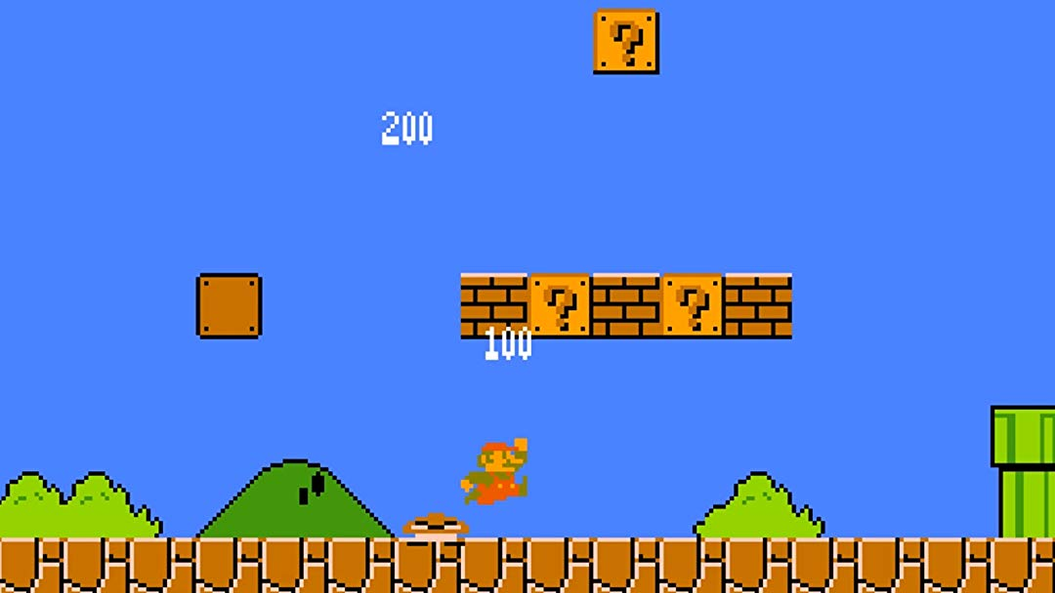

### And Now… Little Big Planet (PlayStation)

This was a resurgence like no other for all platformers and came with a great reception. Its debut game LittleBigPlanet has received wide critical acclaim from reviewers and countless awards such as the D.I.C.E. game of the year award.

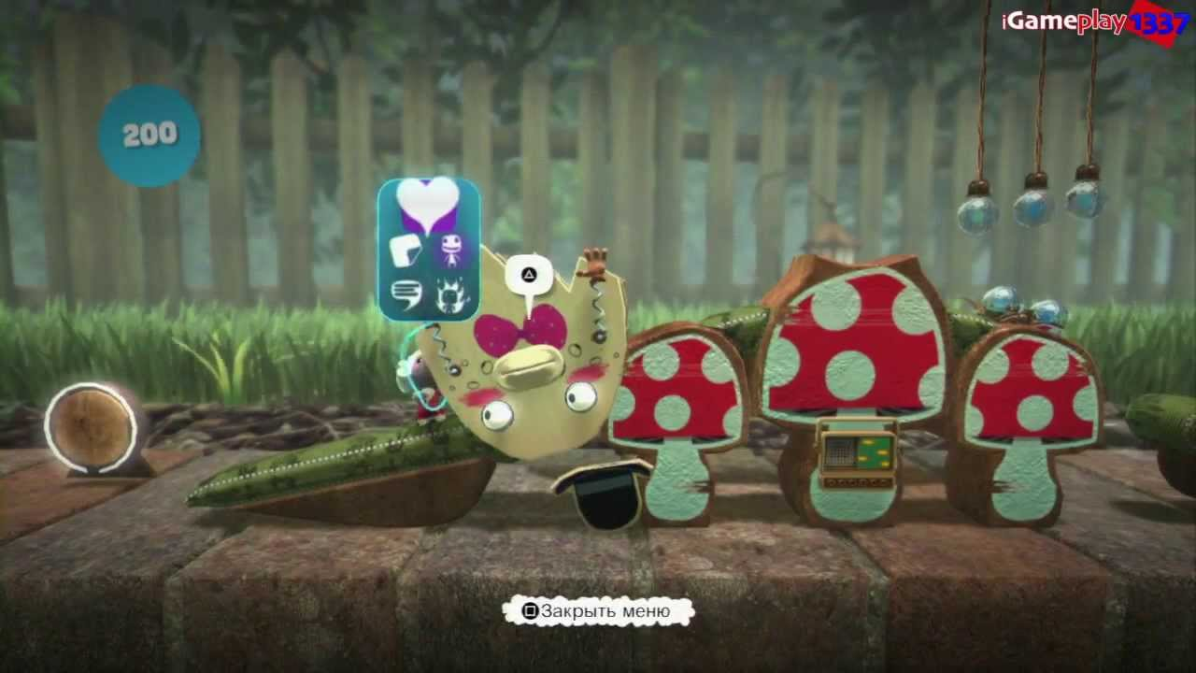

## Components

1. Front End: A term applied to all menus and screens that occur outside of the gameplay. This takes the player from the title screen to the point that gameplay begins.

* Start
* Pause
* Finish/End

2. In-Game Menus: A set of menus and screens accessed in-game, often from a pause menu. These form part of the game mechanisms rather than being distinctly separate.

3. Control Mechanisms: The way in which the player controls the game entities. Many games have just one control mechanism.

* UI Buttons (up, down, left, right)
* Touch

4. The Game: The gameplay screens showing the initial setup, how the action starts, a midpoint in play and the winning/progression conditions depending on the game you are designing. If the game is episodic in nature, then explain how episodes are defined and how the player moves between them.

* Platformer
  + Type?
    - Continuous
    - Ever-Changing
    - Different levels
      * How many?
  + Background?
* Avatar/Character
  + Have Health?
    - How much
* Press START
* Objectives
  + Coins / Points / Bonuses
  + Positive objectives
  + Negative objectives
    - * All leads to total overall score
* Enemies?

