# Mobile Applications Development 3 Project

## Intro

## Author: Shane Moran

## 2D Unity Platform Game

## Overview

The design document was made out to develop a platformer game. The main concept’s will be to move an avatar or character through an ever-changing world and in doing so, you will have to jump over obstacles, defeat enemies and collect bonuses. The overall aim is to collect as many of these bonuses, which will accumulate to overall score before finishing.

#### Character

Gorilla’s objective is to defeat and pass as many as possible in order to meet his objective

#### Levels (Difficulty)

3 levels, Easy, Medium and Hard.

#### Environment and Background

Environment is made up of a grass terrain with water pits.

#### Enemies

Monkeys, who can attack by hitting or throwing rocks.

#### Bonuses

Tokens, which award both health and add towards your overall score.

## Research

From … Hudson’s Adventure Island (NES), which is a side-scrolling platform game produced by Hudson Soft that was released in Japan on September 12, 1986. I picked this as it was this first video game I’d ever played, a simple side-scrolling platform game produced over 30 years ago.

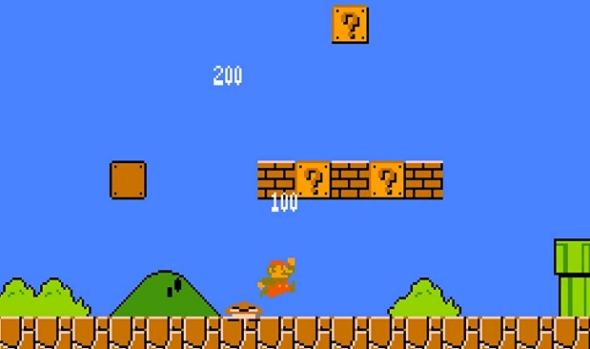To … Super Mario Bros. which was a platform video game developed and published by Nintendo. Players control Mario, or his brother Luigi in the multiplayer mode, as they travel the Mushroom Kingdom to rescue Princess Toadstool from Bowser. They must traverse side-scrolling stages while avoiding hazards such as enemies and pits with the aid of power-ups such as the mushrooms, fire flower’s and the star man. I spent hours altogether collecting coins and eating mushrooms with this rapid little Italian.

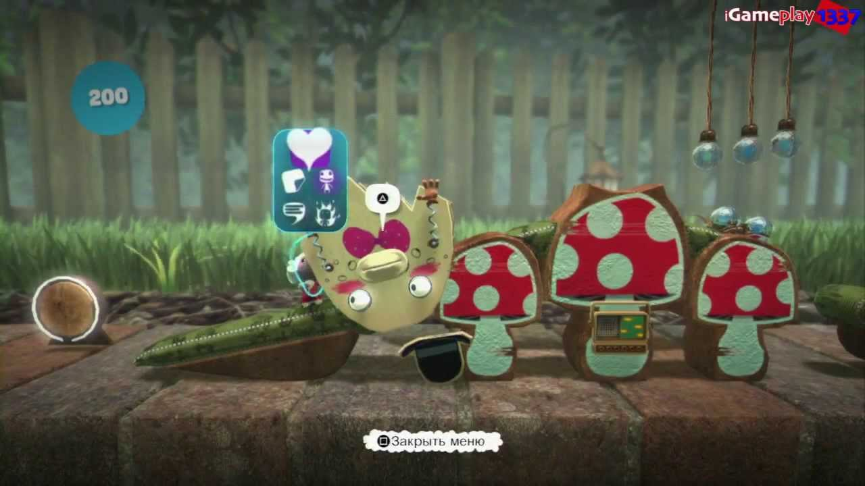And Now… Little Big Planet (PlayStation) is a puzzle-platformer video game, that includes user-generated content, for the PS3, developed by Media Molecule and published by Sony Computer Entertainment Europe. With an array of characters to choose from and levels with various styles, this made the game’s target audience very broad for such a simplistic concept. This was a resurgence like no other for all platformers and came with a great reception. Its debut game LittleBigPlanet has received wide critical acclaim from reviewers and countless awards such as the D.I.C.E. game of the year award.

## **Components**

1. **Front End:** A term applied to all menus and screens that occur outside of the gameplay. This takes the player from the title screen to the point that gameplay begins.

* **Splash screen**
  + Tap to get to Main Menu
  + **Main Menu**

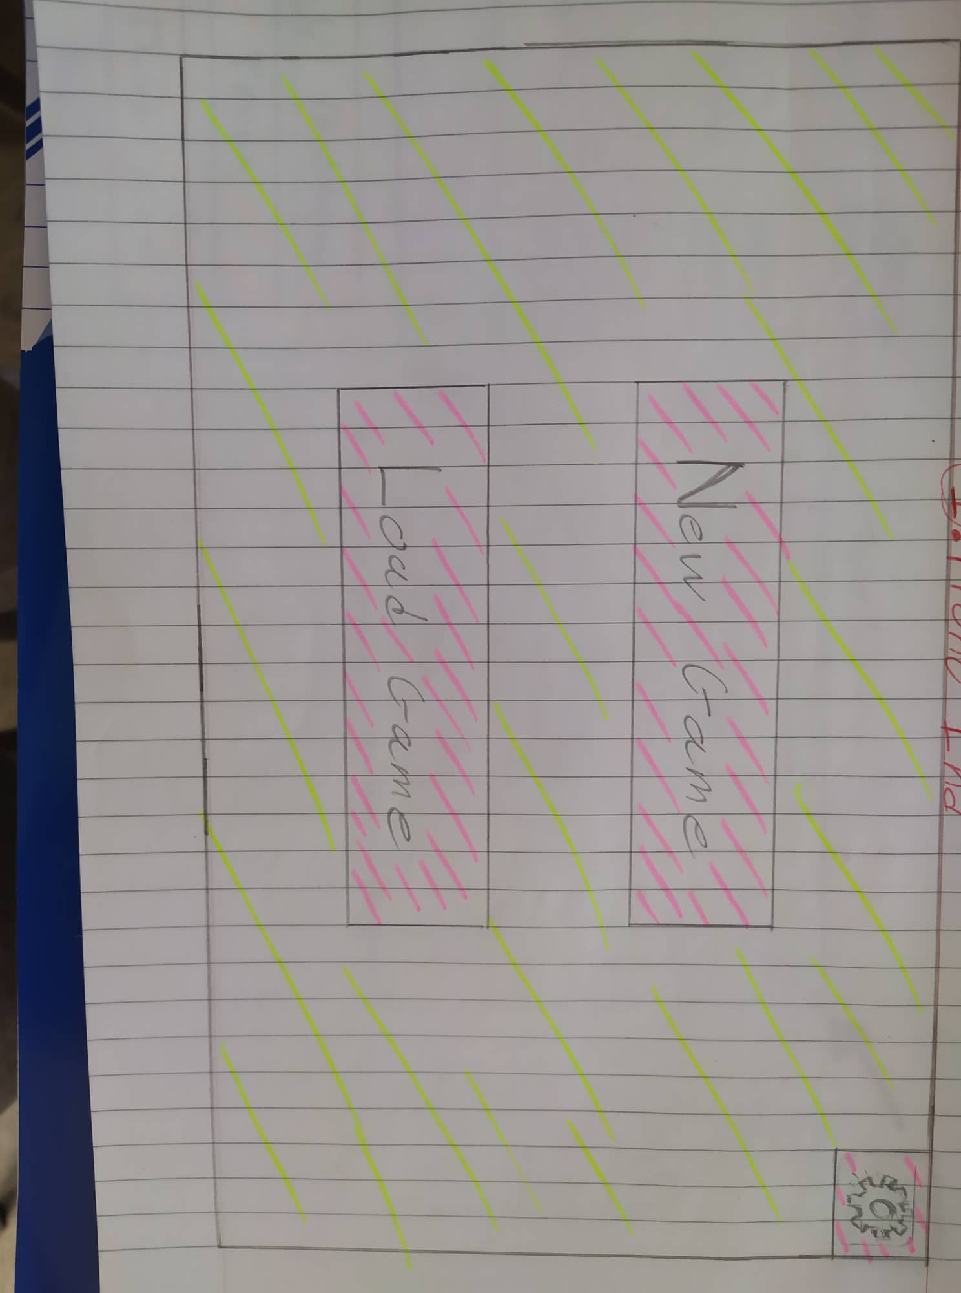

* + - **New Game**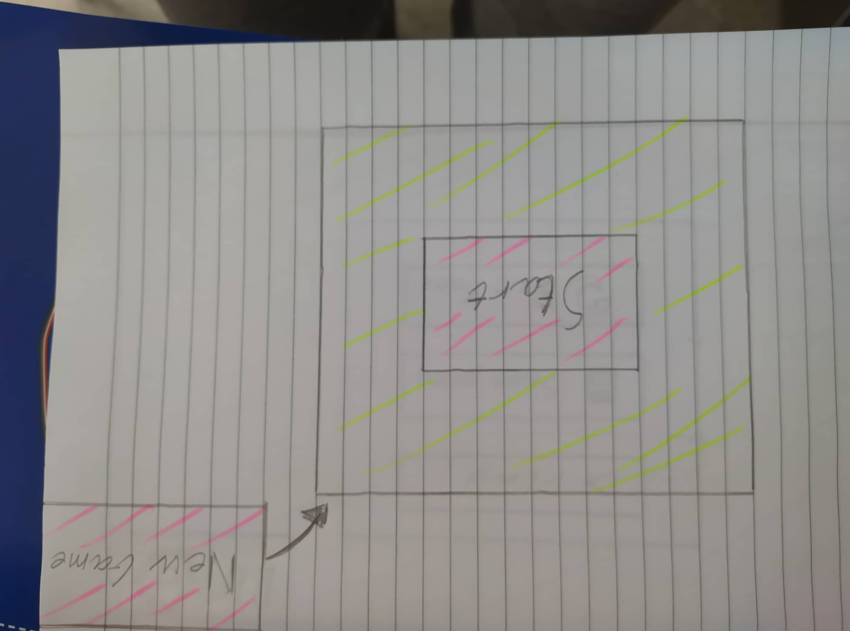
      * *New game created, overwrites previous one*
      * ***Select Difficulty***

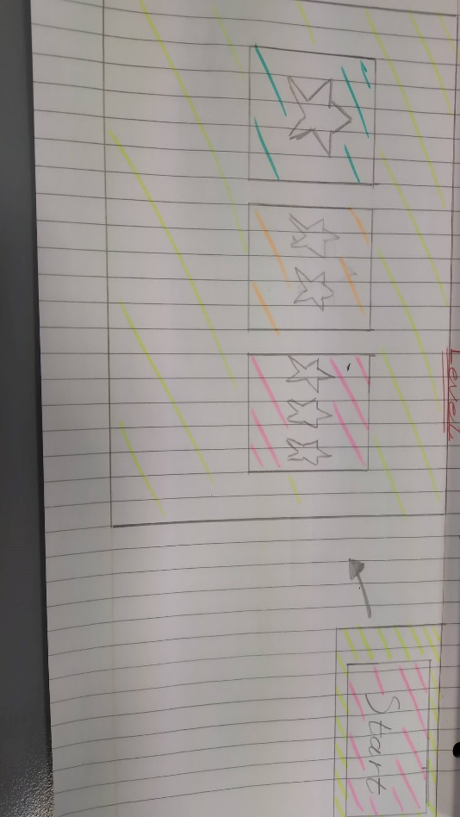

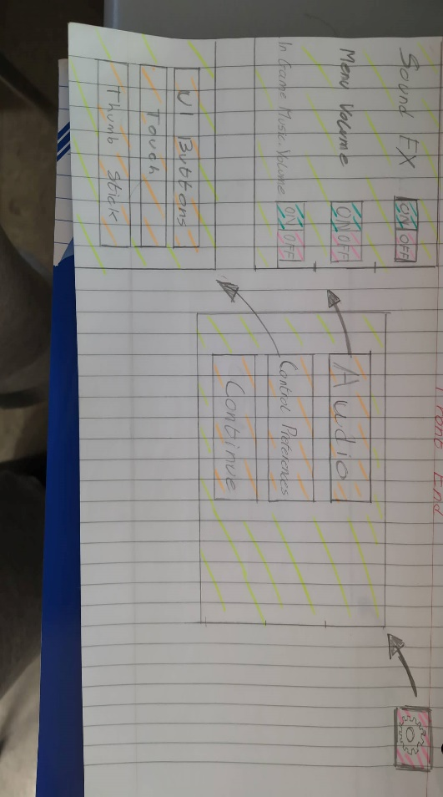

* + - **Load Game**
      * Load previously saved game
    - **Settings**
      * 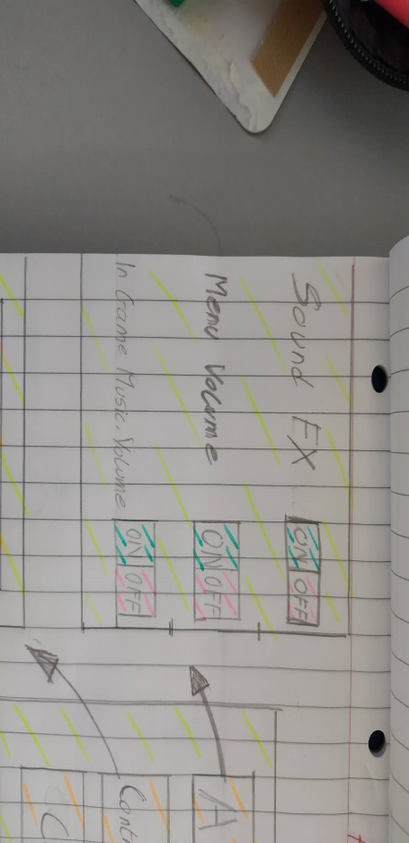**Audio**
      * *(I chose on/off because volume can be adjusted by the phone’s audio itself)*
        + Sound effects
        + Menu vol.
        + 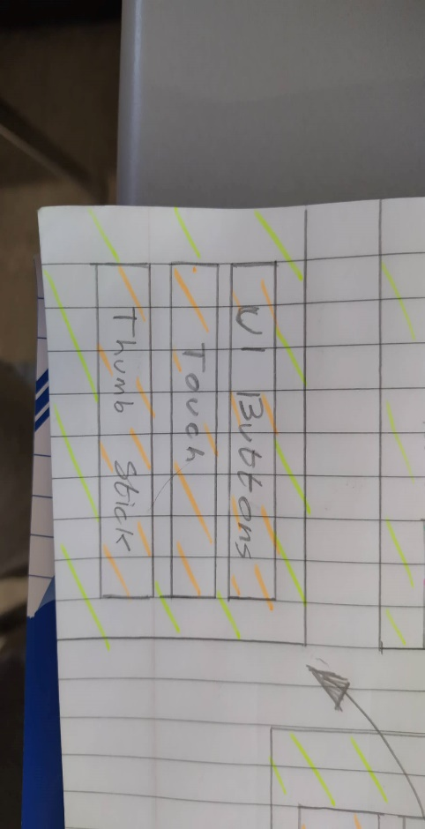In game Music vol.
      * Controls Preference
      * Exit/ Continue back to main menu

**2. In-Game Menus:** A set of menus and screens accessed in-game, often from a pause menu. These form part of the game mechanisms rather than being distinctly separate.

* 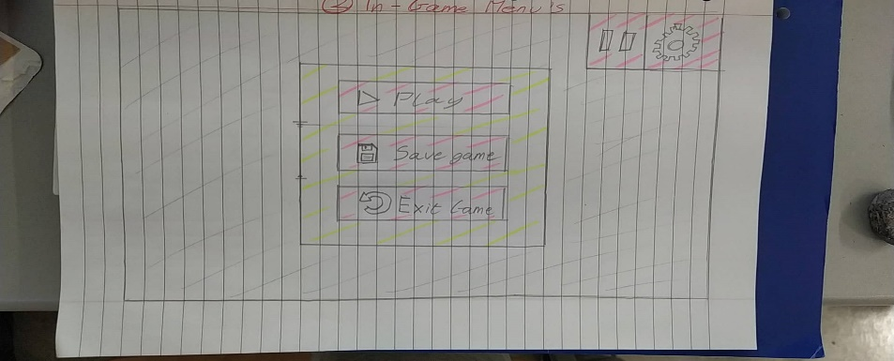Play
* Save Game
* Exit (to main menu)

**3. Control Mechanisms:** The way in which the player controls the game entities. Many games have just one control mechanism.

* Multiple options to choose from
* UI Buttons (up, down, left, right)

or

* Touch

or

* Thumb stick

**4. The Game:** The gameplay screens showing the initial setup, how the action starts, a midpoint in play and the winning/progression conditions depending on the game you are designing. If the game is episodic in nature, then explain how episodes are defined and how the player moves between them.

* Platformer
  + Type
    - Objective-based
    - Ever-Changing
    - Different levels
      * 3
  + Background
* Avatar/Character
  + Health
    - Health bar
      * Increases/ Decreases by collecting tokens
      * +
        + Collects tokens to increase health by 10%
        + Adds 1 to total score
      * -
        + Monkeys throws rocks at character, decrease health by 20%
* Objectives
* **Tokens**
  + 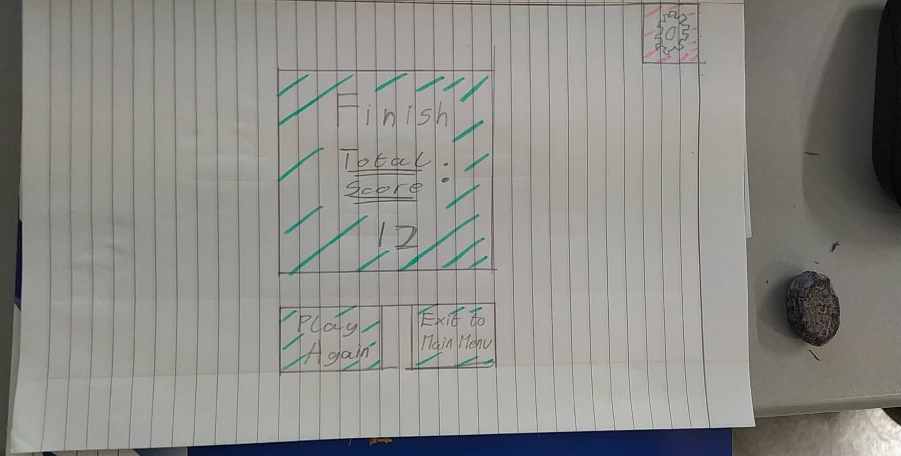Coins / Points / Bonuses
  + Positive objectives
  + Negative objectives
    - **All leads to total overall score**
* Enemies spawn until objective is reached(location)

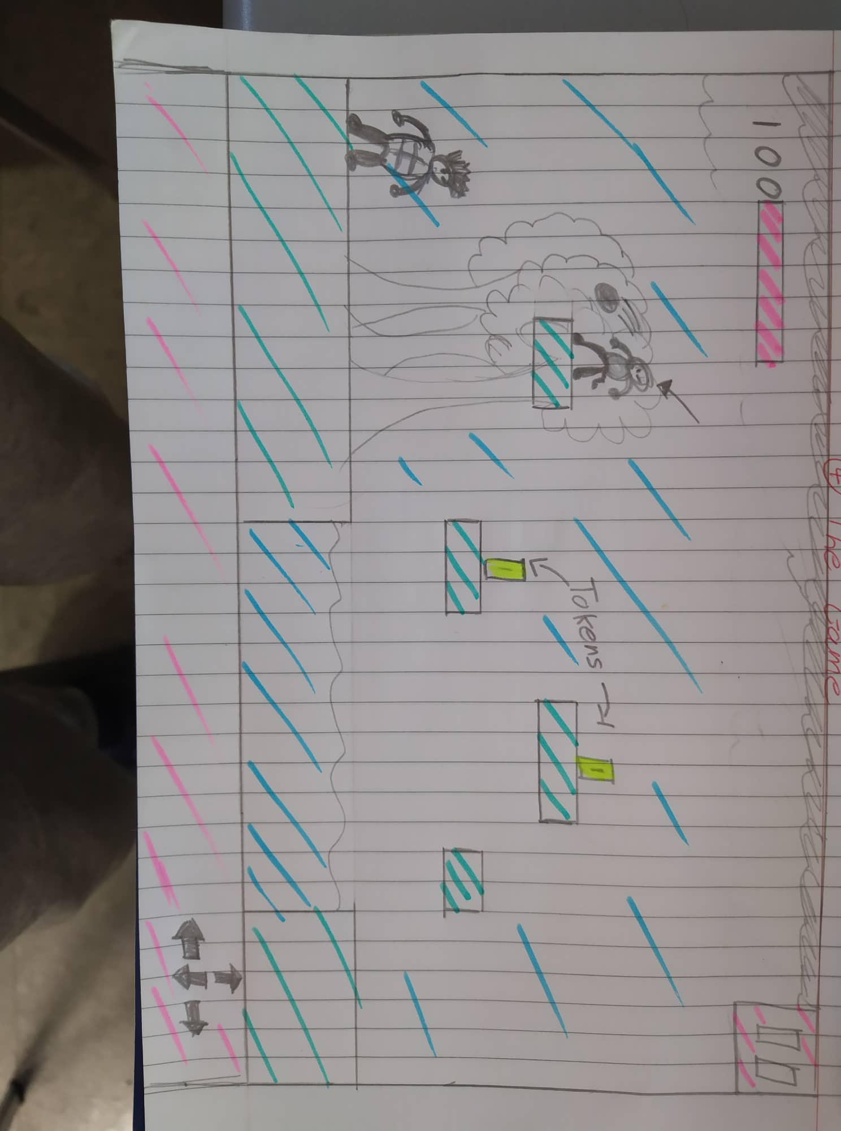

**Original Brainstorm**

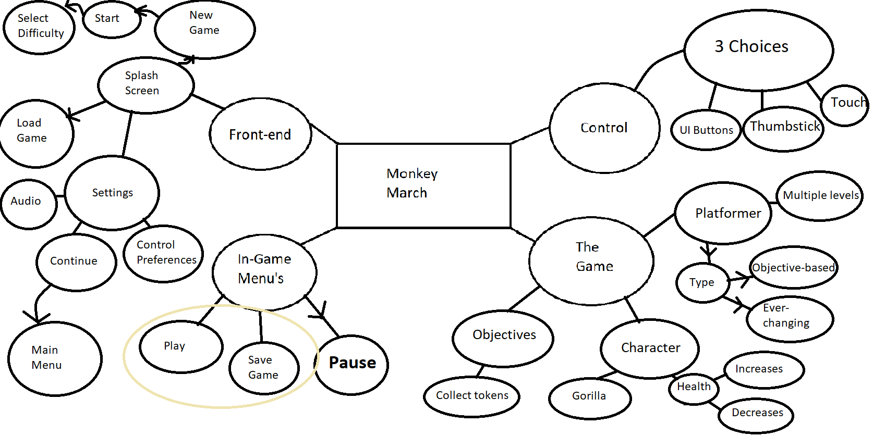

## Test Plan

