Fusion Data Analysis Report

SimilPatternTool

Pattern Summary:

|  |  |  |
| --- | --- | --- |
| Confidence | Shot | Interval (s) |
| 1.0000 | 56900 | [1020.018, 1030.586054] |
| 0.9768 | 56965 | [1020.068, 1030.634406] |
| 0.9730 | 56966 | [1025.3512, 1035.917728] |
| 0.9597 | 56911 | [1289.5037, 1300.071815] |

Results: Discharges 56965 and 56966 show high similarity and temporal proximity to the reference discharge 56900. Discharge 56911, despite exhibiting a similar pattern, occurs significantly later. This temporal difference suggests that while the shape of the signal might be similar, the underlying physical mechanisms or experimental conditions could be different.

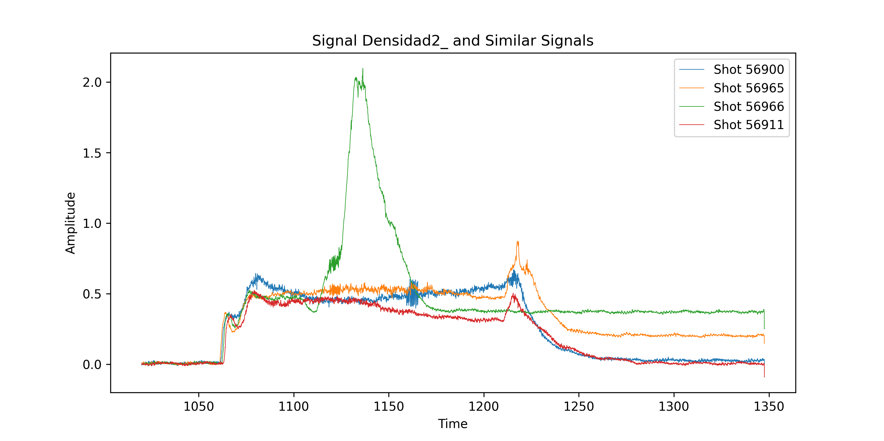

SimilPatternTool

Pattern Summary:

|  |  |
| --- | --- |
| Confidence | Shot |
| 1.0000 | 56918 |
| 0.7460 | 56914 |
| 0.7143 | 57000 |
| 0.7143 | 56952 |

Results: While no time intervals were provided in the summary, the lower confidence values for shots 56914, 57000, and 56952 compared to the reference shot (56918) suggest a moderate level of similarity in the HALFAC4 signal. Further analysis, potentially including visual inspection of the plotted signals, is recommended to determine the nature and significance of these similarities.

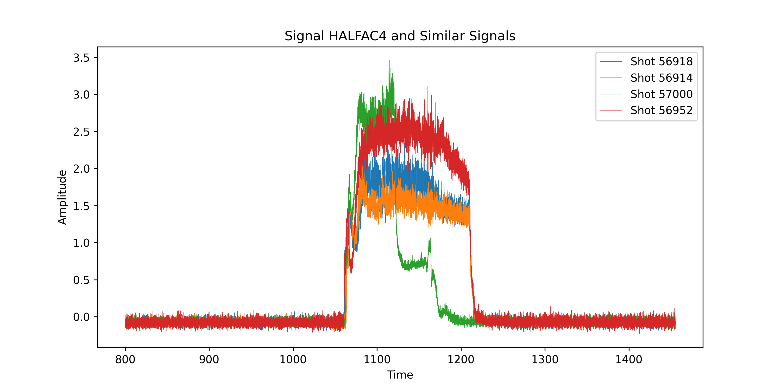

ShotLlama2

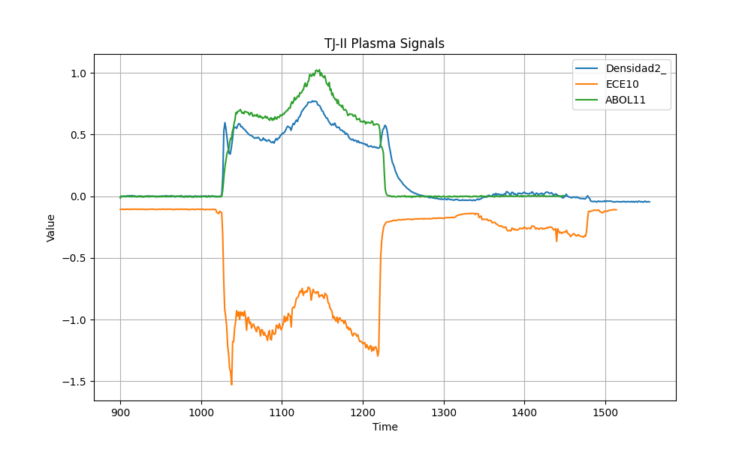

CsvUpdate

Results: The highest number of discharges were performed in 2013, totaling 3749. This analysis is limited to the available data, which only included information for 2013.

CsvUpdate

Results: A comment made at 11:27 notes sparking ("chisposa") on a component, likely within the fusion reactor, but remaining intact ("aguanta entera"). The value "0" for "limitador_z1" likely indicates a specific position or state of this limiter. The wall conditioning information ("Boronizado y Litiado el 7 de noviembre de 2016") provides context, placing this observation after boronization and lithium coating on November 7, 2016. Boron and lithium are used in fusion reactors for plasma impurity control and performance enhancement.

CsvUpdate

Results: There were 555 discharges in June 2023. This result is based on the count of entries for "N_DESCARGA" (discharge number) recorded during June 2023.