Fusion Data Analysis Report

SimilPatternTool

Pattern Summary:

|  |  |  |
| --- | --- | --- |
| Confidence | Shot | Interval |
| 1.0000 | 56900 | [1020.018, 1030.586054] |
| 0.9768 | 56965 | [1020.068, 1030.634406] |
| 0.9730 | 56966 | [1025.3512, 1035.917728] |
| 0.9597 | 56911 | [1289.5037, 1300.071815] |

Results:

Discharges 56965 and 56966 show high similarity to the reference discharge 56900 within the extended time interval. Discharge 56911, despite showing similarity, occurs significantly later, potentially indicating a different operational scenario. The analysis considered a wider time range than initially specified to capture patterns extending beyond the [1020, 1027] window.

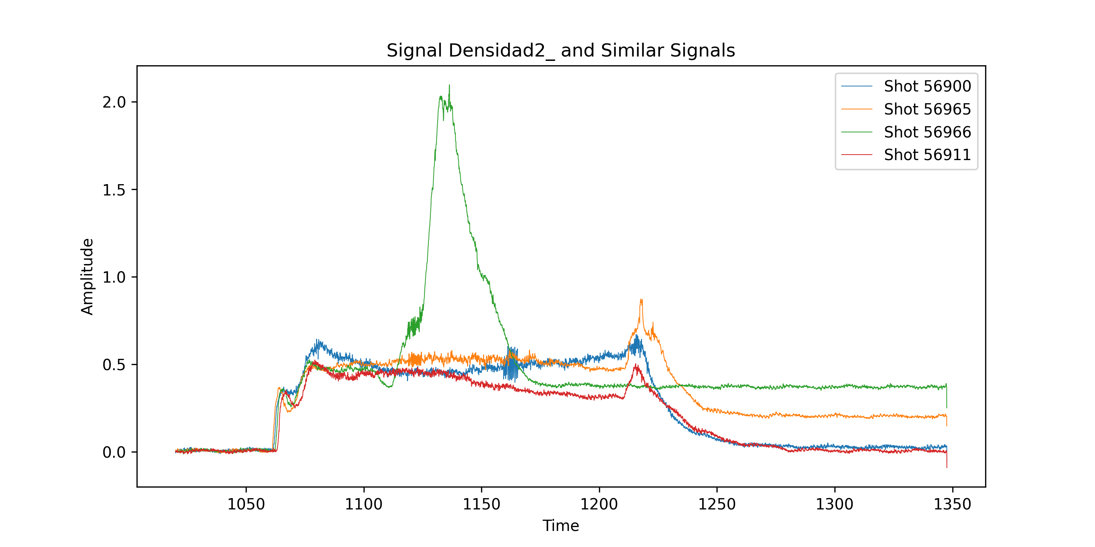

SimilPatternTool

Pattern Summary:

|  |  |
| --- | --- |
| Confidence | Shot |
| 1.0000 | 56918 |
| 0.7460 | 56914 |
| 0.7143 | 57000 |
| 0.7143 | 56952 |

Results:

The results for HALFAC4 similarity show a lower confidence compared to the previous Densidad2_ query. This indicates less similar patterns for this signal.

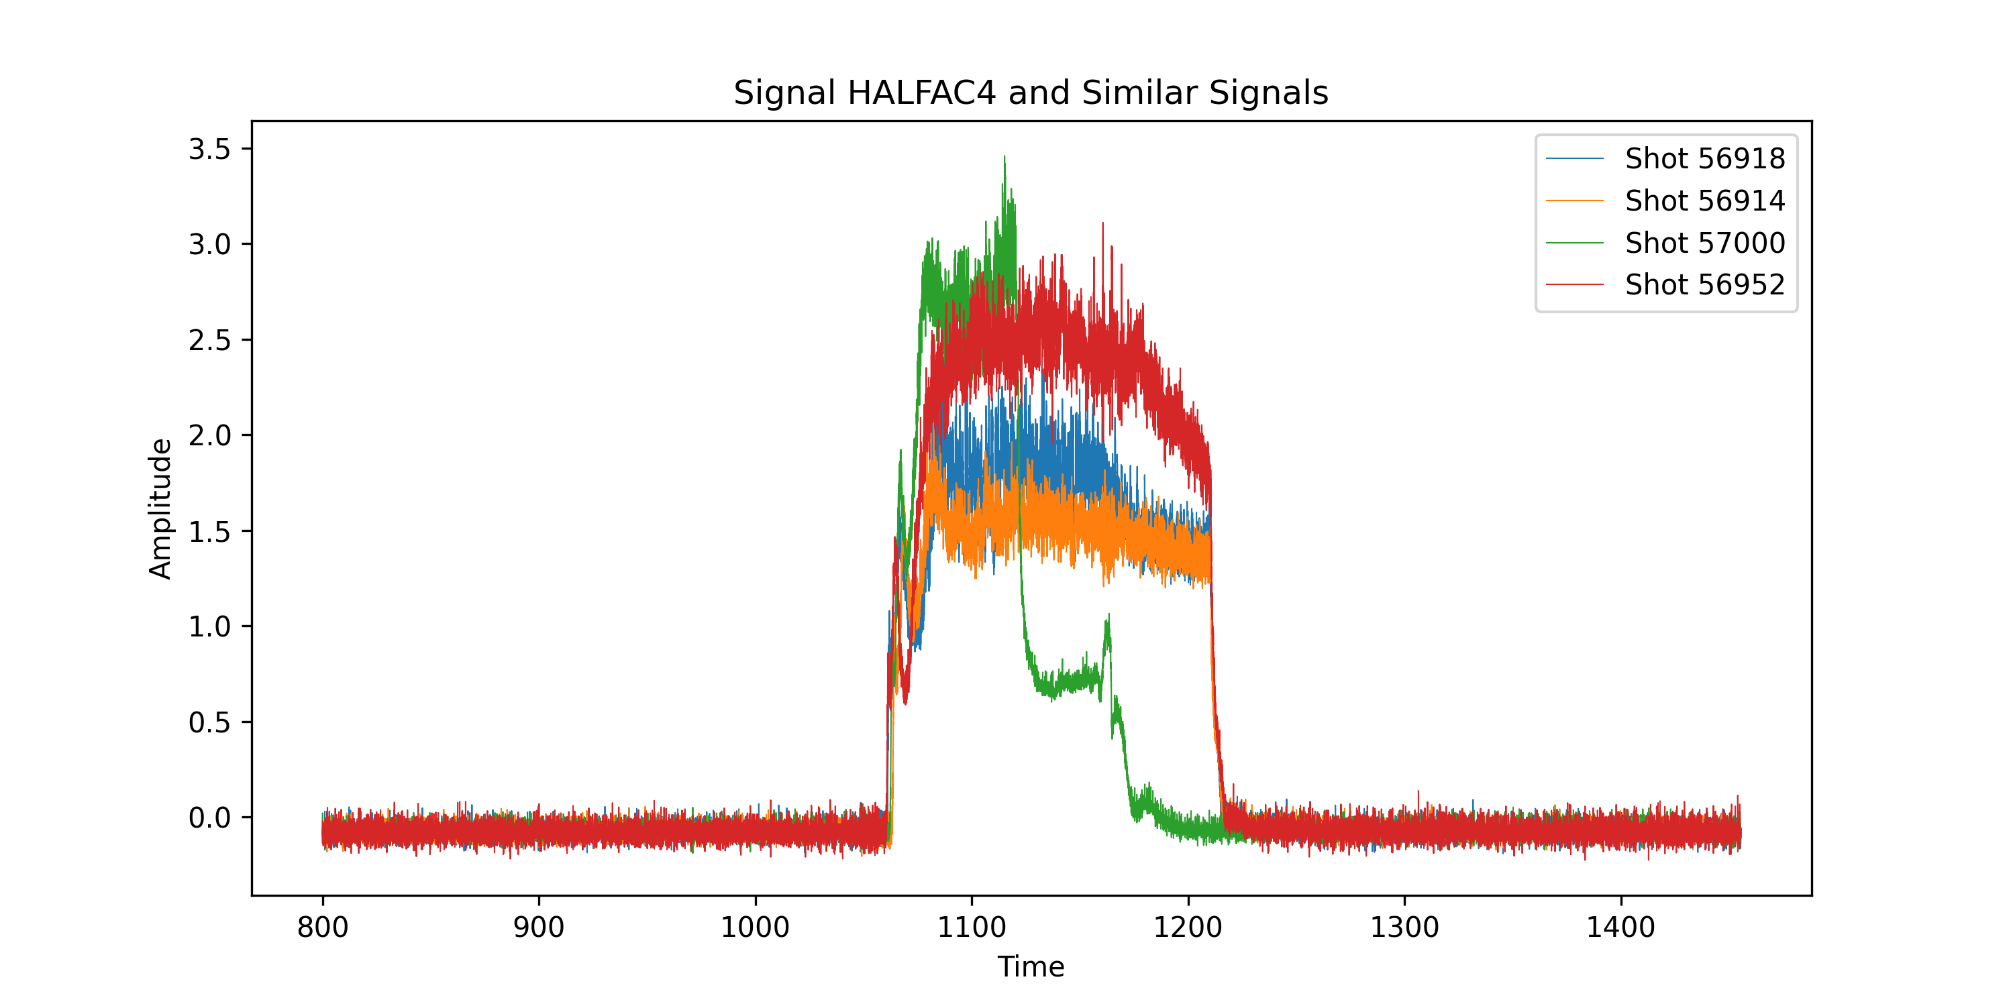

SimilPatternTool

Pattern Summary:

|  |  |
| --- | --- |
| Confidence | Shot |
| 1.0000 | 56900 |
| 0.7619 | 56935 |
| 0.7460 | 56967 |
| 0.7460 | 56901 |

Results:

Similar to the HALFAC4 analysis, this query, while targeting Densidad2_ but without a specified time window, yields lower confidence scores than the initial query, suggesting a dependence on the time window for stronger pattern matching.

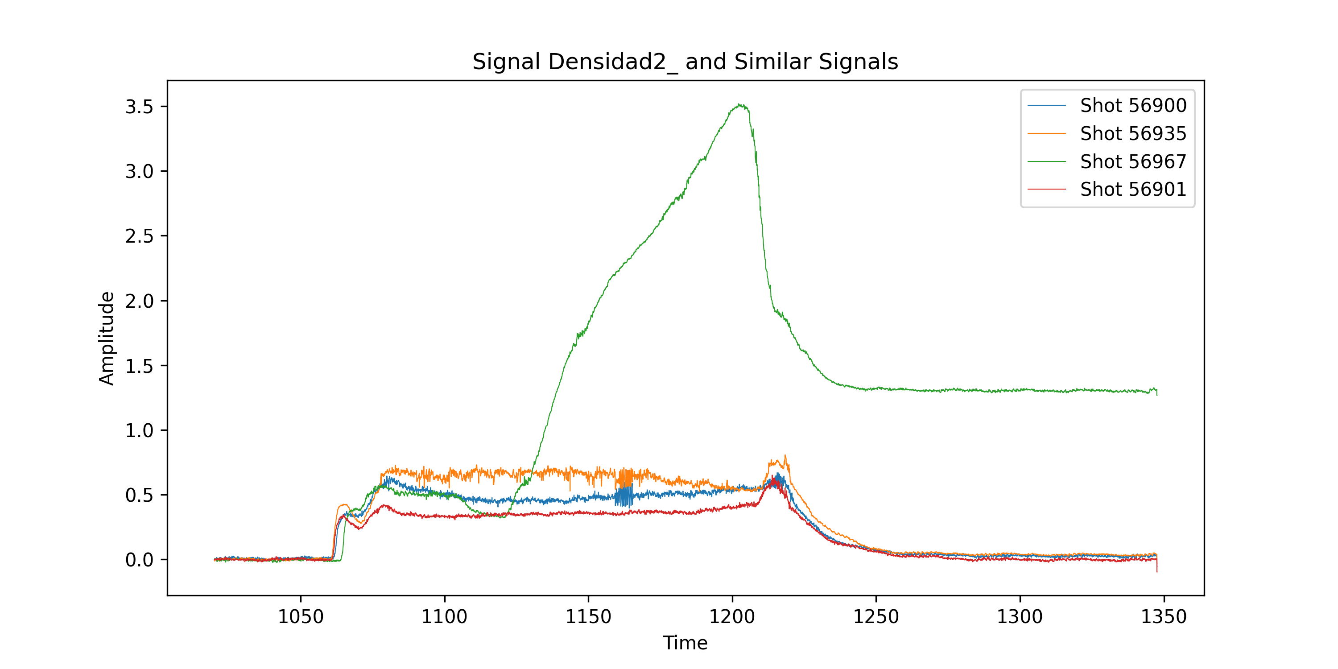

SimilPatternTool

Pattern Summary:

|  |  |  |
| --- | --- | --- |
| Confidence | Shot | Interval |
| 1.0000 | 56900 | [1020.018, 1030.586054] |
| 0.9768 | 56965 | [1020.068, 1030.634406] |
| 0.9730 | 56966 | [1025.3512, 1035.917728] |
| 0.9597 | 56911 | [1289.5037, 1300.071815] |



ShotLlama2

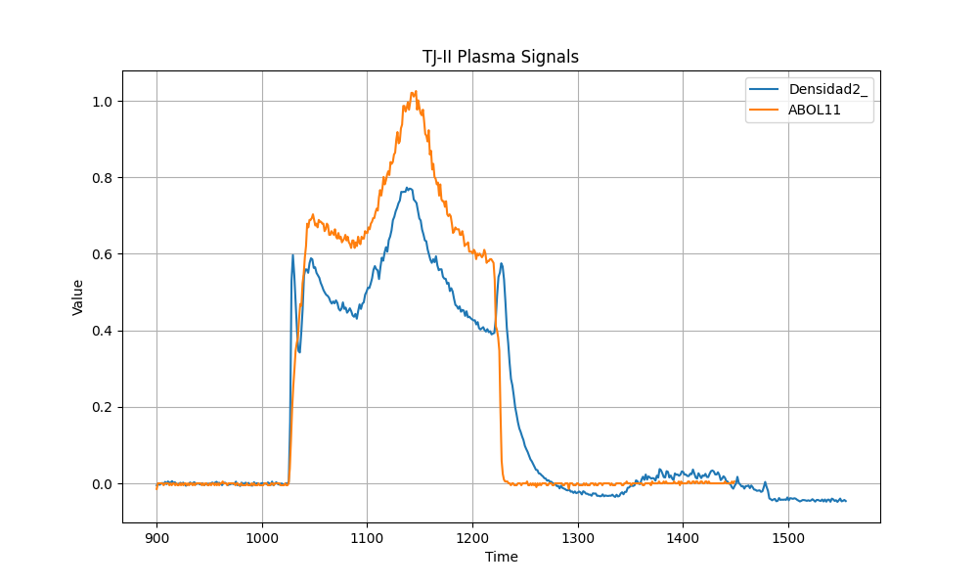

ShotLlama2



ShotLlama2



ShotLlama2



CsvUpdate

Results:

The year 2013 had the most discharges (3749).

CsvUpdate

Results:

The comment "Est muy "chisposa" pero aguanta entera" suggests sparking on a reactor component that remains intact. The limitador_z1 value of "0" likely indicates its state or position. The wall conditioning information ("Boronizado y Litiado el 7 de noviembre de 2016") provides context for the experiment.

CsvUpdate

Results:

There were 555 discharges in June 2023.

CsvUpdate

Results:

The comment describes a fusion experiment where the target density was slightly lower than usual, and the NBI coupled more smoothly. The maximum density was slightly above 2 (units unspecified).

CsvUpdate

Results:

The year 2013 had the most discharges (3749).