**Classification metrics**

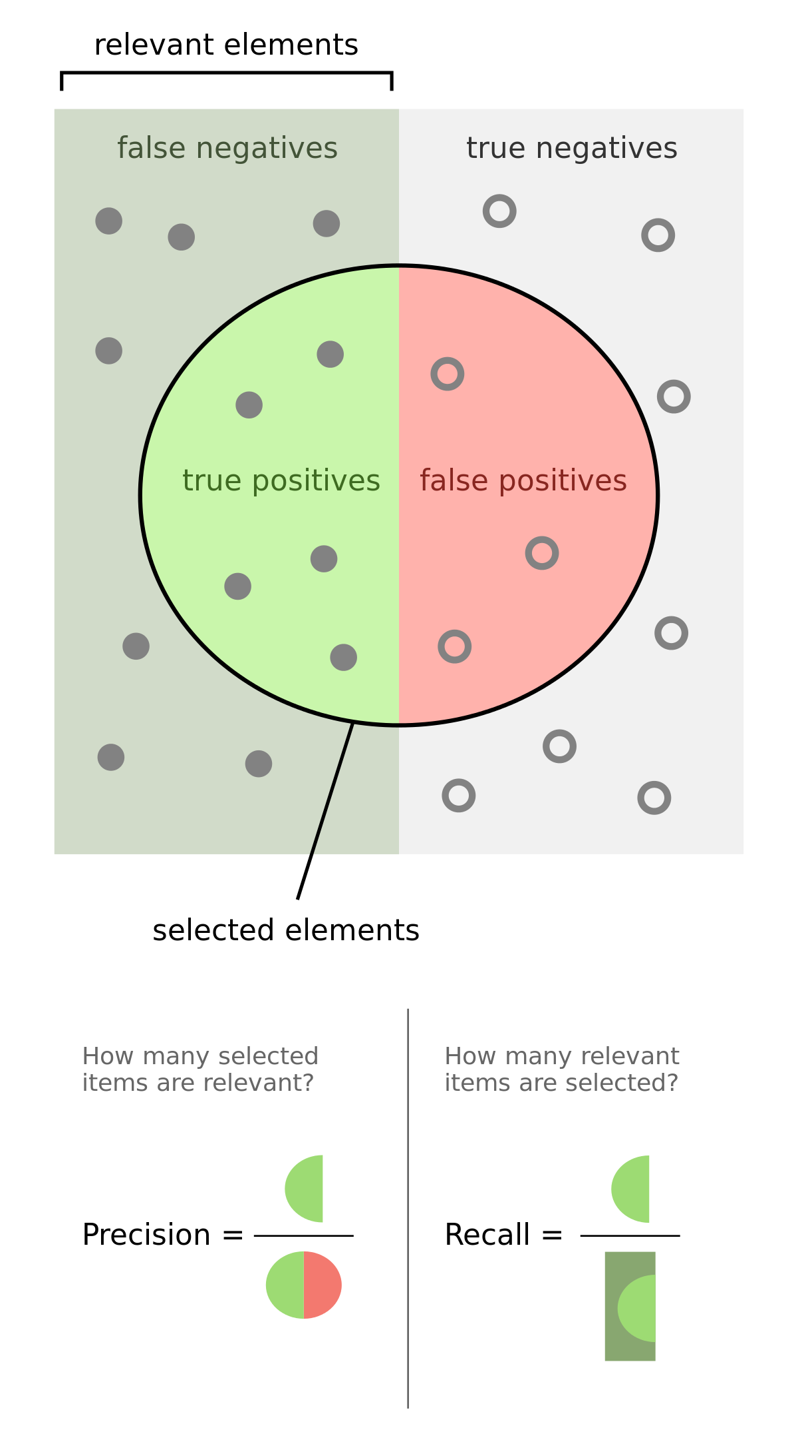

$$Accuracy = \frac{TP + TN}{P + N} = \frac{TP + TN}{TP + TN + FP + FN}$$

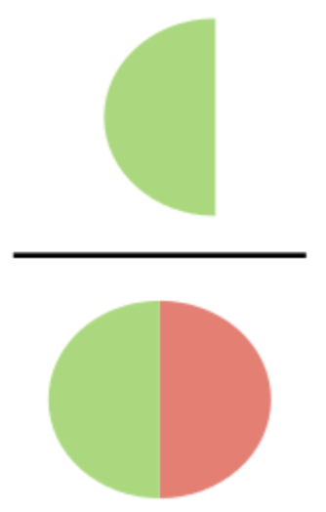

how many selected

items are relevant?

$$Precision = \frac{TP}{TP+FP} =$$



how many relevant

items are selected?

$$Recall = \frac{TP}{P} = \frac{TP}{TP + FN}=$$

**Classification metrics**

**Confusion matrix**

|  |  |  |  |
| --- | --- | --- | --- |
|  |  | True condition | |
|  |  | 1 | 0 |
| Predicted  condition | 1 | TP | FP (type I error) |
| 0 | FN (type II error) | TN |

$$F_{1}score = 2*\frac{Precision*Recall}{Precision + Recall}$$

$$F_{β}score = {(1+ β}^{2})*\frac{Precision*Recall}{β^{2}*Precision + Recall}$$

$$True Positive Rate \left(TPR\right)= \frac{TP}{P} = \frac{TP}{TP + FN}$$

$$False Positive Rate \left(FPR\right)= \frac{FP}{N} = \frac{FP}{FP + TN}$$

ROC - curve

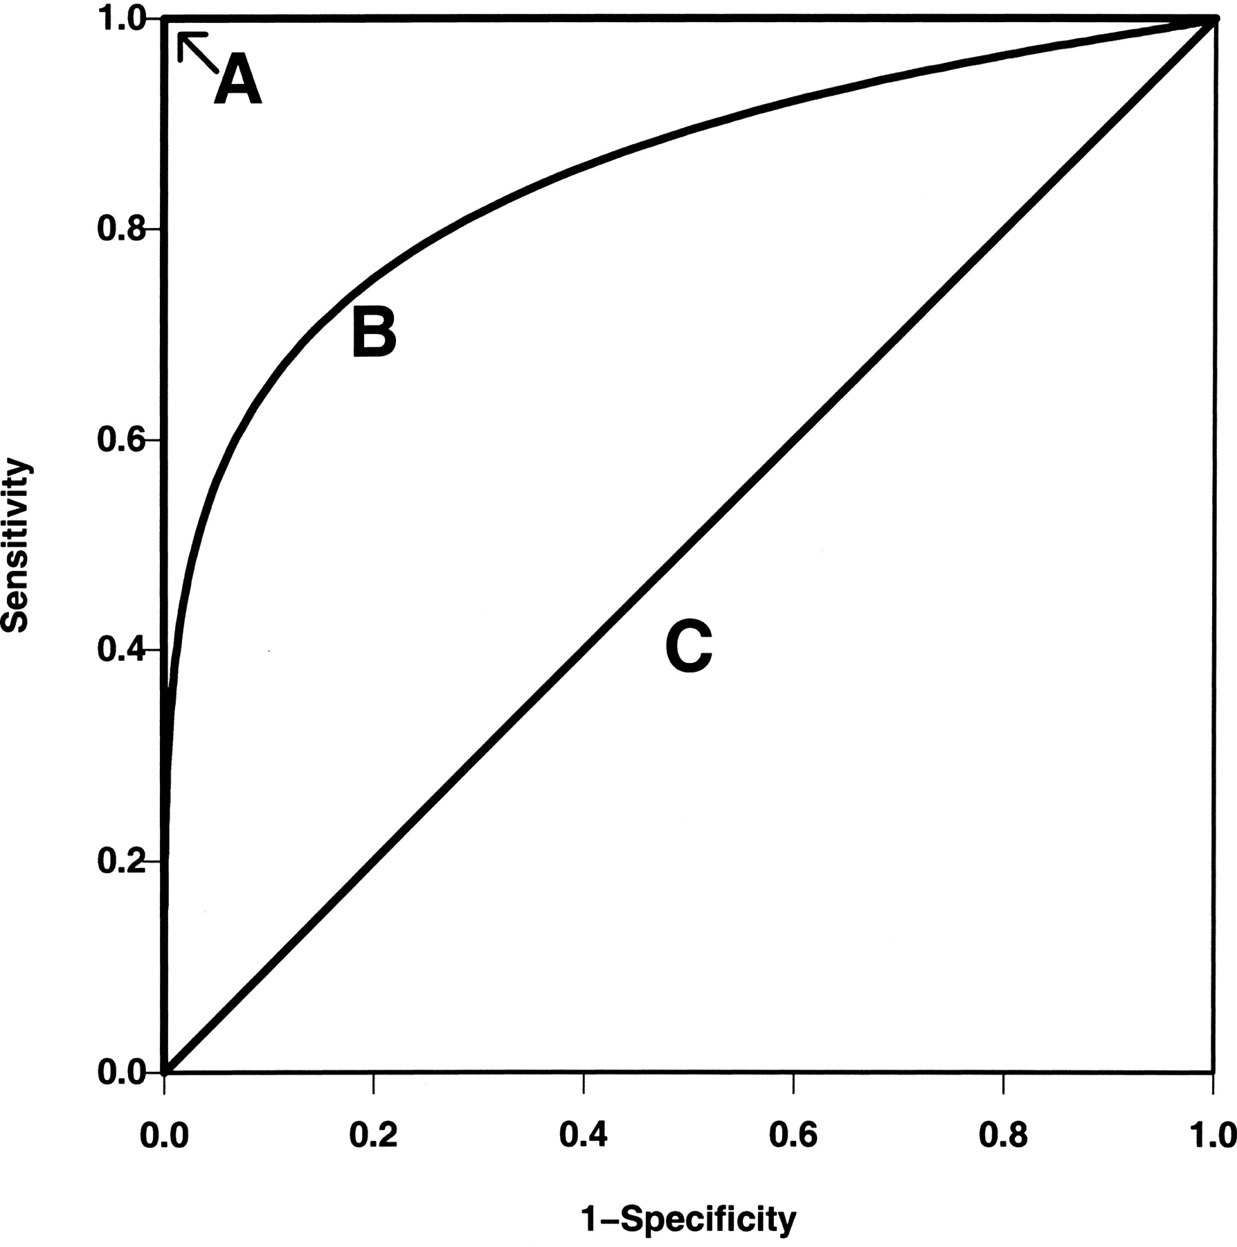

False Positive Rate

True Positive Rate

$$LogLoss = -\frac{1}{N}\sum_{i=1}^{n}{[y_{i}*log\left(\hat{y_{i}}\right) +\left(1- y_{i}\right)*log(1-\hat{y_{i}})]}$$