IPMI Coursework

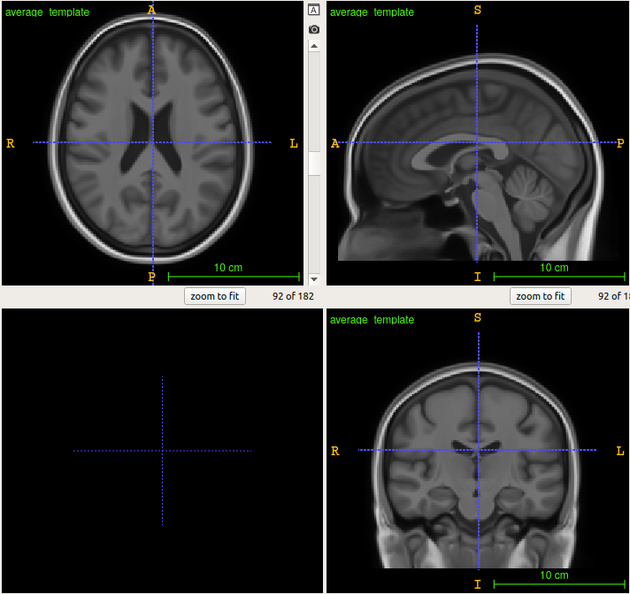
Average template
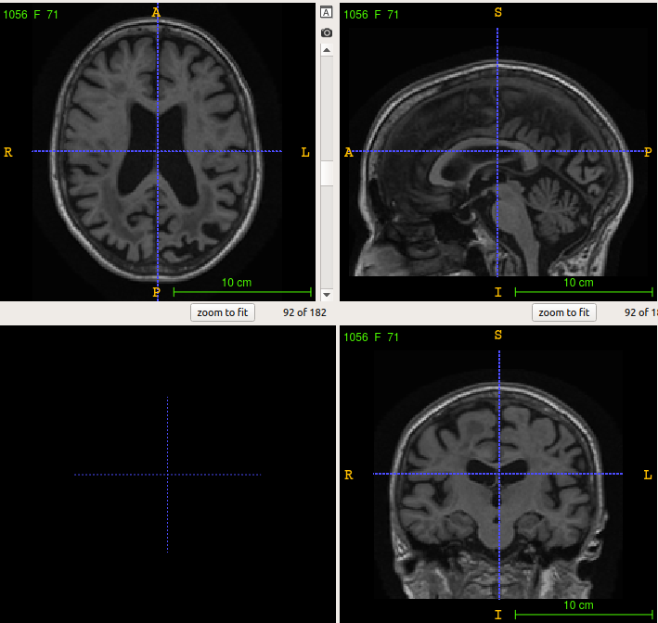
Image of Patient 1056

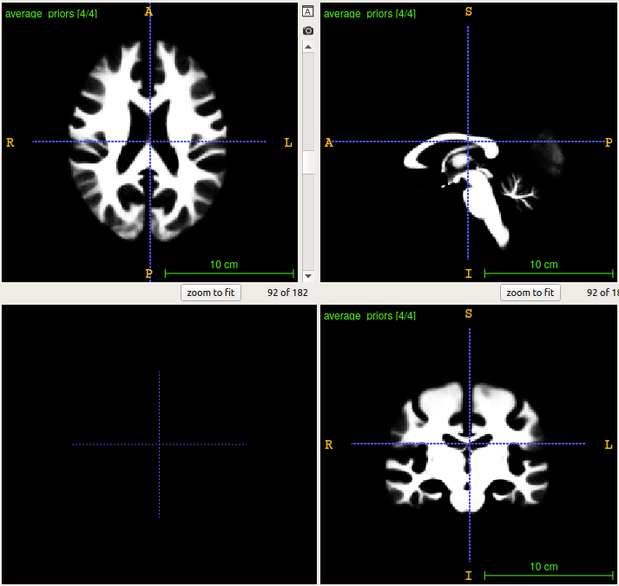
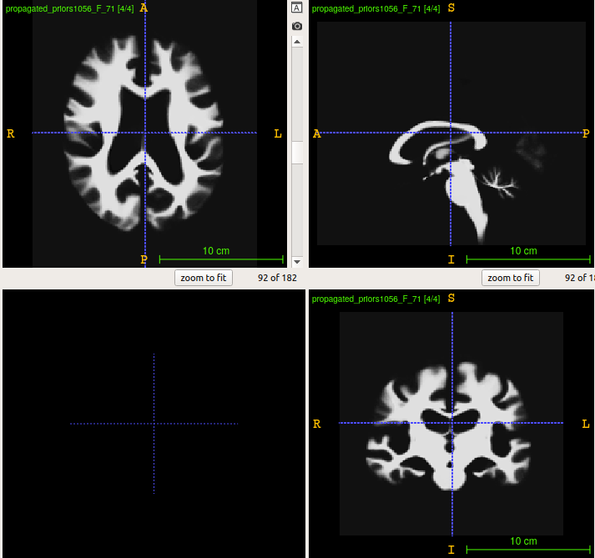
average prior
propagated prior patient 1056, beta = 0.5
Step 1
GM segmentation with variable Beta for patient 1056

Beta = 0.1

Beta = 0.5

Beta = 2.5

Observation
Our matrix G = 1_{6x6} – I * 6 penalises adjacent voxels being in different classes. As expected the boundaries are sharper because regularisation is stronger as beta increases.

Step 2
2.1
First, you will need to align all subjects’ scans independently to the provided
average template image (using reg_aladin and reg_f3d if using NiftyReg) [5]. You will obtain the
transformations that maps the average image to all other scans.

Code: Module: make_priors_and_labels.py
Functions: linear_registrations, non_linear_registration
Output:
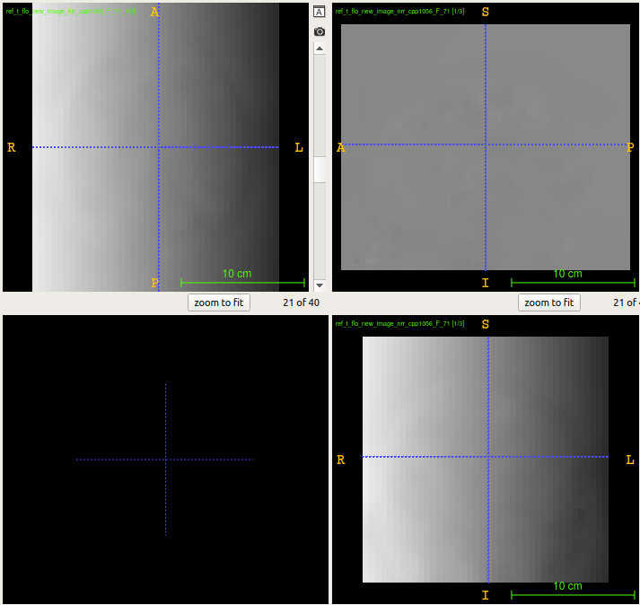
Transformations that maps the average image to patient 1056

2.2 Jacobian
Second, you can generate the Jacobian determinant maps for all subject (using reg_jacobian if using NiftyReg)
Code: Module: make_priors_and_labels.py
Functions: make_jacobians

2.3
Third using the provided average image parcelation, you can compute the average Jacobian determinant values for all regions of interest [5].

2.4 Jacobian Properties
What are the desired properties for the Jacobian determinant maps? [5]

The Jacobian determinant shows the volumetric change at each voxel or region. Values exceeding 1 indicate volumetric expansion, equal to one indicate volume preservation and less than 1 indicate contraction.

The desired properties of the Jacobian determinant maps are that all values exceed 0. Values of zero indicate a voxel has vanished during registration and the registration process was thus imperfect and causes loss of information about that voxel in the registered image. Values less than zero are an even worse failure of registration for that pixel, indicating that voxel has been deformed into other regions.
The Jacobian determinant map is saved to reg_f3d’s -cpp option TO CONFIRM ' -cpp ' + path_out_ff + 'ref_t_flo_new_image_nrr_cpp' + file_name
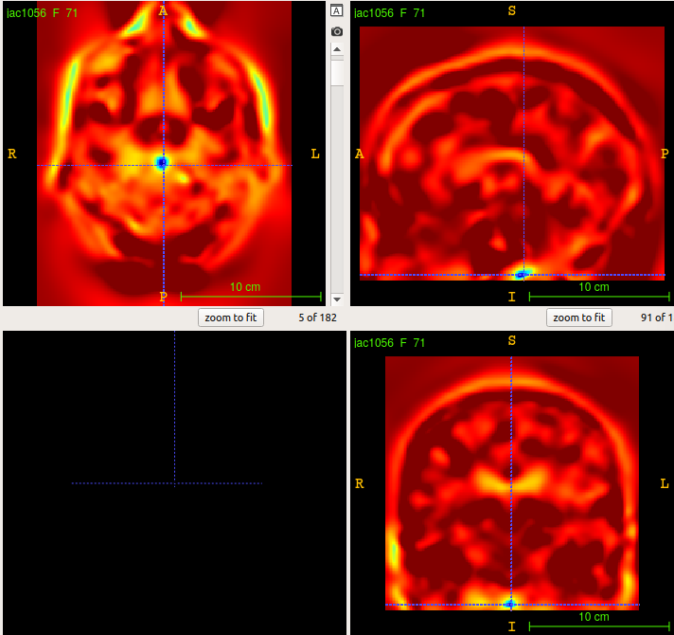
With no log jacobian determinant penalty some voxels have zero (yellow) and others negative (green, blue) values: The frequency is confirmed by the colour map and log frequencygram below.

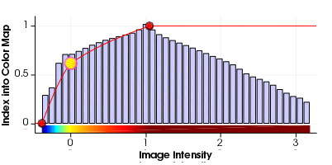
on log scale:

2.5 Positive Jacobians
Explain how you promoted them when running the registration? [5]
Positive values of the Jacobian determinant were promoted by using a penalty term of the squared Jacobian determinant log. Reg_f3d’s regularisation options include -jl, the weight of log of the Jacobian determinant penalty term. The default weight value is 0.0 which gave …% zero and …% negative pixels or histogram on the first run.

How did you check that these properties were enforced? [5]

