

**CSC7054**

**Web and Mobile App Development**

Travel Journal Android Application (TravelMate)

Cathal Hills - 40059110

Shawn Morrow - 40063384

David Leavy - 40060552

Sarah Law – 40080429



Introduction

To start this project a group decision was made to use Android Studio as our development environment. We came to the conclusion quite quickly that we would develop a travel journal application that would allow users to record their thoughts while on the move, and the locations they created these journal entries at would be saved and could be loaded up at a later date, along with the actual entry and a mood setting showing how the user felt at the time of the entry’s creation. We felt this was a good idea as it is something a lot of explorers and travellers would use on a daily basis, and would allow them to record their exploits for sharing with others. We concluded that we could create an app that was easier to use and much more straightforward than many entries on the Google Play App Store. This report covers both the design and features of our application in depth.

Requirements

The Problem

Our problem being faced by the end user/customer is that there are several apps which do similar things but do not contain a simple amalgamation of the features we/the end user would prefer, in this case the ability to create journal entries that are tied to a location which can then be referenced and shown on a map. The location data must be accurate and the application must allow the user to see the locations of each journal entry as well as a list of these which can be selected and viewed. The user should be able to access this information offline, as this application could theoretically be used anywhere in the world and online reception is not always available.

System Requirements

|  |  |  |  |
| --- | --- | --- | --- |
| **Requirement No.** | **Requirement** | **Brief Description** | **Priority** |
| 1. | User should be able to write and save a journal entry | End User can write an entry and save this to the database |  |
| 2. | Journal entry should be tied to a location on the world map | Entries can be input with a location stamp with coordinates |  |
| 3. | User should be able to view these entries on a list | The entries are viewable in a list on a separate page of the application |  |
| 4. | User should be able to view these entries on a map | The entries are viewable on a world map using their coordinates |  |
| 5. | User should be able to depict what mood they were in when they wrote an entry | A mood slider (1-10) is usable with the entries on input |  |
| 6. | User’s mood should be displayed with entry | The mood value is displayed beside the entry title/content |  |
| 7. | App is easy to navigate | The application is clearly signposted and buttons are labelled correctly |  |
| 8. | App production quality is of a high value | The icon and other visual features are of a high quality and resolution so as to be easy to view |  |
| 9. | App functionality is clearly explained for end user | The help page explains what each section of the application is for |  |
| 10. | User can set a “Home” Location in the settings menu | A default location can be set for when no connection is available |  |

Functional Requirements Specification

Stakeholders

Possible parties interested in the system could include:

* Facebook
* Google (in a Google+ capacity)
* Governments of tourist areas (?)

Actors and Goals

The main actors that will interact with and use this application would be members of the public, as their goal would be to find and use an application that would allow them to document their travels and record their experiences. This aim will tie into our System Requirements to be included in the finished application.

Use Cases

|  |  |  |
| --- | --- | --- |
| Case No. | Casual Description | Related Requirements |
| 1. | User wishes to write an entry while on holiday | 1,2,5 |
| 2. | User wishes to view their previous entries | 1,2,3,4 |
| 3. | User wishes to view the locations in which they recorded their previous entries | 1,2,4 |
| 4. | User wishes to make an entry with location enabled, but has no connection | 1,2,10 |
| 5. | User wishes to find out how to use the app | 7,8,9 |
| 6. | User wishes to record their mood with an entry | 1,5 |
| 7. | User wishes to view the various moods they have been in on previous entries | 6 |
| 8. | User wishes to set a “Home” location as a default | 10 |

Use Case Diagram

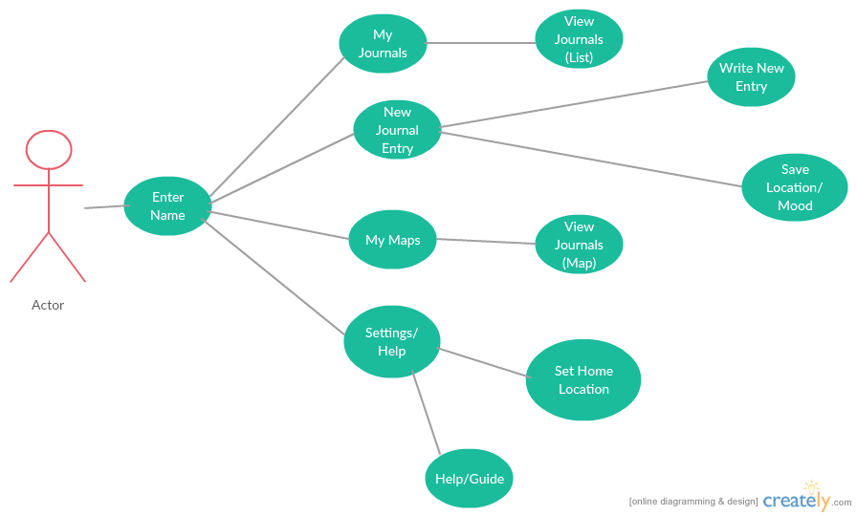

User Interface Specification

Preliminary Design

We quickly came to a decision on how our main menus would look in the application, along with the various functions it would allow access to. We settled on a grid based menu design with flat design icons so as to provide a modern and clean look, this would also help with providing a user friendly experience. Our first sketches are below:

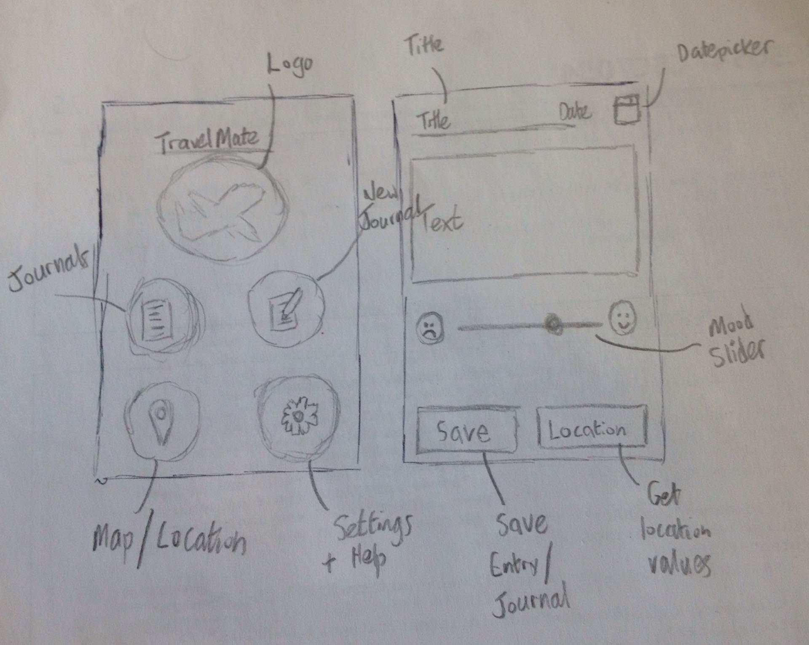

Progression of Design

We moved on from these initial sketches with some mock-ups created in Photoshop, this would give us a clearer idea of the outcome we wanted and was a way to visualise how we wanted the finished product to look, and it also gave us something to aim for quality wise. This allowed us to talk about and brainstorm potential new idea and features, or designs that could be added to the application. The digital mock-ups we produced are below:

Design

Features

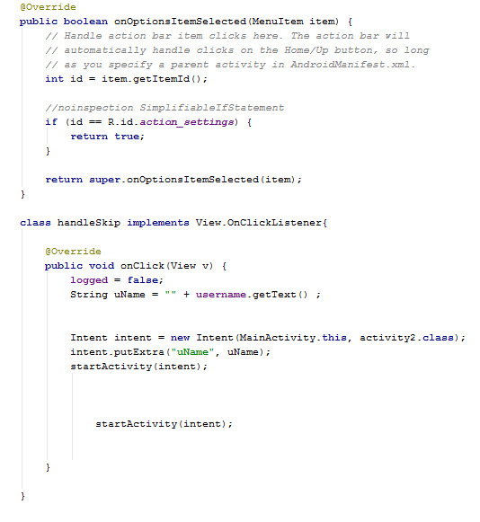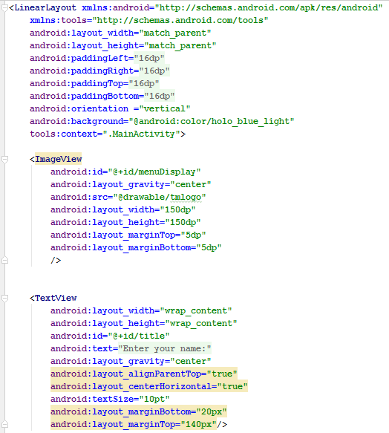TravelMate provides users with a platform to record their experiences while on the move, recording their location and mood. The opening screen displays the logo we created along with a prompt and a text entry allowing the user to enter their name to personalise the experience, the user also has the option to skip this process for a more standardised experience. Examples of some of the code behind and XML for this page are displayed below to demonstrate how we achieved this, along with an example image of the finished page:

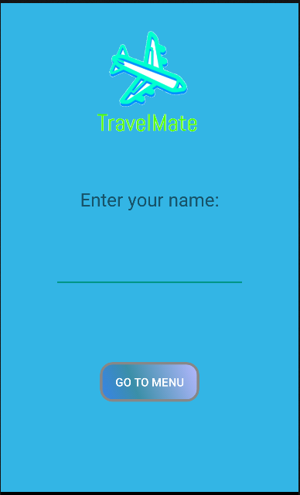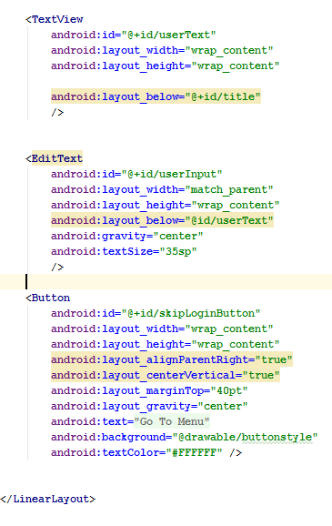

The application features a selection of other functionalities displayed using a flat design aesthetic that we will now go into detail about, this includes:

* List of Journal Entries
* Map of Journal Entries
* New Journal Entry
* Settings such as setting a “Home” Location
* A Guide page to explain other functionality

The code behind and XML for these pieces of functionality follows:

List of Journal Entries (My Journal)

Map of Journal Entries (My Maps)

New Journal Entry

Settings

Guide

Domain Model

Plan of Work

References

1. Google Developers - <http://developer.android.com/index.html>
2. StackOverflow - <http://stackoverflow.com/>
3. TutorialsPoint - <http://www.tutorialspoint.com/>
4. Xamarin - [developer.xamarin.com/guides/android/getting_started/hello,android/](https://developer.xamarin.com/guides/android/getting_started/hello,android/)
5. XDA Developers - <http://www.xda-developers.com/>
6. Android Authority - <http://www.androidauthority.com/>