000

001

002

003

004

005

006

007

008

009

010

011

012

013

014

015

016

017

018

019

020

021

022

023

024

025

026

027

028

029

030

031

032

033

034

035

036

037

038

039

040

041

042

043

044

045

046

047

048

049

050

051

052

053

054

055

056

057

058

059

060

061

062

063

064

065

066

067

068

069

070

071

072

073

074

075

076

078

079

080

081

082

083

084

085

086

087

Clustering DNA sequences by relative compression

|  |  |
| --- | --- |
| Morteza Hosseini1  Diogo Pratas1  Armando J. Pinho1 | 1 IEETA/DETI, University of Aveiro |

Abstract

Calibration of lens distortion has traditionally proceeded in one of three ways. The first is to use known correspondences between feature points in one or more images, and the world 3D points

1. Introduction

Calibration of lens distortion has traditionally proceeded in one of three ways. The first is to use known correspondences between feature points in one or more images, and the world 3D points. This is typically done using a checkerboard or a calibration grid of dots where corners or dot centres can be reliably located [7]. A second class of calibration techniques is termed auto-

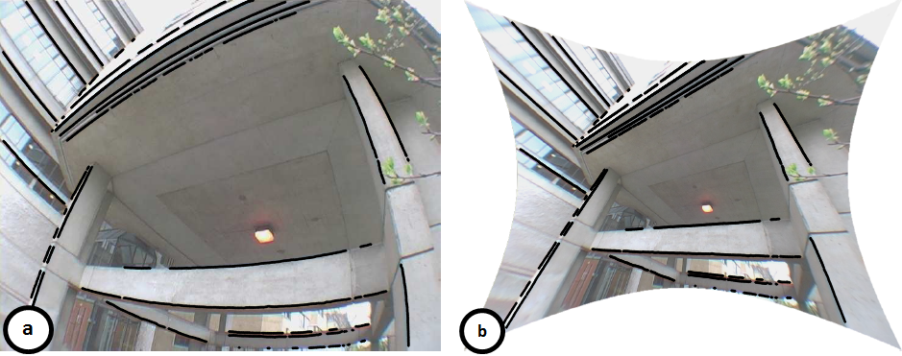

Figure 1: Edges corresponding to straight lines in the real world are detected (a) and the plumbline constraint is used to compute the distortion parameters, giving the rectified image (b)

which

exhibiting moderate to severe distortion.

* 1. Subsection

Sddsdadasdasdasdsadasdasdasdfdfdggf bdgfgdfgdfg dfgfdj dfgdfjh ghdf jhgfdj jhdfhjh gjdfhgj

1. Results

The proposed method is implemented and publicly available at <https://github.com/smortezah/Clusico>, under GPLv3 license. The machine used for the tests had an 8-core 3.40 GHz Intel® Core™ i7-6700 CPU with 32 GB RAM.

For the experiments, we have used 30 mitochondrial DNA (mtDNA) sequences from three groups of Actinopterygii (Ray-finned fishes), Chondrichthyes (Cartilaginous fishes) and Mammalia, that can be downloaded from <https://www.ncbi.nlm.nih.gov/nuccore>. The size of these sequences varies from 16,189 to 18,431 bases.

In order to classify the sequences, we first ran GeCo on all sequences, considering them as references as well as targets. As the result, normalized relative compression (NRC) values were obtained, that can be calculated as

, (1)



Implementation of this method by edge detection and edge linking is described in the paper,

References

[1] D. C. Brown. Close-range camera calibration. *Photogrammetric Eng.*, 37(8):855–866, 1971.

[2] D. Claus and A. W. Fitzgibbon. A rational function lens distortion model for general cameras. In Proc*. CVPR*, pages 213–219, 2005.

[3] F. Devernay and O. Faugeras. Straight lines have to be straight. *MVA*, 13:14–24, 2001.

000

001

002

003

004

005

006

007

008

009

010

011

012

013

014

015

016

017

018

019

020

021

022

023

024

025

026

027

028

029

030

031

032

033

034

035

036

037

038

039

040

041

042

043

044

045

046

047

048

049

050

051

052

053

054

055

056

057

058

059

060

061

062

063

064

065

066

067

068

069

070

071

072

073

074

075

076

078

079

080

081

082

083

084

085

086

087

[4] A. W. Fitzgibbon. Simultaneous linear estimation of multiple view geometry and lens distortion. In *Proc. CVPR*, 2001.

[5] R. I. Hartley and A. Zisserman. *Multiple View Geometry in Computer Vision*. Cambridge University Press, ISBN: 0521623049, 2000.

[6] R. Swaminathan and S. Nayar. Nonmetric calibration of wide-angle lenses and polycameras. *IEEE T-PAMI*, 22(10):1172–1178, 2000.

[7] Y. R. Tsai. An efficient and accurate camera calibration technique for 3D machine vision. In *Proc. CVPR*, 1986.

[8] Z. Zhang. On the epipolar geometry between two images with lens distortion. In *Proc. ICPR*, pages 407–411, 1996.