Resources

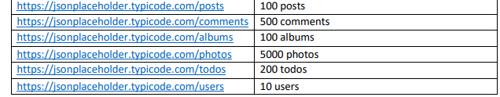

Methods to test

Approach

* Postman app 8.12.2(update on Friday) .
* 2 variables are used 2, passed to the collection via data.json (Remember to activate it if you want to run tests in postman)

postNo : post number to use in the request

userNo: user number to use in the request

* Collection is structured as

User folder contains requests where userNo is passed.

Post folder contains requests where postNo is used.

Sequence

* Type of tests :

Positive with correct value

Negative : no body/ different format

Out of resources

Post/Get/Put comment of non-existing post/comment/user/album/todo

Post already exists post number/comment/user/album/todo

Delete non existing post/comment/user/album/todo.

Test status code code of the call

|  |  |
| --- | --- |
| Test user# -1 post #-1 (same 0 and max+1) | Result |
| Get post | 404/ok |
| Get comment of the post | 200/ko |
| Get comment post as query | 200/ok |
| Put post | 500/ko |
| Delete post | 200/ko |
| Get post user | 200/ko |

Update on the server perform mock operation as documented.

For post request, server back the first resource available. Base on the assumption (to be verify) that resources are reused, so post number will stay always between 1 and 100, I have add additional test in order to verify

the number returned is under limit (fails until update operation will really perform the action).

Second type of test is related to check the response type in order to be sure

User# integer,

Id# number,

Title string,

Body string

This test fails in case of post operation (see bug#6)

* htmlextra reporter with newman for final report.

Open topics

Improve test coverage

Create html report after run collection

