ESM_4
This analysis estimates the prevalence of modern slavery among domestic workers in the UK using multiple RDS methodologies. We examine two primary indicators across various population size assumptions and estimation techniques.

RDS Estimation Results
This section presents comprehensive RDS estimates across all population size scenarios and estimation methods.

ESM_4 Table1 Comprehensive RDS Estimates: Prevalence estimates for all indicators across population sizes and RDS methods (RDS-I, RDS-SS) with neighborhood bootstrap confidence intervals.
 | RDS-I Estimator |  |  |  | RDS-SS Estimator
Indicator | 50K | 100K | 980K | 1.74M | 50K | 100K | 980K | 1.74M
Document withholding | 49.4% (25.5–56.2) | 49.4% (25.2–55.9) | 49.4% (25.3–56.3) | 49.4% (25.4–56.1) | 34.2% (25.6–56.2) | 34.2% (25.1–56.5) | 34.2% (25.2–56.0) | 34.2% (25.3–56.5)
Excessive working hours | 92.8% (71.8–92.8) | 92.8% (71.8–92.5) | 92.8% (71.4–92.9) | 92.8% (71.7–92.8) | 83.7% (71.5–93.0) | 83.7% (71.5–93.0) | 83.7% (71.5–93.0) | 83.7% (71.6–92.8)
Limited access to help | 57.7% (54.7–80.0) | 57.7% (54.8–79.8) | 57.7% (55.1–80.3) | 57.7% (54.9–80.0) | 59.4% (54.9–80.1) | 59.4% (55.1–80.2) | 59.4% (54.7–80.2) | 59.4% (54.8–80.1)
Pay-related issues | 59.3% (34.5–63.5) | 59.3% (34.8–63.0) | 59.3% (34.2–63.5) | 59.3% (34.2–63.6) | 49.7% (34.0–63.8) | 49.7% (34.2–64.1) | 49.7% (34.8–63.4) | 49.7% (34.6–63.5)
Threats and abuse | 65.2% (40.3–71.7) | 65.2% (40.2–72.0) | 65.2% (40.5–72.1) | 65.2% (40.6–72.1) | 57.2% (40.9–72.5) | 57.2% (40.9–72.0) | 57.2% (40.1–72.3) | 57.2% (40.6–72.6)
Note: RDS-I: Salganik-Heckathorn estimator; RDS-SS: Gile's Successive Sampling estimator. Population sizes represent assumed UK domestic worker totals: 50K, 100K, 980K, and 1.74M. Estimates shown as prevalence (95% CI) from neighbourhood bootstrap with 1,000 resamples.

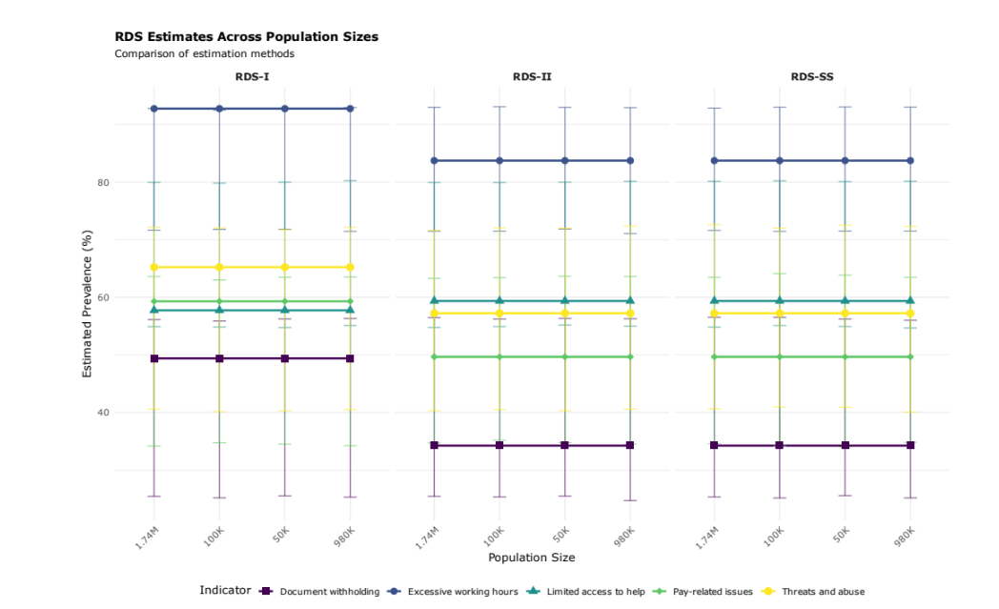

ESM_4 Fig1 RDS Sensitivity to Population Size: Comparison of RDS estimates across all population size scenarios. Each panel shows one RDS method with point estimates and 95% bootstrap confidence intervals varying by population size.

Model-Assisted Estimates by Population Size
ESM_4 Table2: Model-Assisted Estimates by Population Size and Seed Selection. Source: Authors’ Own Work.
 |  | Prevalence Estimates (95% CrI)
Seed Selection | Population Size | Document Withholding | Pay Issues | Excessive Hours | Threats/Abuse
sample | 50,000 | 34.1% (16.1%, 52.1%) | 49.3% (35.2%, 63.4%) | 84.0% (72.3%, 95.8%) | 57.1% (34.6%, 79.6%)
sample | 980,000 | 34.3% (16.4%, 52.2%) | 49.5% (35.6%, 63.5%) | 83.7% (71.9%, 95.6%) | 57.3% (35.4%, 79.3%)
sample | 1,740,000 | 34.3% (16.0%, 52.7%) | 49.1% (34.9%, 63.3%) | 83.8% (72.1%, 95.6%) | 57.0% (34.7%, 79.3%)
random | 50,000 | 34.1% (16.1%, 52.1%) | 49.3% (35.2%, 63.4%) | 84.0% (72.3%, 95.8%) | 57.1% (34.6%, 79.6%)
random | 980,000 | 34.3% (16.4%, 52.2%) | 49.5% (35.6%, 63.5%) | 83.7% (71.9%, 95.6%) | 57.3% (35.4%, 79.3%)
random | 1,740,000 | 34.3% (16.0%, 52.7%) | 49.1% (34.9%, 63.3%) | 83.8% (72.1%, 95.6%) | 57.0% (34.7%, 79.3%)
degree | 50,000 | 34.1% (16.1%, 52.1%) | 49.3% (35.2%, 63.4%) | 84.0% (72.3%, 95.8%) | 57.1% (34.6%, 79.6%)
degree | 980,000 | 34.3% (16.4%, 52.2%) | 49.5% (35.6%, 63.5%) | 83.7% (71.9%, 95.6%) | 57.3% (35.4%, 79.3%)
degree | 1,740,000 | 34.3% (16.0%, 52.7%) | 49.1% (34.9%, 63.3%) | 83.8% (72.1%, 95.6%) | 57.0% (34.7%, 79.3%)
Note: Model-Assisted estimates from Gile & Handcock (2015) Bayesian inference. CrI = Credible Interval from posterior distribution.

Model-Assisted Sensitivity Analysis
This section presents comprehensive sensitivity analysis for Model-Assisted inference estimates across all exploitation indicators, examining robustness to population size assumptions and seed selection methods. ESM_4 Fig2 and ESM_4 Fig3 show MA estimates are robust to these parameter choices.

ESM_4 Table3 Model-Assisted Sensitivity Analysis: Point estimates and 95% credible intervals across all parameter combinations. Estimates from Gile & Handcock (2015) Bayesian Model-Assisted inference.
label | Degree: 50K | Random: 50K | Sample: 50K | Degree: 980K | Random: 980K | Sample: 980K | Degree: 1.74M | Random: 1.74M | Sample: 1.74M
Document Withholding | 34.1% (16.1-52.1%) | 34.1% (16.1-52.1%) | 34.1% (16.1-52.1%) | 34.3% (16.4-52.2%) | 34.3% (16.4-52.2%) | 34.3% (16.4-52.2%) | 34.3% (16.0-52.7%) | 34.3% (16.0-52.7%) | 34.3% (16.0-52.7%)
Pay-Related Issues | 49.3% (35.2-63.4%) | 49.3% (35.2-63.4%) | 49.3% (35.2-63.4%) | 49.5% (35.6-63.5%) | 49.5% (35.6-63.5%) | 49.5% (35.6-63.5%) | 49.1% (34.9-63.3%) | 49.1% (34.9-63.3%) | 49.1% (34.9-63.3%)
Threats/Abuse | 57.1% (34.6-79.6%) | 57.1% (34.6-79.6%) | 57.1% (34.6-79.6%) | 57.3% (35.4-79.3%) | 57.3% (35.4-79.3%) | 57.3% (35.4-79.3%) | 57.0% (34.7-79.3%) | 57.0% (34.7-79.3%) | 57.0% (34.7-79.3%)
Excessive Hours | 84.0% (72.3-95.8%) | 84.0% (72.3-95.8%) | 84.0% (72.3-95.8%) | 83.7% (71.9-95.6%) | 83.7% (71.9-95.6%) | 83.7% (71.9-95.6%) | 83.8% (72.1-95.6%) | 83.8% (72.1-95.6%) | 83.8% (72.1-95.6%)
Limited Access to Help | 58.2% (46.0-70.4%) | 58.2% (46.0-70.4%) | 58.2% (46.0-70.4%) | 58.3% (46.1-70.6%) | 58.3% (46.1-70.6%) | 58.3% (46.1-70.6%) | 58.4% (46.2-70.7%) | 58.4% (46.2-70.7%) | 58.4% (46.2-70.7%)
Any Exploitation | 94.9% (61.5-100.0%) | 94.9% (61.5-100.0%) | 94.9% (61.5-100.0%) | 95.0% (62.2-100.0%) | 95.0% (62.2-100.0%) | 95.0% (62.2-100.0%) | 94.8% (59.2-100.0%) | 94.8% (59.2-100.0%) | 94.8% (59.2-100.0%)
Note: Estimates from Gile & Handcock (2015) Bayesian Model-Assisted inference. Population sizes: 50K, 100K, 980K, 1.74M domestic workers. Seed methods: Degree (by network degree), Random, Sample (from data). CrI = Bayesian credible interval.

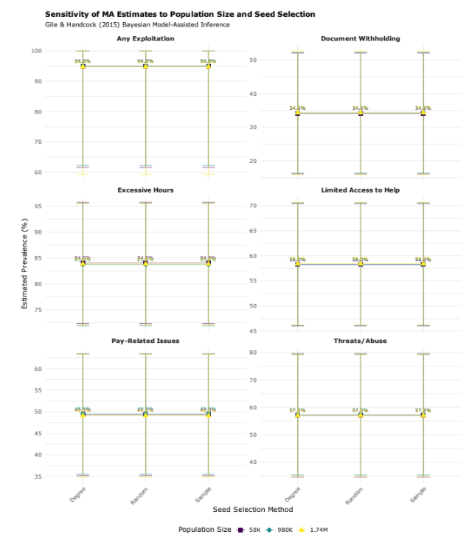

ESM_4 Fig2 Model-Assisted Sensitivity by Population Size and Seed Selection: Point estimates with 95% credible intervals for each exploitation indicator across all parameter combinations. Each panel shows one indicator with estimates varying by population size (color) and seed selection method (shape).

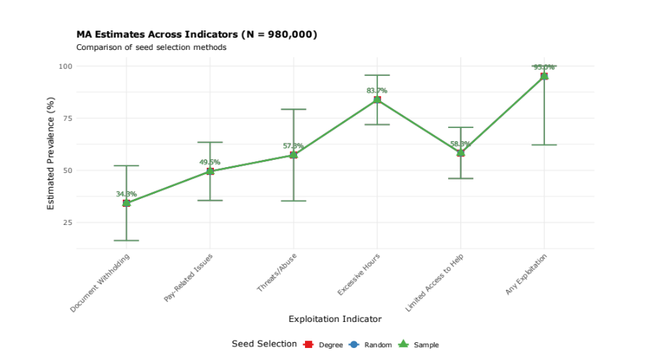
ESM_4 Fig3 Model-Assisted Point Estimate Comparison: Direct comparison of point estimates across all indicators, fixing population size at 980K. Lines connect estimates using the same seed selection method, showing consistency across indicators.

NSUM Sensitivity Analysis
The NSUM estimates presented in the main text used neighborhood bootstrap resampling, Sequential Sampling weights, and the Modified Basic Scale-Up (MBSU) estimator with a population size of 980,000. To assess the robustness of these findings, we conducted comprehensive sensitivity analyses varying four key methodological choices: (1) bootstrap method, (2) weighting scheme, (3) population size assumption, and (4) NSUM estimator specification.

Sensitivity to Bootstrap Method
We compared four bootstrap resampling approaches: neighborhood bootstrap, tree bootstrap, chain bootstrap, and sequential sampling bootstrap. As shown in ESM_4 Table 4, all methods produce nearly identical point estimates, with variation only in confidence interval widths. This demonstrates that our findings are robust to the choice of bootstrap method, with the neighborhood bootstrap providing slightly more conservative (wider) confidence intervals than alternative approaches.

ESM_4 Table 4: Sensitivity Analysis: Bootstrap Method Comparison. All estimates use SS weights, N=980,000, and MBSU (Moderate) adjustment. Source: Authors’ Own Work.
Bootstrap Method | Outcome | Point Estimate | 95% CI Lower | 95% CI Upper | Prevalence (%)
chain | Access to Help | 19,885.25 | 9,065.943 | 46,394.68 | 2.03% (0.93% - 4.73%)
neighboot | Access to Help | 19,885.25 | 6,539.872 | 47,818.24 | 2.03% (0.67% - 4.88%)
ss | Access to Help | 19,885.25 | 9,724.907 | 45,652.08 | 2.03% (0.99% - 4.66%)
tree | Access to Help | 19,885.25 | 9,384.441 | 44,972.27 | 2.03% (0.96% - 4.59%)
chain | Document Withholding | 10,614.74 | 4,208.011 | 27,779.56 | 1.08% (0.43% - 2.83%)
neighboot | Document Withholding | 10,614.74 | 2,905.123 | 30,651.82 | 1.08% (0.30% - 3.13%)
ss | Document Withholding | 10,614.74 | 4,043.849 | 27,114.03 | 1.08% (0.41% - 2.77%)
tree | Document Withholding | 10,614.74 | 4,442.185 | 26,596.79 | 1.08% (0.45% - 2.71%)
chain | Excessive Hours | 29,248.47 | 20,279.843 | 52,819.48 | 2.98% (2.07% - 5.39%)
neighboot | Excessive Hours | 29,248.47 | 18,064.258 | 53,994.30 | 2.98% (1.84% - 5.51%)
ss | Excessive Hours | 29,248.47 | 20,828.321 | 51,614.84 | 2.98% (2.13% - 5.27%)
tree | Excessive Hours | 29,248.47 | 20,516.331 | 52,876.12 | 2.98% (2.09% - 5.40%)
chain | Pay Issues | 28,182.36 | 19,510.454 | 49,813.16 | 2.88% (1.99% - 5.08%)
neighboot | Pay Issues | 28,182.36 | 18,621.784 | 55,708.78 | 2.88% (1.90% - 5.68%)
ss | Pay Issues | 28,182.36 | 20,207.083 | 48,369.21 | 2.88% (2.06% - 4.94%)
tree | Pay Issues | 28,182.36 | 20,147.528 | 49,462.95 | 2.88% (2.06% - 5.05%)
chain | Threats/Abuse | 26,328.26 | 18,812.507 | 47,540.65 | 2.69% (1.92% - 4.85%)
neighboot | Threats/Abuse | 26,328.26 | 18,179.435 | 57,424.35 | 2.69% (1.86% - 5.86%)
ss | Threats/Abuse | 26,328.26 | 18,859.240 | 44,641.39 | 2.69% (1.92% - 4.56%)
tree | Threats/Abuse | 26,328.26 | 18,678.408 | 46,053.23 | 2.69% (1.91% - 4.70%)
Note: All estimates use Sequential Sampling weights, population size of 980,000, and MBSU estimator with moderate adjustments (δ=0.9, τ=0.85).

Sensitivity to Weight Method
We compared Volz-Heckathorn (VH) and Sequential Sampling (SS) weighting schemes ESM_4 Table5. Results were identical for both methods, as both approaches appropriately account for the RDS sampling design and degree-based inclusion probabilities. This validates our choice of SS weights for the main analysis.

ESM_4 Table5 Sensitivity Analysis: Weight Method Comparison. All estimates use neighborhood bootstrap, N=980,000, and MBSU (Moderate) adjustment. Source: Authors’ Own Work.
Weight Method | Outcome | Point Estimate | 95% CI Lower | 95% CI Upper | Prevalence (%)
SS | Access to Help | 19,885.25 | 6,539.872 | 47,818.24 | 2.03% (0.67% - 4.88%)
VH | Access to Help | 19,885.25 | 6,539.872 | 47,818.24 | 2.03% (0.67% - 4.88%)
SS | Document Withholding | 10,614.74 | 2,905.123 | 30,651.82 | 1.08% (0.30% - 3.13%)
VH | Document Withholding | 10,614.74 | 2,905.123 | 30,651.82 | 1.08% (0.30% - 3.13%)
SS | Excessive Hours | 29,248.47 | 18,064.258 | 53,994.30 | 2.98% (1.84% - 5.51%)
VH | Excessive Hours | 29,248.47 | 18,064.258 | 53,994.30 | 2.98% (1.84% - 5.51%)
SS | Pay Issues | 28,182.36 | 18,621.784 | 55,708.78 | 2.88% (1.90% - 5.68%)
VH | Pay Issues | 28,182.36 | 18,621.784 | 55,708.78 | 2.88% (1.90% - 5.68%)
SS | Threats/Abuse | 26,328.26 | 18,179.435 | 57,424.35 | 2.69% (1.86% - 5.86%)
VH | Threats/Abuse | 26,328.26 | 18,179.435 | 57,424.35 | 2.69% (1.86% - 5.86%)
Note: VH = Volz-Heckathorn weights; SS = Sequential Sampling weights. Both methods produce identical estimates as expected for RDS data.

Sensitivity to Population Size
We tested four population size scenarios: 50,000, 100,000, 980,000, and 1,740,000 (ESM_4 Table 6). As expected, absolute counts scaled linearly with population size assumptions, while prevalence rates remained constant. This validates our estimation approach and demonstrates that the choice of population size affects the scale but not the proportional prevalence estimates.

ESM_4 Table 6 Sensitivity Analysis: Population Size Comparison. All estimates use neighborhood bootstrap, SS weights, and MBSU (Moderate) adjustment. Source: Authors’ Own Work.
Population Size | Outcome | Point Estimate | 95% CI Lower | 95% CI Upper | Prevalence (%)
50,000 | Access to Help | 1,014.5535 | 333.6670 | 2,439.706 | 2.03% (0.67% - 4.88%)
100,000 | Access to Help | 2,029.1070 | 667.3339 | 4,879.412 | 2.03% (0.67% - 4.88%)
980,000 | Access to Help | 19,885.2490 | 6,539.8722 | 47,818.238 | 2.03% (0.67% - 4.88%)
1,740,000 | Access to Help | 35,306.4626 | 11,611.6099 | 84,901.769 | 2.03% (0.67% - 4.88%)
50,000 | Document Withholding | 541.5682 | 148.2205 | 1,563.868 | 1.08% (0.30% - 3.13%)
100,000 | Document Withholding | 1,083.1364 | 296.4411 | 3,127.737 | 1.08% (0.30% - 3.13%)
980,000 | Document Withholding | 10,614.7367 | 2,905.1225 | 30,651.818 | 1.08% (0.30% - 3.13%)
1,740,000 | Document Withholding | 18,846.5733 | 5,158.0747 | 54,422.616 | 1.08% (0.30% - 3.13%)
50,000 | Excessive Hours | 1,492.2687 | 921.6458 | 2,754.811 | 2.98% (1.84% - 5.51%)
100,000 | Excessive Hours | 2,984.5374 | 1,843.2916 | 5,509.622 | 2.98% (1.84% - 5.51%)
980,000 | Excessive Hours | 29,248.4665 | 18,064.2575 | 53,994.296 | 2.98% (1.84% - 5.51%)
1,740,000 | Excessive Hours | 51,930.9508 | 32,073.2736 | 95,867.424 | 2.98% (1.84% - 5.51%)
50,000 | Pay Issues | 1,437.8754 | 950.0910 | 2,842.285 | 2.88% (1.90% - 5.68%)
100,000 | Pay Issues | 2,875.7508 | 1,900.1821 | 5,684.569 | 2.88% (1.90% - 5.68%)
980,000 | Pay Issues | 28,182.3576 | 18,621.7844 | 55,708.778 | 2.88% (1.90% - 5.68%)
1,740,000 | Pay Issues | 50,038.0635 | 33,063.1682 | 98,911.504 | 2.88% (1.90% - 5.68%)
50,000 | Threats/Abuse | 1,343.2783 | 927.5222 | 2,929.814 | 2.69% (1.86% - 5.86%)
100,000 | Threats/Abuse | 2,686.5566 | 1,855.0444 | 5,859.628 | 2.69% (1.86% - 5.86%)
980,000 | Threats/Abuse | 26,328.2551 | 18,179.4355 | 57,424.355 | 2.69% (1.86% - 5.86%)
1,740,000 | Threats/Abuse | 46,746.0856 | 32,277.7732 | 101,957.527 | 2.69% (1.86% - 5.86%)
Note: Prevalence rates remain constant across population sizes, demonstrating validity of estimation approach. We use N=980,000 as our baseline estimate of UK domestic worker population.

Sensitivity to NSUM Method and Adjustment Factors
The choice of NSUM estimator and adjustment factors had substantial impact on estimates (ESM_4 Table7). We compared MBSU with three adjustment factor sets (no adjustment, moderate, conservative) and GNSUM Symmetric estimation. GNSUM estimates matched MBSU (No Adjustment) exactly for all indicators, while conservative MBSU adjustments (δ\(\delta=0.8\) τ\(\tau=0.7\)) produced estimates approximately 1.8 times higher than unadjusted estimates. Moderate adjustments (δ=0.9, τ=0.85) provided intermediate values approximately 1.3 times higher than baseline, representing our preferred specification that acknowledges likely visibility and reporting barriers while avoiding extreme assumptions.

ESM_4 Table7 Sensitivity Analysis: NSUM Method and Adjustment Factor Comparison. All estimates use neighborhood bootstrap, SS weights, and N=980,000. Source: Authors’ Own Work.
NSUM Method | Outcome | Point Estimate | 95% CI Lower | 95% CI Upper | Prevalence (%)
GNSUM Symmetric
GNSUM Symmetric | Access to Help | 15,212.216 | 5,003.002 | 36,580.95 | 1.55% (0.51% - 3.73%)
MBSU (Conservative) | Access to Help | 27,164.671 | 8,933.933 | 65,323.13 | 2.77% (0.91% - 6.67%)
MBSU (Moderate) | Access to Help | 19,885.249 | 6,539.872 | 47,818.24 | 2.03% (0.67% - 4.88%)
MBSU (No Adjustment) | Access to Help | 15,212.216 | 5,003.002 | 36,580.95 | 1.55% (0.51% - 3.73%)
GNSUM Symmetric | Document Withholding | 8,120.274 | 2,222.419 | 23,448.64 | 0.83% (0.23% - 2.39%)
MBSU Conservative (δ=0.8, τ=0.7)
MBSU (Conservative) | Document Withholding | 14,500.488 | 3,968.605 | 41,872.57 | 1.48% (0.40% - 4.27%)
MBSU (Moderate) | Document Withholding | 10,614.737 | 2,905.123 | 30,651.82 | 1.08% (0.30% - 3.13%)
MBSU (No Adjustment) | Document Withholding | 8,120.274 | 2,222.419 | 23,448.64 | 0.83% (0.23% - 2.39%)
GNSUM Symmetric | Excessive Hours | 22,375.077 | 13,819.157 | 41,305.64 | 2.28% (1.41% - 4.21%)
MBSU (Conservative) | Excessive Hours | 39,955.494 | 24,677.066 | 73,760.07 | 4.08% (2.52% - 7.53%)
MBSU Moderate (δ=0.9, τ=0.85)
MBSU (Moderate) | Excessive Hours | 29,248.467 | 18,064.258 | 53,994.30 | 2.98% (1.84% - 5.51%)
MBSU (No Adjustment) | Excessive Hours | 22,375.077 | 13,819.157 | 41,305.64 | 2.28% (1.41% - 4.21%)
GNSUM Symmetric | Pay Issues | 21,559.504 | 14,245.665 | 42,617.22 | 2.20% (1.45% - 4.35%)
MBSU (Conservative) | Pay Issues | 38,499.114 | 25,438.688 | 76,102.17 | 3.93% (2.60% - 7.77%)
MBSU (Moderate) | Pay Issues | 28,182.358 | 18,621.784 | 55,708.78 | 2.88% (1.90% - 5.68%)
MBSU No Adjustment (δ=1.0, τ=1.0)
MBSU (No Adjustment) | Pay Issues | 21,559.504 | 14,245.665 | 42,617.22 | 2.20% (1.45% - 4.35%)
GNSUM Symmetric | Threats/Abuse | 20,141.115 | 13,907.268 | 43,929.63 | 2.06% (1.42% - 4.48%)
MBSU (Conservative) | Threats/Abuse | 35,966.277 | 24,834.407 | 78,445.77 | 3.67% (2.53% - 8.00%)
MBSU (Moderate) | Threats/Abuse | 26,328.255 | 18,179.435 | 57,424.35 | 2.69% (1.86% - 5.86%)
MBSU (No Adjustment) | Threats/Abuse | 20,141.115 | 13,907.268 | 43,929.63 | 2.06% (1.42% - 4.48%)
Note: MBSU = Modified Basic Scale-Up; GNSUM = Generalized Network Scale-Up Method; δ = degree ratio (network size differences); τ = visibility/true positive rate (transmission and reporting accuracy). Adjustment factors control for network degree differences and visibility/reporting biases in network-based estimation.

Summary of Sensitivity Analyses
Across all 64 parameter combinations tested (4 bootstrap methods × 4 population sizes × 2 weight methods × 2 NSUM methods), prevalence estimates ranged from 0.83% to 4.08% for the five exploitation indicators. The most important source of variation was the choice of adjustment factors, with conservative adjustments producing estimates up to twice as high as unadjusted estimates. Bootstrap method, weight scheme, and population size assumptions had minimal impact on prevalence rates, demonstrating the robustness of our findings to these methodological choices.
For the main text analysis, we selected neighborhood bootstrap (providing conservative confidence intervals), SS weights (standard for RDS data), N=980,000 (based on EU labor force data), and MBSU with moderate adjustments (acknowledging likely barriers while avoiding extreme assumptions). This specification provides credible estimates while acknowledging uncertainty and avoiding both overly optimistic and overly pessimistic scenarios.

