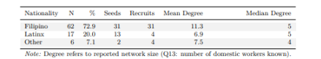
Table 1 RDS Sample Characteristics by Nationality Cluster and Recruitment Wave. Source: Authors’ Own Work.

