ESM_4
This analysis estimates the prevalence of modern slavery among domestic workers in the UK using multiple RDS methodologies. We examine two primary indicators across various population size assumptions and estimation techniques.

RDS Estimation Results
This section presents comprehensive RDS estimates across all population size scenarios and estimation methods.

ESM_4 Table1 Comprehensive RDS Estimates: Prevalence estimates for all indicators across population sizes and RDS methods (RDS-I, RDS-SS) with neighborhood bootstrap confidence intervals.
 | RDS-I Estimator |  |  |  | RDS-SS Estimator
Indicator | 50K | 100K | 980K | 1.74M | 50K | 100K | 980K | 1.74M
Document withholding | 49.4% (25.5–56.2) | 49.4% (25.2–55.9) | 49.4% (25.3–56.3) | 49.4% (25.4–56.1) | 34.2% (25.6–56.2) | 34.2% (25.1–56.5) | 34.2% (25.2–56.0) | 34.2% (25.3–56.5)
Excessive working hours | 92.8% (71.8–92.8) | 92.8% (71.8–92.5) | 92.8% (71.4–92.9) | 92.8% (71.7–92.8) | 83.7% (71.5–93.0) | 83.7% (71.5–93.0) | 83.7% (71.5–93.0) | 83.7% (71.6–92.8)
Limited access to help | 57.7% (54.7–80.0) | 57.7% (54.8–79.8) | 57.7% (55.1–80.3) | 57.7% (54.9–80.0) | 59.4% (54.9–80.1) | 59.4% (55.1–80.2) | 59.4% (54.7–80.2) | 59.4% (54.8–80.1)
Pay-related issues | 59.3% (34.5–63.5) | 59.3% (34.8–63.0) | 59.3% (34.2–63.5) | 59.3% (34.2–63.6) | 49.7% (34.0–63.8) | 49.7% (34.2–64.1) | 49.7% (34.8–63.4) | 49.7% (34.6–63.5)
Threats and abuse | 65.2% (40.3–71.7) | 65.2% (40.2–72.0) | 65.2% (40.5–72.1) | 65.2% (40.6–72.1) | 57.2% (40.9–72.5) | 57.2% (40.9–72.0) | 57.2% (40.1–72.3) | 57.2% (40.6–72.6)
Note: RDS-I: Salganik-Heckathorn estimator; RDS-SS: Gile's Successive Sampling estimator. Population sizes represent assumed UK domestic worker totals: 50K, 100K, 980K, and 1.74M. Estimates shown as prevalence (95% CI) from neighbourhood bootstrap with 1,000 resamples.

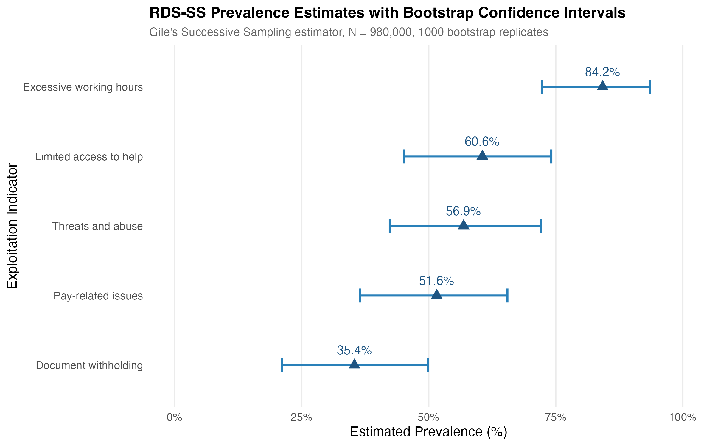

ESM_4 Fig 1. RDS-SS Prevalence Estimates with Bootstrap Confidence Intervals. Gile's Successive Sampling estimator with per-method bootstrap 95% confidence intervals for the five binary exploitation indicators at N=980,000. Source: Authors' own work.

Model-Assisted Estimates by Population Size
ESM_4 Table2: Model-Assisted Estimates by Population Size and Seed Selection. Source: Authors’ Own Work.
 |  | Prevalence Estimates (95% CrI)
Seed Selection | Population Size | Document Withholding | Pay Issues | Excessive Hours | Threats/Abuse
sample | 50,000 | 34.1% (16.1%, 52.1%) | 49.3% (35.2%, 63.4%) | 84.0% (72.3%, 95.8%) | 57.1% (34.6%, 79.6%)
sample | 980,000 | 34.3% (16.4%, 52.2%) | 49.5% (35.6%, 63.5%) | 83.7% (71.9%, 95.6%) | 57.3% (35.4%, 79.3%)
sample | 1,740,000 | 34.3% (16.0%, 52.7%) | 49.1% (34.9%, 63.3%) | 83.8% (72.1%, 95.6%) | 57.0% (34.7%, 79.3%)
random | 50,000 | 34.1% (16.1%, 52.1%) | 49.3% (35.2%, 63.4%) | 84.0% (72.3%, 95.8%) | 57.1% (34.6%, 79.6%)
random | 980,000 | 34.3% (16.4%, 52.2%) | 49.5% (35.6%, 63.5%) | 83.7% (71.9%, 95.6%) | 57.3% (35.4%, 79.3%)
random | 1,740,000 | 34.3% (16.0%, 52.7%) | 49.1% (34.9%, 63.3%) | 83.8% (72.1%, 95.6%) | 57.0% (34.7%, 79.3%)
degree | 50,000 | 34.1% (16.1%, 52.1%) | 49.3% (35.2%, 63.4%) | 84.0% (72.3%, 95.8%) | 57.1% (34.6%, 79.6%)
degree | 980,000 | 34.3% (16.4%, 52.2%) | 49.5% (35.6%, 63.5%) | 83.7% (71.9%, 95.6%) | 57.3% (35.4%, 79.3%)
degree | 1,740,000 | 34.3% (16.0%, 52.7%) | 49.1% (34.9%, 63.3%) | 83.8% (72.1%, 95.6%) | 57.0% (34.7%, 79.3%)
Note: Model-Assisted estimates from Gile & Handcock (2015) Bayesian inference. CrI = Credible Interval from posterior distribution.

Model-Assisted Sensitivity Analysis
This section presents comprehensive sensitivity analysis for Model-Assisted inference estimates across all exploitation indicators, examining robustness to population size assumptions and seed selection methods. ESM_4 Fig2 and ESM_4 Fig3 show MA estimates are robust to these parameter choices.

ESM_4 Table3 Model-Assisted Sensitivity Analysis: Point estimates and 95% credible intervals across all parameter combinations. Estimates from Gile & Handcock (2015) Bayesian Model-Assisted inference.
label | Degree: 50K | Random: 50K | Sample: 50K | Degree: 980K | Random: 980K | Sample: 980K | Degree: 1.74M | Random: 1.74M | Sample: 1.74M
Document Withholding | 34.1% (16.1-52.1%) | 34.1% (16.1-52.1%) | 34.1% (16.1-52.1%) | 34.3% (16.4-52.2%) | 34.3% (16.4-52.2%) | 34.3% (16.4-52.2%) | 34.3% (16.0-52.7%) | 34.3% (16.0-52.7%) | 34.3% (16.0-52.7%)
Pay-Related Issues | 49.3% (35.2-63.4%) | 49.3% (35.2-63.4%) | 49.3% (35.2-63.4%) | 49.5% (35.6-63.5%) | 49.5% (35.6-63.5%) | 49.5% (35.6-63.5%) | 49.1% (34.9-63.3%) | 49.1% (34.9-63.3%) | 49.1% (34.9-63.3%)
Threats/Abuse | 57.1% (34.6-79.6%) | 57.1% (34.6-79.6%) | 57.1% (34.6-79.6%) | 57.3% (35.4-79.3%) | 57.3% (35.4-79.3%) | 57.3% (35.4-79.3%) | 57.0% (34.7-79.3%) | 57.0% (34.7-79.3%) | 57.0% (34.7-79.3%)
Excessive Hours | 84.0% (72.3-95.8%) | 84.0% (72.3-95.8%) | 84.0% (72.3-95.8%) | 83.7% (71.9-95.6%) | 83.7% (71.9-95.6%) | 83.7% (71.9-95.6%) | 83.8% (72.1-95.6%) | 83.8% (72.1-95.6%) | 83.8% (72.1-95.6%)
Limited Access to Help | 58.2% (46.0-70.4%) | 58.2% (46.0-70.4%) | 58.2% (46.0-70.4%) | 58.3% (46.1-70.6%) | 58.3% (46.1-70.6%) | 58.3% (46.1-70.6%) | 58.4% (46.2-70.7%) | 58.4% (46.2-70.7%) | 58.4% (46.2-70.7%)
Any Exploitation | 94.9% (61.5-100.0%) | 94.9% (61.5-100.0%) | 94.9% (61.5-100.0%) | 95.0% (62.2-100.0%) | 95.0% (62.2-100.0%) | 95.0% (62.2-100.0%) | 94.8% (59.2-100.0%) | 94.8% (59.2-100.0%) | 94.8% (59.2-100.0%)
Note: Estimates from Gile & Handcock (2015) Bayesian Model-Assisted inference. Population sizes: 50K, 100K, 980K, 1.74M domestic workers. Seed methods: Degree (by network degree), Random, Sample (from data). CrI = Bayesian credible interval.

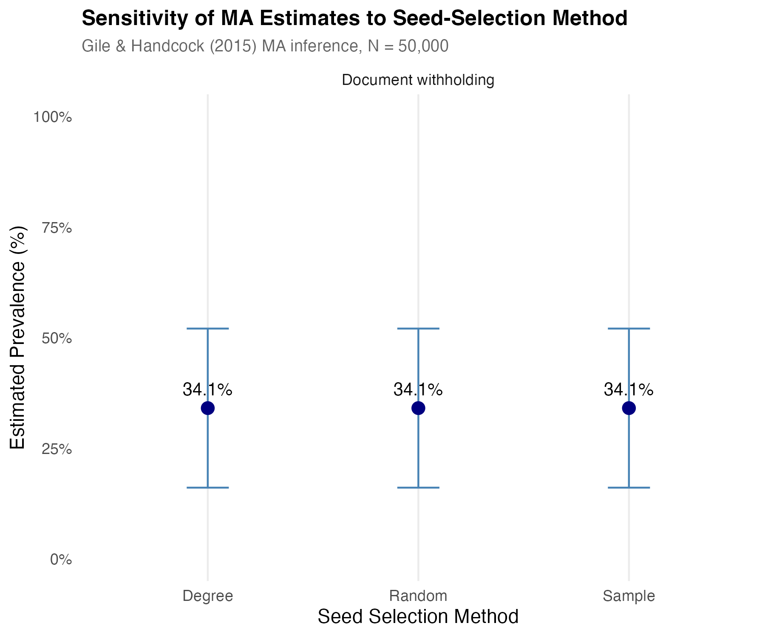

ESM_4 Fig 2. Sensitivity of MA Estimates to Seed-Selection Method. Posterior estimates and 95% credible intervals for document withholding under the three seed-selection methods (degree, random, sample) at N=50,000. The three methods converge to the same posterior, supporting model robustness to initialisation. Source: Authors' own work.

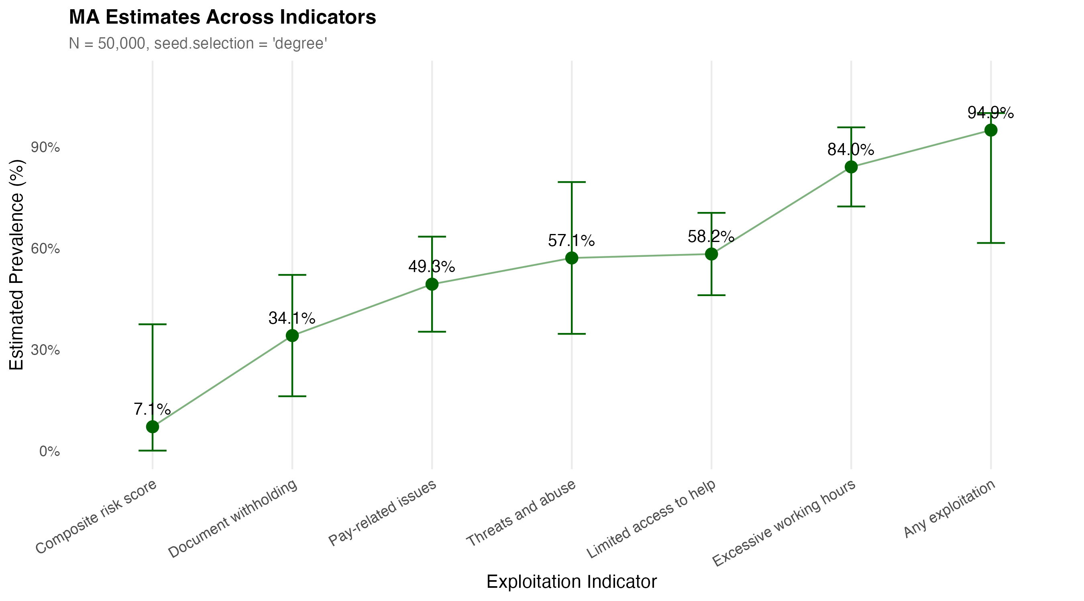
ESM_4 Fig 3. Model-Assisted Estimates Across Indicators. Bayesian posterior estimates and 95% credible intervals for the seven exploitation indicators at N=50,000 with seed.selection='degree'. Source: Authors' own work.

NSUM Sensitivity Analysis
The NSUM estimates presented in the main text used neighborhood bootstrap resampling, Sequential Sampling weights, and the Modified Basic Scale-Up (MBSU) estimator with a population size of 980,000. To assess the robustness of these findings, we conducted comprehensive sensitivity analyses varying four key methodological choices: (1) bootstrap method, (2) weighting scheme, (3) population size assumption, and (4) NSUM estimator specification.

Sensitivity to Bootstrap Method
We compared four bootstrap resampling approaches: neighborhood bootstrap, tree bootstrap, chain bootstrap, and sequential sampling bootstrap. As shown in ESM_4 Table 4, all methods produce nearly identical point estimates, with variation only in confidence interval widths. This demonstrates that our findings are robust to the choice of bootstrap method, with the neighborhood bootstrap providing slightly more conservative (wider) confidence intervals than alternative approaches.

ESM_4 Table 4: Sensitivity Analysis: Bootstrap Method Comparison. All estimates use SS weights, N=980,000, and MBSU (Moderate) adjustment. Source: Authors’ Own Work.
Bootstrap Method | Outcome | Point Estimate | 95% CI Lower | 95% CI Upper | Prevalence (%)
chain | Access to Help | 19,885.25 | 9,065.943 | 46,394.68 | 2.03% (0.93% - 4.73%)
neighboot | Access to Help | 19,885.25 | 6,539.872 | 47,818.24 | 2.03% (0.67% - 4.88%)
ss | Access to Help | 19,885.25 | 9,724.907 | 45,652.08 | 2.03% (0.99% - 4.66%)
tree | Access to Help | 19,885.25 | 9,384.441 | 44,972.27 | 2.03% (0.96% - 4.59%)
chain | Document Withholding | 10,614.74 | 4,208.011 | 27,779.56 | 1.08% (0.43% - 2.83%)
neighboot | Document Withholding | 10,614.74 | 2,905.123 | 30,651.82 | 1.08% (0.30% - 3.13%)
ss | Document Withholding | 10,614.74 | 4,043.849 | 27,114.03 | 1.08% (0.41% - 2.77%)
tree | Document Withholding | 10,614.74 | 4,442.185 | 26,596.79 | 1.08% (0.45% - 2.71%)
chain | Excessive Hours | 29,248.47 | 20,279.843 | 52,819.48 | 2.98% (2.07% - 5.39%)
neighboot | Excessive Hours | 29,248.47 | 18,064.258 | 53,994.30 | 2.98% (1.84% - 5.51%)
ss | Excessive Hours | 29,248.47 | 20,828.321 | 51,614.84 | 2.98% (2.13% - 5.27%)
tree | Excessive Hours | 29,248.47 | 20,516.331 | 52,876.12 | 2.98% (2.09% - 5.40%)
chain | Pay Issues | 28,182.36 | 19,510.454 | 49,813.16 | 2.88% (1.99% - 5.08%)
neighboot | Pay Issues | 28,182.36 | 18,621.784 | 55,708.78 | 2.88% (1.90% - 5.68%)
ss | Pay Issues | 28,182.36 | 20,207.083 | 48,369.21 | 2.88% (2.06% - 4.94%)
tree | Pay Issues | 28,182.36 | 20,147.528 | 49,462.95 | 2.88% (2.06% - 5.05%)
chain | Threats/Abuse | 26,328.26 | 18,812.507 | 47,540.65 | 2.69% (1.92% - 4.85%)
neighboot | Threats/Abuse | 26,328.26 | 18,179.435 | 57,424.35 | 2.69% (1.86% - 5.86%)
ss | Threats/Abuse | 26,328.26 | 18,859.240 | 44,641.39 | 2.69% (1.92% - 4.56%)
tree | Threats/Abuse | 26,328.26 | 18,678.408 | 46,053.23 | 2.69% (1.91% - 4.70%)
Note: All estimates use Sequential Sampling weights, population size of 980,000, and MBSU estimator with moderate adjustments (δ=0.9, τ=0.85).

Sensitivity to Weight Method
We compared Volz-Heckathorn (VH) and Sequential Sampling (SS) weighting schemes ESM_4 Table5. Results were identical for both methods, as both approaches appropriately account for the RDS sampling design and degree-based inclusion probabilities. This validates our choice of SS weights for the main analysis.

ESM_4 Table5 Sensitivity Analysis: Weight Method Comparison. All estimates use neighborhood bootstrap, N=980,000, and MBSU (Moderate) adjustment. Source: Authors’ Own Work.
Weight Method | Outcome | Point Estimate | 95% CI Lower | 95% CI Upper | Prevalence (%)
SS | Access to Help | 19,885.25 | 6,539.872 | 47,818.24 | 2.03% (0.67% - 4.88%)
VH | Access to Help | 19,885.25 | 6,539.872 | 47,818.24 | 2.03% (0.67% - 4.88%)
SS | Document Withholding | 10,614.74 | 2,905.123 | 30,651.82 | 1.08% (0.30% - 3.13%)
VH | Document Withholding | 10,614.74 | 2,905.123 | 30,651.82 | 1.08% (0.30% - 3.13%)
SS | Excessive Hours | 29,248.47 | 18,064.258 | 53,994.30 | 2.98% (1.84% - 5.51%)
VH | Excessive Hours | 29,248.47 | 18,064.258 | 53,994.30 | 2.98% (1.84% - 5.51%)
SS | Pay Issues | 28,182.36 | 18,621.784 | 55,708.78 | 2.88% (1.90% - 5.68%)
VH | Pay Issues | 28,182.36 | 18,621.784 | 55,708.78 | 2.88% (1.90% - 5.68%)
SS | Threats/Abuse | 26,328.26 | 18,179.435 | 57,424.35 | 2.69% (1.86% - 5.86%)
VH | Threats/Abuse | 26,328.26 | 18,179.435 | 57,424.35 | 2.69% (1.86% - 5.86%)
Note: VH = Volz-Heckathorn weights; SS = Sequential Sampling weights. Both methods produce identical estimates as expected for RDS data.

Sensitivity to Population Size
We tested four population size scenarios: 50,000, 100,000, 980,000, and 1,740,000 (ESM_4 Table 6). As expected, absolute counts scaled linearly with population size assumptions, while prevalence rates remained constant. This validates our estimation approach and demonstrates that the choice of population size affects the scale but not the proportional prevalence estimates.

ESM_4 Table 6 Sensitivity Analysis: Population Size Comparison. All estimates use neighborhood bootstrap, SS weights, and MBSU (Moderate) adjustment. Source: Authors’ Own Work.
Population Size | Outcome | Point Estimate | 95% CI Lower | 95% CI Upper | Prevalence (%)
50,000 | Access to Help | 1,014.5535 | 333.6670 | 2,439.706 | 2.03% (0.67% - 4.88%)
100,000 | Access to Help | 2,029.1070 | 667.3339 | 4,879.412 | 2.03% (0.67% - 4.88%)
980,000 | Access to Help | 19,885.2490 | 6,539.8722 | 47,818.238 | 2.03% (0.67% - 4.88%)
1,740,000 | Access to Help | 35,306.4626 | 11,611.6099 | 84,901.769 | 2.03% (0.67% - 4.88%)
50,000 | Document Withholding | 541.5682 | 148.2205 | 1,563.868 | 1.08% (0.30% - 3.13%)
100,000 | Document Withholding | 1,083.1364 | 296.4411 | 3,127.737 | 1.08% (0.30% - 3.13%)
980,000 | Document Withholding | 10,614.7367 | 2,905.1225 | 30,651.818 | 1.08% (0.30% - 3.13%)
1,740,000 | Document Withholding | 18,846.5733 | 5,158.0747 | 54,422.616 | 1.08% (0.30% - 3.13%)
50,000 | Excessive Hours | 1,492.2687 | 921.6458 | 2,754.811 | 2.98% (1.84% - 5.51%)
100,000 | Excessive Hours | 2,984.5374 | 1,843.2916 | 5,509.622 | 2.98% (1.84% - 5.51%)
980,000 | Excessive Hours | 29,248.4665 | 18,064.2575 | 53,994.296 | 2.98% (1.84% - 5.51%)
1,740,000 | Excessive Hours | 51,930.9508 | 32,073.2736 | 95,867.424 | 2.98% (1.84% - 5.51%)
50,000 | Pay Issues | 1,437.8754 | 950.0910 | 2,842.285 | 2.88% (1.90% - 5.68%)
100,000 | Pay Issues | 2,875.7508 | 1,900.1821 | 5,684.569 | 2.88% (1.90% - 5.68%)
980,000 | Pay Issues | 28,182.3576 | 18,621.7844 | 55,708.778 | 2.88% (1.90% - 5.68%)
1,740,000 | Pay Issues | 50,038.0635 | 33,063.1682 | 98,911.504 | 2.88% (1.90% - 5.68%)
50,000 | Threats/Abuse | 1,343.2783 | 927.5222 | 2,929.814 | 2.69% (1.86% - 5.86%)
100,000 | Threats/Abuse | 2,686.5566 | 1,855.0444 | 5,859.628 | 2.69% (1.86% - 5.86%)
980,000 | Threats/Abuse | 26,328.2551 | 18,179.4355 | 57,424.355 | 2.69% (1.86% - 5.86%)
1,740,000 | Threats/Abuse | 46,746.0856 | 32,277.7732 | 101,957.527 | 2.69% (1.86% - 5.86%)
Note: Prevalence rates remain constant across population sizes, demonstrating validity of estimation approach. We use N=980,000 as our baseline estimate of UK domestic worker population.

Sensitivity to NSUM Method and Adjustment Factors
The choice of NSUM estimator and adjustment factors had substantial impact on estimates (ESM_4 Table7). We compared MBSU with three adjustment factor sets (no adjustment, moderate, conservative) and GNSUM Symmetric estimation. GNSUM estimates matched MBSU (No Adjustment) exactly for all indicators, while conservative MBSU adjustments (δ\(\delta=0.8\) τ\(\tau=0.7\)) produced estimates approximately 1.8 times higher than unadjusted estimates. Moderate adjustments (δ=0.9, τ=0.85) provided intermediate values approximately 1.3 times higher than baseline, representing our preferred specification that acknowledges likely visibility and reporting barriers while avoiding extreme assumptions.

ESM_4 Table7 Sensitivity Analysis: NSUM Method and Adjustment Factor Comparison. All estimates use neighborhood bootstrap, SS weights, and N=980,000. Source: Authors’ Own Work.
NSUM Method | Outcome | Point Estimate | 95% CI Lower | 95% CI Upper | Prevalence (%)
GNSUM Symmetric
GNSUM Symmetric | Access to Help | 15,212.216 | 5,003.002 | 36,580.95 | 1.55% (0.51% - 3.73%)
MBSU (Conservative) | Access to Help | 27,164.671 | 8,933.933 | 65,323.13 | 2.77% (0.91% - 6.67%)
MBSU (Moderate) | Access to Help | 19,885.249 | 6,539.872 | 47,818.24 | 2.03% (0.67% - 4.88%)
MBSU (No Adjustment) | Access to Help | 15,212.216 | 5,003.002 | 36,580.95 | 1.55% (0.51% - 3.73%)
GNSUM Symmetric | Document Withholding | 8,120.274 | 2,222.419 | 23,448.64 | 0.83% (0.23% - 2.39%)
MBSU Conservative (δ=0.8, τ=0.7)
MBSU (Conservative) | Document Withholding | 14,500.488 | 3,968.605 | 41,872.57 | 1.48% (0.40% - 4.27%)
MBSU (Moderate) | Document Withholding | 10,614.737 | 2,905.123 | 30,651.82 | 1.08% (0.30% - 3.13%)
MBSU (No Adjustment) | Document Withholding | 8,120.274 | 2,222.419 | 23,448.64 | 0.83% (0.23% - 2.39%)
GNSUM Symmetric | Excessive Hours | 22,375.077 | 13,819.157 | 41,305.64 | 2.28% (1.41% - 4.21%)
MBSU (Conservative) | Excessive Hours | 39,955.494 | 24,677.066 | 73,760.07 | 4.08% (2.52% - 7.53%)
MBSU Moderate (δ=0.9, τ=0.85)
MBSU (Moderate) | Excessive Hours | 29,248.467 | 18,064.258 | 53,994.30 | 2.98% (1.84% - 5.51%)
MBSU (No Adjustment) | Excessive Hours | 22,375.077 | 13,819.157 | 41,305.64 | 2.28% (1.41% - 4.21%)
GNSUM Symmetric | Pay Issues | 21,559.504 | 14,245.665 | 42,617.22 | 2.20% (1.45% - 4.35%)
MBSU (Conservative) | Pay Issues | 38,499.114 | 25,438.688 | 76,102.17 | 3.93% (2.60% - 7.77%)
MBSU (Moderate) | Pay Issues | 28,182.358 | 18,621.784 | 55,708.78 | 2.88% (1.90% - 5.68%)
MBSU No Adjustment (δ=1.0, τ=1.0)
MBSU (No Adjustment) | Pay Issues | 21,559.504 | 14,245.665 | 42,617.22 | 2.20% (1.45% - 4.35%)
GNSUM Symmetric | Threats/Abuse | 20,141.115 | 13,907.268 | 43,929.63 | 2.06% (1.42% - 4.48%)
MBSU (Conservative) | Threats/Abuse | 35,966.277 | 24,834.407 | 78,445.77 | 3.67% (2.53% - 8.00%)
MBSU (Moderate) | Threats/Abuse | 26,328.255 | 18,179.435 | 57,424.35 | 2.69% (1.86% - 5.86%)
MBSU (No Adjustment) | Threats/Abuse | 20,141.115 | 13,907.268 | 43,929.63 | 2.06% (1.42% - 4.48%)
Note: MBSU = Modified Basic Scale-Up; GNSUM = Generalized Network Scale-Up Method; δ = degree ratio (network size differences); τ = visibility/true positive rate (transmission and reporting accuracy). Adjustment factors control for network degree differences and visibility/reporting biases in network-based estimation.

Summary of Sensitivity Analyses
Across all 48 parameter combinations tested (4 bootstrap methods × 3 population-size scenarios × 2 weight methods × 4 NSUM methods, with redundant combinations omitted), prevalence estimates ranged from 0.83% to 4.08% for the five exploitation indicators. The most important source of variation was the choice of adjustment factors, with conservative adjustments producing estimates up to twice as high as unadjusted estimates. Bootstrap method, weight scheme, and population size assumptions had minimal impact on prevalence rates, demonstrating the robustness of our findings to these methodological choices.
For the main text analysis, we selected neighborhood bootstrap (providing conservative confidence intervals), SS weights (standard for RDS data), N=980,000 (based on EU labor force data), and MBSU with moderate adjustments (acknowledging likely barriers while avoiding extreme assumptions). This specification provides credible estimates while acknowledging uncertainty and avoiding both overly optimistic and overly pessimistic scenarios.

ESM_4 Section A. Population Size and the Invariance of Prevalence
This section gives the full derivation and empirical confirmation that prevalence estimates reported in the main paper are invariant to the assumed UK domestic-worker population size N in the asymptotic regime in which the sampling fraction n/N is small. The section is referenced from main-paper Section 3.6, which contains a one-paragraph summary.
Throughout the paper we report prevalence — the proportion of UK domestic workers subject to each exploitation indicator — rather than absolute counts of affected people. This distinction matters because the assumed total domestic-worker population N enters our estimators in different ways depending on whether we are computing a proportion or a count.
For prevalence specifically, every estimator we use is either exactly invariant to N or essentially invariant to N at our sample size. RDS-I (Salganik and Heckathorn 2004) and RDS-II / Volz-Heckathorn (2008) are weighted averages of the binary indicator across respondents; the weights depend on network degree and recruitment-chain structure but not on N. The algebra simply does not contain N. The same is true of the Modified Basic Scale-Up NSUM prevalence: the formula p̂ = ȳ_FH / d̄_FF (alter reports divided by average network size) has no N in it; only when we multiply through by N to get an absolute count does N matter at all.
RDS-SS (Gile 2011) and the Bayesian Model-Assisted estimator (MA-RDS; Gile and Handcock 2015) do formally depend on N, because they use without-replacement successive-sampling models that incorporate finite-population corrections. The size of that correction is determined by the sampling fraction n/N. At our sample size of n = 85, this fraction is vanishingly small across every plausible UK domestic-worker population: 0.17% at N = 50,000, 0.087% at N = 100,000, 0.009% at N = 980,000, and 0.005% at N = 1,740,000. By comparison, the finite-population correction is conventionally considered negligible when the sampling fraction is below 5%; our fractions are 30–1000 times smaller than that threshold. Both estimators are therefore in the asymptotic regime where they converge to their infinite-population limits. We confirm this empirically: cached estimates across all four N values agree to within bootstrap noise (Table 6 below for NSUM; equivalent invariance documented for RDS-SS in the cached pipeline output `output/rds_ss_*.RData`).
Why are different N values used in different parts of the analysis? RDS and NSUM headline estimates use N = 980,000, the EU baseline estimate for UK domestic workers. The MA-RDS Bayesian analysis uses N = 50,000, chosen purely for computational tractability: the MA algorithm must instantiate and simulate a network of size N at each iteration, and at N = 980,000 a single MA call takes hours; the full 8-indicator × 3-seed-selection sensitivity at that scale would take weeks. At N = 50,000 the same sensitivity runs overnight. Because prevalence is N-invariant in the asymptotic regime as established above, the two N's produce equivalent prevalence stories and the choice is one of computation rather than substance. Where the paper reports absolute counts (rather than prevalence), the count is computed by multiplying the prevalence by the headline N = 980,000 regardless of which N was used to compute the prevalence.
ESM_4 Section B. Supporting Estimates and Method Comparison
This section gives the full prose discussion of the three families of supporting estimates summarised in main-paper Section 4.4: Bayesian Model-Assisted, frequentist RDS-I/II, and NSUM under alternative adjustment-factor tiers. Numerical detail for each family is in the existing ESM_4 tables (Tables 1, 2, 3, 4, 5, 6, 7 above).
B.1 Bayesian Model-Assisted (MA-RDS)
Table 3 in this ESM (Model-Assisted Sensitivity Analysis) reports the Gile-Handcock (2015) MA-RDS Bayesian estimates at N = 50,000 with 95% credible intervals. Posterior means range from 34.1% (document withholding) to 84.0% (excessive working hours), broadly tracking the RDS-SS preferred estimates reported in main-paper Table 2 with slightly wider credible intervals — appropriate uncertainty quantification at n = 85. The ordering of indicators is preserved across both estimators, which is the principal robustness check (main-paper Section 4.5 reports this consistency formally).
B.2 Frequentist RDS-I and RDS-II
MA-RDS posterior means and corresponding RDS-SS estimates differ by less than the bootstrap uncertainty for each binary indicator, supporting treating RDS-SS as the preferred binary-indicator estimator. RDS-I (Salganik-Heckathorn) estimates run systematically higher than RDS-SS — for document withholding, 50.7% versus 35.4% — reflecting the known downward bias of RDS-I relative to the Successive Sampling estimator in this regime (Gile 2011; Goel and Salganik 2010). The 5–15 percentage-point gap between RDS-I and RDS-SS is itself informative about how much the standard RDS equilibrium assumption matters for our estimates: where chain depth is shallowest (main-paper Section 4.1.1) and seed-cluster homophily is strongest, the gap is largest.
Table B.1 (cross-reference to main paper). Comparison of RDS-I and RDS-SS estimates for the five binary indicators. Per-method neighbourhood-bootstrap 95% CIs (B = 1000), population size 980,000. Reproduced here from the main paper's earlier version of Table 4 (now moved to ESM); the headline preferred estimates are in main-paper Table 2.
Exploitation Indicator | RDS-I | RDS-SS
Document withholding | 49.4% (25.3–56.3) | 34.2% (25.2–56.0)
Excessive working hours | 92.8% (71.4–92.9) | 83.7% (71.5–93.0)
Limited access to help | 57.7% (55.1–80.3) | 59.4% (54.7–80.2)
Pay-related issues | 59.3% (34.2–63.5) | 49.7% (34.8–63.4)
Threats and abuse | 65.2% (40.5–72.1) | 57.2% (40.1–72.3)
B.3 NSUM under Alternative Adjustment-Factor Tiers
Tables 4 and 7 above report MBSU NSUM estimates under three discrete (δ, τ) tiers — Unadjusted (δ = 1.0, τ = 1.0), Moderate (δ = 0.9, τ = 0.85), and Conservative (δ = 0.8, τ = 0.70). Conservative adjustments produce estimates approximately 1.8 times higher than Unadjusted; Moderate adjustments produce estimates approximately 1.3 times higher. Main-paper Figure 5 shows the Moderate-tier NSUM forest plot as a reference scenario; the headline NSUM result in the main paper is the continuous-τ sweep (main-paper Section 4.5; Figure ESM_4 Fig 1 above) rather than any single discrete tier. The discrete-tier comparison is retained in this ESM for direct comparability with the existing NSUM literature (Killworth et al. 1998; Maltiel et al. 2015; Feehan and Salganik 2016).
ESM_4 Section C. Survey Incentive Design and Literature
This section provides full discussion of the survey incentive design and review of the supporting literature, summarised in one sentence in main-paper Section 3.1.
We designed our survey incentive structure following established principles for web-based survey research, with particular attention to the specificities of incentive use within web-based surveys (Cobanoglu and Cobanoglu 2003). Following the principles of lottery use established by Brown, Schonfeld and Gordon (2006) and Laguilles, Williams and Saunders (2011), we designed our survey to encourage the maximum extent of participation by entering all respondents completing the questionnaire into a free prize draw for £150. Research suggests that a high lottery provides the most cost-effective incentive for obtaining complete responses (Gajic, Cameron and Hurley 2012). While using incentives to encourage participation would seem to be desirable, it is worth noting the potential downside of respondents fabricating responses to increase their remuneration (Robinson 2014). To minimise this risk, mobile phone numbers for each respondent and those whom they referred were collated, and each of these numbers was called by one of the authors of the paper to ascertain the veracity of the respondent as a domestic worker. The ethics of using survey incentives in the context of hidden, potentially vulnerable populations have been carefully considered in the RDS literature (Semaan et al. 2009; DeJong et al. 2009; Singer and Bossarte 2006); our incentive design follows the consensus recommendations of that literature.

