Copy for my portfolio (September 17, 2017)

# Main Page

## Blurbs

EatSleepPoop: The Eat Sleep Poop App helps parents log important information about their newborn babies. I recently joined the team to redesign the UX based on user insights and testing.

Animal Cop: Animal Cop is a digital reporting system for concerned citizens and a management application for Humane Officers, created for the Pittsburgh Humane Animal Rescue shelter using a user-centered design process to create a solution that simplifies the animal abuse reporting and investigation process.

Yemen Water Dashboard

Copy Needed

learnfolio

Copy Needed

Afterhours

Copy Needed

About me

I'm a digital designer, developer and researcher currently working with [CrowdRise](http://www.crowdrise.com), part of the [GoFundMe](http://www.gofundme.com) family. I get to make things work for awesome non-profit organizations from the Red Cross and American Cancer Society to your local non-profit animal shelter and YMCA. I'm always looking for to connect with people working on interesting projects that help people to more good. 

# CASE STUDIES

# Animal Cop

## Overview (what, who, why, how)

Animal Cop is a digital reporting system for concerned citizens and a management application for Humane Officers, created for the Pittsburgh Humane Animal Rescue shelter using a user-centered design process to create a solution that simplifies the animal abuse reporting and investigation process.

Team Animal Cop included (names). I acted as the product manager throughout this project, keeping our group rolling over the course of the semester long assignment, as well as playing a key role in building out the front-end development of the final interactive prototype.

## Initial Research

In order to help the Humane Animal Rescue shelter provide better humane investigation services and help the community, our client sought a computer-based system that supports:

1. residents in reporting possible abuse

2. the shelter’s new HO in managing those cases and interacting with other agencies

3. staff who work with animals that may been subject to abuse and who interact with potential offenders and witnesses during intake and adoptions.

We used a variety of HCI methods including interviews, contextual inquiries and literature reviews, and distilled our insights using different conceptual modeling and diagramming.

## Insights

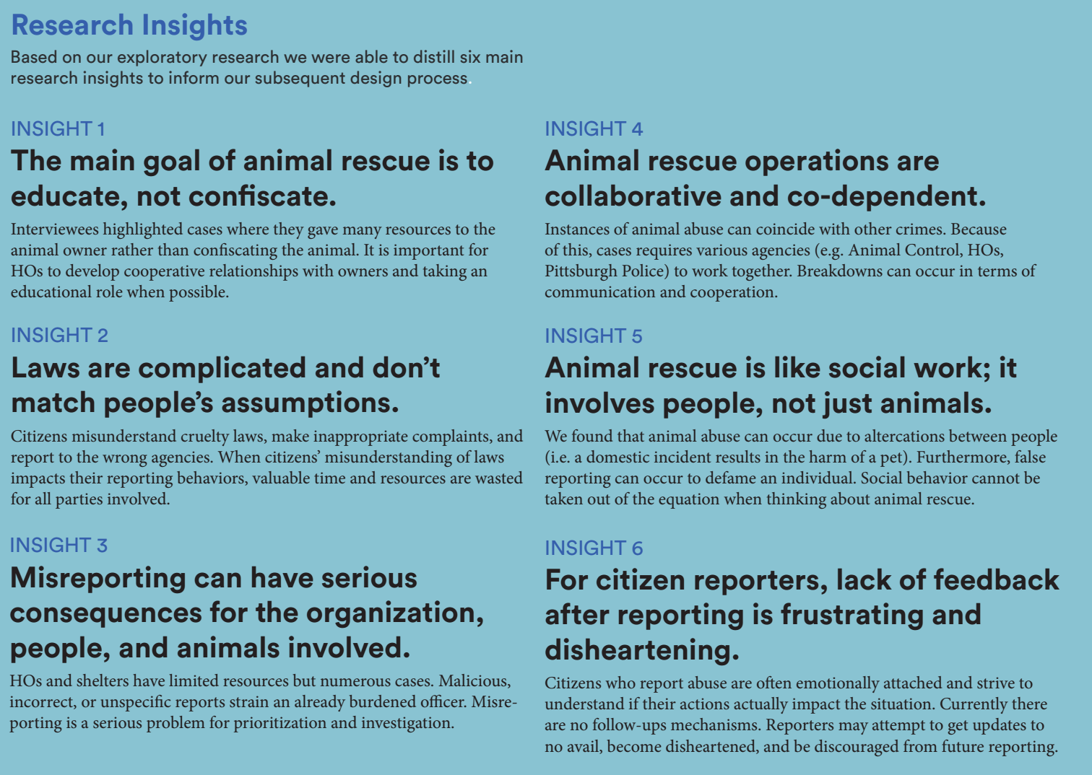

## Ideation

We went through three cycles of prototyping, user testing and iteration before designing our final MVP; lo-fidelity storyboards, mid-fidelity wireframes, and high-fidelity interactive HTML/ CSS prototype.

(graphic of each phase of the process with a single image to represent it, fade-in, 3-column design)

1. Collaboratively brainstorming with our clients and then group visioning as a team. (Image of brainstorming)
2. Created storyboards, speed dated them with stakeholders and potential users.
3. Evaluation of high level insights from feedback based on feasibility and priority.

## Prototyping

During this phrase, we separated development of the HO and citizen side, hoping to focus specifically on the issues and needs of these distinct user groups. As such, we began with lo-fidelity prototypes using paper and Google forms and then progressed to mid-fidelity prototyping with HTML/CSS and Axure. Finally, we developed our designs into a final functional system comprised of a citizen reporting form and a humane officer management tool.

Graphic of “process”- HO vs Citizen Side

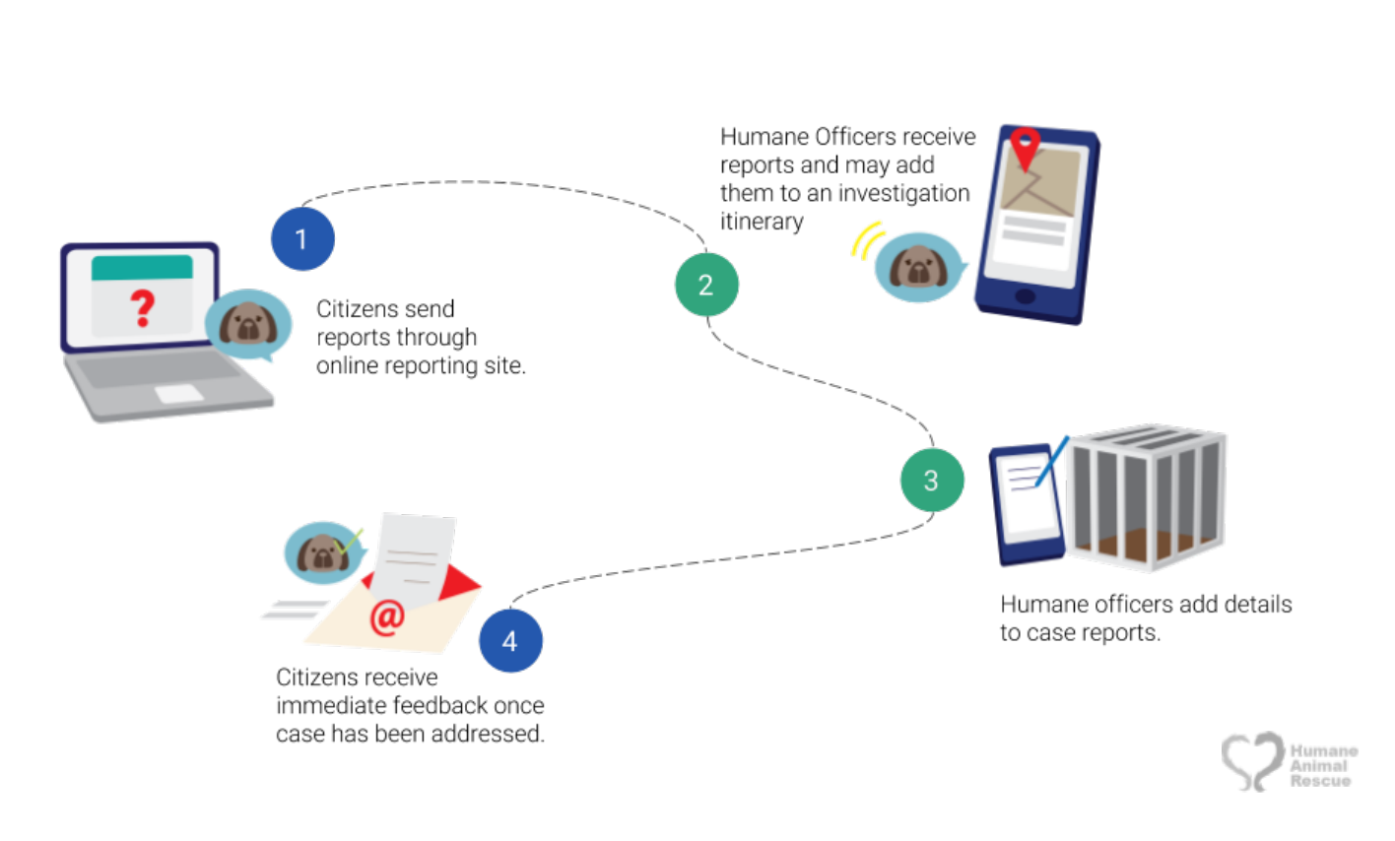

(2-col design for paragraph texts)

Citizen:

We created a low-fidelity prototype using Google Forms and paper popups, which included main question types, which include the personal information of the reporter, the time/location of the incident, and the description of the animal(s) involved. The goal of this iteration was to consider the types of questions that would appear on the form and to evaluate whether the content and framing of these questions was appropriate. We tested this prototype by conducting task analysis with potential users.

We showed users images of animals in cruelty and neglect situations and then asked them to report based on the information from the image and the scenario we gave.

For the second iteration, we built the actual website using the Materialize CSS framework which allowed some more flexibility in how we structured our questions and input fields. We also occasionally returned to fast prototyping tools like InVision and static images to get feedback on particular elements of the form. We conducted more task analysis and small-scale A/B tests to iterate through these designs. To evaluate these versions, we recruited participants from around CMU with little to no reporting experience and took them through a similar protocol as before with changes in images and scenarios. One major change we made was incorporating both scenarios that would constitute as animal cruelty and ones that would not. This allowed us to understand what participants would do in situations where the form was not the right tool for them to report.

Key Features:

(have on a slider)

Reducing Inappropriate Reporting (show slide)

## Insights

## Final product details

## Reflections

Team Animal Cop worked hard to create a fully-functional MVP to deliver to our non-profit clients, because we wanted to create something that they could make use of as soon as possible. Additionally, we created documentation of both our process and technical documentation of the MVP in order to empower others to innovate upon what we began, which is available publically. While the solution is designed specifically for the Humane Society, we encourage others to consider adopting it, as an open source solution for other shelters and communities to utilize.

# EatSleepPoop

## Overview (what, who, why, how)

Eat Sleep Poop App helps parents log important information about their newborn babies, created a few years ago by recent parent, and UX researcher, Sergi Bosch. I’ve been working with the team since July to evaluate and redesign the UX and UI based on user insights, testing and analytics, and eventually designing for wearables.

## Initial Research

Before digging into the design, I needed to gain a deeper understanding of my users- parents of newborn babies up to 5 months old. I used three strategies to gain initial insights:

* Quick user interviews and user testing sessions with new parents (coworkers).
* Heuristic evaluation of the app as a whole, creating a map of user interactions and goals throughout the app.
* Competitive Analysis to identify design patterns and key features of other solutions.

## Insights

Three main insights:

* Users are motivated by meaningful data
* Users want reminders, but want control over how much they want to receive them.
* Users often use only one or two features of the app frequently.
* Multiuser support is key in reflecting the collaborative nature of parenting.

## Ideation/ prototyping

* Consolidating controls
* Reframing as “widgets”

## Insights

## Current State/ Next steps

This is an ongoing project, and much of my work has yet to be implemented. I am in the process of collaborating on a product roadmap to identity how we can update the UX seamlessly.

# processbook

## Overview (what, who, why, how)

Processbook helps K-12 and college students create multimedia portfolios that both celebrate their achievements and support critical self-reflection and growth.

## Background

I’ve been interested in the role that portfolios play in the learning experience, both when done effectively and ineffectively for over three years, inspired by my own experiences building portfolios as an artist, designer and researcher. I believe that portfolios can play a key role, particularly in guiding project-based learning experiences.

The concept of Processbook grew out a number of projects related to student academic portfolios that I participated in as a design student and student leader at Carnegie Mellon. I participated for two years as the student representative on a committee to redesign the General Education program of Dietrich College, CMU’s College of Social Sciences and Humanities. Through this experience, we discovered a key, underserved need for teaching self-reflection and communication throughout the undergraduate experience, particularly in social sciences and STEM disciplines. At the same time, I participated in Jodi….’s course on Service Design, and where my team worked with the Alumni office to design the framework for a solution to support alumni and student connections.

## Research

In designing Processbook, I first consolidated insights and findings from the three projects I worked on related to portfolios with the intent of identifying common insights and trends in terms of the role of a portfolio as a whole, as well as pain points surrounding their use.

## Insights

What is a “portfolio”?

* Portfolio as reflection
* Portfolio as working tool for growth
* Portfolio as communication tool

What is difficult about making a portfolio?

* Communicating process
* Developing a grounded sense of self
* Creating as a part of the process, rather than an afterthought

## Ideation/ prototyping

* Service Mapping
* Rapid interviews and testing with storyboard and paper prototypes
* Identifying core users
* Identifying use cases
* Wireframing

## Insights

## Current State/ Next steps

This project is very much ongoing, and developing key relationships to support continued testing and deployment is key.

* User testing

# Best Practices of Teaching Online

## Overview (what, who, why, how)

Best Practices of Teaching Online is an interactive online course that guides learners through the process of creating an online course, combining both design and instructional principles. I created this course as an Instructional and Design Fellow at TechChange, for both internal and client utilization.

## Background

TechChange is a DC based startup that creates innovative and engaging online learning courses on topics key to global development and technological understanding, working with NGOs. While many courses are available to the public on TechChange, the platform is also designed to allow NGOs to use self-service, to create their own learning experiences.

## Research

Interviewed coworkers on their experience working with clients attempting to create courses themselves.

Competitive analysis of other materials and courses on instructional design and online teaching, identifying effective language, media forms and interactions.

## Insights

* While clients often have extensive content knowledge and some educational background, designing a course online is a different beast.
* Clients have minimal background in visual or interaction design
* There are a couple good resources online for instructional designers, but they are overwhelming and assume understanding of basic learning principles that clients may not possess.

## Ideation/ prototyping

* Customer Experience map of client creating their own course to identify pain points
* Determine which areas required the most resources
* Outline of materials
* Creation of a single section, prototyped with team member without expert knowledge

## Insights

* Things are interesting, but it’s still difficult to go from theory to practice.
* Solution: Sample files to work with and structured way of documenting progress with a workbook.

## Current State/ Next steps

# bigchats

## Overview (what, who, why, how)

## Initial Research

## Insights

## Ideation/ prototyping

## Insights

## Current State/ Next steps

# Pregnancy App

## Overview (what, who, why, how)

## My Role

I worked as a Research Assistant conducting a competitive analysis

## Initial Research

## Insights

## Ideation/ prototyping

## Insights

## Current State/ Next steps

# MORE PROJECTS (lightboxes only)

# Websites

## Overview (what, who, why, how)

American Cancer Society CrowdRise landing pages

Designed and built custom responsive microsites connected to database with Ajax.

# CrowdRise landing pages

## Overview (what, who, why, how)

Designed and built over 10 responsive landing pages with analytics integration for the crowdrise.com home page.

# Intercultural Journeys

## Overview (what, who, why, how)

Pro-bono website redesign for Philly-based cultural performance center.

# Yemen Water dashboard

## Overview (what, who, why, how)

Animated dashboard to communicate water availability in Yemen and the effects on society. Created with …….

# Mental health app

## Overview (what, who, why, how)

Mental health tool for students and mental health clinicians using biofeedback techniques.