Steepest Descent Method (SDM)
A 1D Projection Method for Symmetric Positive Definite Linear Systems
Individual Project
Course: Numerical Methods of Linear Algebra for Sparse Matrices
Project Name: SDM
Student: Адейеми Коладе Дамилола
Lecturer: Anna Nasedkina, PhD, Assoc. Prof.
Institution: Southern Federal University
Date: July 2026

1. Introduction
The Steepest Descent Method (SDM) is a one-dimensional (1D) projection method for solving the linear system Ax = b, where A is an n×n symmetric positive definite (SPD) matrix. It belongs to the family of projection methods introduced in Lecture 12: an approximate solution is sought in a search subspace K subject to a Petrov–Galerkin orthogonality condition on a subspace of constraints L. For SDM both subspaces coincide with the current residual direction, K = L = span{r_k}, which (because A is SPD) yields an orthogonal projection that minimises the A-norm of the error at every step.
This report presents the MATLAB implementation of SDM, its theoretical derivation within the projection framework, its convergence properties, and numerical results on small dense systems, larger systems (n = 100, 1000, 3000), and real sparse SPD matrices from the Matrix Market, together with a comparison against MATLAB's built-in Conjugate Gradient solver (pcg).

2. Theoretical Aspects

2.1 SDM as a 1D projection method
Following the general projection framework (Lecture 12), we seek x̃ = x0 + δ with δ ∈ K such that the residual r = b − Ax̃ is orthogonal to L (Petrov–Galerkin condition). For a 1D method dim K = dim L = 1. SDM chooses the residual as the basis of both subspaces:
K = L = span{ r_k }, A is symmetric positive definite (SPD).
Equivalently, SDM minimises the quadratic functional
f(x) = (1/2)(A x, x) − (b, x), with gradient ∇f(x) = A x − b = −r.
The steepest-descent direction is therefore the residual r_k. The step length α_k that minimises f along r_k is obtained from the orthogonality condition (r_{k+1}, r_k) = 0:
α_k = (r_k, r_k) / (A r_k, r_k).

2.2 Algorithm — modified form (Lecture 12, p.14)
The modified algorithm uses a residual recurrence so that only ONE matrix-by-vector product (A·r) is required per iteration:
Input : A (SPD), b, x0, tol, kmax
Output: x, r, ||r||_2, ||r||_2/||b||_2, k, residual history
r0 = b - A*x0 ; p0 = A*r0
for k = 0,1,2, ... :
if ||r_k||_2 / ||b||_2 < tol -> stop
alpha_k = (r_k , r_k) / (p_k , r_k) % p_k = A r_k
x_{k+1} = x_k + alpha_k * r_k
r_{k+1} = r_k - alpha_k * p_k % recurrence, saves 1 MVP
p_{k+1} = A * r_{k+1}
end
The stopping criterion is the RELATIVE residual ‖r_k‖₂/‖b‖₂ < tol, computed inside the function, as required by the project specification.

2.3 Convergence (Lecture 12, Theorem 2)
If A is SPD, SDM converges for any initial guess x0, and the error decreases monotonically in the A-norm (energy norm) ‖v‖_A = √(A v, v):
||x_{k+1} - x*||_A <= ((λmax - λmin)/(λmax + λmin)) * ||x_k - x*||_A
where λmax, λmin are the extreme eigenvalues of A and x* is the exact solution. The contraction factor equals (κ − 1)/(κ + 1) with κ = λmax/λmin the (spectral) condition number. As κ → ∞ the factor → 1 and convergence stalls; this κ-dependence is confirmed experimentally in Section 4.

3. MATLAB Implementation
The function SDM.m implements the modified algorithm. Its signature returns the residual norm and the relative residual norm explicitly, as required by the specification:
function [x, r, rnorm, relres, k, rnorm_hist] = SDM(A, b, x0, tol, kmax)
x = x0; r = b - A*x; p = A*r;
nb = norm(b,2); if nb==0, nb = 1; end
rnorm = norm(r,2); rnorm_hist(1) = rnorm;
for k = 0:kmax
if rnorm/nb < tol || k==kmax, break; end
Ar = p; alpha = (r'*r)/(r'*Ar);
x = x + alpha*r; r = r - alpha*Ar; p = A*r;
rnorm = norm(r,2); rnorm_hist(k+2) = rnorm;
end
relres = rnorm/nb;
Outputs: x (solution), r (final residual), rnorm = ‖r‖₂, relres = ‖r‖₂/‖b‖₂, k (iterations), and rnorm_hist (residual history for convergence plots). Only one matrix-vector product A·r is formed per iteration. All norms are the Euclidean 2-norm ‖·‖₂ = √(·,·).

4. Numerical Results
For every test we report the residual norm ‖r‖₂, the relative residual ‖r‖₂/‖b‖₂, the absolute and relative error against the known exact solution, the iteration count, and (where relevant) CPU time — the standard set of metrics used throughout the course.

4.1 Test 1 — Small 3×3 SPD system (known solution)
A = [4 2 0; 2 5 2; 0 2 4]; x_exact = [1;2;3]; b = A*x_exact;
x0 = zeros(3,1); tol = 1e-12; kmax = 1000;
Metric | Value
Computed solution x | [1.000000, 2.000000, 3.000000]
Absolute error ‖x−x*‖₂ | 1.106e-11
Relative error ‖x−x*‖₂/‖x*‖₂ | 2.956e-12
Error in A-norm ‖x−x*‖_A | 1.510e-11
Residual norm ‖r‖₂ | 2.418e-11
Relative residual ‖r‖₂/‖b‖₂ | 9.527e-13
Iterations k | 56
Converged | Yes

Observation: SDM recovers the exact solution to machine precision. Repeating the solve from a different initial guess x0 = [5; −3; 10] gives the same solution in the same 56 iterations, confirming Theorem 2 (convergence for any initial guess).

4.2 Test 2 — Random 10×10 SPD system
Generated as A = TᵀT + 0.1·I with T = randn(10), which guarantees A is SPD. tol = 1e-8.
Metric | Value
Condition number κ(A) | 3.131e+02
Absolute error ‖x−x*‖₂ | 1.495e-06
Relative error | 4.394e-07
Residual norm ‖r‖₂ | 2.080e-07
Relative residual ‖r‖₂/‖b‖₂ | 9.966e-09
Iterations k | 2179
Converged (relres < tol) | Yes

Observation: with κ ≈ 3.1×10² the method needs ~2179 iterations. Note that the error (≈1.5×10⁻⁶) is larger than the relative residual because error ≈ κ(A) × relative residual.

4.3 Test 3 — Performance scaling (n = 100, 1000, 3000)
SPD systems A = TᵀT + n·I were generated so that the condition number stays moderate (κ ≈ 5) for every size; this isolates the effect of problem SIZE on CPU time. tol = 1e-6.
Size n | κ(A) | Iterations | CPU (s) | Rel. error | Rel. residual
100 | 4.66 | 28 | 0.0012 | 1.30e-06 | 8.06e-07
1000 | 4.97 | 31 | 0.0020 | 1.07e-06 | 6.83e-07
3000 | 4.99 | 30 | 0.0204 | 1.38e-06 | 8.82e-07

Observation: the iteration count is essentially constant (28–31) because κ is fixed, while CPU time grows with n (each iteration costs one O(n²) matrix-vector product). This confirms that SDM convergence depends on the CONDITIONING of A, not directly on its size.
A single well-conditioned 100×100 system (κ ≈ 7.4×10², 2545 iterations to ‖r‖₂/‖b‖₂ < 1e-6) illustrates the typical residual history:
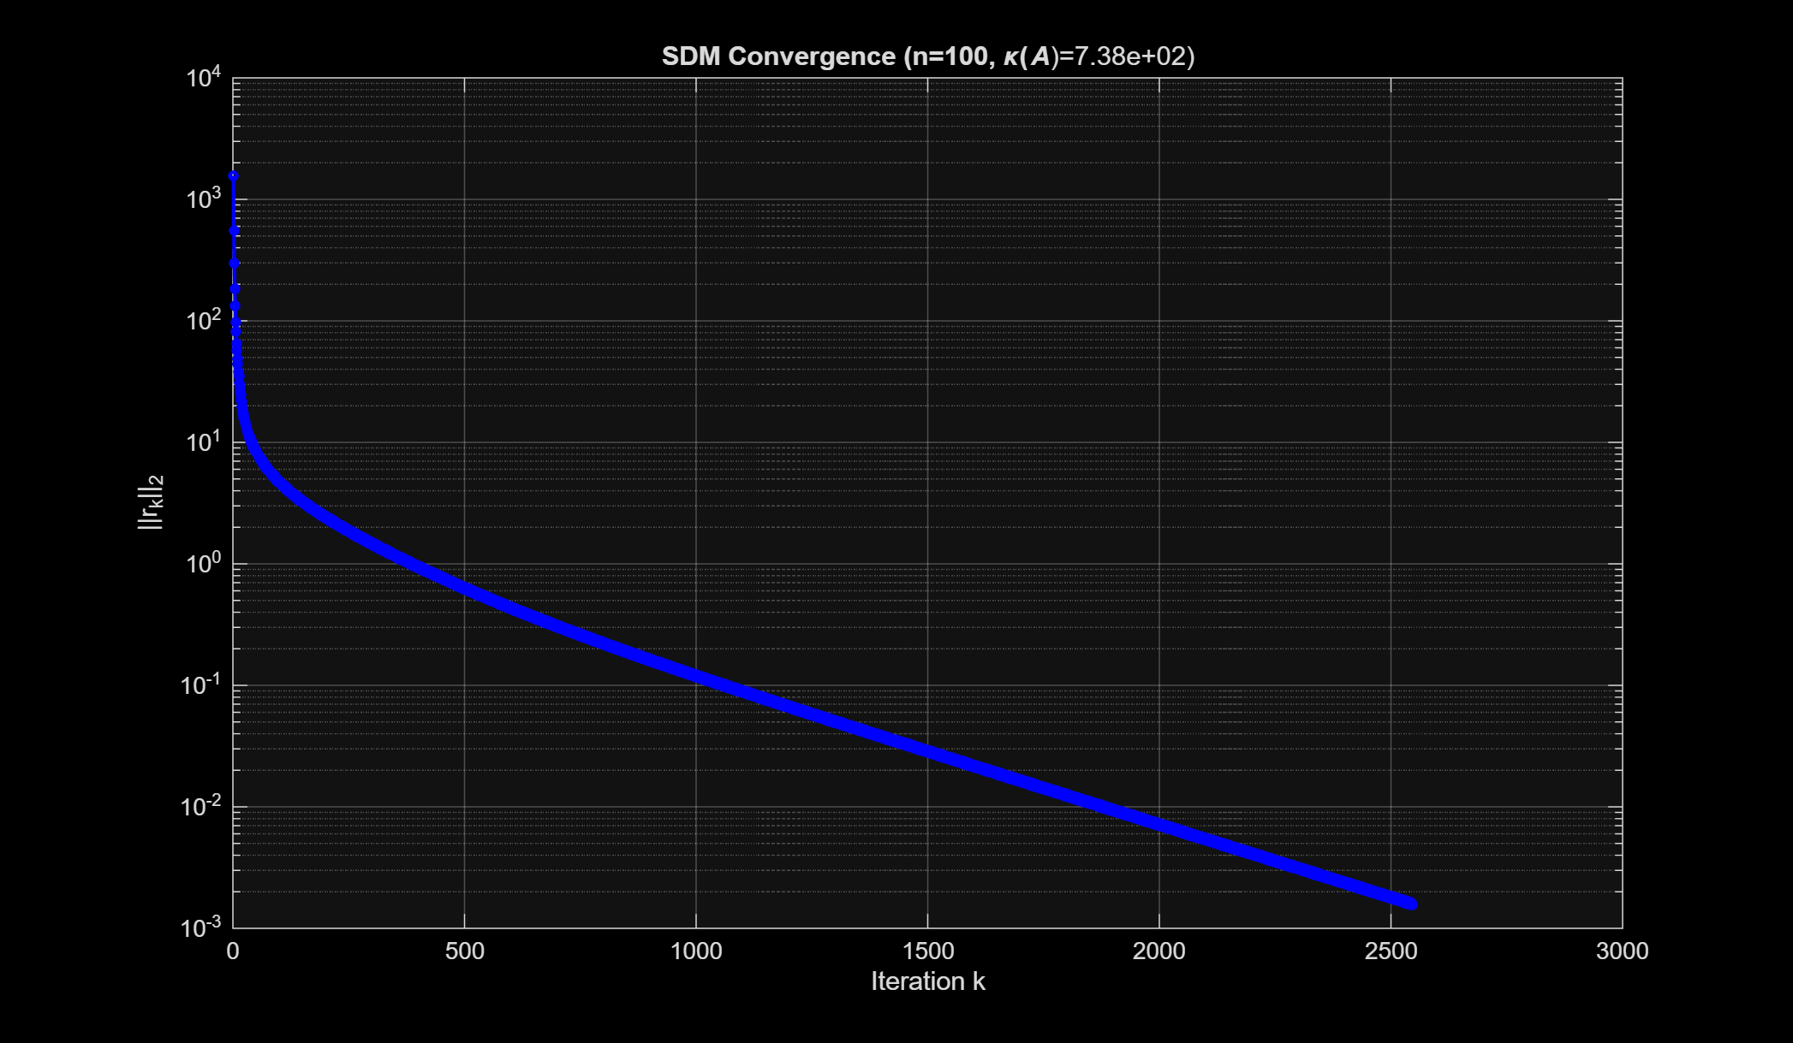
Figure 1. SDM residual convergence for a 100×100 SPD system (semilog scale).

4.4 Test 4 — Effect of the condition number
Two 10×10 SPD matrices with very different condition numbers were solved to expose the κ-dependence predicted by Theorem 2.
Matrix | κ(A) | Iterations | Behaviour
Well-conditioned (tridiagonal [-1 4 -1]) | 2.84 | 17 | Fast, smooth
Ill-conditioned (TᵀT + 1e-4·I) | 4.26e+04 | 20000 (cap) | Stagnates

Observation: the well-conditioned system converges in 17 iterations, whereas the ill-conditioned system (κ ≈ 4.3×10⁴) has not converged after 20000 iterations — its contraction factor (κ−1)/(κ+1) ≈ 0.99995 means almost no progress per step. The log–log plot below shows the smooth descent of the well-conditioned case against the long stagnating plateau of the ill-conditioned case (the characteristic SDM zig-zag is visible early on).
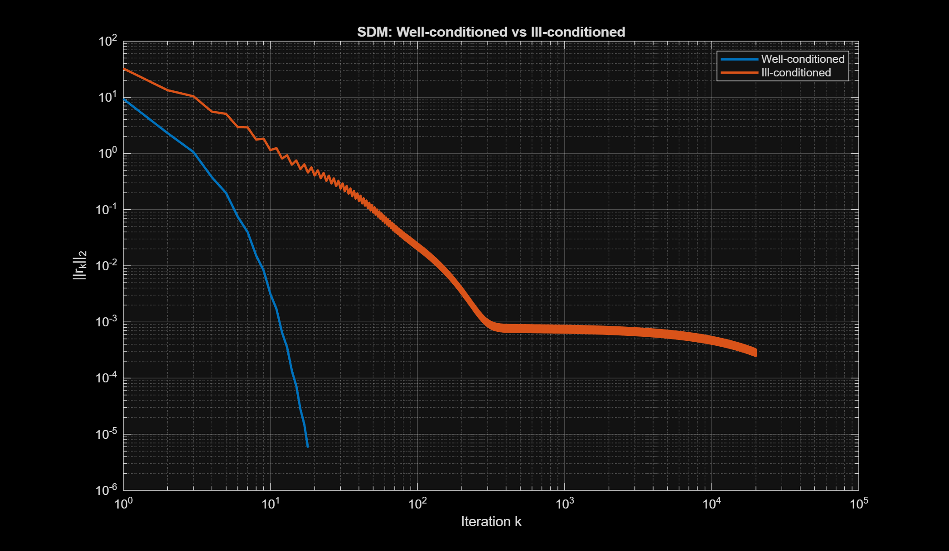
Figure 2. SDM convergence: well-conditioned vs ill-conditioned (log–log scale).

4.5 Test 5 — Real sparse SPD matrices from the Matrix Market
Two real sparse SPD matrices were loaded from the Matrix Market using the attached mmread.m function: gr_30_30 (a 900×900 nine-point Laplacian on a 30×30 grid) and bcsstk01 (a 48×48 structural-engineering stiffness matrix). For each, the matrix properties were verified the way the lectures require — symmetry from the closeness ‖A − Aᵀ‖₁ (not exact equality via isequal) and positive definiteness from the Cholesky factorization (chol returns p = 0):
Property | gr_30_30 | bcsstk01
Size | 900 × 900 | 48 × 48
Nonzeros (nnz) | 7744 (99.0% sparse) | 400 (82.6% sparse)
Symmetry defect ‖A−Aᵀ‖₁ | 0.00e+00 | 0.00e+00
Positive definite (chol p=0) | Yes | Yes
Condition number (condest) | 3.77e+02 | 1.60e+06

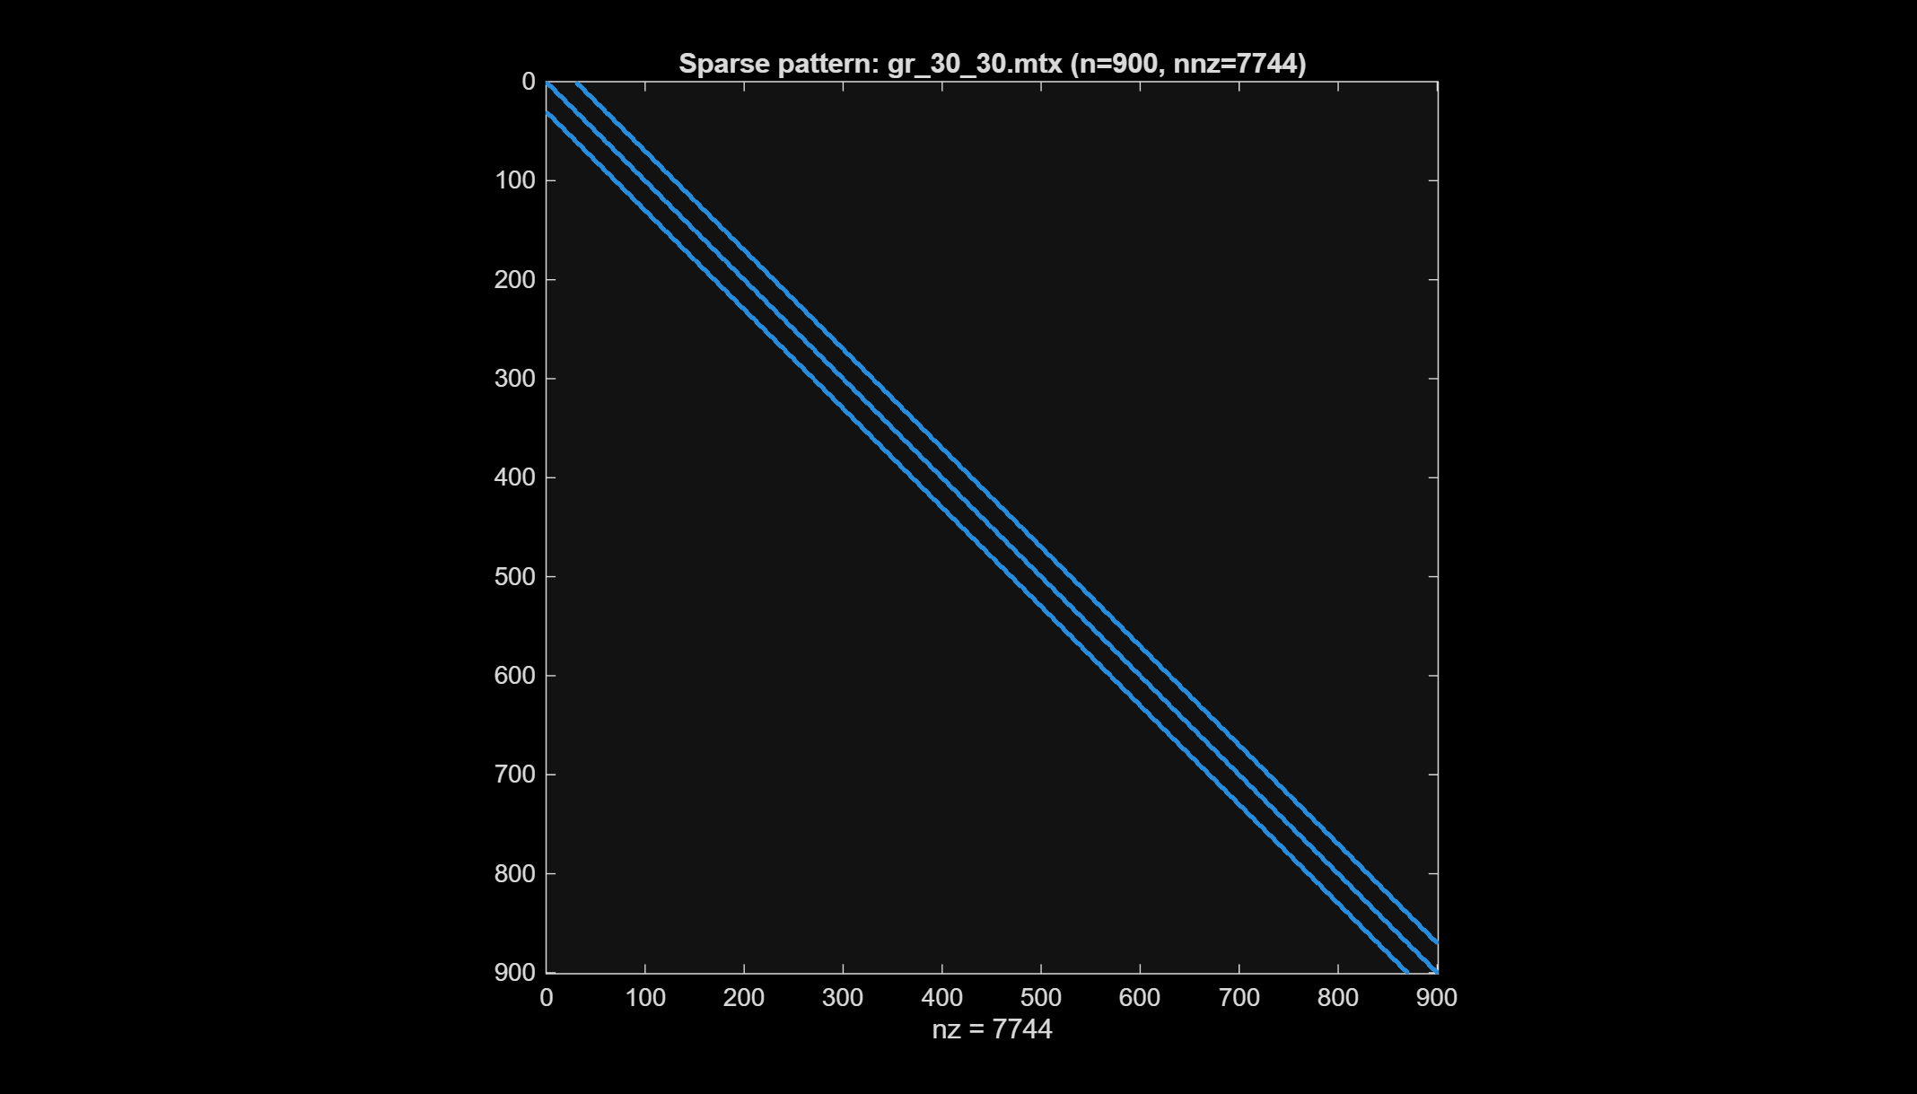
Figure 3. Sparsity pattern of gr_30_30 (900×900 banded Laplacian).
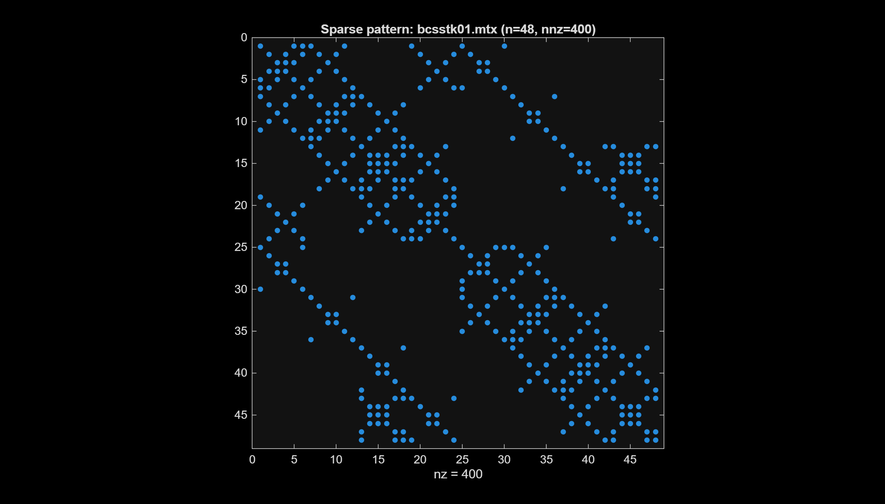
Figure 4. Sparsity pattern of bcsstk01 (48×48 structural stiffness matrix).
SDM was compared against MATLAB’s Conjugate Gradient solver pcg on both matrices (tol = 1e-6, kmax = 20000):
Matrix | Method | Iterations | Rel. residual | Rel. error | Converged
gr_30_30 | SDM | 455 | 9.94e-07 | 9.63e-05 | Yes
gr_30_30 | CG (pcg) | 52 | 8.70e-07 | 6.14e-06 | Yes
bcsstk01 | SDM | 20000 (cap) | 1.51e-05 | 2.67e-01 | No
bcsstk01 | CG (pcg) | 78 | 7.66e-07 | 6.66e-02 | Yes

Observation: on the well-conditioned gr_30_30 (κ ≈ 3.8×10²) SDM converges in 455 iterations and CG in 52 — both succeed, CG faster. On the ill-conditioned bcsstk01 (κ ≈ 1.6×10⁶) SDM fails to converge within 20000 iterations (relative error 0.27), whereas CG converges in 78 iterations. This real-data experiment confirms the theory of Section 2.3: SDM’s convergence collapses as κ grows, while CG’s A-orthogonal search directions keep it effective. (Even CG shows a larger error on bcsstk01, because the extreme conditioning amplifies error ≈ κ × relative residual.)
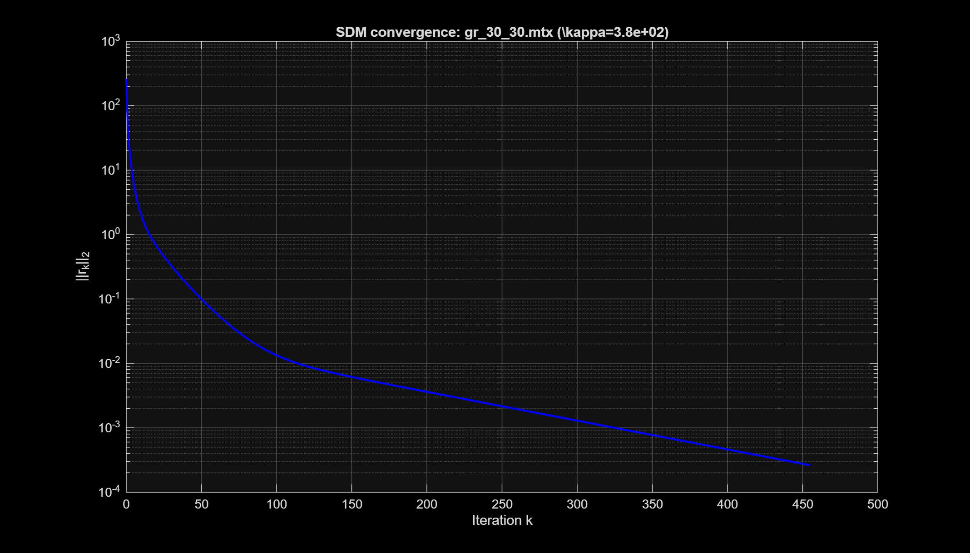
Figure 5. SDM convergence on gr_30_30 — converges in ~455 iterations.
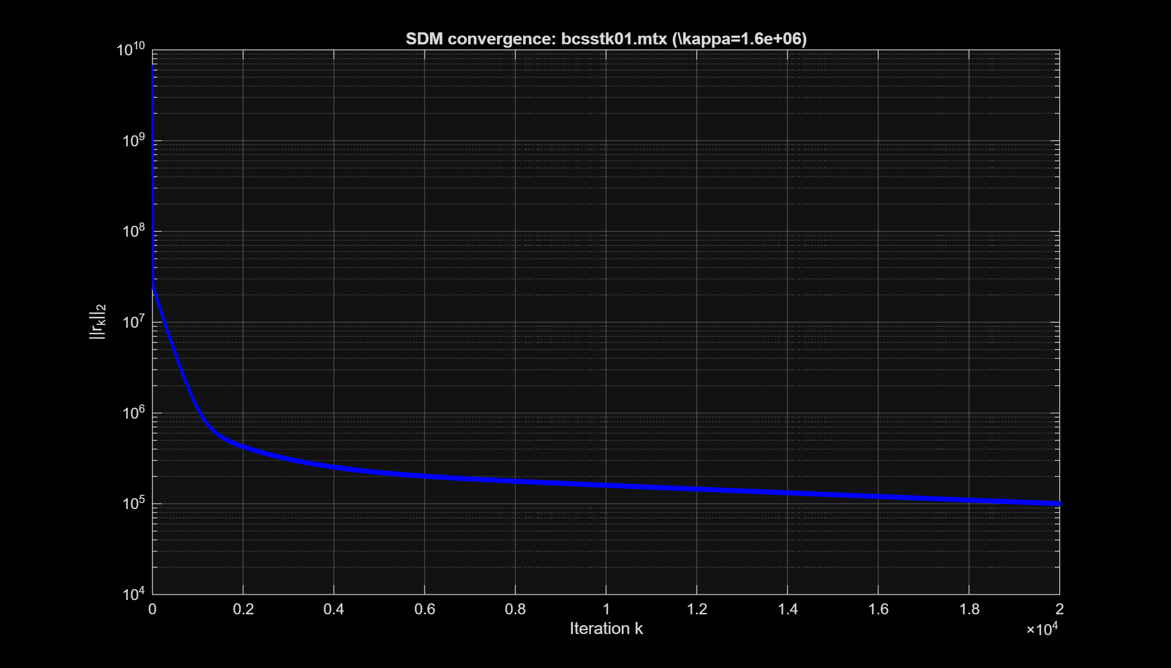
Figure 6. SDM convergence on bcsstk01 — the residual stagnates (no convergence).

5. Discussion
Q1. Why does SDM converge slowly for ill-conditioned systems?
By Theorem 2 the A-norm error contracts by (κ−1)/(κ+1) per iteration. For κ = 2.84 this is ≈ 0.48 (fast); for κ = 4.3×10⁴ it is ≈ 0.99995 (essentially no progress), matching Test 4.
Q2. How does SDM compare with Conjugate Gradient (CG)?
CG (a Krylov subspace method) forces successive search directions to be A-orthogonal, removing the zig-zag and giving far faster convergence for the same SPD systems. On the real matrix gr_30_30 CG needed 52 iterations versus 455 for SDM; on the ill-conditioned bcsstk01 CG converged in 78 iterations while SDM failed to converge in 20000. The gap widens sharply as κ increases, so CG is strictly preferable for SPD systems, and SDM is best viewed as the conceptual building block that motivates it.
Q3. When would you use an iterative method rather than a direct solver?
Direct solvers (LU/Cholesky) cost O(n³) work and O(n²) memory and cause fill-in for sparse matrices. For large sparse SPD systems, projection/Krylov methods such as SDM and CG need only matrix-vector products (O(nnz) per step) and preserve sparsity, making them the practical choice.

6. Conclusions
The Steepest Descent Method was implemented in MATLAB as a 1D projection method and validated on small, large, and sparse SPD systems.
Advantages:
- Simple to implement; one matrix-vector product per iteration (O(nnz) cost).
- Guaranteed convergence for any SPD matrix and any initial guess (Theorem 2).
- Monotonic decrease of the error in the A-norm at every step.
Limitations:
- Convergence rate degrades as (κ−1)/(κ+1); very slow for ill-conditioned systems.
- Restricted to symmetric positive definite matrices.
- Zig-zag search directions are far from optimal — CG is strictly superior.
Future work: the natural next step is the Conjugate Gradient method (A-orthogonal directions), and, for general nonsymmetric systems, GMRES.

References
- Nasedkina, A. Lecture 12: Projection methods for linear systems. 1D projection methods. Southern Federal University, 2026.
- Nasedkina, A. Lecture 10: Direct and iterative methods. General formulation of iterative methods. Southern Federal University, 2026.
- Nasedkina, A. Lecture 2: Vector and matrix norms; Lecture 6: Positive definite matrices. Southern Federal University, 2026.
- Saad, Y. Iterative Methods for Sparse Linear Systems, 2nd Ed. SIAM, 2003.
- Barrett, R. et al. Templates for the Solution of Linear Systems: Building Blocks for Iterative Methods. SIAM, 1994.

