Lab 2. Git.
Presented by: Adeyemi Kolade Damilola

Instruction:
Please follow the steps below (each step should be accompanied by a screenshot confirming that you have completed it):

- Sign up for a GitHub account if you do not have one.
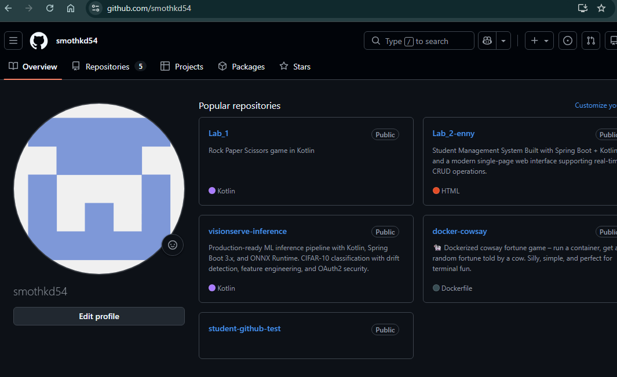

- Create a new public repository named student-github-test.
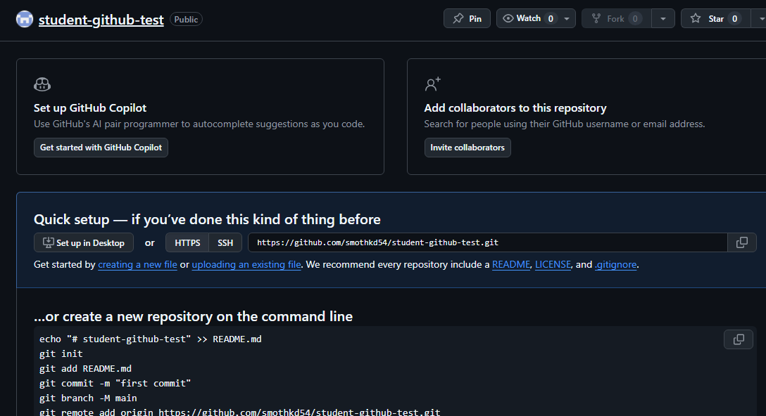
- Add a README.md file to your repository.
- Write a short introduction about yourself in README.md (3–5 sentences in English).
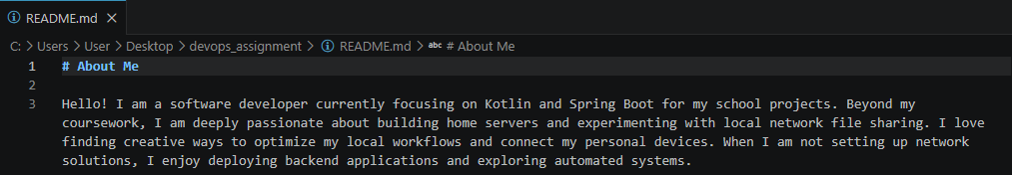
- Commit your changes with a clear message in English.
- Create a new folder named documents in your repository.
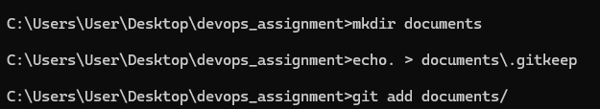
- Add a file bio.txt inside the documents folder.
- Write a more detailed description about yourself in bio.txt (country, interests, studies, hobbies).
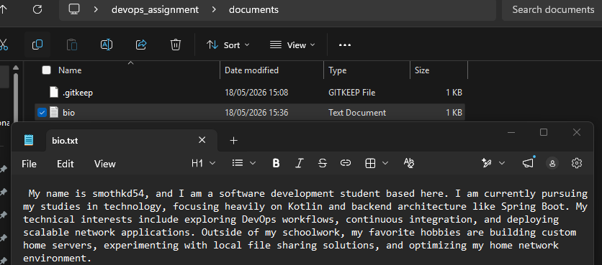
- Commit the new file with an appropriate commit message.
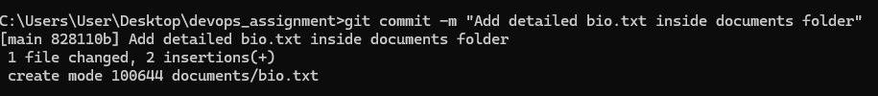
- Edit the README.md file and add a link to your bio.txt file.
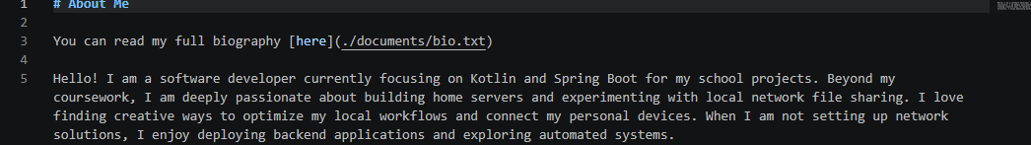
- Commit the changes to README.md.
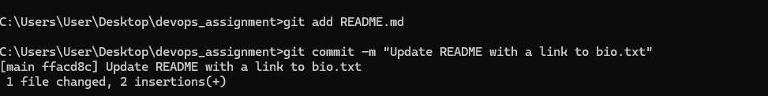
- Create a new branch named feature-update.
- Switch to the feature-update branch.
- Make a small change in bio.txt (for example, add a new hobby).
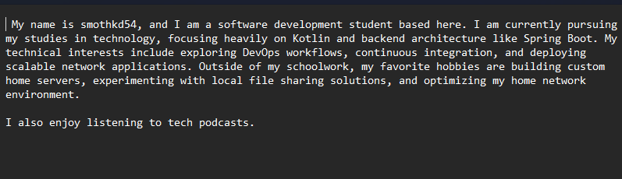
- Commit the change on the feature-update branch.
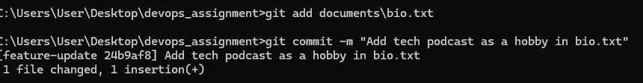
- Create a new branch named bugfix-readme.
- Switch to the bugfix-readme branch.
- Fix a small mistake in README.md (for example, correct a typo)
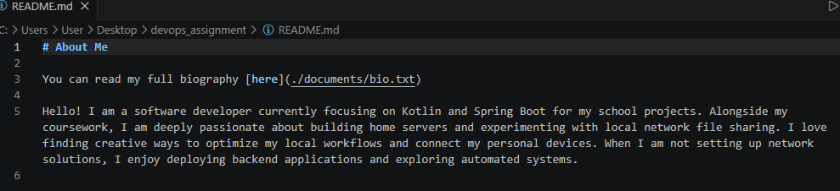
- Commit the fix on the bugfix-readme branch.
- Create a new branch named add-resources.
- Switch to the add-resources branch.
- Add a new file resources.txt in the documents folder.
- List 3 useful resources for learning English in resources.txt.
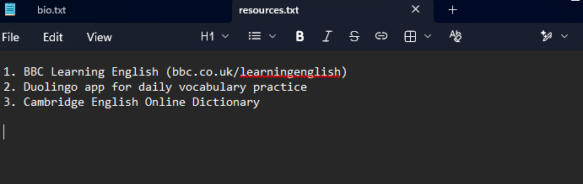
- Commit the new file on the add-resources branch.
- Open a new issue in your repository titled “Add learning resources”.
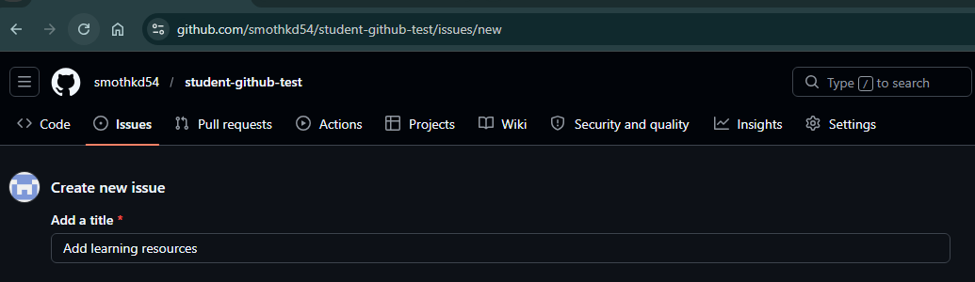
- Write a short description in the issue explaining what you added.
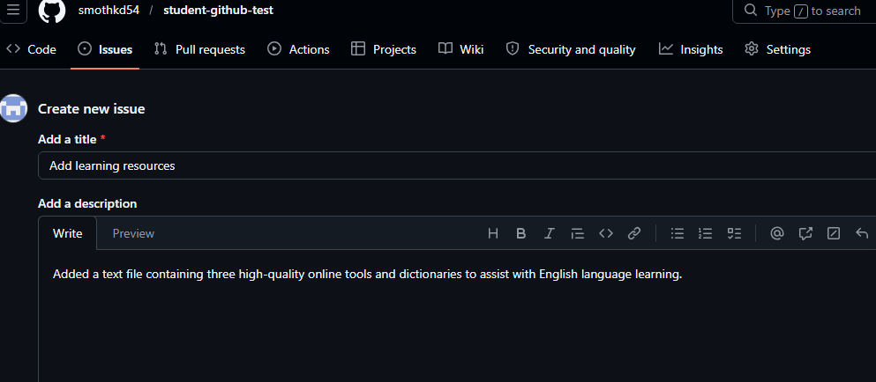
- Create a pull request from add-resources to main.
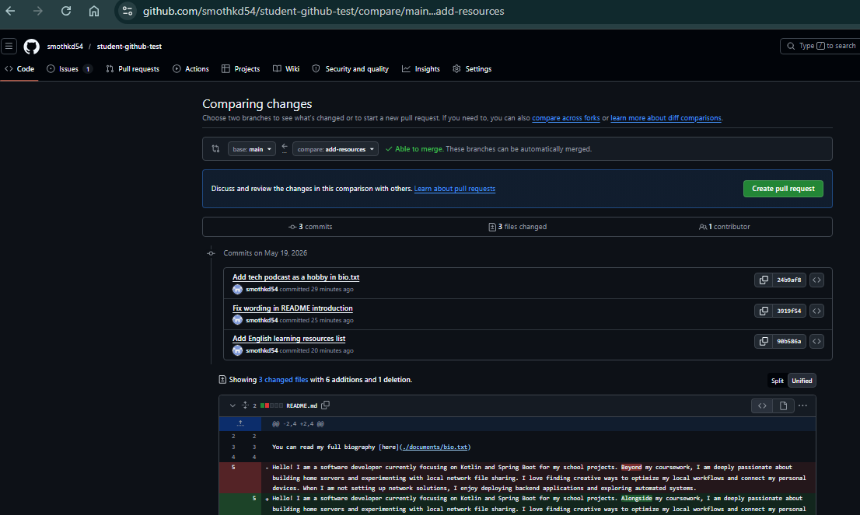
- Write a clear title and description for your pull request.
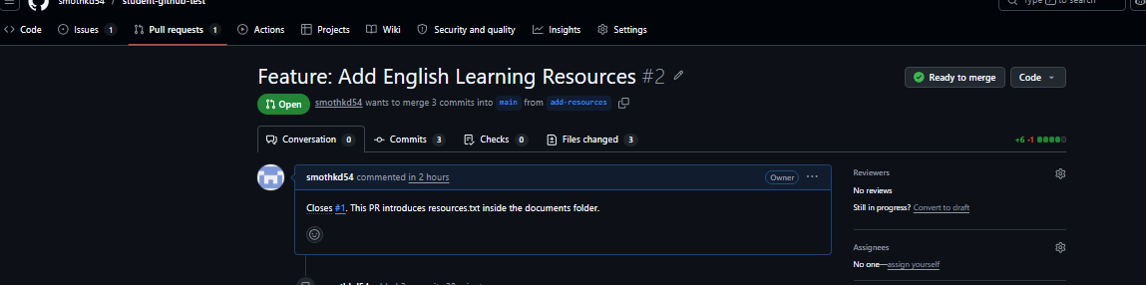
- Merge the pull request into main.
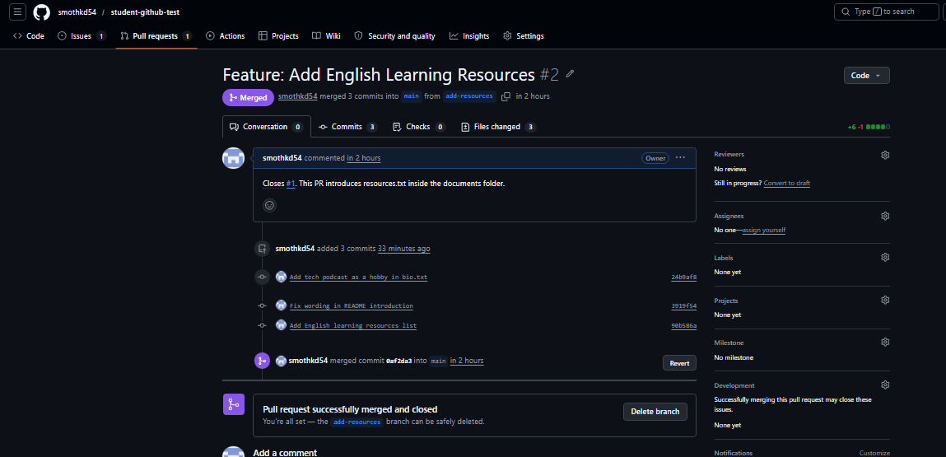
- Delete the branches feature-update, bugfix-readme, and add-resources after merging.
