download link

<https://ipfs.io/ipfs/QmQgobxe8pYV7Fi8u9h5JFnhyod51sXMZmQ58byaSaQ3F6?filename=smp.zip>

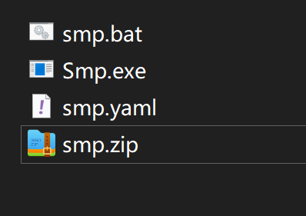

Run this file after the decompression

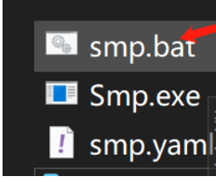

Normal running state

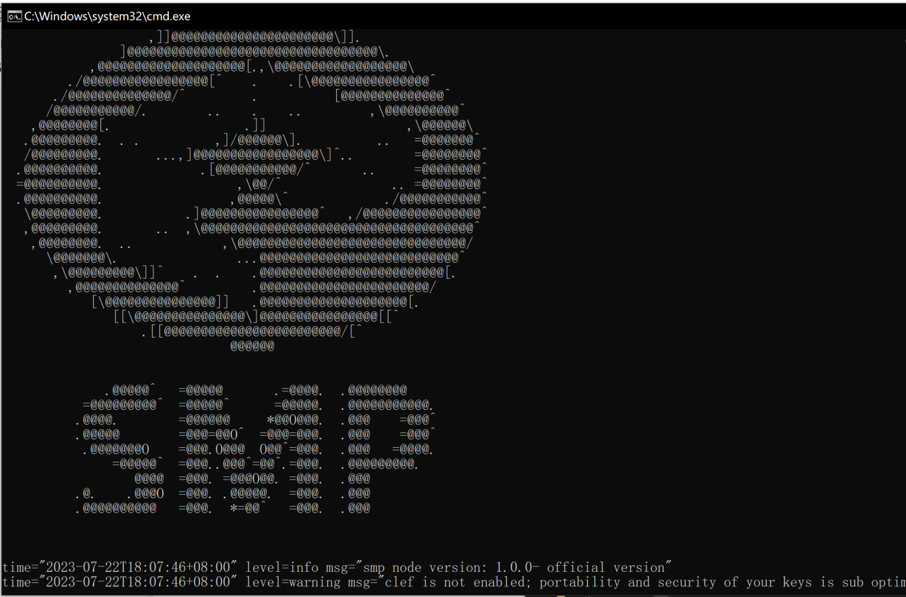

This address is your node address

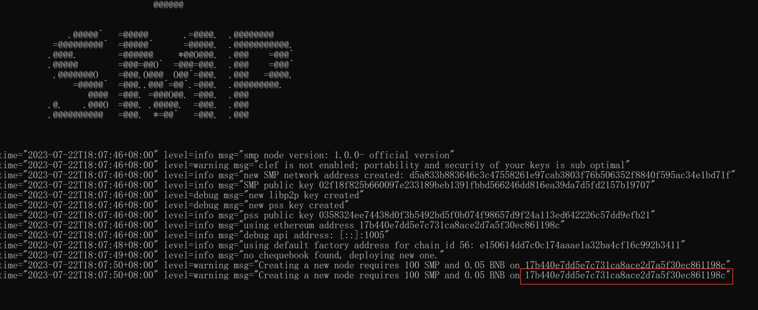

Copy down (17b440e7dd5e7c731ca8ace2d7a5f30ec861198c) to recharge 100 SMP and 0.05 BNB inside. The SMP ZK node of the main network is automatically generated.

The nodes are generated normally below

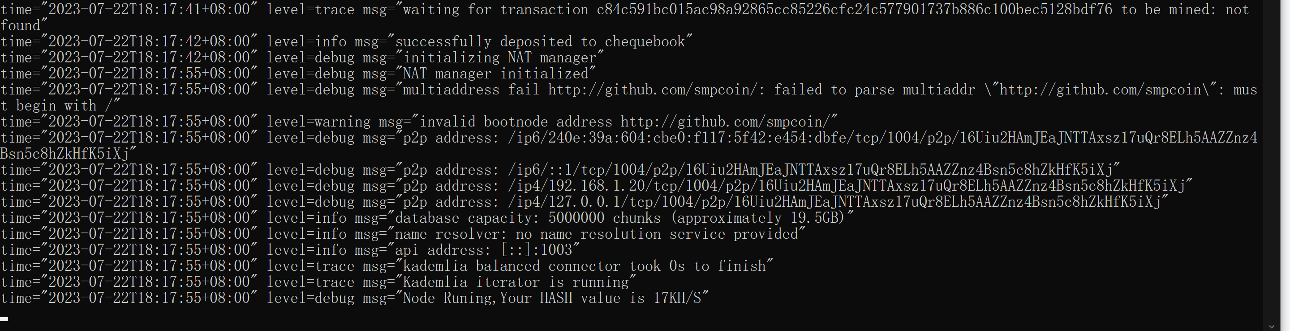

Query mining output

According to the GitHub data https: / / github.com/smpcoin/resources/

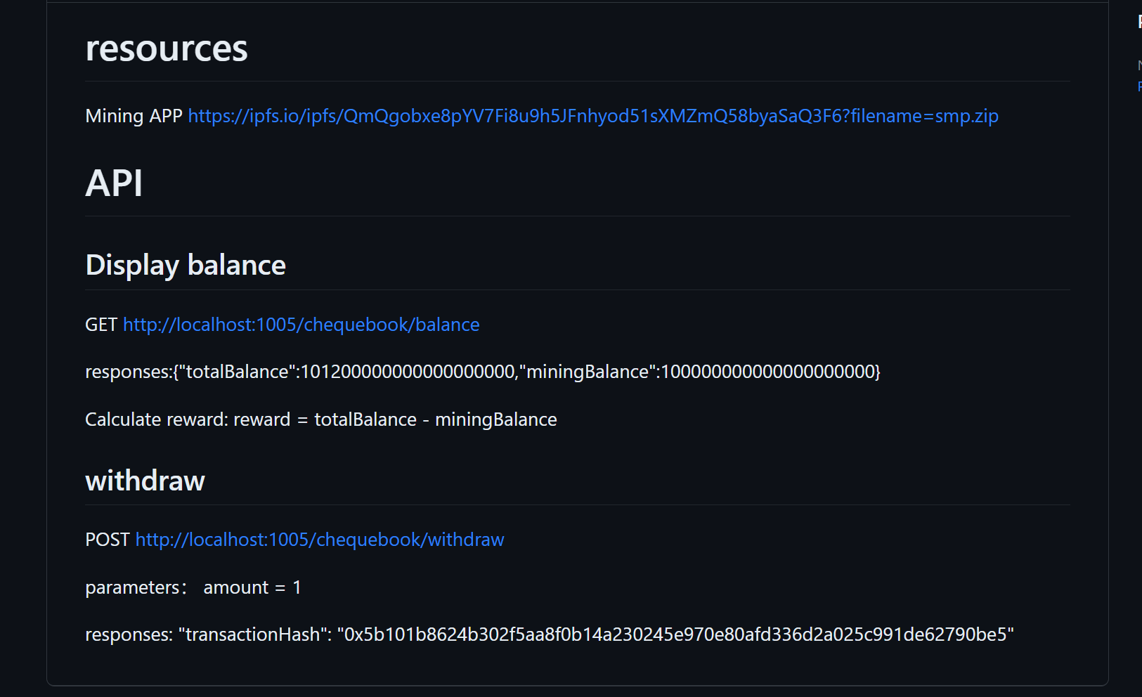

View the yield

<http://127.0.0.1:1005/chequebook/balance>

True yield = totalBalance-miningBalance

Only the true yields greater than 1 can be extracted.

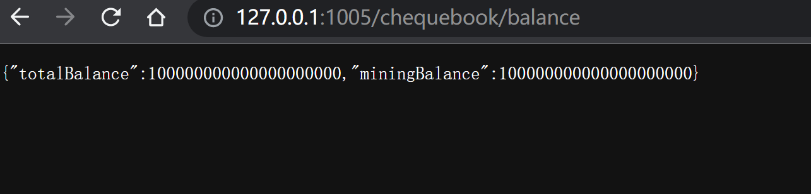

Withdraw income

[POST http://localhost:1005/chequebook/withdraw](http://localhost:1005/chequebook/withdraw)

parameters： amount = 1

Export the node account for the BSC network

<https://ipfs.io/ipfs/QmUds6RkMj9rdqqVSP3652pPa1VSB8GKgNnpiyB1Jf163o?filename=Smpkey.exe>

Download Export Tools

Use the code export to find the node location

S mpkey .exe C:/100/keys 123

Note that the 123 is the default password

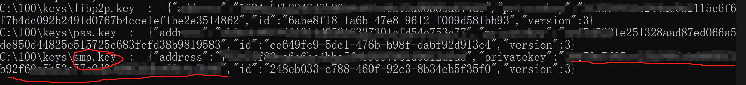

Password import into the wallet to transfer the revenue