HOSTEL MANAGEMENT SYSTEM
A MERN Stack Web Application with Role-Based Dashboards and PhonePe Payment Integration

Project Report Submitted for College Project Evaluation
Student Name: ______________________________
Roll Number: ______________________________
Department: ______________________________
College: ______________________________
Academic Year: 2025-2026

Table of Contents
1. Certificate
2. Acknowledgement
3. Abstract
4. Introduction
5. Problem Statement
6. Objectives
7. Scope
8. Technology Stack
9. System Architecture
10. Modules
11. User Roles and Permissions
12. Database Design
13. API Design
14. Authentication and Authorization
15. PhonePe Payment Integration
16. Frontend Design
17. Performance Improvements
18. Deployment
19. Testing
20. Limitations and Future Enhancements
21. Conclusion
Appendix A. Code Explanation
Appendix B. Diagrams

1. Certificate
This is to certify that the project titled Hostel Management System has been developed as a college project to demonstrate a complete full-stack web application for hostel administration. The project includes public pages, secure login, role-based dashboards, resident management, staff management, room allocation, maintenance tracking, billing, notifications, and PhonePe UAT payment integration.
The system has been designed and implemented using MongoDB, Express.js, React.js, Node.js, Tailwind CSS, JWT authentication, Mongoose, and Vercel deployment configuration. It represents a practical implementation of modern web development concepts and solves a realistic campus administration problem.

2. Acknowledgement
I sincerely thank my project guide, faculty members, and department for their support and guidance during the completion of this project. Their suggestions helped in improving the design, functionality, documentation, and presentation of the system.
I also acknowledge the official documentation and open-source communities of React, Node.js, MongoDB, Tailwind CSS, Vercel, and PhonePe Developer APIs. These resources helped me understand real-world concepts such as REST API design, authentication, role-based routing, cloud database connectivity, payment gateway integration, and deployment.

3. Abstract
The Hostel Management System is a MERN stack web application developed to simplify daily hostel operations in a college environment. Manual hostel management often depends on registers, spreadsheets, offline payment confirmation, and informal communication. This creates delays, duplicate records, poor tracking, and lack of transparency for residents and administrators.
The proposed system provides a centralized platform for three user roles: Admin, Staff, and Resident. Admin can manage staff, residents, rooms, maintenance, announcements, and billing. Staff can manage operational activities such as rooms, residents, maintenance, and announcements. Residents can view assigned room details, raise maintenance requests, view bills, pay using PhonePe UAT checkout, and refresh payment status.
The project demonstrates full-stack development, secure authentication, database modeling, API development, frontend routing, responsive UI design, payment gateway integration, dashboard analytics, performance optimization, and deployment preparation. The result is a professional and practical web application suitable for college project evaluation and future real-world enhancement.

4. Introduction
Hostels are an essential part of college infrastructure. A hostel administration team must manage resident records, room capacity, allocation status, monthly billing, maintenance complaints, notices, and communication. When these operations are handled manually, the process becomes time-consuming and error-prone.
This project introduces a web-based system that reduces administrative workload and improves visibility. The application provides a clean interface for hostel authorities and a self-service portal for residents. All important records are stored in a centralized MongoDB database, and the frontend communicates with the backend through secure REST APIs.
The system is built with deployment in mind. Hostnames and ports are not hardcoded; instead, the application uses environment variables. This makes the project suitable for local development and online deployment through services such as Vercel, Netlify, or Render.

5. Problem Statement
The main problem addressed by this project is the lack of a centralized digital platform for hostel operations. In many colleges, hostel records are managed manually, and residents depend on staff availability for basic information such as room details, pending dues, or maintenance status.
Manual workflows create multiple issues: data duplication, delayed complaint resolution, difficulty in tracking bill payment, poor communication, and limited reporting. A digital system is required to improve speed, accountability, and transparency.

6. Objectives
- Develop a full-stack MERN application for hostel administration.
- Implement secure login and role-based access control.
- Provide public pages for hostel information and resident application.
- Manage staff, residents, rooms, maintenance requests, bills, and notifications.
- Integrate PhonePe UAT checkout for online resident bill payment.
- Provide role-specific dashboards with charts and summary information.
- Optimize key pages such as billing, maintenance, and my room for faster loading.
- Prepare the project for cloud deployment using configurable environment variables.

7. Scope
The scope of the project includes digital record management for college hostels. It supports resident registration, admin/staff-created users, room allocation, maintenance tracking, billing, payment verification, announcements, notifications, and analytics.
The system is suitable for a small to medium hostel environment. It can be extended for multi-hostel campuses, mess management, attendance, biometric integration, SMS/email alerts, and advanced reporting.

8. Technology Stack
The technology stack was selected to support fast development, scalability, and clean separation between frontend and backend. React provides component-based UI development, Express provides API routing, MongoDB stores flexible hostel data, and Tailwind CSS enables responsive styling.
Layer | Technology | Purpose
Frontend | React, Vite, Tailwind CSS | Responsive UI, routing, charts, forms
Backend | Node.js, Express.js | REST API and business logic
Database | MongoDB Atlas, Mongoose | Cloud data storage and schema modeling
Security | JWT, bcrypt | Authentication and password protection
Payment | PhonePe Standard Checkout UAT | Online bill payment testing
Deployment | Vercel | Frontend and backend hosting

9. System Architecture
The architecture follows a client-server model. The React frontend runs in the browser and sends API requests to the Express backend. The backend validates JWT tokens, checks user roles, communicates with MongoDB Atlas, and integrates with PhonePe UAT APIs.
This separation improves maintainability. Frontend and backend can be deployed independently, and the frontend only needs the backend API URL through VITE_API_BASE_URL.

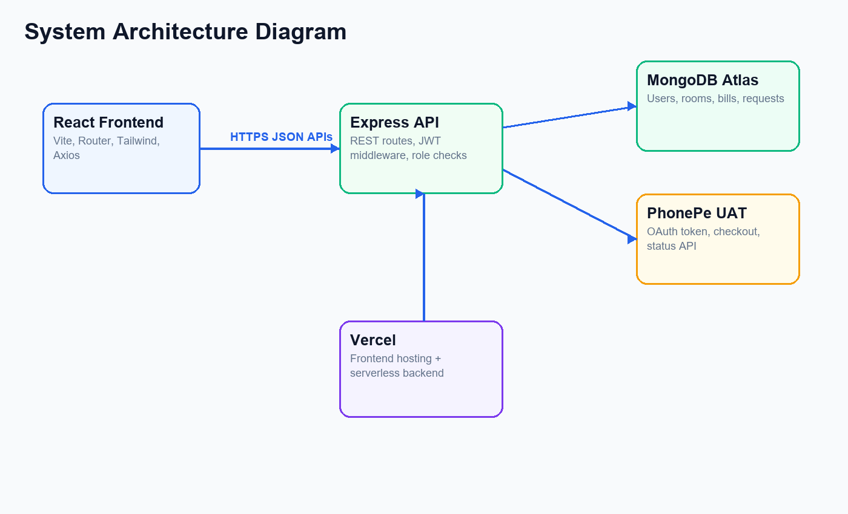

10. Modules
- Authentication Module: Handles resident registration, login, password hashing, JWT generation, and session persistence.
- User Management Module: Allows admin to manage staff and admin/staff to manage residents.
- Room Module: Supports room creation, editing, deletion, allocation, removal, room status, and resident room view.
- Maintenance Module: Allows residents to raise complaints and staff/admin to update progress.
- Billing Module: Generates invoices, supports cash marking for admin/staff, and online PhonePe payment for residents.
- Notification Module: Stores in-app notifications for billing, maintenance, room, and general updates.
- Dashboard Module: Provides role-specific cards and charts for operational overview.

11. User Roles and Permissions
Admin is the highest-level role and can manage staff, residents, rooms, billing, maintenance, and announcements. Staff can handle daily hostel operations but cannot manage staff accounts. Residents have limited access to self-service pages.
Role | Main Permissions | Restricted Actions
Admin | Manage staff, residents, rooms, billing, maintenance, announcements | None in project scope
Staff | Manage residents, rooms, maintenance, announcements | Cannot manage staff
Resident | View room, raise maintenance, view/pay bills | Cannot access admin/staff modules

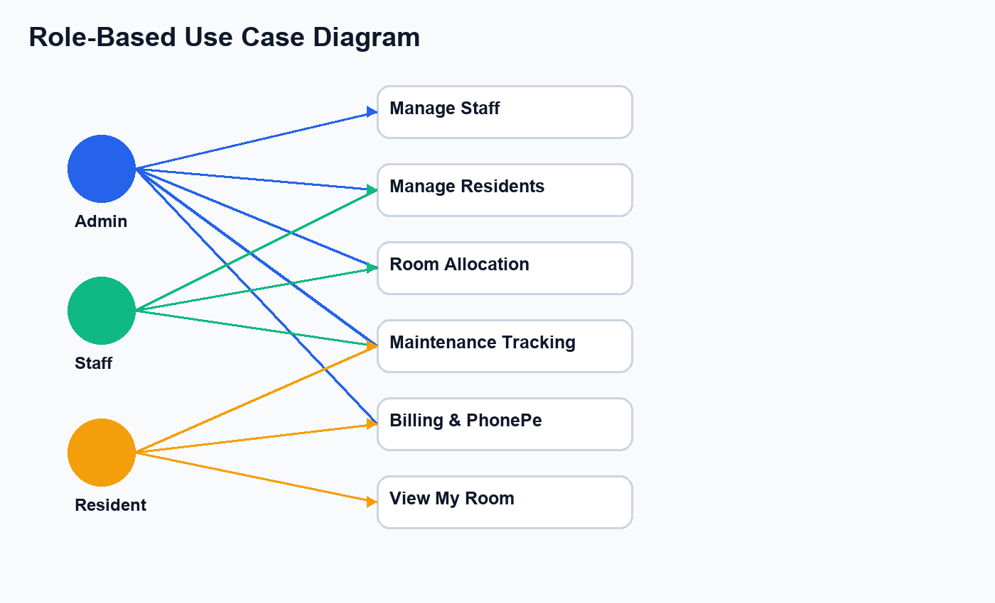

12. Database Design
MongoDB Atlas is used as the database. Mongoose schemas define the structure of application collections. The main collections are User, Room, Billing, Maintenance, and Notification.
References are used to link records. A room stores occupant references, a user stores assignedRoom, billing records refer to resident and room, and maintenance records refer to the resident who raised the request.
Collection | Important Fields | Purpose
User | name, email, password, role, assignedRoom | Stores all users and resident details
Room | roomNumber, capacity, occupants, status | Stores room and allocation records
Billing | resident, room, totalAmount, status, transactionId | Stores invoices and payment status
Maintenance | resident, title, priority, status | Stores maintenance complaints
Notification | recipient, title, message, isRead | Stores in-app alerts

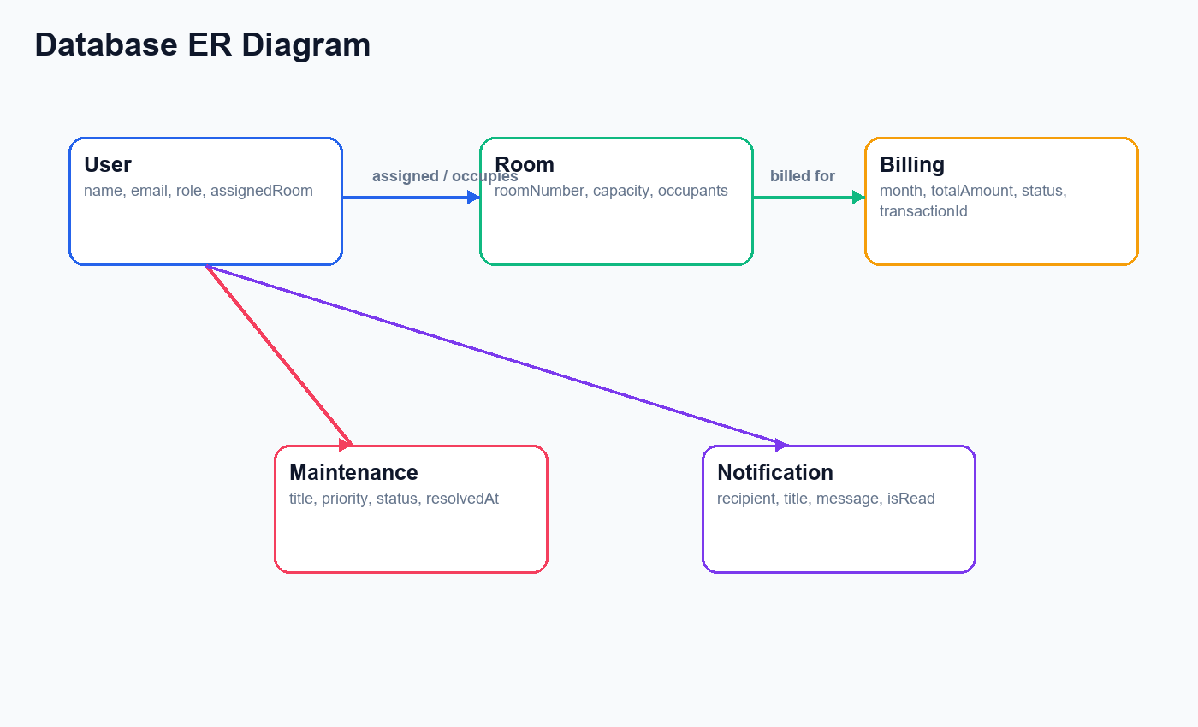

13. API Design
The backend follows REST API principles. Routes are grouped by module under /api/auth, /api/users, /api/rooms, /api/maintenance, /api/billing, and /api/notifications.
Protected routes use JWT middleware. Admin-only and admin-or-staff middleware is used for role-based authorization. The backend returns JSON responses and standard HTTP status codes.
API Group | Sample Endpoint | Purpose
Auth | POST /api/auth/login | Login and JWT generation
Users | GET /api/users/residents | Resident management
Rooms | GET /api/rooms/my | Resident room details
Maintenance | POST /api/maintenance | Create request
Billing | POST /api/billing/:id/initiate-payment | Start PhonePe checkout
Notifications | GET /api/notifications/my | Fetch alerts

14. Authentication and Authorization
Authentication is implemented using email/password login. Passwords are hashed using bcrypt before being stored. JWT tokens are generated after successful login and used by the frontend in Authorization headers.
Authorization is enforced on both frontend and backend. Frontend ProtectedRoute controls page access, while backend middleware prevents unauthorized API access even if a user manually calls an endpoint.

15. PhonePe UAT Payment Integration
The project integrates PhonePe Standard Checkout UAT for testing online payments. When a resident initiates payment, the backend creates a merchant order id, saves it in the billing record, generates a PhonePe OAuth token, and creates a checkout order.
After payment, the backend checks PhonePe order status. If the order state is COMPLETED, the invoice is marked as Paid. For QR testing in local development, a Check Status button is provided because mobile localhost redirects cannot reach the laptop backend.

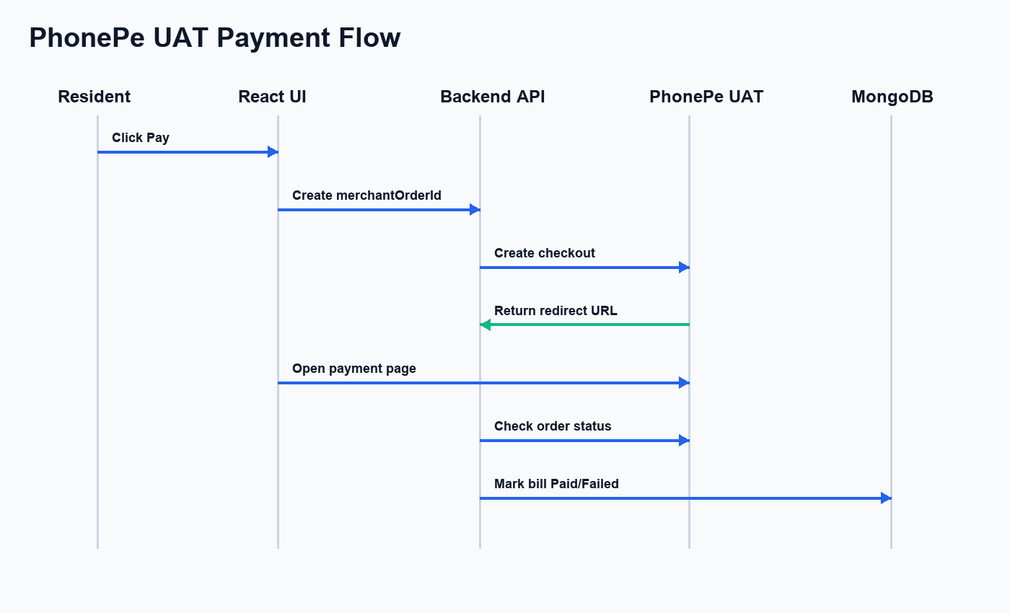

16. Frontend Design
The frontend uses React Router for public and protected routes. Public pages include Home, About, Contact, Login, and Signup. Protected dashboard pages are nested under DashboardLayout.
The dashboard uses a light theme, sharp rectangular cards, and visual charts such as pie charts, bar charts, and area graphs. UI elements are styled with Tailwind CSS and use responsive layouts for different screen sizes.

17. Performance Improvements
Billing page data for admin/staff is loaded using parallel API requests. The My Room page uses a dedicated backend endpoint so it does not download all room records. Maintenance submit/status updates update local state instead of always refetching the full list.
Several backend list queries use lean reads to reduce Mongoose overhead when full document methods are not needed. The serverless backend also waits for MongoDB connection before processing API routes to avoid buffering timeout errors.

18. Deployment
The project is prepared for deployment on Vercel. The backend exports the Express app through api/index.js and includes vercel.json. The frontend has a Vercel rewrite file so refreshing React routes works correctly.
MongoDB Atlas is used as the deployed database. Environment variables in Vercel store secrets such as MONGO_URI, JWT_SECRET, PhonePe credentials, and frontend API base URL.

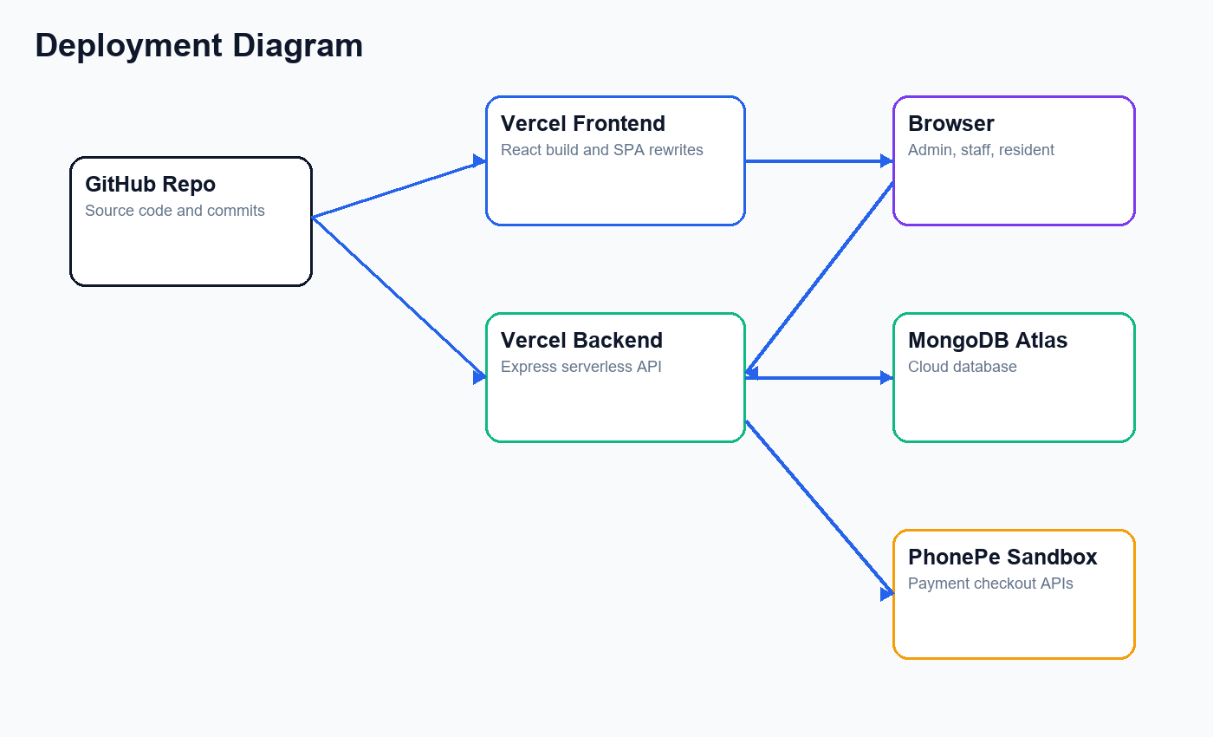

19. Testing
Testing was performed for resident registration, login, protected routing, admin/staff operations, resident self-service pages, room assignment, maintenance flow, billing generation, PhonePe checkout redirection, and payment status refresh.
Build verification was performed using npm run build for the frontend. Backend route import tests verified that Express route modules load correctly. Deployment testing verified Vercel routing and MongoDB Atlas connectivity.
Test Area | Test Case | Expected Result
Authentication | Login with valid credentials | Dashboard opens
Authorization | Resident opens admin route | Access denied/redirect
Room | Assign resident to room | Room occupancy updates
Maintenance | Resident raises request | Request appears in list
Billing | PhonePe UAT payment | Invoice status becomes Paid
Deployment | Refresh dashboard route | SPA route works

20. Limitations and Future Enhancements
The current payment integration uses PhonePe UAT and requires production credentials before real money transactions. File uploads are stored as base64 strings, which is acceptable for a college demo but should be replaced with cloud storage in production.
Future improvements include PDF invoice generation, password reset, email/SMS alerts, hostel mess management, attendance tracking, advanced reports, and real-time notifications.

21. Conclusion
The Hostel Management System successfully demonstrates a practical full-stack solution for college hostel administration. It replaces manual workflows with a centralized, role-based, deployment-ready application.
The project combines frontend design, backend API development, MongoDB modeling, authentication, authorization, payment integration, dashboard analytics, performance optimization, and documentation. It is suitable for college project demonstration and can be extended for real-world use.

Appendix A: Code Explanation
This code verifies credentials, compares password hashes, and generates a signed token used for authenticated API access.

JWT Login Route
router.post('/login', async (req, res) => {
const { email, password } = req.body;
const user = await User.findOne({ email });
if (!user) return res.status(404).json({ message: "User not found" });
const isMatch = await bcrypt.compare(password, user.password);
if (!isMatch) return res.status(400).json({ message: "Invalid credentials" });
const token = jwt.sign(
{ id: user._id, role: user.role },
process.env.JWT_SECRET,
{ expiresIn: '1d' }
);
res.json({ token, user: { id: user._id, name: user.name, role: user.role } });
});
This frontend guard prevents unauthenticated or unauthorized users from opening protected dashboard pages.

Protected Route
const ProtectedRoute = ({ children, allowedRoles }) => {
const { user } = useContext(AuthContext);
if (!user) return <Navigate to="/login" replace />;
if (allowedRoles && !allowedRoles.includes(user.role)) {
return <Navigate to="/dashboard" replace />;
}
return children;
};
This code creates a PhonePe checkout request and returns the redirect URL to the resident frontend.

PhonePe Payment Initiation
const payload = {
merchantOrderId,
amount: Math.round(invoice.totalAmount * 100),
paymentFlow: {
type: "PG_CHECKOUT",
merchantUrls: { redirectUrl: callbackUrl }
}
};
const paymentResponse = await initiatePhonePePayment(payload);
res.json({ redirectUrl: paymentResponse.redirectUrl });
This endpoint improves performance by returning only the logged-in resident's assigned room.

Room Optimization Endpoint
router.get('/my', protect, async (req, res) => {
if (!req.user.assignedRoom) return res.json(null);
const room = await Room.findById(req.user.assignedRoom)
.populate('occupants', 'name email contactNumber courseDetails')
.lean();
res.json(room);
});

Appendix B: Complete Diagram Set

System Architecture Diagram


Role-Based Use Case Diagram


Database ER Diagram


PhonePe Payment Flow Diagram


Deployment Diagram


