**HTML HELP WORKSHOP**

**Check is it installed or not**

Goes to search option and search HTML help Workshop .if it's there directly open else download and installed follow this link https://www.microsoft.com/en-us/download/details.aspx?id=21138

# Create Project

1)Left top click **File ->project->project name ->next->next->finished**

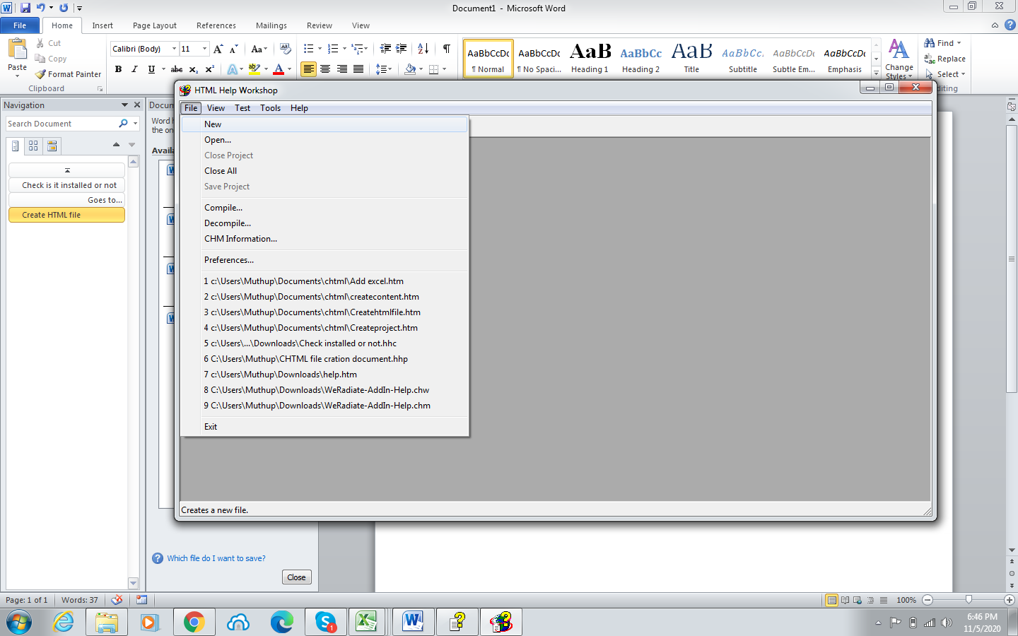

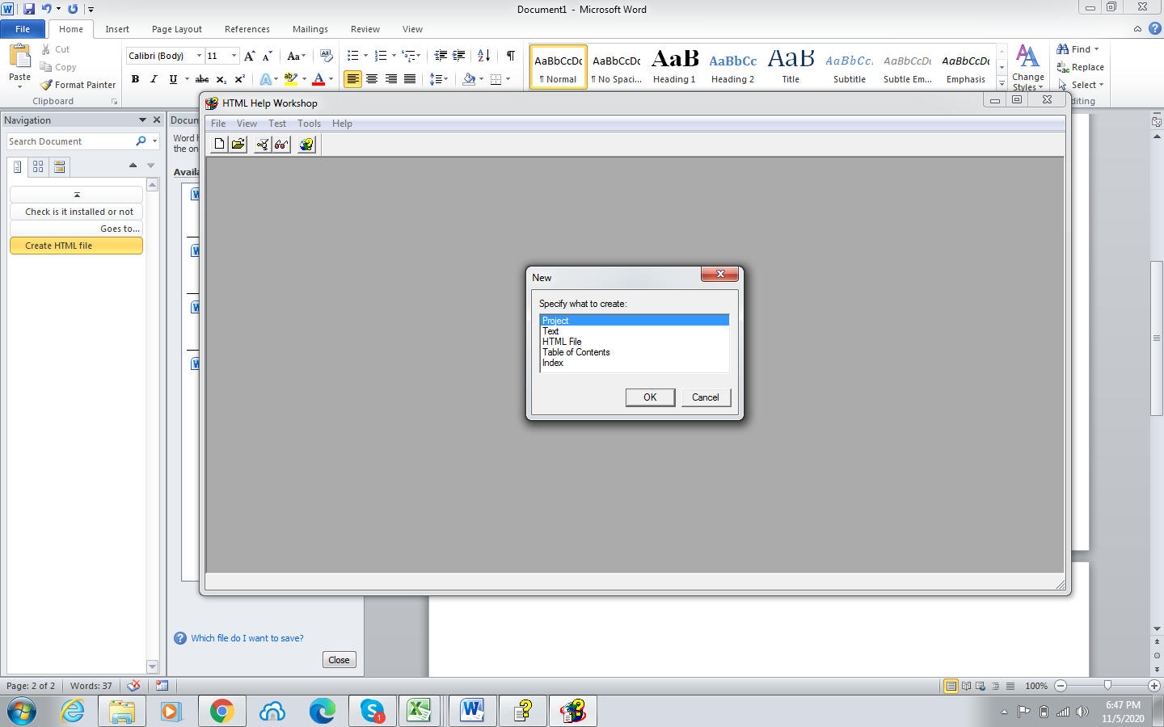

# Create HTML file

# 1)Left top click new and follow the images

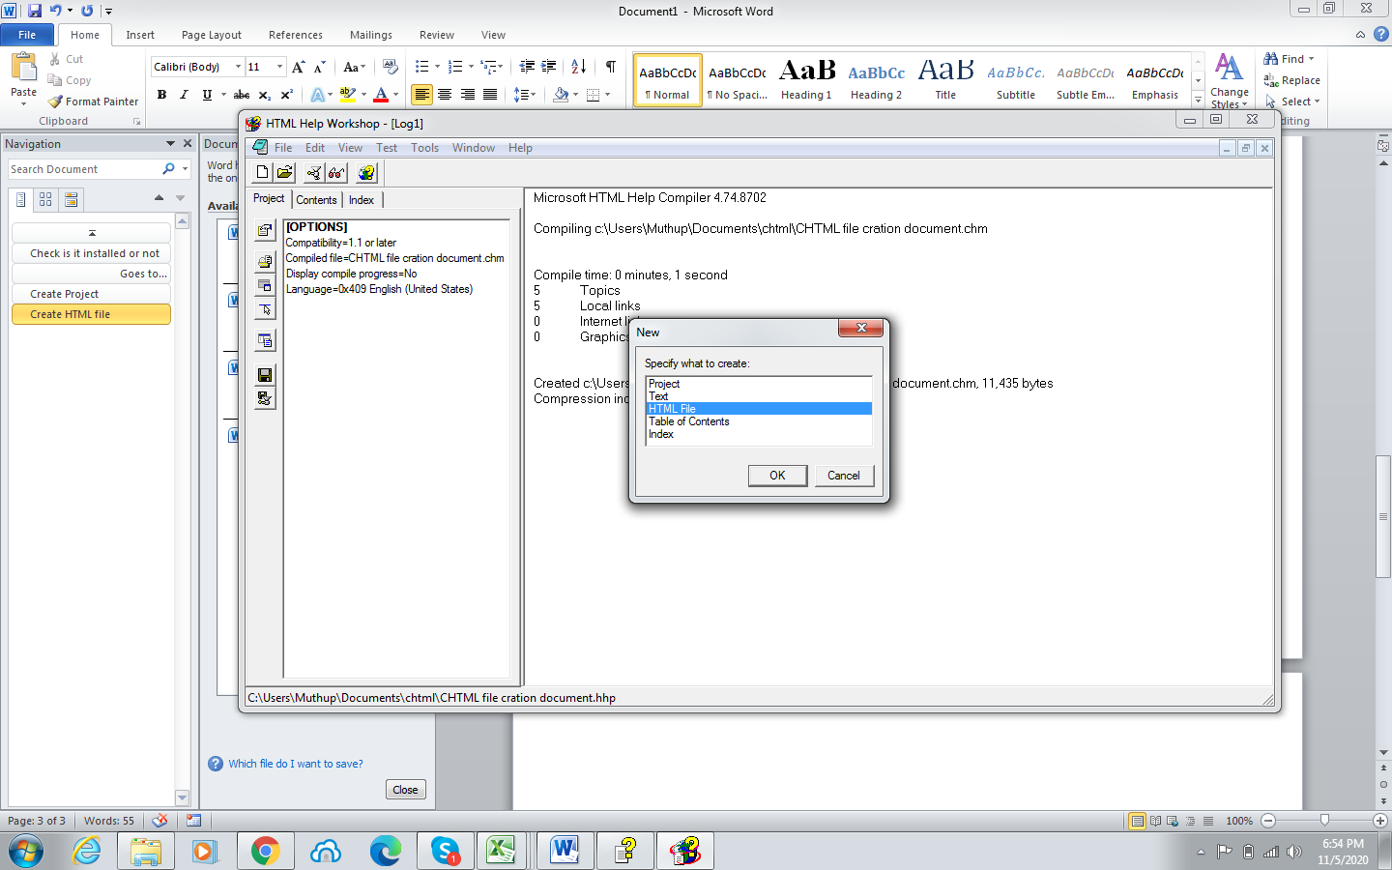

2) Enter the title name

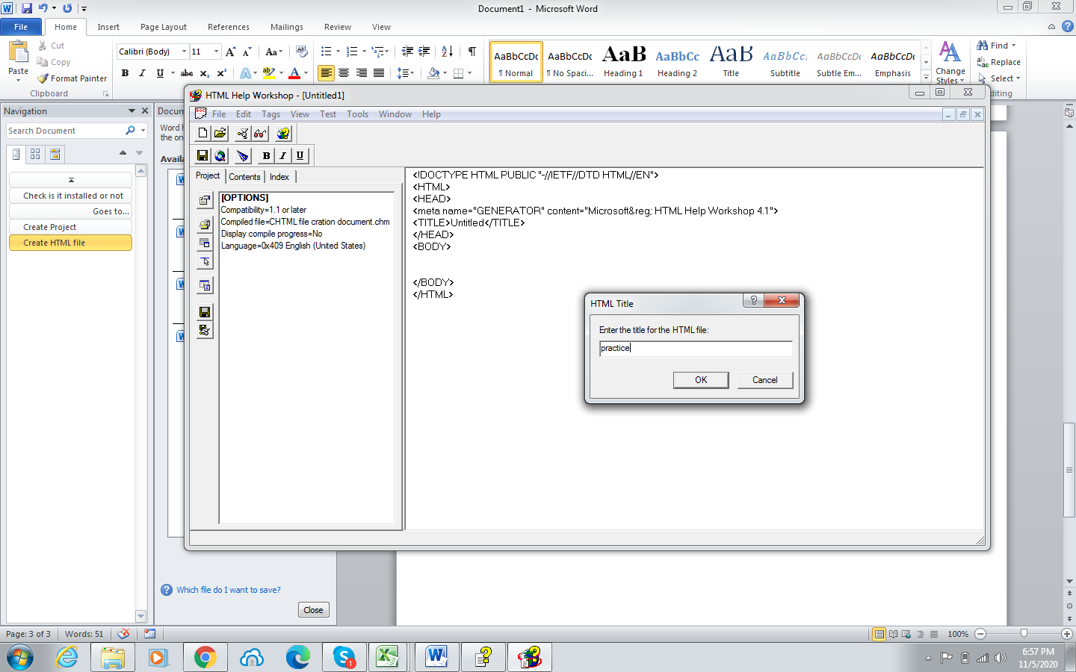

3)Which type of content you want write here using html tags and save the file

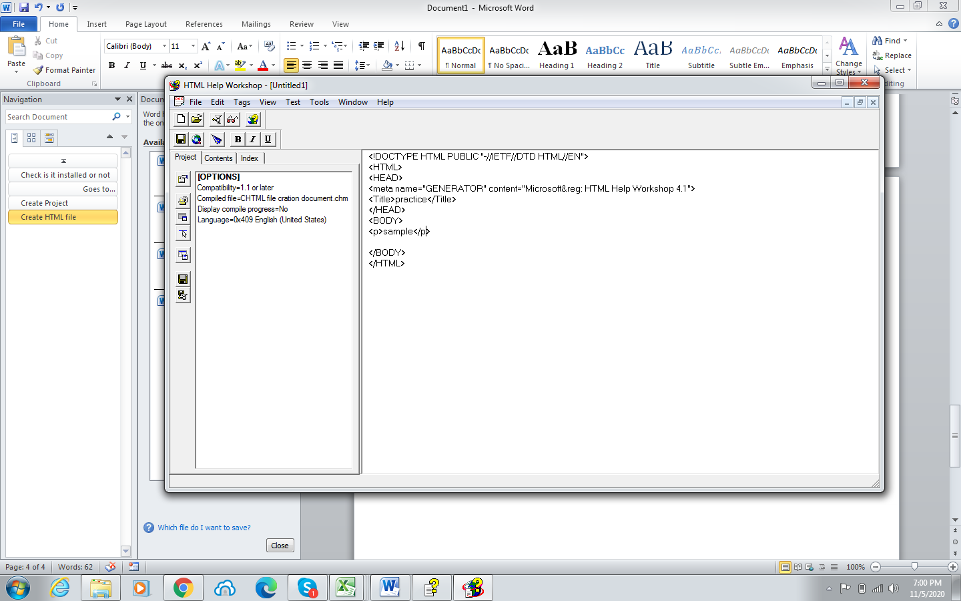

# Create content

# 1)Click Contents button -> then click ok

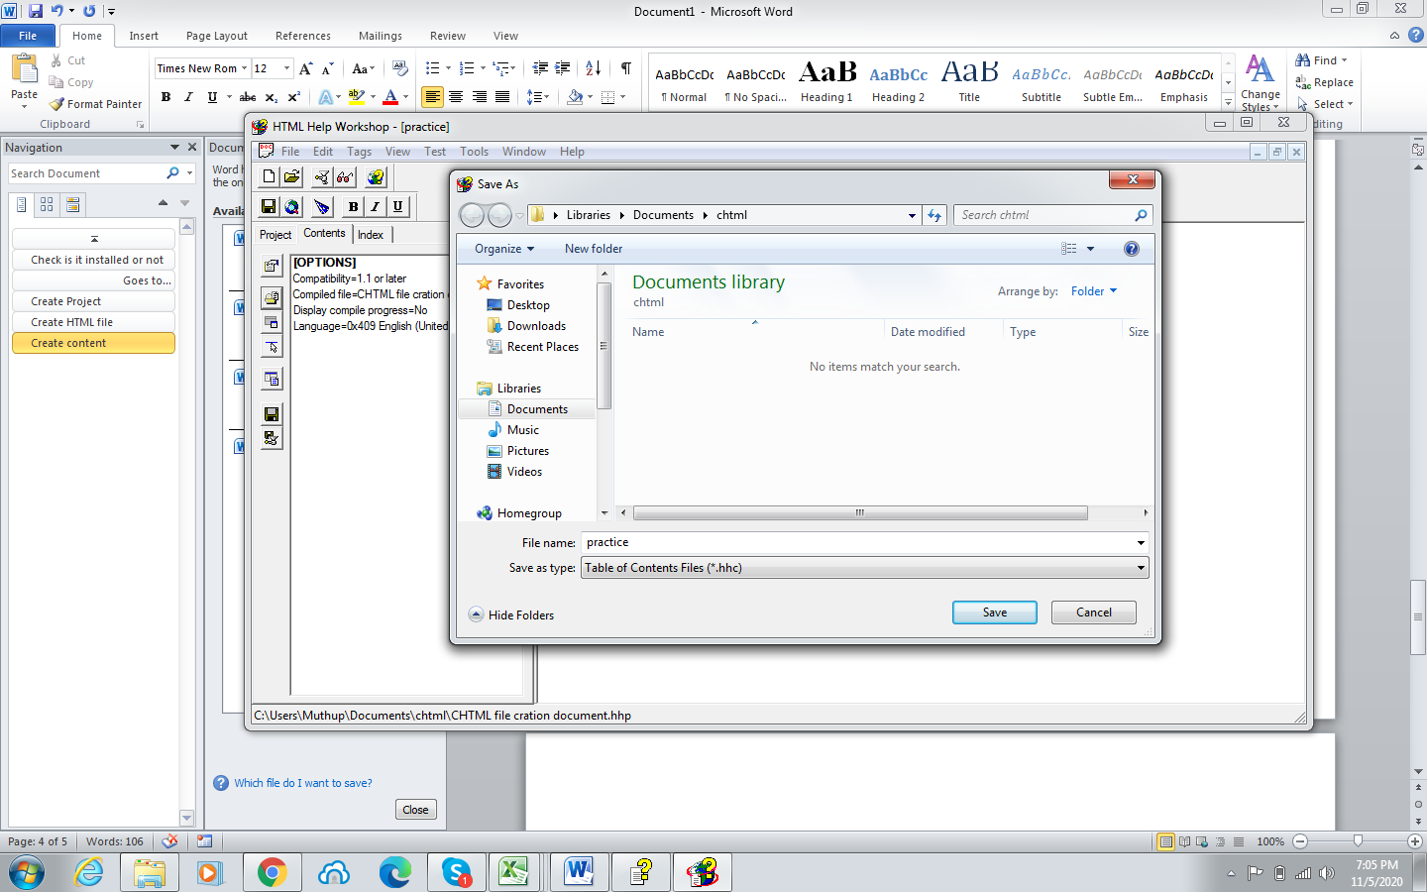

2)Then click content icon its open enter content label name then click add and link the that html file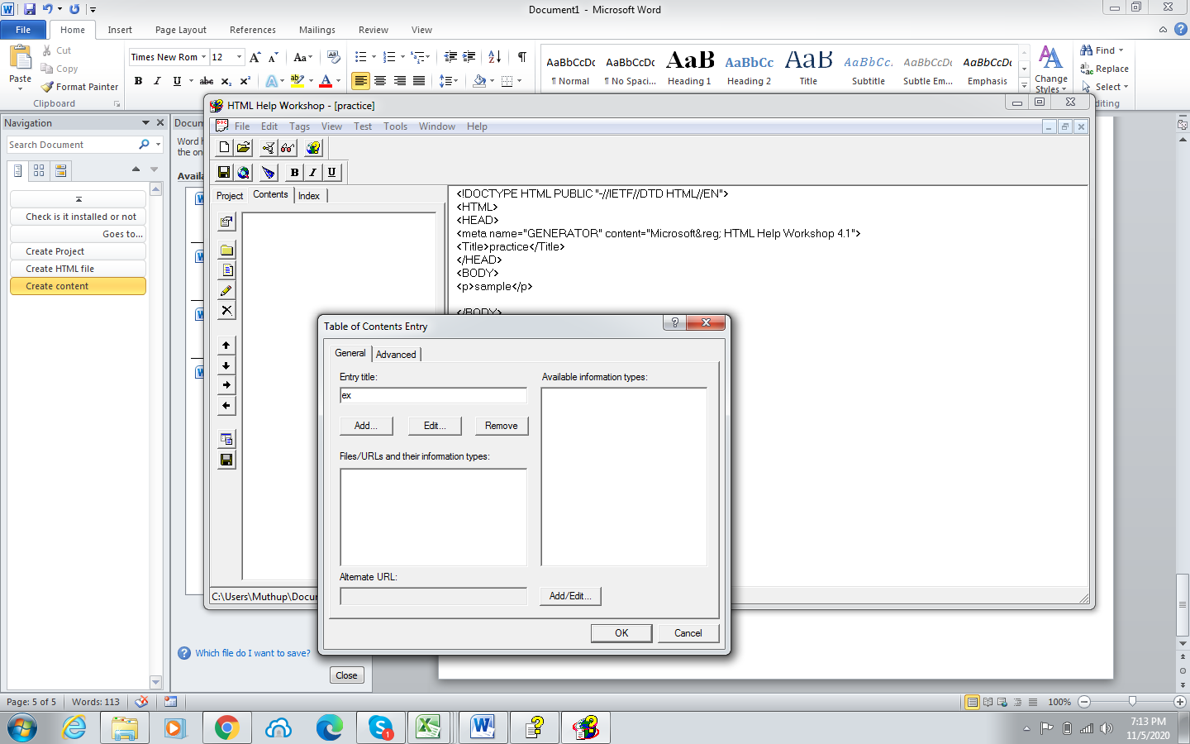

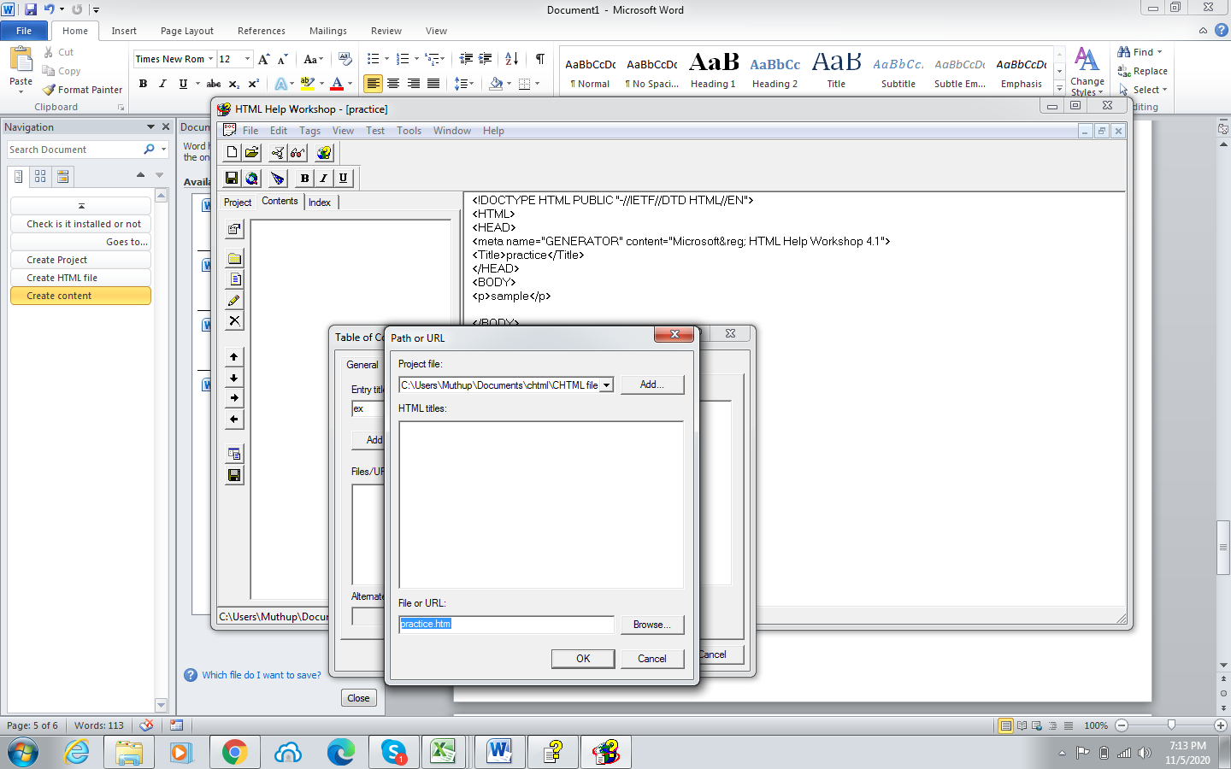

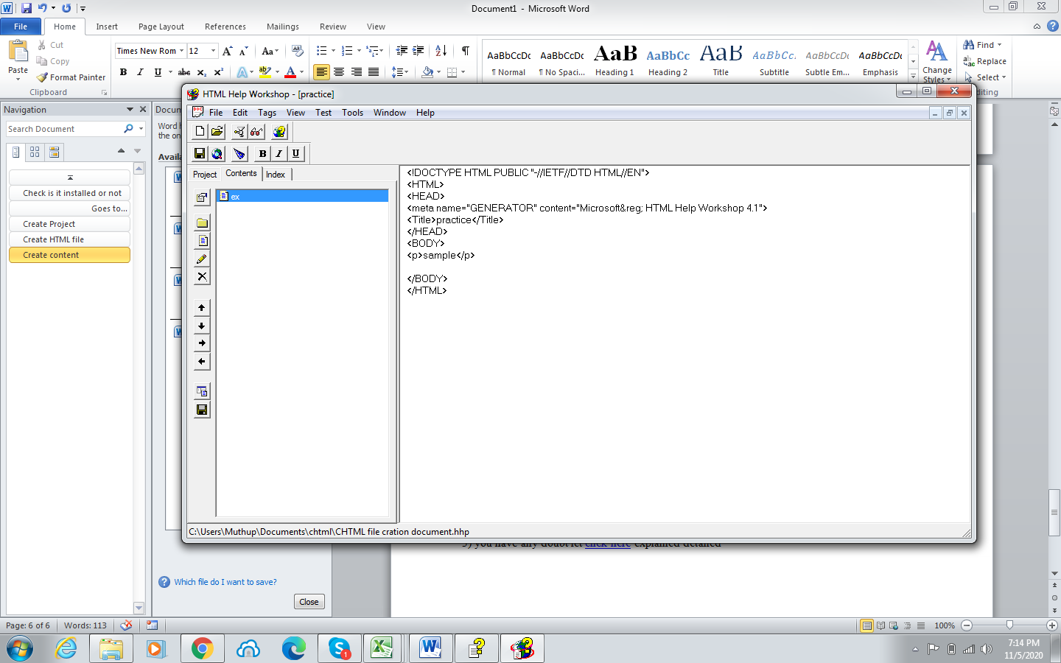

3)Click file then save all and compile your project

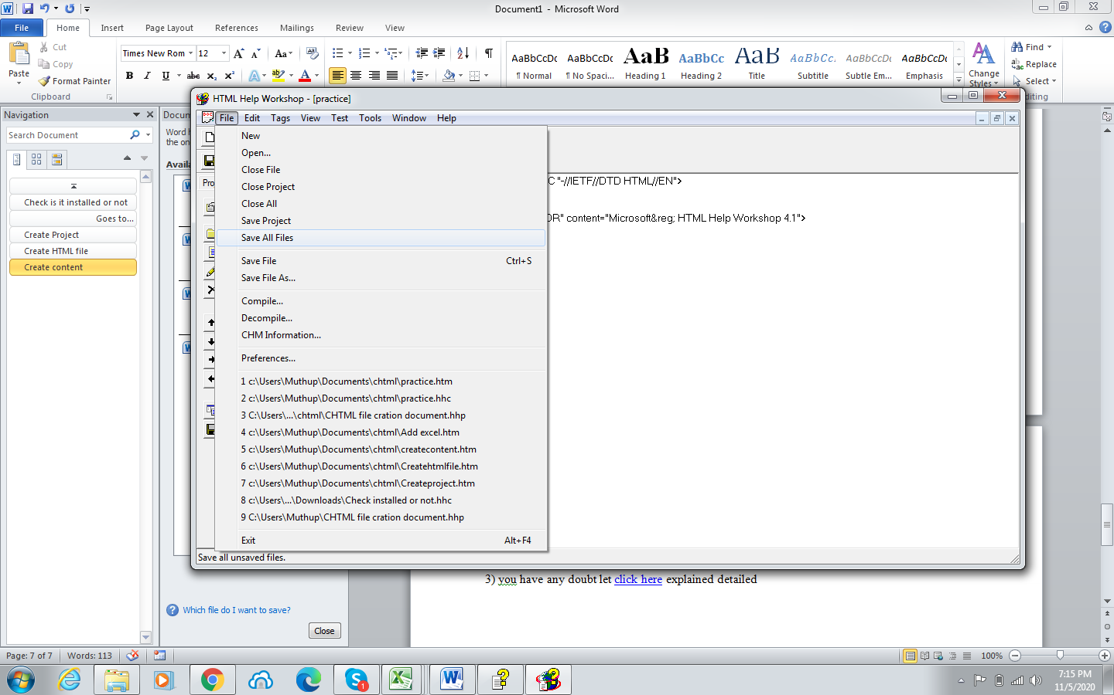

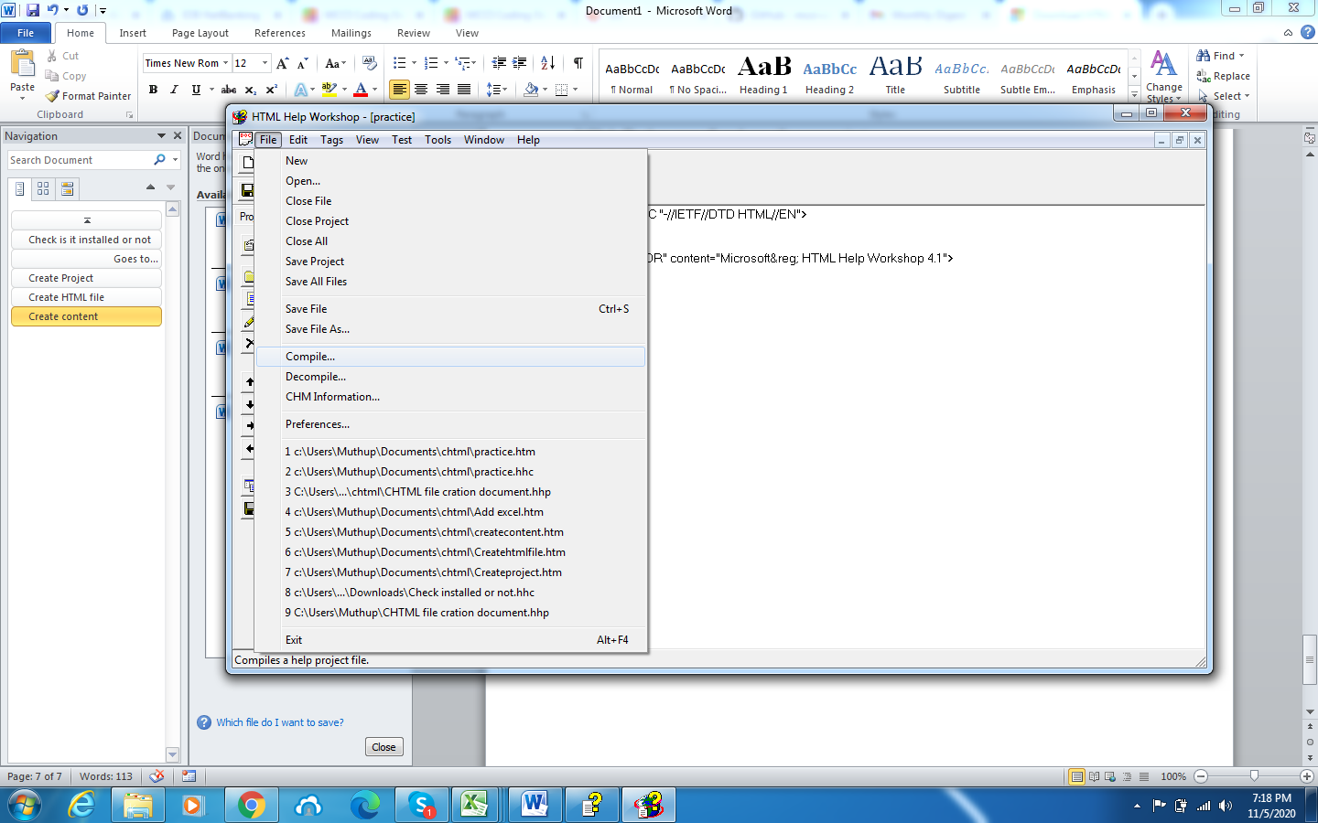

# Chm file add to excel

Define one function and asign the chm file path  
  
Sub weradiate_DT_help_button()  
     Shell ("cmd /cstart C:\Users\Muthup\Documents\chtml\help.chm")  
End Sub

