**MCCI Windsor Google Sheet Add On Install and Usage Procedure**

**Google Sheet Add-on Install Procedure:**

1)First sign in google acoount

2) open **G-suit** in google and then search weradiate click install this(G-suit link: <https://gsuite.google.com/marketplace>)



3) open google sheet in google and then click add on next click WERADIATE-DATA-TEMPLATE shows only help at that time you will do one more step.(google sheet link: <https://docs.google.com/spreadsheets/d/1oM2HJmeCYLwGT_IvySKoEtRLLMiUWO3SMmb9k_fAmpg/edit#gid=0>)

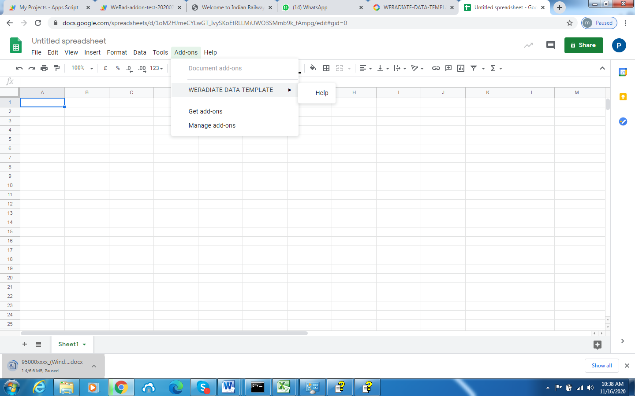

4)Click add on next click manage add on and in that weradiate app show three dots click that then click use this document and refresh this page .

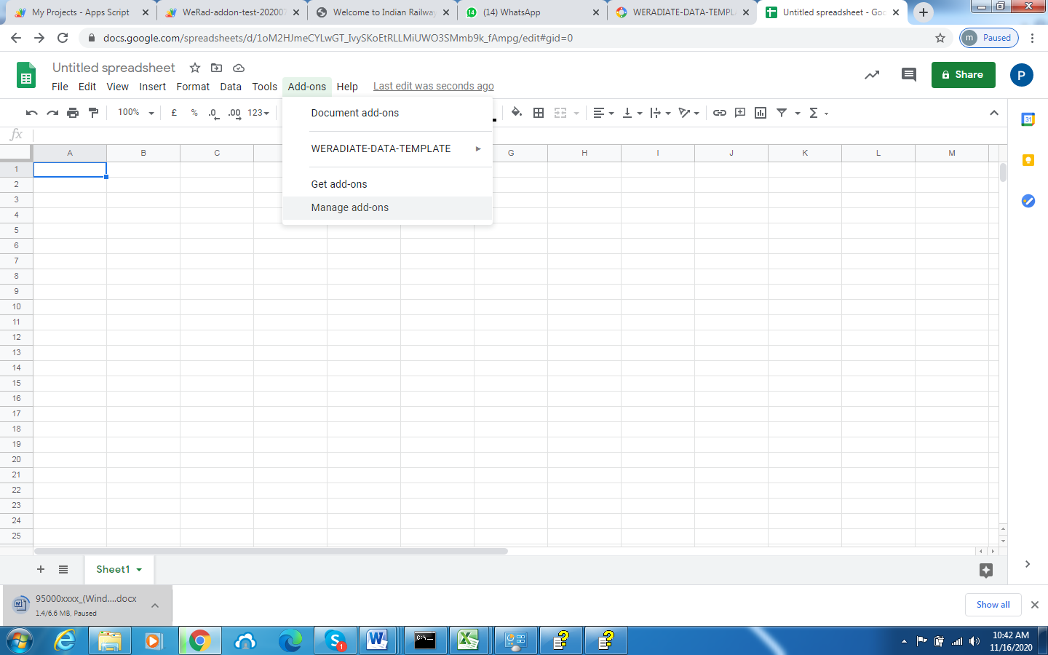

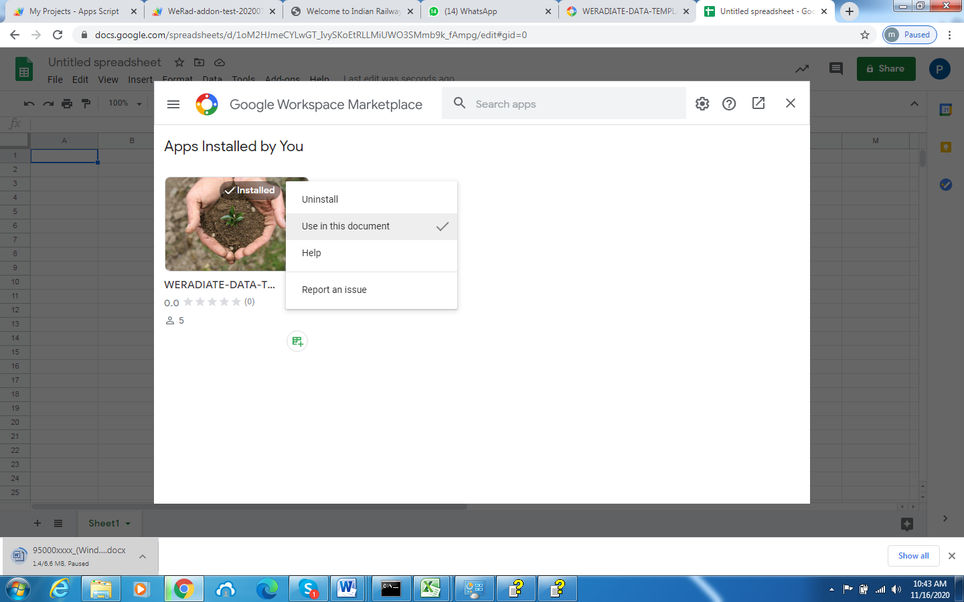

5)Again click add on next click WERADIATE-DATA-TEMPLATE then click manage connection that times shows below image.

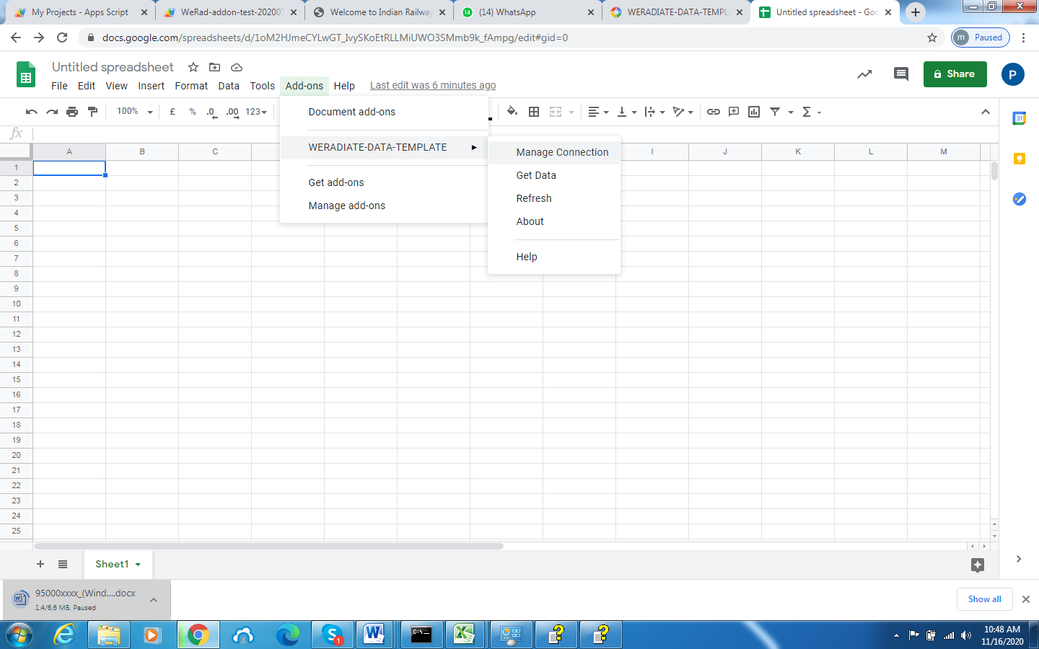

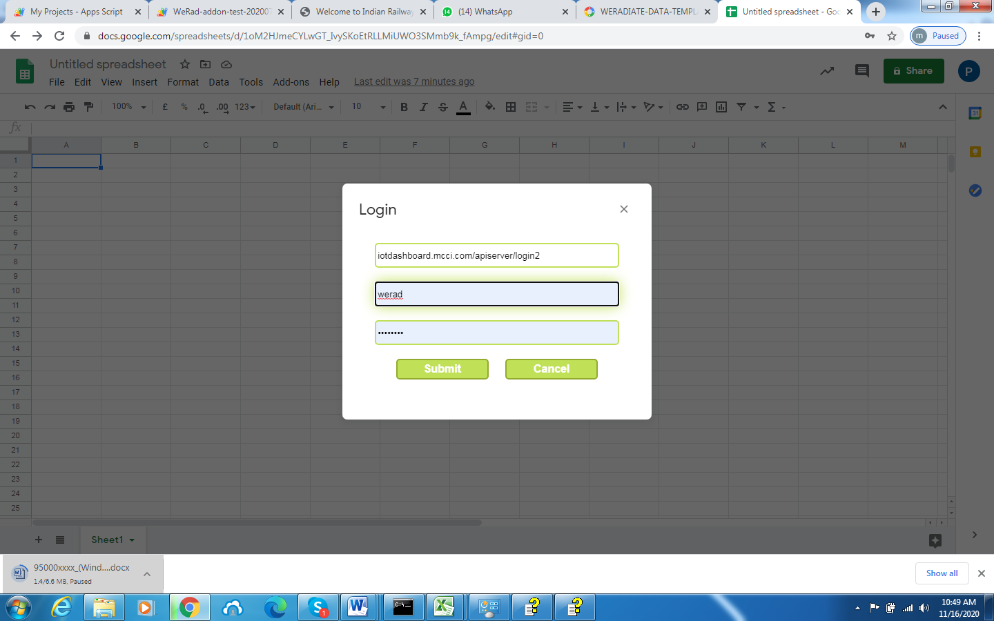

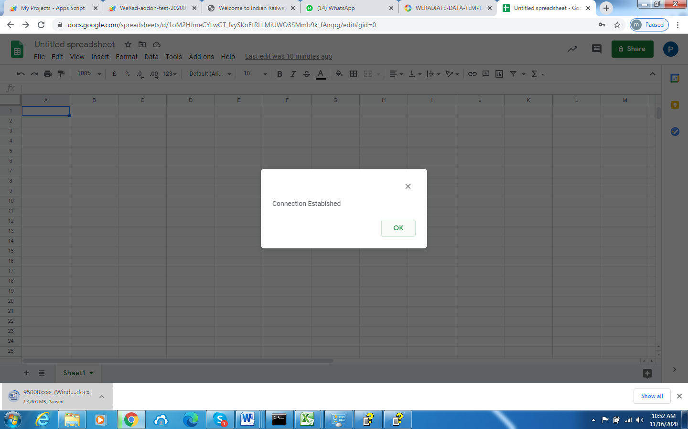

6) Then Click get data that time shows below image

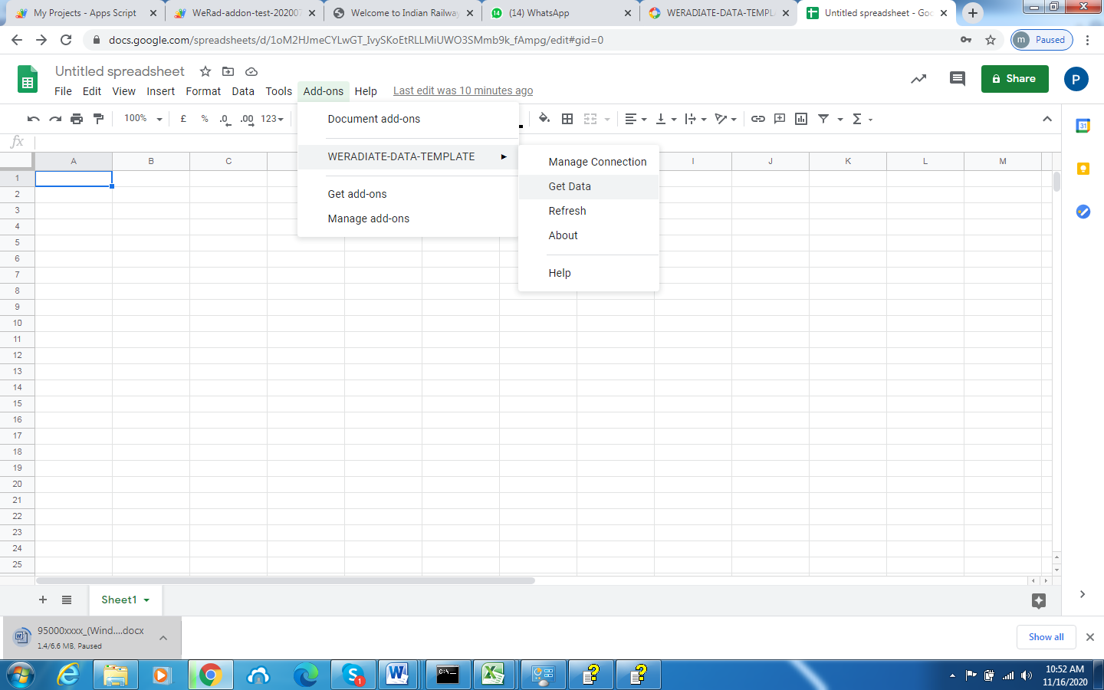

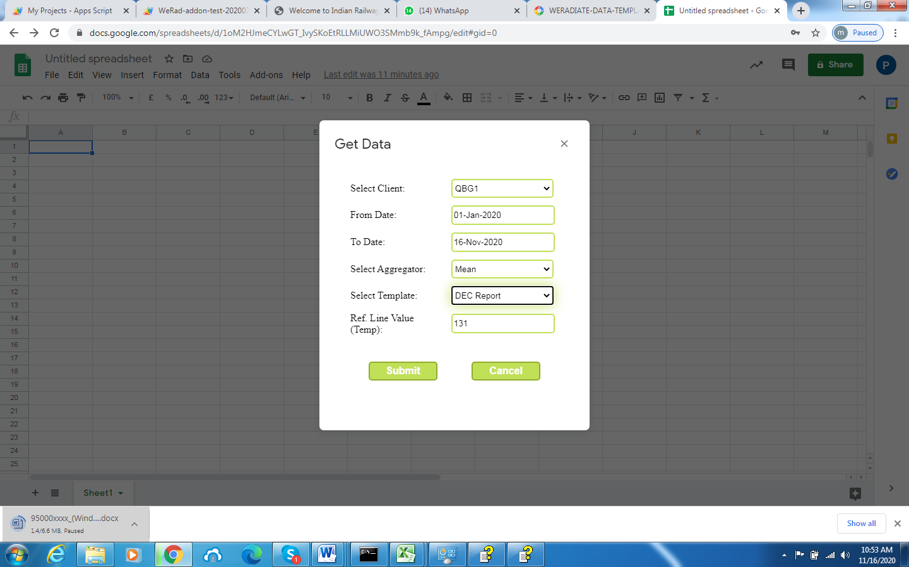

7)Enter submit then open below image page then shows data(**Note:some time does not shows any data that time right top of chrome shows one pop up icon in search bar click on that next click always allow pop-up**)

