**GIT**

**Why we need git?**

software developers to work together and maintain a complete history of their work.

Git installation :

Follow this link download and install like other application installation process

<http://git-scm.com/>

Version Control System:

**Version Control System (VCS)** is a software that helps software developers to work together and maintain a complete history of their work.

* Allows developers to work simultaneously.
* Does not allow overwriting each other’s changes.
* Maintains a history of every version.

Git commands:

* 1. Set name and email for git to when use commit

git config --global user.name "smppandi1998"

git config --global user.email “[muthupandip1998@gmail.com](mailto:muthupandip1998@gmail.com)”

type this comment **git config –list** and see ouput

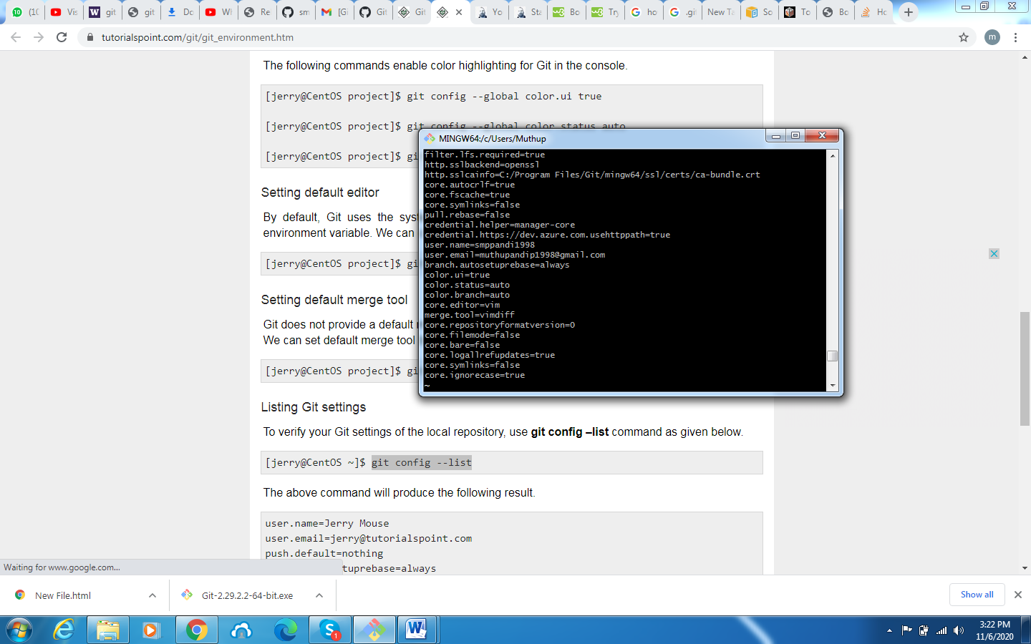

2) To create a new **local Git repo** in your current directory

$ git init folder name

$ git add filename

$ git commit -m "first message"

3) To clone a remote repo to your current directory

$ git clone url localDirectoryName

Example:

$ git clone https://github.com/smppandi1998/sample.git practice

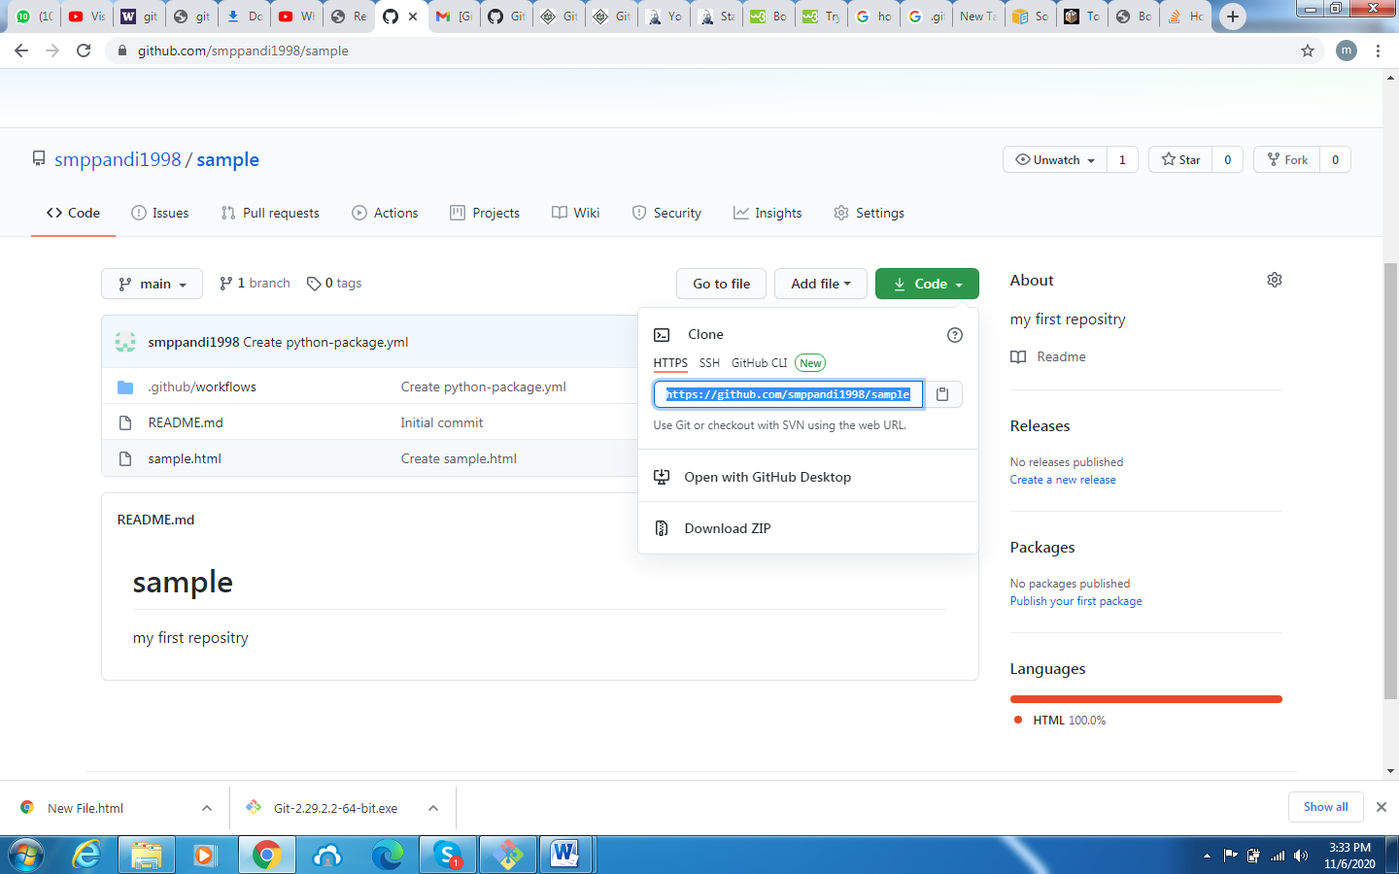

4) view the status of your files in the working directory and staging area

$ git status

5) shows diff of what is staged and what is modified but unstaged

$ git diff

6) fetch from a remote repo and try to merge into the current branch

$ git pull

7) push your new branches and data to a remote repository

$ git push

8)create a new local branch.

$ git branch name

9) list all local branches.

$ git branch

10) switch to a given local branch.

$ git checkout branchname

11) merge changes from a branch into the local master.

$ git checkout master

$ git merge branchname