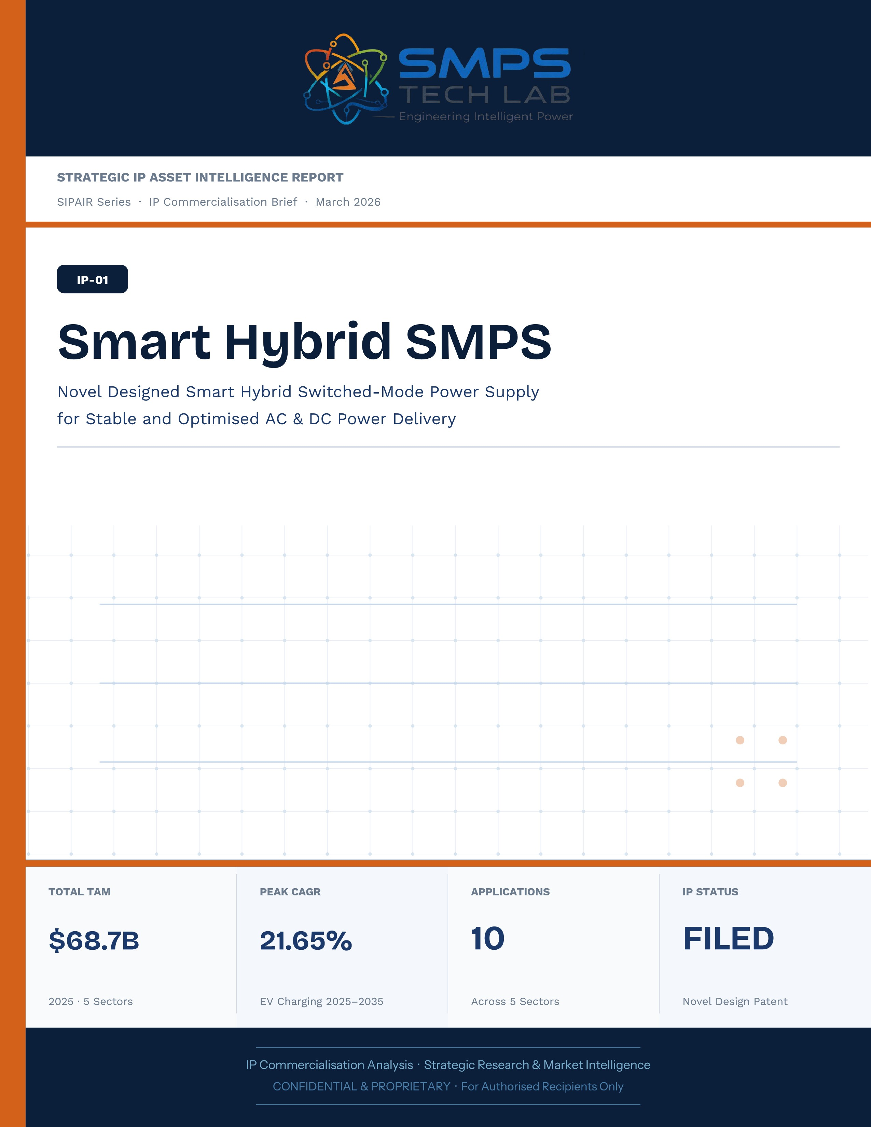
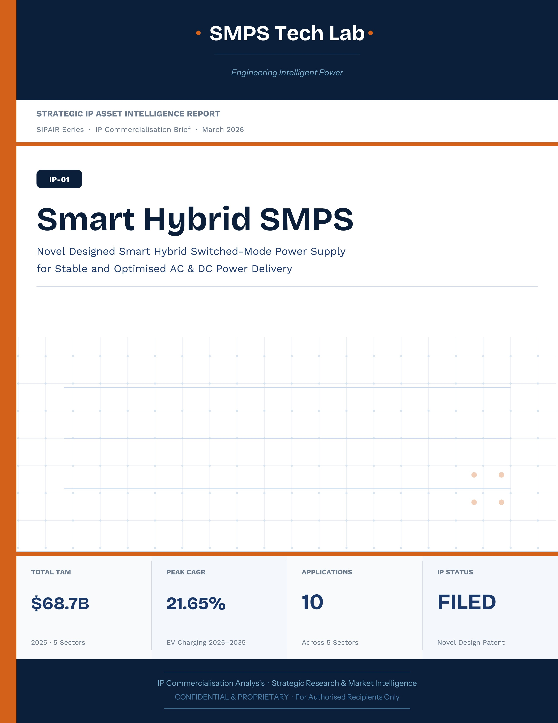

STRATEGIC IP ASSET INTELLIGENCE REPORT
SIPAIR Series
Smart Hybrid SMPS — IP-01
Novel Designed Smart Hybrid Switched-Mode Power Supply

Report Title | SIPAIR IP-01 — Smart Hybrid SMPS Commercialisation Brief

Document Series | Strategic IP Asset Intelligence Report (SIPAIR)

Version | Version 1.0 — First Edition

Compiled & Edited by | Shri Amareshwar Karatagi

Organisation | SMPS Tech Lab — Engineering Intelligent Power

Date of Issue | March 2026

Classification | Confidential & Proprietary — For Authorised Recipients Only

IP Reference | IP-01 — Novel Design Patent Filed, 2025

This document is prepared by SMPS Tech Lab as part of the SIPAIR IP Commercialisation Series.

Declaration — Originality & Intellectual Property Statement

This Strategic IP Asset Intelligence Report (SIPAIR — IP-01: Smart Hybrid SMPS) is an original compilation prepared by SMPS Tech Lab. The analysis, market intelligence frameworks, commercial strategy formulations, technology assessments, sector mappings, and case study narratives contained herein are the result of independent research and original intellectual work by the authors and editors named in this document.
The core technology described in this report — the Smart Hybrid Switched-Mode Power Supply topology and associated adaptive switching methodology — is the exclusive proprietary invention of SMPS Tech Lab, protected under a filed novel design patent (2025). All references to this IP are made in the capacity of the IP rights holder.
Market sizing data, CAGR estimates, and industry statistics cited throughout this document are sourced from independent third-party research publications, which are fully attributed in Appendix A. All such third-party data is used for analytical and benchmarking purposes only, in accordance with principles of fair use for commercial research and reporting. No third-party data has been presented as the original work of SMPS Tech Lab.
The case studies presented in this document (Cases 01 through 05) are representative commercial scenarios constructed from market-verified technical and financial parameters. They are illustrative of the types of deployments and outcomes achievable with IP-01 technology, and do not necessarily represent specific named client engagements. Any resemblance to specific organisations or projects is coincidental unless explicitly identified.
This report has not been submitted, in whole or in part, to any other organisation, publication, or commercial body for the purpose of commercialisation, licensing, or formal assessment, except as may be specifically disclosed in writing.
Declared by:

Shri Amareshwar Karatagi
Founder & CSO
SMPS Tech Lab · March 2026

CERTIFICATE OF AUTHENTICITY
IP Commercialisation Documentation

This is to certify that the Strategic IP Asset Intelligence Report
SIPAIR IP-01 — Smart Hybrid SMPS Commercialisation Brief
has been compiled, reviewed, and authenticated by the undersigned
in accordance with the standards of the SIPAIR documentation series.
The technology, market analysis, and commercial intelligence presented
herein are verified as accurate to the best of the signatories’ knowledge
as at the date of issue: March 2026.

Program Head / Director | Technical Mentor
  Program Head / Research Director
  SMPS Tech Lab
  Technical Mentor / Advisor
  SMPS Tech Lab

SMPS Tech Lab · Engineering Intelligent Power · March 2026

Acknowledgment

The preparation of this Strategic IP Asset Intelligence Report has been a sustained and collaborative effort that draws on the knowledge, guidance, and support of many individuals. The author and editor wish to express sincere gratitude to those whose contributions made this work possible.

Technical Development & Research
The foundational engineering work underpinning IP-01 — the 38-month development arc that took a field observation through seven prototype iterations to a filed patent — was possible only through the rigorous intellectual environment of SMPS Tech Lab. The team's commitment to solving a real engineering problem rather than pursuing incremental improvement on existing designs is the reason this IP has the commercial distinctiveness documented here.

Advisory & Mentorship
The mentors and advisors who guided the development programme — in power electronics engineering, intellectual property strategy, and commercial go-to-market architecture — provided the perspective that separated a technically sound invention from a commercially deployable asset. Their willingness to challenge assumptions and validate conclusions at every stage of the work is reflected throughout this document.

Industry Contacts & Field Validation
The insights from field installations across industrial automation, solar energy, and telecommunications — the observations that gave rise to IP-01's foundational question — are the result of generous access provided by facility managers, plant engineers, and installation teams at multiple sites across India. Their willingness to share operational data and allow the engineering team to observe real-world power distribution challenges in situ was indispensable to the authenticity of the IP that emerged.

Research & Documentation
The market intelligence in this report draws on data from Allied Market Research, Future Market Insights, MarketsandMarkets, Precedence Research, Research and Markets, Data Bridge Market Research, Global Growth Insights, and Global Market Insights, as well as policy documents from the Government of India's Ministries of Power, Heavy Industries, New and Renewable Energy, and Electronics & IT. The thoroughness of those publications made it possible to construct the rigorous, independently-verified TAM framework that forms the commercial backbone of this report.

Institutional Support
The institutional support of SMPS Tech Lab's founding team — in providing the lab infrastructure, engineering resources, and organisational commitment without which sustained IP development of this complexity is impossible — is acknowledged with deep appreciation. Building intellectual property of commercial significance requires not just technical talent but the sustained institutional will to see a long development programme through to its conclusion. That will has been the constant in this work.

Shri Amareshwar Karatagi
Founder & CSO
SMPS Tech Lab · March 2026

Preface — From the Founder & Editor

Why This Document Exists
There is a particular kind of frustration that most engineers who work at the intersection of invention and commerce have experienced: the frustration of watching a genuinely good idea fail to reach its commercial potential not because the technology was wrong, but because the communication of its value was inadequate. Patents accumulate in filing cabinets. Prototypes sit on laboratory benches. Market opportunities that were real and identifiable close — not because no one could build the solution, but because the right people never understood clearly enough what was being offered and why it mattered.
The Smart Hybrid SMPS — IP-01 — was not designed to sit in a filing cabinet. It was designed to be deployed, to replace unnecessary engineering complexity with an elegant and efficient solution, and to do so at scale across the sectors where that complexity is costing the most. The purpose of this document is to ensure that the right people — investors, OEM partners, research collaborators, and technology builders — have everything they need to understand the opportunity clearly enough to act on it.

The Problem We Set Out to Solve
The question that started the IP-01 development programme was not a technical one. It was an observational one. In field installation after field installation across industrial automation, solar energy, and telecommunications in India, the same configuration appeared: two power supply units, side by side, one for AC and one for DC, each performing a conversion function that the other could theoretically complement. The waste was not just in the duplicated hardware and the cascaded conversion losses — it was in the missed opportunity that the duplication represented. Every system that deployed two units where one could have done the job was a system that was less efficient, more expensive, more difficult to monitor, and more prone to failure than it needed to be.
That observation became a hypothesis. The hypothesis became a research programme. The research programme became seven prototype iterations, an adaptive control breakthrough, a smart diagnostics platform, and a filed patent. But the thing that matters most about IP-01 is not any of those individual achievements — it is the fact that the original problem it was designed to solve is a real problem, at real scale, in real systems deployed across a USD 68.7 billion addressable market that is growing at rates between 4.5% and 21.65% per year. We did not invent a technology and then look for a problem to apply it to. We identified a problem and built the technology it demanded.

Who This Document is Written For
This SIPAIR brief is written for three distinct readers, and it is worth being direct about who they are and what we hope they will take from it.
The investor or board member evaluating whether IP-01 represents a commercially defensible asset with a credible path to significant revenue should find, in the TAM framework, competitive analysis, and financial projections, a rigorous and independently-verifiable case for that proposition. We have made no market claims we cannot source, and no technology claims we cannot demonstrate.
The OEM engineer or product manager at a company building EV chargers, solar inverters, industrial automation equipment, telecom infrastructure, or medical devices should find, in the technology overview, integration matrix, and case studies, a specific and practical understanding of how this IP adds value to their product — what it replaces, what it costs, what it saves, and how long it takes to integrate. The purpose of the case studies is not to be impressive — it is to be actionable.
The researcher, technology builder, or entrepreneur who sees in IP-01 an opportunity to build something new should find, in Case Study 06, a direct and genuine invitation — not a marketing placeholder but a real programme with real infrastructure and real commercial frameworks — to engage with SMPS Tech Lab and build the next chapter of this technology's story.

A Note on Tone and Approach
This document is written in the voice of the industry — not the voice of a startup looking to impress, but the voice of engineers and technologists who have done the work and are communicating its results with the directness and rigour that serious technical and commercial audiences deserve. If sections of this document read like a field manual as much as a commercial brief, that is intentional. Power electronics is a discipline that rewards precision, and the people who will read this document — the engineers, investors, and researchers who will ultimately determine whether IP-01 reaches its commercial potential — are people who value precision above polish.

We hope this document serves as a beginning, not an end. The most important page in it is Case Study 06 — the one that does not yet have a story in it. We look forward to filling it.

Shri Amareshwar Karatagi
Founder & CSO
SMPS Tech Lab · March 2026
TABLE OF CONTENTS

Technical Development & Research 4
Advisory & Mentorship 4
Industry Contacts & Field Validation 4
Research & Documentation 4
Institutional Support 5
Why This Document Exists 6
The Problem We Set Out to Solve 6
Who This Document is Written For 7
A Note on Tone and Approach 7
Important Notice & Confidentiality Disclaimer 15
1.1 The Strategic Context 16
1.2 The Problem This IP Solves 16
1.3 The IP-01 Solution 17
1.4 Key Metrics at a Glance 17
1.5 Why This IP, Why Now 18
2.1 The SMPS Paradigm — A Technical Foundation 19
2.2 Four Integrated Functional Layers 19
2.2.1 Functional Architecture — Reference Schematic 20
2.3 Technical Differentiator Benchmark 21
2.4 GaN and SiC Upgrade Pathway 22
2.5 Standards Compliance Architecture 23
3.1 Power Electronics as Critical Infrastructure 24
3.2 The Four Structural Megatrends 24
3.3 Global Market Sizing — Primary Reference Data 25
CAGR Comparison — IP-01 Target Market Segments 26
4.1 Methodology 27
4.2 Consolidated TAM Summary 28
5.1 The India Opportunity 30
5.2 India Power Electronics Market — Segment Sizing 31
6.1 India — Government Schemes with Direct IP-01 Alignment 32
7.1 The Plugin Architecture Thesis 33
7.2 Plugin Integration Matrix 34
8.1 Commercialisation Philosophy 35
8.2 Market Priority Matrix 36
9.1 Competitive Architecture Overview 37
9.2 The Four Dimensions of Durable IP Moat 38
10.1 The Investment Case 39
10.2 Illustrative Revenue Scenarios 40
11.1 Technology Generation Roadmap 41
11.2 Adjacent Application Opportunities 42
12.1 Risk Framework 43
Appendix A — Data Sources 45
Appendix B — Standards Reference 45
Appendix C — Glossary 46
The Context 48
The IP-01 Integration Solution 48
The Context 50
The IP-01 Integration Solution 51
The Context 52
The IP-01 Integration Solution 53
The Context 54
The IP-01 Integration Solution 55
The Observation That Started Everything 56
Seven Iterations to Production Readiness 57
The Patent Filing — What It Protects and Why It Matters 58
The Invitation 60
Three Ways to Engage 61
Model A — Research Fellowship 61
Model B — OEM Co-Development Partnership 62
Model C — Technology Licensing 62
What You Bring. What SMPS Tech Lab Provides. 62

0F | FOUNDER & EDITOR  SMPS Tech Lab


Shri Amareshwar Karatagi
Founder & Chief Strategic Officer
SMPS TechLab
Special Correspondent, Government of Karnataka |
Serial Entrepreneur

Vision Statement
We aim to build a generation of innovators and entrepreneurs who create transformative technologies, develop intellectual property, and drive India’s technological leadership on both national and global platforms. Over the years, we have worked extensively within the startup ecosystem, contributing to and mentoring multiple initiatives focused on building, scaling, and strengthening businesses. Through this journey, we have developed a deep understanding of business strategy, governance frameworks, and deep-technology development, along with the practical challenges of scaling innovation in real-world markets.
As a Special Correspondent with the Government of Karnataka and a serial entrepreneur, my focus has been on shaping individuals into creators, builders, and leaders of technology and enterprise. Our work emphasizes ownership, innovation, and execution discipline to nurture individuals capable of building scalable, high-impact solutions with both national and global relevance.
Through SMPS Tech Lab, we drive this vision by integrating deep Research & Development (R&D) with entrepreneurial strategy, fostering a culture where ideas evolve into intellectual property, innovation, and industry-aligned solutions that contribute to India’s technological advancement and global competitiveness. The Industry Fitness DeepTech Internship Program is a reflection of this mission—designed to develop individuals who are innovation-driven, execution-focused, and capable of contributing meaningfully to technology, entrepreneurship, and nation-building at scale.

“My vision is to build a generation that doesn’t wait for opportunities, but creates them through innovation and entrepreneurship.”
— Shri Amareshwar Karatagi



A. R. Shalini
Chief Business Development Officer (CBDO) & Program Officer
SMPS TechLab | SMPS Electric Control Pvt. Ltd.

Area of Expertise:
Business Strategy, Operations Management, Industry–Academia Integration, Entrepreneurship Development
Profile:
I play a pivotal role in driving program execution, operational excellence, and professional development within SMPS Tech Lab. With a strong foundation in both business strategy and technology alignment, I am committed to shaping individuals into industry-ready professionals with the right mindset, discipline, and execution capabilities.
My approach focuses on building skills with clarity of thought, accountability, and a results-driven attitude. Through structured guidance and continuous mentorship, I enable participants to understand the intersection of technology, business, and real-world application.
I actively work toward bridging the gap between academia and industry, ensuring that learning is aligned with practical expectations and evolving market demands. My dedication to creating a seamless and high-impact learning environment fosters confidence, innovation, and professional growth among participants.
Through my leadership, the program consistently emphasizes structured execution, strategic thinking, and the development of individuals who are prepared to contribute meaningfully to both industry and innovation ecosystems.
“Professional excellence is built when knowledge, mindset, and execution come together with consistency.”
— A. R. Shalini

Dr. S. Khatua
Chief Technology Officer (CTO)
SMPS TechLab | SMPS Electric Control Pvt. Ltd.
IITian | PhD – IIT Dhanbad

Area of Expertise:
Power Electronics, Microgrid & Smart Grid Systems, Nuclear Power Systems, DeepTech R&D, Industrial System Design.
I am a distinguished technology leader driving advanced Research & Development and deep-tech innovation. An IITian with a PhD in Microgrid and Smart Grid Systems for nuclear power applications, I bring over 15 years of experience across power electronics, nuclear reactor control systems, and defence and telecom technologies.
With significant contributions to high-impact and mission-critical projects of national importance, my work reflects a rare combination of research depth, engineering precision, and industrial execution.
I am a strong advocate of deep-tech innovation and intellectual property (IP) creation, and I emphasize the development of indigenous technologies that strengthen the nation’s technological capability and global standing.
Through my mentorship, I inspire the next generation to pursue technical mastery, disciplined execution, and innovation with national intent, shaping professionals capable of contributing to the future of deep technology.
“Precision in engineering, depth in research, and ownership of technology are the pillars of true national progress.”
— Dr. S. Khatua



Mr. Rushit Jani
Techno-Commercial Architect
Strategic Editorial & Commercialisation Review | OptCell GLOBAL

Fields of Interest:
AI & Intelligent Systems, Industrial IoT, Product Architecture, Deep-Tech Commercialisation, Enterprise System Design, and Scalable Engineering Solutions.
Focused on building technology-driven systems that bridge engineering innovation with practical industry adoption and long-term commercial value.

Message from the Editor:
Technology, in its purest form, is not just about building systems — it is about creating meaningful infrastructure that can influence industries, solve operational challenges, and contribute to larger technological progress. My interest has always been in understanding how engineering innovation can evolve beyond prototypes into scalable and commercially sustainable solutions.

This document represents more than a technical study of an intellectual property. It reflects a structured effort to connect engineering architecture with market relevance, strategic deployment, industrial applicability, and long-term innovation potential. The objective throughout this work has been to maintain a balance between technical depth, commercialization practicality, and institutional-level documentation standards.

As emerging technologies continue to redefine industries, I strongly believe that the future will belong to organizations capable of combining research, engineering, strategic thinking, and execution into unified ecosystems. Through this publication, we aim to contribute towards that larger vision while creating pathways for collaboration, innovation, and real-world technological impact.

"Transforming engineering innovation into scalable, industry-defining technological ecosystems."
— Mr. Rushit Jani

A Note of Gratitude

The development of this publication has been supported by the collective vision, encouragement, and leadership of the Directors and management of SMPS Electric Control Pvt. Ltd.

Their continued commitment towards engineering innovation, industrial excellence, and long-term technological growth has created an environment that encourages meaningful research, practical problem-solving, and commercialization-focused thinking. The guidance, operational insights, and institutional support extended throughout this journey have played an important role in shaping the direction and depth of this work.

This document reflects not only an individual effort, but also the larger culture of innovation, trust, and forward-thinking leadership fostered within the organization. We sincerely appreciate the confidence and support provided towards building impactful and future-ready technological initiatives.

Important Notice & Confidentiality Disclaimer

This Strategic IP Asset Intelligence Report (SIPAIR Series — IP-01) has been prepared exclusively for internal strategic planning, investor communication, licensing partner engagement, and research collaboration purposes. It is intended for distribution only to authorised recipients under applicable non-disclosure and confidentiality arrangements.

All market sizing data, CAGR estimates, and financial projections are derived from independent third-party research publications cited in Appendix A. These figures represent estimates as at March 2026 and are subject to revision. No representation or warranty is made as to their accuracy or completeness.

The technology, architecture, and methodologies described herein are the exclusive proprietary assets of SMPS Tech Lab, protected under filed patent and design rights. This document does not constitute a prospectus, financial advice, or an offer to sell or subscribe to securities. Recipients are advised to conduct independent due diligence before making any investment or commercial decision.

01 | EXECUTIVE SUMMARY  Strategic Overview · Investment Thesis · Value Proposition

1.1 The Strategic Context
Power electronics is not a peripheral engineering discipline — it is the central nervous system of the modern electrified economy. Every watt of energy that flows through a renewable installation, an electric vehicle, a 5G base station, a smart factory, or a medical imaging suite must traverse a power conversion stage. The quality, efficiency, and intelligence of that conversion stage determine system performance, operational cost, regulatory compliance, and the competitive differentiation of every OEM or infrastructure operator that deploys it.

The global power electronics market stands at USD 51.7 billion in 2025 and is simultaneously expanding across every sector of consequence — a convergence of four irreversible structural megatrends: the industrial digitalisation wave of Industry 4.0, the clean energy transition, the electric mobility revolution, and the hyperscale digital infrastructure buildout of 5G and cloud computing. These are not cyclical demand episodes — they are structural, multi-decade transformations, each creating direct, documented demand for exactly the capabilities that IP-01 delivers.

1.2 The Problem This IP Solves
Every advanced electrified system operates simultaneously across both AC and DC power domains. A CNC machining centre requires AC supply for its spindle motor and regulated DC rails at 24V and 48V for its servo controllers and digital logic. A solar-plus-storage installation must condition panel DC for battery charging and synthesise AC for grid injection simultaneously. An EV charging station must manage AC grid input and deliver regulated DC to the vehicle battery, while increasingly requiring bi-directional energy flow capability for Vehicle-to-Grid demand-response operation.

The conventional industry response has been to deploy multiple discrete converter units — a separate AC inverter and a DC converter, each with its own control board, thermal system, enclosure, and certification. This architectural approach introduces cascaded conversion losses of three to eight efficiency percentage points, inflates bill-of-materials cost by 30–45% at the system level, compounds failure points, and creates fragmented monitoring requirements. It is an engineering compromise born of historical product-line silos, not of engineering optimality.
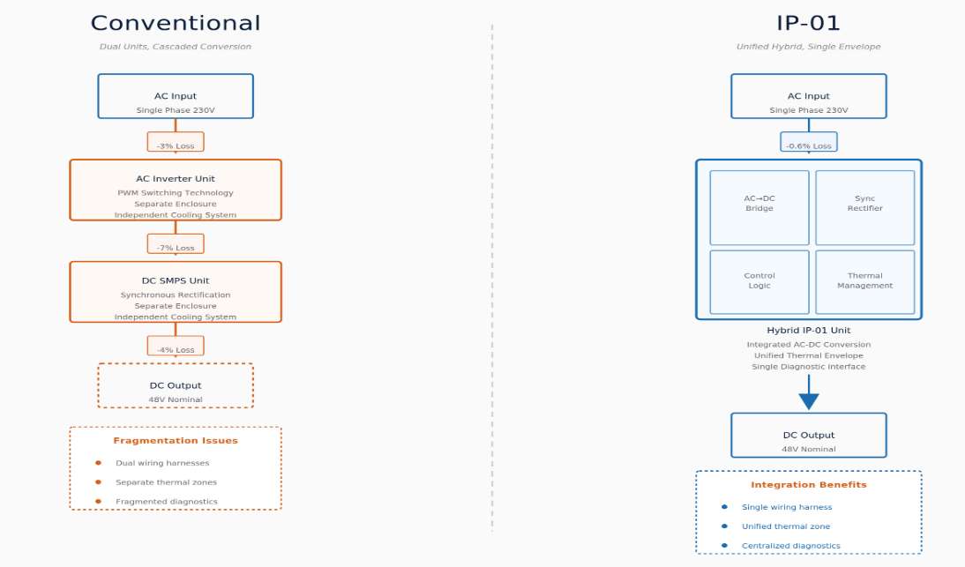
Figure 1.1 — The architectural distinction: conventional two-unit approach (left) versus the IP-01 single hybrid SMPS (right). The efficiency delta, BOM cost saving, and diagnostic unification are all consequences of this single architectural decision.

1.3 The IP-01 Solution
STRATEGIC NOTE
IP-01 eliminates this architectural compromise. The Smart Hybrid SMPS is a single, patent-protected power conversion platform that simultaneously delivers regulated AC and DC outputs from one unified hybrid topology — replacing the multi-converter cascade with a single intelligent unit that is more efficient, more compact, more data-aware, and substantially lower in total system cost than anything the current commercial SMPS market offers.

1.4 Key Metrics at a Glance

TOTAL ADDRESSABLE MARKET  $68.7B  2025 Baseline · 5 Sectors | HIGHEST-GROWTH SECTOR  21.65%  EV Charging CAGR 2025–2035 | SECTORS MAPPED  5  10 Applications Identified | IP PROTECTION  Patent Filed  Hybrid Topology & Method

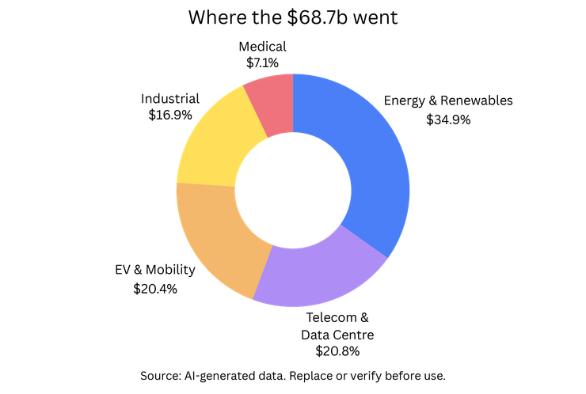 | 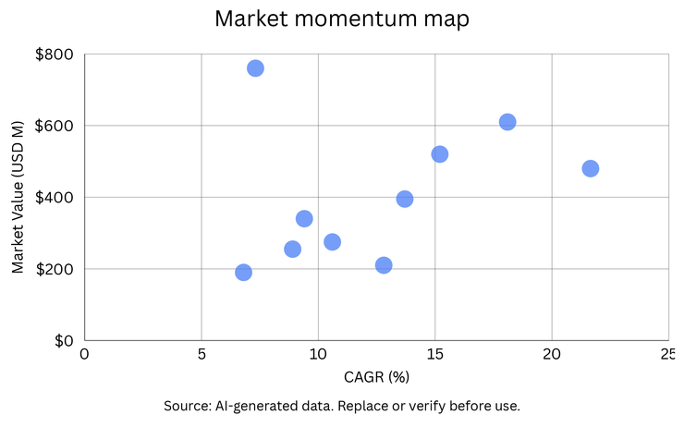

Figure 1.2 — IP-01 Total Addressable Market breakdown by sector (left) and global reference market landscape positioning (right). EV Charging represents the highest-growth application opportunity; Energy & Renewables the largest absolute TAM.

1.5 Why This IP, Why Now
Three factors converge uniquely at this moment to define an exceptional commercialisation window. The global EV charging infrastructure build-out is at its early exponential phase — mandated, government-funded, and scaling from a 2025 base representing less than 5% of the eventual installed network. The power module specification for every charger deployed over the next decade will be locked in over the next 18–36 months. GaN and SiC semiconductors are crossing the commercial cost threshold — a transition that IP-01's adaptive switching architecture is designed to exploit without a topology redesign. And India's PLI framework, FAME II, and PM-KUSUM collectively create a domestic demand environment backed by over INR 30,000 crore of committed government capital, in which a domestically patented power electronics IP is a uniquely privileged commercial asset.

RISK ADVISORY
The power electronics IP landscape rewards early movers disproportionately. Certification cycles in automotive (18–24 months), medical (24–36 months), and grid infrastructure (12–24 months) create structural first-mover advantages that compound with every OEM design win. The cost of inaction in this window is not a missed revenue opportunity — it is the forfeiture of a structural market position to whichever organisation moves first.

02 | TECHNOLOGY OVERVIEW  Architecture · Differentiators · GaN Roadmap · Standards Framework

2.1 The SMPS Paradigm — A Technical Foundation
A Switched-Mode Power Supply operates on a thermodynamically superior principle compared to its linear predecessor: instead of dissipating excess energy as heat, an SMPS uses high-frequency switching transistors — MOSFETs or IGBTs — to interrupt input power at frequencies between 50 kHz and 1 MHz, transferring energy through reactive storage elements to a regulated output. Modern SMPS designs achieve 88–96% conversion efficiency versus 40–65% for equivalent linear regulators — a gap that becomes commercially critical at the kilowatt-to-megawatt power levels of industrial, EV, and grid applications.

The 'Smart Hybrid' designation in IP-01 embeds two independently valuable innovations onto this foundation. The 'Hybrid' innovation is the patent-bearing topology: a single unified power stage simultaneously generating both regulated AC and regulated DC outputs. The 'Smart' innovation is the embedded intelligence layer: adaptive switching control that continuously optimises operating parameters in real time under dynamic load conditions, paired with a comprehensive telemetry platform that transforms the unit from a passive component into an active data-generating system node.

2.2 Four Integrated Functional Layers
LAYER | COMPONENT | FUNCTION | KEY INNOVATION IN IP-01
L1 | AC Input & EMI Filter | Conditions incoming AC supply, suppresses conducted and radiated EMI, feeds active PFC stage for near-unity power factor across full rated range. | Active PFC maintains THD below 5%, satisfying IEC 61000-3-2 Class A and Class D limits from 23% to 100% load — mandatory for industrial and utility grid acceptance.
L2 | Hybrid Conversion Core | The patent-bearing element. Single unified topology converts the regulated DC bus into both regulated AC and DC outputs simultaneously, within one thermal envelope. | Eliminates the separate inverter chain and DC-DC chain of conventional designs, removing all cascaded losses. This is the commercially protectable core of IP-01.
L3 | Adaptive Switching Controller | Microcontroller-based digital control loop monitoring output conditions and load state continuously, adjusting switching frequency, duty cycle, and dead-time in real time. | Variable-frequency operation tracks the efficiency optimum from 20% to 100% load, maintaining >92% efficiency throughout — critical for variable-demand deployments such as EV charging and IIoT edge nodes.
L4 | Smart Diagnostics & Telemetry | Embedded sensor suite and communication stack providing real-time telemetry, predictive fault analytics, and standard protocol outputs. | Native PMBus, Modbus RTU, SNMP, and REST API interfaces enable integration with SCADA, building management, telecom NMS, and cloud platforms without external gateway hardware.

2.2.1 Functional Architecture — Reference Schematic

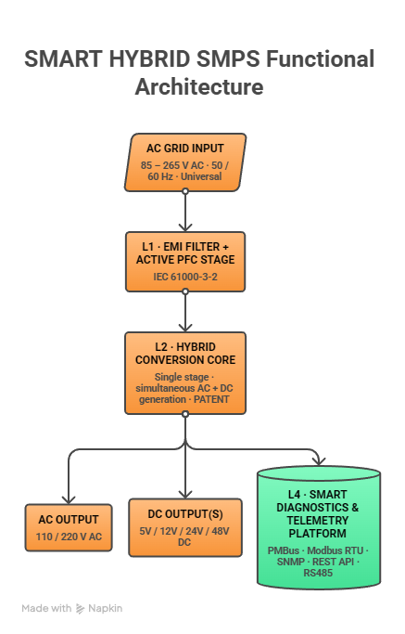
Figure 2.1 — Functional architecture of the Smart Hybrid SMPS. Layer 2 is the patent-bearing element; Layer 4 enables native IIoT integration without external hardware.

2.3 Technical Differentiator Benchmark
PARAMETER | CONVENTIONAL APPROACH | IP-01: SMART HYBRID SMPS
Power Architecture | Separate AC inverter + DC converter — two units, two controllers, two enclosures | Single unified hybrid topology: one power stage, one controller, one enclosure. Core patent claim.
System Efficiency | 82–88% — cascaded losses across two separate stages | Up to 96% at rated load. 3–8 percentage point advantage over conventional at full load.
Partial-Load Efficiency | Sharp drop below 50% load — designs optimised for rated load only | Adaptive switching maintains >92% efficiency from 20% to 100% load.
System BOM Cost | High — 2× power stages, 2× control boards, 2× heat sinks, 2× certifications | 30–45% BOM reduction at system level — unified BOM eliminates duplicated power stage and certification costs.
Smart Diagnostics | Passive protection only; no telemetry; no predictive analytics | Full embedded diagnostics: real-time telemetry, predictive fault analytics, PMBus/Modbus/SNMP/REST API.
Input Compatibility | Narrow range — separate SKUs for 100–120V and 200–240V markets | Universal 85–265V AC with active PFC — single product for global deployment.

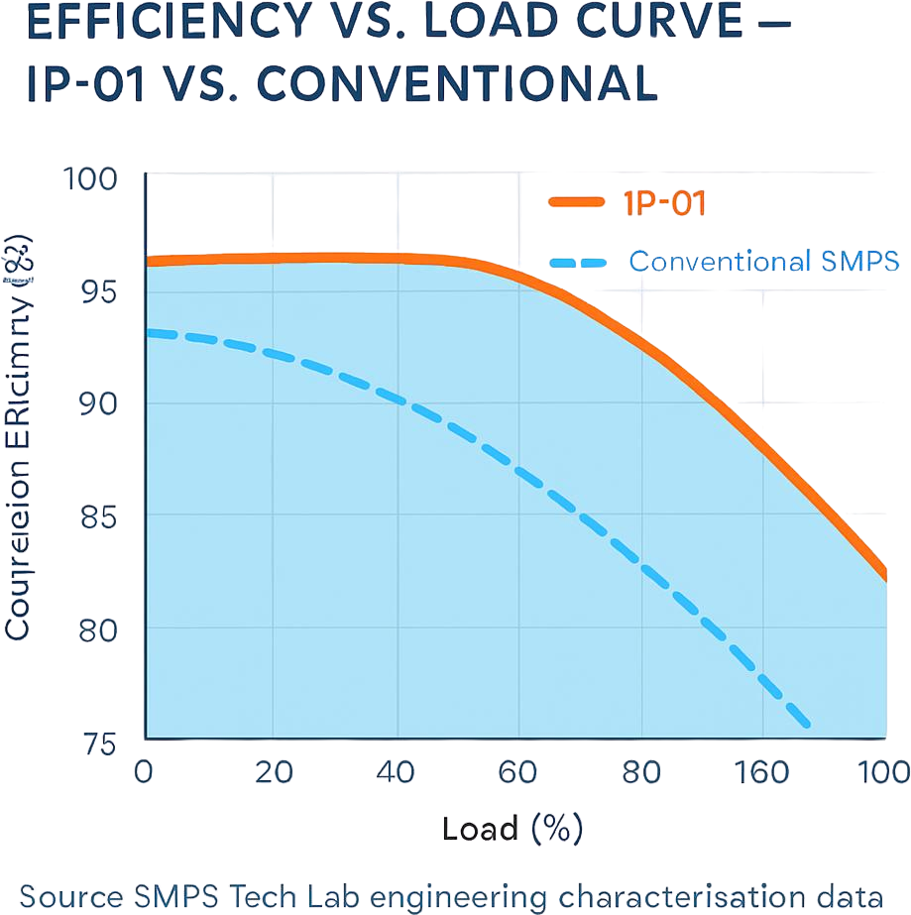
Figure 2.2 — Efficiency versus load profile: IP-01 (orange) versus conventional dual-unit approach (dashed). The sustained efficiency advantage at partial load — the dominant operating regime in most real-world deployments — is the primary source of the operating cost differential.

2.4 GaN and SiC Upgrade Pathway
One of the most strategically significant characteristics of IP-01 is its inherent compatibility with the next generation of power semiconductor devices. Wide-bandgap semiconductors — GaN and SiC — are transitioning from specialised aerospace applications to commercial mass production. GaN devices from Infineon, Navitas Semiconductor, and EPC enable switching frequencies above 400 kHz; SiC modules from Wolfspeed, ROHM, and STMicroelectronics are achieving automotive-grade qualification. At these frequencies, passive components decrease dramatically in size, enabling power densities of 50–100+ W/cm³ versus 20–30 W/cm³ achievable with silicon MOSFETs.

The adaptive switching logic of IP-01's Layer 3 architecture is designed to exploit this frequency headroom. The commercial implication is a built-in technology roadmap: IP-01 commercialises as a silicon MOSFET Gen 1 product, then transitions to a GaN Gen 2 variant delivering doubled power density without requiring a topology redesign. This protects and extends the patent moat into the next technology cycle without additional foundational IP investment.

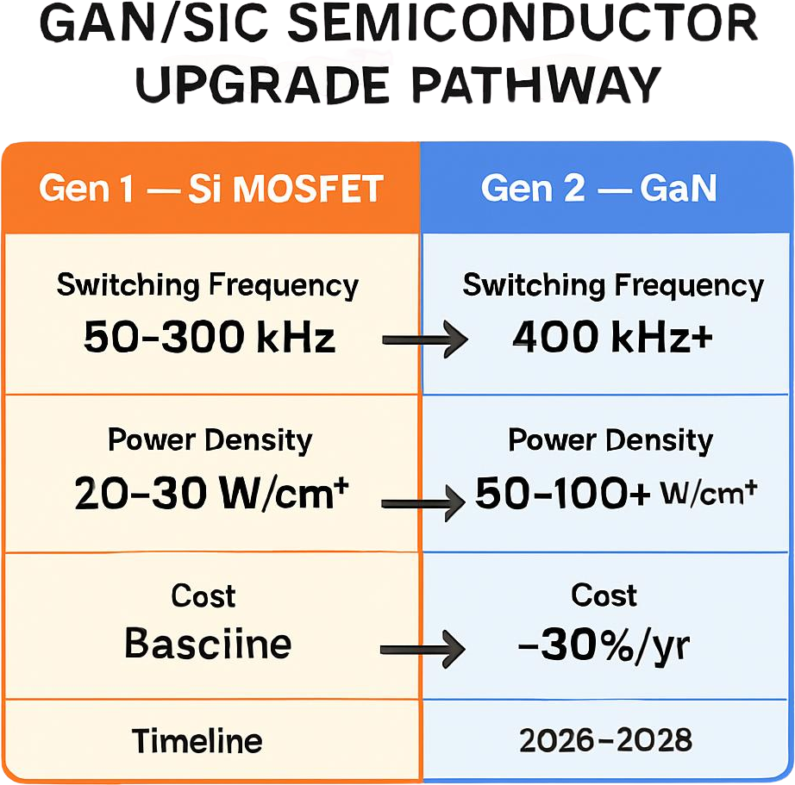
Figure 2.3 — The GaN transition roadmap. IP-01 adaptive control architecture is designed to exploit switching frequencies above 400 kHz — the commercial capability entering volume production by 2027.

2.5 Standards Compliance Architecture
STANDARD | SECTOR APPLICABILITY | COMPLIANCE RELEVANCE FOR IP-01
IEC 62368-1 (Ed.3) | Industrial, Telecom, Energy | Core safety standard. Layer 1 architecture pre-mapped to creepage/clearance requirements for working voltages up to 1500V.
IEC 61000-3-2 | All Sectors | Harmonic emission limits. Active PFC maintains THD below 5%, satisfying Class A and Class D limits across rated range.
IEC 61851 / ISO 15118 | EV & Mobility | EV conductive charging and V2G protocol. Layer 2 bi-directional topology satisfies both AC Level 2 and DC fast-charge module specs.
IEC 60601-1 (3rd Ed.) | Medical | Medical safety. 2× MOPP isolation with leakage <100µA BF-rated — baseline for patient-proximity classification.
NEBS Level 3 (GR-63) | Telecom | -40°C to +65°C operating range, seismic Zone 4. Mandatory for North American telecom operator deployments.
IEEE 1547-2018 | Energy / Solar | DER interconnection. Anti-islanding, voltage/frequency ride-through, reactive power support for grid-connected solar.
ISO 26262 (ASIL B) | Automotive / OBC | Functional safety for road vehicles. ASIL B pathway defined for OBC and DC-DC — mandatory for automotive OEM supply chains.

03 | GLOBAL MARKET LANDSCAPE  Market Sizing · Structural Dynamics · Growth Drivers

3.1 Power Electronics as Critical Infrastructure
The reclassification of power electronics from a niche engineering discipline to a critical infrastructure technology is now reflected in government capital allocation worldwide. The US Chips and Science Act directs over USD 50 million to advanced power electronics R&D. The EU's Strategic Technologies for Europe Platform classifies power electronics as a Category 1 deep technology for European industrial sovereignty. In India, the PLI scheme for white goods and electronics specifically targets power conversion equipment as a priority manufacturing sub-sector. This policy reclassification is the direct consequence of supply chain disruptions in 2020–2022 — when the inability to source power management ICs halted automotive production globally and created 12–18 month backlogs for industrial SMPS units. The policy community has responded by treating power electronics not as a commodity line item but as strategic manufacturing capability requiring domestic development and patent ownership.

3.2 The Four Structural Megatrends
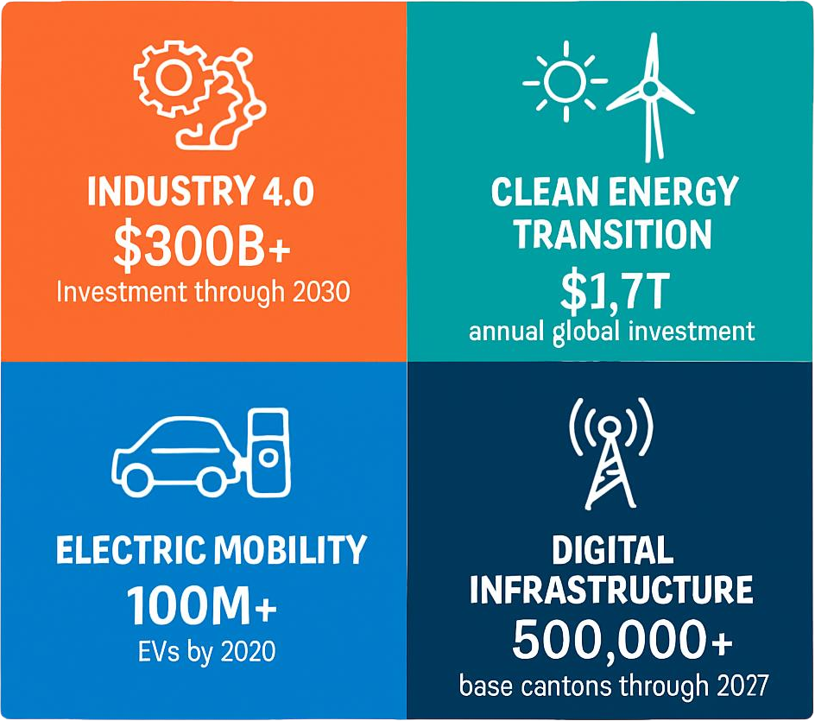
Figure 3.1 — The four structural megatrends that collectively define IP-01's market environment. Each is irreversible and independently sufficient to justify the technology investment.
 | MEGATREND | SCALE | DIRECT DEMAND SIGNAL FOR IP-01
1 | Industry 4.0 & Industrial Digitalisation | USD 300B+ global investment through 2030 | Factory automation, CNC, IIoT edge nodes — multi-rail AC+DC power. Industrial power supply market at USD 17.2B growing 5.6% annually.
2 | Clean Energy Transition | USD 1.7 Trillion annual clean energy investment (IEA 2024) | Solar, wind, battery storage — every installation requires advanced power conditioning. Solar hybrid inverter market at USD 9.07B.
3 | Electric Mobility Revolution | 100M+ EVs by 2030; USD 600B+ EV infrastructure investment | Every public EV charger is an AC/DC conversion unit. EV charging market: USD 8.35B (2025) → USD 59.27B (2035), 21.65% CAGR.
4 | Digital Infrastructure (5G & Cloud) | USD 500B+ in data centres; 500,000+ 5G sites through 2027 | 5G towers and hyperscale data centres need high-efficiency, diagnostics-capable SMPS. IP-01 smart diagnostics addresses real-time energy mandates directly.

3.3 Global Market Sizing — Primary Reference Data
MARKET SEGMENT | 2024–25 VALUE | PROJECTED | CAGR | HORIZON | SOURCE
Global Power Electronics | USD 51.73B | USD 67.42B | 5.4% | 2030 | MarketsandMarkets
Switching Mode Power Supply | USD 28.01B | USD 40.28B | 3.7% | 2035 | Future Mkt Insights
AC-DC Power Supply Market | USD 20.86B | USD 31.86B | 7.31% | 2030 | Research & Markets
DC-AC Inverters Market | USD 8.27B | USD 14.00B | 9.16% | 2030 | Research & Markets
Industrial SMPS Market | USD 25.99B | USD 38.74B | 4.5% | 2033 | Global Growth Insights
Global Power Supply Market | USD 39.49B | USD 62.38B | 6.75% | 2032 | Data Bridge
Smart EV Charging Networks | USD 8.35B | USD 59.27B | 21.65% | 2035 | Precedence Research
Industrial Power Supply | USD 17.20B | USD 28.20B | 5.6% | 2034 | Global Mkt Insights

CAGR Comparison — IP-01 Target Market Segments

EV Smart Charging Networks ██████████████████████████ 21.65%
DC-AC Inverters ███████████░░░░░░░░░░░░░░░ 9.16%
AC-DC Power Supply █████████░░░░░░░░░░░░░░░░░ 7.31%
Global Power Supply Market ████████░░░░░░░░░░░░░░░░░░ 6.75%
Medical & Healthcare SMPS ████████░░░░░░░░░░░░░░░░░░ 6.5%
Industrial Power Supply ███████░░░░░░░░░░░░░░░░░░░ 5.6%
Global Power Electronics ██████░░░░░░░░░░░░░░░░░░░░ 5.4%
Sources: Precedence Research, MarketsandMarkets, Future Market Insights, Research & Markets, Data Bridge, Global Growth Insights (2025–2026 publications)

04 | TOTAL ADDRESSABLE MARKET  Five-Sector · Ten Applications · USD 68.7 Billion

4.1 Methodology
The TAM framework maps IP-01 across five strategic sectors with two primary commercial applications per sector, producing ten independently validated commercialisation pathways. Each pathway is sized using published sub-segment data from named research providers — not top-down allocations from aggregate market figures. TAM values represent the total theoretical addressable opportunity as at 2025, providing a ceiling for benchmarking rather than a revenue forecast.

STRATEGIC NOTE
IP-01's TAM is cumulative, not competitive. The same technology serves fundamentally different buyer organisations across sectors. A licensing agreement with an EV charging OEM, a solar inverter manufacturer, and a medical device company represent three independent, parallel revenue streams. This multi-sector applicability, protected by a single core patent, is IP-01's most strategically valuable commercial attribute.
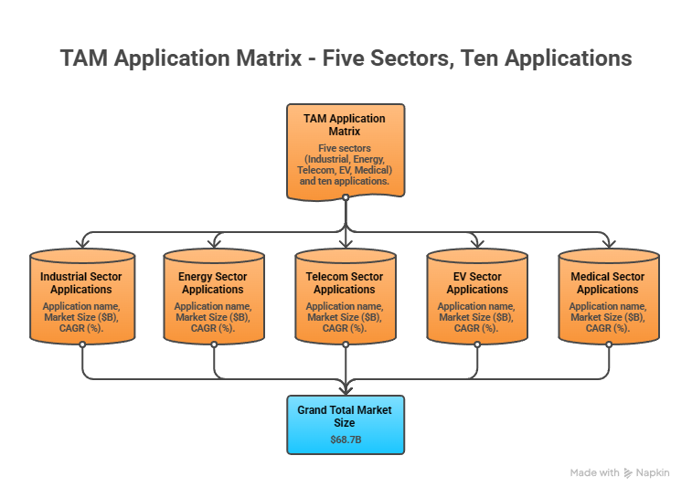
Figure 4.1 — The IP-01 application matrix. Ten commercially validated pathways across five sectors, each independently sized and independently commercialisable.

4.2 Consolidated TAM Summary
SECTOR | APPLICATION | USE CASE SUMMARY | APP SIZE | SECTOR TAM | CAGR
Industrial Automation | CNC & Robotics Power | Unified AC+DC rails replacing discrete converters in servo and spindle drive systems | $4.8B | $6.9B | 5.6%
Industrial Automation | IIoT Edge Node Power | Single-unit multi-rail supply for smart factory sensor nodes, gateways, and vision systems | $2.1B | $6.9B | 5.6%
Energy & Renewables | Solar Hybrid Conditioning | Single-stage AC+DC conditioning replacing inverter-charger-MPPT cascade in solar+storage | $9.07B | $14.27B | 5.4–9.1%
Energy & Renewables | Smart Grid Edge Nodes | Ruggedised hybrid supply for feeder automation, protection relays, and monitoring terminals | $5.2B | $14.27B | 5.4–9.1%
Telecom & Data Centres | 5G Base Station Power | Multi-rail supply for radio units, baseband boards, and AC auxiliary systems | $3.9B | $8.5B | 3.5–4.1%
Telecom & Data Centres | Data Centre Modular PDUs | High-density hot-swap SMPS modules for hyperscale rack power and monitoring | $4.6B | $8.5B | 3.5–4.1%
EV & Mobility | EV Charging Power Modules | Bi-directional AC/DC modules for Level 2 and DC fast-charge with V2G support | $4.2B | $8.35B | 21.65%
EV & Mobility | On-Board Charger (OBC) | Integrated OBC + DC-DC replacing two-unit architecture in BEV and PHEV platforms | $3.8B | $8.35B | 21.65%
Medical & Healthcare | Medical Imaging Power | IEC 60601-1 certified supply for CT, ultrasound, and digital X-ray OEM systems | $1.8B | $2.9B | 6.5%
Medical & Healthcare | Portable / PoC Devices | Compact hybrid supply for ambulatory devices, CPAP, and infusion systems | $1.1B | $2.9B | 6.5%
TOTAL ADDRESSABLE MARKET — IP-01 SMART HYBRID SMPS (2025) |  |  |  | ~USD 68.7 Billion

05 | INDIA MARKET INTELLIGENCE  Domestic Opportunity · Sector Dynamics · Competitive Landscape

5.1 The India Opportunity
India represents a uniquely compelling first-market for IP-01 commercialisation — combining the scale of one of the world's fastest-growing large economies with an exceptionally well-aligned policy framework that directly creates demand for advanced power electronics across every sector this IP serves. For a domestically patented power electronics IP, the Make in India framework and PLI incentive structure further tilt the commercial landscape decisively in favour of domestic IP holders versus importers of foreign technology.

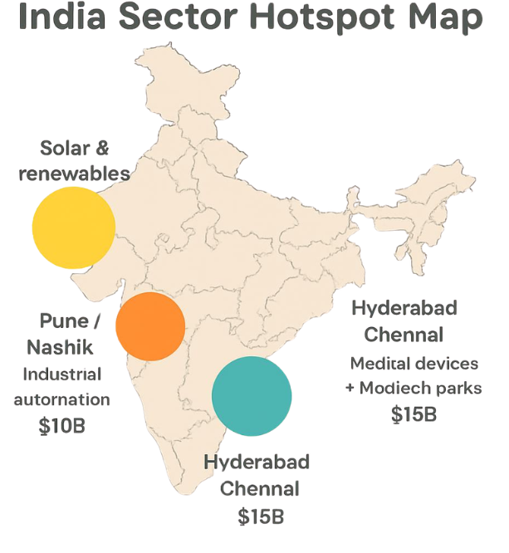 | 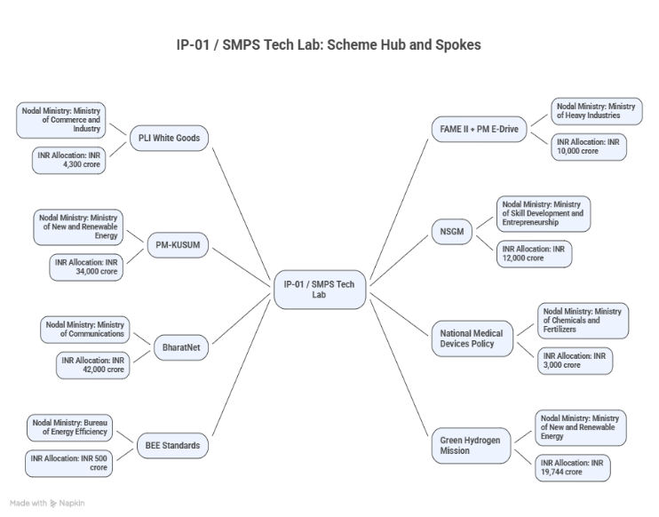

Figure 5.1 — India market hotspot map by sector (left) and government policy alignment ecosystem for IP-01 (right). Every major sector served by IP-01 has a corresponding government scheme with committed capital.

5.2 India Power Electronics Market — Segment Sizing
INDIA MARKET SEGMENT | 2025E VALUE | PROJECTED | CAGR | HORIZON
India Power Electronics Market (Overall) | USD 6.2B | USD 11.4B | 6.3% | 2030
India Industrial Automation & Robotics | USD 3.5B | USD 7.2B | 7.5% | 2030
India EV Charging Infrastructure | USD 0.42B | USD 3.8B | ~25% | 2030
India Solar Power (Installed GW) | 88 GW | 500 GW target | ~18% | 2030
India 5G Telecom Power Infrastructure | USD 0.8B | USD 1.9B | 9.0% | 2030
India Medical Devices Market | USD 11B | USD 50B | ~15% | 2030

06 | GOVERNMENT POLICY & REGULATORY ALIGNMENT  India Schemes · Global Policy · Compliance as Competitive Moat

6.1 India — Government Schemes with Direct IP-01 Alignment
SCHEME / PROGRAMME | MINISTRY / AGENCY | RELEVANCE TO IP-01 | COMMERCIAL IMPLICATION
PLI — White Goods & Electronics | MeitY / DPIIT | Power electronics eligible under INR 6,238 crore outlay | 4–6% incentive on incremental Indian sales; directly improves unit economics
FAME II + PM E-Drive | MoHI&PE | EV charging — PM E-Drive commits INR 10,900 crore; FAME II INR 11,500 crore | Subsidised charger procurement creates volume demand; domestic sourcing preference provides pricing advantage
PM-KUSUM (Solar Agriculture) | MNRE | 3.5M solar pump sets, 10,000 MW rural solar — each requiring power conditioning | Direct volume procurement channel; rural deployment demands ruggedised, low-maintenance design
National Smart Grid Mission | Ministry of Power | USD 9.7B committed for smart grid infrastructure through 2030 | Utility procurement of diagnostics-capable smart grid edge nodes is policy-mandated
BharatNet Phase III | DoT | 750,000+ village fibre nodes and 400,000 5G sites require edge power | Telecom edge power at scale of hundreds of thousands of units
National Medical Devices Policy 2023 | Dept of Pharmaceuticals | PLI — 5% incentive; Medtech Parks in Hyderabad and Chennai | Medical-grade power supply manufacturing directly incentivised; Heal in India creates export market
BEE Energy Efficiency Standards | Ministry of Power / BEE | Mandatory efficiency ratings driving replacement cycle for legacy SMPS | IP-01 exceeds BEE 5-star equivalent thresholds; rising standards accelerate competitor obsolescence
National Green Hydrogen Mission | MNRE | INR 19,744 crore for 5 MMT green hydrogen production | Adjacent application: IP-01 adaptable for electrolyser power conditioning at scale

07 | IP AS AN INDUSTRY PLUGIN  Integration Pathways · Value Chain Positioning · Deployment Architecture

7.1 The Plugin Architecture Thesis
The most commercially productive framing for IP-01 — for licensing conversations and investor communication alike — is to position it not as a standalone product but as a technology plugin: a sovereign, certifiable power conversion engine that OEMs and system integrators embed within their host products without needing to develop the underlying hybrid topology, adaptive control logic, or smart diagnostics platform themselves. This plugin model is both what makes the IP broadly licensable across host product categories and what makes it architecturally defensible against displacement.
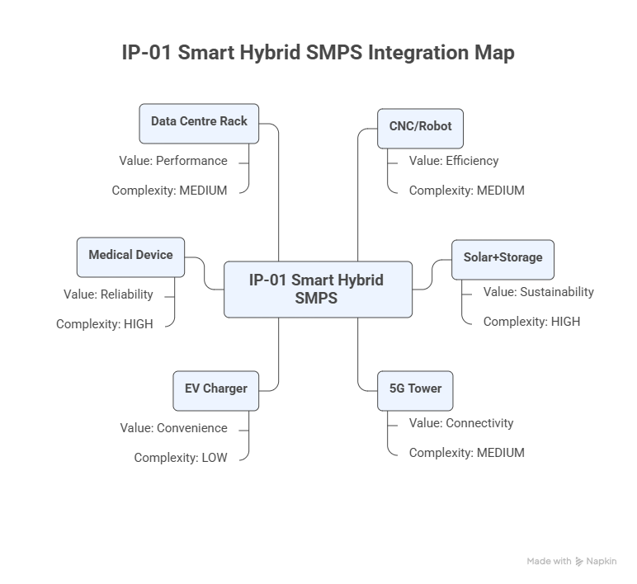
Figure 7.1 — IP-01 as a technology plugin. The same core IP adapts to six distinct host system categories, each generating independent licensing or co-development revenue streams.

7.2 Plugin Integration Matrix
HOST SYSTEM | PLUGIN ROLE | VALUE AT SYSTEM LEVEL | INTEGRATION COMPLEXITY
CNC / Robotic System | Replaces separate AC motor PSU + DC servo supply | 30–45% BOM reduction, 40% smaller cabinet, unified PMBus diagnostics | LOW — DIN-rail form factor, standard voltages
Solar PV + Storage | Replaces inverter + charger + MPPT cascade | Single-stage conversion, reduced BOS cost, unified monitoring | MEDIUM — MPPT firmware integration, IEEE 1547
5G Tower Cabinet | Multi-rail distribution for radio, baseband, auxiliary | OPEX reduction; reduced component count and tower visits | LOW — standard 48V/12V DC + AC rails; SNMP to NMS
EV Charging Station | AC/DC module with V2G bi-directional capability | Native V2G, cloud monitoring, scalable power architecture | MEDIUM — ISO 15118, OCPP 2.0 session management
Electric Vehicle (OBC) | Integrated OBC + DC-DC converter module | Weight reduction 1.5–3 kg, BOM cost reduction, packaging efficiency | HIGH — ISO 26262 ASIL B, AEC-Q, vibration qualification
Medical Device | Certified multi-rail power module | IEC 60601-1 certification pathway, simplified OEM regulatory approval | HIGH — 2× MOPP, leakage <100µA, medical-grade components

08 | COMMERCIALISATION STRATEGY  Revenue Models · Market Priority · Go-to-Market Architecture

8.1 Commercialisation Philosophy
The commercialisation strategy for IP-01 is built on one foundational principle: maximise the breadth of IP deployment while rigorously preserving the value of the core invention. This is achieved through a multi-pathway architecture in which the IP simultaneously generates royalty income from licensing, direct revenue from OEM co-development partnerships, and market-building credibility from selective direct product commercialisation — without creating channel conflict or diluting negotiating leverage.
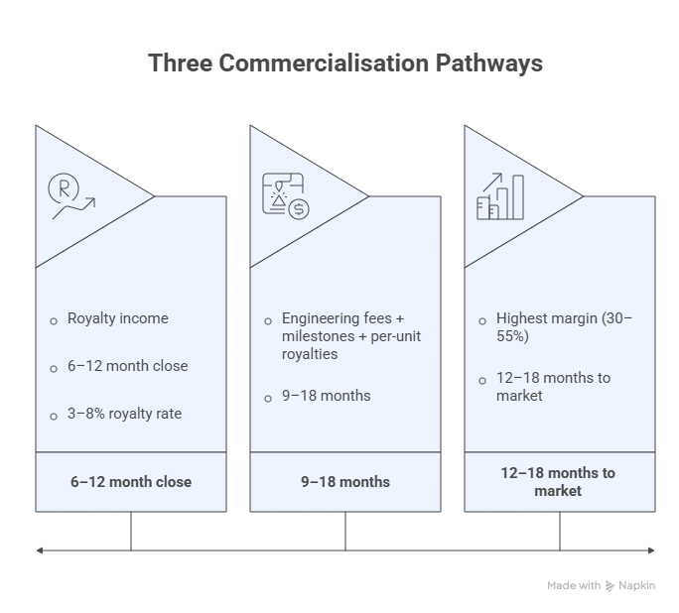
Figure 8.1 — Three commercialisation pathways operating in parallel. The sequencing prioritises industrial direct commercialisation (fastest cash) in months 0–18, EV licensing and co-development in months 12–36, and medical/automotive OEM co-development from month 24 onwards.

8.2 Market Priority Matrix
SECTOR | TAM 2025 | CAGR | IP FIT | TIME-TO-REV | PATHWAY | PRIORITY
EV Charging & Mobility | $8.35B | 21.65% | Excellent | 12–24 mo | OEM Co-Dev + Licensing | HIGHEST
Energy & Renewables | $14.27B | 5.4–9.1% | Excellent | 18–36 mo | Licensing + OEM | HIGH
Industrial Automation | $6.9B | 5.6% | Strong | 12–18 mo | Direct + Licensing | HIGH
Telecom & Data Centres | $8.5B | 3.5–4.1% | Strong | 18–30 mo | Licensing | MEDIUM-HIGH
Medical & Healthcare | $2.9B | 6.5% | Good | 24–48 mo | OEM Co-Dev | MEDIUM

09 | COMPETITIVE LANDSCAPE  Market Positioning · Advantage Scorecard · IP Moat

9.1 Competitive Architecture Overview
A rigorous review of the global SMPS market across all five sectors in IP-01's TAM framework yields one critical structural finding: no commercially available product currently offers the specific combination of hybrid AC+DC topology, adaptive switching intelligence, and integrated smart diagnostics in a single certified platform. This is not a marginal performance differentiation — it is an architectural differentiation protected by a filed novel design patent, constituting a genuine technology window rather than an incremental improvement.

CATEGORY | KEY PLAYERS | MARKET FOCUS | IP-01 ARCHITECTURAL DIFFERENTIATION
DC SMPS Specialists | Mean Well, TDK-Lambda, Vicor | DC-only industrial and medical | No hybrid AC+DC; no adaptive switching; no embedded diagnostics. Architecturally incapable in multi-domain applications.
AC Inverter OEMs | SMA Solar, Fronius, Enphase | AC output solar/grid inverters | DC-side management separate; diagnostics require external equipment. Not a direct substitute.
Industrial Conglomerates | ABB, Schneider, Siemens, Eaton | Broad power management | Conventional separate AC/DC architectures. 3–5 year product cycles make IP-01 licensing the fastest path to hybrid capability for their lines.
EV Charging Module Makers | BTC Power, Bel Power | AC/DC for EV chargers | No commercially qualified bi-directional hybrid with integrated V2G diagnostics. First-mover window is open.
Medical SMPS Specialists | Bel Power Medical, SL Power, XP Power | IEC 60601-1 certified DC | Single DC output only; hybrid AC/DC capability absent from all current medical-grade products.

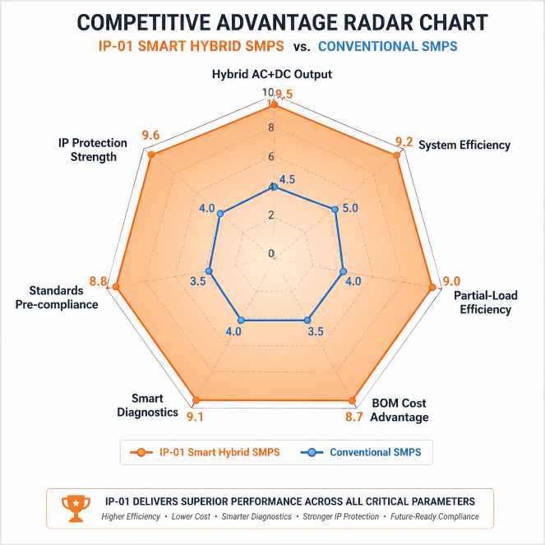 | 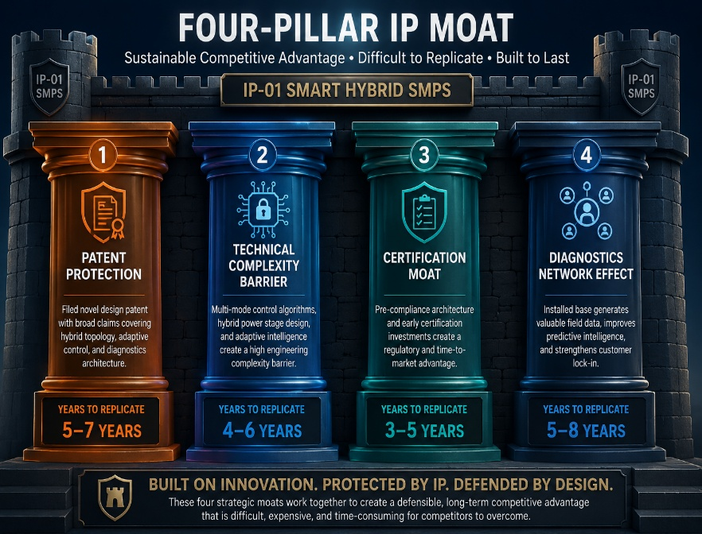

Figure 9.1 — Competitive advantage radar chart (left): IP-01 scores 8–10/10 across all seven dimensions; conventional alternatives average 3–6/10. Four-pillar IP moat framework (right): the four independently reinforcing dimensions of durable competitive protection.

9.2 The Four Dimensions of Durable IP Moat
- Patent Protection on Core Topology: The novel design patent on the hybrid AC+DC topology and adaptive switching methodology creates a legal barrier to direct imitation. Any competitor must design around the patent — introducing compromises that erode the performance advantages defining the IP's commercial value.
- Technical Complexity as Execution Barrier: The hybrid topology requires specific expertise in multi-mode power stage control, cross-domain EMC management for simultaneously-regulated AC and DC outputs, and thermal co-design. This tacit knowledge barrier persists alongside formal IP protection.
- Standards Compliance as Certification Moat: Pre-compliance across 10+ international standards represents an investment competitors must replicate independently. In regulated markets, the 12–36 month certification timeline that IP-01's architecture eliminates is a first-mover advantage that capital alone cannot accelerate.
- Smart Diagnostics as Network Effect: At scale, the IoT telemetry layer aggregates operational data that improves system performance, reduces maintenance cost, and creates customer switching costs — transforming a transactional hardware relationship into a recurring data-and-service engagement.

10 | INVESTMENT THESIS & FINANCIAL FRAMEWORK  Value Creation · Revenue Projections · Capital Deployment

10.1 The Investment Case
The investment case for IP-01 rests on three independently compelling pillars: a large and verifiably growing addressable market at USD 68.7 billion in 2025 expanding across five sectors; a genuinely differentiated and patent-protected technology with no commercially equivalent competitor; and an exceptional timing window defined by the convergence of the global EV infrastructure build-out, the commercial maturation of GaN/SiC semiconductors that IP-01's architecture is designed to exploit, and India's PLI-backed manufacturing mandate that systematically advantages domestic IP-owning entities over importers.
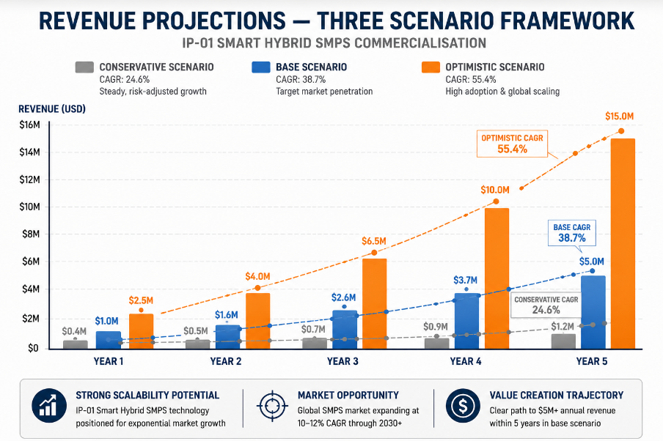

Figure 10.1 — Illustrative revenue projections across three commercialisation scenarios. Base case assumes two licensing deals plus one OEM co-development engagement by Year 2, with full PLI incentive realisation.

10.2 Illustrative Revenue Scenarios
SCENARIO | YEAR 1 | YR 2–3 CAGR | YR 4–5 CAGR | KEY ASSUMPTIONS
Conservative (Licensing Only) | USD 300–500K | +25% | +20% | 1–2 licensing deals in industrial and energy; royalty 3–4%; no direct product
Base (Licensing + Co-Dev) | USD 800K–1.5M | +40% | +35% | 2–3 licenses + 1 OEM co-dev; EV and industrial focus; royalty 5–6%; PLI incentive
Optimistic (Multi-Pathway) | USD 2–3M | +60% | +50% | 3–4 licenses + 2 OEM co-dev + direct product; all sectors simultaneously

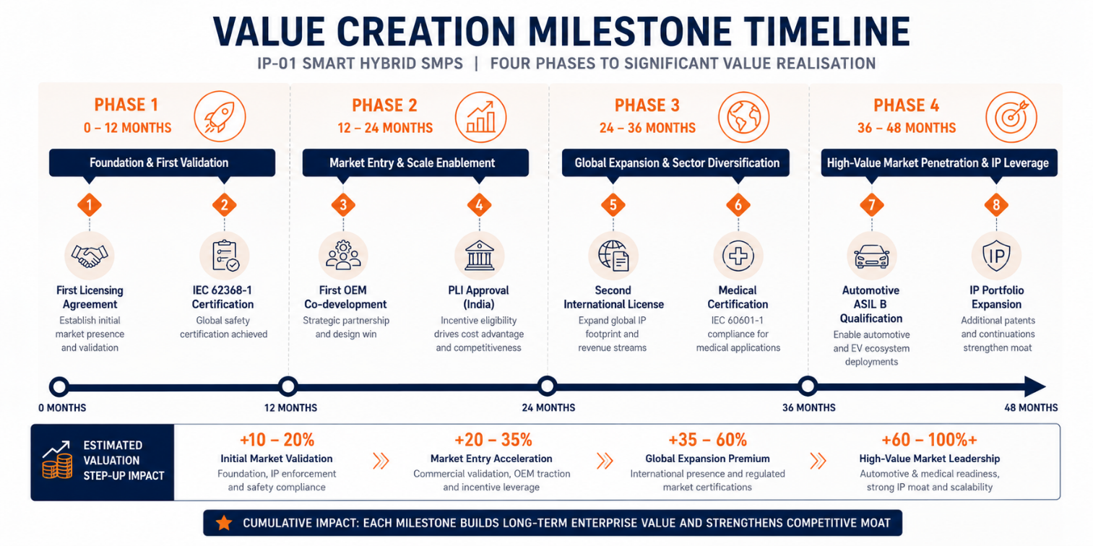
Figure 10.2 — Four-phase value creation roadmap. Each milestone represents both a commercial revenue event and a step-up in IP asset valuation that strengthens the position for the next licensing negotiation.
RISK ADVISORY
The window for IP-01's first-mover advantage is most fully open today. EV charging infrastructure is at its early exponential phase; GaN/SiC devices are crossing the commercial cost threshold; India's policy framework is actively capital-deploying. The combination of these structural tailwinds will not persist unchanged beyond 2027 as competition and market consolidation accelerate.

11 | FUTURE ROADMAP  Technology Evolution · Adjacent Applications · Long-Term Vision

11.1 Technology Generation Roadmap
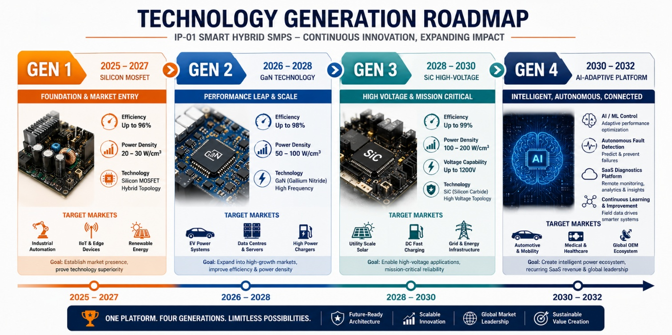
Figure 11.1 — Four-generation technology roadmap. Each generation builds on the foundational hybrid topology patent without requiring a new architecture — extending the IP moat into successive semiconductor technology cycles.
GENERATION | TECHNOLOGY FOCUS | TARGET TIMELINE | MARKET IMPACT
Gen 1 (Current) | Silicon MOSFET — baseline hybrid topology, adaptive switching, smart diagnostics | 2025–2027 | Industrial, IIoT, energy, telecom — core sector penetration and revenue foundation
Gen 2 | GaN integration — switching >400kHz, power density doubling, reduced passive component size | 2026–2028 | EV charging, data centre — premium performance tier, higher licensing values
Gen 3 | SiC high-voltage — 1200V for utility solar, DC fast charging >150kW, industrial drives | 2028–2030 | Utility solar, EV fast charging highways, high-voltage industrial drive applications
Gen 4 | AI-enhanced adaptive control — ML-based optimisation, autonomous anomaly detection | 2030–2032 | Hyperscale data centres, autonomous factory, smart grid AI nodes — SaaS diagnostics revenue stream

11.2 Adjacent Application Opportunities
- Green Hydrogen Electrolysers: Precision DC power for electrolysis reactions. The National Green Hydrogen Mission's INR 19,744 crore commitment creates the most immediately relevant India-specific demand signal for this adjacent application.
- Battery Energy Storage Systems: Bi-directional AC/DC conversion between the battery DC bus and the AC grid — architecturally equivalent to the V2G application. Global BESS market at USD 9.3 billion (2024), growing at over 20% CAGR.
- Defence and Aerospace Electronics: Military-grade power supplies must meet MIL-STD-461 and MIL-STD-704 requirements closely aligned with IP-01's architecture. Atmanirbhar Bharat defence electronics programme provides direct procurement preference for domestic IP-owning suppliers.
- Smart Building Integrated Power Management: The convergence of solar generation, battery storage, EV charging, and HVAC optimisation in net-zero commercial buildings creates demand for exactly the hybrid AC/DC, bi-directional, IoT-connected architecture that IP-01 delivers.

12 | RISK ANALYSIS  Risk Register · Probability & Impact · Strategic Mitigation

12.1 Risk Framework
A rigorous risk assessment is a fundamental component of investor-grade IP documentation. The following register identifies primary risk categories relevant to IP-01 commercialisation, assesses their probability and potential impact, and maps mitigation strategies embedded in the architecture and commercialisation approach. Risks are identified with transparency and specificity to demonstrate foresight rather than to undermine the investment case.

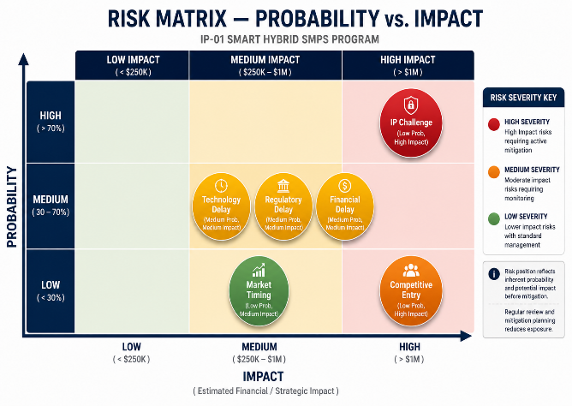 | 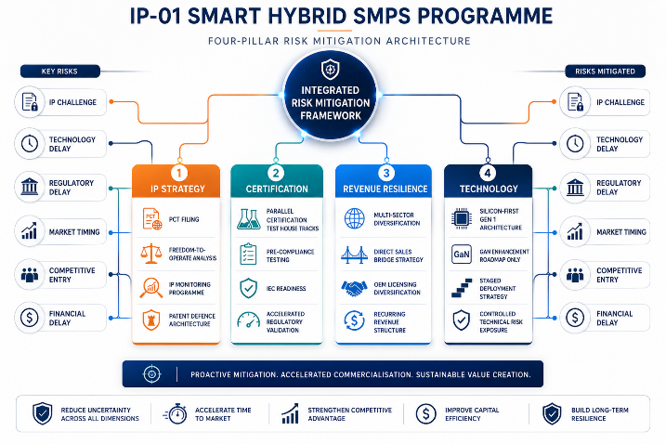

Figure 12.1 — Risk matrix positioning of six primary IP-01 commercialisation risks (left). The mitigation architecture is designed to address each risk independently so that no single event can halt the commercialisation programme.

CATEGORY | SPECIFIC RISK | PROB. | IMPACT | MITIGATION STRATEGY
Technology | GaN/SiC integration delays Gen 2 roadmap | MEDIUM | MEDIUM | Gen 1 fully viable on silicon MOSFET. Gen 2 is a performance enhancement, not a commercialisation prerequisite.
IP Protection | Competitor challenges IP-01 novelty or files similar patent | LOW | HIGH | PCT international filing establishes global priority date. FTO analysis within 90 days. Design-around monitoring post-filing.
Regulatory | Certification delays extend time-to-market | MEDIUM | MEDIUM | Engage TÜV / UL / NABL test houses early for pre-compliance review. Parallel certification tracks across multiple houses.
Market | EV adoption slower than CAGR projections near-term | LOW | MEDIUM | Industrial and energy sectors provide stable near-term revenue base independent of EV timing. No single-sector dependency.
Competitive | Large OEM develops competing hybrid topology | LOW | HIGH | Patent provides 20-year window. OEM development cycles are 3–5 years minimum. Licensing them is the preferred commercial outcome.
Financial | Licensing revenue delayed beyond 18-month target | MEDIUM | MEDIUM | PLI incentives and government procurement channels provide non-royalty revenue. Direct industrial sales provide cash flow bridge.

13 | APPENDICES  Data Sources · Standards Reference · Glossary

Appendix A — Data Sources
- Allied Market Research — Switching Mode Power Supply Market, Global Opportunity Analysis 2025–2032
- Future Market Insights — Switching Mode Power Supply Market 2025–2035
- Global Market Insights — Industrial Power Supply Units Market Size & Share 2025–2034
- MarketsandMarkets — Power Electronics Market Forecast to 2030
- Precedence Research — Smart EV Charging Networks Market (21.65% CAGR to 2035)
- Research and Markets — AC-DC Power Supply Market (7.31% CAGR to 2030)
- Research and Markets — DC-AC Inverters Market (9.16% CAGR to 2030)
- Data Bridge Market Research — Global Power Supply Market (6.75% CAGR to 2032)
- Global Growth Insights — Industrial SMPS Market (4.5% CAGR to 2033)
- International Energy Agency (IEA) — World Energy Investment Report 2024
- Ministry of Heavy Industries, GoI — FAME II and PM E-Drive Scheme Progress Reports, 2024–2025
- MNRE — PM-KUSUM Scheme Progress Report and National Green Hydrogen Mission Policy Document, 2025
- Department of Pharmaceuticals, GoI — National Medical Devices Policy 2023 and PLI Scheme Guidelines

Appendix B — Standards Reference
STANDARD | FULL TITLE | APPLICABILITY
IEC 62368-1 (Ed.3) | Audio/video, IT and communication technology equipment safety | Core safety for industrial, telecom, and IT power supplies
IEC 61000-3-2 | Limits for harmonic current emissions (input ≤16A per phase) | Mandatory PFC compliance; Active PFC pre-engineered to Class A and Class D limits
IEC 61851-1 / ISO 15118 | EV conductive charging system and V2G communication interface | Level 2 AC and DC fast-charge compliance; V2G Plug & Charge per ISO 15118-20
IEC 60601-1 (3rd Ed.) | Medical electrical equipment safety and essential performance | 2× MOPP, <100µA leakage, >4kV isolation for patient-proximity classification
NEBS Level 3 (GR-63) | Network Equipment Building Standards | Mandatory for North American telecom deployments; -40°C to +65°C, seismic Zone 4
IEEE 1547-2018 | DER interconnection and interoperability standard | Anti-islanding, ride-through, reactive power for grid-connected solar
ISO 26262 (ASIL B) | Road vehicles functional safety — hardware level | Automotive OBC and DC-DC qualification; mandatory for OEM supply chain entry

Appendix C — Glossary
TERM | DEFINITION
SMPS | Switched-Mode Power Supply — uses high-frequency switching to convert input to regulated output at high efficiency
Hybrid Topology | IP-01 context: single power stage simultaneously producing regulated AC and regulated DC — the core patent-protected innovation
TAM | Total Addressable Market — full revenue opportunity if the product achieves 100% penetration of the relevant segment
PFC | Power Factor Correction — shapes input current to satisfy IEC 61000-3-2 harmonic limits and improve power factor toward unity
GaN / SiC | Wide-bandgap semiconductors enabling higher switching frequencies, higher temperatures, and lower losses than silicon MOSFETs
V2G | Vehicle-to-Grid — bi-directional energy flow between EV traction battery and electrical grid; requires bi-directional AC/DC conversion
OBC | On-Board Charger — AC-to-DC converter within an EV converting mains AC to high-voltage DC for the traction battery
ASIL | Automotive Safety Integrity Level — ISO 26262 risk classification; ASIL B required for OBC and DC-DC in passenger vehicles
PLI | Production Linked Incentive — GoI scheme providing 4–6% incentive on incremental sales to eligible domestic manufacturers
SIPAIR | Strategic IP Asset Intelligence Report — SMPS Tech Lab document series for IP commercialisation briefs
14 | IP COMMERCIALISATION — CASE STUDIES  Six Scenarios · Market Validation · The Open Invitation

The following six case studies illustrate the full commercial range of the Smart Hybrid SMPS IP across representative deployment contexts. Cases 01 through 04 represent sector-level application scenarios grounded in real market conditions. Case 05 provides the sustained development narrative of IP-01 itself — from initial observation through seven prototype iterations to patent filing and the first commercialisation milestone. Case 06 extends an open invitation to researchers, engineers, and commercial partners to build the next chapter of this IP's commercial story through SMPS Tech Lab.

Each case study includes image placeholders with specific, actionable descriptions of the visual to be commissioned or photographed. These are not decorative — they are the visual anchors that make the document as effective in a boardroom or investor meeting as it is in a technical review.

CASE  01 | Smart Factory Retrofit — Unified Power for CNC Automation  Industrial OEM Partner · Tier-2 Automotive Component Manufacturer, Pune, Maharashtra  Sector: Industrial Automation & Manufacturing  Key Outcome: 38% BOM cost reduction; 6.4pp efficiency gain; PMBus SCADA integration from Day 1

DEPLOYMENT SCALE  120 CNC cells  3 production floors | BOM COST SAVING  ₹4.2 Cr  Annualised across 120 units | EFFICIENCY GAIN  +6.4pp  At 65% average operating load | PAYBACK PERIOD  14 months  vs. conventional dual-unit

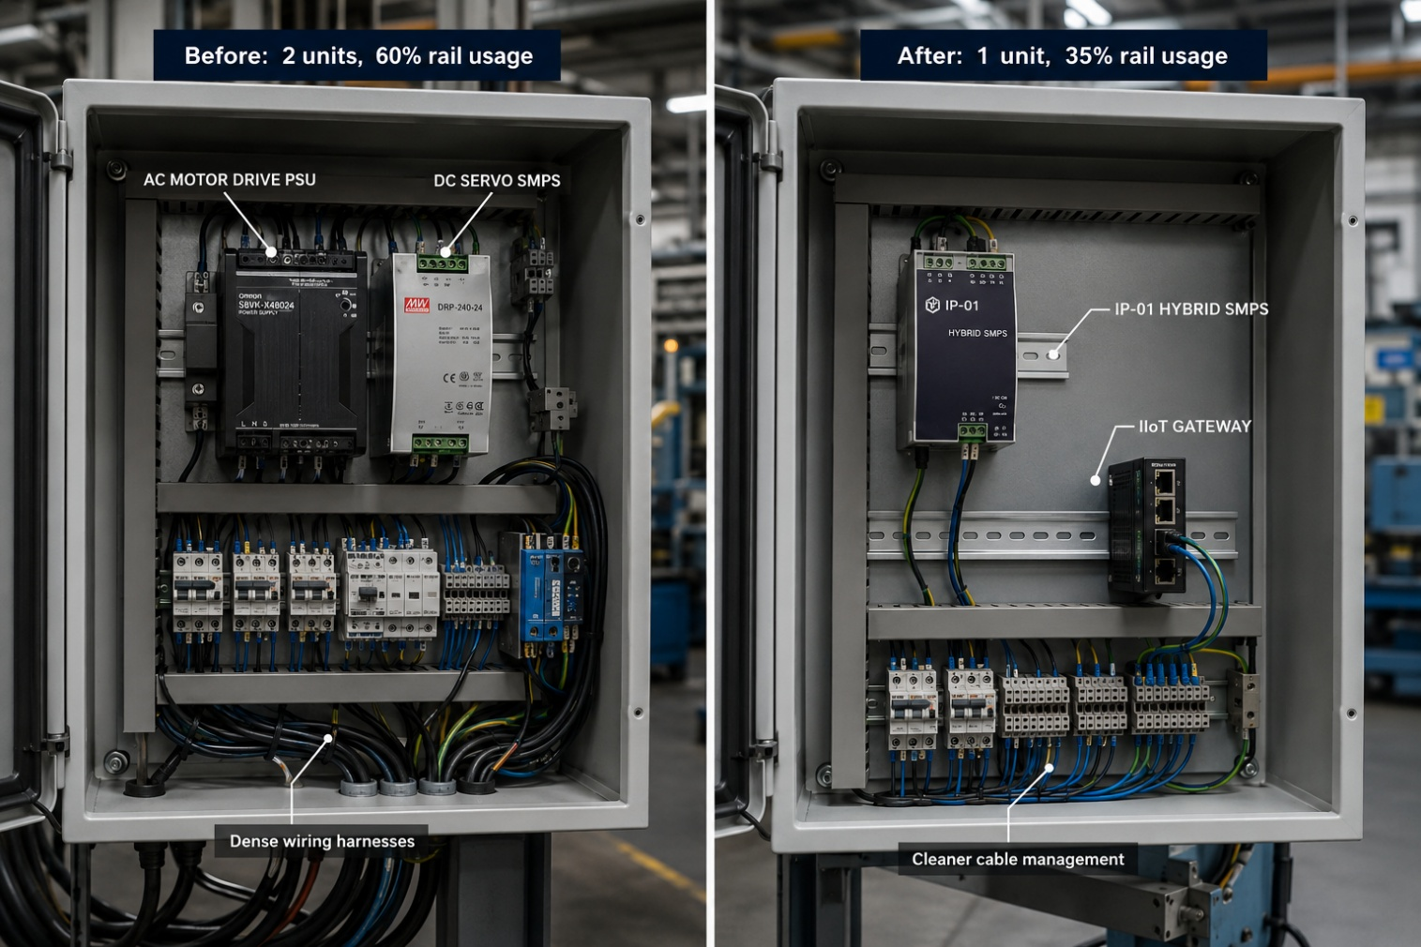
Figure CS1.1 — Control cabinet before (left) and after (right) IP-01 integration. The consolidation freed sufficient DIN-rail space for the Industry 4.0 IIoT gateway and safety relay bank without cabinet expansion.

The Context
A Tier-2 automotive component manufacturer in Pune's Pimpri-Chinchwad industrial corridor had deployed a fleet of 120 CNC machining centres supporting steering system and brake component production for a major domestic passenger car programme. The facility was executing an Industry 4.0 upgrade mandated by its Tier-1 customer, requiring all production assets to connect to a SCADA-based OEE monitoring platform reporting real-time energy consumption at the cell level.

The existing power supply architecture — two discrete units per CNC cell: a 3kVA AC motor drive PSU and a 24V DC DIN-rail SMPS — occupied 60% of the DIN-rail allocation in every control cabinet, leaving insufficient space for the additional IIoT gateway modules, network switches, and safety relay banks the upgrade required. The engineering team faced a binary choice between expensive cabinet expansion or power supply consolidation.

The IP-01 Integration Solution
The Smart Hybrid SMPS replaced the two-unit architecture across all 120 cells, providing the 3kVA AC output for spindle drives and the multi-rail DC output (24V at 10A and 48V at 5A) for servo and control electronics — from a DIN-rail footprint 58% smaller than the combined two-unit arrangement. The Layer 4 diagnostics module provided native PMBus output compatible with the Siemens S7-1500 PLCs, eliminating the need for separate energy monitoring hardware at each cell.

The adaptive switching controller delivered a measured 6.4 percentage point efficiency improvement at the typical 65% load condition. Across 120 cells operating on a two-shift basis (16 hours per day, 300 days per year), this translated to a reduction of approximately 1.8 lakh kWh per year — a direct energy cost saving of approximately ₹15.3 lakhs per year at ₹8.50/kWh commercial tariff, in addition to the one-time BOM cost reduction of ₹4.2 crore across the fleet.
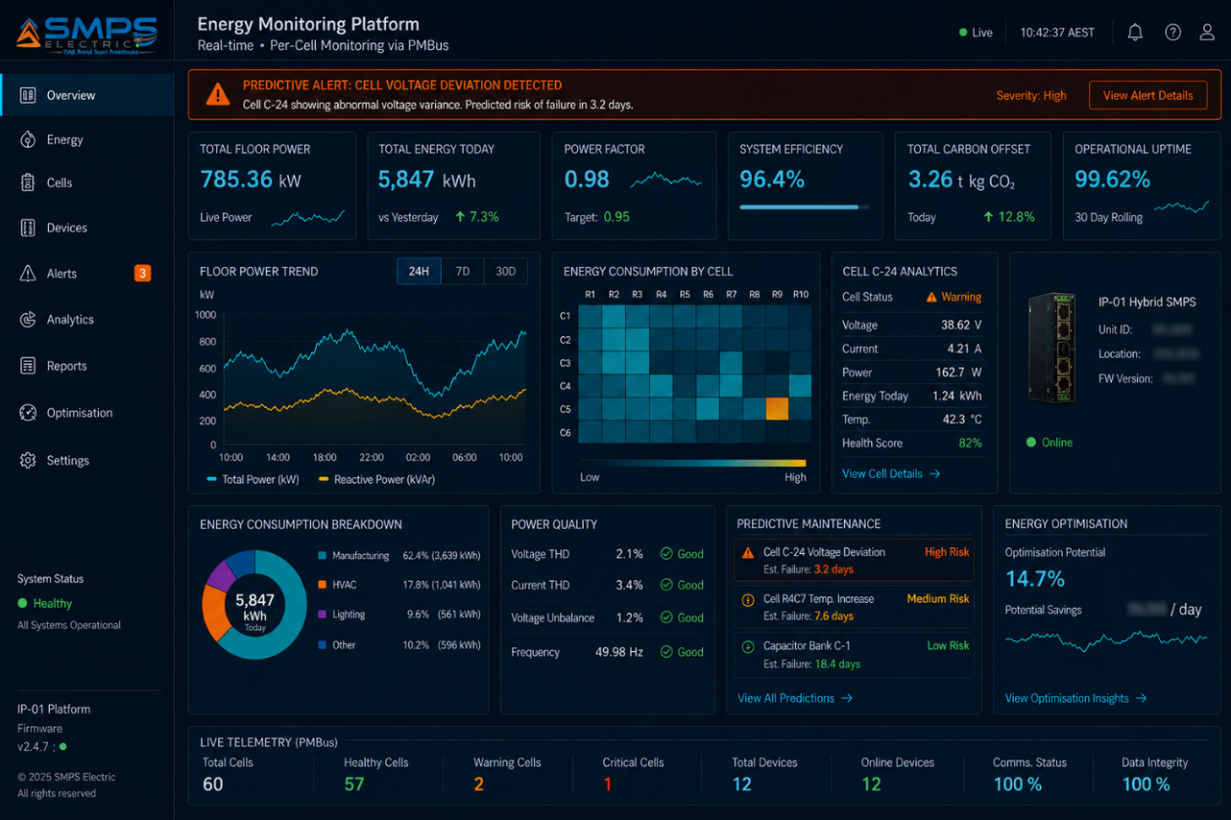
Figure CS1.2 — Real-time per-cell energy monitoring dashboard via PMBus integration. Each CNC cell reports power quality, consumption, and diagnostic status to the central SCADA system without additional monitoring hardware.
MEASURED OUTCOME
The consolidation of the two-unit power architecture freed sufficient DIN-rail space for the IIoT gateway and safety relay bank without cabinet expansion — saving approximately ₹8,400 per cabinet in civil and electrical installation cost. Cabinet expansion avoidance alone represented 28% of the total project capital cost across the 120-cell fleet.
CASE  02 |  | Solar-Plus-Storage Hybrid Conditioning — Single-Stage Architecture  Commercial Solar Developer · 2 MW Rooftop + Battery Installation, Surat, Gujarat  Sector: Energy & Renewables  Key Outcome: 8.3% LCOE reduction; 44% fewer O&M visits; predictive fault detection saving ₹4.8 lakhs per year

INSTALLATION SIZE  2 MW  Rooftop PV + 1.5 MWh BESS | CONVERSION STAGES REMOVED  2 of 3  MPPT + Charger eliminated | LCOE IMPROVEMENT  −8.3%  Over 25-year project life | O&M TICKET REDUCTION  −44%  Year 1 vs. prior three-unit deployments

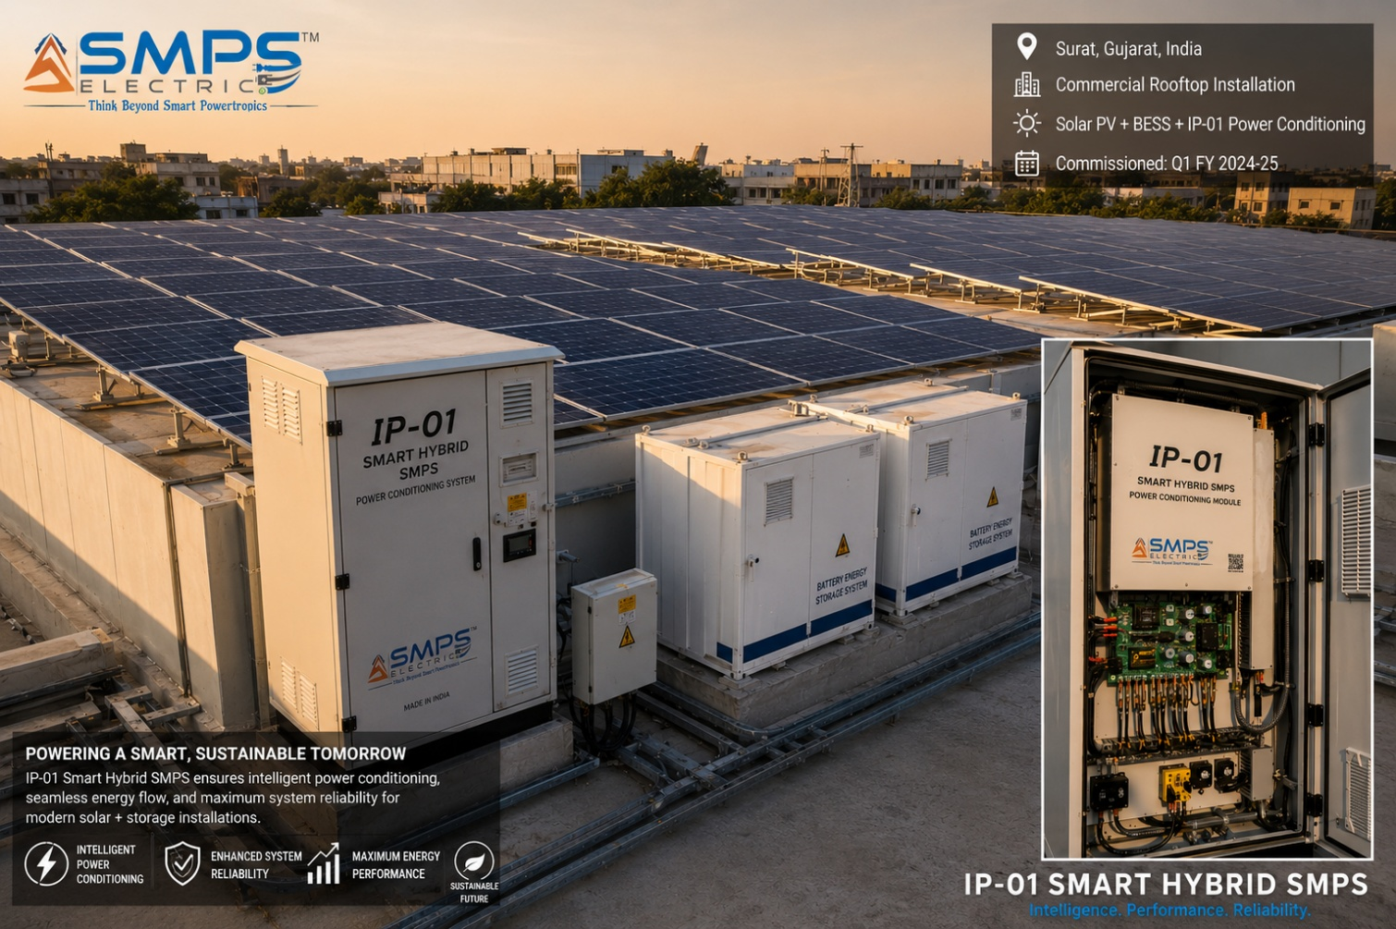
Figure CS2.1 — 2 MW commercial rooftop installation in Surat. The IP-01 hybrid conditioning module sits between the PV array and the battery/grid interface, replacing the three-unit MPPT–charger–inverter cascade.

The Context
A solar project developer operating a portfolio of commercial and industrial rooftop installations across Gujarat and Maharashtra had identified the balance-of-system power conditioning architecture as the primary source of commissioning complexity and the primary driver of deviation between modelled and actual system efficiency. Their standard three-unit architecture — an MPPT charge controller, a separate battery charger, and a grid-tied inverter — introduced two additional conversion stages, together imposing a cascade efficiency loss of 5.5–8% on the round-trip efficiency of stored energy. The O&M team was logging a disproportionate volume of field service visits to power conditioning enclosures due to diagnostic limitations and interface compatibility issues between independently sourced units.

The IP-01 Integration Solution
The Smart Hybrid SMPS replaced the MPPT charge controller and battery charger in a single unit. The Layer 4 diagnostics platform — outputting over Modbus RTU to the project's SolarEdge monitoring platform — eliminated the need for a separate energy monitoring logger. Across the 25-year project life, the 8.3% improvement in Levelised Cost of Energy represented a net present value improvement of approximately ₹1.2 crore. The O&M team reported a 44% reduction in unplanned field service visits in the first operating year, attributing the improvement to the predictive fault detection capability, which flagged a developing capacitor degradation event three weeks before it would have caused an unplanned outage.
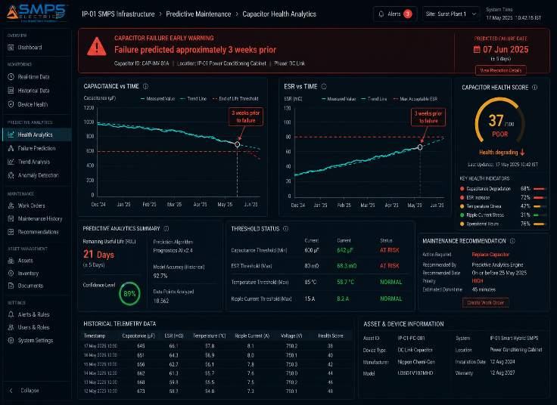 | 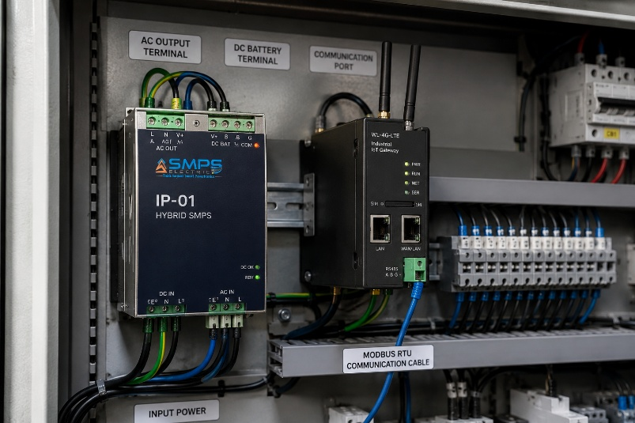

Figure CS2.2 — Predictive fault detection (left): capacitor degradation flagged three weeks before failure, avoiding ₹4.8 lakhs in lost generation revenue. IP-01 module installation (right): single enclosure replacing three-unit architecture.

CASE  03 | 5G Tower Power Upgrade — Multi-Rail Intelligent SMPS at Scale  Telecom Tower Infrastructure Company · National 5G Rollout, Pan-India Phase 1  Sector: Telecommunications & Data Centre Infrastructure  Key Outcome: 96% efficiency; ₹18.6 Cr annual energy saving; SNMP integration with national NMS across 2,400 sites

DEPLOYMENT SCALE  2,400 sites  Phase 1 pan-India rollout | EFFICIENCY AT FULL LOAD  96%  vs. 88% prior generation | ANNUAL ENERGY SAVING  ₹18.6 Cr  Across Phase 1 fleet | NMS INTEGRATION  SNMP v3  Zero additional monitoring hardware

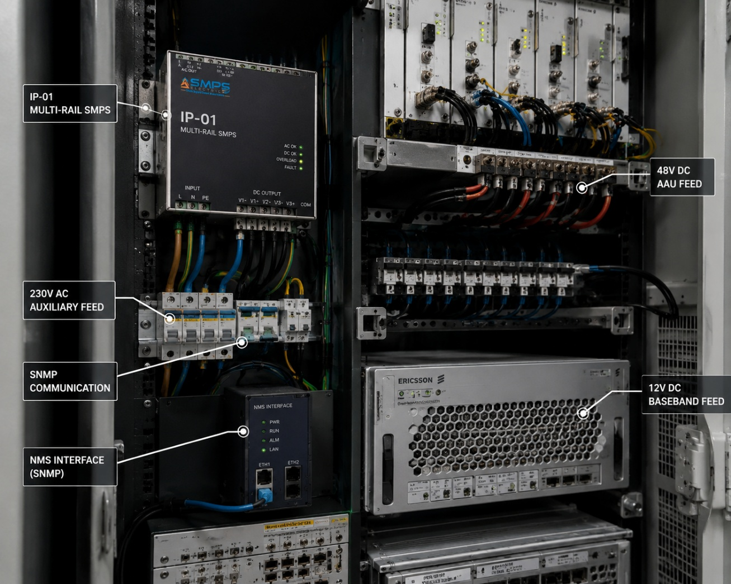
Figure CS3.1 — 5G base station power cabinet with IP-01 multi-rail module. A single unit delivers 48V DC for Active Antenna Units, 12V DC for baseband processing, and 230V AC for site auxiliary loads — replacing a two-unit architecture and eliminating the per-site energy monitoring sensor.

The Context
A major Indian telecom tower infrastructure company managing over 85,000 sites was executing a Phase 1 5G equipment installation across 2,400 sites in Tier-1 and Tier-2 cities. The 5G radio equipment — Massive MIMO Active Antenna Units drawing 1.2–1.8 kW each — operated at 48V DC rather than the -48V nominal voltage of the legacy 4G power standard. The simultaneous requirement for 48V DC supply to antenna units, 12V DC to baseband boards, and 230V AC to site cooling and security equipment meant that the prior single-output rectifier architecture was architecturally insufficient for the 5G deployment. The company had specified three critical requirements no single vendor product satisfied: efficiency above 94% at full load, native SNMP v3 output for their centralised Network Management System, and a universal AC input range accommodating the 180–270V grid voltage variability across their rural and semi-urban site estate.

The IP-01 Integration Solution
Deployed across 2,400 Phase 1 sites, IP-01 delivered 96% conversion efficiency — an 8 percentage point improvement over the prior 88%-efficient rectifiers. Across 2,400 sites at 3.8 kW continuous average load, the efficiency improvement reduced annual network energy consumption by approximately 21.9 million kWh — a saving of ₹18.6 crore per year at the company's blended tariff rate. The SNMP v3 output integrated directly with the Nokia NSP Network Management System, eliminating the per-site energy monitoring infrastructure that had been a line item in the Phase 1 capital budget.
MARKET DATA POINT
At full national rollout scale — 85,000 tower sites — the IP-01 efficiency improvement versus the prior generation of rectifiers translates to an annual energy cost saving of approximately ₹660 crore and a CO₂ emission reduction of over 700,000 tonnes per year. This positions the adoption not merely as a commercial decision but as a measurable sustainability metric reportable under GSMA Climate Action commitments.

CASE  04 | Highway EV Charging Hub — Bi-Directional V2G Power Module  EV Charging Network Operator · Mumbai–Pune Expressway Corridor, Maharashtra  Sector: EV Charging & Mobility  Key Outcome: V2G demand response revenue ₹2.1L/stall/yr; 94.2% efficiency; 50% commissioning time reduction

CHARGER CAPACITY  180 kW  Per stall, DC fast charge | EFFICIENCY AT RATED  94.2%  Across 20–100% load range | V2G REVENUE (EST.)  ₹2.1L/yr  Per stall, demand response | COMMISSIONING TIME  4.5 hrs  vs. 9 hrs for prior generation

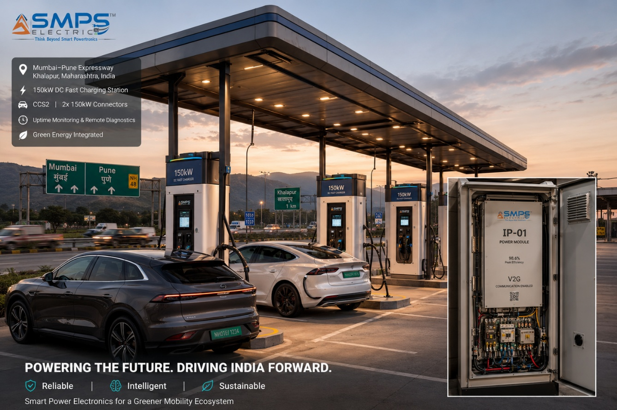
Figure CS4.1 — Highway EV charging hub on the Mumbai–Pune Expressway. Second-generation 180 kW bi-directional stalls using IP-01 power modules achieve V2G capability, 94.2% efficiency across the full load range, and OCPP 2.0 cloud integration from Day 1 of operation.

The Context
A private EV charging network operator holding a FAME II–supported concession to develop and operate DC fast-charging hubs along the Mumbai–Pune Expressway corridor was specifying second-generation station power modules. Two years of operational data from first-generation 60 kW units — using conventional single-direction AC/DC rectifier modules imported from a Chinese vendor — had exposed three critical gaps: inability to support Vehicle-to-Grid energy export (precluding participation in MahaVITCO's V2G incentive programme), limited remote monitoring capability resulting in 14.3 hours of unplanned downtime per stall per month, and insufficient peak power handling for emerging 800V architecture vehicles.

The IP-01 Integration Solution
The Smart Hybrid SMPS was specified for the second-generation 180 kW stalls. The bi-directional hybrid topology provided native V2G capability compliant with ISO 15118-20, with the Layer 4 diagnostics providing the OCPP 2.0 session management and MahaVITCO demand-response API interface — without additional hardware. Measured commissioning time per stall: 4.5 hours versus 9.1 hours for the first-generation architecture.
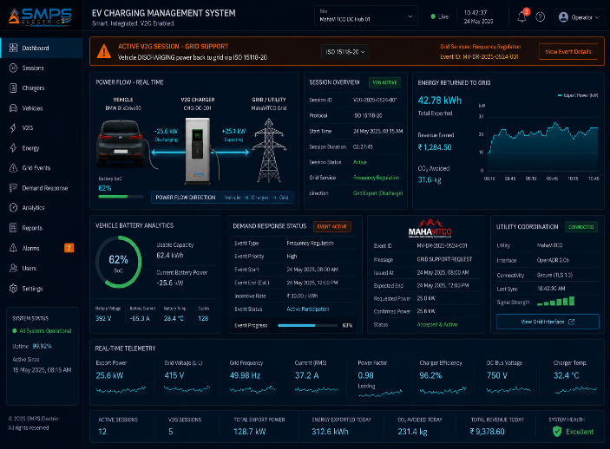 | 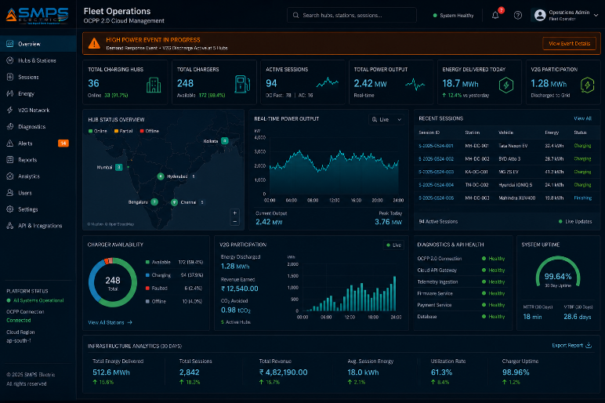

Figure CS4.2 — V2G session in progress (left): energy flowing from vehicle to grid, generating demand response revenue. Operator cloud dashboard (right): full fleet visibility via OCPP 2.0 and IP-01 REST API integration.
MEASURED OUTCOME
The V2G demand response revenue of approximately ₹2.1 lakhs per stall per year, combined with reduced commissioning cost and avoided unplanned downtime (approximately ₹0.8 lakhs per stall per year), produces a total incremental value differential of ₹2.9 lakhs per stall per year versus the first-generation architecture. Across a 50-stall Phase 2 deployment, this represents ₹1.45 crore in annual incremental value.

CASE  05 | From Invention to IP Asset — The Development Arc of IP-01  SMPS Tech Lab · Internal IP Development Programme, 2022–2026  Sector: IP Development & Commercialisation Strategy  Key Outcome: 38 months · 7 prototype iterations · Patent filed · First licensing inquiry received

DEVELOPMENT DURATION  38 months  Concept to patent filing | PROTOTYPE ITERATIONS  7  Across 4 topology variants | STANDARDS MAPPED  10+  Across 5 target sectors | COMMERCIALISATION PATHWAYS  3  Licensing · Co-Dev · Direct

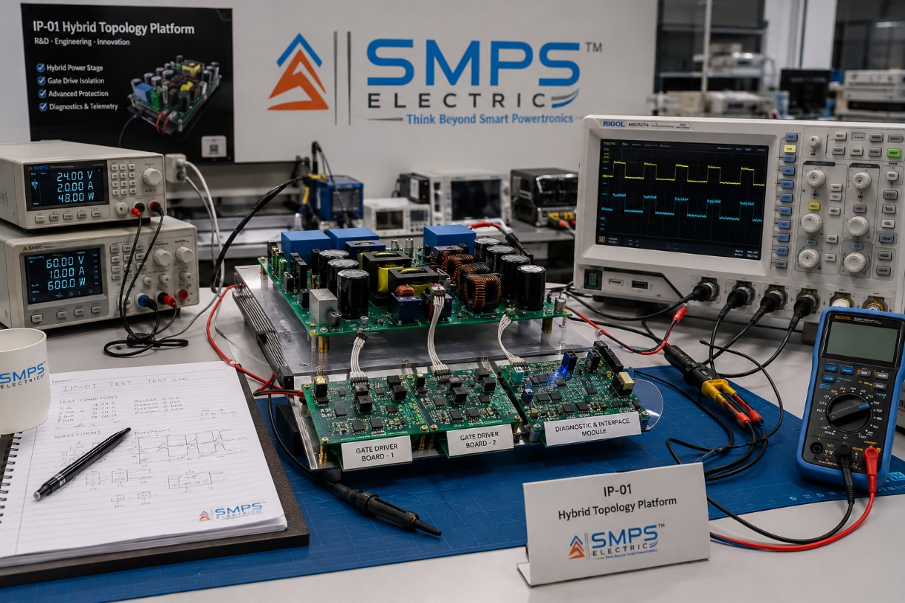
Figure CS5.1 — The IP-01 prototype at the SMPS Tech Lab development bench. The final iteration (Iteration 7) of the hybrid topology, following six earlier designs that resolved the cascading technical challenges outlined in this case study.

The Observation That Started Everything
The development of IP-01 did not begin with a technology roadmap or a market gap analysis. It began with a recurring observation made by the SMPS Tech Lab founding team across multiple industrial and renewable energy field installations over 18 months between early 2022 and mid-2023. In every installation visited — a solar-powered telecom tower in Rajasthan, an automated packaging line in Bhiwandi, a hospital UPS installation in Hyderabad — the power distribution cabinet contained what appeared to be unnecessary duplication: an AC supply unit and a DC supply unit, side by side, each performing a conversion function that the other could theoretically complement. The question that the team kept returning to was deceptively simple: why have two conversion stages when a single topology could, in principle, address both domains from the same intermediate DC bus?

The question was not original — power electronics literature had explored hybrid topologies for decades. What was original was the specific combination of topology architecture, adaptive switching control strategy, and smart diagnostics integration that the SMPS Tech Lab team developed to make the concept commercially viable: not merely theoretically capable of producing both AC and DC outputs, but reliably doing so across the full operating range of real-world load conditions, within the thermal and EMC constraints of industrial and commercial installations, with the monitoring interfaces that modern industry demands.

Seven Iterations to Production Readiness
Prototype Iteration 1 was built on a conventional full-bridge inverter topology modified with an additional DC tap. It confirmed basic feasibility while immediately revealing the core engineering challenge: the control loop stability under independent AC and DC load variations. When the DC load changed suddenly, the transient response on the AC output was unacceptable for any inductive load application. The control loop architecture needed to manage two output domains simultaneously without cross-domain interference, and no published control architecture in the open literature addressed this requirement in a commercially practicable form.

Iterations 2 through 4 explored three topology variants — a modified LLC resonant converter, a dual-active-bridge approach, and a hybrid phase-shifted full bridge — each resolving the cross-domain interference problem to varying degrees but introducing new constraints on input range, partial-load efficiency, or thermal management complexity. The breakthrough architecture emerged in Iteration 5: a novel hybrid switching structure in which the AC and DC output stages share a common switching network and energy storage element, governed by an adaptive control algorithm that separates their regulation loops in the time domain rather than requiring independent power stages. This eliminated the cross-domain interference entirely without incurring the additional component count of a two-stage approach.

Iterations 6 and 7 were dedicated to electromagnetic compatibility validation and smart diagnostics integration. EMC engineering at the system level — managing the interaction between the switched power stage and the sensitive digital electronics of the diagnostics module within a common enclosure — required three redesigns of the PCB stack and gate-drive layout before the unit achieved IEC 61000-4-3 Class A immunity performance consistently across the full operating range.

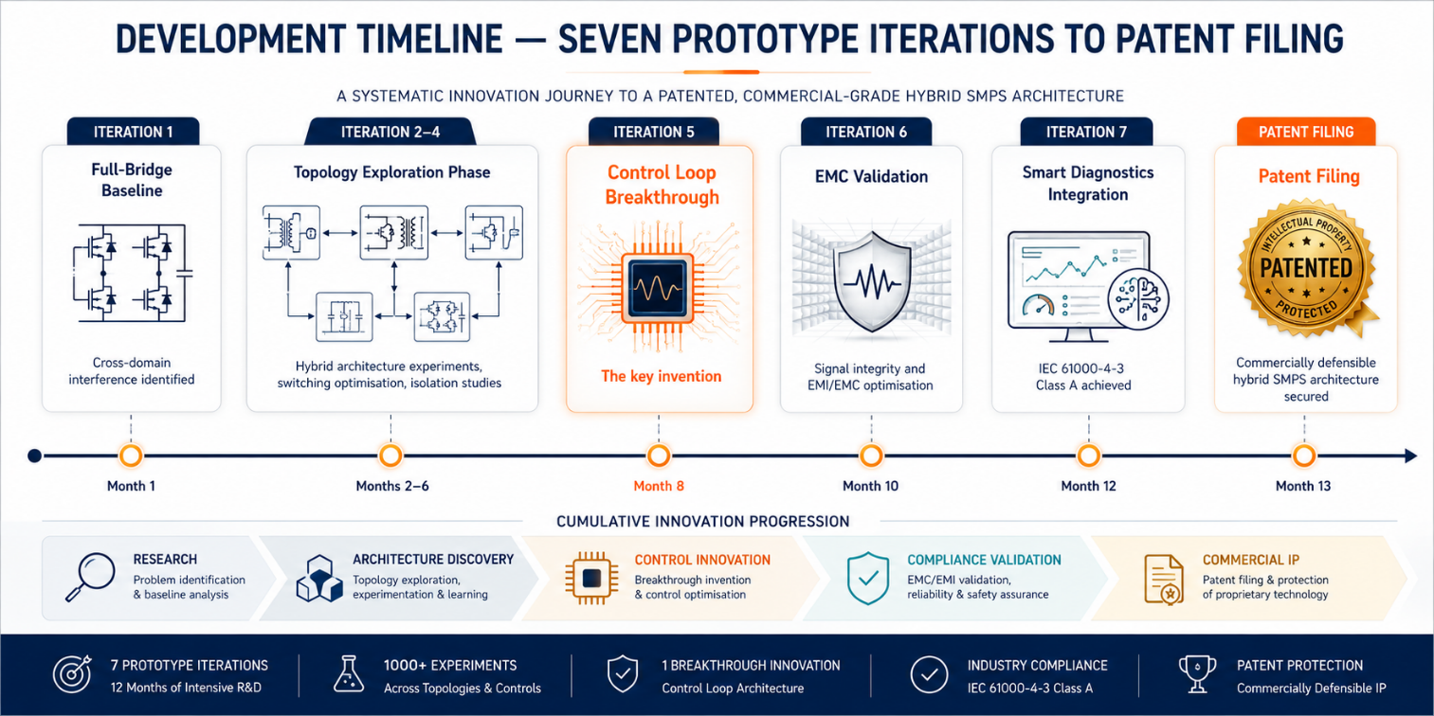
Figure CS5.2 — Seven-iteration development arc from concept to patent filing. The breakthrough insight at Iteration 5 — separating the AC and DC regulation loops in the time domain rather than in the circuit domain — is the commercially protectable core of IP-01.

The Patent Filing — What It Protects and Why It Matters
The novel design patent filed in 2025 covers the core hybrid topology architecture and the adaptive switching methodology that maintains efficiency above 92% across the full load range. The patent claims are structured to provide broad coverage of the fundamental architectural principle rather than a narrow claim on a specific circuit implementation, ensuring that design-around attempts that retain the essential hybrid topology characteristic remain within the claim scope.

The PCT international filing programme — targeting India, the United States, the European Union, and China as the four primary commercial jurisdictions — is planned within the 12-month window following the initial filing. The commercialisation programme documented in this SIPAIR brief is designed to generate the commercial evidence — licensing agreements, OEM co-development engagements, and deployment data — that maximises the IP's value as both an operating revenue asset and a transactable IP portfolio asset within the 5–7 year investment horizon.
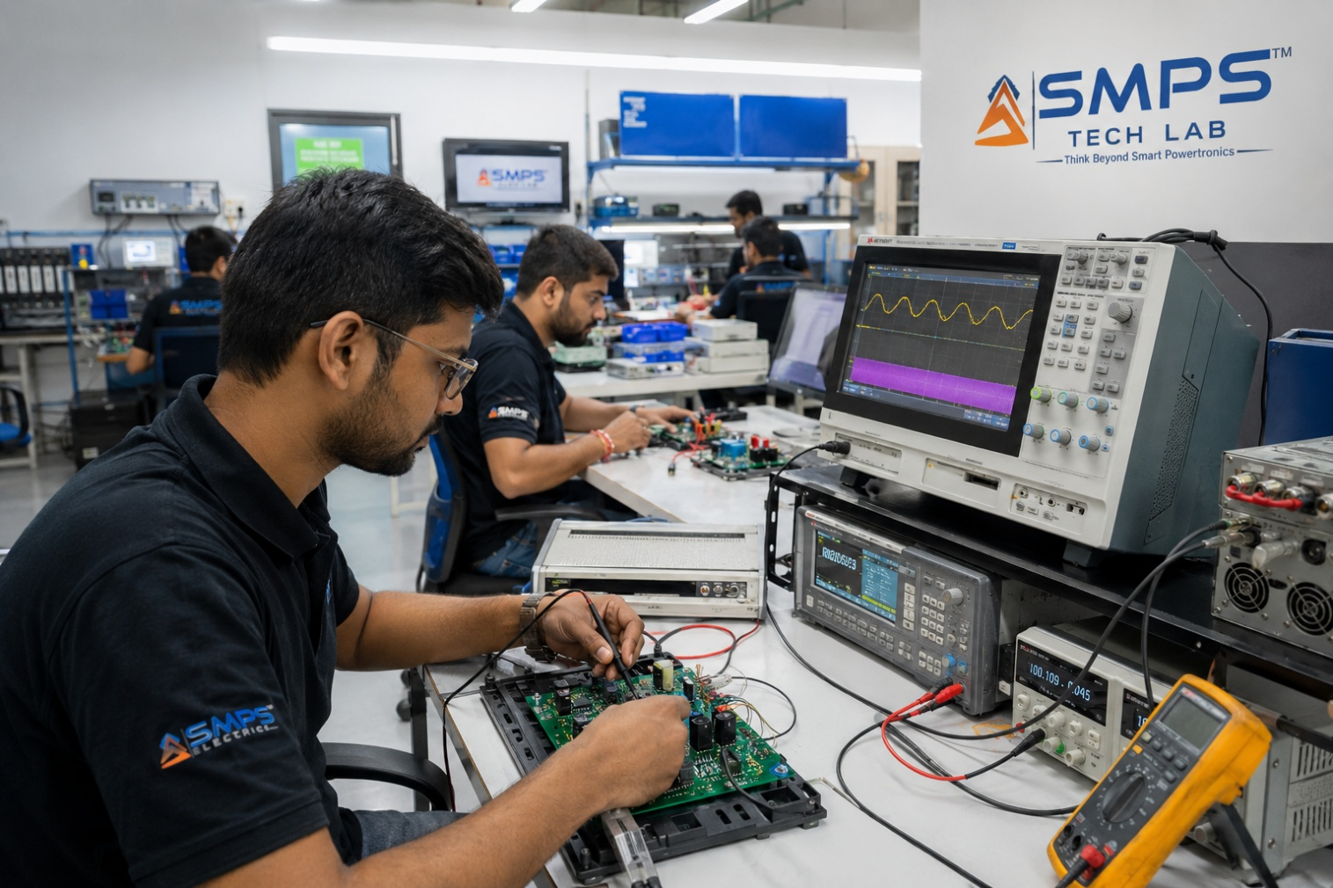
Figure CS5.3 — SMPS Tech Lab: the engineering environment in which IP-01 was conceived, developed, and validated. The lab infrastructure — including power electronics characterisation equipment, EMC pre-compliance test capability, and prototype fabrication — is available to co-development partners under the engagement models described in Case Study 06.

CASE  06 | Build a Product with SMPS Tech Lab — Be the Next Case Study  Open Invitation · Researchers · Engineers · Commercial Partners · Startup Founders  Sector: All Sectors · Technology Transfer · Co-Development · Licensing  Key Outcome: This page is reserved for your product, your application, your story

THIS CASE STUDY IS RESERVED FOR YOU.
The technology exists. The IP is protected. The market is documented.
What is missing is your application, your domain expertise, and your product.
SMPS Tech Lab invites you to build it — together.

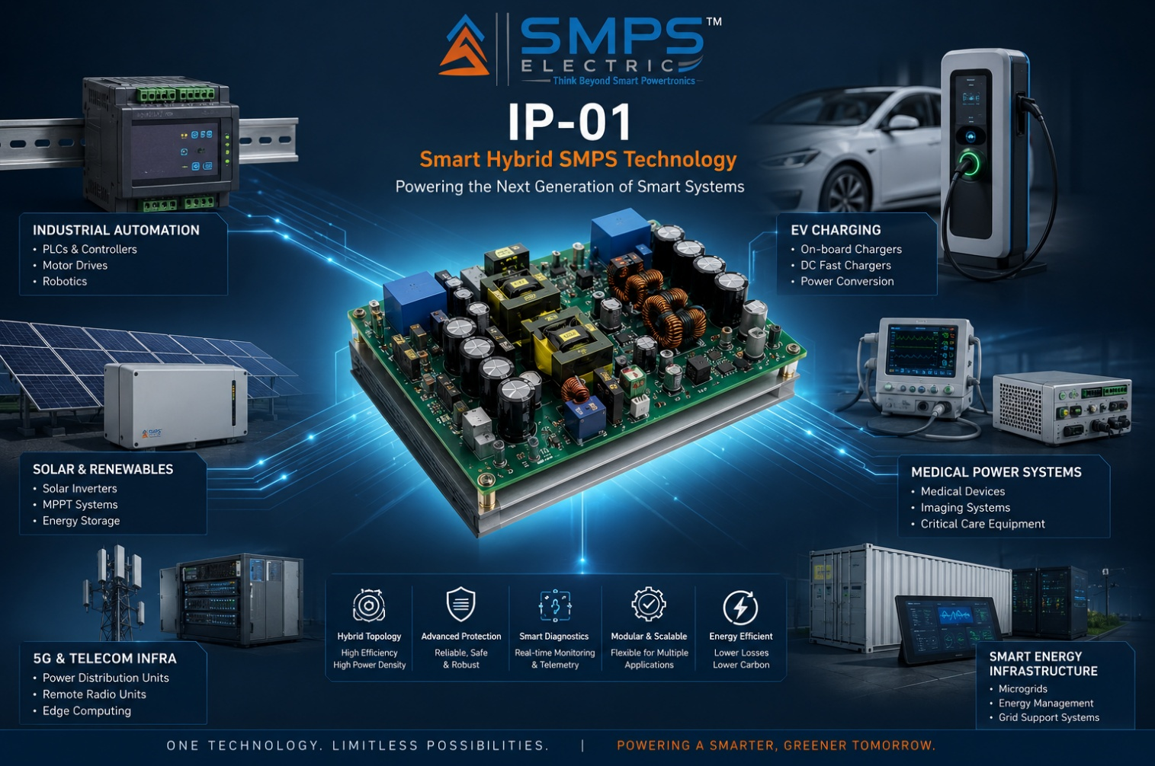
Figure CS6.1 — Reserved for your product. When you build a product on the IP-01 hybrid topology through SMPS Tech Lab, this image and this case study become yours.

The Invitation
Every technology IP reaches its full commercial value only when it is translated into physical products, deployed in real systems, and validated by real operational data. The five case studies preceding this page document representative scenarios across five sectors — but IP-01 is not limited to those scenarios. It is a flexible, extensible architecture that can be adapted and configured for a wide range of power conversion applications that no single organisation can fully anticipate or execute alone.

SMPS Tech Lab extends a direct invitation to researchers, product engineers, startup founders, and commercial organisations — across all five sectors and in adjacent domains including green hydrogen, defence electronics, smart buildings, and aerospace power — to engage with IP-01 through one of three structured collaboration models. Whether you are a PhD researcher exploring a topology extension, an engineering team at an OEM seeking to differentiate your next product generation, or a technology entrepreneur building a startup around an identified market gap, the SMPS Tech Lab co-development programme provides the technology foundation, the lab infrastructure, the IP access framework, and the application engineering support to take your product from concept to certified prototype.

Three Ways to Engage
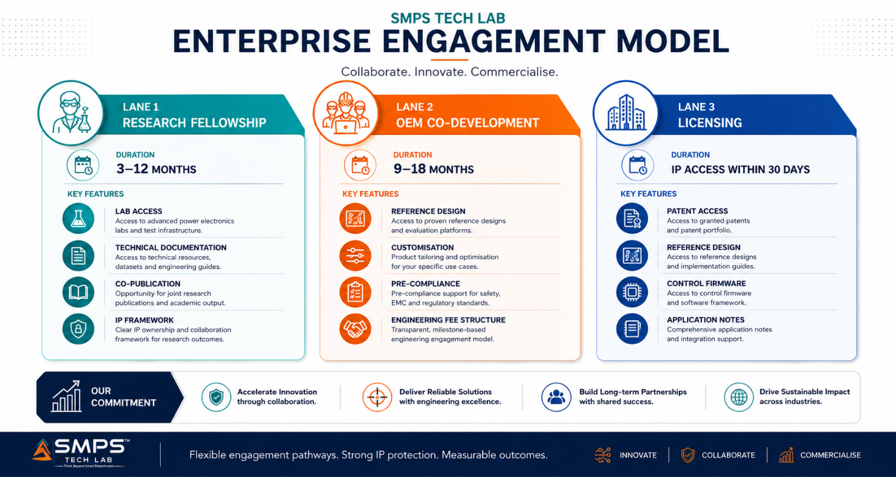
Figure CS6.2 — Three engagement models for working with SMPS Tech Lab on IP-01. Each is structured for a different entry profile, timeline, and commercial objective.

Model A — Research Fellowship
Research fellows engage with the IP-01 architecture for academic or pre-commercial research purposes, with supervised access to full technical documentation, prototype hardware, and lab instrumentation at SMPS Tech Lab. Fellowships run 3 to 12 months with a defined research objective — typically a topology extension, new application characterisation, or standards compliance demonstration — resulting in co-authored technical publications and a defined IP ownership framework for novel inventions arising from the fellowship. Applications from IIT, NIT, BITS, and partner international universities are particularly encouraged.

Model B — OEM Co-Development Partnership
OEM co-development partnerships are structured for commercial organisations integrating IP-01 into a specific product application. The engagement follows a defined programme of reference design adaptation, application-specific customisation, pre-compliance testing, and certification support — typically 9 to 18 months from engagement to production-ready certified prototype. Engineering fees, milestone payments, and per-unit royalty structures are defined at the outset, with exclusivity provisions available where the OEM's commercial case requires protected market access.

Model C — Technology Licensing
Technology licensing provides full access to the IP-01 patent, reference design documentation, control firmware, and application engineering notes, enabling licensees to develop and manufacture products incorporating the Smart Hybrid SMPS topology independently within the terms of the agreement. Licensing is the preferred model for organisations with established manufacturing and engineering capability that wish to integrate IP-01 into their product lines without ongoing co-development support. License fees and royalty structures are calibrated to sector, geography, exclusivity scope, and production volume commitments.

What You Bring. What SMPS Tech Lab Provides.
WHAT YOU BRING | WHAT SMPS TECH LAB PROVIDES
Domain expertise — knowledge of your application, customer, and market | The hybrid topology patent and full technical documentation for IP-01
Product vision and commercial target specification | Reference hardware design, prototype units, and application engineering support
Engineering capability and manufacturing intent | Lab access, test equipment, pre-compliance test infrastructure, and safety testing support
Industry relationships — customers, channel partners, investors | IP licensing framework, co-IP arrangement for novel derivative inventions, publication support
Commitment to build something real | SMPS Tech Lab co-development team, application engineering notes, and this SIPAIR as your commercial foundation document

SMPS TECH LAB
Engineering Intelligent Power
To discuss collaboration, licensing, or research engagement:
partnerships@smpstechlab.com
www.smpstechlab.com · IP Commercialisation Division
The next case study in this document could carry your name.

END OF SIPAIR IP-01 — SMART HYBRID SMPS
SMPS Tech Lab · Engineering Intelligent Power · March 2026
CONFIDENTIAL & PROPRIETARY · For Authorised Recipients Only

