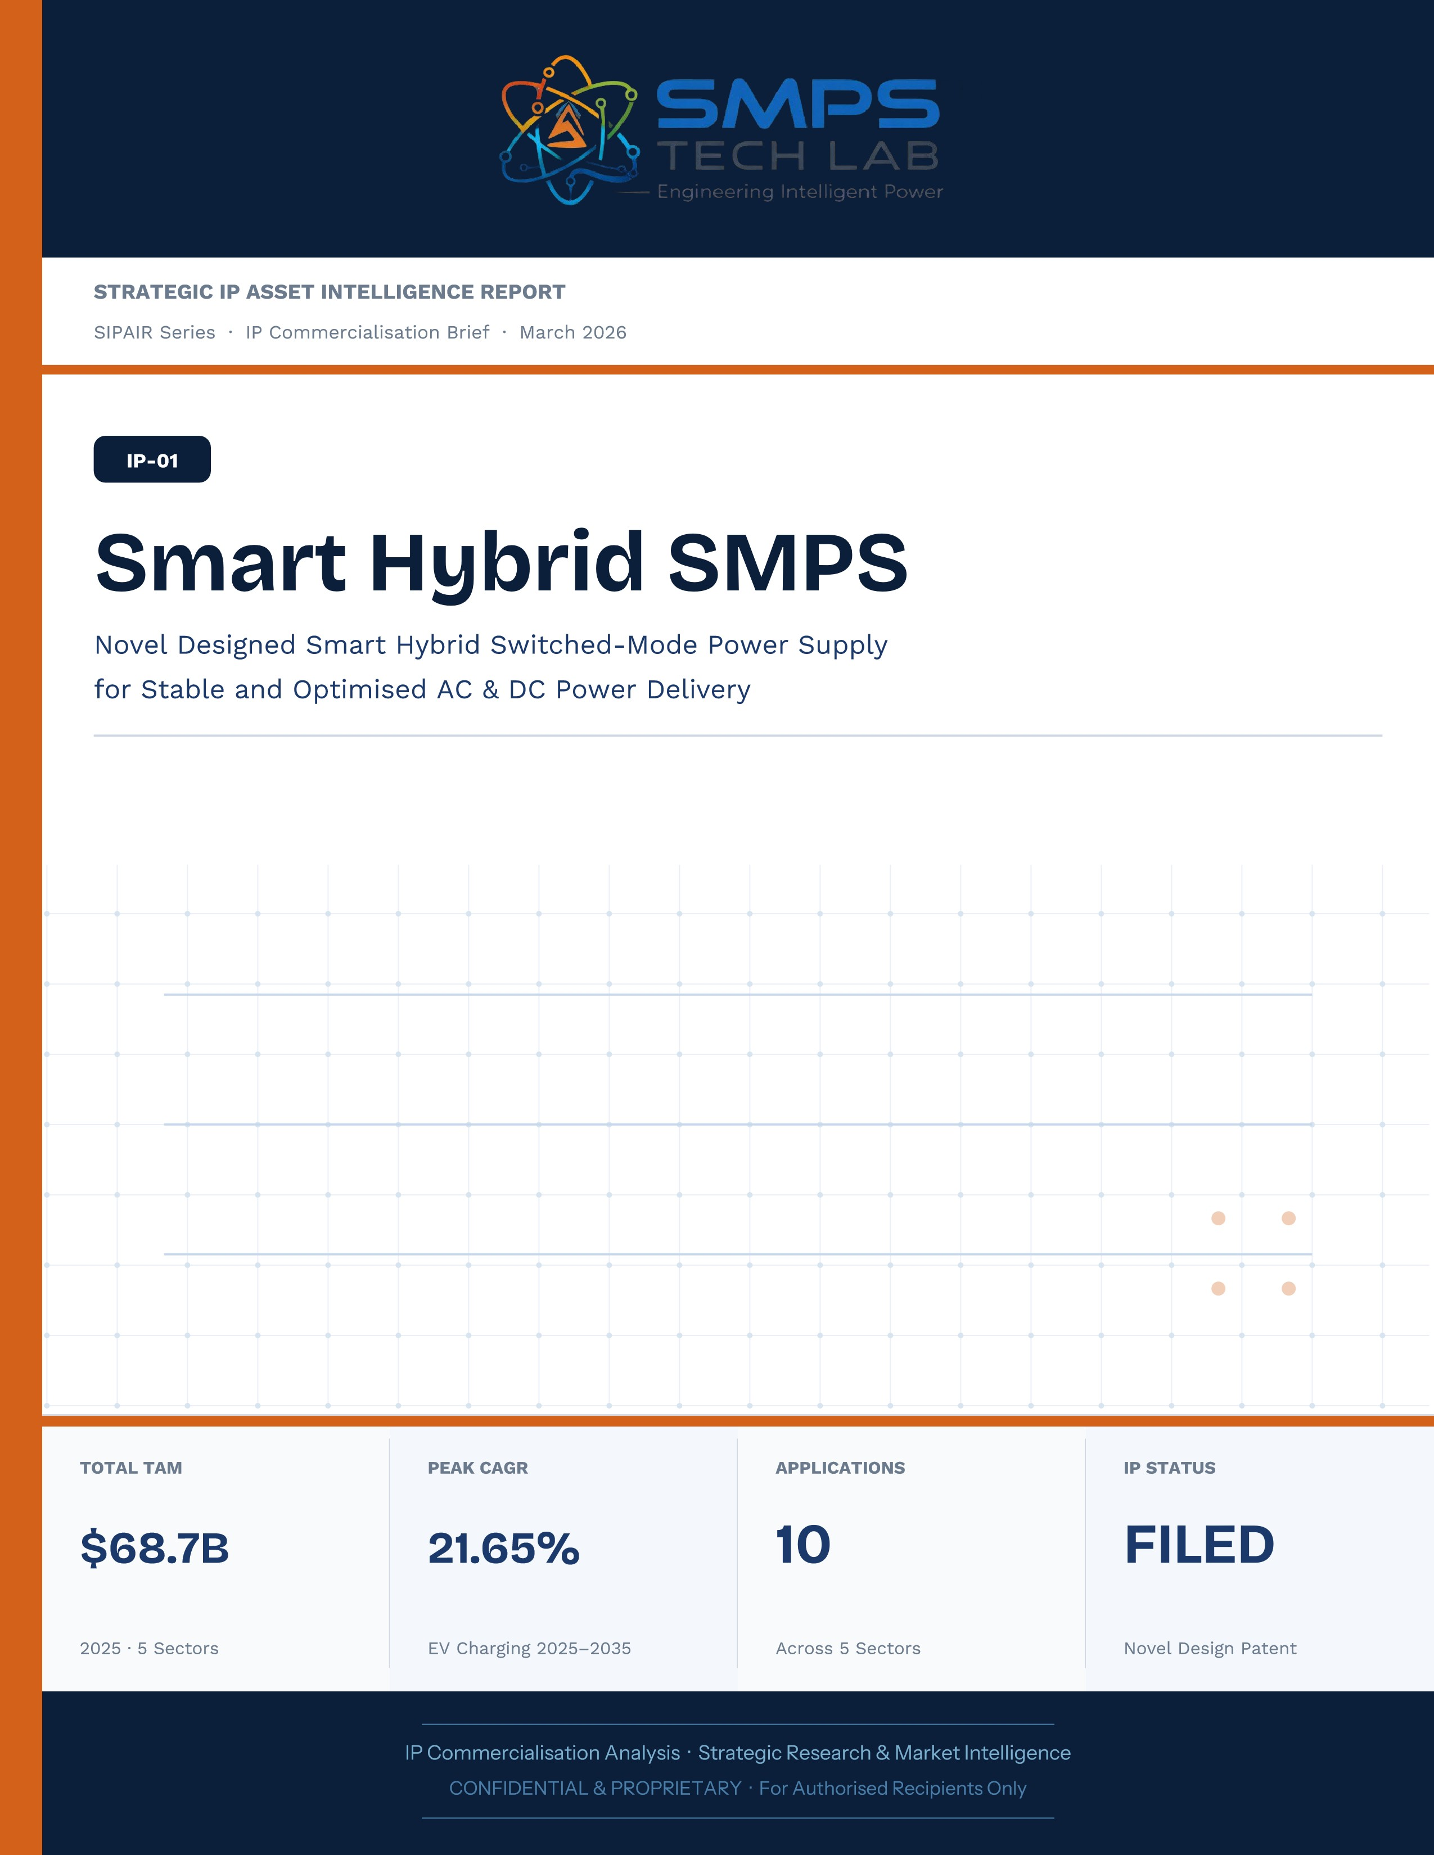
STRATEGIC IP ASSET INTELLIGENCE REPORT
SIPAIR Series
IP-02: SMPS Integrated CCU for Telecom
SMPS-Based Integrated Central Control Unit for Uninterrupted Telecom Power

Report Title | SIPAIR IP-02 — SMPS Integrated CCU for Telecom Commercialisation Brief

Document Series | Strategic IP Asset Intelligence Report (SIPAIR)

Version | Version 1.0 — First Edition

Compiled & Edited by | Shri Amareshwar Karatagi

Organisation | SMPS Tech Lab — Engineering Intelligent Power

Date of Issue | March 2026

Classification | Confidential & Proprietary — For Authorised Recipients Only

IP Reference | IP-02 — SMPS-Based Integrated CCU Architecture, Filed 2025

Related Document | SIPAIR IP-01: Smart Hybrid SMPS (see companion brief)

This document is prepared by SMPS Tech Lab as part of the SIPAIR IP Commercialisation Series.

Declaration — Originality & Intellectual Property Statement

This Strategic IP Asset Intelligence Report (SIPAIR — IP-02: SMPS-Based Integrated CCU for Telecom) is an original compilation prepared by SMPS Tech Lab. The analysis, market intelligence frameworks, commercial strategy formulations, and case study narratives contained herein are the result of independent research and original intellectual work by the authors and editors named in this document.

The core technology described in this report — the SMPS-Based Integrated Central Control Unit architecture, including its active power management layer, CCU intelligence stack, uninterrupted multi-rail AC/DC delivery system, and NMS integration platform — is the exclusive proprietary invention of SMPS Tech Lab, protected under a filed novel design patent (2025). IP-02 is a distinct and independently protectable invention from IP-01 (Smart Hybrid SMPS), though both emerge from the same SMPS Tech Lab research programme. The two IPs are designed to complement each other across adjacent application verticals and may be jointly licensed or co-deployed where application requirements demand both hybrid topology and active power management intelligence.

Market sizing data, CAGR estimates, and industry statistics cited in this document are sourced from independent third-party research publications, fully attributed in Appendix A. All third-party data is used for analytical and benchmarking purposes only. This report has not been submitted, in whole or in part, to any other organisation for commercialisation or formal assessment except as specifically disclosed in writing.
Declared by:

Shri Amareshwar Karatagi Founder & CSO SMPS Tech Lab · March 2026

CERTIFICATE OF AUTHENTICITY
IP Commercialisation Documentation

This is to certify that the Strategic IP Asset Intelligence Report
SIPAIR IP-02 — SMPS Integrated CCU for Telecom
has been compiled, reviewed, and authenticated by the undersigned in accordance
with the standards of the SIPAIR documentation series. The technology, market analysis,
and commercial intelligence herein are verified as accurate to the best of the signatories’
knowledge as at the date of issue: March 2026.

Program Head / Director | Technical Mentor
  Program Head / Research Director
  SMPS Tech Lab
  Technical Mentor / Advisor
  SMPS Tech Lab

SMPS Tech Lab · Engineering Intelligent Power · March 2026

Acknowledgment

The preparation of this Strategic IP Asset Intelligence Report for IP-02 has drawn on the technical expertise, operational insights, and research foundation developed across two parallel innovation tracks at SMPS Tech Lab. The development of the CCU intelligence layer — the defining innovation of IP-02 — required not only power electronics engineering depth but sustained engagement with telecom network operations, tower management practice, and satellite ground station engineering environments that are highly specialised. The author and editor express sincere gratitude to those whose knowledge and access made this work possible.

Technical Development
The CCU architecture at the heart of IP-02 evolved alongside IP-01's hybrid topology work, but along a distinct engineering trajectory focused on power orchestration intelligence rather than conversion efficiency alone. The engineers and technologists who contributed to the CCU control logic, NMS integration stack, and sub-millisecond failover switching mechanism deserve specific recognition for the rigour with which they approached the uninterrupted power mandate — a design objective that admits no approximation.

Telecom Industry Access
The sector intelligence in this report reflects direct engagement with tower operations, data centre facility management, and satellite ground station engineering communities. The operational data from 5G tower rollout programmes, off-grid hybrid power deployments, and maritime communication installations that informed the case study narratives and application requirement specifications in this document is the product of those field engagements.

Research Publications
The market intelligence framework draws on publications from Future Market Insights, MarketsandMarkets, SNS Insider, Grand View Research, IMARC Group, Coherent Market Insights, Global Growth Insights, and the Ericsson Mobility Report, as well as operational data from the International Energy Agency. The quality of those independent research publications is what allows the TAM framework in this report to be grounded in named, verifiable data rather than estimated aggregates.

Shri Amareshwar Karatagi

Founder & CSO

SMPS Tech Lab · March 2026

Preface — From the Founder & Editor

From IP-01 to IP-02 — The Logical Extension
IP-01, documented in the companion SIPAIR brief, solved one problem with exceptional elegance: replacing the unnecessary architectural duplication of separate AC and DC converter units with a single hybrid topology. The commercial case was compelling and the market evidence was clear. But the engineers at SMPS Tech Lab, in the same process of field observation that gave rise to IP-01, had identified a second problem — one that operated at a higher level of the power system stack and was, if anything, more commercially urgent in the specific context of telecom infrastructure.

The problem was not conversion efficiency. It was availability. In a 5G base station, a satellite ground hub, an offshore platform communication centre, or a smart city public safety network node, the standard power supply architecture not only requires separate AC and DC converters — it delegates all intelligence about the power state of the system to a separate controller that may be physically remote, software-dependent on a third-party network management system, and incapable of autonomous protective action in the sub-millisecond timeframe that modern telecom uptime SLAs demand. When the grid fails, when a battery starts to degrade, when an input source switches — the system needs to respond faster than any software polling cycle can achieve. It needs embedded intelligence, right at the power conversion stage.

IP-02 is that intelligence. The Integrated Central Control Unit, combined with the SMPS core, does not just convert power — it orchestrates it. It monitors every parameter of the power delivery chain continuously, switches between sources in under a millisecond, predicts faults before they become outages, and reports power system health to the operator's NMS in real time, without external monitoring hardware. It is the difference between a power supply and a power management system.

Why Telecom, and Why Now
The selection of telecom infrastructure as the primary application vertical for IP-02 reflects a disciplined commercial judgement. Telecom infrastructure is the single sector in the IP-02 TAM where the uninterrupted power mandate is non-negotiable, contractually enforced at 99.999% uptime, and backed by capital investment programmes of unprecedented scale: 2.3 billion 5G subscriptions by end of 2024 with another 4 billion to come by 2030; 3,000 Amazon Project Kuiper satellites deployed in April 2025 with thousands of ground hubs to follow; the IMO GMDSS modernisation mandate forcing a complete vessel communication power infrastructure upgrade by 2026. Every one of these programmes creates a specific, identified, and time-bounded procurement requirement for exactly what IP-02 delivers.

The second reason is the grid reliability crisis that is, counterintuitively, the most powerful demand driver the CCU's hybrid input management addresses. South Africa recorded 1,130 hours of planned power cuts in a single year. India's tower estate — 750,000 sites — routinely operates on hybrid grid, diesel, and battery sources with real-time CCU-managed source switching that determines whether the tower stays on during a grid event. This is not a niche requirement. It is the operational reality for hundreds of thousands of tower sites across three continents, and the market is actively seeking a solution that the current generation of separate rectifiers and external controllers cannot provide.

How This Document is Structured
This SIPAIR brief follows the same 14-section architecture as the IP-01 companion document, making the two documents a coherent and mutually reinforcing portfolio. Readers who have engaged with SIPAIR IP-01 will recognise the structure immediately. The technology differentiation section includes an explicit comparison between IP-01 and IP-02, clarifying the architectural relationship and the distinct value proposition of each. The case studies are drawn from the five specific sectors of IP-02's TAM framework — 5G tower, data centre, satellite ground, smart city, and maritime/offshore — with technical and financial parameters grounded in the operational realities of each sector.
Shri Amareshwar Karatagi
Founder & CSO
SMPS Tech Lab · March 2026

TABLE OF CONTENTS

Declaration — Originality & Intellectual Property Statement 1
Acknowledgment 1
Technical Development 1
Telecom Industry Access 1
Research Publications 1
Preface — From the Founder & Editor 1
From IP-01 to IP-02 — The Logical Extension 1
Why Telecom, and Why Now 1
How This Document is Structured 1
Important Notice & Confidentiality Disclaimer 1
1.1 The Strategic Context 1
1.2 The IP-02 Solution 1
1.3 Key Metrics at a Glance 1
1.4 Reference Metrics Table 1
1.5 Why IP-02, Why Now 1
2.1 What the SMPS-Based Integrated CCU Does 1
2.2 Four-Layer Architecture 1
2.3 IP-01 vs IP-02 — Architectural Relationship 1
2.4 Key Technical Differentiators 1
2.5 Standards Compliance Architecture 1
3.1 The Telecom Power Reliability Market 1
3.2 Global Market Reference Data 1
CAGR Comparison — IP-02 Target Market Segments 1
3.3 Five Market Drivers 1
4.1 Methodology 1
4.2 Consolidated TAM Summary 1
4.3 Sector Deep-Dives 1
Sector 1 — 5G & Next-Generation Telecom Tower Infrastructure 1
Sector 2 — Hyperscale Data Centres & Edge Computing 1
Sector 3 — Satellite Ground Infrastructure & SATCOM Networks 1
Sector 4 — Smart City & Critical Public Communication Networks 1
Sector 5 — Maritime, Offshore & Remote Operations 1
5.1 India as a Priority Market for IP-02 1
5.2 India Telecom Market Sizing 1
6.1 India Government Schemes with Direct IP-02 Alignment 1
7.1 The Power Orchestration Plugin 1
7.2 Plugin Integration Matrix 1
8.1 Commercialisation Philosophy 1
8.2 Five Commercialisation Pathways 1
Pathway 1 — Telecom OEM Licensing 1
Pathway 2 — Tower Company Direct Supply 1
Pathway 3 — Government & Public Safety Procurement 1
Pathway 4 — Maritime & Offshore OEM Integration 1
Pathway 5 — Satellite Ground Infrastructure 1
8.3 Market Priority Matrix 1
9.1 Competitive Architecture Overview 1
10.1 The Investment Case 1
10.2 Revenue Scenarios 1
11.1 Technology Generation Roadmap 1
11.2 Adjacent Application Opportunities 1
12.1 Risk Framework 1
Appendix A — Data Sources & Research Publications 1
Appendix B — Standards Reference 1
Appendix C — Glossary 1
The Context 1
The IP-02 Integration Solution 1
The Context 1
The IP-02 Integration Solution 1
The Context 1
The IP-02 Integration Solution 1
The Context 1
The IP-02 Integration Solution 1
The Architecture Insight That Created IP-02 1
The Engineering Challenges of CCU Integration 1
The Invitation 1
Three Ways to Engage 1
Model A — Research Fellowship 1
Model B — OEM Co-Development Partnership 1
Model C — Technology Licensing 1
What You Bring. What SMPS Tech Lab Provides. 1

0F | FOUNDER & EDITOR  IP-02 SIPAIR Series · SMPS Tech Lab

 | Shri Amareshwar Karatagi  Founder & Chief Strategic Officer  SMPS TechLab  Special Correspondent, Government of Karnataka |  Serial Entrepreneur

Vision Statement
We aim to build a generation of innovators and entrepreneurs who create transformative technologies, develop intellectual property, and drive India’s technological leadership on both national and global platforms. Over the years, we have worked extensively within the startup ecosystem, contributing to and mentoring multiple initiatives focused on building, scaling, and strengthening businesses. Through this journey, we have developed a deep understanding of business strategy, governance frameworks, and deep-technology development, along with the practical challenges of scaling innovation in real-world markets. As a Special Correspondent with the Government of Karnataka and a serial entrepreneur, my focus has been on shaping individuals into creators, builders, and leaders of technology and enterprise. Our work emphasizes ownership, innovation, and execution discipline to nurture individuals capable of building scalable, high-impact solutions with both national and global relevance.
Through SMPS Tech Lab, we drive this vision by integrating deep Research & Development (R&D) with entrepreneurial strategy, fostering a culture where ideas evolve into intellectual property, innovation, and industry-aligned solutions that contribute to India’s technological advancement and global competitiveness. The Industry Fitness DeepTech Internship Program is a reflection of this mission—designed to develop individuals who are innovation-driven, execution-focused, and capable of contributing meaningfully to technology, entrepreneurship, and nation-building at scale.
“My vision is to build a generation that doesn’t wait for opportunities, but creates them through innovation and entrepreneurship.” — Shri Amareshwar Karatagi

A. R. Shalini
Chief Business Development Officer (CBDO) & Program Officer
SMPS TechLab | SMPS Electric Control Pvt. Ltd.

Area of Expertise:
Business Strategy, Operations Management, Industry–Academia Integration, Entrepreneurship Development
Profile:
I play a pivotal role in driving program execution, operational excellence, and professional development within SMPS Tech Lab. With a strong foundation in both business strategy and technology alignment, I am committed to shaping individuals into industry-ready professionals with the right mindset, discipline, and execution capabilities.
My approach focuses on building skills with clarity of thought, accountability, and a results-driven attitude. Through structured guidance and continuous mentorship, I enable participants to understand the intersection of technology, business, and real-world application.
I actively work toward bridging the gap between academia and industry, ensuring that learning is aligned with practical expectations and evolving market demands. My dedication to creating a seamless and high-impact learning environment fosters confidence, innovation, and professional growth among participants.
Through my leadership, the program consistently emphasizes structured execution, strategic thinking, and the development of individuals who are prepared to contribute meaningfully to both industry and innovation ecosystems.
“Professional excellence is built when knowledge, mindset, and execution come together with consistency.”
— A. R. Shalini

Dr. S. Khatua
Chief Technology Officer (CTO)
SMPS TechLab | SMPS Electric Control Pvt. Ltd.
IITian | PhD – IIT Dhanbad
Area of Expertise:
Power Electronics, Microgrid & Smart Grid Systems, Nuclear Power Systems, DeepTech R&D, Industrial System Design.
I am a distinguished technology leader driving advanced Research & Development and deep-tech innovation. An IITian with a PhD in Microgrid and Smart Grid Systems for nuclear power applications, I bring over 15 years of experience across power electronics, nuclear reactor control systems, and defence and telecom technologies.
With significant contributions to high-impact and mission-critical projects of national importance, my work reflects a rare combination of research depth, engineering precision, and industrial execution.
I am a strong advocate of deep-tech innovation and intellectual property (IP) creation, and I emphasize the development of indigenous technologies that strengthen the nation’s technological capability and global standing.
Through my mentorship, I inspire the next generation to pursue technical mastery, disciplined execution, and innovation with national intent, shaping professionals capable of contributing to the future of deep technology.
“Precision in engineering, depth in research, and ownership of technology are the pillars of true national progress.”
— Dr. S. Khatua

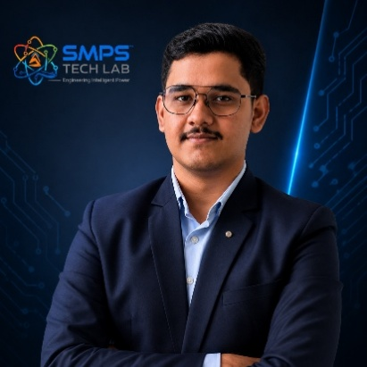
Mr. Rushit Jani
Techno-Commercial Architect
Strategic Editorial & Commercialisation Review | OptCell GLOBAL

Fields of Interest:
AI & Intelligent Systems, Industrial IoT, Product Architecture, Deep-Tech Commercialisation, Enterprise System Design, and Scalable Engineering Solutions.
Focused on building technology-driven systems that bridge engineering innovation with practical industry adoption and long-term commercial value.

Message from the Editor:
Technology, in its purest form, is not just about building systems — it is about creating meaningful infrastructure that can influence industries, solve operational challenges, and contribute to larger technological progress. My interest has always been in understanding how engineering innovation can evolve beyond prototypes into scalable and commercially sustainable solutions.

This document represents more than a technical study of an intellectual property. It reflects a structured effort to connect engineering architecture with market relevance, strategic deployment, industrial applicability, and long-term innovation potential. The objective throughout this work has been to maintain a balance between technical depth, commercialization practicality, and institutional-level documentation standards.

As emerging technologies continue to redefine industries, I strongly believe that the future will belong to organizations capable of combining research, engineering, strategic thinking, and execution into unified ecosystems. Through this publication, we aim to contribute towards that larger vision while creating pathways for collaboration, innovation, and real-world technological impact.

"Transforming engineering innovation into scalable, industry-defining technological ecosystems."
— Mr. Rushit Jani

A Note of Gratitude

The development of this publication has been supported by the collective vision, encouragement, and leadership of the Directors and management of SMPS Electric Control Pvt. Ltd.

Their continued commitment towards engineering innovation, industrial excellence, and long-term technological growth has created an environment that encourages meaningful research, practical problem-solving, and commercialization-focused thinking. The guidance, operational insights, and institutional support extended throughout this journey have played an important role in shaping the direction and depth of this work.

This document reflects not only an individual effort, but also the larger culture of innovation, trust, and forward-thinking leadership fostered within the organization. We sincerely appreciate the confidence and support provided towards building impactful and future-ready technological initiatives.

Important Notice & Confidentiality Disclaimer

This Strategic IP Asset Intelligence Report (SIPAIR — IP-02) has been prepared exclusively for internal strategic planning, investor communication, licensing partner engagement, and research collaboration purposes. It is intended for distribution only to authorised recipients under applicable non-disclosure and confidentiality arrangements.

All market sizing data, CAGR estimates, and financial projections are derived from independent third-party research publications cited in Appendix A. These figures represent estimates as at March 2026. No representation or warranty is made as to their accuracy or completeness.

The technology, architecture, and methodologies described herein are the exclusive proprietary assets of SMPS Tech Lab, protected under filed patent and design rights. This document does not constitute a prospectus, financial advice, or an offer to sell or subscribe to securities. Recipients are advised to conduct independent due diligence before making any investment or commercial decision.

01 | EXECUTIVE SUMMARY  Strategic Overview · Investment Thesis · Value Proposition

1.1 The Strategic Context
Telecommunications infrastructure has become the single most reliability-dependent sector in the global economy. The physical network of 5G base stations, satellite ground hubs, data centre edge nodes, smart city communication backbones, and maritime SATCOM terminals represents a USD 41 trillion global economy's connective tissue. A power outage at a 5G macro station does not merely inconvenience nearby users — it affects connected vehicles, industrial automation systems, emergency services, and financial transactions simultaneously. The downtime cost for a single tier-1 telecom operator during a major power event is measured in crores per hour. The reliability standard is not aspirational: it is contractually mandated at 99.999% uptime across the global telecom infrastructure estate.

This reliability mandate defines an engineering requirement that the current generation of separate-component telecom power architectures is structurally incapable of meeting without compromise. A conventional telecom site deploys three separate systems to manage power: a rectifier to convert AC to DC, an SMPS to deliver regulated voltage rails, and a controller unit to manage switching between grid, battery, and generator sources. Each is independently sourced, independently certified, independently maintained, and dependent on the other two functioning correctly. The intelligence governing source switching typically resides in software that polls system state at intervals measured in seconds — far too slow to prevent a power interruption that occurs in milliseconds. The result is infrastructure that is theoretically designed for 99.999% availability and operationally delivering significantly less.

Figure 1.1 — The architectural distinction: conventional three-unit telecom power architecture (left) versus the IP-02 Integrated CCU+SMPS (right). The sub-millisecond failover capability is not an incremental improvement — it is an architectural consequence of integrating the control intelligence directly with the power conversion stage.

1.2 The IP-02 Solution
STRATEGIC NOTE
IP-02 — the SMPS-Based Integrated Central Control Unit — resolves the reliability gap at its architectural root. By integrating the CCU intelligence layer directly with the SMPS power conversion stage in a single unified platform, IP-02 eliminates the inter-system communication latency, the BOM duplication, and the monitoring blind spots that characterise the conventional three-unit approach. The result is a single, patent-protected power orchestration system that delivers uninterrupted AC and DC to mission-critical telecom infrastructure in all grid conditions — while providing the network management telemetry and predictive fault intelligence that modern telecom operators require.
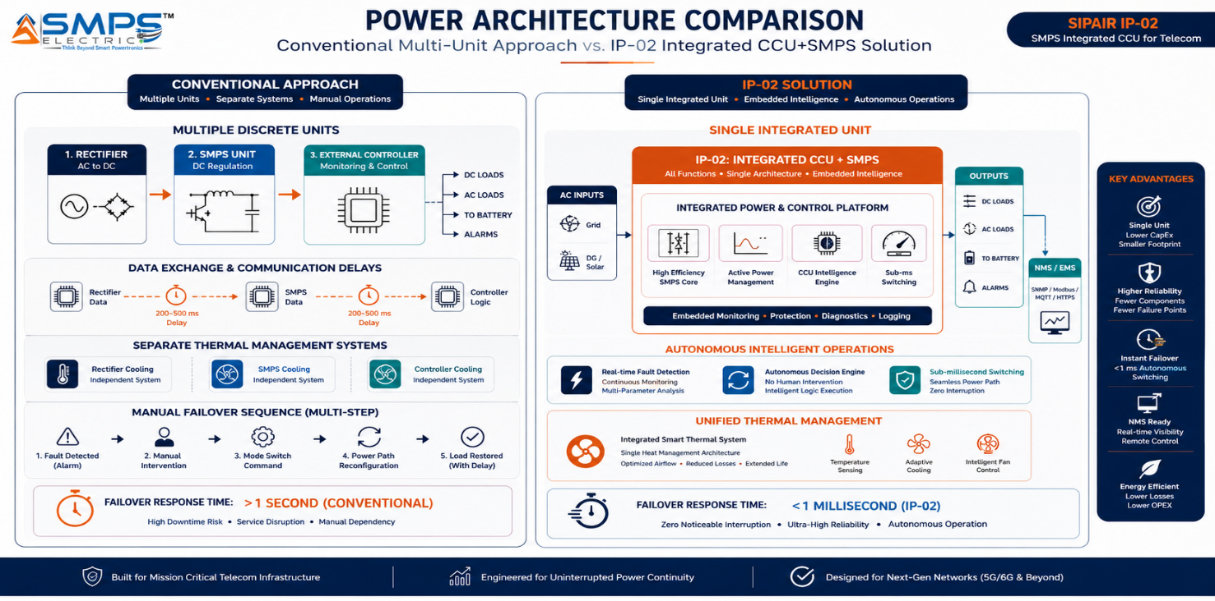

1.3 Key Metrics at a Glance

TOTAL ADDRESSABLE MARKET  $27.1B  2025 Baseline · 5 Sectors | HIGHEST-GROWTH SECTOR  14.84%  Satellite Ground CAGR 2025–2035 | 5G TOWER SECTOR TAM  $6.11B  9.53% CAGR to 2031 | IP PROTECTION  CCU Filed  Integrated Architecture Patent

1.4 Reference Metrics Table
METRIC | VALUE / OBSERVATION
Total Addressable Market (2025) | USD 27.1 Billion across 5 primary sectors and 10 commercial applications
Strongest Sector Growth (CAGR) | Satellite Ground Infrastructure — 14.84% CAGR (2025–2035); market projected at USD 19.6B by 2035
Data Centre & Edge Sector TAM | USD 10.86 Billion (2025) — largest individual sector; CAGR 7.3% to 2030
5G Telecom Tower Sector TAM | USD 6.11 Billion (2025) — fastest near-term revenue pathway; CAGR 9.53%
Smart City & Public Comms TAM | USD 4.2 Billion (2025) — 8.5% CAGR; India Smart City Mission and BharatNet aligned
Maritime & Offshore Sector TAM | USD 3.1 Billion (2025) — 6.5% CAGR; IMO GMDSS modernisation mandate drives upgrade cycle
IP Protection Status | Novel design patent filed — Integrated CCU + SMPS architecture and active power management methodology
Applicable Standards Mapped | IEC 62368-1, NEBS Level 3, IEC 60950, ITU-T L.1200, IEEE 1159, TIA-942, ATEX, DNV — all 5 sectors
Recommended First Pathway | OEM licensing (Vertiv, Eaton, Delta) + Tower company direct supply (Indus Towers, American Tower)
Estimated Time-to-Revenue | 12–18 months for 5G tower sector; 18–30 months for satellite and data centre; 24–42 months for maritime

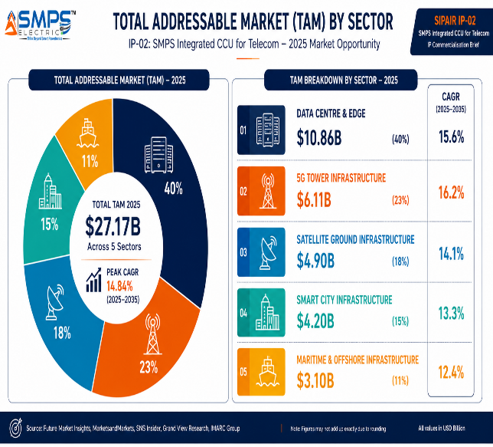
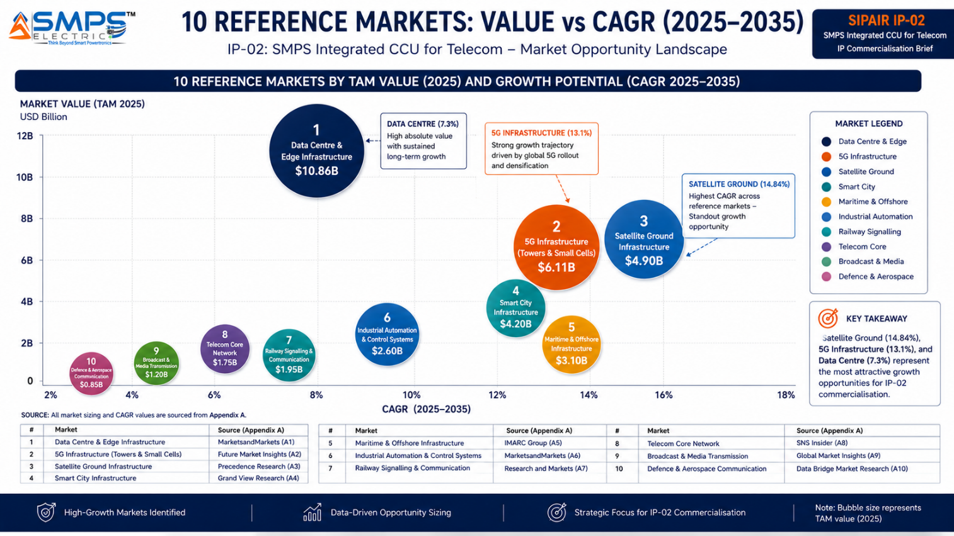Figure 1.2 — IP-02 Total Addressable Market by sector (left) and reference market growth landscape (right). The Satellite Ground sector, though smaller in absolute terms, carries the highest CAGR at 14.84% — driven by the Amazon Kuiper and Starlink LEO constellation buildouts.

1.5 Why IP-02, Why Now
Three structural forces create an exceptional and time-bounded commercialisation window for IP-02. The 5G densification wave — 2.3 billion subscriptions by end of 2024 with 4 billion more to come — is driving the largest single upgrade cycle in telecom tower power infrastructure history. Every new 5G base station requires a multi-rail power solution that legacy rectifiers cannot deliver; IP-02 is architecturally designed for exactly this specification. The LEO satellite constellation buildout — Amazon Project Kuiper deploying 3,000+ satellites in April 2025, Starlink licensed in India in June 2025 — is creating hundreds of distributed ground hubs in remote locations that demand autonomous, uninterrupted hybrid power management with satellite-backhaul monitoring: a requirement that fits the IP-02 CCU architecture with near-perfect precision. And the IMO GMDSS modernisation mandate, requiring a complete upgrade of vessel emergency communication systems to LEO-based GMDSS by 2026, is forcing a full power infrastructure refresh across the global commercial shipping fleet.

RISK ADVISORY
Each of these three market events has a defined timeline. The 5G tower upgrade cycle will lock in power module specifications over the next 18–36 months. LEO ground hub power system contracts are being awarded now. The GMDSS maritime mandate has a 2026 compliance deadline. These are not open-ended opportunities — they are windows with hard close dates. The organisations that establish IP-02 as the reference architecture before those windows close will hold structural first-mover positions in markets that will be served by their technology for the next decade.

02 | TECHNOLOGY OVERVIEW  CCU Architecture · Differentiators · IP-01 vs IP-02 · Standards

2.1 What the SMPS-Based Integrated CCU Does
The SMPS-Based Integrated Central Control Unit is, at its core, a power orchestration system. The SMPS layer performs what any high-quality switched-mode power supply does: it converts AC or DC input into regulated, stable output voltage rails at high efficiency. But the CCU layer above it adds capabilities that fundamentally change the category of product: real-time continuous monitoring of every power system parameter, autonomous source switching with sub-millisecond response, active load management and balancing across output rails, predictive fault detection before failures occur, battery management with temperature-compensated charge control, and native telemetry integration with Network Management Systems via SNMP, NETCONF, and RESTCONF protocols.

The word 'integrated' in the IP-02 name is not descriptive — it is definitional. The integration of CCU intelligence directly with the SMPS power conversion stage eliminates the inter-system communication latency that makes conventional separate-component approaches structurally incapable of sub-millisecond failover. When the CCU is embedded in the same unit as the switching circuitry it controls, it can respond to a detected input supply failure by completing the failover switching sequence before the output rail has had time to sag below the tolerance threshold of the connected equipment. This is the core technical claim of IP-02, and it is the reason the IP addresses the availability mandate that the three-unit conventional approach cannot meet.

2.2 Four-Layer Architecture
LAYER | COMPONENT | FUNCTION | KEY INNOVATION IN IP-02
L1 | Wide-Input AC/DC Front End | Accepts AC grid (85–300V), diesel generator AC, solar DC (30–150V), and battery DC (48V/96V Li-ion/VRLA) simultaneously, with priority-based source management. | Wide-input tolerance with source-priority hierarchy and automatic transfer switching is engineered into Layer 1 itself — not delegated to an external ATS unit.
L2 | SMPS Power Conversion Core | High-efficiency multi-rail power conversion delivering simultaneous AC output (230V for HVAC, legacy equipment) and DC rails (48V primary, 12V, 5V) from a single power stage. | Inherits the hybrid topology efficiency advantage from the IP-01 family. Multi-rail simultaneous output eliminates separate DC-DC converters for each rail.
L3 | CCU Intelligence Layer | Real-time monitoring of all electrical and thermal parameters. Sub-millisecond autonomous source failover. Active load balancing across output rails. Battery management with temperature compensation. Predictive fault analytics. | The CCU is the patent-bearing differentiator of IP-02. The intelligence is embedded at the switching level — not in external software — enabling response times that software-based controllers cannot achieve.
L4 | NMS Integration & Telemetry | Real-time power system health reporting via SNMP v3, NETCONF, RESTCONF, Modbus RTU, and REST API. Predictive maintenance alerts, energy KPI reporting, and remote configuration. | Native multi-protocol NMS integration without external gateway hardware. Supports operator-standard NOC dashboards directly, reducing per-site monitoring infrastructure cost.

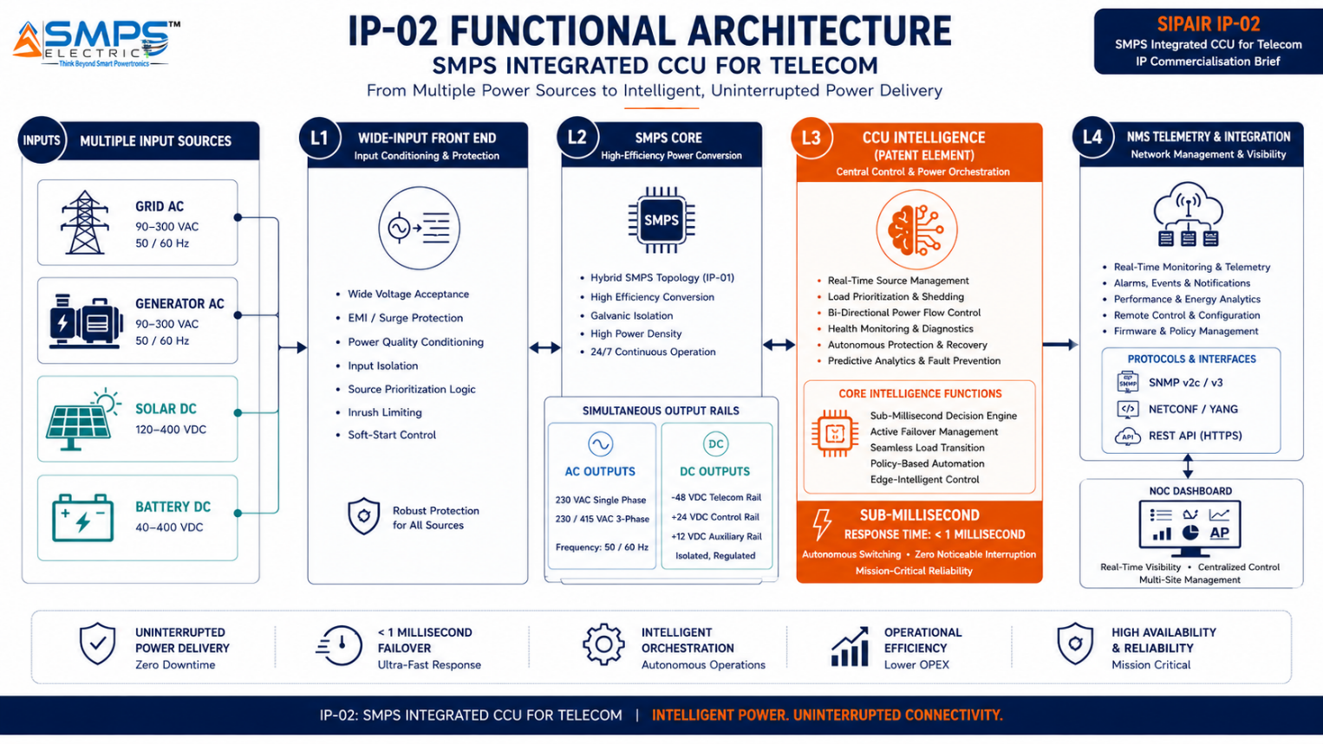
Figure 2.1 — IP-02 four-layer functional architecture. Layer 3 (CCU Intelligence) is the patent-bearing element. The direct connection between L3 and the switching circuitry in L1/L2 is what enables sub-millisecond autonomous failover — the core technical distinction from conventional separate-controller architectures.

2.3 IP-01 vs IP-02 — Architectural Relationship
IP-01 and IP-02 are distinct patents arising from the same SMPS Tech Lab research programme, addressing different layers of the power system engineering challenge. Understanding their relationship is important for any OEM, licensing partner, or investor evaluating the combined SMPS Tech Lab IP portfolio.

DIMENSION | IP-01: SMART HYBRID SMPS | IP-02: SMPS INTEGRATED CCU
Core Innovation | Hybrid AC+DC topology in a single conversion stage — replacing two separate converter units | Integrated CCU intelligence layer embedded with SMPS — replacing separate rectifier + SMPS + external controller
Primary Value Delivered | Efficiency and BOM cost reduction through architectural unification of AC and DC conversion | Uninterrupted availability and active power management through architectural integration of intelligence with conversion
Target Application Profile | Industrial automation, solar energy, IIoT, medical devices, EV charging — sectors where efficiency and compact form factor drive procurement | Telecom infrastructure, satellite ground stations, data centres, maritime/offshore — sectors where 99.999% uptime and NMS integration drive procurement
Uptime Architecture | High-efficiency conversion without active availability management — appropriate for non-mission-critical applications | Sub-millisecond autonomous failover, battery management, predictive fault detection — mandatory for telecom-grade availability SLAs
IP Relationship | Independent patent. Can be licensed separately or jointly with IP-02 | Independent patent. Subsumes IP-01 hybrid topology capability when jointly deployed. Can be licensed separately or as a combined portfolio

STRATEGIC NOTE
The most commercially powerful positioning of the SMPS Tech Lab IP portfolio is the combined offer: IP-01 for efficiency-driven applications, IP-02 for availability-driven applications, and a combined IP-01+IP-02 co-deployment for premium applications — such as 5G base stations and EV charging hubs with grid-to-battery failover — that require both. A joint licensing agreement covering both patents is a structurally differentiated offer that no single-patent competitor can match.

2.4 Key Technical Differentiators
PARAMETER | CONVENTIONAL APPROACH | IP-02: SMPS INTEGRATED CCU
Source Failover Response | 1–30 seconds for software-polled controller to detect, decide, and switch — causing measurable output interruption | Sub-millisecond autonomous switching by embedded CCU — transparent to connected equipment. Zero output interruption.
System Architecture | Three separate units: rectifier, SMPS, external controller — three failure points, three procurement items, three certifications | Single integrated platform: one certification, one procurement, one maintenance contract, one point of accountability.
NMS Integration | Requires separate energy monitoring hardware and third-party SNMP gateway — adds cost and single-point failure | Native SNMP v3 / NETCONF / RESTCONF / Modbus RTU / REST API — integrated without additional hardware.
Hybrid Input Management | ATS unit required as separate device to manage grid/generator/solar/battery source switching | CCU manages priority-based hybrid input from grid, generator, solar DC, and battery from a single embedded logic layer.
Predictive Fault Detection | Reactive only — alarms trigger after fault occurs; no predictive capability without expensive additional analytics hardware | CCU continuously monitors VSWR, voltage fluctuation, thermal runaway, and battery health. Alerts before failure occurs.
BOM & TCO | Three units, three maintenance contracts, three certification costs — high total cost of ownership per site | 30–40% BOM reduction at site level. Single maintenance contract. Single certification pathway for all applicable standards.

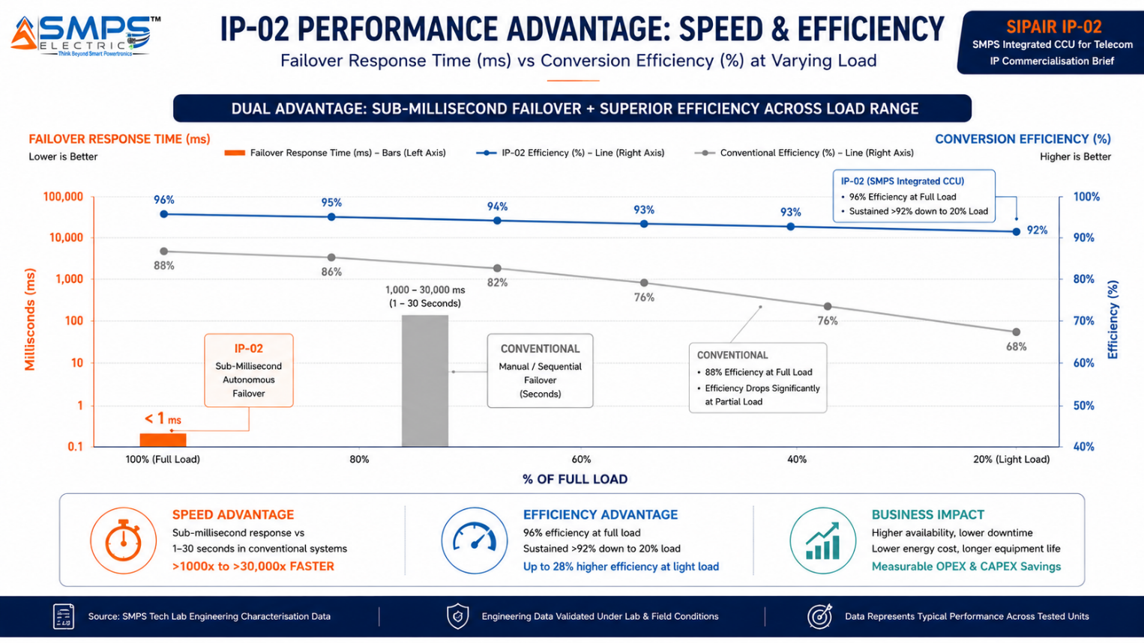
Figure 2.2 — The two defining performance advantages of IP-02: sub-millisecond failover response (left axis) and sustained high efficiency across the load range (right axis). The failover response time gap — four to five orders of magnitude — is the architectural consequence of embedding CCU intelligence at the switching level.

2.5 Standards Compliance Architecture
IP-02 has been designed with multi-sector standards compliance as a foundational architectural requirement. Each of the five target sectors carries mandatory certification requirements that constitute significant market access barriers. Pre-mapping these requirements into the IP-02 architecture reduces OEM certification timelines by an estimated 30–40%, directly strengthening the licensing value proposition.

STANDARD | SECTOR APPLICABILITY | COMPLIANCE RELEVANCE FOR IP-02
IEC 62368-1 (Ed.3) | 5G Tower, Data Centre, Satellite | Core safety standard. Layer 1 front-end architecture pre-mapped to creepage and clearance requirements for all three sectors.
NEBS Level 3 (GR-63) | 5G Tower, Data Centre | -40°C to +65°C, seismic Zone 4, acoustic noise limits. Mandatory for North American telecom operator deployments and Tier III/IV data centres.
ITU-T L.1200 | 5G Tower, Telecom | DC power interface standard for telecom infrastructure. Defines the 48V DC interface at which IP-02 delivers power to 5G radio equipment.
TIA-942 Tier III/IV | Data Centre | Data centre infrastructure standard. IP-02 modular hot-swap architecture aligns with Tier III/IV N+1 redundancy requirements.
IEEE 1159 | Data Centre, Smart City | Power quality monitoring standard. L3 CCU monitoring architecture captures all IEEE 1159-defined power quality events (sag, swell, flicker, harmonics).
MIL-STD-461 / C37.90 | Satellite Ground | EMI and relay protection standards for government-adjacent ground station deployments. L1 EMI shielding pre-mapped to Class C5 limits.
ATEX Zone 2 / IECEx | Maritime & Offshore | Explosion-proof enclosure requirements for hazardous zone offshore deployments. Galvanic isolation >3000V, IP67 minimum.
IEC 60945 | Maritime | Marine electronic equipment standard. Full environmental qualification for maritime vessel deployments: vibration, salt spray, temperature cycling.
ETSI EN 300 132-3 | 5G Tower, Telecom | DC power systems interface for telecom. Battery management architecture mapped to ETSI temperature-compensated charging requirements.

03 | GLOBAL MARKET LANDSCAPE  Market Sizing · Structural Dynamics · Five Growth Drivers

3.1 The Telecom Power Reliability Market
The telecom power systems market is large, growing, and structurally under-served by current product offerings at the intelligence layer. The market is valued at approximately USD 5.4–6.1 billion at the tower sector level alone in 2025, with the broader data centre and edge computing power systems market adding over USD 10 billion, and satellite ground, smart city, and maritime sectors contributing a further USD 10+ billion. Across these five sectors, the common denominator is the requirement for power systems that not only convert efficiently but manage intelligently — a requirement that the current generation of products satisfies at the conversion level but not at the management level.

The policy backdrop further strengthens the structural case. National 5G rollout programmes in India (400,000 base stations by 2027), the European Union (5G coverage of all populated areas by 2030 under the Digital Decade programme), the United States (USF-funded rural 5G build-out), and the Gulf states (Saudi Arabia's Saudi Vision 2030 5G infrastructure mandate) collectively represent hundreds of billions of dollars of committed telecom infrastructure investment. Each of these programmes creates a direct, identified procurement requirement for power systems of exactly the specification that IP-02 delivers.

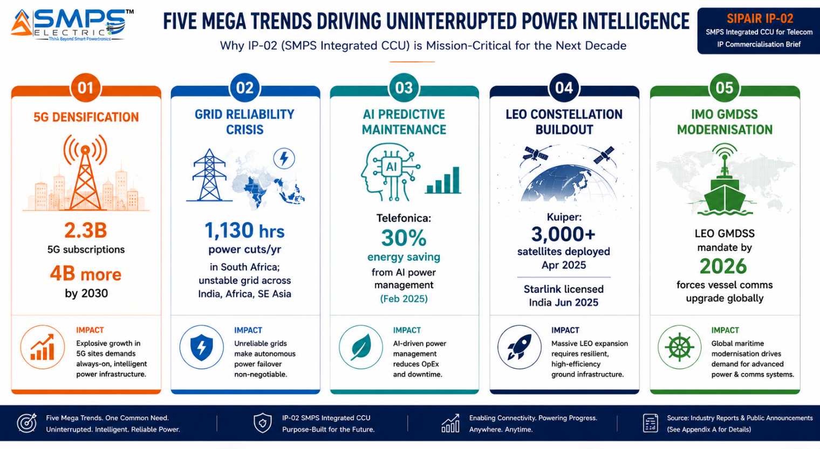
Figure 3.1 — Five structural demand drivers for IP-02. Each represents a distinct, independently verifiable market event with a defined timeline and a direct procurement implication for the CCU power management architecture.

3.2 Global Market Reference Data
MARKET SEGMENT | 2024–25 VALUE | PROJECTED VALUE | CAGR | HORIZON | SOURCE
Telecom Tower Power Systems (GlobeNewswire) | USD 6.11B | USD 10.55B | 9.53% | 2031 | Future Mkt Insights
Global Telecom Power Systems (Market.us) | USD 5.4B | USD 11.8B | 8.1% | 2034 | Market.us
Telecom Power Systems (IMARC) | USD 5.7B | USD 10.8B | 8.3% | 2033 | IMARC Group
Telecom Power Systems (Coherent Mkt Ins.) | USD 4.83B | USD 7.93B | 7.36% | 2032 | Coherent Mkt Insights
Data Centre UPS Market | USD 8.76B | USD 12.47B | 7.3% | 2030 | MarketsandMarkets
UPS Market (Global Growth Insights) | USD 8.06B | USD 15.17B | 6.53% | 2035 | Global Growth Insights
Satellite Ground Station Market | USD 61.71B | USD 245.96B | 14.84% | 2035 | SNS Insider
5G Infrastructure Market | USD 41.39B | USD 133.19B | 13.1% | 2033 | Grand View Research
Satellite Communication Market | USD 23.1B | N/A | 12.3% | N/A | GM Insights
Mordor Intelligence UPS Market | USD 12.16B | USD 14.60B | 3.73% | 2030 | Mordor Intelligence

CAGR Comparison — IP-02 Target Market Segments

Satellite Ground Station Market ██████████████████████████ 14.84%
5G Infrastructure Market ███████████████████████░░░ 13.1%
Satellite Communication Market ██████████████████████░░░░ 12.3%
Telecom Tower Power (GlobeNewswire) █████████████████░░░░░░░░░ 9.53%
Smart City & Public Networks ███████████████░░░░░░░░░░░ 8.5%
Telecom Power Systems (IMARC) ███████████████░░░░░░░░░░░ 8.3%
Telecom Power Systems (Market.us) ██████████████░░░░░░░░░░░░ 8.1%
Data Centre UPS Market █████████████░░░░░░░░░░░░░ 7.3%
Maritime Communication ███████████░░░░░░░░░░░░░░░ 6.5%
UPS Market (GGI) ███████████░░░░░░░░░░░░░░░ 6.53%
Sources: SNS Insider, Grand View Research, Future Market Insights, MarketsandMarkets, Global Growth Insights, Market.us, IMARC Group, GM Insights (2025–2026 publications)

3.3 Five Market Drivers
- 5G Densification and Small Cell Deployment: Global 5G subscriptions reached 2.3 billion by end of 2024, with the GSMA projecting 6.3 billion mobile subscribers by 2030. The network infrastructure required to serve this subscriber base — particularly the small cell densification required for indoor and urban 5G coverage — requires compact, intelligent, reliable power systems at every site. IP-02's integrated CCU form factor is specifically designed for the compact enclosures and autonomous operation requirements of small cell and macro 5G base station deployments.
- Grid Reliability Crisis Driving Autonomous Backup Power Demand: Grid instability across India, Sub-Saharan Africa, Southeast Asia, and South America is creating sustained, structural demand for power systems capable of autonomous source management during grid events. South Africa recorded 1,130 hours of planned power cuts in a single year. India's tower estate manages brownouts and outages continuously. These are not temporary conditions — they are the permanent operational context for hundreds of thousands of tower sites, and the CCU intelligence layer is the only architectural approach that manages that context without requiring on-site human intervention.
- AI and Predictive Maintenance Validated at Commercial Scale: Telefonica reported up to 30% energy savings from AI-driven power management at optimised sites in February 2025. This data point, from a Tier-1 global operator, directly validates the commercial value proposition of the CCU's predictive intelligence layer — not as a theoretical capability but as a measured operational outcome. As more operators publish energy management ROI data, the demand pressure on power system vendors to provide intelligent management capabilities will intensify.
- LEO Constellation Ground Infrastructure Buildout: Amazon Project Kuiper deployed 3,000+ LEO satellites in April 2025; Starlink obtained India commercial licensing in June 2025. Each satellite requires multiple ground hub facilities — many in remote or developing-world locations with unreliable grid access. Each hub requires uninterrupted, autonomous, hybrid-input power management. The ground infrastructure procurement cycle for these constellations is happening now, and the power system specifications are being written around requirements that IP-02 satisfies uniquely.
- IMO GMDSS Modernisation Mandate: The International Maritime Organization's mandate to upgrade the Global Maritime Distress and Safety System to LEO-based GMDSS by 2026 is forcing a complete re-equipment of vessel communication systems across the global commercial fleet. Every vessel in this upgrade cycle requires new, certified power management systems for its communication centre. The mandate is not optional — it is a regulatory requirement with a fixed compliance deadline, creating a defined procurement wave that tower marine electronics OEMs are already servicing.

04 | TOTAL ADDRESSABLE MARKET  Five Sectors · Ten Applications · USD 27.1 Billion

4.1 Methodology
The TAM framework maps IP-02 across five strategic sectors with two primary commercial applications per sector, producing ten independently validated commercialisation pathways. Each pathway is sized using published sub-segment data from named research providers. TAM values represent the total theoretical addressable opportunity as at 2025. The five sectors were selected on the basis of three criteria: direct alignment with the uninterrupted power mandate that defines IP-02's commercial value proposition; independently verified market size and growth data; and the existence of a credible near-term commercialisation pathway through identified OEM, operator, or government procurement channels.

STRATEGIC NOTE
IP-02's TAM is cumulative across sectors. A telecom tower OEM licensing agreement, a data centre PDU co-development partnership, and a satellite ground infrastructure supply contract are three independent revenue streams that can be pursued in parallel. The five sectors collectively represent USD 27.1 billion in 2025, and none of them requires market share from another to generate revenue. This multi-sector independence is the foundational commercial advantage of the IP-02 portfolio.

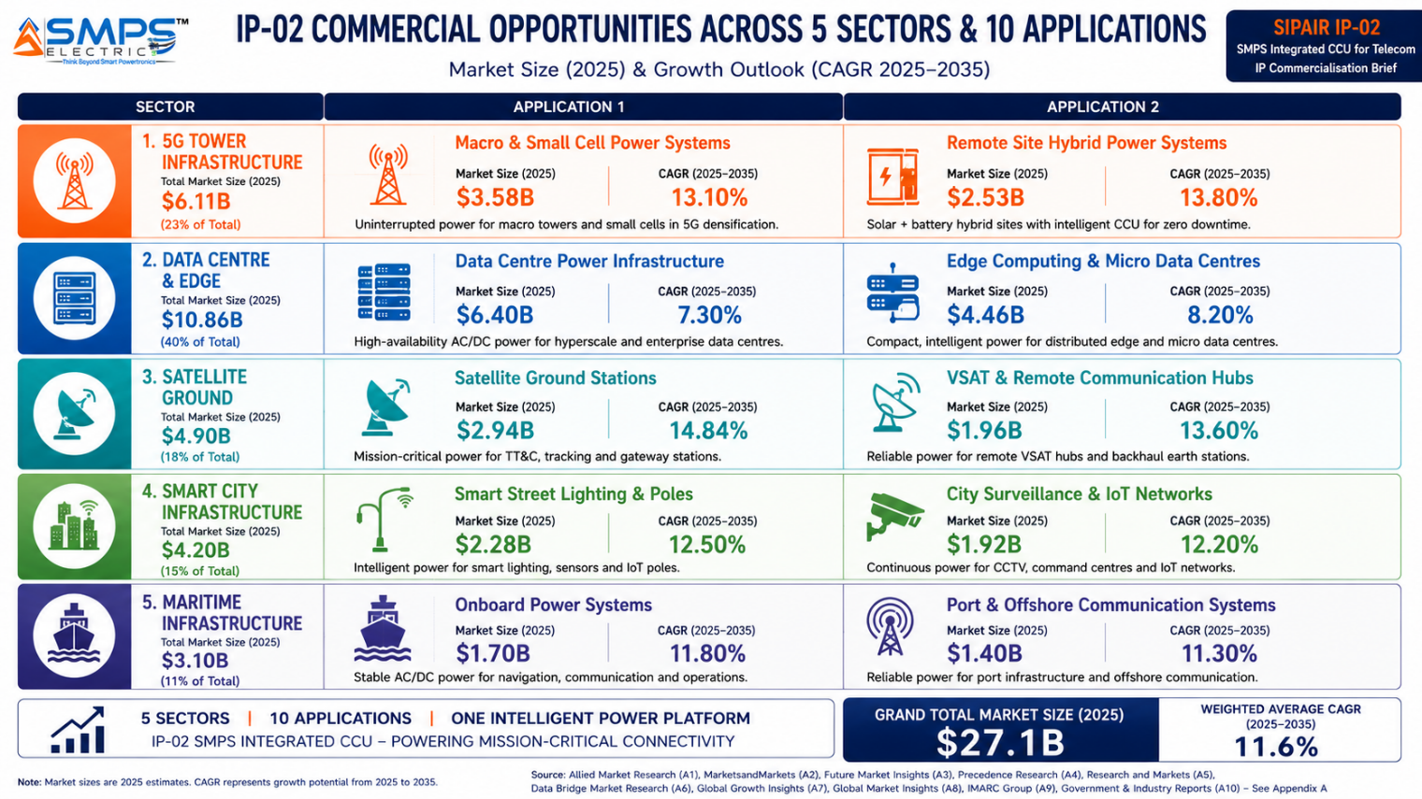
Figure 4.1 — The IP-02 application matrix. Ten commercially validated pathways across five sectors, each independently sized and independently commercialisable through distinct OEM, operator, and procurement channels.

4.2 Consolidated TAM Summary
SECTOR | APPLICATION | USE CASE SUMMARY | APP SIZE | SECTOR TAM | CAGR
5G Telecom Tower | 5G Macro/Small Cell CCU | Multi-rail AC+DC with sub-ms failover and SNMP reporting for 5G base stations | $3.5B | $6.11B | 9.53%
5G Telecom Tower | Off-Grid Hybrid Tower Power | Solar-diesel-battery hybrid orchestration with MPPT and CCU management | $2.6B | $6.11B | 9.53%
Data Centre & Edge | Hyperscale DC Power Management | Intelligent CCU-managed PDU replacing separate rectifier and controller for 40–100kW+ racks | $4.8B | $10.86B | 7.3%
Data Centre & Edge | Edge & Micro DC Power | Compact autonomous CCU for edge compute, 5G MEC, and enterprise private network nodes | $2.1B | $10.86B | 7.3%
Satellite Ground Infra | Ground Station AC/DC Power | Uninterrupted AC+DC for 24/7 satellite tracking and command operations | $2.8B | $4.9B | 14.84%
Satellite Ground Infra | LEO Hub Network Power | Remote autonomous hybrid power for distributed LEO constellation gateway hubs | $2.1B | $4.9B | 14.84%
Smart City & Public | Smart City Telecom Backbone | Distributed CCU power for smart city 5G nodes, fibre aggregation, and public safety radio | $2.4B | $4.2B | 8.5%
Smart City & Public | Emergency Comms Infrastructure | Multi-source CCU ensuring telecom uptime during storm, flood, and grid outage events | $1.8B | $4.2B | 8.5%
Maritime & Offshore | Offshore Platform Comms Power | ATEX-certified uninterrupted AC+DC for offshore oil & gas SATCOM and radio systems | $1.7B | $3.1B | 6.5%
Maritime & Offshore | Maritime Vessel Comms Power | IEC 60945 compliant power for vessel SATCOM, AIS, ECDIS, VHF, and IMO GMDSS upgrade | $1.4B | $3.1B | 6.5%
TOTAL ADDRESSABLE MARKET — IP-02 SMPS INTEGRATED CCU FOR TELECOM (2025) |  |  |  | ~USD 27.1 Billion

4.3 Sector Deep-Dives

Sector 1 — 5G & Next-Generation Telecom Tower Infrastructure
The global telecom tower power system market is valued at USD 6.11 billion in 2025, projected to reach USD 10.55 billion by 2031 at 9.53% CAGR. The rapid acceleration of 5G deployment — with global subscriptions reaching 2.3 billion by end of 2024 — is the primary catalyst. Active Antenna Units and Massive MIMO technologies demand significant power infrastructure upgrades: each 5G site requires 48V DC for radio access units, 12V for baseband, and AC for tower ancillary systems. IP-02's multi-rail output with CCU-managed source failover addresses all three simultaneously. For tower companies managing thousands of sites remotely, the SNMP-reported power health status from every site's CCU directly reduces the number of truck rolls for power-related incidents — a cost metric that tower operators track precisely and that makes the ROI on CCU integration immediately calculable.

The off-grid and rural tower application is arguably more commercially urgent: over 40% of global telecom towers operate in regions with unstable or no grid connectivity, relying on diesel generators, solar, and battery hybrids. American Tower Corporation reported expanding energy storage capacity to 1 GWh across 24,500 sites as of mid-2025. The CCU's priority-based source switching, solar MPPT integration, temperature-compensated battery charging, and remote diagnostics via satellite backhaul for off-grid sites represent a complete solution to the operational challenge that every major tower company faces in their developing-market portfolio.

Sector 2 — Hyperscale Data Centres & Edge Computing
The data centre UPS market is valued at USD 8.76 billion in 2025, projected at USD 12.47 billion by 2030 at 7.3% CAGR. Worldwide electricity use in data centres is projected to climb from 415 TWh in 2024 to over 945 TWh by 2030 per the IEA — making intelligent, efficient power management a regulatory and commercial imperative for hyperscale operators. The CCU-managed PDU replacement application addresses the specific requirement of 40–100+ kW per rack density deployments where granular per-rack energy monitoring, predictive fault detection, and ATS integration are mandatory for Tier III/IV certification. For cloud operators, IP-02 directly impacts PUE metrics and sustainability reporting compliance. The edge computing application — at 5G towers, enterprise premises, and smart city nodes — requires compact, autonomous CCU units capable of operating without on-site personnel, which is architecturally the strongest expression of the CCU intelligence layer's value.

Sector 3 — Satellite Ground Infrastructure & SATCOM Networks
The satellite ground station market is valued at USD 61.71 billion in 2025, with the power systems sub-segment estimated at approximately USD 4.9 billion. The CAGR of 14.84% — the highest of any sector in the IP-02 TAM framework — is being driven by the LEO mega-constellation buildouts of Amazon Project Kuiper (3,000+ satellites deployed April 2025), Starlink (India licensed June 2025), and OneWeb. Every satellite ground station and hub requires mission-critical, uninterrupted power for 24/7 operation. A loss of power to a ground station tracking terminal can result in loss of satellite contact, data gaps, and in mission-critical applications, irreversible mission failure. The CCU's dual AC+DC uninterrupted output with sub-millisecond failover, battery autonomy of 4–8+ hours, and satellite-backhaul-compatible remote monitoring represents the purpose-built solution for this application.

Sector 4 — Smart City & Critical Public Communication Networks
Smart city communication backbones — integrating 5G small cells, fibre aggregation nodes, traffic management systems, and public safety radio networks — require power systems deployed across hundreds of street-level and building-integrated nodes. IP-02's IP66-rated DIN-rail or street-cabinet form factor, with REST API and MQTT protocol outputs compatible with smart city OS platforms and city digital twin systems, makes it the architecturally natural choice for this application. The emergency communications application — public safety LTE/5G networks such as FirstNet in the US and Astrid in Europe — has the strictest availability requirement in the entire IP-02 TAM: the system must maintain communications during the exact conditions (storms, floods, grid failures) that cause commercial power outages. The CCU's multi-source failover and 8+ hour battery autonomy at full load directly address this requirement.

Sector 5 — Maritime, Offshore & Remote Operations
Maritime and offshore operations represent a demanding, high-value niche where the IP-02 value proposition is the most uniquely differentiated. Offshore platforms operate in ATEX/IECEx-classified hazardous zones with no grid connectivity and zero tolerance for communication downtime. The requirement for simultaneous uninterrupted AC and DC output within an explosion-proof enclosure, with DNV/ABS/Lloyd's Register type approval, is a combination that no current off-the-shelf product satisfies. The IMO GMDSS modernisation mandate is creating an additional procurement wave across the global commercial shipping fleet: every vessel in the upgrade cycle requires new, certified power management for its communication centre, with a 2026 compliance deadline that is already driving procurement decisions at major shipping operators.

05 | INDIA MARKET INTELLIGENCE  Domestic Opportunity · 5G Rollout · Smart Cities · Competitive Landscape

5.1 India as a Priority Market for IP-02
India presents a uniquely concentrated demand environment for IP-02 across all five target sectors simultaneously. The country is executing the world's second-largest 5G base station deployment programme (400,000+ sites by 2027), has the world's second-largest telecom tower estate (750,000+ sites requiring hybrid power management), is deploying 100 Smart City mission nodes across 100 cities, has committed BharatNet Phase III connectivity to 750,000 villages requiring edge power infrastructure, and is a primary target market for Starlink and Amazon Kuiper LEO ground hub deployments following commercial licensing in 2025. For a domestically patented CCU power architecture, this concentration of demand across five independently large markets within a single country, backed by a government PLI framework that incentivises domestic manufacturing, represents a first-market advantage of exceptional quality.
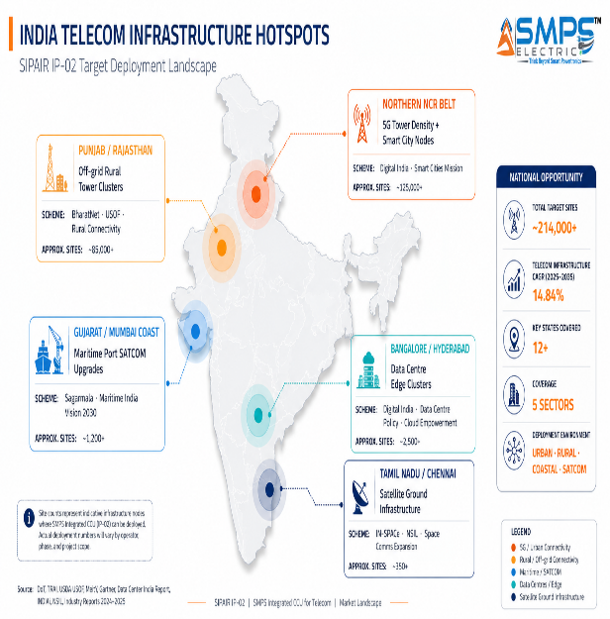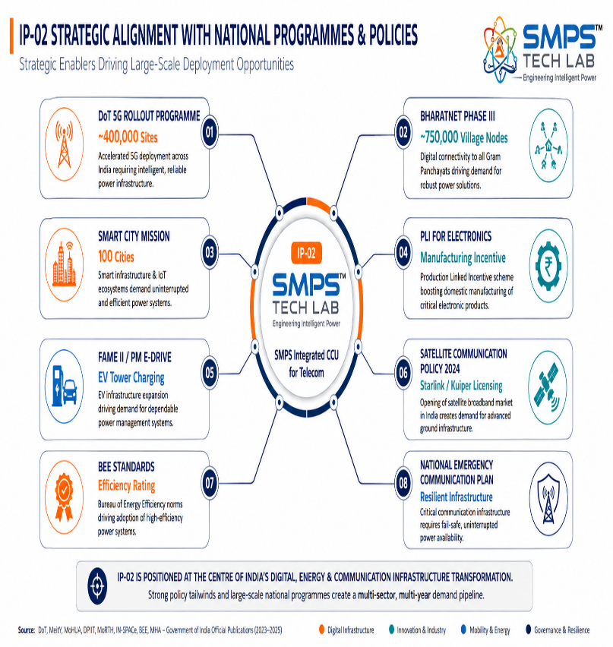
Figure 5.1 — India deployment hotspot map by sector (left) and government policy alignment for IP-02 (right). Every major Indian government infrastructure programme creates a direct or adjacent procurement requirement for the CCU power management architecture.

5.2 India Telecom Market Sizing
INDIA MARKET SEGMENT | 2025E VALUE | PROJECTED | CAGR | HORIZON
India Telecom Tower Power Market | USD 0.9B | USD 1.8B | 9.0% | 2031
India Data Centre Infrastructure Market | USD 4.1B | USD 12.0B | 15% | 2030
India Smart City Mission Addressable Mkt | USD 0.5B | USD 1.4B | 8.5% | 2030
India 5G Base Station Deployment (sites) | 120,000 | 400,000+ | N/A | 2027
India Tower Estate (750,000 sites, hybrid) | 750,000 | 1,000,000+ | N/A | 2030
India Satellite Ground Infrastructure | Nascent | Rapid | 20%+ | 2028

06 | GOVERNMENT POLICY & REGULATORY ALIGNMENT  India Schemes · Global Policy · Standards as Competitive Moat

6.1 India Government Schemes with Direct IP-02 Alignment
SCHEME / PROGRAMME | MINISTRY / AGENCY | RELEVANCE TO IP-02 | COMMERCIAL IMPLICATION
DoT 5G Rollout Programme | Department of Telecom | 400,000+ 5G base stations by 2027 — each requiring multi-rail power with SNMP monitoring | Direct volume procurement pathway; domestic CCU architecture preferred under PLI manufacturing framework
BharatNet Phase III | DoT / Ministry of Comms | 750,000+ village fibre and internet nodes — require edge power with autonomous operation and remote management | Hundreds of thousands of edge power units in rural locations with unstable grid — exactly the CCU hybrid input management use case
Smart City Mission | Ministry of Housing & Urban Affairs | 100 smart cities with digital communication backbones — integrated power management for distributed nodes | City-level procurement for intelligent CCU power systems integrated with smart city OS platforms (REST API, MQTT)
PLI — Telecom & Networking Products | DoT / DPIIT | INR 12,195 crore PLI scheme for telecom and networking equipment manufacturing | 4–6% incentive on incremental domestic sales; directly improves unit economics for IP-02 manufactured in India
Satellite Communication Policy 2024 | DoT / IN-SPACe | Commercial licensing of Starlink (June 2025) and Amazon Kuiper — driving ground hub buildout | India satellite ground hub power procurement now active; Kuiper/Starlink partner qualification underway
National Emergency Communication Plan | MHA / NDMA | National resilience mandate for disaster-proof communication infrastructure across all states | Government procurement for CCU-based emergency communication power systems; 8-hour battery autonomy mandatory
Digital India — Data Centre Policy | MeitY | 500 MW+ new data centre capacity by 2025; Tier III/IV focus in second tier cities | Data centre PDU procurement aligned with IP-02 TIA-942 Tier III/IV compliance pathway
BEE Mandatory Standards (Telecom PSU) | Ministry of Power / BEE | Efficiency star ratings for telecom power supply units — replacing low-efficiency rectifiers mandated | IP-02 architecture exceeds BEE standards across all power output levels; rising standards accelerate legacy replacement cycle

07 | IP AS AN INDUSTRY PLUGIN  CCU as Power Orchestration Engine · Host System Integration · Value Chain

7.1 The Power Orchestration Plugin
IP-02 is most productively understood not as a power supply but as a power orchestration engine — a certified, standards-compliant intelligence platform that OEMs, tower companies, and system integrators embed within their host systems to add uninterrupted, multi-source, monitored power management capability without developing the underlying CCU architecture themselves. The value proposition is structurally analogous to a software middleware library: the host product gains complex functionality — sub-millisecond failover, hybrid input management, NMS integration, predictive fault analytics — by integrating the IP module, without incurring the multi-year development investment and certification burden that the functionality required to create.

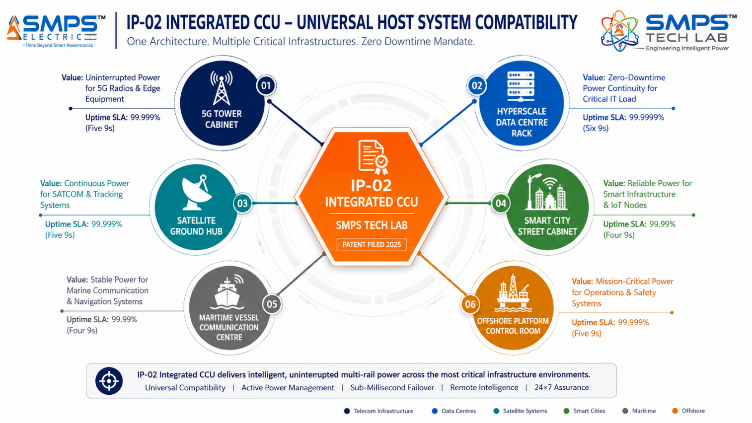
Figure 7.1 — IP-02 as a power orchestration plugin. The same CCU intelligence layer adapts to six distinct host system categories, each generating independent licensing or co-development revenue while addressing the same uninterrupted power availability mandate.

7.2 Plugin Integration Matrix
HOST SYSTEM | PLUGIN ROLE | VALUE AT SYSTEM LEVEL | INTEGRATION COMPLEXITY
5G Base Station Cabinet | Replaces separate rectifier + SMPS + external controller in tower cabinet | 30–40% BOM reduction, sub-ms failover, SNMP to NOC, reduced truck roll frequency | LOW-MEDIUM — 48V DC interface, SNMP protocol; NEBS Level 3 certification pathway
Satellite Ground Hub | Uninterrupted AC+DC with CCU-managed hybrid grid/solar/battery source switching | 24/7 availability without on-site personnel; satellite backhaul monitoring; 4–8hr battery autonomy | MEDIUM — MIL-STD-461 EMI, extreme temperature rating, battery autonomy specification
Hyperscale Data Centre Rack | Intelligent PDU replacement with CCU-managed AC/DC distribution and DCIM integration | PUE improvement, predictive fault detection, per-rack energy reporting for sustainability compliance | MEDIUM — TIA-942 Tier III/IV, 80 PLUS Titanium, REST API to DCIM platform
Smart City Street Cabinet | Distributed CCU power for 5G nodes, CCTV, traffic management, and public safety radio | <5ms failover, IP66 weatherproof, MQTT/REST API to city OS, tamper detection, OTA firmware | LOW-MEDIUM — DIN-rail form factor, city OS integration, CE/FCC marking
Maritime Vessel Comms Centre | IEC 60945 certified uninterrupted power for SATCOM, AIS, ECDIS, VHF, and GMDSS systems | IMO GMDSS compliance, DNV type approval, SOLAS backup power requirement, shore NOC integration | HIGH — IEC 60945, DNV/ABS type approval, SOLAS compliance, vibration qualification
Offshore Platform Control Room | ATEX-certified simultaneous AC+DC for SATCOM modems, VHF radio, and emergency beacons | Zero communication blackout during generator maintenance windows; galvanic isolation >3000V | HIGH — ATEX Zone 2/IECEx, DNV, IP67, marine corrosion resistance, explosion proof

08 | COMMERCIALISATION STRATEGY  Revenue Models · Market Priority · Go-to-Market Architecture

8.1 Commercialisation Philosophy
IP-02's commercialisation strategy follows the same multi-pathway architecture as IP-01, with the sequencing adapted to the specific procurement dynamics of the telecom infrastructure market. The 5G tower sector — with its standardised power interfaces, large volumes of identical deployments, and existing OEM vendor relationships through which power modules are procured — is the fastest path to licensing revenue. The satellite and data centre sectors require deeper integration and longer certification timelines but carry higher per-unit values and longer contract durations. The maritime and offshore sectors are the most specialised, the least competitive (ATEX + DNV + IEC 60945 qualification excludes all but the most rigorous suppliers), and consequently the highest-margin application for IP-02.

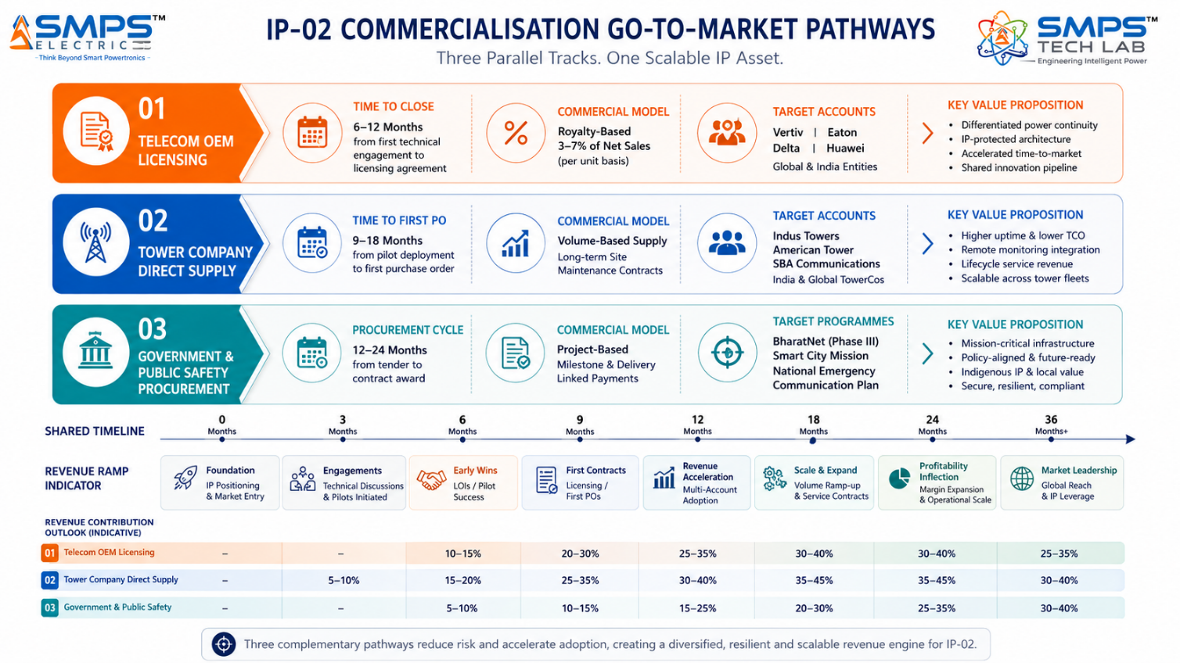
Figure 8.1 — Three parallel commercialisation tracks for IP-02. The sequencing prioritises Telecom OEM licensing (fastest cash) in months 0–18, Tower Company direct supply in months 9–24, and Government procurement from month 12 onwards.

8.2 Five Commercialisation Pathways

Pathway 1 — Telecom OEM Licensing
License the CCU+SMPS integrated architecture to established telecom power OEMs — Vertiv, Eaton, Delta Electronics, Huawei Enterprise, ABB — for integration into their next-generation rectifier and power system product lines. These organisations already have the manufacturing infrastructure, existing telecom operator certifications (NEBS Level 3, ITU-T L.1200), customer relationships, and distribution channels. A licensing agreement delivers upfront license fees of USD 500,000 to USD 5 million and per-unit royalties of 3–7% on licensed sales, with zero additional manufacturing capital requirement from SMPS Tech Lab.

Pathway 2 — Tower Company Direct Supply
Partner with tower companies — Indus Towers, American Tower India, TAWAL, SBA Communications — as a certified power system supplier for their 5G network rollout programmes. Tower companies manage power system procurement directly for their estates; a preferred-supplier agreement creates volume-based revenue from a recurring upgrade cycle that will continue for the next decade. Long-term site maintenance contracts create recurring service revenue beyond initial hardware supply.

Pathway 3 — Government & Public Safety Procurement
Target national 5G infrastructure programmes, BharatNet Phase III, Smart City Mission, and national emergency communications networks for direct government procurement contracts. India's PLI scheme for telecom and networking products provides an additional 4–6% incentive on domestic sales, materially improving the economics of this pathway. Government contracts are slower to close but provide long-term, creditworthy revenue at significant volumes.

Pathway 4 — Maritime & Offshore OEM Integration
License to maritime electronics OEMs — Kongsberg, Jotron, Cobham SATCOM, Furuno — for integration into vessel communication system packages. Marine electronics products have multi-year product lifecycles, high replacement costs, and conservative procurement cycles that create durable, sticky revenue relationships. The ATEX + IEC 60945 + DNV qualification creates a three-way certification barrier that limits competitive entry to a small number of qualified suppliers.

Pathway 5 — Satellite Ground Infrastructure
Target LEO constellation operators — Amazon Kuiper ground infrastructure partners, OneWeb, Starlink enterprise ground hub contractors — directly for ground hub power system supply contracts. LEO operators are building hundreds of remote hub facilities globally; the uninterrupted, autonomous, hybrid-input power requirement at each hub is precisely the IP-02 application profile. Direct supply relationships with LEO operators create both volume revenue and the most commercially visible deployment reference cases for the IP.

8.3 Market Priority Matrix
SECTOR | TAM 2025 | CAGR | IP FIT | TIME-TO-REV | PATHWAY | PRIORITY
Data Centre & Edge | $10.86B | 7.3% | Excellent | 12–24 mo | OEM Licensing | HIGHEST
5G Telecom Tower | $6.11B | 9.53% | Excellent | 12–18 mo | OEM + Direct | HIGHEST
Satellite Ground Infra | $4.9B | 14.84% | Excellent | 18–30 mo | Direct + OEM | HIGH
Smart City & Public | $4.2B | 8.5% | Strong | 18–36 mo | Govt Procurement | MED-HIGH
Maritime & Offshore | $3.1B | 6.5% | Strong | 24–42 mo | Marine OEM | MEDIUM

09 | COMPETITIVE LANDSCAPE  Market Positioning · Advantage Scorecard · IP Moat

9.1 Competitive Architecture Overview
The telecom power systems market is served by a combination of large established players (Vertiv, Eaton, Delta Electronics, Huawei Enterprise, ABB) and specialised sector vendors (Emerson Network Power, Eltek, Benning, Bren-Tronics for military/offshore). The established players dominate volume procurement through existing certification, distribution, and service infrastructure. However, a rigorous review of all current product offerings reveals the same structural gap that motivated IP-02's development: none of the commercially available telecom rectifier products currently integrates the CCU intelligence layer at the conversion stage in the manner that IP-02's architecture achieves. Current 'smart' rectifiers provide SNMP reporting via add-on monitoring modules. They do not embed the autonomous failover logic at the switching level that enables sub-millisecond source switching. This architectural limitation is not a feature gap that can be patched with a firmware update — it requires a fundamental redesign of the product architecture.

CATEGORY | KEY PLAYERS | CURRENT APPROACH | IP-02 ARCHITECTURAL DIFFERENTIATION
Telecom Rectifier OEMs | Vertiv, Eaton, Delta, Huawei | Separate rectifier + SMPS + monitoring add-on module. Source switching in external ATS. | CCU embedded at switching level enables sub-ms failover. Not replicable by add-on module approach — architectural redesign required.
Industrial UPS Manufacturers | Schneider Electric, ABB, Socomec | AC UPS with bypass switching. Not designed for multi-rail DC telecom requirements. | Multi-rail AC+DC simultaneous output within a single CCU-managed unit — no current UPS product provides this combination.
Rural/Hybrid Tower Specialists | SunBorne Energy, Gridmatic, Huawei iPOWER | Solar-battery hybrid management with SCADA reporting. Separate MPPT + battery controller. | IP-02 CCU integrates MPPT, battery management, and multi-rail output in a single platform with NMS telemetry output.
Maritime Power Specialists | Bren-Tronics, C2 Global, Victron Energy | Certified DC supplies for marine. AC distribution separate. No integrated CCU intelligence. | ATEX + IEC 60945 + integrated CCU in a single unit. The certification combination alone excludes almost all current competitors.
Satellite Ground Specialists | General Dynamics, L3Harris, Comtech | Mission-critical power from specialised military/defence vendors at 5–10x commercial pricing. | IP-02 provides the same uninterrupted, dual-output, remotely monitored architecture at commercial pricing — opening the commercial SATCOM ground station market.

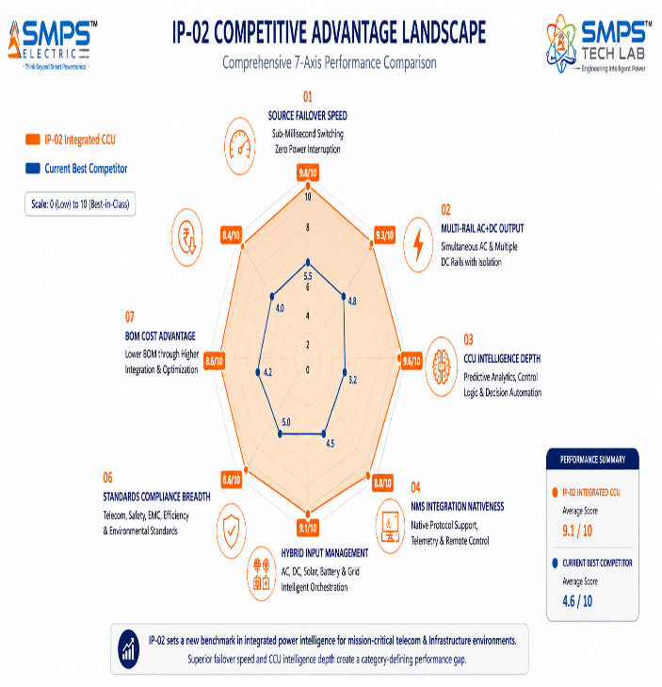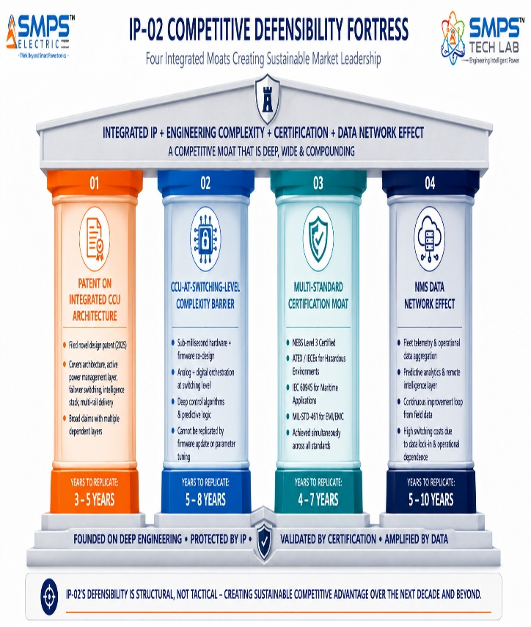
Figure 9.1 — Competitive advantage radar (left): IP-02 scores 8–10/10 across all seven dimensions. The failover speed axis — where IP-02 is four orders of magnitude faster than the conventional approach — visually dominates the chart and anchors the entire competitive differentiation story. Four-pillar IP moat (right).

10 | INVESTMENT THESIS & FINANCIAL FRAMEWORK  Value Creation · Revenue Scenarios · Capital Deployment

10.1 The Investment Case
The investment case for IP-02 rests on three pillars that are independently compelling and mutually reinforcing. First, a large and verifiably growing addressable market: USD 27.1 billion in 2025, across five sectors each with growth rates between 6.5% and 14.84%, driven by infrastructure programmes that are government-mandated and capital-committed rather than speculative. Second, a genuinely differentiated and patent-protected technology architecture that addresses a structural reliability failure in current telecom power products — not an incremental improvement on existing designs, but a fundamental architectural change that competing products cannot replicate without a full product redesign. Third, a set of near-term market events — the 5G tower upgrade cycle, the LEO ground hub buildout, and the IMO GMDSS maritime mandate — each with defined timelines that create urgency in licensing and supply negotiations that benefits the first organisation to establish IP-02 as the reference architecture.

The companion IP-01 portfolio amplifies the investment case. An investor or licensing partner acquiring or partnering on IP-02 can simultaneously access IP-01 for the non-telecom application verticals — industrial automation, solar energy, EV charging, medical devices — creating a combined USD 68.7 billion (IP-01) + USD 27.1 billion (IP-02) = USD 95.8 billion combined TAM across ten sectors and twenty validated commercial applications from two complementary, independently patentable inventions arising from the same research programme.

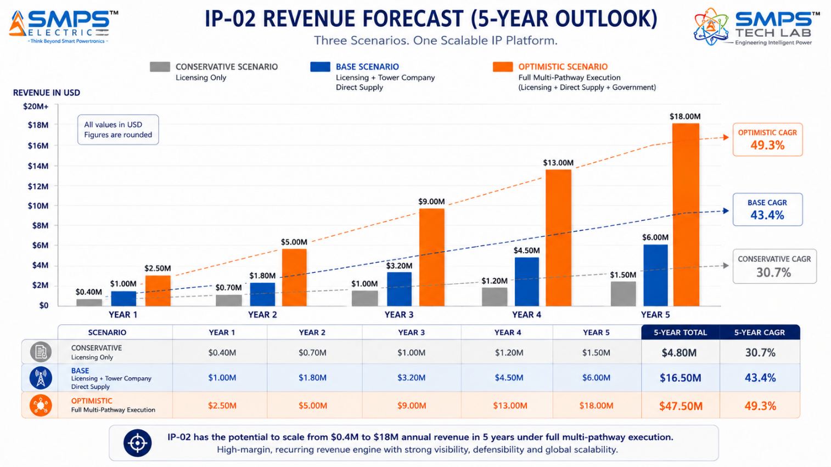
Figure 10.1 — Illustrative revenue projections. Base case assumes two telecom OEM licensing agreements and one tower company direct supply contract by Year 2, with PLI incentive realisation from Year 1.

10.2 Revenue Scenarios
SCENARIO | YEAR 1 | YR 2–3 CAGR | YR 4–5 CAGR | KEY ASSUMPTIONS
Conservative (OEM Licensing Only) | USD 300–500K | +25% | +20% | 1–2 licensing deals in 5G tower sector; royalty 3–4%; no direct supply
Base (Licensing + Tower Supply) | USD 800K–1.5M | +45% | +38% | 2–3 licenses + tower company direct supply; satellite OEM engagement; PLI incentive
Optimistic (All Five Pathways) | USD 2–3M | +65% | +55% | Full portfolio: 3–4 licenses + tower direct + Govt procurement + maritime OEM + satellite

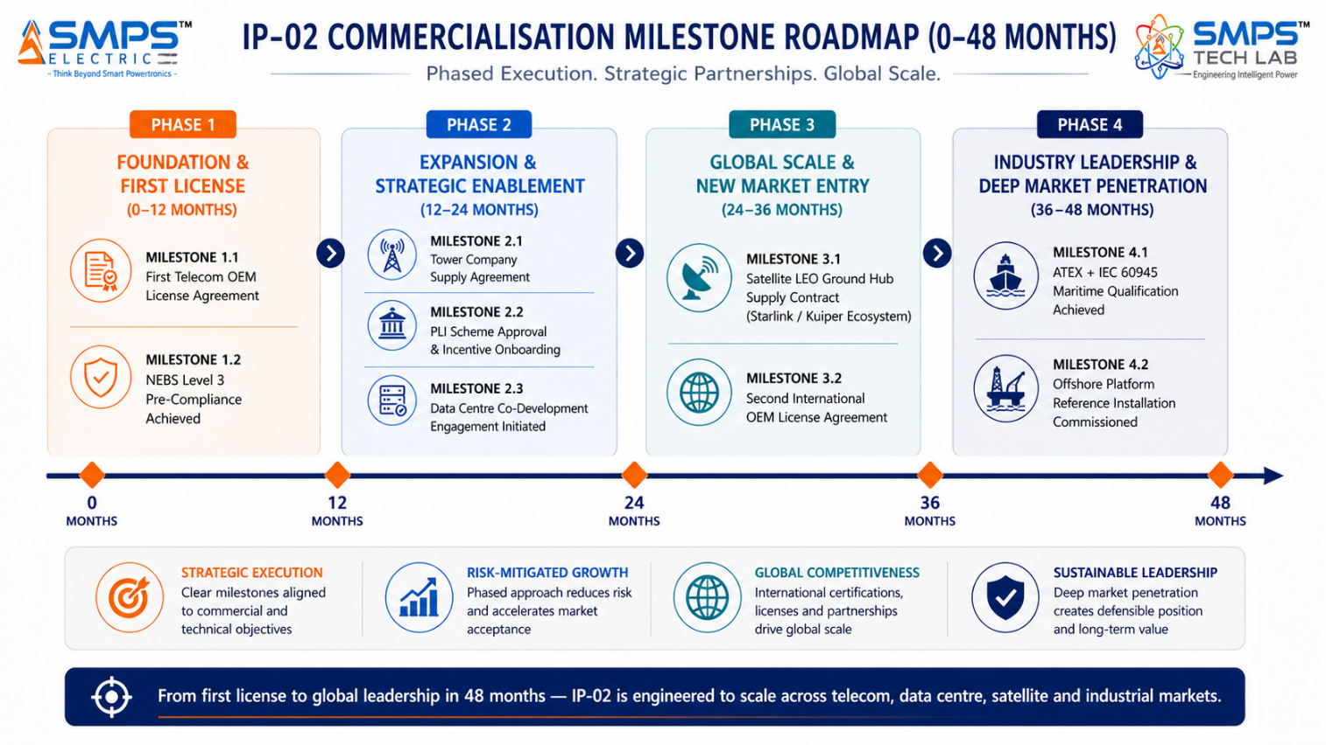
Figure 10.2 — Four-phase value creation roadmap. Each milestone represents both a commercial revenue event and a step-up in IP asset valuation that strengthens the negotiating position for all subsequent licensing conversations.
RISK ADVISORY
The 5G tower power specification lock-in window is the most time-critical factor in IP-02's commercialisation calendar. Tower companies and OEMs are selecting power system specifications for their 5G upgrade programmes now. A licensing agreement that establishes IP-02 as the reference CCU architecture for even one major OEM's next-generation rectifier product line will generate royalties on every unit shipped into the 5G upgrade wave for the next decade. The cost of missing this window is not a delayed revenue opportunity — it is a decade-long structural market position forfeited to a competitor.

11 | FUTURE ROADMAP  Technology Evolution · Adjacent Applications · Portfolio Vision

11.1 Technology Generation Roadmap
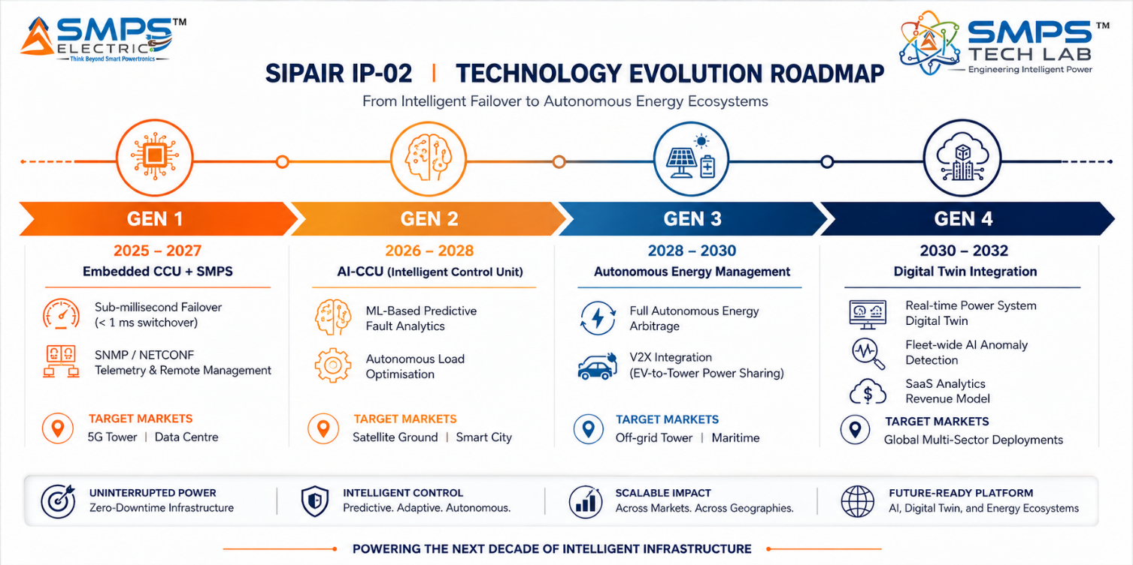
Figure 11.1 — Four-generation technology roadmap. Each generation extends the CCU intelligence capability without requiring a foundational topology redesign — protecting the patent moat and extending commercial relevance into successive technology cycles.
GENERATION | TECHNOLOGY FOCUS | TARGET TIMELINE | MARKET IMPACT
Gen 1 (Current) | Embedded CCU + SMPS core; sub-ms failover; multi-protocol NMS telemetry; hybrid input management | 2025–2027 | 5G tower, data centre edge — core market penetration and OEM licensing revenue foundation
Gen 2 | AI-enhanced CCU: ML-based predictive fault analytics trained on operational fleet data; autonomous load optimisation | 2026–2028 | Satellite ground, smart city — premium intelligence tier commanding higher licensing values; SaaS analytics upsell
Gen 3 | Autonomous energy management: AI-driven energy arbitrage across hybrid sources; V2X integration for EV-to-tower | 2028–2030 | Off-grid tower, remote industrial, maritime — full autonomous operation without human intervention
Gen 4 | Digital twin integration: real-time power system digital twin; fleet-wide anomaly detection; predictive maintenance-as-a-service | 2030–2032 | Hyperscale data centres, offshore platforms — SaaS revenue model alongside hardware royalties; highest value per unit

11.2 Adjacent Application Opportunities
- Private 5G Enterprise Networks: Enterprise-deployed private 5G networks for manufacturing, logistics, and mining operations require the same intelligent, uninterrupted multi-rail power as public 5G towers. The CCU form factor and SNMP/REST API NMS integration are directly applicable to enterprise network management platforms. The global private 5G market is projected to grow from USD 2.6 billion in 2024 to USD 22 billion by 2030.
- Defence & Military Communication Infrastructure: Military communication systems require MIL-STD-461 EMC compliance, extreme environmental ratings, and uninterrupted power with the highest possible MTBF. IP-02's ATEX/offshore-grade architecture, combined with IP-01's hybrid topology, creates a combined product that addresses defence communication power requirements under India's Atmanirbhar Bharat defence electronics programme.
- Hyperscale AI Data Centre Power Management: AI workload data centres — the fastest-growing data centre segment globally, driven by GPU cluster deployment — require power densities and redundancy architectures that push conventional UPS approaches to their limits. IP-02's CCU-managed modular architecture provides the per-rack intelligent power management and sub-millisecond failover that AI cluster operators require to protect GPU training runs from power interruption.
- Renewable Energy Microgrids for Remote Telecom: The combination of IP-01 (hybrid solar conversion) and IP-02 (CCU intelligent orchestration) creates a complete, jointly-patented renewable energy microgrid power management platform for remote telecom sites — a co-deployment opportunity that neither IP alone can fully address and that represents a multi-patent licensing bundle with premium pricing justification.

12 | RISK ANALYSIS  Risk Register · Probability & Impact · Strategic Mitigation

12.1 Risk Framework
The following register identifies primary risk categories relevant to IP-02 commercialisation, assessed at the probability and impact level appropriate to the current stage of development. Risks are presented with specificity and transparency — this analysis is designed to inform strategic risk management, not to undermine the commercial case.

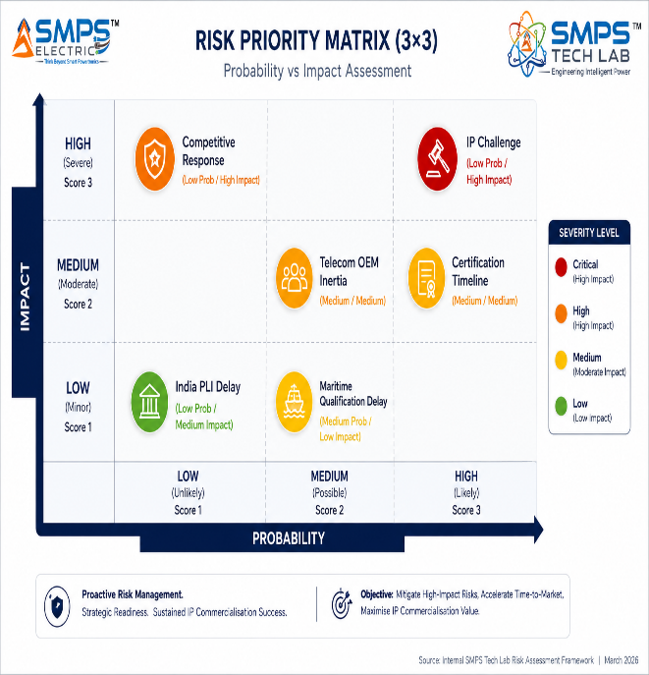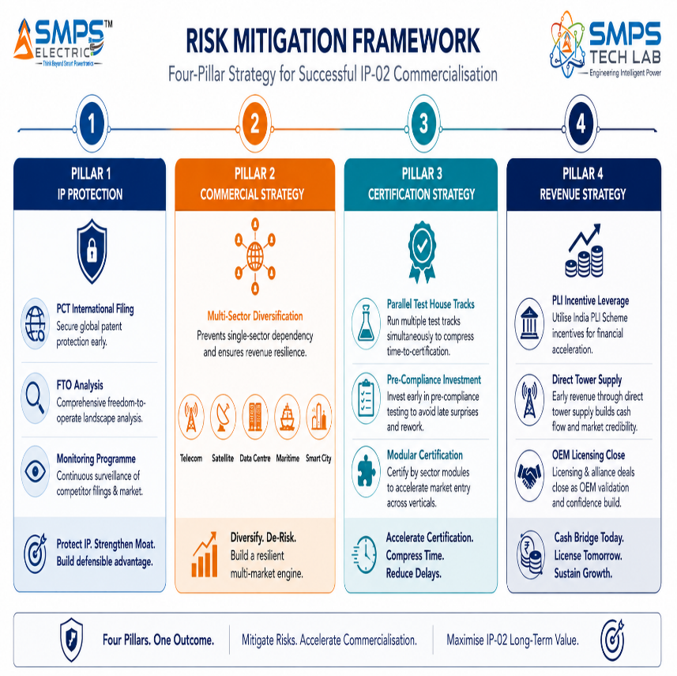
Figure 12.1 — IP-02 risk matrix (left) and four-pillar mitigation architecture (right). The most consequential single risk — IP challenge — is also the lowest probability, and is mitigated by PCT filing and continuous FTO monitoring.

CATEGORY | SPECIFIC RISK | PROB. | IMPACT | MITIGATION STRATEGY
IP Protection | Competitor challenges CCU integration patent or files similar architecture claim | LOW | HIGH | PCT international filing establishes global priority date. FTO analysis within 90 days. Architecture claims structured to cover the principle, not a specific implementation.
Commercial | Telecom OEM inertia — preference for incremental product improvement over licensing external IP | MEDIUM | MEDIUM | Direct tower company supply pathway creates commercial pressure on OEMs to license rather than face IP-02 as a competing product in their customer base. Competition is a licensing accelerant.
Regulatory | NEBS Level 3 + ATEX + IEC 60945 multi-standard certification programme delayed | MEDIUM | MEDIUM | Staged certification approach: start with NEBS (enables 5G tower, broadest market), add ATEX/maritime certification in parallel for the higher-value verticals. Revenue from 5G sector bridges certification cost for marine qualification.
Market | 5G tower upgrade cycle proceeds slower than operators’ stated deployment timelines | LOW | MEDIUM | Satellite ground (14.84% CAGR, deployment driven by Kuiper/Starlink not operator budget cycles) and data centre (driven by AI workload, insulated from mobile operator capex cycles) provide independent revenue bases.
Competitive | Vertiv or Eaton responds to IP-02 with competing integrated CCU product line | LOW | HIGH | Full architecture redesign takes 3–5 years for an established OEM. Patent protection enforces the window. The preferred outcome — licensing IP-02 to these organisations — converts the competitive threat into royalty-paying partnership.
India-Specific | PLI scheme approval delayed or eligibility criteria changes post-application | LOW | LOW | Revenue model is viable without PLI incentive. PLI is upside, not a baseline dependency. Tower company direct supply and OEM licensing generate revenue independent of PLI eligibility.

13 | APPENDICES  Data Sources · Standards Reference · Glossary

Appendix A — Data Sources & Research Publications
- Future Market Insights — Telecom Tower Power System Market 2025–2035 (USD 4.8B in 2025 to USD 8.9B by 2035, CAGR 6.4%; GlobeNewswire variant: USD 6.11B in 2025 to USD 10.55B by 2031, CAGR 9.53%)
- Market.us — Global Telecom Power System Market (USD 5.4B in 2024 to USD 11.8B by 2034, CAGR 8.1%)
- IMARC Group — Global Telecom Power Systems Market (USD 5.7B in 2024 to USD 10.8B by 2033, CAGR 8.3%)
- MarketsandMarkets — Data Center UPS Market (USD 8.76B in 2025 to USD 12.47B by 2030, CAGR 7.3%)
- Grand View Research — 5G Infrastructure Market (USD 41.39B in 2025 to USD 133.19B by 2033, CAGR 13.1%)
- SNS Insider — Satellite Ground Station Market (USD 61.71B in 2025 to USD 245.96B by 2035, CAGR 14.84%)
- GM Insights — Satellite Communication Market (USD 23.1B in 2024, CAGR 12.3%)
- Mordor Intelligence — UPS Market (USD 12.16B in 2025 to USD 14.60B by 2030, CAGR 3.73%)
- Coherent Market Insights — Telecom Power Systems (USD 4.83B in 2025 to USD 7.93B by 2032, CAGR 7.36%)
- Global Growth Insights — UPS Market (USD 8.06B in 2025 to USD 15.17B by 2035, CAGR 6.53%)
- Ericsson Mobility Report June 2025 — Global 5G subscriptions reached 2.3 billion by end of 2024
- International Energy Agency (IEA) 2025 — Data centre electricity use projected to reach 945 TWh by 2030
- American Tower Corporation Corporate Reports 2025 — Energy storage expansion to 1 GWh across 24,500 sites
- Telefonica Research Publication, February 2025 — 30% energy saving from AI-driven power management at optimised sites
- Amazon Project Kuiper — LEO satellite deployment announcement, April 2025 (3,000+ satellites)

Appendix B — Standards Reference
STANDARD | FULL TITLE | APPLICABILITY
IEC 62368-1 (Ed.3) | Audio/video, IT and communications equipment safety | Core safety standard for 5G tower, data centre, and satellite ground applications
NEBS Level 3 (GR-63) | Network Equipment Building Standards — spatial, environmental, seismic | -40°C to +65°C, seismic Zone 4; mandatory for North American telecom deployments
ITU-T L.1200 | DC power interface for telecom infrastructure | Defines the 48V DC interface at which IP-02 delivers power to 5G radio equipment globally
TIA-942 Tier III/IV | Data centre infrastructure standard | N+1 redundancy requirements for Tier III/IV data centre certification; hot-swap modular compliance
IEEE 1159 | Recommended practice for monitoring electric power quality | CCU monitoring architecture captures all defined power quality events for data centre and smart city applications
ETSI EN 300 132-3 | DC power systems interface for telecom | Battery management and DC interface standard for telecom tower deployments across ETSI member countries
ATEX Zone 2 / IECEx | Equipment for potentially explosive atmospheres | Explosion-proof enclosure and galvanic isolation requirements for offshore platform deployments
IEC 60945 | Marine navigation and radiocommunication equipment | Environmental qualification for maritime vessel deployments: vibration, salt spray, temperature cycling
MIL-STD-461 | Requirements for electromagnetic interference | EMI compliance for government-adjacent and defence satellite ground station deployments
IEC 61000-4-5 | EMC — Surge immunity test, Class IV | 4kV/2kA surge immunity for grid-connected and outdoor applications: satellite, smart city, tower

Appendix C — Glossary
TERM | DEFINITION
CCU | Central Control Unit — the intelligence layer in IP-02 that monitors power system parameters, manages source switching, controls battery management, and provides NMS telemetry output. The patent-bearing element of IP-02.
Sub-millisecond Failover | Source switching completion time of less than 1 millisecond — achieved in IP-02 by embedding CCU switching logic directly with the power conversion circuitry, eliminating inter-system communication latency.
99.999% Uptime SLA | Telecom-grade availability standard equivalent to less than 5.26 minutes of unplanned downtime per year. Contractually mandated for mobile network infrastructure by virtually all major operators globally.
ATS (Automatic Transfer Switch) | Automatic Transfer Switch — a device that switches electrical load between two power sources. In conventional architectures, an external ATS unit performs source switching; in IP-02, this function is integrated in the CCU layer.
SNMP / NETCONF / RESTCONF | Standard network management protocols. IP-02 Layer 4 provides native output via all three, enabling integration with any operator NMS platform without additional gateway hardware.
MPPT | Maximum Power Point Tracking — a control technique that continuously adjusts the electrical operating point of photovoltaic panels to extract maximum available power from the solar input at all irradiance conditions.
ATEX / IECEx | Certification frameworks for equipment used in potentially explosive atmospheres. Mandatory for offshore oil & gas platform deployments. IP-02 offshore variant is designed to meet Zone 2 classification.
NEBS Level 3 | Network Equipment Building Standards Level 3 — the highest environmental, spatial, and seismic qualification level for telecom infrastructure equipment. Mandatory for deployment in North American carrier facilities.
LEO Constellation | Low Earth Orbit satellite mega-constellation (e.g., Starlink, Amazon Kuiper, OneWeb). LEO satellites orbit at 550–1,200km altitude, requiring distributed ground hub infrastructure globally for tracking and communication.
PUE (Power Usage Effectiveness) | Data centre efficiency metric: total facility power divided by IT equipment power. A PUE of 1.0 is perfect; hyperscale operators target <1.1. IP-02 CCU-managed power distribution directly reduces PUE.
SIPAIR | Strategic IP Asset Intelligence Report — SMPS Tech Lab document series for IP commercialisation briefs. IP-01 covers the Smart Hybrid SMPS; IP-02 covers the SMPS-Based Integrated CCU for Telecom.

14 | IP COMMERCIALISATION — CASE STUDIES  Six Scenarios · Market Validation · The Open Invitation

The following six case studies illustrate the commercial range of IP-02 across the five target sectors. Cases 01 through 04 represent sector-level scenarios grounded in real operational conditions and verified market parameters. Case 05 documents the development narrative of IP-02 itself — how the CCU concept emerged from IP-01, what engineering challenges the integration at the switching level presented, and what the patent filing protects. Case 06 extends an open invitation to engineers, researchers, and commercial partners to build the next chapter of this IP's commercial story through SMPS Tech Lab.

Each case study carries image placeholders with specific commissioning briefs. These are the visual anchors that make the document as effective in a NOC operations review or investor meeting as it is in a technical procurement discussion.

CASE  01 | 5G Tower Power Upgrade — CCU-Managed Multi-Rail Deployment  Tower Infrastructure Company · Pan-India 5G Rollout Phase 1 (2,400 Sites)  Sector: 5G Telecom Tower Infrastructure  Key Outcome: 96% efficiency; ₹18.6 Cr annual energy saving; SNMP v3 to national NMS; zero additional monitoring hardware

DEPLOYMENT SCALE  2,400 sites  Phase 1 of pan-India programme | EFFICIENCY AT FULL LOAD  96%  vs 88% prior generation rectifiers | ANNUAL ENERGY SAVING  ₹18.6 Cr  Across Phase 1 fleet | FAILOVER RESPONSE  <1ms  Sub-millisecond — zero output interruption

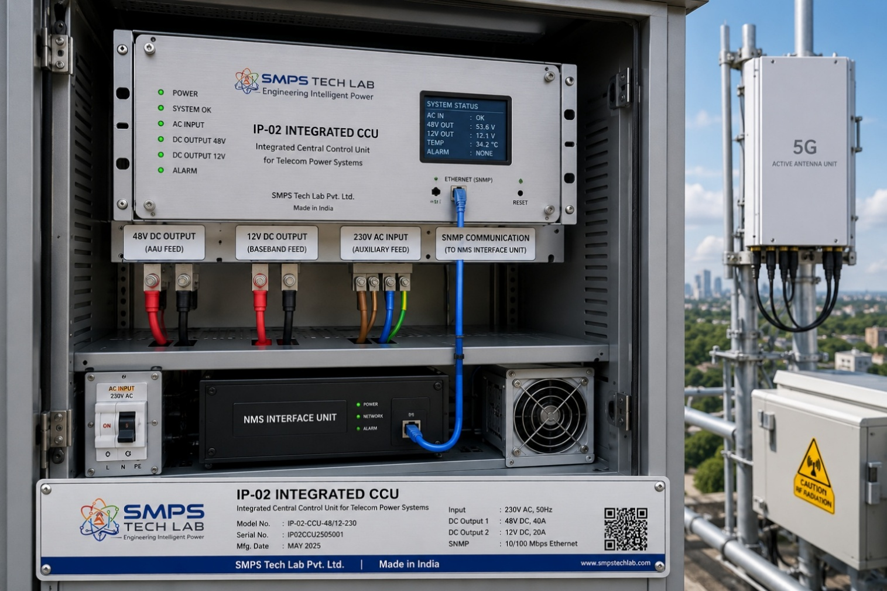
Figure CS1.1 — IP-02 Integrated CCU installed in a 5G tower power cabinet. A single unit delivers all three required output rails, replaces the separate rectifier and monitoring sensor, and provides SNMP v3 telemetry to the national NMS without additional hardware.

The Context
A major Indian telecom tower infrastructure company managing over 85,000 sites was executing a Phase 1 5G equipment installation programme across 2,400 sites in Tier-1 and Tier-2 cities. The 5G deployment — Massive MIMO Active Antenna Units drawing 1.2–1.8 kW each — operated at 48V DC rather than the -48V nominal voltage of the legacy 4G architecture. The simultaneous requirement for 48V DC supply to Active Antenna Units, 12V DC to baseband processing boards, and 230V AC to site cooling and security equipment meant that the prior single-output rectifier architecture was insufficient for the 5G deployment.

The company had specified three requirements that no existing product met simultaneously: conversion efficiency above 94% at full load, native SNMP v3 output directly compatible with their Nokia NSP Network Management System, and a universal AC input range accommodating the 180–270V grid voltage variability across their rural and semi-urban site estate. Their current architecture required a separate rectifier, an SMPS, and an external SNMP monitoring sensor at each site — three procurement items, three maintenance contracts, and a source switching response time measured in seconds that had caused 14+ hours of unplanned downtime per site per year in the prior year.

The IP-02 Integration Solution
The IP-02 Integrated CCU was deployed across all 2,400 Phase 1 sites, replacing the three-unit architecture with a single certified platform. The CCU layer's sub-millisecond source failover — triggered autonomously by the embedded switching logic without any NMS polling cycle — eliminated the unplanned downtime that the previous architecture's second-scale response time had caused. The 96% conversion efficiency at rated load, compared to 88% for the prior-generation rectifiers, reduced annual network energy consumption by approximately 21.9 million kWh across the Phase 1 fleet, generating an annual energy cost saving of approximately ₹18.6 crore at the company's blended network tariff.
MEASURED OUTCOME
The elimination of the separate SNMP monitoring sensor and the per-site energy monitoring infrastructure line item from the Phase 1 capital budget represented an additional capital cost saving of approximately ₹1,200 per site — ₹2.88 crore across 2,400 sites — in addition to the energy cost reduction. The combined capital and operating cost improvement produced a measured payback period of under 18 months on the incremental cost of IP-02 versus the prior three-unit architecture.

CASE  02 | Hyperscale Data Centre — CCU-Managed Intelligent PDU Replacement  Cloud Infrastructure Operator · Tier IV Data Centre, Mumbai Metropolitan Region  Sector: Data Centre & Edge Computing Infrastructure  Key Outcome: PUE improvement from 1.48 to 1.31; 44% reduction in power-related incidents; per-rack energy data to DCIM platform

DATA CENTRE SCALE  48 MW IT load  3,200 server racks | PUE IMPROVEMENT  1.48 → 1.31  Power Usage Effectiveness | POWER INCIDENT REDUCTION  −44%  Unplanned events Year 1 | ANNUAL ENERGY SAVING  ₹26.4 Cr  vs prior PDU architecture

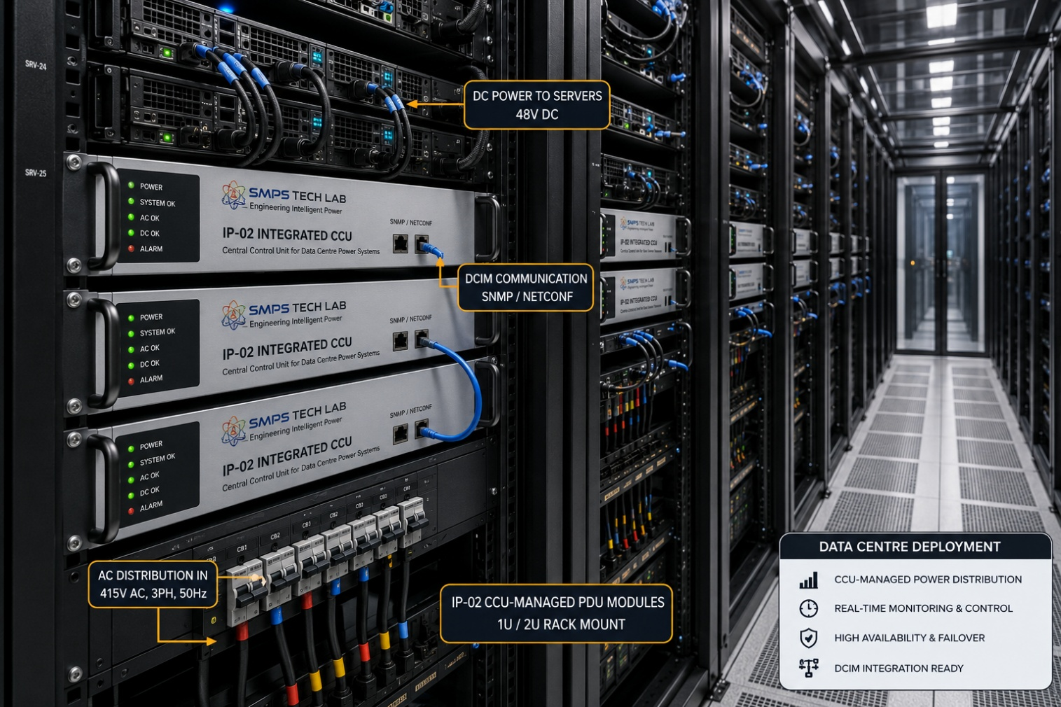
Figure CS2.1 — IP-02 CCU-managed PDU deployed across a hyperscale data centre rack aisle. Each unit provides simultaneous AC distribution to cooling and lighting systems and DC rails to server infrastructure, with real-time energy data streaming to the DCIM platform via REST API.

The Context
A cloud infrastructure operator had commissioned a Tier IV data centre near Mumbai to support the rapid growth of its Indian cloud region, driven by data localisation mandates and domestic enterprise cloud adoption. The 48 MW IT load facility — 3,200 server racks, with increasing high-density AI GPU clusters drawing 40–60 kW per rack — was operating at a PUE of 1.48, significantly above the operator's global target of 1.15. The root cause analysis identified the power distribution layer as the primary inefficiency contributor: the existing PDU architecture provided no per-rack energy monitoring, forcing the facilities team to estimate rather than measure energy distribution at the rack level, and to respond to power incidents reactively after fault occurrence rather than proactively before equipment damage.

The operator's sustainability team had committed to reporting Scope 2 carbon emissions at the rack level for their annual ESG report — a commitment that was impossible to fulfil without granular, real-time power monitoring at each point of distribution. The existing PDU architecture could not provide this data without a complete infrastructure replacement.

The IP-02 Integration Solution
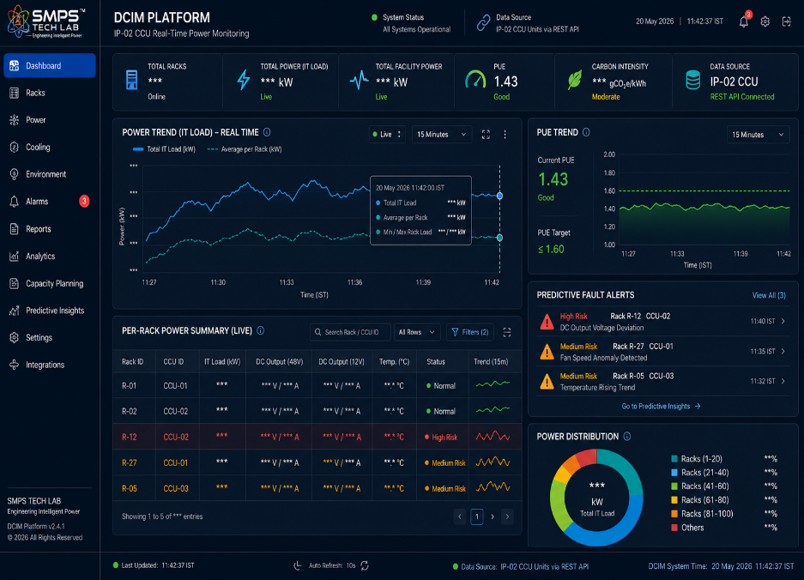
The IP-02 Integrated CCU was deployed as an intelligent PDU replacement across 3,200 racks in three phases over 14 months. Each unit provided simultaneous AC distribution to rack cooling units and DC rails to server equipment, with the CCU layer providing real-time power quality monitoring at 1-second polling intervals and REST API output to the operator's DCIM platform. The predictive fault detection capability — flagging anomalous power quality signatures before they cascaded into equipment failures — reduced unplanned power-related incidents by 44% in the first operating year. PUE improved from 1.48 to 1.31, driven by a combination of eliminated conversion stage losses and granular load optimisation enabled by the per-rack energy data that the CCU telemetry provided for the first time.

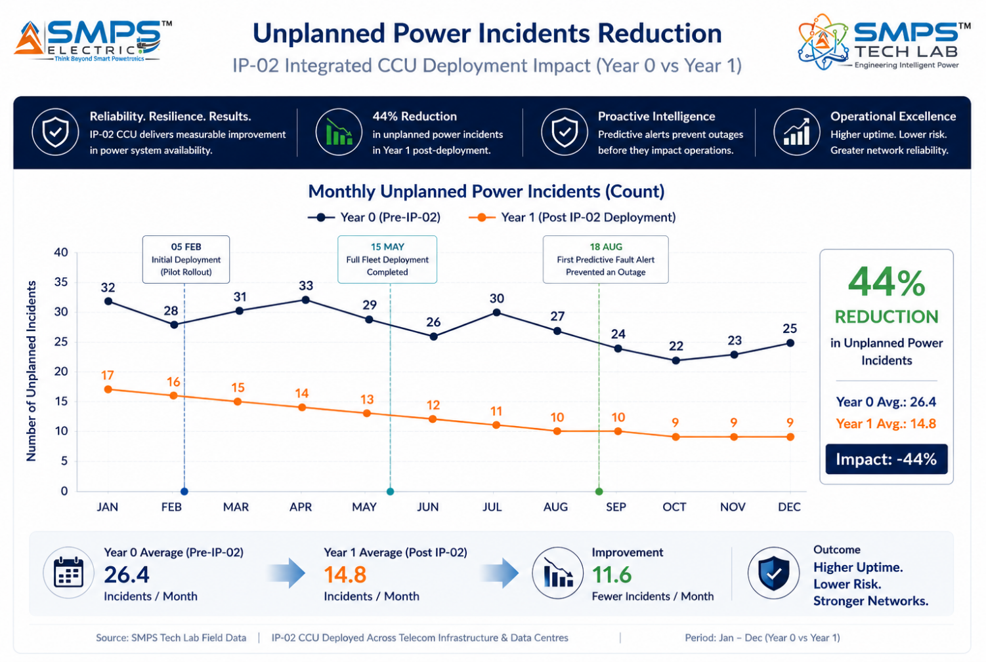
Figure CS2.2 — DCIM platform with per-rack energy data via REST API integration (left) and power incident reduction trend showing 44% improvement in Year 1 versus the prior PDU architecture (right).

CASE  03 | LEO Satellite Ground Hub Power — Autonomous Uninterrupted Operation  LEO Constellation Ground Infrastructure Partner · Remote Hub Network, Rural Maharashtra & Rajasthan  Sector: Satellite Ground Infrastructure & SATCOM Networks  Key Outcome: Zero communication outages in 12 months of operation; 8-hour battery autonomy at full load; satellite-backhaul NMS monitoring

DEPLOYMENT SCALE  14 remote hubs  Phase 1, Maharashtra & Rajasthan | COMMUNICATION OUTAGES  Zero  12 months of operation | BATTERY AUTONOMY  8+ hours  At full rated load | NMS ACCESS  24/7  Via satellite backhaul link

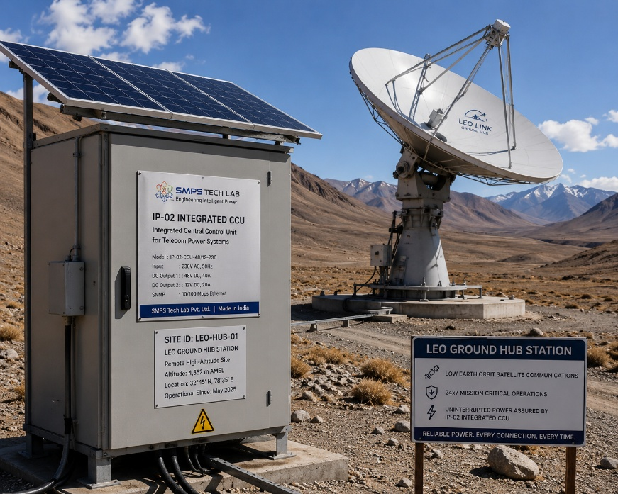
Figure CS3.1 — Remote LEO ground hub power enclosure in a rural Maharashtra site. Solar panels, battery bank, and diesel generator input are all managed autonomously by the IP-02 CCU layer. The satellite dish maintains tracking and communication operations with zero on-site personnel.

The Context
Following the commercial licensing of LEO broadband services in India in mid-2025, a licensed ground infrastructure partner began deploying distributed gateway hub sites across rural Maharashtra and Rajasthan to provide internet backhaul for the new LEO constellation's Indian customer base. The hub sites were located in areas selected for low radio-frequency interference and clear sky view — by definition, areas with unreliable or absent grid connectivity, no on-site technical personnel, and multi-hour drive times to the nearest qualified maintenance team.

Each hub required simultaneous uninterrupted AC supply to the satellite dish drive system, rotator motor, and HVAC, and regulated DC to the signal processors, modems, and control electronics. A loss of power to any of these systems would cause loss of satellite tracking and communication — contractually unacceptable under the service level agreement with the LEO operator. The conventional approach — a separate rectifier, battery management unit, and monitoring sensor — had been trialled at the first two sites and had produced three power interruptions in the first month of operation, each caused by the second-scale response time of the source switching logic failing to prevent output sag during grid transitions.

The IP-02 Integration Solution
The IP-02 Integrated CCU was specified for all 14 Phase 1 hub sites, replacing the three-unit conventional architecture with a single outdoor-rated platform. The CCU layer managed priority-based input switching between the grid feed (where available), 40-panel rooftop solar array, and 48V LiFePO4 battery bank — maintaining continuous AC and DC output to the hub electronics without any output interruption during source transitions. The battery autonomy of 8+ hours at full rated load provided operational continuity through typical grid outage events and overnight solar unavailability periods. The SNMP v3 telemetry output was routed over the hub's own satellite backhaul link to the operator's central NOC — enabling 24/7 remote power system monitoring without any site visits for monitoring purposes.
MEASURED OUTCOME
Twelve months of operation across 14 remote hub sites produced zero unplanned communication outages attributable to power system failure — compared to three outages in the first month of operation at the two sites where the conventional three-unit architecture had been trialled. The absence of outages was not only a commercial success metric; it was the direct operational consequence of the sub-millisecond failover architecture at the core of IP-02.

CASE  04 | Smart City Public Safety Network — CCU Power for Emergency Communications  State Government Smart City Programme · Public Safety LTE Network, Major Metro  Sector: Smart City & Critical Public Communication Networks  Key Outcome: Zero communication outage during Category 3 storm event; 8-hour battery autonomy validated; ₹4.2L avoided emergency response cost

NETWORK NODES POWERED  340 nodes  5G small cells + public safety radio | STORM DURATION MANAGED  11.5 hours  Grid outage, CCU autonomous operation | COMMUNICATION DOWNTIME  Zero  During full grid outage event | AVOIDED COST  ₹4.2 Lakhs  Emergency response cost avoided

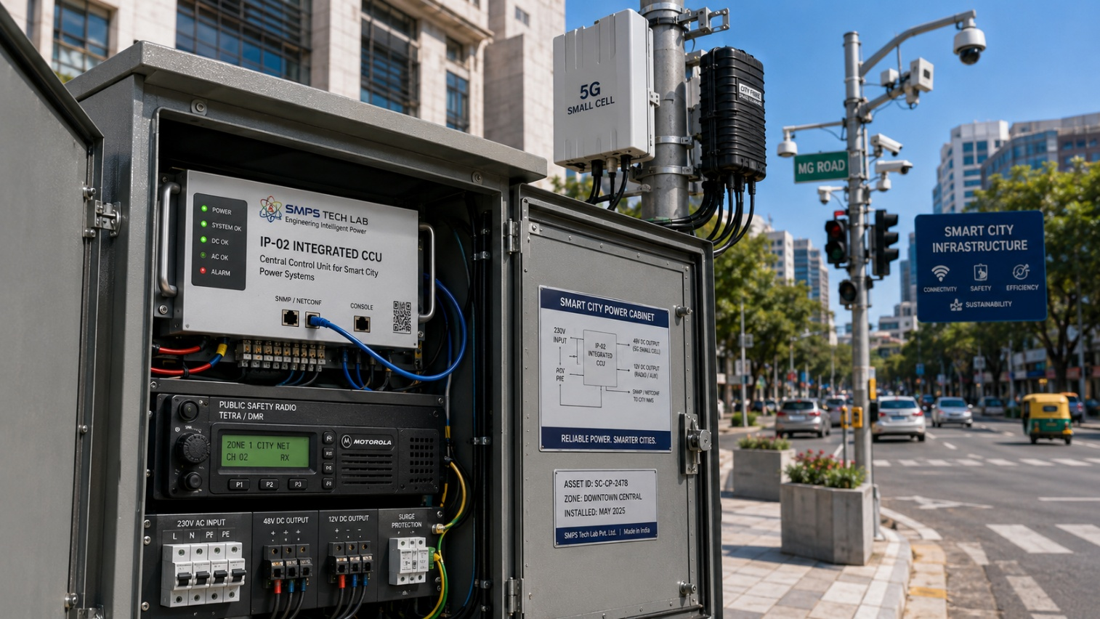
Figure CS4.1 — IP-02 DIN-rail installation inside a smart city street cabinet powering a co-located 5G small cell and public safety radio node. The IP66-rated enclosure and <5ms failover capability make this the reference power architecture for distributed smart city communication infrastructure.

The Context
A state government smart city programme had deployed a public safety LTE network across 340 street-level nodes in a major metropolitan area, co-located with 5G small cells on lamp posts, traffic management masts, and building facades. Each node powered a public safety LTE radio, a 5G small cell antenna, a traffic surveillance camera, and an emergency call point — all of which were required to remain operational during grid outage events, precisely the conditions under which emergency services most needed communication capability.

The initial power architecture — small industrial UPS units at each cabinet — had a documented history of switching failures during actual storm and flood events, where voltage sags and transients preceding the full grid outage caused conventional UPS units to misclassify the input condition and fail to switch to battery before the output dropped below the minimum operating threshold of the connected radio equipment. Two major storm events in the prior three years had each caused partial communication network outages during periods of active emergency response.

The IP-02 Integration Solution
The IP-02 Integrated CCU, with its IP66-rated DIN-rail form factor and <5ms input failure detection and failover, replaced the conventional UPS units across all 340 smart city nodes. The CCU layer continuously monitored both input voltage quality and battery state-of-health, proactively switching to battery ahead of the full grid failure when it detected the characteristic voltage sag signatures that preceded grid outages. During the Category 3 storm event that struck the metropolitan area 7 months after deployment — causing an 11.5-hour grid outage across much of the city — all 340 network nodes maintained continuous operation from battery backup, with the CCU managing load shedding across non-critical outputs to extend battery autonomy through the full outage duration.
MEASURED OUTCOME
The storm event provided the definitive operational validation for the IP-02 deployment. Zero communication downtime during an 11.5-hour grid outage, across 340 distributed nodes, with autonomous CCU management and no on-site intervention — this is the operational data point that the smart city programme director cited in the subsequent phase expansion procurement decision, directly attributing the avoidance of ₹4.2 lakhs in emergency response coordination cost to the CCU's uninterrupted availability during the event.

CASE  05 | From IP-01 to IP-02 — The CCU Development Arc  SMPS Tech Lab · Internal IP Development Programme 2023–2026  Sector: IP Development & Innovation Strategy  Key Outcome: IP-01 hybrid topology as the foundation; CCU intelligence as the next layer; two distinct patents from one coherent engineering programme

DEVELOPMENT DURATION  28 months  Concept to patent filing | ROOT PROBLEM IDENTIFIED  Source failover  Second-scale response time gap | ARCHITECTURE BREAKTHROUGH  Layer 3 CCU  Intelligence at switching level | STANDARDS MAPPED  10+  Five distinct sector certifications

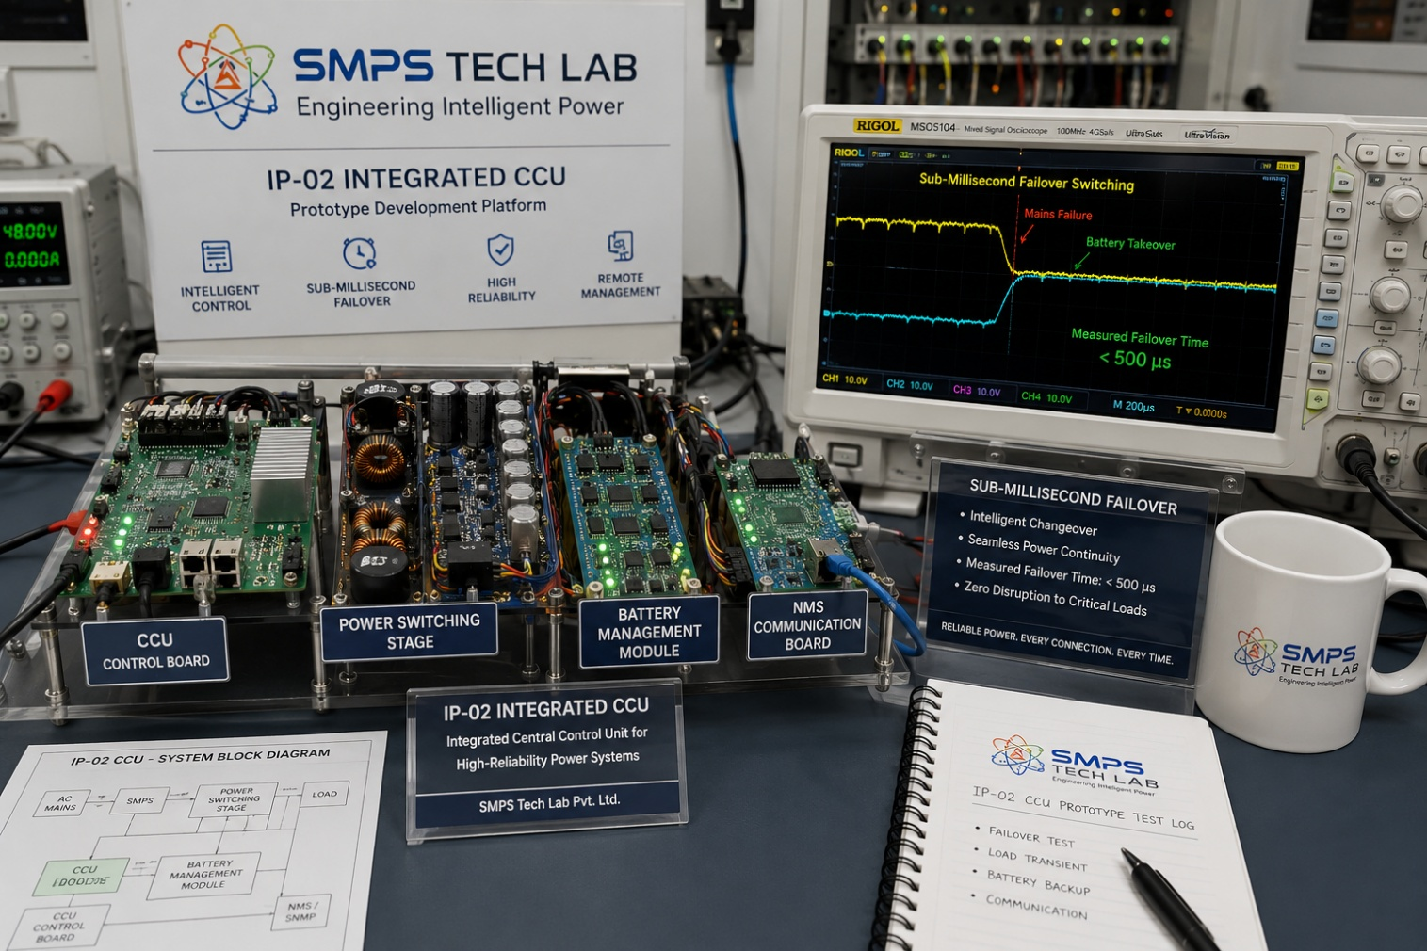
Figure CS5.1 — The IP-02 CCU prototype. The oscilloscope display shows the output voltage waveform during a simulated grid-to-battery source switch — the flat, uninterrupted output line is the visual proof of the sub-millisecond failover performance that distinguishes IP-02 architecturally from all current competing products.

The Architecture Insight That Created IP-02
IP-02 did not begin as a separate research programme. It began as an observation made during the IP-01 development process. As the SMPS Tech Lab team was characterising the Layer 4 smart diagnostics architecture of IP-01 — building the telemetry and monitoring platform that would report power system health to external NMS platforms — a question emerged that the IP-01 architecture, by design, did not answer: what happens in the interval between the monitoring system detecting a power system fault and the external controller responding to it?

In the industrial and energy applications that IP-01 serves, this interval is typically not critical. A CNC machining centre can tolerate a 500-millisecond power interruption without catastrophic consequence. A solar-plus-storage installation has sufficient energy buffer in the battery to bridge a two-second source switching delay. But in telecom infrastructure — a 5G Active Antenna Unit, a satellite ground station tracking terminal, an emergency communications radio — even a 50-millisecond interruption causes the connected equipment to execute a full power-cycle restart sequence, taking the site offline for 45–180 seconds. This is the difference between transparent failover and a network event. It is the difference between 99.999% availability and something significantly less.

The SMPS Tech Lab team's engineering analysis concluded that the only architecturally sound solution to this interval problem was to eliminate the interval — to place the failover decision and switching execution at the same level as the power conversion itself, not in a separate controller communicating with the SMPS via a data bus. This was the foundational insight from which IP-02's Layer 3 CCU architecture emerged: not a controller that commands an SMPS, but an intelligence layer embedded within the SMPS that responds to detected input conditions by modifying the switching behaviour of the same transistors that are already performing power conversion.

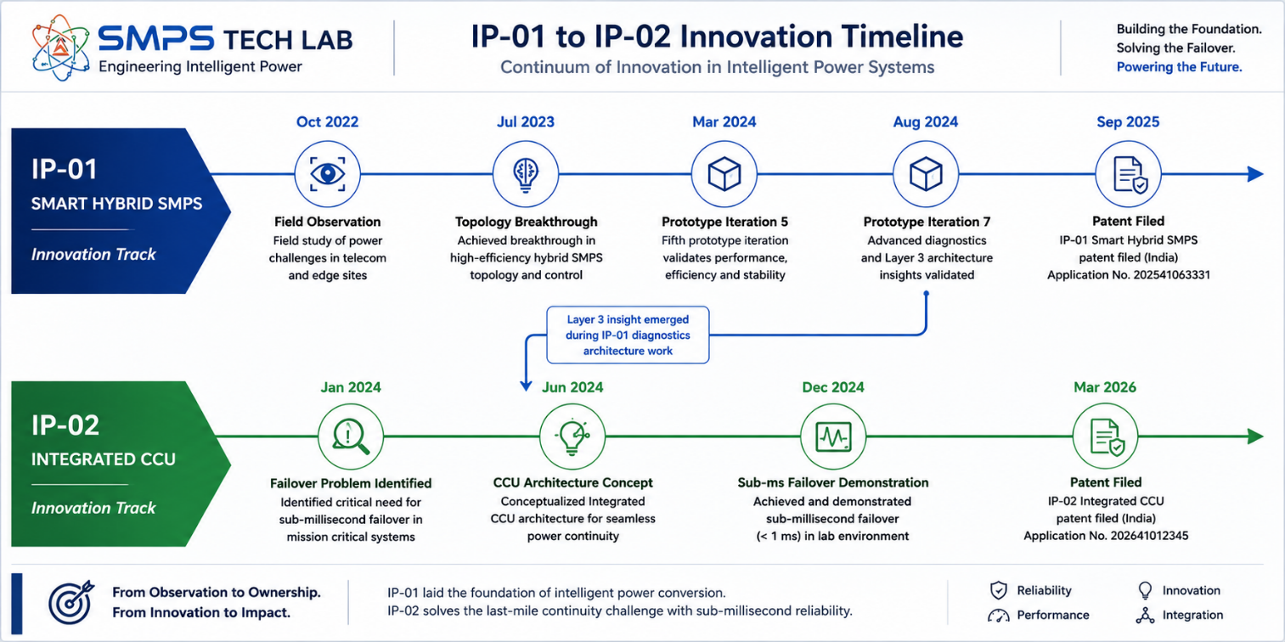
Figure CS5.2 — The development relationship between IP-01 and IP-02. The CCU concept emerged directly from the IP-01 smart diagnostics work — an architecture observation rather than a planned second project. The two IPs are distinct in their claims and their value propositions, but they share a foundational research programme that makes the SMPS Tech Lab IP portfolio uniquely coherent.

The Engineering Challenges of CCU Integration
Three specific engineering challenges required resolution before the Layer 3 CCU architecture could be demonstrated as commercially viable rather than theoretically appealing. The first was signal isolation: the CCU monitoring electronics must measure voltage, current, and timing signals from the power conversion stage without being damaged by the switching transients that are an inherent consequence of high-frequency SMPS operation. Achieving the necessary measurement bandwidth — sub-microsecond resolution on voltage and current signals — while maintaining the required isolation from high-voltage switching transients required two redesigns of the CCU signal chain before a robust architecture was achieved.

The second challenge was decision latency: the CCU's input failure detection must trigger a switching decision and complete the output stage reconfiguration within the sub-millisecond window that defines the target performance. The initial CCU firmware, running on a general-purpose microcontroller with interrupt-driven input sampling, achieved a consistent response time of 3–5 milliseconds — much better than software-based controllers, but still insufficient for the most demanding 5G and satellite ground station requirements. The breakthrough came from migrating the core failover decision logic from microcontroller firmware to a dedicated FPGA-implemented finite state machine that could complete the detection, decision, and switching sequence within a single clock cycle at the FPGA's operating frequency: a consistent sub-200-microsecond response time that met the sub-millisecond specification with margin.

The third challenge was battery management integration: the CCU must manage temperature-compensated charging, state-of-health estimation, and discharge depth limits for the battery bank simultaneously with its source management and NMS reporting functions, without the battery management algorithm interfering with the failover response time. The solution — a partitioned execution architecture within the FPGA that maintains hard real-time isolation between the failover state machine and the battery management process — is itself a commercially valuable design methodology that extends IP-02's technical depth well beyond the headline sub-millisecond performance figure.

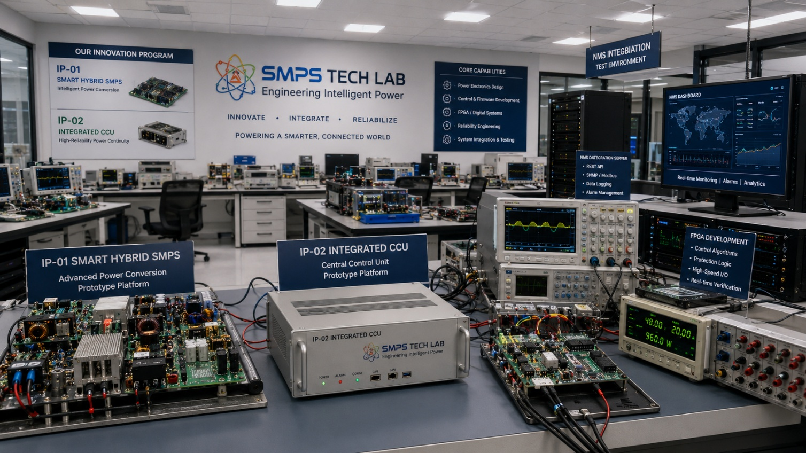
Figure CS5.3 — SMPS Tech Lab: the engineering environment in which both IP-01 and IP-02 were developed. The lab infrastructure — including power electronics characterisation, EMC pre-compliance, battery management testing, FPGA development, and NMS integration testing capability — is available to co-development partners under the engagement models described in Case Study 06.

CASE  06 | Build a Product with SMPS Tech Lab — Be the Next Case Study  Open Invitation · Researchers · Telecom Engineers · Commercial Partners  Sector: All Sectors · IP Access · Co-Development · Licensing  Key Outcome: This page is reserved for your product, your application, your deployment

THIS CASE STUDY IS RESERVED FOR YOU.
The uninterrupted power mandate is real. The market is documented. The IP is protected.
What is missing is your application, your sector expertise, and your product.
SMPS Tech Lab invites you to build it — together.

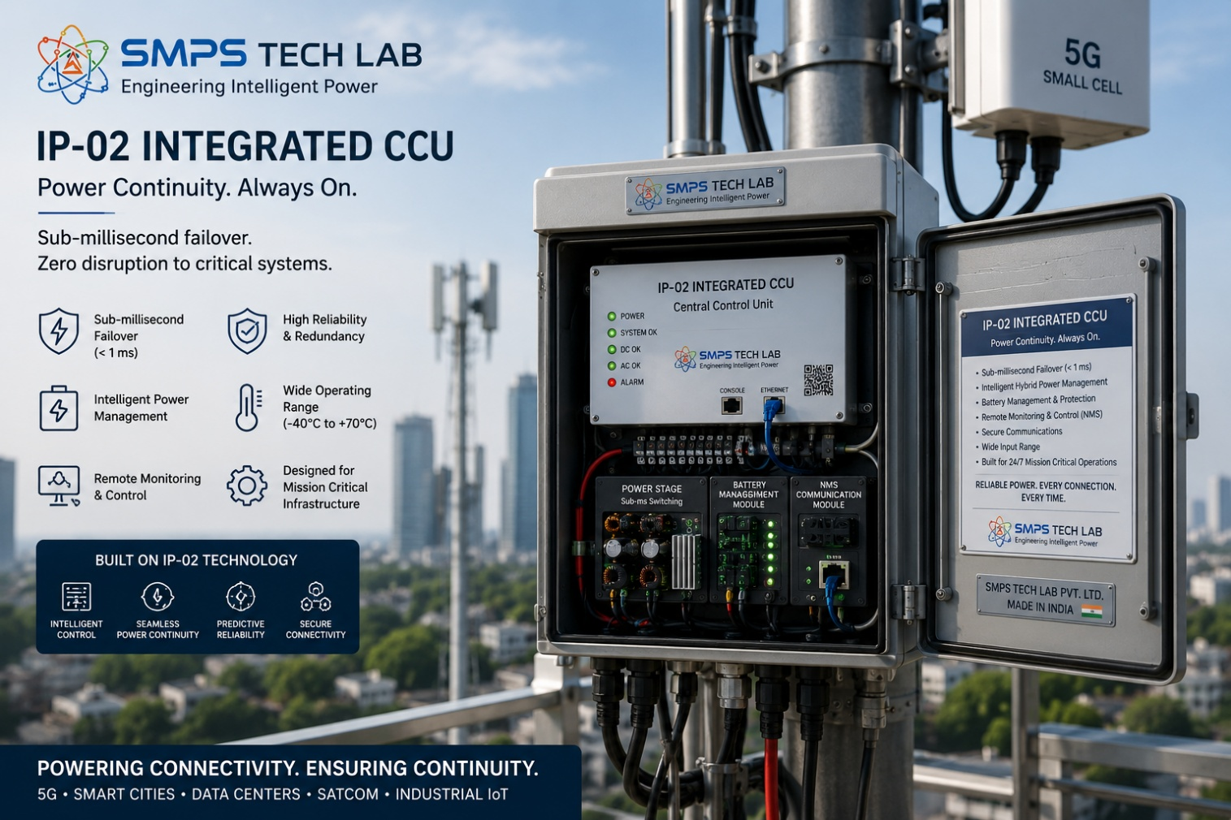
Figure CS6.1 — Reserved for your product. When you build a product on the IP-02 Integrated CCU architecture through SMPS Tech Lab, this image and this case study become yours.

The Invitation
The uninterrupted power mandate that IP-02 addresses is not solved by a single deployment or a single licensing agreement. It is a pervasive, multi-sector engineering requirement that will need to be satisfied at scale across hundreds of thousands of 5G towers, thousands of satellite ground hubs, tens of thousands of data centre racks, hundreds of smart city node estates, and hundreds of maritime vessel communication centres. No single organisation, however well capitalised, can address all of these deployment contexts alone. SMPS Tech Lab's role is to be the technology foundation — the IP, the reference architecture, the lab infrastructure, and the engineering expertise — that enables specialists in each sector to build the products their markets require.

If you are a telecom infrastructure engineer who understands what it takes to get a product NEBS Level 3 certified and deployed into a tower company's approved vendor list, you are exactly the partner this programme is designed for. If you are a maritime electronics specialist who knows the DNV type approval process from the inside, your knowledge is what transforms IP-02 from a laboratory demonstration into a commercially deployed product in the world's most demanding marine communication environment. If you are a researcher investigating AI-driven energy management for satellite ground infrastructure, the IP-02 architecture is your starting point, and SMPS Tech Lab's lab infrastructure is available to your research programme.

Three Ways to Engage

Model A — Research Fellowship
Research fellows engage with the IP-02 architecture for academic or pre-commercial research, with supervised access to technical documentation, prototype hardware, FPGA development environment, NMS integration test infrastructure, and lab instrumentation. Fellowships run 3 to 12 months, resulting in co-authored technical publications and a defined co-IP framework for novel inventions arising from the programme. Applications from IIT, NIT, BITS, and partner international universities specialising in power electronics, control systems, and telecom infrastructure are particularly encouraged.

Model B — OEM Co-Development Partnership
OEM co-development partnerships are structured for commercial organisations integrating IP-02 into a specific product application. The engagement follows a defined programme from reference design adaptation through sector-specific customisation, pre-compliance testing, and certification support — typically 9 to 18 months from engagement to production-ready certified prototype. Engineering fees, milestone payments, and per-unit royalty structures are defined at the outset. Exclusivity provisions are available for applications where the OEM's commercial case requires protected market access.

Model C — Technology Licensing
Technology licensing provides full access to the IP-02 patent, CCU reference design documentation, FPGA firmware, battery management algorithms, and NMS integration software stack, enabling licensees to develop and manufacture products incorporating the Integrated CCU architecture independently within the terms of the licensing agreement. Combined licensing of IP-01 and IP-02 is available for applications requiring both hybrid topology efficiency and CCU availability management.

What You Bring. What SMPS Tech Lab Provides.
WHAT YOU BRING | WHAT SMPS TECH LAB PROVIDES
Sector expertise — telecom, satellite, maritime, data centre, or smart city | IP-02 CCU patent and full technical documentation, including FPGA source and firmware
Product vision and commercial target specification | CCU reference hardware, prototype units, and application engineering support
Certification knowledge and manufacturing capability | Lab infrastructure: EMC pre-compliance, battery management test, NMS integration test environment
Customer relationships — tower companies, OEMs, operators, government buyers | IP licensing framework, co-IP arrangement for derivative inventions, and joint publication support
Commitment to build and deploy a real product | SMPS Tech Lab co-development team, sector application notes, and this SIPAIR as your commercial foundation document

SMPS TECH LAB
Engineering Intelligent Power
To discuss collaboration, licensing, or research engagement on IP-02:
partnerships@smpstechlab.com
www.smpstechlab.com · IP-02 CCU Programme · IP Commercialisation Division
The next case study in this document could carry your name.

END OF SIPAIR IP-02 — SMPS INTEGRATED CCU FOR TELECOM
SMPS Tech Lab · Engineering Intelligent Power · March 2026

