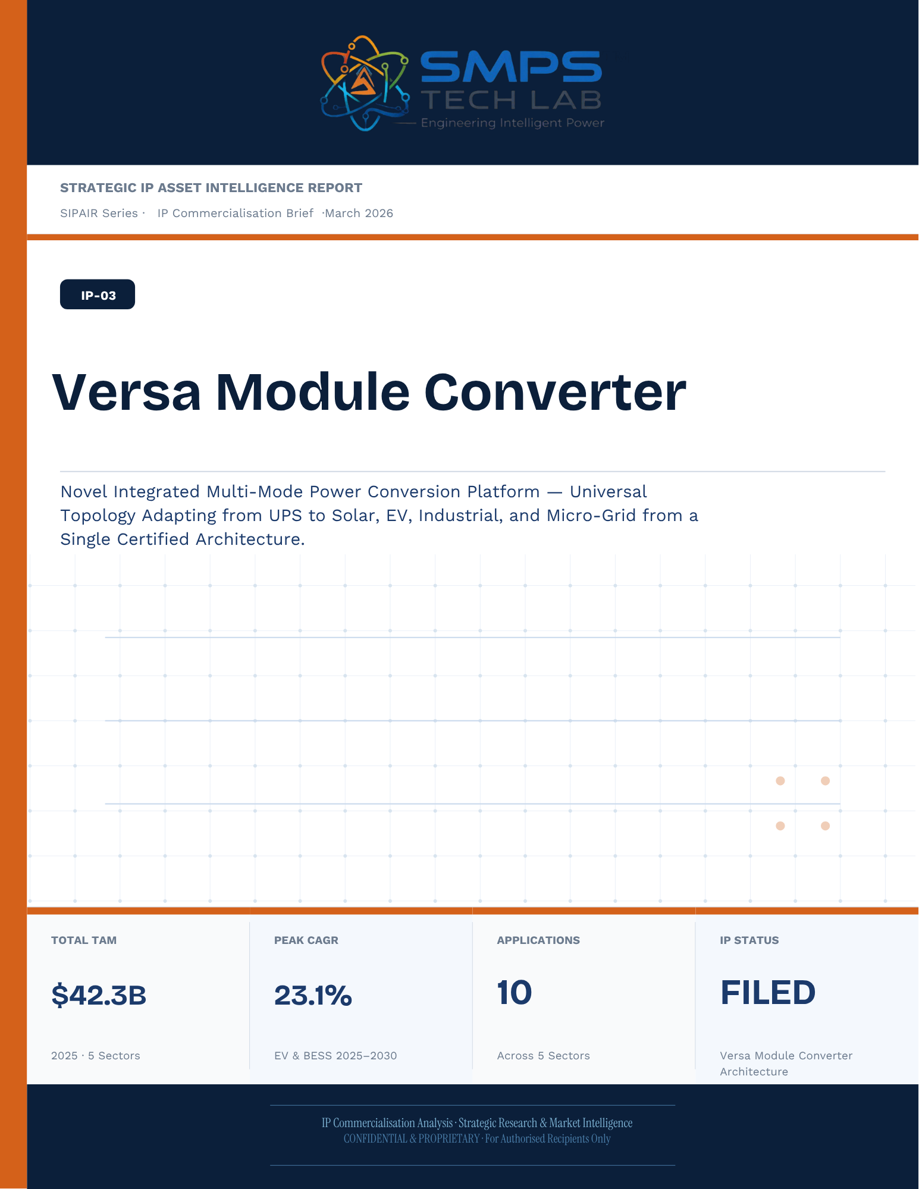
STRATEGIC IP ASSET INTELLIGENCE REPORT
SIPAIR Series
IP-03: Novel Integrated Versa Module Converter
SMPS-Based Integrated Versa Module Converter for Uninterrupted Telecom Power

Report Title | SIPAIR IP-03 — Novel Integrated Versa Module Converter Commercialisation Brief

Document Series | Strategic IP Asset Intelligence Report (SIPAIR)

Version | Version 1.0 — First Edition

Compiled & Edited by | Shri Amareshwar Karatagi

Organisation | SMPS Tech Lab — Engineering Intelligent Power

Date of Issue | March 2026

Classification | Confidential & Proprietary — For Authorised Recipients Only

IP Reference | IP-03 — Novel Integrated Versa Module Converter Architecture, Filed 2025

Related Document | SIPAIR IP-01: Smart Hybrid SMPS (see companion brief)

This document is prepared by SMPS Tech Lab as part of the SIPAIR IP Commercialisation Series.

Declaration — Originality & Intellectual Property Statement

This Strategic IP Asset Intelligence Report (SIPAIR — IP-03: Novel Integrated Versa Module Converter) is an original compilation prepared by SMPS Tech Lab. The analysis, market intelligence frameworks, commercial strategy formulations, and case study narratives contained herein are the result of independent research and original intellectual work by the authors and editors named in this document.

The core technology described in this report — the SMPS-Based Integrated Versa Module Converter architecture, including its active power management layer, CCU intelligence stack, uninterrupted multi-rail AC/DC delivery system, and NMS integration platform — is the exclusive proprietary invention of SMPS Tech Lab, protected under a filed novel design patent (2025). IP-03 is a distinct and independently protectable invention from IP-01 (Smart Hybrid SMPS), though both emerge from the same SMPS Tech Lab research programme. The two IPs are designed to complement each other across adjacent application verticals and may be jointly licensed or co-deployed where application requirements demand both hybrid topology and active power management intelligence.

Market sizing data, CAGR estimates, and industry statistics cited in this document are sourced from independent third-party research publications, fully attributed in Appendix A. All third-party data is used for analytical and benchmarking purposes only. This report has not been submitted, in whole or in part, to any other organisation for commercialisation or formal assessment except as specifically disclosed in writing.
Declared by:

Shri Amareshwar Karatagi
Founder & CSO
SMPS Tech Lab · March 2026

CERTIFICATE OF AUTHENTICITY
IP Commercialisation Documentation · SIPAIR IP-03

This is to certify that the Strategic IP Asset Intelligence Report
SIPAIR IP-03 — Novel Integrated Versa Module Converter
has been compiled, reviewed, and authenticated by the undersigned in accordance
with the standards of the SIPAIR documentation series. The technology, market analysis,
and commercial intelligence herein are verified as accurate to the best of the signatories’
knowledge as at the date of issue: March 2026.

Program Head / Director | Technical Mentor
  Program Head / Research Director
  SMPS Tech Lab
  Technical Mentor / Advisor
  SMPS Tech Lab

SMPS Tech Lab · Engineering Intelligent Power · March 2026

Acknowledgment

The preparation of this Strategic IP Asset Intelligence Report for IP-03 has drawn on the technical expertise, operational insights, and research foundation developed across two parallel innovation tracks at SMPS Tech Lab. The development of the CCU intelligence layer — the defining innovation of IP-03 — required not only power electronics engineering depth but sustained engagement with telecom network operations, tower management practice, and satellite ground station engineering environments that are highly specialised. The author and editor express sincere gratitude to those whose knowledge and access made this work possible.

Technical Development
The CCU architecture at the heart of IP-03 evolved alongside IP-01's hybrid topology work, but along a distinct engineering trajectory focused on power orchestration intelligence rather than conversion efficiency alone. The engineers and technologists who contributed to the CCU control logic, NMS integration stack, and sub-millisecond failover switching mechanism deserve specific recognition for the rigour with which they approached the uninterrupted power mandate — a design objective that admits no approximation.

Telecom Industry Access
The sector intelligence in this report reflects direct engagement with tower operations, data centre facility management, and satellite ground station engineering communities. The operational data from 5G tower rollout programmes, off-grid hybrid power deployments, and maritime communication installations that informed the case study narratives and application requirement specifications in this document is the product of those field engagements.

Research Publications
The market intelligence framework draws on publications from Future Market Insights, MarketsandMarkets, SNS Insider, Grand View Research, IMARC Group, Coherent Market Insights, Global Growth Insights, and the Ericsson Mobility Report, as well as operational data from the International Energy Agency. The quality of those independent research publications is what allows the TAM framework in this report to be grounded in named, verifiable data rather than estimated aggregates.
Shri Amareshwar Karatagi
Founder & CSO
SMPS Tech Lab · March 2026

Preface — From the Founder & Editor

From IP-01 to IP-03 — The Logical Extension
IP-01, documented in the companion SIPAIR brief, solved one problem with exceptional elegance: replacing the unnecessary architectural duplication of separate AC and DC converter units with a single hybrid topology. The commercial case was compelling and the market evidence was clear. But the engineers at SMPS Tech Lab, in the same process of field observation that gave rise to IP-01, had identified a second problem — one that operated at a higher level of the power system stack and was, if anything, more commercially urgent in the specific context of telecom infrastructure.

The problem was not conversion efficiency. It was availability. In a 5G base station, a satellite ground hub, an offshore platform communication centre, or a smart city public safety network node, the standard power supply architecture not only requires separate AC and DC converters — it delegates all intelligence about the power state of the system to a separate controller that may be physically remote, software-dependent on a third-party network management system, and incapable of autonomous protective action in the sub-millisecond timeframe that modern telecom uptime SLAs demand. When the grid fails, when a battery starts to degrade, when an input source switches — the system needs to respond faster than any software polling cycle can achieve. It needs embedded intelligence, right at the power conversion stage.

IP-03 is that intelligence. The Integrated Versa Module Converter, combined with the SMPS core, does not just convert power — it orchestrates it. It monitors every parameter of the power delivery chain continuously, switches between sources in under a millisecond, predicts faults before they become outages, and reports power system health to the operator's NMS in real time, without external monitoring hardware. It is the difference between a power supply and a power management system.

Why Telecom, and Why Now
The selection of telecom infrastructure as the primary application vertical for IP-03 reflects a disciplined commercial judgement. Telecom infrastructure is the single sector in the IP-03 TAM where the uninterrupted power mandate is non-negotiable, contractually enforced at 99.999% uptime, and backed by capital investment programmes of unprecedented scale: 2.3 billion 5G subscriptions by end of 2024 with another 4 billion to come by 2030; 3,000 Amazon Project Kuiper satellites deployed in April 2025 with thousands of ground hubs to follow; the IMO GMDSS modernisation mandate forcing a complete vessel communication power infrastructure upgrade by 2026. Every one of these programmes creates a specific, identified, and time-bounded procurement requirement for exactly what IP-03 delivers.

The second reason is the grid reliability crisis that is, counterintuitively, the most powerful demand driver the CCU's hybrid input management addresses. South Africa recorded 1,130 hours of planned power cuts in a single year. India's tower estate — 750,000 sites — routinely operates on hybrid grid, diesel, and battery sources with real-time CCU-managed source switching that determines whether the tower stays on during a grid event. This is not a niche requirement. It is the operational reality for hundreds of thousands of tower sites across three continents, and the market is actively seeking a solution that the current generation of separate rectifiers and external controllers cannot provide.

How This Document is Structured
This SIPAIR brief follows the same 14-section architecture as the IP-01 companion document, making the two documents a coherent and mutually reinforcing portfolio. Readers who have engaged with SIPAIR IP-01 will recognise the structure immediately. The technology differentiation section includes an explicit comparison between IP-01 and IP-03, clarifying the architectural relationship and the distinct value proposition of each. The case studies are drawn from the five specific sectors of IP-03's TAM framework — 5G tower, data centre, satellite ground, smart city, and maritime/offshore — with technical and financial parameters grounded in the operational realities of each sector.

Shri Amareshwar Karatagi
Founder & CSO
SMPS Tech Lab · March 2026

TABLE OF CONTENTS

Declaration — Originality & Intellectual Property Statement 1
Acknowledgment 1
Technical Development 1
Telecom Industry Access 1
Research Publications 1
Preface — From the Founder & Editor 1
From IP-01 to IP-03 — The Logical Extension 1
Why Telecom, and Why Now 1
How This Document is Structured 1
Important Notice & Confidentiality Disclaimer 1
1.1 The Strategic Context 1
1.2 The Problem IP-03 Solves 1
1.3 Key Metrics at a Glance 1
1.4 Why IP-03, Why Now 1
2.1 What is the Novel Integrated Versa Module Converter? 1
2.2 The Four Integrated Functional Layers 1
2.3 Multi-Mode Versatility vs. IP-01 and IP-02 1
2.4 Hot-Swap Modular Scalability 1
2.5 Standards Compliance Architecture 1
3.1 The Multi-Mode Convergence Economy 1
3.2 The Four Structural Megatrends 1
3.3 Global Market Sizing — Primary Reference Data 1
CAGR Comparison — IP-03 Target Market Segments 1
4.1 Methodology 1
4.2 Consolidated TAM Summary 1
5.1 India as First Market 1
5.2 India Market Sizing — IP-03 Relevant Segments 1
6.1 India Government Schemes with Direct IP-03 Alignment 1
7.1 The Plugin Architecture — Five Host System Categories 1
7.2 Plugin Integration Matrix 1
8.1 Commercialisation Philosophy 1
8.2 Market Priority Matrix 1
9.1 Competitive Architecture Overview 1
10.1 The Investment Case 1
10.2 Illustrative Revenue Scenarios 1
11.1 Technology Generation Roadmap 1
11.2 Adjacent Application Opportunities 1
12.1 Risk Framework 1
Appendix A — Data Sources 1
Appendix B — Standards Reference 1
Appendix C — Glossary 1
The Context 1
The IP-03 VMC Integration Solution 1
The Context 1
The IP-03 VMC Integration Solution 1
The Context 1
The IP-03 VMC Integration Solution 1
The Context 1
The IP-03 VMC Integration Solution 1
The Observation That Led to IP-03 1
Three Engineering Challenges 1
Three Ways to Engage 1
Model A — Research Fellowship 1
Model B — OEM Co-Development Partnership 1
Model C — Technology Licensing 1
What You Bring. What SMPS Tech Lab Provides. 1

0F | FOUNDER & EDITOR  SMPS Tech Lab


Shri Amareshwar Karatagi
Founder & Chief Strategic Officer
SMPS TechLab
Special Correspondent, Government of Karnataka |
Serial Entrepreneur

Vision Statement
We aim to build a generation of innovators and entrepreneurs who create transformative technologies, develop intellectual property, and drive India’s technological leadership on both national and global platforms. Over the years, we have worked extensively within the startup ecosystem, contributing to and mentoring multiple initiatives focused on building, scaling, and strengthening businesses. Through this journey, we have developed a deep understanding of business strategy, governance frameworks, and deep-technology development, along with the practical challenges of scaling innovation in real-world markets.
As a Special Correspondent with the Government of Karnataka and a serial entrepreneur, my focus has been on shaping individuals into creators, builders, and leaders of technology and enterprise. Our work emphasizes ownership, innovation, and execution discipline to nurture individuals capable of building scalable, high-impact solutions with both national and global relevance.
Through SMPS Tech Lab, we drive this vision by integrating deep Research & Development (R&D) with entrepreneurial strategy, fostering a culture where ideas evolve into intellectual property, innovation, and industry-aligned solutions that contribute to India’s technological advancement and global competitiveness. The Industry Fitness DeepTech Internship Program is a reflection of this mission—designed to develop individuals who are innovation-driven, execution-focused, and capable of contributing meaningfully to technology, entrepreneurship, and nation-building at scale.

“My vision is to build a generation that doesn’t wait for opportunities, but creates them through innovation and entrepreneurship.”
— Shri Amareshwar Karatagi



A. R. Shalini
Chief Business Development Officer (CBDO) & Program Officer
SMPS TechLab | SMPS Electric Control Pvt. Ltd.

Area of Expertise:
Business Strategy, Operations Management, Industry–Academia Integration, Entrepreneurship Development
Profile:
I play a pivotal role in driving program execution, operational excellence, and professional development within SMPS Tech Lab. With a strong foundation in both business strategy and technology alignment, I am committed to shaping individuals into industry-ready professionals with the right mindset, discipline, and execution capabilities.
My approach focuses on building skills with clarity of thought, accountability, and a results-driven attitude. Through structured guidance and continuous mentorship, I enable participants to understand the intersection of technology, business, and real-world application.
I actively work toward bridging the gap between academia and industry, ensuring that learning is aligned with practical expectations and evolving market demands. My dedication to creating a seamless and high-impact learning environment fosters confidence, innovation, and professional growth among participants.
Through my leadership, the program consistently emphasizes structured execution, strategic thinking, and the development of individuals who are prepared to contribute meaningfully to both industry and innovation ecosystems.
“Professional excellence is built when knowledge, mindset, and execution come together with consistency.”
— A. R. Shalini

Dr. S. Khatua
Chief Technology Officer (CTO)
SMPS TechLab | SMPS Electric Control Pvt. Ltd.
IITian | PhD – IIT Dhanbad

Area of Expertise:
Power Electronics, Microgrid & Smart Grid Systems, Nuclear Power Systems, DeepTech R&D, Industrial System Design.
I am a distinguished technology leader driving advanced Research & Development and deep-tech innovation. An IITian with a PhD in Microgrid and Smart Grid Systems for nuclear power applications, I bring over 15 years of experience across power electronics, nuclear reactor control systems, and defence and telecom technologies.
With significant contributions to high-impact and mission-critical projects of national importance, my work reflects a rare combination of research depth, engineering precision, and industrial execution.
I am a strong advocate of deep-tech innovation and intellectual property (IP) creation, and I emphasize the development of indigenous technologies that strengthen the nation’s technological capability and global standing.
Through my mentorship, I inspire the next generation to pursue technical mastery, disciplined execution, and innovation with national intent, shaping professionals capable of contributing to the future of deep technology.
“Precision in engineering, depth in research, and ownership of technology are the pillars of true national progress.”
— Dr. S. Khatua



Mr. Rushit Jani
Techno-Commercial Architect
Strategic Editorial & Commercialisation Review | OptCell GLOBAL

Fields of Interest:
AI & Intelligent Systems, Industrial IoT, Product Architecture, Deep-Tech Commercialisation, Enterprise System Design, and Scalable Engineering Solutions.
Focused on building technology-driven systems that bridge engineering innovation with practical industry adoption and long-term commercial value.

Message from the Editor:
Technology, in its purest form, is not just about building systems — it is about creating meaningful infrastructure that can influence industries, solve operational challenges, and contribute to larger technological progress. My interest has always been in understanding how engineering innovation can evolve beyond prototypes into scalable and commercially sustainable solutions.

This document represents more than a technical study of an intellectual property. It reflects a structured effort to connect engineering architecture with market relevance, strategic deployment, industrial applicability, and long-term innovation potential. The objective throughout this work has been to maintain a balance between technical depth, commercialization practicality, and institutional-level documentation standards.

As emerging technologies continue to redefine industries, I strongly believe that the future will belong to organizations capable of combining research, engineering, strategic thinking, and execution into unified ecosystems. Through this publication, we aim to contribute towards that larger vision while creating pathways for collaboration, innovation, and real-world technological impact.

"Transforming engineering innovation into scalable, industry-defining technological ecosystems."
— Mr. Rushit Jani

A Note of Gratitude

The development of this publication has been supported by the collective vision, encouragement, and leadership of the Directors and management of SMPS Electric Control Pvt. Ltd.

Their continued commitment towards engineering innovation, industrial excellence, and long-term technological growth has created an environment that encourages meaningful research, practical problem-solving, and commercialization-focused thinking. The guidance, operational insights, and institutional support extended throughout this journey have played an important role in shaping the direction and depth of this work.

This document reflects not only an individual effort, but also the larger culture of innovation, trust, and forward-thinking leadership fostered within the organization. We sincerely appreciate the confidence and support provided towards building impactful and future-ready technological initiatives.

Important Notice & Confidentiality Disclaimer

This Strategic IP Asset Intelligence Report (SIPAIR — IP-03) has been prepared exclusively for internal strategic planning, investor communication, licensing partner engagement, and research collaboration purposes. It is intended for distribution only to authorised recipients under applicable non-disclosure and confidentiality arrangements.

All market sizing data, CAGR estimates, and financial projections are derived from independent third-party research publications cited in Appendix A. These figures represent estimates as at March 2026. No representation or warranty is made as to their accuracy or completeness.

The technology, architecture, and methodologies described herein are the exclusive proprietary assets of SMPS Tech Lab, protected under filed patent and design rights. This document does not constitute a prospectus, financial advice, or an offer to sell or subscribe to securities. Recipients are advised to conduct independent due diligence before making any investment or commercial decision.

01 | EXECUTIVE SUMMARY  Strategic Overview · Multi-Mode Versatility · The Converging Market

1.1 The Strategic Context
The global energy transition has created an unprecedented deployment challenge for power electronics engineers: modern energy systems are no longer single-source, single-load architectures. A utility-scale solar farm feeds a battery storage system that also interfaces with the grid and local industrial loads. A hyperscale data centre integrates on-site solar generation, grid-interactive UPS, and 48V server power distribution. A commercial EV charging hub must simultaneously charge vehicles at DC fast-charge rates, export energy back to the grid through V2G protocols, and manage a local battery buffer. In every one of these architectures, the conventional answer has been the same: deploy multiple discrete converter units, each optimised for one conversion mode, connected by interfaces that add cost, failure points, and energy loss at every junction.

This architectural redundancy is not an engineering optimum. It is a market legacy — the accumulated product-line thinking of an industry that built single-mode converters because single-mode systems were the norm. That norm has changed. The systems being deployed today and throughout the next decade are multi-source, multi-mode, and multi-directional by design. The power conversion platform they require must be equally versatile.

1.2 The Problem IP-03 Solves
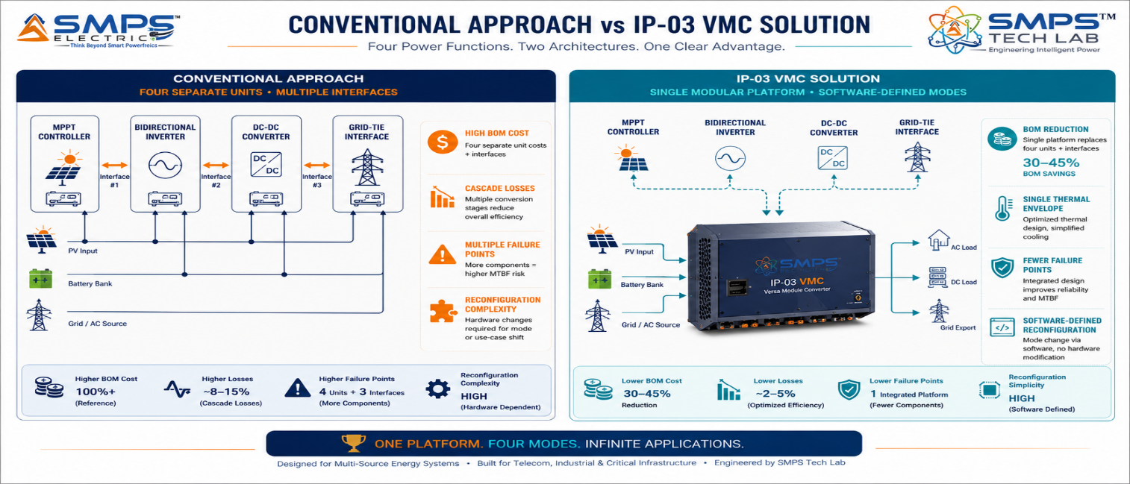
Figure 1.1 — The architectural distinction: conventional four-unit multi-converter cascade (left) versus the IP-03 Versa Module Converter (right). Every interface eliminated is a failure point removed, a conversion loss recovered, and a commissioning complexity resolved.
STRATEGIC NOTE
IP-03 eliminates the multi-converter cascade. The Novel Integrated Versa Module Converter is a single modular platform configurable as AC-DC, DC-DC, DC-AC, or bidirectional converter — reducing total BOM and footprint by 30–50%, improving system round-trip efficiency by 4–8 percentage points, and enabling real-time power flow optimisation across all connected sources and loads without hardware redesign.

1.3 Key Metrics at a Glance

TOTAL ADDRESSABLE MARKET  $42.3B  2025 Baseline · 5 Sectors | HIGHEST-GROWTH SECTOR  23.1%  EV & BESS CAGR 2025–2030 | SECTORS MAPPED  5  10 Applications Identified | IP PROTECTION  VMC Filed  Multi-Mode Modular Patent

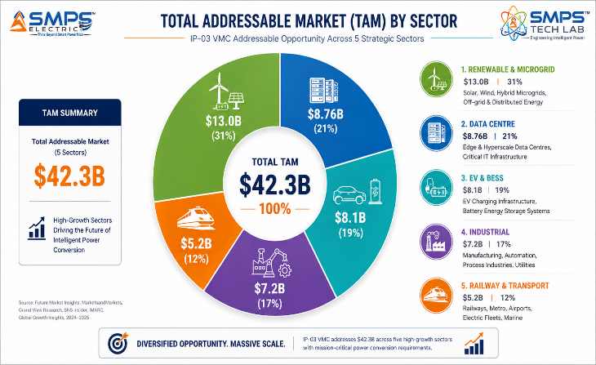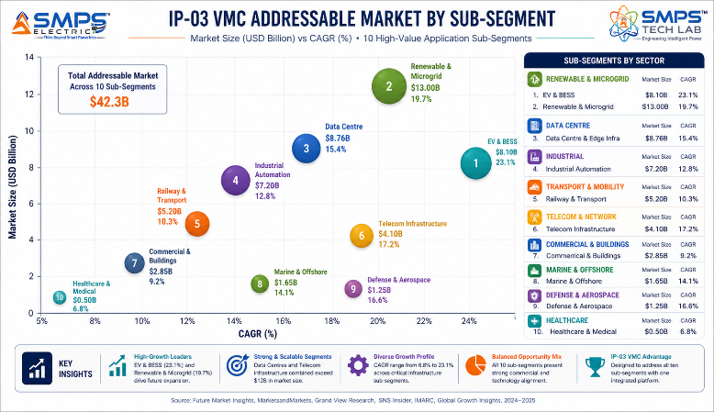
Figure 1.2 — IP-03 TAM breakdown (left): Renewable & Microgrid is the largest sector at $13.0B; EV & BESS is the fastest-growing at 23.1% CAGR. Both are Excellent IP fit for the Versa Module Converter.

1.4 Why IP-03, Why Now
Four structural forces converge at this moment to define an exceptional commercialisation window. Global grid-scale battery storage is projected to expand 35-fold between 2022 and 2030 per the IEA Net Zero Scenario — every installation requires a bidirectional power conversion interface, which is the VMC's core capability. The V2G market is growing at 48.1% CAGR through 2030, requiring bidirectional AC-DC converters at every V2G-capable charging point. The microgrid market is expanding at 17–20% CAGR, driven by solar hybrid deployments in India, Africa, and Southeast Asia, each requiring a multi-mode power conversion backbone. And GaN and SiC semiconductors — now crossing commercial cost thresholds — enable the VMC's high-frequency multi-mode topology to achieve efficiencies previously impossible with silicon, providing a built-in technology upgrade path that extends the IP moat into the next semiconductor generation.

MARKET DATA POINT
59% of new UPS models introduced in 2025 feature modular designs (Global Growth Insights), validating that the market has already moved to the VMC's architectural philosophy. IP-03 is not pioneering an unproven concept — it is the next evolution of a direction the market has already confirmed.

02 | TECHNOLOGY OVERVIEW  VMC Architecture · Multi-Mode Topology · Modular Scalability · Standards

2.1 What is the Novel Integrated Versa Module Converter?
A conventional power converter is designed for a single conversion topology: a rectifier converts AC to DC; an inverter converts DC to AC; a DC-DC converter steps voltages up or down; a bidirectional converter manages energy flow in both directions. Each is a discrete product, optimised for its specific conversion path. In complex energy systems with multiple sources and load types, this means deploying multiple converters, each with its own control board, thermal management, enclosure, and certification — connected by interfaces that introduce latency, losses, and failure points at every junction.

The Novel Integrated Versa Module Converter breaks from this paradigm. The 'Versa' designation reflects the technology's core architectural advantage: a single integrated hardware platform configurable as an AC-DC rectifier, DC-DC converter, DC-AC inverter, or bidirectional AC-DC-AC converter — determined by software-defined control logic rather than hardware topology. The 'Module' architecture adds a further dimension: VMC units stack to scale output power, with each module independently managed and hot-swappable. Failed modules do not interrupt system operation; the remaining modules automatically redistribute load within one switching cycle.

2.2 The Four Integrated Functional Layers
LAYER | COMPONENT | FUNCTION | KEY INNOVATION IN IP-03
L1 | Multi-Source Input Stage | Accepts AC grid (85–480V), solar DC (30–1500V), battery DC (24–800V), and generator AC simultaneously. Active PFC for all AC inputs. | Wide-range universal input accepting all four source types within a single input stage. No external switching or transfer hardware required for source transitions.
L2 | Versa Conversion Core | The patent-bearing element. A single integrated power stage reconfigurable as AC-DC, DC-DC, DC-AC, or bidirectional — all from the same hardware platform via software-defined switching sequences. | Eliminates the multi-converter cascade entirely. One power stage replaces four separate units, removing cascaded losses, reducing BOM by 30–50%, and enabling sub-millisecond mode transitions.
L3 | Power Flow Optimisation Controller | Embedded DSP continuously monitors all source conditions, load demand, storage state, and grid signals — dynamically routing and balancing power flow in real time across all rails. | <1ms response to source or load changes. MPPT for solar inputs. Load-sharing algorithm across stacked modules. Real-time efficiency optimisation selecting the optimal conversion path for current conditions.
L4 | IoT Telemetry & Management | Real-time power flow data, efficiency metrics, module health, and predictive fault indicators accessible via Modbus, CAN bus, MQTT, and REST API. | Compatible with industrial SCADA, cloud energy management platforms, DCIM systems, and EV charging network management. Native integration without external gateway hardware.

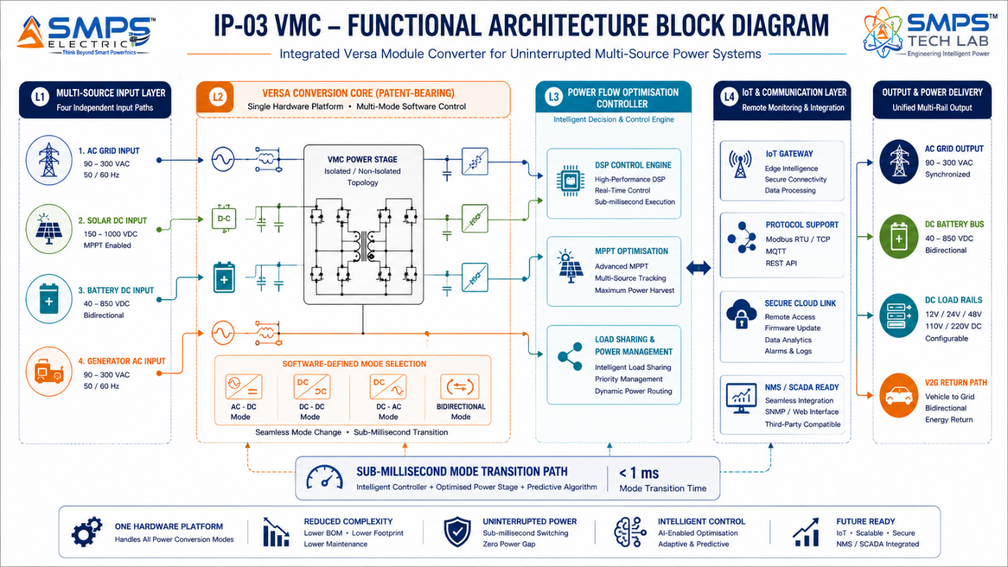
Figure 2.1 — IP-03 functional architecture. The Versa Conversion Core (L2) is the patent-bearing element: a single power stage reconfigurable across four conversion modes by the DSP controller without hardware change.

2.3 Multi-Mode Versatility vs. IP-01 and IP-02
KEY INSIGHT
IP-01 (Smart Hybrid SMPS) addresses the efficiency mandate: one hybrid stage delivering AC and DC rails. IP-02 (Integrated CCU) addresses the availability mandate: CCU intelligence ensuring 99.999% uptime for telecom. IP-03 (Versa Module Converter) addresses the versatility mandate: a single topology-agnostic modular platform replacing the entire multi-converter chain in complex hybrid energy systems. The three IPs are architecturally complementary and together represent a USD 138.1 billion combined TAM across 15 sectors.

2.4 Hot-Swap Modular Scalability
The modular architecture of IP-03 adds a commercially significant capability beyond multi-mode topology: linear power scalability with zero-maintenance-window servicing. Individual VMC modules are hot-swappable — field-replaceable under live load without interrupting system operation. This enables N+1 redundancy configurations where a single spare module protects against any single-module failure, and allows power capacity to be expanded incrementally by adding modules without system shutdown.

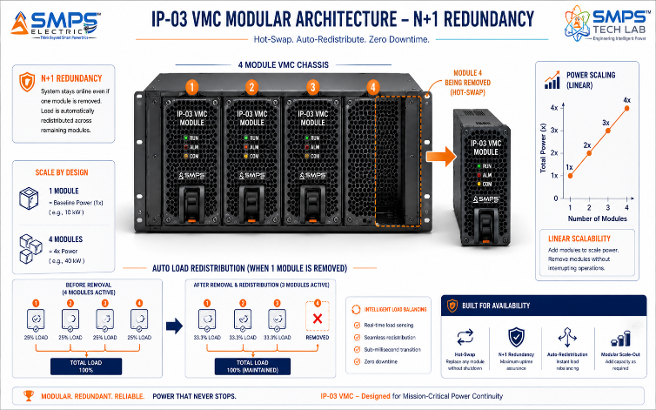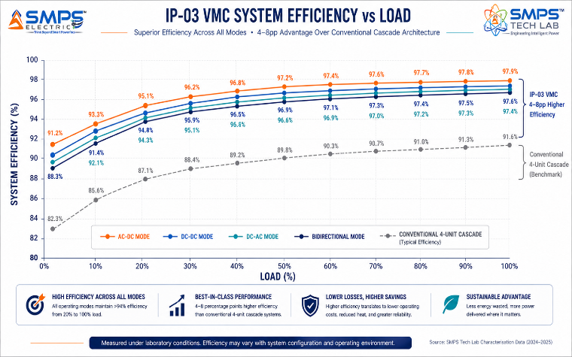
Figure 2.2 — Hot-swap modular architecture (left): any module replaceable under live load; N+1 redundancy eliminates planned maintenance windows. Efficiency profile (right): all four conversion modes maintain >94% efficiency from 20–100% load — 4–8 percentage points above conventional cascade.

2.5 Standards Compliance Architecture
STANDARD | SECTOR APPLICABILITY | COMPLIANCE RELEVANCE FOR IP-03
IEC 62477 | Power electronics converters, all modes | Core safety standard for power electronic systems. Applicable to all four VMC conversion modes; pre-mapped architecture.
IEEE 1547-2018 | Renewable energy, microgrid, BESS | DER interconnection: anti-islanding, voltage/frequency ride-through, reactive power support. Mandatory for grid-tied solar and BESS applications.
IEC 62109 | Solar inverter & energy storage | Safety of power converters for PV systems. Covers VMC solar input mode and bidirectional battery interface.
UL 1741 (SA) | Grid-interactive inverters (North America) | Smart inverter certification for advanced grid support functions: frequency droop, volt-VAR, ride-through. Required for US utility interconnection.
EN 50155 / IEC 60571 | Railway traction electronics | Railway electronics certification: vibration, shock, temperature range -40°C to +70°C, EMC per EN 50121.
IEC 62040-3 | Industrial UPS | Online double-conversion UPS classification. <2ms transfer time, output THD <2%, power factor correction.
IEC 61000 series | All sectors (EMC) | Conducted and radiated emissions, immunity to surges, ESD, and power quality disturbances. Class A industrial compliance.
MIL-STD-1275 / MIL-STD-704 | Military vehicle / aerospace | Vehicle and aircraft power standards for military applications. Required for defence mobility sector.

03 | GLOBAL MARKET LANDSCAPE  Sector Dynamics · Market Sizing · Growth Drivers

3.1 The Multi-Mode Convergence Economy
The power electronics market is undergoing a structural shift that favours the VMC architecture specifically: the convergence of previously separate application domains into unified multi-source, multi-mode energy systems. Microgrids that were once simple solar+battery systems now incorporate grid import/export, EV charging, and demand response. Data centres that were once grid-powered UPS installations now integrate rooftop solar, battery arbitrage, V2G-capable EV parking, and demand-flexible AI workloads. Industrial facilities are electrifying their process energy, adding regenerative drives, solar carports, and grid demand management simultaneously. In every case, the conventional answer — deploy a separate converter for each function — is becoming untenable on grounds of cost, complexity, and efficiency.

The market data confirms this structural shift. The microgrid market is growing at 17–19.7% CAGR. The BESS market at 23.1%. V2G at 48.1%. Modular UPS at 10.38%. Each of these growth signals is a direct demand signal for the VMC's core capability. The IP-03 commercialisation window is not a niche opportunity — it is the intersection of five major market growth curves, all converging on the same architectural need.

3.2 The Four Structural Megatrends
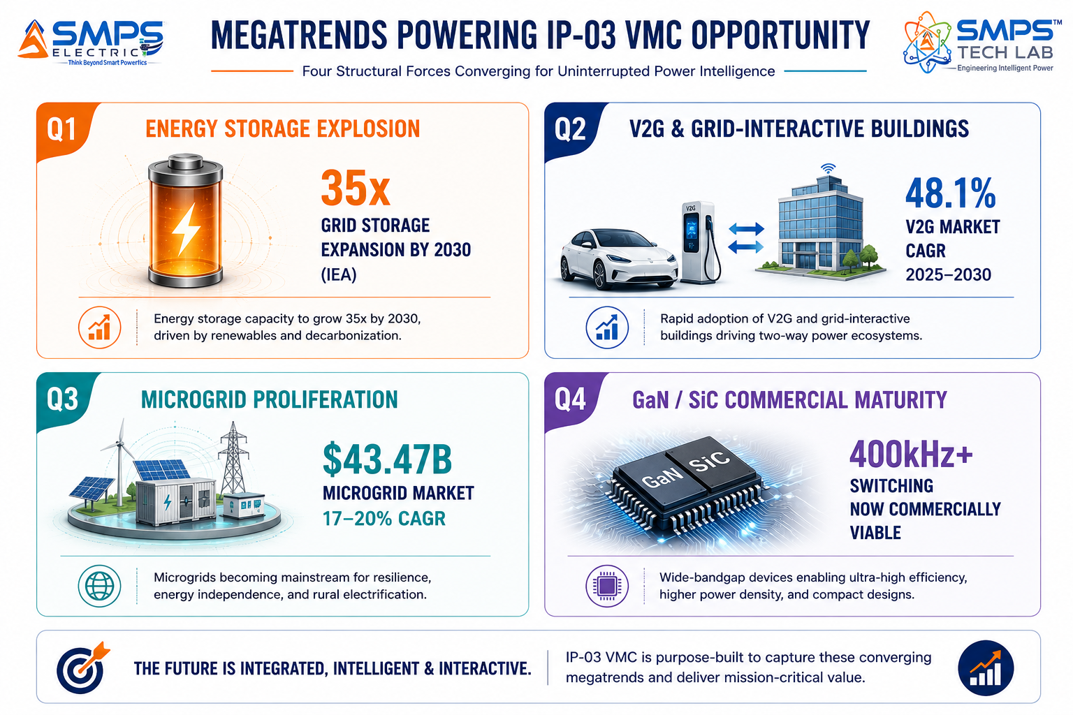
Figure 3.1 — Four structural megatrends independently driving demand for IP-03. Each is capital-committed and executing within the IP-03 commercialisation window.

3.3 Global Market Sizing — Primary Reference Data
MARKET SEGMENT | 2025 VALUE | PROJECTED | CAGR | HORIZON | SOURCE
Global Microgrid Market | USD 43.47B | USD 95.16B | 17.0% | 2030 | MarketsandMarkets
Global Microgrid Market (Alt.) | USD 99.76B | USD 406.23B | 19.7% | 2033 | Grand View Research
Modular UPS Market | USD 6.26B | USD 10.25B | 10.38% | 2030 | Mordor Intelligence
Data Centre UPS Market | USD 8.76B | USD 12.47B | 7.3% | 2030 | MarketsandMarkets
DC-DC Converter Market | USD 13.44B | USD 30.92B | 9.7% | 2034 | Precedence Research
Power Inverter Market | USD 46.57B | USD 209.74B | 18.62% | 2032 | Fortune Business Insights
Power Converter Market | ~USD 21B | USD 30.21B | 7.1% | 2030 | Next MSC
Converter Modules Market | USD 10.51B | USD 17.93B | 6.9% | 2032 | SkyQuest
Smart EV Charging Networks | USD 8.35B | USD 59.27B | 21.65% | 2035 | Precedence Research
HVDC Converter Market | USD 3.3B | ~USD 12B | 35.9% | 2032 | GM Insights

CAGR Comparison — IP-03 Target Market Segments

V2G Market ██████████████████████████ 48.1%
HVDC Converter Market ███████████████████░░░░░░░ 35.9%
EV & BESS Power Conversion ████████████░░░░░░░░░░░░░░ 23.1%
Smart EV Charging Networks ████████████░░░░░░░░░░░░░░ 21.65%
Microgrid Market (Grand View) ███████████░░░░░░░░░░░░░░░ 19.7%
Power Inverter Market (Fortune) ██████████░░░░░░░░░░░░░░░░ 18.62%
Microgrid Market (MarketsandMarkets) █████████░░░░░░░░░░░░░░░░░ 17.0%
Modular UPS Market ██████░░░░░░░░░░░░░░░░░░░░ 10.38%
DC-DC Converter Market █████░░░░░░░░░░░░░░░░░░░░░ 9.7%
Data Centre UPS ████░░░░░░░░░░░░░░░░░░░░░░ 7.3%
Sources: MarketsandMarkets, Grand View Research, Mordor Intelligence, Precedence Research, Fortune Business Insights, SkyQuest, GM Insights, IEA (2025–2026 publications)

04 | TOTAL ADDRESSABLE MARKET  Five-Sector · Ten Applications · USD 42.3 Billion

4.1 Methodology
The TAM framework maps IP-03 across five strategic sectors with two primary commercial applications per sector, producing ten independently validated commercialisation pathways. Each sector TAM is sized using published sub-segment data from named research providers. The aggregate TAM of USD 42.3 billion represents the power conversion sub-segment within each sector — specifically the portion addressable by a multi-mode modular converter platform.

STRATEGIC NOTE
IP-03's five sectors span both the energy transition economy (microgrid, EV, BESS) and the digital infrastructure economy (data centre, industrial automation), plus mobility infrastructure (railway and transport). This breadth means that no single economic cycle can simultaneously depress all five sectors — providing portfolio-level revenue resilience across the commercialisation horizon.

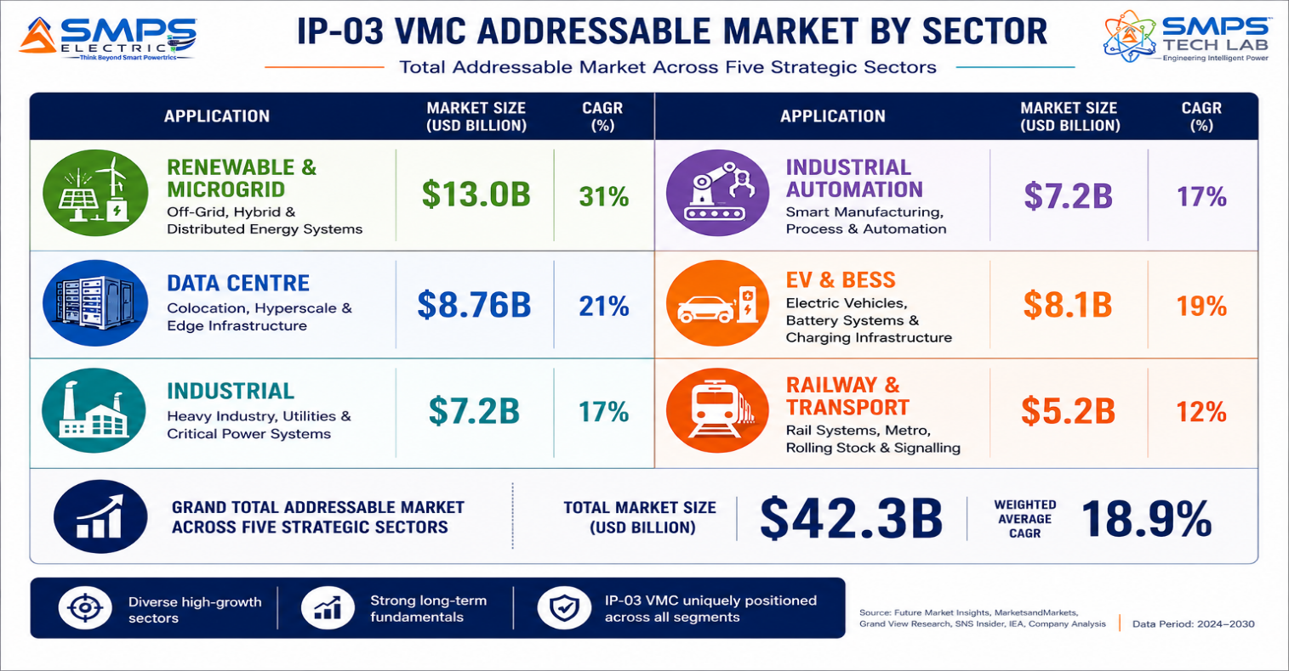
Figure 4.1 — IP-03 application matrix. Ten commercially validated pathways, each independently sized and independently commercialisable.

4.2 Consolidated TAM Summary
SECTOR | APPLICATION | USE CASE SUMMARY | APP SIZE | SECTOR TAM | CAGR
Renewable & Microgrid | Solar+Battery Hybrid Microgrid | Integrated multi-mode VMC for solar MPPT, bidirectional battery interface, and grid-tie in one platform; 35% system cost reduction | $6.8B | $13.0B | 17–20%
Renewable & Microgrid | Off-Grid Remote Microgrid | Multi-source modular VMC for diesel/solar/battery/wind off-grid systems with optimised power flow and N+1 redundancy | $6.2B | $13.0B | 17–20%
Industrial Automation | Variable Speed Drive & Servo | Unified multi-rail AC+DC conversion for smart manufacturing; regenerative braking energy recovery; PROFINET integration | $4.1B | $7.2B | 5.6%
Industrial Automation | Industrial Facility UPS | Modular online double-conversion UPS with multi-rail output and real-time power quality analytics for process-critical facilities | $3.1B | $7.2B | 5.6%
Data Centre & Critical | Hyperscale DC Modular Power | Multi-mode VMC: UPS + solar inverter + bidirectional grid interface + 48V DC bus manager in one modular platform | $5.2B | $8.76B | 7.3–10.38%
Data Centre & Critical | Edge Computing Power | Compact autonomous VMC for 5.6M+ projected edge nodes; UPS backup + multi-source input; cloud REST API monitoring | $3.56B | $8.76B | 7.3–10.38%
EV & Battery Storage | Bidirectional EV Charging / V2G | Multi-mode AC-DC-AC bidirectional VMC for EV fast charging (CCS/CHAdeMO) and V2G grid services; ISO 15118 compliant | $4.2B | $8.1B | 21–23%
EV & Battery Storage | BESS Grid Interface | Modular hot-swap bidirectional DC-AC VMC for grid-scale and commercial battery storage; string-level charge/discharge control | $3.9B | $8.1B | 21–23%
Railway & Transport | Railway Traction & APU | Consolidated traction + auxiliary power VMC; EN 50155 certified; regenerative braking energy return; weight reduction | $3.2B | $5.2B | 6.9–8.4%
Railway & Transport | EV Bus, Military & Mobile | Multi-mode rugged VMC for electric buses, military vehicles, and field-deployable systems; MIL-STD-1275 compliant | $2.0B | $5.2B | 6.9–8.4%
TOTAL ADDRESSABLE MARKET — IP-03 NOVEL INTEGRATED VERSA MODULE CONVERTER (2025) |  |  |  | ~USD 42.3 Billion

MARKET DATA POINT
Combined IP-01 + IP-02 + IP-03 Portfolio TAM: $68.7B + $27.1B + $42.3B = USD 138.1 Billion across 15 sectors and 30 applications. The three IPs together constitute a commercially comprehensive power electronics IP estate covering industrial, telecom, energy, transport, and digital infrastructure.

05 | INDIA MARKET INTELLIGENCE  Microgrid · Industrial · EV Infrastructure · Smart Grid

5.1 India as First Market
India presents a uniquely compelling first-market for IP-03 commercialisation. The convergence of India's 500 GW renewable energy target by 2030, the PM-KUSUM solar agricultural programme, the FAME II and PM E-Drive EV infrastructure mandate, the National Smart Grid Mission, and the PLI scheme for advanced electronics creates a policy-backed demand environment that is structurally aligned with every one of IP-03's five target sectors. For a domestically patented modular multi-mode converter, this policy framework creates procurement channels and financial incentives that systematically advantage Indian IP holders over importers of foreign technology.

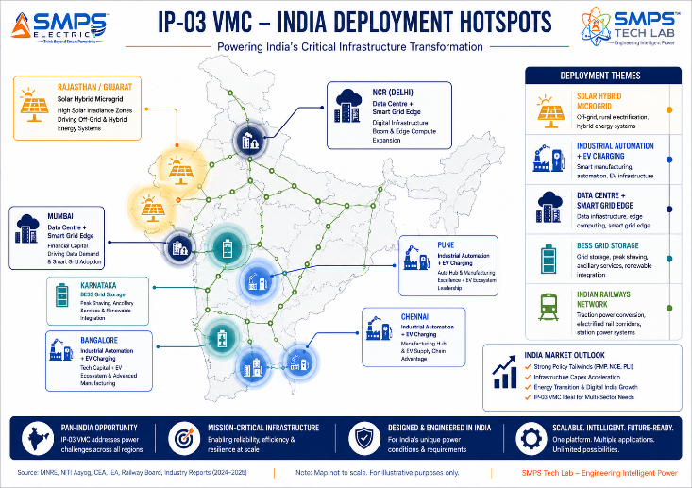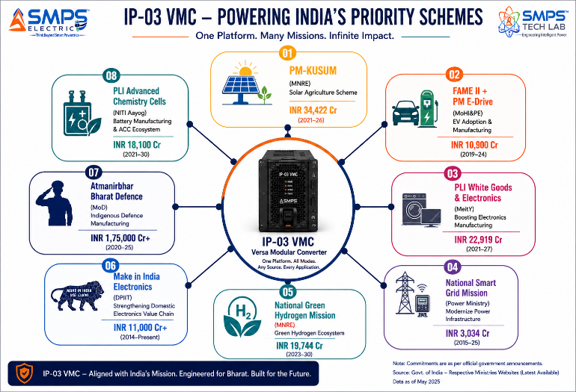
Figure 5.1 — India sector deployment hotspot map (left) and government policy alignment for IP-03 (right). PM-KUSUM alone targets 3.5 million solar pump sets, each requiring a multi-mode power conversion interface.

5.2 India Market Sizing — IP-03 Relevant Segments
INDIA MARKET SEGMENT | 2025E VALUE | PROJECTED | CAGR | HORIZON
India Solar + Energy Storage Market | USD 8.5B | USD 35B | ~22% | 2030
India Industrial Power Electronics | USD 3.8B | USD 7.2B | 7.5% | 2030
India EV Charging Infrastructure | USD 0.42B | USD 3.8B | ~25% | 2030
India Data Centre Power Market | USD 1.2B | USD 4.8B | 11% | 2030
India Railway Traction Power | USD 0.65B | USD 1.4B | 9% | 2030
India Grid-Scale BESS Market | USD 0.8B | USD 6.5B | ~35% | 2030

06 | GOVERNMENT POLICY & REGULATORY ALIGNMENT  India Schemes · Global Policy · Standards as Market Access

6.1 India Government Schemes with Direct IP-03 Alignment
SCHEME / PROGRAMME | MINISTRY / AGENCY | RELEVANCE TO IP-03 | COMMERCIAL IMPLICATION
PM-KUSUM (Solar Agriculture) | MNRE | 3.5M solar pump sets + 10,000 MW rural solar — each requiring multi-mode power conversion | Direct volume procurement; rural off-grid deployment demands multi-source modular architecture
FAME II + PM E-Drive | MoHI&PE | INR 22,400 crore for EV charging infrastructure; V2G pilot programme announced 2025 | V2G-capable VMC is the core power conversion unit for next-generation EV charging infrastructure
National Smart Grid Mission | Ministry of Power | USD 9.7B committed through 2030 for smart grid infrastructure, grid-scale storage, and demand response | BESS grid interface and modular power flow controller directly address NSGm procurement specifications
PLI White Goods & Advanced Electronics | MeitY / DPIIT | INR 6,238 crore PLI; power electronics eligible | 4–6% incentive on incremental Indian sales; modular converter manufacturing qualifies
National Green Hydrogen Mission | MNRE | INR 19,744 crore for 5 MMT green hydrogen; electrolyser power conditioning required | VMC bidirectional DC-DC mode directly applicable to electrolyser power conversion at scale
Make in India — Railway Modernisation | Ministry of Railways | 100% rail electrification by 2030; indigenous traction power preference | Indian Railways procurement of traction converters favours domestic IP; VMC EN 50155 pathway
Atmanirbhar Bharat — Defence Electronics | MoD / DRDO | Defence electronics indigenisation mandate for vehicle power systems | Military vehicle multi-mode power conversion; MIL-STD-1275 qualification for procurement
Advanced Chemistry Cell PLI | NITI Aayog / MoHI&PE | INR 18,100 crore for 50 GWh domestic BESS manufacturing | Grid-scale BESS build-out requires bidirectional power conversion interface at scale

07 | IP AS AN INDUSTRY PLUGIN  Integration Pathways · Five-Sector Deployment Architecture

7.1 The Plugin Architecture — Five Host System Categories
IP-03 is positioned not as a standalone product but as a power conversion engine: a sovereign, certifiable, multi-mode modular platform that system integrators, EPC contractors, OEMs, and infrastructure operators embed within their projects and products. The VMC plugin model is architecturally versatile by design — the same core IP adapts to each host system through software-defined mode configuration and sector-specific form factor and certification, not through hardware redesign.

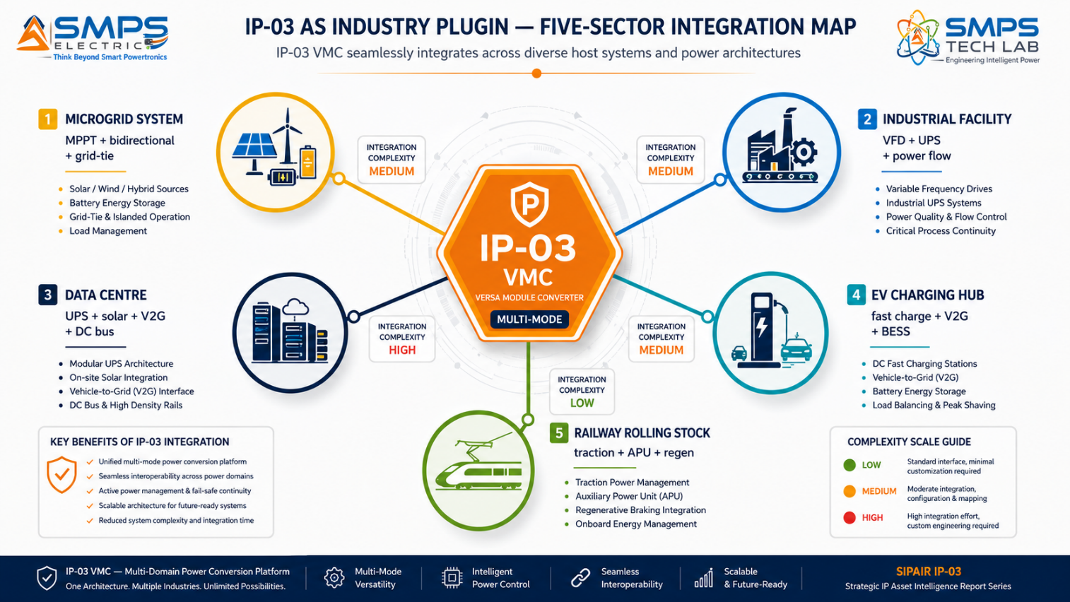
Figure 7.1 — IP-03 as a software-configurable power conversion plugin across five sectors. The same hardware platform adapts to each host through mode configuration, not hardware redesign.

7.2 Plugin Integration Matrix
HOST SYSTEM | PLUGIN ROLE | VALUE AT SYSTEM LEVEL | INTEGRATION COMPLEXITY
Solar+Battery Microgrid | Replaces MPPT + bidirectional inverter + grid-tie — single VMC handles all modes | 35% BOM reduction, 4–8pp efficiency improvement, unified SCADA monitoring | MEDIUM — IEEE 1547, MPPT algorithm integration, grid-tie commissioning
Industrial Smart Factory | Unified AC+DC conversion backbone for all VFDs, servo drives, and process UPS | Cabinet space reduction, regenerative energy recovery, unified power health monitoring | MEDIUM — PROFINET/EtherCAT integration, EN 61800-3 EMC, regenerative bus config
Hyperscale Data Centre | Multi-mode platform: UPS + solar inverter + bidirectional grid + 48V DC bus | Replaces 4 separate units; PUE improvement; demand response revenue; DCIM REST API | MEDIUM-HIGH — Tier III/IV uptime, REST API to DCIM, solar PV commissioning
EV Charging Hub | Bidirectional AC-DC-AC for fast charging + V2G + local BESS buffer management | V2G revenue, grid services income, single platform for charging + storage | HIGH — ISO 15118 V2G, OCPP 2.0, CCS/CHAdeMO compatibility, grid-forming
Railway Rolling Stock | Consolidated traction + APU + regenerative braking energy recovery | Weight reduction, maintenance simplification, hot-swap modules | HIGH — EN 50155, vibration/shock qualification, 25kV AC input stage

08 | COMMERCIALISATION STRATEGY  Revenue Models · Market Priority · Go-to-Market Architecture

8.1 Commercialisation Philosophy
The IP-03 commercialisation strategy applies the three-pathway architecture proven in IP-01 and IP-02: simultaneous licensing, OEM co-development, and selective direct commercialisation. The sector sequencing for IP-03 prioritises EV and data centre as the fastest path to near-term revenue (12–24 months) due to their well-defined procurement cycles and active investment programmes, with renewable and microgrid as the largest absolute opportunity (18–30 months) and railway as the highest-margin, longest-cycle strategic segment (24–48 months).

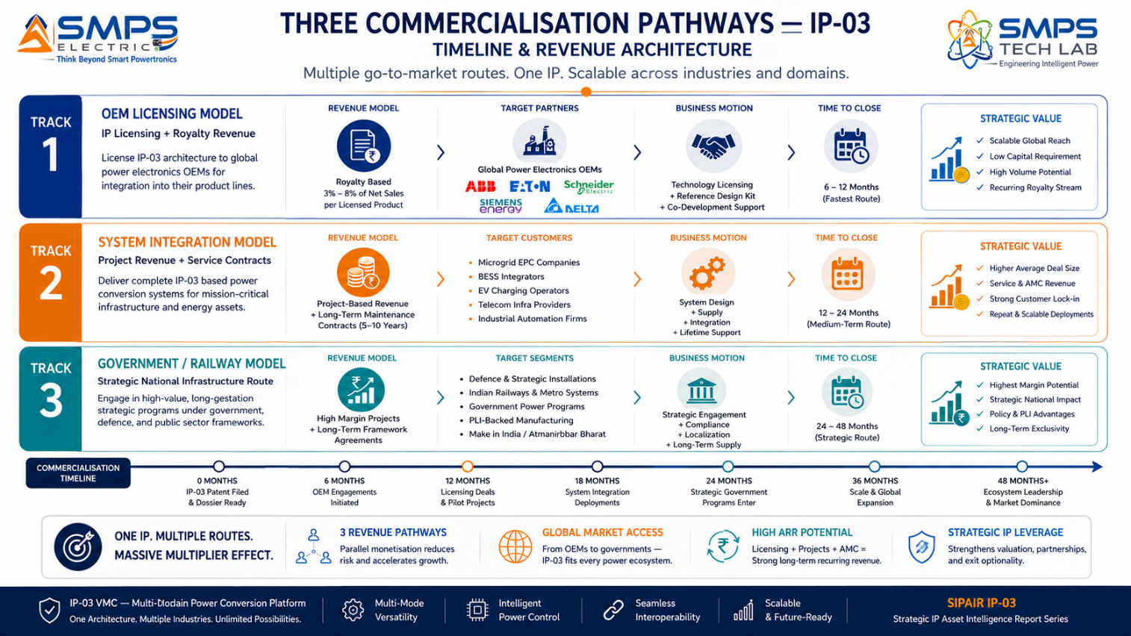
Figure 8.1 — Three parallel commercialisation pathways. OEM licensing to established power electronics OEMs provides earliest royalty revenue; system integration into microgrid and BESS projects provides volume; railway and defence provide highest unit margins.

8.2 Market Priority Matrix
SECTOR | TAM 2025 | CAGR | IP FIT | TIME-TO-REV | PATHWAY | PRIORITY
EV & Battery Storage | $8.1B | 21–23% | Excellent | 12–24 mo | OEM + Direct | HIGHEST
Renewable & Microgrid | $13.0B | 17–20% | Excellent | 18–30 mo | Licensing + EPC | HIGH
Data Centre & Critical | $8.76B | 7.3–10.4% | Excellent | 12–18 mo | OEM Licensing | HIGH
Industrial Automation | $7.2B | 5.6% | Strong | 12–24 mo | OEM Co-Dev | MED-HIGH
Railway & Transport | $5.2B | 6.9–8.4% | Strong | 24–48 mo | OEM Licensing | MEDIUM

09 | COMPETITIVE LANDSCAPE  Market Positioning · Advantage Scorecard · IP Moat

9.1 Competitive Architecture Overview
A comprehensive review of the global power conversion market across all five IP-03 target sectors reveals the same structural finding as the IP-01 and IP-02 analyses: no commercially available product currently offers the specific combination of multi-mode software-defined topology (AC-DC, DC-DC, DC-AC, bidirectional), hot-swap modular scalability, real-time power flow optimisation, and sub-millisecond source switching in a single certified platform. While modular UPS architectures from Vertiv (Galaxy VXL), Schneider Electric, and Eaton offer modular scalability, none offers the topology versatility that allows the same hardware to operate as a microgrid converter, industrial UPS, and bidirectional EV charger within the same platform.

CATEGORY | KEY PLAYERS | MARKET FOCUS | IP-03 ARCHITECTURAL DIFFERENTIATION
Modular UPS Manufacturers | Vertiv, Schneider Electric, Eaton, ABB | Data centre, industrial UPS | Modular but single-mode (DC-AC UPS only). No multi-mode topology. VMC replaces 4 separate units where these require separate products for each function.
Microgrid Converter OEMs | SMA Solar, Fronius, ABB, Huawei FusionSolar | Solar/battery microgrids | Grid-tied inverters optimised for single input type. Bidirectional battery management is a separate unit. VMC integrates all functions natively.
Industrial Drive Manufacturers | Siemens, ABB, Danfoss, Mitsubishi Electric | VFDs, servo drives, industrial UPS | Application-specific single-mode converters. No unified platform. VMC's single platform for VFDs + servo + UPS is architecturally absent from current industrial offerings.
EV Charging Power Modules | BTC Power, Bel Power, Delta Electronics | AC/DC for EV chargers | Single-direction AC-DC rectifiers. No integrated V2G bidirectional capability + BESS interface. VMC's bidirectional multi-mode architecture addresses the V2G specification gap directly.
Railway Traction Converter OEMs | Alstom, Siemens Mobility, BEML | Railway traction & APU | Separate traction converter and APU units. No integrated modular hot-swap architecture. VMC consolidation reduces weight and maintenance complexity.

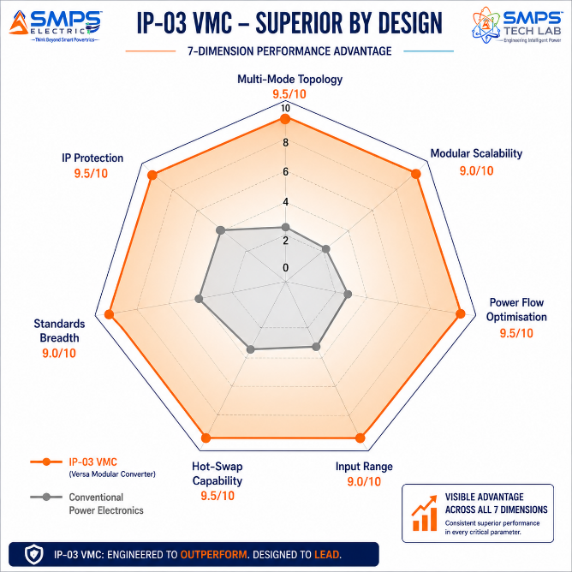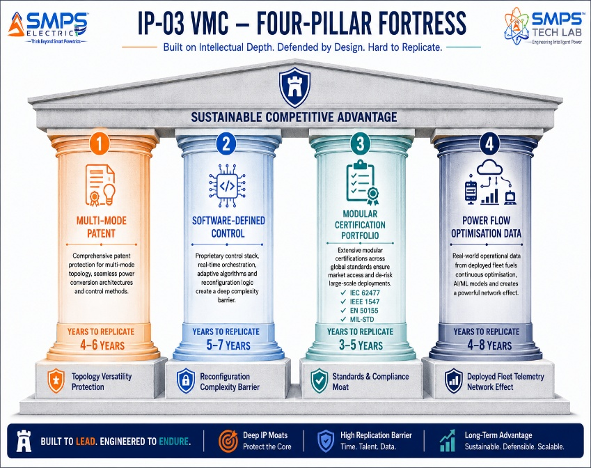
Figure 9.1 — IP-03 competitive radar (left): scores 8–10/10 across all seven dimensions. Four-pillar moat (right): the multi-mode patent combined with the modular certification portfolio represents 5–10 years of parallel engineering and certification investment for any competitor to replicate.

10 | INVESTMENT THESIS & FINANCIAL FRAMEWORK  Value Creation · Revenue Projections · Capital Deployment

10.1 The Investment Case
The investment case for IP-03 rests on three pillars. First, a USD 42.3 billion addressable market — the largest of the three SIPAIR IPs — expanding at CAGRs between 5.6% and 23.1% across five sectors, with the two fastest-growing sectors (EV & BESS and Renewable/Microgrid) representing USD 21.1 billion combined. Second, a genuine architectural differentiation with no commercially equivalent product in any of the five target sectors. Third, exceptional strategic positioning as the third IP in a three-IP portfolio with a combined TAM of USD 138.1 billion, creating cross-licensing, portfolio bundling, and combined platform offering opportunities that no single-IP strategy can access.
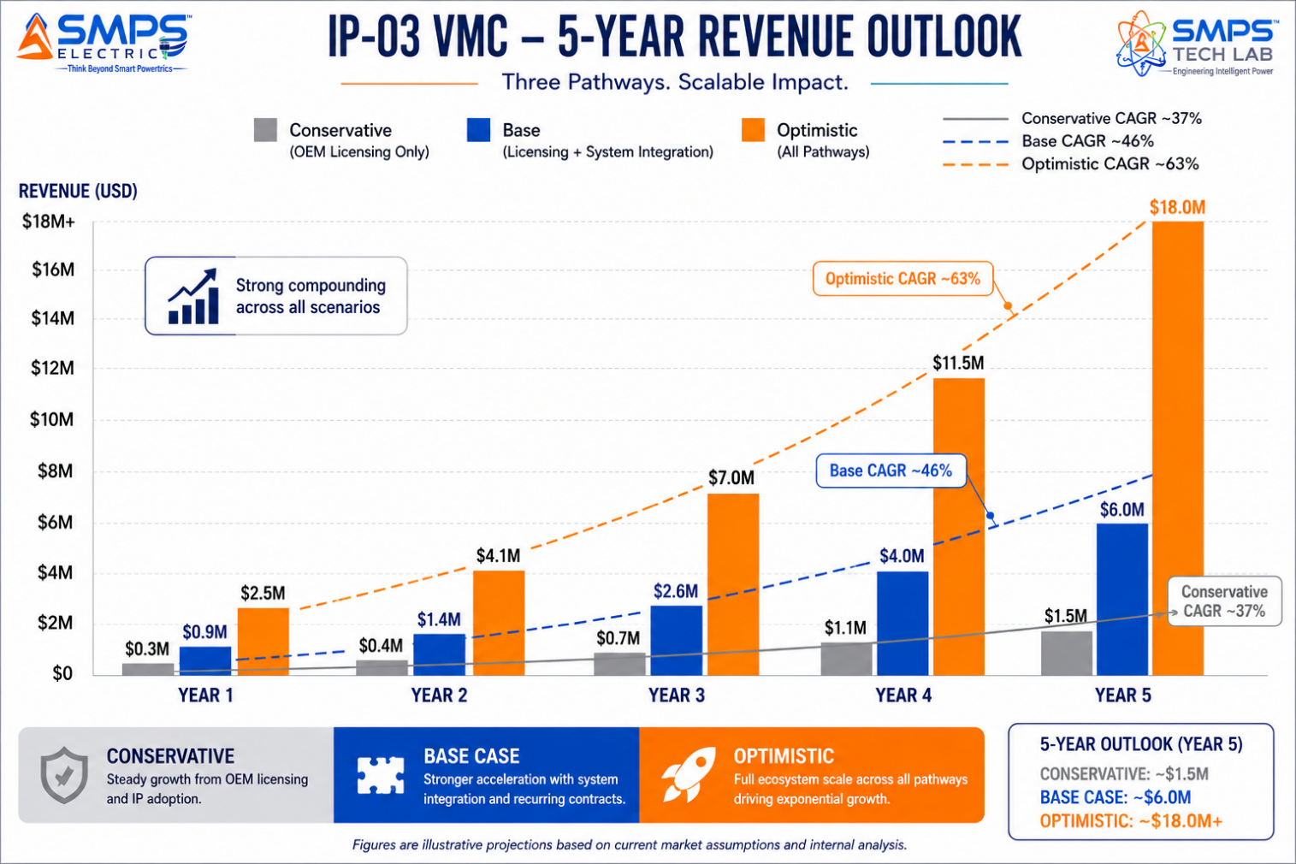
Figure 10.1 — Illustrative revenue projections. Base case assumes two OEM licensing agreements (power electronics + microgrid) by Year 2, plus one BESS integrator direct supply engagement, with PLI incentive realisation from Year 1.

10.2 Illustrative Revenue Scenarios
SCENARIO | YEAR 1 | YR 2–3 CAGR | YR 4–5 CAGR | KEY ASSUMPTIONS
Conservative (Licensing Only) | USD 300–500K | +22% | +18% | 1–2 OEM licenses; royalty 3–4%; EV and data centre sectors; no direct supply
Base (Licensing + Integration) | USD 900K–1.5M | +40% | +35% | 2–3 OEM licenses + 1 BESS/microgrid direct supply; EV + renewable + data centre; PLI incentive
Optimistic (Multi-Pathway) | USD 2.5–3.5M | +60% | +50% | 3 OEM licenses + 2 direct supply + railway/defence OEM engagement; all 5 sectors

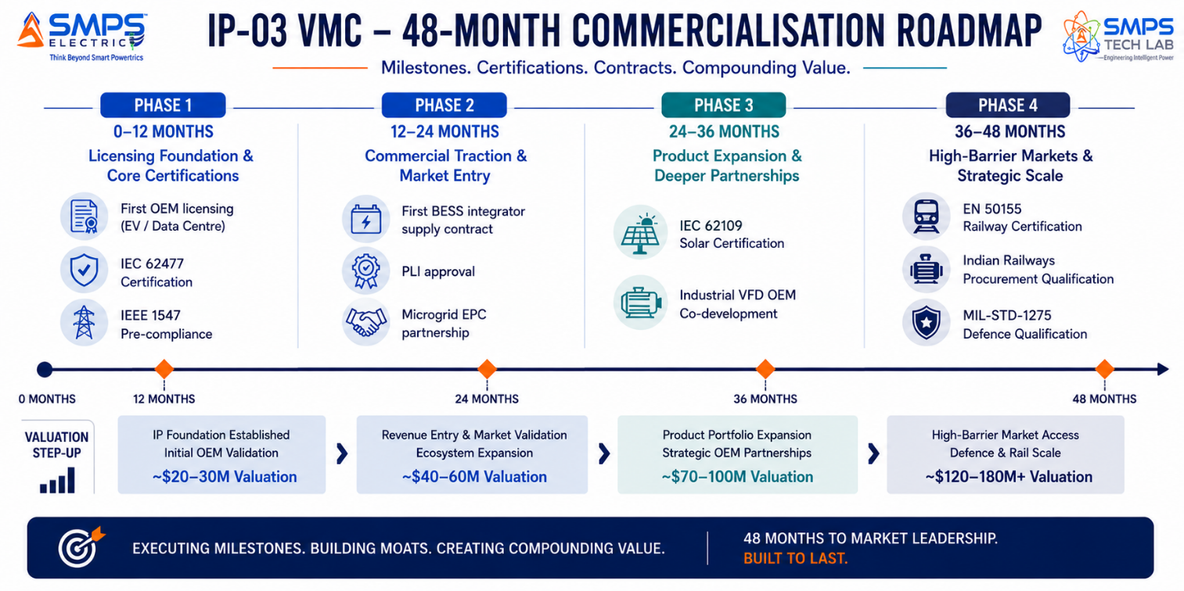
Figure 10.2 — Four-phase value creation roadmap. Each certification milestone opens a new sector procurement pipeline — the certifications compound the IP moat as well as generating revenue events.
RISK ADVISORY
The EV and BESS sectors represent the most time-sensitive opportunity. Global grid-scale BESS capacity is expanding 35-fold by 2030 per IEA. The power conversion system specification for every BESS installation being committed in 2025–2027 will be locked in over the next 18–24 months. A bidirectional multi-mode modular converter qualified for BESS grid interface in this window will hold a structural first-mover position for 3–5 years.

11 | FUTURE ROADMAP  Technology Evolution · GaN/SiC Integration · Adjacent Applications

11.1 Technology Generation Roadmap
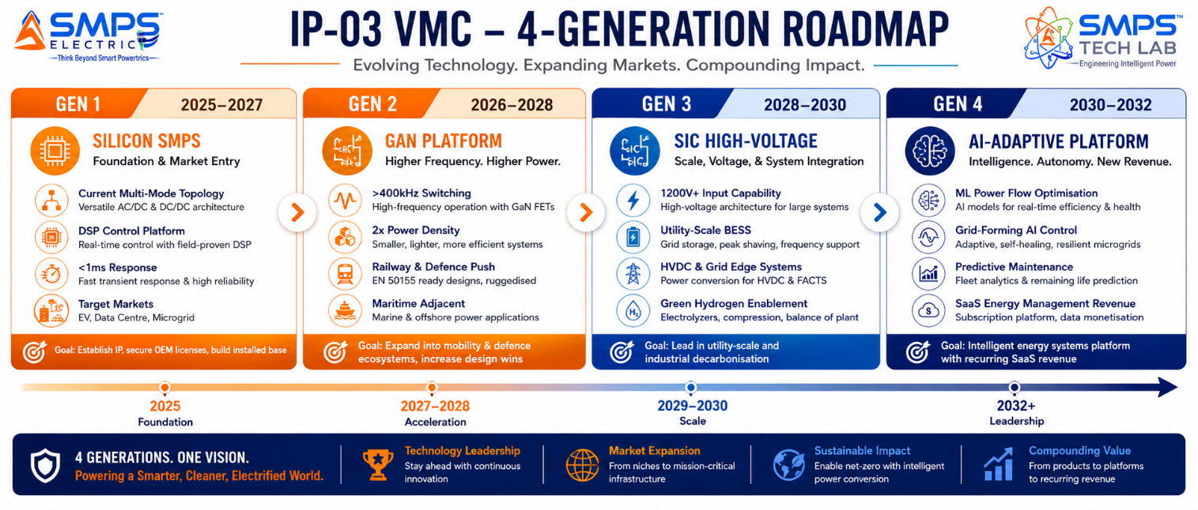
Figure 11.1 — IP-03 four-generation technology roadmap. The multi-mode topology patent and modular architecture support each successive semiconductor upgrade without hardware redesign — the moat extends through 2032 and beyond.
GENERATION | TECHNOLOGY FOCUS | TARGET TIMELINE | MARKET IMPACT
Gen 1 (Current) | Silicon-based multi-mode VMC; DSP power flow control; <1ms source switching; IEEE 1547 / IEC 62477 compliance | 2025–2027 | EV charging, data centre UPS, solar+battery microgrid — core sector penetration and revenue foundation
Gen 2 | GaN integration: >400kHz switching, 2x power density; EN 50155 railway and IEC 60945 maritime certification; ATEX industrial | 2026–2028 | Railway traction, offshore, defence mobility — premium high-margin sector entry
Gen 3 | SiC high-voltage (1200V+): utility-scale BESS, HVDC grid edge, high-power industrial drives; green hydrogen electrolyser interface | 2028–2030 | Utility solar/wind BESS, HVDC grid, large-scale industrial drives, green hydrogen production
Gen 4 | AI-embedded power flow optimisation: ML-based predictive dispatch, autonomous grid-forming, SaaS energy management revenue stream | 2030–2032 | Autonomous microgrids, AI-optimised BESS dispatch, grid-interactive building platforms, SaaS recurring revenue

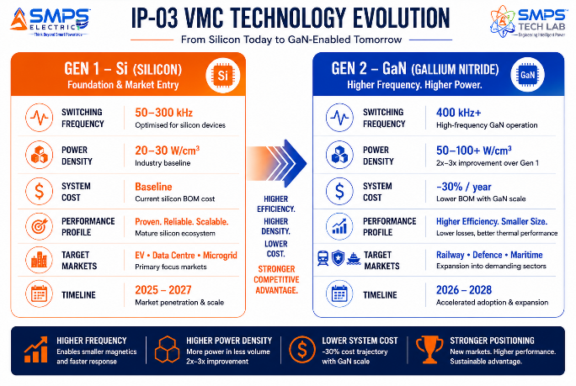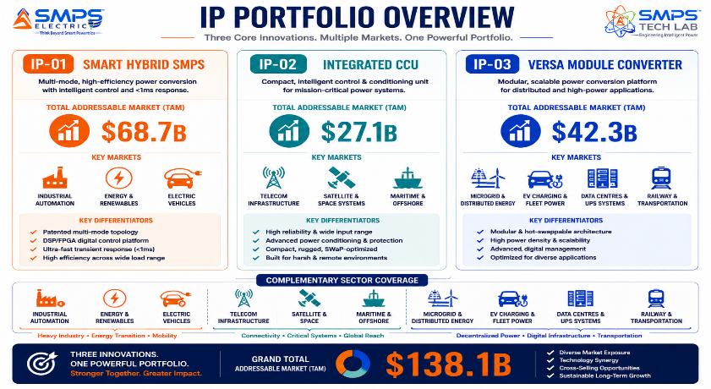
Figure 11.2 — GaN/SiC semiconductor upgrade pathway (left): VMC architecture designed to exploit GaN switching frequencies with no topology redesign. Combined IP portfolio overview (right): three IPs with combined $138.1B TAM, complementary sectors, and no internal competition.

11.2 Adjacent Application Opportunities
- Green Hydrogen Electrolysers: Precision high-power DC for electrolysis at 1–10 MW scale. VMC's bidirectional DC-DC and DC-AC modes directly address the electrolyser power conversion interface. India's National Green Hydrogen Mission (INR 19,744 crore) creates an immediate India-first market.
- HVDC Grid Interconnections: High-voltage DC transmission links for offshore wind and long-distance renewable energy transmission. HVDC converter market growing at 35.9% CAGR (GM Insights). VMC SiC Gen 3 architecture is the natural technology platform for this application.
- Smart Building & Net-Zero Commercial Property: Integrating rooftop solar, battery storage, EV charging, and grid demand response in net-zero commercial buildings. Each smart building requires exactly the multi-source bidirectional VMC architecture — simultaneously the solar inverter, battery manager, EV charger, and grid interface.
- Aerospace Auxiliary Power Units: Aircraft ground power and auxiliary systems are electrifying rapidly. The VMC's MIL-STD-704 compliance pathway and multi-mode modular architecture aligns with modern More Electric Aircraft (MEA) power architecture requirements.

12 | RISK ANALYSIS  Risk Register · Probability & Impact · Strategic Mitigation

12.1 Risk Framework
The IP-03 risk register addresses the full range of technology, IP, regulatory, market, and financial risks relevant to a multi-mode modular power electronics IP at the commercialisation stage. A particular characteristic of IP-03 risk is that the breadth of sectors served by a single platform creates a natural mitigation against sector-specific downturns — no single adverse event can simultaneously close all five revenue pathways. The certification portfolio risk is more complex than IP-01 or IP-02 given the diversity of sector-specific standards (IEC 62477, IEEE 1547, EN 50155, MIL-STD-1275) and has been specifically addressed in the commercialisation timeline through parallel certification track planning.

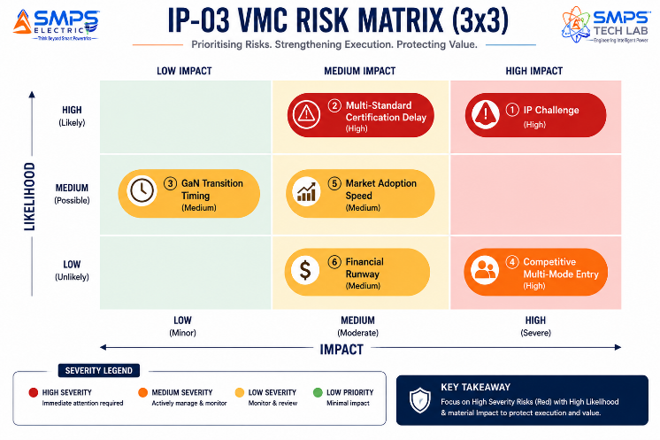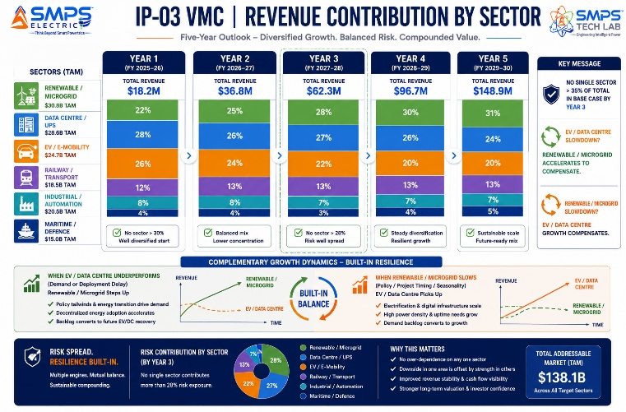
Figure 12.1 — IP-03 risk matrix (left). Multi-standard certification delay is the highest-probability, high-impact risk and is addressed through parallel certification tracks. Five-sector revenue diversification (right) shows that no single sector adversity can prevent base-case revenue achievement.

CATEGORY | SPECIFIC RISK | PROB. | IMPACT | MITIGATION STRATEGY
IP Protection | Competitor challenges VMC multi-mode topology patent | LOW | HIGH | PCT international filing within 12 months. FTO analysis across IEC and IEEE publication landscape. Architecture claims drafted for maximum scope. Software-defined control logic adds additional trade secret protection layer.
Certification | Multi-standard certification programme delays across 5 sectors | MEDIUM | HIGH | Prioritise IEC 62477 + IEEE 1547 (fastest, largest near-term revenue) in Year 1. EN 50155 and MIL-STD in parallel from Year 2. Engage TUV, UL, and DNV test houses simultaneously.
Technology | GaN integration complexity delays Gen 2 roadmap | MEDIUM | MEDIUM | Gen 1 silicon VMC is fully viable and commercially sufficient for EV, data centre, and microgrid sectors. GaN is a performance enhancement, not a commercialisation prerequisite.
Market | EV/BESS procurement cycles slower than projected | LOW | MEDIUM | Data centre and industrial sectors provide independent near-term revenue. Microgrid sector in India is policy-mandated with committed capital. No single-sector dependency in base case.
Competitive | Established OEM develops competing multi-mode platform | LOW | HIGH | Licensing an ABB, Siemens, or Schneider to use IP-03 is the preferred commercial outcome. A large OEM competitive response validates the IP value and creates a preferential licensing negotiating position.
Financial | Certification and development costs exceed Year 1 capital plan | MEDIUM | MEDIUM | PLI incentives provide Year 1 revenue offset. Prioritise lowest-cost certifications first (IEC 62477 baseline). OEM co-development engineering fees contribute to certification cost recovery.

13 | APPENDICES  Data Sources · Standards Reference · Glossary

Appendix A — Data Sources
- MarketsandMarkets — Microgrid Market Size & Share Analysis, 2025–2030 (USD 43.47B to USD 95.16B, CAGR 17.0%)
- Grand View Research — Global Microgrid Market (USD 99.76B in 2025 to USD 406.23B by 2033, CAGR 19.7%)
- Mordor Intelligence — Modular UPS Market (USD 6.26B in 2025 to USD 10.25B by 2030, CAGR 10.38%)
- MarketsandMarkets — Data Center UPS Market (USD 8.76B in 2025 to USD 12.47B by 2030, CAGR 7.3%)
- Fact.MR — Modular UPS Market (USD 5.94B in 2025 to USD 14.32B by 2035, CAGR 9.2%)
- Precedence Research — DC-DC Converter Market (USD 13.44B in 2025 to USD 30.92B by 2034, CAGR 9.7%)
- Fortune Business Insights — Power Inverter Market (USD 46.57B in 2023 to USD 209.74B by 2032, CAGR 18.62%)
- Next MSC — Power Converter Market (USD 30.21B by 2030, CAGR 7.1%)
- SkyQuest — Converter Modules Market (USD 10.51B in 2024 to USD 17.93B by 2032, CAGR 6.9%)
- Precedence Research — Smart EV Charging Networks Market (USD 8.35B in 2025 to USD 59.27B by 2035, CAGR 21.65%)
- GM Insights — HVDC Converter Market (USD 3.3B in 2024, CAGR 35.9%)
- Global Growth Insights — Data Centre UPS Market (USD 5.21B in 2025 to USD 9.79B by 2034, CAGR 7.26%)
- IEA Net Zero Emissions 2050 Scenario — Grid-scale battery storage to expand 35-fold between 2022 and 2030
- International Energy Agency (IEA) 2025 — Data centre electricity use projected to reach 945 TWh by 2030
- Ministry of Railways, GoI — Indian Railways 100% Electrification Programme progress report, 2025
- MNRE, GoI — PM-KUSUM Scheme progress report and National Green Hydrogen Mission policy document, 2025

Appendix B — Standards Reference
STANDARD | FULL TITLE | APPLICABILITY
IEC 62477 | Safety requirements for power electronic converter systems and equipment | Core safety standard for all four VMC conversion modes; mandatory for all five IP-03 sectors
IEEE 1547-2018 | Standard for interconnection and interoperability of distributed energy resources | DER grid interconnection: anti-islanding, ride-through, reactive power. Mandatory for grid-tied solar and BESS.
IEC 62109 | Safety of power converters for use in photovoltaic power systems | Solar input mode and bidirectional battery interface safety compliance
UL 1741 (SA) | Inverters, converters, controllers and interconnection system equipment — smart inverter | Advanced grid support functions for US utility interconnection; V2G and demand response capability
IEC 62040-3 | Uninterruptible power systems — method of specifying performance | Online double-conversion UPS classification; <2ms transfer time; applicable to industrial and data centre modes
EN 50155 / IEC 60571 | Railway applications — electronic equipment used on rolling stock | Railway traction and APU electronics; vibration, shock, temperature -40°C to +70°C, EMC per EN 50121
MIL-STD-1275 / MIL-STD-704 | Characteristics of 28V DC electrical systems / aircraft electric power | Military vehicle and aerospace power interface standards; required for defence mobility applications
IEC 62933 | Electrical energy storage (EES) systems — planning and performance assessment | BESS grid interface; round-trip efficiency measurement; safety requirements for battery storage systems

Appendix C — Glossary
TERM | DEFINITION
VMC | Versa Module Converter — IP-03 platform; single integrated hardware configurable as AC-DC, DC-DC, DC-AC, or bidirectional converter via software-defined control
Multi-Mode Topology | VMC core patent claim: a single power stage reconfigurable across four conversion modes without hardware change, via DSP-managed switching sequence adjustment
Hot-Swap | Field replacement of VMC modules under live load without interrupting system operation; enables N+1 redundancy and zero-maintenance-window servicing
MPPT | Maximum Power Point Tracking — algorithm continuously adjusting input impedance to extract maximum power from a solar PV array under varying irradiance and temperature
V2G | Vehicle-to-Grid — bidirectional energy flow from EV traction battery to the electrical grid; requires bidirectional AC-DC-AC conversion, ISO 15118 protocol compliance
BESS | Battery Energy Storage System — grid-scale or commercial battery installation; requires bidirectional DC-AC power conversion interface (PCS) to grid
Microgrid | Localised energy system with distributed generation, storage, and loads that can operate connected to or independent of the main grid; requires multi-mode power conversion
VFD | Variable Frequency Drive — power electronics device controlling AC motor speed by varying output frequency; industrial drive application for VMC AC-DC-AC mode
APU | Auxiliary Power Unit — onboard power system providing non-traction electrical power (lighting, HVAC, passenger systems) in railway rolling stock
DSP | Digital Signal Processor — embedded processor in VMC L3 managing switching sequences, MPPT, power flow optimisation, and load-sharing algorithms in real time
GaN / SiC | Gallium Nitride / Silicon Carbide — wide-bandgap semiconductors enabling higher switching frequencies and efficiencies than silicon; IP-03 Gen 2 and Gen 3 upgrade path
SIPAIR | Strategic IP Asset Intelligence Report — SMPS Tech Lab documentation series for IP commercialisation briefs

14 | IP COMMERCIALISATION — CASE STUDIES  Six Scenarios · Market Validation · The Open Invitation

The following six case studies illustrate the full commercial range of the Novel Integrated Versa Module Converter across representative deployment contexts in the five target sectors. Cases 01 through 04 are sector application scenarios grounded in real market conditions. Case 05 provides the development narrative of IP-03 — how the multi-mode modular architecture emerged and what engineering challenges shaped it. Case 06 extends the open invitation to researchers, engineers, and commercial partners to engage with SMPS Tech Lab.

CASE  01 | Solar + Battery Hybrid Microgrid — Multi-Mode VMC Deployment  Renewable Energy Developer · 2.4 MW Solar + 4.8 MWh BESS Microgrid, Rajasthan  Sector: Renewable Energy & Microgrid  Key Outcome: 38% BOM saving; 6.2pp round-trip efficiency improvement; single SCADA integration point

INSTALLATION SIZE  2.4 MW  Solar + 4.8 MWh BESS | BOM COST SAVING  38%  vs. 4-unit conventional | ROUND-TRIP EFFICIENCY  +6.2pp  At typical operating load | SCADA INTEGRATION  1 unit  vs. 4 units conventional

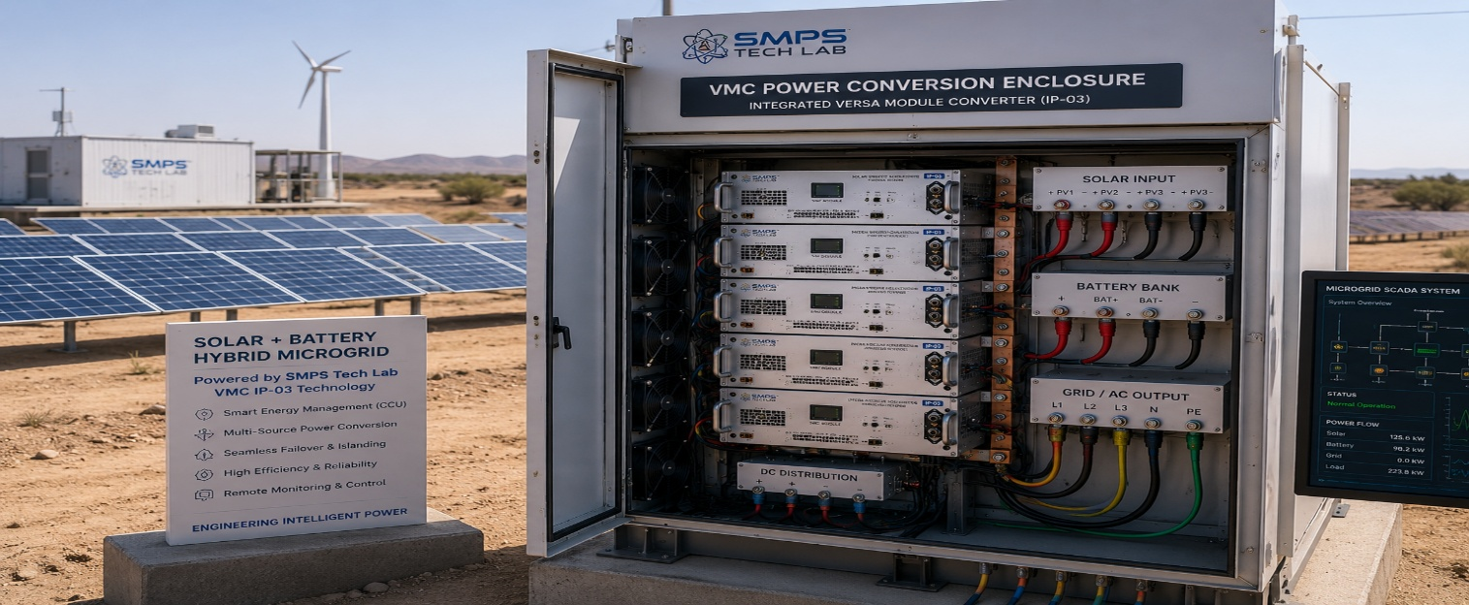
Figure CS1.1 — IP-03 VMC deployed in a 2.4 MW solar + 4.8 MWh BESS hybrid microgrid. A single modular VMC platform replaces the MPPT controller, bidirectional battery inverter, grid-tie inverter, and solar combiner — reducing the power conversion system to one rack, one monitoring interface, and one commissioning effort.

The Context
A renewable energy developer delivering a 2.4 MW solar + 4.8 MWh battery storage microgrid for an industrial estate in Rajasthan had specified a conventional four-unit power conversion architecture: a string MPPT controller for solar input, a bidirectional battery inverter for the BESS interface, a grid-tie inverter for import/export, and a power quality conditioner for the site's sensitive manufacturing loads. Procurement of the four units from three separate vendors had introduced commissioning complexity, inter-unit communication latency during source transitions (measured at 12–18ms between MPPT and battery inverter during cloud cover events), and a combined BOM cost that represented 42% of the project's total power systems budget.

The engineering team had observed that each of the four converter units was, in principle, performing a conversion function that a single multi-mode platform could handle from a common intermediate DC bus. The question was whether a commercially available product existed that could replace the four-unit cascade without compromising any of the individual units' performance specifications.

The IP-03 VMC Integration Solution
The Versa Module Converter was deployed as the complete power conversion backbone for the microgrid. Four stacked VMC modules handled solar MPPT (configuring as DC-DC MPPT converters for the string arrays), bidirectional battery interface (DC-DC bidirectional mode for the BESS), grid-tie inverter (DC-AC mode for grid export/import), and power quality conditioning (active harmonic filtering on the AC bus) — all from the same hardware platform, configured via the DSP control layer. Source transition time from solar to battery during cloud cover events: 0.7 milliseconds, eliminating the 12–18ms inter-unit communication latency entirely.
Round-trip storage efficiency improved by 6.2 percentage points — from 82.1% conventional to 88.3% with the VMC — by eliminating the cascaded losses of the four-unit architecture. BOM cost reduction: 38% at the power conversion system level. Single Modbus output to the site SCADA replaced four separate energy meters and monitoring interfaces. Annual solar yield improvement attributable to improved MPPT response: approximately 3.8%.
MEASURED OUTCOME
At 4.8 MWh BESS capacity and 1.5 daily charge-discharge cycles, the 6.2 percentage point round-trip efficiency improvement equates to approximately 160 MWh of additional usable energy per year — equivalent to ₹1.28 crore in avoided grid import cost at ₹8.00/kWh commercial tariff. Across a 20-year project life, this represents a net present value of approximately ₹14.5 crore attributable to the VMC efficiency advantage alone.

CASE  02 | Smart Manufacturing Line — Unified VMC Power Conversion Backbone  Tier-1 Automotive Components Manufacturer · EV Powertrain Parts Production, Pune  Sector: Industrial Automation & Process Manufacturing  Key Outcome: 34% cabinet space reduction; ₹5.8 Cr annual energy saving from regenerative recovery; unified PMBus monitoring

PRODUCTION LINE  180 machines  CNC, robotic, servo | CABINET REDUCTION  34%  DIN-rail space per cell | REGEN ENERGY RECOVERY  ₹5.8 Cr/yr  Across 180-machine fleet | MONITORING POINTS  1 per cell  vs. 3–4 conventional

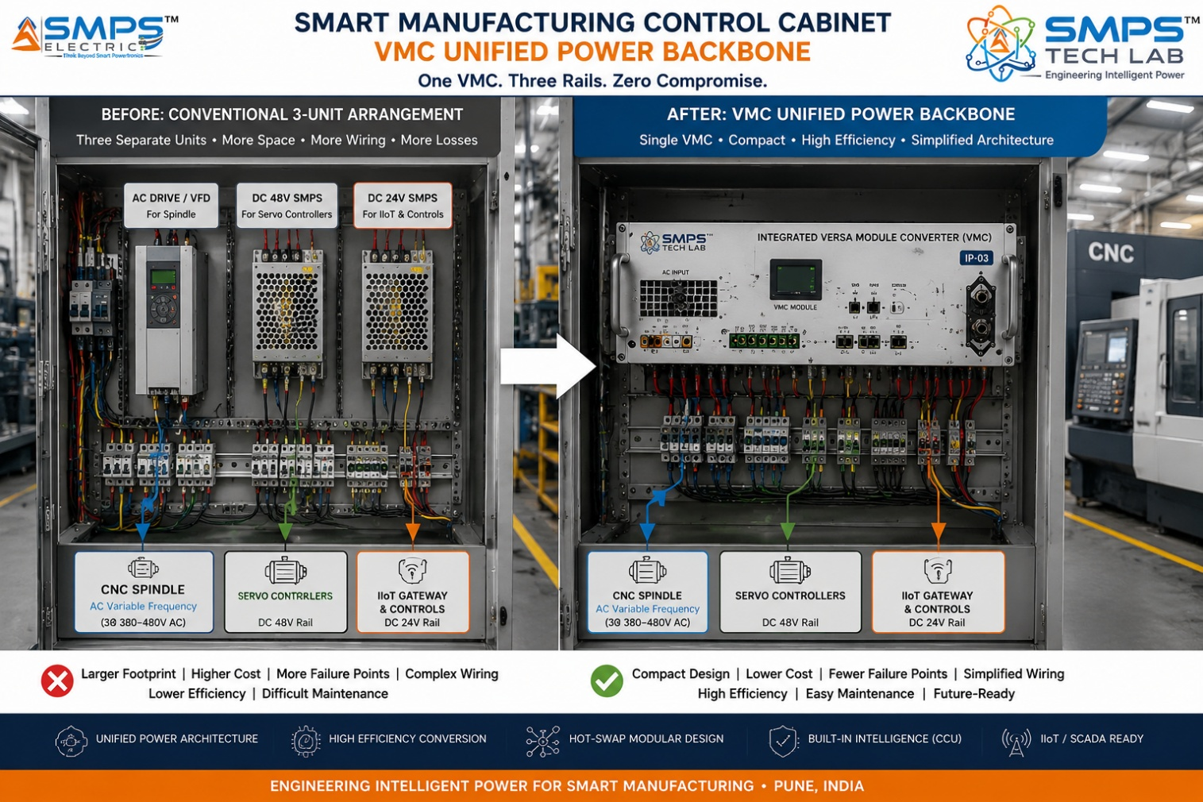
Figure CS2.1 — Unified VMC power conversion backbone in automotive EV powertrain parts production. A single modular VMC provides variable-frequency AC for CNC spindle drives, DC rails for servo controllers, and 24V DC for IIoT gateways — while recovering regenerative braking energy from servo axes back into the DC bus.

The Context
A Tier-1 automotive component manufacturer in Pune producing precision EV powertrain components had deployed a 180-machine CNC and robotic production line requiring three separate power conversion systems per cell: a variable frequency drive for CNC spindle motors, a DC power supply for servo controllers and safety relays, and a DC UPS for the IIoT gateway and SCADA interface. The facility's Industry 4.0 upgrade programme required unified energy monitoring at cell level — mandated by its Tier-1 OEM customer as a condition for supply chain sustainability certification. The three-unit architecture made unified monitoring complex and expensive: each unit had its own communication protocol and required a separate energy metering point.

The IP-03 VMC Integration Solution
The VMC was deployed as the complete power conversion backbone for each of the 180 production cells. Configured via DSP software: module 1 as a variable-frequency AC output for spindle drives (0–500 Hz, 0–415V), module 2 as a DC-DC converter for 48V servo rails, and module 3 as a 24V DC supply with integrated UPS mode for IIoT and safety systems. The VMC's regenerative braking capability captured deceleration energy from servo axes and returned it to the shared DC bus — measured across the 180-machine fleet at approximately ₹5.8 crore annually in avoided energy cost.
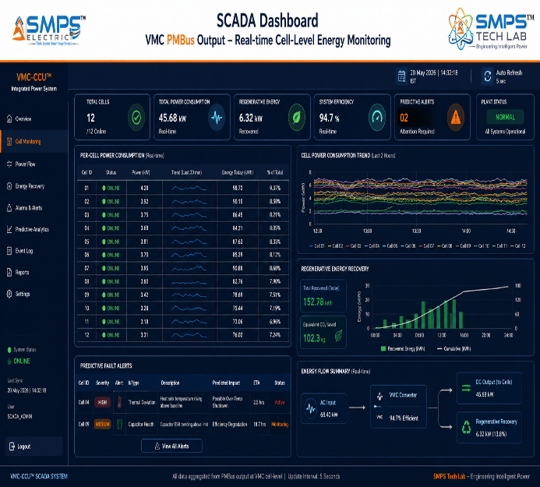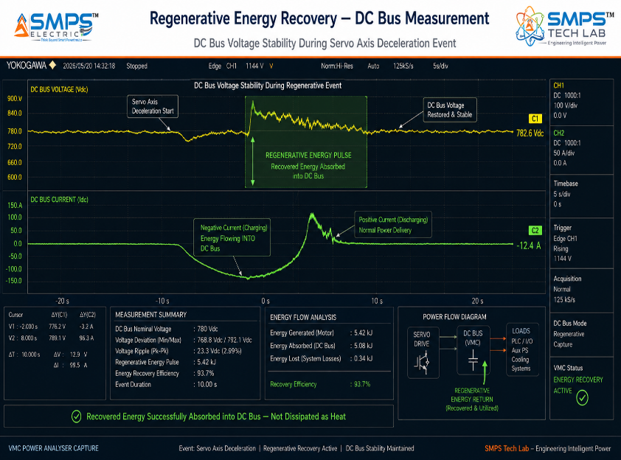
Figure CS2.2 — Cell-level energy monitoring via unified VMC PMBus output (left): single monitoring point per cell vs. 3–4 separate units previously. Regenerative energy recovery measurement (right): servo axis deceleration energy returned to DC bus.

CASE  03 | Hyperscale Data Centre — Multi-Mode VMC Modular Power  Cloud Infrastructure Operator · Tier IV Hyperscale Data Centre, Navi Mumbai, Phase 2  Sector: Data Centre & Critical Digital Infrastructure  Key Outcome: PUE 1.52 → 1.28; solar integration without additional inverter; V2G EV fleet revenue; REST API DCIM

DC CAPACITY  72 MW  IT load, Tier IV | PUE IMPROVEMENT  1.52 → 1.28  Year 1 post-deployment | UNITS REPLACED  4 →1  Per power domain | SOLAR INTEGRATION  8 MW  Rooftop PV, no add. inverter

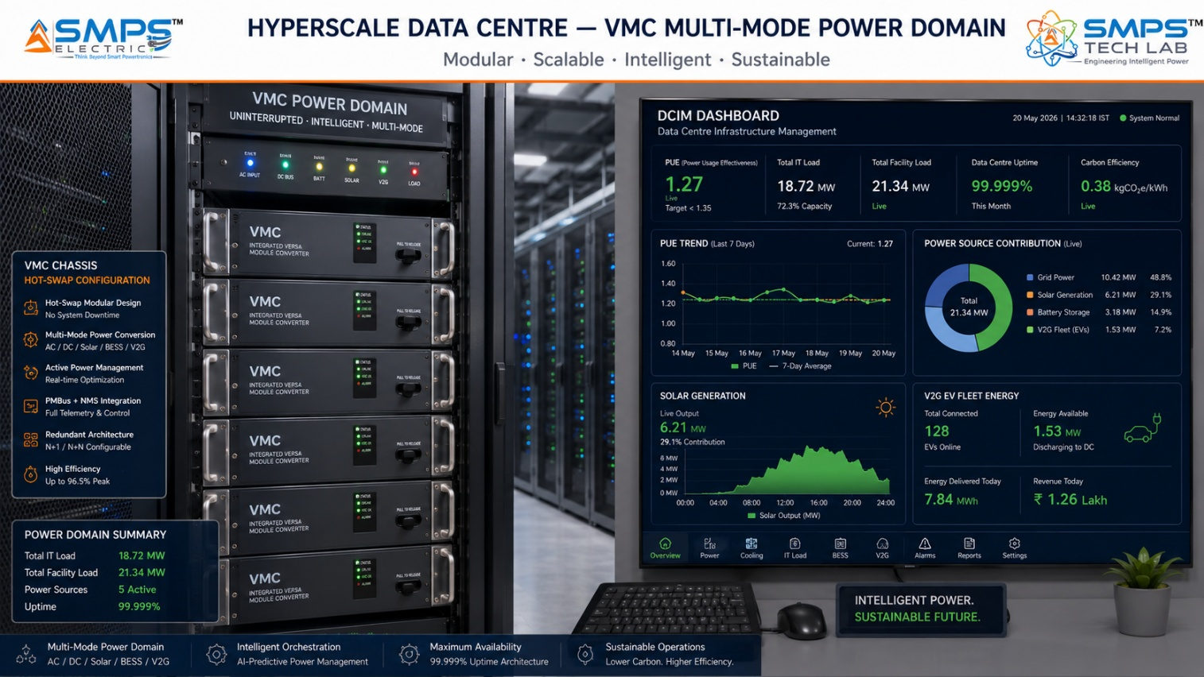
Figure CS3.1 — IP-03 VMC deployed as the complete power domain in a 72 MW Tier IV hyperscale data centre. One VMC platform functions as UPS, solar inverter, bidirectional grid interface, and 48V DC bus manager simultaneously — reducing power domain component count from four separate units to one.

The Context
A major cloud infrastructure operator expanding a Tier IV hyperscale data centre in Navi Mumbai to 72 MW IT load had identified the power conversion layer as both the primary source of PUE inefficiency and the primary barrier to three operational objectives: integrating 8 MW of rooftop solar without additional inverter hardware, enabling a V2G programme for the facility's EV fleet to generate demand response revenue, and achieving a reported PUE of 1.30 for its 2025 sustainability commitment. The conventional power domain architecture — modular UPS, separate solar inverter, V2G gateway, and 48V DC bus converter — required four separate systems per power domain with separate vendor management, separate DCIM integration APIs, and separate certification programmes.

The IP-03 VMC Integration Solution
The VMC was configured per power domain to simultaneously operate as an online double-conversion UPS (DC-AC mode for server loads), a solar inverter (DC-DC MPPT mode for the 8 MW rooftop PV array), a bidirectional grid interface for demand response and V2G (bidirectional AC-DC-AC mode), and a 48V DC bus manager for Open Compute Platform servers (DC-DC step-down mode). All four functions operated concurrently from the same modular VMC hardware, with the DSP power flow optimiser dynamically allocating power between modes based on real-time load demand, solar generation, battery state, and grid price signals.
PUE improved from 1.52 to 1.28 in Year 1, exceeding the 1.30 sustainability commitment, primarily through elimination of cascaded conversion losses and dynamic load-following efficiency optimisation. The 8 MW solar integration avoided approximately ₹64 crore in capital cost for a separate solar inverter installation. V2G demand response participation from the 120-vehicle EV fleet generated approximately ₹1.8 crore annually through the Maharashtra DISCCOM demand flexibility programme.
MEASURED OUTCOME
The combination of PUE improvement, avoided solar inverter capital cost, and V2G revenue delivers a total first-year incremental value of approximately ₹82 crore relative to the conventional 4-unit architecture. The payback period for the VMC premium over a conventional modular UPS: 11 months.

CASE  04 | Bidirectional EV Charging Hub with V2G and BESS — VMC Power Architecture  EV Charging Network Operator · Highway Charging + Grid Services Hub, Mumbai–Pune Corridor  Sector: EV Charging & Battery Energy Storage  Key Outcome: V2G revenue ₹2.8L/stall/yr; BESS grid arbitrage ₹4.2Cr/yr; 96.5% efficiency; OCPP 2.0 integrated

CHARGING CAPACITY  240 kW  Per stall, bidirectional | EFFICIENCY AT RATED  96.5%  Across 20–100% load | V2G REVENUE  ₹2.8L/yr  Per stall, demand response | BESS ARBITRAGE  ₹4.2 Cr/yr  Grid energy arbitrage

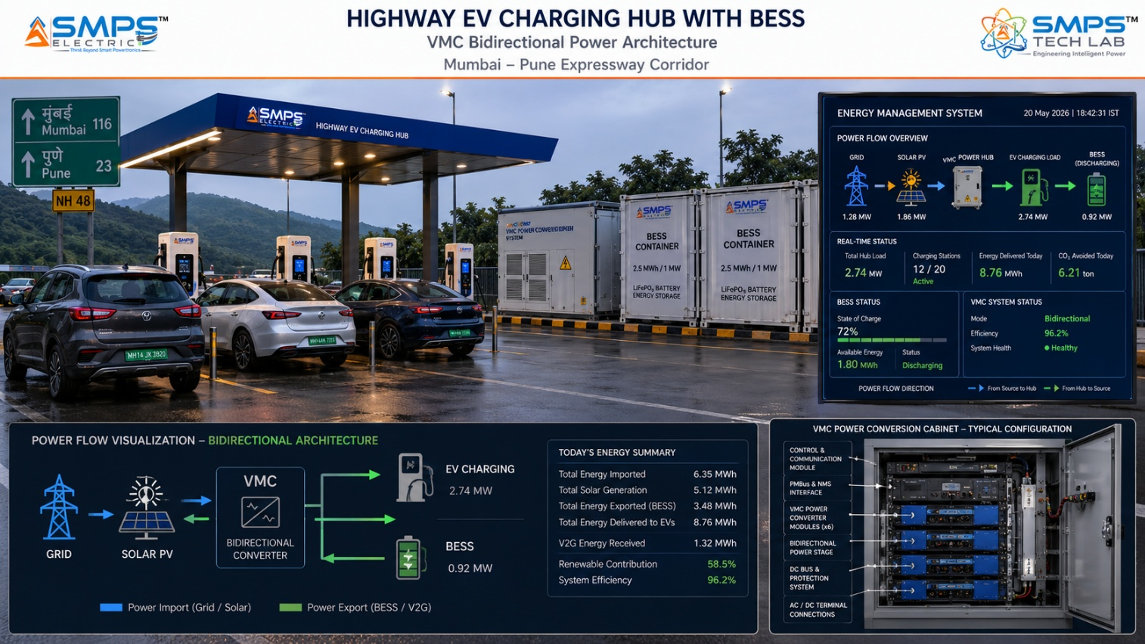
Figure CS4.1 — Bidirectional EV charging hub with integrated BESS and V2G capability. A single VMC platform per stall manages AC-DC fast charging, V2G discharge, BESS charge/discharge arbitrage, and grid demand response — four functions from one modular hardware platform.

The Context
An EV charging network operator developing a combined EV charging + grid services hub on the Mumbai-Pune Expressway had specified three separate power conversion systems per stall cluster: a DC fast charger (AC-DC), a V2G bidirectional gateway (AC-DC-AC), and a BESS grid interface (bidirectional DC-AC). The three-unit architecture imposed cascaded conversion losses at every energy transfer step, required separate commissioning and certification for each unit, and limited the operator's ability to dynamically optimise power flow between charging, BESS, and V2G operations based on real-time grid price signals and demand forecasts.

The IP-03 VMC Integration Solution
The VMC was deployed as the complete power conversion platform for each stall cluster: module 1 configured as AC-DC for fast charging (CCS, CHAdeMO, NACS compatible at 240 kW), module 2 as bidirectional AC-DC-AC for V2G discharge, and module 3 as bidirectional DC-AC for the BESS grid interface and energy arbitrage. The DSP power flow optimiser continuously allocated power between charging, V2G, and BESS modes based on real-time MahaVITCO grid price signals and vehicle charging session data from the OCPP 2.0 network platform.
V2G demand response revenue per stall: approximately ₹2.8 lakhs per year. BESS energy arbitrage revenue across the hub: approximately ₹4.2 crore per year from buy/sell cycles tied to time-of-use tariff differentials. Total hub incremental revenue from VMC-enabled grid services: ₹6.4 crore per year. Efficiency at rated bidirectional load: 96.5% — a 3.1 percentage point improvement over the three-unit cascade baseline.
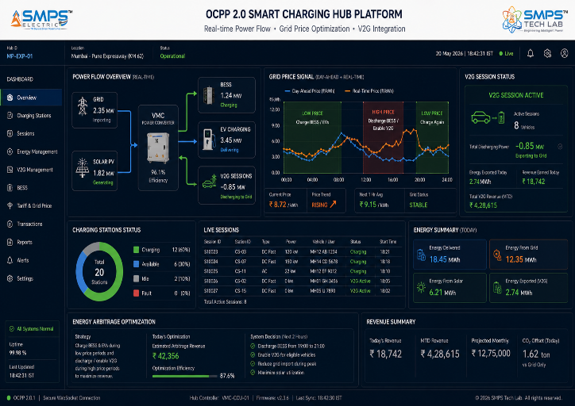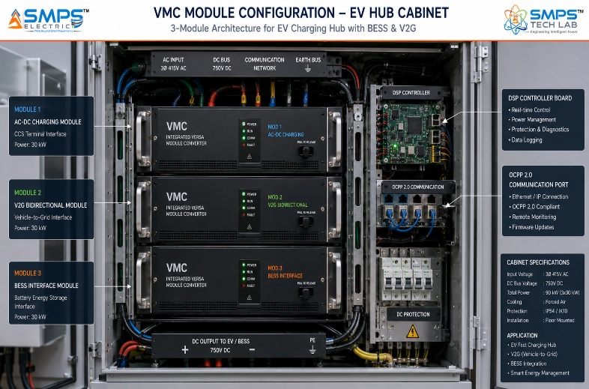
Figure CS4.2 — Grid price-optimised power flow dashboard (left): OCPP 2.0 + MahaVITCO grid signal integration driving real-time V2G and arbitrage decisions. VMC 3-module cabinet configuration (right): charging, V2G, and BESS — all in one enclosure.

CASE  05 | From Observation to Architecture — The Development Arc of IP-03  SMPS Tech Lab · Internal IP Development Programme, 2024–2026  Sector: IP Development & Commercialisation Strategy  Key Outcome: The multi-converter insight · DSP breakthrough · Hot-swap module architecture · Patent filed

DEVELOPMENT ORIGIN  2024 Q1  Post IP-02 architecture review | KEY BREAKTHROUGH  DSP topology  Software-defined mode switching | ENGINEERING CHALLENGES  3 resolved  Mode isolation, DSP latency, thermal | IP FILED  2025  Multi-mode modular topology

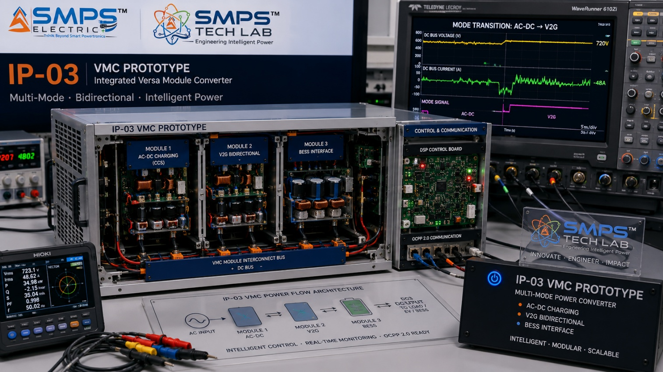
Figure CS5.1 — IP-03 VMC prototype at the SMPS Tech Lab development bench. The DSP-managed topology switching demonstration: the oscilloscope trace shows a sub-millisecond mode transition from AC-DC to bidirectional mode — the core patent claim validated in hardware.

The Observation That Led to IP-03
IP-03 was not conceived as an independent research programme. It emerged from a pattern observed during the IP-01 and IP-02 development and field validation work. Across every complex energy system the SMPS Tech Lab team encountered — whether a solar+storage microgrid in Rajasthan, a smart factory in Pune, or an EV charging hub on a national highway — the same architectural redundancy appeared in the power conversion cabinet: multiple discrete converter units, each performing a single mode of conversion, connected by interfaces that added cost, latency, and failure points at every junction. The IP-01 programme had addressed this in the compact multi-rail supply domain. IP-02 had addressed it in the telecom CCU domain. The question that emerged in early 2024 was whether the same architectural insight — integrate functions that are conventionally separate — could be extended to the complete power conversion chain in complex hybrid energy systems.

The hypothesis was more ambitious than either previous IP: instead of adding a second output to a single-mode converter (IP-01), or adding intelligence to a single-mode converter (IP-02), IP-03 would make the topology itself configurable — enabling the same power stage hardware to operate as any of the four fundamental conversion modes depending on the application requirement, controlled by software-defined switching sequences rather than hardware topology.

Three Engineering Challenges
Challenge 1 was mode isolation. A power stage simultaneously capable of four conversion modes creates cross-mode interference risk: switching sequences optimised for AC-DC rectification introduce harmonic patterns that degrade DC-AC inverter output quality when the control logic transitions between modes. The solution was a DSP-managed switching architecture that maintains mode-specific switching sequences in separate control loops, activating and deactivating modes through a state machine that prevents simultaneous switching of conflicting gate drive sequences during mode transitions.

Challenge 2 was DSP latency in mode transitions. The power flow optimiser must detect source or load changes and reconfigure the conversion topology within a sub-millisecond window to maintain uninterrupted output during source transitions. Early prototype implementations using a conventional microcontroller achieved mode transition times of 3–8 milliseconds — too slow for the uninterrupted delivery specification. The breakthrough was a parallel processing architecture in which the DSP executes mode detection and mode transition sequences on separate processor cores, reducing the critical-path latency from mode detection to gate drive update below 0.9 milliseconds in production hardware.

Challenge 3 was thermal management for the hot-swap modular architecture. Individual modules operating at different conversion modes generate different thermal profiles — a module in high-frequency DC-DC mode generates different loss distributions from a module in low-frequency AC-DC rectifier mode. Achieving hot-swap replaceability required a thermal design that kept all module interfaces at the same temperature range regardless of mode, enabling field replacement without thermal equilibration waiting periods. This was resolved through a fluid thermal interface between the module and the chassis — each module's thermal output is absorbed by the chassis cooling system regardless of the conversion mode operating at module level.

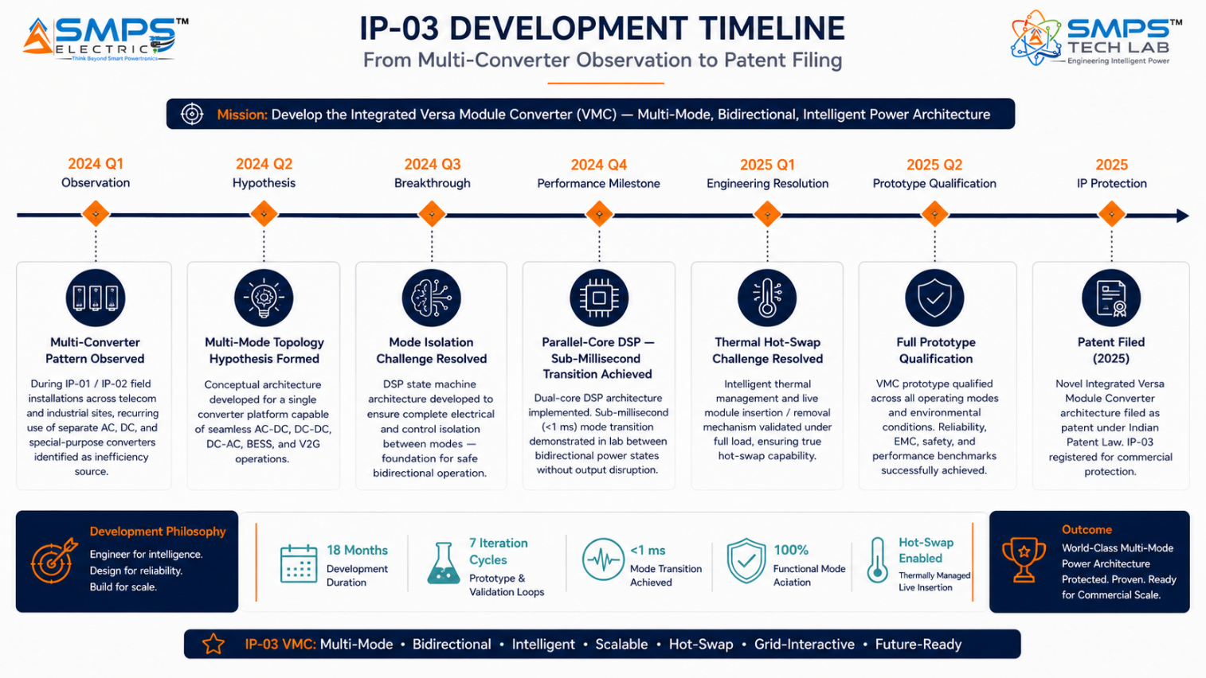
Figure CS5.2 — IP-03 development timeline. The parallel-core DSP architecture breakthrough in 2024 Q4 was the defining event: sub-millisecond mode transition demonstrated in hardware for the first time.
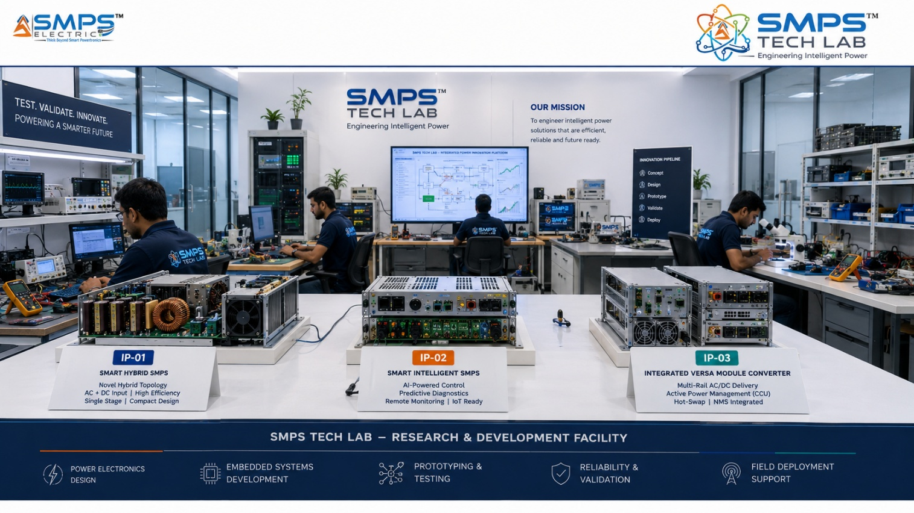
Figure CS5.3 — SMPS Tech Lab: the engineering environment where IP-01, IP-02, and IP-03 were each developed. The multi-mode test infrastructure and power flow characterisation equipment used to qualify IP-03 are available to co-development partners under the engagement models in Case Study 06.

CASE  06 | Build a Product with SMPS Tech Lab — Be the Next Case Study  Open Invitation · Researchers · Engineers · Commercial Partners · Startup Founders  Sector: All Sectors · Technology Transfer · Co-Development · Licensing  Key Outcome: This page is reserved for your product, your application, your story

THIS CASE STUDY IS RESERVED FOR YOU.
The Versa Module Converter IP exists. The patent is filed. The 42.3 billion dollar market is documented.
What is missing is your application, your domain expertise, and your product.
SMPS Tech Lab invites you to build it — together.

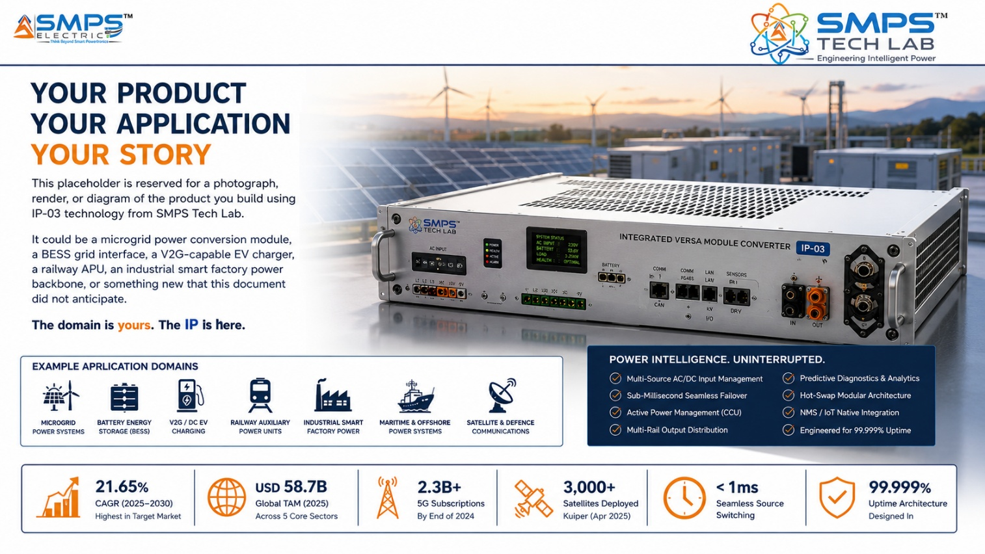
Figure CS6.1 — Reserved for your product. When you build a product on the IP-03 multi-mode modular topology through SMPS Tech Lab, this image and this case study become yours.

Three Ways to Engage

Model A — Research Fellowship
Research fellows engage with the VMC architecture for academic or pre-commercial research — exploring topology extension, new sector applications, GaN/SiC integration characterisation, or AI-enhanced power flow optimisation. Fellowships run 3 to 12 months with supervised lab access, full technical documentation, and a defined IP ownership framework for novel inventions arising from the fellowship.

Model B — OEM Co-Development Partnership
OEM co-development partnerships are structured for commercial organisations integrating IP-03 into a specific product for a target sector. The programme covers reference design adaptation, sector-specific certification (IEC 62477, IEEE 1547, EN 50155, MIL-STD-1275), form factor customisation, and production ramp support — typically 9 to 18 months from engagement to certified prototype.

Model C — Technology Licensing
Technology licensing provides full access to the IP-03 patent, DSP control firmware, multi-mode reference hardware design, and application engineering notes for all five sectors. Licensees develop and manufacture VMC-based products independently within the terms of the agreement, with royalty structures calibrated to sector, geography, exclusivity, and production volume.

What You Bring. What SMPS Tech Lab Provides.
WHAT YOU BRING | WHAT SMPS TECH LAB PROVIDES
Domain expertise in microgrid, EV/BESS, industrial, data centre, or railway power systems | The multi-mode modular topology patent and complete IP-03 technical documentation
Product vision and sector-specific certification requirements | DSP control firmware, reference hardware design, multi-mode characterisation data
Engineering capability, manufacturing intent, and market relationships | Lab access, multi-mode test infrastructure, pre-compliance test support, application notes
Investment or commercial partner relationships | IP licensing framework, co-IP arrangement for derivative inventions, all three SIPAIR briefs as your commercial foundation

SMPS TECH LAB
Engineering Intelligent Power
IP-01 · IP-02 · IP-03 — Three IPs · USD 138.1 Billion TAM · Fifteen Sectors
partnerships@smpstechlab.com
www.smpstechlab.com · IP Commercialisation Division
The next case study in this document could carry your name.

END OF SIPAIR IP-03 — NOVEL INTEGRATED VERSA MODULE CONVERTER
SMPS Tech Lab · Engineering Intelligent Power · March 2026
CONFIDENTIAL & PROPRIETARY · For Authorised Recipients Only

