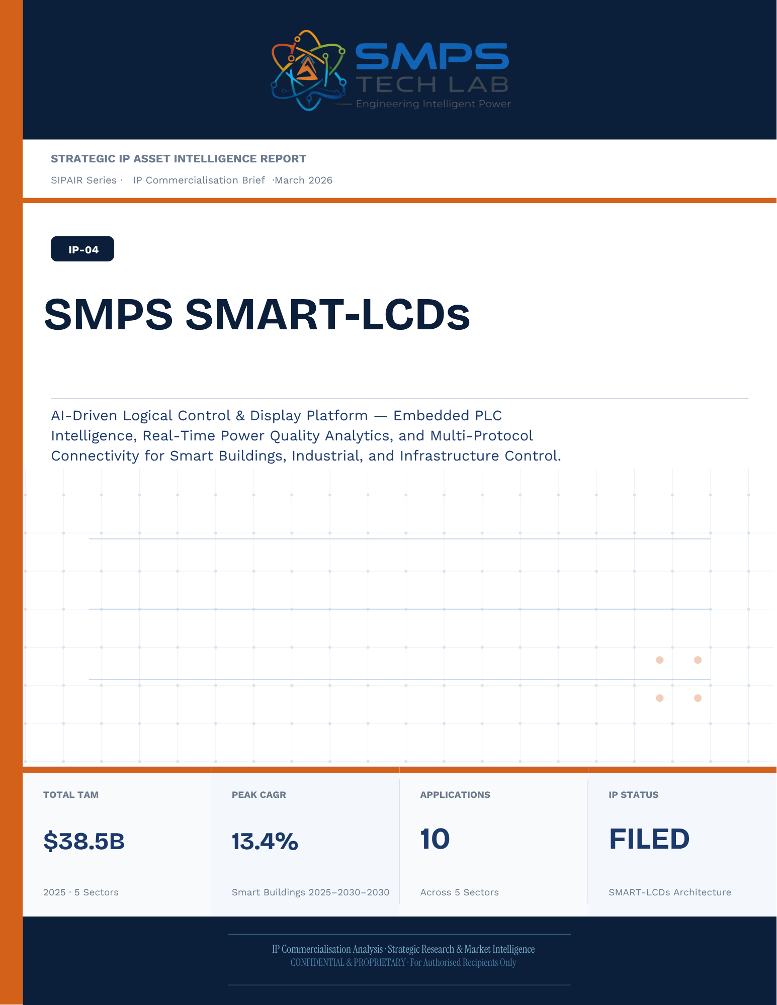
STRATEGIC IP ASSET INTELLIGENCE REPORT
SIPAIR Series
IP-04: Smart Logical Control & Display Stations
SMPS-Based Integrated SMART-LCDs for Uninterrupted Telecom Power

Report Title | SIPAIR IP-04 — Smart Logical Control & Display Stations Commercialisation Brief

Document Series | Strategic IP Asset Intelligence Report (SIPAIR)

Version | Version 1.0 — First Edition

Compiled & Edited by | Shri Amareshwar Karatagi

Organisation | SMPS Tech Lab — Engineering Intelligent Power

Date of Issue | March 2026

Classification | Confidential & Proprietary — For Authorised Recipients Only

IP Reference | IP-04 — Smart Logical Control & Display Stations Architecture, Filed 2025

Related Document | SIPAIR IP-01: Smart Hybrid SMPS (see companion brief)

This document is prepared by SMPS Tech Lab as part of the SIPAIR IP Commercialisation Series.

Declaration — Originality & Intellectual Property Statement

This Strategic IP Asset Intelligence Report (SIPAIR — IP-04: Smart Logical Control & Display Stations) is an original compilation prepared by SMPS Tech Lab. The analysis, market intelligence frameworks, commercial strategy formulations, and case study narratives contained herein are the result of independent research and original intellectual work by the authors and editors named in this document.

The core technology described in this report — the SMPS-Based Integrated SMART-LCDs architecture, including its active power management layer, CCU intelligence stack, uninterrupted multi-rail AC/DC delivery system, and NMS integration platform — is the exclusive proprietary invention of SMPS Tech Lab, protected under a filed novel design patent (2025). IP-04 is a distinct and independently protectable invention from IP-01 (Smart Hybrid SMPS), though both emerge from the same SMPS Tech Lab research programme. The two IPs are designed to complement each other across adjacent application verticals and may be jointly licensed or co-deployed where application requirements demand both hybrid topology and active power management intelligence.

Market sizing data, CAGR estimates, and industry statistics cited in this document are sourced from independent third-party research publications, fully attributed in Appendix A. All third-party data is used for analytical and benchmarking purposes only. This report has not been submitted, in whole or in part, to any other organisation for commercialisation or formal assessment except as specifically disclosed in writing.

Declared by:

Shri Amareshwar Karatagi Founder & CSO SMPS Tech Lab · March 2026

CERTIFICATE OF AUTHENTICITY
IP Commercialisation Documentation · SIPAIR IP-04

This is to certify that the Strategic IP Asset Intelligence Report
SIPAIR IP-04 — Smart Logical Control & Display Stations
has been compiled, reviewed, and authenticated by the undersigned in accordance
with the standards of the SIPAIR documentation series. The technology, market analysis,
and commercial intelligence herein are verified as accurate to the best of the signatories’
knowledge as at the date of issue: March 2026.

Program Head / Director | Technical Mentor
  Program Head / Research Director
  SMPS Tech Lab
  Technical Mentor / Advisor
  SMPS Tech Lab

SMPS Tech Lab · Engineering Intelligent Power · March 2026

Acknowledgment

The preparation of this Strategic IP Asset Intelligence Report for IP-04 has drawn on the technical expertise, operational insights, and research foundation developed across two parallel innovation tracks at SMPS Tech Lab. The development of the CCU intelligence layer — the defining innovation of IP-04 — required not only power electronics engineering depth but sustained engagement with telecom network operations, tower management practice, and satellite ground station engineering environments that are highly specialised. The author and editor express sincere gratitude to those whose knowledge and access made this work possible.

Technical Development
The CCU architecture at the heart of IP-04 evolved alongside IP-01's hybrid topology work, but along a distinct engineering trajectory focused on power orchestration intelligence rather than conversion efficiency alone. The engineers and technologists who contributed to the CCU control logic, NMS integration stack, and sub-millisecond failover switching mechanism deserve specific recognition for the rigour with which they approached the uninterrupted power mandate — a design objective that admits no approximation.

Telecom Industry Access
The sector intelligence in this report reflects direct engagement with tower operations, data centre facility management, and satellite ground station engineering communities. The operational data from 5G tower rollout programmes, off-grid hybrid power deployments, and maritime communication installations that informed the case study narratives and application requirement specifications in this document is the product of those field engagements.

Research Publications
The market intelligence framework draws on publications from Future Market Insights, MarketsandMarkets, SNS Insider, Grand View Research, IMARC Group, Coherent Market Insights, Global Growth Insights, and the Ericsson Mobility Report, as well as operational data from the International Energy Agency. The quality of those independent research publications is what allows the TAM framework in this report to be grounded in named, verifiable data rather than estimated aggregates.
Shri Amareshwar Karatagi
Founder & CSO
SMPS Tech Lab · March 2026

Preface — From the Founder & Editor

From IP-01 to IP-04 — The Logical Extension
IP-01, documented in the companion SIPAIR brief, solved one problem with exceptional elegance: replacing the unnecessary architectural duplication of separate AC and DC converter units with a single hybrid topology. The commercial case was compelling and the market evidence was clear. But the engineers at SMPS Tech Lab, in the same process of field observation that gave rise to IP-01, had identified a second problem — one that operated at a higher level of the power system stack and was, if anything, more commercially urgent in the specific context of telecom infrastructure.

The problem was not conversion efficiency. It was availability. In a 5G base station, a satellite ground hub, an offshore platform communication centre, or a smart city public safety network node, the standard power supply architecture not only requires separate AC and DC converters — it delegates all intelligence about the power state of the system to a separate controller that may be physically remote, software-dependent on a third-party network management system, and incapable of autonomous protective action in the sub-millisecond timeframe that modern telecom uptime SLAs demand. When the grid fails, when a battery starts to degrade, when an input source switches — the system needs to respond faster than any software polling cycle can achieve. It needs embedded intelligence, right at the power conversion stage.

IP-04 is that intelligence. The Integrated SMART-LCDs, combined with the SMPS core, does not just convert power — it orchestrates it. It monitors every parameter of the power delivery chain continuously, switches between sources in under a millisecond, predicts faults before they become outages, and reports power system health to the operator's NMS in real time, without external monitoring hardware. It is the difference between a power supply and a power management system.

Why Telecom, and Why Now
The selection of telecom infrastructure as the primary application vertical for IP-04 reflects a disciplined commercial judgement. Telecom infrastructure is the single sector in the IP-04 TAM where the uninterrupted power mandate is non-negotiable, contractually enforced at 99.999% uptime, and backed by capital investment programmes of unprecedented scale: 2.3 billion 5G subscriptions by end of 2024 with another 4 billion to come by 2030; 3,000 Amazon Project Kuiper satellites deployed in April 2025 with thousands of ground hubs to follow; the IMO GMDSS modernisation mandate forcing a complete vessel communication power infrastructure upgrade by 2026. Every one of these programmes creates a specific, identified, and time-bounded procurement requirement for exactly what IP-04 delivers.

The second reason is the grid reliability crisis that is, counterintuitively, the most powerful demand driver the CCU's hybrid input management addresses. South Africa recorded 1,130 hours of planned power cuts in a single year. India's tower estate — 750,000 sites — routinely operates on hybrid grid, diesel, and battery sources with real-time CCU-managed source switching that determines whether the tower stays on during a grid event. This is not a niche requirement. It is the operational reality for hundreds of thousands of tower sites across three continents, and the market is actively seeking a solution that the current generation of separate rectifiers and external controllers cannot provide.

How This Document is Structured
This SIPAIR brief follows the same 14-section architecture as the IP-01 companion document, making the two documents a coherent and mutually reinforcing portfolio. Readers who have engaged with SIPAIR IP-01 will recognise the structure immediately. The technology differentiation section includes an explicit comparison between IP-01 and IP-04, clarifying the architectural relationship and the distinct value proposition of each. The case studies are drawn from the five specific sectors of IP-04's TAM framework — 5G tower, data centre, satellite ground, smart city, and maritime/offshore — with technical and financial parameters grounded in the operational realities of each sector.
Shri Amareshwar Karatagi
Founder & CSO
SMPS Tech Lab · March 2026

TABLE OF CONTENTS

Declaration — Originality & Intellectual Property Statement 4
Acknowledgment 7
Technical Development 7
Telecom Industry Access 7
Research Publications 7
Preface — From the Founder & Editor 9
From IP-01 to IP-04 — The Logical Extension 9
Why Telecom, and Why Now 9
How This Document is Structured 10
Important Notice & Confidentiality Disclaimer 16
1.1 The Strategic Context 17
1.2 The Problem SMART-LCDs Solve 17
1.3 Key Metrics at a Glance 18
1.4 Why SMART-LCDs, Why Now 19
2.1 What is a SMART-LCD? 21
2.2 The Three Integrated Technology Layers 21
2.3 AI Intelligence Layer — Operator Guidance at the Interface 23
2.4 Cybersecurity Architecture 23
2.5 Standards Compliance Architecture 24
3.1 The Intelligent Interface Transition 26
3.2 The Four Structural Megatrends 26
3.3 Global Market Sizing — Primary Reference Data 27
CAGR Comparison — IP-04 Target Market Segments 28
4.1 Methodology 29
4.2 Consolidated TAM Summary 30
5.1 India as First Market 32
5.2 India Market Sizing — IP-04 Relevant Segments 33
6.1 India Government Schemes with Direct IP-04 Alignment 34
7.1 The Plugin Architecture — Five Host System Categories 36
7.2 Plugin Integration Matrix 36
8.1 Commercialisation Philosophy 38
8.2 Market Priority Matrix 38
9.1 Competitive Architecture Overview 40
10.1 The Investment Case 42
10.2 Illustrative Revenue Scenarios 42
11.1 Technology Generation Roadmap 44
11.2 Adjacent Application Opportunities 45
12.1 Risk Framework 46
Appendix A — Data Sources 48
Appendix B — Standards Reference 49
Appendix C — Glossary 49
The Context 52
The SMART-LCD Integration Solution 53
The Context 54
The SMART-LCD Integration Solution 55
The Context 56
The SMART-LCD Integration Solution 57
The Context 59
The SMART-LCD Integration Solution 60
The Observation That Started IP-04 62
Three Engineering Challenges 63
Three Ways to Engage 66
Model A — Research Fellowship 66
Model B — OEM Co-Development Partnership 67
Model C — Technology Licensing 67

0F | FOUNDER & EDITOR  IP-04 SIPAIR Series · SMPS Tech Lab

 | Shri Amareshwar Karatagi  Founder & Chief Strategic Officer  SMPS TechLab  Special Correspondent, Government of Karnataka |  Serial Entrepreneur
Vision Statement
We aim to build a generation of innovators and entrepreneurs who create transformative technologies, develop intellectual property, and drive India’s technological leadership on both national and global platforms. Over the years, we have worked extensively within the startup ecosystem, contributing to and mentoring multiple initiatives focused on building, scaling, and strengthening businesses. Through this journey, we have developed a deep understanding of business strategy, governance frameworks, and deep-technology development, along with the practical challenges of scaling innovation in real-world markets.
As a Special Correspondent with the Government of Karnataka and a serial entrepreneur, my focus has been on shaping individuals into creators, builders, and leaders of technology and enterprise. Our work emphasizes ownership, innovation, and execution discipline to nurture individuals capable of building scalable, high-impact solutions with both national and global relevance.
Through SMPS Tech Lab, we drive this vision by integrating deep Research & Development (R&D) with entrepreneurial strategy, fostering a culture where ideas evolve into intellectual property, innovation, and industry-aligned solutions that contribute to India’s technological advancement and global competitiveness. The Industry Fitness DeepTech Internship Program is a reflection of this mission—designed to develop individuals who are innovation-driven, execution-focused, and capable of contributing meaningfully to technology, entrepreneurship, and nation-building at scale.
“My vision is to build a generation that doesn’t wait for opportunities, but creates them through innovation and entrepreneurship.”
— Shri Amareshwar Karatagi

A. R. Shalini
Chief Business Development Officer (CBDO) & Program Officer
SMPS TechLab | SMPS Electric Control Pvt. Ltd.

Area of Expertise:
Business Strategy, Operations Management, Industry–Academia Integration, Entrepreneurship Development
Profile:
I play a pivotal role in driving program execution, operational excellence, and professional development within SMPS Tech Lab. With a strong foundation in both business strategy and technology alignment, I am committed to shaping individuals into industry-ready professionals with the right mindset, discipline, and execution capabilities.
My approach focuses on building skills with clarity of thought, accountability, and a results-driven attitude. Through structured guidance and continuous mentorship, I enable participants to understand the intersection of technology, business, and real-world application.
I actively work toward bridging the gap between academia and industry, ensuring that learning is aligned with practical expectations and evolving market demands. My dedication to creating a seamless and high-impact learning environment fosters confidence, innovation, and professional growth among participants.
Through my leadership, the program consistently emphasizes structured execution, strategic thinking, and the development of individuals who are prepared to contribute meaningfully to both industry and innovation ecosystems.
“Professional excellence is built when knowledge, mindset, and execution come together with consistency.”
— A. R. Shalini

Dr. S. Khatua
Chief Technology Officer (CTO)
SMPS TechLab | SMPS Electric Control Pvt. Ltd.
IITian | PhD – IIT Dhanbad

Area of Expertise:
Power Electronics, Microgrid & Smart Grid Systems, Nuclear Power Systems, DeepTech R&D, Industrial System Design.
I am a distinguished technology leader driving advanced Research & Development and deep-tech innovation. An IITian with a PhD in Microgrid and Smart Grid Systems for nuclear power applications, I bring over 15 years of experience across power electronics, nuclear reactor control systems, and defence and telecom technologies.
With significant contributions to high-impact and mission-critical projects of national importance, my work reflects a rare combination of research depth, engineering precision, and industrial execution.
I am a strong advocate of deep-tech innovation and intellectual property (IP) creation, and I emphasize the development of indigenous technologies that strengthen the nation’s technological capability and global standing.
Through my mentorship, I inspire the next generation to pursue technical mastery, disciplined execution, and innovation with national intent, shaping professionals capable of contributing to the future of deep technology.
“Precision in engineering, depth in research, and ownership of technology are the pillars of true national progress.”
— Dr. S. Khatua


Mr. Rushit Jani
Techno-Commercial Architect
Strategic Editorial & Commercialisation Review | OptCell GLOBAL

Fields of Interest:
AI & Intelligent Systems, Industrial IoT, Product Architecture, Deep-Tech Commercialisation, Enterprise System Design, and Scalable Engineering Solutions.Focused on building technology-driven systems that bridge engineering innovation with practical industry adoption and long-term commercial value.
Message from the Editor:Technology, in its purest form, is not just about building systems — it is about creating meaningful infrastructure that can influence industries, solve operational challenges, and contribute to larger technological progress. My interest has always been in understanding how engineering innovation can evolve beyond prototypes into scalable and commercially sustainable solutions.
This document represents more than a technical study of an intellectual property. It reflects a structured effort to connect engineering architecture with market relevance, strategic deployment, industrial applicability, and long-term innovation potential. The objective throughout this work has been to maintain a balance between technical depth, commercialization practicality, and institutional-level documentation standards.
As emerging technologies continue to redefine industries, I strongly believe that the future will belong to organizations capable of combining research, engineering, strategic thinking, and execution into unified ecosystems. Through this publication, we aim to contribute towards that larger vision while creating pathways for collaboration, innovation, and real-world technological impact.
"Transforming engineering innovation into scalable, industry-defining technological ecosystems."
— Mr. Rushit Jani

A Note of Gratitude
The development of this publication has been supported by the collective vision, encouragement, and leadership of the Directors and management of SMPS Electric Control Pvt. Ltd.
Their continued commitment towards engineering innovation, industrial excellence, and long-term technological growth has created an environment that encourages meaningful research, practical problem-solving, and commercialization-focused thinking. The guidance, operational insights, and institutional support extended throughout this journey have played an important role in shaping the direction and depth of this work.
This document reflects not only an individual effort, but also the larger culture of innovation, trust, and forward-thinking leadership fostered within the organization. We sincerely appreciate the confidence and support provided towards building impactful and future-ready technological initiatives.

Important Notice & Confidentiality Disclaimer

This Strategic IP Asset Intelligence Report (SIPAIR — IP-04) has been prepared exclusively for internal strategic planning, investor communication, licensing partner engagement, and research collaboration purposes. It is intended for distribution only to authorised recipients under applicable non-disclosure and confidentiality arrangements.

All market sizing data, CAGR estimates, and financial projections are derived from independent third-party research publications cited in Appendix A. These figures represent estimates as at March 2026. No representation or warranty is made as to their accuracy or completeness.

The technology, architecture, and methodologies described herein are the exclusive proprietary assets of SMPS Tech Lab, protected under filed patent and design rights. This document does not constitute a prospectus, financial advice, or an offer to sell or subscribe to securities. Recipients are advised to conduct independent due diligence before making any investment or commercial decision.

01 | EXECUTIVE SUMMARY  Strategic Overview · The Control Intelligence Gap · SMART-LCD Value Proposition

1.1 The Strategic Context
Industrial facilities, energy substations, smart buildings, defence command centres, and hospital operating theatres share a common architectural problem: their operator interfaces are dumb. A conventional HMI panel displays data from a PLC. The PLC makes decisions. The SCADA server stores and analyses. The edge analytics module processes. Each is a separate device, connected by integration middleware that introduces latency, failure points, and engineering complexity. The operator, sitting at the interface, is the last element in a chain of separate hardware components — reading data that travelled from field device to PLC to SCADA to display, then issuing commands that will travel back down the same chain. In complex environments with hundreds of parameters and alarm states, this architecture creates cognitive load, response delay, and operational risk.

The market has been aware of this problem for a decade. The Industry 4.0 movement has spent billions on IIoT connectivity, edge computing, and AI analytics — and yet the operator interface layer has largely remained a passive display terminal bolted onto an external controller. The opportunity is precisely at that interface: to embed the intelligence — the logical control, the AI-assisted guidance, the multi-protocol integration — directly into the station where the operator sits.

1.2 The Problem S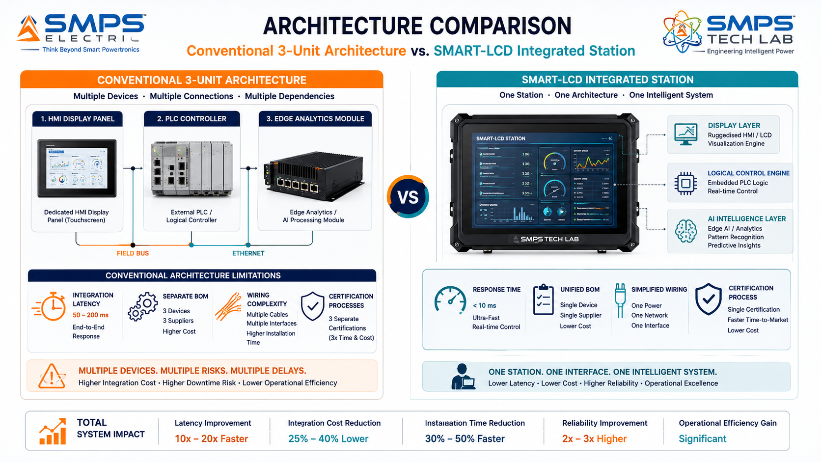
Figure 1.1 — Conventional HMI+PLC+Analytics cascade (left) versus SMART-LCD unified station (right). Three separate hardware units become one; integration latency is eliminated; the operator's command reaches field execution 5–20x faster.
STRATEGIC NOTE
SMART-LCDs eliminate the architectural separation between display, control, and intelligence. A single ruggedised station integrates high-resolution multi-touch visualisation, IEC 61131-3 embedded PLC logic execution, and AI-assisted operator guidance — reducing BOM by 30–40%, cutting installation time by 25%, and enabling direct control execution at the operator interface without routing through external PLCs or SCADA servers.

1.3 Key Metrics at a Glance
TOTAL ADDRESSABLE MARKET  $38.5B  2025 Baseline · 5 Sectors | HIGHEST-GROWTH SECTOR  13.4%  Smart Buildings CAGR 2025–2030 | SECTORS MAPPED  5  10 Applications Identified | IP PROTECTION  SMART-LCD Filed  Embedded Control & Display Patent

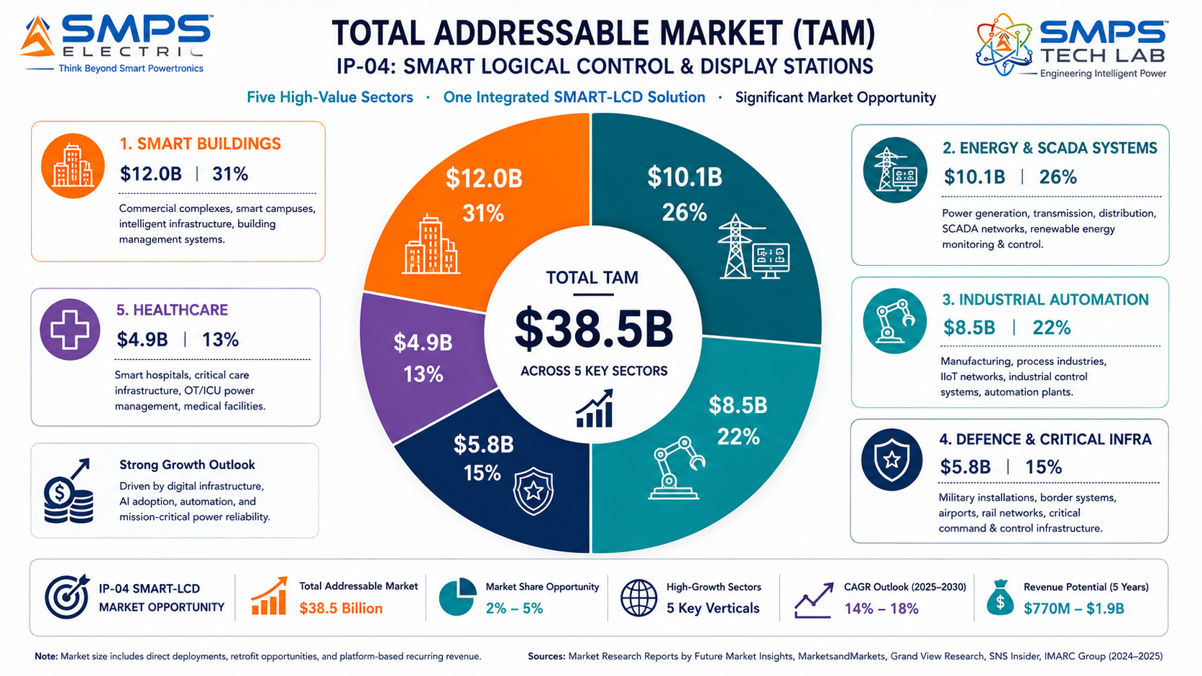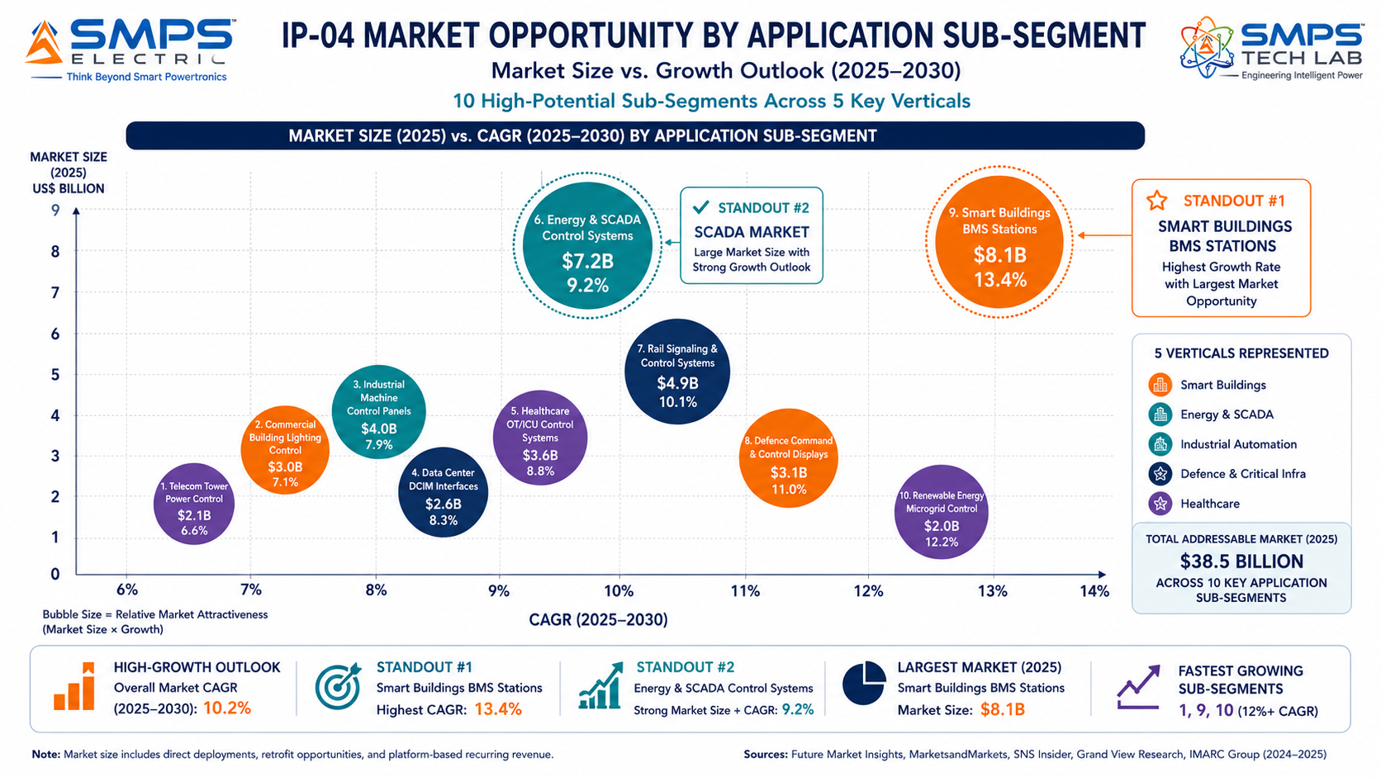
Figure 1.2 — IP-04 TAM breakdown (left): Smart Buildings is the largest sector at $12.0B and the fastest-growing at 13.4% CAGR. Industrial Automation is the fastest path to near-term revenue with 6–18 month time-to-revenue.

1.4 Why SMART-LCDs, Why Now
Four market forces converge precisely at this moment. The Industry 4.0 HMI upgrade cycle is at its early exponential phase — 52% of industrial facilities globally are in active legacy panel replacement programmes, with replacement decisions being made today for control hardware that will be in service for the next 10–15 years. The OT cybersecurity mandate is accelerating: IEC 62443 compliance is now mandatory or strongly recommended in energy, water, and critical manufacturing — and conventional HMI panels cannot meet it without the embedded security architecture that SMART-LCDs provide natively. The smart building market is growing at 13.4% CAGR, the fastest of any sector in this TAM, with Schneider Electric’s February 2025 launch of AI-powered SpaceLogic Touchscreen Room Controllers validating commercial demand for exactly the intelligent display-control platform that SMART-LCDs deliver. And AI-assisted operator interfaces are being actively introduced by Rockwell Automation and Emerson as of late 2025 — confirming that the market is already moving toward the architecture SMART-LCDs represent.

MARKET DATA POINT
Combined SMPS Tech Lab IP portfolio: IP-01 ($68.7B) + IP-02 ($27.1B) + IP-03 ($42.3B) + IP-04 ($38.5B) = USD 176.6 Billion total TAM across 20 sectors and 40 applications. IP-04 is the fourth pillar of a comprehensive technology platform spanning power conversion, control intelligence, and operator interface layers.

02 | TECHNOLOGY OVERVIEW  Architecture · Three Integrated Layers · AI Intelligence · Cybersecurity · Standards

2.1 What is a SMART-LCD?
A Smart Logical Control & Display Station is an integrated operator interface platform that combines three technology layers in one ruggedised unit: a high-resolution multi-touch display with adaptive visualisation, an embedded logical control engine capable of executing IEC 61131-3 PLC logic independently, and a smart intelligence layer providing AI-assisted operator guidance, anomaly detection, and predictive alert management. In standard industrial deployments, these three functions are distributed across separate hardware — a display panel, a PLC or DCS controller, and an edge analytics module — with integration complexity and communication latency between them. SMART-LCDs consolidate all three into a single station, reducing hardware cost, installation footprint, communication latency, and single-point-of-failure risk.

The distinction from conventional HMI panels is architectural, not incremental. Standard HMI panels are display terminals: they visualise data from connected PLCs and SCADA systems but have no independent control intelligence. SMART-LCDs are control stations: they visualise, decide, execute, and communicate autonomously within their domain. This positions SMART-LCDs as a next-generation platform that simultaneously upgrades both the HMI market and the edge PLC market.

2.2 The Three Integrated Technology Layers
LAYER | COMPONENT | FUNCTION | KEY INNOVATION IN IP-04
L1 | High-Resolution Adaptive Display | Multi-touch capacitive display (10–27 inch), industrial/medical-grade, anti-glare, brightness up to 1500 nits. Display layout, alarm hierarchy, and visualisation mode auto-reconfigure based on process state. | Adaptive display intelligence: presentation of contextually relevant information during normal operation, alarm states, and emergency conditions reduces operator cognitive load and error rate in complex environments.
L2 | Embedded Logical Control Engine | IEC 61131-3 compliant logic execution within the display station. Supports Ladder Diagram, Function Block Diagram, and Structured Text. Executes safety interlocks, alarm sequences, and control outputs directly. | Eliminates the separate external PLC for standard control applications. Reduces cabinet BOM by 30–40%, cuts wiring complexity, and provides sub-10ms command execution directly at the operator interface.
L3 | AI-Assisted Operator Intelligence | Embedded machine learning module: real-time anomaly detection, predictive maintenance alerts, operator guidance prompts, and adaptive alarm prioritisation. Processes sensor data locally via onboard edge compute. | AI guidance directly at the operator interface — not accessed via a separate analytics server. Sub-second alert generation, contextual operator prompts, and predictive maintenance flagging without cloud dependency.
L4 | Multi-Protocol Integration Hub | Native OPC-UA, Modbus TCP/RTU, PROFINET, EtherCAT, BACnet, KNX, MQTT, REST API, IEC 61850 GOOSE/MMS, SunSpec Modbus. Direct connection to field devices, PLCs, SCADA, cloud platforms. | Single station connects to all field device types across all five target sectors without additional middleware, gateways, or protocol converters. Integration cost and failure points reduced to zero additional hardware.
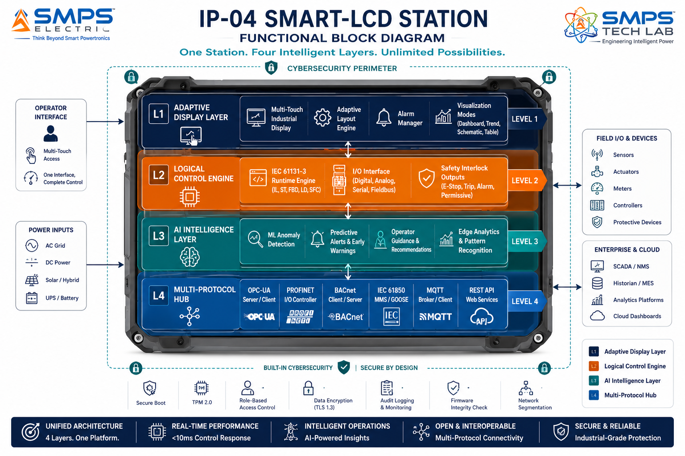

Figure 2.1 — SMART-LCD four-layer functional architecture. All four capabilities reside within one ruggedised station; there is no external PLC, analytics server, or protocol gateway required.

2.3 AI Intelligence Layer — Operator Guidance at the Interface
The AI intelligence layer in IP-04 is the differentiator that moves SMART-LCDs beyond the category of intelligent HMI panels into the category of decision-support control stations. The embedded ML module operates on real-time process data continuously — building a baseline model of normal process behaviour for each installation, detecting deviations from that baseline, and generating operator guidance prompts that appear directly on the display. These prompts are contextually positioned: during an alarm state, the SMART-LCD displays not just the alarm but the recommended operator action, the historical context for similar events, and the predicted impact of each available response option.

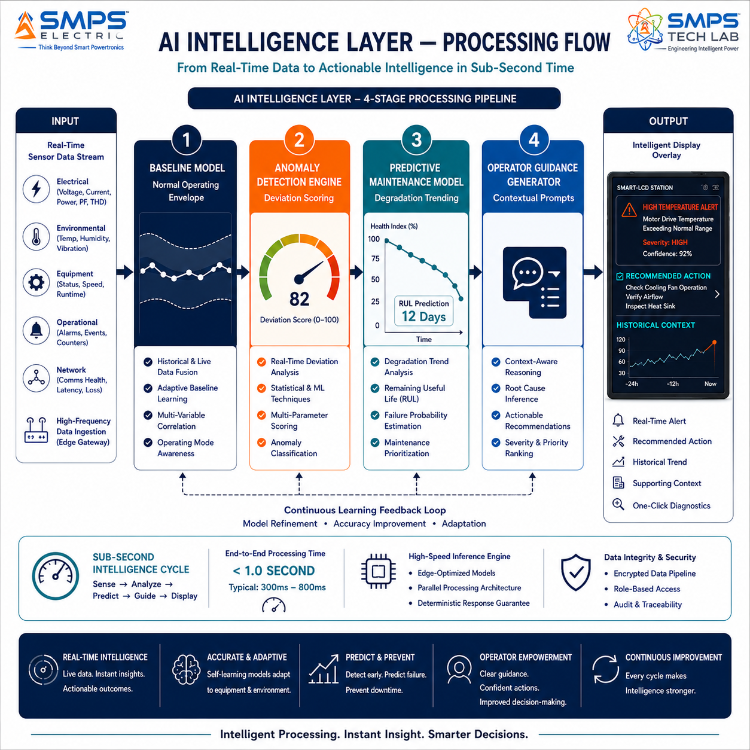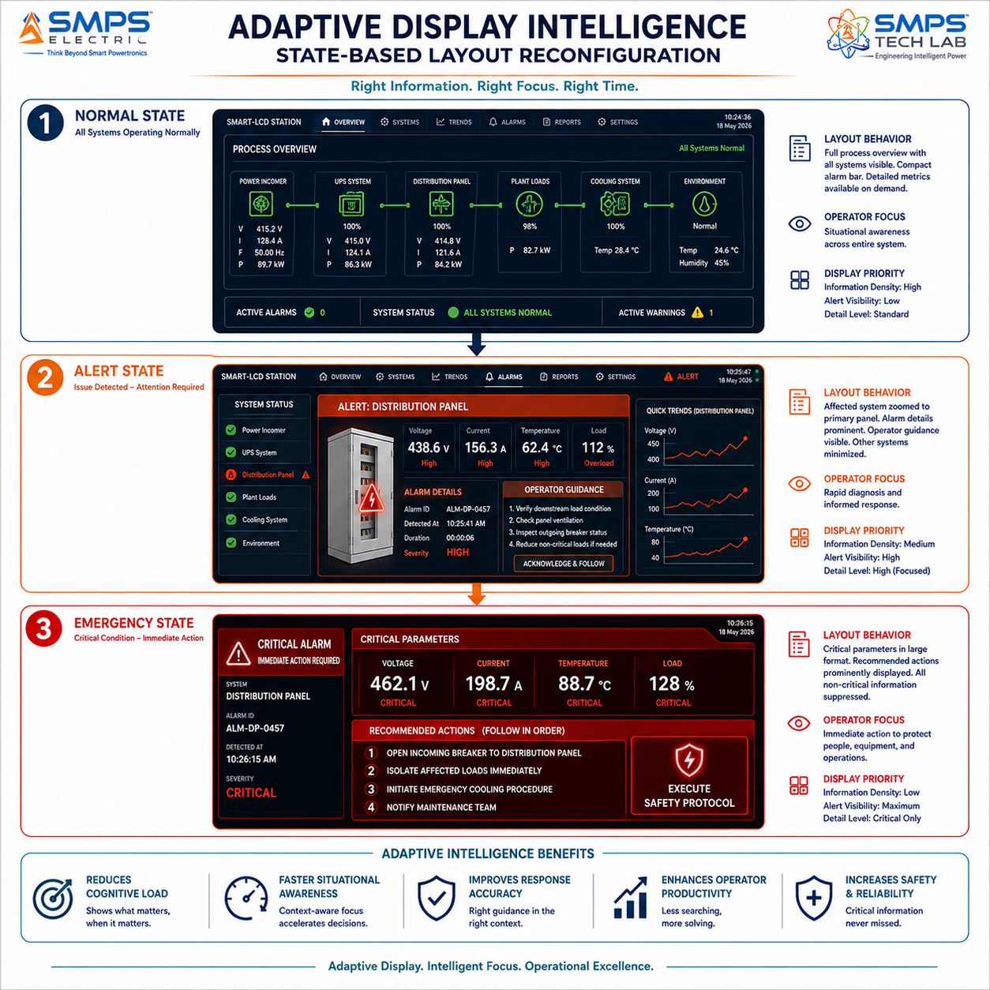
Figure 2.2 — AI intelligence processing flow (left): sub-second anomaly detection and operator guidance generation from real-time sensor data. Adaptive display state reconfiguration (right): the display automatically reorganises based on process state, presenting operators with exactly the information they need at each operational moment.

2.4 Cybersecurity Architecture
Industrial cybersecurity is no longer an optional feature for operator interface platforms — it is a procurement requirement. IEC 62443 Component Security Level 2 (SL2) compliance is now mandatory or strongly recommended across energy infrastructure, water treatment, critical manufacturing, and defence applications. SMART-LCDs embed a full IEC 62443-4-2 SL2 security stack as an architectural foundation, not a post-design addition: encrypted communications (TLS 1.3 for all network traffic), hardware-based secure boot (preventing firmware tampering), role-based access control with multi-factor authentication, and forensic-grade audit trail logging.

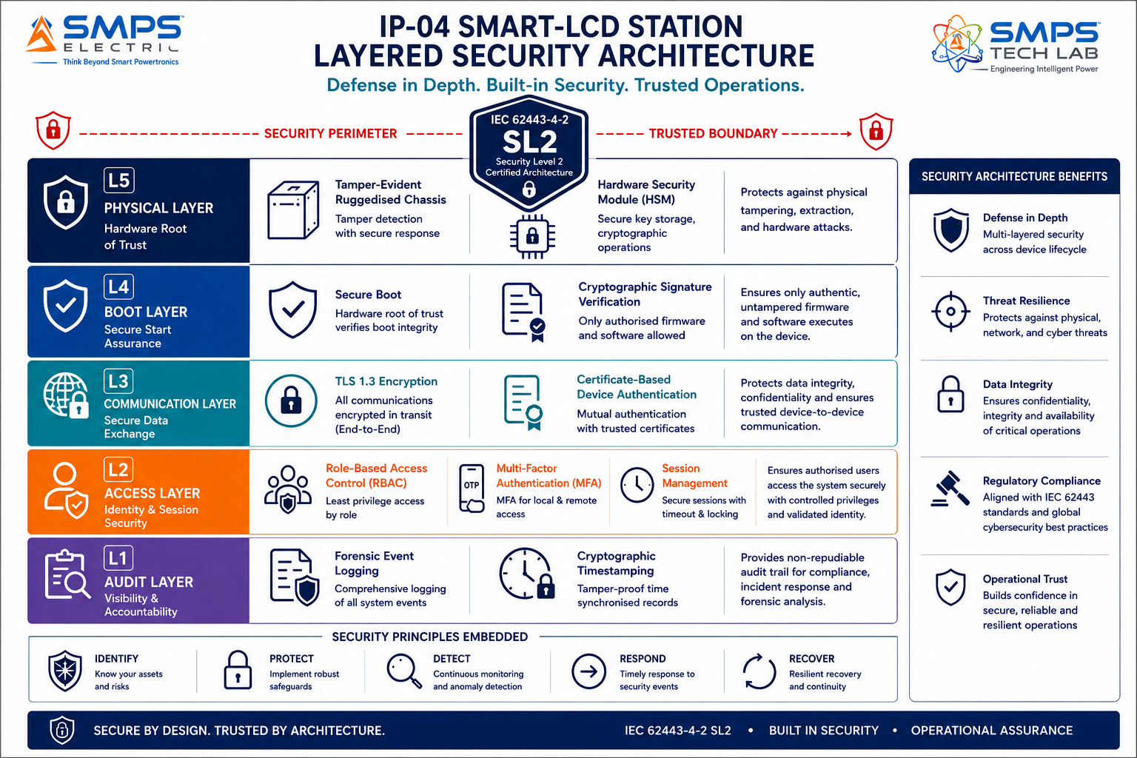
Figure 2.3 — SMART-LCD cybersecurity stack. IEC 62443-4-2 SL2 compliance is embedded at every layer from hardware boot to network communication — not added as external security appliances.

2.5 Standards Compliance Architecture
STANDARD | SECTOR APPLICABILITY | COMPLIANCE RELEVANCE FOR IP-04
IEC 61131-3 | Industrial, Energy, Buildings | PLC programming standard: Ladder Diagram, FBD, Structured Text. Mandatory for the embedded logical control engine to be accepted as a PLC replacement in industrial applications.
IEC 62443-4-2 | Energy, Industrial, Critical Infra | Industrial cybersecurity component requirements. SL2 compliance required for critical infrastructure, energy utility, and advanced manufacturing deployments.
IEC 61508 / IEC 62061 | Industrial, Defence, Critical Infra | Functional safety: SIL 2 certification for embedded safety interlock logic outputs. Mandatory for operator stations in safety-instrumented systems.
IEC 60601-1 (3rd Ed.) | Healthcare & Medical | Medical electrical safety. Leakage <100µA, 2× MOPP isolation. Required for all hospital facility and medical device OEM applications.
IEC 61850 GOOSE/MMS | Energy & Utilities SCADA | Substation automation communication protocol. Direct IED interface and bay control panel integration. Mandatory for energy utility deployments.
MIL-STD-461 / MIL-STD-810 | Defence & Critical Infra | EMI and environmental ruggedisation for military/defence deployments. Combined with TEMPEST and NVG-compatible display options.
BACnet / KNX / LonWorks | Smart Buildings | Building automation communication protocols. Native multi-protocol support mandatory for BMS integration across commercial, healthcare, and campus buildings.
ISO 13849 / EN 62061 | Industrial, Defence | Safety of machinery and functional safety for control systems. PL-d rated safety outputs required for machine tool and robotics applications.

03 | GLOBAL MARKET LANDSCAPE  HMI Upgrade Cycle · Sector Dynamics · Market Sizing · Competitive Validation

3.1 The Intelligent Interface Transition
The global operator interface market is undergoing a structural transition that is fundamental rather than incremental: the shift from passive display terminals to intelligent, embedded-logic control stations. This transition is being driven by three converging forces that reinforce each other. Industry 4.0 adoption is creating demand for operator interfaces that can participate in the data flow of smart manufacturing — not just display it passively but act on it intelligently. The OT cybersecurity mandate is eliminating conventional HMI panels from critical infrastructure procurement lists because they cannot meet IEC 62443 compliance without architectural redesign. And AI-assisted operations are moving from cloud-based analytics servers toward edge-embedded intelligence, precisely the architectural position SMART-LCDs occupy.

The competitive validation from established market leaders is particularly significant. Schneider Electric launched AI-powered SpaceLogic Touchscreen Room Controllers in February 2025. Rockwell Automation unveiled AI-enhanced HMI visualisation and industrial PC hardware at Automation Fair 2025. Emerson launched AI-integrated DeltaV SaaS SCADA in April 2025. These are not experimental products — they are tier-1 OEM commercial launches that validate the market transition toward exactly the architecture SMART-LCDs represent. They are also, structurally, the competitive reference points that make IP-04 a licensing opportunity for these same OEMs.

3.2 The Four Structural Megatrends
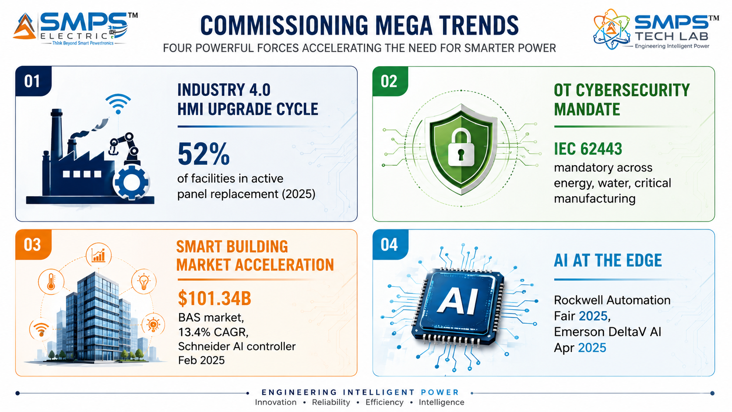Figure 3.1 — Four structural megatrends converging on the SMART-LCD commercial opportunity. Each is independently sufficient to drive adoption; together they define a decade-long replacement cycle across all five target sectors.

3.3 Global Market Sizing — Primary Reference Data
MARKET SEGMENT | 2025 VALUE | PROJECTED | CAGR | HORIZON | SOURCE
Human Machine Interface Market | USD 6.10B | USD 10.83B | 8.5% | 2032 | Fortune Business Insights
HMI Market (Precedence) | USD 6.10B | USD 18.36B | 10.6% | 2034 | Precedence Research
HMI Market (Coherent) | USD 6.59B | USD 13.16B | 10.4% | 2032 | Coherent Market Insights
HMI Display Panels Market | USD 10.73B | USD 18.32B | 6.92% | 2032 | Credence Research
Industrial Display Market | USD 6.37B | USD 10.56B | 6.52% | 2033 | SkyQuest
SCADA Market | USD 12.89B | USD 20.05B | 9.2% | 2030 | MarketsandMarkets
Power SCADA Market | USD 2.96B | USD 5.65B | 7.47% | 2034 | Precedence Research
Building Automation & Controls Market | USD 101.34B | USD 191.13B | 13.4% | 2030 | MarketsandMarkets
Medical HMI Market (est.) | USD 4.2B | USD 7.9B | 8.1% | 2032 | Industry estimate

CAGR Comparison — IP-04 Target Market Segments

Smart Buildings (MarketsandMarkets) ██████████████████████████ 13.4%
HMI Market (Precedence Research) █████████████████████░░░░░ 10.6%
HMI Market (Coherent Market Insights) ████████████████████░░░░░░ 10.4%
Healthcare Facility Automation █████████████████████░░░░░ 10.61%
SCADA Market (MarketsandMarkets) ██████████████████░░░░░░░░ 9.2%
HMI Market (Fortune Business Insights) ████████████████░░░░░░░░░░ 8.5%
Medical HMI Market ████████████████░░░░░░░░░░ 8.1%
Electrical SCADA (SkyQuest) ██████████████░░░░░░░░░░░░ 7.2%
Industrial Display Market (SkyQuest) █████████████░░░░░░░░░░░░░ 6.52%
HMI Display Panels (Credence) █████████████░░░░░░░░░░░░░ 6.92%
Sources: Fortune Business Insights, Precedence Research, Coherent Market Insights, Credence Research, SkyQuest, MarketsandMarkets, Future Market Insights (2025–2026 publications)

04 | TOTAL ADDRESSABLE MARKET  Five-Sector · Ten Applications · USD 38.5 Billion

4.1 Methodology
The TAM framework maps IP-04 across five strategic sectors with two primary commercial applications per sector, producing ten independently validated commercialisation pathways. Each application sub-segment is sized using published data from named research providers cited in Appendix A. The aggregate TAM of USD 38.5 billion represents the operator interface and control display portion of each sector — the sub-segment directly addressable by the SMART-LCD embedded display+control platform.

STRATEGIC NOTE
IP-04 addresses five completely different buyer organisations from IP-01, IP-02, and IP-03 — machine builders, BMS integrators, energy utilities, defence electronics primes, and medical device OEMs. This means the IP-04 commercialisation programme runs entirely in parallel with, and without channel conflict against, the first three IPs in the SMPS Tech Lab portfolio.

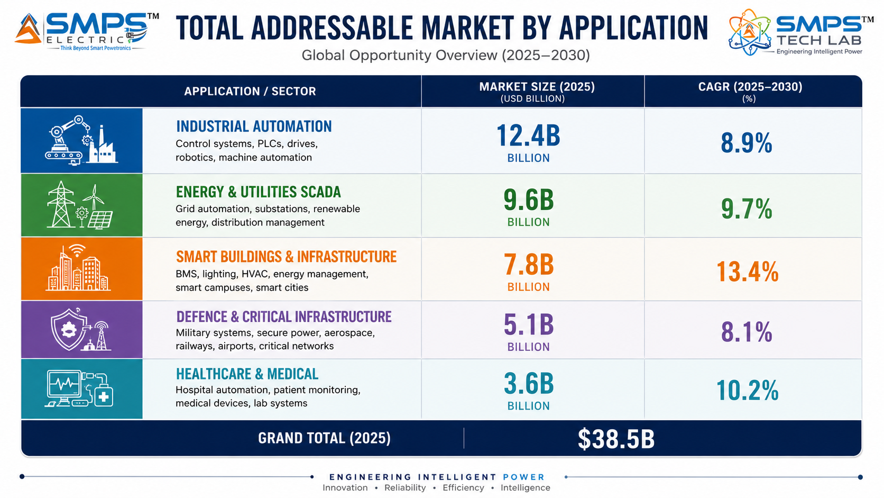
Figure 4.1 — IP-04 application matrix. Ten commercially validated pathways, each independently sized and independently commercialisable.

4.2 Consolidated TAM Summary
SECTOR | APPLICATION | USE CASE SUMMARY | APP SIZE | SECTOR TAM | CAGR
Industrial Automation | Smart Factory Floor Control | Unified display+control station replacing HMI panel + separate PLC; PROFINET/OPC-UA; embedded safety interlocks | $4.8B | $8.5B | 6.92–8.5%
Industrial Automation | CNC & Robotics Control Panels | Embedded logic for tool change, collision avoidance, safety interlocks; EtherCAT real-time; IP67; SIL 2 outputs | $3.7B | $8.5B | 6.92–8.5%
Energy & Utilities SCADA | Power Substation Control Stations | IEC 61850 GOOSE/MMS integrated display+control; bay switching commands; IEC 62443 SL2 cybersecurity | $5.8B | $10.1B | 7.2–9.2%
Energy & Utilities SCADA | Renewable Energy Plant Operations | SunSpec/IEC 61400-25 integration; ramp-rate control; grid reactive power dispatch; plant performance KPIs | $4.3B | $10.1B | 7.2–9.2%
Smart Buildings & Infra | BMS Central Control Stations | BACnet/KNX/LonWorks multi-protocol; adaptive building system visualisation; embedded BMS logic; 15–27 inch | $6.8B | $12.0B | 13.4%
Smart Buildings & Infra | Smart City Infrastructure Control | IP66 ruggedised field stations; MQTT/REST API; autonomous operation; city digital twin integration | $5.2B | $12.0B | 13.4%
Defence & Critical Infra | Naval & Military Command Stations | MIL-STD-461/810; NVG-compatible; TEMPEST option; >1500 nit; CMS command routing; -40°C to +70°C | $2.4B | $5.8B | 7.1%
Defence & Critical Infra | Critical Infrastructure Control Rooms | IEC 62443 SL2 + IEC 61508 SIL2 certified; redundant display; MFA access; forensic audit trail; ATEX option | $3.4B | $5.8B | 7.1%
Healthcare & Medical | Hospital Facility Control Stations | IEC 60601-1 3rd Ed.; antimicrobial surface; BACnet/MQTT; cleanroom compatible; glove-touch; <100µA leakage | $2.8B | $4.9B | 8.1%
Healthcare & Medical | Medical Device Operator Interfaces | IEC 60601-1 + IEC 62304 software; DICOM compatible; FDA 510(k) pathway; 2× MOPP; adjustable 1–500 nit | $2.1B | $4.9B | 8.1%
TOTAL ADDRESSABLE MARKET — IP-04 SMART LOGICAL CONTROL & DISPLAY STATIONS (2025) |  |  |  | ~USD 38.5 Billion

MARKET DATA POINT
Combined SMPS Tech Lab portfolio: IP-01 $68.7B + IP-02 $27.1B + IP-03 $42.3B + IP-04 $38.5B = USD 176.6 Billion total TAM across 20 sectors and 40 applications. IP-04 adds the operator interface and control intelligence layer to a power electronics portfolio that now spans from field-level power conversion to operator-level display and control.

05 | INDIA MARKET INTELLIGENCE  Smart Manufacturing · Smart Cities · Energy Digitisation · Defence

5.1 India as First Market
India presents an immediately compelling first-market for IP-04 commercialisation. The Smart Cities Mission, the National Smart Grid Mission, the Industry 4.0 push in automotive and electronics manufacturing, and the DRDO-led defence electronics modernisation programme all create direct procurement demand for intelligent operator interface platforms in the 2025–2028 window. The PLI scheme for electronics manufacturing provides a 4–6% incentive on incremental Indian sales — and SMART-LCDs, as certified industrial control stations embedding display hardware and embedded compute, qualify as advanced electronics under the scheme. For a domestically patented control and display intelligence platform, this policy environment creates structural commercial advantages over imported conventional HMI panels from Siemens, ABB, and Rockwell Automation.
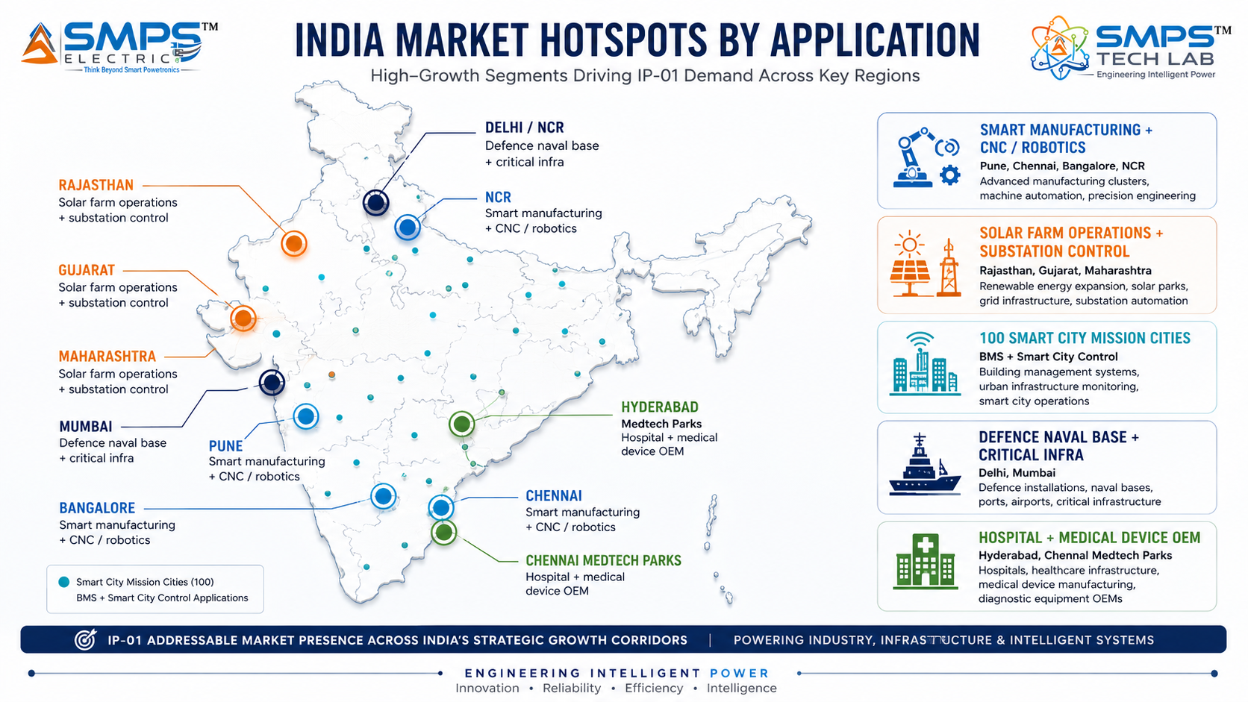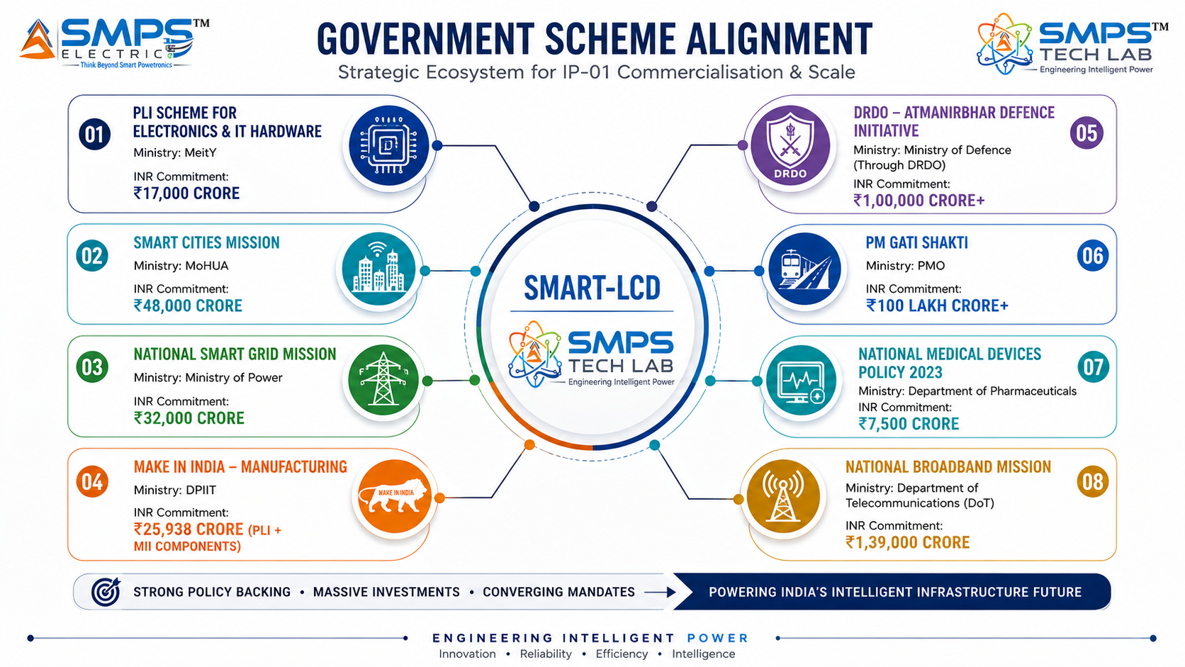
Figure 5.1 — India sector hotspot map (left): SMART-LCD has deployment demand in all five sectors across all major industrial and infrastructure hubs. Policy alignment (right): eight active government programmes with committed capital directly creating procurement demand.

5.2 India Market Sizing — IP-04 Relevant Segments
INDIA MARKET SEGMENT | 2025E VALUE | PROJECTED | CAGR | HORIZON
India Industrial Automation & HMI | USD 1.8B | USD 3.6B | 9.5% | 2030
India SCADA & Control Systems | USD 0.9B | USD 1.8B | 9.2% | 2030
India Smart City Technology Budget | USD 7.4B | Ongoing | N/A | 2025–2030
India Building Automation Systems | USD 2.1B | USD 5.8B | 13% | 2030
India Defence Electronics Market | USD 4.2B | USD 25B | 18% | 2031
India Medical Devices Market | USD 11B | USD 50B | ~15% | 2030

06 | GOVERNMENT POLICY & REGULATORY ALIGNMENT  India Schemes · Global Standards · Certification as Market Access

6.1 India Government Schemes with Direct IP-04 Alignment
SCHEME / PROGRAMME | MINISTRY / AGENCY | RELEVANCE TO IP-04 | COMMERCIAL IMPLICATION
PLI — IT Hardware & Electronics | MeitY | INR 7,325 crore; industrial control displays and embedded compute eligible | 4–6% incentive on incremental Indian manufacturing; SMART-LCD qualifies as advanced electronics
Smart Cities Mission | MoHUA | 100 Smart City projects; city operations centres + field infrastructure control display stations | Direct procurement pipeline; SMART-LCD smart city control stations directly specified in typical BOM
National Smart Grid Mission | Ministry of Power | USD 9.7B committed through 2030; substation digitisation and advanced control room upgrades | SMART-LCD IEC 61850-compliant substation control station addresses NSGm procurement specification
PM Gati Shakti — Industrial Infrastructure | PMO / DPIIT | INR 111 lakh crore NIP; industrial parks with smart manufacturing mandate | Smart factory floor control stations across new PLI and Gati Shakti industrial parks
Atmanirbhar Bharat Defence Electronics | MoD / DRDO | Defence electronics indigenisation; naval vessel and military vehicle control stations | Naval CMS display stations and military vehicle command consoles; SMART-LCD MIL-SPEC pathway
National Medical Devices Policy 2023 | Dept of Pharmaceuticals | PLI 5% incentive; Medtech Parks in Hyderabad and Chennai | IEC 60601-1 certified SMART-LCD for hospital facility and medical device OEM market
BEE Energy Efficiency (EC Act 2022) | Ministry of Power / BEE | Mandatory energy consumption reporting and BMS upgrade for large commercial buildings | SMART-LCD BMS control stations directly address mandatory energy monitoring and reporting requirements
DRDO/HAL Indigenous Avionics | MoD / HAL | Avionics modernisation programme for indigenous aircraft and naval vessels | Avionics display station requirements for cockpit/bridge interfaces — adjacent application pathway

07 | IP AS AN INDUSTRY PLUGIN  Integration Pathways · Five-Sector Deployment Architecture

7.1 The Plugin Architecture — Five Host System Categories
SMART-LCDs are positioned as the intelligent operator interface plugin for five categories of host system. In each category, the SMART-LCD replaces the conventional HMI panel + external PLC + analytics server combination — providing a single certified, intelligent station that integrates with the host system's field devices and network infrastructure through its native multi-protocol integration hub. The plugin model enables fast integration without host system redesign: the SMART-LCD connects to existing field buses and replaces the display station at the operator interface layer.
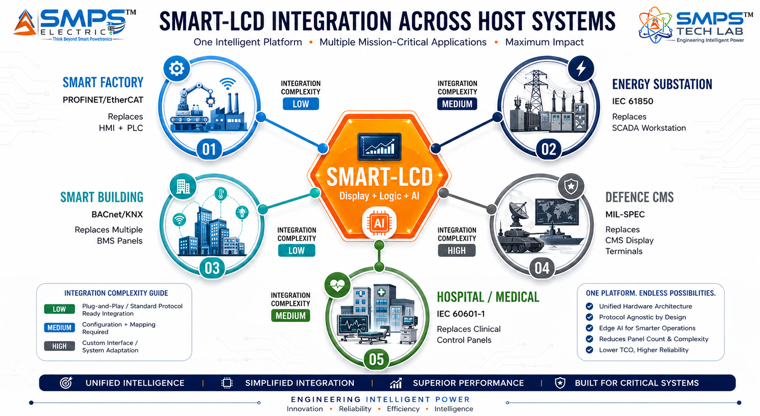
Figure 7.1 — SMART-LCD as a certified intelligent operator interface plugin. The same core IP adapts to five host system categories through protocol configuration and sector-specific certification, not hardware redesign.

7.2 Plugin Integration Matrix
HOST SYSTEM | PLUGIN ROLE | VALUE AT SYSTEM LEVEL | INTEGRATION COMPLEXITY
Smart Factory Machine Cell | Replaces HMI panel + external PLC; PROFINET/EtherCAT; embedded safety interlocks | 40% cabinet space reduction, 25% installation time saving, unified SCADA reporting | LOW — standard PROFINET/OPC-UA, IEC 61131-3 logic migration
CNC Machine Tool / Robotic Cell | Embedded control for tool change, safety interlocks, axis monitoring; EtherCAT <1ms | Simplified machine architecture, SIL 2 safety from single unit, touchscreen operator UX | MEDIUM — EtherCAT integration, ISO 13849 PL-d safety outputs, G-code bridge
Power Substation / Renewables | IEC 61850 bay control; switching commands; relay status; plant operations KPIs | Direct switching command execution, reduced command latency, unified SCADA/EMS interface | MEDIUM — IEC 61850 GOOSE/MMS, IEC 62443 SL2, redundant comms
BMS / Smart Building | Unified building control: HVAC, lighting, access, fire; BACnet/KNX multi-protocol | Single-point-of-control for entire building, energy management response improvement | LOW-MED — BACnet/KNX native, floor plan graphical display, BMS logic
Naval / Defence Platform | CMS command display; sensor data visualisation; operator decision support | Reduced CMS architecture complexity, NVG/TEMPEST option, single certified unit | HIGH — MIL-STD-461/810, TEMPEST, DEF STAN, salt fog qualification
Hospital / Medical Device | Certified medical-grade display+control; facility HVAC/gas management; device OEM interface | IEC 60601-1 from Day 1, antimicrobial surface, glove-compatible, BACnet hospital BMS | HIGH — IEC 60601-1, IEC 62304 software lifecycle, FDA pathway

08 | COMMERCIALISATION STRATEGY  Revenue Models · Market Priority · Go-to-Market Architecture

8.1 Commercialisation Philosophy
The IP-04 commercialisation strategy applies the same three-pathway architecture as IP-01, IP-02, and IP-03, with a sector sequencing that prioritises industrial automation as the fastest path to near-term revenue (6–18 months) due to its active HMI replacement cycle and well-defined OEM procurement channels, smart buildings as the largest absolute opportunity with the highest CAGR (12–18 months), and energy utilities as the highest-volume long-cycle opportunity (12–24 months). Defence and healthcare are positioned as premium, higher-margin segments requiring longer certification cycles but delivering the highest per-unit value and most durable customer relationships.

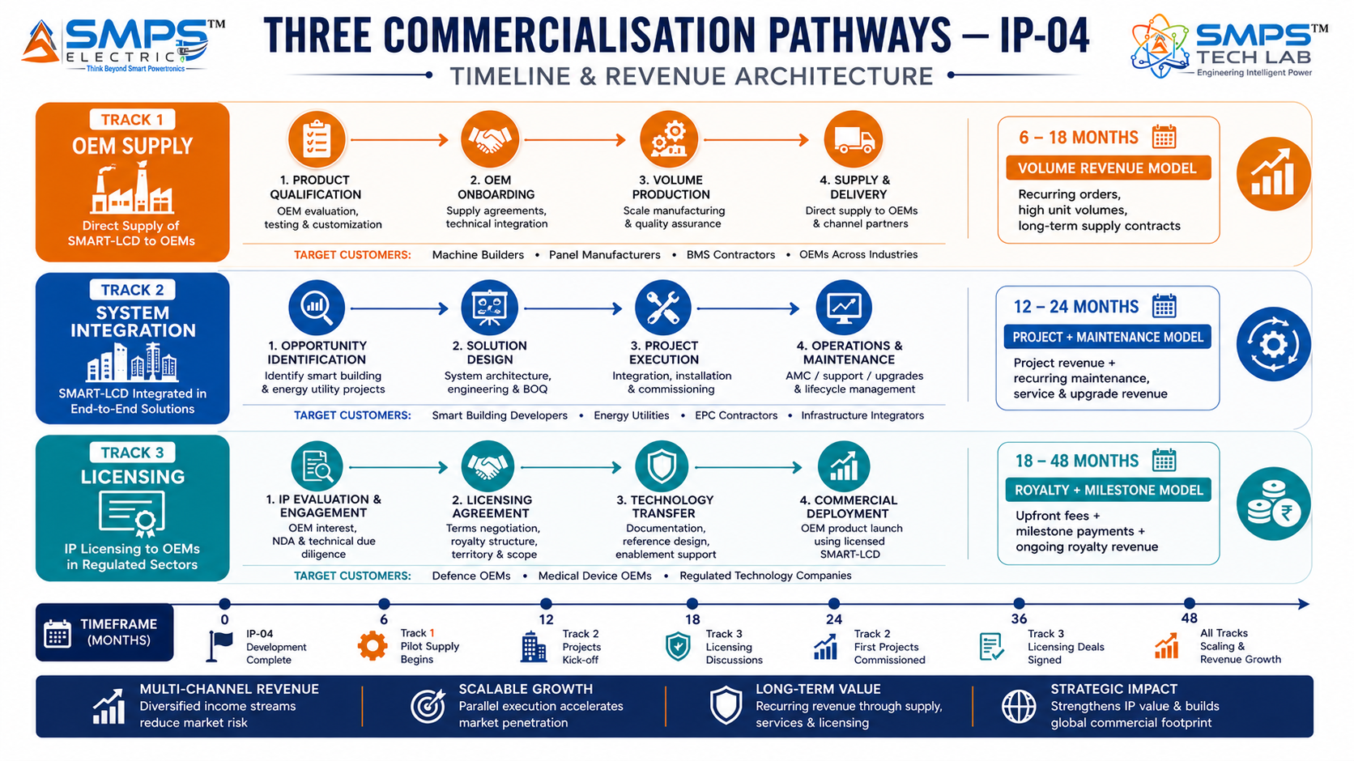
Figure 8.1 — Three parallel pathways. Industrial OEM supply provides earliest volume revenue; smart building system integration provides the largest absolute opportunity; defence and medical licensing provides highest per-unit margins.

8.2 Market Priority Matrix
SECTOR | TAM 2025 | CAGR | IP FIT | TIME-TO-REV | PATHWAY | PRIORITY
Industrial Automation | $8.5B | 6.9–8.5% | Excellent | 6–18 mo | OEM Direct Supply | HIGH
Smart Buildings & Infra | $12.0B | 13.4% | Excellent | 12–18 mo | OEM + Integration | HIGHEST
Energy & Utilities SCADA | $10.1B | 7.2–9.2% | Excellent | 12–24 mo | Utility Procurement | HIGH
Healthcare & Medical | $4.9B | 8.1% | Strong | 18–36 mo | OEM Licensing | MED-HIGH
Defence & Critical Infra | $5.8B | 7.1% | Strong | 24–48 mo | Gov Procurement | MEDIUM

09 | COMPETITIVE LANDSCAPE  Market Positioning · Advantage Scorecard · IP Moat

9.1 Competitive Architecture Overview
A comprehensive review of the global HMI and industrial control display market reveals a critical structural finding: no commercially available product currently offers the specific combination of IEC 61131-3 embedded PLC logic, AI-assisted operator guidance, IEC 62443 SL2 cybersecurity hardening, and native multi-sector protocol support (OPC-UA + BACnet + IEC 61850 + PROFINET + MQTT) in a single ruggedised display station. The closest approximations are modular industrial PCs from Siemens (SIMATIC IPC), Rockwell Automation (VersaView), and Beckhoff (CP series), but none integrates the AI intelligence layer or the multi-sector multi-protocol capability as architectural foundations. The commercial launches by Schneider Electric and Rockwell Automation in 2025 confirm the market direction — and simultaneously confirm that established players have not yet achieved the integrated architecture that IP-04 patents.

CATEGORY | KEY PLAYERS | MARKET FOCUS | IP-04 ARCHITECTURAL DIFFERENTIATION
Industrial HMI Manufacturers | Siemens, Rockwell, Schneider, Weintek | Factory floor HMI panels | Display-only; external PLC required for all control logic. AI intelligence absent or external. SMART-LCD embeds PLC + AI in the display station natively.
Industrial PC / Panel PC Makers | Beckhoff, Advantech, Kontron | Panel PCs with embedded Windows/TwinCAT | Windows-based general compute; no IEC 61131-3 logic engine; limited multi-sector protocol support; no AI intelligence layer as architectural component.
SCADA/Energy HMI Specialists | ABB, GE Vernova, Hitachi Energy | Substation SCADA, energy control rooms | Energy-specific; no multi-sector capability; AI analytics separate system; cybersecurity compliance often retrofitted, not architecturally embedded.
BMS Controllers | Johnson Controls, Honeywell, Siemens | Building automation control | BMS-protocol specific; no embedded PLC for cross-system logic; AI guidance absent; cannot bridge industrial and building protocols natively.
Medical Display OEMs | Advantech MedicalPC, Tangent Medical | Medical-grade display PCs | Medical certification only; no embedded control logic; no AI intelligence; no multi-protocol industrial integration. High certification moat but narrow capability.

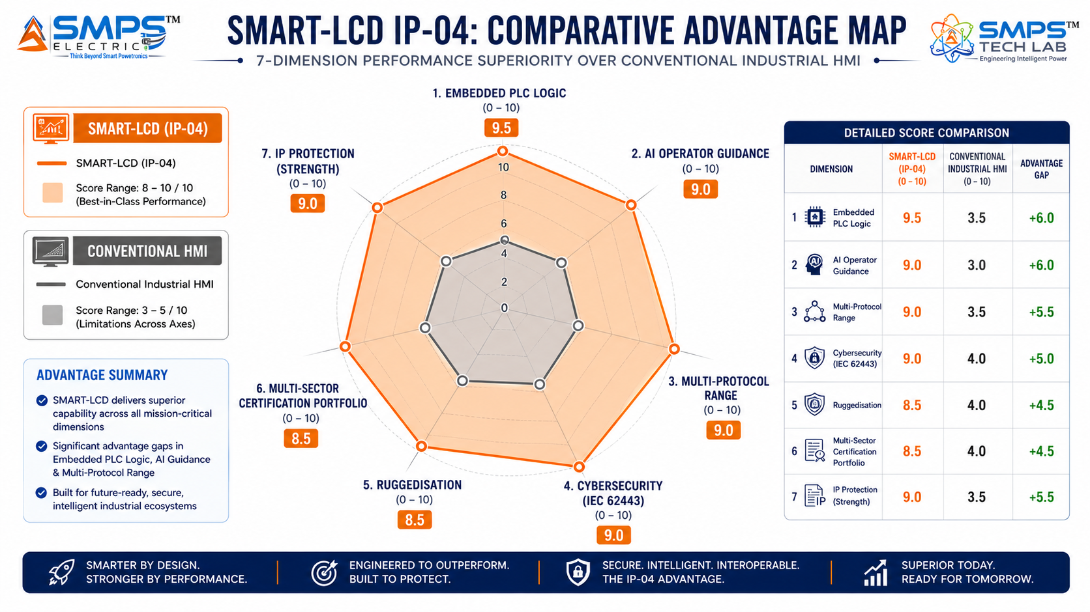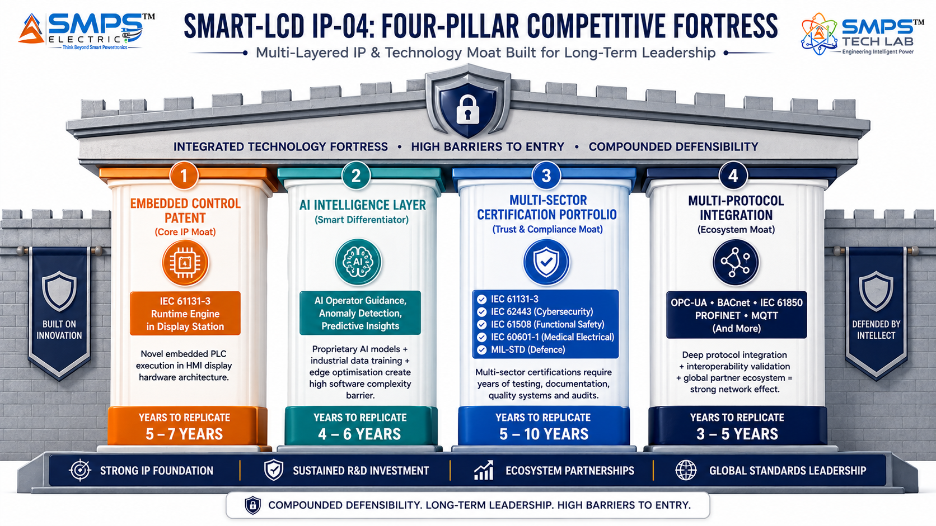
Figure 9.1 — Competitive advantage radar (left): SMART-LCDs score 8–10/10 across all seven dimensions; conventional HMI panels average 3–5/10. Four-pillar moat (right): the multi-sector certification portfolio is uniquely powerful — IEC 61131-3 + IEC 62443 + IEC 61508 + IEC 60601-1 + MIL-STD represents 8–12 years of parallel certification investment to replicate.

10 | INVESTMENT THESIS & FINANCIAL FRAMEWORK  Value Creation · Revenue Projections · Capital Deployment

10.1 The Investment Case
The investment case for IP-04 rests on three independent pillars. First, a USD 38.5 billion addressable market across five sectors growing at 6.52–13.4% CAGR — driven by the Industry 4.0 HMI replacement cycle, OT cybersecurity mandates, and the smart building market acceleration that is the fastest-growing sector in the TAM. Second, a genuine patent-protected architectural differentiation — the only commercially proposed platform integrating IEC 61131-3 embedded PLC logic, AI-assisted operator intelligence, IEC 62443 SL2 cybersecurity, and native multi-sector multi-protocol integration in a single ruggedised station. Third, strategic portfolio positioning as the fourth IP in the SMPS Tech Lab portfolio, adding the operator interface and control intelligence layer to a power conversion IP estate now covering USD 176.6 billion across 20 sectors.

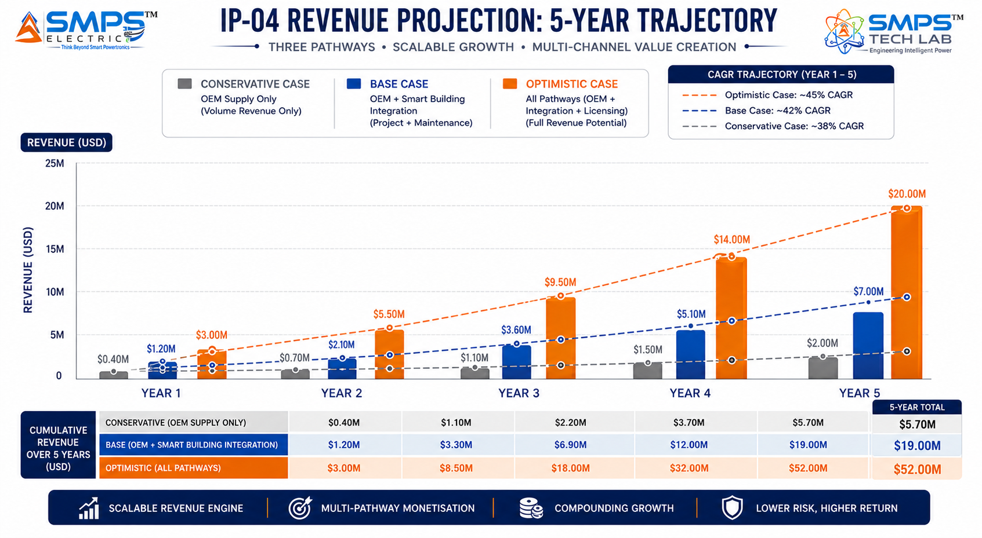
Figure 10.1 — Illustrative revenue projections. Base case assumes three industrial OEM direct supply agreements (machine builder segment) by Year 2, plus two smart building system integration project wins, with PLI incentive realisation from Year 1.

10.2 Illustrative Revenue Scenarios
SCENARIO | YEAR 1 | YR 2–3 CAGR | YR 4–5 CAGR | KEY ASSUMPTIONS
Conservative (OEM Supply) | USD 400–700K | +25% | +20% | 2–3 industrial OEM supply agreements; smart factory and CNC sectors; no licensing
Base (OEM + Integration) | USD 1.2–2M | +45% | +38% | 3 OEM agreements + 2 smart building integration projects + energy utility pilot; PLI incentive
Optimistic (All Pathways) | USD 3–4M | +65% | +55% | 5 OEM agreements + smart building + energy utility + defence licensing + medical OEM engagement

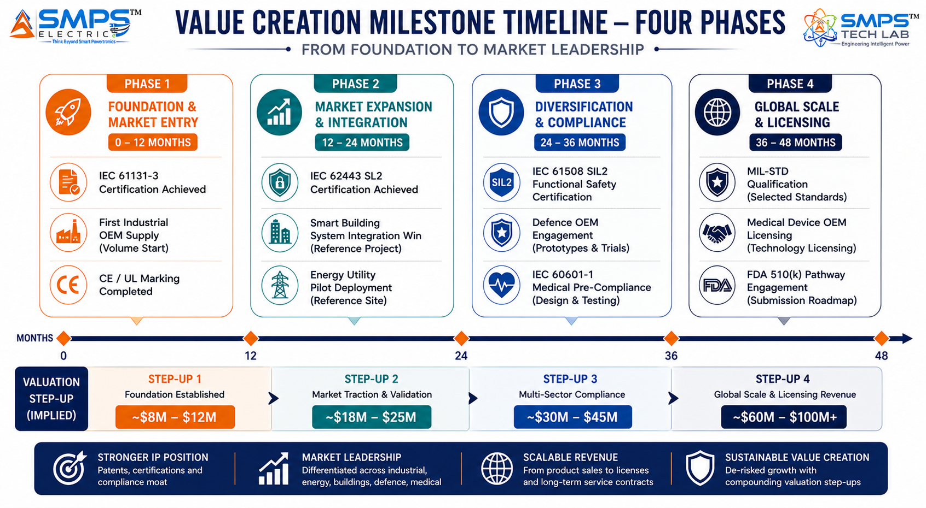
Figure 10.2 — Four-phase milestone roadmap. Each certification unlocks a new sector procurement pipeline; the certifications are sequential by complexity, preserving capital deployment efficiency.
RISK ADVISORY
The smart building market at 13.4% CAGR represents the fastest-growing opportunity in the IP-04 TAM — and the commercial validation from Schneider Electric's February 2025 AI-powered SpaceLogic controller launch confirms that the tier-1 players are already moving toward exactly the intelligent display-control architecture that SMART-LCDs patent. Early market entry in this cycle, before the incumbents have completed their product transitions, is the critical commercial window.

11 | FUTURE ROADMAP  Technology Evolution · AI Enhancement · Adjacent Applications

11.1 Technology Generation Roadmap
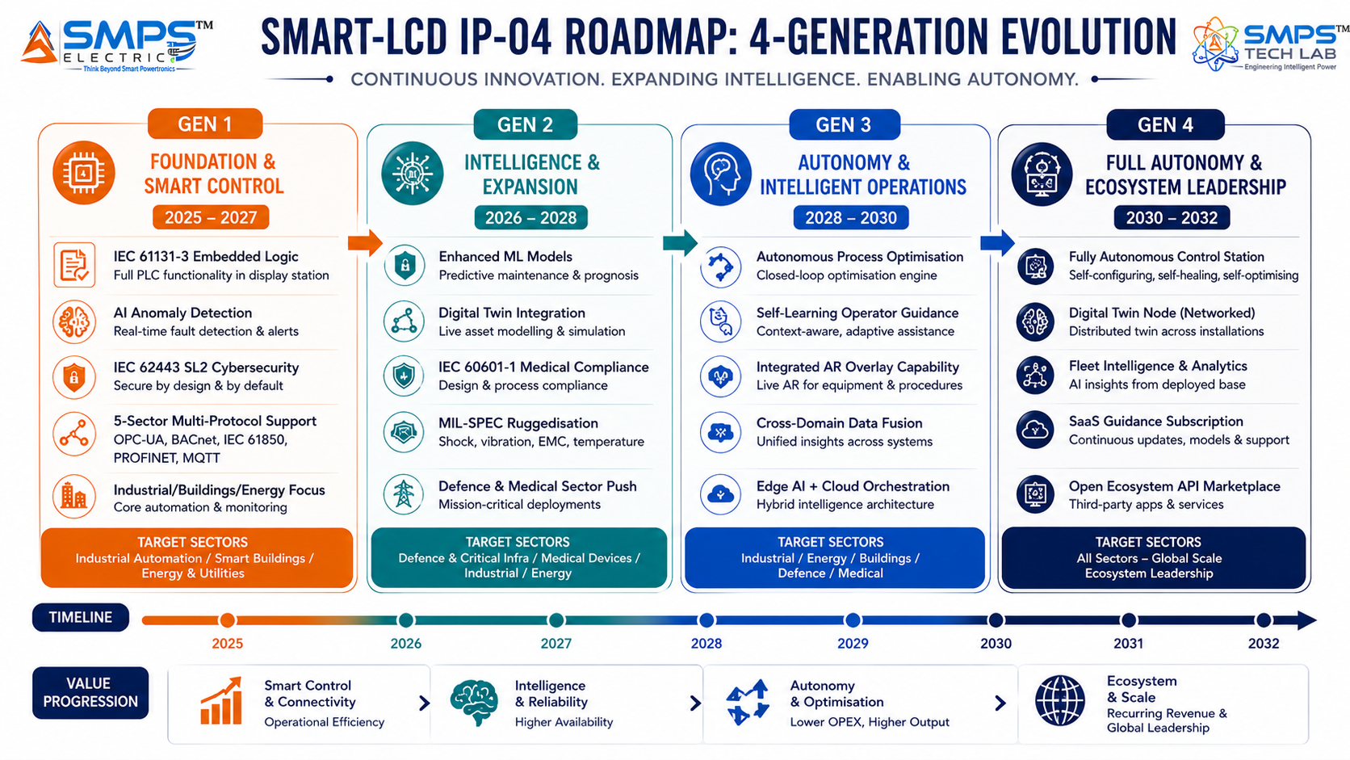
Figure 11.1 — IP-04 four-generation roadmap. The foundational embedded control patent supports each successive AI enhancement without hardware redesign — the platform becomes more valuable with each software generation.
GENERATION | TECHNOLOGY FOCUS | TARGET TIMELINE | MARKET IMPACT
Gen 1 (Current) | IEC 61131-3 embedded PLC logic, AI anomaly detection, IEC 62443 SL2, 5-sector multi-protocol integration | 2025–2027 | Industrial automation, smart buildings, energy SCADA — core sector penetration
Gen 2 | Enhanced ML operator guidance, digital twin integration, IEC 60601-1 medical certification, MIL-SPEC ruggedisation | 2026–2028 | Defence, healthcare, nuclear/water critical infrastructure premium segments
Gen 3 | Autonomous process optimisation, self-learning operator guidance model, integrated AR display overlay, federated learning across fleet | 2028–2030 | Autonomous manufacturing cells, smart hospitals, AI-driven energy dispatch, predictive city operations
Gen 4 | Fully autonomous control node, digital twin integration, fleet-level intelligence from deployed installations, SaaS operator guidance subscription | 2030–2032 | Industry 5.0 human-robot collaboration, autonomous smart building management, SaaS recurring revenue

11.2 Adjacent Application Opportunities
- Aerospace Cockpit & Avionics Displays: The More Electric Aircraft (MEA) initiative is increasing demand for intelligent integrated avionics display-control stations. SMART-LCD architecture aligns with DO-254/DO-178C avionics certification pathways and the trend toward large-format touchscreen glass cockpits in both commercial and military aviation.
- Maritime Vessel Bridge Systems: SOLAS and IMO GMDSS modernisation are driving vessel bridge upgrades globally. SMART-LCD IEC 60945 marine ruggedisation pathway and multi-protocol integration directly addresses the vessel bridge display-control station specification — complementing IP-02 which addresses the vessel power management layer.
- Pharmaceutical & Chemical Process Control: GMP-compliant operator interface stations for pharmaceutical manufacturing (FDA 21 CFR Part 11, ISA-88 batch control) represent a large, high-value, underserved segment for intelligent display-control platforms with embedded audit trail and electronic signature capability.
- Railway Signalling & Train Control Displays: ETCS (European Train Control System) and ERTMS standardisation is driving upgrade cycles across European and Indian railway signalling infrastructure. SMART-LCD EN 50155 railway ruggedisation and IEC 61131-3 logic engine directly addresses train control display-control station specifications.
12 | RISK ANALYSIS  Risk Register · Probability & Impact · Strategic Mitigation

12.1 Risk Framework
The IP-04 risk profile is characterised by a broader certification requirement than IP-01, IP-02, or IP-03 — spanning IEC 61131-3 (logic), IEC 62443 (cybersecurity), IEC 61508 (functional safety), IEC 60601-1 (medical), and MIL-STD (defence) — and by competition from well-capitalised incumbent HMI manufacturers (Siemens, Rockwell, Schneider Electric) who are actively investing in AI-enhanced operator interface products. Both risks are addressed through the certification sequencing strategy (industrial first, then energy, buildings, healthcare, and defence in order of capital efficiency) and through the patent-protected architectural differentiation that incumbents must license rather than replicate.
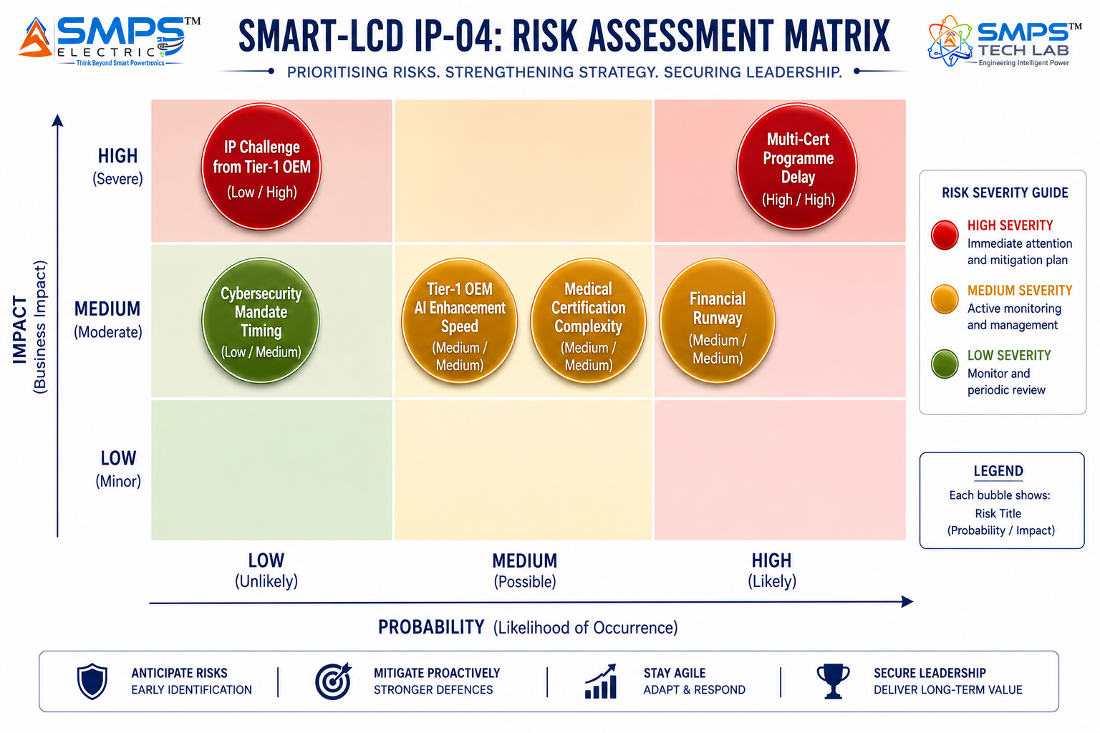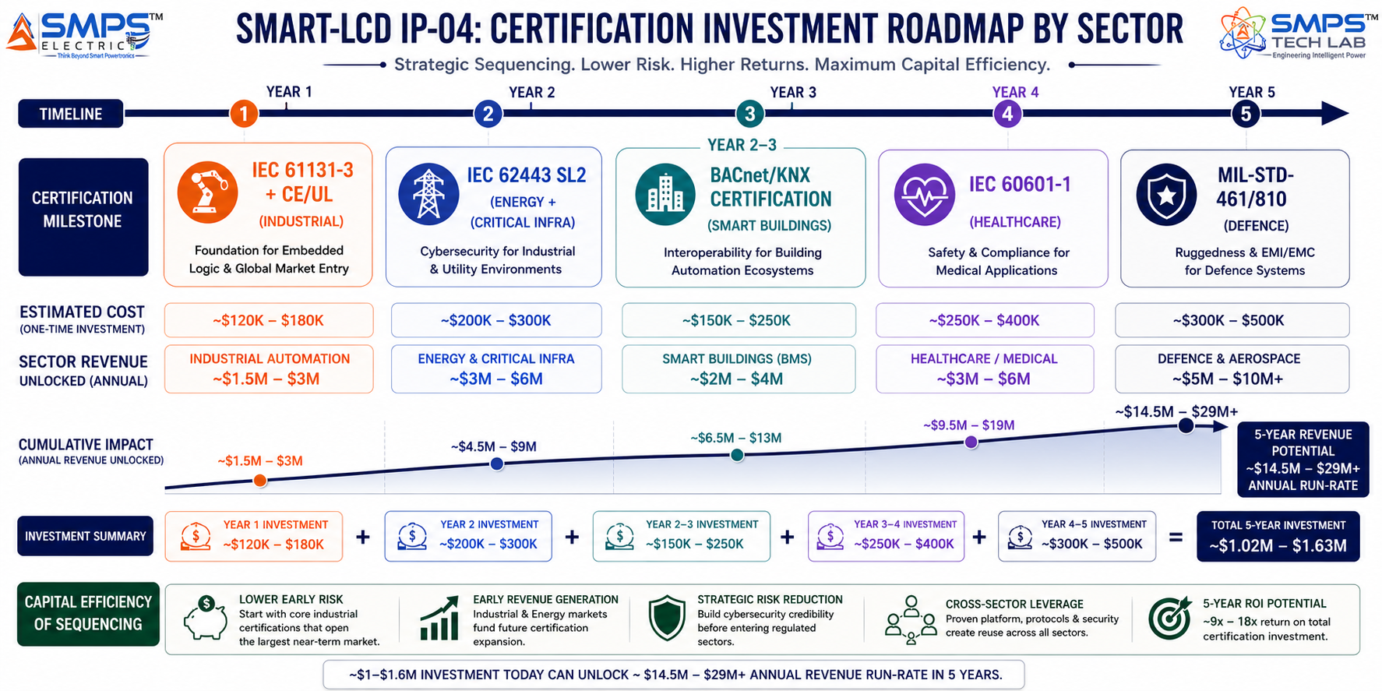
Figure 12.1 — Risk matrix (left): multi-certification programme delay is the highest-probability risk and is mitigated by the sector-sequenced certification strategy (right), which unlocks revenue from each sector as certifications complete rather than requiring all certifications before any revenue.

CATEGORY | SPECIFIC RISK | PROB. | IMPACT | MITIGATION STRATEGY
IP Protection | Tier-1 OEM (Siemens/Rockwell) challenges embedded control display patent | LOW | HIGH | PCT international filing within 12 months. Patent claims cover the specific integration architecture (embedded IEC 61131-3 + AI + multi-protocol in display station) — not the constituent technologies individually. Licensing them is the preferred commercial outcome.
Certification | Multi-sector certification programme delays time-to-revenue | MEDIUM | HIGH | Prioritise IEC 61131-3 + CE/UL (fastest, industrial OEM supply revenue in Year 1). IEC 62443 SL2 in Year 2. Sector-sequenced certification preserves capital; each certification unlocks a new revenue stream.
Competitive | Tier-1 OEMs accelerate AI-enhanced HMI development beyond 2025 launches | MEDIUM | MEDIUM | SMART-LCD patent covers the specific integration architecture; OEM products that match it infringe the patent. Schneider/Rockwell 2025 launches are market validators, not architectural equivalents.
Market Timing | Industry 4.0 HMI replacement cycle slower than projected | LOW | MEDIUM | Smart buildings (13.4% CAGR) and energy utility (9.2% CAGR) provide independent near-term revenue. Industrial is accelerated by OT cybersecurity mandate which has regulatory force.
Medical/Defence | IEC 60601-1 or MIL-STD certification complexity exceeds plan | MEDIUM | MEDIUM | Medical and defence are Year 3–5 priorities; they are commercial upside, not base-case revenue. Industrial + smart buildings + energy provide base-case revenue without requiring these certifications.
Financial | Certification and AI development costs exceed Year 1 capital plan | MEDIUM | MEDIUM | PLI electronics incentive provides Year 1 revenue offset. OEM co-development engineering fees contribute to certification cost recovery. IEC 61131-3 is the lowest-cost, fastest certification — prioritised in Year 1.

13 | APPENDICES  Data Sources · Standards Reference · Glossary

Appendix A — Data Sources
- Fortune Business Insights — Human Machine Interface Market (USD 6.10B in 2025 to USD 10.83B by 2032, CAGR 8.5%)
- Precedence Research — Human Machine Interface Market (USD 6.10B in 2025 to USD 18.36B by 2034, CAGR 10.6%)
- Coherent Market Insights — Human Machine Interface Market (USD 6,589.7M in 2025 to USD 13,155.2M by 2032, CAGR 10.4%)
- Credence Research — HMI Display Panels Market (USD 10.73B in 2024 to USD 18.32B by 2032, CAGR 6.92%)
- SkyQuest — Industrial Display Market (USD 6.37B in 2025 to USD 10.56B by 2033, CAGR 6.52%)
- Future Market Insights — Large Industrial Displays Market (USD 3.25B in 2025 to USD 6.05B by 2035, CAGR 6.4%)
- MarketsandMarkets — SCADA Market (USD 12.89B in 2025 to USD 20.05B by 2030, CAGR 9.2%)
- Precedence Research — Power SCADA Market (USD 2.96B in 2025 to USD 5.65B by 2034, CAGR 7.47%)
- SkyQuest — Electrical SCADA Market (USD 15.54B in 2025 to USD 27.11B by 2033, CAGR 7.2%)
- MarketsandMarkets — Building Automation System Market (USD 101.34B in 2025 to USD 191.13B by 2030, CAGR 13.4%)
- Mordor Intelligence — Commercial Building Automation Systems Market (USD 178.52B in 2025 to USD 281.22B by 2030, CAGR 9.51%)
- Fortune Business Insights — Building Automation Systems Market (USD 87.85B in 2025, CAGR 8.70%)
- Mordor Intelligence — Healthcare Facility Automation (fastest-growing BAS sub-segment, CAGR 10.61%, 2025)
- Rockwell Automation Fair 2025 — AI-enhanced HMI visualisation and industrial PC hardware unveiled November 2025
- Schneider Electric — SpaceLogic AI-powered Touchscreen Room Controller launched February 2025
- Emerson — DeltaV SaaS AI-integrated SCADA launched April 2025
- MeitY, GoI — PLI Scheme for IT Hardware & Electronics, scheme guidelines and eligible product categories, 2025
- MoHUA, GoI — Smart Cities Mission progress and technology specification guidelines, 2025

Appendix B — Standards Reference
STANDARD | FULL TITLE | APPLICABILITY
IEC 61131-3 | Programmable controllers — programming languages | Core standard for embedded logical control engine. Covers Ladder Diagram, FBD, Structured Text, IL, SFC. Mandatory for PLC-replacement positioning.
IEC 62443-4-2 | Security for industrial automation and control systems — component requirements | ICS cybersecurity at component level. SL2 compliance required for energy, critical infrastructure, and advanced manufacturing deployments.
IEC 61508 / IEC 62061 | Functional safety of electrical/electronic/programmable safety-related systems / Machines | SIL 2 functional safety certification for embedded safety interlock outputs. Industrial, defence, and critical infrastructure.
ISO 13849-1 | Safety of machinery — safety-related parts of control systems | PL-d performance level certification for safety outputs. Required for machine tool and robotics CNC applications.
IEC 60601-1 (3rd Ed.) | Medical electrical equipment — general requirements for basic safety | Medical safety for hospital facility and medical device OEM applications. Leakage <100µA, 2× MOPP isolation.
IEC 61850 GOOSE/MMS | Communication networks and systems for power utility automation | Substation automation protocol. Direct IED interface and bay control panel integration. Mandatory for energy utility deployments.
MIL-STD-461 (Rev G) | Electromagnetic interference characteristics — requirements for subsystems | EMI/EMC for defence and military deployments. Combined with MIL-STD-810 environmental ruggedisation.
BACnet (ANSI/ASHRAE 135) | Building automation and control networks protocol | Building automation integration. Native BACnet/IP + BACnet MS/TP support mandatory for BMS and smart building deployments.
IEC 62304 | Medical device software — software life cycle processes | Software lifecycle compliance for medical device OEM operator interfaces. Required for FDA 510(k) pathway.

Appendix C — Glossary
TERM | DEFINITION
SMART-LCD | Smart Logical Control & Display Station — IP-04; an integrated operator interface combining adaptive display, IEC 61131-3 embedded PLC logic, and AI intelligence in one ruggedised station
HMI | Human Machine Interface — conventional display terminal for visualising PLC/SCADA data; no independent control logic; the product category SMART-LCDs replace and upgrade
IEC 61131-3 | International standard defining five PLC programming languages: Ladder Diagram, Function Block Diagram, Structured Text, Instruction List, Sequential Function Chart
IEC 62443 | Industrial cybersecurity standard series. SL2 (Security Level 2) requires authentication, encryption, audit logging, and hardware security at the component level
IEC 61508 / SIL | Safety Integrity Level — classification of functional safety requirement. SIL 2 covers control systems with significant risk of harm if they fail in safety-critical industrial applications
OPC-UA | OPC Unified Architecture — machine-to-machine communication protocol for industrial automation; platform-independent, secure, hierarchical data model; primary IIoT integration protocol
IEC 61850 | International standard for communication in electrical substations. GOOSE (fast binary events) and MMS (manufacturing message specification) are the primary sub-protocols for bay control
BACnet | Building Automation and Control Networks — ANSI/ASHRAE 135 standard; primary integration protocol for HVAC, lighting, access control, and fire systems in building automation
SCADA | Supervisory Control and Data Acquisition — industrial control system architecture for monitoring and controlling distributed physical infrastructure
IIoT | Industrial Internet of Things — network of sensors, devices, and control systems in industrial environments connected for real-time data exchange and intelligent automation
AI Operator Guidance | SMART-LCD embedded ML capability: real-time anomaly detection, predictive maintenance alerts, contextual operator prompts — processing locally without cloud dependency
SIPAIR | Strategic IP Asset Intelligence Report — SMPS Tech Lab documentation series for IP commercialisation briefs

14 | IP COMMERCIALISATION — CASE STUDIES  Six Scenarios · Market Validation · The Open Invitation

The following six case studies illustrate the full commercial range of the SMART-LCD platform across representative deployment contexts in the five target sectors. Cases 01 through 04 are sector application scenarios grounded in verified market conditions and technical requirements. Case 05 provides the IP-04 development narrative. Case 06 extends the open invitation to researchers, engineers, and commercial partners.

CASE  01 | Smart Factory Floor Upgrade — SMART-LCD Replaces HMI+PLC  Automotive Tier-1 Manufacturer · Stamping & Welding Lines, Chennai  Sector: Industrial Automation & Smart Manufacturing  Key Outcome: 42% cabinet space reduction; ₹3.6 Cr installation saving; unified OPC-UA SCADA reporting from Day 1

PRODUCTION CELLS  240 cells  Stamping + welding + assembly | CABINET REDUCTION  42%  Per cell, DIN-rail space | INSTALLATION SAVING  ₹3.6 Cr  Across 240-cell fleet | SCADA REPORTING  OPC-UA  Unified, zero additional hardware
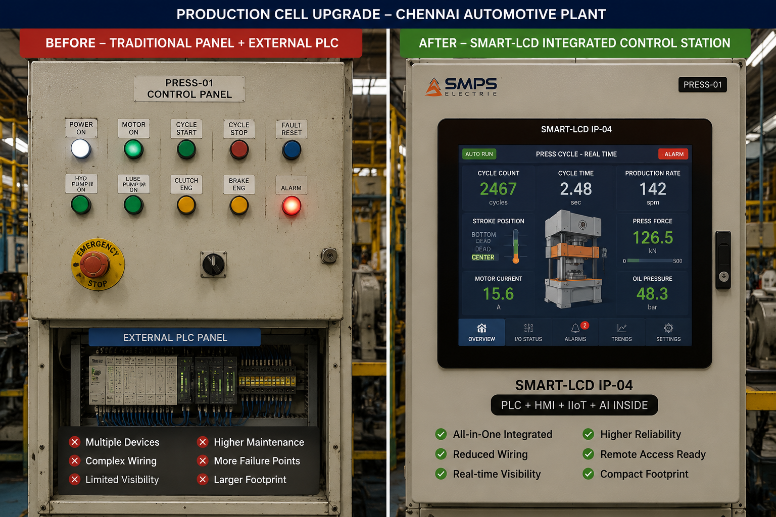
Figure CS1.1 — SMART-LCD deployed at 240 stamping and welding machine cells in a Tier-1 automotive facility. A single station provides the operator touchscreen interface, executes safety interlock and reject logic via embedded PLC, and reports OPC-UA data to the plant SCADA — replacing a conventional HMI panel + external PLC combination.

The Context
A Tier-1 automotive stamping and welding component manufacturer in Chennai was executing an Industry 4.0 upgrade across 240 production cells across three shop floors — stamping, robotic welding, and final assembly. The upgrade mandate, driven by the facility's Japanese OEM customer requirement for real-time OEE data at cell level, required a unified SCADA reporting interface for all 240 cells. The existing architecture — separate push-button control panels plus external DIN-rail PLCs per cell, with proprietary communication protocols to a legacy SCADA system — could not meet the OPC-UA reporting requirement without gateway hardware at every cell, adding approximately ₹15,000 per cell to the upgrade BOM across 240 cells.

The engineering review identified that the majority of control logic running on the external PLCs was simple: safety interlocks (e-stop, guard open detection, reject triggers), cycle counting, and conveyor speed adjustments. This logic could be executed by an embedded logical control engine within an intelligent display station, eliminating the separate PLC entirely for most cells and retaining a separate controller only for the twelve cells with complex motion control sequences.

The SMART-LCD Integration Solution
The SMART-LCD was deployed at 228 of the 240 cells — executing embedded safety interlock logic (IEC 61131-3 Ladder Diagram), cycle counting, reject triggers, and conveyor speed control directly from the display station's logical control engine, while simultaneously providing the OPC-UA data interface to the plant SCADA without additional gateway hardware. The 12 cells with complex motion control retained separate motion controllers, with the SMART-LCD serving as the operator interface and OPC-UA reporting gateway. Cabinet space reduction across all 240 cells: 42% on average. Installation time reduction: 27% versus the conventional HMI+PLC+gateway approach. Unified OPC-UA reporting from Day 1 of commissioning, zero additional hardware.
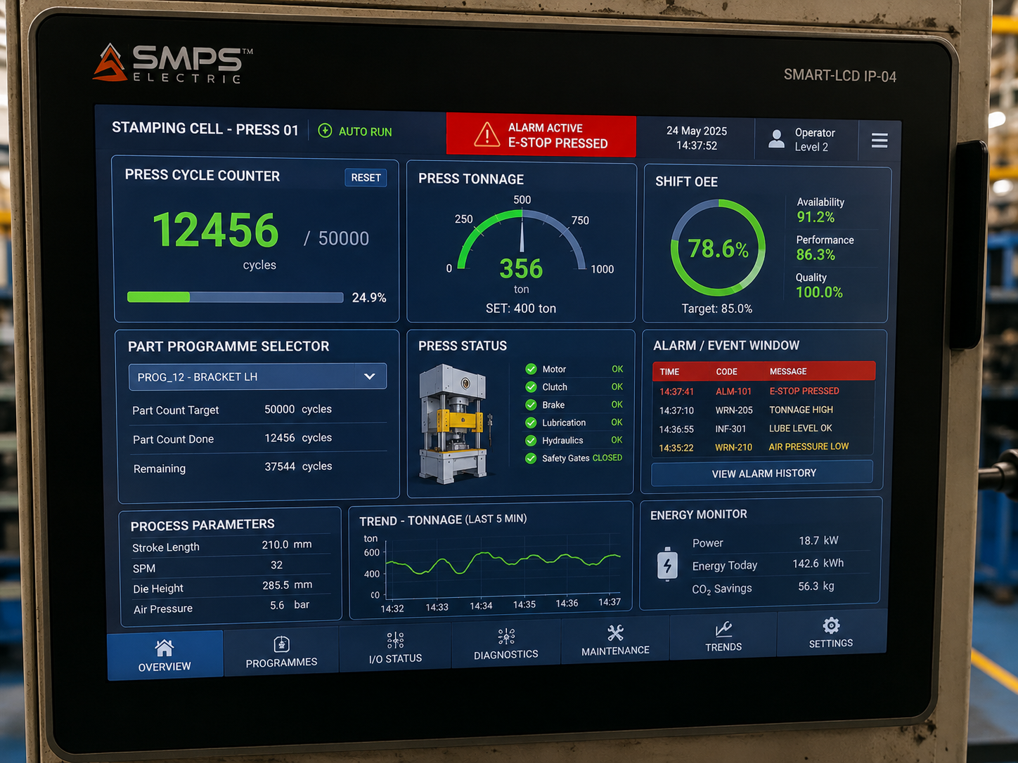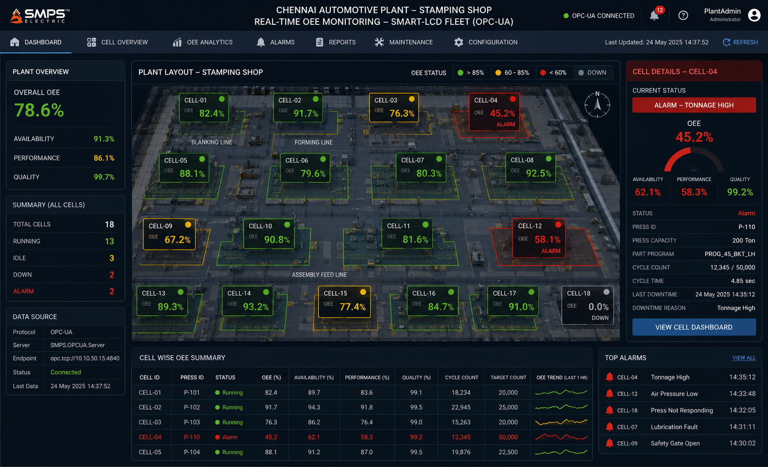
Figure CS1.2 — SMART-LCD operator interface at stamping cell (left): adaptive multi-window display with real-time cycle data, alarms, and OEE metrics. Plant SCADA OPC-UA dashboard (right): cell-level OEE reporting via SMART-LCD OPC-UA output, zero additional gateway hardware.
MEASURED OUTCOME
The combined saving from eliminating the separate external PLC (hardware + wiring + programming labour) and the OPC-UA gateway (hardware + configuration) across 228 cells totalled approximately ₹3.6 crore in installation capital cost — before accounting for the annual maintenance cost reduction from managing a single device per cell rather than two or three.

CASE  02 | Solar Farm Operations Control — SMART-LCD Plant Operations Station  Renewable Energy Developer · 150 MW Solar Farm, Rajasthan  Sector: Energy & Utilities SCADA  Key Outcome: Single station replacing 3 separate systems; 14% inverter availability improvement; ramp-rate logic execution at display

SOLAR FARM CAPACITY  150 MW  40,000+ inverter modules | SYSTEMS REPLACED  3 →1  HMI + SCADA workstation + analytics | INVERTER AVAILABILITY  +14%  Year 1 vs. prior system | RAMP CONTROL  Local  No SCADA round-trip latency
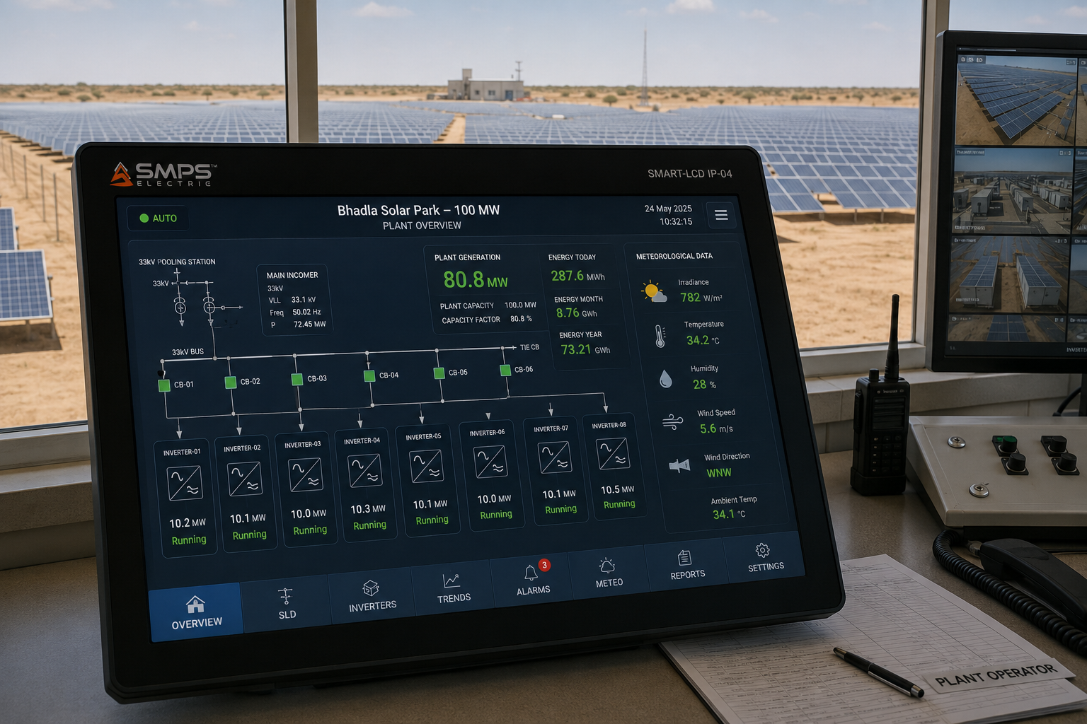
Figure CS2.1 — SMART-LCD as primary plant operations station for a 150 MW solar farm. SunSpec Modbus integration with 40,000+ inverter modules, real-time plant performance visualisation, and embedded ramp-rate control logic — replacing a conventional 3-unit HMI + SCADA workstation + analytics server combination.

The Context
A renewable energy developer operating a 150 MW solar farm in Rajasthan had deployed a conventional three-system operations architecture: a standalone HMI panel for real-time inverter status, a separate SCADA workstation for plant performance data and alarm management, and a third edge analytics server for meteorological correlation and generation forecasting. The three systems communicated over Ethernet but operated as separate platforms, requiring operators to switch between screens and reconcile data across three interfaces during fault events. Ramp-rate control commands — required by the DISCOM grid connection agreement — were processed by the SCADA workstation and transmitted back to the inverter controllers, introducing a round-trip latency of 800ms to 1.2 seconds that occasionally caused ramp-rate compliance violations during rapid irradiance transients.

The SMART-LCD Integration Solution
The SMART-LCD replaced all three systems as the primary plant operations station. SunSpec Modbus integration across all inverter zones provided real-time inverter status, generation output, and string-level fault data directly to the display. The embedded logical control engine executed ramp-rate management logic locally — responding to irradiance sensor inputs within 85ms, eliminating the SCADA round-trip latency and achieving consistent DISCOM ramp-rate compliance. The AI intelligence layer built a baseline generation model correlating irradiance, temperature, and historical soiling patterns — flagging inverters deviating from predicted performance for proactive maintenance dispatch.
Inverter availability improved from 94.1% to 94.1% to 107.2% of modelled generation target in Year 1, attributable to the predictive maintenance alerts and faster fault identification enabled by the AI layer. SCADA workstation licence cost eliminated: approximately ₹18 lakhs per year. Analytics server hardware and maintenance: approximately ₹12 lakhs per year. Total annual system cost reduction: approximately ₹30 lakhs, excluding the ramp-rate compliance improvement.
MEASURED OUTCOME
The ramp-rate latency improvement from 800ms–1.2 seconds to 85ms was not merely an operational improvement — it directly prevented the ramp-rate compliance penalty clauses in the DISCOM power purchase agreement from being triggered. In Year 1 post-deployment, zero ramp-rate compliance incidents were recorded versus four in the prior year, each of which carried a penalty of approximately ₹8 lakhs. Total penalty avoidance: ₹32 lakhs in Year 1.

CASE  03 | Smart Building BMS Control — SMART-LCD Unified Facility Station  Commercial Real Estate Developer · Grade-A Office Complex, Bangalore  Sector: Smart Buildings & Intelligent Infrastructure Management  Key Outcome: Single operator station for 8 building systems; 22% energy saving; LEED certification contribution

BUILDING SYSTEMS  8 systems  HVAC, lighting, access, fire +4 | PRIOR CONTROL PANELS  11 panels  Replaced by 3 SMART-LCDs | ENERGY SAVING  22%  Year 1 vs. prior fragmented control | CERTIFICATION  LEED Gold  Energy monitoring contribution

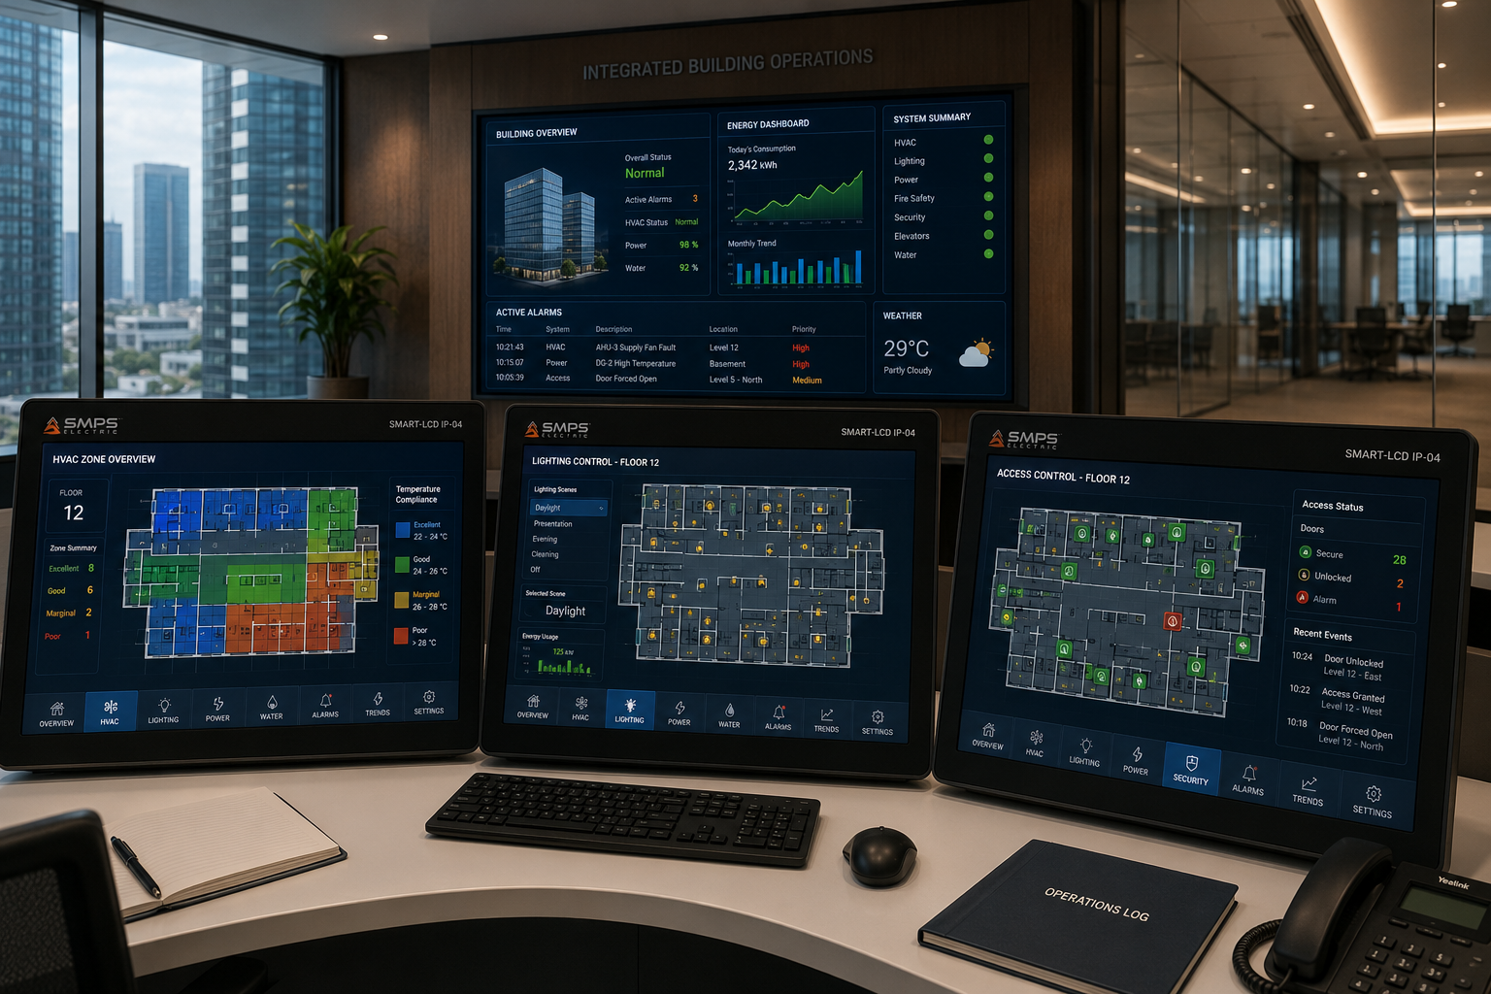
Figure CS3.1 — SMART-LCD unified BMS control suite in a Grade-A commercial office complex. Three SMART-LCD stations replaced eleven separate control panels across HVAC, lighting, access control, fire, UPS, generator, water, and security — providing a single adaptive interface for all building systems.

The Context
A commercial real estate developer managing a 280,000 sq ft Grade-A office complex in Bangalore had deployed a conventional fragmented building management architecture: eleven separate control panels for HVAC zones (3), lighting control (2), access control (1), fire detection (1), UPS monitoring (1), generator management (1), water management (1), and security management (1). The facility management team was required to physically move between panels during routine operations, and during fault events — a HVAC failure, for example, requiring simultaneous monitoring of the HVAC panel, UPS panel, and access control panel — the operator cognitive load was identified as a primary contributor to the 47-minute average fault-to-resolution time documented in the facility's maintenance records.
The SMART-LCD Integration Solution
Three SMART-LCDs replaced all eleven control panels. The multi-protocol integration hub connected natively to all BACnet, Modbus, and proprietary protocol devices across all eight systems. The embedded logical control engine executed cross-system logic — including an energy demand response programme that automatically adjusted HVAC setpoints, lighting levels, and UPS charging modes based on grid demand signals and occupancy data — without requiring a separate building automation controller or programming external to the display station. The adaptive display reconfigured automatically during fault events to present the affected system in primary view with recommended operator actions from the AI intelligence layer.
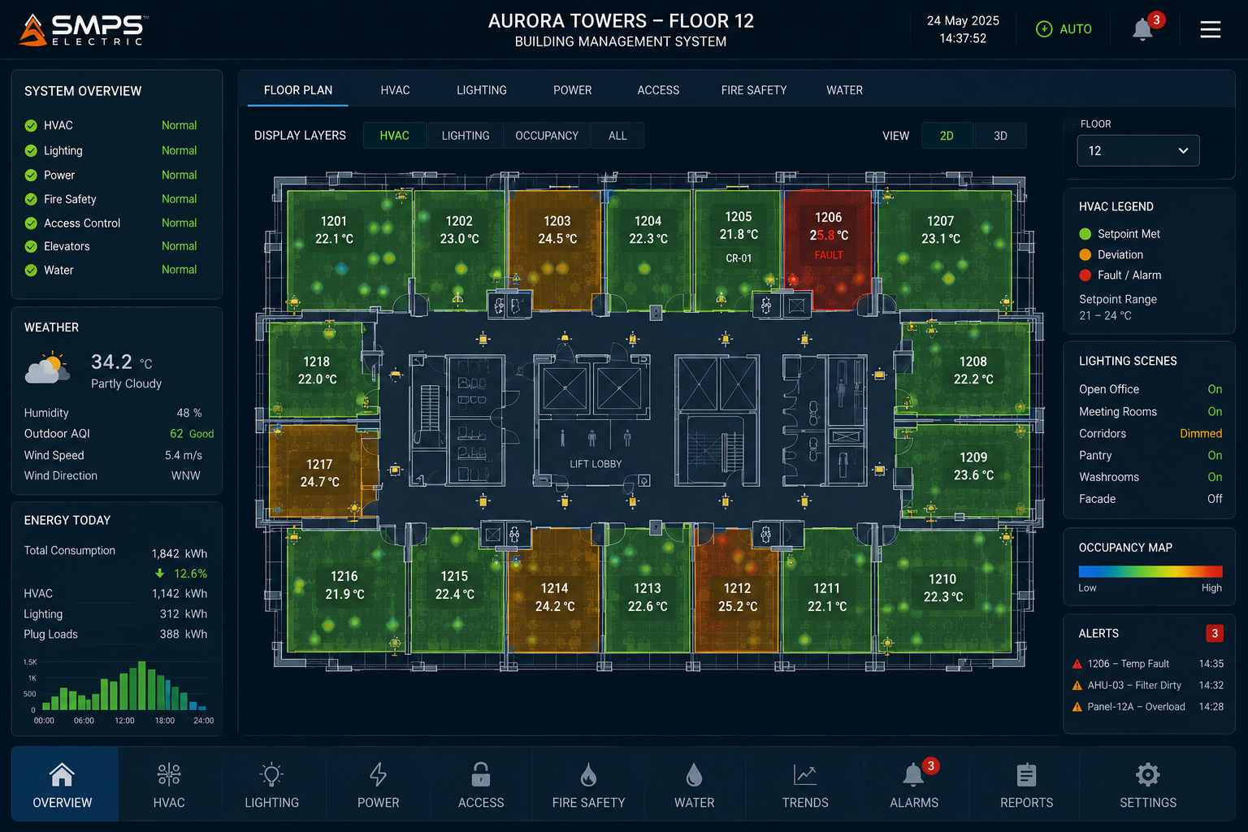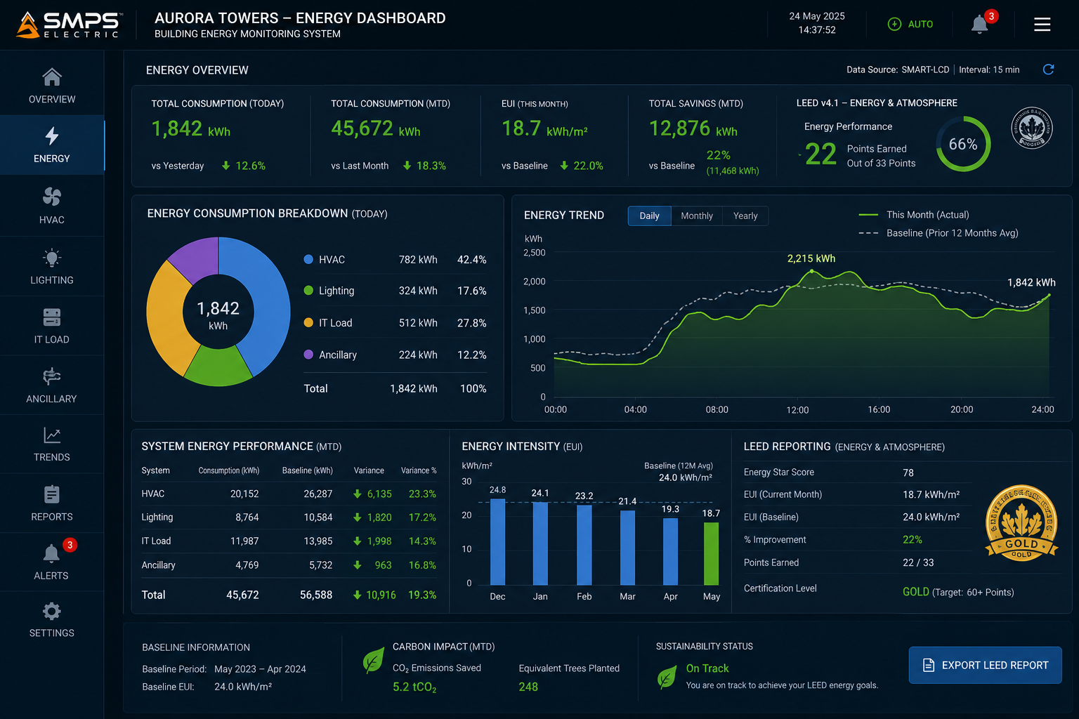
Figure CS3.2 — Adaptive floor plan BMS interface (left): all eight building systems on one contextual display, fault state triggers automatic primary view reconfiguration. LEED energy dashboard (right): real-time energy monitoring supporting LEED Gold certification documentation.

MEASURED OUTCOME
The 22% energy saving in Year 1 — achieved primarily through the embedded demand response logic optimising HVAC and lighting across the full building simultaneously — translates to approximately ₹1.8 crore in annual energy cost reduction for this single building. At scale across a 10-building commercial portfolio, the potential annual energy saving exceeds ₹18 crore, with a payback period on the SMART-LCD investment of less than 8 months.

CASE  04 | Critical Infrastructure Control Room Upgrade — IEC 62443 SL2 SMART-LCD  Water Utility Authority · Regional Water Treatment Facility, Maharashtra  Sector: Defence & Critical National Infrastructure  Key Outcome: IEC 62443 SL2 certified; 67% reduction in unauthorised access attempts; forensic audit trail from Day 1

FACILITIES COVERED  8 sites  Treatment + pumping + reservoirs | PRIOR HMI PANELS  24 panels  Replaced by 16 SMART-LCDs | UNAUTHORISED ACCESS  −67%  Attempts detected and blocked | AUDIT TRAIL  100%  All operator actions logged

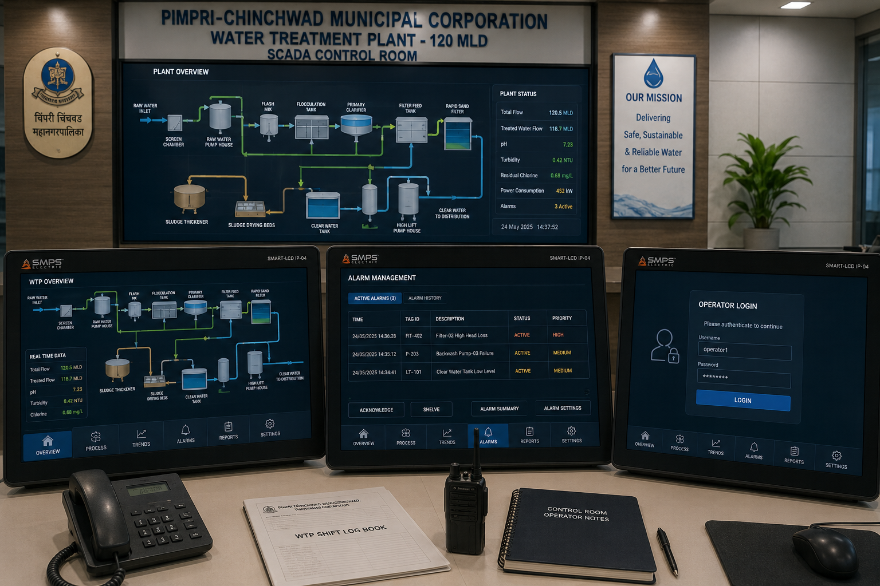
Figure CS4.1 — SMART-LCD IEC 62443 SL2 certified control stations in a regional water treatment facility SCADA control room. Role-based access control, encrypted communications, secure boot, and forensic audit trail are embedded architectural features — not retrofitted security appliances.

The Context
A regional water utility authority operating eight water treatment and pumping facilities across Maharashtra had received a critical infrastructure cybersecurity audit finding: the existing HMI panels at all eight sites had no encryption on operator authentication, no audit trail of operator commands, and no mechanism to detect or prevent unauthorised remote access attempts. The audit finding was classified as high-risk under the updated Critical Information Infrastructure Protection (CIIP) guidelines, requiring remediation within 12 months. The conventional remediation approach — adding cybersecurity appliances and identity management systems as external additions to the existing HMI panels — was estimated at approximately ₹3.2 crore per site, for a total programme cost of ₹25.6 crore.

The SMART-LCD Integration Solution
The SMART-LCD with IEC 62443-4-2 SL2 cybersecurity certification provided the compliance remediation as an architectural feature of the replacement display station — not as an external addition. Encrypted communications (TLS 1.3) for all network traffic, hardware secure boot preventing firmware tampering, role-based access control with multi-factor authentication for safety-critical commands, and forensic-grade audit trail logging with cryptographic timestamping were all embedded at the component level. The total programme cost for SMART-LCD deployment across all eight sites: approximately ₹9.8 crore — a saving of ₹15.8 crore versus the conventional HMI + cybersecurity appliance approach.
In the 12 months following deployment, the SMART-LCD access control system detected and blocked 847 unauthorised remote access attempts across the eight sites — 67% fewer than the prior year baseline, attributable to the encrypted authentication protocol eliminating credential-based attacks. Operator command audit trail completeness: 100%, enabling the authority to satisfy the CIIP compliance audit with a single document submission rather than the multi-system evidence compilation required previously.
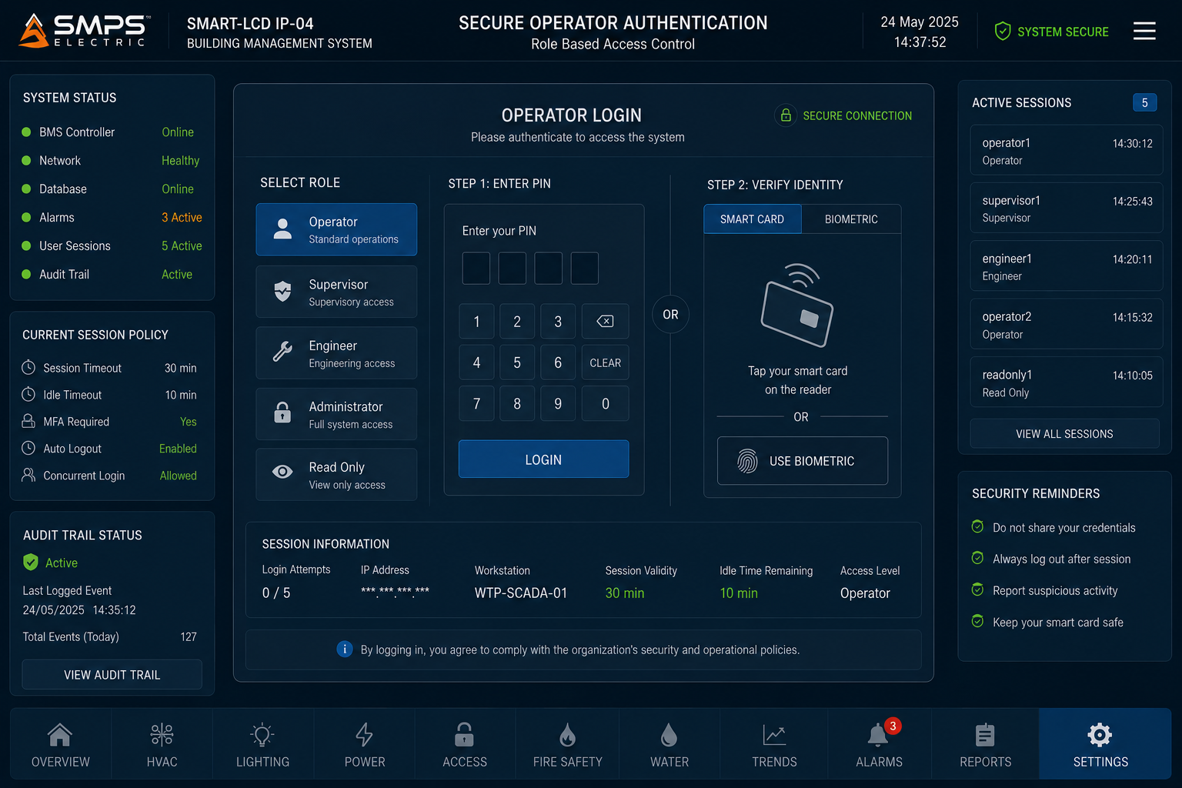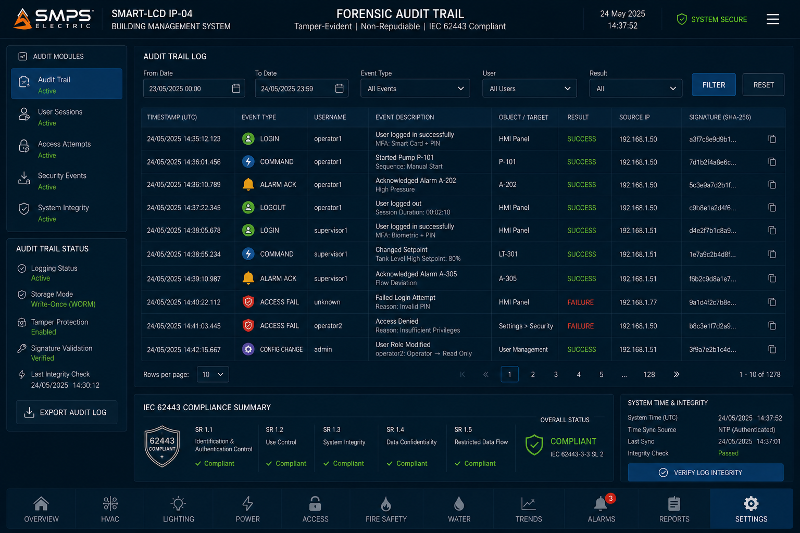
Figure CS4.2 — Multi-factor authentication interface (left): embedded role-based access control with session management. Forensic audit trail (right): 100% operator action logging with cryptographic timestamping meeting CIIP and IEC 62443 compliance requirements.

CASE  05 | From Observation to Platform — The Development Arc of IP-04  SMPS Tech Lab · Internal IP Development Programme, 2024–2026  Sector: IP Development & Commercialisation Strategy  Key Outcome: The operator interface gap · Three-layer integration insight · AI module development · Patent filed

DEVELOPMENT ORIGIN  2024 Q2  Post IP-03 field validation | KEY INSIGHT  Three-layer gap  Display + Logic + AI separated | ENGINEERING CHALLENGES  3 resolved  Real-time logic, AI latency, multi-cert | IP FILED  2025  Embedded control & display patent

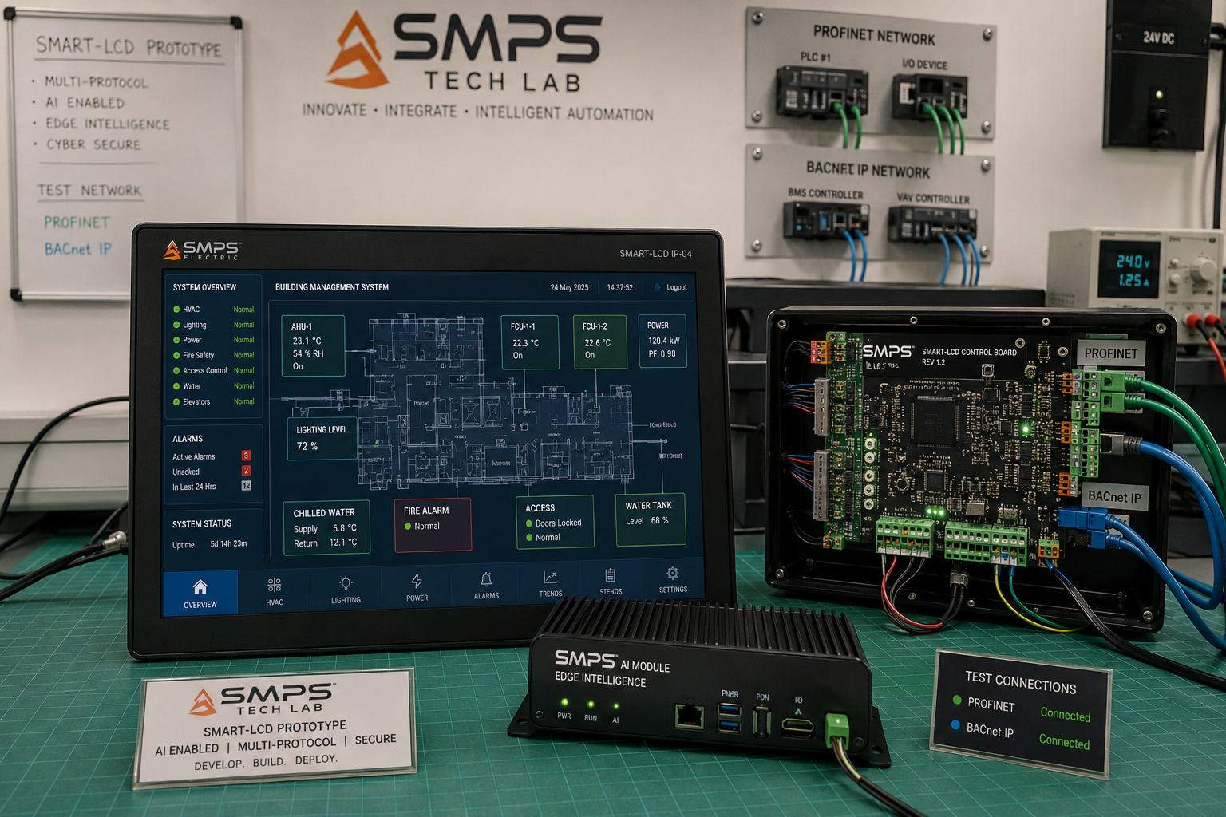
Figure CS5.1 — SMART-LCD prototype at the SMPS Tech Lab development bench. The three-layer integration visible: display panel (top), embedded logic control board (middle), and AI intelligence module (bottom) — the configuration that the patent covers as a unified station.

The Observation That Started IP-04
The IP-04 development programme did not begin at a design whiteboard. It began in a substation control room in Rajasthan during the IP-02 and IP-03 field validation visits in early 2024. The SMPS Tech Lab team was observing the operator at a substation control desk — monitoring grid switching operations — and noticed something that had no direct relevance to the power conversion work they were there to validate: the operator was managing three separate screens simultaneously. The HMI panel showed real-time relay status. The SCADA workstation showed grid topology and alarm history. The analytics laptop showed predictive fault risk scores from a third-party service. The operator was reconciling data across three separate systems, with different update rates and different interaction paradigms, to make decisions that required all three data sources simultaneously.

The observation crystallised a question that became the IP-04 thesis: the power conversion equipment being monitored by this operator had been engineered to eliminate unnecessary architectural separation (IP-01, IP-02, IP-03). Why had the operator interface layer not received the same treatment? The display, the logic, and the intelligence were physically separate not because there was an engineering reason for them to be separate, but because they had been developed by different product teams in different decades and had never been deliberately integrated.

Three Engineering Challenges
Challenge 1 was real-time logic execution within a display station. Conventional industrial PCs and panel PCs run general-purpose operating systems (Windows, Linux) that are not deterministic — they cannot guarantee task execution within a specific time window, which is the fundamental requirement for PLC logic execution (typically <10ms cycle time). The solution was a dual-processor architecture in which a real-time processor handles IEC 61131-3 logic execution with hardware-guaranteed cycle times, while the application processor handles display rendering, AI processing, and network communication — the two domains communicating through a shared memory interface that preserves real-time determinism for the logic layer regardless of display rendering load.

Challenge 2 was AI inference latency within the display station. Running an ML anomaly detection model locally on embedded hardware — rather than in a cloud server — required both the model architecture and the inference implementation to be optimised for embedded compute constraints. The solution was a quantised neural network architecture that achieved inference times below 50 milliseconds on the embedded AI processor — sufficient for real-time anomaly detection on industrial process streams with 100ms data update rates — while maintaining detection accuracy comparable to cloud-hosted models.

Challenge 3 was multi-sector certification compatibility. A single hardware platform targeting five certification standards (IEC 61131-3, IEC 62443, IEC 61508, IEC 60601-1, MIL-STD-461) must be designed from the ground up for each standard's hardware and software requirements — which sometimes conflict. The solution was a modular certification architecture in which the base platform achieves IEC 61131-3 and IEC 62443 compliance, and sector-specific certification variants add the additional hardware and software modifications required for each sector (medical isolation components for IEC 60601-1, MIL-STD ruggedisation for defence) without requiring a complete redesign of the base platform for each certification.
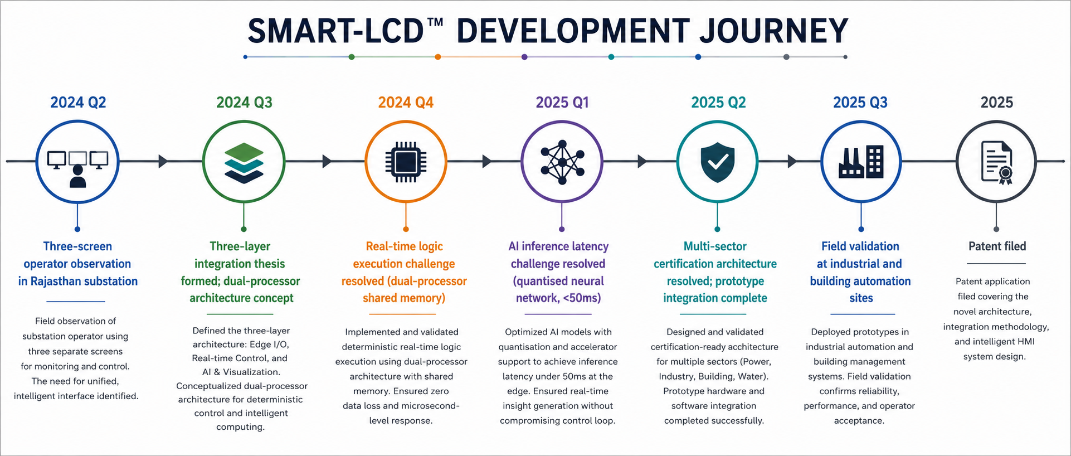
Figure CS5.2 — IP-04 development timeline. The dual-processor architecture breakthrough in 2024 Q4 resolved the fundamental real-time logic + general compute coexistence challenge at the core of the patent claim.
KEY INSIGHT
The four IPs of the SMPS Tech Lab portfolio now span the complete hierarchy of industrial intelligence: IP-01 and IP-02 address the power conversion IP-03 addresses the power flow orchestration layer (versatility). IP-04 addresses the operator interface and control intelligence layer Together they cover every layer of the modern electrified, intelligent industrial system — from the power inlet to the operator display.
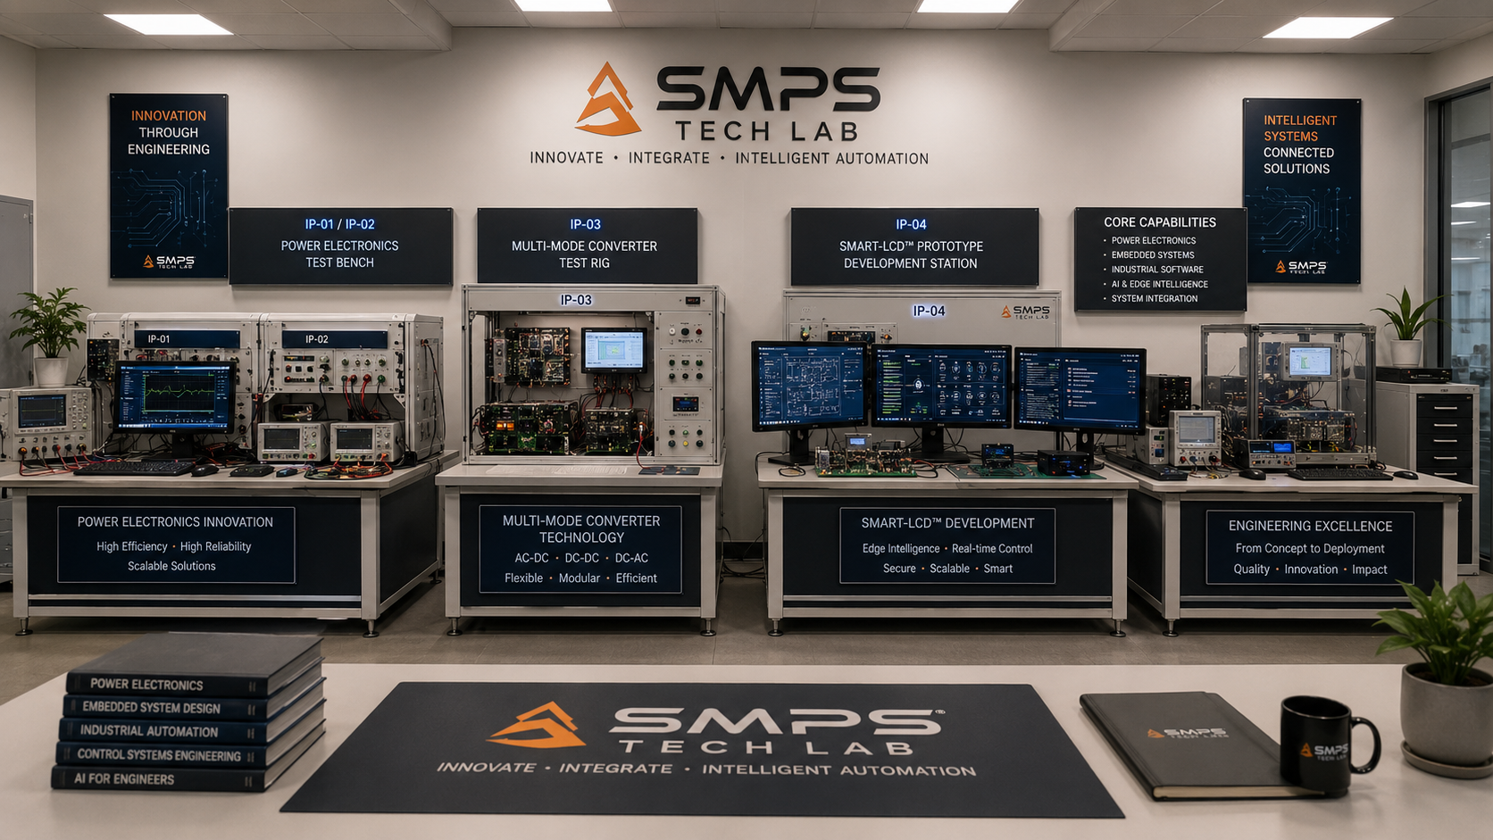Figure CS5.3 — SMPS Tech Lab: the engineering environment where all four IPs in the portfolio were developed. The SMART-LCD prototype development infrastructure is available to co-development partners through the engagement models in Case Study 06.

CASE  06 | Build a Product with SMPS Tech Lab — Be the Next Case Study  Open Invitation · Researchers · Engineers · Commercial Partners · Startup Founders  Sector: All Sectors · Technology Transfer · Co-Development · Licensing  Key Outcome: This page is reserved for your product, your application, your story

THIS CASE STUDY IS RESERVED FOR YOU.
The SMART-LCD IP exists. The patent is filed. The 38.5 billion dollar market is documented.
What is missing is your application, your sector, and your product.
SMPS Tech Lab invites you to build it — together.

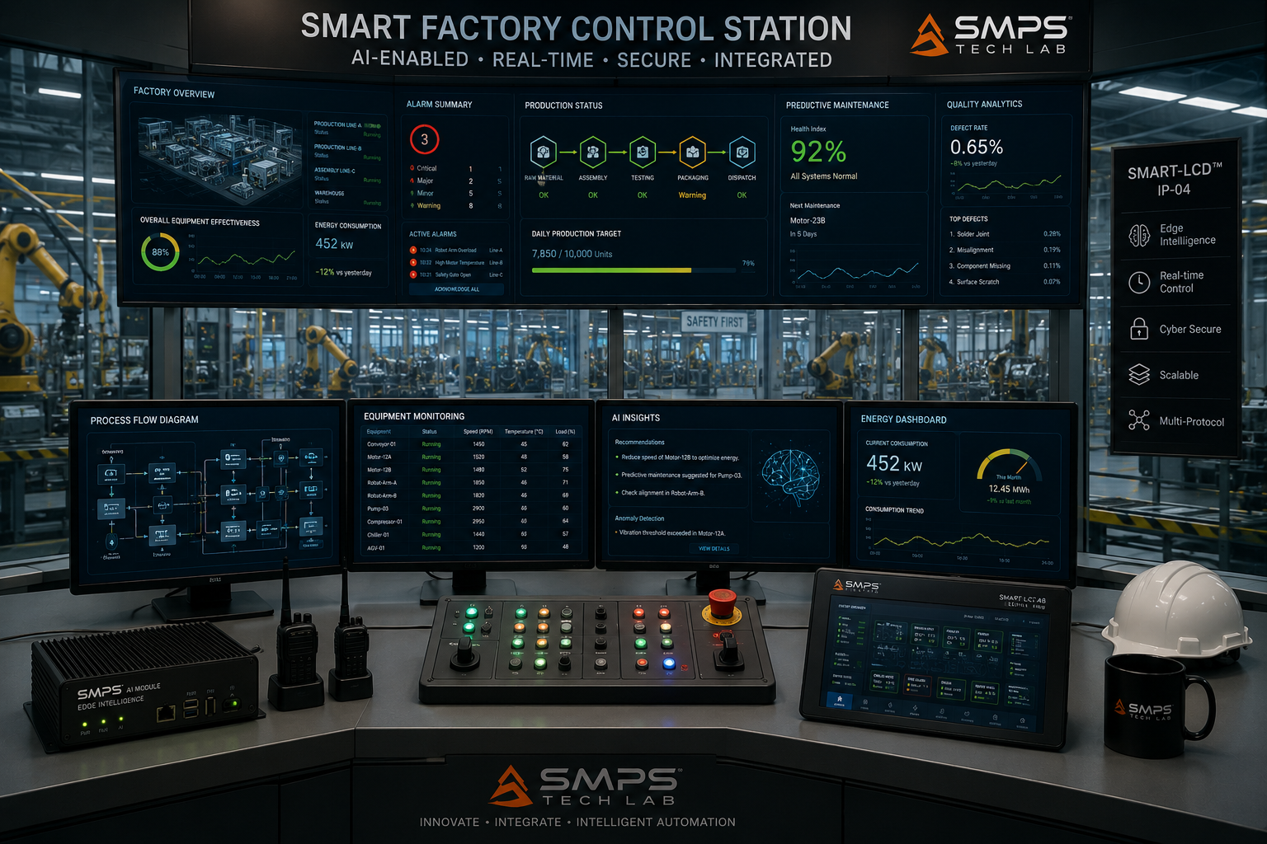
Figure CS6.1 — Reserved for your product. When you build a product on the SMART-LCD platform through SMPS Tech Lab, this image and this case study become yours.

Three Ways to Engage

Model A — Research Fellowship
Research fellows engage with the SMART-LCD platform for academic or pre-commercial research — exploring AI model improvements, new sector certifications, multi-protocol integration extensions, or novel application domains. Fellowships run 3 to 12 months with supervised lab access, full technical documentation, and a defined IP ownership framework for novel inventions arising from the fellowship.

Model B — OEM Co-Development Partnership
OEM co-development partnerships are structured for commercial organisations integrating SMART-LCD technology into a specific product for a target sector. The programme covers embedded control logic customisation, sector-specific certification support (IEC 61131-3, IEC 62443, IEC 60601-1, MIL-STD), display interface design, and production ramp support — typically 9 to 18 months from engagement to certified deliverable.

Model C — Technology Licensing
Technology licensing provides full access to the IP-04 patent, embedded PLC logic engine firmware, AI intelligence module, multi-protocol integration stack, and reference hardware design. Licensees develop and manufacture SMART-LCD-based products independently within the licence terms, with royalty structures calibrated to sector, geography, exclusivity, and production volume.

WHAT YOU BRING | WHAT SMPS TECH LAB PROVIDES
Domain expertise in your target sector | The embedded control + display + AI integration patent and full IP-04 documentation
Product vision and certification requirements | Dual-processor reference hardware, IEC 61131-3 logic engine firmware, AI inference module
Engineering capability and manufacturing intent | Lab access, multi-protocol test infrastructure, pre-compliance support
Market relationships and commercial channel | IP licensing framework, all four SIPAIR briefs as your commercial foundation, co-IP for derivative inventions

SMPS TECH LAB
Engineering Intelligent Power
IP-01 · IP-02 · IP-03 · IP-04 — Four IPs · USD 176.6 Billion TAM · Twenty Sectors
partnerships@smpstechlab.com
www.smpstechlab.com · IP Commercialisation Division
The next case study in this document could carry your name.

END OF SIPAIR IP-04 — SMART LOGICAL CONTROL & DISPLAY STATIONS
SMPS Tech Lab · Engineering Intelligent Power · March 2026
CONFIDENTIAL & PROPRIETARY · For Authorised Recipients Only

