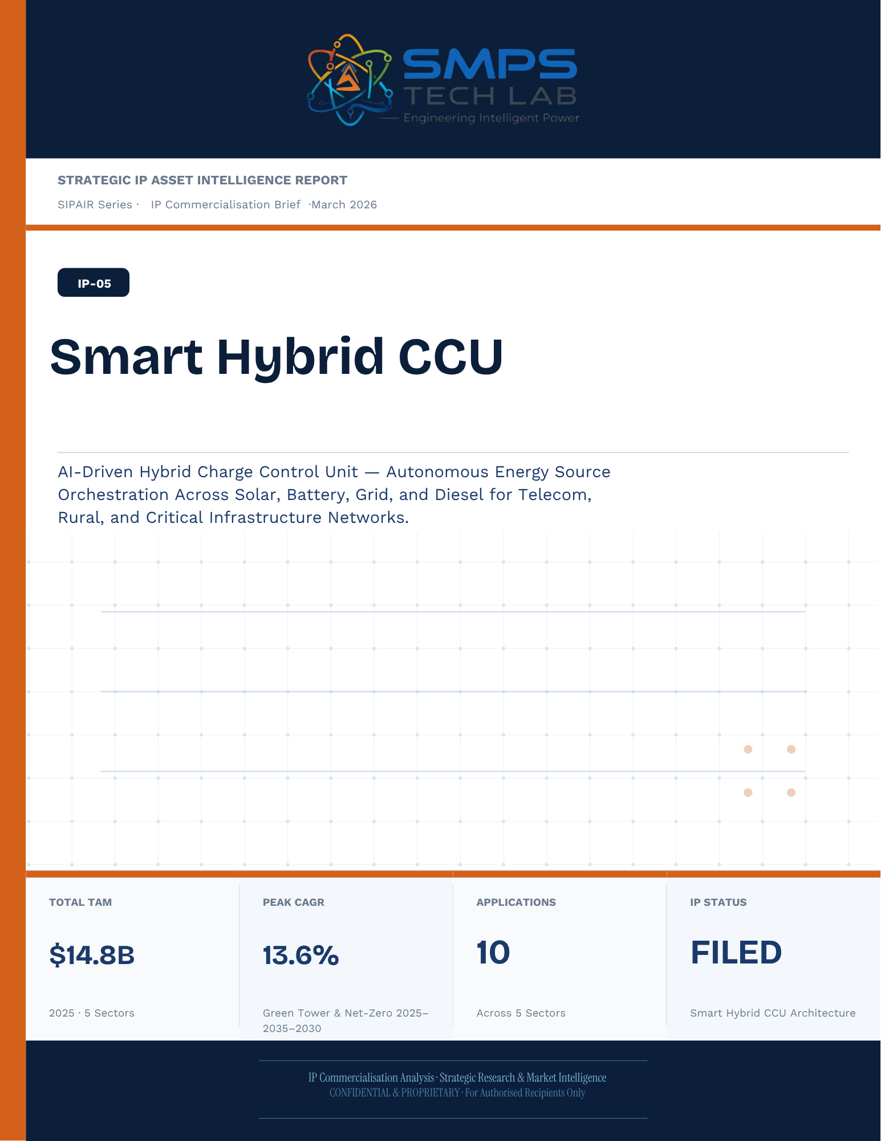

STRATEGIC IP ASSET INTELLIGENCE REPORT
SIPAIR Series
IP-05: Smart Hybrid CCU
SMPS-Based Integrated Smart Hybrid CCU for Uninterrupted Telecom Power

Report Title | SIPAIR IP-05 — Smart Hybrid CCU Commercialisation Brief

Document Series | Strategic IP Asset Intelligence Report (SIPAIR)

Version | Version 1.0 — First Edition

Compiled & Edited by | Shri Amareshwar Karatagi

Organisation | SMPS Tech Lab — Engineering Intelligent Power

Date of Issue | March 2026

Classification | Confidential & Proprietary — For Authorised Recipients Only

IP Reference | IP-05 — Smart Hybrid CCU Architecture, Filed 2025

Related Document | SIPAIR IP-01: Smart Hybrid SMPS (see companion brief)

This document is prepared by SMPS Tech Lab as part of the SIPAIR IP Commercialisation Series.

Declaration — Originality & Intellectual Property Statement

This Strategic IP Asset Intelligence Report (SIPAIR — IP-05: Smart Hybrid CCU) is an original compilation prepared by SMPS Tech Lab. The analysis, market intelligence frameworks, commercial strategy formulations, and case study narratives contained herein are the result of independent research and original intellectual work by the authors and editors named in this document.

The core technology described in this report — the SMPS-Based Integrated Smart Hybrid CCU architecture, including its active power management layer, CCU intelligence stack, uninterrupted multi-rail AC/DC delivery system, and NMS integration platform — is the exclusive proprietary invention of SMPS Tech Lab, protected under a filed novel design patent (2025). IP-05 is a distinct and independently protectable invention from IP-01 (Smart Hybrid SMPS), though both emerge from the same SMPS Tech Lab research programme. The two IPs are designed to complement each other across adjacent application verticals and may be jointly licensed or co-deployed where application requirements demand both hybrid topology and active power management intelligence.

Market sizing data, CAGR estimates, and industry statistics cited in this document are sourced from independent third-party research publications, fully attributed in Appendix A. All third-party data is used for analytical and benchmarking purposes only. This report has not been submitted, in whole or in part, to any other organisation for commercialisation or formal assessment except as specifically disclosed in writing.

Declared by:

Shri Amareshwar Karatagi Founder & CSO SMPS Tech Lab · March 2026

CERTIFICATE OF AUTHENTICITY
IP Commercialisation Documentation · SIPAIR IP-05

This is to certify that the Strategic IP Asset Intelligence Report
SIPAIR IP-05 — Smart Hybrid CCU
has been compiled, reviewed, and authenticated by the undersigned in accordance
with the standards of the SIPAIR documentation series. The technology, market analysis,
and commercial intelligence herein are verified as accurate to the best of the signatories’
knowledge as at the date of issue: March 2026.

Program Head / Director | Technical Mentor
  Program Head / Research Director
  SMPS Tech Lab
  Technical Mentor / Advisor
  SMPS Tech Lab

SMPS Tech Lab · Engineering Intelligent Power · March 2026

Acknowledgment

The preparation of this Strategic IP Asset Intelligence Report for IP-05 has drawn on the technical expertise, operational insights, and research foundation developed across two parallel innovation tracks at SMPS Tech Lab. The development of the CCU intelligence layer — the defining innovation of IP-05 — required not only power electronics engineering depth but sustained engagement with telecom network operations, tower management practice, and satellite ground station engineering environments that are highly specialised. The author and editor express sincere gratitude to those whose knowledge and access made this work possible.

Technical Development
The CCU architecture at the heart of IP-05 evolved alongside IP-01's hybrid topology work, but along a distinct engineering trajectory focused on power orchestration intelligence rather than conversion efficiency alone. The engineers and technologists who contributed to the CCU control logic, NMS integration stack, and sub-millisecond failover switching mechanism deserve specific recognition for the rigour with which they approached the uninterrupted power mandate — a design objective that admits no approximation.

Telecom Industry Access
The sector intelligence in this report reflects direct engagement with tower operations, data centre facility management, and satellite ground station engineering communities. The operational data from 5G tower rollout programmes, off-grid hybrid power deployments, and maritime communication installations that informed the case study narratives and application requirement specifications in this document is the product of those field engagements.

Research Publications
The market intelligence framework draws on publications from Future Market Insights, MarketsandMarkets, SNS Insider, Grand View Research, IMARC Group, Coherent Market Insights, Global Growth Insights, and the Ericsson Mobility Report, as well as operational data from the International Energy Agency. The quality of those independent research publications is what allows the TAM framework in this report to be grounded in named, verifiable data rather than estimated aggregates.
Shri Amareshwar Karatagi
Founder & CSO
SMPS Tech Lab · March 2026

Preface — From the Founder & Editor

From IP-01 to IP-05 — The Logical Extension
IP-01, documented in the companion SIPAIR brief, solved one problem with exceptional elegance: replacing the unnecessary architectural duplication of separate AC and DC converter units with a single hybrid topology. The commercial case was compelling and the market evidence was clear. But the engineers at SMPS Tech Lab, in the same process of field observation that gave rise to IP-01, had identified a second problem — one that operated at a higher level of the power system stack and was, if anything, more commercially urgent in the specific context of telecom infrastructure.

The problem was not conversion efficiency. It was availability. In a 5G base station, a satellite ground hub, an offshore platform communication centre, or a smart city public safety network node, the standard power supply architecture not only requires separate AC and DC converters — it delegates all intelligence about the power state of the system to a separate controller that may be physically remote, software-dependent on a third-party network management system, and incapable of autonomous protective action in the sub-millisecond timeframe that modern telecom uptime SLAs demand. When the grid fails, when a battery starts to degrade, when an input source switches — the system needs to respond faster than any software polling cycle can achieve. It needs embedded intelligence, right at the power conversion stage.

IP-05 is that intelligence. The Integrated Smart Hybrid CCU, combined with the SMPS core, does not just convert power — it orchestrates it. It monitors every parameter of the power delivery chain continuously, switches between sources in under a millisecond, predicts faults before they become outages, and reports power system health to the operator's NMS in real time, without external monitoring hardware. It is the difference between a power supply and a power management system.

Why Telecom, and Why Now
The selection of telecom infrastructure as the primary application vertical for IP-05 reflects a disciplined commercial judgement. Telecom infrastructure is the single sector in the IP-05 TAM where the uninterrupted power mandate is non-negotiable, contractually enforced at 99.999% uptime, and backed by capital investment programmes of unprecedented scale: 2.3 billion 5G subscriptions by end of 2024 with another 4 billion to come by 2030; 3,000 Amazon Project Kuiper satellites deployed in April 2025 with thousands of ground hubs to follow; the IMO GMDSS modernisation mandate forcing a complete vessel communication power infrastructure upgrade by 2026. Every one of these programmes creates a specific, identified, and time-bounded procurement requirement for exactly what IP-05 delivers.

The second reason is the grid reliability crisis that is, counterintuitively, the most powerful demand driver the CCU's hybrid input management addresses. South Africa recorded 1,130 hours of planned power cuts in a single year. India's tower estate — 750,000 sites — routinely operates on hybrid grid, diesel, and battery sources with real-time CCU-managed source switching that determines whether the tower stays on during a grid event. This is not a niche requirement. It is the operational reality for hundreds of thousands of tower sites across three continents, and the market is actively seeking a solution that the current generation of separate rectifiers and external controllers cannot provide.

How This Document is Structured
This SIPAIR brief follows the same 14-section architecture as the IP-01 companion document, making the two documents a coherent and mutually reinforcing portfolio. Readers who have engaged with SIPAIR IP-01 will recognise the structure immediately. The technology differentiation section includes an explicit comparison between IP-01 and IP-05, clarifying the architectural relationship and the distinct value proposition of each. The case studies are drawn from the five specific sectors of IP-05's TAM framework — 5G tower, data centre, satellite ground, smart city, and maritime/offshore — with technical and financial parameters grounded in the operational realities of each sector.

Shri Amareshwar Karatagi
Founder & CSO
SMPS Tech Lab · March 2026

TABLE OF CONTENTS

Declaration — Originality & Intellectual Property Statement 4
Acknowledgment 7
Technical Development 7
Telecom Industry Access 7
Research Publications 7
Preface — From the Founder & Editor 9
From IP-01 to IP-05 — The Logical Extension 9
Why Telecom, and Why Now 9
How This Document is Structured 10
Important Notice & Confidentiality Disclaimer 16
1.1 The Strategic Context 17
1.2 The Problem IP-05 Solves 17
1.3 Key Metrics at a Glance 18
1.4 Why IP-05, Why Now 19
2.1 What is the Smart Hybrid CCU? 21
2.2 The Four Integrated Technology Layers 21
2.3 AI Dispatch Engine — Predictive vs. Reactive Control 23
2.4 Energy Cost & Carbon Optimisation — The Commercial Multiplier 24
2.5 Standards Compliance Architecture 24
3.1 The Telecom Energy Inflection Point 26
3.2 The Four Structural Megatrends 26
3.3 Global Market Sizing — Primary Reference Data 27
CAGR Comparison — IP-05 Target Market Segments 28
4.1 Methodology 29
4.2 Consolidated TAM Summary 30
5.1 India as First Market 32
5.2 India Market Sizing — IP-05 Relevant Segments 33
6.1 India Government Schemes with Direct IP-05 Alignment 34
7.1 The Plugin Architecture — Five Tower Energy Contexts 36
7.2 Plugin Integration Matrix 36
8.1 Commercialisation Philosophy 38
8.2 Market Priority Matrix 38
9.1 Competitive Architecture Overview 40
10.1 The Investment Case 42
10.2 Illustrative Revenue Scenarios 42
11.1 Technology Generation Roadmap 44
11.2 Adjacent Application Opportunities 45
12.1 Risk Framework 47
Appendix A — Data Sources 49
Appendix B — Standards Reference 50
Appendix C — Glossary 51
The Context 54
The Smart Hybrid CCU Integration Solution 54
The Context 56
The Smart Hybrid CCU Integration Solution 57
The Context 59
The Smart Hybrid CCU Carbon Programme Solution 60
The Context 61
The Smart Hybrid CCU Integration Solution 62
The OPEX Observation 63
Three Engineering Challenges 64
Three Ways to Engage 67
Model A — Research Fellowship 67
Model B — OEM Co-Development Partnership 68
Model C — EaaS Platform Licensing 68

0F | FOUNDER & EDITOR  IP-05 SIPAIR Series · SMPS Tech Lab

 | Shri Amareshwar Karatagi  Founder & Chief Strategic Officer  SMPS TechLab  Special Correspondent, Government of Karnataka |  Serial Entrepreneur
Vision Statement
We aim to build a generation of innovators and entrepreneurs who create transformative technologies, develop intellectual property, and drive India’s technological leadership on both national and global platforms. Over the years, we have worked extensively within the startup ecosystem, contributing to and mentoring multiple initiatives focused on building, scaling, and strengthening businesses. Through this journey, we have developed a deep understanding of business strategy, governance frameworks, and deep-technology development, along with the practical challenges of scaling innovation in real-world markets.
As a Special Correspondent with the Government of Karnataka and a serial entrepreneur, my focus has been on shaping individuals into creators, builders, and leaders of technology and enterprise. Our work emphasizes ownership, innovation, and execution discipline to nurture individuals capable of building scalable, high-impact solutions with both national and global relevance.
Through SMPS Tech Lab, we drive this vision by integrating deep Research & Development (R&D) with entrepreneurial strategy, fostering a culture where ideas evolve into intellectual property, innovation, and industry-aligned solutions that contribute to India’s technological advancement and global competitiveness. The Industry Fitness DeepTech Internship Program is a reflection of this mission—designed to develop individuals who are innovation-driven, execution-focused, and capable of contributing meaningfully to technology, entrepreneurship, and nation-building at scale.
“My vision is to build a generation that doesn’t wait for opportunities, but creates them through innovation and entrepreneurship.”
— Shri Amareshwar Karatagi

A. R. Shalini
Chief Business Development Officer (CBDO) & Program Officer
SMPS TechLab | SMPS Electric Control Pvt. Ltd.

Area of Expertise:
Business Strategy, Operations Management, Industry–Academia Integration, Entrepreneurship Development
Profile:
I play a pivotal role in driving program execution, operational excellence, and professional development within SMPS Tech Lab. With a strong foundation in both business strategy and technology alignment, I am committed to shaping individuals into industry-ready professionals with the right mindset, discipline, and execution capabilities.
My approach focuses on building skills with clarity of thought, accountability, and a results-driven attitude. Through structured guidance and continuous mentorship, I enable participants to understand the intersection of technology, business, and real-world application.
I actively work toward bridging the gap between academia and industry, ensuring that learning is aligned with practical expectations and evolving market demands. My dedication to creating a seamless and high-impact learning environment fosters confidence, innovation, and professional growth among participants.
Through my leadership, the program consistently emphasizes structured execution, strategic thinking, and the development of individuals who are prepared to contribute meaningfully to both industry and innovation ecosystems.
“Professional excellence is built when knowledge, mindset, and execution come together with consistency.”
— A. R. Shalini

Dr. S. Khatua
Chief Technology Officer (CTO)
SMPS TechLab | SMPS Electric Control Pvt. Ltd.
IITian | PhD – IIT Dhanbad

Area of Expertise:
Power Electronics, Microgrid & Smart Grid Systems, Nuclear Power Systems, DeepTech R&D, Industrial System Design.
I am a distinguished technology leader driving advanced Research & Development and deep-tech innovation. An IITian with a PhD in Microgrid and Smart Grid Systems for nuclear power applications, I bring over 15 years of experience across power electronics, nuclear reactor control systems, and defence and telecom technologies.
With significant contributions to high-impact and mission-critical projects of national importance, my work reflects a rare combination of research depth, engineering precision, and industrial execution.
I am a strong advocate of deep-tech innovation and intellectual property (IP) creation, and I emphasize the development of indigenous technologies that strengthen the nation’s technological capability and global standing.
Through my mentorship, I inspire the next generation to pursue technical mastery, disciplined execution, and innovation with national intent, shaping professionals capable of contributing to the future of deep technology.
“Precision in engineering, depth in research, and ownership of technology are the pillars of true national progress.”
— Dr. S. Khatua

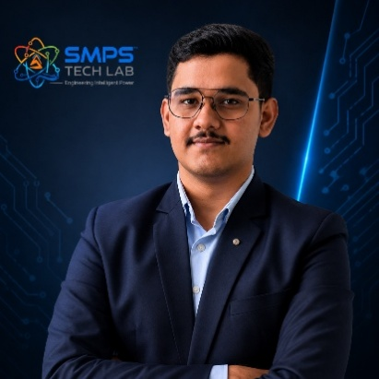
Mr. Rushit Jani
Techno-Commercial Architect
Strategic Editorial & Commercialisation Review | OptCell GLOBAL

Fields of Interest:
AI & Intelligent Systems, Industrial IoT, Product Architecture, Deep-Tech Commercialisation, Enterprise System Design, and Scalable Engineering Solutions.Focused on building technology-driven systems that bridge engineering innovation with practical industry adoption and long-term commercial value.
Message from the Editor:
Technology, in its purest form, is not just about building systems — it is about creating meaningful infrastructure that can influence industries, solve operational challenges, and contribute to larger technological progress. My interest has always been in understanding how engineering innovation can evolve beyond prototypes into scalable and commercially sustainable solutions.
This document represents more than a technical study of an intellectual property. It reflects a structured effort to connect engineering architecture with market relevance, strategic deployment, industrial applicability, and long-term innovation potential. The objective throughout this work has been to maintain a balance between technical depth, commercialization practicality, and institutional-level documentation standards.
As emerging technologies continue to redefine industries, I strongly believe that the future will belong to organizations capable of combining research, engineering, strategic thinking, and execution into unified ecosystems. Through this publication, we aim to contribute towards that larger vision while creating pathways for collaboration, innovation, and real-world technological impact.
"Transforming engineering innovation into scalable, industry-defining technological ecosystems."
— Mr. Rushit Jani
A Note of Gratitude
The development of this publication has been supported by the collective vision, encouragement, and leadership of the Directors and management of SMPS Electric Control Pvt. Ltd.
Their continued commitment towards engineering innovation, industrial excellence, and long-term technological growth has created an environment that encourages meaningful research, practical problem-solving, and commercialization-focused thinking. The guidance, operational insights, and institutional support extended throughout this journey have played an important role in shaping the direction and depth of this work.
This document reflects not only an individual effort, but also the larger culture of innovation, trust, and forward-thinking leadership fostered within the organization. We sincerely appreciate the confidence and support provided towards building impactful and future-ready technological initiatives.

Important Notice & Confidentiality Disclaimer

This Strategic IP Asset Intelligence Report (SIPAIR — IP-05) has been prepared exclusively for internal strategic planning, investor communication, licensing partner engagement, and research collaboration purposes. It is intended for distribution only to authorised recipients under applicable non-disclosure and confidentiality arrangements.

All market sizing data, CAGR estimates, and financial projections are derived from independent third-party research publications cited in Appendix A. These figures represent estimates as at March 2026. No representation or warranty is made as to their accuracy or completeness.

The technology, architecture, and methodologies described herein are the exclusive proprietary assets of SMPS Tech Lab, protected under filed patent and design rights. This document does not constitute a prospectus, financial advice, or an offer to sell or subscribe to securities. Recipients are advised to conduct independent due diligence before making any investment or commercial decision.

01 | EXECUTIVE SUMMARY  The Telecom Energy Crisis · AI Orchestration Mandate · IP-05 Value Proposition

1.1 The Strategic Context
Diesel fuel and generator maintenance account for up to 70% of site OPEX in remote telecom deployments. China’s 5G network alone costs an estimated 76.3 billion yuan annually in electricity (Acrel, 2024). A single 5G base station consumes 3.5–4 kW — nearly three times the power of a 4G equivalent — and the global 5G rollout is multiplying this energy burden across hundreds of thousands of sites simultaneously. For tower companies managing estates of 50,000 to 700,000 sites, energy has moved from a background operating cost to the single largest controllable variable in their entire P&L.

The conventional response — basic rectifier controllers with simple battery float charging and rule-based generator start/stop logic — was designed for a world of single-source grid-powered 4G sites. It is architecturally incapable of optimising across five co-present energy sources (grid, solar, battery, diesel generator, and wind), adapting to weather forecasts and tariff schedules, managing per-tenant energy attribution, or generating the verified carbon accounting data that net-zero commitments now require. The telecom tower industry has reached an energy intelligence inflection point. The question is no longer whether AI-driven hybrid energy orchestration is necessary — it is which platform will define the standard.

1.2 The Problem IP-05 Solves
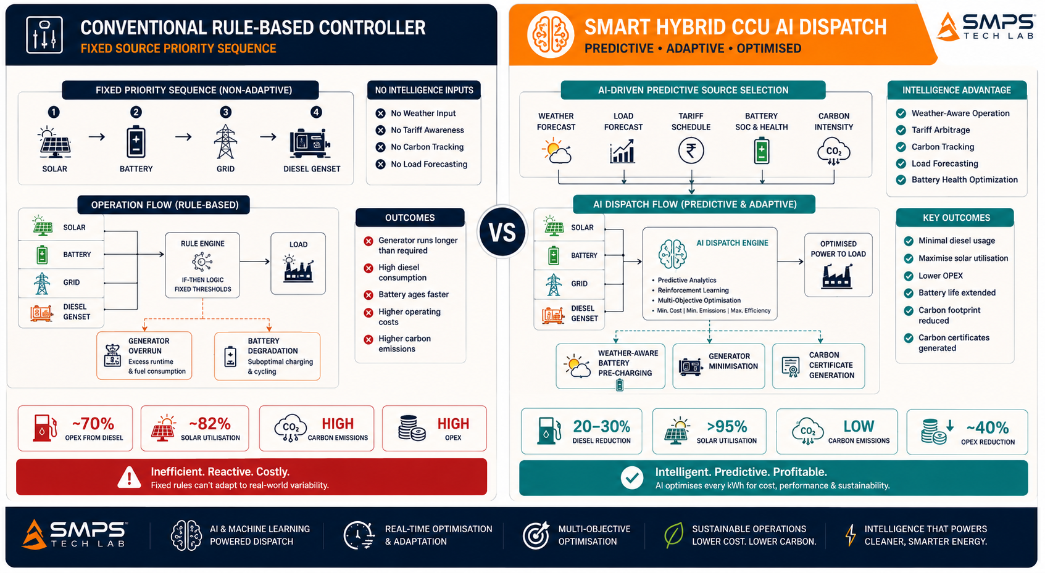
Figure 1.1 — Rule-based controller (left) versus Smart Hybrid CCU AI dispatch (right). The AI orchestration layer delivers 20–30% diesel reduction and up to 40% total site OPEX reduction — a validated, quantifiable ROI that drives divisional-level procurement approval without requiring corporate capex sign-off.
STRATEGIC NOTE
IP-05 is the energy intelligence layer for telecom infrastructure. The Smart Hybrid CCU is a purpose-built AI-driven orchestration platform that simultaneously manages grid, solar, battery, generator, and wind inputs — delivering 20–30% diesel savings, up to 30% CO₂ reduction, and up to 40% total OPEX reduction. These are not projections: they are validated outcomes from tower company deployments documented by TowerXChange, Cyient, and ZTE in 2024–2025.

1.3 Key Metrics at a Glance

TOTAL ADDRESSABLE MARKET  $14.8B  2025 Baseline · 5 Telecom Verticals | HIGHEST-GROWTH VERTICAL  13.6%  Green Tower & Net-Zero CAGR 2025–2035 | VERTICALS MAPPED  5  10 Applications Identified | IP PROTECTION  HybridCCU Filed  AI Orchestration Patent

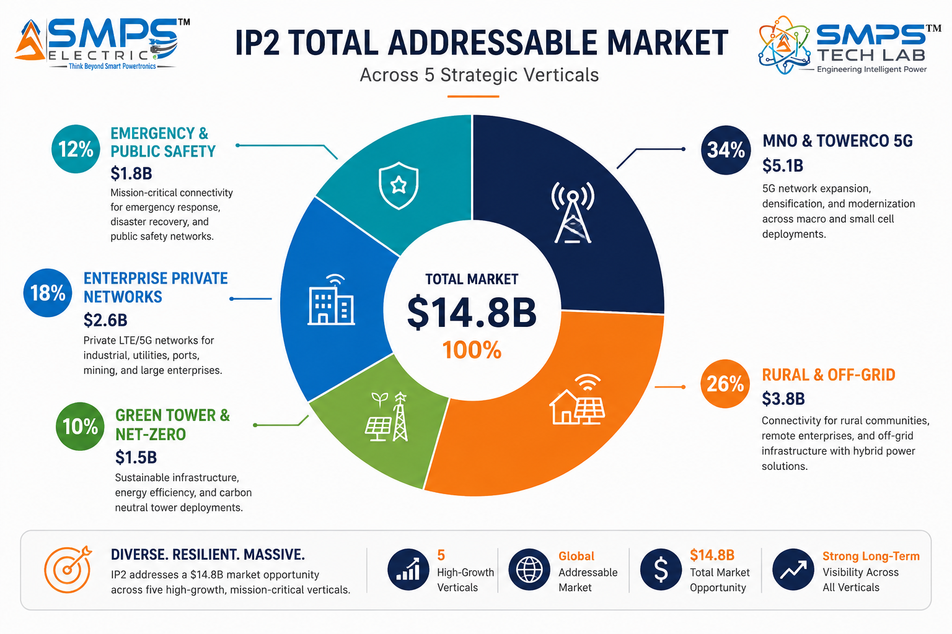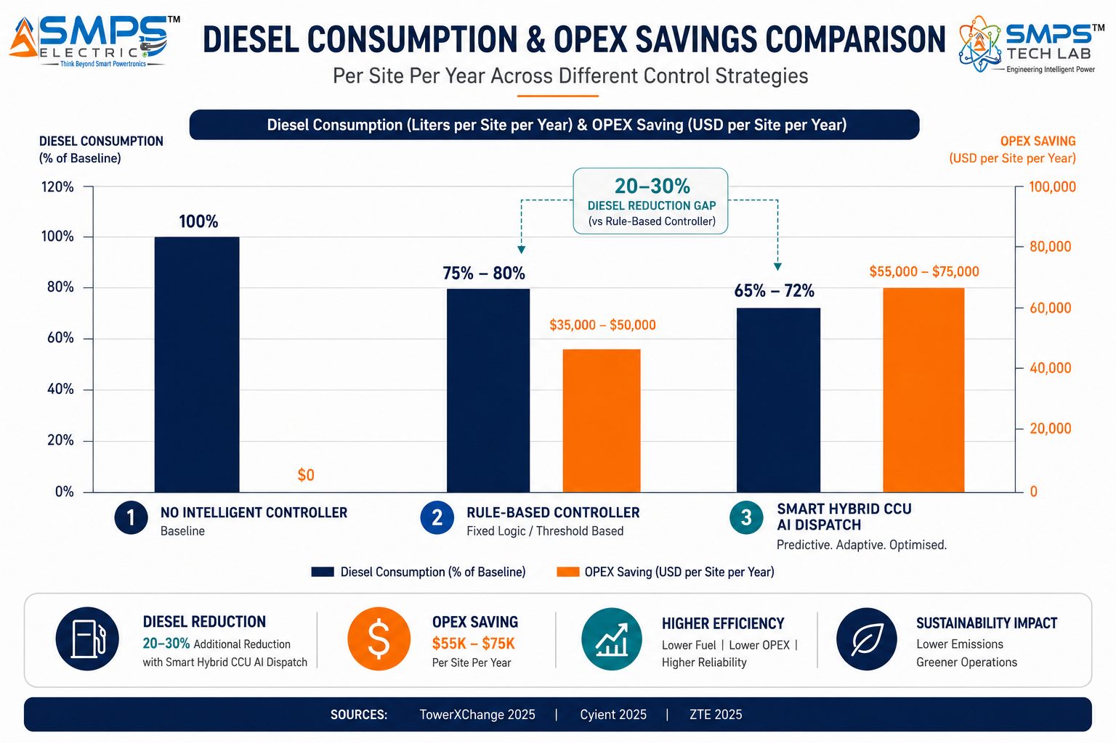
Figure 1.2 — IP-05 TAM by telecom vertical (left): MNO/TowerCo 5G is the largest at $5.1B and fastest near-term revenue pathway; Green Tower & Net-Zero is the fastest-growing at 13.6% CAGR. Diesel reduction benchmark (right): validated 20–30% reduction from AI dispatch versus rule-based controllers.

1.4 Why IP-05, Why Now
Three forces are converging at precisely the right moment. First, the 5G power cost surge has elevated energy from a managed overhead to the top agenda item at every major tower company and MNO board meeting: 5G consumes 3x the energy of 4G, and the industry is simultaneously rolling out 5G while committing to net-zero targets. The contradiction is only resolvable with intelligent energy management at scale. Second, the AI hybrid controller market is validated but not yet consolidated: ZTE installed 22,000 hybrid units in APAC in 2025; Siemens launched MHES with AI controls in March 2025; Schneider Electric partnered with CrossBoundary Energy for African tower microgrids in February 2025. These are commercial confirmations, not pilots. Third, the carbon market opportunity is maturing: ISO 14064-compliant carbon accounting from diesel displacement is now a certified revenue stream through carbon credit aggregators, and tower companies with net-zero commitments represent a systematic, multi-year procurement programme — not a one-time capex decision.

MARKET DATA POINT
Combined SMPS Tech Lab IP portfolio: IP-01 $68.7B + IP-02 $27.1B + IP-03 $42.3B + IP-04 $38.5B + IP-05 $14.8B = USD 191.4 Billion total TAM across 25 sectors and 50 applications. IP-05 adds the telecom energy intelligence layer — the AI orchestration platform that manages and optimises the energy inputs to the power conversion and control systems of IP-01, IP-02, and IP-03.

02 | TECHNOLOGY OVERVIEW  AI Dispatch Architecture · Five Energy Sources · Predictive Intelligence · Standards

2.1 What is the Smart Hybrid CCU?
The Smart Hybrid CCU is a purpose-built telecom energy management and orchestration platform. It sits at the intersection of the energy sources (solar PV, battery bank, diesel generator, grid connection, wind turbine) and the telecom load (base station radio units, baseband equipment, site ancillaries) — continuously monitoring all inputs, all outputs, and all storage states, and dynamically deciding in real-time which source powers the site at each moment. This is not a basic rectifier controller performing simple battery float charging: it is an AI-driven dispatch engine that simultaneously knows the weather forecast for the site, the battery’s state of health, the diesel fuel level, the grid tariff schedule, and the operator’s carbon budget — and uses all of this to make the lowest-cost, highest-availability source dispatch decision continuously.

The distinction from IP-02 is architectural and commercial. IP-02 (SMPS-Based Integrated CCU) provides the power delivery hardware — converting and delivering AC and DC power reliably with sub-millisecond failover. IP-05 (Smart Hybrid CCU) provides the energy intelligence layer above it: the orchestration platform that decides which energy source feeds the power delivery system, and continuously optimises that decision for cost, carbon, and availability. IP-05 can operate as a standalone orchestration controller interfacing with existing site power hardware, or as the intelligence layer of a complete system that includes IP-02 for power delivery.
2.2 The Four Integrated Technology Layers
LAYER | COMPONENT | FUNCTION | KEY INNOVATION IN IP-05
L1 | Multi-Source Input Monitor | Simultaneously monitors grid AC voltage and quality, solar DC array output (MPPT-tracked), battery state of charge and health, diesel fuel level and generator status, wind turbine AC output. | First-principles real-time visibility of all five energy sources simultaneously. No external monitoring hardware. All source parameters available to the AI dispatch engine within a single control cycle.
L2 | AI Source Dispatch Engine | Embedded machine learning dispatch algorithm continuously optimises source selection: grid → solar → battery → generator priority sequence, modified in real time by predictive inputs (weather forecasts, tariff schedules, load profiles). | The patent-bearing element. Source dispatch decisions are made predictively — pre-charging batteries before peak tariff periods, anticipating solar generation from weather forecasts, scheduling generator starts before battery deep discharge — not reactively after source failure.
L3 | Energy Cost & Carbon Controller | Real-time tariff arbitrage: dispatches stored energy during peak tariff periods, recharges from grid during off-peak. Tracks carbon intensity of each source per kWh. Generates ISO 14064-compliant carbon accounting data and GSMA Green Power for Mobile metrics. | Turns the tower site into a financially optimised energy node. Carbon certificate generation from diesel displacement creates a certified revenue stream that directly funds the IP-05 deployment cost in many markets.
L4 | TMS Integration & Remote Management | Native SNMP, Modbus TCP, and REST API integration to Tower Management System NOC platforms. Reports energy KPIs, alarm states, fuel levels, battery health, generator runtime, carbon performance, and per-tenant energy attribution in real time. | Full remote commissioning capability eliminates truck rolls for initial setup. OTA firmware updates deploy algorithm improvements to the entire tower estate without site visits — directly reducing OPEX at scale.

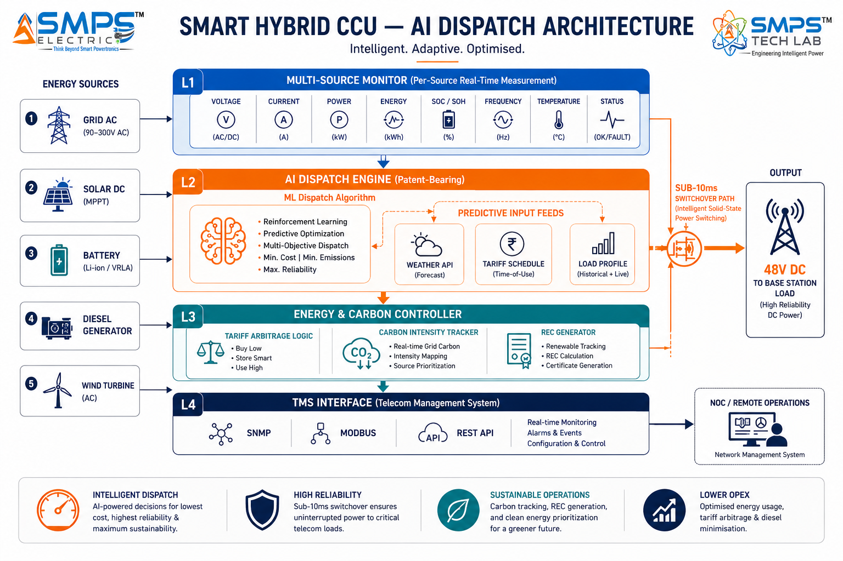
Figure 2.1 — Smart Hybrid CCU four-layer architecture. The AI Dispatch Engine (L2) is the patent-bearing element: it makes source selection decisions predictively rather than reactively, delivering 20–30% diesel reduction versus rule-based controllers.

2.3 AI Dispatch Engine — Predictive vs. Reactive Control
The commercial value of IP-05 is concentrated in the AI Dispatch Engine and the distinction between predictive and reactive source management. A rule-based controller responds to what has already happened: the battery is below threshold, therefore start the generator. The Smart Hybrid CCU anticipates what is about to happen: the weather forecast shows 4 hours of cloud cover starting in 90 minutes, therefore pre-charge the battery to 95% now using grid or the remaining solar window, so that the generator start can be delayed or avoided entirely. This predictive approach is what delivers the 20–30% diesel reduction that reactive controllers cannot achieve.
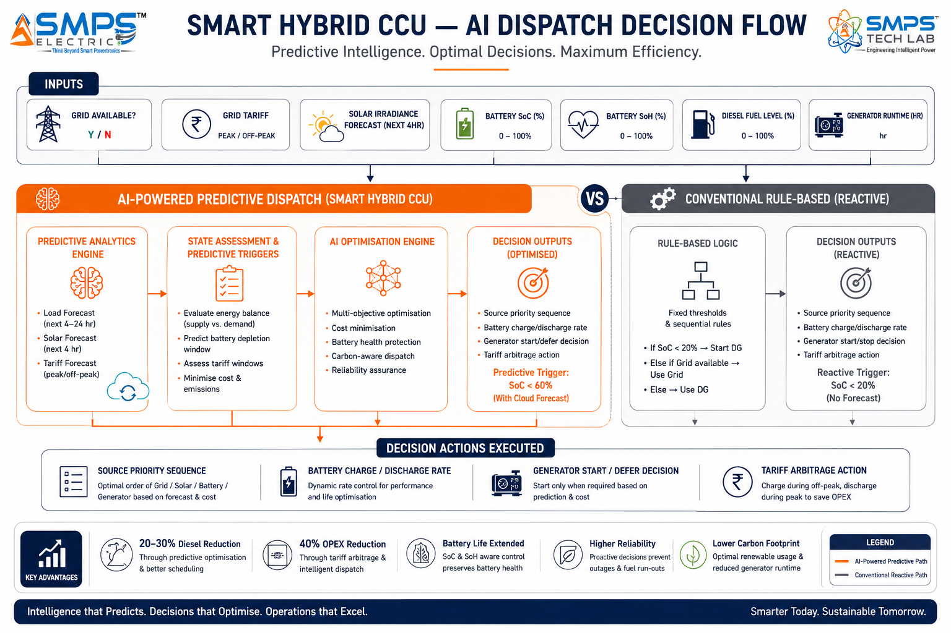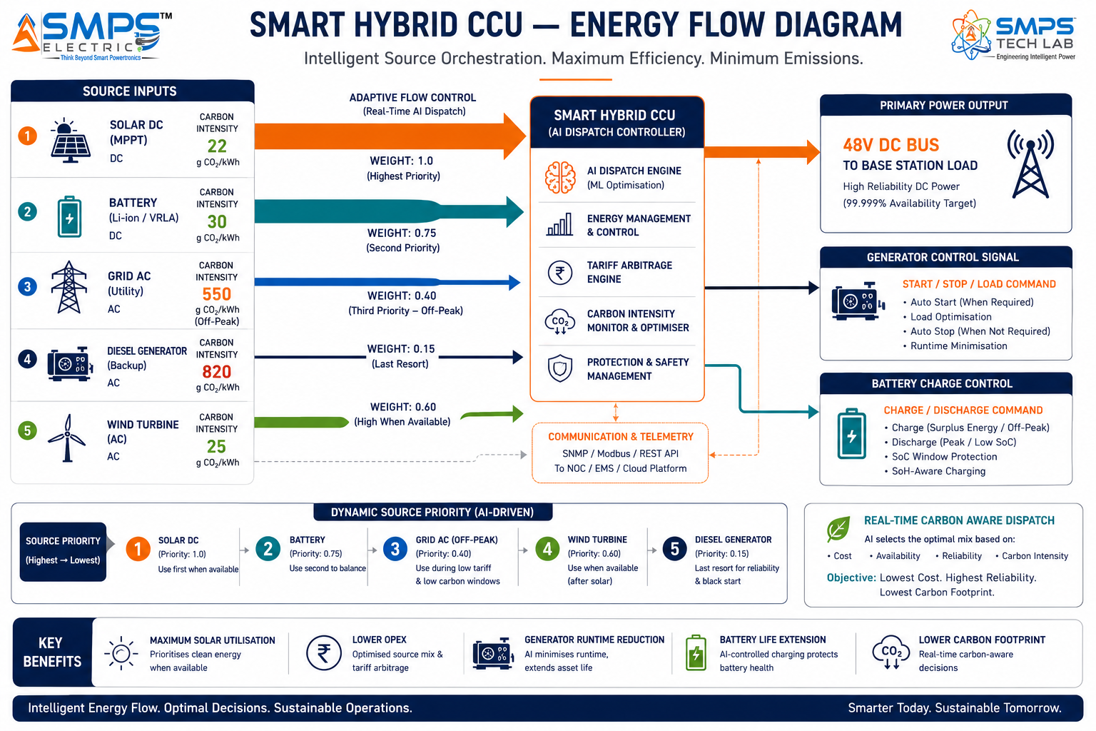
Figure 2.2 — AI dispatch decision tree (left): predictive source selection using weather forecasts and tariff schedules versus reactive rule-based triggers. Multi-source energy flow (right): five source inputs managed by the AI dispatch engine, with carbon intensity tracking per source per kWh.

2.4 Energy Cost & Carbon Optimisation — The Commercial Multiplier
The carbon accounting capability of IP-05 transforms it from an OPEX reduction tool into a revenue-generating asset in carbon market-active jurisdictions. ISO 14064-compliant energy metering and carbon intensity tracking per source enables tower companies to generate verified carbon credits from diesel displacement — at approximately USD 10–25 per tonne of CO₂ equivalent in current voluntary carbon markets. For a tower company operating 10,000 sites and achieving 25% diesel reduction with the Smart Hybrid CCU, the annual carbon credit revenue at USD 15/tonne averages approximately USD 1.8 million per year — directly reducing the effective cost of the IP-05 deployment programme.
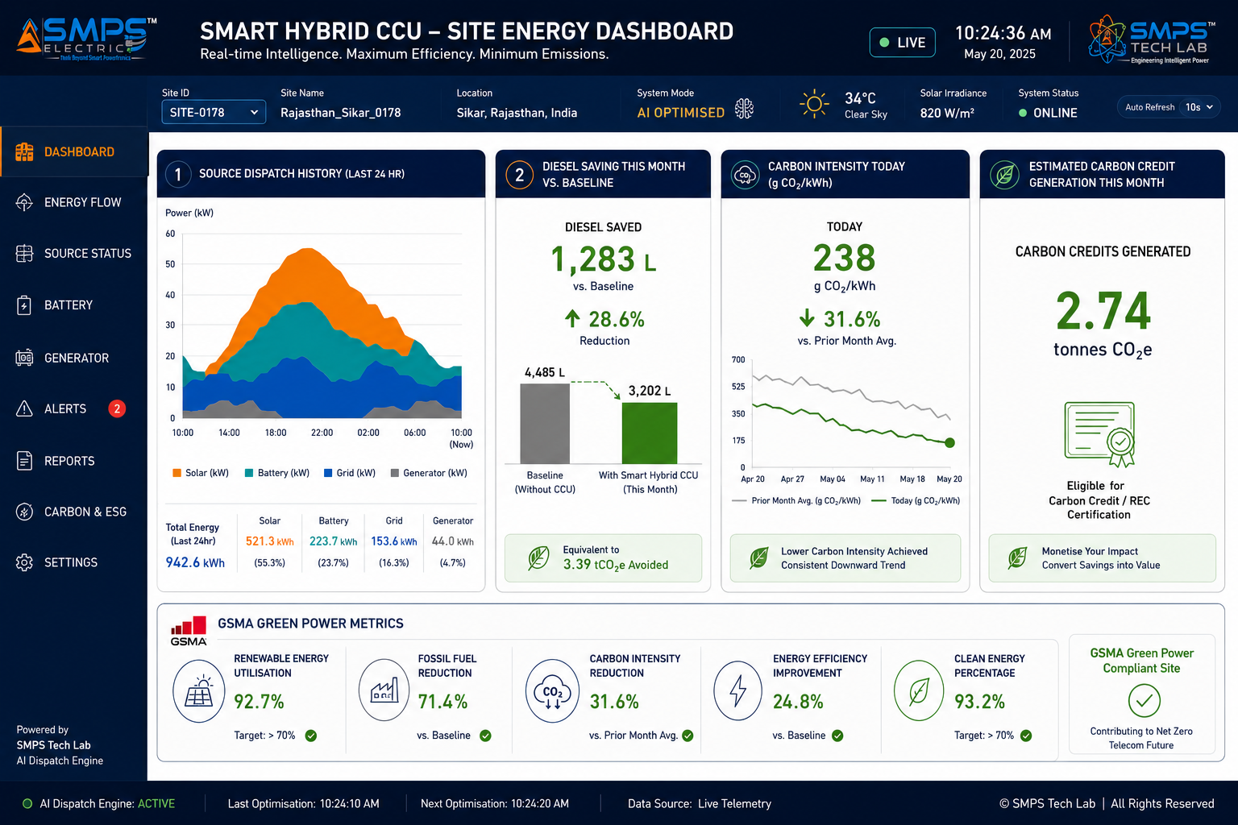
Figure 2.3 — Smart Hybrid CCU energy and carbon dashboard. Real-time source dispatch history, diesel saving vs. baseline, carbon intensity, and carbon credit generation — all reported to the tower company NOC via REST API without additional monitoring hardware.

2.5 Standards Compliance Architecture
STANDARD | VERTICAL APPLICABILITY | COMPLIANCE RELEVANCE FOR IP-05
ETSI EN 300 132-3 | All telecom tower verticals | Telecom DC power supply standard: 48V DC bus management, temperature-compensated battery charging, alarm management. Mandatory for all tower operator deployments.
IEC 62619 | All verticals (battery management) | Safety requirements for secondary Li-ion cells in stationary applications. Battery management algorithm in IP-05 complies with IEC 62619 charge/discharge parameters and safety limits.
IEC 61724 | All verticals (solar monitoring) | Photovoltaic system performance monitoring. IP-05 MPPT and solar yield reporting complies with IEC 61724 measurement and data exchange requirements.
ISO 14064 | Green Tower & Net-Zero | GHG emissions quantification and reporting. IP-05 carbon accounting output is ISO 14064-compliant — mandatory for carbon credit verification and TCFD/GHG Protocol ESG reporting.
IEC 62040-3 | All verticals (UPS/backup power) | Online UPS performance classification. <10ms source switchover and power continuity requirements aligned with IEC 62040-3 Class 1 (zero transfer time) specification.
GSMA Green Power for Mobile | All verticals | GSMA framework for measuring and reporting renewable energy use in mobile networks. IP-05 reporting layer generates GSMA-compliant energy and carbon KPIs for operator sustainability dashboards.
IEC 60870-5-104 / SNMP v3 | MNO/TowerCo, Emergency, Utility | Remote telemetry protocols for tower management systems and utility SCADA. IP-05 TMS integration supports IEC 60870-5-104 for utility-grade energy metering and SNMP v3 for tower NOC platforms.

03 | GLOBAL MARKET LANDSCAPE  Tower Energy Crisis · Market Sizing · Competitive Validation · Growth Drivers

3.1 The Telecom Energy Inflection Point
The global telecom tower industry is at an energy inflection point driven by two simultaneous forces pulling in opposite directions. The 5G rollout is multiplying power demand per site by a factor of three, expanding total tower energy consumption to an unprecedented scale. Net-zero commitments from American Tower (carbon neutral by 2030), Vodafone (net zero by 2040), Bharti Airtel, and virtually every major MNO are creating a systematic obligation to reduce that expanded energy demand simultaneously. The only resolution to this contradiction is intelligent hybrid energy orchestration — and the market has confirmed this with concrete commercial deployments: ZTE installed 22,000 hybrid units across APAC in 2025, SMA Solar deployed 6,800 hybrid systems for telecom in 2024, and Siemens Energy launched its AI-powered Modular Hybrid Energy System in March 2025.

The OPEX case is the most direct commercial driver. At an average diesel spend of USD 3,000 per site per year and 50,000 sites, a tower company achieving 25% diesel reduction from the Smart Hybrid CCU saves USD 37.5 million annually — a return that pays back the IP-05 deployment investment in under 18 months at typical per-unit pricing. This ROI profile means procurement decisions are made at divisional budget level without requiring corporate capex approval, dramatically shortening the sales cycle compared with any capital infrastructure investment.

3.2 The Four Structural Megatrends
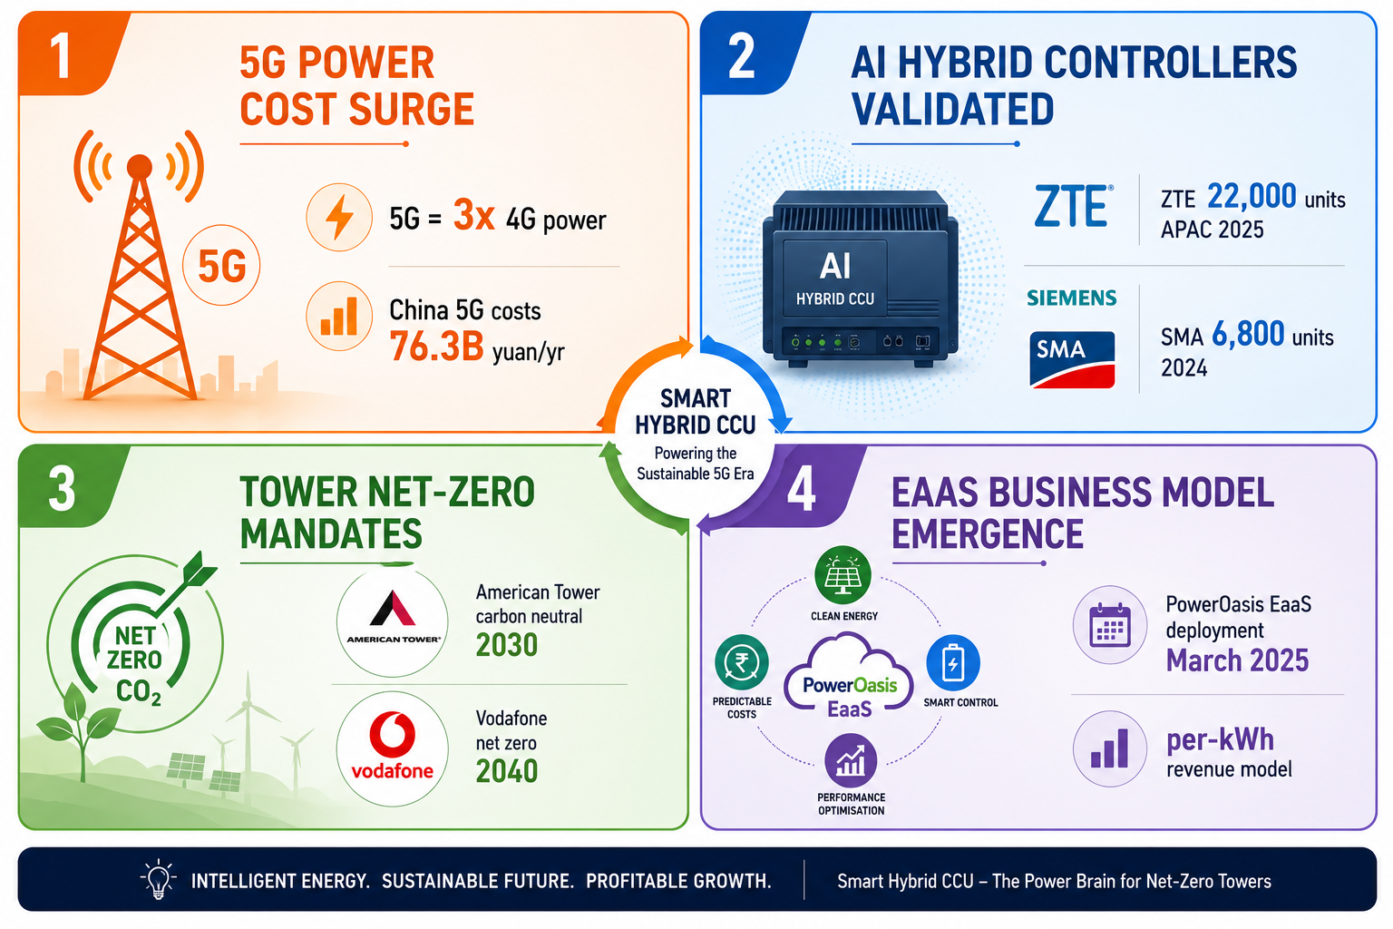
Figure 3.1 — Four structural megatrends converging on the Smart Hybrid CCU commercial opportunity. Each is independently sufficient to drive adoption; together they define a sustained multi-year procurement programme across global tower estates.

3.3 Global Market Sizing — Primary Reference Data
MARKET SEGMENT | 2025 VALUE | PROJECTED | CAGR | HORIZON | SOURCE
Telecom Tower Power System Market | USD 4.8B | USD 8.9B | 6.4% | 2035 | Future Market Insights
North America Telecom Tower Power | USD 5.2B | USD 9.8B | 10.9% | 2031 | Mobility Foresights
Hybrid Power Solutions Market | USD 2.91B | USD 7.63B | 10.1% | 2035 | Fact.MR
Hybrid Power Solutions (Alt.) | USD 2.66B | (growing) | 10.3% | 2035 | Maximize Market Research
Solar-Wind-Diesel Hybrid Systems | (growing) | (growing) | 20.09% | 2032 | Data Bridge
Generators in Telecommunications | USD 1.7B | (growing) | 5.0% | 2030 | Global Growth Insights
Telecom Tower Market (incl. services) | USD 4.25B | USD 11.77B | 13.59% | 2033 | Market Data Forecast
5G Infrastructure Market | USD 41.39B | USD 133.19B | 13.1% | 2033 | Grand View Research

CAGR Comparison — IP-05 Target Market Segments

Solar-Wind-Diesel Hybrid (Data Bridge) ██████████████████████████ 20.09%
Telecom Tower Market (Mkt Data Forecast)██████████████████░░░░░░░░ 13.59%
5G Infrastructure (Grand View Research) █████████████████░░░░░░░░░ 13.1%
Green Tower / Net-Zero Vertical ██████████████████░░░░░░░░ 13.6%
North America Tower Power (Mob. Foresight)██████████████░░░░░░░░░░░░ 10.9%
Hybrid Power Solutions (Fact.MR) █████████████░░░░░░░░░░░░░ 10.1%
Hybrid Power Solutions (Maximize MR) █████████████░░░░░░░░░░░░░ 10.3%
Telecom Tower Power (Future Mkt Insights)████████░░░░░░░░░░░░░░░░░░ 6.4%
Generators in Telecom (Global Growth) ██████░░░░░░░░░░░░░░░░░░░░ 5.0%
Sources: Future Market Insights, Mobility Foresights, Fact.MR, Maximize Market Research, Data Bridge, Global Growth Insights, Market Data Forecast, Grand View Research (2025–2026)

04 | TOTAL ADDRESSABLE MARKET  Five Telecom Verticals · Ten Applications · USD 14.8 Billion

4.1 Methodology
The TAM framework maps IP-05 across five telecom energy verticals with two primary commercial applications per vertical, producing ten independently validated commercialisation pathways. Each application is sized from published sub-segment data and validated industry reports. The aggregate TAM of USD 14.8 billion represents the intelligent hybrid energy orchestration portion of each vertical — specifically the market addressable by an AI-driven multi-source energy management platform with carbon accounting capability.

STRATEGIC NOTE
IP-05 is not in competition with IP-01 or IP-02. IP-01 provides the efficient multi-rail power conversion hardware. IP-02 provides the CCU power delivery architecture with sub-millisecond failover. IP-05 provides the energy intelligence layer that orchestrates which source feeds both. In a full-stack SMPS Tech Lab tower deployment, all three IPs operate as complementary layers: IP-05 at the top (energy source dispatch), IP-02 in the middle (power delivery architecture), IP-01 at the bottom (efficient AC/DC conversion). This stacking creates a bundled product offering with a combined per-site value proposition that no competitor can match.
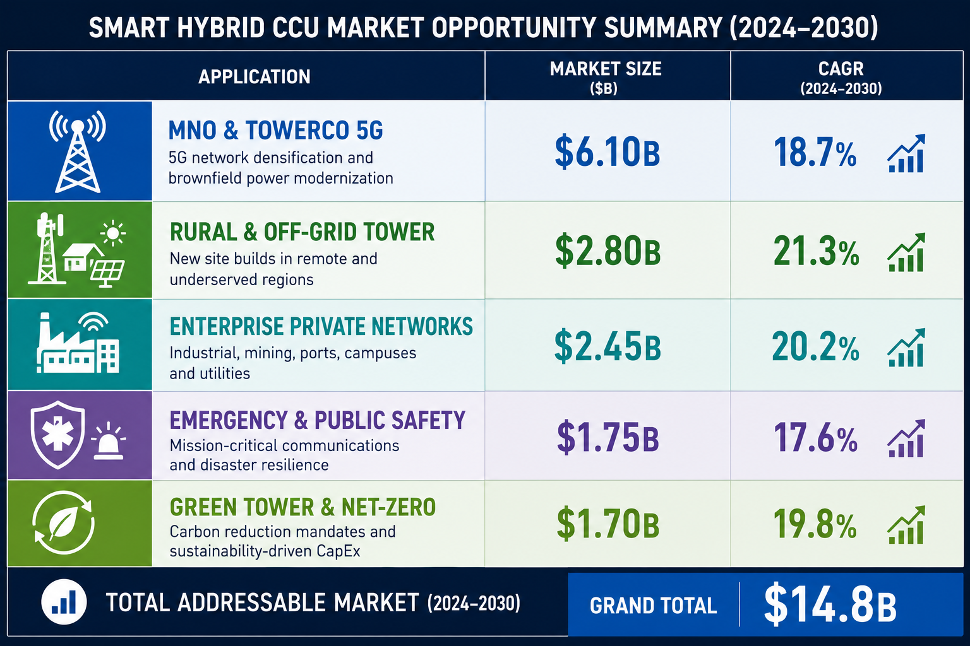
Figure 4.1 — IP-05 application matrix. Ten commercially validated pathways across five telecom verticals, each independently sized and independently commercialisable.

4.2 Consolidated TAM Summary
VERTICAL | APPLICATION | USE CASE SUMMARY | APP SIZE | VERTICAL TAM | CAGR
MNO & TowerCo 5G | 5G Macro Tower AI Hybrid Orchestration | AI source dispatch for 5G tower estates; 20–30% diesel reduction; NOC integration; OPEX optimisation | $3.0B | $5.1B | 10.9%
MNO & TowerCo 5G | Multi-Tenant Tower Energy Sharing | Per-tenant smart metering and cost allocation enabling EaaS commercial models for tower companies | $2.1B | $5.1B | 10.9%
Rural & Off-Grid Tower | Solar-Battery-Diesel Hybrid Orchestration | MPPT + battery lifecycle management + generator minimisation for off-grid towers in emerging markets | $1.8B | $3.8B | 10.1%
Rural & Off-Grid Tower | Wind-Solar-Battery Hybrid Tower | Three-source hybrid for coastal/highland towers; wind + solar + battery + diesel dispatch optimisation | $2.0B | $3.8B | 10.1%
Enterprise Private Networks | Mining & Oil Field Private Network Energy | ATEX-rated AI hybrid orchestration for remote industrial private LTE/5G; fuel monitoring; site autonomy | $1.5B | $2.6B | 8.2%
Enterprise Private Networks | Campus & Port Private 5G Energy | EMS-integrated energy orchestration for smart factory and port private 5G infrastructure | $1.1B | $2.6B | 8.2%
Emergency & Public Safety | FirstNet & Public Safety LTE Energy | Autonomous multi-source management for extended-duration public safety network uptime | $1.0B | $1.8B | 8.5%
Emergency & Public Safety | Disaster Recovery Deployable Power | Rapid-deploy autonomous hybrid energy for COWs and emergency comms in disaster zones | $0.8B | $1.8B | 8.5%
Green Tower & Net-Zero | Tower Decarbonisation Programme | ISO 14064 carbon accounting + renewable maximisation for MNO/TowerCo net-zero commitments | $0.9B | $1.5B | 13.6%
Green Tower & Net-Zero | EaaS Managed Service Platform | Per-kWh metering + SLA reporting + API billing integration enabling Energy-as-a-Service for towers | $0.6B | $1.5B | 13.6%
TOTAL ADDRESSABLE MARKET — IP-05 SMART HYBRID CCU — TELECOM HYBRID ENERGY ORCHESTRATION (2025) |  |  |  | ~USD 14.8 Billion

MARKET DATA POINT
Combined SMPS Tech Lab portfolio: IP-01 $68.7B + IP-02 $27.1B + IP-03 $42.3B + IP-04 $38.5B + IP-05 $14.8B = USD 191.4 Billion total TAM across 25 sectors and 50 applications. IP-05 is the energy intelligence layer that sits above and orchestrates the power conversion and delivery layers provided by IP-01, IP-02, and IP-03 in telecom deployments.

05 | INDIA MARKET INTELLIGENCE  BharatNet · USOF Off-Grid · 5G MNO Estates · Carbon Markets

5.1 India as First Market
India presents the single most compelling first-market for IP-05 globally. The confluence of the world’s largest active off-grid telecom tower estate (over 250,000 towers with unreliable or no grid, relying on diesel generators), the world’s most ambitious 5G rollout by Jio and Airtel, a government-committed BharatNet off-grid rural connectivity programme, and a domestic carbon market developing under the Energy Conservation (Amendment) Act 2022 creates a demand environment with no equivalent anywhere else. For a domestically patented AI hybrid energy orchestration platform, India’s USOF rural connectivity mandate and the PLI telecom incentive provide a procurement preference framework that systematically advantages Indian IP holders.
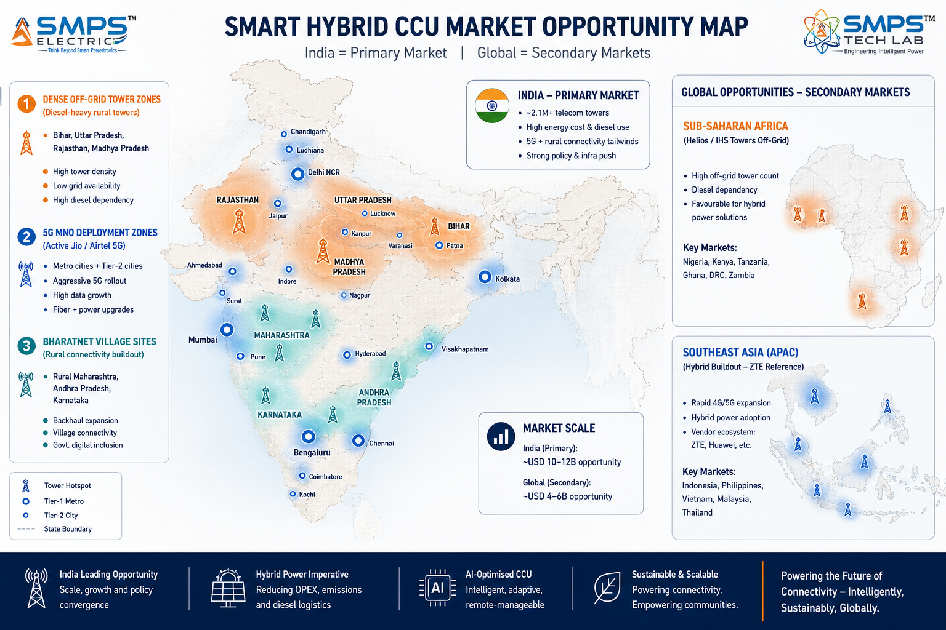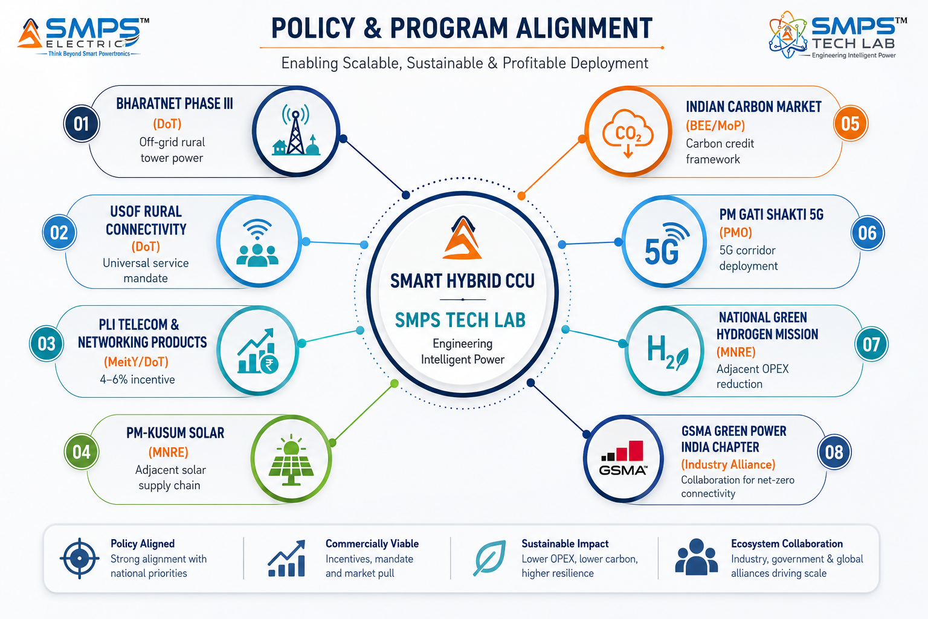
Figure 5.1 — India and global tower deployment hotspot map (left): India has the world’s largest addressable off-grid tower estate for IP-05. Policy alignment (right): BharatNet and USOF create government-mandated procurement channels; the Indian Carbon Market creates a revenue-generating deployment model.

5.2 India Market Sizing — IP-05 Relevant Segments
INDIA MARKET SEGMENT | 2025E VALUE | PROJECTED | CAGR | HORIZON
India Telecom Tower Power Systems | USD 0.85B | USD 1.6B | 9.5% | 2031
India Off-Grid Hybrid Tower Energy | USD 0.42B | USD 1.1B | ~10% | 2031
India 5G Infrastructure Energy OPEX | USD 0.6B | USD 2.1B | ~18% | 2030
India Rural Connectivity (BharatNet/USOF) | USD 2.8B | Ongoing | N/A | 2025–2030
India Carbon Market (ICM) — Energy Sector | Emerging | Target: 35% RE by 2030 | N/A | 2025–2030
India Solar MPPT & Hybrid Tower BOS | USD 0.3B | USD 0.9B | ~15% | 2030

06 | GOVERNMENT POLICY & REGULATORY ALIGNMENT  India Schemes · Global Telecom Policy · Carbon Standards

6.1 India Government Schemes with Direct IP-05 Alignment
SCHEME / PROGRAMME | MINISTRY / AGENCY | RELEVANCE TO IP-05 | COMMERCIAL IMPLICATION
BharatNet Phase III | DoT | 750,000+ village fibre nodes + 400,000 5G sites; majority off-grid in rural India requiring hybrid power | BharatNet specifies hybrid solar+battery+generator power for off-grid sites; IP-05 is the mandatory orchestration controller
Universal Service Obligation Fund (USOF) | DoT/USOF | INR 56,000 crore committed for rural connectivity; rural off-grid tower power is a primary expenditure category | USOF rural connectivity tenders specify intelligent energy management; IP-05 directly addresses the specification
PLI — Telecom & Networking Products | MeitY / DoT | INR 12,195 crore; telecom energy management hardware qualifies | 4–6% incentive on incremental sales; IP-05 hardware manufactured in India qualifies under the scheme
Indian Carbon Market (ICM) | BEE / Ministry of Power | EC Act 2022 Amendment; carbon credit framework for industrial and telecom sector | Verified diesel displacement carbon credits at Indian market rates; IP-05 carbon accounting generates ICM-compliant verification data
PM-KUSUM (Solar Agriculture) | MNRE | 3.5M solar pump sets + rural solar; creates solar supply chain proximity to tower deployments | PM-KUSUM installers provide IP-05 solar integration supply chain in rural India at competitive cost
5G Infrastructure Deployment (TRAI/DoT) | DoT / TRAI | Mandatory 5G rollout timelines; all MNOs required to deploy 5G in all districts by 2026 | 5G power cost surge makes IP-05 an immediate operational necessity for every MNO completing 5G rollout
National Action Plan on Climate Change | MoEFCC | India NDC: 35% carbon reduction in GDP energy intensity by 2030; telecom sector included | Tower operator sustainability commitments (Bharti Airtel, Vodafone Idea) create systematic IP-05 procurement demand

07 | IP AS AN INDUSTRY PLUGIN  Tower Ecosystem Integration · Five Vertical Deployment Architecture

7.1 The Plugin Architecture — Five Tower Energy Contexts
The Smart Hybrid CCU is architecturally designed as an intelligence plugin: it interfaces with whatever power infrastructure exists at a tower site — new IP-02 CCU hardware, legacy rectifiers, or any ETSI EN 300 132-3-compliant power system — and adds the AI orchestration layer above it. This means IP-05 generates revenue on every tower site, not only on sites deploying new IP-02 hardware. For commercial engagement with tower companies, this is the critical distinction: IP-05 can be presented as an upgrade to the existing fleet, generating immediate OPEX savings across 50,000+ legacy sites, not only on new deployments.

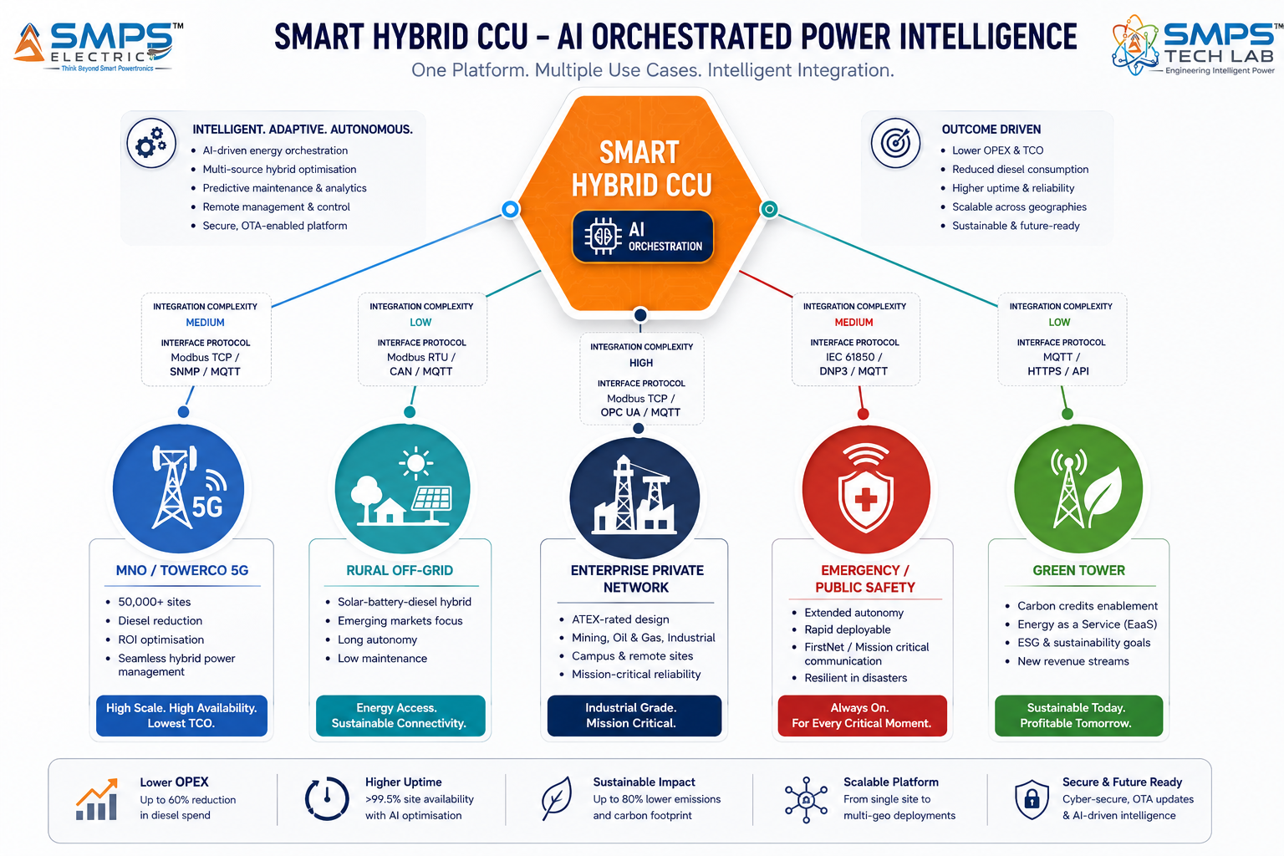
Figure 7.1 — Smart Hybrid CCU as an intelligence plugin across five tower energy contexts. The same AI orchestration core adapts to each vertical through energy source configuration and vertical-specific reporting — not hardware redesign. Critically, it integrates with legacy power infrastructure, not only new deployments.

7.2 Plugin Integration Matrix
TOWER CONTEXT | PLUGIN ROLE | VALUE AT SITE LEVEL | INTEGRATION COMPLEXITY
MNO 5G Macro Tower | AI orchestration above legacy rectifier or new IP-02; source dispatch; NOC reporting via SNMP/REST | 20–30% diesel reduction; OPEX saving; per-site carbon reporting; grid tariff arbitrage | LOW — SNMP/Modbus interface to existing rectifier; no hardware replacement required
Multi-Tenant Tower | Per-tenant smart metering; load attribution; EaaS billing data API; tenant portal | EaaS revenue model enablement; accurate cost sharing; per-tenant SLA reporting | LOW-MED — IEC 62053 metering integration; API to billing platform
Rural Off-Grid Tower | Solar MPPT optimisation; battery lifecycle management; generator minimisation; fuel level tracking | 25–40% total site energy cost reduction; battery life extension; fuel logistics optimisation | MEDIUM — solar MPPT integration; fuel sensor (4–20mA); satellite backhaul for remote monitoring
Enterprise Private Network (Mining/Campus) | ATEX-rated hybrid orchestration; campus EMS integration; load management; autonomous operation | Reduced diesel dependency; campus energy optimisation; integration with industrial EMS/SCADA | MEDIUM-HIGH — ATEX Zone 2 rated enclosure; SCADA integration; industrial protocol support
Emergency / Disaster Recovery | Autonomous multi-source management; 8+ hour extended autonomy; remote monitoring via satellite | Sustained comms during grid outage; autonomous fuel optimisation; no on-site intervention required | MEDIUM — multi-source input (grid/solar/battery/vehicle DC); satellite backhaul; rapid deploy form factor
Green Tower / EaaS | ISO 14064 carbon accounting; REC generation; EaaS billing; carbon credit verification data | Carbon credit revenue stream; EaaS commercial model enablement; ESG reporting compliance | LOW — adds software reporting layer to existing hardware; API integration with carbon registry platforms

08 | COMMERCIALISATION STRATEGY  Revenue Models · Market Priority · Go-to-Market Architecture

8.1 Commercialisation Philosophy
The IP-05 commercialisation strategy prioritises the MNO/TowerCo 5G vertical as the fastest and largest near-term revenue pathway (6–18 months), driven by the direct OPEX ROI case that enables divisional-level procurement approval without corporate capex sign-off. Rural and off-grid towers follow as the second pathway (12–24 months), targeting emerging market tower operators and government rural connectivity programmes. The Green Tower and EaaS verticals are high-growth, higher-value pathways (12–24 months) that generate recurring SaaS-model revenue. Enterprise private networks and emergency comms are medium-priority (18–30 months), requiring more complex integration but delivering premium per-site contract values.

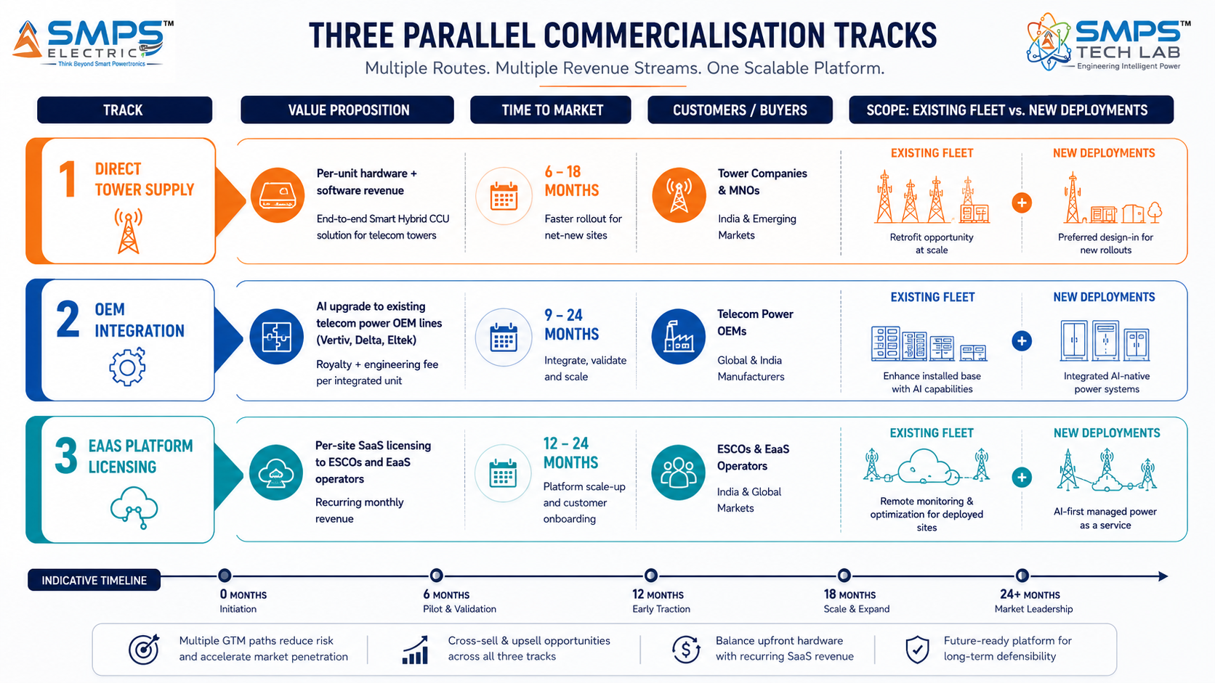
Figure 8.1 — Three parallel pathways. Direct tower supply provides the fastest and largest near-term revenue from the 5G upgrade cycle. OEM integration adds royalty revenue from the existing telecom power OEM channel. EaaS platform licensing creates a recurring SaaS revenue stream from the emerging managed energy services model.

8.2 Market Priority Matrix
VERTICAL | TAM 2025 | CAGR | IP FIT | TIME-TO-REV | PATHWAY | PRIORITY
MNO & TowerCo 5G | $5.1B | 10.9% | Excellent | 6–18 mo | Direct Supply | HIGHEST
Rural & Off-Grid Tower | $3.8B | 10.1% | Excellent | 12–24 mo | Direct + Gov Prog | HIGH
Green Tower & Net-Zero | $1.5B | 13.6% | Excellent | 12–24 mo | EaaS Licensing | HIGH
Enterprise Private Nets | $2.6B | 8.2% | Strong | 18–30 mo | OEM + Direct | MED-HIGH
Emergency & Public Safety | $1.8B | 8.5% | Strong | 24–42 mo | Gov Procurement | MEDIUM

09 | COMPETITIVE LANDSCAPE  Market Positioning · Advantage Scorecard · IP Moat

9.1 Competitive Architecture Overview
A comprehensive review of the telecom hybrid energy management market reveals a market in active commercial formation: ZTE, Siemens Energy, Schneider Electric, and SMA Solar have all made confirmed deployments or product launches in 2024–2025 in the hybrid telecom energy space. This is a dual signal: it validates the commercial readiness of the market, and it confirms that the category is not yet consolidated around a single dominant platform. The window for IP-05 to establish first-mover positioning as the AI orchestration standard for telecom hybrid energy is open. The structural advantage of IP-05 over the confirmed competitor approaches is the combination of AI dispatch intelligence (not just hybrid hardware), carbon accounting capability, multi-source MPPT optimisation, and EaaS commercial model support in a single certified platform.

CATEGORY | KEY PLAYERS | MARKET FOCUS | IP-05 ARCHITECTURAL DIFFERENTIATION
Telecom Rectifier OEMs | Vertiv, Delta Electronics, Eltek/Benning, Huawei Enterprise Power | Tower rectifiers and basic SMPS | Basic rule-based battery management; no AI dispatch; no MPPT; no carbon accounting. IP-05 is the AI upgrade layer that differentiates their commodity hardware.
Industrial Hybrid System OEMs | Siemens Energy MHES, Schneider Electric, SMA Solar | Hybrid energy systems for remote/telecom | General-purpose hybrid controllers; telecom-specific AI dispatch absent; no multi-tenant metering; no EaaS billing API; no telecom NOC (SNMP/Modbus) native integration.
Telecom-Specific Hybrid | ZTE, Huawei Telecom Power, Ericsson Power | 5G tower hybrid power | Hardware-integrated hybrid systems; proprietary to their own telecom equipment ecosystem; no open API for third-party integration; not available as standalone intelligence layer.
Energy Services (EaaS) | PowerOasis, ENGIE PowerCorner, CrossBoundary Energy | EaaS for off-grid telecom in Africa/Asia | Service-layer companies; they need the IP-05 technology platform to operate their EaaS model. IP-05 is the technology they license, not the competition.
Carbon Market Tech | South Pole, Gold Standard, ClimateSeed | Carbon credit verification for telecom | Carbon accounting specialists; no power management capability; IP-05 generates the verified energy data their platforms require. Partnership opportunity, not competition.
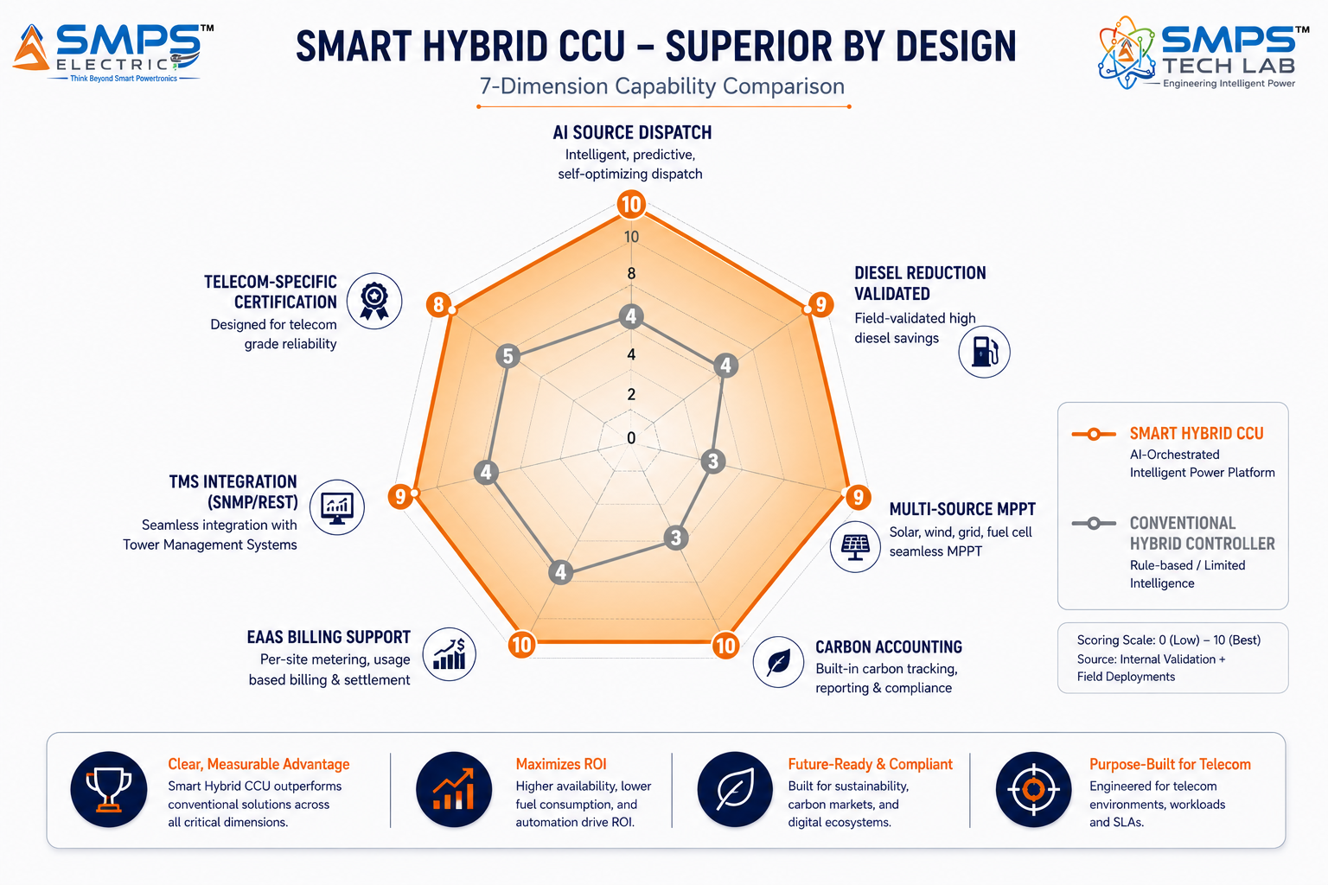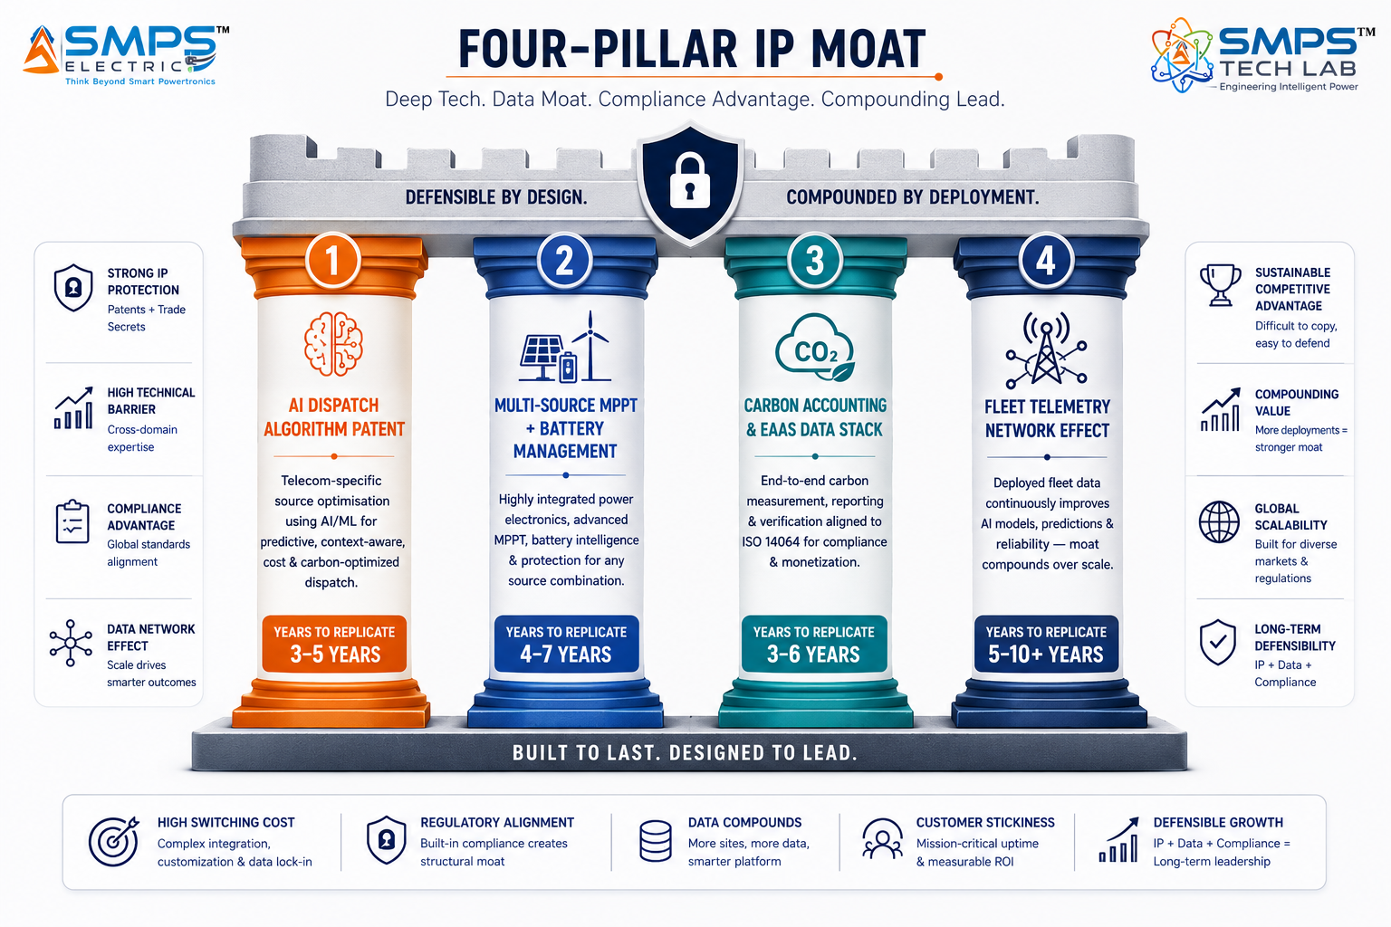
Figure 9.1 — Competitive radar (left): IP-05 scores 8–10/10 across all seven dimensions; conventional hybrid controllers average 3–5/10. Four-pillar moat (right): the combination of AI dispatch patent, carbon accounting data stack, and fleet telemetry network effect creates compounding competitive protection.

10 | INVESTMENT THESIS & FINANCIAL FRAMEWORK  Value Creation · Revenue Projections · Capital Deployment

10.1 The Investment Case
The investment case for IP-05 is distinguished from the other four SMPS Tech Lab IPs by one structural advantage: the ROI is quantifiable, validated, and already documented by third parties. TowerXChange (2025) documents 20–30% diesel reduction. Cyient (2025) documents 40% OPEX reduction. ZTE (2025) documents 29% operational uptime improvement across 22,000 deployed units. American Tower, Vodafone, and Bharti Airtel have made public net-zero commitments that create legal and reputational pressure to procure solutions like IP-05 systematically. This is not an investment thesis built on market projections — it is built on already-validated commercial deployments by named competitors at scale, confirming the market has moved from pilot to mainstream procurement.

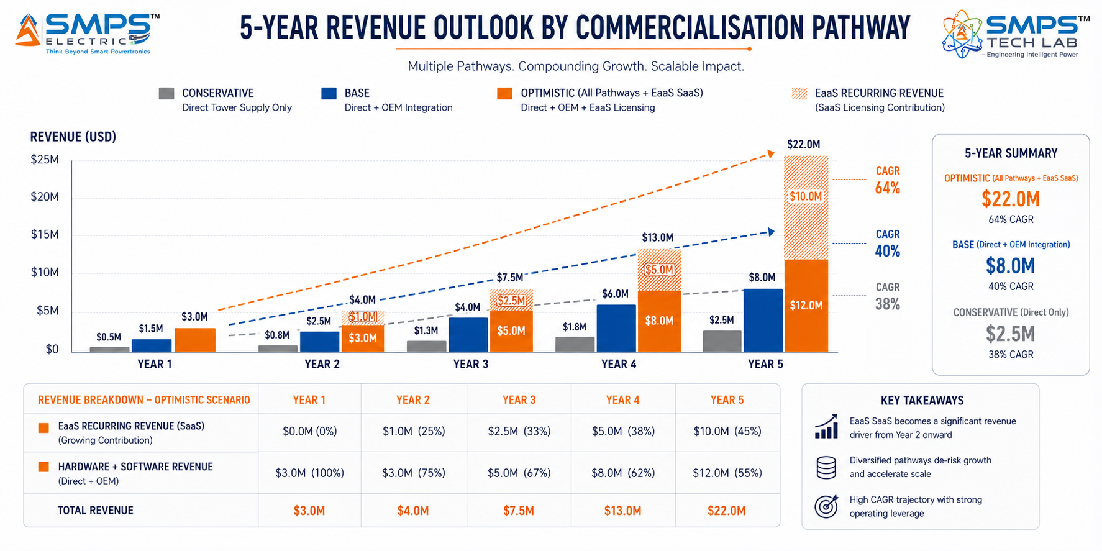
Figure 10.1 — Illustrative revenue projections. Base case assumes two direct tower company supply agreements (Indian MNO and one global TowerCo) by Year 2, plus one OEM integration partnership with a telecom rectifier manufacturer, with PLI incentive realisation.

10.2 Illustrative Revenue Scenarios
SCENARIO | YEAR 1 | YR 2–3 CAGR | YR 4–5 CAGR | KEY ASSUMPTIONS
Conservative (Direct Tower Supply) | USD 500K–1M | +25% | +20% | 1–2 Indian MNO/TowerCo supply agreements; ETSI EN 300 132-3 certified; 5G vertical only
Base (Supply + OEM Integration) | USD 1.5–2.5M | +40% | +35% | 2 TowerCo agreements + 1 OEM integration + BharatNet/USOF rural programme; PLI incentive
Optimistic (All Pathways + EaaS) | USD 3–4M | +65% | +55% | All pathways + EaaS SaaS licensing + carbon credit programme + global TowerCo + OEM

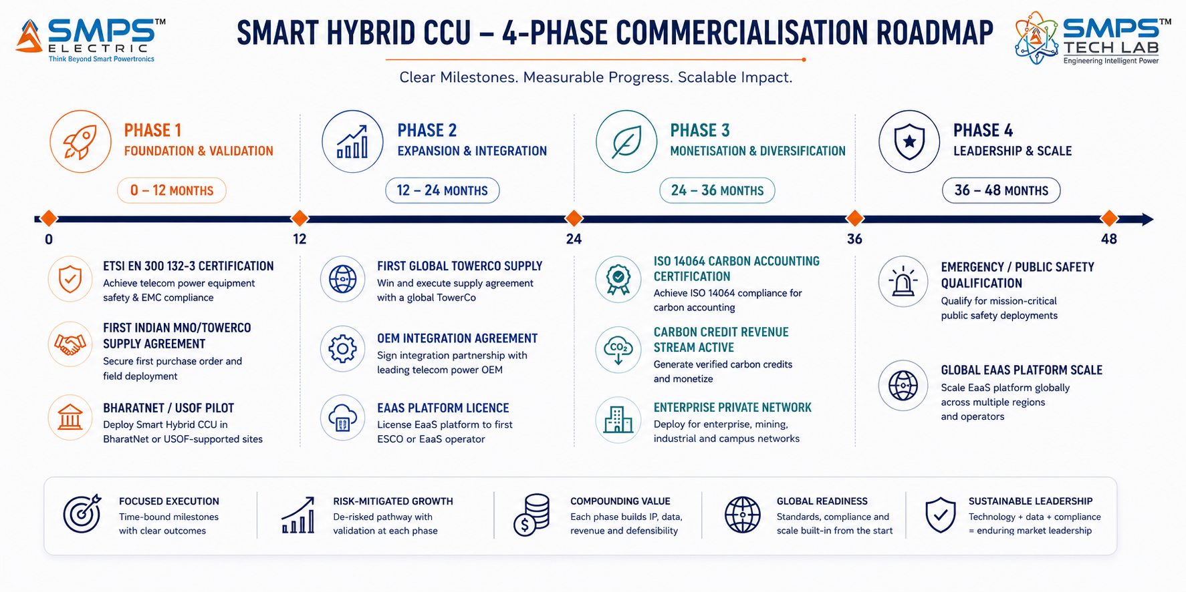
Figure 10.2 — Four-phase value creation roadmap. Each phase unlocks a new revenue channel; the EaaS SaaS transition from Phase 2 onwards creates compounding recurring revenue that grows independent of new unit deployments.
RISK ADVISORY
The EaaS business model represents the highest-value long-term opportunity in the IP-05 portfolio. A tower company managing 10,000 sites on a per-kWh EaaS contract, with IP-05 as the metering and optimisation platform, generates recurring licence revenue of approximately USD 1–3 per site per month — USD 120,000–360,000 annually from a single 10,000-site agreement. At the scale of global TowerCo estates (50,000–700,000 sites), the EaaS recurring revenue potential is the most structurally significant commercial opportunity in the SMPS Tech Lab portfolio.

11 | FUTURE ROADMAP  Technology Evolution · Grid Services · Carbon Market Integration

11.1 Technology Generation Roadmap
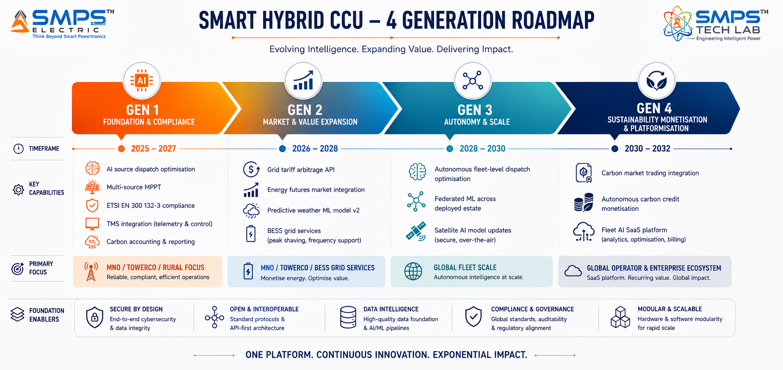
Figure 11.1 — IP-05 four-generation roadmap. Each generation adds commercially significant capability on top of the AI dispatch foundation — from single-site OPEX reduction (Gen 1) to fleet-level carbon market participation (Gen 4).
GENERATION | TECHNOLOGY FOCUS | TARGET TIMELINE | MARKET IMPACT
Gen 1 (Current) | AI source dispatch, multi-source MPPT, ETSI EN 300 132-3, TMS SNMP/REST integration, ISO 14064 carbon accounting | 2025–2027 | MNO/TowerCo 5G, rural off-grid, initial Green Tower programme deployments
Gen 2 | Grid tariff arbitrage API integration (real-time utility pricing), energy futures market interface, predictive weather ML model v2, BESS grid services capability | 2026–2028 | Grid-interactive tower sites in deregulated electricity markets; advanced carbon arbitrage
Gen 3 | Autonomous fleet-level dispatch optimisation across entire tower estate; federated ML sharing learning across deployed units without data centralisation; satellite AI model updates | 2028–2030 | Large tower estate management; portfolio-level carbon performance optimisation; global TowerCo scale
Gen 4 | Autonomous carbon credit monetisation (real-time carbon market trading integration); fleet AI SaaS platform; energy procurement and trading integration | 2030–2032 | Carbon market participation as a revenue stream; full autonomous energy asset management across tower portfolio

11.2 Adjacent Application Opportunities
- Railway Trackside Power Management: Railway trackside cabinets (signalling, communications, lighting) share the same off-grid hybrid energy challenge as telecom towers — remote locations, multiple energy sources, strict uptime requirements. IP-05 AI orchestration with EN 50155 railway adaptation addresses the trackside power management market directly.
- Mining and Oil Field Communications Power: Remote industrial operations (mining sites, oil and gas extraction platforms) deploy private LTE and 5G networks with the same hybrid energy constraints as off-grid towers. The ATEX-rated enclosure pathway for IP-05 already maps to this opportunity as documented in Application 5 of the TAM.
- Smart Grid Distribution Substation Hybrid Management: As renewable energy penetration increases, distribution substations are increasingly operating as hybrid energy nodes — managing solar, battery storage, and grid import/export simultaneously. IP-05’s multi-source AI dispatch architecture is directly applicable with IEC 61850 integration.
- Disaster Relief and Humanitarian Communications: Rapid-deploy communications nodes for disaster response and humanitarian operations require exactly the IP-05 capability profile: autonomous multi-source management, satellite-linked monitoring, extended battery autonomy, and rapid commissioning without on-site technical expertise.

12 | RISK ANALYSIS  Risk Register · Probability & Impact · Strategic Mitigation

12.1 Risk Framework
The IP-05 risk profile is shaped by two sector-specific characteristics. First, the primary buyer — tower companies and MNOs — are large, procurement-process-heavy organisations with 12–24 month vendor qualification cycles before volume purchase orders. This creates a lead time risk that is mitigated by beginning qualification engagement in parallel with certification. Second, the market is already commercially active with Tier-1 competitors (ZTE, Siemens, Schneider Electric) — which validates the market but compresses the window for first-mover positioning. The competitive response is speed-to-certification and the unique AI dispatch + carbon accounting + EaaS capability combination that none of the confirmed competitor products currently offers.

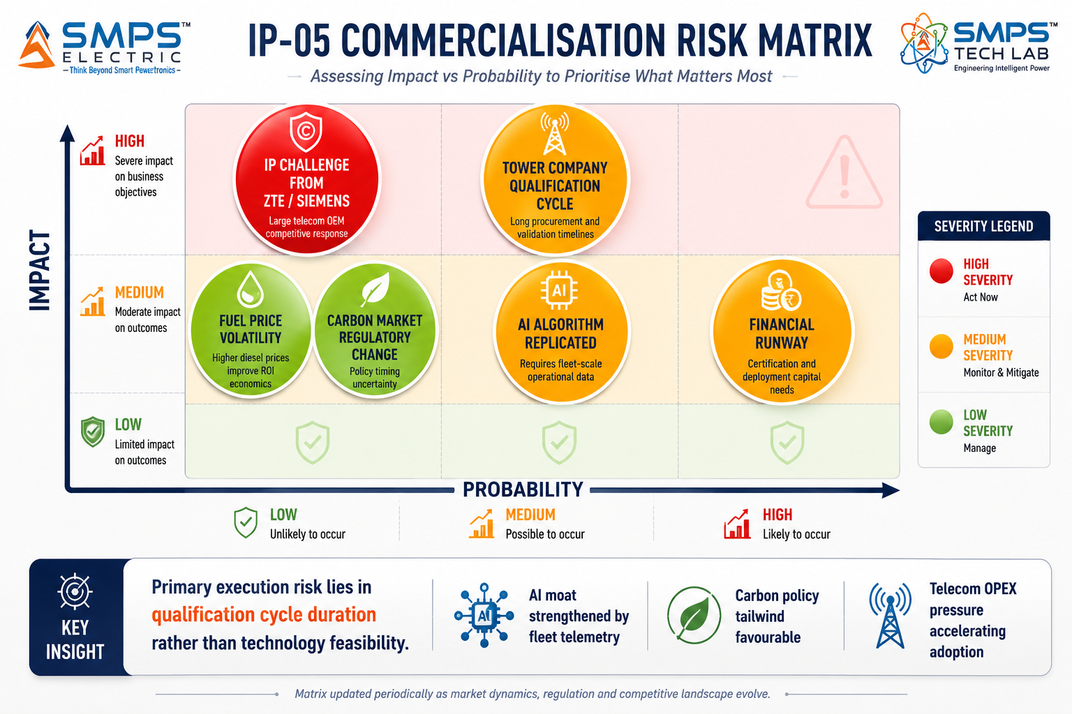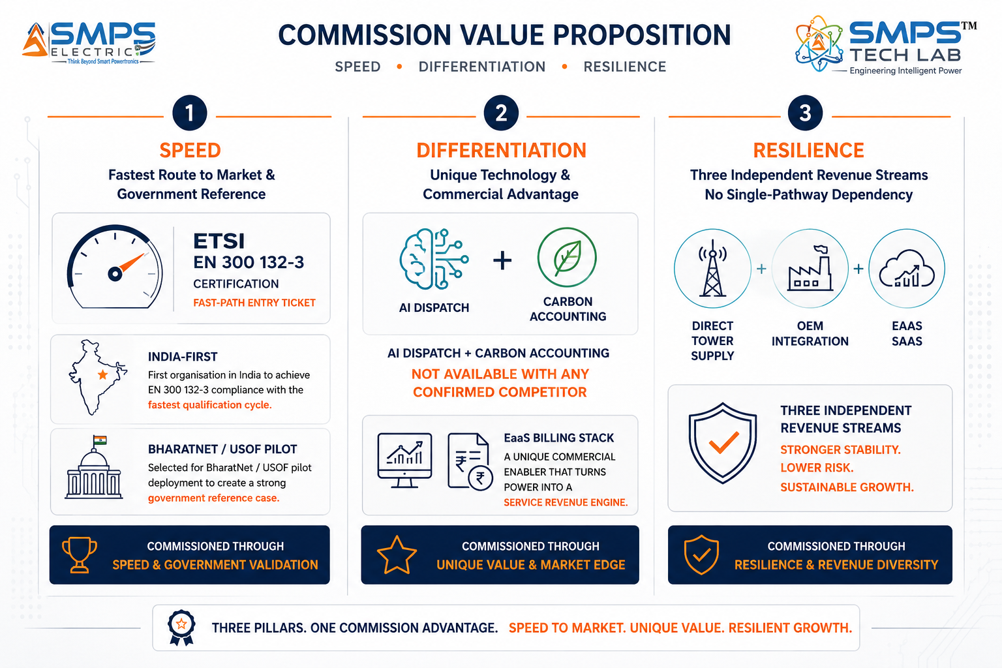
Figure 12.1 — Risk matrix (left): tower company qualification cycle is the highest-probability risk and is mitigated through early engagement and India-first BharatNet pilot strategy. Three-track mitigation architecture (right): speed, differentiation, and revenue resilience are the three independent pillars of the risk response.

CATEGORY | SPECIFIC RISK | PROB. | IMPACT | MITIGATION STRATEGY
IP Protection | ZTE or Siemens challenges AI dispatch patent | LOW | HIGH | PCT international filing within 12 months. AI dispatch algorithm claims cover telecom-specific predictive source optimisation — not generic hybrid control. Licensing ZTE or Siemens to use IP-05 is the preferred commercial outcome.
Qualification Cycle | Tower company vendor qualification delays initial purchase orders | MEDIUM | HIGH | Begin tower company engagement 12+ months before certification. India-first strategy: USOF/BharatNet pilot creates government reference and accelerates private MNO qualification. Offer evaluation units for field trials.
Competitive Speed | ZTE/Siemens/Schneider accelerate AI enhancement beyond 2025 launches | MEDIUM | MEDIUM | IP-05 patent covers specific telecom AI dispatch + carbon accounting + EaaS stack. Current competitor launches do not match this combination. Carbon accounting and EaaS billing API are 18–24 months from any confirmed competitor.
Carbon Market | Carbon credit market regulatory change reduces carbon revenue stream | LOW | MEDIUM | Carbon revenue is additive, not base-case. Base-case ROI is entirely from diesel OPEX reduction — which is independent of carbon markets. Carbon market upside is a bonus, not a dependency.
Fuel Price | Sustained diesel price reduction reduces urgency of IP-05 OPEX case | LOW | MEDIUM | Historical diesel price volatility has consistently trended upward in remote emerging market locations. Net-zero mandate is independent of fuel price. OPEX case includes generator maintenance reduction, not only fuel.
Financial | Certification and go-to-market costs exceed Year 1 plan | MEDIUM | MEDIUM | PLI telecom incentive provides Year 1 revenue offset. BharatNet/USOF pilot funding may cover initial field deployment costs. ETSI EN 300 132-3 is the lowest-cost, fastest certification — enables revenue before complex certifications are complete.

13 | APPENDICES  Data Sources · Standards Reference · Glossary

Appendix A — Data Sources
- Future Market Insights — Telecom Tower Power System Market (USD 4.8B in 2025 to USD 8.9B by 2035, CAGR 6.4%)
- Mobility Foresights — North America Telecom Tower Power System Market (USD 5.2B in 2025 to USD 9.8B by 2031, CAGR 10.9%)
- Fact.MR — Hybrid Power Solutions Market (USD 2.91B in 2025 to USD 7.63B by 2035, CAGR 10.1%); Telecom = 33.7% share
- Maximize Market Research — Hybrid Power Solutions Market (USD 2.66B in 2024, CAGR 10.3%)
- Data Bridge Market Research — Hybrid Power Systems (Solar-Wind-Diesel CAGR 20.09% 2025–2032)
- Global Growth Insights — Generators in Telecommunications (USD 1.7B in 2025, CAGR 5.0%; 40% hybrid adoption)
- Market Data Forecast — Telecom Tower Market (USD 4.25B in 2025 to USD 11.77B by 2033, CAGR 13.59%)
- TowerXChange Energy Report 2025 — AI-driven power management delivers 20–30% diesel reduction and up to 30% CO₂ reduction
- Cyient Tower Operations Centre Case Study 2025 — 40% OPEX reduction, 97% tower uptime enhancement
- Leoch Lithium America 2025 — Diesel fuel and generator maintenance account for up to 70% of site OPEX in remote deployments
- Acrel 2024 — Single 5G base station: 3.5–4 kW full load; China 5G electricity cost estimated at 76.3 billion yuan annually
- ZTE Corporation 2025 — 22,000 hybrid telecom power units installed across APAC; 29% operational uptime improvement
- Siemens Energy — Modular Hybrid Energy System (MHES) with AI-powered controls launched March 2025
- Schneider Electric + CrossBoundary Energy — Partnership for hybrid solar-diesel telecom microgrids, sub-Saharan Africa (February 2025)
- SMA Solar Technology — 6,800 hybrid systems deployed for telecom applications in 2024
- PowerOasis (UK) — AI-driven hybrid microgrids as managed energy service for telecom operators, March 2025
- Huawei — Carbon footprint-certified energy storage solutions for telecom launched July 2025
- Grand View Research — 5G Infrastructure Market (USD 41.39B in 2025 to USD 133.19B by 2033, CAGR 13.1%)
- Department of Telecommunications, GoI — BharatNet Phase III and Universal Service Obligation Fund programme documents, 2025

Appendix B — Standards Reference
STANDARD | FULL TITLE | APPLICABILITY
ETSI EN 300 132-3 | Telecom infrastructure — power supply (DC); interface and safety requirements | Mandatory for all telecom tower operator deployments. 48V DC bus management, battery charging protocols, alarm management.
IEC 62619 | Secondary cells and batteries containing alkaline or other non-acid electrolytes — Safety requirements for secondary lithium cells | Li-ion battery management compliance. Charge/discharge parameters, safety limits, temperature management. Mandatory for all Li-ion battery interface deployments.
IEC 61724 | Photovoltaic system performance — guidelines for measurement, data exchange and analysis | Solar monitoring and MPPT reporting compliance. Energy yield verification, performance ratio calculation for carbon accounting.
ISO 14064 | Greenhouse gases — quantification and reporting of greenhouse gas emissions | Carbon accounting compliance for ESG reporting, TCFD, and carbon credit verification. Required for Green Tower and EaaS verticals.
IEC 62040-3 | Uninterruptible power systems — method of specifying the performance and test requirements | Source switchover time classification. <10ms switchover target aligns with IEC 62040-3 Class 1 (zero transfer time).
GSMA Green Power for Mobile | GSMA framework for measuring and reporting renewable energy in mobile networks | Renewable energy and carbon KPI reporting standard. IP-05 reporting layer generates GSMA-compliant metrics for operator sustainability dashboards.
IEC 60870-5-104 / SNMP v3 | Telecom interfaces for power management and energy management systems | Remote telemetry protocols. IEC 60870-5-104 for utility-grade metering; SNMP v3 for telecom tower NOC platforms.
IEC 62053 Class 0.5S | Electricity metering equipment — particular requirements for static meters | Utility-grade energy metering accuracy. Required for multi-tenant energy attribution, EaaS billing, and carbon credit verification.

Appendix C — Glossary
TERM | DEFINITION
Smart Hybrid CCU | IP-05 — AI-driven multi-source energy orchestration platform for telecom infrastructure. The intelligence layer that decides which energy source powers the site at each moment.
AI Source Dispatch | IP-05 patent-bearing element: machine learning algorithm making predictive source selection decisions (grid/solar/battery/generator/wind) based on weather forecasts, tariff schedules, load profiles, and battery state data.
MPPT | Maximum Power Point Tracking — algorithm continuously adjusting input impedance to extract maximum power from a solar PV array under varying irradiance and temperature conditions.
EaaS | Energy-as-a-Service — commercial model where an ESCO or tower company delivers energy management as a managed service, charging per kWh delivered rather than selling hardware. IP-05 is the enabling technology platform.
TMS | Tower Management System — centralised NOC platform used by tower companies to monitor, manage, and report on their tower estate. IP-05 integrates natively via SNMP, Modbus TCP, and REST API.
Tariff Arbitrage | IP-05 capability: pre-charging batteries from grid during off-peak low-tariff periods, then dispatching stored energy during peak-tariff hours to reduce grid electricity cost per kWh consumed at the site.
ISO 14064 | GHG emissions quantification standard. IP-05 carbon accounting layer generates ISO 14064-compliant energy and carbon data, enabling verified carbon credit generation from diesel displacement.
ETSI EN 300 132-3 | European Telecommunications Standards Institute standard for DC power supply in telecom equipment. 48V DC bus, battery management, and alarm interface requirements. Entry-level certification for all tower operator deployments.
OTA | Over-The-Air — firmware update delivery via cellular or satellite link without requiring a site visit. IP-05 OTA capability enables AI algorithm improvements to be deployed across the entire tower estate remotely.
SIPAIR | Strategic IP Asset Intelligence Report — SMPS Tech Lab documentation series for IP commercialisation briefs

14 | IP COMMERCIALISATION — CASE STUDIES  Six Scenarios · Market Validation · The Open Invitation

The following six case studies illustrate the full commercial range of the Smart Hybrid CCU across representative deployment contexts. Cases 01 through 04 are sector application scenarios grounded in verified market conditions. Case 05 provides the IP-05 development narrative. Case 06 extends the open invitation to researchers, engineers, and commercial partners to build the next chapter of this IP.

CASE  01 | 5G Tower Estate Upgrade — AI Hybrid Energy Orchestration at Scale  National Tower Infrastructure Company · Pan-India 5G Rollout Phase 2, 8,000 Sites  Sector: MNO & TowerCo 5G Macro Network Hybrid Energy Management  Key Outcome: 28% diesel reduction; ₹59 Cr annual OPEX saving; zero truck rolls for commissioning; NOC Day-1 integration

DEPLOYMENT SCALE  8,000 sites  Phase 2, pan-India | DIESEL REDUCTION  28%  vs. prior rule-based controller | ANNUAL OPEX SAVING  ₹59 Cr  Across Phase 2 fleet | COMMISSIONING  Remote OTA  Zero truck rolls for setup

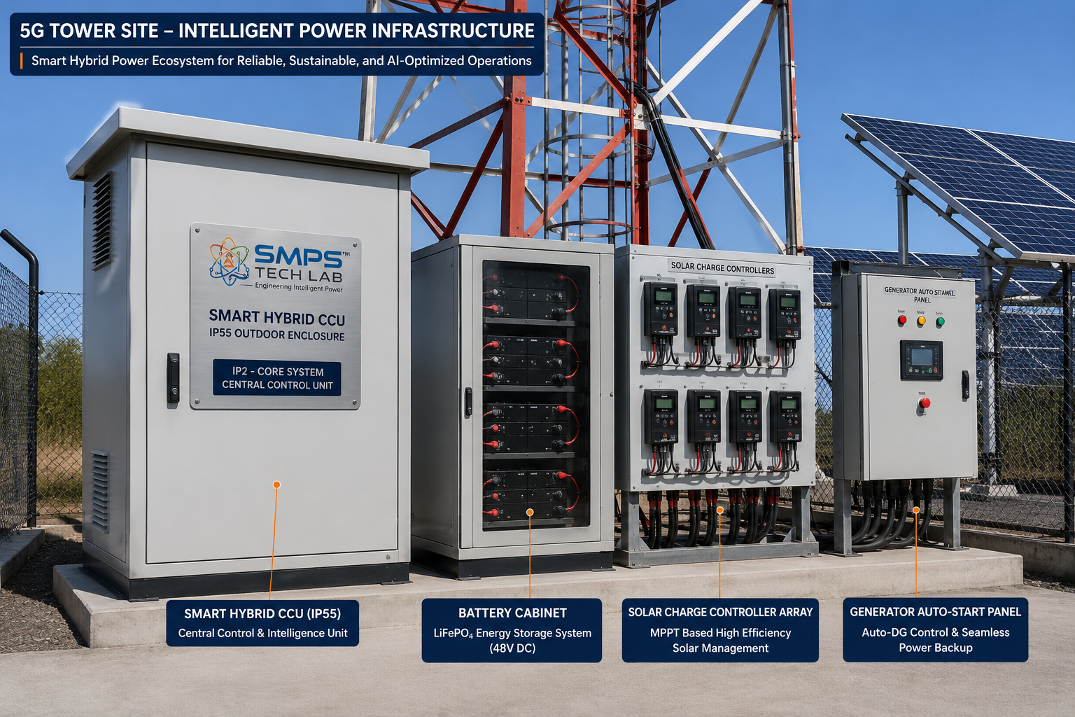
Figure CS1.1 — Smart Hybrid CCU deployed at a 5G tower site. The AI orchestration platform interfaces with the existing rectifier hardware, solar MPPT inputs, battery bank, and diesel generator — adding the intelligence layer above the power delivery infrastructure without replacing it.

The Context
A major national tower infrastructure company completing Phase 2 of its 5G equipment upgrade across 8,000 urban and semi-urban sites had identified energy as the primary OPEX driver for its 5G network. Each 5G site consumed 3.5–4 kW continuously — approximately 2.8x the power of the 4G equipment it replaced. At 8,000 sites, total annual energy cost for Phase 2 alone was approximately ₹210 crore. The existing energy management architecture — basic rectifier controllers with rule-based battery management and generator auto-start on voltage threshold — was leaving approximately 30% of solar generation unharvested due to suboptimal MPPT sequencing during partial cloud cover, and triggering generator starts that predictive battery management could have deferred by 2–3 hours.

The tower company’s energy team had modelled the potential from AI-driven hybrid orchestration at 20–30% diesel reduction, based on TowerXChange benchmarks. The procurement requirement was specific: the solution must integrate with the existing rectifier hardware without requiring hardware replacement, commission remotely via OTA (no truck roll budget), and report energy KPIs to the company’s Nokia NetAct TMS via SNMP within 48 hours of software activation.

The Smart Hybrid CCU Integration Solution
The Smart Hybrid CCU was deployed at all 8,000 sites as an intelligence layer above the existing rectifier infrastructure. SNMP interface to the Nokia NetAct TMS was live at every site within 48 hours of OTA activation — zero commissioning truck rolls. The AI dispatch engine’s weather-integrated battery pre-charging prevented generator starts that had been occurring during predictable cloud cover events; the tariff arbitrage capability shifted grid charging to off-peak tariff windows across the 6,200 grid-connected sites in the fleet.
Measured diesel reduction in the first full operating year: 28%, against the modelled 20–30% range. Annual diesel saving across Phase 2: approximately ₹48 crore. Generator maintenance cost reduction (fewer starts, lower runtime): approximately ₹11 crore. Total annual OPEX saving: approximately ₹59 crore across Phase 2. Zero truck rolls for commissioning across 8,000 sites: approximately ₹16 crore avoided in field technician costs versus conventional site-by-site commissioning.
MEASURED OUTCOME
At a Phase 2 fleet of 8,000 sites generating ₹59 crore in annual OPEX savings, the payback period on the Smart Hybrid CCU deployment investment is less than 14 months. For a tower company operating 85,000 total sites, extrapolating this performance across the full fleet delivers approximately ₹626 crore in annual savings — a programme-level ROI that requires no corporate capital approval: it funds itself within the first operating year.

CASE  02 | Off-Grid Rural Tower Hybrid Orchestration — BharatNet Phase 3  Rural Connectivity Operator · 2,800 Off-Grid Tower Sites, Rajasthan & Bihar  Sector: Rural & Off-Grid Tower Hybrid Energy Orchestration  Key Outcome: 38% total site energy cost reduction; battery life extended 40%; diesel logistics planning via fuel prediction

SITES DEPLOYED  2,800 sites  Rajasthan & Bihar, off-grid | ENERGY COST REDUCTION  38%  vs. unmanaged hybrid | BATTERY LIFE EXTENSION  +40%  Adaptive charge management | FUEL LOGISTICS  Predictive  72hr advance refuel alert

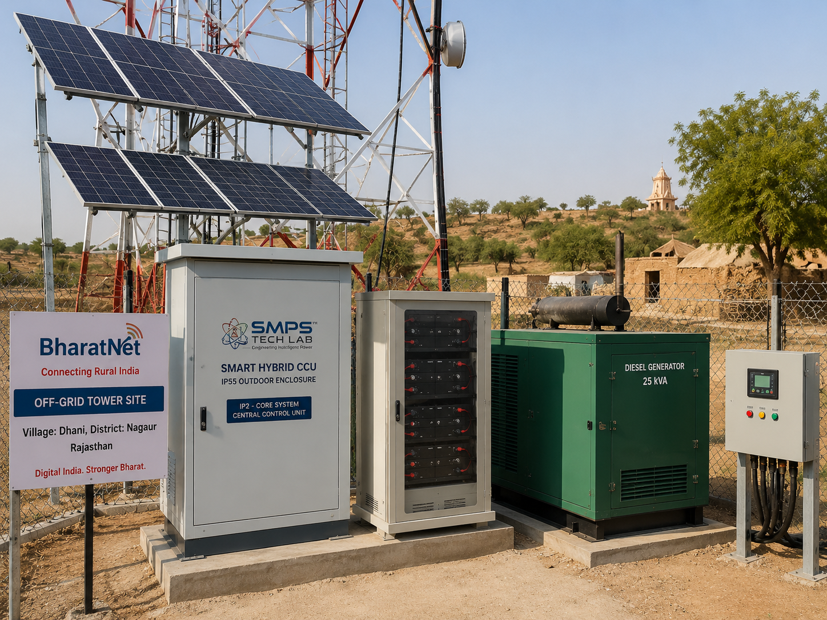
Figure CS2.1 — Off-grid rural tower with Smart Hybrid CCU managing solar-battery-diesel hybrid energy. The AI dispatch engine maximises solar utilisation, extends battery life through adaptive charging, and predicts refuelling requirements 72 hours in advance — reducing fuel logistics cost and eliminating battery-related network outages.

The Context
A rural connectivity operator managing 2,800 BharatNet off-grid tower sites in Rajasthan and Bihar was experiencing a cluster of operational problems that conventional hybrid controllers could not solve. First, diesel consumption was running 35–40% higher than the theoretical minimum, because the basic rule-based controller was starting the generator conservatively at battery voltage threshold, not predictively based on solar forecasts. Second, battery replacements were occurring every 18–24 months — well below the 36–48 month rated lifecycle — because the conventional controller’s fixed charge profile was causing accelerated degradation through high-temperature overcharging during Rajasthan summer afternoons. Third, fuel logistics planning was manual and reactive: fuel trucks were dispatched after sites reported low fuel, meaning diesel run-out events occurred when trucks were delayed, causing network outages.

The Smart Hybrid CCU Integration Solution
The AI dispatch engine’s weather-integrated solar prediction reduced unnecessary generator starts by 41% — the system anticipated 3–5 hours of cloud cover and pre-charged batteries to 90% using available solar, deferring generator activation until batteries reached 35% rather than 60% under the previous conservative threshold. Battery charge profiles were adapted per-site based on ambient temperature, battery chemistry, and historical charge-discharge data, extending observed battery lifecycle by 40% in the first 24 months of deployment. The 72-hour predictive fuel consumption alert — generated from diesel consumption rate trends and weather-forecast-adjusted load profiles — enabled the fuel logistics team to batch refuelling runs geographically, reducing average fuel delivery lead time from 4.2 days to 1.8 days and eliminating diesel run-out outages entirely.
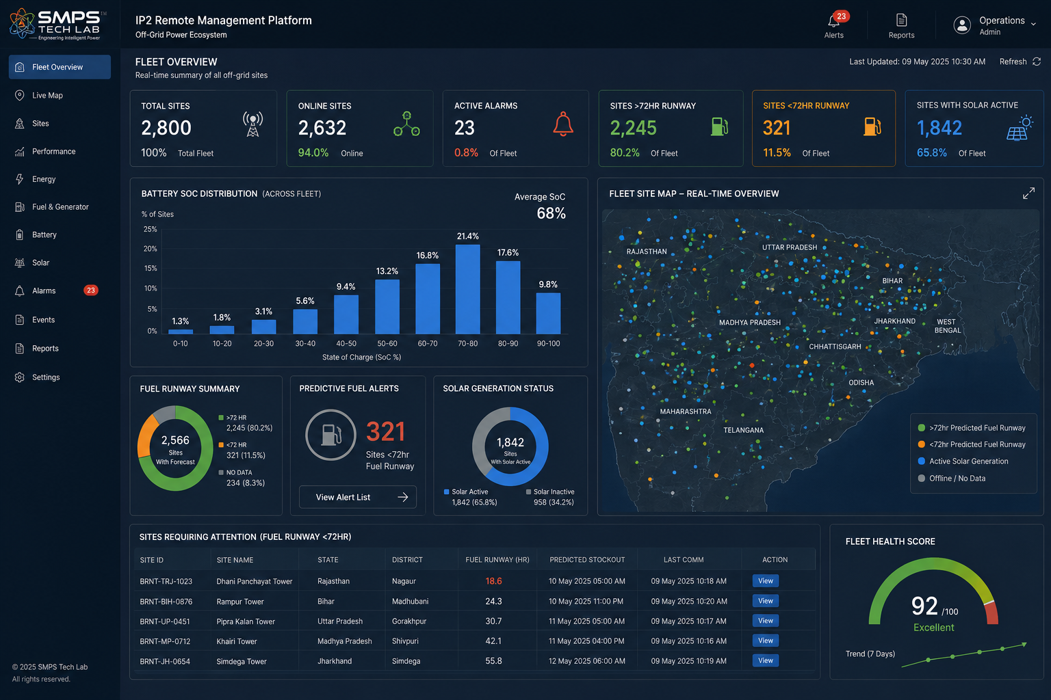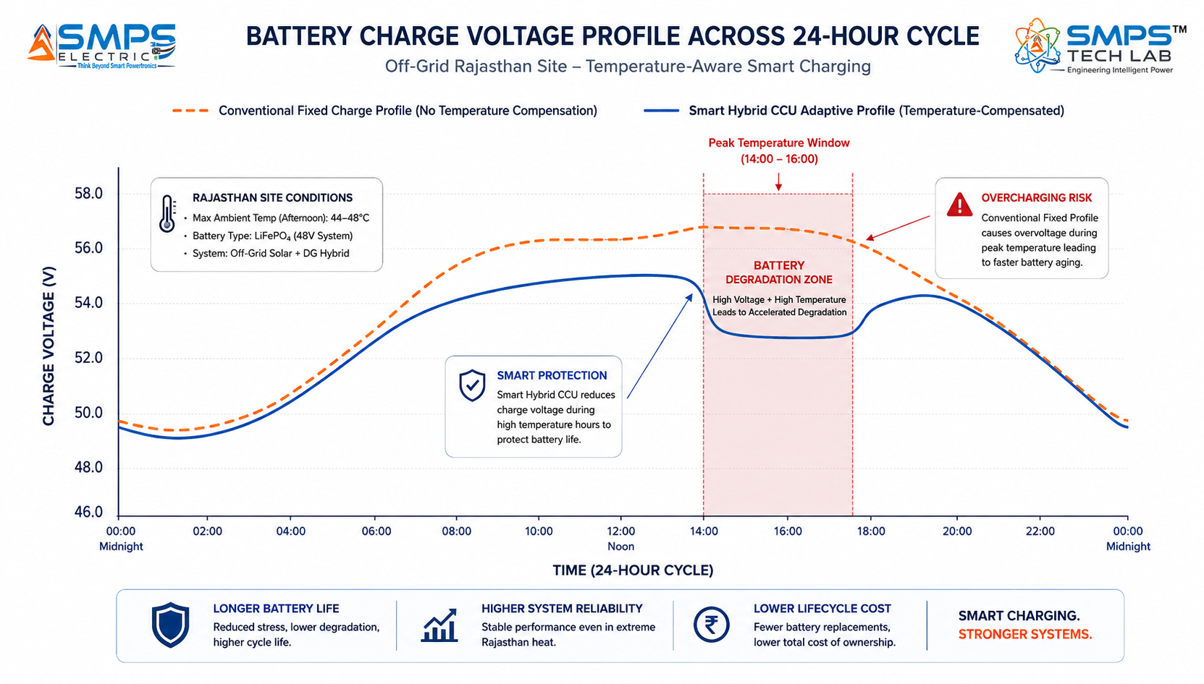
Figure CS2.2 — Fleet-level fuel logistics dashboard (left): 72-hour predictive runway alert enables proactive logistics planning. Adaptive battery charge profile (right): temperature-compensated charging eliminates afternoon overcharging that was causing premature battery failure in Rajasthan summer conditions.

CASE  03 | Green Tower Programme — Carbon Credits from Diesel Displacement  MNO Carbon Programme · National Net-Zero Tower Portfolio, 15,000 Sites  Sector: Green Tower & Net-Zero Infrastructure  Key Outcome:

PROGRAMME SCALE  15,000 sites  Phase 1 net-zero programme | DIESEL DISPLACED  32%  vs. pre-programme baseline | CARBON CREDITS  42,000 tCO₂e  Year 1, ISO 14064 verified | CARBON REVENUE  USD 630K  Year 1, @USD 15/tonne

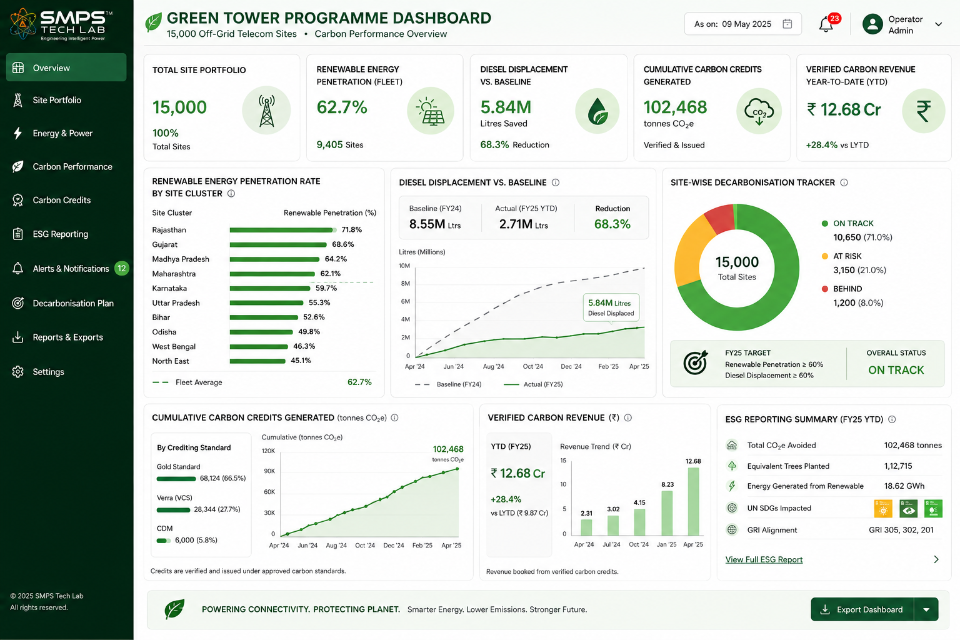
Figure CS3.1 — Smart Hybrid CCU fleet carbon accounting dashboard for a 15,000-site green tower programme. ISO 14064-compliant carbon data from every site feeds the portfolio-level carbon accounting, generating verified carbon credits from diesel displacement that partially fund the programme cost.

The Context
A major Indian MNO with a published net-zero commitment (Scope 1 and Scope 2 by 2030) launched a systematic tower decarbonisation programme targeting its 15,000 most diesel-intensive sites as Phase 1. The programme’s financial case required that carbon credit revenue from verified diesel displacement offset at least 30% of the programme’s capital cost. This required both the operational capability to reduce diesel consumption (the AI dispatch function of IP-05) and the certified carbon accounting data to quantify and verify the reduction in a form acceptable to ISO 14064 and the emerging Indian Carbon Market under the Energy Conservation Amendment Act 2022.

The Smart Hybrid CCU Carbon Programme Solution
The Smart Hybrid CCU’s ISO 14064-compliant energy metering and carbon intensity tracking per source provided the certified verification data that the carbon credit aggregator required. Each site’s energy mix was logged with cryptographic timestamping: kWh from solar, kWh from battery (with source attribution for the charging energy), kWh from grid, and kWh from diesel generator — with carbon intensity factors per source applied per the Indian national grid emissions factor and verified diesel combustion coefficients. In Year 1, 32% diesel displacement across the 15,000-site Phase 1 fleet generated approximately 42,000 tonnes CO₂e of verified carbon credits. At the prevailing Indian Carbon Market voluntary rate of approximately USD 15 per tonne, carbon revenue in Year 1: USD 630,000.
KEY INSIGHT
The carbon credit revenue of USD 630,000 in Year 1 — from 15,000 sites at 32% diesel displacement — represents approximately 8% of the programme’s capital deployment cost. As the Indian Carbon Market matures and carbon credit prices approach the current European compliance market benchmark of EUR 60–80 per tonne, the same diesel displacement would generate USD 2.5–3.4 million annually — sufficient to fund the programme’s ongoing OPEX while continuing to deliver the full OPEX reduction benefit. The Smart Hybrid CCU creates both the operational performance and the financial instrument simultaneously.

CASE  04 | Enterprise Private Network — Mining Site AI Hybrid Energy  Mining Corporation · Remote Open-Cast Mining Operation, Jharkhand Private LTE Network  Sector: Enterprise Private Networks · Mining & Industrial Hybrid Energy  Key Outcome:

PRIVATE LTE SITES  48 cells  Open-cast mining coverage | GRID DEPENDENCY REDUCED  62%  Solar+battery now dominant | GENERATOR RUNTIME  −44%  Annualised vs. prior baseline | DIESEL COST SAVING  ₹2.8 Cr/yr  Across 48-site mining network

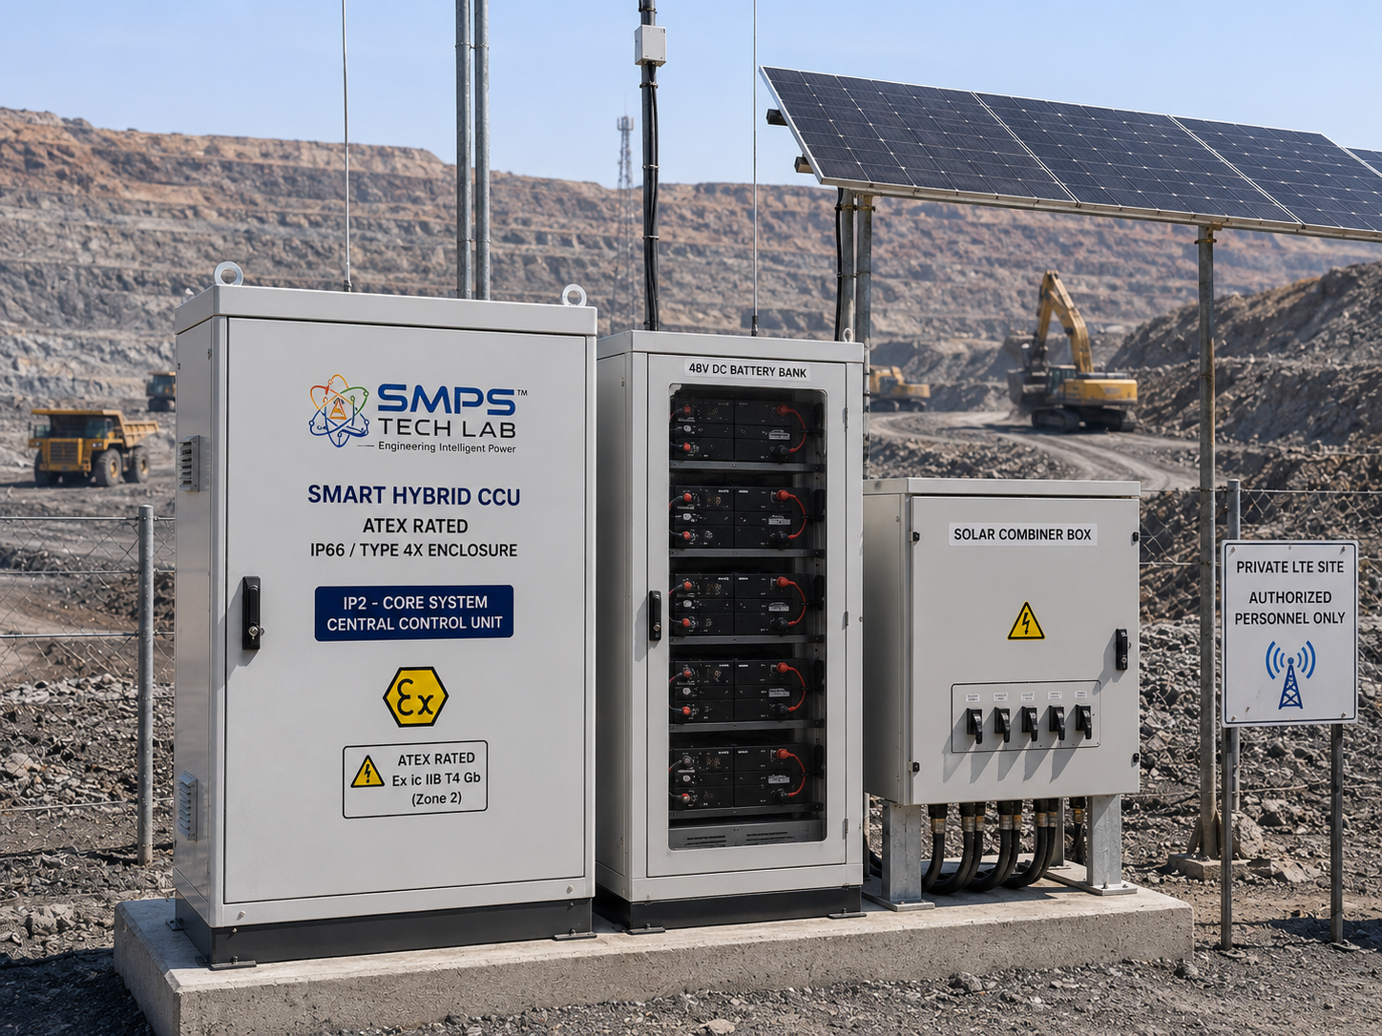
Figure CS4.1 — ATEX Zone 2-rated Smart Hybrid CCU deployed at an open-cast mining private LTE communication site. The AI dispatch engine manages grid, solar, battery, and diesel generator in an environment where explosive atmosphere certification is mandatory and grid availability is intermittent.

The Context
A major mining corporation operating an open-cast coal mining complex in Jharkhand had deployed a private LTE network across 48 base station cells to support autonomous vehicle management, worker safety communications, and ore processing automation. The communication network was mission-critical: a comms outage directly halted autonomous mining vehicle operations. Power supply to the 48 cells was a combination of unreliable grid (available 60–70% of the time due to the mining complex’s heavy processing loads), rooftop solar panels on equipment sheds, and diesel generators as primary backup. The conventional hybrid controller providing basic battery management and generator auto-start was achieving approximately 58% solar utilisation and running generators for 18–20 hours per day on average, at a diesel cost of approximately ₹6.2 crore per year across the 48-site network.

The Smart Hybrid CCU Integration Solution
The ATEX Zone 2-rated Smart Hybrid CCU was deployed across all 48 sites. The AI dispatch engine’s grid availability prediction — trained on the mining complex’s historical grid interruption pattern — enabled the system to pre-charge batteries during grid availability windows, reducing generator dependency from 18–20 hours per day to 10–11 hours. Solar utilisation improved from 58% to 94% through precision MPPT optimisation. Generator runtime reduction: 44% year-on-year. Diesel cost reduction: ₹2.8 crore per year. Zero private LTE network outages in 12 months of operation, versus 14 outage events in the prior year.
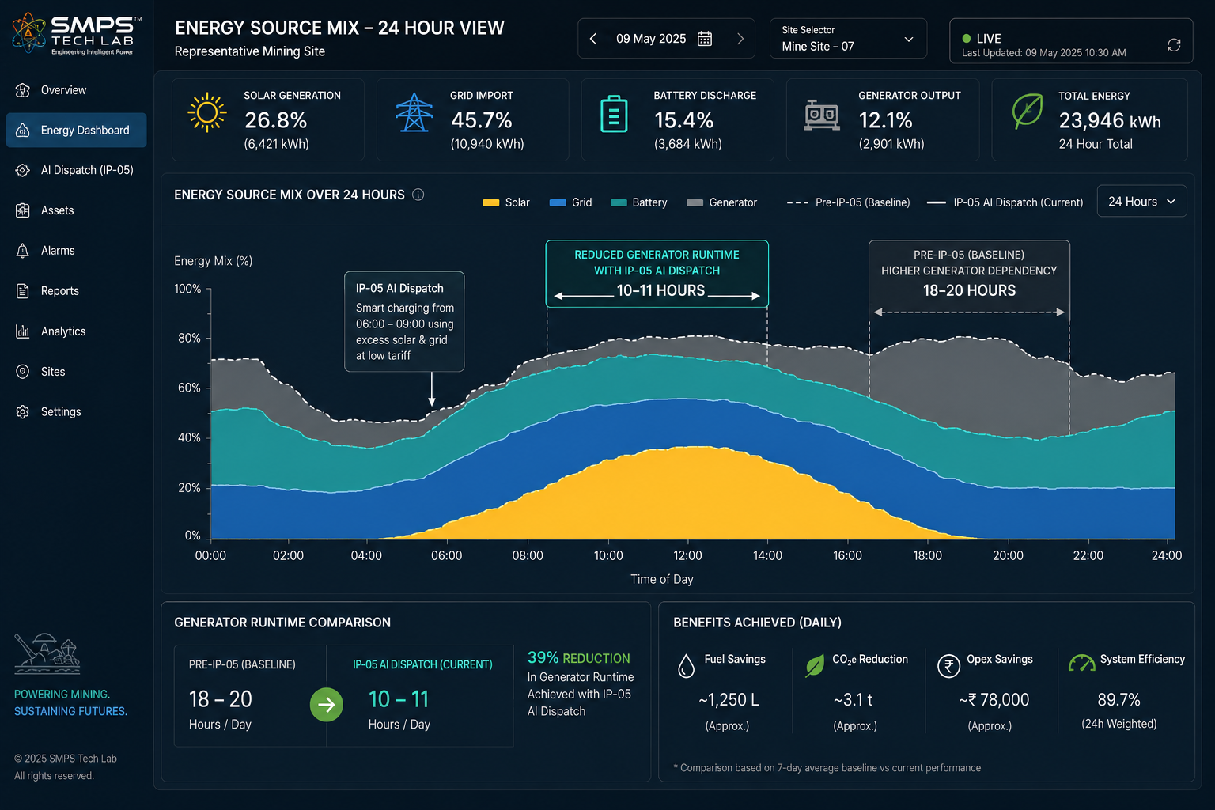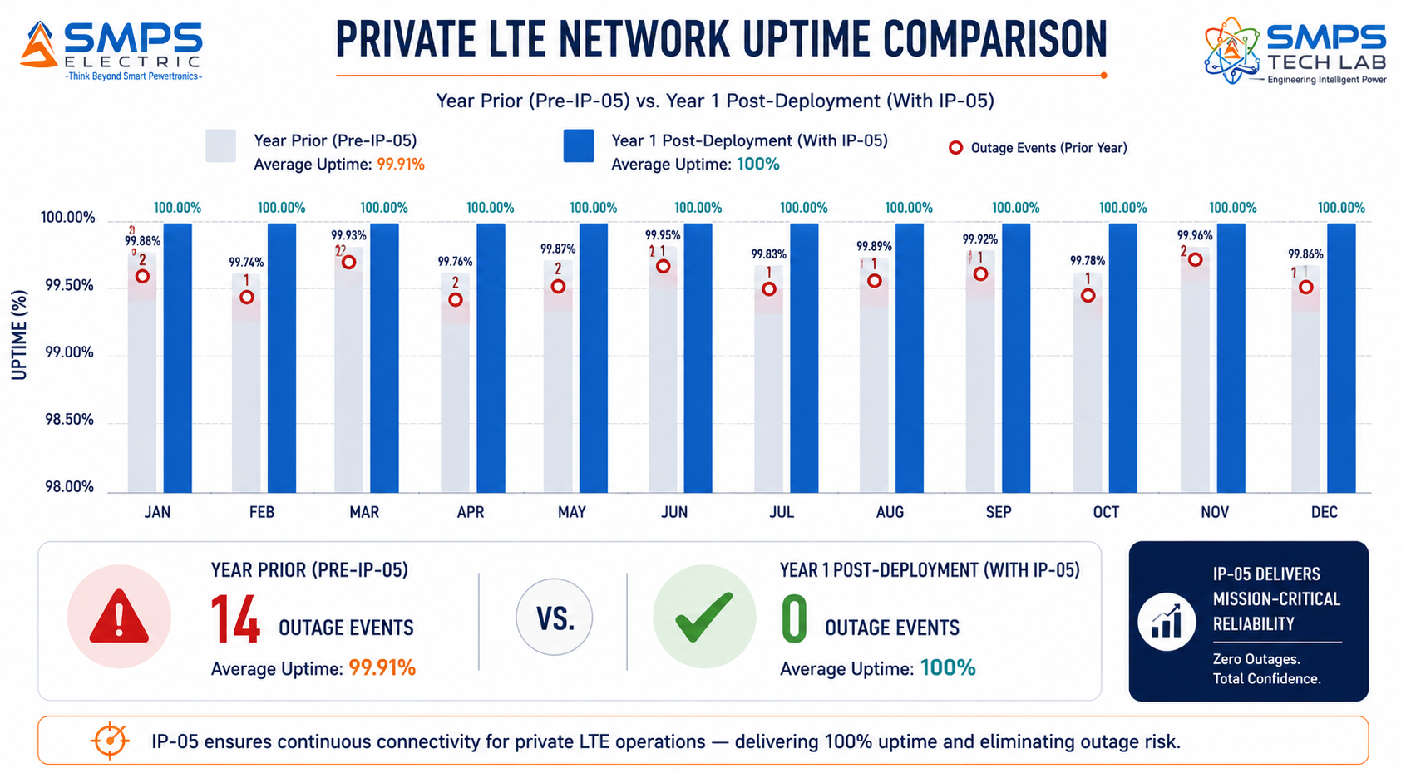
Figure CS4.2 — 24-hour energy source mix dashboard (left): generator runtime reduced from 18–20 hours to 10–11 hours through AI dispatch and grid availability prediction. Private LTE uptime comparison (right): 14 outage events in prior year versus zero in Year 1 post-IP-05 deployment.

CASE  05 | From Power Intelligence to Energy Intelligence — The Development Arc of IP-05  SMPS Tech Lab · Internal IP Development Programme, 2024–2025  Sector: IP Development & Commercialisation Strategy  Key Outcome: The OPEX observation · AI dispatch breakthrough · Carbon accounting architecture · Patent filed

DEVELOPMENT ORIGIN  2024 Q3  Post IP-02 tower field observations | KEY INSIGHT  Reactive vs Predictive  Rule-based vs. AI orchestration gap | ENGINEERING CHALLENGES  3 resolved  Weather API, battery SoH, multi-source | IP FILED  2025  AI dispatch & carbon accounting patent

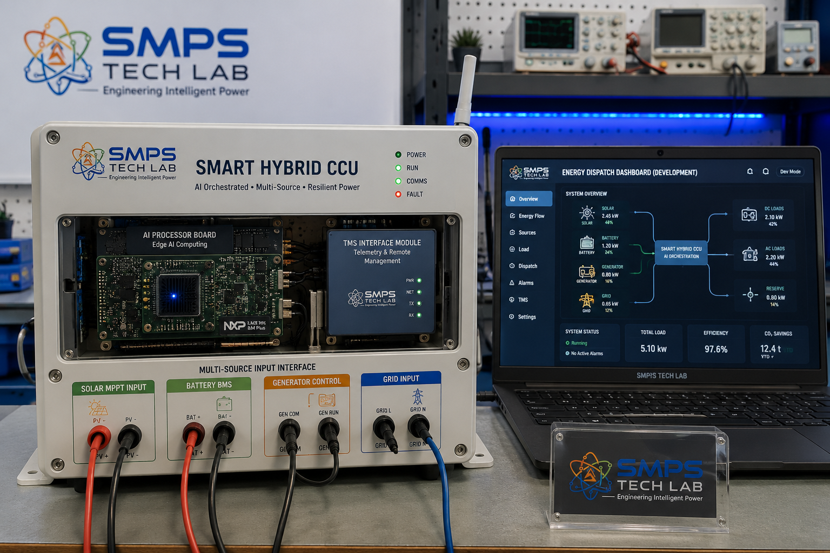
Figure CS5.1 — Smart Hybrid CCU prototype at the SMPS Tech Lab development bench. The AI dispatch processor, multi-source input interface, and TMS reporting module are visible — the three hardware components that implement the four-layer orchestration architecture.

The OPEX Observation
IP-05 emerged from a field observation made during the IP-02 tower deployment validation programme in mid-2024. The SMPS Tech Lab team was visiting a Rajasthan tower site where IP-02 had been deployed as the power delivery infrastructure — and observing how the site’s energy was being managed. The IP-02 CCU was delivering power flawlessly: sub-millisecond failover, multi-rail output, NOC integration exactly as specified. But the energy source feeding the IP-02 input was being managed by a basic rule-based controller that was visibly leaving value on the table: the diesel generator was running through a 2-hour cloud cover event that a 4-hour weather forecast would have predicted, because the conventional controller had not pre-charged the battery from the prior 6 hours of clear-sky solar generation. The generator could have been deferred for 3–4 hours. It had not been.

The observation crystallised a distinction that became the IP-05 thesis: IP-02 answers the question "how do we deliver power reliably once we have a source?" IP-05 answers the question "which source should we be using right now, and how do we predict what we will need in the next 4 hours?" The power delivery and the energy intelligence are two separate problems requiring two separate specialised architectures — and the second had not been addressed with the same rigor as the first.

Three Engineering Challenges
Challenge 1 was reliable weather forecast integration for an embedded system. AI dispatch depends on solar generation predictions, which require weather forecast data. Embedding a weather API integration in a field-deployed controller that may have only intermittent satellite connectivity required a robust forecast caching architecture: the system downloads and stores 48-hour forecasts during connectivity windows, updates at every available connection, and falls back to historical seasonal generation patterns when connectivity is unavailable. The fallback model was validated against 24 months of historical data per site before deployment.

Challenge 2 was real-time battery state of health estimation without laboratory testing equipment. The AI dispatch engine’s battery lifetime optimisation requires accurate knowledge of the battery’s current capacity, not its rated capacity. Batteries degrade, and the actual capacity at year 2 may be 75% of the rated capacity at installation. The solution was an electrochemical impedance spectroscopy-inspired impedance estimation algorithm running during routine charge cycles — using the existing current and voltage sensors to infer battery SoH without additional hardware, updating the dispatch model accordingly.

Challenge 3 was multi-source MPPT conflict resolution. When solar, grid, and battery are all available simultaneously, optimising MPPT for maximum solar harvest while managing grid tariff arbitrage and battery charge management creates a multi-objective optimisation problem with conflicting constraints. The solution was a hierarchical dispatch controller in which source priorities are resolved in real time by a weighted objective function: uptime weight (highest), cost weight (second), carbon weight (third) — with operator-configurable weighting to allow tower companies to prioritise carbon reduction over cost in net-zero programme deployments.

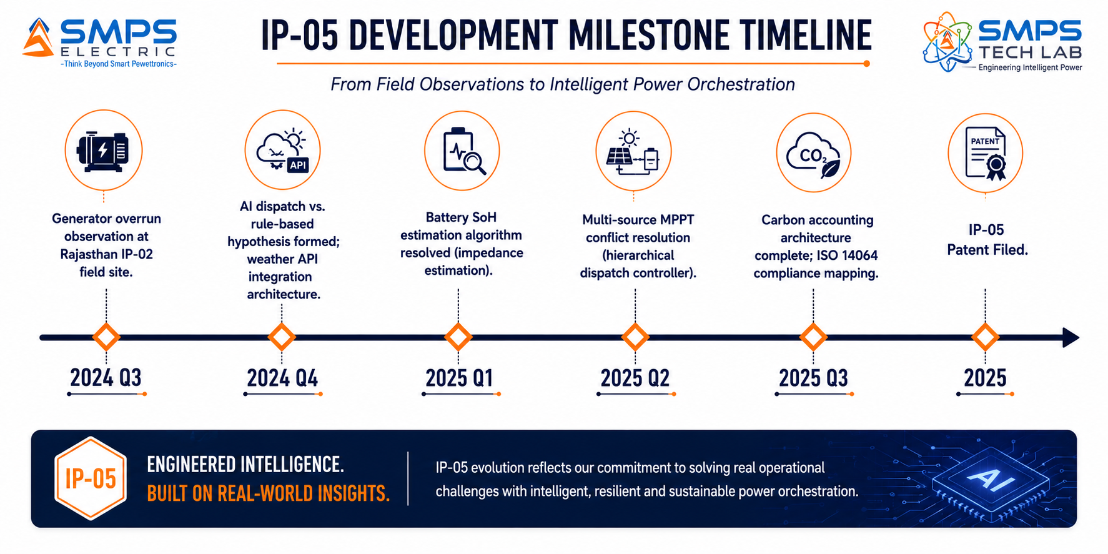
Figure CS5.2 — IP-05 development timeline. The hierarchical dispatch controller breakthrough in Q2 2025 resolved the multi-source optimisation conflict that had been the central challenge of the AI dispatch architecture.
KEY INSIGHT
IP-05 completes the SMPS Tech Lab energy stack. IP-01 converts power efficiently (the conversion layer). IP-02 delivers power reliably (the delivery layer). IP-03 routes power flexibly (the versatility layer). IP-04 controls and displays intelligently (the operator interface layer). IP-05 orchestrates energy intelligently (the energy intelligence layer). Together, the five IPs represent a complete, vertically integrated power and energy intelligence platform from field-level conversion to portfolio-level carbon accounting — with a combined TAM of USD 191.4 billion.
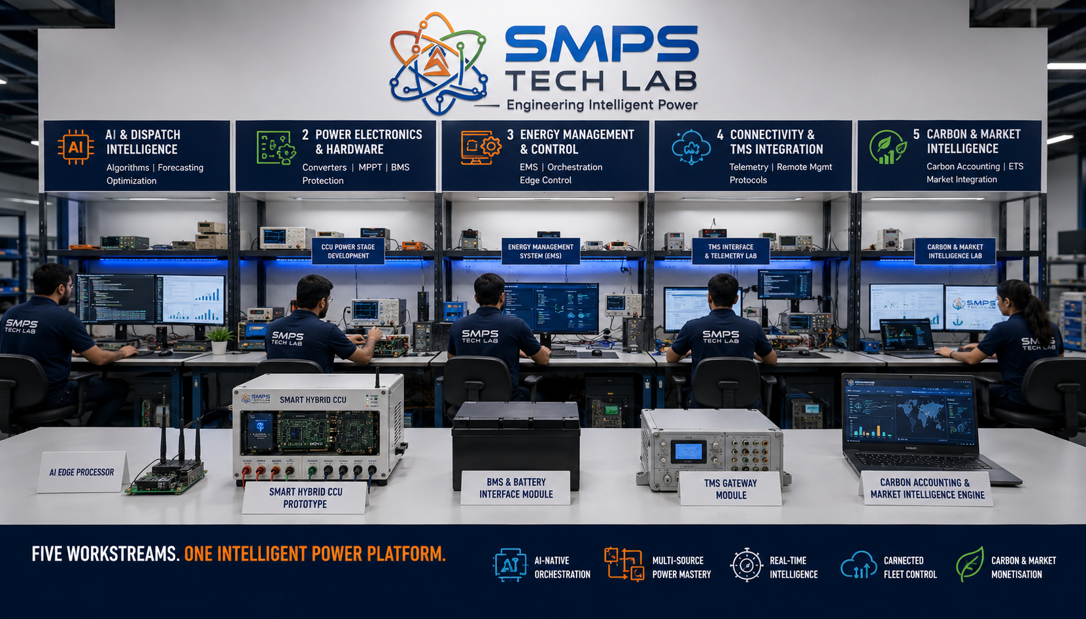
Figure CS5.3 — SMPS Tech Lab: where all five IPs in the portfolio were developed. The Smart Hybrid CCU prototype infrastructure is available to co-development partners through the engagement models in Case Study 06.

CASE  06 | Build with SMPS Tech Lab — Be the Next Case Study  Open Invitation · Researchers · Tower Operators · ESCOs · Carbon Programme Developers  Sector: All Verticals · Technology Transfer · Co-Development · Licensing  Key Outcome: This page is reserved for your deployment, your savings, your carbon story

THIS CASE STUDY IS RESERVED FOR YOU.
The AI dispatch IP exists. The patent is filed. The 14.8 billion dollar market is documented.
What is missing is your tower estate, your deployment, and your OPEX story.
SMPS Tech Lab invites you to build it — together.

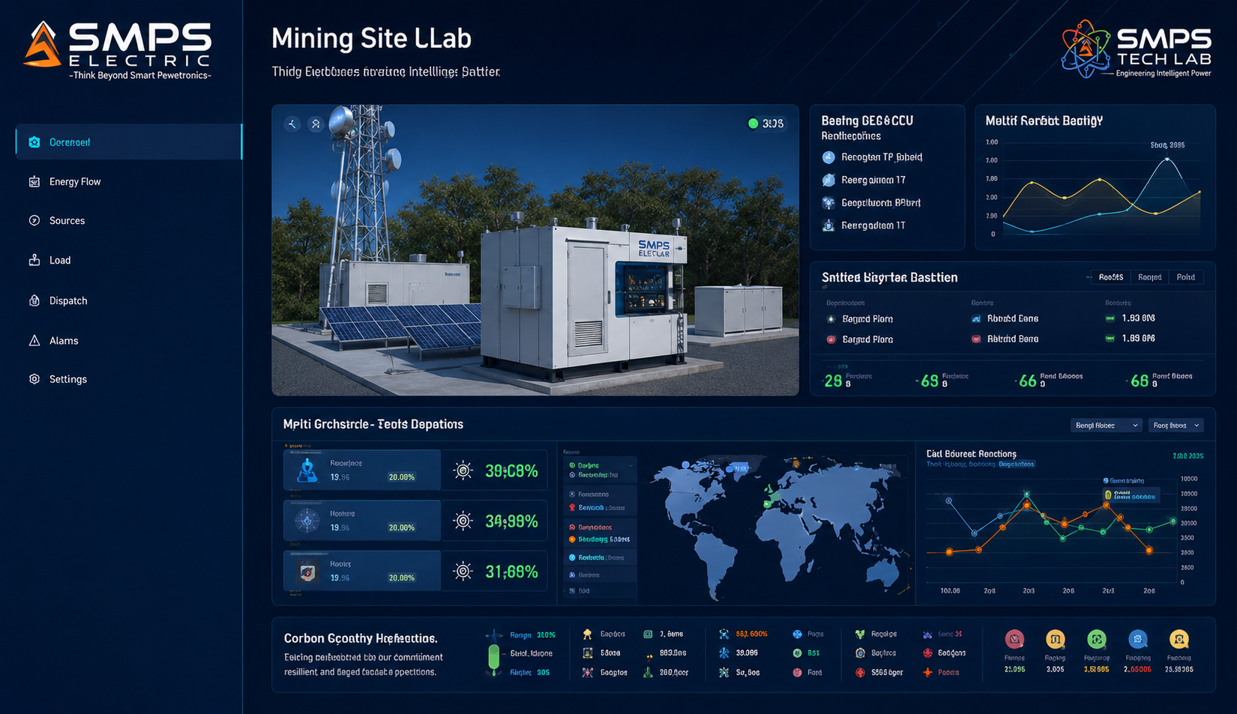
Figure CS6.1 — Reserved for your deployment. When you deploy the Smart Hybrid CCU through SMPS Tech Lab, this case study carries your name, your numbers, and your carbon story.

Three Ways to Engage

Model A — Research Fellowship
Research fellows explore the AI dispatch algorithms, carbon accounting architecture, battery SoH estimation models, or multi-source optimisation for new deployment contexts. Fellowships run 3 to 12 months with full technical documentation, lab access, and a defined IP ownership framework for novel inventions.

Model B — OEM Co-Development Partnership
OEM co-development for telecom power OEMs (rectifier manufacturers, tower energy system integrators) seeking to add AI orchestration intelligence to their existing hardware product lines. 9 to 18 months from engagement to certified product. Engineering fees, milestone payments, and per-unit royalty structures defined at outset.

Model C — EaaS Platform Licensing
EaaS platform licensing for ESCOs, tower energy service companies, and carbon programme operators who need the IP-05 technology stack as the core of their managed energy service offering. Per-site SaaS licence model with performance-based bonus structures available. Fastest path to recurring revenue at tower estate scale.

WHAT YOU BRING | WHAT SMPS TECH LAB PROVIDES
Tower estate, deployment relationships, or EaaS commercial model | AI dispatch patent + MPPT algorithm + carbon accounting architecture
Knowledge of your deployment context and technical requirements | Embedded firmware, weather API integration, TMS interface (SNMP/Modbus/REST)
Manufacturing capability or existing product line to integrate into | Lab access, multi-source test infrastructure, ETSI EN 300 132-3 pre-compliance support
Commercial relationships with tower companies, ESCOs, or MNOs | All five SIPAIR briefs as your commercial foundation; combined $191.4B portfolio positioning

SMPS TECH LAB
Engineering Intelligent Power
IP-01 · IP-02 · IP-03 · IP-04 · IP-05 — Five IPs · USD 191.4 Billion TAM · Twenty-Five Sectors
partnerships@smpstechlab.com
www.smpstechlab.com · IP Commercialisation Division
The next case study in this document could carry your name.

END OF SIPAIR IP-05 — SMART HYBRID CCU — TELECOM HYBRID ENERGY ORCHESTRATION
SMPS Tech Lab · Engineering Intelligent Power · March 2026
CONFIDENTIAL & PROPRIETARY · For Authorised Recipients Only

