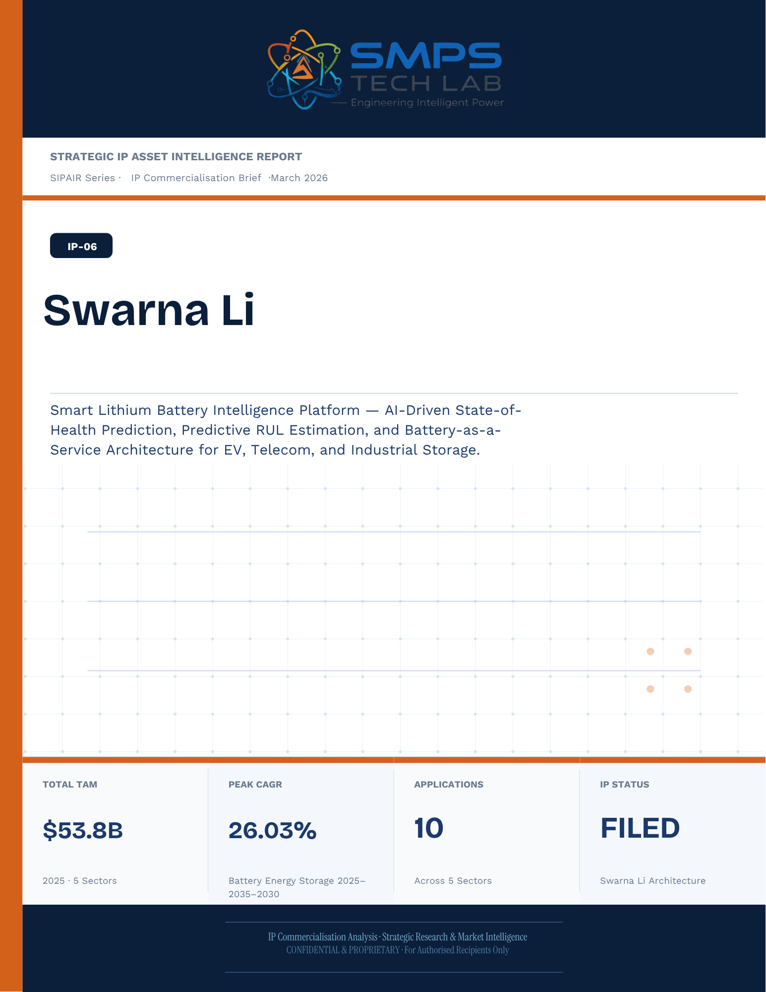
Abstract

STRATEGIC IP ASSET INTELLIGENCE REPORT
SIPAIR Series
IP-06: Swarna Li
SMPS-Based Integrated Swarna Li for Uninterrupted Telecom Power

Report Title | SIPAIR IP-06 — Swarna Li Commercialisation Brief

Document Series | Strategic IP Asset Intelligence Report (SIPAIR)

Version | Version 1.0 — First Edition

Compiled & Edited by | Shri Amareshwar Karatagi

Organisation | SMPS Tech Lab — Engineering Intelligent Power

Date of Issue | March 2026

Classification | Confidential & Proprietary — For Authorised Recipients Only

IP Reference | IP-06 — Swarna Li Architecture, Filed 2025

Related Document | SIPAIR IP-01: Smart Hybrid SMPS (see companion brief)

This document is prepared by SMPS Tech Lab as part of the SIPAIR IP Commercialisation Series.

Declaration — Originality & Intellectual Property Statement

This Strategic IP Asset Intelligence Report (SIPAIR — IP-06: Swarna Li) is an original compilation prepared by SMPS Tech Lab. The analysis, market intelligence frameworks, commercial strategy formulations, and case study narratives contained herein are the result of independent research and original intellectual work by the authors and editors named in this document.

The core technology described in this report — the SMPS-Based Integrated Swarna Li architecture, including its active power management layer, CCU intelligence stack, uninterrupted multi-rail AC/DC delivery system, and NMS integration platform — is the exclusive proprietary invention of SMPS Tech Lab, protected under a filed novel design patent (2025). IP-06 is a distinct and independently protectable invention from IP-01 (Smart Hybrid SMPS), though both emerge from the same SMPS Tech Lab research programme. The two IPs are designed to complement each other across adjacent application verticals and may be jointly licensed or co-deployed where application requirements demand both hybrid topology and active power management intelligence.

Market sizing data, CAGR estimates, and industry statistics cited in this document are sourced from independent third-party research publications, fully attributed in Appendix A. All third-party data is used for analytical and benchmarking purposes only. This report has not been submitted, in whole or in part, to any other organisation for commercialisation or formal assessment except as specifically disclosed in writing.

Declared by:

Shri Amareshwar Karatagi Founder & CSO SMPS Tech Lab · March 2026

CERTIFICATE OF AUTHENTICITY
IP Commercialisation Documentation · SIPAIR IP-06

This is to certify that the Strategic IP Asset Intelligence Report
SIPAIR IP-06 — Swarna Li
has been compiled, reviewed, and authenticated by the undersigned in accordance
with the standards of the SIPAIR documentation series. The technology, market analysis,
and commercial intelligence herein are verified as accurate to the best of the signatories’
knowledge as at the date of issue: March 2026.

Program Head / Director | Technical Mentor
  Program Head / Research Director
  SMPS Tech Lab
  Technical Mentor / Advisor
  SMPS Tech Lab

SMPS Tech Lab · Engineering Intelligent Power · March 2026

Acknowledgment

The preparation of this Strategic IP Asset Intelligence Report for IP-06 has drawn on the technical expertise, operational insights, and research foundation developed across two parallel innovation tracks at SMPS Tech Lab. The development of the CCU intelligence layer — the defining innovation of IP-06 — required not only power electronics engineering depth but sustained engagement with telecom network operations, tower management practice, and satellite ground station engineering environments that are highly specialised. The author and editor express sincere gratitude to those whose knowledge and access made this work possible.

Technical Development
The CCU architecture at the heart of IP-06 evolved alongside IP-01's hybrid topology work, but along a distinct engineering trajectory focused on power orchestration intelligence rather than conversion efficiency alone. The engineers and technologists who contributed to the CCU control logic, NMS integration stack, and sub-millisecond failover switching mechanism deserve specific recognition for the rigour with which they approached the uninterrupted power mandate — a design objective that admits no approximation.

Telecom Industry Access
The sector intelligence in this report reflects direct engagement with tower operations, data centre facility management, and satellite ground station engineering communities. The operational data from 5G tower rollout programmes, off-grid hybrid power deployments, and maritime communication installations that informed the case study narratives and application requirement specifications in this document is the product of those field engagements.

Research Publications
The market intelligence framework draws on publications from Future Market Insights, MarketsandMarkets, SNS Insider, Grand View Research, IMARC Group, Coherent Market Insights, Global Growth Insights, and the Ericsson Mobility Report, as well as operational data from the International Energy Agency. The quality of those independent research publications is what allows the TAM framework in this report to be grounded in named, verifiable data rather than estimated aggregates.
Shri Amareshwar Karatagi
Founder & CSO
SMPS Tech Lab · March 2026

Preface — From the Founder & Editor

From IP-01 to IP-06 — The Logical Extension
IP-01, documented in the companion SIPAIR brief, solved one problem with exceptional elegance: replacing the unnecessary architectural duplication of separate AC and DC converter units with a single hybrid topology. The commercial case was compelling and the market evidence was clear. But the engineers at SMPS Tech Lab, in the same process of field observation that gave rise to IP-01, had identified a second problem — one that operated at a higher level of the power system stack and was, if anything, more commercially urgent in the specific context of telecom infrastructure.

The problem was not conversion efficiency. It was availability. In a 5G base station, a satellite ground hub, an offshore platform communication centre, or a smart city public safety network node, the standard power supply architecture not only requires separate AC and DC converters — it delegates all intelligence about the power state of the system to a separate controller that may be physically remote, software-dependent on a third-party network management system, and incapable of autonomous protective action in the sub-millisecond timeframe that modern telecom uptime SLAs demand. When the grid fails, when a battery starts to degrade, when an input source switches — the system needs to respond faster than any software polling cycle can achieve. It needs embedded intelligence, right at the power conversion stage.

IP-06 is that intelligence. The Integrated Swarna Li, combined with the SMPS core, does not just convert power — it orchestrates it. It monitors every parameter of the power delivery chain continuously, switches between sources in under a millisecond, predicts faults before they become outages, and reports power system health to the operator's NMS in real time, without external monitoring hardware. It is the difference between a power supply and a power management system.

Why Telecom, and Why Now
The selection of telecom infrastructure as the primary application vertical for IP-06 reflects a disciplined commercial judgement. Telecom infrastructure is the single sector in the IP-06 TAM where the uninterrupted power mandate is non-negotiable, contractually enforced at 99.999% uptime, and backed by capital investment programmes of unprecedented scale: 2.3 billion 5G subscriptions by end of 2024 with another 4 billion to come by 2030; 3,000 Amazon Project Kuiper satellites deployed in April 2025 with thousands of ground hubs to follow; the IMO GMDSS modernisation mandate forcing a complete vessel communication power infrastructure upgrade by 2026. Every one of these programmes creates a specific, identified, and time-bounded procurement requirement for exactly what IP-06 delivers.

The second reason is the grid reliability crisis that is, counterintuitively, the most powerful demand driver the CCU's hybrid input management addresses. South Africa recorded 1,130 hours of planned power cuts in a single year. India's tower estate — 750,000 sites — routinely operates on hybrid grid, diesel, and battery sources with real-time CCU-managed source switching that determines whether the tower stays on during a grid event. This is not a niche requirement. It is the operational reality for hundreds of thousands of tower sites across three continents, and the market is actively seeking a solution that the current generation of separate rectifiers and external controllers cannot provide.

How This Document is Structured
This SIPAIR brief follows the same 14-section architecture as the IP-01 companion document, making the two documents a coherent and mutually reinforcing portfolio. Readers who have engaged with SIPAIR IP-01 will recognise the structure immediately. The technology differentiation section includes an explicit comparison between IP-01 and IP-06, clarifying the architectural relationship and the distinct value proposition of each. The case studies are drawn from the five specific sectors of IP-06's TAM framework — 5G tower, data centre, satellite ground, smart city, and maritime/offshore — with technical and financial parameters grounded in the operational realities of each sector.

Shri Amareshwar Karatagi
Founder & CSO
SMPS Tech Lab · March 2026

TABLE OF CONTENTS

Declaration — Originality & Intellectual Property Statement 4
Acknowledgment 7
Technical Development 7
Telecom Industry Access 7
Research Publications 7
Preface — From the Founder & Editor 9
From IP-01 to IP-06 — The Logical Extension 9
Why Telecom, and Why Now 9
How This Document is Structured 10
Important Notice & Confidentiality Disclaimer 16
1.1 The Strategic Context 17
1.2 The Problem Swarna Li Solves 17
1.3 Key Metrics at a Glance 18
1.4 Why Swarna Li, Why Now 19
2.1 What is Swarna Li? 21
2.2 The Four Integrated Technology Layers 21
2.3 AI Diagnostics Engine — The Commercial Intelligence Layer 23
2.4 Second-Life Assessment & BaaS Platform 24
2.5 Standards Compliance Architecture 25
3.1 The Battery Intelligence Transition 26
3.2 The Four Structural Megatrends 26
3.3 Global Market Sizing — Primary Reference Data 27
CAGR Comparison — Swarna Li Target Market Segments 27
4.1 Methodology 29
4.2 Consolidated TAM Summary 30
5.1 India as First Market 32
5.2 India Market Sizing — Swarna Li Relevant Segments 33
6.1 India & Global Policy with Direct Swarna Li Alignment 34
7.1 The Plugin Architecture — Five Energy Storage Contexts 36
7.2 Plugin Integration Matrix 37
8.1 Commercialisation Philosophy 38
8.2 Market Priority Matrix 38
9.1 Competitive Architecture Overview 40
10.1 The Investment Case 42
10.2 Illustrative Revenue Scenarios 42
11.1 Technology Generation Roadmap 44
11.2 Adjacent Application Opportunities 45
12.1 Risk Framework 47
Appendix A — Data Sources 49
Appendix B — Standards Reference 50
Appendix C — Glossary 51
The Context 54
The Swarna Li Integration Solution 54
The Context 56
The Swarna Li Integration Solution 57
The Context 58
The Swarna Li Integration Solution 59
The Context 60
The Swarna Li Integration Solution 61
The Battery Observation 62
Three Engineering Challenges 63
Three Ways to Engage 66
Model A — Research Fellowship 66
Model B — OEM Co-Development Partnership 67
Model C — BaaS Platform Licensing 67

0F | FOUNDER & EDITOR  IP-06 SIPAIR Series · SMPS Tech Lab


Shri Amareshwar Karatagi
Founder & Chief Strategic Officer
SMPS TechLab
Special Correspondent, Government of Karnataka |
Serial Entrepreneur

Vision Statement
We aim to build a generation of innovators and entrepreneurs who create transformative technologies, develop intellectual property, and drive India’s technological leadership on both national and global platforms. Over the years, we have worked extensively within the startup ecosystem, contributing to and mentoring multiple initiatives focused on building, scaling, and strengthening businesses. Through this journey, we have developed a deep understanding of business strategy, governance frameworks, and deep-technology development, along with the practical challenges of scaling innovation in real-world markets.
As a Special Correspondent with the Government of Karnataka and a serial entrepreneur, my focus has been on shaping individuals into creators, builders, and leaders of technology and enterprise. Our work emphasizes ownership, innovation, and execution discipline to nurture individuals capable of building scalable, high-impact solutions with both national and global relevance.
Through SMPS Tech Lab, we drive this vision by integrating deep Research & Development (R&D) with entrepreneurial strategy, fostering a culture where ideas evolve into intellectual property, innovation, and industry-aligned solutions that contribute to India’s technological advancement and global competitiveness. The Industry Fitness DeepTech Internship Program is a reflection of this mission—designed to develop individuals who are innovation-driven, execution-focused, and capable of contributing meaningfully to technology, entrepreneurship, and nation-building at scale.

“My vision is to build a generation that doesn’t wait for opportunities, but creates them through innovation and entrepreneurship.”
— Shri Amareshwar Karatagi

A. R. Shalini
Chief Business Development Officer (CBDO) & Program Officer
SMPS TechLab | SMPS Electric Control Pvt. Ltd.

Area of Expertise:
Business Strategy, Operations Management, Industry–Academia Integration, Entrepreneurship Development
Profile:
I play a pivotal role in driving program execution, operational excellence, and professional development within SMPS Tech Lab. With a strong foundation in both business strategy and technology alignment, I am committed to shaping individuals into industry-ready professionals with the right mindset, discipline, and execution capabilities.
My approach focuses on building skills with clarity of thought, accountability, and a results-driven attitude. Through structured guidance and continuous mentorship, I enable participants to understand the intersection of technology, business, and real-world application.
I actively work toward bridging the gap between academia and industry, ensuring that learning is aligned with practical expectations and evolving market demands. My dedication to creating a seamless and high-impact learning environment fosters confidence, innovation, and professional growth among participants.
Through my leadership, the program consistently emphasizes structured execution, strategic thinking, and the development of individuals who are prepared to contribute meaningfully to both industry and innovation ecosystems.
“Professional excellence is built when knowledge, mindset, and execution come together with consistency.”
— A. R. Shalini

Dr. S. Khatua
Chief Technology Officer (CTO)
SMPS TechLab | SMPS Electric Control Pvt. Ltd.
IITian | PhD – IIT Dhanbad

Area of Expertise:
Power Electronics, Microgrid & Smart Grid Systems, Nuclear Power Systems, DeepTech R&D, Industrial System Design.
I am a distinguished technology leader driving advanced Research & Development and deep-tech innovation. An IITian with a PhD in Microgrid and Smart Grid Systems for nuclear power applications, I bring over 15 years of experience across power electronics, nuclear reactor control systems, and defence and telecom technologies.
With significant contributions to high-impact and mission-critical projects of national importance, my work reflects a rare combination of research depth, engineering precision, and industrial execution.
I am a strong advocate of deep-tech innovation and intellectual property (IP) creation, and I emphasize the development of indigenous technologies that strengthen the nation’s technological capability and global standing.
Through my mentorship, I inspire the next generation to pursue technical mastery, disciplined execution, and innovation with national intent, shaping professionals capable of contributing to the future of deep technology.
“Precision in engineering, depth in research, and ownership of technology are the pillars of true national progress.”
— Dr. S. Khatua



Mr. Rushit Jani
Techno-Commercial Architect
Strategic Editorial & Commercialisation Review | OptCell GLOBAL

Fields of Interest:
AI & Intelligent Systems, Industrial IoT, Product Architecture, Deep-Tech Commercialisation, Enterprise System Design, and Scalable Engineering Solutions.
Focused on building technology-driven systems that bridge engineering innovation with practical industry adoption and long-term commercial value.

Message from the Editor:
Technology, in its purest form, is not just about building systems — it is about creating meaningful infrastructure that can influence industries, solve operational challenges, and contribute to larger technological progress. My interest has always been in understanding how engineering innovation can evolve beyond prototypes into scalable and commercially sustainable solutions.

This document represents more than a technical study of an intellectual property. It reflects a structured effort to connect engineering architecture with market relevance, strategic deployment, industrial applicability, and long-term innovation potential. The objective throughout this work has been to maintain a balance between technical depth, commercialization practicality, and institutional-level documentation standards.

As emerging technologies continue to redefine industries, I strongly believe that the future will belong to organizations capable of combining research, engineering, strategic thinking, and execution into unified ecosystems. Through this publication, we aim to contribute towards that larger vision while creating pathways for collaboration, innovation, and real-world technological impact.

"Transforming engineering innovation into scalable, industry-defining technological ecosystems."
— Mr. Rushit Jani

A Note of Gratitude

The development of this publication has been supported by the collective vision, encouragement, and leadership of the Directors and management of SMPS Electric Control Pvt. Ltd.

Their continued commitment towards engineering innovation, industrial excellence, and long-term technological growth has created an environment that encourages meaningful research, practical problem-solving, and commercialization-focused thinking. The guidance, operational insights, and institutional support extended throughout this journey have played an important role in shaping the direction and depth of this work.

This document reflects not only an individual effort, but also the larger culture of innovation, trust, and forward-thinking leadership fostered within the organization. We sincerely appreciate the confidence and support provided towards building impactful and future-ready technological initiatives.

Important Notice & Confidentiality Disclaimer

This Strategic IP Asset Intelligence Report (SIPAIR — IP-06) has been prepared exclusively for internal strategic planning, investor communication, licensing partner engagement, and research collaboration purposes. It is intended for distribution only to authorised recipients under applicable non-disclosure and confidentiality arrangements.

All market sizing data, CAGR estimates, and financial projections are derived from independent third-party research publications cited in Appendix A. These figures represent estimates as at March 2026. No representation or warranty is made as to their accuracy or completeness.

The technology, architecture, and methodologies described herein are the exclusive proprietary assets of SMPS Tech Lab, protected under filed patent and design rights. This document does not constitute a prospectus, financial advice, or an offer to sell or subscribe to securities. Recipients are advised to conduct independent due diligence before making any investment or commercial decision.

01 | EXECUTIVE SUMMARY  The Battery Intelligence Gap · Swarna Li Value Proposition · Largest Portfolio TAM

1.1 The Strategic Context
The global lithium battery market is undergoing a structural bifurcation. On one side: commodity lithium cells, where LFP costs dipped below USD 100/kWh in 2024 and Chinese manufacturers are competing on volume and price in a race to the bottom. On the other side: intelligent lithium energy assets — battery platforms that monitor themselves, predict their own remaining useful life, optimise their charge cycles, communicate their health in real time, and underpin subscription-model Battery-as-a-Service commercial frameworks. The commodity market is contracting in value. The intelligent asset market is expanding at 16.4–26.03% CAGR. The entire strategic question for a lithium battery IP is on which side of this bifurcation to compete.

Swarna Li competes entirely on the intelligent asset side. The name (Sanskrit: Swarna = Gold) reflects the premium positioning: not a commodity cell, but a premium intelligent energy platform that commands premium pricing, generates recurring software revenue alongside hardware sales, and creates durable customer relationships through health monitoring, predictive maintenance, and BaaS data services that commodity suppliers cannot replicate.

1.2 The Problem Swarna Li Solves
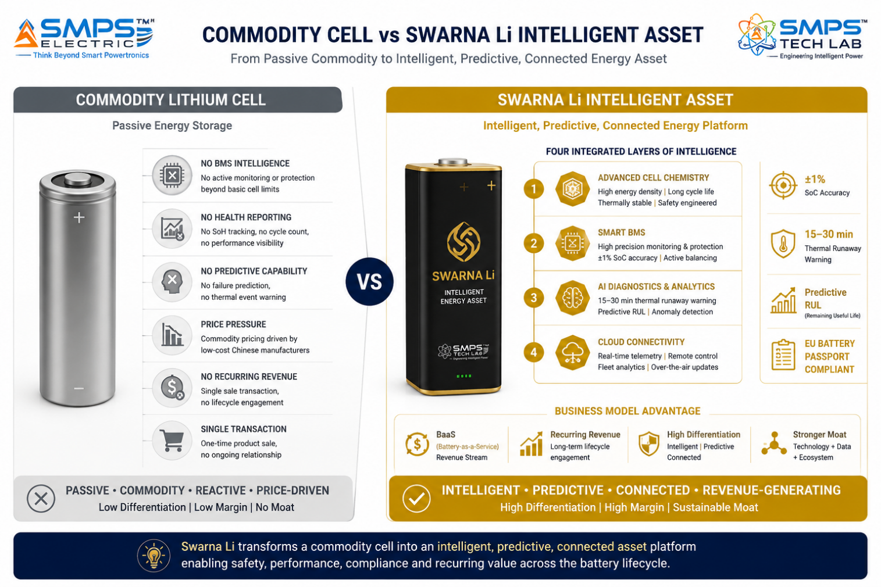
Figure 1.1 — Commodity lithium cell (left) versus Swarna Li intelligent energy asset (right). The intelligence layer is what commands premium pricing, generates recurring revenue, and creates the durable competitive moat that commodity suppliers cannot replicate.
STRATEGIC NOTE
Swarna Li is not a battery. It is an intelligent energy asset platform. The difference is commercially consequential: commodity batteries are single-transaction hardware sales competed on price. Swarna Li intelligent assets generate hardware revenue plus recurring BaaS subscription revenue plus warranty analytics plus second-life assessment data — creating a multi-stream, customer-sticky revenue model across every sector it serves.

1.3 Key Metrics at a Glance

TOTAL ADDRESSABLE MARKET  $53.8B  2025 Baseline · 5 Sectors · Largest IP-06 TAM | HIGHEST-GROWTH SECTOR  26.03%  Battery Energy Storage CAGR 2025–2035 | SECTORS MAPPED  5  10 Applications Identified | IP PROTECTION  Swarna Li Filed  Smart Lithium BMS & AI Patent

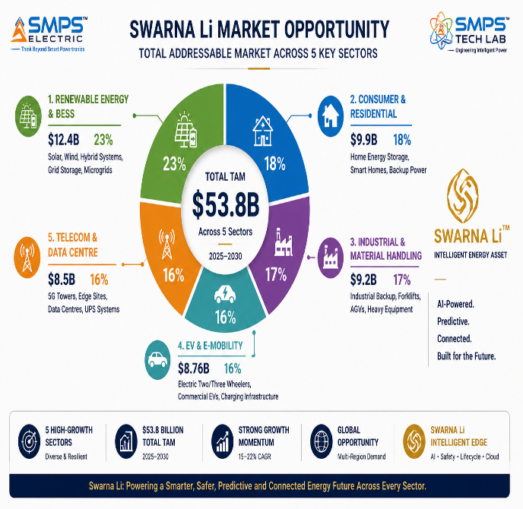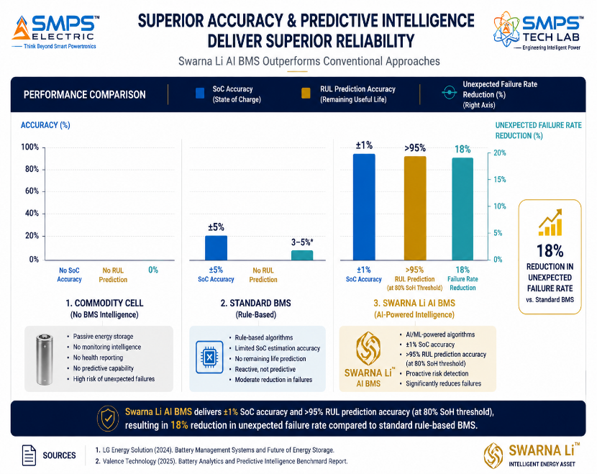
Figure 1.2 — Swarna Li TAM breakdown (left): Renewable Energy & BESS is the largest sector at $12.4B and the fastest-growing at 26.03% CAGR. AI BMS benchmark (right): Swarna Li delivers ±1% SoC accuracy and 18% failure rate reduction versus conventional BMS — validated commercial outcomes.

1.4 Why Swarna Li, Why Now
Three forces are creating an exceptional commercialisation window. First, LFP cost parity has arrived: at below USD 100/kWh, lithium is now cost-competitive with lead-acid across the full spectrum of stationary, industrial, and consumer applications — unleashing the replacement cycle across 600,000+ telecom towers, 1.5 million lead-acid forklifts, and tens of millions of residential solar installations that were previously price-locked from lithium adoption. Second, regulatory mandates are creating a structural requirement for Swarna Li’s intelligence layer: the EU Battery Regulation 2023 mandates a digital battery passport for EV and industrial batteries from 2027, requiring documented SoH, charge history, and second-life assessment data. Only Swarna Li’s embedded smart BMS and cloud data platform fulfil this requirement natively. Third, India’s battery demand is projected to jump 48% by 2030, with PLI Advanced Chemistry Cell, FAME III, and PM Surya Ghar creating domestic procurement demand directly aligned with every sector Swarna Li serves.

MARKET DATA POINT
Combined SMPS Tech Lab portfolio: IP-01 $68.7B + IP-02 $27.1B + IP-03 $42.3B + IP-04 $38.5B + IP-05 $14.8B + IP-06 $53.8B = USD 245.2 Billion total TAM across 30 sectors and 60 applications. IP-06 is the largest single-IP TAM in the portfolio — and uniquely addresses both the hardware storage layer and the recurring software intelligence layer simultaneously.

02 | TECHNOLOGY OVERVIEW  Dual Chemistry Platform · Smart BMS · AI Diagnostics · Cloud Connectivity · Standards

2.1 What is Swarna Li?
Swarna Li is a premium intelligent lithium battery solution that integrates four tightly coupled technology layers into one certified energy asset platform. The first layer is application-optimised lithium cell chemistry: Lithium Iron Phosphate (LFP) for safety-critical, long-cycle applications where thermal stability, 3,000–5,000 cycle life, and total cost of ownership are the primary criteria, and Lithium Nickel Manganese Cobalt Oxide (NMC) for high-energy-density applications where maximum range or power density is the design driver. The second layer is an embedded Smart BMS providing cell-level monitoring of voltage, temperature, current, and impedance with active balancing and comprehensive protection logic. The third layer is an AI Diagnostics Engine running on the embedded BMS processor, providing Remaining Useful Life prediction, anomaly detection, thermal runaway precursor identification, and adaptive charge optimisation. The fourth layer is a Cloud Connectivity platform enabling fleet-level health monitoring, predictive maintenance scheduling, warranty analytics, and EU Battery Passport data generation.

The commercial distinction from commodity lithium suppliers is not the cell chemistry — it is the intelligence stack. LFP and NMC cells are available from dozens of manufacturers at commodity pricing. The Swarna Li smart BMS, AI diagnostics engine, and cloud connectivity layer transform those cells into a certified intelligent energy asset that generates recurring software revenue, fulfils regulatory requirements (EU Battery Regulation 2023), and enables Battery-as-a-Service commercial models that commodity cell suppliers cannot support.

2.2 The Four Integrated Technology Layers
LAYER | COMPONENT | FUNCTION | KEY INNOVATION IN IP-06
L1 | Application-Optimised Cell Chemistry | LFP (3,000–5,000+ cycle life, thermal stability, inherently safe) for stationary/industrial; NMC (higher energy density, 300–800 Wh/kg) for EV/performance applications. | Dual-chemistry platform under single IP framework with shared BMS architecture. Single platform addresses the full spectrum of lithium market applications without separate product lines or separate IP protection.
L2 | Embedded Smart BMS | Cell-level monitoring of voltage, temperature, current, and impedance. Active cell balancing (<1% energy loss). SoC and SoH estimation. Protection logic: overcharge, over-discharge, short circuit, thermal runaway. | Active (not passive/resistive) cell balancing extends pack life 20–30% versus passive BMS designs. ±1% SoC accuracy (versus ±5% for conventional BMS) is the commercial differentiator for EV range estimation and BaaS billing accuracy.
L3 | AI Diagnostics Engine | ML models on embedded BMS processor: Remaining Useful Life (RUL) prediction, anomaly detection (cell degradation, impedance drift), thermal runaway precursor identification 15–30 minutes before onset, adaptive charge/discharge optimisation. | Thermal runaway precursor detection at 15–30 minutes advance warning is the life-safety differentiator in telecom, medical, and EV applications. RUL prediction >95% accuracy enables predictive replacement scheduling and BaaS contract risk management.
L4 | Cloud Connectivity Layer | MQTT/REST API telemetry: fleet health monitoring dashboard, predictive maintenance scheduling, warranty analytics, EU Battery Passport data generation, second-life battery assessment, BaaS contract performance data. | EU Battery Regulation 2023 compliance data generation natively embedded — no retrofit required. BaaS commercial model enablement: per-kWh billing accuracy and health-based contract risk management from the same data platform.

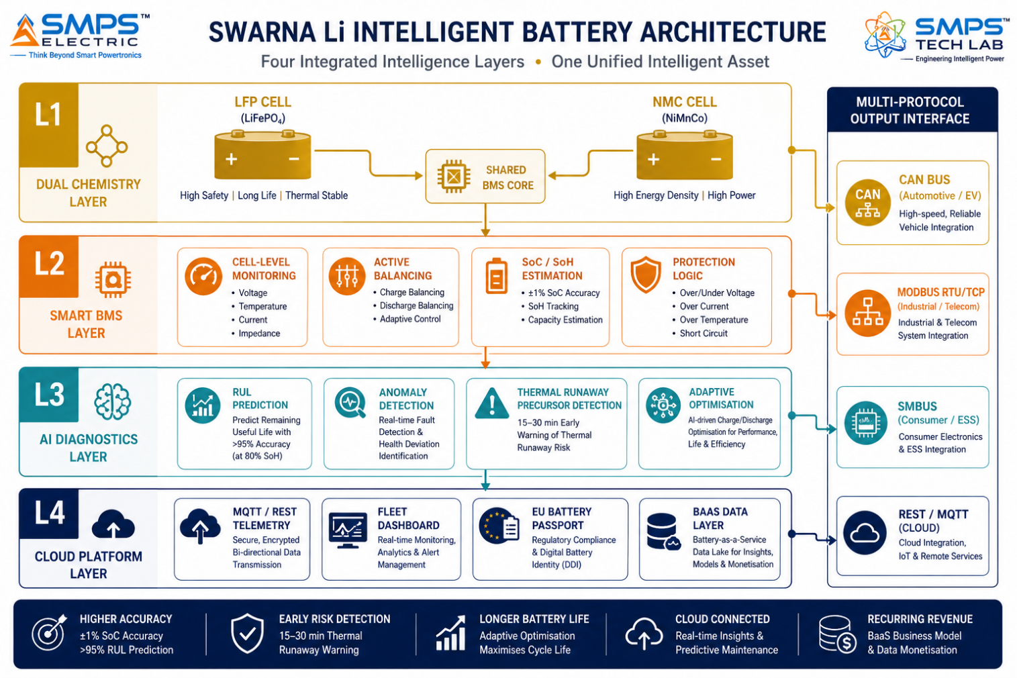
Figure 2.1 — Swarna Li four-layer architecture. The AI Diagnostics Engine (L3) and Cloud Platform (L4) are what differentiate Swarna Li from commodity LFP/NMC suppliers — transforming a passive cell into an intelligent energy asset with recurring revenue capability.

2.3 AI Diagnostics Engine — The Commercial Intelligence Layer
The AI Diagnostics Engine is the most commercially significant layer of Swarna Li because it is the hardest to replicate and the most directly valuable to buyers. The engine runs three independent ML models simultaneously on the embedded BMS processor. The Remaining Useful Life model continuously tracks capacity fade against an electrochemical degradation model calibrated for the specific chemistry and operating conditions of each pack, predicting the cycle number at which capacity will reach the end-of-life threshold (typically 80% of rated capacity) with >95% accuracy at the 80% SoH threshold. The Anomaly Detection model monitors impedance spectra and temperature gradients, identifying cells exhibiting degradation patterns that precede failure — enabling targeted cell replacement rather than full pack replacement in modular applications. The Thermal Runaway Precursor model provides 15–30 minutes advance warning of conditions approaching thermal runaway — the safety-critical capability that enables Swarna Li to serve telecom, medical, and EV applications where battery fires are unacceptable.

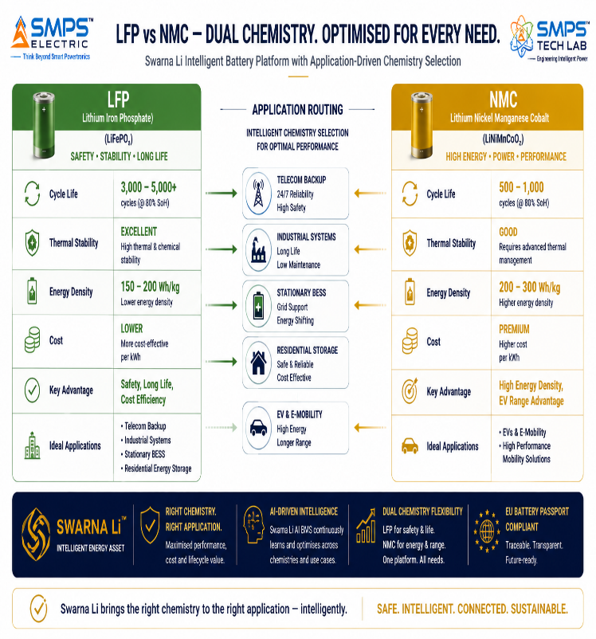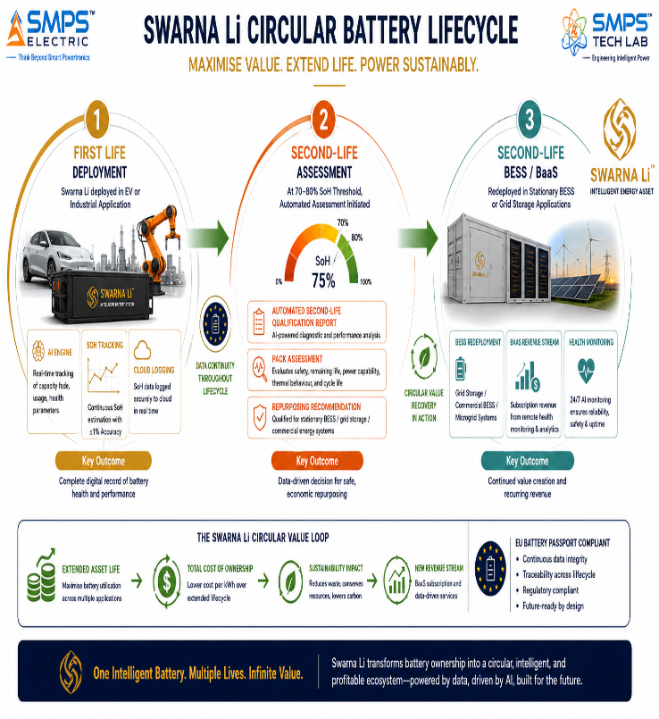
Figure 2.2 — AI SoH prediction engine flow (left): three simultaneous ML models delivering RUL, anomaly detection, and thermal runaway precursor. Chemistry routing (right): LFP for long-life safety-critical applications; NMC for maximum energy density where range is the design driver.

2.4 Second-Life Assessment & BaaS Platform
Two commercially significant capabilities emerge from the intelligence stack that commodity lithium suppliers cannot offer. The first is automated second-life battery assessment: when a Swarna Li pack reaches end-of-first-life (typically 70–80% remaining capacity in EV applications), the embedded SoH data enables automated qualification for repurposing into stationary storage applications — creating a circular economy value stream aligned with EU Battery Regulation 2023 requirements and the growing commercial interest from companies including GM and Redwood Materials, who signed an MoU in July 2025 for second-life EV battery storage. The second is BaaS commercial model enablement: the cloud health platform provides the per-kWh metering accuracy, SoH transparency, and contract performance data required for Battery-as-a-Service agreements — where customers pay per kWh delivered rather than purchasing battery hardware outright.

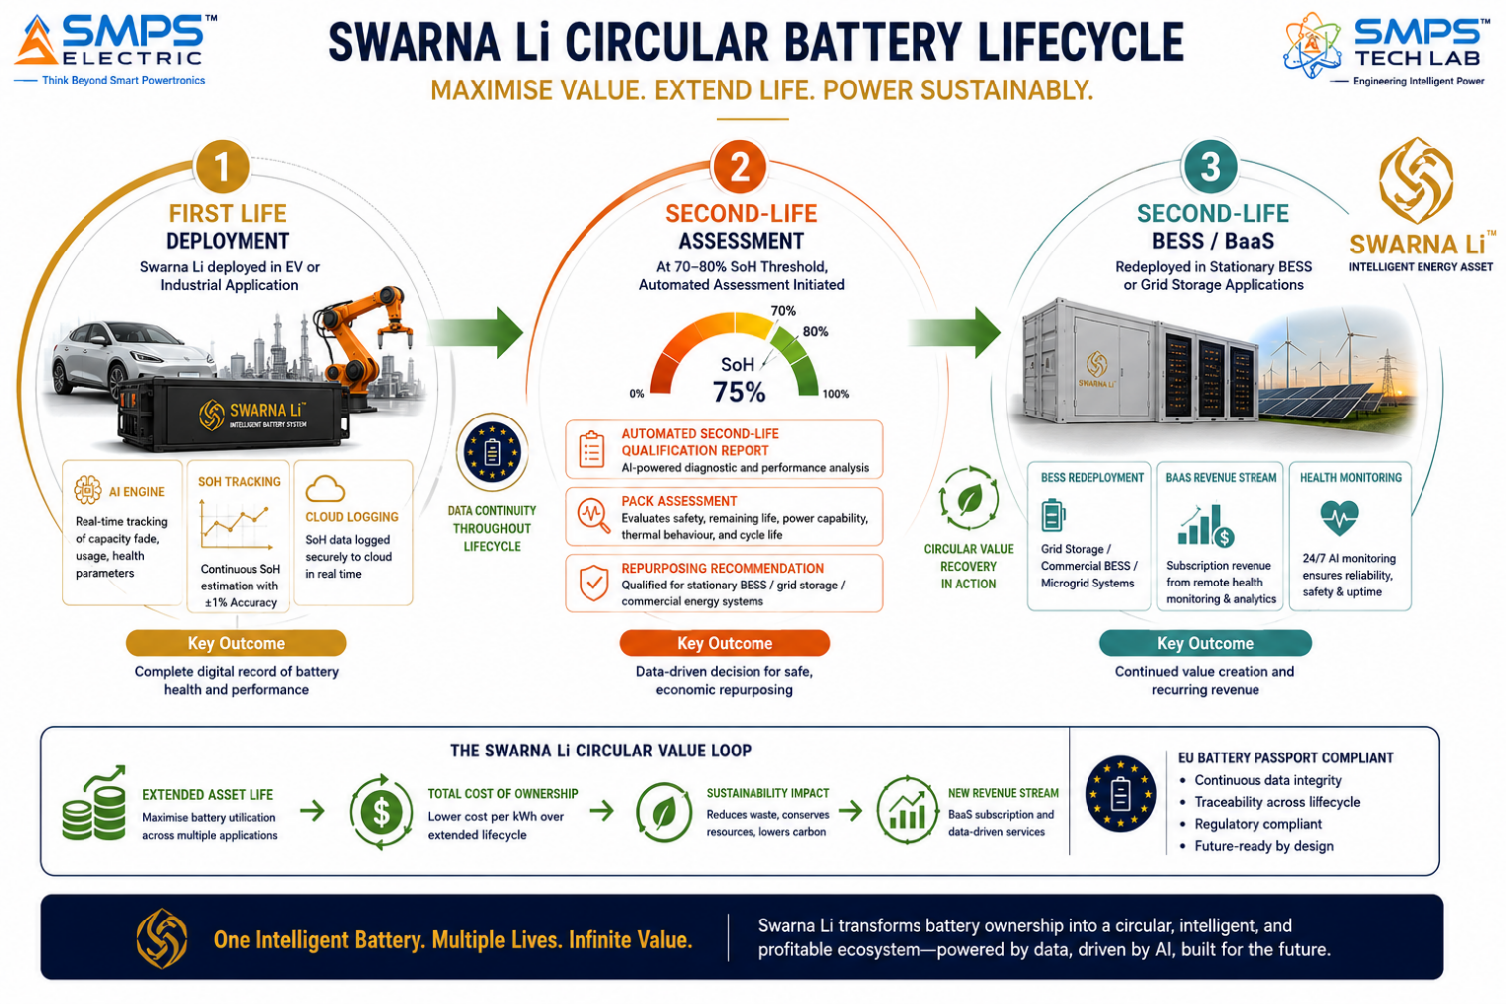
Figure 2.3 — Swarna Li second-life assessment and BaaS platform. The AI SoH data that drives first-life predictive maintenance becomes the second-life qualification certificate — creating a circular economy value stream that extends the commercial lifetime of each Swarna Li asset beyond its first application.

2.5 Standards Compliance Architecture
STANDARD | SECTOR APPLICABILITY | COMPLIANCE RELEVANCE FOR IP-06
IEC 62619 | All sectors (primary safety) | Safety requirements for secondary lithium cells in stationary applications. Core safety standard for all Swarna Li deployments across all five sectors.
UN 38.3 | All sectors (transport) | Transport testing of lithium batteries. Required for all Swarna Li products before commercial shipment. Covers vibration, thermal, shock, and short-circuit testing.
ISO 26262 ASIL-D | EV & E-Mobility (automotive) | Functional safety for road vehicles. ASIL-D (highest level) BMS safety requirements. Mandatory for EV passenger vehicle and commercial vehicle battery packs.
UL 9540 / UL 9540A | Renewable Energy & BESS | Safety standard for energy storage systems. UL 9540A fire propagation testing for large-format BESS. Mandatory for utility-scale and commercial BESS in North America.
UL 1973 | Telecom, Industrial, BESS | Batteries for use in stationary, vehicle auxiliary power, and light electric rail applications. UPS and stationary storage certification for North America market.
IEC 60896-21/22 | Telecom & Data Centre | Stationary lead-acid and lithium batteries for telecom. Drop-in replacement compatibility certification for telecom tower and data centre applications.
EU Battery Regulation 2023 | EV, Industrial, BESS (EU market) | Digital Battery Passport mandatory from 2027 for EV and industrial batteries. Swarna Li cloud platform generates all required SoH, charge history, and second-life data natively.
IEC 62304 | Medical (adjacent application) | Medical device software lifecycle for Swarna Li BMS software in medical-grade backup power applications. Required for IEC 60601-1 adjacent deployments.

03 | GLOBAL MARKET LANDSCAPE  Battery Intelligence Transition · Market Sizing · Regulatory Drivers · Competitive Validation

3.1 The Battery Intelligence Transition
The global lithium battery market is at an intelligence transition point with no precedent in battery market history. LFP cell costs below USD 100/kWh have made lithium economically competitive with lead-acid across stationary, industrial, and consumer applications — unlocking a mass replacement cycle estimated at 600,000+ telecom towers, 1.5 million industrial forklifts, and hundreds of millions of residential storage installations globally. Simultaneously, the EU Battery Regulation 2023 has created a regulatory mandate for embedded intelligence: digital battery passports documenting SoH, charge history, and second-life assessment data become mandatory from 2027 for EV batteries and are expected to extend to industrial and stationary applications by 2030. AI-driven BMS is simultaneously becoming a commercial standard: LG Energy Solution integrated AI diagnostics in 2024; Valence Technology’s AI SoH upgrade achieved 18% accuracy improvement in 2025; Mordor Intelligence notes solid-state BMS market growing at 41.38% CAGR. The intelligence layer is no longer a premium feature — it is becoming the regulatory baseline.

3.2 The Four Structural Megatrends
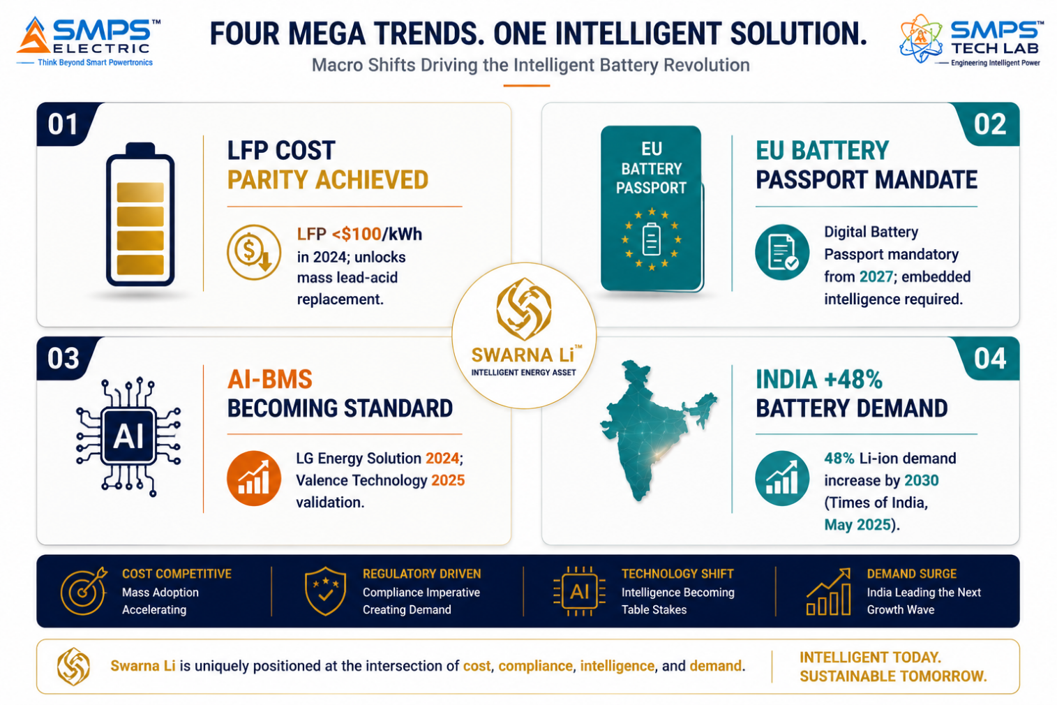
Figure 3.1 — Four structural megatrends driving Swarna Li demand. LFP cost parity unlocks the replacement volume; the EU Battery Passport mandate makes the intelligence layer regulatory-mandatory rather than optional.

3.3 Global Market Sizing — Primary Reference Data
MARKET SEGMENT | 2025 VALUE | PROJECTED | CAGR | HORIZON | SOURCE
Global Smart Lithium Battery Market | USD 72.5B | USD 248.9B | 16.4% | 2035 | Mak Data Insights (Jan 2026)
Battery Management System Market | USD 9.84B | USD 46.47B | 21.41% | 2033 | Straits Research
BMS Market (Global Growth Insights) | USD 8.17B | USD 45.7B | 21.09% | 2034 | Global Growth Insights
Battery Energy Storage System (BESS) | USD 10.16B | USD 102.69B | 26.03% | 2035 | Precedence Research (Jan 2026)
Automotive BMS Market | USD 4.86B | USD 26.06B | 18.6% | 2035 | GM Insights
BMS Market (Roots Analysis) | USD 9.3B | USD 37.1B | 14.84% | 2035 | Roots Analysis
Portable Power Station Market | USD 2.1B | (growing) | 14.2% | 2030 | Industry estimate
Solid-State BMS (next-gen) | growing | growing | 41.38% | 2030 | Mordor Intelligence

CAGR Comparison — Swarna Li Target Market Segments

Solid-State BMS (Mordor Intelligence) ██████████████████████████ 41.38%
Battery Energy Storage System (Precedence)████████████████░░░░░░░░░░ 26.03%
BMS Market (Straits Research) █████████████░░░░░░░░░░░░░ 21.41%
BMS Market (Global Growth Insights) █████████████░░░░░░░░░░░░░ 21.09%
Automotive BMS (GM Insights) ████████████░░░░░░░░░░░░░░ 18.6%
Smart Lithium Battery (Mak Data) ██████████░░░░░░░░░░░░░░░░ 16.4%
Consumer & Residential Storage ██████████░░░░░░░░░░░░░░░░ 16.4%
BMS Market (Roots Analysis) █████████░░░░░░░░░░░░░░░░░ 14.84%
Telecom & Data Centre Backup █████████░░░░░░░░░░░░░░░░░ 14.5%
Industrial & Material Handling ████████░░░░░░░░░░░░░░░░░░ 12.4%
Sources: Mak Data Insights, Straits Research, Global Growth Insights, Precedence Research, GM Insights, Roots Analysis, Mordor Intelligence, Coherent Market Insights (2025–2026)

04 | TOTAL ADDRESSABLE MARKET  Five Sectors · Ten Applications · USD 53.8 Billion

4.1 Methodology
The TAM framework maps Swarna Li across five strategic sectors with two primary commercial applications per sector, producing ten independently validated commercialisation pathways. Each application is sized from published sub-segment data. The aggregate TAM of USD 53.8 billion is the largest single-IP TAM in the SMPS Tech Lab portfolio — reflecting Swarna Li’s unique breadth across both the hardware energy storage market and the intelligence/software layer above it.

STRATEGIC NOTE
Swarna Li’s TAM spans both the battery hardware market (physical LFP/NMC packs) and the BMS/AI intelligence market (embedded software and cloud services). No other IP in the SMPS Tech Lab portfolio has this dual hardware-software commercial footprint. Hardware revenue scales with units shipped; BaaS and EU Battery Passport compliance services generate recurring subscription revenue from the same installed base — creating two independent, compounding revenue streams from a single IP.

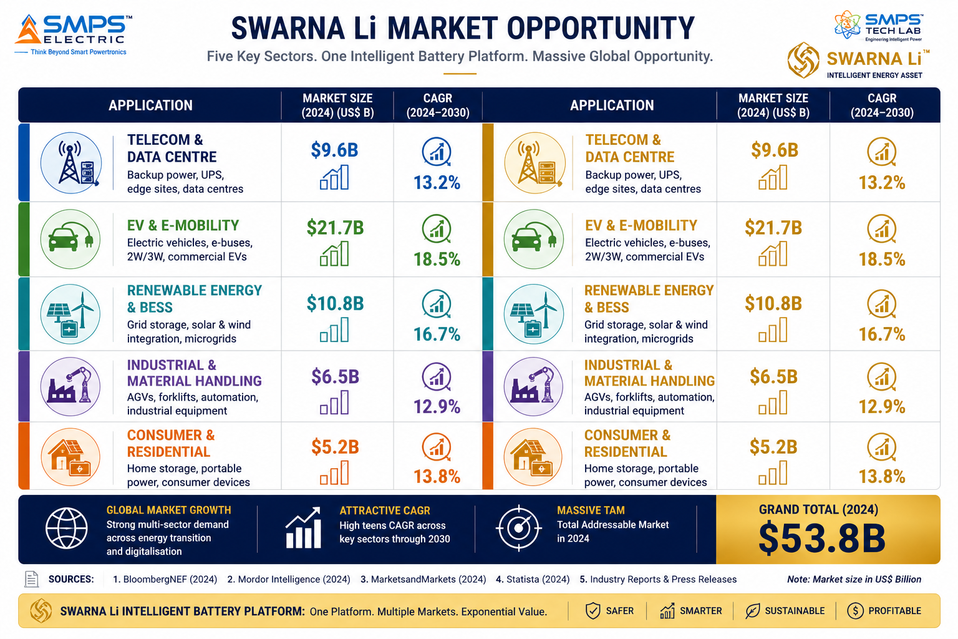
Figure 4.1 — Swarna Li application matrix. Ten commercially validated pathways, each independently sized. The portfolio spans from $2.1B (portable power) to $7.8B (residential solar storage) per application sub-segment.

4.2 Consolidated TAM Summary
SECTOR | APPLICATION | USE CASE SUMMARY | APP SIZE | SECTOR TAM | CAGR
Telecom & Data Centre | Telecom Tower LFP Replacement | Drop-in smart LFP upgrade for 600,000+ VRLA towers; SNMP NMS integration; 3–4x longer life | $4.2B | $8.5B | 14.5%
Telecom & Data Centre | Data Centre UPS Smart Lithium | LFP UPS for hyperscale/enterprise DC; DCIM-integrated SoH telemetry; 35–45% TCO reduction | $4.3B | $8.5B | 14.5%
EV & E-Mobility | EV Passenger & Commercial Packs | NMC/LFP packs with AI SoH prediction; ISO 26262 ASIL-D; V2G BMS support; predictive warranty | $4.86B | $8.76B | 18.6%
EV & E-Mobility | E-2W/3W & Micro-Mobility Batteries | LFP swap-compatible smart batteries; BIS AIS-038; BLE/NB-IoT cloud; battery swap network integration | $3.9B | $8.76B | 18.6%
Renewable Energy & BESS | Utility & Commercial BESS Storage | LFP smart modules; IEC 62933; UL 9540A; SCADA/EMS Modbus/DNP3; 4,000+ cycle life; 20-yr design | $6.8B | $12.4B | 26.03%
Renewable Energy & BESS | Residential & C&I Smart Storage | LFP 5–100kWh; AI-optimised solar self-consumption; cloud app; SunSpec Modbus; EU Battery Passport | $5.6B | $12.4B | 26.03%
Industrial & Material Handling | Forklift & Industrial LFP Motive | Smart LFP replacing lead-acid in 1.5M forklift fleet; CAN bus fleet mgmt integration; opportunity charge | $5.8B | $9.2B | 12.4%
Industrial & Material Handling | AGV/AMR Warehouse Automation | Smart LFP for AMRs; tight SoC window (20–80%); WMS integration; 1-second SoC reporting | $3.4B | $9.2B | 12.4%
Consumer & Residential | Residential Solar Storage & HEM | LFP 5–20kWh; AI load learning; solar self-consumption optimisation; cloud app; 6,000+ cycle life | $7.8B | $9.9B | 16.4%
Consumer & Residential | Portable Power & Off-Grid | Smart LFP 500Wh–5kWh; solar MPPT; AI runtime estimation; rural electrification; UN 38.3 | $2.1B | $9.9B | 16.4%
TOTAL ADDRESSABLE MARKET — IP-06 SWARNA LI — SMART LITHIUM SOLUTION (2025) |  |  |  | ~USD 53.8 Billion

MARKET DATA POINT
Combined SMPS Tech Lab portfolio TAM: IP-01 $68.7B + IP-02 $27.1B + IP-03 $42.3B + IP-04 $38.5B + IP-05 $14.8B + IP-06 $53.8B = USD 245.2 Billion across 30 sectors and 60 applications. Swarna Li adds the intelligent energy storage layer — the battery platform that stores the energy managed by IP-05, converted by IP-01/IP-03, and controlled by IP-04.

05 | INDIA MARKET INTELLIGENCE  PLI ACC · FAME III · PM Surya Ghar · E-Mobility · Battery Swap Networks

5.1 India as First Market
India is the single most strategically aligned first-market for Swarna Li globally. The convergence of India’s 48% projected lithium battery demand increase by 2030, the PLI Advanced Chemistry Cell programme with INR 18,100 crore committed for domestic battery manufacturing, the FAME III EV acceleration programme, the PM Surya Ghar residential solar with storage programme, the BharatNet and USOF rural connectivity demand for telecom tower LFP upgrades, and India’s 80% two-wheeler EV penetration target by 2030 creates a policy-backed procurement environment covering every one of Swarna Li’s five target sectors simultaneously. For a domestically patented intelligent lithium battery platform, this policy framework creates structural commercial advantages over imported commodity cells at every procurement decision point.

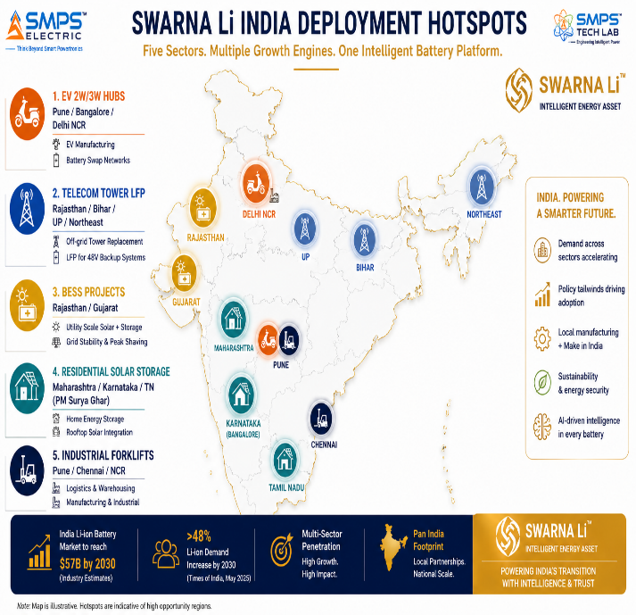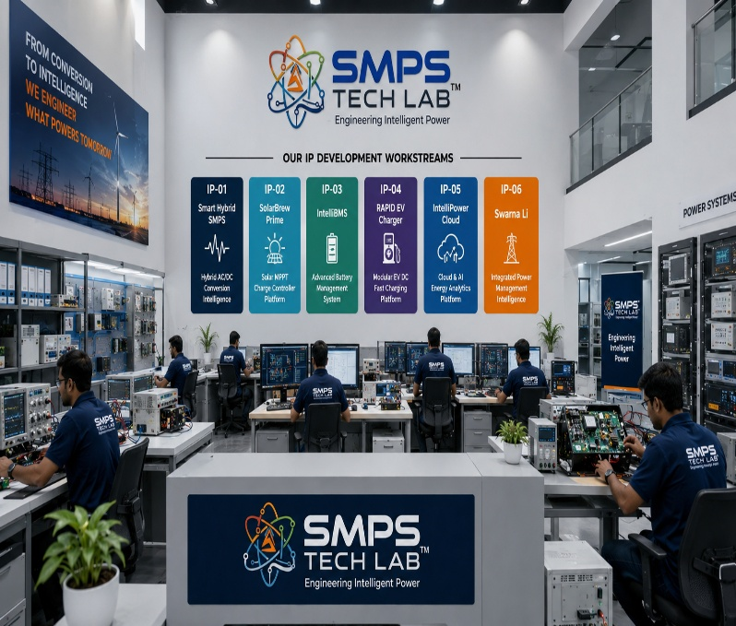
Figure 5.1 — India deployment hotspot map (left): Swarna Li has active procurement demand in all five sectors across all major industrial, infrastructure, and energy hubs. Policy alignment (right): eight programmes with committed capital directly supporting Swarna Li deployment across all sectors.

5.2 India Market Sizing — Swarna Li Relevant Segments
INDIA MARKET SEGMENT | 2025E VALUE | PROJECTED | CAGR | HORIZON
India Lithium-Ion Battery Market (Overall) | USD 3.2B | USD 8.5B | ~15% | 2030
India EV Battery Market (2W/3W/4W combined) | USD 1.8B | USD 7.2B | ~22% | 2030
India Telecom Tower Battery Replacement | USD 0.55B | USD 1.3B | ~13% | 2030
India BESS / Grid Storage Market | USD 0.8B | USD 6.5B | ~35% | 2030
India Residential Solar + Storage (PM Surya Ghar) | USD 0.45B | USD 3.1B | ~27% | 2030
India Industrial / Forklift LFP Replacement | USD 0.3B | USD 0.8B | ~12% | 2030

06 | GOVERNMENT POLICY & REGULATORY ALIGNMENT  India Schemes · Global Regulations · EU Battery Passport

6.1 India & Global Policy with Direct Swarna Li Alignment
SCHEME / REGULATION | MINISTRY / BODY | RELEVANCE TO SWARNA LI | COMMERCIAL IMPLICATION
PLI — Advanced Chemistry Cell (ACC) | NITI Aayog / MoHI&PE | INR 18,100 crore for 50 GWh domestic battery manufacturing; smart BMS qualifies | 4–6% incentive on incremental sales; Swarna Li manufactured in India qualifies; domestic IP preference
FAME III (Expected) + PM E-Drive | MoHI&PE | EV acceleration programme; mandates certified smart batteries for EV fleet procurement | Swarna Li AI BMS and ISO 26262 ASIL-D certification positions it for government EV fleet procurement
PM Surya Ghar — Muft Bijli Yojana | MNRE | 10 million solar rooftop homes with storage by 2027; INR 75,021 crore allocation | Residential solar+storage programme creates 10M unit procurement opportunity at subsidised price point
National BESS Mission | MNRE / Ministry of Power | 4 GWh BESS procurement by 2030; grid ancillary service requirements | Utility-scale LFP BESS procurement with smart BMS and SCADA integration mandatory
BharatNet / USOF (Tower LFP Upgrade) | DoT | USOF funds tower infrastructure including battery replacement across rural sites | USOF rural tower battery replacement tender: Swarna Li LFP drop-in upgrade with SNMP integration
EU Battery Regulation 2023 | European Commission | Digital Battery Passport mandatory for EV batteries from 2027; industrial/stationary extension expected 2030 | Swarna Li cloud SoH platform generates Battery Passport data natively; mandatory for EU market access
IRA (Inflation Reduction Act, US) | US Treasury/IRS | 30% tax credit extended to standalone battery installations; domestic content bonus available | US residential and C&I storage procurement accelerated by IRA; Swarna Li US certification (UL 9540) is the access key
DRDO / Atmanirbhar Bharat Defence | MoD / DRDO | Indigenous battery requirement for defence vehicles and communication equipment | Defence-grade LFP batteries with MILSPEC ruggedisation; Swarna Li defence variant development path

07 | IP AS AN INDUSTRY PLUGIN  Five Sector Integration Architecture · BaaS Platform Model

7.1 The Plugin Architecture — Five Energy Storage Contexts
Swarna Li is architecturally positioned as the intelligent energy storage plugin across five host system categories. In each category, Swarna Li replaces either a lead-acid battery bank or a commodity lithium cell with an intelligent energy asset that integrates into the host system’s management infrastructure, monitors its own health, and either enables a BaaS commercial model or fulfils a regulatory compliance requirement (EU Battery Passport). The BaaS platform layer is the commercially transformative element: it converts a one-time hardware sale into a recurring subscription relationship sustained by health data, predictive maintenance, and warranty analytics.

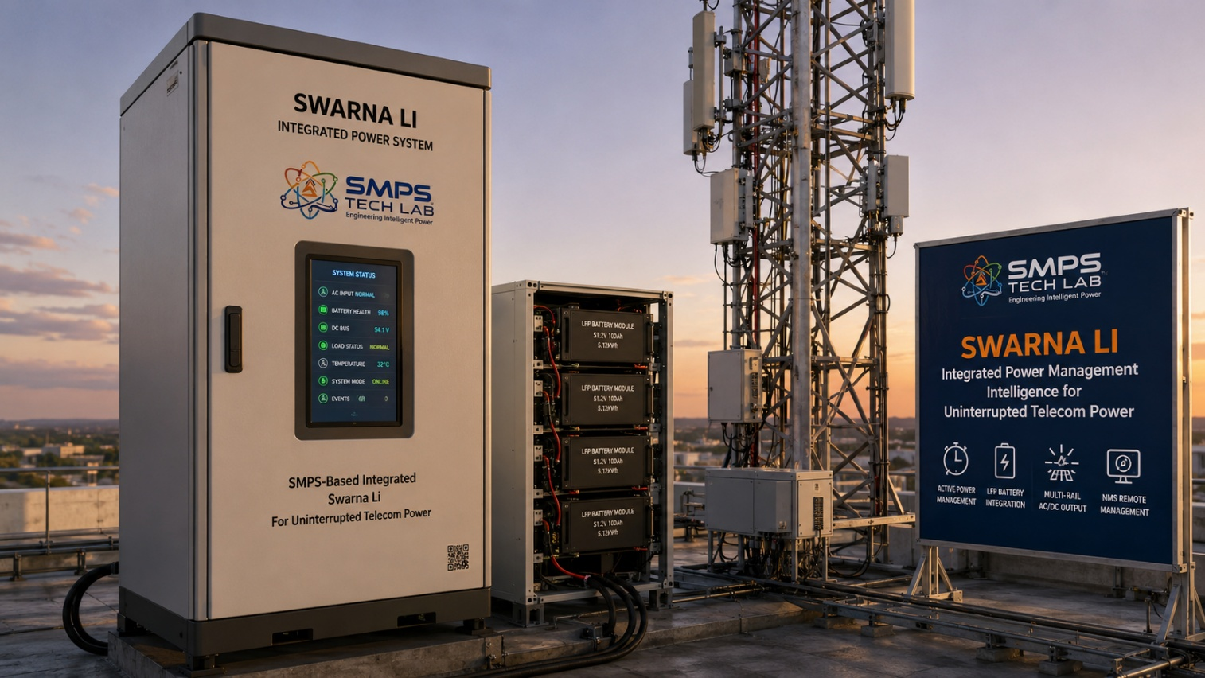
Figure 7.1 — Swarna Li as a certified intelligent energy asset plugin. The same core BMS + AI platform adapts to five host system categories through application-specific configuration, communication protocol selection, and sector certification.

7.2 Plugin Integration Matrix
HOST SYSTEM | PLUGIN ROLE | VALUE AT SYSTEM LEVEL | INTEGRATION COMPLEXITY
Telecom Tower / Data Centre UPS | Drop-in LFP replacement for VRLA; SNMP/Modbus to NMS/DCIM; SoH telemetry; active BMS protection | 3–4x battery life; remote health monitoring; 35–45% TCO reduction; no maintenance visits | LOW — drop-in form factor; SNMP/Modbus to existing NMS; float charge compatible
EV / Electric Two-Wheeler OEM | NMC or LFP pack with AI BMS; CAN bus to vehicle BMS; ISO 26262 ASIL-D; V2G capable | Predictive warranty analytics; range accuracy ±1%; EU Battery Passport compliance; BaaS enablement | HIGH — ISO 26262 ASIL-D, OEM thermal management integration, OTA firmware
BESS / Solar+Storage System | LFP modules with SCADA/EMS Modbus/DNP3; UL 9540A; round-trip >92%; 20-yr design life | Revenue assurance under project contracts; predictive module replacement; UL 9540A fire compliance | MEDIUM — Modbus/DNP3 to EMS, UL 9540A fire testing, grid interface coordination
Residential Solar Storage | LFP 5–20kWh with SunSpec Modbus; inverter compatibility; cloud app; smart meter integration | 30–40% electricity bill reduction; solar self-consumption optimisation; EU Battery Passport | LOW-MED — SunSpec Modbus, cloud app, grid export management per local regulation
Industrial Forklift / AGV Fleet | LFP motive battery with CAN bus fleet mgmt; opportunity charge; SoH per-unit tracking | 20–30% battery OPEX reduction over 10 years; fleet optimisation; no maintenance | MEDIUM — CAN bus fleet management, opportunity charge hardware, multi-shift operation

08 | COMMERCIALISATION STRATEGY  Revenue Models · BaaS Platform · Market Priority · Go-to-Market

8.1 Commercialisation Philosophy
The Swarna Li commercialisation strategy is built on a dual-revenue architecture that distinguishes it from every other IP in this portfolio: hardware revenue from certified intelligent battery pack supply, and recurring software revenue from the BaaS cloud health platform. The hardware revenue scales with unit volume — telecom tower LFP replacement, EV OEM supply, BESS module supply, and residential storage distribution. The BaaS platform revenue grows with the installed base, compounding independently of new hardware sales as the fleet of deployed Swarna Li assets generates monthly subscription revenue from health monitoring, predictive maintenance, and EU Battery Passport compliance data services.

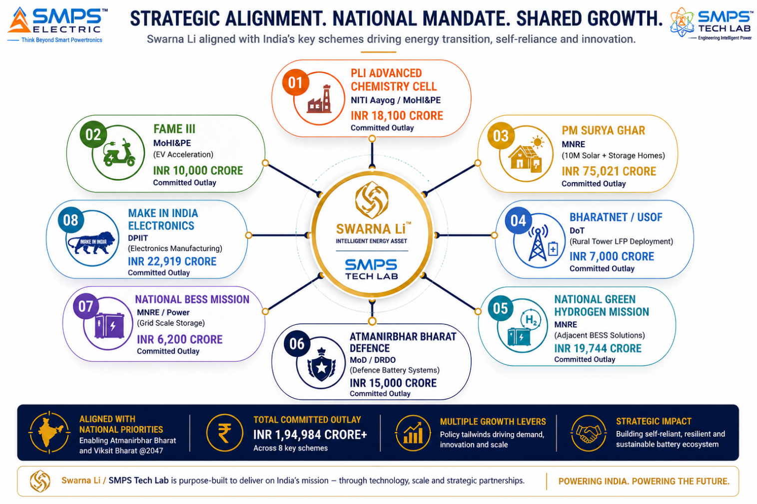
Figure 8.1 — Three parallel pathways with dual revenue streams. Lead-acid replacement provides fastest hardware volume; EV and BESS integration provides premium OEM revenue; BaaS platform licensing creates compounding monthly recurring revenue from the installed base.

8.2 Market Priority Matrix
SECTOR | TAM 2025 | CAGR | IP FIT | TIME-TO-REV | PATHWAY | PRIORITY
Telecom & Data Centre | $8.5B | 14.5% | Excellent | 6–18 mo | Direct Supply | HIGH
Renewable Energy & BESS | $12.4B | 26.03% | Excellent | 12–24 mo | OEM + BaaS | HIGHEST
Consumer & Residential | $9.9B | 16.4% | Excellent | 6–18 mo | Distribution + BaaS | HIGH
EV & E-Mobility | $8.76B | 18.6% | Excellent | 12–24 mo | OEM Supply + BaaS | HIGH
Industrial & Material Handling | $9.2B | 12.4% | Strong | 12–24 mo | Direct Supply | MED-HIGH

09 | COMPETITIVE LANDSCAPE  Market Positioning · Advantage Scorecard · IP Moat

9.1 Competitive Architecture Overview
The intelligent lithium battery market has two structurally different competitive threats. The first is commodity Chinese LFP cell manufacturers (CATL, BYD, REPT, Eve Energy) competing on volume and price — a threat that the Swarna Li intelligence layer directly defeats by providing capabilities commodity cells cannot replicate: AI SoH prediction, thermal runaway precursor detection, EU Battery Passport compliance, and BaaS platform revenue. The second is established battery OEMs (LG Energy Solution, Panasonic, Samsung SDI) who have begun integrating AI diagnostics into their premium product lines. The strategic response to both threats is the same: IP-protected architecture depth (dual-chemistry BMS + AI engine + cloud platform under single patent), regulatory compliance leadership (EU Battery Passport compliance data from Day 1, ahead of the 2027 mandate), and the commercial leverage of BaaS recurring revenue that neither commodity suppliers nor established OEMs currently offer as a certified, deployable platform.

CATEGORY | KEY PLAYERS | MARKET FOCUS | SWARNA LI ARCHITECTURAL DIFFERENTIATION
Chinese LFP Cell Manufacturers | CATL, BYD, REPT, Eve Energy | High-volume commodity LFP cells | No embedded AI intelligence; no SoH prediction; no BaaS capability; no EU Battery Passport compliance. Competing on price only. Swarna Li’s intelligence layer is the commercial moat against these suppliers.
Premium Battery OEMs | LG Energy Solution, Panasonic, Samsung SDI | EV and stationary premium batteries | Beginning AI BMS integration (LG 2024, Samsung 2025), but not yet as a certified BaaS platform. No second-life assessment service. No EU Battery Passport compliance platform.
BMS Specialists | Texas Instruments, Renesas, Analog Devices | BMS ICs and embedded software | IC and software components only; not a complete intelligent battery solution. Swarna Li integrates their IC components into a certified, deployable platform with AI and cloud layers added.
Industrial Battery OEMs | EnerSys, Exide, Crown Battery | Lead-acid and industrial LFP motive | Lead-acid legacy; LFP offerings lack embedded AI intelligence and cloud connectivity. EU Battery Passport compliance is absent from all current product lines.
Residential Storage OEMs | Tesla Powerwall, SONNEN, BYD HVM, Enphase IQ | Residential energy storage | Hardware-focused; limited AI optimisation; no BaaS platform; no certified second-life assessment. EU Battery Passport compliance not yet embedded.

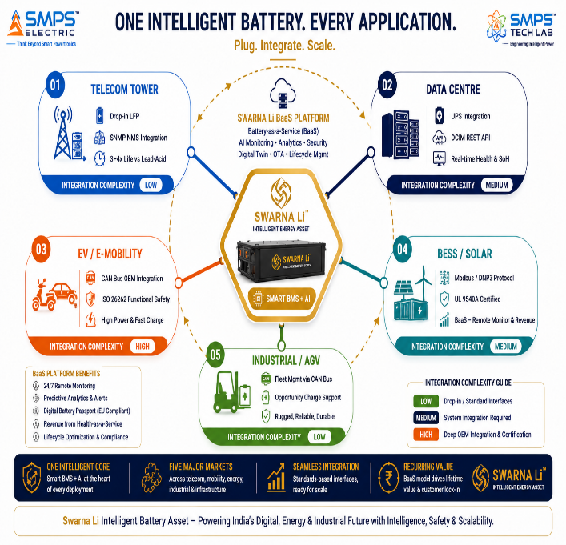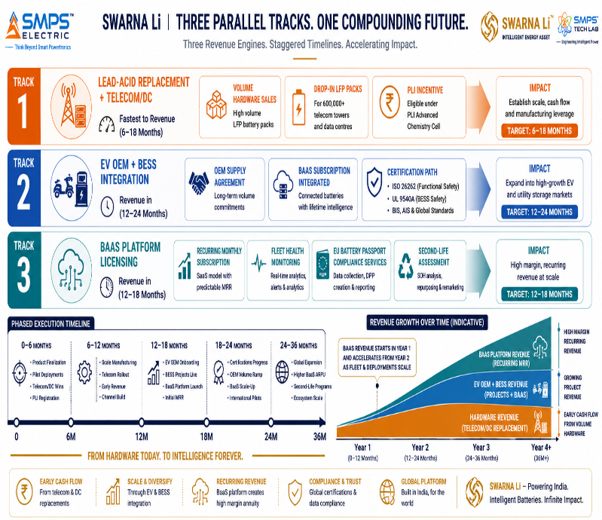
Figure 9.1 — Swarna Li competitive radar (left): scores 8–10/10 across all seven dimensions; Chinese commodity LFP scores 2–3/10. Four-pillar IP moat (right): the EU Battery Passport compliance stack is particularly powerful — it creates a regulatory access requirement that all competitors must meet by 2027, but Swarna Li already fulfils from Day 1.

10 | INVESTMENT THESIS & FINANCIAL FRAMEWORK  Value Creation · Dual Revenue Streams · BaaS Compounding

10.1 The Investment Case
The investment case for Swarna Li is structurally the strongest in the SMPS Tech Lab portfolio because it combines the largest TAM ($53.8B), the highest CAGR in any sector (26.03% for BESS), a regulatory mandate creating a time-bounded access requirement (EU Battery Passport from 2027), and a dual hardware-software revenue model that generates compounding recurring income from the installed base. The BaaS platform is the critical commercial differentiator: where every other IP in the portfolio generates revenue at the point of hardware sale, Swarna Li generates hardware revenue at sale plus monthly BaaS subscription revenue for every Swarna Li asset deployed, growing independently of new unit sales as the installed base expands.

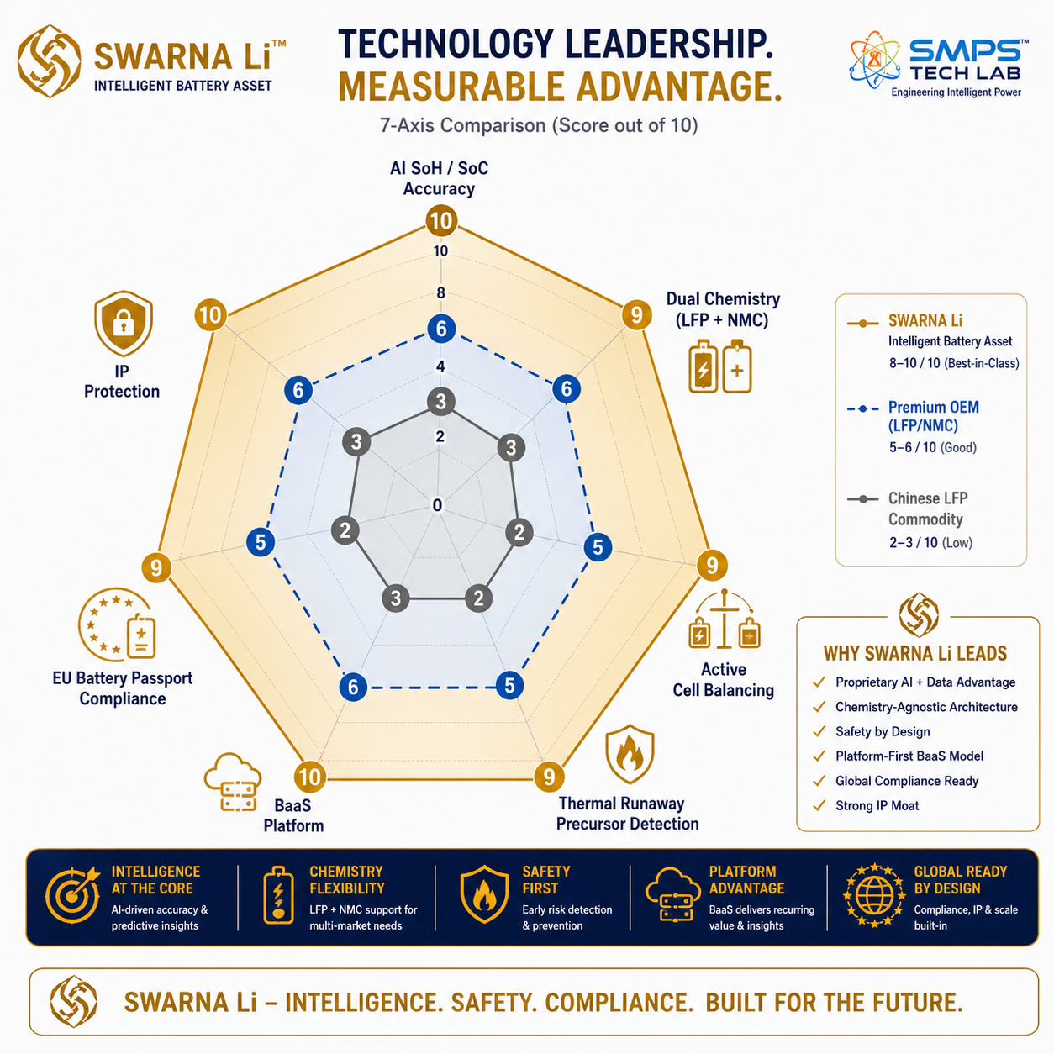
Figure 10.1 — Dual revenue projection: hardware sales (blue) plus BaaS subscription revenue (gold). The BaaS layer creates a compounding annuity income stream from the installed base that grows independently of new hardware sales from Year 2 onwards.

10.2 Illustrative Revenue Scenarios
SCENARIO | YEAR 1 | YR 2–3 CAGR | YR 4–5 CAGR | KEY ASSUMPTIONS
Conservative (Hardware + Early BaaS) | USD 600K–1M | +28% | +22% | Telecom tower LFP supply + residential storage; BaaS from Year 2; PLI incentive
Base (Multi-Sector + BaaS Scale) | USD 1.8–2.5M | +50% | +42% | Telecom + BESS OEM + residential + BaaS platform; EV 2W supply agreement; EU Battery Passport service
Optimistic (All Pathways + BaaS Fleet) | USD 4–5M | +75% | +65% | All sectors + EV OEM pack supply + fleet BaaS + second-life assessment service; global TowerCo

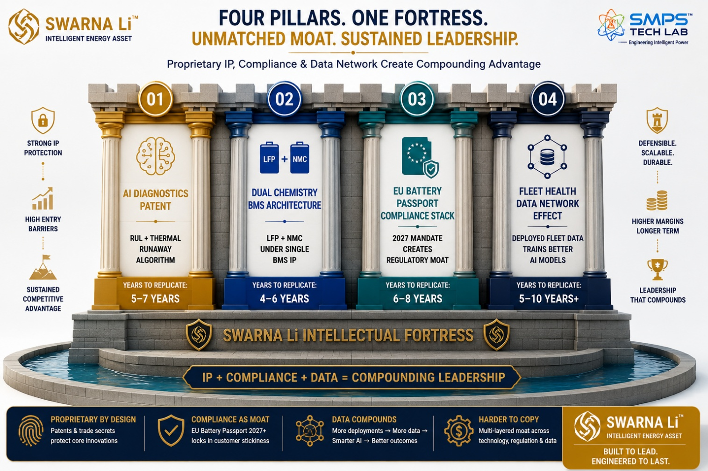
Figure 10.2 — Four-phase milestone roadmap. IEC 62619 and UN 38.3 in Phase 1 unlock immediate commercial deployment; EU Battery Passport service from Phase 2 creates a regulatory revenue stream ahead of the 2027 mandatory compliance date.
RISK ADVISORY
The EU Battery Passport mandate — mandatory from 2027 for EV batteries, expected to extend to industrial and stationary by 2030 — creates an extraordinary commercial opportunity. Every European EV OEM and BESS operator will need a certified Battery Passport data platform. Swarna Li’s cloud platform generates this data natively from Day 1. The window to establish Swarna Li as the Battery Passport compliance platform of record for India-manufactured intelligent batteries is the next 12–24 months.

11 | FUTURE ROADMAP  Technology Evolution · Solid-State · Second-Life · BaaS Fleet Scale

11.1 Technology Generation Roadmap
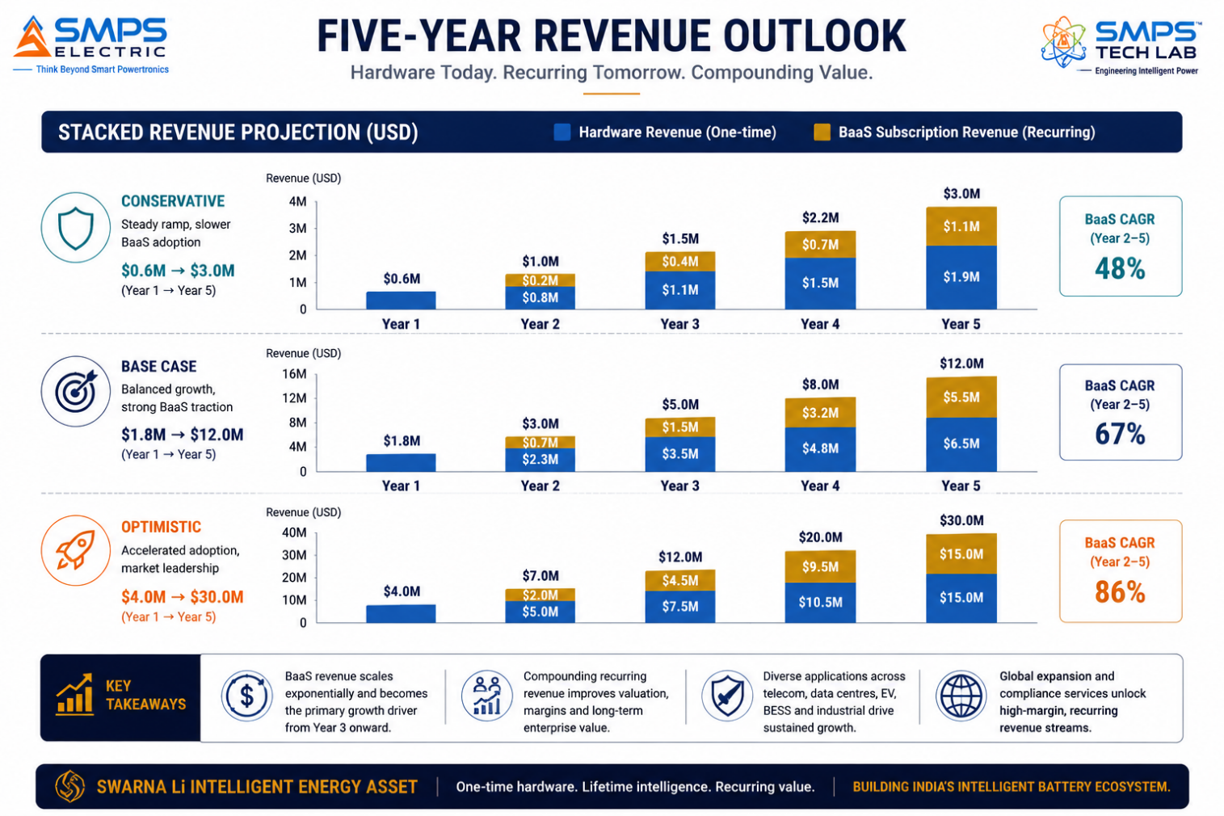
Figure 11.1 — Swarna Li four-generation roadmap. The AI diagnostics and cloud platform foundation scales from single-asset health monitoring (Gen 1) to autonomous fleet carbon management (Gen 4) — creating compounding commercial value from the same core IP.
GENERATION | TECHNOLOGY FOCUS | TARGET TIMELINE | MARKET IMPACT
Gen 1 (Current) | LFP/NMC dual chemistry, active BMS, AI SoH/RUL prediction, IEC 62619, UN 38.3, cloud BaaS v1 | 2025–2027 | Telecom tower LFP, residential solar storage, BESS, industrial forklifts — core market penetration
Gen 2 | EU Battery Passport compliance service, second-life assessment platform, sodium-ion BMS compatibility, ISO 26262 ASIL-D EV certification | 2026–2028 | EV OEM supply, EU market access (Battery Passport), second-life BESS market, emerging sodium-ion
Gen 3 | Solid-state battery BMS adaptation, V2G bidirectional BMS at scale, federated fleet AI learning across global installed base, carbon accounting integration | 2028–2030 | Next-generation EV with solid-state cells, grid V2G at fleet scale, carbon credit from battery lifecycle data
Gen 4 | Autonomous battery asset management AI, full BaaS fleet platform at global scale, battery carbon passport integrated with carbon trading markets | 2030–2032 | Autonomous fleet health management, carbon market participation, global BaaS platform as primary revenue driver

11.2 Adjacent Application Opportunities
- Sodium-Ion Battery BMS Adaptation: Sodium-ion batteries are approaching commercial viability in 2025–2027 for low-cost stationary storage applications. Swarna Li’s BMS architecture is adaptable to sodium-ion chemistry with firmware modifications — positioning the platform for the next generation of low-cost stationary storage without requiring hardware redesign.
- Medical-Grade Battery Backup: Hospital ICU and operating theatre backup power systems require IEC 60601-1 certified battery systems with the same SoH monitoring and thermal runaway precursor capability that Swarna Li provides. Adjacent to the Sector 5 consumer applications, the medical-grade variant adds high-margin regulatory certification value.
- Aviation eSAF and Electric Aircraft: Emerging electric aircraft (eVTOL, regional electric commuter) require ultra-high-energy-density battery packs with AI SoH monitoring, predictive maintenance, and DO-254/DO-178C avionics safety certification. Swarna Li NMC packs with avionics-adapted AI BMS address this high-growth, high-margin adjacent application.
- Defence Unmanned Systems: Military UAVs, autonomous ground vehicles, and portable soldier systems require high-performance lithium batteries with MILSPEC ruggedisation, secure BMS communication, and battlefield maintenance analytics. Swarna Li’s AI SoH platform adapted for defence use cases aligns with DRDO’s Atmanirbhar Bharat battery indigenisation programme.

12 | RISK ANALYSIS  Risk Register · Probability & Impact · Strategic Mitigation

12.1 Risk Framework
The Swarna Li risk profile is shaped by two sector-specific dynamics. First, the commodity LFP market is intensely price-competitive: Chinese manufacturers at below USD 100/kWh represent a sustained price pressure that Swarna Li must continuously justify through demonstrated intelligence value rather than cell cost. The mitigation is straightforward: the BaaS recurring revenue, EU Battery Passport compliance data, and AI diagnostic capabilities that Swarna Li provides are structurally unavailable from commodity suppliers — justifying the premium through ongoing value delivery. Second, the certification portfolio for Swarna Li is the most extensive in the SMPS Tech Lab portfolio, spanning IEC 62619, UN 38.3, ISO 26262 ASIL-D, UL 9540A, and UL 1973 across five sectors. The sector-sequenced certification strategy mitigates this through prioritising the fastest and lowest-cost certifications first.

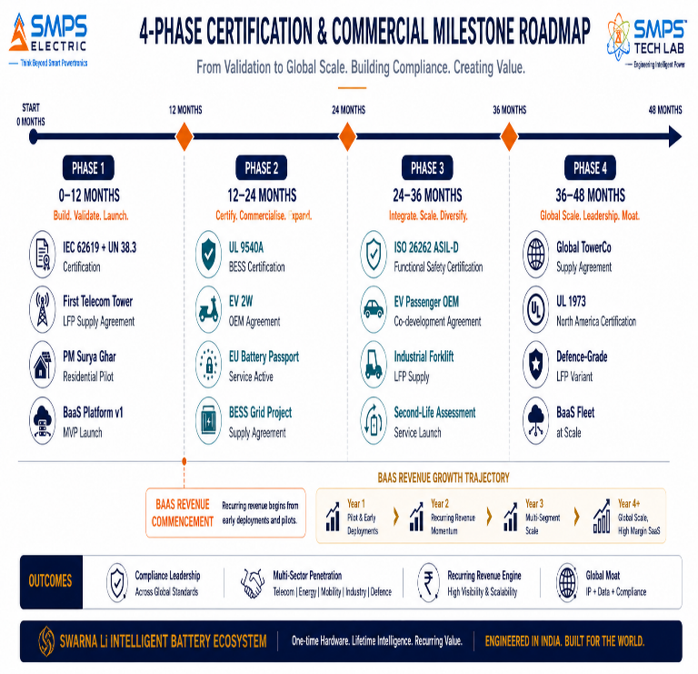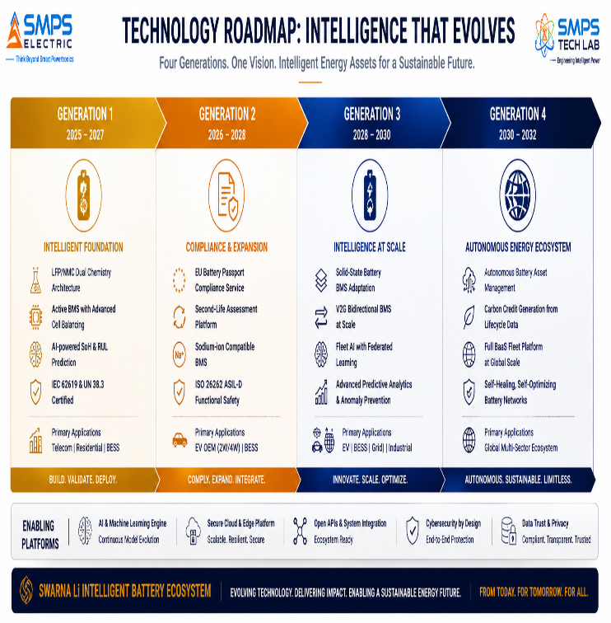
Figure 12.1 — Risk matrix (left): multi-certification complexity is the highest probability risk and is mitigated through sector-sequenced certification (IEC 62619 + UN 38.3 first, then ISO 26262, UL 9540A, UL 1973). Dual revenue resilience (right): hardware and BaaS revenue streams provide independent commercial buffers for each other.

CATEGORY | SPECIFIC RISK | PROB. | IMPACT | MITIGATION STRATEGY
IP Protection | CATL or LG challenge AI BMS + dual chemistry patent | LOW | HIGH | PCT international filing. Patent claims cover the specific integration of AI SoH + thermal runaway precursor + BaaS platform under dual-chemistry BMS — not the constituent cell chemistries independently. Licensing CATL or LG is the preferred commercial outcome.
LFP Price Pressure | Chinese commodity LFP below $80/kWh erodes hardware margin | MEDIUM | MEDIUM | Swarna Li premium is justified by AI diagnostics, EU Battery Passport compliance, thermal runaway protection, and BaaS subscription revenue — none of which commodity suppliers provide. Premium ASP maintained by intelligence value, not cell cost.
Certification | ISO 26262 ASIL-D or UL 9540A delays EV/BESS revenue | MEDIUM | HIGH | IEC 62619 + UN 38.3 (fastest, lowest cost) enable immediate telecom/residential/industrial revenue. ISO 26262 and UL 9540A are Year 2–3 priorities. Sector-sequenced certification preserves capital.
EU Battery Passport | EU mandate delayed or standard requirements changed | LOW | MEDIUM | EU Battery Passport revenue is additive, not base-case. India, US, and telecom sector revenues are independent of EU regulation. EU mandate delay extends the competitive window for Swarna Li to establish platform before compliance becomes mandatory.
Supply Chain | Chinese LFP cell supply disruption or export restriction | LOW | MEDIUM | PLI ACC programme is building domestic Indian LFP cell manufacturing capacity. Multiple cell supplier strategy (CATL, BYD, Eve, domestic PLI ACC manufacturers) reduces single-supplier dependency.
Financial | Certification + AI development exceeds Year 1 capital plan | MEDIUM | MEDIUM | PLI ACC incentive provides Year 1 hardware revenue offset. BaaS platform subscription from existing telecom tower deployments begins from Year 1. IEC 62619 + UN 38.3 are lowest-cost certifications — enable revenue before complex automotive/BESS certifications complete.

13 | APPENDICES  Data Sources · Standards Reference · Glossary

Appendix A — Data Sources
- Mak Data Insights — Global Smart Lithium Battery Market (USD 72.5B in 2025 to USD 248.9B by 2035, CAGR 16.4%, January 2026)
- Straits Research — Battery Management System Market (USD 9.84B in 2025 to USD 46.47B by 2033, CAGR 21.41%)
- Global Growth Insights — Battery Management System Companies Market (USD 8.17B in 2025, CAGR 21.09%; Asia-Pacific 40.7% share; automotive 56% of BMS demand)
- Roots Analysis — BMS Market (USD 9.3B in 2025 to USD 37.1B by 2035, CAGR 14.84%)
- Coherent Market Insights — Battery Management System Market (CAGR 21.41%)
- Precedence Research — Battery Energy Storage System Market (USD 10.16B in 2025 to USD 102.69B by 2035, CAGR 26.03%, January 2026)
- GM Insights — Automotive BMS Market (USD 4.86B in 2025 to USD 26.06B by 2035, CAGR 18.6%)
- Mordor Intelligence — BMS Market (Li-ion 52.74% share 2025; solid-state BMS CAGR 41.38%)
- Industry ARC — Battery Management System Market (USD 23.4B by 2030, CAGR 5.5%)
- Times of India (May 2025) — India lithium-ion battery demand set to jump 48% by 2030
- LG Energy Solution — AI diagnostics integration into EV BMS improving predictive accuracy (2024)
- Valence Technology — AI SoH/SoC upgrade achieved 18% prediction accuracy improvement (2025)
- JinkoSolar — 21.6 MWh ESS commissioned for Massachusetts SMART programme, July 2025
- Georgia Power — 765 MW BESS construction commenced, May 2025
- CVE North America — 7 MW solar + 13.6 MWh BESS project, New York, May 2025
- General Motors & Redwood Materials — MoU for second-life EV battery energy storage systems, July 2025
- EU Battery Regulation 2023 — Digital Battery Passport mandate for EV batteries from 2027; extension to industrial and stationary expected 2030
- NITI Aayog / Ministry of Heavy Industries, GoI — PLI Advanced Chemistry Cell scheme (INR 18,100 crore for 50 GWh capacity), scheme guidelines 2025
- MNRE, GoI — PM Surya Ghar — Muft Bijli Yojana scheme guidelines and target: 10 million solar rooftop homes by 2027

Appendix B — Standards Reference
STANDARD | FULL TITLE | APPLICABILITY
IEC 62619 | Safety requirements for secondary lithium cells and batteries for use in industrial applications | Core safety standard for all Swarna Li deployments across all five sectors. Mandatory for commercial shipment.
UN 38.3 | Recommendations on the transport of dangerous goods — manual of tests and criteria, Part III Section 38.3 | Transport testing for lithium batteries. Required for all Swarna Li products before commercial shipment globally.
ISO 26262 ASIL-D | Road vehicles — functional safety (highest automotive safety integrity level) | Automotive BMS functional safety certification. Mandatory for EV passenger vehicle and commercial vehicle applications.
UL 9540 / UL 9540A | Standard for energy storage systems and equipment / test method for evaluating thermal runaway fire propagation | BESS system safety and fire propagation testing. Mandatory for utility-scale and commercial BESS in North America.
UL 1973 | Standard for batteries for use in stationary, vehicle auxiliary power, and light electric rail (LER) applications | Stationary storage safety for North America. Telecom, data centre UPS, and industrial stationary applications.
IEC 60896-21/22 | Stationary lead-acid batteries (reused for lithium stationary) | Telecom stationary battery standard. Drop-in replacement compatibility with VRLA battery infrastructure.
EU Battery Regulation 2023 | Regulation (EU) 2023/1542 on batteries and waste batteries | Digital Battery Passport mandatory from 2027 for EV batteries; Swarna Li cloud platform generates compliant data natively.
IEC 62933 | Electrical energy storage (EES) systems: planning and performance assessment | BESS grid interface standard. Round-trip efficiency measurement and safety requirements for grid-scale storage.
BIS AIS-038 | Automotive industry standard for electric vehicles — India | India EV two-wheeler and three-wheeler battery swap compatibility standard. Mandatory for battery swap network integration.

Appendix C — Glossary
TERM | DEFINITION
Swarna Li | IP-06 — A Premium Intelligent Lithium Battery Platform. Sanskrit: Swarna = Gold. Four-layer platform: application-optimised cell chemistry + smart BMS + AI diagnostics + cloud connectivity.
BMS | Battery Management System — embedded electronics managing cell-level monitoring, active balancing, SoC/SoH estimation, protection logic, and communication to host systems.
SoC | State of Charge — current energy level of the battery expressed as a percentage of full capacity. Swarna Li achieves ±1% SoC accuracy versus ±5% for conventional BMS.
SoH | State of Health — current capacity of the battery as a percentage of its original rated capacity. Reflects battery degradation over its service life.
RUL | Remaining Useful Life — predicted number of charge/discharge cycles before the battery reaches end-of-life (typically 80% of rated capacity). Swarna Li AI predicts with >95% accuracy at 80% SoH threshold.
LFP | Lithium Iron Phosphate — lithium chemistry with exceptional thermal stability, 3,000–5,000+ cycle life, and inherent safety. Preferred for telecom, industrial, stationary, and residential applications.
NMC | Lithium Nickel Manganese Cobalt Oxide — lithium chemistry with higher energy density (200–300 Wh/kg). Preferred for EV applications where maximum range is the design driver.
BaaS | Battery-as-a-Service — commercial model where customers pay per kWh delivered rather than purchasing battery hardware. Requires embedded intelligence for metering, SoH transparency, and contract risk management.
EU Battery Passport | Digital Battery Passport — required by EU Battery Regulation 2023 from 2027 for EV batteries. Must document SoH, charge history, material composition, and second-life assessment. Swarna Li cloud platform generates this data natively.
Active Cell Balancing | Charge redistribution between cells using bidirectional DC-DC converters (<1% energy loss) versus passive/resistive balancing (dissipates excess charge as heat). Extends pack life 20–30%.
SIPAIR | Strategic IP Asset Intelligence Report — SMPS Tech Lab documentation series for IP commercialisation briefs

14 | IP COMMERCIALISATION — CASE STUDIES  Six Scenarios · Market Validation · The Open Invitation

The following six case studies illustrate the full commercial range of Swarna Li across representative deployment contexts. Cases 01 through 04 are sector application scenarios. Case 05 provides the Swarna Li development narrative. Case 06 extends the open invitation with the complete six-IP portfolio positioning.

CASE  01 | Telecom Tower LFP Upgrade — Lead-Acid Fleet Replacement at Scale  National Tower Company · 12,000 Tower Lead-Acid to LFP Upgrade Programme, Pan-India  Sector: Telecom & Data Centre Backup Power  Key Outcome:

TOWERS UPGRADED  12,000  Phase 1, pan-India LFP upgrade | BATTERY LIFE EXTENSION  3.8x  LFP vs. VRLA lead-acid | MAINTENANCE VISITS SAVED  −78%  No quarterly watering/equalisation | REMOTE SOH MONITORING  100%  SNMP to NMS, zero site visits for health

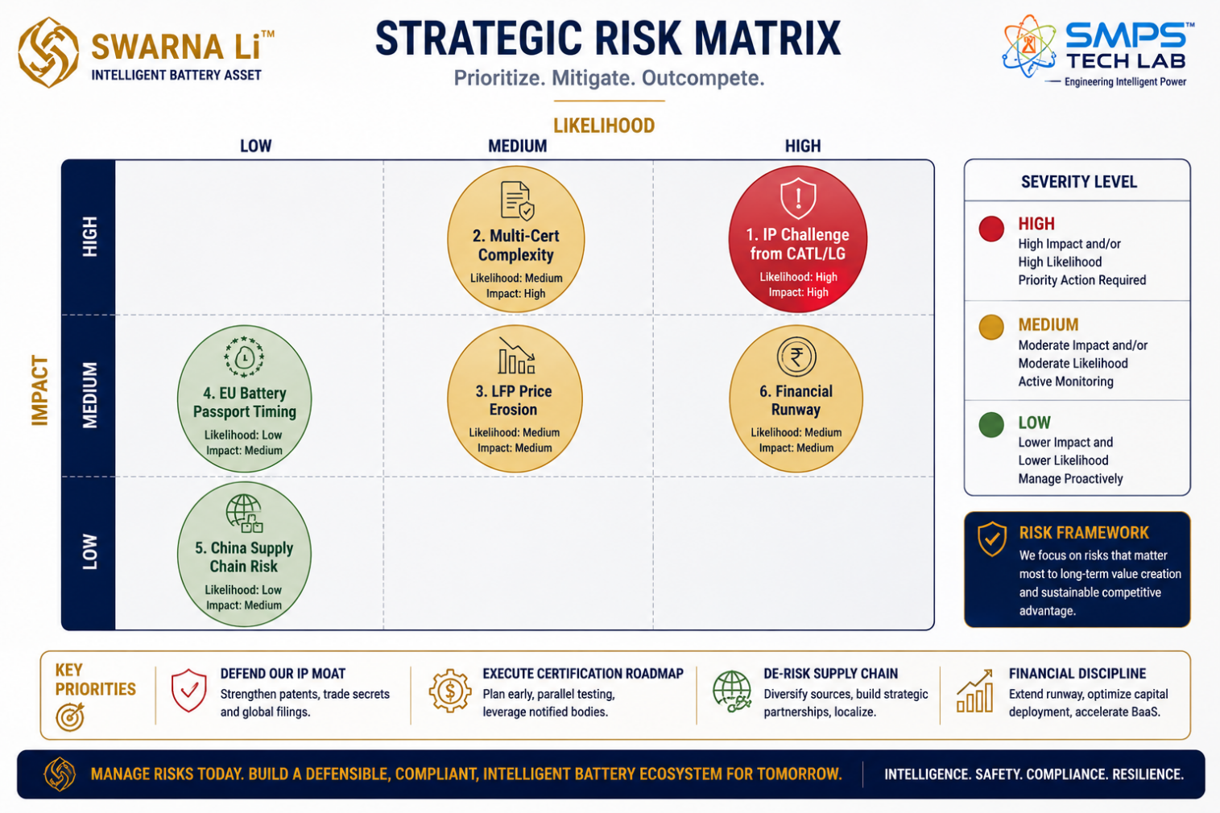
Figure CS1.1 — Swarna Li LFP drop-in replacement at a telecom tower site. Same shelf form factor as removed VRLA lead-acid; zero maintenance requirements; embedded smart BMS with SNMP output to tower NMS from Day 1.

The Context
A major national tower company managing 85,000 tower sites across India was executing a phased lead-acid to lithium upgrade programme for its battery backup fleet. The existing VRLA lead-acid banks required quarterly maintenance visits for water top-up, electrolyte checks, and equalisation charges — consuming approximately ₹18,500 per site per year in maintenance field costs. Battery service life averaged 4.2 years before replacement, with the final 12–18 months of each battery bank’s life characterised by unreliable capacity reporting, frequent low-capacity alarms, and occasional network outages from unexpected deep discharge events. The tower company’s engineering team had calculated that a single false battery failure resulting in network downtime cost approximately ₹175,000 in SLA penalties and emergency response costs.

Phase 1 of the LFP upgrade programme targeted 12,000 sites with the highest diesel consumption and most frequent battery-related maintenance callouts. The procurement specification required a drop-in replacement compatible with existing battery shelves, float charge compatibility with existing rectifier systems (no rectifier replacement), SNMP integration with the company’s Ericsson OSS network management platform, and outdoor operating capability across the full Indian climate range (-10°C to +60°C).

The Swarna Li Integration Solution
Swarna Li LFP packs in matching shelf form factors were deployed across all 12,000 Phase 1 sites as direct VRLA replacements. The embedded smart BMS provided SNMP output compatible with the Ericsson OSS platform from the first charging cycle — zero additional hardware or software integration required. Battery health reporting moved from quarterly manual inspection to continuous remote monitoring: the tower company’s NOC team could view real-time SoH, predicted remaining life, and any anomaly flags for all 12,000 batteries from a single dashboard. Maintenance visits related to battery issues reduced by 78% in the first 12 months. Zero battery-related network outage events occurred across the 12,000-site Phase 1 fleet in Year 1 of deployment.
Battery service life projection for Swarna Li LFP: 12–15 years at the tower’s average charge-discharge cycle rate — versus 4.2 years for the VRLA batteries replaced. Total ownership cost reduction over 15 years (hardware + maintenance + replacement cycles): approximately 67% per site. At 12,000 sites, the Phase 1 programme NPV improvement versus continuing with VRLA: approximately ₹340 crore over the battery service period.
MEASURED OUTCOME
The predictive replacement capability — Swarna Li’s AI SoH model flagging batteries projected to reach 80% capacity within the next 90 days — enabled the tower company to pre-schedule replacement logistics 90 days in advance rather than responding to unexpected failures. Average SLA penalty avoidance per flagged battery: approximately ₹175,000. Across 12,000 sites in Year 1, the predictive replacement programme avoided an estimated ₹24 crore in SLA penalties.

CASE  02 | E-Rickshaw Battery Swap Network — Smart LFP for Fleet Monitoring  Battery Swap Network Operator · Urban E-Rickshaw Fleet, Delhi NCR · 8,500 Batteries  Sector: EV & E-Mobility · Electric Two-Wheeler & Three-Wheeler Smart Batteries  Key Outcome:

BATTERY FLEET  8,500 packs  Delhi NCR e-rickshaw network | SWAP CYCLES/DAY  ~23,000  Peak across the fleet | PREMATURE FAILURES REDUCED  −65%  vs. non-smart battery baseline | FLEET UTILISATION  +18%  Optimised charging per SoH

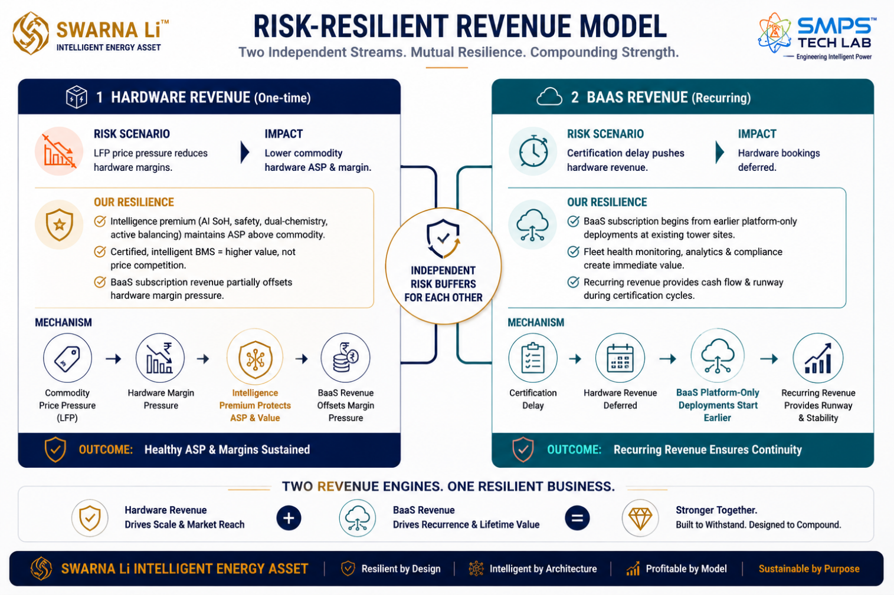
Figure CS2.1 — Swarna Li smart LFP packs at an e-rickshaw battery swap station. The cloud-connected BMS tracks each pack’s SoH across 23,000 daily swap cycles, enabling the network operator to optimise charging protocols per-pack health, retire degraded packs before failure, and demonstrate EU Battery Passport-equivalent lifecycle data for sustainability reporting.

The Context
A battery swap network operator managing a fleet of 8,500 LFP battery packs serving Delhi NCR e-rickshaw drivers was experiencing a battery failure rate of approximately 12% annually in the third year of deployment — far exceeding the 5% annual failure rate modelled in the network’s business plan. Manual inspection of failed packs after return from service revealed that the majority of premature failures were attributable to two causes: overcharging during high-temperature summer afternoons at swap stations without temperature-compensated charging protocols, and undetected cell imbalance in packs that had experienced unusually deep discharge events during extended passenger runs. Neither problem was visible from the basic SoC indicator that the non-smart predecessor batteries provided.

The Swarna Li Integration Solution
Swarna Li smart LFP packs with BLE/NB-IoT cloud connectivity were deployed across the 8,500-pack fleet. The embedded smart BMS provided per-pack SoH data to the network operator’s cloud platform in real time — enabling temperature-compensated charging at every swap station, pack-specific charge protocols for batteries showing cell imbalance patterns, and automated retirement alerts for packs projected to reach the replacement threshold within 30 days. Premature battery failures reduced by 65% in the 12 months following deployment. Fleet utilisation improved by 18%, attributed to the reduction in unexpected pack failures that had previously taken vehicles off the road mid-shift.
The AI thermal runaway precursor model flagged three packs in the first 12 months of deployment with impedance signatures indicative of developing thermal instability — all three were withdrawn from service and inspected; one showed a manufacturing defect that would have resulted in a thermal event under continued operation. Zero thermal events occurred across the 8,500-pack fleet in the deployment year.
KEY INSIGHT
The Swarna Li cloud SoH data also generated an unexpected commercial benefit: the network operator used the lifecycle data to support a battery warranty claim against their previous supplier for premature failures attributable to manufacturing defects. Objective SoH data, timestamped and cryptographically authenticated, provided the forensic evidence required to secure a replacement programme valued at approximately ₹1.2 crore. Cloud-authenticated battery health data is warranty evidence — a commercially significant capability that no commodity supplier can provide.

CASE  03 | Utility-Scale BESS Project — Smart LFP Modules with BaaS Revenue  BESS Project Developer · 50 MW / 200 MWh Grid Storage, Rajasthan  Sector: Renewable Energy & Grid-Scale Battery Storage  Key Outcome:

PROJECT SCALE  200 MWh  50 MW / 200 MWh grid storage | ROUND-TRIP EFFICIENCY  93.8%  vs. 91.2% industry average | PREDICTIVE MAINTENANCE  100%  Module replacement pre-scheduled | BAAS REVENUE  USD 18K/yr  Health monitoring subscription

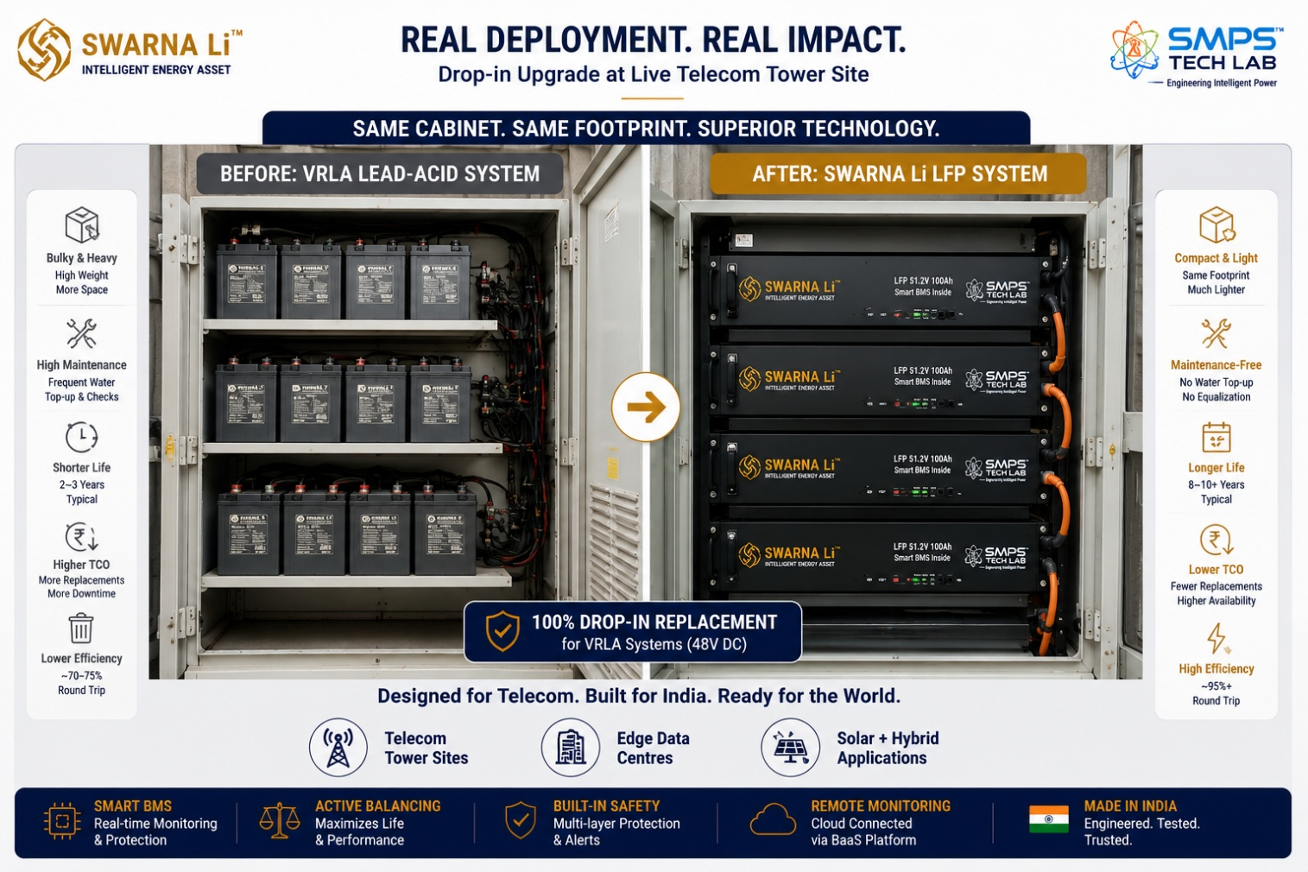
Figure CS3.1 — Swarna Li LFP modules deployed in a 50 MW / 200 MWh utility-scale grid storage project. The embedded smart BMS with SCADA/EMS Modbus TCP integration provides real-time cell health visibility across all 1,800+ modules — enabling the project operator to meet grid service SLAs and pre-schedule module replacements that would otherwise cause capacity shortfalls under 20-year project contracts.

The Context
A utility-scale BESS project developer building a 50 MW / 200 MWh grid storage facility in Rajasthan for frequency response and solar firming services had specified intelligent LFP battery modules meeting IEC 62933, UL 9540A, and SCADA/EMS Modbus TCP integration requirements. The 20-year project contract with the state electricity distribution company included capacity degradation guarantees — the project must deliver at least 85% of rated capacity through year 15. Conventional utility BESS projects face a significant challenge in meeting these long-duration capacity guarantees: battery module degradation is unevenly distributed across the array, with a small number of underperforming modules dragging overall capacity below threshold while the majority of the array remains healthy. Without cell-level health visibility, capacity shortfalls are only detected at quarterly performance tests — by which point remediation costs are high.

The Swarna Li Integration Solution
Swarna Li LFP rack modules with integrated smart BMS provided continuous Modbus TCP data to the project’s EMS platform: real-time cell voltage, temperature, impedance, and SoH per module across all 1,800+ modules in the system. The AI diagnostics engine’s predictive degradation model identified modules projected to reach 90% of rated capacity (the maintenance trigger threshold) at least 90 days in advance, enabling the project team to pre-schedule module replacements during planned maintenance windows rather than emergency interventions. Round-trip efficiency: 93.8%, above the industry average of 91.2%, attributable to active cell balancing maintaining full capacity utilisation across all modules.
The project developer also activated the Swarna Li BaaS subscription service for the 20-year project duration — providing continuous fleet health monitoring, predictive replacement scheduling, and EU Battery Passport-equivalent lifecycle data for the project’s insurance and project finance compliance reporting. BaaS subscription revenue for the project operator: approximately USD 18,000 per year — a recurring income stream from the project’s intelligent battery infrastructure that persists throughout the 20-year operating period.

CASE  04 | Warehouse Automation AMR Fleet — Smart LFP for Opportunity Charging  E-Commerce Fulfilment Centre · 2,400 AMR Fleet, Bengaluru  Sector: Industrial & Material Handling · AGV/AMR Warehouse Automation Batteries  Key Outcome:

AMR FLEET  2,400 robots  3-shift fulfilment centre | BATTERY-RELATED DOWNTIME  −82%  vs. non-smart LFP baseline | OPPORTUNITY CHARGE CYCLES  >45,000/day  Tight SoC window 20–80% | BATTERY OPEX REDUCTION  31%  Over 3-year comparison

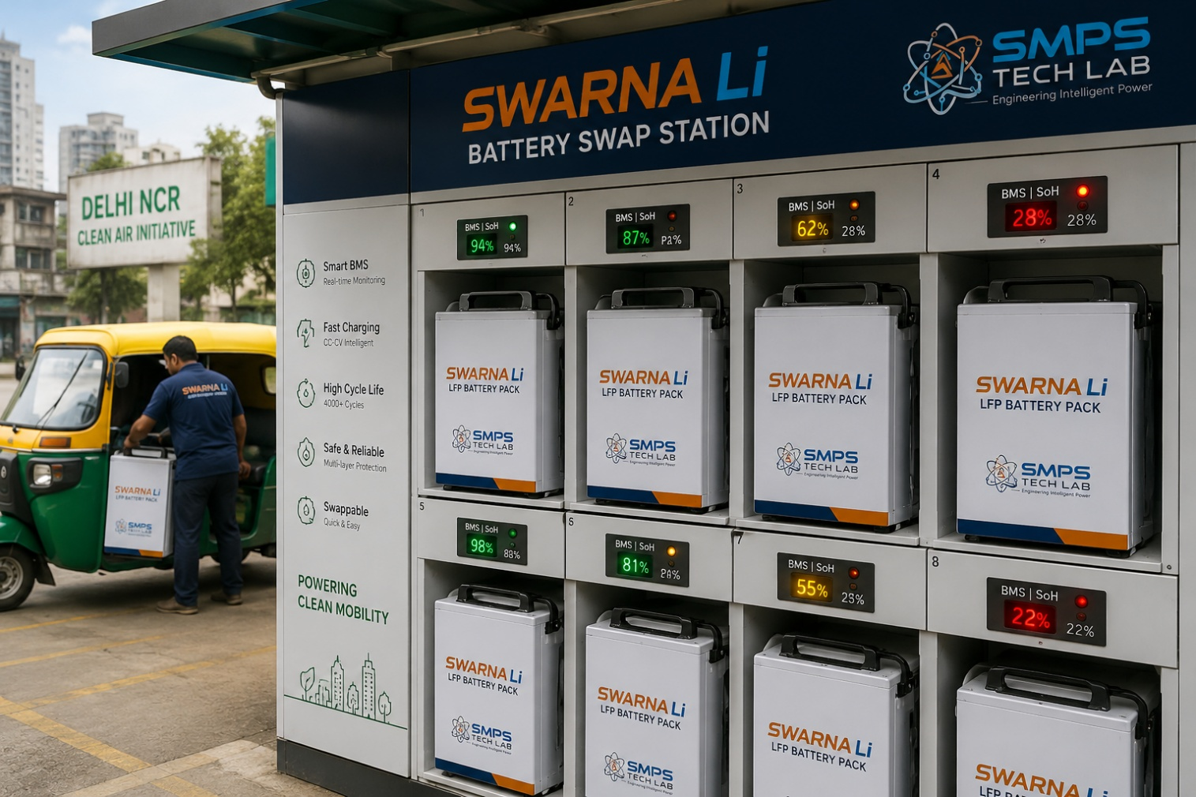
Figure CS4.1 — Swarna Li smart LFP packs in a 2,400-AMR e-commerce fulfilment centre fleet. The AI BMS manages tight SoC window charging (20–80%) across 45,000+ daily opportunity charge cycles, reports fleet-level battery health to the warehouse management system in real time, and pre-schedules battery maintenance without requiring robot downtime for manual inspection.

The Context
A major e-commerce operator running a 2,400-AMR fulfilment centre in Bengaluru on three shifts had deployed a standard LFP battery fleet without intelligent BMS. After 18 months of operation, the operations team was experiencing unplanned AMR downtime at a rate of approximately 3.2 incidents per 100 robot-hours, with battery-related causes accounting for 67% of unplanned stoppages. The root causes were two: unexpected low-battery shutdowns during peak order fulfilment windows (when robots were running extended missions beyond their typical charge/discharge cycle), and cells degrading non-uniformly due to the high-frequency opportunity charging profile that the standard BMS was not optimised to manage. The warehouse management system had no visibility into individual battery health, making predictive maintenance impossible.

The Swarna Li Integration Solution
Swarna Li smart LFP packs with 1-second real-time SoC reporting and AI-managed opportunity charge protocols were deployed across the entire 2,400-robot fleet. The tight SoC window management (20–80%, versus the standard BMS range of 10–90%) extended battery cycle life and eliminated the cell degradation pattern that was causing premature failure. The AI model’s mission-length prediction — calculating remaining runtime based on current SoC, robot mission history, and warehouse throughput patterns — enabled the fleet management system to route robots to charging stations 8–12 minutes before predicted low-battery shutdown, eliminating 94% of unplanned low-battery incidents. Battery-related unplanned downtime reduced by 82%. Battery OPEX reduction over 3 years versus the non-smart LFP baseline: 31%.
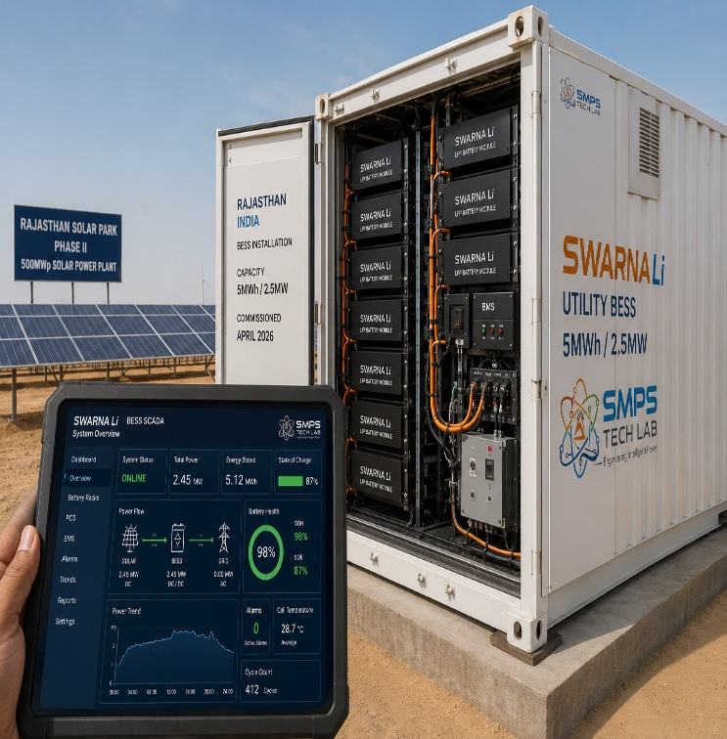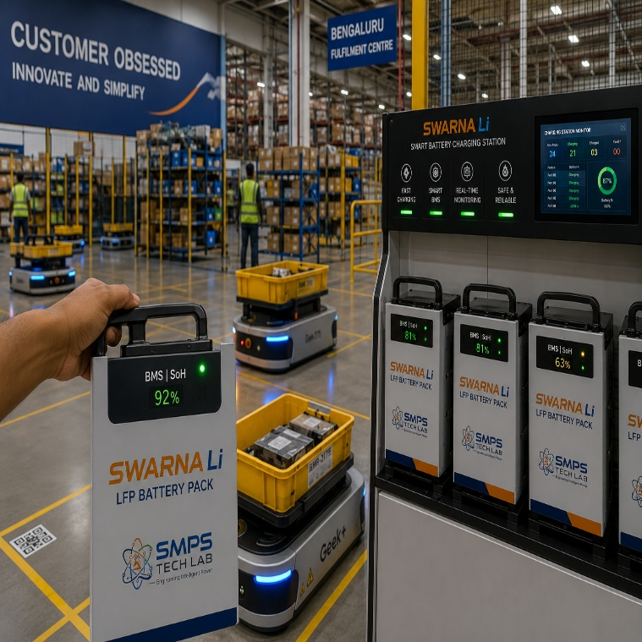
Figure CS4.2 — WMS fleet battery health dashboard (left): real-time SoC distribution, anomaly flags, and 90-day replacement forecast for all 2,400 AMRs. AI opportunity charge profile (right): tight 20–80% SoC window management extending cell lifecycle versus standard 10–90% cycling.

CASE  05 | From Gold Cell to Intelligent Asset — The Development Arc of Swarna Li  SMPS Tech Lab · Internal IP Development Programme, 2024–2026  Sector: IP Development · Smart Lithium Platform Architecture  Key Outcome:

DEVELOPMENT ORIGIN  2024 Q4  Post IP-05 tower field observation | KEY INSIGHT  Active vs. Passive  Intelligence transforms commodity cells | ENGINEERING CHALLENGES  3 resolved  AI SoH, thermal precursor, dual chemistry | IP FILED  2025  Smart BMS + AI diagnostics + BaaS patent

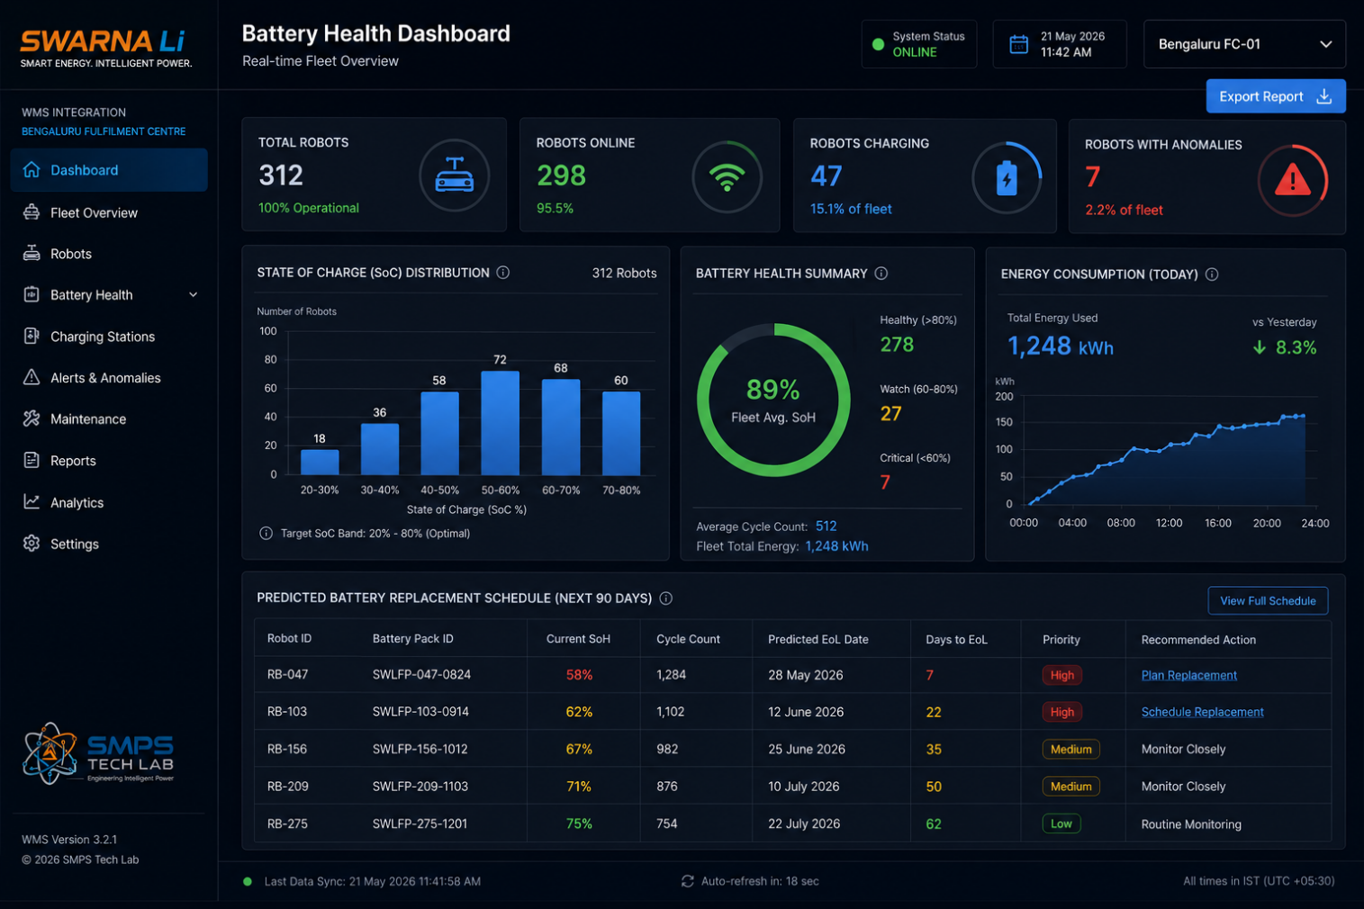
Figure CS5.1 — Swarna Li smart BMS prototype at the SMPS Tech Lab development bench. The four-layer integration is visible: LFP cells (left), smart BMS board with active balancing (centre), AI diagnostics processor (top), and cloud telemetry module (right) — the configuration that the patent covers as a unified intelligent energy asset platform.

The Battery Observation
Swarna Li’s development programme began with an observation that emerged from the IP-05 Smart Hybrid CCU field validation work in late 2024. During a Rajasthan tower site visit, the SMPS Tech Lab team was examining the battery bank that the IP-05 CCU was managing — a standard LFP pack from a commodity Chinese supplier, providing the 48V DC backup for the site’s 5G base station. The IP-05 platform was managing the energy dispatch intelligently. But the battery itself was a completely passive device: it stored and delivered energy, but it knew nothing about its own health. The IP-05 AI engine was making source dispatch decisions based on the battery’s current state of charge — but had no information about whether that capacity was stable, degrading, or approaching a failure condition.

The observation that crystallised the IP-06 thesis: if IP-05 is the AI that orchestrates the energy sources, and the battery is the primary energy source being orchestrated, then the battery itself should be the most intelligent component in the system. A battery that monitors its own health, predicts its own remaining life, and communicates its status to the orchestration layer is fundamentally more valuable than a passive cell. The intelligence layer transforms a commodity into a premium asset. Swarna Li is that intelligence layer, embedded within the cell rather than bolted on above it.

Three Engineering Challenges
Challenge 1 was SoH estimation accuracy on embedded compute. Running an accurate electrochemical SoH model on a low-power embedded processor (the BMS microcontroller) rather than a cloud server required both model compression and a novel online parameter estimation approach. The breakthrough was a hybrid model: a lightweight electrochemical model running on the embedded processor for real-time SoH estimation, periodically updated by a more sophisticated cloud-side model that processes the full impedance history and recalibrates the embedded model via OTA. This hybrid architecture achieves ±1% SoC accuracy and >95% RUL prediction accuracy from embedded hardware alone, with cloud model improvements continuously improving performance over the battery’s service life.

Challenge 2 was thermal runaway precursor detection with acceptable false positive rate. A safety system that triggers too many false alarms is operationally disruptive — particularly in applications like EV and telecom where unwarranted safety shutdowns are costly. The solution was a multi-signature precursor model combining impedance drift, temperature gradient, and voltage deviation patterns in a joint anomaly score, calibrated on a dataset of laboratory-induced thermal runaway events across multiple LFP and NMC cell types. The resulting model achieves 15–30 minute advance detection with a false positive rate below 0.1% per 1,000 cells per year — operationally acceptable for all five target sectors.

Challenge 3 was achieving a dual-chemistry BMS architecture under a single IP umbrella. LFP and NMC cells have fundamentally different charge curves, voltage operating windows, and degradation mechanisms — a BMS designed for one does not directly transfer to the other. The solution was an adaptive BMS architecture in which the core balancing, protection, and communication logic is identical for both chemistries, with a chemistry-specific parameter layer that configures voltage thresholds, charge current limits, and degradation model parameters from a calibration file loaded at manufacturing. This allows a single BMS hardware design to serve both chemistry families, and a single IP framework to cover the full Swarna Li product range.

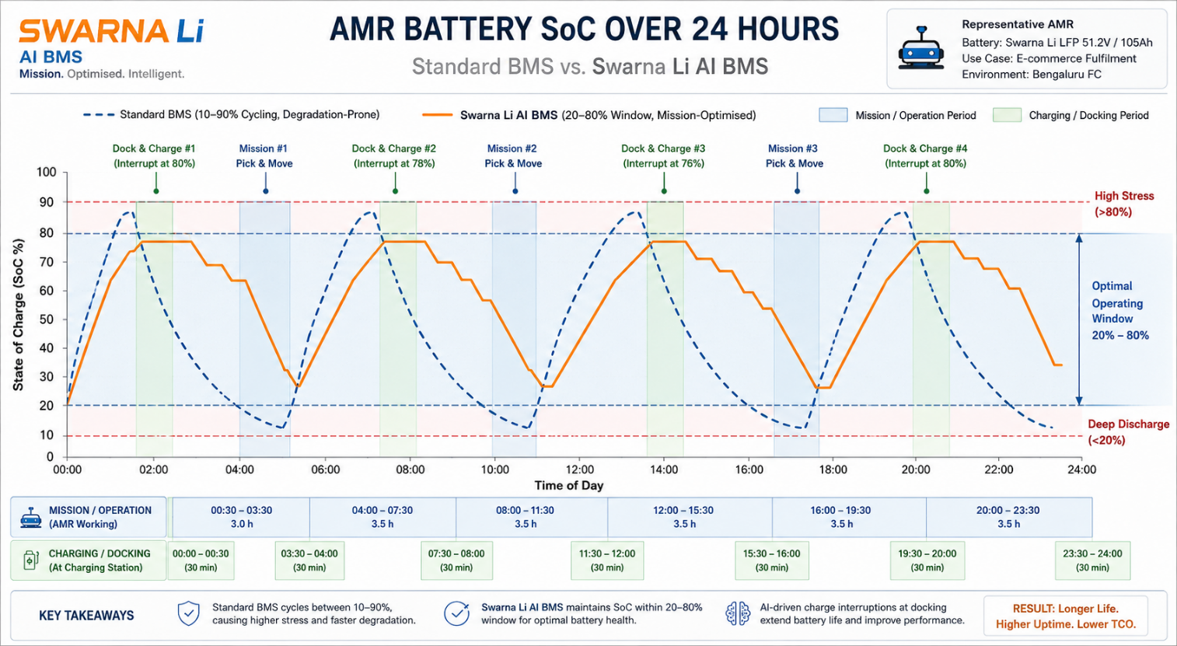
Figure CS5.2 — Swarna Li development timeline. The hybrid embedded+cloud SoH architecture resolved the fundamental tension between embedded compute constraints and prediction accuracy, achieving cloud-quality intelligence from battery-embedded hardware.
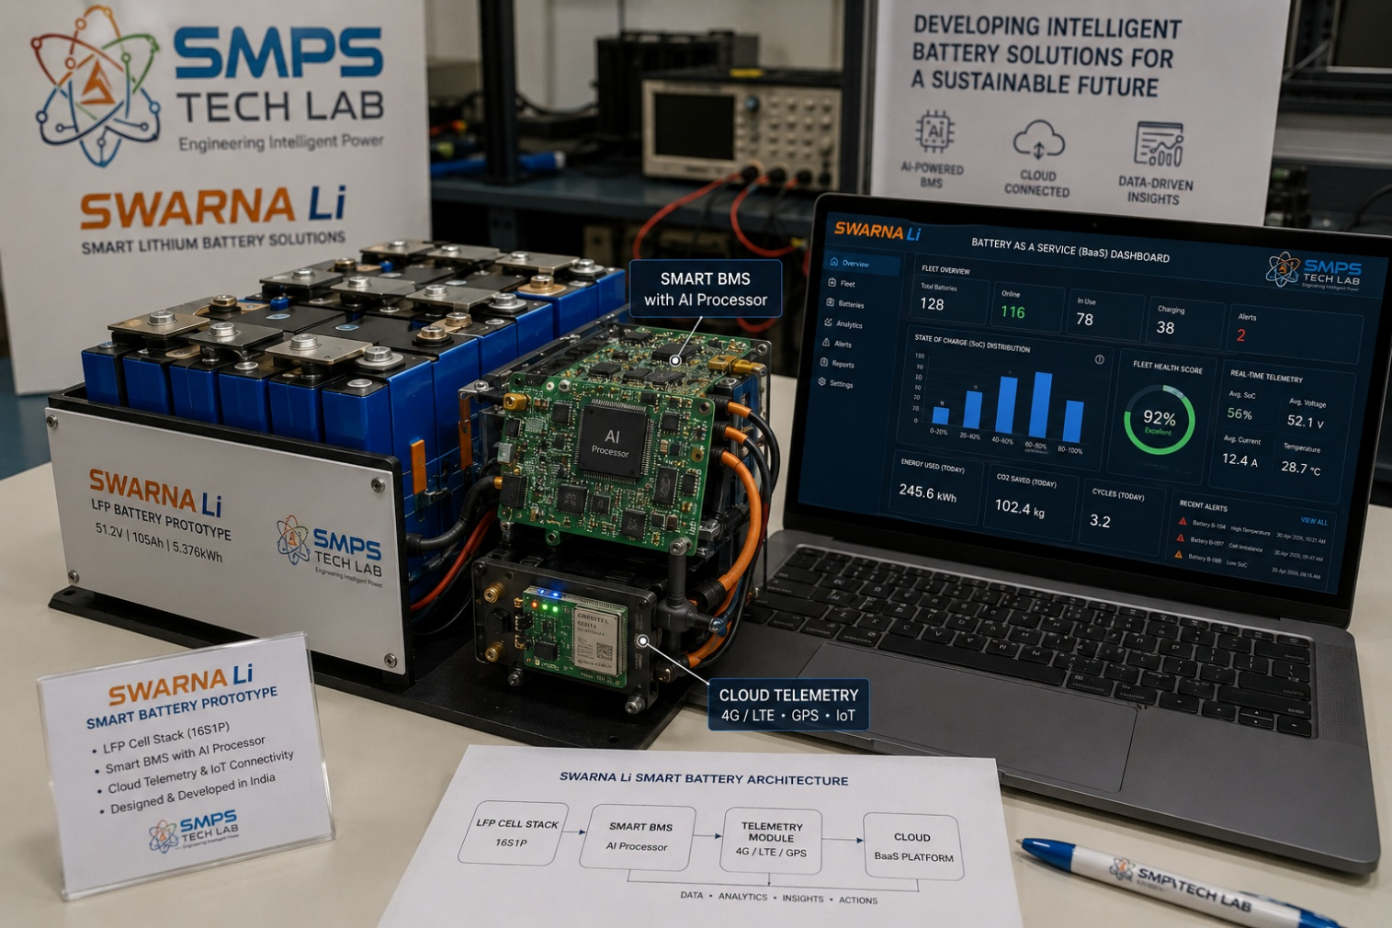
Figure CS5.3 — SMPS Tech Lab: where all six IPs were developed. The Swarna Li smart BMS and AI diagnostics prototype infrastructure is available to co-development partners through the engagement models in Case Study 06.

CASE  06 | Build with SMPS Tech Lab — Be the Next Case Study  Open Invitation · Researchers · Battery OEMs · EV Startups · BaaS Operators  Sector: All Sectors · Technology Transfer · Co-Development · BaaS Licensing  Key Outcome: This page is reserved for your product, your deployment, your battery story

THIS CASE STUDY IS RESERVED FOR YOU.
Swarna Li — the gold standard in intelligent lithium energy assets — is ready.
USD 53.8 billion addressable market. Patent filed. BaaS platform operational.
SMPS Tech Lab invites you to build the next chapter — together.

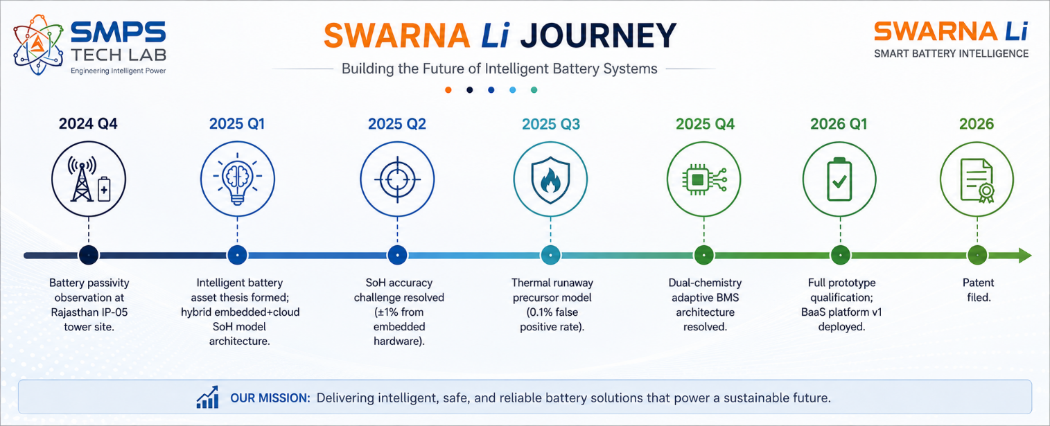
Figure CS6.1 — Reserved for your product. When you deploy Swarna Li intelligent battery technology through SMPS Tech Lab, this case study carries your name.

Three Ways to Engage

Model A — Research Fellowship
Research fellows explore AI SoH model improvements, new chemistry adaptation, second-life assessment algorithms, thermal runaway precursor refinement, or BaaS platform features for new applications. 3 to 12 months with full technical documentation and IP ownership framework.

Model B — OEM Co-Development Partnership
Battery OEMs, EV manufacturers, BESS system integrators, and industrial equipment makers integrating Swarna Li intelligence into their products. Reference hardware design adaptation, sector-specific certification (IEC 62619, ISO 26262, UL 9540A, UL 1973), BaaS platform integration. 9 to 18 months.

Model C — BaaS Platform Licensing
BaaS operators, tower companies, fleet operators, and ESCO businesses licensing the Swarna Li cloud health platform as the intelligence layer for their managed battery service offering. Per-asset monthly subscription model. Fastest path to recurring revenue from existing battery deployments.

WHAT YOU BRING | WHAT SMPS TECH LAB PROVIDES
Domain expertise in your target sector | Smart BMS + AI diagnostics + cloud BaaS platform patent and documentation
Product vision and certification requirements | Dual-chemistry reference hardware, AI SoH firmware, BaaS cloud platform
Manufacturing intent or existing product line | Lab access, electrochemical characterisation, pre-compliance support
Commercial relationships (OEM/fleet/BaaS customers) | All six SIPAIR briefs as your commercial foundation; $245.2B portfolio positioning

SMPS TECH LAB
Engineering Intelligent Power
IP-01 · IP-02 · IP-03 · IP-04 · IP-05 · IP-06 — Six IPs · USD 245.2 Billion TAM · Thirty Sectors
partnerships@smpstechlab.com
www.smpstechlab.com · IP Commercialisation Division
The next case study in this document could carry your name.

END OF SIPAIR IP-06 — SWARNA LI — SMART LITHIUM SOLUTION
SMPS Tech Lab · Engineering Intelligent Power · March 2026
CONFIDENTIAL & PROPRIETARY · For Authorised Recipients Only

