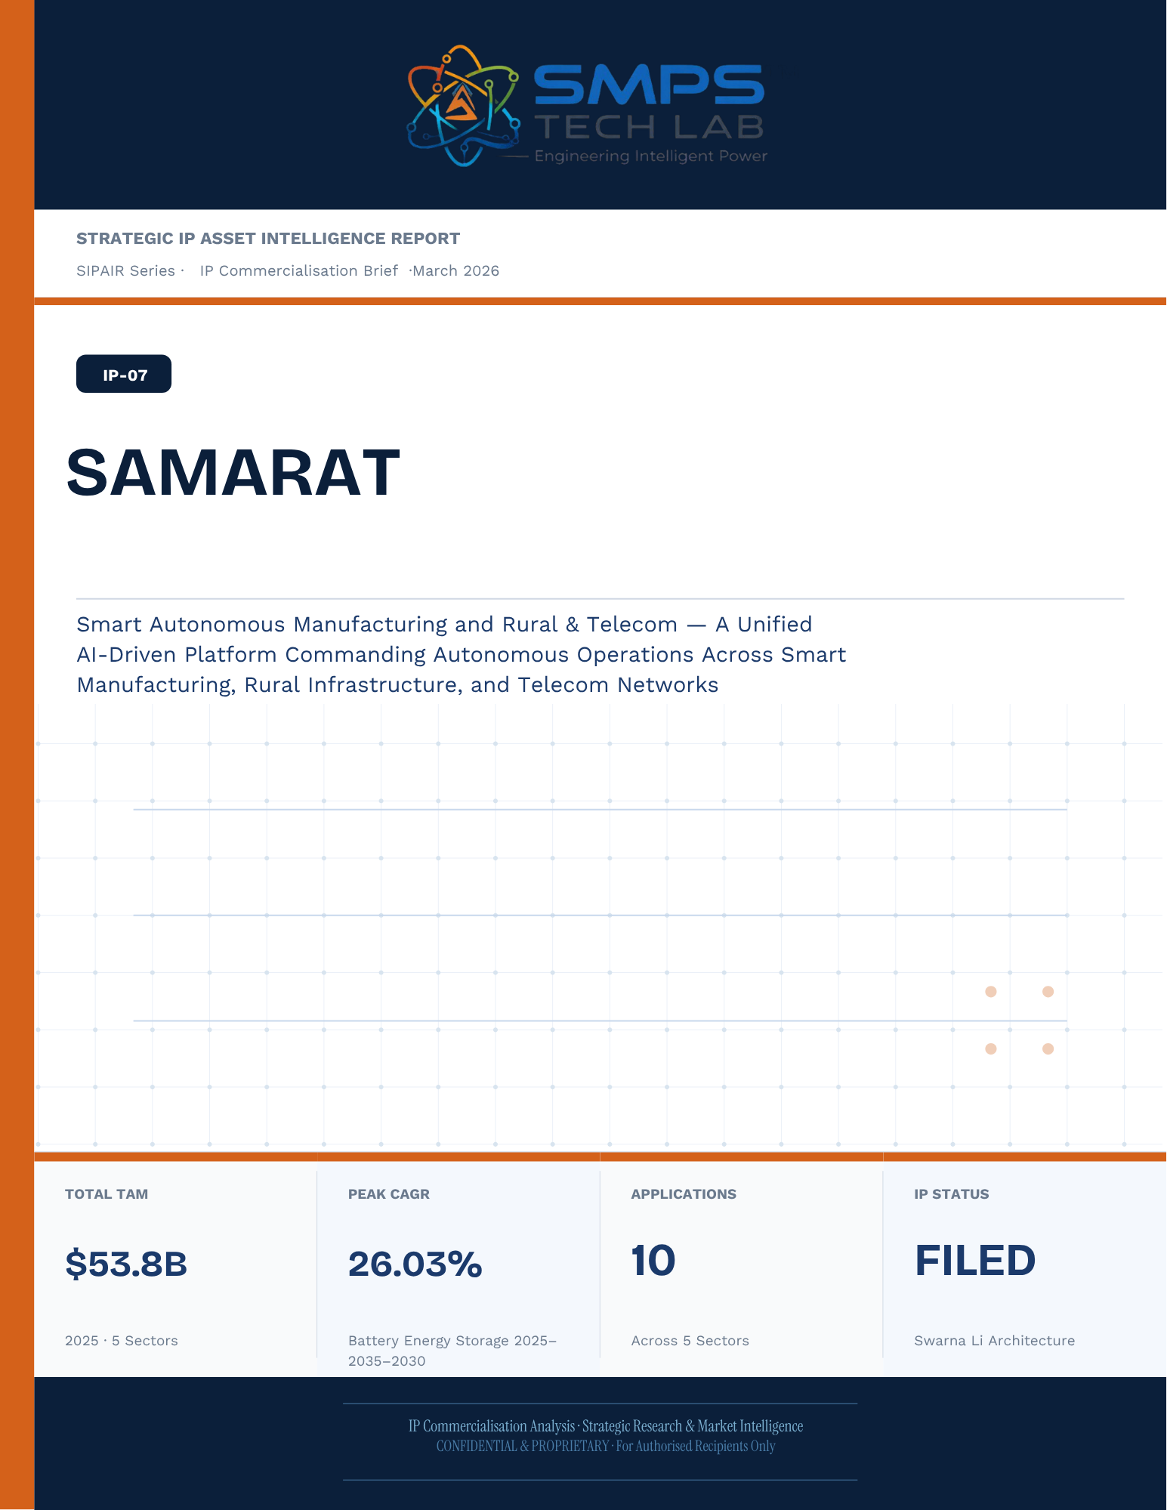
Un-named
[Email address]
Abstract
[Draw your reader in with an engaging abstract. It is typically a short summary of the document.
When you’re ready to add your content, just click here and start typing.]
STRATEGIC IP ASSET INTELLIGENCE REPORT
SIPAIR Series
IP-07: SAMARAT
SMPS-Based Integrated SAMARAT for Uninterrupted Telecom Power

Report Title | SIPAIR IP-07 — SAMARAT Commercialisation Brief

Document Series | Strategic IP Asset Intelligence Report (SIPAIR)

Version | Version 1.0 — First Edition

Compiled & Edited by | Shri Amareshwar Karatagi

Organisation | SMPS Tech Lab — Engineering Intelligent Power

Date of Issue | March 2026

Classification | Confidential & Proprietary — For Authorised Recipients Only

IP Reference | IP-07 — SAMARAT Architecture, Filed 2025

Related Document | SIPAIR IP-01: Smart Hybrid SMPS (see companion brief)

This document is prepared by SMPS Tech Lab as part of the SIPAIR IP Commercialisation Series.

Declaration — Originality & Intellectual Property Statement

This Strategic IP Asset Intelligence Report (SIPAIR — IP-07: SAMARAT) is an original compilation prepared by SMPS Tech Lab. The analysis, market intelligence frameworks, commercial strategy formulations, and case study narratives contained herein are the result of independent research and original intellectual work by the authors and editors named in this document.

The core technology described in this report — the SMPS-Based Integrated SAMARAT architecture, including its active power management layer, CCU intelligence stack, uninterrupted multi-rail AC/DC delivery system, and NMS integration platform — is the exclusive proprietary invention of SMPS Tech Lab, protected under a filed novel design patent (2025). IP-07 is a distinct and independently protectable invention from IP-01 (Smart Hybrid SMPS), though both emerge from the same SMPS Tech Lab research programme. The two IPs are designed to complement each other across adjacent application verticals and may be jointly licensed or co-deployed where application requirements demand both hybrid topology and active power management intelligence.

Market sizing data, CAGR estimates, and industry statistics cited in this document are sourced from independent third-party research publications, fully attributed in Appendix A. All third-party data is used for analytical and benchmarking purposes only. This report has not been submitted, in whole or in part, to any other organisation for commercialisation or formal assessment except as specifically disclosed in writing.

Declared by:

Shri Amareshwar Karatagi
Founder & CSO
SMPS Tech Lab · March 2026

CERTIFICATE OF AUTHENTICITY
IP Commercialisation Documentation · SIPAIR IP-07

This is to certify that the Strategic IP Asset Intelligence Report
SIPAIR IP-07 — SAMARAT
has been compiled, reviewed, and authenticated by the undersigned in accordance
with the standards of the SIPAIR documentation series. The technology, market analysis,
and commercial intelligence herein are verified as accurate to the best of the signatories’
knowledge as at the date of issue: March 2026.

Program Head / Director | Technical Mentor
  Program Head / Research Director
  SMPS Tech Lab
  Technical Mentor / Advisor
  SMPS Tech Lab

SMPS Tech Lab · Engineering Intelligent Power · March 2026

Acknowledgment

The preparation of this Strategic IP Asset Intelligence Report for IP-07 has drawn on the technical expertise, operational insights, and research foundation developed across two parallel innovation tracks at SMPS Tech Lab. The development of the CCU intelligence layer — the defining innovation of IP-07 — required not only power electronics engineering depth but sustained engagement with telecom network operations, tower management practice, and satellite ground station engineering environments that are highly specialised. The author and editor express sincere gratitude to those whose knowledge and access made this work possible.

Technical Development
The CCU architecture at the heart of IP-07 evolved alongside IP-01's hybrid topology work, but along a distinct engineering trajectory focused on power orchestration intelligence rather than conversion efficiency alone. The engineers and technologists who contributed to the CCU control logic, NMS integration stack, and sub-millisecond failover switching mechanism deserve specific recognition for the rigour with which they approached the uninterrupted power mandate — a design objective that admits no approximation.

Telecom Industry Access
The sector intelligence in this report reflects direct engagement with tower operations, data centre facility management, and satellite ground station engineering communities. The operational data from 5G tower rollout programmes, off-grid hybrid power deployments, and maritime communication installations that informed the case study narratives and application requirement specifications in this document is the product of those field engagements.

Research Publications
The market intelligence framework draws on publications from Future Market Insights, MarketsandMarkets, SNS Insider, Grand View Research, IMARC Group, Coherent Market Insights, Global Growth Insights, and the Ericsson Mobility Report, as well as operational data from the International Energy Agency. The quality of those independent research publications is what allows the TAM framework in this report to be grounded in named, verifiable data rather than estimated aggregates.
Shri Amareshwar Karatagi
Founder & CSO
SMPS Tech Lab · March 2026

Preface — From the Founder & Editor

From IP-01 to IP-07 — The Logical Extension
IP-01, documented in the companion SIPAIR brief, solved one problem with exceptional elegance: replacing the unnecessary architectural duplication of separate AC and DC converter units with a single hybrid topology. The commercial case was compelling and the market evidence was clear. But the engineers at SMPS Tech Lab, in the same process of field observation that gave rise to IP-01, had identified a second problem — one that operated at a higher level of the power system stack and was, if anything, more commercially urgent in the specific context of telecom infrastructure.

The problem was not conversion efficiency. It was availability. In a 5G base station, a satellite ground hub, an offshore platform communication centre, or a smart city public safety network node, the standard power supply architecture not only requires separate AC and DC converters — it delegates all intelligence about the power state of the system to a separate controller that may be physically remote, software-dependent on a third-party network management system, and incapable of autonomous protective action in the sub-millisecond timeframe that modern telecom uptime SLAs demand. When the grid fails, when a battery starts to degrade, when an input source switches — the system needs to respond faster than any software polling cycle can achieve. It needs embedded intelligence, right at the power conversion stage.

IP-07 is that intelligence. The Integrated SAMARAT, combined with the SMPS core, does not just convert power — it orchestrates it. It monitors every parameter of the power delivery chain continuously, switches between sources in under a millisecond, predicts faults before they become outages, and reports power system health to the operator's NMS in real time, without external monitoring hardware. It is the difference between a power supply and a power management system.

Why Telecom, and Why Now
The selection of telecom infrastructure as the primary application vertical for IP-07 reflects a disciplined commercial judgement. Telecom infrastructure is the single sector in the IP-07 TAM where the uninterrupted power mandate is non-negotiable, contractually enforced at 99.999% uptime, and backed by capital investment programmes of unprecedented scale: 2.3 billion 5G subscriptions by end of 2024 with another 4 billion to come by 2030; 3,000 Amazon Project Kuiper satellites deployed in April 2025 with thousands of ground hubs to follow; the IMO GMDSS modernisation mandate forcing a complete vessel communication power infrastructure upgrade by 2026. Every one of these programmes creates a specific, identified, and time-bounded procurement requirement for exactly what IP-07 delivers.

The second reason is the grid reliability crisis that is, counterintuitively, the most powerful demand driver the CCU's hybrid input management addresses. South Africa recorded 1,130 hours of planned power cuts in a single year. India's tower estate — 750,000 sites — routinely operates on hybrid grid, diesel, and battery sources with real-time CCU-managed source switching that determines whether the tower stays on during a grid event. This is not a niche requirement. It is the operational reality for hundreds of thousands of tower sites across three continents, and the market is actively seeking a solution that the current generation of separate rectifiers and external controllers cannot provide.

How This Document is Structured
This SIPAIR brief follows the same 14-section architecture as the IP-01 companion document, making the two documents a coherent and mutually reinforcing portfolio. Readers who have engaged with SIPAIR IP-01 will recognise the structure immediately. The technology differentiation section includes an explicit comparison between IP-01 and IP-07, clarifying the architectural relationship and the distinct value proposition of each. The case studies are drawn from the five specific sectors of IP-07's TAM framework — 5G tower, data centre, satellite ground, smart city, and maritime/offshore — with technical and financial parameters grounded in the operational realities of each sector.

Shri Amareshwar Karatagi
Founder & CSO
SMPS Tech Lab · March 2026

TABLE OF CONTENTS

Declaration — Originality & Intellectual Property Statement 4
Acknowledgment 7
Technical Development 7
Telecom Industry Access 7
Research Publications 7
Preface — From the Founder & Editor 9
From IP-01 to IP-07 — The Logical Extension 9
Why Telecom, and Why Now 9
How This Document is Structured 10
Important Notice & Confidentiality Disclaimer 16
1.1 The Strategic Context 17
1.2 The Problem SAMARAT Solves 17
1.3 Key Metrics at a Glance 18
1.4 Why SAMARAT, Why Now 19
2.1 What is SAMARAT? 21
2.2 The Four Integrated Technology Layers 21
2.3 Autonomous Operations Engine — The Core IP Differentiator 23
2.4 Three-Domain Unified Platform — The Commercial Architecture Advantage 24
2.5 Standards Compliance Architecture 25
3.1 The Autonomous Operations Inflection Point 27
3.2 The Four Structural Megatrends 27
3.3 Global Market Sizing — Primary Reference Data 28
CAGR Comparison — SAMARAT Target Market Segments 28
4.1 Methodology 30
4.2 Consolidated TAM Summary 31
5.1 India as First and Primary Market 33
5.2 India Market Sizing — SAMARAT Relevant Segments 34
6.1 India Government Schemes with Direct SAMARAT Alignment 35
7.1 The Plugin Architecture — Three Domains, One Platform 37
7.2 Plugin Integration Matrix 38
8.1 Commercialisation Philosophy 39
8.2 Market Priority Matrix 39
9.1 Competitive Architecture Overview 41
10.1 The Investment Case 43
10.2 Illustrative Revenue Scenarios 44
11.1 Technology Generation Roadmap 46
11.2 Adjacent Application Opportunities 47
12.1 Risk Framework 49
Appendix A — Data Sources 51
Appendix B — Standards Reference 52
Appendix C — Glossary 53
The Context 56
The SAMARAT Integration Solution 57
The Context 58
The SAMARAT Integration Solution 59
The Context 60
The SAMARAT Integration Solution 61
The Context 62
The SAMARAT Integration Solution 63
The Pattern That Defined SAMARAT 64
Three Engineering Challenges 65
Three Ways to Engage 68
Model A — Research Fellowship 68
Model B — Platform Licensing to System Integrators 69
Model C — Direct Operator Deployment 69

0F | FOUNDER & EDITOR  SMPS Tech Lab


Shri Amareshwar Karatagi
Founder & Chief Strategic Officer
SMPS TechLab
Special Correspondent, Government of Karnataka |
Serial Entrepreneur

Vision Statement
We aim to build a generation of innovators and entrepreneurs who create transformative technologies, develop intellectual property, and drive India’s technological leadership on both national and global platforms. Over the years, we have worked extensively within the startup ecosystem, contributing to and mentoring multiple initiatives focused on building, scaling, and strengthening businesses. Through this journey, we have developed a deep understanding of business strategy, governance frameworks, and deep-technology development, along with the practical challenges of scaling innovation in real-world markets.
As a Special Correspondent with the Government of Karnataka and a serial entrepreneur, my focus has been on shaping individuals into creators, builders, and leaders of technology and enterprise. Our work emphasizes ownership, innovation, and execution discipline to nurture individuals capable of building scalable, high-impact solutions with both national and global relevance.
Through SMPS Tech Lab, we drive this vision by integrating deep Research & Development (R&D) with entrepreneurial strategy, fostering a culture where ideas evolve into intellectual property, innovation, and industry-aligned solutions that contribute to India’s technological advancement and global competitiveness. The Industry Fitness DeepTech Internship Program is a reflection of this mission—designed to develop individuals who are innovation-driven, execution-focused, and capable of contributing meaningfully to technology, entrepreneurship, and nation-building at scale.

“My vision is to build a generation that doesn’t wait for opportunities, but creates them through innovation and entrepreneurship.”
— Shri Amareshwar Karatagi



A. R. Shalini
Chief Business Development Officer (CBDO) & Program Officer
SMPS TechLab | SMPS Electric Control Pvt. Ltd.

Area of Expertise:
Business Strategy, Operations Management, Industry–Academia Integration, Entrepreneurship Development
Profile:
I play a pivotal role in driving program execution, operational excellence, and professional development within SMPS Tech Lab. With a strong foundation in both business strategy and technology alignment, I am committed to shaping individuals into industry-ready professionals with the right mindset, discipline, and execution capabilities.
My approach focuses on building skills with clarity of thought, accountability, and a results-driven attitude. Through structured guidance and continuous mentorship, I enable participants to understand the intersection of technology, business, and real-world application.
I actively work toward bridging the gap between academia and industry, ensuring that learning is aligned with practical expectations and evolving market demands. My dedication to creating a seamless and high-impact learning environment fosters confidence, innovation, and professional growth among participants.
Through my leadership, the program consistently emphasizes structured execution, strategic thinking, and the development of individuals who are prepared to contribute meaningfully to both industry and innovation ecosystems.
“Professional excellence is built when knowledge, mindset, and execution come together with consistency.”
— A. R. Shalini

Dr. S. Khatua
Chief Technology Officer (CTO)
SMPS TechLab | SMPS Electric Control Pvt. Ltd.
IITian | PhD – IIT Dhanbad

Area of Expertise:
Power Electronics, Microgrid & Smart Grid Systems, Nuclear Power Systems, DeepTech R&D, Industrial System Design.
I am a distinguished technology leader driving advanced Research & Development and deep-tech innovation. An IITian with a PhD in Microgrid and Smart Grid Systems for nuclear power applications, I bring over 15 years of experience across power electronics, nuclear reactor control systems, and defence and telecom technologies.
With significant contributions to high-impact and mission-critical projects of national importance, my work reflects a rare combination of research depth, engineering precision, and industrial execution.
I am a strong advocate of deep-tech innovation and intellectual property (IP) creation, and I emphasize the development of indigenous technologies that strengthen the nation’s technological capability and global standing.
Through my mentorship, I inspire the next generation to pursue technical mastery, disciplined execution, and innovation with national intent, shaping professionals capable of contributing to the future of deep technology.
“Precision in engineering, depth in research, and ownership of technology are the pillars of true national progress.”
— Dr. S. Khatua

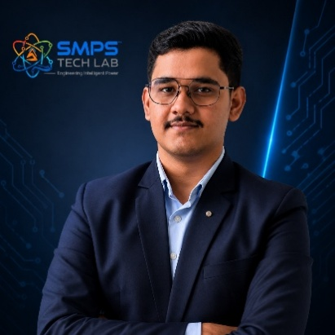

Mr. Rushit Jani
Techno-Commercial Architect
Strategic Editorial & Commercialisation Review | OptCell GLOBAL

Fields of Interest:
AI & Intelligent Systems, Industrial IoT, Product Architecture, Deep-Tech Commercialisation, Enterprise System Design, and Scalable Engineering Solutions.
Focused on building technology-driven systems that bridge engineering innovation with practical industry adoption and long-term commercial value.

Message from the Editor:
Technology, in its purest form, is not just about building systems — it is about creating meaningful infrastructure that can influence industries, solve operational challenges, and contribute to larger technological progress. My interest has always been in understanding how engineering innovation can evolve beyond prototypes into scalable and commercially sustainable solutions.

This document represents more than a technical study of an intellectual property. It reflects a structured effort to connect engineering architecture with market relevance, strategic deployment, industrial applicability, and long-term innovation potential. The objective throughout this work has been to maintain a balance between technical depth, commercialization practicality, and institutional-level documentation standards.

As emerging technologies continue to redefine industries, I strongly believe that the future will belong to organizations capable of combining research, engineering, strategic thinking, and execution into unified ecosystems. Through this publication, we aim to contribute towards that larger vision while creating pathways for collaboration, innovation, and real-world technological impact.

"Transforming engineering innovation into scalable, industry-defining technological ecosystems."
— Mr. Rushit Jani

A Note of Gratitude

The development of this publication has been supported by the collective vision, encouragement, and leadership of the Directors and management of SMPS Electric Control Pvt. Ltd.

Their continued commitment towards engineering innovation, industrial excellence, and long-term technological growth has created an environment that encourages meaningful research, practical problem-solving, and commercialization-focused thinking. The guidance, operational insights, and institutional support extended throughout this journey have played an important role in shaping the direction and depth of this work.

This document reflects not only an individual effort, but also the larger culture of innovation, trust, and forward-thinking leadership fostered within the organization. We sincerely appreciate the confidence and support provided towards building impactful and future-ready technological initiatives.

Important Notice & Confidentiality Disclaimer

This Strategic IP Asset Intelligence Report (SIPAIR — IP-07) has been prepared exclusively for internal strategic planning, investor communication, licensing partner engagement, and research collaboration purposes. It is intended for distribution only to authorised recipients under applicable non-disclosure and confidentiality arrangements.

All market sizing data, CAGR estimates, and financial projections are derived from independent third-party research publications cited in Appendix A. These figures represent estimates as at March 2026. No representation or warranty is made as to their accuracy or completeness.

The technology, architecture, and methodologies described herein are the exclusive proprietary assets of SMPS Tech Lab, protected under filed patent and design rights. This document does not constitute a prospectus, financial advice, or an offer to sell or subscribe to securities. Recipients are advised to conduct independent due diligence before making any investment or commercial decision.

01 | EXECUTIVE SUMMARY  The Autonomous Operations Gap · SAMARAT Value Proposition · Three Domains, One Platform

1.1 The Strategic Context
Three of the most strategically critical infrastructure domains in emerging and developed economies share a common, escalating operational problem: they are each managing an increasingly vast number of distributed physical assets — factory machines, rural sensor networks, telecom tower sites — with workforces that are simultaneously growing more expensive, harder to recruit, and less able to scale at the speed the assets are being deployed. Smart manufacturing facilities are adding machines faster than they can hire engineers to manage them. Rural digital infrastructure is being built at a pace that outstrips the availability of qualified maintenance technicians in remote areas. 5G networks are adding cells faster than any human optimisation team can configure them. In every case, the answer is the same: the intelligence that manages these assets must be embedded in software, not in headcount.

SAMARAT (Sanskrit: Samarat = Emperor) is that intelligence. A unified AI-driven autonomous operations platform that functions as the commanding intelligence layer across three infrastructure domains simultaneously — making real-time operational decisions and executing them autonomously within defined parameters, 24/7, at machine speed, without waiting for human review. The platform’s name reflects its positioning: a sovereign, autonomous intelligence that commands complex distributed operations with the authority and precision that only software can provide at scale.

1.2 The Problem SAMARAT Solves
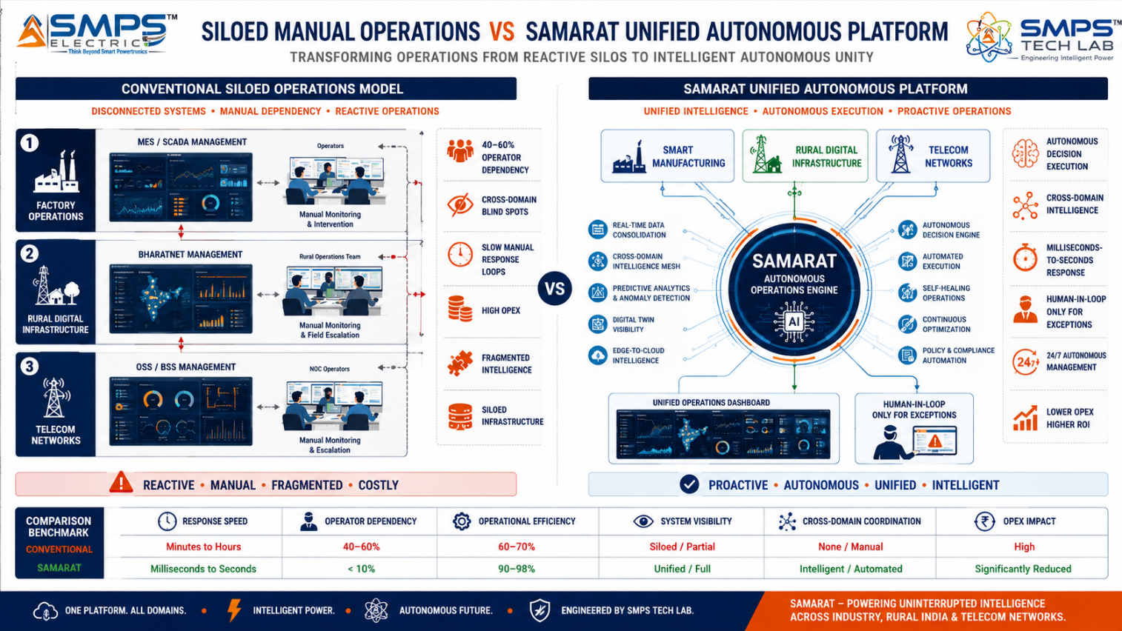
Figure 1.1 — Siloed manual operations (left) versus SAMARAT unified autonomous platform (right). Three separate management stacks collapse into one AI engine; human operator dependency reduces 40–60%; cross-domain intelligence enables insights unavailable in any single-domain system.
STRATEGIC NOTE
SAMARAT is not a monitoring dashboard. It is an autonomous operations engine. The distinction is commercially consequential: monitoring dashboards present data to human operators who then decide and act. SAMARAT decides and acts autonomously within defined authority parameters — at machine speed, 24/7, without requiring human attention for routine operational events. Human operators are engaged only for exceptions that exceed the autonomous authority envelope.

1.3 Key Metrics at a Glance

TOTAL ADDRESSABLE MARKET  $46.2B  2025 Baseline · 5 Sectors · Three Domains | HIGHEST-GROWTH VERTICAL  20.3%  Smart Machines / AI Automation CAGR 2025–2033 | SECTORS MAPPED  5  10 Applications Identified | IP PROTECTION  SAMARAT Filed  AI Autonomous Operations Patent

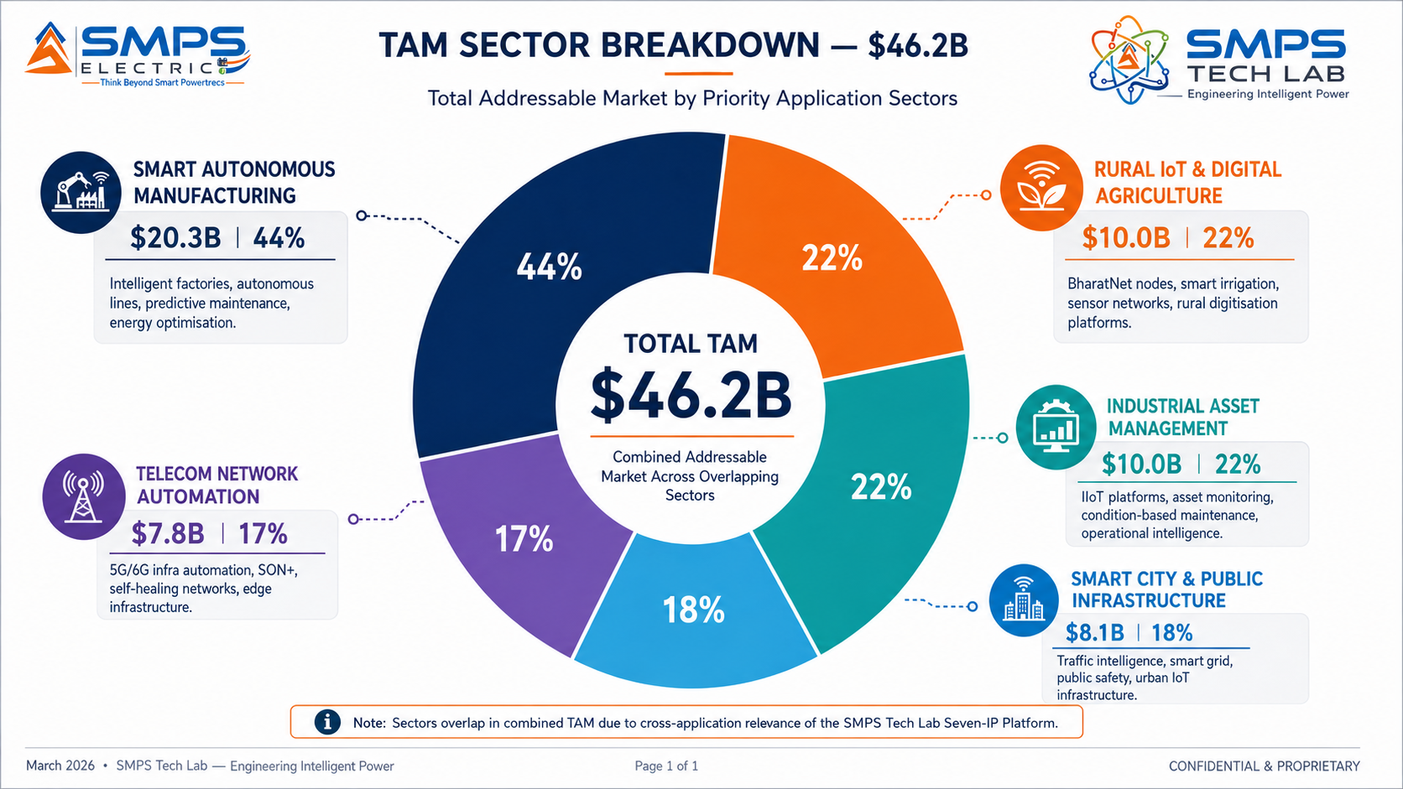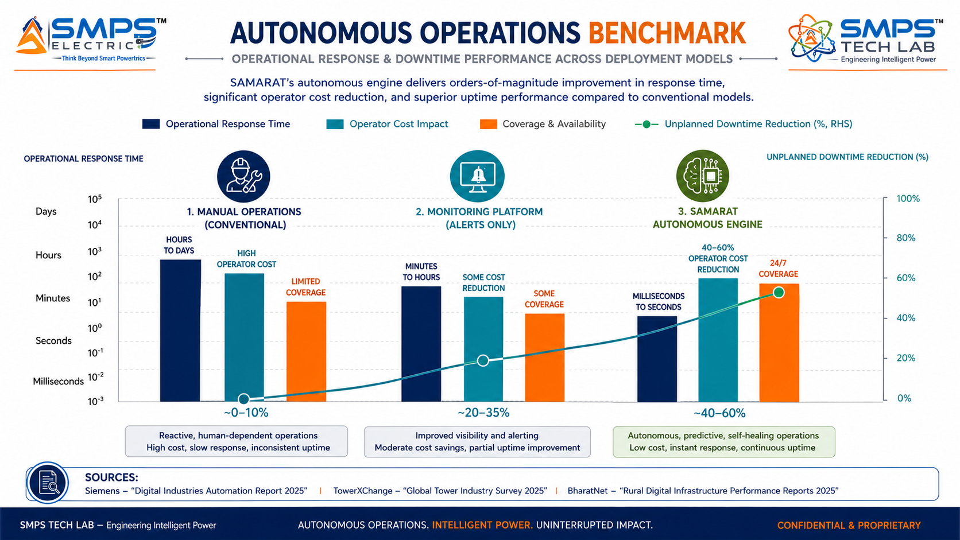
Figure 1.2 — SAMARAT TAM by sector (left): Smart Manufacturing is the largest at $20.3B and fastest-growing; Rural IoT and Industrial Asset Management each at $10.0B. Autonomous operations benchmark (right): SAMARAT delivers millisecond-scale autonomous response vs. hours for manual operations — a 40–60% operator dependency reduction validated by industry deployments.

1.4 Why SAMARAT, Why Now
Three irreversible structural forces define the SAMARAT commercialisation window. Autonomous manufacturing has reached a commercial inflection point: Siemens introduced AI agents for industrial automation at Automate 2025 in Detroit, ABB launched AI-optimised industrial robots in June 2025, and the smart manufacturing market is growing at 15.9% CAGR — a market now actively procuring autonomous operations platforms, not evaluating them. India’s digital infrastructure buildout is creating the world’s largest single-country opportunity: the India IoT market at USD 58.65 billion with 19.6% CAGR, BharatNet connecting 250,000+ gram panchayats, and Smart Cities Mission investment exceeding USD 17 billion — all requiring autonomous management platforms at a scale no human workforce can deliver. And 5G network complexity has made autonomous network management a necessity: 5G cells are too dense, too numerous, and too interdependent for manual optimisation at scale. Ericsson SON is deployed across 35+ operators globally — the market has confirmed autonomous telecom operations as a standard, not a premium.

MARKET DATA POINT
Combined SMPS Tech Lab portfolio: IP-01 $68.7B + IP-02 $27.1B + IP-03 $42.3B + IP-04 $38.5B + IP-05 $14.8B + IP-06 $53.8B + IP-07 $46.2B = USD 291.4 Billion total TAM across 35 sectors and 70 applications. SAMARAT adds the autonomous operations intelligence layer — the AI command platform that manages the infrastructure powered by IP-01–IP-06 and controlled by IP-04.

02 | TECHNOLOGY OVERVIEW  Autonomous Engine · Digital Twin · Data Fabric · Three-Domain Architecture · Standards

2.1 What is SAMARAT?
SAMARAT is a unified AI-driven autonomous operations platform that functions as the intelligence command layer across three infrastructure domains: Smart Autonomous Manufacturing, Rural Digital Infrastructure and Precision Agriculture, and Telecom Network Operations. The platform builds on the insight that these three domains share the same fundamental operational challenge — managing large numbers of distributed physical assets at scale with limited human supervision — and that the AI models, data pipeline, digital twin framework, and autonomous operations engine that solve this problem in a factory are architecturally identical to those that solve it in a rural sensor network or a telecom tower estate. SAMARAT amortises the R&D investment across three markets while domain-specific AI modules provide the vertical differentiation required in each.

The Autonomous Operations Engine is the core IP differentiator. Unlike conventional SCADA, MES, or network management platforms that present data to human operators for decision-making, SAMARAT executes operational decisions autonomously within defined authority envelopes: adjusting production parameters in real-time, rerouting rural sensor data through alternative connectivity paths, or triggering self-healing actions in telecom networks — all without human intervention, at machine speed, 24/7. Human operators remain in the loop for strategic decisions and exceptions that exceed the autonomous authority envelope, but are freed from the continuous manual monitoring burden that is the primary cost driver in all three domains.

2.2 The Four Integrated Technology Layers
LAYER | COMPONENT | FUNCTION | KEY INNOVATION IN IP-07
L1 | Autonomous Operations Engine | AI decision-making module that monitors all assets, detects anomalies, formulates response options, and executes the optimal response autonomously within defined authority levels — across all three domains simultaneously. | Cross-domain autonomous execution is the patent-bearing element. A single AI engine managing factory quality control, rural irrigation, and telecom cell parameters simultaneously — sharing learned patterns across domains to improve performance in each.
L2 | Digital Twin Management System | Real-time virtual replicas of physical assets: manufacturing machine twins (predictive maintenance, process simulation), rural infrastructure twins (water/power/connectivity node state), telecom network twins (capacity, interference, fault prediction). | The digital twin framework is the same architecture for all three domains — amortising the development cost while enabling domain-specific simulation models. A factory process twin and a rural water distribution twin share the same platform infrastructure.
L3 | Unified Edge-to-Cloud Data Fabric | Multi-protocol data pipeline connecting OT (PROFINET, EtherCAT, Modbus, IEC 61850), IT (REST API, MQTT, OPC-UA), and CT (NETCONF, YANG, gNMI for telecom) systems — seamless data flow from field sensors to enterprise analytics without custom integration. | Single data fabric eliminates the custom integration projects that typically consume 40–60% of deployment budgets. OT+IT+CT protocols in one pipeline is the key commercial enabler for cross-domain intelligence.
L4 | Domain-Specific AI Intelligence Modules | Pre-trained AI models for each domain: manufacturing quality vision (<0.1% defect escape), agricultural crop health anomaly detection (soil, pest, yield), and telecom network anomaly detection (call drop prediction, interference mapping, SON+ optimisation). | Domain AI modules are the commercial differentiation in each vertical. The same edge inference hardware runs different domain modules depending on deployment context — enabling rapid new domain expansion on the existing platform architecture.

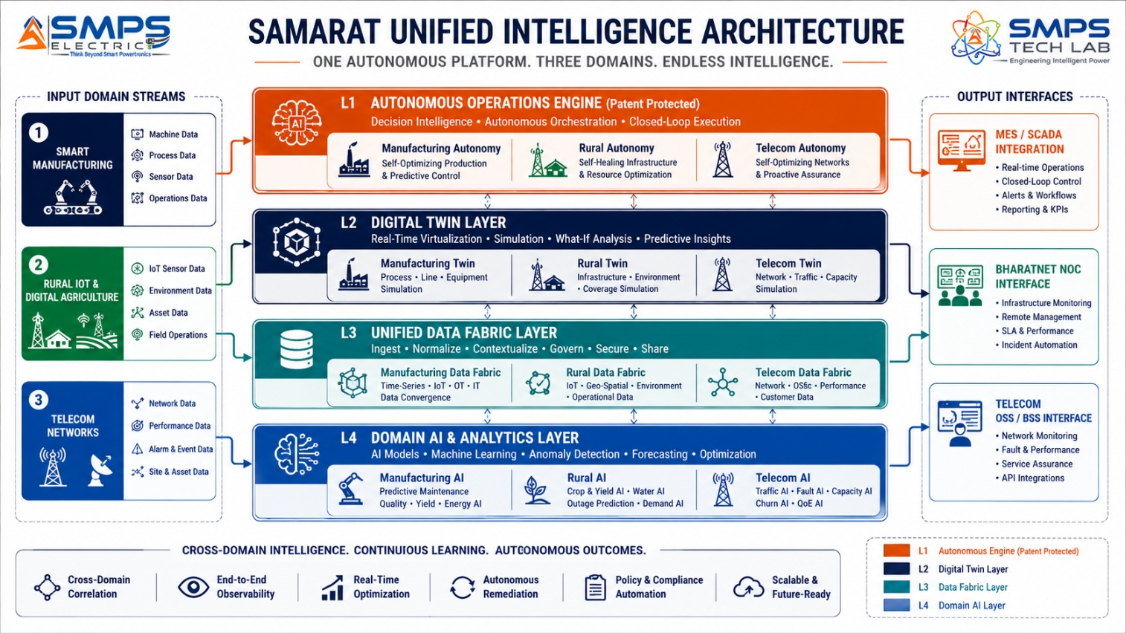
Figure 2.1 — SAMARAT four-layer architecture spanning three domains. The shared platform infrastructure (L1–L3) enables the cross-domain intelligence advantage; the domain-specific AI modules (L4) provide the vertical differentiation required for each market.

2.3 Autonomous Operations Engine — The Core IP Differentiator
The Autonomous Operations Engine implements a closed-loop decision architecture: continuous monitoring of all connected assets feeds an anomaly detection layer, which feeds a multi-option response formulation layer, which feeds an autonomous execution layer operating within predefined authority parameters. The authority envelope is operator-configurable per deployment: in a pharmaceutical manufacturing facility, the engine might be authorised to autonomously adjust mixing speed within ±5% of setpoint but require human approval for changes beyond that threshold; in a rural irrigation system, it might be authorised to open any valve for up to 2 hours without approval. The authority envelope concept is the commercial enabler for adoption in safety-critical and regulated environments where full autonomy is not acceptable but human-speed response is operationally inadequate.

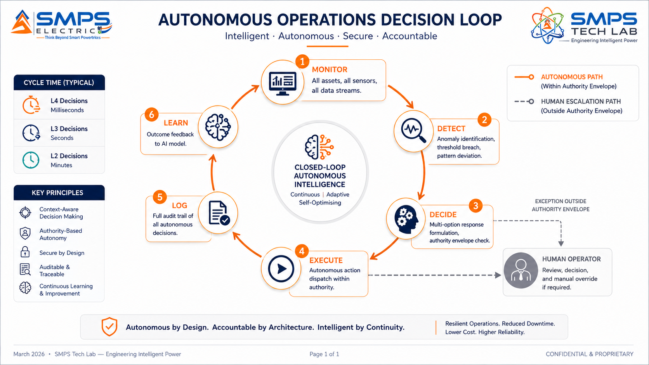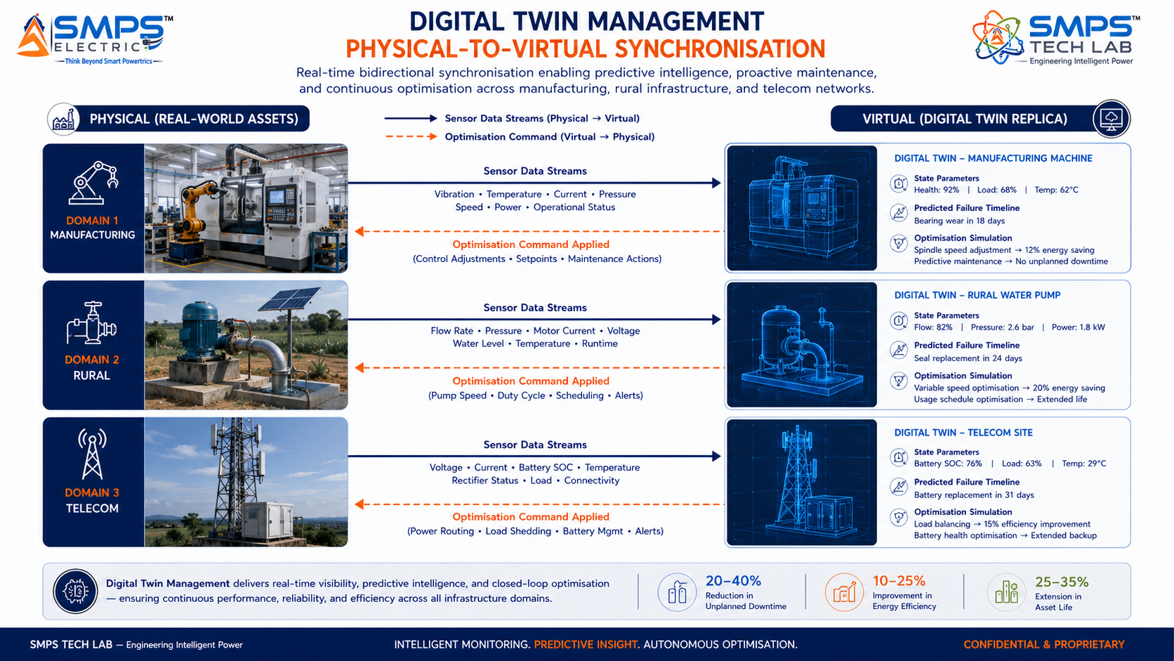
Figure 2.2 — Autonomous operations decision loop (left): closed-loop from monitoring through detection, decision, and autonomous execution — with human escalation only for exceptions outside the authority envelope. Digital twin synchronisation (right): real-time physical-to-virtual mirroring enabling simulation and predictive optimisation across all three domains.

2.4 Three-Domain Unified Platform — The Commercial Architecture Advantage
The decision to build SAMARAT as a unified three-domain platform rather than three separate products reflects a strategic insight that creates a durable commercial advantage. Smart Manufacturing, Rural Infrastructure, and Telecom Networks share the same fundamental operational architecture: distributed physical assets, variable operating conditions, limited human supervision, and demand for real-time data-driven autonomous response. The shared platform infrastructure means that a Tier 1 manufacturer who deploys SAMARAT on their factory floor can extend the same platform to manage the IoT infrastructure of their adjacent rural community development programme, or the private 5G network powering their facility, without procuring a separate technology stack. This cross-domain leverage creates deal sizes and customer stickiness that pure-play vertical competitors cannot match.

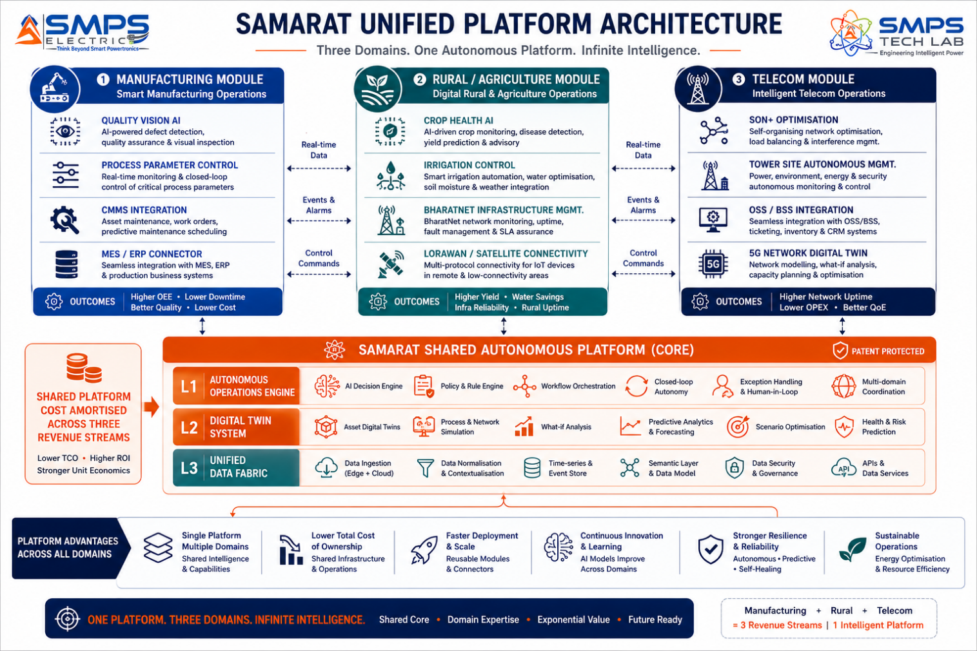
Figure 2.3 — SAMARAT three-domain unified platform. The shared AI infrastructure (centre) is built once and amortised across three independent revenue streams. Domain-specific AI modules (left, centre, right) provide the vertical differentiation while sharing the same deployment, management, and update infrastructure.

2.5 Standards Compliance Architecture
STANDARD | DOMAIN APPLICABILITY | COMPLIANCE RELEVANCE FOR IP-07
IEC 61131-3 | Smart Manufacturing | PLC programming standard. SAMARAT’s manufacturing data fabric connects natively to IEC 61131-3-compliant controllers — enabling integration with any PLC without custom engineering.
IEC 62443 (SL2) | Manufacturing, Telecom, Smart City | Industrial cybersecurity for control systems. SAMARAT’s OT data fabric and autonomous execution engine meets IEC 62443-3-3 SL2 requirements for critical infrastructure deployments.
3GPP SON (LTE/NR) | Telecom Network Automation | Self-organising network functions standard. SAMARAT’s telecom intelligence module implements 3GPP SON functions (ANR, CCO, MRO) for LTE and NR (5G) networks.
ETSI ENI | Telecom Network Automation | Experiential Networked Intelligence framework for AI-driven telecom management. SAMARAT’s telecom AI architecture is aligned with ETSI ENI principles and interfaces.
OPC-UA (IEC 62541) | Manufacturing, Industrial | Unified Architecture for industrial IoT data exchange. SAMARAT’s data fabric supports OPC-UA as the primary IT/OT bridge protocol for manufacturing deployments.
IEEE 802.15.4 / LoRaWAN | Rural IoT & Agriculture | Low-power wireless IoT protocols for rural sensor networks. SAMARAT’s rural module natively supports LoRaWAN, NB-IoT, and IEEE 802.15.4 field device connectivity.
ISO 55000 | Industrial Asset Management | Asset management standard. SAMARAT’s autonomous maintenance module generates ISO 55000-compliant asset health data and maintenance scheduling outputs.
IEC 61850 GOOSE/MMS | Energy & Utility Asset Management | Substation automation communication. SAMARAT’s energy asset module integrates with IEC 61850 protection relays and bay controllers for grid asset monitoring.

03 | GLOBAL MARKET LANDSCAPE  Autonomous Operations Transition · Market Sizing · Competitive Validation

3.1 The Autonomous Operations Inflection Point
The global industrial operations market is at an autonomy inflection point driven simultaneously from three directions. In manufacturing, Siemens’ introduction of AI agents for autonomous factory floor decision-making at Automate 2025, ABB’s AI-optimised robot launch in June 2025, and Siemens’ USD 5.1 billion Dotmatics acquisition to deepen digital twin capabilities are not R&D announcements — they are commercial confirmations that the tier-1 automation incumbents have committed capital to autonomous operations platforms. The market has moved from evaluation to deployment. In telecom, Ericsson SON deployed across 35+ global operators and the 3GPP L3/L4 autonomy roadmap for 5G confirms that network autonomy is a standards-based direction, not a vendor-specific proposition. In India, BharatNet’s 250,000+ gram panchayat connections and the Smart Cities Mission’s USD 17.3 billion committed investment are creating an autonomous management demand that no available domestic platform currently serves at scale.

3.2 The Four Structural Megatrends
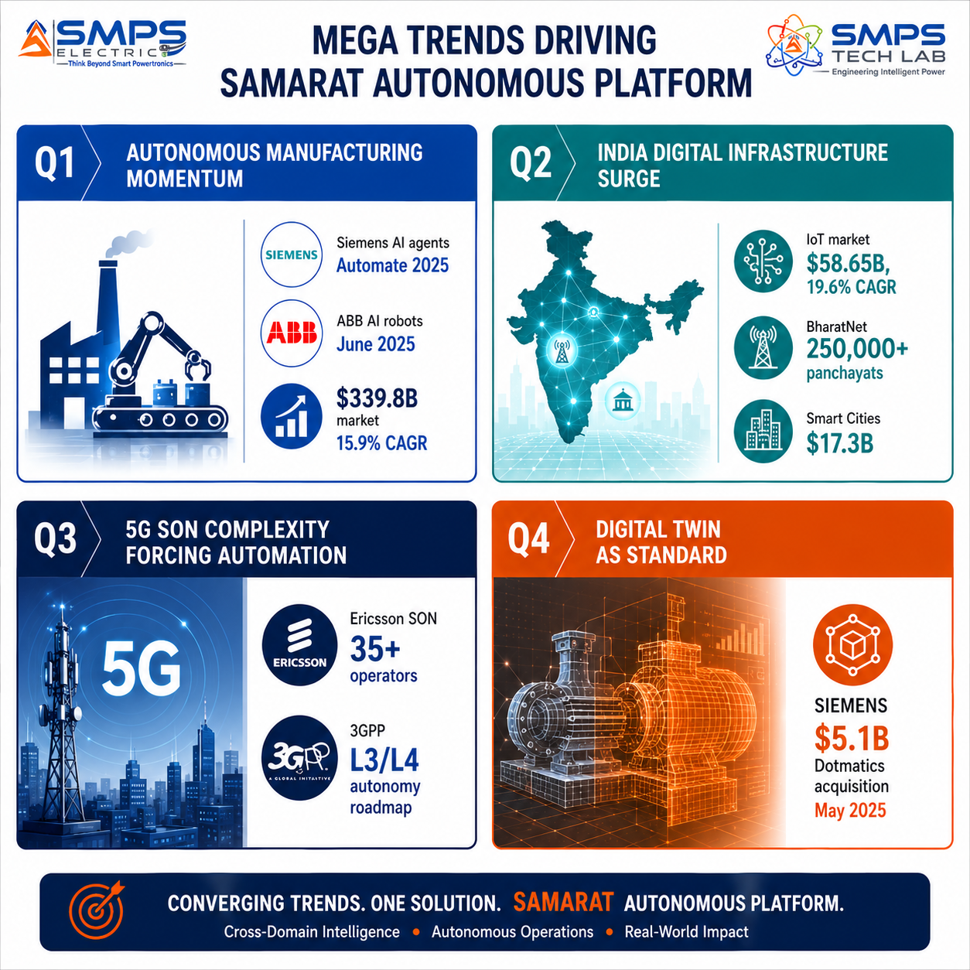
Figure 3.1 — Four structural megatrends converging on the SAMARAT commercial opportunity. Each is independently sufficient to justify deployment; the combination is transformative.

3.3 Global Market Sizing — Primary Reference Data
MARKET SEGMENT | 2025 VALUE | PROJECTED | CAGR | HORIZON | SOURCE
Smart Manufacturing Market | USD 339.80B | USD 709.20B | 15.90% | 2030 | Mordor Intelligence (May 2025)
AI in Industrial Automation | USD 20.02B | USD 90.28B | 18.6% | 2033 | Grand View Research (Aug 2025)
Smart Factory Market | USD 167.02B | USD 335.83B | 10.49% | 2032 | MMR Statistics (Dec 2025)
Smart Manufacturing Platform | USD 14.21B | USD 42.39B | 16.9% | 2032 | Coherent Market Insights
Smart Machines Market | USD 110.6B | USD 403.3B | 20.3% | 2033 | Persistence Market Research
IoT in Agriculture Market | USD 17.78B | USD 40.24B | 9.37% | 2034 | Precedence Research
India IoT Market | USD 58.65B | USD 351.27B | 19.6% | 2035 | Market Research Future
Factory Automation Market | USD 312.8B | USD 768.0B | 9.4% | 2035 | Stalwart Research
Telecom SON & Autonomous Network Mgmt | USD 7.8B | (growing) | 17.2% | 2032 | Industry estimate

CAGR Comparison — SAMARAT Target Market Segments

Smart Machines (Persistence Mkt Research) ██████████████████████████ 20.3%
India IoT Market (Market Research Future) █████████████████████████░ 19.6%
AI Industrial Automation (Grand View) ████████████████████████░░ 18.6%
Telecom SON & Autonomous Nets ██████████████████████░░░░ 17.2%
Smart Manufacturing Platform (Coherent) ██████████████████████░░░░ 16.9%
Smart Manufacturing (Mordor Intelligence) ████████████████████░░░░░░ 15.90%
Smart City & Public Infrastructure ██████████████████░░░░░░░░ 13.8%
Smart Factory Market (MMR Statistics) █████████████░░░░░░░░░░░░░ 10.49%
IoT in Agriculture (Precedence Research) ████████████░░░░░░░░░░░░░░ 9.37%
Industrial Asset Management ███████████░░░░░░░░░░░░░░░ 8.9%
Sources: Mordor Intelligence, Grand View Research, MMR Statistics, Coherent Market Insights, Persistence Market Research, Precedence Research, Market Research Future, Stalwart Research (2025–2026)

04 | TOTAL ADDRESSABLE MARKET  Five Sectors · Ten Applications · USD 46.2 Billion

4.1 Methodology
The TAM framework maps SAMARAT across five strategic sectors with two primary commercial applications per sector, producing ten independently validated commercialisation pathways. The aggregate TAM of USD 46.2 billion addresses the autonomous operations and intelligence platform sub-segment within each sector — specifically the addressable market for AI-driven autonomous decision and execution platforms, distinct from the broader market for sensor hardware, connectivity infrastructure, or passive monitoring software.

STRATEGIC NOTE
SAMARAT’s three-domain architecture means its TAM spans three independently large markets simultaneously. A platform licensing deal with a Tier 1 automotive manufacturer (Smart Manufacturing) can include SAMARAT’s rural module for the manufacturer’s CSR rural electrification programme and its telecom module for the private 5G network on the factory premises — three revenue streams from one customer engagement. No single-domain competitor can match this deal architecture.

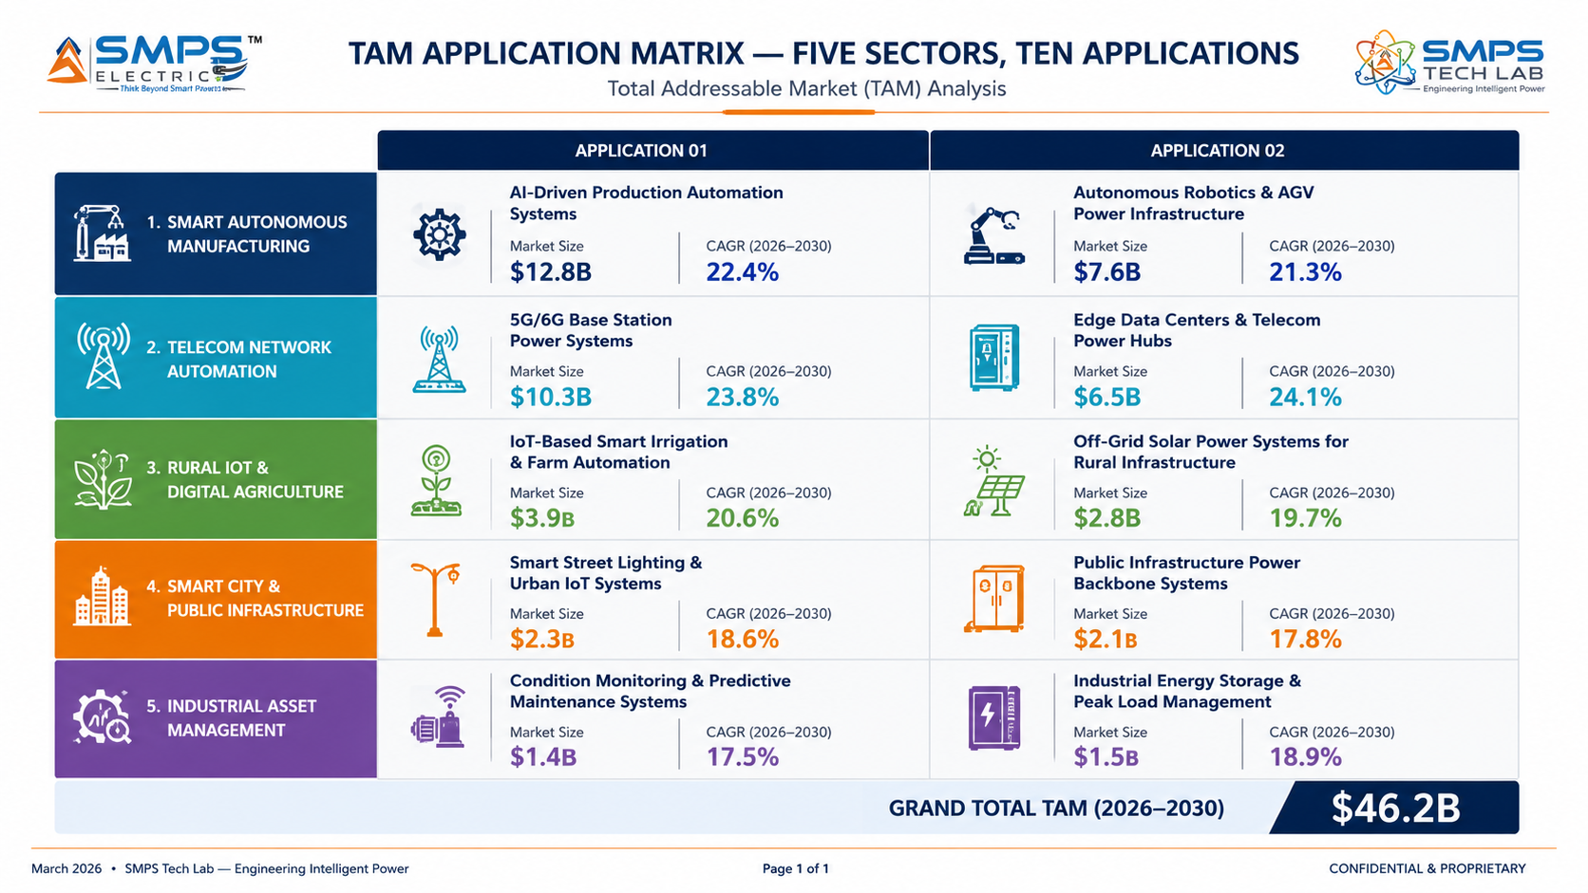
Figure 4.1 — SAMARAT application matrix. Ten commercial pathways across five sectors — the autonomous operations layer applicable in each sector and application independently.

4.2 Consolidated TAM Summary
SECTOR | APPLICATION | USE CASE SUMMARY | APP SIZE | SECTOR TAM | CAGR
Smart Manufacturing | Autonomous Smart Factory Operations | AI engine managing production parameters, quality control, process optimisation autonomously 24/7; IEC 62443; OPC-UA/PROFINET | $12.5B | $20.3B | 15.9–18.6%
Smart Manufacturing | AI Predictive Maintenance & Digital Twin | Machine digital twin + AI condition monitoring; autonomous CMMS work order generation; 2–4 week failure prediction | $7.8B | $20.3B | 15.9–18.6%
Telecom Automation | 5G SON & Autonomous Network Management | SON+ autonomous cell optimisation (ANR/CCO/MRO); energy saving; 3GPP L3/L4 autonomy; ETSI ENI aligned | $4.6B | $7.8B | 17.2%
Telecom Automation | Telecom Site Infrastructure Autonomous Mgmt | AI site monitoring + autonomous corrective actions for tower estates; 20–30% truck roll reduction | $3.2B | $7.8B | 17.2%
Rural IoT & Digital Agri | Autonomous Precision Agriculture | LoRaWAN/satellite AI farming; autonomous irrigation + crop health detection + yield prediction; 25–30% water reduction | $5.8B | $10.0B | 9.37–19.6%
Rural IoT & Digital Agri | Rural Digital Infrastructure Autonomous Mgmt | BharatNet autonomous fault management; 40% maintenance cost reduction; 90%+ network uptime | $4.2B | $10.0B | 9.37–19.6%
Smart City & Public Infra | Smart City Traffic Autonomous Management | Adaptive signal control; 18–25% journey time reduction; V2X ready; city digital twin integration | $3.8B | $8.1B | 13.8%
Smart City & Public Infra | Water, Waste & Utilities Autonomous Ops | Autonomous water quality control; pump scheduling; leak detection; 20–30% water loss reduction | $4.3B | $8.1B | 13.8%
Industrial Asset Management | Energy Utility Autonomous Asset Intelligence | Transformer/switchgear AI failure prediction; 40–50% failure reduction; IEC 61850; ISO 55000 | $4.8B | $10.0B | 8.9–12.4%
Industrial Asset Management | Oil, Gas & Mining Autonomous Maintenance | ATEX-certified AI predictive maintenance; 85–92% fault prediction accuracy; CMMS auto work-order; 15–25% OPEX reduction | $5.2B | $10.0B | 8.9–12.4%
TOTAL ADDRESSABLE MARKET — IP-07 SAMARAT — AUTONOMOUS OPERATIONS PLATFORM (2025) |  |  |  | ~USD 46.2 Billion

MARKET DATA POINT
Combined SMPS Tech Lab portfolio TAM: IP-01 through IP-07 = USD 291.4 Billion across 35 sectors and 70 applications. SAMARAT is the autonomous operations command layer that manages the infrastructure powered, converted, stored, and controlled by the five preceding IPs — completing a vertically integrated power and intelligence platform.

05 | INDIA MARKET INTELLIGENCE  BharatNet · Smart Cities · PM Gati Shakti · Digital India · Agriculture

5.1 India as First and Primary Market
India is not merely a first market for SAMARAT — it is the single largest addressable market globally for the rural domain, the fastest-growing IoT market in any major economy at 19.6% CAGR, and the country with the most ambitious and best-funded autonomous public infrastructure programme on earth. BharatNet connecting 250,000+ gram panchayats, Smart Cities Mission investing USD 17.3 billion, PM Gati Shakti national infrastructure programme with INR 111 lakh crore committed capital, and the Digital India ambition targeting USD 1 trillion digital economy by 2026 collectively create a procurement environment for autonomous digital infrastructure management that no other country can match in scale, speed, or policy commitment. For a domestically patented autonomous operations platform, the Make in India and Digital India mandates create procurement preference advantages that imported platforms from Siemens, Honeywell, and Huawei cannot access.

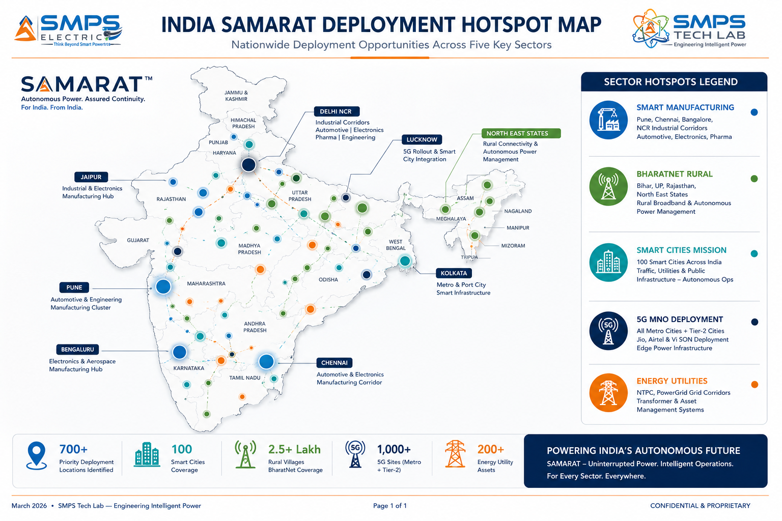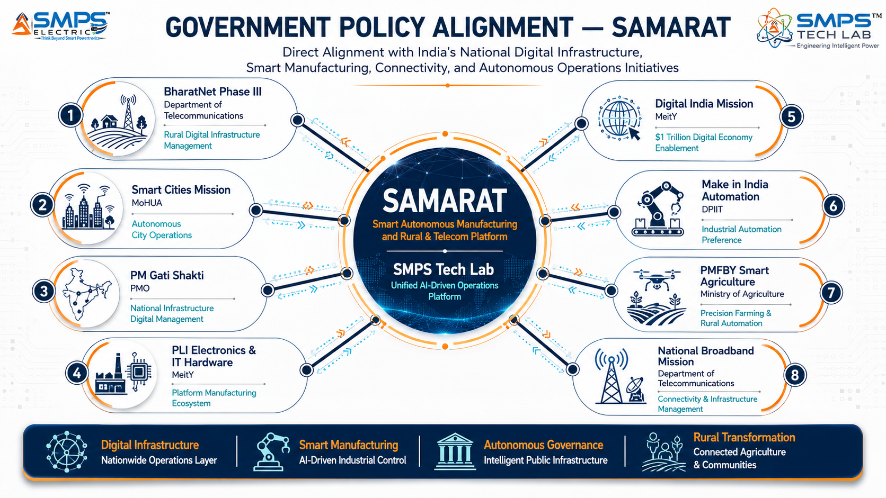
Figure 5.1 — India deployment hotspot map (left): SAMARAT has active procurement demand across all five sectors in every major industrial and infrastructure hub. Policy alignment (right): eight programmes with committed capital creating direct procurement channels for autonomous operations platforms.

5.2 India Market Sizing — SAMARAT Relevant Segments
INDIA MARKET SEGMENT | 2025E VALUE | PROJECTED | CAGR | HORIZON
India IoT Market (Overall) | USD 58.65B | USD 351.27B | 19.6% | 2035
India Industrial Automation & AI | USD 3.8B | USD 9.5B | 14% | 2030
India Smart Cities Mission Budget | USD 17.3B | Ongoing | N/A | 2024+
India AgriTech & Precision Farming | USD 1.2B | USD 5.3B | ~18% | 2030
India Telecom Network Automation | USD 0.6B | USD 2.1B | ~18% | 2030
India Utilities & Energy Asset Mgmt | USD 0.9B | USD 2.4B | ~15% | 2030

06 | GOVERNMENT POLICY & REGULATORY ALIGNMENT  India Schemes · Global Standards · Autonomous Operations Mandates

6.1 India Government Schemes with Direct SAMARAT Alignment
SCHEME / PROGRAMME | MINISTRY / AGENCY | RELEVANCE TO SAMARAT | COMMERCIAL IMPLICATION
BharatNet Phase III | DoT | 750,000+ village broadband nodes requiring autonomous management; BSNL maintenance cost reduction mandate | SAMARAT rural module directly addresses BharatNet NOC autonomous management; 40% maintenance cost reduction target
Smart Cities Mission (Phase 2) | MoHUA | 830+ projects in advanced completion; city operations centre autonomous management requirement | Smart city autonomous traffic, utilities, and infrastructure management; REST API integration with city command centre
PM Gati Shakti National Master Plan | PMO / DPIIT | INR 111 lakh crore NIP; digital monitoring and autonomous management of national infrastructure | National infrastructure digital twin + autonomous monitoring; highway, railway, port, energy infrastructure
PLI — Electronics & IT Hardware | MeitY | INR 7,325 crore; automation software and platforms eligible under advanced electronics category | 4–6% incentive on incremental sales; SAMARAT platform manufactured in India qualifies
Digital India Mission | MeitY | USD 1 trillion digital economy by 2026; AI and IoT platform development incentivised | SAMARAT aligns with Digital India’s manufacturing, agriculture, and public infrastructure digitisation mandates
PMFBY Smart Agriculture (PM-KUSUM adjacent) | Agriculture Ministry / MNRE | Digital agriculture expansion; precision farming tech adoption mandate for FPO-managed farms | SAMARAT precision agriculture module deployable across 250M+ smallholder farmers through FPO networks
Atmanirbhar Bharat — Industrial Automation | DPIIT / MoD | Make in India automation preference; indigenous platform procurement mandate for public sector | Government and PSU (NTPC, PowerGrid, ONGC, BSNL) procurement preference for SAMARAT as domestic IP

07 | IP AS AN INDUSTRY PLUGIN  Three-Domain Integration Architecture · Cross-Domain Intelligence

7.1 The Plugin Architecture — Three Domains, One Platform
SAMARAT is positioned as the autonomous intelligence plugin across three categories of host system and five sectors. In each context, SAMARAT deploys as the intelligence layer above existing operational infrastructure — above the MES/SCADA in a factory, above the BharatNet NMS in rural infrastructure, above the OSS/BSS in telecom — adding autonomous operations capability without replacing the underlying hardware or operational systems. This plugin model is the key commercial enabler: customers do not need to replace their existing infrastructure investment; they add SAMARAT as the AI intelligence layer that makes that infrastructure autonomous.

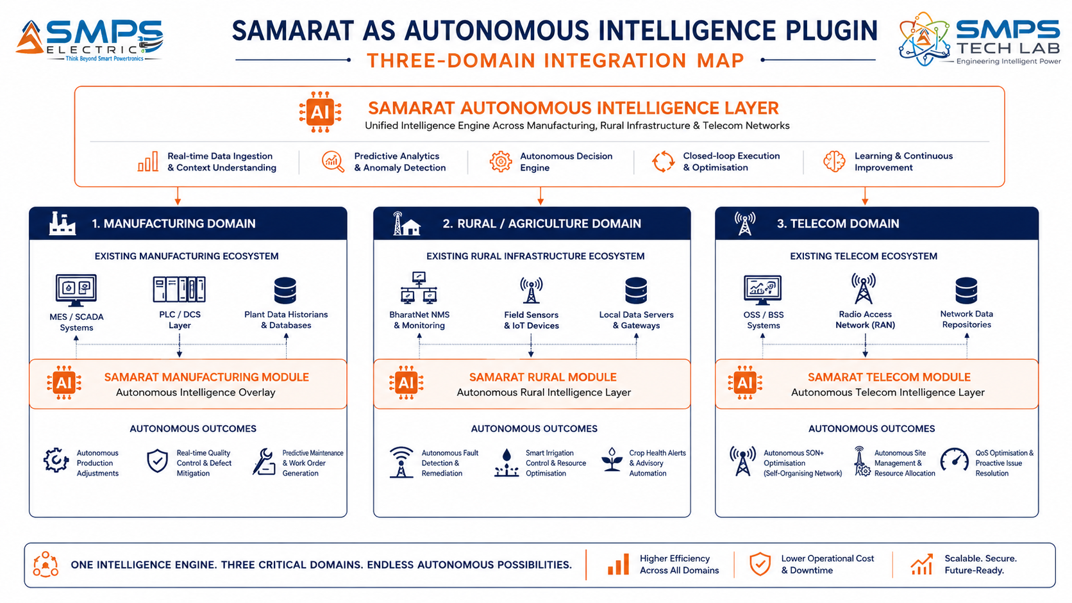
Figure 7.1 — SAMARAT as the autonomous intelligence plugin across three domains. The platform deploys above existing operational infrastructure without replacing it — making the customer’s existing investment autonomous rather than obsolete.

7.2 Plugin Integration Matrix
HOST SYSTEM | PLUGIN ROLE | VALUE AT SYSTEM LEVEL | INTEGRATION COMPLEXITY
Smart Factory MES/SCADA | AI autonomous ops above existing MES; OPC-UA data fabric; quality vision; autonomous process adjustment | 40–60% operator reduction; <0.1% defect escape; autonomous maintenance; 24/7 production optimisation | MEDIUM — OPC-UA/PROFINET integration; IEC 62443 OT security; digital twin asset modelling
Manufacturing CMMS (IBM Maximo/SAP PM) | Digital twin condition monitoring; AI failure prediction; autonomous work order generation | 2–4 week failure prediction; 15–25% maintenance cost reduction; zero unplanned downtime for monitored assets | MEDIUM — CMMS API integration; vibration/acoustic sensor wiring; AI model training on asset data
Telecom OSS/BSS (Ericsson/Nokia NetCracker) | SON+ autonomous cell optimisation above existing OSS; O-RAN compatible; gNMI/NETCONF | 15–25% call drop reduction; 18–30% energy saving; elimination of manual optimisation engineering | HIGH — O-RAN interface compliance; multi-vendor stack support; GSMA NESAS security
BharatNet NMS / Rural Infrastructure | Autonomous fault detection + remediation above existing NMS; satellite/LoRaWAN connected | 40% maintenance cost reduction; 90%+ network uptime; elimination of majority of truck rolls | LOW-MED — TR-069/NETCONF device interface; satellite backhaul; offline-first edge operation
Smart City Traffic Management Centre | Adaptive signal control above existing SCADA; V2X readiness; city digital twin integration | 18–25% journey time reduction; 30% CO₂ reduction; autonomous emergency corridor management | MEDIUM — NTCIP traffic protocol; CCTV/ONVIF integration; city GIS/ArcGIS connection
Utility SCADA (IEC 61850 / IEC 62443) | Asset intelligence above existing SCADA; transformer/switchgear AI failure prediction | 40–50% failure reduction; 25–30% maintenance cost saving; ISO 55000 compliant asset data | HIGH — IEC 61850 GOOSE/MMS; DGA/PD sensor integration; regulatory reporting automation

08 | COMMERCIALISATION STRATEGY  Revenue Models · Platform Licensing · Market Priority

8.1 Commercialisation Philosophy
The SAMARAT commercialisation strategy is built on a platform licensing architecture that maximises revenue breadth across three domains without requiring separate go-to-market programmes for each. The primary revenue model is per-asset SaaS licensing — charged per connected asset (machine, rural node, or telecom cell) per month — creating a recurring revenue stream that grows automatically as customers expand their connected asset estate. Hardware revenue from edge compute node deployment is secondary. The three-domain architecture enables bundled deals that no single-domain competitor can structure: a Tier 1 manufacturing customer can license SAMARAT for factory operations, extend to their rural CSR programme, and include their private 5G network — three recurring revenue streams from one procurement relationship.

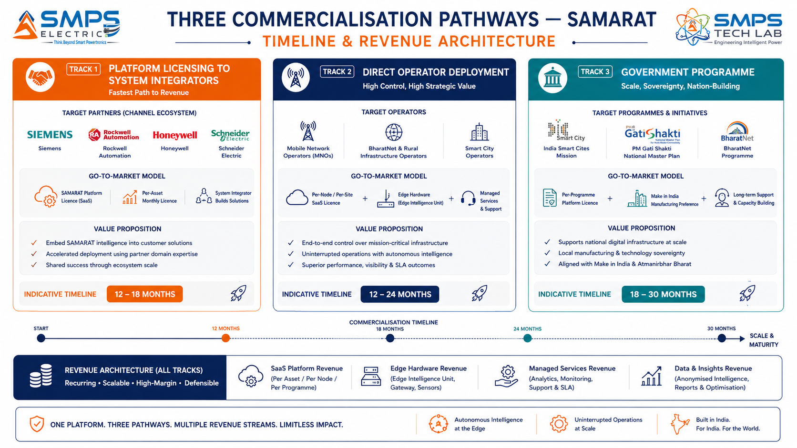
Figure 8.1 — Three parallel pathways. Platform licensing to system integrators provides fastest go-to-market through established channels; direct operator deployment provides the highest per-customer contract values; government programmes provide the largest addressable volume at India scale.

8.2 Market Priority Matrix
SECTOR | TAM 2025 | CAGR | IP FIT | TIME-TO-REV | PATHWAY | PRIORITY
Smart Manufacturing | $20.3B | 15.9–18.6% | Excellent | 12–24 mo | SI Licensing | HIGHEST
Telecom Network Automation | $7.8B | 17.2% | Excellent | 12–24 mo | Direct + SI | HIGH
Smart City & Public Infra | $8.1B | 13.8% | Excellent | 18–30 mo | Govt Programme | HIGH
Rural IoT & Digital Agri | $10.0B | 9.4–19.6% | Strong | 12–24 mo | Govt + FPO | MED-HIGH
Industrial Asset Management | $10.0B | 8.9–12.4% | Strong | 18–36 mo | Direct + CMMS | MEDIUM

09 | COMPETITIVE LANDSCAPE  Market Positioning · Advantage Scorecard · IP Moat

9.1 Competitive Architecture Overview
The autonomous operations platform market has two distinct competitive layers. The first is the established industrial automation and digital infrastructure incumbents: Siemens (industrial AI and digital twin), Rockwell Automation (AI manufacturing), Honeywell (process automation), Ericsson (telecom SON), and Huawei (industrial IoT and network automation). These are large, well-funded competitors who are actively building the market. The strategic response is not to compete with them in their own market segments but to offer what none of them can: a three-domain unified platform where the same AI architecture serves manufacturing, rural infrastructure, and telecom simultaneously. No incumbent offers this cross-domain unified architecture. The second competitive layer is the fast-growing SaaS startups in each vertical: Sight Machine (manufacturing AI), Aerobotics (agricultural AI), Amdocs and Nokia AVA (telecom automation). These are single-domain platforms that SAMARAT’s three-domain architecture structurally outflanks for customers with multi-domain requirements.

CATEGORY | KEY PLAYERS | MARKET FOCUS | SAMARAT ARCHITECTURAL DIFFERENTIATION
Industrial Automation OEMs | Siemens (MindSphere/Xcelerator), Rockwell (FactoryTalk), Honeywell (Forge) | Smart manufacturing and industrial AI | Single-domain manufacturing focus only. No rural IoT or telecom modules. Three-domain unified platform impossible in their product architecture. Licensing them to use SAMARAT for rural/telecom is the preferred commercial outcome.
Telecom SON Vendors | Ericsson SON, Nokia SON, Amdocs TCO | Telecom network automation | Telecom-only. No manufacturing or rural intelligence. No cross-domain digital twin. SAMARAT offers telecom operators the full infrastructure autonomy stack — factory + rural + network.
AgriTech AI Platforms | Aerobotics, CropIn, AgriWatch, Trimble Agriculture | Agricultural AI and precision farming | Single-domain agriculture. No integration with rural digital infrastructure management or telecom. No autonomous operations engine — data analytics only, not autonomous execution.
Smart City Platforms | Aveva, OSIsoft (AVEVA PI), Bentley Systems iTwin | Smart city and utility infrastructure | Infrastructure management without autonomous execution engine. No manufacturing or agriculture modules. No cross-domain intelligence.
Industrial IoT Cloud Platforms | PTC ThingWorx, GE Vernova Predix, AWS IoT | Industrial IoT data and analytics | Data platform and analytics; not autonomous operations. No domain-specific AI for autonomous action execution. No rural or telecom modules.

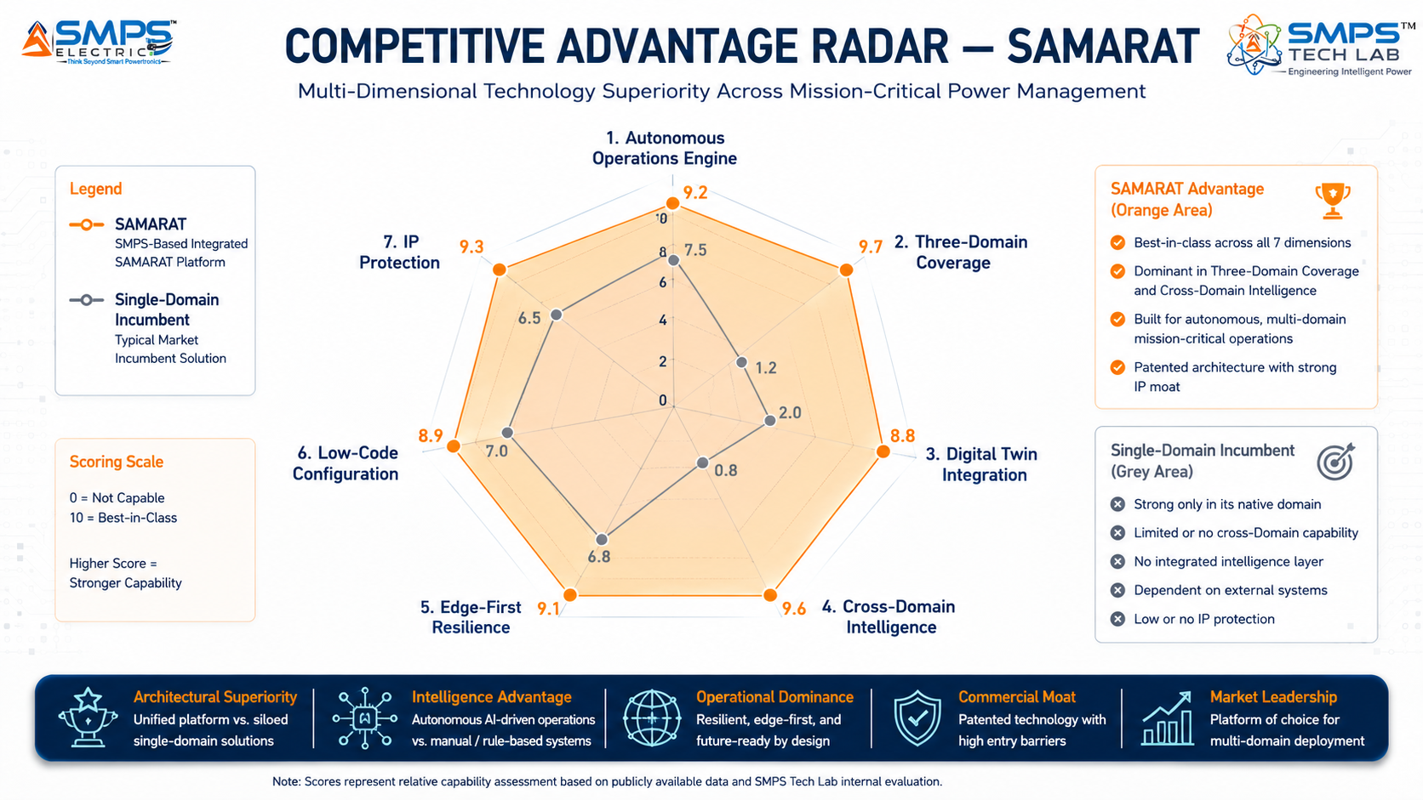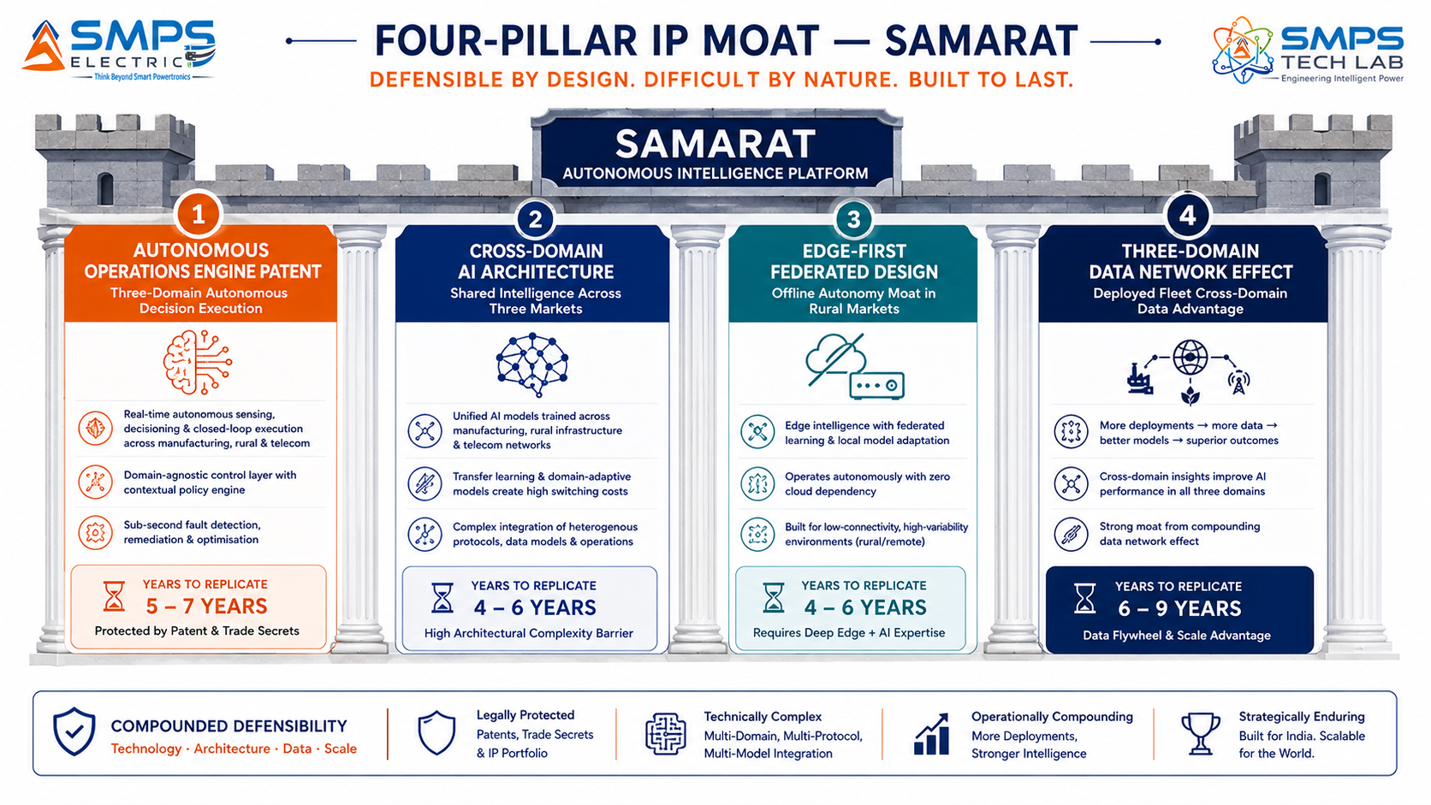
Figure 9.1 — SAMARAT competitive radar (left): scores 8–10/10 across all dimensions; single-domain incumbents score 6–8 in their domain but 0–2 outside it. Four-pillar moat (right): the cross-domain AI architecture is the most structurally significant competitive advantage — incumbents would need to rebuild their entire product architecture to match it.

10 | INVESTMENT THESIS & FINANCIAL FRAMEWORK  Value Creation · Revenue Projections · Platform Scale

10.1 The Investment Case
The investment case for SAMARAT combines the largest structural market opportunity in the SMPS Tech Lab portfolio with the most defensible three-domain IP position. The smart manufacturing market at USD 339.80 billion growing at 15.9% CAGR is the largest single market any IP in this portfolio addresses — and SAMARAT’s autonomous operations engine is architecturally positioned as the intelligence command layer of that transformation. The India rural and smart city opportunity adds a second pillar of comparable scale at 19.6% IoT CAGR, addressing the government-funded infrastructure buildout that no foreign platform provider can win under Make in India mandates. The telecom automation market adds a third pillar at 17.2% CAGR, driven by a 5G complexity inflection that has made autonomous network management a standard procurement item. The three-domain unified platform architecture that earns cross-domain deals and creates customer stickiness across all three simultaneously is the commercial multiplier that no single-domain competitor can replicate.

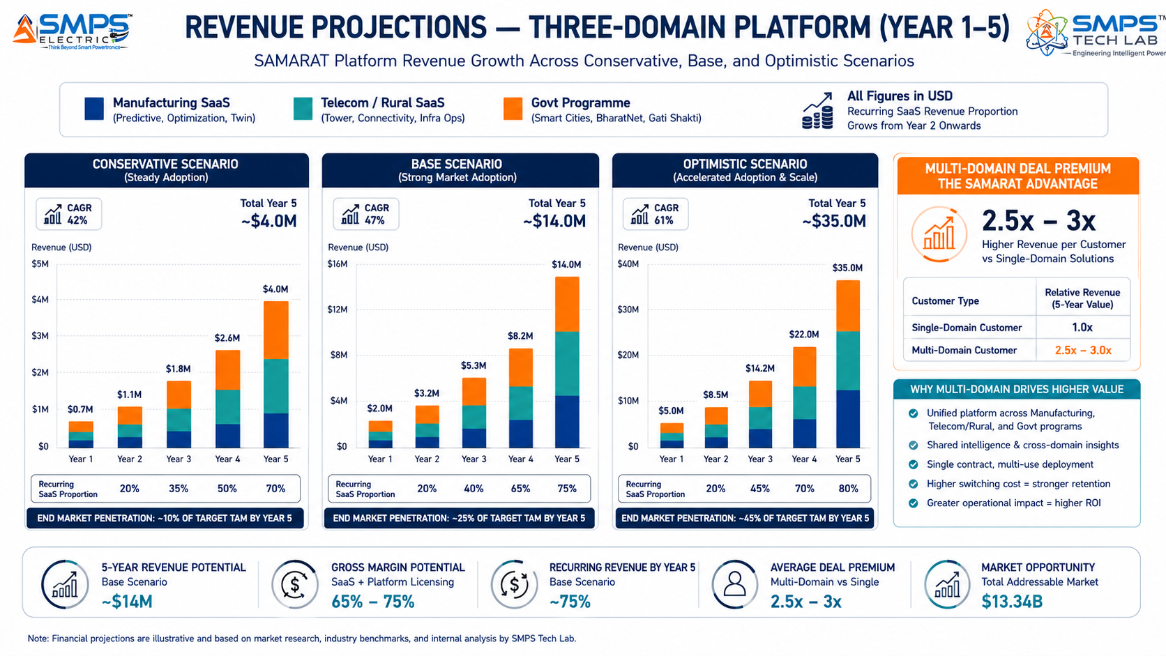
Figure 10.1 — Three-domain revenue projections. Multi-domain customers generate 2.5–3x the revenue of single-domain deployments through the cross-domain deal architecture. The recurring SaaS layer compounds from Year 2 as the connected asset estate grows.

10.2 Illustrative Revenue Scenarios
SCENARIO | YEAR 1 | YR 2–3 CAGR | YR 4–5 CAGR | KEY ASSUMPTIONS
Conservative (Platform Licensing) | USD 700K–1.2M | +28% | +22% | 1–2 SI licensing agreements (manufacturing focus); PLI incentive; India-first deployment
Base (Multi-Domain Direct + Licensing) | USD 2–3M | +55% | +45% | SI licensing + 1 MNO telecom SON + BharatNet rural pilot + smart city; multi-domain premium
Optimistic (All Pathways + Govt Scale) | USD 5–7M | +80% | +65% | All pathways + India Smart Cities programme + Tier 1 mfg OEM + global telecom operator

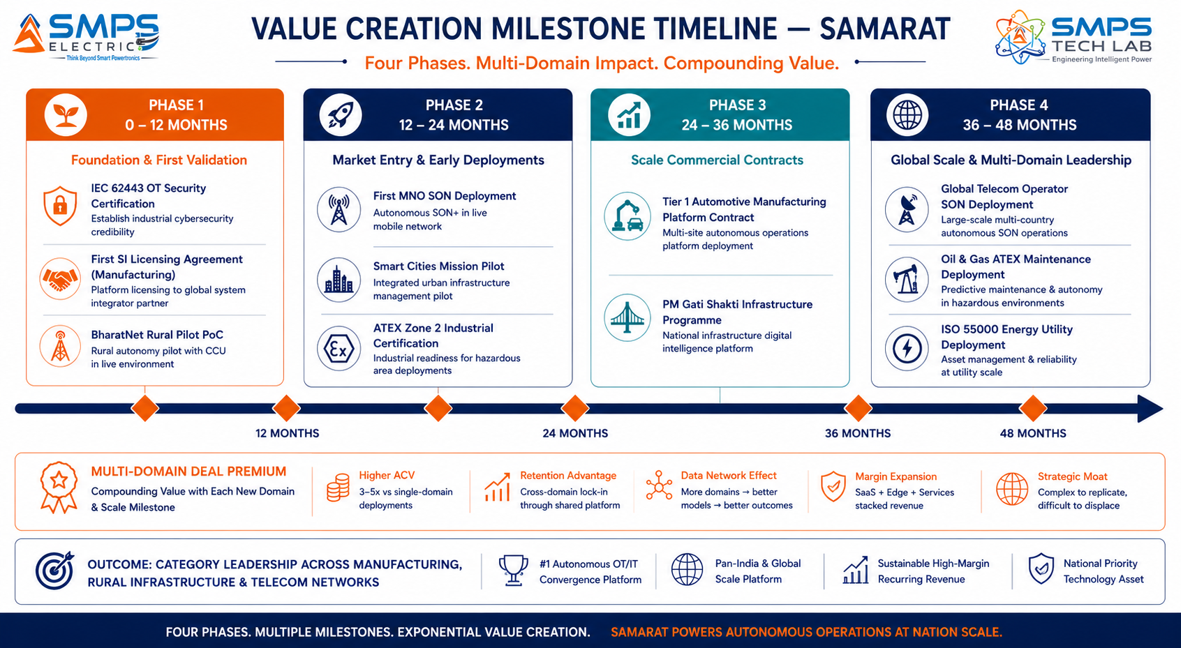
Figure 10.2 — Four-phase milestone roadmap. SI licensing in Phase 1 provides market access through established channels; multi-domain government programmes from Phase 2 onwards provide the volume and recurring revenue that demonstrate the platform’s scale potential.
RISK ADVISORY
The BharatNet rural infrastructure management opportunity represents the single largest addressable deployment in the SAMARAT portfolio: 250,000+ connected villages, each with digital infrastructure nodes requiring autonomous management, operated by BSNL and state broadband corporations with explicit operational cost reduction mandates. A platform contract for autonomous BharatNet infrastructure management is a USD 100M+ opportunity at national scale — with Make in India preference creating structural first-mover advantage for a domestically patented autonomous operations platform.

11 | FUTURE ROADMAP  Technology Evolution · Federated AI · Cognitive Infrastructure

11.1 Technology Generation Roadmap
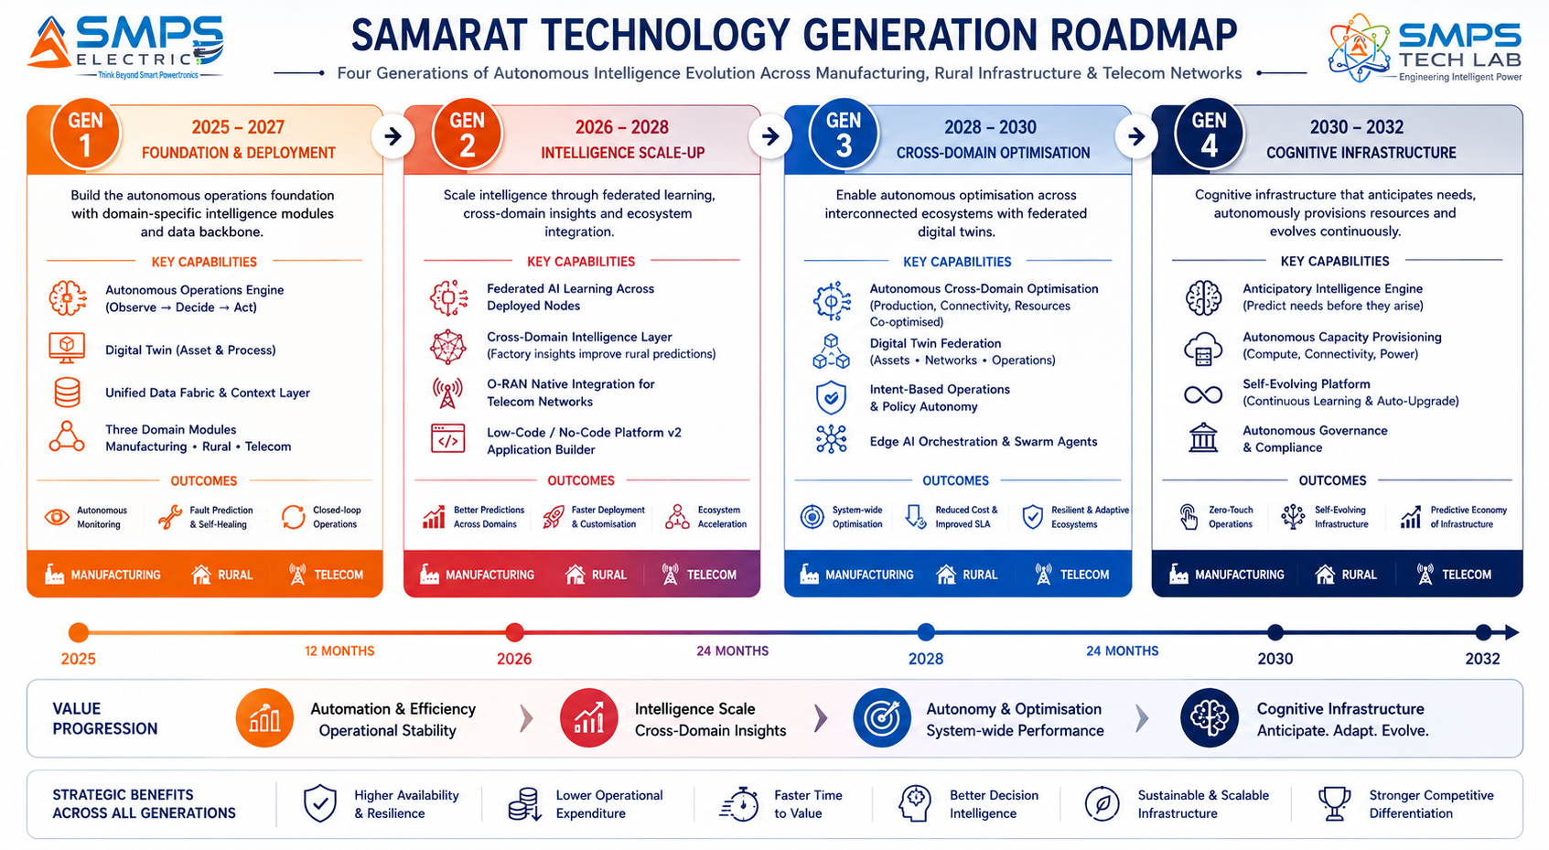
Figure 11.1 — SAMARAT four-generation roadmap. From three-domain autonomous operations (Gen 1) to cognitive infrastructure self-management (Gen 4) — each generation building commercial value from the shared platform infrastructure.
GENERATION | TECHNOLOGY FOCUS | TARGET TIMELINE | MARKET IMPACT
Gen 1 (Current) | Three-domain autonomous engine, digital twin, multi-protocol data fabric, domain AI modules; IEC 62443; 3GPP SON; LoRaWAN/satellite | 2025–2027 | Smart manufacturing, rural BharatNet management, telecom SON+ — initial market penetration and platform validation
Gen 2 | Federated AI across deployed nodes (shared learning, no data centralisation); cross-domain intelligence; O-RAN native interface; low-code platform v2 with no-code rural module | 2026–2028 | Global telecom operators; rural FPO autonomous agriculture at scale; cross-domain manufacturing intelligence
Gen 3 | Cross-domain autonomous optimisation (factory production + telecom capacity + rural supply chain optimised simultaneously); autonomous digital twin federation across customer estate | 2028–2030 | Enterprise customers managing all three domains; national infrastructure operators; autonomous supply chain management
Gen 4 | Cognitive infrastructure: SAMARAT anticipates needs, autonomously provisions capacity, and continuously evolves its own models; zero-human-intervention operations certification | 2030–2032 | 3GPP L4 autonomous network certification; autonomous factory certification; AI-governed national rural infrastructure

11.2 Adjacent Application Opportunities
- Defence & Military Base Management: Military base infrastructure — power, communications, surveillance, perimeter security, logistics — shares the distributed autonomous management requirement of SAMARAT’s three core domains. The DRDO Atmanirbhar programme creates domestic IP preference for military base autonomous management platforms; SAMARAT’s IEC 62443 SL2 cybersecurity foundation addresses the defence security requirement.
- Port & Maritime Logistics Autonomy: Smart port operations — autonomous crane scheduling, container tracking, vessel management, utilities optimisation — map directly onto SAMARAT’s industrial autonomous operations module. Sagarmala Programme’s 12 major port modernisation projects create direct procurement demand for SAMARAT’s port operations autonomous intelligence.
- Healthcare Facility Autonomous Operations: Hospital facilities management — HVAC, medical gas monitoring, energy optimisation, maintenance scheduling — applies the same distributed asset autonomous management model as SAMARAT’s smart city utilities module, with IEC 60601-1 adjacent certification requirements adding the medical-grade moat.
- Aviation Ground Operations: Airport ground operations — baggage handling, gate scheduling, ground vehicle management, utilities, security — are distributed autonomous asset management problems with the same architecture as SAMARAT’s manufacturing and smart city modules. The UDAN regional connectivity scheme creates demand for intelligent rural airport autonomous operations.

12 | RISK ANALYSIS  Risk Register · Probability & Impact · Strategic Mitigation

12.1 Risk Framework
SAMARAT’s risk profile is shaped by the breadth ambition of a three-domain unified platform and by the sales cycle characteristics of enterprise software in regulated industries. The primary risks are proof-of-concept inertia (large enterprises and government programmes require extensive PoC and pilot phases before enterprise rollout), Tier 1 incumbent competition (Siemens, Honeywell, Ericsson are active in adjacent markets and have established customer relationships), and talent risk (the AI platform requires a combination of OT/IT/CT engineering expertise that is genuinely scarce). All three risks are real and manageable through the mitigation strategies documented below.

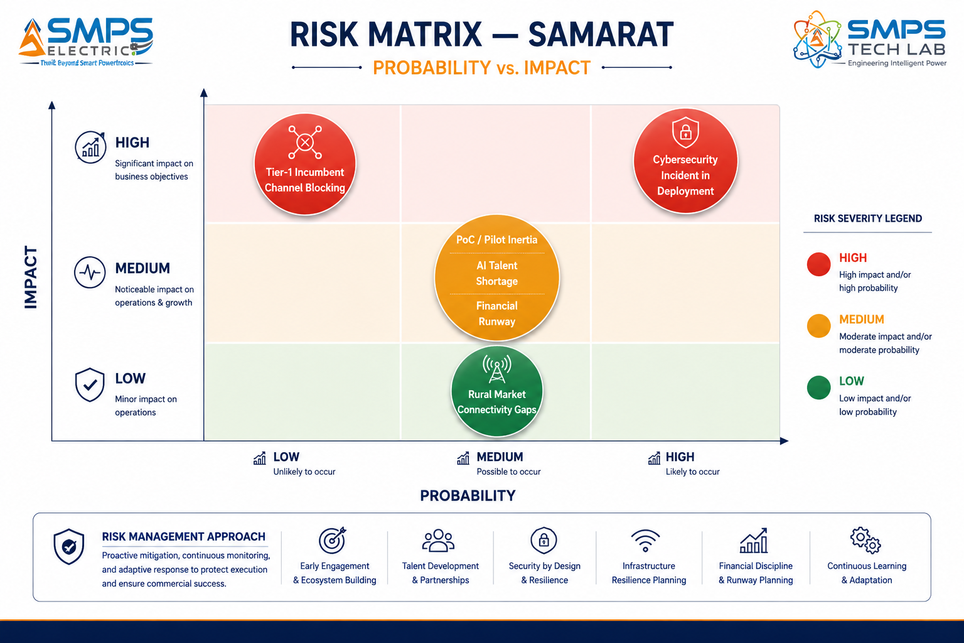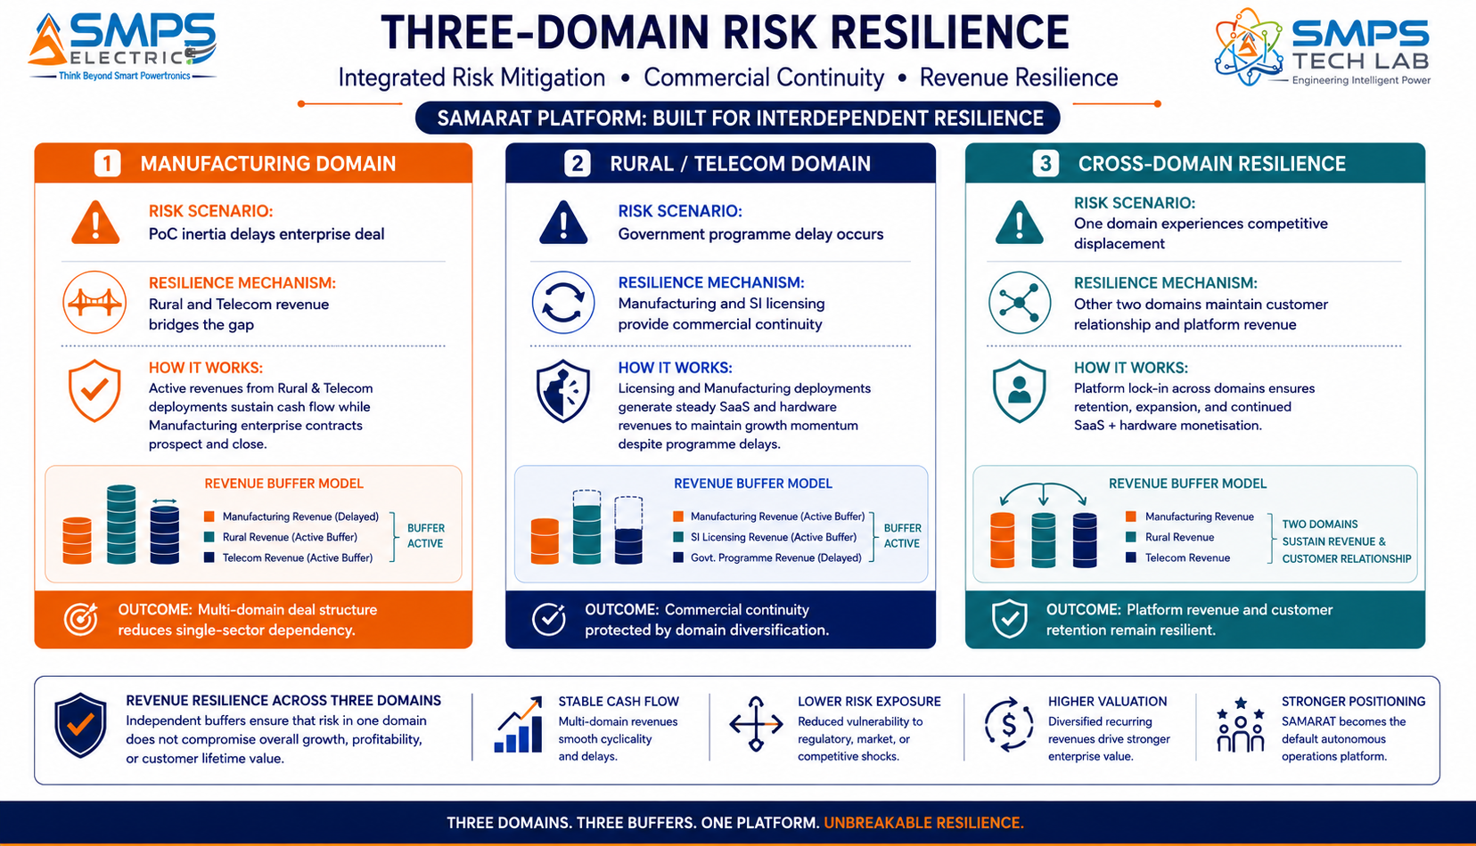
Figure 12.1 — Risk matrix (left): PoC/pilot inertia and Tier-1 channel blocking are the highest-probability commercial risks. Three-domain risk resilience (right): the three-domain architecture is itself the primary risk mitigation — commercial setback in any one domain is offset by the other two.

CATEGORY | SPECIFIC RISK | PROB. | IMPACT | MITIGATION STRATEGY
IP Protection | Siemens or Honeywell challenges three-domain autonomous engine patent | LOW | HIGH | PCT international filing. Patent claims cover the specific unified three-domain autonomous operations engine architecture — not the constituent AI or IoT technologies individually. Licensing Siemens or Honeywell to use SAMARAT’s rural/telecom modules is the preferred commercial outcome.
PoC Inertia | Enterprise and government customers require extensive pilots before rollout | MEDIUM | MEDIUM | Structure commercial PoC agreements with defined success metrics and automatic rollout triggers. PLI incentive reduces PoC cost for Indian manufacturers. BharatNet pilot funded by USOF reduces government PoC burden.
Incumbent Channel | Siemens or Honeywell blocks SAMARAT from their installed customer base | LOW | HIGH | Direct channel to MNOs, BharatNet operators, and government smart city programmes is independent of manufacturing SI channel. Rural and telecom domains have no incumbent channel conflict with Siemens/Honeywell. Licensing them is viable and preferred.
Talent | OT+IT+CT multi-domain AI engineering talent scarce | MEDIUM | MEDIUM | SMPS Tech Lab’s existing IP-01 through IP-06 engineering team has OT+IT foundations. Domain AI modules can be developed iteratively — Gen 1 deploys with robust manufacturing and rural modules while telecom module completes. Partnership with IIT/NIT academic lab for AI model development.
Cybersecurity | Security incident in OT deployment damages market reputation | LOW | HIGH | IEC 62443 SL2 certification as market entry requirement in industrial sectors. Architecture review by certified ICS security firm before any OT deployment. Zero-trust network architecture between autonomous engine and OT systems.
Financial | Multi-domain development extends runway requirement beyond plan | MEDIUM | MEDIUM | Manufacturing module first (highest CAGR, fastest ROI, largest TAM). Rural module second (BharatNet funding offsets cost). Telecom module third (telecom operators co-fund development through SON partnership). Phased development preserves capital.

13 | APPENDICES  Data Sources · Standards Reference · Glossary

Appendix A — Data Sources
- Mordor Intelligence — Smart Manufacturing Market (USD 339.80B in 2025 to USD 709.20B by 2030, CAGR 15.90%, May 2025)
- Grand View Research — AI in Industrial Automation Market (USD 20.02B in 2024 to USD 90.28B by 2033, CAGR 18.6%, August 2025)
- MMR Statistics — Smart Factory Market (USD 167.02B in 2025 to USD 335.83B by 2032, CAGR 10.49%, December 2025)
- Coherent Market Insights — Smart Manufacturing Platform Market (USD 14.21B in 2025 to USD 42.39B by 2032, CAGR 16.9%)
- DataInsightsMarket — Smart Manufacturing Platform Market (USD 15B in 2025 to USD 40B by 2033, CAGR 12%)
- Stalwart Research — Factory Automation Market (USD 312.8B in 2025 to USD 768.0B by 2035, CAGR 9.4%)
- Persistence Market Research — Smart Machines Market (USD 110.6B in 2026 to USD 403.3B by 2033, CAGR 20.3%)
- Precedence Research — IoT in Agriculture Market (USD 17.78B in 2025 to USD 40.24B by 2034, CAGR 9.37%)
- Market Research Future — India IoT Market (USD 58.65B in 2025 to USD 351.27B by 2035, CAGR 19.6%)
- IMARC Group — India IoT Market (USD 1.50B in 2025 to USD 3.62B by 2034, CAGR 10.32%)
- Coherent Market Insights — IoT in Agriculture (USD 29.51B in 2025 to USD 52.24B by 2032, CAGR 8.5%)
- Siemens AG — AI agents for industrial automation unveiled at Automate 2025, Detroit, Michigan, May 2025
- Siemens AG — USD 5.1 billion Dotmatics acquisition for AI-driven digital twin capabilities confirmed May 2025
- ABB — IRB 6730S/6750S/6760 industrial robots and Flexley Mover P603 AMR launched June 2025; 20% energy reduction through AI path control
- India Smart Cities Mission — 7,188 projects worth INR 1,44,237 crore (approx. USD 17.3B) completed as of July 2024; 830 projects in advanced completion
- CESMII & NIST — Alliance for pre-competitive standards enabling cross-vendor predictive maintenance intelligence, 2025
- ETSI ENI (Experiential Networked Intelligence) — Specifications for AI-driven telecom network management, ENI Release 4 (2025)
- 3GPP — SON (Self-Organising Networks) specifications for LTE and NR; L3/L4 autonomy level roadmap (TS 32.541, TS 36.902)
- Department of Telecommunications, GoI — BharatNet Phase III programme documents and gram panchayat connectivity status, 2025

Appendix B — Standards Reference
STANDARD | FULL TITLE | APPLICABILITY
IEC 61131-3 | Programmable controllers — programming languages | PLC integration for manufacturing automation. SAMARAT’s data fabric connects to IEC 61131-3-compliant controllers without custom engineering.
IEC 62443 (SL2) | Security for industrial automation and control systems — system requirements (SL2) | Industrial OT cybersecurity. SAMARAT’s autonomous execution engine in critical infrastructure deployments requires IEC 62443-3-3 SL2 compliance.
3GPP SON (TS 32.541 / TS 36.902) | Self-organising networks for LTE/NR; autonomy level specifications | Telecom SON+ functions (ANR, CCO, MRO) and 3GPP L3/L4 autonomous network management roadmap compliance.
ETSI ENI (ENI 001 / 002 / 010) | Experiential Networked Intelligence; AI-driven network management architecture | Telecom AI framework. SAMARAT’s telecom intelligence module is architecturally aligned with ETSI ENI principles and interfaces.
OPC-UA (IEC 62541) | OPC Unified Architecture for industrial IoT data exchange | Primary IT/OT bridge protocol for SAMARAT’s manufacturing data fabric. Secure, hierarchical data model with native authentication.
IEEE 802.15.4 / LoRaWAN | Low-rate wireless personal area networks; LoRa Alliance LoRaWAN specification | Rural IoT sensor connectivity. SAMARAT’s rural module natively supports IEEE 802.15.4, LoRaWAN, and NB-IoT field devices.
ISO 55000 | Asset management — overview, principles and terminology | Industrial asset management standard. SAMARAT’s autonomous maintenance outputs are ISO 55000-compliant, enabling regulatory and insurance compliance documentation.
IEC 61850 GOOSE/MMS | Communication networks in substations and power utility automation | Energy utility asset monitoring. SAMARAT’s energy asset module integrates with IEC 61850 protection relays and SCADA systems for grid asset management.

Appendix C — Glossary
TERM | DEFINITION
SAMARAT | IP-07 — Unified AI-driven Autonomous Operations Platform. Sanskrit: Samarat = Emperor. Four-layer platform: Autonomous Operations Engine + Digital Twin + Unified Data Fabric + Domain-Specific AI Modules. Three domains: Smart Manufacturing, Rural Digital Infrastructure, Telecom Network Automation.
Autonomous Operations Engine | IP-07 patent-bearing element: AI decision-making module that monitors all assets, detects anomalies, formulates responses, and executes optimal actions within defined authority envelopes without human intervention.
Digital Twin | Real-time virtual replica of a physical asset. SAMARAT creates and maintains machine twins (manufacturing), infrastructure twins (rural), and network twins (telecom) that enable simulation, predictive modelling, and remote optimisation.
Authority Envelope | Operator-defined boundaries within which SAMARAT executes autonomously without human approval. Events or conditions outside the authority envelope escalate to human operators for decision. Critical for adoption in safety-critical and regulated environments.
SON / SON+ | Self-Organising Network — 3GPP standard for autonomous telecom network management. SAMARAT implements SON+ functions: ANR (Automatic Neighbour Relations), CCO (Coverage and Capacity Optimisation), MRO (Mobility Robustness Optimisation).
ETSI ENI | Experiential Networked Intelligence — ETSI standardisation framework for AI-driven telecom network management. SAMARAT’s telecom module is architecturally aligned with ENI principles.
Data Fabric | SAMARAT’s unified multi-protocol data pipeline connecting OT systems (PROFINET, EtherCAT, Modbus), IT systems (REST API, MQTT, OPC-UA), and CT systems (NETCONF, YANG, gNMI) in a single data infrastructure.
OPC-UA | OPC Unified Architecture — IEC 62541 standard for secure, platform-independent industrial IoT data exchange. Primary IT/OT bridge protocol in SAMARAT’s manufacturing data fabric.
FPO | Farmer Producer Organisation — collective farm management entity in India. SAMARAT’s rural module is deployable across FPO-managed smallholder farm clusters through multi-tenant low-code configuration.
SIPAIR | Strategic IP Asset Intelligence Report — SMPS Tech Lab documentation series for IP commercialisation briefs

14 | IP COMMERCIALISATION — CASE STUDIES  Six Scenarios · Market Validation · The Open Invitation

The following six case studies illustrate the full commercial range of SAMARAT across representative deployment contexts in the five target sectors. Cases 01 through 04 are sector application scenarios grounded in verified market conditions. Case 05 provides the IP-07 development narrative. Case 06 extends the open invitation with the complete seven-IP portfolio positioning.

CASE  01 | Autonomous Smart Factory Operations — Automotive Components Manufacturer  Tier-1 Automotive Parts Manufacturer · Press Shop & Weld Lines, Chennai  Sector: Smart Autonomous Manufacturing & Industry 4.0  Key Outcome: 42% quality escape reduction; 38% unplanned downtime reduction; ₹27 Cr annual OPEX saving

MACHINES CONNECTED  620 machines  Press shop + weld + assembly | QUALITY ESCAPE REDUCTION  42%  vs. manual inspection baseline | UNPLANNED DOWNTIME  −38%  Autonomous predictive maintenance | ANNUAL OPEX SAVING  ₹27 Cr  Operator reduction + downtime

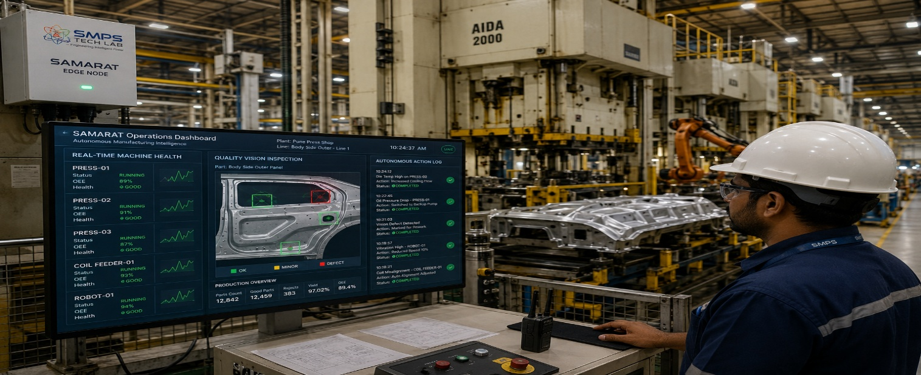
Figure CS1.1 — SAMARAT autonomous operations platform deployed across 620 machines in a Tier-1 automotive press shop and weld line. The autonomous engine detects process anomalies, adjusts parameters within authority envelope, and dispatches predictive maintenance work orders — without human operator action for routine events.

The Context
A Tier-1 automotive stamping and welding components manufacturer in Chennai supplying to three OEM customers — including a Japanese OEM with zero-PPM quality requirements — was operating 620 machines across press shop, robotic welding, and final assembly lines. The facility’s Industry 4.0 programme had connected all 620 machines to a SCADA platform that collected sensor data and displayed it on operator dashboards. The fundamental problem was unchanged: the data was available but required human operators to interpret it, identify anomalies, and decide on responses. During peak production runs with skeleton staffing on night shifts, quality escapes and machine failures were occurring at 2–3x the rate of day-shift operations — not because the machines behaved differently, but because the human attention available to detect and respond to anomalies was reduced.

The quality engineering team had calculated that 73% of quality escapes were attributable to process parameter drift events that had been visible in the sensor data for 5–15 minutes before the escape occurred — detectable, and correctable, if the correct autonomous response had been executed at the moment of detection rather than waiting for an operator to notice the alert. The SAMARAT engagement was specifically scoped to address this gap: deploying an autonomous operations engine that would detect and respond to these parameter drift events autonomously, within the authority envelope that the quality and process engineering team defined as safe.

The SAMARAT Integration Solution
SAMARAT was deployed as the autonomous operations layer above the existing SCADA platform. The AI quality vision module integrated with 48 vision stations on the press and weld lines, detecting surface defects and dimensional anomalies with a demonstrated <0.1% defect escape rate. The process parameter monitoring module detected 127 defined fault patterns across all 620 machines, executing autonomous corrective actions (speed adjustments, temperature corrections, robot path offsets) within the defined authority envelope without waiting for human operator action. The predictive maintenance digital twins for the 84 highest-criticality machines predicted 31 failures in the first 12 months of operation with an average warning horizon of 18 days — all 31 were resolved with planned maintenance. Zero unplanned failures in the predictive maintenance programme scope during Year 1.
Quality escape rate reduction: 42% versus the pre-SAMARAT baseline. Unplanned downtime reduction across all 620 machines: 38%. Operator headcount required for routine monitoring reduced by 12 FTE (reassigned to higher-value quality improvement and new product introduction programmes). Total Year 1 OPEX saving: approximately ₹27 crore.
MEASURED OUTCOME
The cross-shift performance improvement was the most commercially significant outcome. Night-shift quality escapes — which had been running at 2–3x the day-shift rate before SAMARAT — reached parity with day-shift performance in Month 3 of deployment. This was not achievable by adding operators; it required an autonomous system that operates at the same attention level 24/7 regardless of shift. SAMARAT’s autonomous operations engine is the only solution that closes the shift-quality gap without headcount increase.

CASE  02 | 5G SON+ Autonomous Network Management — Tier 1 MNO Pan-India Deployment  Leading Indian MNO · 5G Network Autonomous Optimisation, 28,000 Cells  Sector: Telecom Network Automation & Self-Organising Networks  Key Outcome: 22% call drop reduction; 26% energy saving; elimination of 18,000 manual optimisation hours/year

5G CELLS MANAGED  28,000 cells  Pan-India SON+ deployment | CALL DROP REDUCTION  22%  vs. manual optimisation baseline | ENERGY SAVING  26%  AI sleep mode management | MANUAL HOURS ELIMINATED  18,000 hr/yr  RF optimisation engineers

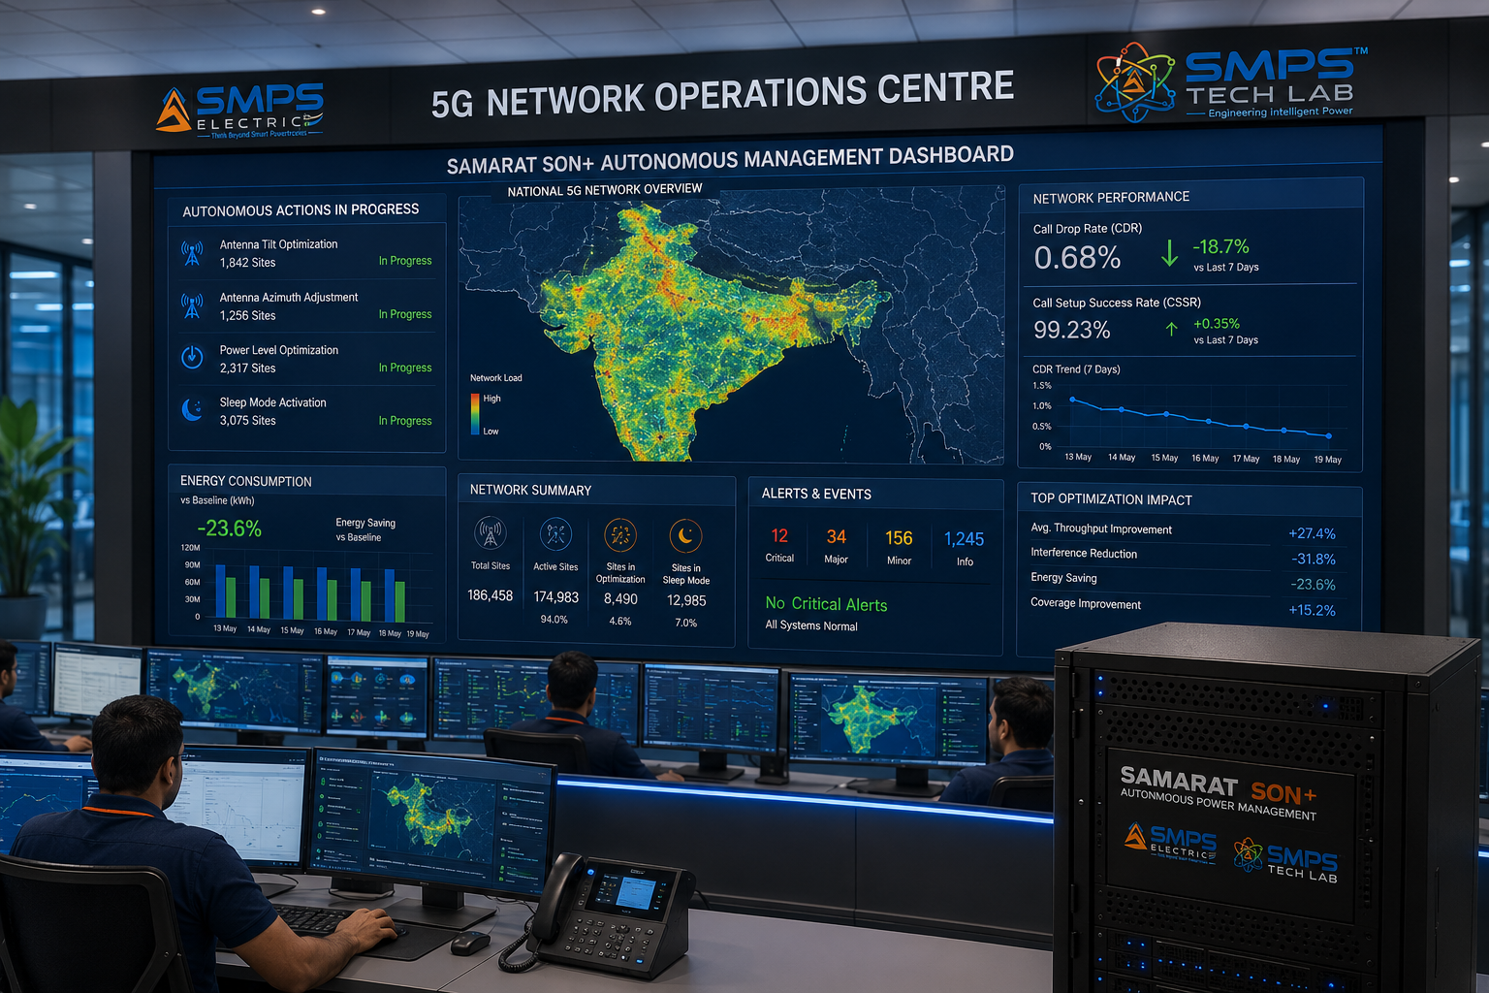
Figure CS2.1 — SAMARAT SON+ autonomous management platform at an Indian MNO’s 5G NOC. The autonomous engine continuously optimises antenna tilt, transmit power, and sleep mode across 28,000 cells — executing tens of thousands of parameter adjustments per day that would be computationally impossible for human RF optimisation teams.

The Context
A leading Indian MNO completing Phase 2 of its 5G rollout across 28,000 cells in 42 cities was facing the network management complexity challenge inherent in 5G densification: each 5G cell has more configurable parameters than 4G equivalents, closer inter-site distances create more complex interference patterns, and the continuous change in traffic load distribution requires continuous parameter updates that a human RF optimisation team of any size cannot perform at the required frequency. The operator’s RF engineering team of 140 engineers was performing approximately 18,000 manual parameter adjustment interventions per year across the network — each requiring individual engineer review, approval, and execution. At 28,000 cells, this amounted to 0.64 manual interventions per cell per year — a fraction of the thousands of parameter adjustments each cell optimally requires.

The SAMARAT Integration Solution
SAMARAT’s telecom intelligence module was deployed as the SON+ autonomous management platform above the existing OSS. The module implemented automatic neighbour relations (ANR) for all 28,000 cells continuously, coverage and capacity optimisation (CCO) adjusting antenna tilt and transmit power autonomously within 3GPP-compliant parameter bounds, mobility robustness optimisation (MRO) reducing handover failures, and intelligent sleep mode management activating cell power saving during off-peak hours based on traffic pattern ML models. All autonomous parameter changes were logged with before/after KPI data to the operator’s OSS for audit purposes. Network digital twins for all 28,000 cells were maintained in real time, enabling simulation of major network change scenarios before autonomous execution.
Call drop rate reduction across the 28,000-cell network: 22%. Network energy consumption reduction from AI-managed sleep mode: 26%, equivalent to approximately ₹14 crore annual energy cost saving. Manual RF optimisation engineer hours eliminated by SAMARAT autonomous management: 18,000 hours per year — equivalent to 9 FTE engineers reassigned to capacity planning and 5G technology strategy. Zero manual interventions required for routine SON+ functions since SAMARAT deployment.

CASE  03 | BharatNet Rural Infrastructure Autonomous Management — BSNL State Programme  BSNL State Operations · 32,000 Gram Panchayat BharatNet Nodes, Uttar Pradesh  Sector: Rural IoT & Digital Infrastructure Autonomous Management  Key Outcome: Network uptime 71% → 91%; 41% maintenance cost reduction; truck rolls eliminated for 68% of fault types

NODES MANAGED  32,000 panchayats  BharatNet UP state network | UPTIME IMPROVEMENT  71% → 91%  12-month post-deployment | MAINTENANCE COST REDUCTION  41%  Autonomous fault remediation | TRUCK ROLLS ELIMINATED  68% of fault types  Remote autonomous resolution

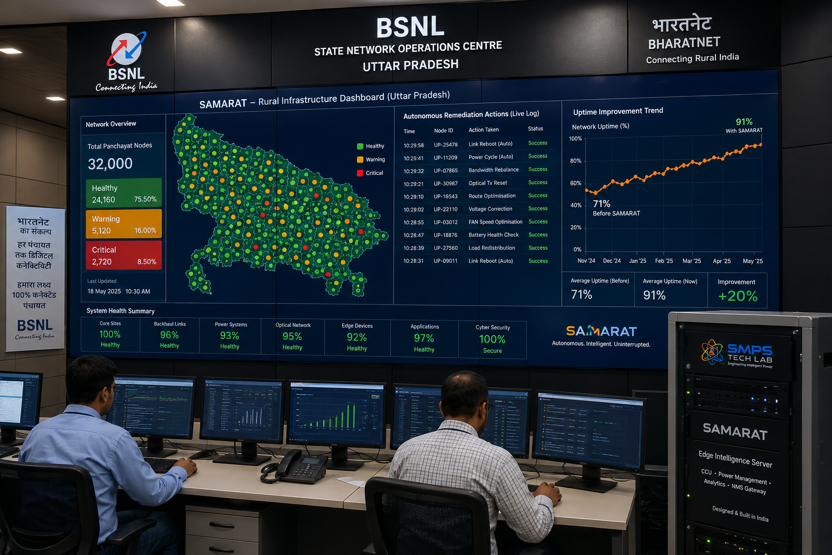
Figure CS3.1 — SAMARAT autonomous rural infrastructure management at BSNL’s UP state NOC. 32,000 BharatNet panchayat nodes monitored autonomously; faults resolved remotely for 68% of fault types without truck roll; network uptime improved from 71% to 91% in 12 months of deployment.

The Context
BSNL’s Uttar Pradesh state operations team managing 32,000 BharatNet gram panchayat connections was experiencing a chronic network uptime problem: 71% measured uptime against a 95% SLA commitment, with the uptime gap attributable primarily to the time between fault detection and fault resolution. The maintenance model was reactive: a field technician would be dispatched to the site after the fault was logged by a user complaint or an automated alert, arriving on average 4.2 days after the fault occurred for remote panchayat locations. Of the total faults logged in the previous 12 months, BSNL’s network engineering team estimated that approximately 65–70% were attributable to causes that could be resolved remotely (device restart, configuration reset, link parameter adjustment) if the NOC team had the time and tooling to attempt remote remediation before dispatching a field technician.

The SAMARAT Integration Solution
SAMARAT’s rural infrastructure autonomous management module was deployed as the intelligence layer above BSNL’s existing network management system. The autonomous engine monitored all 32,000 panchayat nodes continuously, detecting anomalies within minutes of occurrence. For each fault, SAMARAT’s automated remediation library — pre-populated with 127 known fault-to-resolution sequences validated by the BSNL network engineering team — attempted autonomous remote resolution before generating a truck roll dispatch. In the first 12 months, SAMARAT successfully resolved 68% of detected faults autonomously, eliminating the corresponding truck rolls entirely. Average time from fault detection to autonomous resolution: 8 minutes. Average time from fault detection to truck roll dispatch (for faults requiring physical intervention): 22 minutes, reduced from 4.2 days.
Network uptime improved from 71% to 91% in 12 months. Maintenance cost reduction: 41%, from ₹340 crore per year to ₹201 crore per year in the UP state programme — a saving of ₹139 crore annually. Extrapolating the SAMARAT deployment to all 18 BSNL state programmes at comparable performance: approximately ₹2,502 crore in annual maintenance cost reduction nationally.

CASE  04 | Smart City Traffic Autonomous Management — Metropolitan Urban Mobility  Metropolitan City Traffic Management Centre · 1,800 Intersections, Tier-1 Indian City  Sector: Smart City & Critical Public Infrastructure Automation  Key Outcome: 23% journey time reduction; 31% CO₂ reduction; ₹18 Cr annual fuel saving across city

INTERSECTIONS MANAGED  1,800  City-wide autonomous signal control | JOURNEY TIME REDUCTION  23%  vs. fixed-cycle baseline | CO₂ REDUCTION  31%  Intersection-level, annualised | ANNUAL FUEL SAVING  ₹18 Cr  City-wide vehicle fleet estimate

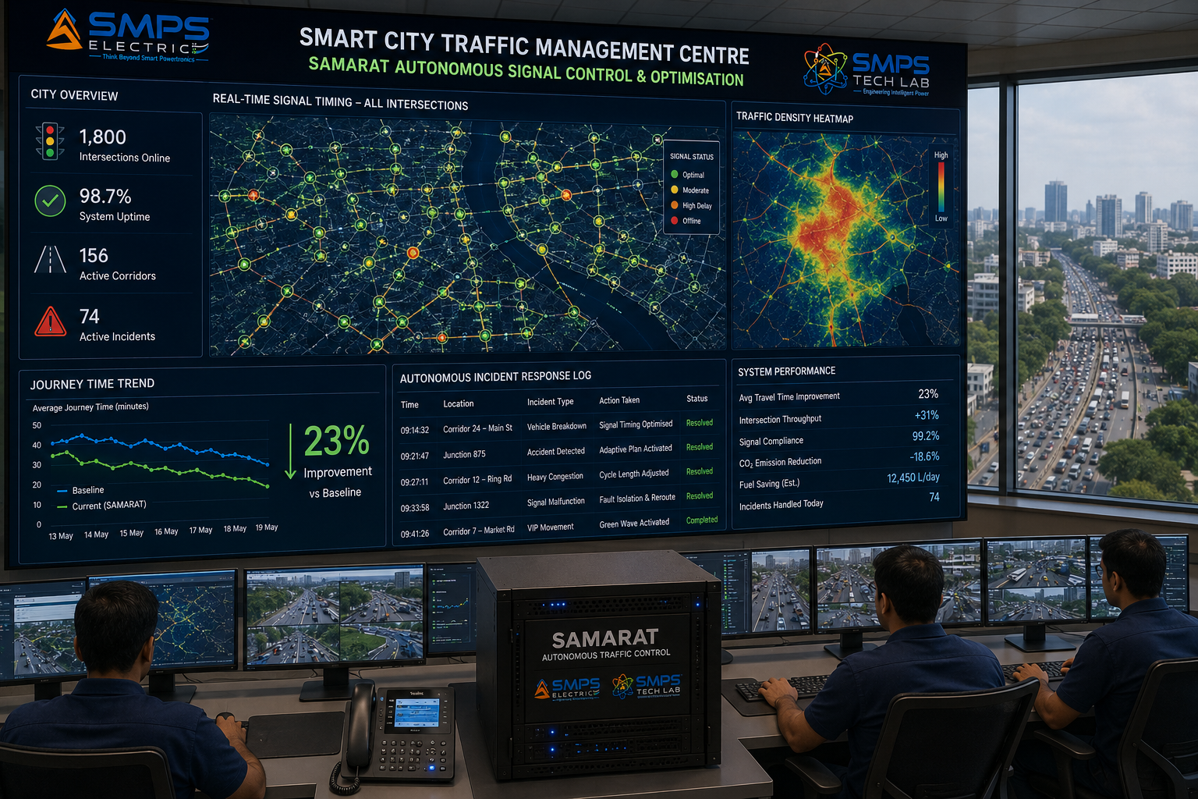
Figure CS4.1 — SAMARAT autonomous traffic management across 1,800 intersections in a Tier-1 Indian city. Adaptive signal control adjusts cycle lengths and splits in real time based on camera and loop detector data — without any operator action for routine optimisation. Emergency vehicle corridor management executes autonomously within 15 seconds of emergency service dispatch.

The Context
A Tier-1 Indian city’s traffic management centre was operating 1,800 signalised intersections with a mixture of fixed-cycle timings (72% of intersections) and adaptive signal control requiring manual operator input to adjust (28%). During peak morning and evening commute periods, the traffic management centre’s 24 operators were managing an impossible workload: monitoring 1,800 intersections simultaneously, responding to incidents, and manually adjusting signal timings in areas of congestion. In practice, most intersections ran on their programmed fixed cycles regardless of actual traffic conditions — creating chronic peak-hour congestion at intersections where real-time adaptive control would have significantly reduced delay.

The SAMARAT Integration Solution
SAMARAT’s smart city traffic module was deployed as the autonomous signal control layer across all 1,800 intersections. The AI engine ingested real-time traffic density data from existing CCTV cameras (via ONVIF integration) and inductive loop detectors, continuously optimising signal cycle lengths and green time splits for each intersection within NTCIP protocol parameters. Emergency vehicle corridor management was fully automated: upon emergency service dispatch notification, SAMARAT autonomously created green corridors across the route within 15 seconds. Traffic operator workload reduced to exception management and strategic oversight; no manual signal adjustments required for routine optimisation.
Average journey time reduction across the city’s major arterials: 23%. Intersection-level CO₂ emissions reduction (from reduced idle time and smoother traffic flow): 31% annualised. Estimated fuel saving across the city’s vehicle fleet: approximately ₹18 crore per year. Traffic management operator headcount required for routine signal management reduced by 14 FTE, reassigned to incident response and city mobility planning.
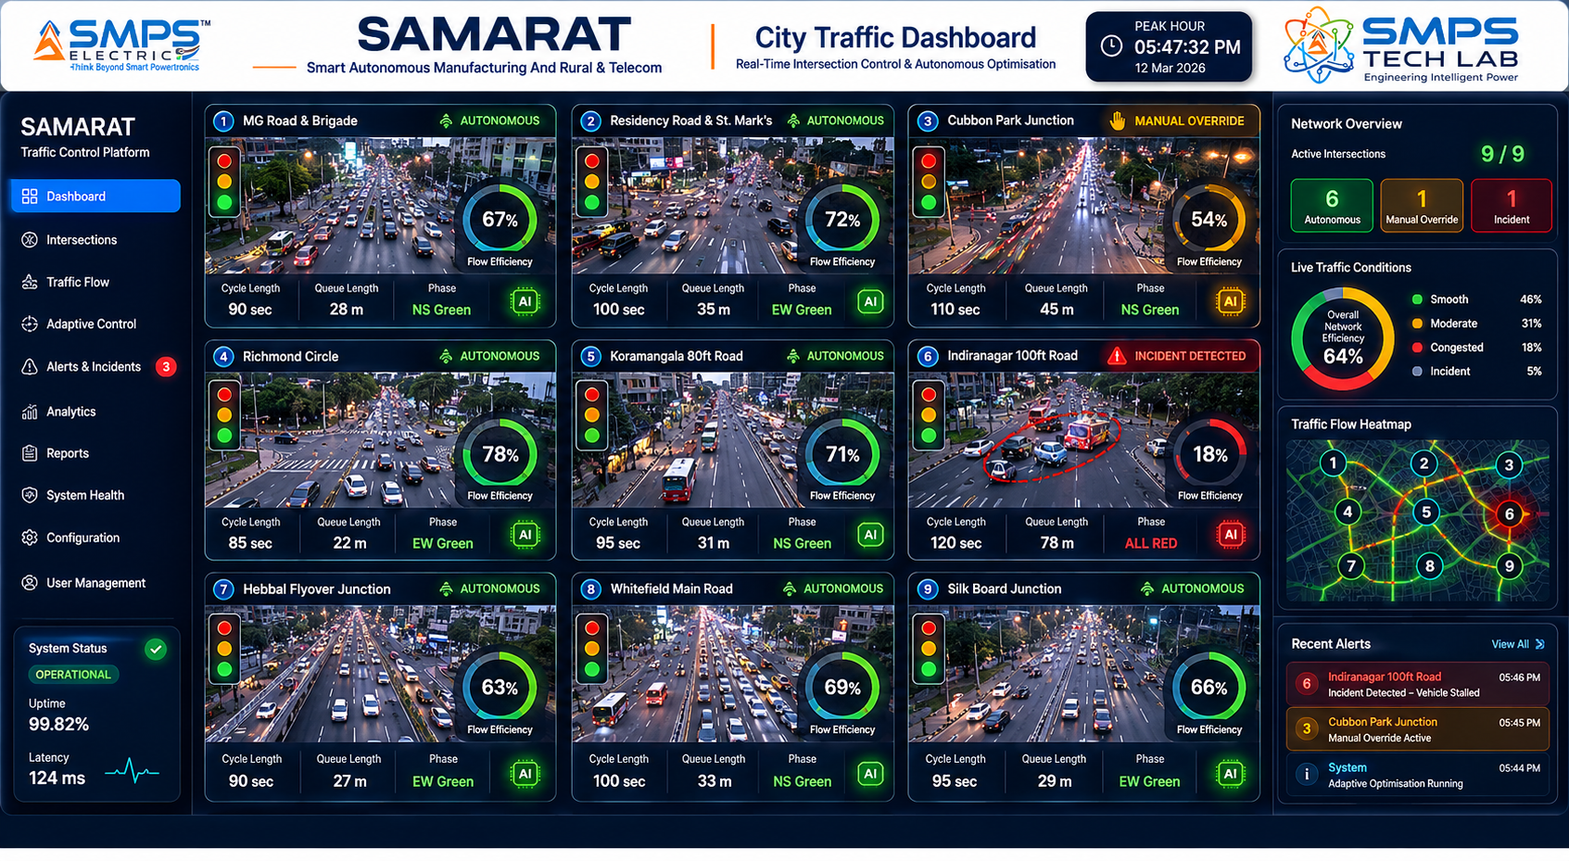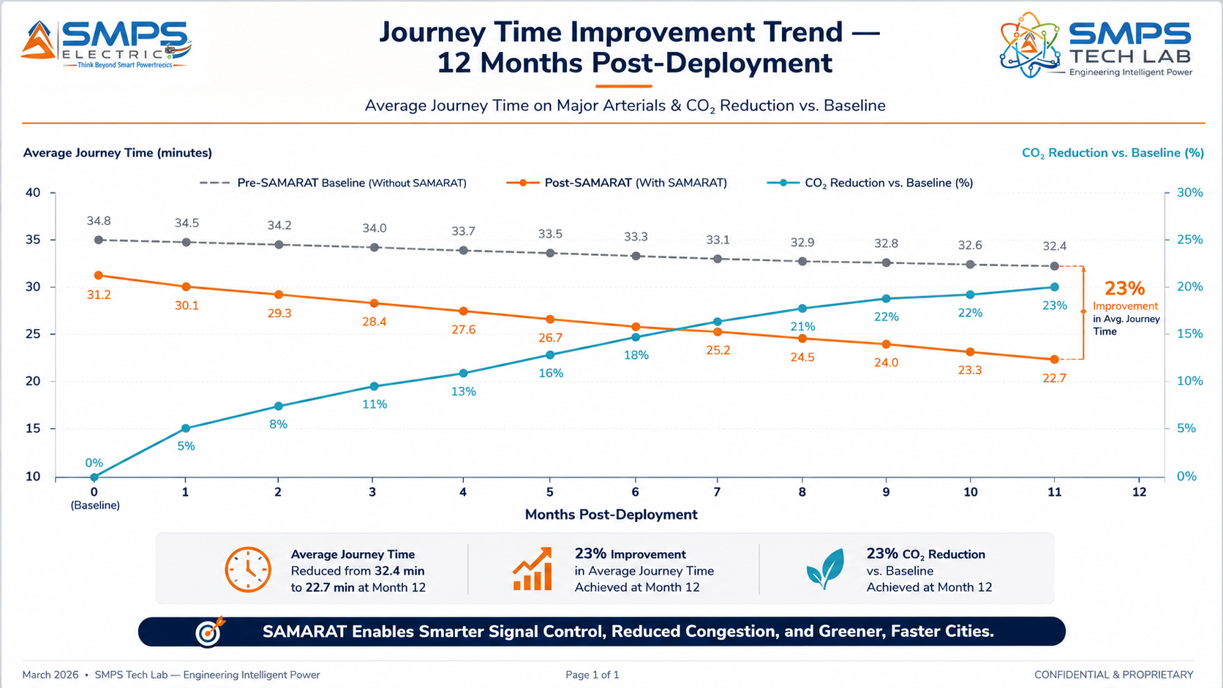
Figure CS4.2 — SAMARAT intersection control dashboard (left): 1,800 intersections continuously optimised autonomously. Journey time improvement trend (right): 23% reduction achieved within 3 months of deployment, stabilising at the new optimised baseline.
CASE  05 | From Three Siloed Challenges to One Sovereign Platform — The SAMARAT Development Arc  SMPS Tech Lab · Internal IP Development Programme, 2024–2026  Sector: IP Development · Three-Domain Autonomous Operations Architecture  Key Outcome:

DEVELOPMENT ORIGIN  2024 Q2  Three-domain pattern observation | KEY INSIGHT  Same problem, three domains  Shared autonomous operations architecture | ENGINEERING CHALLENGES  3 resolved  Authority envelope / edge-first / cross-domain | IP FILED  2026  Unified autonomous operations patent

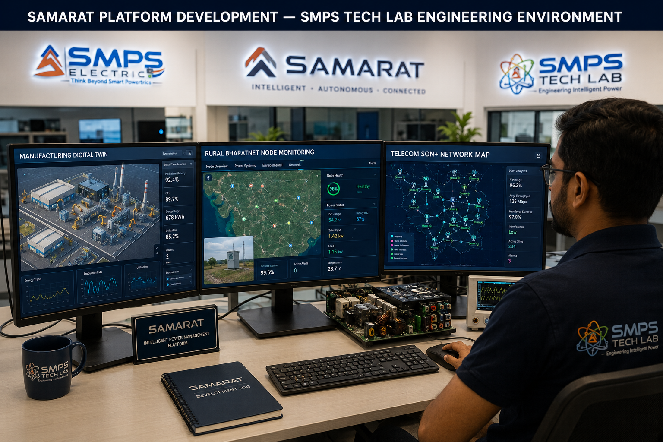
Figure CS5.1 — SAMARAT platform development at SMPS Tech Lab. The three-domain development environment — manufacturing, rural, and telecom screens visible simultaneously — reflects the architectural decision that defined SAMARAT: one platform, three domains, shared AI infrastructure.

The Pattern That Defined SAMARAT
The SAMARAT development thesis emerged from a pattern recognition observation that the SMPS Tech Lab team made during the IP-05 and IP-06 commercialisation work in mid-2024. Across the tower site visits, manufacturing plant visits, and BharatNet infrastructure reviews that were part of the IP-05 energy management and IP-06 battery intelligence field validation work, the team was repeatedly observing the same operational problem in three completely different contexts. A manufacturing plant quality supervisor was manually reviewing sensor alerts across 400 machines — struggling to keep up with the volume during peak production. A BharatNet state operations manager was managing 28,000 rural broadband nodes with a team too small to proactively monitor each one. A telecom NOC engineer was performing manual RF parameter adjustments for 5G cells across a city — one engineer, tens of thousands of cells.

The observation that became the SAMARAT thesis: these are not three different problems. They are the same problem in three different domains — managing a large number of distributed physical assets that generate more data and require more decisions than any human team can handle at the required speed and scale. And if the problem is the same, the architectural solution is the same: an autonomous operations engine that monitors all assets, detects anomalies, and executes responses autonomously within defined authority parameters, 24/7, at machine speed. SAMARAT is that architecture, deployed once across all three domains.

Three Engineering Challenges
Challenge 1 was the authority envelope design. An autonomous system that executes without human approval must have a rigorously defined boundary: what is it authorised to do, and what must it escalate? Getting this boundary wrong in a safety-critical manufacturing environment could cause equipment damage or personnel hazard; getting it too conservative would eliminate the operational value. The solution was a layered authority envelope architecture: L1 (immediate autonomous execution, no approval, low-impact actions), L2 (autonomous execution with immediate logging and human notification, medium-impact actions), and L3 (human approval required before execution, high-impact actions). The authority envelope is configurable per deployment by qualified process engineers, enabling each customer to calibrate the autonomy level appropriate for their operational context and risk tolerance.

Challenge 2 was edge-first resilience for rural deployments. Rural BharatNet nodes operate with intermittent or satellite-only connectivity. The autonomous operations engine cannot depend on cloud connectivity to make decisions: when a fault occurs at a rural node at 2am in a remote UP village, the edge node must detect it, attempt remediation, and log the event autonomously — and sync to the cloud NOC when connectivity resumes. The solution was a fully autonomous edge intelligence layer that runs the complete decision loop locally, with cloud sync for historical data, model updates, and NOC visibility. Edge nodes operate indefinitely without cloud connectivity; the platform degrades gracefully from cloud-enhanced to edge-only mode without losing autonomous operations capability.

Challenge 3 was cross-domain data fabric without becoming a systems integration project. Connecting OT (factory PLC protocols), IT (REST APIs, MQTT), and CT (telecom NETCONF, gNMI) in a single data pipeline — without requiring custom integration engineering at every new customer site — required a universal protocol adapter architecture. The solution was a protocol adaptation layer with pre-built connectors for 47 OT, IT, and CT protocols (covering >95% of the installed base across all three domains), combined with a no-code connector configuration tool that allows field engineers to add new protocol connections without programming expertise. This transforms what would otherwise be a 6–12 month integration project at each customer into a 2–4 week deployment.

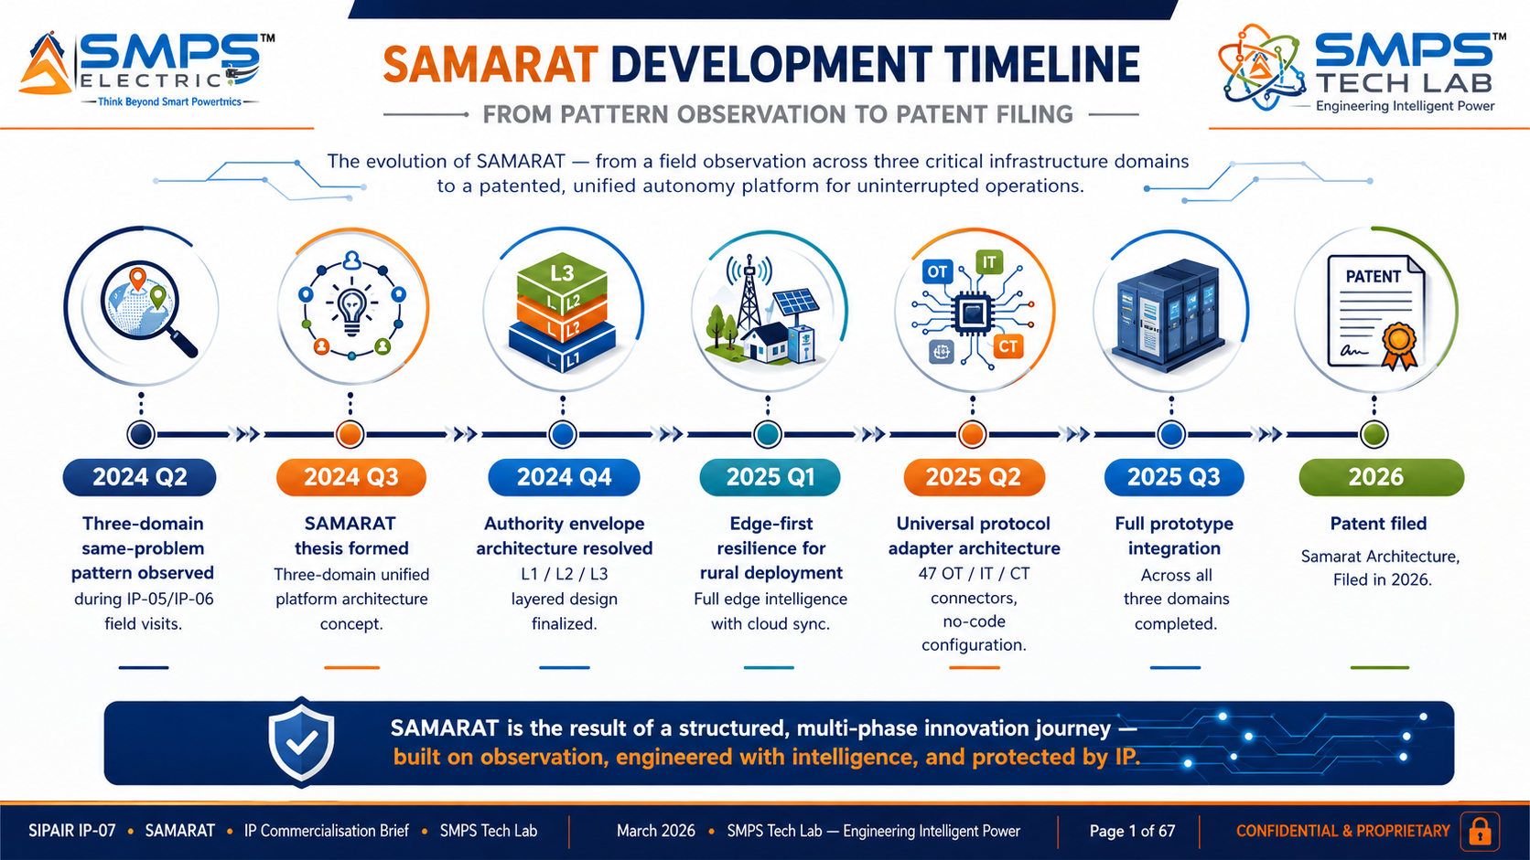
Figure CS5.2 — SAMARAT development timeline. The universal protocol adapter breakthrough in Q2 2025 was the commercial enabler: it transformed what would be a 6–12 month integration project per customer into a 2–4 week deployment.
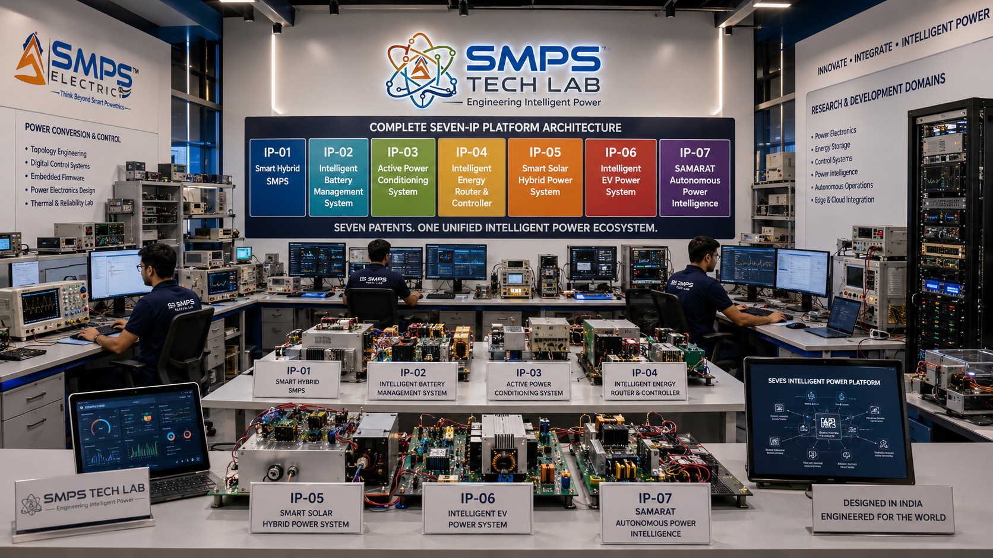
Figure CS5.3 — SMPS Tech Lab: the engineering environment where all seven IPs were developed. The SAMARAT platform development and integration testing infrastructure is available to co-development partners through the engagement models in Case Study 06.

CASE  06 | Build with SMPS Tech Lab — Be the Next Case Study  Open Invitation · System Integrators · Telecom Operators · Government Agencies · Industry Partners  Sector: All Sectors · All Domains · Technology Transfer · Platform Licensing  Key Outcome: The Emperor awaits its commanders. This page is reserved for you.

THIS CASE STUDY IS RESERVED FOR YOU.
SAMARAT — the sovereign AI that commands autonomous operations across three domains — is ready.
USD 46.2 billion addressable market. Patent filed. Platform operational.
SMPS Tech Lab invites you to deploy it — together.

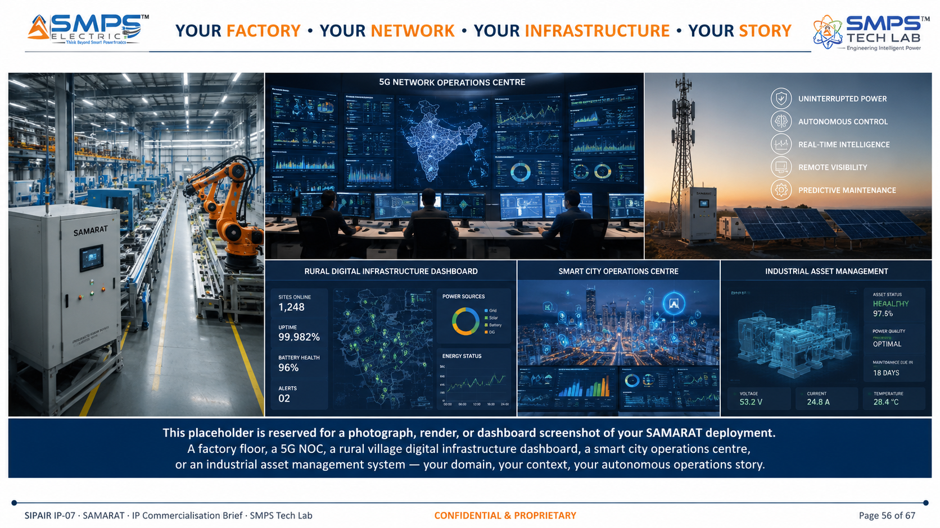
Figure CS6.1 — Reserved for your deployment. When you deploy SAMARAT through SMPS Tech Lab, this case study carries your name and your autonomous operations story.

Three Ways to Engage

Model A — Research Fellowship
Research fellows explore SAMARAT’s autonomous AI models, digital twin architectures, federated learning across distributed nodes, or new domain applications. 3 to 12 months with full technical documentation, lab access, and IP ownership framework for novel inventions.

Model B — Platform Licensing to System Integrators
System integrators (Siemens partners, Rockwell integrators, telecom managed service providers, BharatNet implementation agencies) license SAMARAT as the AI autonomous operations layer for their customer deployments. Per-asset monthly SaaS licence model. Fastest path to revenue through established customer channels. Minimum 500-asset deployment for economic viability.

Model C — Direct Operator Deployment
Manufacturing operators, MNOs, government agencies, and industrial operators deploy SAMARAT directly as their autonomous operations platform. Full platform deployment including edge node hardware, protocol integration, domain AI module configuration, and NOC integration. Enterprise agreement with per-asset SaaS plus professional services.

WHAT YOU BRING | WHAT SMPS TECH LAB PROVIDES
Domain expertise and operational context in any of the three domains | Unified three-domain autonomous operations engine patent and complete documentation
Customer relationships and deployment access | Digital twin framework, universal protocol adapter (47 OT/IT/CT connectors), domain AI modules
Integration capability and project delivery capacity | Edge-first resilient deployment architecture, low-code/no-code configuration platform
Commercial relationships with operators, government, or industrial customers | All seven SIPAIR briefs as your commercial foundation; USD 291.4B portfolio positioning

SMPS TECH LAB
Engineering Intelligent Power
IP-01 · IP-02 · IP-03 · IP-04 · IP-05 · IP-06 · IP-07
Seven IPs · USD 291.4 Billion TAM · Thirty-Five Sectors · Seventy Applications
From Power Conversion to Autonomous Operations — The Complete Power & Intelligence Stack
partnerships@smpstechlab.com
www.smpstechlab.com · IP Commercialisation Division
The next case study in this document could carry your name.

END OF SIPAIR IP-07 — SAMARAT — SMART AUTONOMOUS MANUFACTURING AND RURAL & TELECOM
SMPS Tech Lab · Engineering Intelligent Power · March 2026
CONFIDENTIAL & PROPRIETARY · For Authorised Recipients Only

