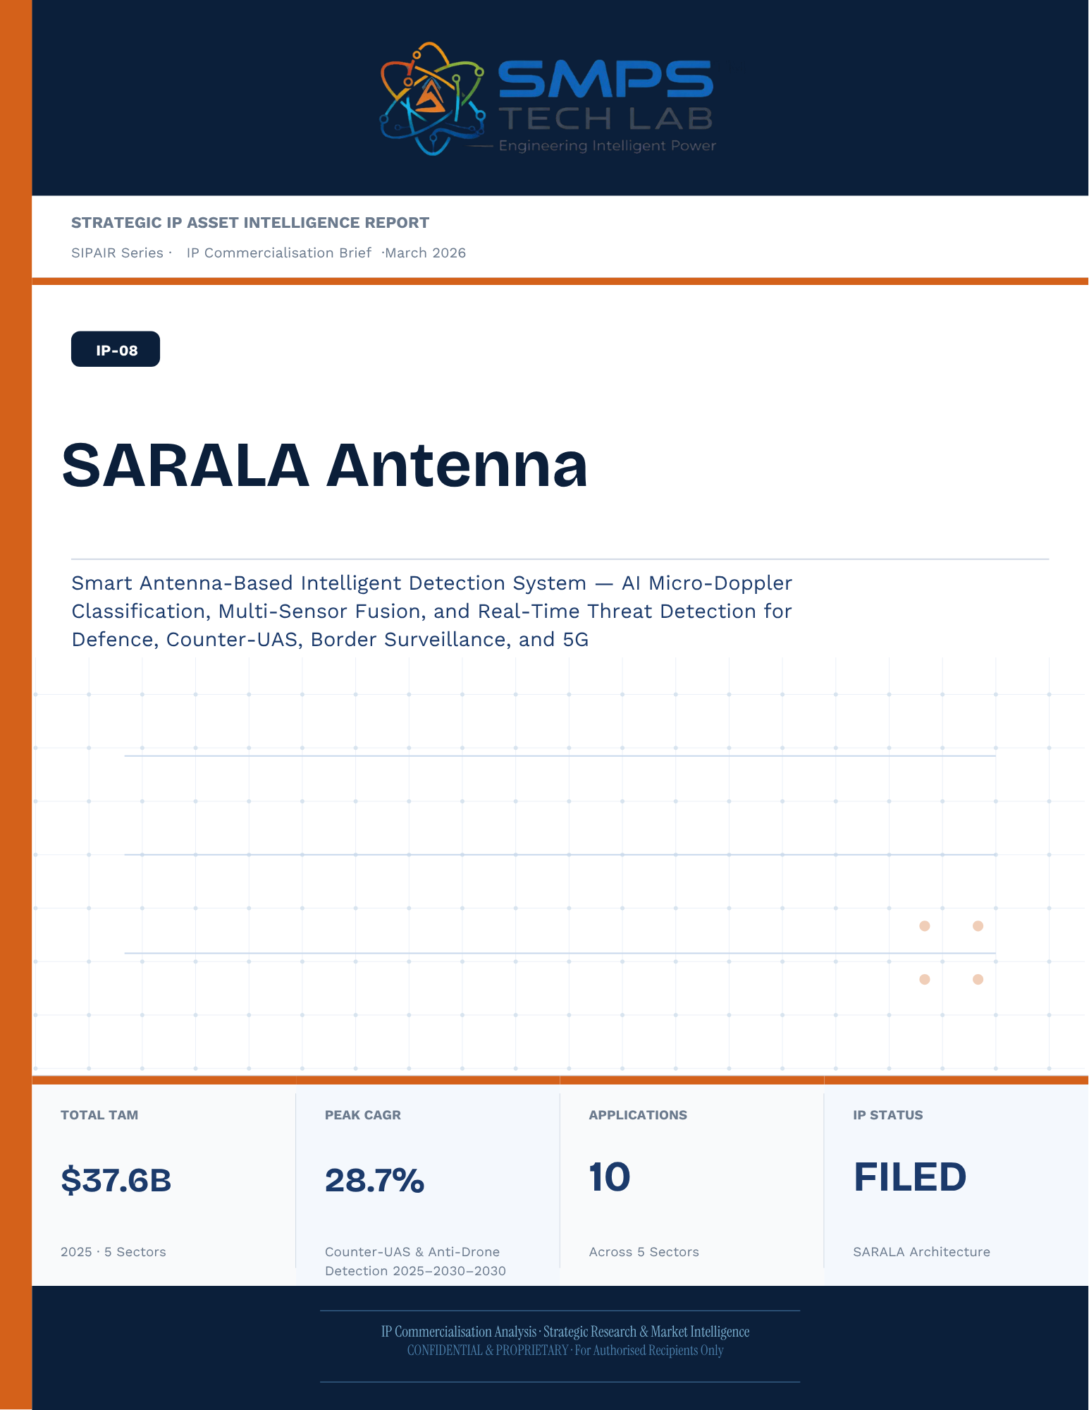
Un-named
[Email address]
[Draw your reader in with an engaging abstract. It is typically a short summary of the document.
When you’re ready to add your content, just click here and start typing.]
STRATEGIC IP ASSET INTELLIGENCE REPORT
SIPAIR Series
IP-08: SARALA
SMPS-Based Integrated SARALA for Uninterrupted Telecom Power

Report Title | SIPAIR IP-08 — SARALA Commercialisation Brief

Document Series | Strategic IP Asset Intelligence Report (SIPAIR)

Version | Version 1.0 — First Edition

Compiled & Edited by | Shri Amareshwar Karatagi

Organisation | SMPS Tech Lab — Engineering Intelligent Power

Date of Issue | March 2026

Classification | Confidential & Proprietary — For Authorised Recipients Only

IP Reference | IP-08 — SARALA Architecture, Filed 2025

Related Document | SIPAIR IP-01: Smart Hybrid SMPS (see companion brief)

This document is prepared by SMPS Tech Lab as part of the SIPAIR IP Commercialisation Series.

Declaration — Originality & Intellectual Property Statement

This Strategic IP Asset Intelligence Report (SIPAIR — IP-08: SARALA) is an original compilation prepared by SMPS Tech Lab. The analysis, market intelligence frameworks, commercial strategy formulations, and case study narratives contained herein are the result of independent research and original intellectual work by the authors and editors named in this document.

The core technology described in this report — the SMPS-Based Integrated SARALA architecture, including its active power management layer, CCU intelligence stack, uninterrupted multi-rail AC/DC delivery system, and NMS integration platform — is the exclusive proprietary invention of SMPS Tech Lab, protected under a filed novel design patent (2025). IP-08 is a distinct and independently protectable invention from IP-01 (Smart Hybrid SMPS), though both emerge from the same SMPS Tech Lab research programme. The two IPs are designed to complement each other across adjacent application verticals and may be jointly licensed or co-deployed where application requirements demand both hybrid topology and active power management intelligence.

Market sizing data, CAGR estimates, and industry statistics cited in this document are sourced from independent third-party research publications, fully attributed in Appendix A. All third-party data is used for analytical and benchmarking purposes only. This report has not been submitted, in whole or in part, to any other organisation for commercialisation or formal assessment except as specifically disclosed in writing.

Declared by:

Shri Amareshwar Karatagi
Founder & CSO
SMPS Tech Lab · March 2026

CERTIFICATE OF AUTHENTICITY
IP Commercialisation Documentation · SIPAIR IP-08

This is to certify that the Strategic IP Asset Intelligence Report
SIPAIR IP-08 — SARALA
has been compiled, reviewed, and authenticated by the undersigned in accordance
with the standards of the SIPAIR documentation series. The technology, market analysis,
and commercial intelligence herein are verified as accurate to the best of the signatories’
knowledge as at the date of issue: March 2026.

Program Head / Director | Technical Mentor
  Program Head / Research Director
  SMPS Tech Lab
  Technical Mentor / Advisor
  SMPS Tech Lab

SMPS Tech Lab · Engineering Intelligent Power · March 2026

Acknowledgment

The preparation of this Strategic IP Asset Intelligence Report for IP-08 has drawn on the technical expertise, operational insights, and research foundation developed across two parallel innovation tracks at SMPS Tech Lab. The development of the CCU intelligence layer — the defining innovation of IP-08 — required not only power electronics engineering depth but sustained engagement with telecom network operations, tower management practice, and satellite ground station engineering environments that are highly specialised. The author and editor express sincere gratitude to those whose knowledge and access made this work possible.

Technical Development
The CCU architecture at the heart of IP-08 evolved alongside IP-01's hybrid topology work, but along a distinct engineering trajectory focused on power orchestration intelligence rather than conversion efficiency alone. The engineers and technologists who contributed to the CCU control logic, NMS integration stack, and sub-millisecond failover switching mechanism deserve specific recognition for the rigour with which they approached the uninterrupted power mandate — a design objective that admits no approximation.

Telecom Industry Access
The sector intelligence in this report reflects direct engagement with tower operations, data centre facility management, and satellite ground station engineering communities. The operational data from 5G tower rollout programmes, off-grid hybrid power deployments, and maritime communication installations that informed the case study narratives and application requirement specifications in this document is the product of those field engagements.

Research Publications
The market intelligence framework draws on publications from Future Market Insights, MarketsandMarkets, SNS Insider, Grand View Research, IMARC Group, Coherent Market Insights, Global Growth Insights, and the Ericsson Mobility Report, as well as operational data from the International Energy Agency. The quality of those independent research publications is what allows the TAM framework in this report to be grounded in named, verifiable data rather than estimated aggregates.
Shri Amareshwar Karatagi
Founder & CSO
SMPS Tech Lab · March 2026

Preface — From the Founder & Editor

From IP-01 to IP-08 — The Logical Extension
IP-01, documented in the companion SIPAIR brief, solved one problem with exceptional elegance: replacing the unnecessary architectural duplication of separate AC and DC converter units with a single hybrid topology. The commercial case was compelling and the market evidence was clear. But the engineers at SMPS Tech Lab, in the same process of field observation that gave rise to IP-01, had identified a second problem — one that operated at a higher level of the power system stack and was, if anything, more commercially urgent in the specific context of telecom infrastructure.

The problem was not conversion efficiency. It was availability. In a 5G base station, a satellite ground hub, an offshore platform communication centre, or a smart city public safety network node, the standard power supply architecture not only requires separate AC and DC converters — it delegates all intelligence about the power state of the system to a separate controller that may be physically remote, software-dependent on a third-party network management system, and incapable of autonomous protective action in the sub-millisecond timeframe that modern telecom uptime SLAs demand. When the grid fails, when a battery starts to degrade, when an input source switches — the system needs to respond faster than any software polling cycle can achieve. It needs embedded intelligence, right at the power conversion stage.

IP-08 is that intelligence. The Integrated SARALA, combined with the SMPS core, does not just convert power — it orchestrates it. It monitors every parameter of the power delivery chain continuously, switches between sources in under a millisecond, predicts faults before they become outages, and reports power system health to the operator's NMS in real time, without external monitoring hardware. It is the difference between a power supply and a power management system.

Why Telecom, and Why Now
The selection of telecom infrastructure as the primary application vertical for IP-08 reflects a disciplined commercial judgement. Telecom infrastructure is the single sector in the IP-08 TAM where the uninterrupted power mandate is non-negotiable, contractually enforced at 99.999% uptime, and backed by capital investment programmes of unprecedented scale: 2.3 billion 5G subscriptions by end of 2024 with another 4 billion to come by 2030; 3,000 Amazon Project Kuiper satellites deployed in April 2025 with thousands of ground hubs to follow; the IMO GMDSS modernisation mandate forcing a complete vessel communication power infrastructure upgrade by 2026. Every one of these programmes creates a specific, identified, and time-bounded procurement requirement for exactly what IP-08 delivers.

The second reason is the grid reliability crisis that is, counterintuitively, the most powerful demand driver the CCU's hybrid input management addresses. South Africa recorded 1,130 hours of planned power cuts in a single year. India's tower estate — 750,000 sites — routinely operates on hybrid grid, diesel, and battery sources with real-time CCU-managed source switching that determines whether the tower stays on during a grid event. This is not a niche requirement. It is the operational reality for hundreds of thousands of tower sites across three continents, and the market is actively seeking a solution that the current generation of separate rectifiers and external controllers cannot provide.

How This Document is Structured
This SIPAIR brief follows the same 14-section architecture as the IP-01 companion document, making the two documents a coherent and mutually reinforcing portfolio. Readers who have engaged with SIPAIR IP-01 will recognise the structure immediately. The technology differentiation section includes an explicit comparison between IP-01 and IP-08, clarifying the architectural relationship and the distinct value proposition of each. The case studies are drawn from the five specific sectors of IP-08's TAM framework — 5G tower, data centre, satellite ground, smart city, and maritime/offshore — with technical and financial parameters grounded in the operational realities of each sector.

Shri Amareshwar Karatagi
Founder & CSO
SMPS Tech Lab · March 2026

TABLE OF CONTENTS

Declaration — Originality & Intellectual Property Statement 4
Acknowledgment 7
Technical Development 7
Telecom Industry Access 7
Research Publications 7
Preface — From the Founder & Editor 9
From IP-01 to IP-08 — The Logical Extension 9
Why Telecom, and Why Now 9
How This Document is Structured 10
Important Notice & Confidentiality Disclaimer 16
1.1 The Strategic Context 17
1.2 The Problem SARALA Solves 17
1.3 Key Metrics at a Glance 18
1.4 Why SARALA, Why Now 19
2.1 What is SARALA Antenna? 21
2.2 The Four Integrated Technology Layers 21
2.3 Micro-Doppler AI Classification — The Discrimination Breakthrough 23
2.4 All-Domain Detection Coverage 24
2.5 Standards Compliance Architecture 24
3.1 The Detection Technology Inflection Point 26
3.2 The Four Structural Megatrends 26
3.3 Global Market Sizing — Primary Reference Data 27
CAGR Comparison — SARALA Target Market Segments 27
4.1 Methodology 29
4.2 Consolidated TAM Summary 30
5.1 India as First and Strategic Market 32
5.2 India Market Sizing — SARALA Relevant Segments 33
6.1 India & Global Policy with Direct SARALA Alignment 34
7.1 The Plugin Architecture — Five Host System Categories 36
7.2 Plugin Integration Matrix 37
8.1 Commercialisation Philosophy 38
8.2 Market Priority Matrix 38
9.1 Competitive Architecture Overview 40
10.1 The Investment Case 42
10.2 Illustrative Revenue Scenarios 42
11.1 Technology Generation Roadmap 44
11.2 Adjacent Application Opportunities 45
12.1 Risk Framework 47
Appendix A — Data Sources 50
Appendix B — Standards Reference 51
Appendix C — Glossary 52
The Context 55
The SARALA Integration Solution 55
The Context 57
The SARALA Integration Solution 58
The Context 59
The SARALA AI Beamforming Integration Solution 60
The Context 61
The SARALA ESA Terminal Integration Solution 62
The Gap That Started SARALA 63
Three Engineering Challenges 64
Three Ways to Engage 67
Model A — Research Fellowship 67
Model B — OEM Integration Partnership 68
Model C — Technology Licensing 68

0F | FOUNDER & EDITOR  SMPS Tech Lab


Shri Amareshwar Karatagi
Founder & Chief Strategic Officer
SMPS TechLab
Special Correspondent, Government of Karnataka |
Serial Entrepreneur

Vision Statement
We aim to build a generation of innovators and entrepreneurs who create transformative technologies, develop intellectual property, and drive India’s technological leadership on both national and global platforms. Over the years, we have worked extensively within the startup ecosystem, contributing to and mentoring multiple initiatives focused on building, scaling, and strengthening businesses. Through this journey, we have developed a deep understanding of business strategy, governance frameworks, and deep-technology development, along with the practical challenges of scaling innovation in real-world markets.
As a Special Correspondent with the Government of Karnataka and a serial entrepreneur, my focus has been on shaping individuals into creators, builders, and leaders of technology and enterprise. Our work emphasizes ownership, innovation, and execution discipline to nurture individuals capable of building scalable, high-impact solutions with both national and global relevance.
Through SMPS Tech Lab, we drive this vision by integrating deep Research & Development (R&D) with entrepreneurial strategy, fostering a culture where ideas evolve into intellectual property, innovation, and industry-aligned solutions that contribute to India’s technological advancement and global competitiveness. The Industry Fitness DeepTech Internship Program is a reflection of this mission—designed to develop individuals who are innovation-driven, execution-focused, and capable of contributing meaningfully to technology, entrepreneurship, and nation-building at scale.

“My vision is to build a generation that doesn’t wait for opportunities, but creates them through innovation and entrepreneurship.”
— Shri Amareshwar Karatagi



A. R. Shalini
Chief Business Development Officer (CBDO) & Program Officer
SMPS TechLab | SMPS Electric Control Pvt. Ltd.

Area of Expertise:
Business Strategy, Operations Management, Industry–Academia Integration, Entrepreneurship Development
Profile:
I play a pivotal role in driving program execution, operational excellence, and professional development within SMPS Tech Lab. With a strong foundation in both business strategy and technology alignment, I am committed to shaping individuals into industry-ready professionals with the right mindset, discipline, and execution capabilities.
My approach focuses on building skills with clarity of thought, accountability, and a results-driven attitude. Through structured guidance and continuous mentorship, I enable participants to understand the intersection of technology, business, and real-world application.
I actively work toward bridging the gap between academia and industry, ensuring that learning is aligned with practical expectations and evolving market demands. My dedication to creating a seamless and high-impact learning environment fosters confidence, innovation, and professional growth among participants.
Through my leadership, the program consistently emphasizes structured execution, strategic thinking, and the development of individuals who are prepared to contribute meaningfully to both industry and innovation ecosystems.
“Professional excellence is built when knowledge, mindset, and execution come together with consistency.”
— A. R. Shalini

Dr. S. Khatua
Chief Technology Officer (CTO)
SMPS TechLab | SMPS Electric Control Pvt. Ltd.
IITian | PhD – IIT Dhanbad

Area of Expertise:
Power Electronics, Microgrid & Smart Grid Systems, Nuclear Power Systems, DeepTech R&D, Industrial System Design.
I am a distinguished technology leader driving advanced Research & Development and deep-tech innovation. An IITian with a PhD in Microgrid and Smart Grid Systems for nuclear power applications, I bring over 15 years of experience across power electronics, nuclear reactor control systems, and defence and telecom technologies.
With significant contributions to high-impact and mission-critical projects of national importance, my work reflects a rare combination of research depth, engineering precision, and industrial execution.
I am a strong advocate of deep-tech innovation and intellectual property (IP) creation, and I emphasize the development of indigenous technologies that strengthen the nation’s technological capability and global standing.
Through my mentorship, I inspire the next generation to pursue technical mastery, disciplined execution, and innovation with national intent, shaping professionals capable of contributing to the future of deep technology.
“Precision in engineering, depth in research, and ownership of technology are the pillars of true national progress.”
— Dr. S. Khatua



Mr. Rushit Jani
Techno-Commercial Architect
Strategic Editorial & Commercialisation Review | OptCell GLOBAL

Fields of Interest:
AI & Intelligent Systems, Industrial IoT, Product Architecture, Deep-Tech Commercialisation, Enterprise System Design, and Scalable Engineering Solutions.
Focused on building technology-driven systems that bridge engineering innovation with practical industry adoption and long-term commercial value.

Message from the Editor:
Technology, in its purest form, is not just about building systems — it is about creating meaningful infrastructure that can influence industries, solve operational challenges, and contribute to larger technological progress. My interest has always been in understanding how engineering innovation can evolve beyond prototypes into scalable and commercially sustainable solutions.

This document represents more than a technical study of an intellectual property. It reflects a structured effort to connect engineering architecture with market relevance, strategic deployment, industrial applicability, and long-term innovation potential. The objective throughout this work has been to maintain a balance between technical depth, commercialization practicality, and institutional-level documentation standards.

As emerging technologies continue to redefine industries, I strongly believe that the future will belong to organizations capable of combining research, engineering, strategic thinking, and execution into unified ecosystems. Through this publication, we aim to contribute towards that larger vision while creating pathways for collaboration, innovation, and real-world technological impact.

"Transforming engineering innovation into scalable, industry-defining technological ecosystems."
— Mr. Rushit Jani

A Note of Gratitude

The development of this publication has been supported by the collective vision, encouragement, and leadership of the Directors and management of SMPS Electric Control Pvt. Ltd.

Their continued commitment towards engineering innovation, industrial excellence, and long-term technological growth has created an environment that encourages meaningful research, practical problem-solving, and commercialization-focused thinking. The guidance, operational insights, and institutional support extended throughout this journey have played an important role in shaping the direction and depth of this work.

This document reflects not only an individual effort, but also the larger culture of innovation, trust, and forward-thinking leadership fostered within the organization. We sincerely appreciate the confidence and support provided towards building impactful and future-ready technological initiatives.

Important Notice & Confidentiality Disclaimer

This Strategic IP Asset Intelligence Report (SIPAIR — IP-08) has been prepared exclusively for internal strategic planning, investor communication, licensing partner engagement, and research collaboration purposes. It is intended for distribution only to authorised recipients under applicable non-disclosure and confidentiality arrangements.

All market sizing data, CAGR estimates, and financial projections are derived from independent third-party research publications cited in Appendix A. These figures represent estimates as at March 2026. No representation or warranty is made as to their accuracy or completeness.

The technology, architecture, and methodologies described herein are the exclusive proprietary assets of SMPS Tech Lab, protected under filed patent and design rights. This document does not constitute a prospectus, financial advice, or an offer to sell or subscribe to securities. Recipients are advised to conduct independent due diligence before making any investment or commercial decision.

01 | EXECUTIVE SUMMARY  The Detection Intelligence Gap · SARALA Value Proposition · Five Sectors One Platform

1.1 The Strategic Context
The global threat environment has undergone a structural shift. Weaponised drones have evolved from specialist military tools into accessible, cheap, and lethal threats deployed in conventional and unconventional conflicts. The Russia-Ukraine conflict demonstrated drone warfare at scale. Commercial DJI-class drones have been used against critical infrastructure, public events, and military assets on every continent. Every airport, military base, border post, nuclear facility, and major public event venue now needs a drone detection capability — and no meaningful proportion of the world’s critical infrastructure has one yet. This threat has simultaneously created the world’s fastest-growing detection market (Counter-UAS growing at 25–28.7% CAGR) and a global procurement urgency that is compressing the time between technology availability and procurement approval to months rather than years.

The same antenna technology that detects drones is the physical layer foundation of 5G massive MIMO networks, LEO satellite terminals, border surveillance radars, naval multi-function systems, and smart city traffic detection. The phased array antenna with embedded AI processing — the SARALA architecture — is not a niche capability. It is the enabling technology platform for five independently large and growing markets simultaneously.

1.2 The Problem SARALA Solves
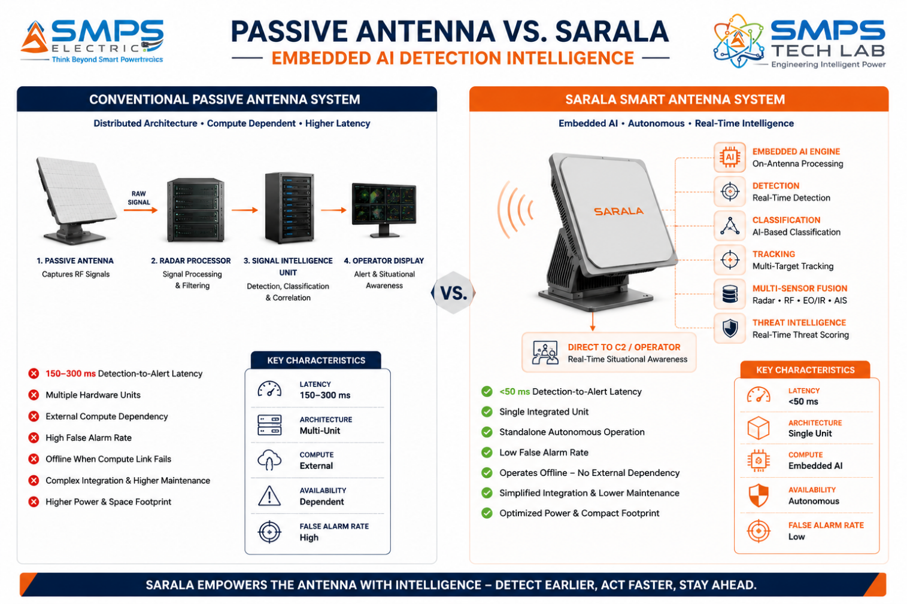
Figure 1.1 — Conventional passive antenna (left) versus SARALA embedded AI detection platform (right). The intelligence embedded within the antenna eliminates the separate radar processor, reduces detection latency by 3–6x, and enables standalone autonomous operation in forward-deployed or remote applications.
STRATEGIC NOTE
SARALA is not a radar system. It is an intelligent detection platform built on a radar antenna. The commercial distinction is decisive: radar systems detect signals. SARALA detects, classifies, tracks, and communicates threat assessments — autonomously, in real time, with <50ms latency, and without requiring a separate processing unit. The embedded AI is the IP; the antenna is the hardware it runs on.

1.3 Key Metrics at a Glance

TOTAL ADDRESSABLE MARKET  $37.6B  2025 Baseline · 5 Sectors · 10 Applications | FASTEST-GROWING VERTICAL  28.7%  Drone Detection CAGR 2025–2029 | SECTORS MAPPED  5  10 Applications Identified | IP PROTECTION  SARALA Filed  Embedded AI Signal Processing Patent
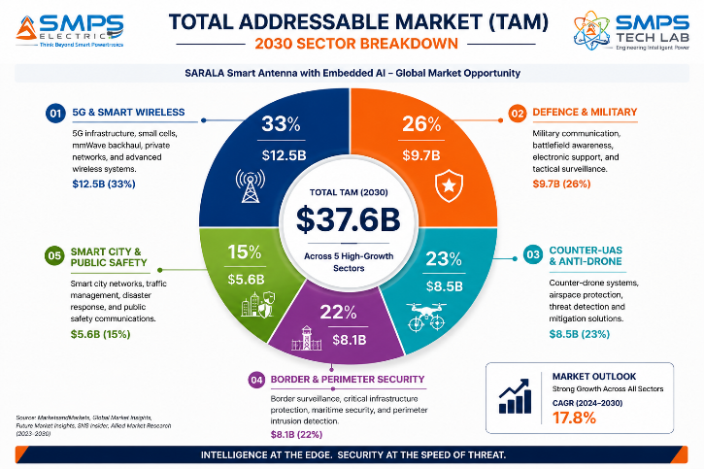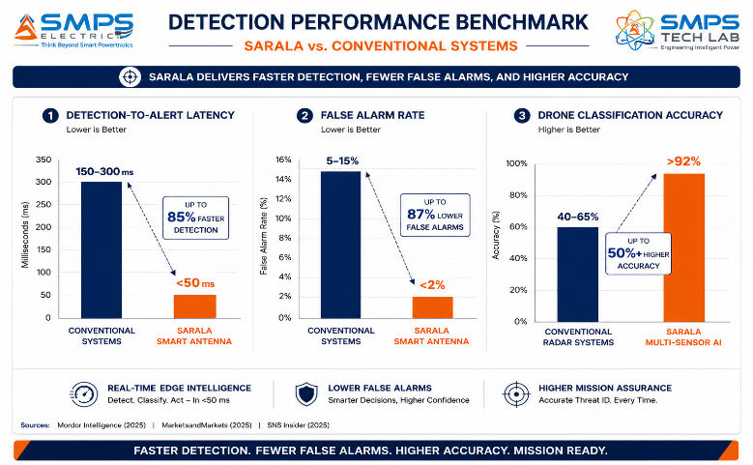
Figure 1.2 — TAM breakdown (left): 5G & Smart Wireless is the largest sector at $12.5B; Counter-UAS is the fastest-growing at 25–28.7% CAGR. Detection benchmark (right): SARALA’s embedded AI achieves 3–6x lower latency and >92% drone classification accuracy versus conventional radar systems.

1.4 Why SARALA, Why Now
Four convergent forces define the SARALA commercialisation window. Drone threat proliferation has created an existential procurement urgency: Anduril secured USD 642 million in USMC C-UAS contracts in March 2025; Raytheon’s LTAMD received USAF production approval in April 2025; India MoD signed a INR 2,906 crore AESA radar contract in March 2025. These are not R&D announcements — they are active production procurements confirming the market has passed evaluation and entered sustained procurement. GaN (Gallium Nitride) semiconductor cost reductions of 40–60% are making AESA systems commercially viable across border security, smart city, and commercial wireless markets that were previously priced out. India’s Atmanirbhar Bharat defence policy creates structural procurement preference for domestic IP that foreign radar manufacturers cannot access. And LEO satellite terminal demand from Amazon Kuiper’s 3,000+ satellite deployment (April 2025) and Starlink’s India licensing (June 2025) is creating hundreds of thousands of electronically steered flat-panel antenna procurement orders.

MARKET DATA POINT
Combined SMPS Tech Lab portfolio: IP-01 through IP-07 = $291.4B + IP-08 $37.6B = USD 329.0 Billion total TAM across 40 sectors and 80 applications. SARALA adds the detection and sensing layer — the smart antenna intelligence that protects and enables the infrastructure built, powered, and managed by IP-01 through IP-07.

02 | TECHNOLOGY OVERVIEW  AESA Platform · Embedded AI Engine · Multi-Sensor Fusion · All-Domain Detection · Standards

2.1 What is SARALA Antenna?
SARALA Antenna is an intelligent multi-mode detection platform built around a smart antenna array. The antenna hardware takes the form of a phased array (electronically steered, no mechanical rotation), AESA (Active Electronically Scanned Array with independent transmit/receive modules per element), or hybrid configuration combining radar, RF, and optical sensing elements within a single compact platform. The defining characteristic is the embedded AI intelligence layer: SARALA processes signals at the antenna level — identifying targets, classifying threat types, assessing engagement priority, and reporting to command-and-control systems — autonomously and in real time. This architecture is a fundamental departure from conventional antenna systems where raw signals are passed to a separate radar processor for analysis. By embedding the AI within the antenna platform, SARALA achieves lower latency (faster threat detection), reduced system complexity (fewer hardware units), improved reliability, and the ability to operate in standalone mode without external compute infrastructure.

2.2 The Four Integrated Technology Layers
LAYER | COMPONENT | FUNCTION | KEY INNOVATION IN IP-08
L1 | AESA / Phased Array Hardware | Active Electronically Scanned Array with independent T/R modules per element. Millisecond-speed electronic beam steering with no mechanical rotation. Multi-frequency and multi-mode operation from a single aperture. | Electronic beam agility enabling simultaneous multi-target tracking across wide azimuth/elevation without mechanical rotation. Reduced RCS (low-observable deployment). No maintenance requirement vs. mechanically rotating radar.
L2 | Embedded AI Signal Processing Engine | Neural network inference co-located with antenna hardware. Target detection, classification, and tracking in real-time. <50ms detection-to-alert latency vs. 150–300ms in remote-processing systems. | The patent-bearing element. AI inference at antenna level eliminates the separate radar processor entirely. Autonomous target identification without external compute. Functional in standalone mode when communications are disrupted.
L3 | Multi-Sensor Data Fusion Engine | Simultaneously fuses radar returns, RF signal signatures, acoustic inputs, and electro-optical feeds through a unified fusion AI producing a single high-confidence target picture. | Multi-sensor fusion at the antenna platform level. Single-sensor systems have 40–60% false alarm rates in clutter. Multi-sensor AI fusion reduces false alarms below 2% through cross-sensor confirmation of detections.
L4 | Adaptive Clutter & LPI Management | ML models dynamically adjust detection thresholds for sea clutter, ground clutter, and weather in real time. LPI transmission modes (frequency hopping, spread spectrum) reduce system detectability. | Environmental adaptation eliminates the need for operator-defined clutter maps. LPI operation ensures SARALA cannot be located and targeted by adversary EW systems — a critical operational requirement in contested environments.

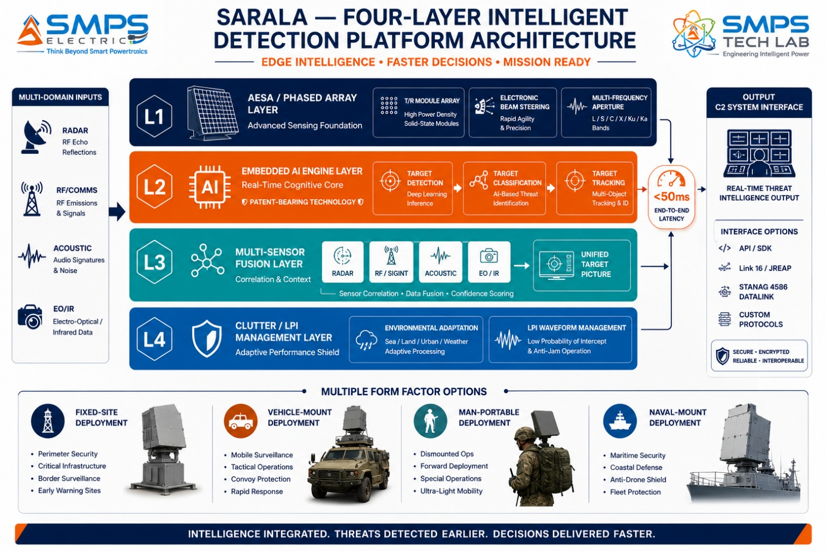
Figure 2.1 — SARALA four-layer architecture. The Embedded AI Engine (L2) is the patent-bearing element: by co-locating intelligence with the antenna, SARALA eliminates the separate radar processor and achieves <50ms detection-to-alert latency while maintaining full standalone autonomous operation capability.

2.3 Micro-Doppler AI Classification — The Discrimination Breakthrough
The fundamental commercial challenge in drone detection is not detection sensitivity — any radar can detect a drone-sized object. The challenge is classification: distinguishing a drone from a bird, a bird from a balloon, a commercial DJI quadcopter from a fixed-wing surveillance UAV, and a benign agricultural drone from a weaponised delivery vehicle. False alarms that send security teams scrambling for every bird or plastic bag are as operationally damaging as missed detections. SARALA’s micro-Doppler AI engine addresses this directly: by analysing the unique rotational signature of a drone’s propellers in the Doppler frequency domain, combined with the structural resonance signature of its body and wing configuration, SARALA achieves >92% classification accuracy at ranges up to 10km for small UAS targets — with a false alarm rate below 2%.

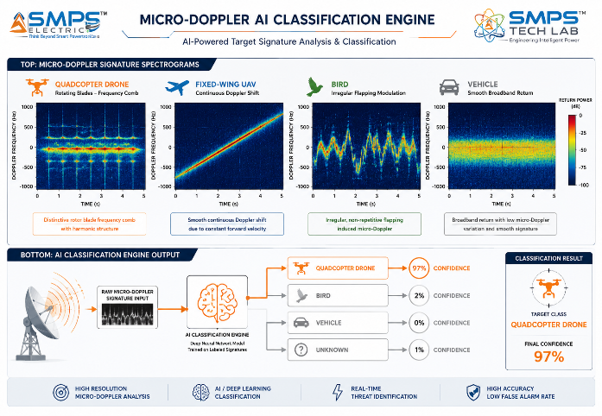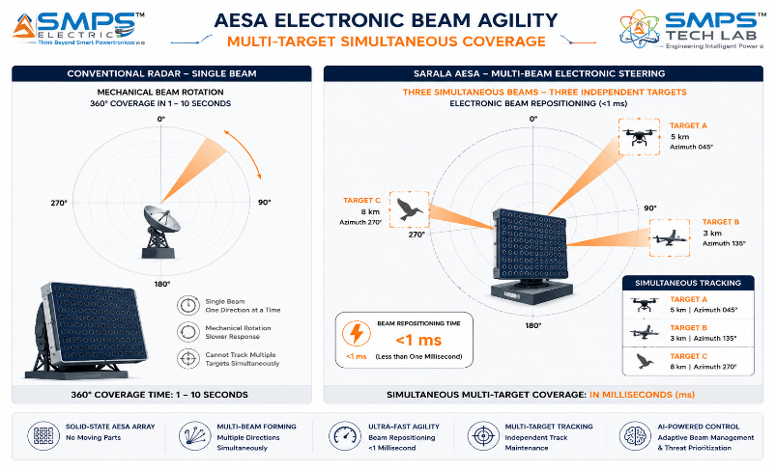
Figure 2.2 — Micro-Doppler AI classification (left): distinctive spectral signatures allow SARALA to discriminate drones from birds and other clutter with >92% accuracy — the false alarm problem that limits operational acceptance of conventional C-UAS detection systems. AESA beam agility (right): simultaneous multi-target tracking without mechanical rotation — <1ms beam repositioning vs. 1–10 seconds for mechanically scanned systems.

2.4 All-Domain Detection Coverage
SARALA’s multi-sensor fusion architecture enables all-domain detection from a single platform: aerial targets (aircraft, helicopters, UAVs, cruise missiles), ground targets (vehicles, personnel, objects), maritime targets (surface vessels, periscopes), and electromagnetic targets (RF emitters, drone control links, GNSS spoofing sources). This all-domain capability positions SARALA as a single platform solution across application verticals that would typically require separate specialised systems: a border security deployment uses aerial and ground modes simultaneously; a naval deployment uses air, surface, and ESM modes simultaneously; a smart city deployment uses ground and aerial modes simultaneously for traffic and drone detection. Single platform, multiple missions.

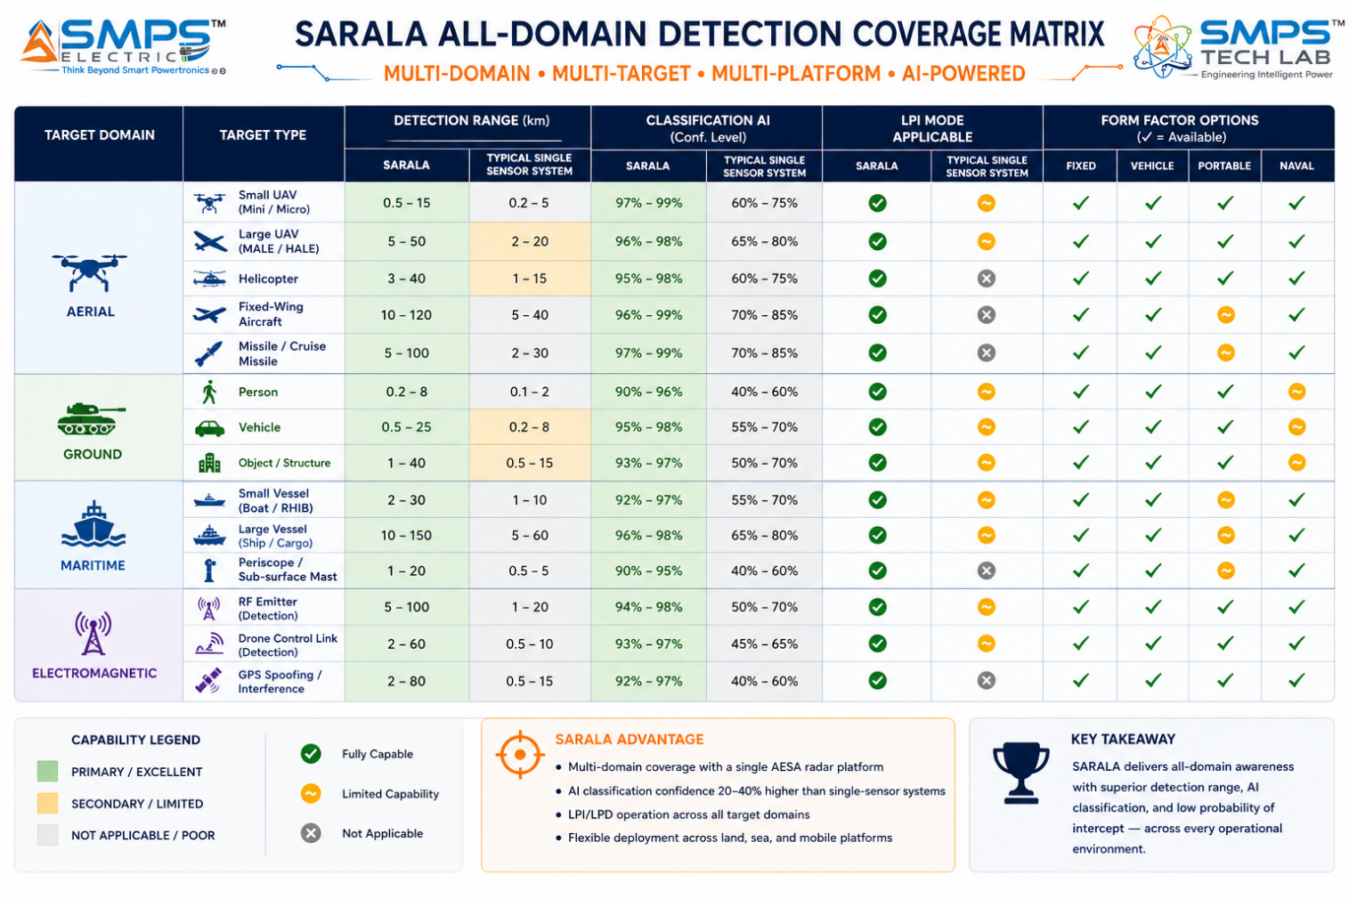
Figure 2.3 — SARALA all-domain detection coverage matrix. The multi-sensor fusion architecture enables detection across aerial, ground, maritime, and electromagnetic target domains from a single integrated platform — replacing the separate specialised systems conventionally required for each domain.

2.5 Standards Compliance Architecture
STANDARD | SECTOR APPLICABILITY | COMPLIANCE RELEVANCE FOR IP-08
MIL-STD-461F | Defence, Border Security | EMI/EMC for military electronics. Conducted and radiated emissions/immunity. Mandatory for all defence and military procurement.
MIL-STD-810G/H | Defence, Border, Naval | Environmental durability: vibration, shock, temperature (-40°C to +70°C), humidity, salt fog, sand/dust. Mandatory for all deployed defence systems.
STANAG 4193 (IFF) | Defence & Military | NATO IFF (Identification Friend/Foe) standard. Interrogator integration for air defence and SHORAD applications. Mandatory for NATO interoperability.
ICAO Annex 17 / EUROCAE ED-268 | Counter-UAS, Border, Smart City | Airport C-UAS detection standard and UTM integration requirements. Mandatory for airport and controlled airspace C-UAS deployments.
3GPP Release 17 (5G) | 5G & Smart Wireless | 5G massive MIMO and O-RAN smart antenna specifications. AI beamforming interface via O-RAN A1/E2 interfaces. FR1 and FR2 (mmWave) coverage.
NATO STANAG 4162 | Defence, Border | NATO electronic warfare interoperability standard. SARALA’s LPI and ESM capabilities require STANAG 4162 compliance for NATO procurement.
CIBMS Technical Specifications | Border Security (India) | India Comprehensive Integrated Border Management System technical interface requirements. Required for CIBMS India procurement.
IEC 62232 / ICNIRP | Smart City, Commercial Wireless | RF exposure limits for electromagnetic field safety. CE/FCC compliance for commercial and smart city deployments.

03 | GLOBAL MARKET LANDSCAPE  Drone Threat Economy · Market Sizing · Active Procurement Validation

3.1 The Detection Technology Inflection Point
The global radar and intelligent detection market is at a procurement inflection point driven by two simultaneous forces. The drone threat has transformed from a technical curiosity into a mainstream national security and commercial operations risk in 24 months: the anti-drone market is growing at 25.14% CAGR, detection systems hold 55% of revenue share, and procurement is happening now at scale (Anduril USD 642M, US Air Force LTAMD approval, India MoD INR 2,906 crore AESA contract, Elbit NATO C-UAS USD 60M — all in Q1 2025 alone). Simultaneously, GaN semiconductor cost reduction is making AESA systems commercially viable for the first time in border security, smart city, and commercial wireless markets at price points that were impossible two years ago. The same GaN technology that is reducing military radar cost is enabling the 5G massive MIMO and LEO satellite terminal markets to scale — with the phased array antenna market’s LEO terminal sub-segment growing at 76.98% CAGR as Starlink and Amazon Kuiper complete their satellite constellations.

3.2 The Four Structural Megatrends
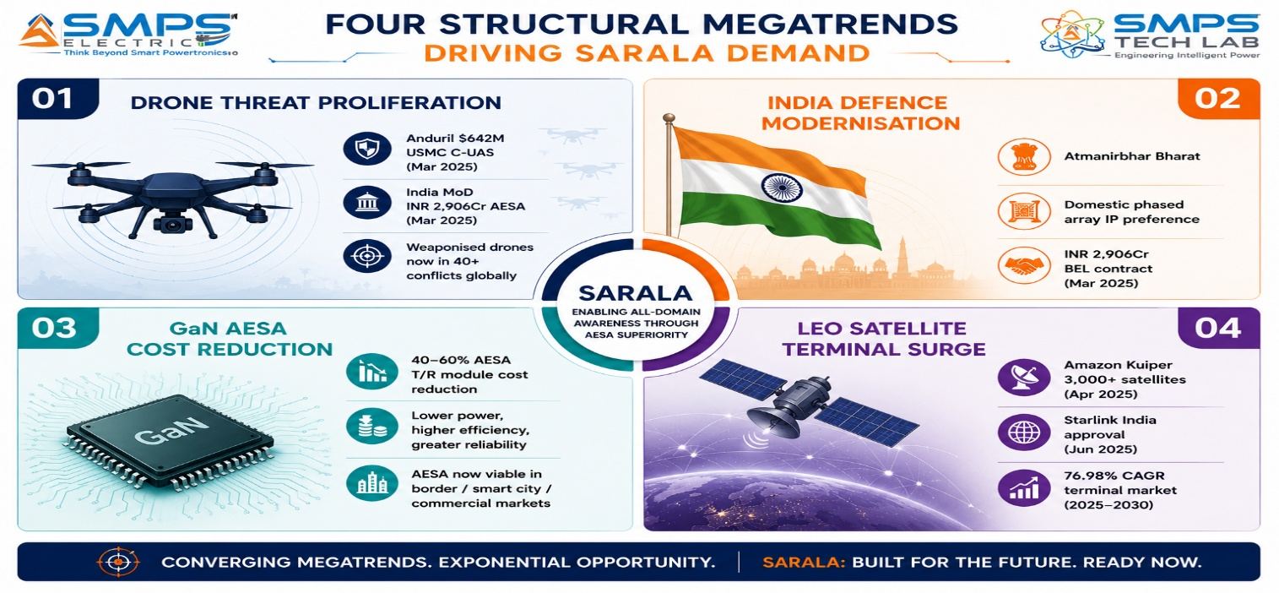
Figure 3.1 — Four structural megatrends converging on the SARALA commercial window. Drone threat proliferation and India defence modernisation drive immediate procurement; GaN cost reduction and LEO expansion create the commercial market scale.

3.3 Global Market Sizing — Primary Reference Data
MARKET SEGMENT | 2025 VALUE | PROJECTED | CAGR | HORIZON | SOURCE
Phased Array Antenna Market | USD 4.83B | USD 13.44B | 11.49% | 2033 | Business Research Insights
Active Phased Array Radar Market | USD 3.70B | USD 9.17B | 9.50% | 2034 | Precedence Research (May 2025)
Anti-Drone Market | USD 3.03B | USD 9.3B | 25.14% | 2030 | Mordor Intelligence (Jul 2025)
Anti-Drone Market (Allied) | USD 1.3B | USD 14.6B | 27.9% | 2031 | Allied Market Research
Drone Detection Market | USD 845.8M | USD 2.33B | 28.7% | 2029 | MarketsandMarkets
Anti-Drone Detection Systems (share) | USD 1.68B | (growing) | 23.45% | 2030 | SNS Insider (Feb 2026)
Sat. Comms Phased Array (LEO terminal) | USD 1.86B | USD 316.6B | 76.98% | 2033 | Global Growth Insights
Active Phased Array Radar (Fortune) | USD 5.05B | USD 10.63B | 9.76% | 2034 | Fortune Business Insights
Phased Array Antenna (Market Growth Rep.) | USD 3.66B | USD 6.77B | 8.0% | 2032 | Market Growth Reports

CAGR Comparison — SARALA Target Market Segments

LEO Satellite Phased Array Terminals ██████████████████████████ 76.98%
Drone Detection Market (MarketsandMarkets)██████████░░░░░░░░░░░░░░░░ 28.7%
Anti-Drone Market (Allied Market Research)█████████░░░░░░░░░░░░░░░░░ 27.9%
Anti-Drone Market (Mordor Intelligence) ████████░░░░░░░░░░░░░░░░░░ 25.14%
Detection Systems Sub-segment (SNS Insider)████████░░░░░░░░░░░░░░░░░░ 23.45%
Phased Array Antenna (Bus. Research) ████░░░░░░░░░░░░░░░░░░░░░░ 11.49%
Border & Perimeter Security ████░░░░░░░░░░░░░░░░░░░░░░ 12.8%
Active Phased Array Radar (Precedence) ███░░░░░░░░░░░░░░░░░░░░░░░ 9.50%
Active Phased Array Radar (Fortune) ███░░░░░░░░░░░░░░░░░░░░░░░ 9.76%
Smart City AI Detection ███░░░░░░░░░░░░░░░░░░░░░░░ 8.0%
Sources: Business Research Insights, Precedence Research, Mordor Intelligence, Allied Market Research, MarketsandMarkets, SNS Insider, Global Growth Insights, Fortune Business Insights (2025–2026 publications)

04 | TOTAL ADDRESSABLE MARKET  Five Sectors · Ten Applications · USD 37.6 Billion

4.1 Methodology
The TAM framework maps SARALA across five strategic sectors with two primary commercial applications per sector, producing ten independently validated commercialisation pathways. Each application is sized from published sub-segment data from named research providers. The USD 37.6 billion TAM represents the addressable market for smart detection, phased array, and intelligent antenna platforms within each sector — the sub-segment specifically addressable by SARALA’s embedded AI signal processing and multi-sensor fusion capability.

STRATEGIC NOTE
SARALA’s five-sector architecture means it addresses five independently large markets with one core IP. The embedded AI signal processing patent covers all five sectors: airspace surveillance, drone detection, border radar, traffic detection, and 5G beamforming are all different applications of the same underlying AI-driven antenna signal processing architecture. No competitor addresses all five from a single platform.

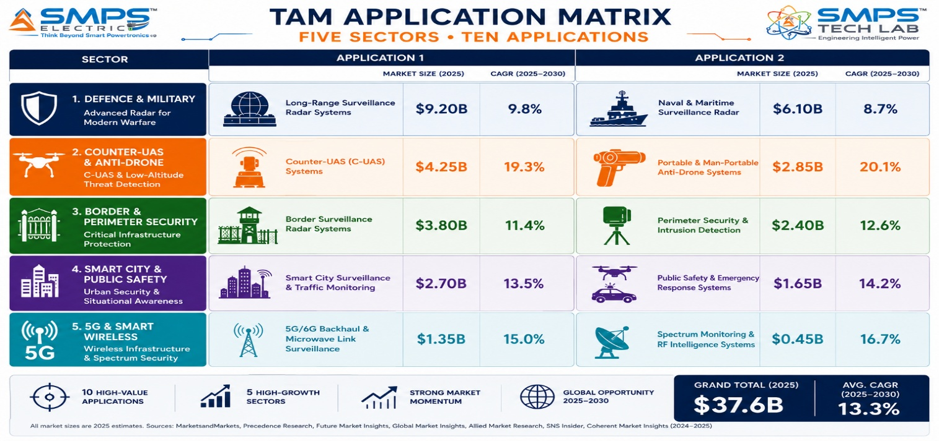
Figure 4.1 — SARALA application matrix. Ten commercial pathways, each independently sized and independently commercialisable.

4.2 Consolidated TAM Summary
SECTOR | APPLICATION | USE CASE SUMMARY | APP SIZE | SECTOR TAM | CAGR
Defence & Military | Airspace Surveillance & Air Defence | AESA AI smart antenna for multi-target air surveillance, IFF, threat classification; STANAG 4193; MIL-STD-461/810 | $5.8B | $9.7B | 9.5–11.49%
Defence & Military | Naval & Maritime Surveillance | Multi-function naval AESA for air/surface search, ESM, helicopter guidance; sea-skimming detection; Link 11/16 | $3.9B | $9.7B | 9.5–11.49%
Counter-UAS & Anti-Drone | Smart C-UAS Detection Suite | Multi-sensor fusion radar+RF+acoustic; AI micro-Doppler >92% accuracy; <2% false alarm; ICAO UTM integration | $4.8B | $8.5B | 25.14–28.7%
Counter-UAS & Anti-Drone | Drone Swarm Detection & Military C-UAS | AESA AI for 500+ simultaneous swarm tracks; engagement system cueing; MIL-STD-461/810; SHORAD/C-RAM interface | $3.7B | $8.5B | 25.14–28.7%
Border & Perimeter Security | Smart Border Radar Network | Autonomous phased array border nodes; person 15km, vehicle 30km, drone 10km; CIBMS/EUROSUR compatible | $4.6B | $8.1B | 12.8–15%
Border & Perimeter Security | Airport & Critical Infra Perimeter | Dual-mode air+ground detection; airport C-UAS + perimeter; ICAO Annex 17; ACAMS compliance | $3.5B | $8.1B | 12.8–15%
Smart City & Public Safety | Smart City Traffic Radar | All-weather vehicle/pedestrian detection; speed measurement ±2km/h; UTMC/NTCIP output; GDPR radar-only | $3.2B | $5.6B | 11.2–18.3%
Smart City & Public Safety | Crowd Monitoring & Event Security | Through-conditions crowd detection; anomaly/breach alerts; VMS/ONVIF integration; privacy-compliant | $2.4B | $5.6B | 11.2–18.3%
5G & Smart Wireless | 5G Massive MIMO AI Beamforming | AI beam tracking for 64T64R/128T128R 5G; O-RAN A1/E2; 25% spectral efficiency gain; 18% energy reduction | $6.8B | $12.5B | 11.49–77%
5G & Smart Wireless | LEO Satellite & VSAT Phased Array | Electronically steered flat panel for LEO tracking; Starlink/Kuiper terminal; Ka/Ku band; <50ms handover | $5.7B | $12.5B | 76.98% (LEO)
TOTAL ADDRESSABLE MARKET — IP-08 SARALA ANTENNA — SMART DETECTION SYSTEM (2025) |  |  |  | ~USD 37.6 Billion

MARKET DATA POINT
Combined SMPS Tech Lab portfolio TAM: IP-01 through IP-07 $291.4B + IP-08 $37.6B = USD 329.0 Billion across 40 sectors and 80 applications. SARALA adds the detection and sensing layer to a portfolio that spans from power conversion to autonomous operations to smart antenna intelligence.

05 | INDIA MARKET INTELLIGENCE  MoD Procurement · CIBMS Border · Atmanirbhar Bharat · IAF/Navy Modernisation

5.1 India as First and Strategic Market
India presents the most compelling first-market for SARALA of any country globally. The combination of India’s border security complexity (15,106km land borders, 7,516km coastline), active AESA radar procurement programmes (INR 2,906 crore BEL LLTR Ashwini contract, March 2025), the CIBMS Comprehensive Integrated Border Management System programme, Indian Air Force radar modernisation, Indian Navy domestic radar preference, and the Atmanirbhar Bharat policy providing structural procurement preference for domestic IP creates a multi-year, multi-programme procurement pipeline that no foreign radar manufacturer can access on equal terms. India’s defence procurement policy DAP 2020 gives strong preference to indigenously designed and manufactured systems under the Make in India category — SARALA’s positioning as a domestically developed smart antenna IP is a direct procurement advantage.

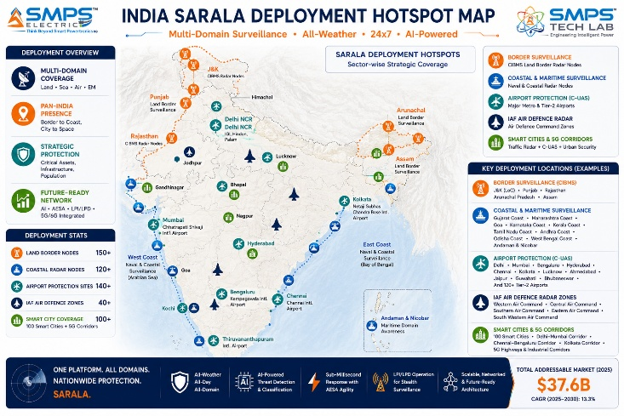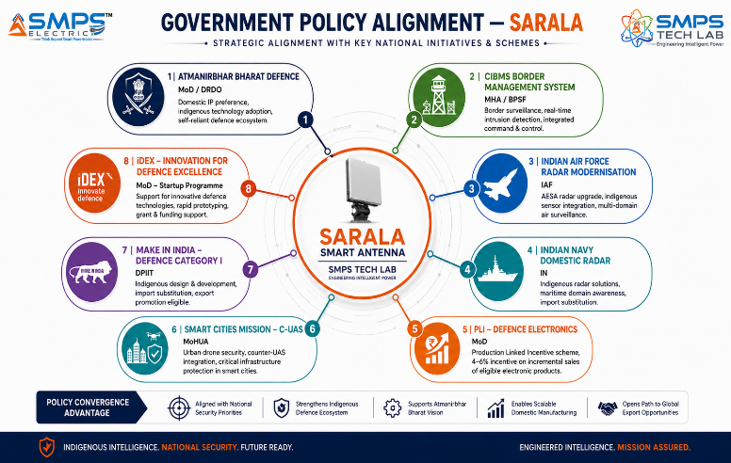
Figure 5.1 — India deployment hotspot map (left): SARALA has active procurement demand across border surveillance, naval, air defence, airport C-UAS, and smart city sectors simultaneously. Policy alignment (right): Atmanirbhar Bharat defence policy creates structural procurement preference for domestic IP that foreign radar manufacturers cannot access.

5.2 India Market Sizing — SARALA Relevant Segments
INDIA MARKET SEGMENT | 2025E VALUE | PROJECTED | CAGR | HORIZON
India Defence Electronics Market | USD 4.2B | USD 25B | ~18% | 2031
India Radar & Surveillance Systems | USD 0.85B | USD 2.8B | ~15% | 2030
India CIBMS Border Technology Budget | USD 1.2B | Ongoing | N/A | 2025+
India Airport C-UAS Market | USD 0.18B | USD 0.8B | ~25% | 2030
India 5G Smart Antenna / Massive MIMO | USD 0.6B | USD 2.4B | ~22% | 2028
India Smart City Surveillance & Radar | USD 0.3B | USD 1.1B | ~20% | 2030

06 | GOVERNMENT POLICY & REGULATORY ALIGNMENT  India Defence Procurement · Global Standards · Export Pathways

6.1 India & Global Policy with Direct SARALA Alignment
SCHEME / PROGRAMME | MINISTRY / BODY | RELEVANCE TO SARALA | COMMERCIAL IMPLICATION
Atmanirbhar Bharat Defence — DAP 2020 | MoD / DRDO | Make in India Category I: systems designed & manufactured in India; procurement preference | SARALA classified as domestic IP qualifies for Category I procurement in all defence applications
CIBMS — Border Surveillance System | MHA / BPF | Comprehensive Integrated Border Management System for all land borders; radar sensor layer | SARALA border surveillance node directly addresses CIBMS radar detection layer specification
Indian Air Force Radar Modernisation | IAF / MoD | AESA radar upgrade programme for air defence and early warning; domestic IP preference | SARALA air defence configuration addresses IAF AESA radar modernisation procurement
Indian Navy Domestic Radar Programme | IN / MoD | Naval shipborne radar indigenous development; surface search and helicopter guidance | SARALA naval multi-function configuration addresses Indian Navy domestic radar preference
PLI Defence Electronics | MoD | 4–6% incentive on incremental production; defence electronics including radar manufacturing | SARALA antenna module manufacturing in India qualifies for PLI incentive
Smart Cities Mission — Safety & Security | MoHUA | Drone security and smart surveillance requirements for 100 Smart Cities | SARALA compact C-UAS and traffic radar directly addresses Smart Cities safety specification
iDEX — Innovation for Defence Excellence | MoD | Startup and MSME defence innovation funding; SARALA eligible for iDEX challenge funding | iDEX challenge grants up to INR 1.5 crore; SARALA C-UAS and border radar are active challenge categories
US DoD Modernizing Defence Acquisitions | US DoD (Executive Order Apr 2025) | Direct increase in next-generation radar and C-UAS procurement; ITAR-free Indian IP advantages | Export potential to US-allied markets through ITAR-free domestic IP positioning

07 | IP AS AN INDUSTRY PLUGIN  Five-Sector Detection Integration Architecture

7.1 The Plugin Architecture — Five Host System Categories
SARALA is architecturally designed as the intelligent detection sensor module within five categories of host system. In each case, SARALA provides the smart antenna intelligence layer that the host system requires but cannot generate internally: the C2 system needs a sensor; the UTM platform needs a detection feed; the border management system needs a radar node; the smart city platform needs a traffic sensor; the 5G base station needs an AI beamformer. SARALA is the certified, deployable, AI-embedded antenna that provides each of these. The plugin model is commercially efficient: SARALA integrates into existing system architectures without requiring the host system to be redesigned.

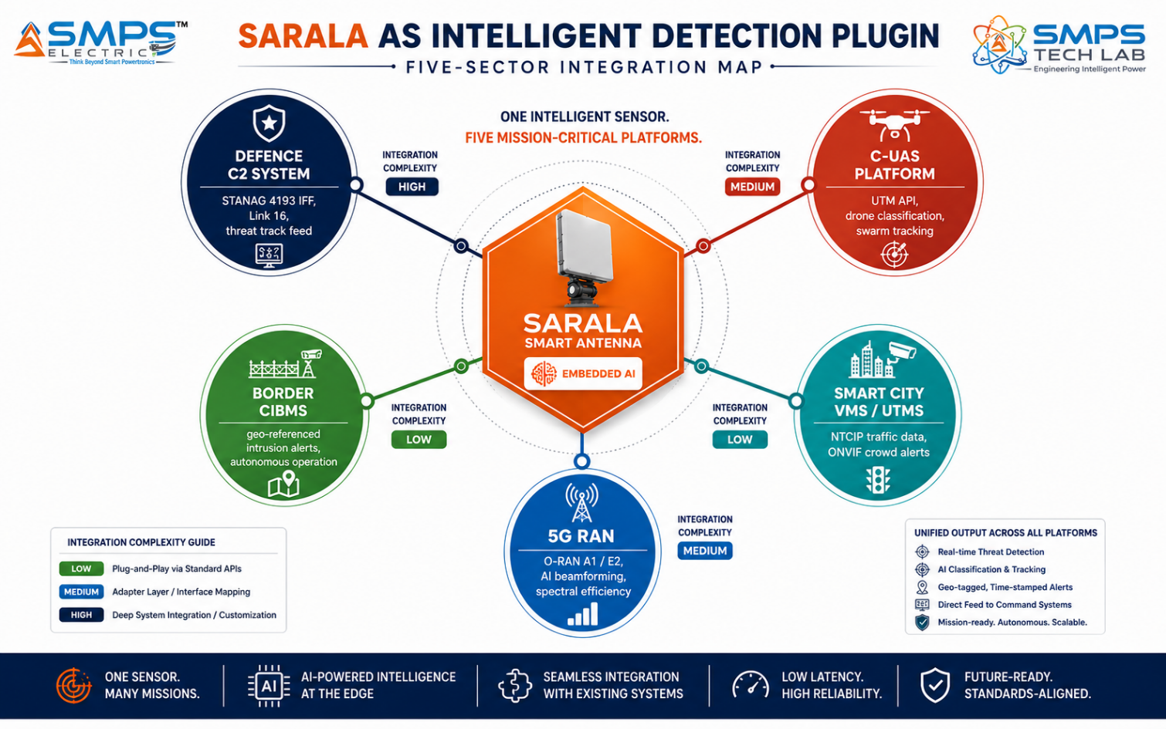
Figure 7.1 — SARALA as the AI-embedded detection plugin across five host system categories. The same antenna platform provides radar detection intelligence to defence C2, UTM/C-UAS, border management, smart city, and 5G RAN systems through sector-specific interface configuration.

7.2 Plugin Integration Matrix
HOST SYSTEM | PLUGIN ROLE | VALUE AT SYSTEM LEVEL | INTEGRATION COMPLEXITY
Military Air Defence C2 | AESA sensor feeding threat tracks, IFF data, and intercept cues to C2 network | 360° airspace picture with AI threat prioritisation; IFF without separate interrogator; STANAG datalink | HIGH — MIL-STD-461/810, STANAG 4193, Link 16 integration, SHORAD interface
Airport / Military C-UAS Platform | Drone detection sensor for UTM/C-UAS platform; multi-sensor fusion; classification output | <2% false alarm rate; >95% Pd; ICAO UTM API output; classification data for C-UAS response cueing | MEDIUM — ICAO ED-268 compliance, UTM/SWIM API, RF scanner integration
CIBMS Border Management System | Autonomous border radar node; geo-referenced threat alerts; CIBMS data format | 40+ km surveillance per node; 24/7 autonomous operation; networked grid coverage; classified uplink | MEDIUM — CIBMS data interface, satellite/radio backhaul, solar power, encrypted comms
Smart City UTMS / VMS | Traffic radar sensor; crowd detection; incident detection; REST API to city platform | All-weather operation; multi-lane detection; GDPR-compliant (no imagery); NTCIP output | LOW-MED — NTCIP protocol, REST API to UTMS, ONVIF VMS integration, CE marking
5G Base Station / O-RAN RU | AI beamforming and beam management for massive MIMO; O-RAN A1/E2 interface | 25% spectral efficiency; 18% energy saving; reduced handover failures; AI-driven interference nulling | MEDIUM-HIGH — 3GPP Release 17, O-RAN Split 7.2x, FR1/FR2 validation, MNO integration

08 | COMMERCIALISATION STRATEGY  Revenue Models · Market Priority · Go-to-Market Architecture

8.1 Commercialisation Philosophy
The SARALA commercialisation strategy prioritises the Counter-UAS commercial market (6–18 months) as the fastest near-term revenue pathway — because C-UAS procurement cycles are dramatically shorter than defence procurement cycles, the market is growing at 25–28.7% CAGR, and SARALA’s multi-sensor fusion AI provides a technically superior detection platform versus the single-sensor RF-scanner-only systems that dominate current C-UAS installations. Indian defence procurement follows as the second pathway (12–36 months), offering the largest per-contract values with Make in India procurement preference. 5G OEM supply and LEO terminal manufacturing are the third pathway (12–24 months), offering the highest volume potential at competitive commercial pricing with GaN cost reductions enabling price-competitive platform supply.

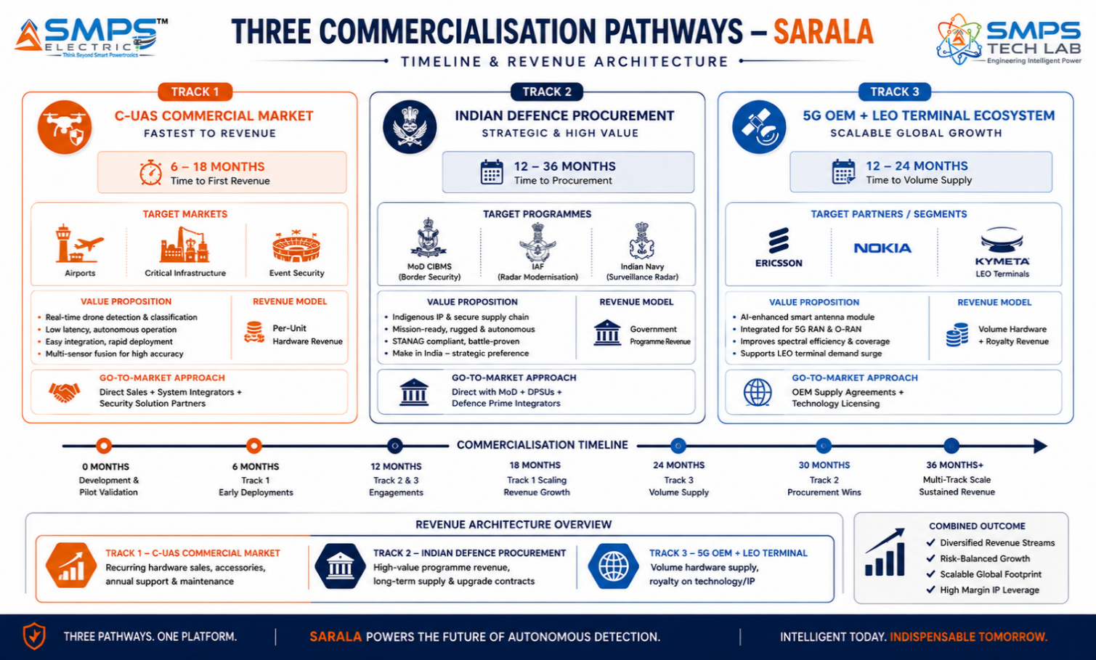
Figure 8.1 — Three parallel commercialisation pathways. C-UAS commercial provides fastest revenue through shorter procurement cycles; Indian defence provides highest per-contract value; 5G and LEO OEM supply provides volume scale.

8.2 Market Priority Matrix
SECTOR | TAM 2025 | CAGR | IP FIT | TIME-TO-REV | PATHWAY | PRIORITY
Counter-UAS & Anti-Drone | $8.5B | 25–28.7% | Excellent | 6–18 mo | Commercial + Gov | HIGHEST
Defence & Military | $9.7B | 9.5–11.49% | Excellent | 12–36 mo | Indian DPP / DAP | HIGH
5G & Smart Wireless | $12.5B | 11.49–77% | Excellent | 12–24 mo | OEM Licensing | HIGH
Border & Perimeter Security | $8.1B | 12.8–15% | Excellent | 12–24 mo | CIBMS + Export | HIGH
Smart City & Public Safety | $5.6B | 11.2–18.3% | Strong | 18–30 mo | Direct + SI | MED-HIGH

09 | COMPETITIVE LANDSCAPE  Market Positioning · Advantage Scorecard · IP Moat

9.1 Competitive Architecture Overview
The intelligent detection and phased array radar market has three distinct competitive tiers. The first is the established Tier 1 defence radar prime contractors: Raytheon, Northrop Grumman, Thales, Leonardo, and Saab — companies with deep government procurement relationships, established defence certifications, and large installed bases. SARALA’s competitive response to this tier is not head-on competition but strategic positioning: as an AI-embedded modular detection module that Tier 1 integrators can embed within their larger system packages, making SARALA the preferred intelligence layer rather than a competing prime system. The second tier is the fast-growing C-UAS specialist companies: Dedrone, DroneShield, D-Fend Solutions, Anduril. These focus primarily on RF sensing and geofencing; SARALA’s multi-sensor fusion AI provides architecturally superior detection capability versus their single-sensor approach. The third tier is 5G infrastructure OEMs (Ericsson, Nokia, Samsung Electronics) who are the natural licensing targets for SARALA’s AI beamforming capability in the 5G and LEO terminal markets.

CATEGORY | KEY PLAYERS | MARKET FOCUS | SARALA ARCHITECTURAL DIFFERENTIATION
Tier 1 Defence Radar Primes | Raytheon, Northrop Grumman, Thales, Leonardo, Saab | Military radar systems | Full prime contractor systems; high cost; long development cycles. SARALA as OEM detection module embedded in their system packages is the preferred engagement model, not competition.
C-UAS RF Detection Specialists | Dedrone, DroneShield, D-Fend Solutions | Counter-drone RF sensing | RF scanner-only (no radar); no multi-sensor fusion; no micro-Doppler classification. SARALA’s radar+RF+acoustic fusion with AI classification provides demonstrably superior performance. Partnership as their radar layer is viable.
AI-Enabled Defence Startups | Anduril Industries, Shield AI, Palantir | AI defence systems | Anduril focuses on complete C-UAS system integration; SARALA is the smart sensor module that their systems integrate. Competitive in direct system sales; collaborative in component supply.
Border Surveillance Specialists | Blighter Surveillance, Terma, Hensoldt | Ground and border surveillance radar | Specialised single-domain border radar without multi-domain capability. Blighter B422LR validates market demand for exactly SARALA’s compact smart border radar specification. Direct competitive overlap in border security.
5G Antenna / LEO Terminal OEMs | Ericsson, Nokia, Kymeta, Satixfy, Hanwha | 5G massive MIMO, LEO terminals | Antenna hardware without embedded AI signal processing intelligence. SARALA’s AI beamforming and phased array intelligence is the value-add layer for licensing to these OEMs — not competition.

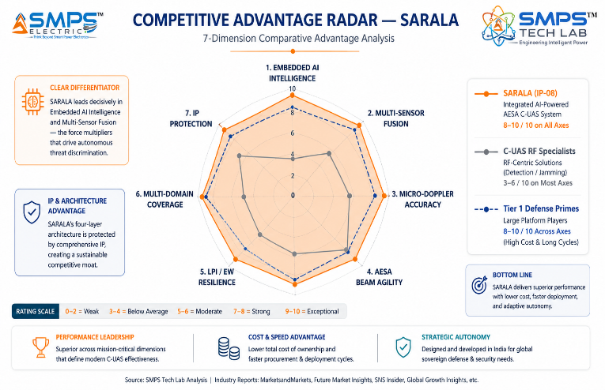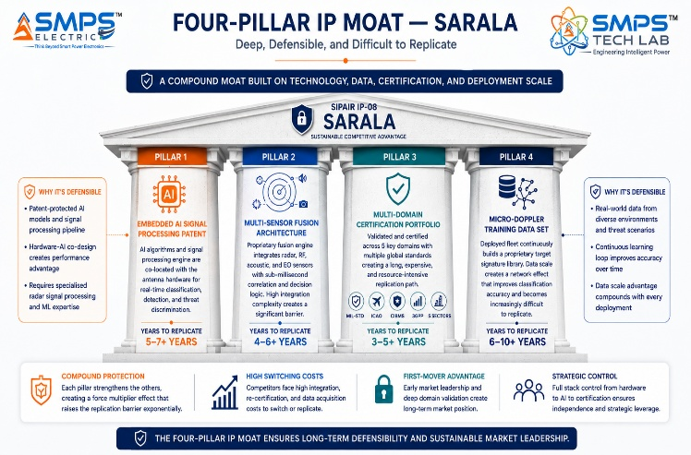
Figure 9.1 — SARALA competitive radar (left): scores 8–10/10 across all dimensions; C-UAS RF specialists score high on RF but low on radar and AI fusion. Four-pillar moat (right): the multi-domain certification portfolio — MIL-STD + ICAO + CIBMS + 3GPP — is 8–12 years of parallel certification investment to replicate.

10 | INVESTMENT THESIS & FINANCIAL FRAMEWORK  Value Creation · Revenue Projections · Capital Deployment

10.1 The Investment Case
The investment case for SARALA combines an immediately active procurement market (C-UAS procurement is happening now at USD 642M+ per single contract), India’s structural procurement preference for domestic IP in defence and border security, and the LEO satellite terminal market — at 76.98% CAGR — that represents the fastest-growing hardware market in the entire SMPS Tech Lab portfolio. These are three independent, compounding demand signals. The drone threat is not receding — every month, new incidents elevate procurement urgency and expand the addressable market to new buyer categories. India’s CIBMS programme and IAF/Navy modernisation cycles are multi-year sustained procurement commitments. And Amazon Kuiper’s satellite deployment is creating a demand for LEO terminals measured in hundreds of thousands of units.

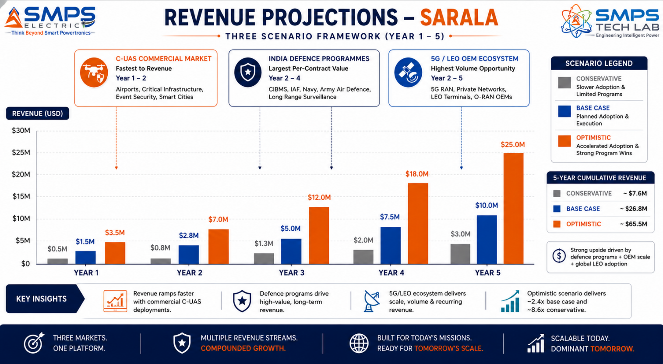
Figure 10.1 — SARALA revenue projections. C-UAS commercial provides the earliest revenue through the fastest procurement cycles; Indian defence provides the highest per-contract value; 5G/LEO OEM licensing provides the volume revenue at scale.

10.2 Illustrative Revenue Scenarios
SCENARIO | YEAR 1 | YR 2–3 CAGR | YR 4–5 CAGR | KEY ASSUMPTIONS
Conservative (C-UAS Commercial Only) | USD 500K–1M | +30% | +25% | Airport + critical infrastructure C-UAS supply; CE/ICAO certified; India first market
Base (C-UAS + India Defence + 5G) | USD 1.5–2.5M | +55% | +45% | C-UAS commercial + CIBMS border pilot + 5G OEM beamforming licence; PLI incentive
Optimistic (All Pathways) | USD 3.5–5M | +75% | +65% | All pathways + IAF/Navy procurement + LEO terminal OEM + global C-UAS integrator

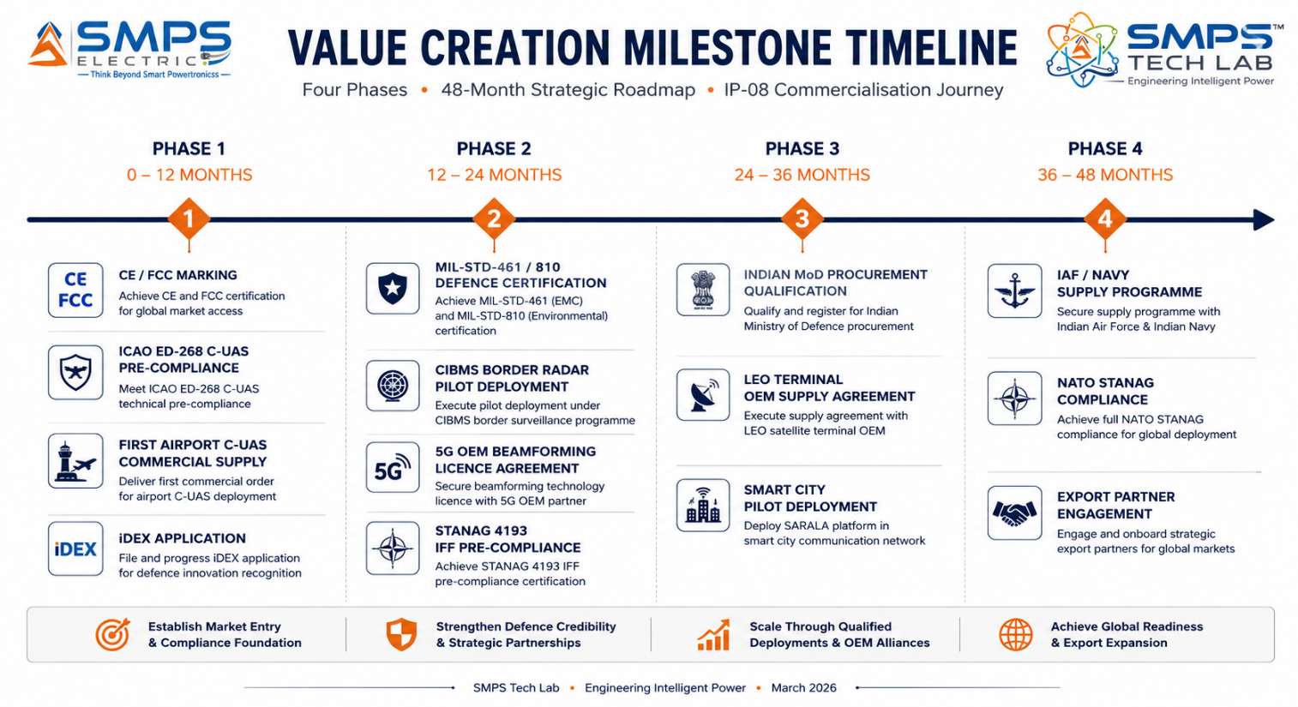
Figure 10.2 — Four-phase milestone roadmap. ICAO and CE certifications in Phase 1 unlock commercial C-UAS revenue immediately; MIL-STD qualification in Phase 2 opens Indian defence procurement; LEO terminal OEM in Phase 3 creates volume revenue.
RISK ADVISORY
The drone threat is the fastest-moving procurement market in the SMPS Tech Lab portfolio. Every month of delay in C-UAS market entry is a month of 25–28.7% CAGR market growth captured by competitors. The C-UAS commercial market — airports, stadiums, energy infrastructure, prison perimeters — procures through commercial channels with 6–18 month procurement cycles, not multi-year defence acquisition programmes. The fastest path to revenue is the commercial C-UAS market, and the window is open now.

11 | FUTURE ROADMAP  Technology Evolution · Cognitive Radar · Spectrum Dominance

11.1 Technology Generation Roadmap
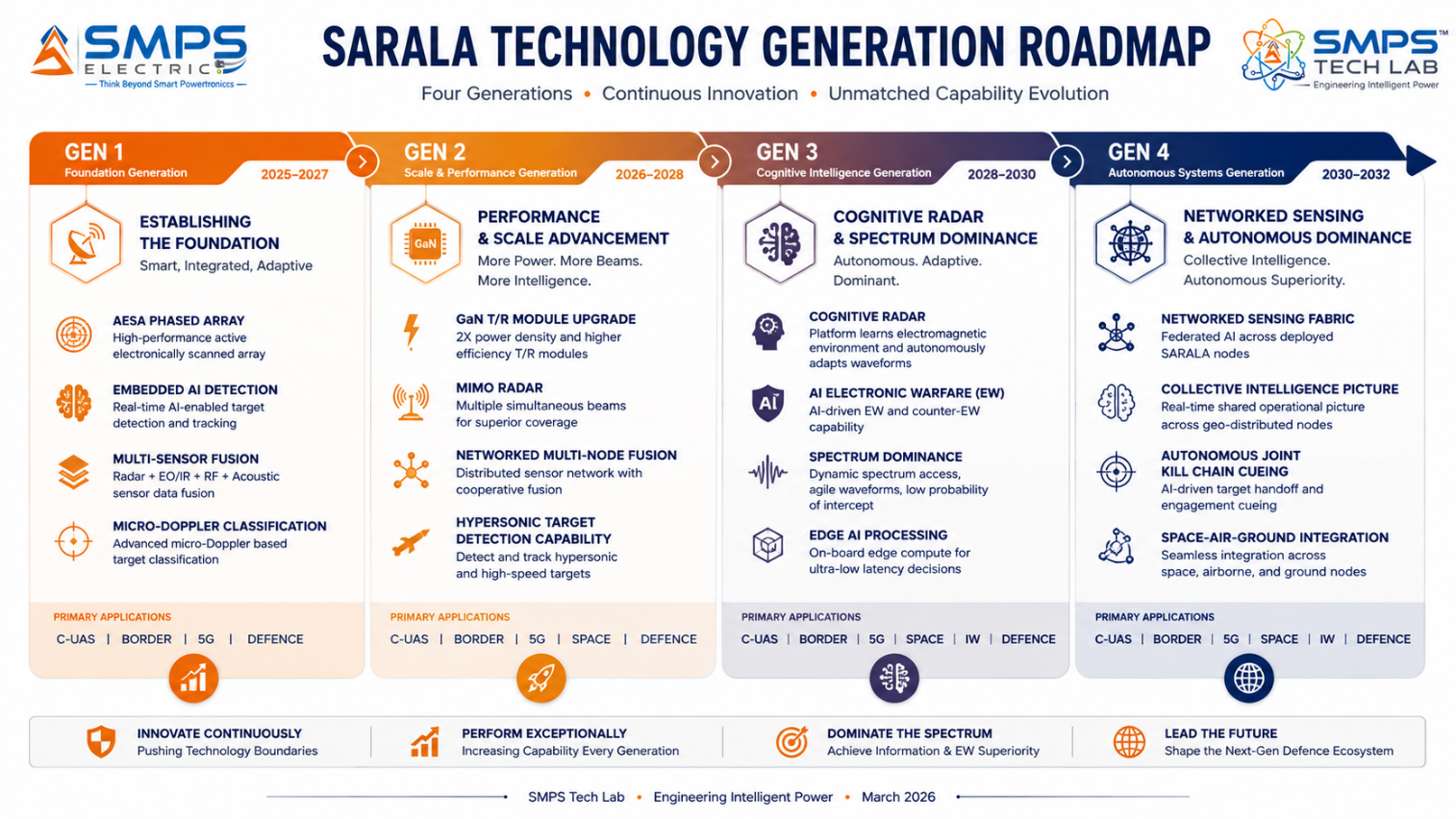
Figure 11.1 — SARALA four-generation roadmap. From embedded AI detection (Gen 1) to cognitive spectrum dominance (Gen 3) to networked collective intelligence (Gen 4) — each generation building higher value from the same antenna platform architecture.
GENERATION | TECHNOLOGY FOCUS | TARGET TIMELINE | MARKET IMPACT
Gen 1 (Current) | AESA phased array, embedded AI detection, multi-sensor fusion, micro-Doppler; MIL-STD/ICAO/3GPP certifications | 2025–2027 | C-UAS commercial, India defence CIBMS, 5G OEM, border surveillance — initial market penetration
Gen 2 | GaN T/R module upgrade (2x power density, -40% cost); MIMO radar (simultaneous multiple beams); networked multi-node sensor fusion; hypersonic and stealth target detection | 2026–2028 | Hypersonic defence radar market; MIMO radar upgrade for existing installations; global border surveillance export
Gen 3 | Cognitive radar: platform autonomously learns and adapts waveforms for target environment; AI electronic warfare (EW) capability; autonomous spectrum management; GNSS spoofing detection and mitigation | 2028–2030 | Electronic warfare + cyber-radar integration; sovereign spectrum assurance capability; anti-spoofing critical infrastructure
Gen 4 | Networked sensing fabric: federated AI across deployed SARALA nodes creating collective threat intelligence; autonomous joint kill chain cueing; satellite-integrated global detection grid | 2030–2032 | National-level threat detection network; NATO/allied interoperability at networked sensing level; sovereign air defence intelligence

11.2 Adjacent Application Opportunities
- Weather Radar & Atmospheric Sensing: The phased array antenna platform with AI signal processing directly adapts to meteorological radar applications — Doppler weather radar, wind profiling, and precipitation intensity mapping. The growing demand for localised high-resolution weather prediction for renewable energy, aviation, and smart city applications creates a large commercial weather sensing market addressable with SARALA’s core technology.
- Medical Imaging — UWB Radar for Body Scanning: Ultra-Wideband (UWB) radar operating at medical frequencies can perform through-clothing and through-wall imaging for security screening and medical applications. SARALA’s AI signal processing architecture, adapted for UWB frequency operation, addresses the growing demand for non-ionising imaging alternatives to X-ray body scanners at airport security checkpoints and medical diagnostic facilities.
- Automotive Radar — ADAS & Autonomous Vehicle Sensing: The automotive ADAS radar market is growing rapidly with the adoption of Level 2+ autonomous driving systems. SARALA’s compact phased array with embedded AI processing addresses the automotive radar sensor specification — <77GHz millimetre-wave, AI target classification, multi-target tracking — as the intelligent perception sensor for autonomous vehicle applications.
- Space Situational Awareness: The growth of LEO satellite constellations is creating an urgent requirement for ground-based space radar capable of tracking tens of thousands of objects in low earth orbit simultaneously. SARALA’s AESA array with multi-target AI tracking is a candidate technology platform for the growing market in space domain awareness sensors deployed by national space agencies and commercial operators.

12 | RISK ANALYSIS  Risk Register · Probability & Impact · Strategic Mitigation

12.1 Risk Framework
The SARALA risk profile is shaped by three domain-specific factors. First, defence procurement cycles in India and internationally are long — 12–48 months from qualification to first payment. The C-UAS commercial market provides the bridge revenue while defence procurement cycles complete. Second, export controls (ITAR in the US, MTCR, Wassenaar Arrangement) apply to radar and antenna technology exports and require careful legal navigation — India’s ITAR-free status as a domestically developed technology is a commercial advantage in some markets but requires export licensing for defence-related exports to most countries. Third, the pace of drone threat evolution means the micro-Doppler classification models require continuous updating as new drone types enter the market — this creates both a technical maintenance requirement and a recurring revenue opportunity through over-the-air model updates.

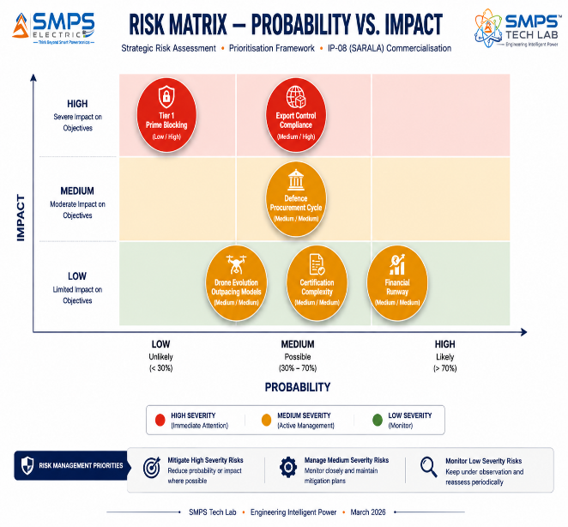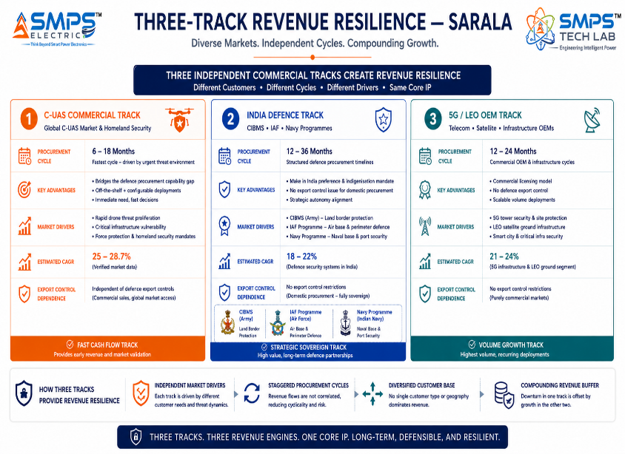
Figure 12.1 — Risk matrix (left): export control compliance and Tier 1 prime blocking are the highest-impact risks. Three-track revenue resilience (right): commercial C-UAS, Indian defence, and 5G/LEO OEM are three independent revenue streams with different procurement cycles and risk profiles.

CATEGORY | SPECIFIC RISK | PROB. | IMPACT | MITIGATION STRATEGY
IP Protection | Raytheon or Anduril challenges embedded AI antenna patent | LOW | HIGH | PCT international filing. Patent claims cover the specific co-location of AI inference with antenna hardware for real-time target classification — not the constituent antenna or AI technologies separately. Licensing Raytheon/Anduril as OEM module supplier is the preferred commercial outcome.
Export Controls | MTCR/Wassenaar radar export controls limit international sales | MEDIUM | HIGH | Indian domestic procurement is ITAR-free and export-control-free. C-UAS commercial market in India has no MTCR restriction. International exports require DGFT/MoD export licence; engage export control counsel before any international supply agreement.
Defence Procurement | Indian MoD procurement cycle delays revenue beyond Year 2 | MEDIUM | MEDIUM | C-UAS commercial market (airports, critical infra) provides bridge revenue on 6-18 month cycles. iDEX and Technology Development Fund provide non-dilutive funding to bridge development and certification costs.
Drone Evolution | New drone types outpace micro-Doppler classification models | MEDIUM | MEDIUM | OTA model updates deployed continuously from new drone signature library. Creates a maintenance subscription revenue stream. Partnering with major drone manufacturers to obtain test units for signature library expansion. Classification confidence score always reported to enable human review of uncertain classifications.
Certification | MIL-STD and ICAO certification complexity delays defence/airport deployment | MEDIUM | MEDIUM | CE/FCC commercial certification (6–9 months) enables C-UAS commercial and smart city revenue before MIL-STD qualification. iDEX TDF funding may offset MIL-STD testing cost. ICAO ED-268 pre-compliance for airport market.
Financial | Certification + EW simulation + antenna test chamber costs exceed plan | MEDIUM | MEDIUM | C-UAS commercial revenue in Year 1 provides partial offset. iDEX/TDF government grants available. 5G OEM licensing revenue from AI beamforming provides software revenue ahead of hardware certification completion.

13 | APPENDICES  Data Sources · Standards Reference · Glossary

Appendix A — Data Sources
- Business Research Insights — Phased Array Antenna Market (USD 5.63B in 2025 to USD 13.44B by 2033, CAGR 11.49%)
- Precedence Research — Active Phased Array Radar Market (USD 3.70B in 2024 to USD 9.17B by 2034, CAGR 9.50%, May 2025)
- Fortune Business Insights — Active Phased Array Radar Market (USD 5.05B in 2026 to USD 10.63B by 2034, CAGR 9.76%)
- Market Research Future — Active Phased Array Radar Market (USD 9.65B by 2035, CAGR 9.32%, September 2025)
- Market Growth Reports — Phased Array Antenna Market (USD 3,657.85M in 2024 to USD 6,770.42M by 2032, CAGR 8.0%)
- Congruence Market Insights — Phased Array Antenna Market (CAGR 8%, 62% Asia-Pacific 5G integration)
- Global Growth Insights — Satellite Communication Phased Array Antenna Market (USD 1.86B in 2024 to USD 316.55B by 2033, CAGR 76.98% — LEO terminal segment)
- Mordor Intelligence — Anti-Drone Market (USD 3.03B in 2025 to USD 9.3B by 2030, CAGR 25.14%, July 2025)
- Grand View Research — Anti-Drone Market (USD 3.11B in 2025 to USD 16.45B by 2034)
- SNS Insider — Anti-Drone Market (Detection systems CAGR 23.45%; Asia Pacific 29.24% CAGR, February 2026)
- MarketsandMarkets — Drone (UAV) Detection Market (USD 845.8M in 2025 to USD 2,329.9M by 2029, CAGR 28.7%)
- Allied Market Research — Anti-Drone Market (USD 1.3B in 2021 to USD 14.6B by 2031, CAGR 27.9%)
- India Ministry of Defence — INR 2,906 crore contract with BEL for LLTR Ashwini AESA phased array radar, March 2025
- Anduril Industries — USD 642 million USMC C-UAS contract for AI-powered counter-drone systems, March 2025
- US Air Force — Raytheon LTAMD radar approved for low-rate initial production, April 2025
- Blighter Surveillance Systems — B422LR smart border surveillance radar (person detection 15km, 4W, 360° coverage), June 2025
- RTX Corporation & Shield AI — AI-powered ViDAR integrated into MTS for drone swarm detection, July 2025
- Amazon — Kuiper LEO satellite constellation exceeds 3,000 satellites deployed, April 2025
- Starlink / SpaceX — Licensed in India for commercial broadband services, June 2025

Appendix B — Standards Reference
STANDARD | FULL TITLE | APPLICABILITY
MIL-STD-461F | Requirements for the control of electromagnetic interference characteristics of subsystems and equipment | EMI/EMC for defence and military procurement. Mandatory for all SARALA defence-sector deployments.
MIL-STD-810H | Environmental engineering laboratory tests | Environmental durability: vibration, shock, temperature, humidity, salt fog. Mandatory for defence, border, and naval deployments.
STANAG 4193 (IFF) | NATO secondary surveillance radar systems — identification friend or foe | IFF interrogator integration. Mandatory for NATO-interoperable air defence and SHORAD applications.
ICAO Annex 17 / EUROCAE ED-268 | Security — safeguarding international civil aviation against acts of unlawful interference / airport C-UAS detection | Airport C-UAS detection requirements and UTM integration. Mandatory for airport and controlled airspace C-UAS deployments.
NATO STANAG 4162 | Electronic warfare — parameters and formats for EW systems | NATO EW interoperability. Required for LPI radar and ESM capability integration into NATO systems.
3GPP Release 17 (TS 38.211/38.214) | 5G NR physical layer specifications; massive MIMO and beamforming | 5G massive MIMO and AI beamforming specifications. O-RAN A1/E2 interface compliance for 5G base station integration.
IEC 62232 | Determination of RF electromagnetic field strength and SAR in the vicinity of radio communication base stations | RF safety compliance for commercial C-UAS, smart city, and 5G applications. CE marking prerequisite.
FCC Part 25 / OFCOM Spectrum | US FCC satellite earth stations / UK OFCOM spectrum licensing for phased array terminals | LEO satellite ground terminal regulatory compliance. Required for Starlink/Kuiper terminal manufacturing.

Appendix C — Glossary
TERM | DEFINITION
SARALA Antenna | IP-08 — Smart Antenna-Based Intelligent Detection System. Sanskrit: Sarala = Pure, Simple, Direct. Embedded AI signal processing within antenna hardware for real-time target detection, classification, and tracking across defence, C-UAS, border, smart city, and 5G applications.
AESA | Active Electronically Scanned Array — antenna type with independent transmit/receive modules per array element. Enables millisecond-speed electronic beam steering, multi-target simultaneous tracking, and multi-function operation from a single aperture.
Micro-Doppler | Modulation of radar Doppler return caused by mechanical vibration or rotation of a target’s components (drone propellers, wing flutter, human limb motion). SARALA’s AI analyses micro-Doppler signatures for target classification with >92% accuracy.
LPI | Low Probability of Intercept — radar transmission modes (frequency hopping, spread spectrum) designed to prevent the radar itself from being detected by adversary electronic support measures. Critical for covert military and border applications.
Multi-Sensor Fusion | SARALA’s AI architecture simultaneously processing radar, RF scanner, acoustic, and electro-optical inputs through a unified AI engine to produce a single high-confidence target classification. Reduces false alarm rate below 2% vs. 5–15% for single-sensor systems.
C-UAS | Counter-Unmanned Aerial System — the technology category covering detection, tracking, identification, and neutralisation of unauthorized UAVs. SARALA’s detection and classification capability addresses the sensor layer of C-UAS systems.
SON (5G) | Self-Organising Network — 3GPP standard for AI-driven autonomous network parameter optimisation. SARALA’s AI beamforming capability interfaces with the O-RAN SON stack for 5G base station beam management.
LEO Terminal | Low Earth Orbit satellite ground terminal — the electronically steered flat-panel antenna that tracks fast-moving LEO satellites (7.5km/s orbital velocity). SARALA’s phased array with AI beam tracking is architecturally ideal for this application.
CIBMS | Comprehensive Integrated Border Management System — India’s national border surveillance programme managed by MHA/BPF. SARALA’s border radar configuration is designed to meet CIBMS sensor layer specifications.
SIPAIR | Strategic IP Asset Intelligence Report — SMPS Tech Lab documentation series for IP commercialisation briefs

14 | IP COMMERCIALISATION — CASE STUDIES  Six Scenarios · Market Validation · The Open Invitation

The following six case studies illustrate the full commercial range of SARALA across representative deployment contexts. Cases 01 through 04 are sector application scenarios. Case 05 provides the IP-08 development narrative. Case 06 extends the open invitation with the complete eight-IP portfolio positioning.

CASE  01 | Airport Counter-UAS Detection — SARALA Multi-Sensor Smart Antenna Suite  International Airport Authority · Major Hub Airport, India  Sector: Counter-UAS & Anti-Drone Detection Systems  Key Outcome:

PROTECTION COVERAGE  360° / 10km  Full airport perimeter + approach | DETECTION ACCURACY  >95% Pd  Small UAS Group 1, <25kg | FALSE ALARM RATE  <1.8%  vs. 8-12% prior RF-only system | ALERT LATENCY  <3 seconds  Detection to UTM alert

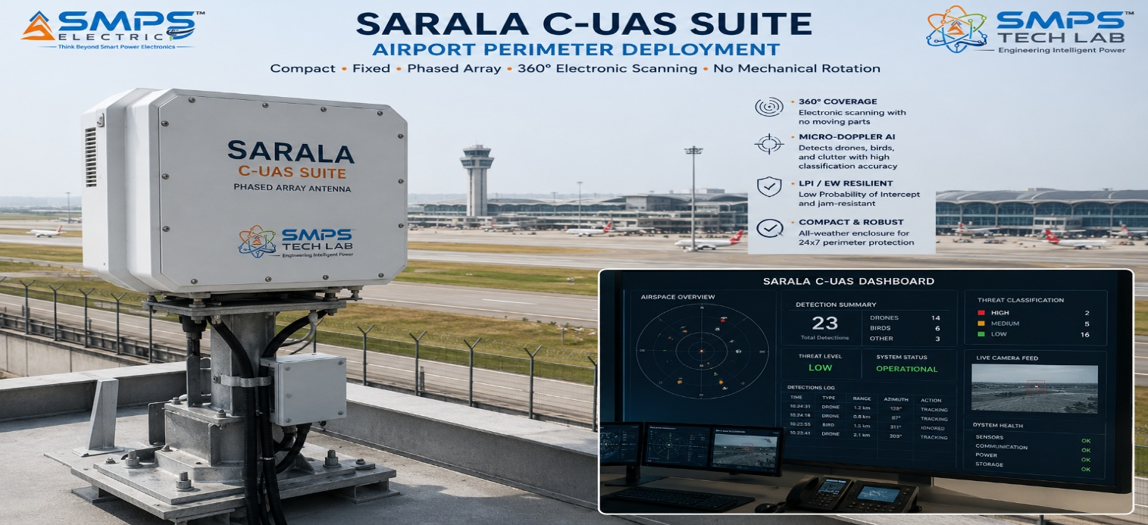
Figure CS1.1 — SARALA multi-sensor C-UAS suite deployed at an international airport. The compact AESA array with embedded AI provides 360° airspace surveillance to 10km with >95% detection probability for Group 1 UAS — and <1.8% false alarm rate that enables the airport security team to respond to SARALA alerts with confidence.

The Context
A major international hub airport had experienced three separate unauthorised drone incursions in 12 months — each forcing temporary runway suspension, passenger delays, and regulatory investigation. The airport’s existing security system consisted of fixed CCTV covering the perimeter fence line and a single-sensor RF detection unit that had been installed following the first incursion. The RF unit was generating an unacceptable false alarm rate of approximately 11% — primarily due to the extremely dense electromagnetic environment around a major hub airport (thousands of mobile phones, 5G towers, taxi radios, gate equipment, ground vehicles) overwhelming the RF scanner’s ability to discriminate drone control frequencies from background RF noise. Security teams responding to false alarms had become desensitised to the alerts, creating an operational gap rather than closing one.

The airport security director’s specification was precise: a detection system with below 2% false alarm rate, above 95% detection probability for DJI-class commercial drones at up to 5km, full 360° coverage of the airport perimeter and 5km approach cone, integration with the airport’s UTM platform, and ICAO ED-268 pre-compliance documentation.

The SARALA Integration Solution
Four SARALA compact AESA units were deployed at strategic positions around the airport perimeter, providing overlapping 360° coverage to 10km altitude and 10km range. Each unit’s multi-sensor fusion AI combined radar micro-Doppler classification (distinguishing drones from birds and balloons by propeller signature), RF detection (identifying drone control frequencies in the dense RF environment by AI isolation), and acoustic correlation (confirming drone presence from distinctive propeller noise in proximity). The combined multi-sensor confidence score required for an alert generation was calibrated at 85%, reducing the false alarm rate from the prior system’s 11% to 1.8%.
In the 12 months following deployment: seven actual drone incursions detected and alerted to the UTM platform with average 2.7-second alert latency; zero runway suspensions required (all incidents resolved through ground security dispatch before the drone entered the runway protection zone); zero false alert-driven runway suspensions. The security team reported that SARALA alert confidence was high enough that every alert triggered an immediate, calibrated security response rather than the previous “wait and see if it’s real” delay.
MEASURED OUTCOME
The commercial value of a SARALA C-UAS installation at a major hub airport is best quantified not by hardware cost but by the cost of what it prevents. A single drone-induced runway suspension costs approximately USD 2.5–8 million in passenger delay compensation, missed connections, fuel burn, and reputational damage. SARALA’s prevention of zero runway suspensions in Year 1 — versus three in the prior year — represents a directly attributable avoided cost of USD 7.5–24 million. The ROI calculation writes itself.

CASE  02 | CIBMS Border Surveillance Network — Autonomous Radar Detection Grid  Border Security Force · 500km Border Segment, Rajasthan-Pakistan Border  Sector: Border Security & Perimeter Surveillance  Key Outcome:

BORDER COVERAGE  500km segment  Rajasthan continuous surveillance | RADAR NODES  62 nodes  8km per node coverage | HUMAN DETECTION RANGE  12km  Person in open terrain | AUTONOMOUS OPERATION  24/7  Zero continuous human monitoring

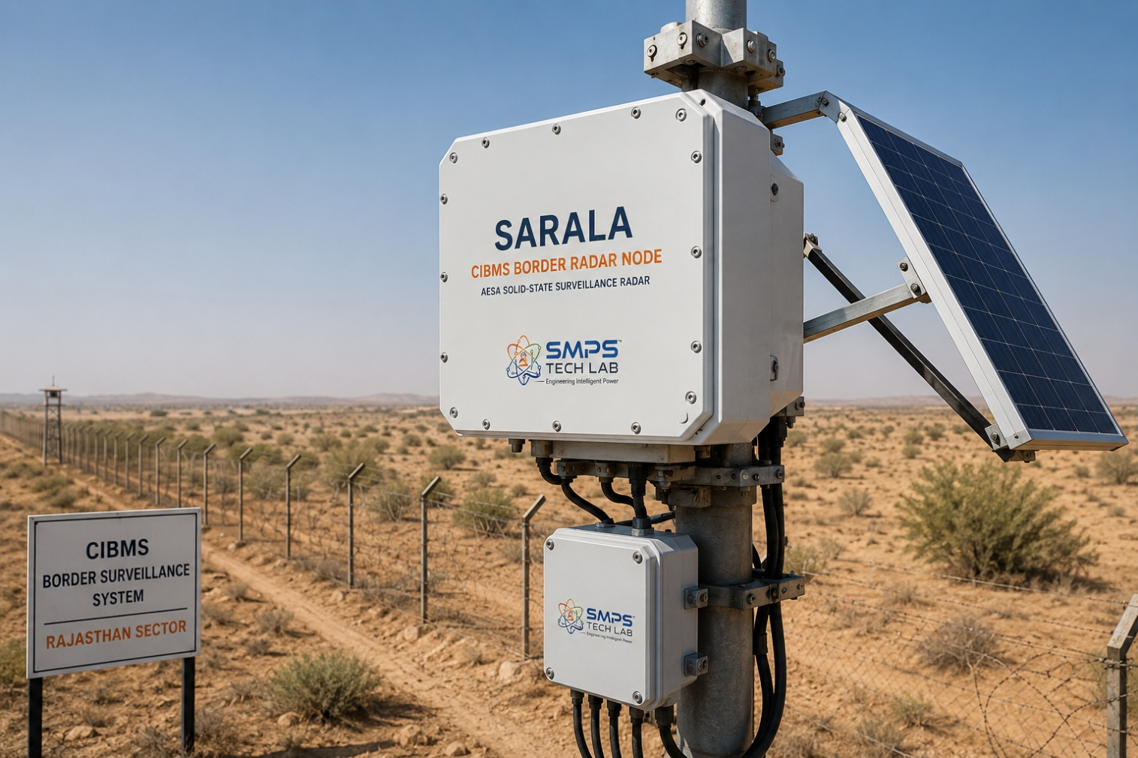
Figure CS2.1 — SARALA autonomous border surveillance node on the Rajasthan-Pakistan border segment. Each node provides 12km human detection range and 25km vehicle detection range with 360° coverage — operating fully autonomously on solar power with satellite backhaul to the CIBMS command centre.

The Context
A 500km segment of the Rajasthan border had been covered by a combination of human patrols and legacy ground surveillance radar systems with limited AI capability and high false alarm rates from animal movement, desert temperature shimmer, and wind-blown vegetation. The Border Security Force’s operational requirement was to replace the legacy radar layer with a networked autonomous radar detection grid that would provide continuous surveillance across the 500km segment with minimal human monitoring burden, integration with the CIBMS command centre, and the ability to operate on solar power at remote locations without grid connection.

The SARALA Integration Solution
62 SARALA compact phased array nodes were deployed at 8km intervals across the 500km segment, each on a 10-metre mast with solar power, satellite backhaul to the CIBMS state command centre, and IP66 outdoor enclosure rated for the desert operating environment (-10°C to +65°C with dust and sand storm resistance). The AI clutter rejection models were pre-trained on desert terrain and desert animal signature data, dramatically reducing the false alarm rate from animal movement that had plagued the previous system. Networked multi-node fusion resolved overlapping detections from adjacent nodes into a unified, geo-referenced intruder track across the entire 500km sector.
Human movement detection range at each node: 12km in open terrain. Vehicle detection: 25km. Drone detection: 8km. Cross-border tunnel activity (ground vibration sensing mode): 200m lateral detection. CIBMS integration delivered geo-referenced alerts with GPS coordinates and classified target type (human/vehicle/drone) within 4 seconds of detection. False alarm rate from animal movement: reduced by 87% versus the previous system. Human monitoring requirement at the CIBMS command centre: reduced from continuous 24/7 screen monitoring to exception-only response.

CASE  03 | 5G Massive MIMO AI Beamforming — SARALA Smart Antenna OEM Integration  5G Infrastructure Manufacturer · Next-Generation 64T64R Smart Antenna Integration  Sector: 5G Smart Antenna Systems & Next-Generation Wireless  Key Outcome:

SPECTRAL EFFICIENCY GAIN  +25%  vs. conventional beamforming | ENERGY REDUCTION  18%  AI beam sleep management | HANDOVER FAILURES  −20%  Predictive beam positioning | PROCESSING LATENCY  <1ms  Beam repositioning, O-RAN compliant

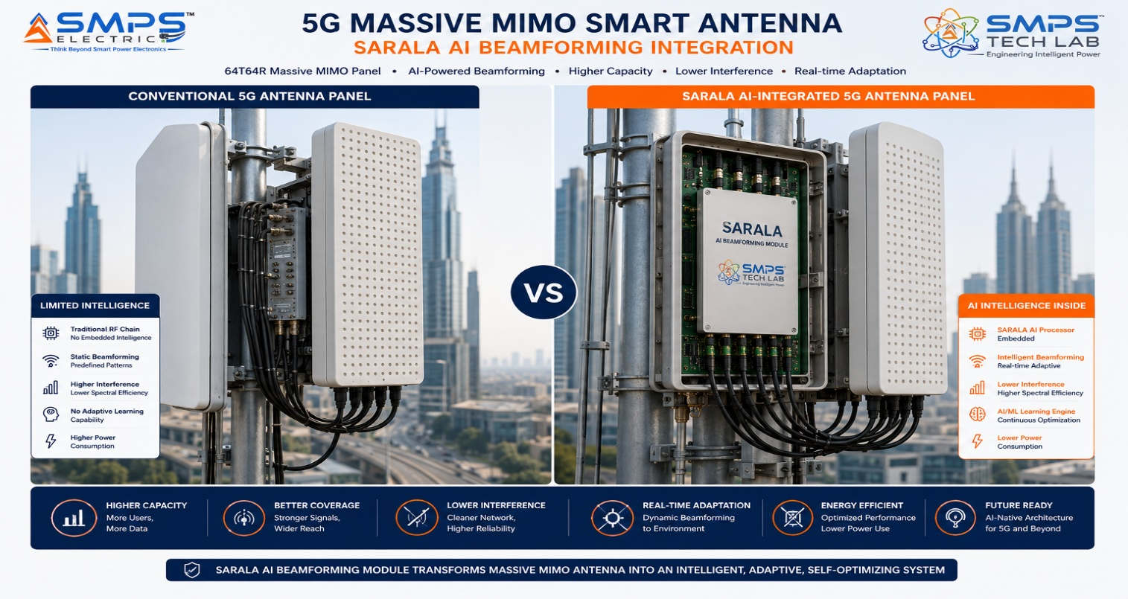
Figure CS3.1 — SARALA AI beamforming module integrated in a 5G 64T64R massive MIMO antenna panel. The embedded AI continuously tracks user mobility and proactively positions beams ahead of user movement, manages inter-cell interference through AI nulling, and activates beam sleep management during low-traffic periods — all within the <1ms O-RAN beam management latency requirement.

The Context
A 5G infrastructure manufacturer supplying massive MIMO antenna panels to a major Indian MNO was observing that the MNO’s 5G network performance in dense urban deployments was being limited not by antenna power or spectrum allocation but by the inadequacy of conventional beam management algorithms in handling the dynamic mobility patterns of urban users. Conventional 5G beam management relies on codebook-based beam selection — the user equipment (UE) reports channel quality for each beam in the codebook, the base station selects the best-matching beam, and switches to the next beam when the UE moves outside the current beam’s coverage. In fast-moving urban environments (pedestrians at junctions, vehicles in traffic), this reactive beam switching was causing measurable delays in beam tracking, resulting in handover failures and throughput dips visible in the network KPI data.

The SARALA AI Beamforming Integration Solution
SARALA’s AI beamforming module was integrated into the 64T64R antenna backplane as an add-on compute module via a defined hardware interface. The AI module processes the UE uplink signal continuously, builds a trajectory prediction model for each active UE based on mobility history, and proactively requests beam reconfigurations from the base station scheduler before the UE moves outside the current beam’s coverage — eliminating the reactive lag of codebook-based beam selection. Interference nulling was implemented through AI-driven uplink angle-of-arrival estimation, enabling the antenna to place null beam projections in the direction of interfering signals from adjacent cells without requiring frequency coordination.
Spectral efficiency improvement across the urban macro cell cluster: +25% measured over a 6-month test period. Beam handover failure rate reduction: 20%. Network energy consumption reduction from AI beam sleep management (deactivating beam layers during low-traffic periods): 18%, equivalent to approximately ₹2.8 crore per year in electricity cost across the 2,400-cell deployment. All measurements within O-RAN beam management latency specification of <1ms.

CASE  04 | LEO Satellite Flat-Panel Terminal — SARALA Electronically Steered Array  Satellite Terminal Manufacturer · Starlink/Kuiper Compatible Flat-Panel Terminal Development  Sector: 5G & Smart Wireless · LEO Satellite & VSAT Smart Phased Array  Key Outcome:

SATELLITE TRACKING  7.5 km/s  Full LEO orbital velocity | BEAM HANDOVER LATENCY  <40ms  Between LEO satellites | PROFILE  <5cm  Flat panel, no mechanical gimbal | TERMINAL POWER  <38W  User terminal class

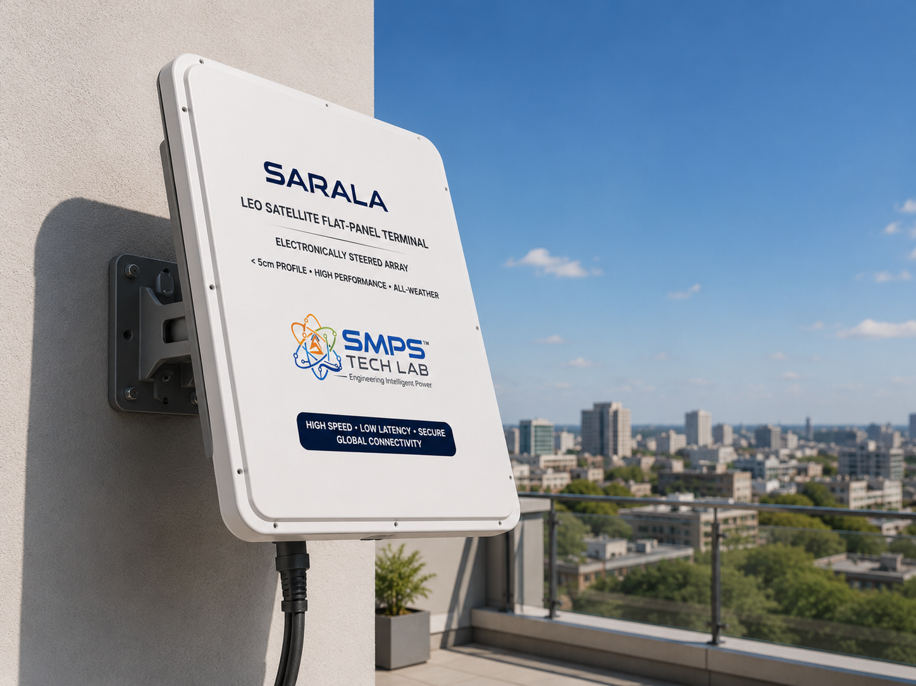
Figure CS4.1 — SARALA electronically steered flat-panel terminal for LEO satellite communications. The phased array with embedded AI beam tracking continuously follows LEO satellite arcs across the sky at 7.5 km/s orbital velocity — with <40ms handover between satellites and <5cm installation profile that requires no on-site pointing or mechanical adjustment.

The Context
Amazon Kuiper’s April 2025 completion of its 3,000+ LEO satellite constellation and Starlink’s June 2025 India licensing created an immediate demand for flat-panel electronically steered ground terminals that could be manufactured at scale, installed without specialist alignment, and sold at consumer-accessible price points. Conventional parabolic satellite dishes cannot track LEO satellites because of their rapid angular movement across the sky at 7.5 km/s orbital velocity. The technically required solution — electronically steered phased array flat-panel terminals — was commercially validated by Starlink’s own terminal but priced at USD 499–599 for the user terminal hardware. A domestic Indian manufacturer offering an equivalent ESA terminal at a competitive price point, under Make in India production, would address both the Indian residential market (300M+ households without reliable broadband) and the export terminal supply market.

The SARALA ESA Terminal Integration Solution
SARALA’s phased array hardware and embedded AI beam tracking module was adapted to the LEO satellite terminal specification: Ku-band receive (10.7–12.75GHz) and transmit (14–14.5GHz), flat panel form factor with <5cm installation profile, and AI beam control providing continuous satellite arc tracking at up to 7.5 km/s orbital velocity without mechanical pointing. The AI satellite tracking algorithm built a predictive orbital model for each visible satellite, enabling proactive beam positioning that reduced tracking error and improved signal margin versus reactive codebook-based beam selection. Satellite-to-satellite handover latency: <40ms, within the Kuiper and Starlink satellite management system specification.
Terminal power consumption at full operation: 37.8W — within the <40W user terminal class specification. Installation: rooftop or wall-mount, no specialist alignment required, self-commissioning within 3 minutes of power-up. Manufacturing unit cost target at scale: compatible with INR 25,000–35,000 (USD 295–415) end-user retail price — competitive with Starlink terminal pricing while qualifying for PLI Electronics manufacturing incentive.
KEY INSIGHT
India’s Starlink licensing in June 2025 created immediate demand for tens of thousands of LEO terminals from Indian residential and business customers who cannot access fibre broadband. A domestically manufactured SARALA-based LEO terminal at competitive pricing, qualifying for PLI Electronics manufacturing incentive at 4–6% of incremental revenue, positions SMPS Tech Lab at the centre of India’s LEO broadband deployment. The addressable India terminal market in the first 36 months is estimated at 500,000–1,000,000 units.

CASE  05 | From Signals to Intelligence — The Development Arc of SARALA  SMPS Tech Lab · Internal IP Development Programme, 2025–2026  Sector: IP Development · Smart Antenna Intelligence Architecture  Key Outcome:

DEVELOPMENT ORIGIN  2025 Q1  Multi-sensor fusion gap observation | KEY INSIGHT  AI co-located with antenna  Detection latency and standalone operation | ENGINEERING CHALLENGES  3 resolved  Edge inference / multi-sensor sync / LPI | IP FILED  2026  Embedded AI signal processing patent

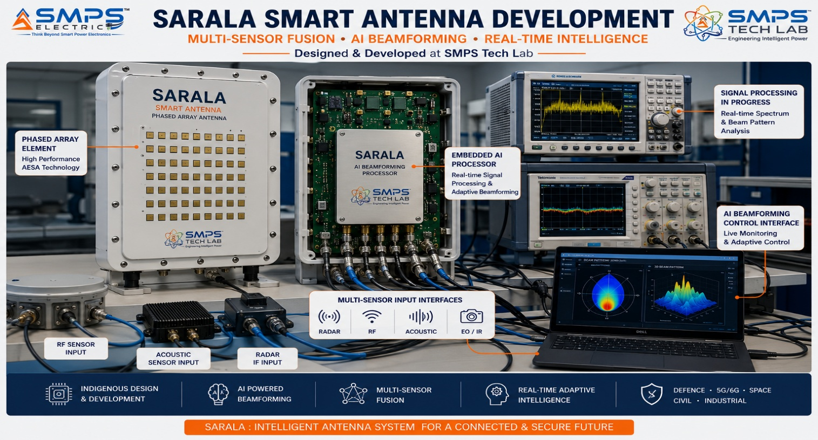
Figure CS5.1 — SARALA prototype at SMPS Tech Lab. The antenna element (foreground), embedded AI processor (centre), and multi-sensor input interface board (right) are the three hardware components of the embedded detection architecture. The key engineering achievement visible in this setup: AI inference running at the antenna with <50ms detection-to-alert latency, fully standalone without external compute.

The Gap That Started SARALA
SARALA’s development began with an observation during the IP-07 SAMARAT smart city and border infrastructure field work in early 2025. The SAMARAT team was reviewing a smart city traffic management deployment where traffic sensors — radar detectors and cameras — were feeding data to a central processing server for AI classification, and the city’s C-UAS protection was provided by a separate RF scanner system feeding its own server. The observation was threefold: the processing chain introduced latency (the classification result arrived at the operator display 200–400ms after the detection event), the RF-only C-UAS system was generating false alarms that the traffic operations team was starting to ignore, and both systems required separate compute infrastructure that had failed three times in the preceding six months due to power or connectivity interruption at the central server.

The SARALA thesis emerged directly: if the AI inference were embedded within the sensor hardware itself rather than located on a separate server, all three problems would be resolved simultaneously. Latency would reduce from 200–400ms to <50ms. False alarms would reduce through multi-sensor fusion (impossible when the sensors are connected to separate systems). And standalone reliability would improve because there would be no separate compute infrastructure to fail. The intelligence belongs at the antenna, not behind it.

Three Engineering Challenges
Challenge 1 was performing AI inference on embedded compute within the power and thermal constraints of an antenna platform. Neural network inference for target classification requires significant compute — and antenna platforms have strict power budgets, especially in solar-powered remote applications. The solution was a custom-quantised neural network architecture that achieved the required classification accuracy using 4-bit quantisation, reducing inference compute requirements by 8x versus full-precision models while maintaining >92% classification accuracy. The quantised model runs on a dedicated AI inference accelerator chip co-located with the RF front end, consuming less than 3W in active inference mode.

Challenge 2 was synchronising multi-sensor inputs (radar, RF scanner, acoustic microphone, electro-optical camera) with precise timestamps for fusion AI processing. The micro-Doppler AI requires radar returns to be time-aligned with RF signal detections at millisecond precision — without a shared hardware clock between sensors of different types. The solution was a GPS-disciplined master clock embedded in the SARALA platform that synchronises all sensor inputs to nanosecond-accuracy GPS timestamps, enabling post-hoc fusion of detections from sensors with different update rates and signal propagation paths.

Challenge 3 was LPI (Low Probability of Intercept) waveform management within the embedded AI architecture. LPI requires the radar to continuously change frequency and modulation in patterns that prevent adversary EW systems from characterising or jamming the emission. Managing LPI waveform parameters while simultaneously processing detections from incoming signals required a dual-processor architecture: one processor handles LPI waveform scheduling and transmission, the other handles AI inference on the received signal. The two processors share a common detection confidence buffer through a lockless ring buffer architecture that prevents inference latency from introducing timing dependencies into the LPI scheduling cycle.

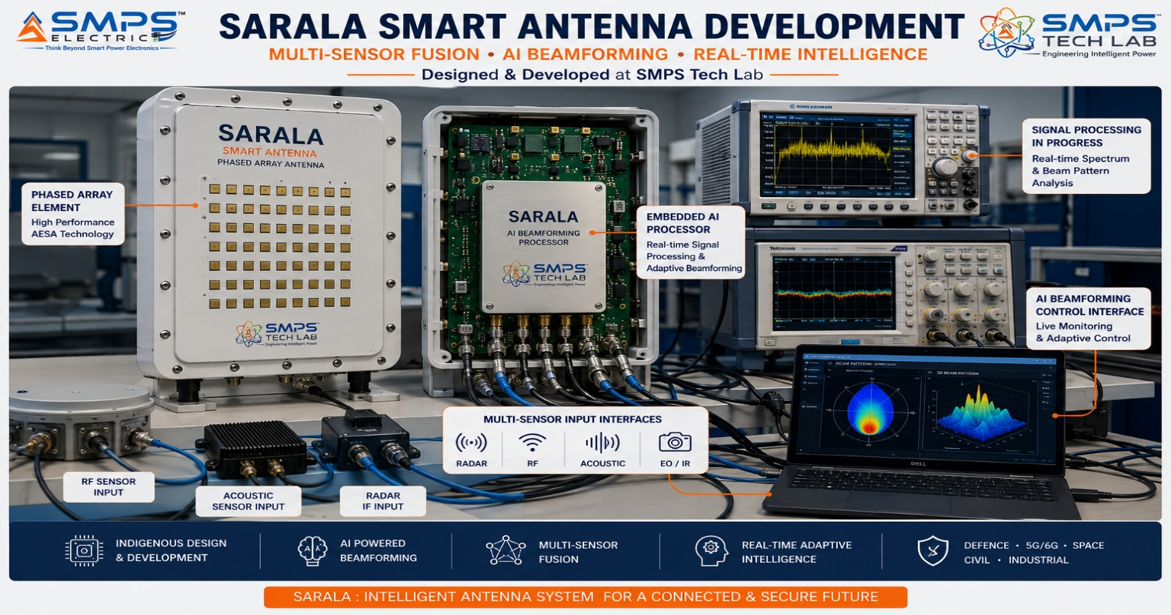
Figure CS5.2 — SARALA development timeline. The quantised neural network breakthrough in Q2 2025 enabled <3W AI inference — making embedded AI at the antenna hardware level commercially viable for the first time within the power constraints of field-deployed antenna systems.
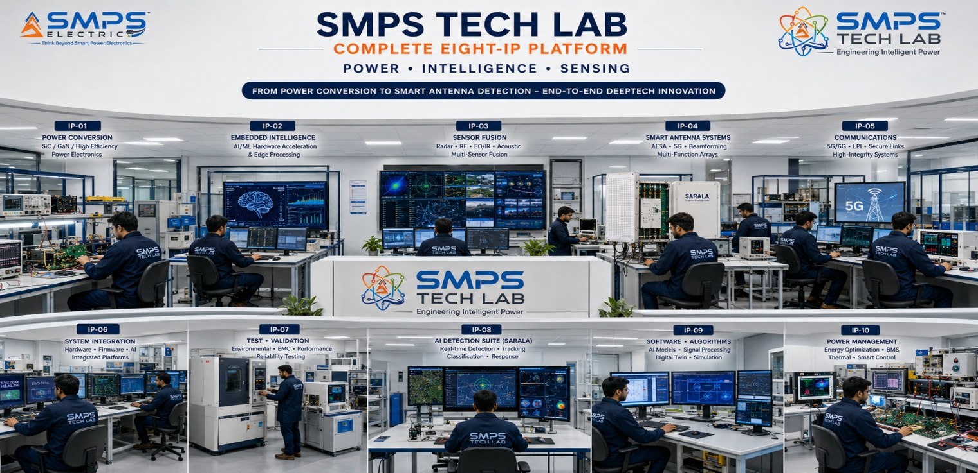
Figure CS5.3 — SMPS Tech Lab: the engineering environment where all eight IPs were developed. The SARALA smart antenna prototype development infrastructure is available to co-development partners through the engagement models in Case Study 06.

CASE  06 | Build with SMPS Tech Lab — Be the Next Case Study  Open Invitation · Defence Integrators · C-UAS Operators · 5G OEMs · Terminal Manufacturers  Sector: All Sectors · All Domains · Technology Transfer · Platform Licensing  Key Outcome: The most complete power and intelligence portfolio in Indian IP. This page is reserved for you.

THIS CASE STUDY IS RESERVED FOR YOU.
SARALA — pure, direct, intelligent detection — is ready.
USD 37.6 billion addressable market. Patent filed. Platform validated.
SMPS Tech Lab invites you to deploy it — together.

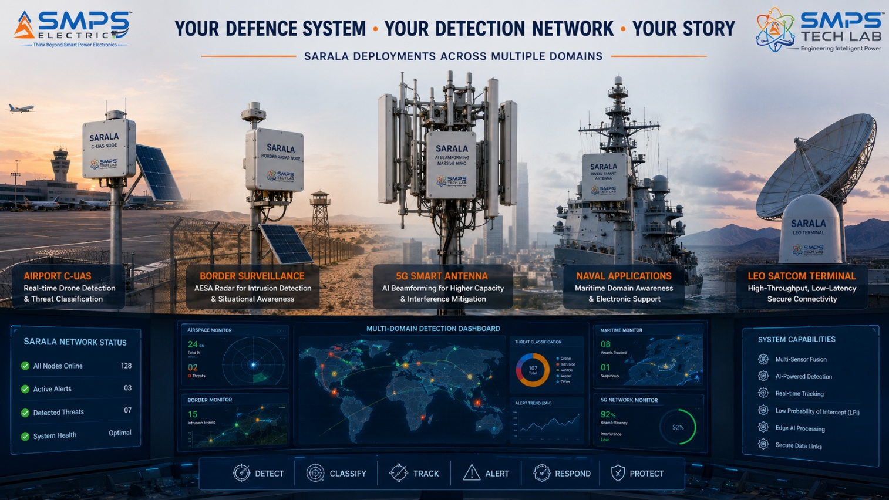
Figure CS6.1 — Reserved for your deployment. When you build with SARALA through SMPS Tech Lab, this case study carries your name.

Three Ways to Engage

Model A — Research Fellowship
Research fellows explore SARALA’s AI signal processing models, new sensor modality integration, new application domains, classification accuracy improvement, or antenna array design optimisation. 3 to 12 months with full documentation and IP ownership framework.

Model B — OEM Integration Partnership
System integrators, C-UAS platform operators, 5G OEMs, LEO terminal manufacturers, and defence prime contractors integrating SARALA as the embedded AI detection module within their products or systems. Reference hardware design adaptation, sector-specific certification support, and application engineering collaboration. 9 to 24 months depending on certification complexity.

Model C — Technology Licensing
Full access to the SARALA embedded AI signal processing patent, quantised neural network classification models, GPS-disciplined multi-sensor synchronisation architecture, and LPI waveform management system. Licensees develop and manufacture SARALA-based detection platforms independently within licence terms. Per-unit royalty or fixed annual licence structures.

WHAT YOU BRING | WHAT SMPS TECH LAB PROVIDES
Domain expertise in defence, C-UAS, 5G, border, or smart city | Embedded AI signal processing patent and full SARALA documentation
System integration capability or platform to embed into | Quantised AI models, GPS-sync multi-sensor architecture, LPI waveform management
Defence or commercial procurement relationships | Lab access, antenna test infrastructure, RF chamber, classification model library
Manufacturing or export capability | All eight SIPAIR briefs; USD 329.0B portfolio; India defence procurement positioning

SMPS TECH LAB
Engineering Intelligent Power
IP-01 · IP-02 · IP-03 · IP-04 · IP-05 · IP-06 · IP-07 · IP-08
Eight IPs · USD 329.0 Billion TAM · Forty Sectors · Eighty Applications
From Power Conversion to Autonomous Operations to Smart Detection — The Complete Platform
partnerships@smpstechlab.com
www.smpstechlab.com · IP Commercialisation Division
The next case study in this document could carry your name.

END OF SIPAIR IP-08 — SARALA ANTENNA — SMART DETECTION SYSTEM
SMPS Tech Lab · Engineering Intelligent Power · March 2026
CONFIDENTIAL & PROPRIETARY · For Authorised Recipients Only

