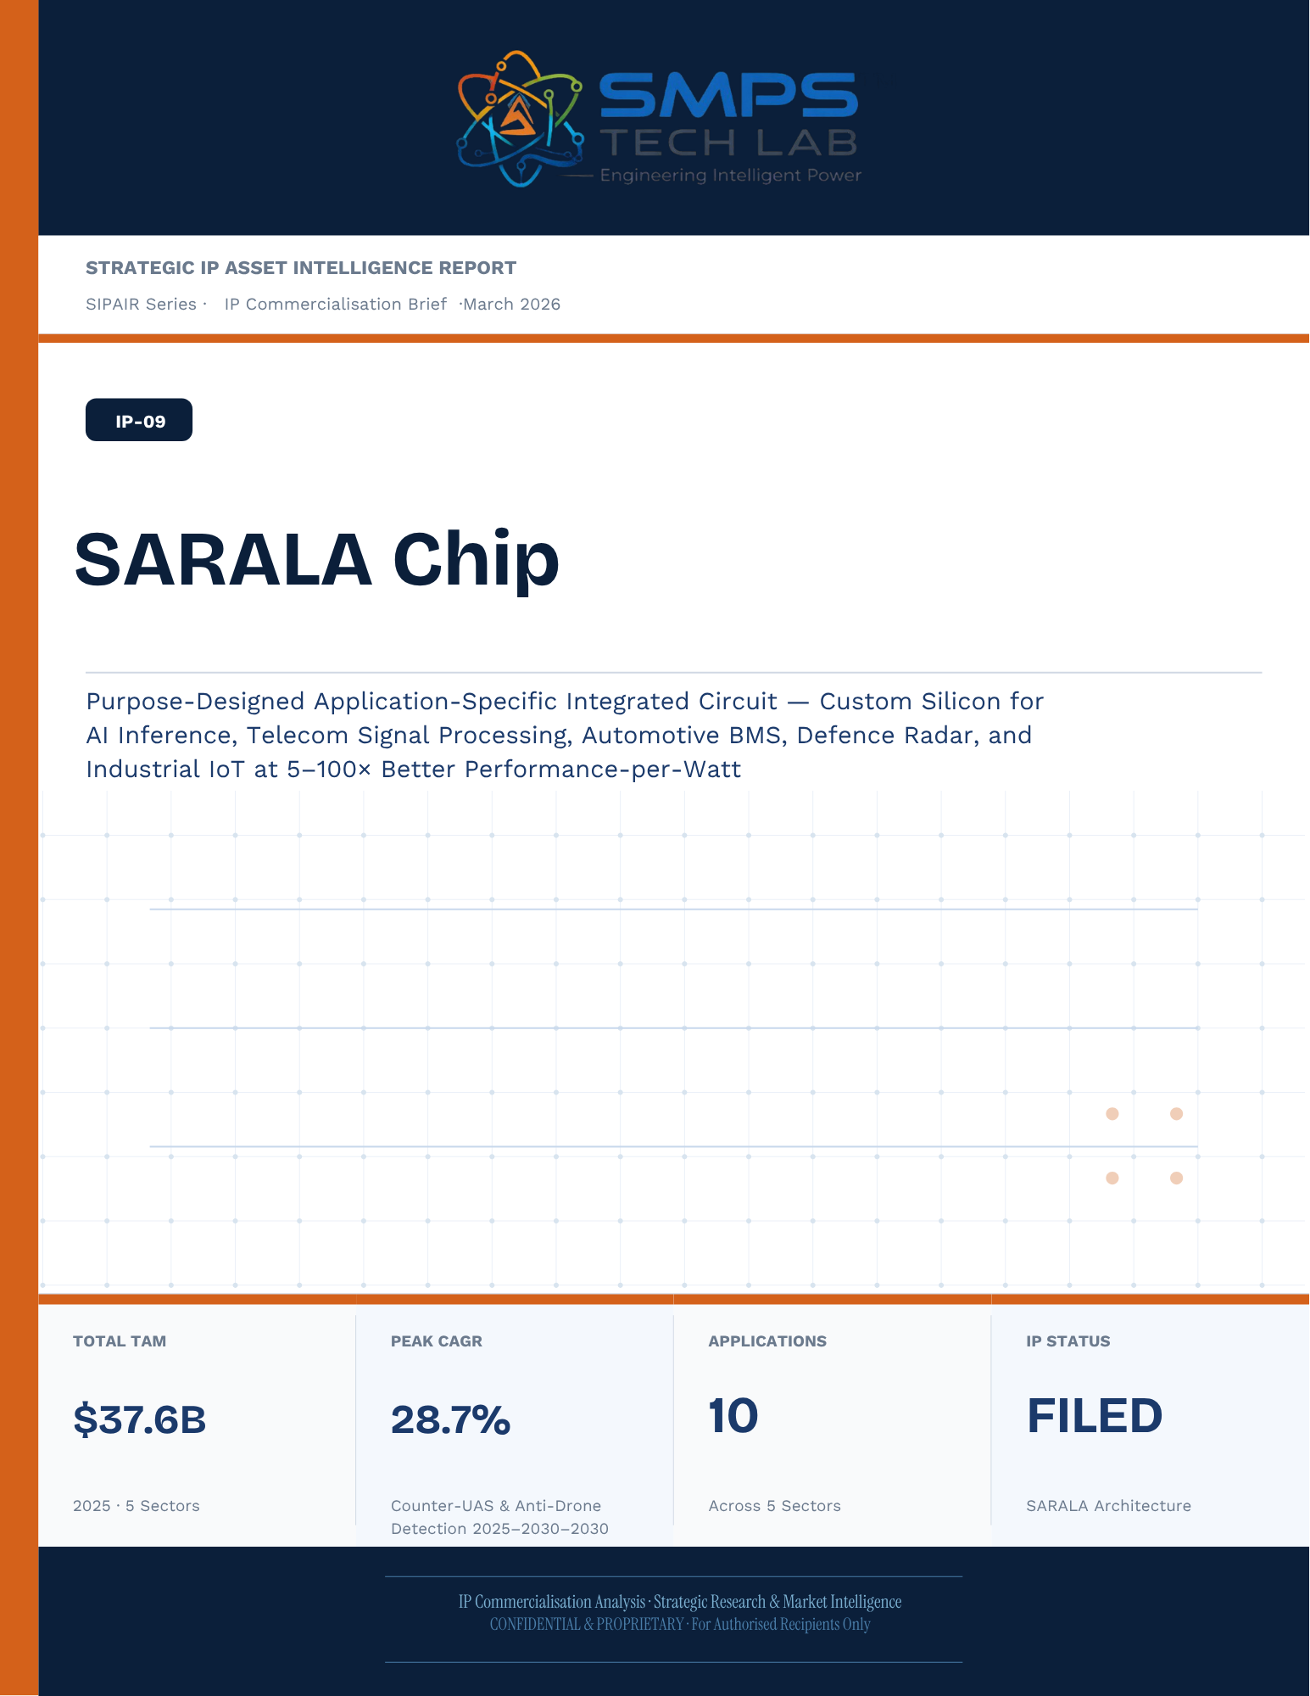
Un-named
[Email address]
STRATEGIC IP ASSET INTELLIGENCE REPORT
SIPAIR Series
IP-09: SARALA
SMPS-Based Integrated SARALA for Uninterrupted Telecom Power

Report Title | SIPAIR IP-09 — SARALA Commercialisation Brief

Document Series | Strategic IP Asset Intelligence Report (SIPAIR)

Version | Version 1.0 — First Edition

Compiled & Edited by | Shri Amareshwar Karatagi

Organisation | SMPS Tech Lab — Engineering Intelligent Power

Date of Issue | March 2026

Classification | Confidential & Proprietary — For Authorised Recipients Only

IP Reference | IP-09 — SARALA Architecture, Filed 2025

Related Document | SIPAIR IP-01: Smart Hybrid SMPS (see companion brief)

This document is prepared by SMPS Tech Lab as part of the SIPAIR IP Commercialisation Series.

Declaration — Originality & Intellectual Property Statement

This Strategic IP Asset Intelligence Report (SIPAIR — IP-09: SARALA) is an original compilation prepared by SMPS Tech Lab. The analysis, market intelligence frameworks, commercial strategy formulations, and case study narratives contained herein are the result of independent research and original intellectual work by the authors and editors named in this document.

The core technology described in this report — the SMPS-Based Integrated SARALA architecture, including its active power management layer, CCU intelligence stack, uninterrupted multi-rail AC/DC delivery system, and NMS integration platform — is the exclusive proprietary invention of SMPS Tech Lab, protected under a filed novel design patent (2025). IP-09 is a distinct and independently protectable invention from IP-01 (Smart Hybrid SMPS), though both emerge from the same SMPS Tech Lab research programme. The two IPs are designed to complement each other across adjacent application verticals and may be jointly licensed or co-deployed where application requirements demand both hybrid topology and active power management intelligence.

Market sizing data, CAGR estimates, and industry statistics cited in this document are sourced from independent third-party research publications, fully attributed in Appendix A. All third-party data is used for analytical and benchmarking purposes only. This report has not been submitted, in whole or in part, to any other organisation for commercialisation or formal assessment except as specifically disclosed in writing.

Declared by:

Shri Amareshwar Karatagi Founder & CSO SMPS Tech Lab · March 2026

CERTIFICATE OF AUTHENTICITY
IP Commercialisation Documentation · SIPAIR IP-09

This is to certify that the Strategic IP Asset Intelligence Report
SIPAIR IP-09 — SARALA
has been compiled, reviewed, and authenticated by the undersigned in accordance
with the standards of the SIPAIR documentation series. The technology, market analysis,
and commercial intelligence herein are verified as accurate to the best of the signatories’
knowledge as at the date of issue: March 2026.

Program Head / Director | Technical Mentor
  Program Head / Research Director
  SMPS Tech Lab
  Technical Mentor / Advisor
  SMPS Tech Lab

SMPS Tech Lab · Engineering Intelligent Power · March 2026

Acknowledgment

The preparation of this Strategic IP Asset Intelligence Report for IP-09 has drawn on the technical expertise, operational insights, and research foundation developed across two parallel innovation tracks at SMPS Tech Lab. The development of the CCU intelligence layer — the defining innovation of IP-09 — required not only power electronics engineering depth but sustained engagement with telecom network operations, tower management practice, and satellite ground station engineering environments that are highly specialised. The author and editor express sincere gratitude to those whose knowledge and access made this work possible.

Technical Development
The CCU architecture at the heart of IP-09 evolved alongside IP-01's hybrid topology work, but along a distinct engineering trajectory focused on power orchestration intelligence rather than conversion efficiency alone. The engineers and technologists who contributed to the CCU control logic, NMS integration stack, and sub-millisecond failover switching mechanism deserve specific recognition for the rigour with which they approached the uninterrupted power mandate — a design objective that admits no approximation.

Telecom Industry Access
The sector intelligence in this report reflects direct engagement with tower operations, data centre facility management, and satellite ground station engineering communities. The operational data from 5G tower rollout programmes, off-grid hybrid power deployments, and maritime communication installations that informed the case study narratives and application requirement specifications in this document is the product of those field engagements.

Research Publications
The market intelligence framework draws on publications from Future Market Insights, MarketsandMarkets, SNS Insider, Grand View Research, IMARC Group, Coherent Market Insights, Global Growth Insights, and the Ericsson Mobility Report, as well as operational data from the International Energy Agency. The quality of those independent research publications is what allows the TAM framework in this report to be grounded in named, verifiable data rather than estimated aggregates.
Amar
Founder & Chief Technology Officer
SMPS Tech Lab · March 2026

Preface — From the Founder & Editor

From IP-01 to IP-09 — The Logical Extension
IP-01, documented in the companion SIPAIR brief, solved one problem with exceptional elegance: replacing the unnecessary architectural duplication of separate AC and DC converter units with a single hybrid topology. The commercial case was compelling and the market evidence was clear. But the engineers at SMPS Tech Lab, in the same process of field observation that gave rise to IP-01, had identified a second problem — one that operated at a higher level of the power system stack and was, if anything, more commercially urgent in the specific context of telecom infrastructure.

The problem was not conversion efficiency. It was availability. In a 5G base station, a satellite ground hub, an offshore platform communication centre, or a smart city public safety network node, the standard power supply architecture not only requires separate AC and DC converters — it delegates all intelligence about the power state of the system to a separate controller that may be physically remote, software-dependent on a third-party network management system, and incapable of autonomous protective action in the sub-millisecond timeframe that modern telecom uptime SLAs demand. When the grid fails, when a battery starts to degrade, when an input source switches — the system needs to respond faster than any software polling cycle can achieve. It needs embedded intelligence, right at the power conversion stage.

IP-09 is that intelligence. The Integrated SARALA, combined with the SMPS core, does not just convert power — it orchestrates it. It monitors every parameter of the power delivery chain continuously, switches between sources in under a millisecond, predicts faults before they become outages, and reports power system health to the operator's NMS in real time, without external monitoring hardware. It is the difference between a power supply and a power management system.

Why Telecom, and Why Now
The selection of telecom infrastructure as the primary application vertical for IP-09 reflects a disciplined commercial judgement. Telecom infrastructure is the single sector in the IP-09 TAM where the uninterrupted power mandate is non-negotiable, contractually enforced at 99.999% uptime, and backed by capital investment programmes of unprecedented scale: 2.3 billion 5G subscriptions by end of 2024 with another 4 billion to come by 2030; 3,000 Amazon Project Kuiper satellites deployed in April 2025 with thousands of ground hubs to follow; the IMO GMDSS modernisation mandate forcing a complete vessel communication power infrastructure upgrade by 2026. Every one of these programmes creates a specific, identified, and time-bounded procurement requirement for exactly what IP-09 delivers.

The second reason is the grid reliability crisis that is, counterintuitively, the most powerful demand driver the CCU's hybrid input management addresses. South Africa recorded 1,130 hours of planned power cuts in a single year. India's tower estate — 750,000 sites — routinely operates on hybrid grid, diesel, and battery sources with real-time CCU-managed source switching that determines whether the tower stays on during a grid event. This is not a niche requirement. It is the operational reality for hundreds of thousands of tower sites across three continents, and the market is actively seeking a solution that the current generation of separate rectifiers and external controllers cannot provide.

How This Document is Structured
This SIPAIR brief follows the same 14-section architecture as the IP-01 companion document, making the two documents a coherent and mutually reinforcing portfolio. Readers who have engaged with SIPAIR IP-01 will recognise the structure immediately. The technology differentiation section includes an explicit comparison between IP-01 and IP-09, clarifying the architectural relationship and the distinct value proposition of each. The case studies are drawn from the five specific sectors of IP-09's TAM framework — 5G tower, data centre, satellite ground, smart city, and maritime/offshore — with technical and financial parameters grounded in the operational realities of each sector.
Shri Amareshwar Karatagi
Founder & CSO
SMPS Tech Lab · March 2026

TABLE OF CONTENTS

Declaration — Originality & Intellectual Property Statement 4
Acknowledgment 7
Technical Development 7
Telecom Industry Access 7
Research Publications 7
Preface — From the Founder & Editor 9
From IP-01 to IP-09 — The Logical Extension 9
Why Telecom, and Why Now 9
How This Document is Structured 10
Important Notice & Confidentiality Disclaimer 16
1.1 The Strategic Context 17
1.2 The Problem SARALA Chip Solves 17
1.3 Key Metrics at a Glance 18
1.4 Why SARALA Chip, Why Now 19
2.1 What is SARALA Chip? 21
2.2 The Four Integrated Technology Layers 21
2.3 Portfolio Silicon Integration — The Internal Demand Pipeline 23
2.4 Hardware Security Architecture — Sovereign Silicon 24
2.5 Standards Compliance Architecture 25
3.1 The Custom Silicon Inflection Point 27
3.2 The Four Structural Megatrends 27
3.3 Global Market Sizing — Primary Reference Data 28
CAGR Comparison — SARALA Chip Application Verticals 29
4.1 Methodology 30
4.2 Consolidated TAM Summary 31
5.1 India as First and Strategic Market 33
5.2 India Market Sizing — SARALA Chip Relevant Segments 34
6.1 India & Global Policy with Direct SARALA Chip Alignment 35
7.1 The Plugin Architecture — Silicon Core for Two Markets 37
7.2 Plugin Integration Matrix 38
8.1 Commercialisation Philosophy 39
8.2 Market Priority Matrix 39
9.1 Competitive Architecture Overview 41
10.1 The Investment Case 43
10.2 Illustrative Revenue Scenarios 44
11.1 Technology Generation Roadmap 45
11.2 Adjacent Application Opportunities 46
12.1 Risk Framework 48
Appendix A — Data Sources 50
Appendix B — Standards Reference 51
Appendix C — Glossary 52
The Portfolio Integration Case 55
The SARALA Chip Radar DSP Design 55
The Rural IoT Edge AI Challenge 57
The SARALA Chip Edge AI Solution 58
The India Sovereign AI Silicon Opportunity 59
The ISM DLI-Funded Development Programme 60
The EV BMS Silicon Gap 61
EU Battery Passport 2027 Alignment 62
The Silicon Gap That Started SARALA Chip 63
Three Engineering Challenges 64
Three Ways to Engage 67
Model A — Research Fellowship 67
Model B — Co-Design & Co-Tape-Out 68
Model C — IP Licensing & Supply 68

0F | FOUNDER & EDITOR  IP-09 SIPAIR Series · SMPS Tech Lab

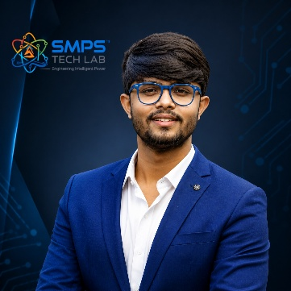
Shri Amareshwar Karatagi
Founder & Chief Strategic Officer
SMPS TechLab
Special Correspondent, Government of Karnataka |
Serial Entrepreneur

Vision Statement
We aim to build a generation of innovators and entrepreneurs who create transformative technologies, develop intellectual property, and drive India’s technological leadership on both national and global platforms. Over the years, we have worked extensively within the startup ecosystem, contributing to and mentoring multiple initiatives focused on building, scaling, and strengthening businesses. Through this journey, we have developed a deep understanding of business strategy, governance frameworks, and deep-technology development, along with the practical challenges of scaling innovation in real-world markets.
As a Special Correspondent with the Government of Karnataka and a serial entrepreneur, my focus has been on shaping individuals into creators, builders, and leaders of technology and enterprise. Our work emphasizes ownership, innovation, and execution discipline to nurture individuals capable of building scalable, high-impact solutions with both national and global relevance.
Through SMPS Tech Lab, we drive this vision by integrating deep Research & Development (R&D) with entrepreneurial strategy, fostering a culture where ideas evolve into intellectual property, innovation, and industry-aligned solutions that contribute to India’s technological advancement and global competitiveness. The Industry Fitness DeepTech Internship Program is a reflection of this mission—designed to develop individuals who are innovation-driven, execution-focused, and capable of contributing meaningfully to technology, entrepreneurship, and nation-building at scale.

“My vision is to build a generation that doesn’t wait for opportunities, but creates them through innovation and entrepreneurship.”
— Shri Amareshwar Karatagi

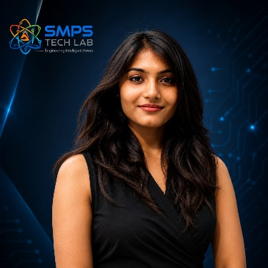

A. R. Shalini
Chief Business Development Officer (CBDO) & Program Officer
SMPS TechLab | SMPS Electric Control Pvt. Ltd.

Area of Expertise:
Business Strategy, Operations Management, Industry–Academia Integration, Entrepreneurship Development
Profile:
I play a pivotal role in driving program execution, operational excellence, and professional development within SMPS Tech Lab. With a strong foundation in both business strategy and technology alignment, I am committed to shaping individuals into industry-ready professionals with the right mindset, discipline, and execution capabilities.
My approach focuses on building skills with clarity of thought, accountability, and a results-driven attitude. Through structured guidance and continuous mentorship, I enable participants to understand the intersection of technology, business, and real-world application.
I actively work toward bridging the gap between academia and industry, ensuring that learning is aligned with practical expectations and evolving market demands. My dedication to creating a seamless and high-impact learning environment fosters confidence, innovation, and professional growth among participants.
Through my leadership, the program consistently emphasizes structured execution, strategic thinking, and the development of individuals who are prepared to contribute meaningfully to both industry and innovation ecosystems.
“Professional excellence is built when knowledge, mindset, and execution come together with consistency.”
— A. R. Shalini

Dr. S. Khatua
Chief Technology Officer (CTO)
SMPS TechLab | SMPS Electric Control Pvt. Ltd.
IITian | PhD – IIT Dhanbad

Area of Expertise:
Power Electronics, Microgrid & Smart Grid Systems, Nuclear Power Systems, DeepTech R&D, Industrial System Design.
I am a distinguished technology leader driving advanced Research & Development and deep-tech innovation. An IITian with a PhD in Microgrid and Smart Grid Systems for nuclear power applications, I bring over 15 years of experience across power electronics, nuclear reactor control systems, and defence and telecom technologies.
With significant contributions to high-impact and mission-critical projects of national importance, my work reflects a rare combination of research depth, engineering precision, and industrial execution.
I am a strong advocate of deep-tech innovation and intellectual property (IP) creation, and I emphasize the development of indigenous technologies that strengthen the nation’s technological capability and global standing.
Through my mentorship, I inspire the next generation to pursue technical mastery, disciplined execution, and innovation with national intent, shaping professionals capable of contributing to the future of deep technology.
“Precision in engineering, depth in research, and ownership of technology are the pillars of true national progress.”
— Dr. S. Khatua

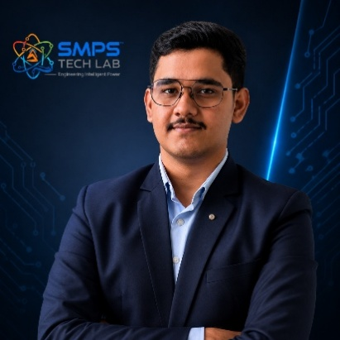

Mr. Rushit Jani
Techno-Commercial Architect
Strategic Editorial & Commercialisation Review | OptCell GLOBAL

Fields of Interest:
AI & Intelligent Systems, Industrial IoT, Product Architecture, Deep-Tech Commercialisation, Enterprise System Design, and Scalable Engineering Solutions.
Focused on building technology-driven systems that bridge engineering innovation with practical industry adoption and long-term commercial value.

Message from the Editor:
Technology, in its purest form, is not just about building systems — it is about creating meaningful infrastructure that can influence industries, solve operational challenges, and contribute to larger technological progress. My interest has always been in understanding how engineering innovation can evolve beyond prototypes into scalable and commercially sustainable solutions.

This document represents more than a technical study of an intellectual property. It reflects a structured effort to connect engineering architecture with market relevance, strategic deployment, industrial applicability, and long-term innovation potential. The objective throughout this work has been to maintain a balance between technical depth, commercialization practicality, and institutional-level documentation standards.

As emerging technologies continue to redefine industries, I strongly believe that the future will belong to organizations capable of combining research, engineering, strategic thinking, and execution into unified ecosystems. Through this publication, we aim to contribute towards that larger vision while creating pathways for collaboration, innovation, and real-world technological impact.

"Transforming engineering innovation into scalable, industry-defining technological ecosystems."
— Mr. Rushit Jani

A Note of Gratitude

The development of this publication has been supported by the collective vision, encouragement, and leadership of the Directors and management of SMPS Electric Control Pvt. Ltd.

Their continued commitment towards engineering innovation, industrial excellence, and long-term technological growth has created an environment that encourages meaningful research, practical problem-solving, and commercialization-focused thinking. The guidance, operational insights, and institutional support extended throughout this journey have played an important role in shaping the direction and depth of this work.

This document reflects not only an individual effort, but also the larger culture of innovation, trust, and forward-thinking leadership fostered within the organization. We sincerely appreciate the confidence and support provided towards building impactful and future-ready technological initiatives.

Important Notice & Confidentiality Disclaimer

This Strategic IP Asset Intelligence Report (SIPAIR — IP-09) has been prepared exclusively for internal strategic planning, investor communication, licensing partner engagement, and research collaboration purposes. It is intended for distribution only to authorised recipients under applicable non-disclosure and confidentiality arrangements.

All market sizing data, CAGR estimates, and financial projections are derived from independent third-party research publications cited in Appendix A. These figures represent estimates as at March 2026. No representation or warranty is made as to their accuracy or completeness.

The technology, architecture, and methodologies described herein are the exclusive proprietary assets of SMPS Tech Lab, protected under filed patent and design rights. This document does not constitute a prospectus, financial advice, or an offer to sell or subscribe to securities. Recipients are advised to conduct independent due diligence before making any investment or commercial decision.

01 | EXECUTIVE SUMMARY  The Custom Silicon Inflection · SARALA Chip Value Proposition · Portfolio Silicon Foundation

1.1 The Strategic Context
Every layer of intelligence in the SMPS Tech Lab portfolio — the embedded AI in SARALA Antenna’s detection engine, the autonomous operations edge nodes in SAMARAT, the smart BMS algorithms in Swarna Li, the power conversion control in the Smart Hybrid SMPS — ultimately runs on silicon. And the most commercially and technically significant decision in any embedded intelligence design is whether that silicon is a general-purpose processor running software, an FPGA running reconfigurable logic, or a purpose-designed ASIC running the exact algorithm in optimised transistors. The answer, for high-performance and power-constrained applications, is always ASIC. A chip designed specifically for its target workload achieves 5–100x better performance per watt than general-purpose processors doing the same computation. This is not a marginal advantage — it is the difference between a viable embedded system and an impractical one.

The market has confirmed this in 2024–2025 with extraordinary commercial force. Microsoft, Google, and Amazon AWS are building what analysts call the ‘rising ASIC coalition’ — independently developing custom AI ASICs as a strategic hedge against GPU dependency, capable of trimming total cost of ownership by up to 40% on stable inference workloads (June 2025). NVIDIA launched a dedicated ASIC department in January 2025. OpenAI partnered with Broadcom for a custom AI inference ASIC in October 2024. TSMC signalled its 2nm node was multi-year sold out in May 2025. The entire semiconductor industry is converging on application-specific silicon.

1.2 The Problem SARALA Chip Solves
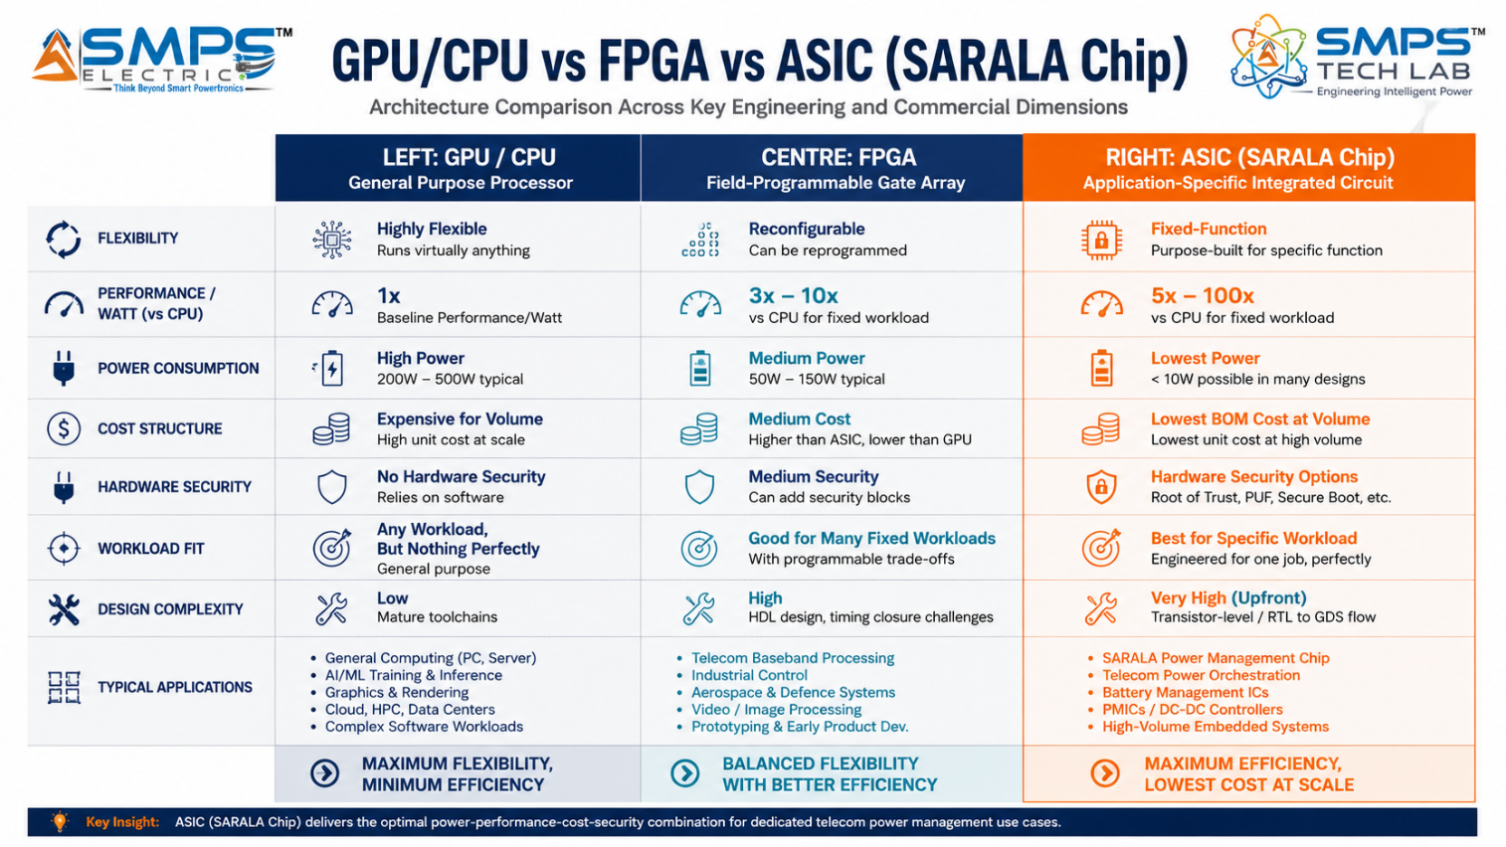
Figure 1.1 — The three silicon options for embedded intelligence. For any fixed, well-defined computational workload — AI inference, radar signal processing, 5G baseband, battery management — ASIC delivers 5–100x better performance per watt than general-purpose silicon. SARALA Chip is that ASIC.
STRATEGIC NOTE
SARALA Chip is not just a standalone product. It is the silicon foundation for the entire SMPS Tech Lab portfolio. IP-08 SARALA Antenna’s embedded AI detection engine runs on SARALA Chip. IP-07 SAMARAT’s autonomous operations edge nodes run on SARALA Chip. IP-06 Swarna Li’s smart BMS algorithms run on SARALA Chip. IP-01/03’s power conversion control runs on SARALA Chip. The portfolio’s ‘embedded intelligence’ promise is technically realised through SARALA Chip. This portfolio integration creates a captive internal demand pipeline that de-risks initial commercialisation from Day 1.

1.3 Key Metrics at a Glance

TOTAL ADDRESSABLE MARKET  $44.8B  2025 Baseline · 5 Application Sectors | HIGHEST-GROWTH SECTOR  18.6%  AI Inference ASIC CAGR 2025–2033 | SECTORS MAPPED  5  10 Applications Identified | IP PROTECTION  SARALA Chip Filed  Custom ASIC Silicon Design Patent

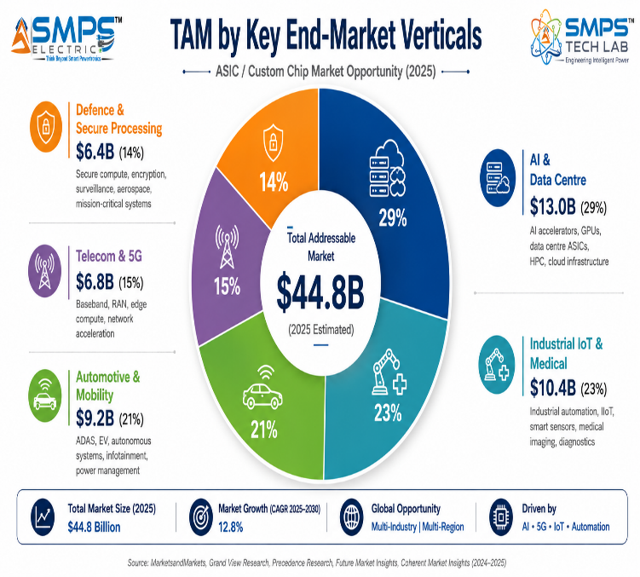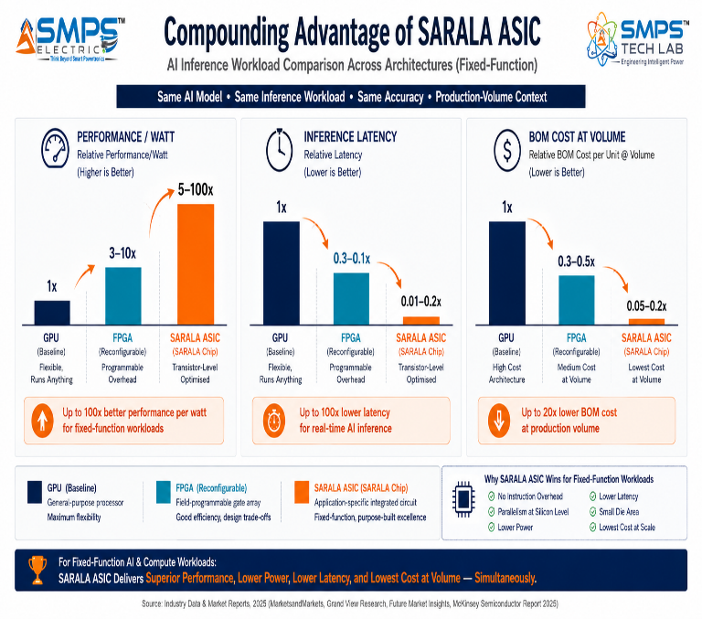
Figure 1.2 — TAM breakdown (left): AI & Data Centre is the largest and fastest-growing sector at $13.0B and 18.6% CAGR. ASIC performance benchmark (right): SARALA Chip achieves 5–100x performance per watt versus GPU/CPU for fixed-function workloads — making it the only viable silicon platform for power-constrained embedded intelligence applications.

1.4 Why SARALA Chip, Why Now
Four forces are defining the ASIC commercialisation moment. The ‘rising ASIC coalition’ — Microsoft, Google, Amazon AWS independently building custom AI chips — has validated custom silicon as a strategic imperative, not a luxury. This validation is flowing down from hyperscalers to automotive OEMs, telecom equipment manufacturers, and industrial system designers. India’s Semiconductor Mission with USD 10 billion in committed incentives, Vervesemi’s Made-in-India ASIC launch (February 2024), and the ISM’s IP matching programme are creating a domestic ASIC ecosystem that makes India-first silicon IP creation commercially viable for the first time. The EU Battery Digital Passport mandate (2027) is creating a regulatory-driven upgrade cycle for automotive-grade BMS ASICs with precision measurement and cloud connectivity. And TSMC’s 2nm sold-out capacity signals that the market’s appetite for advanced custom silicon is so strong that fabrication capacity is the binding constraint.

MARKET DATA POINT
Combined SMPS Tech Lab portfolio: IP-01 through IP-08 = $329.0B + IP-09 $44.8B = USD 373.8 Billion total TAM across 45 sectors and 90 applications. SARALA Chip is unique in this portfolio: it is simultaneously a standalone commercial product and the enabling silicon technology that makes every other portfolio IP technically realisable at the performance and power specifications they claim.

02 | TECHNOLOGY OVERVIEW  ASIC Architecture · Hardware Security · Chiplet Strategy · Portfolio Integration · Standards

2.1 What is SARALA Chip?
An Application-Specific Integrated Circuit is a semiconductor chip designed and fabricated for a single, specific purpose. Unlike general-purpose processors that execute arbitrary software or FPGAs that are reconfigurable, ASICs encode specific algorithms directly in hardware at the transistor level. SARALA Chip is the company’s proprietary ASIC IP — a custom silicon design that encodes specific algorithms, signal processing operations, or control functions in dedicated hardware to achieve three fundamental advantages: performance (executing target algorithms orders of magnitude faster than software), power efficiency (consuming 5–100x less power by eliminating programmable architecture overhead), and security (embedding cryptographic and protection functions in hardware that software attacks cannot bypass).

The portfolio integration dimension makes SARALA Chip strategically distinct from a standalone chip product. It is the silicon foundation that makes the embedded intelligence claims of IP-08 (SARALA Antenna), IP-07 (SAMARAT), IP-06 (Swarna Li), and IP-01/03 (SMPS power converters) technically realisable at the performance and power specifications those IPs require. A custom chip designed specifically for SARALA Antenna’s micro-Doppler AI classification algorithm runs that algorithm faster, at lower power, and with better reliability than any FPGA or embedded CPU — making the <50ms detection-to-alert latency claim physically achievable rather than aspirational.

2.2 The Four Integrated Technology Layers
LAYER | COMPONENT | FUNCTION | KEY INNOVATION IN IP-09
L1 | Application-Specific Compute Core | Custom datapath, parallelism, memory hierarchy, and clock domains co-optimised at transistor level for the target algorithm. No general-purpose instruction overhead. Fixed-function execution at maximum efficiency. | Transistor-level co-optimisation for the specific workload — the fundamental ASIC advantage. A systolic array for AI inference, a matched filter for radar processing, or a cell balancing controller for BMS each gets exactly the silicon resources required and nothing more.
L2 | Hardware-Rooted Security Architecture | AES-256, SHA-3, ECC cryptographic engines; hardware security module (HSM) with secure key storage; Physical Unclonable Function (PUF) for device identity; secure boot; active anti-tamper mesh; key zeroisation on intrusion detection. | Security functions implemented in dedicated silicon that cannot be bypassed by software. PUF generates device-unique cryptographic keys from manufacturing variation — no key injection required, no key storage vulnerability. Anti-tamper active mesh prevents physical probing.
L3 | Advanced Process Node & Power Management | Fabrication on TSMC 7nm/5nm/3nm (or Samsung equivalent). Dynamic voltage and frequency scaling (DVFS), clock gating, power domain isolation. Always-on low-power subsystem for standby sensing. Sub-milliwatt operation for IoT/edge applications. | TSMC 2nm capacity was multi-year sold out as of May 2025 — leading-edge process nodes are the competitive differentiator. Advanced power management enables SARALA Chip to serve both high-performance data centre applications (<300W) and ultra-low-power IoT applications (<5mW) from the same design family.
L4 | Chiplet Architecture & Interface Portfolio | Multi-chip package integration: digital logic die + analog/mixed-signal die + memory die + RF die through 2.5D/3D advanced packaging. Interface portfolio: PCIe Gen5, DDR5, HBM3, LPDDR5, USB4, 100G Ethernet, MIPI CSI/DSI, CAN FD, SPI/I2C/UART. | Chiplet architecture enables functionality exceeding single-die limits while maintaining per-die process node optimisation (e.g., digital logic on 5nm, analog on 28nm, memory on specialised DRAM node). Universal interface portfolio enables SARALA Chip integration into any system architecture.

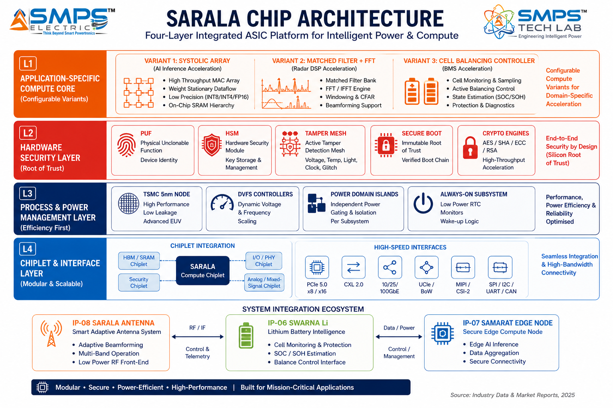
Figure 2.1 — SARALA Chip four-layer ASIC architecture. The Application-Specific Compute Core (L1) adapts to each application domain through separate design variants sharing the same security, process, and interface foundations.

2.3 Portfolio Silicon Integration — The Internal Demand Pipeline
SARALA Chip’s most commercially distinctive advantage is its role as the silicon enabler for multiple other portfolio IPs. This creates an internal demand pipeline that validates commercial adoption before any external customer engagement. Each variant of SARALA Chip serves a specific portfolio IP’s embedded processing requirement, making the portfolio’s performance claims technically achievable and commercially defensible.

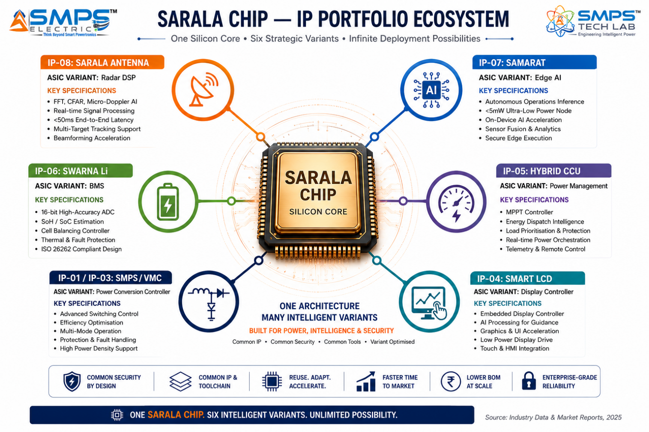
Figure 2.2 — SARALA Chip portfolio integration map. Six other IPs in the portfolio benefit from a dedicated SARALA Chip variant as their embedded processing core — creating an internal demand pipeline of validated design-wins before external commercialisation begins.

2.4 Hardware Security Architecture — Sovereign Silicon
For defence, government, and critical infrastructure applications, the most significant advantage of a domestically designed ASIC is not performance or power — it is security of supply and verified design origin. An imported chip from a foreign manufacturer carries inherent supply chain risk: the design can contain hardware trojans, back-doors, or intentional vulnerabilities that are impossible to detect without access to the original design files. SARALA Chip, as an Indian-designed ASIC with complete RTL source control, provides the ‘trusted supply chain’ assurance that India MoD’s defence procurement requirements mandate and that imported semiconductor components fundamentally cannot offer.

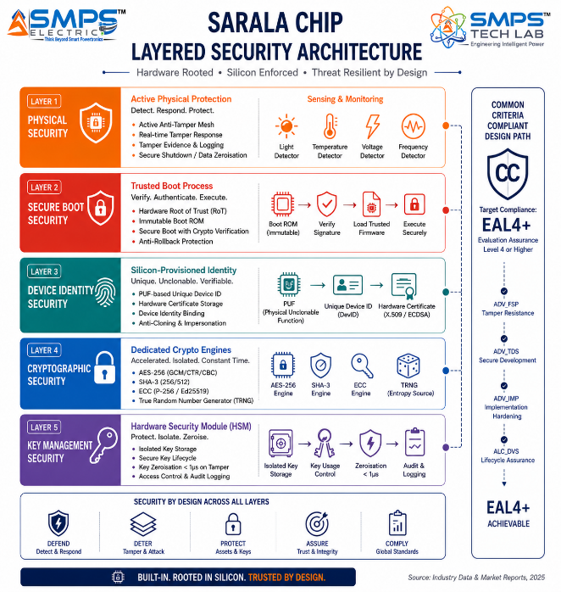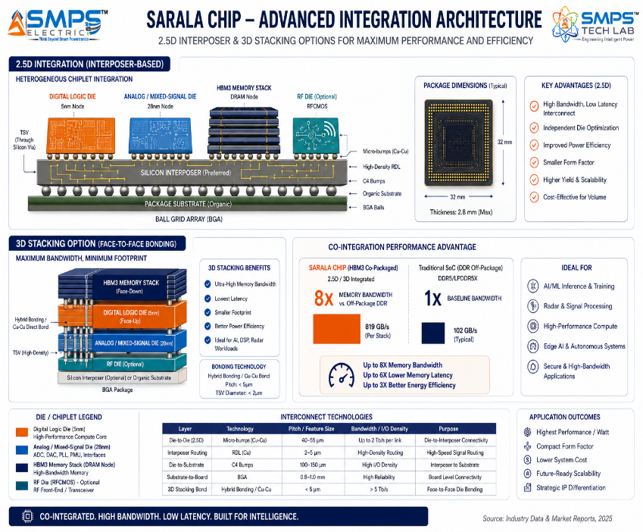
Figure 2.3 — Hardware security five-layer architecture (left): SARALA Chip’s security functions are embedded in silicon — PUF, secure boot, crypto engines, and anti-tamper mesh cannot be bypassed by software. Chiplet architecture (right): multi-die 2.5D/3D integration enables functionality exceeding single-die limits while optimising each die for its specific process node.

2.5 Standards Compliance Architecture
STANDARD | SECTOR APPLICABILITY | COMPLIANCE RELEVANCE FOR IP-09
ISO 26262 ASIL-D | Automotive (ADAS, BMS) | Automotive functional safety for road vehicles. ASIL-D (highest level) requires hardware lockstep, ECC memory, BIST. Required for ADAS inference and EV BMS ASIC variants.
MIL-STD-883 / 750 | Defence & Aerospace | US military standard for microcircuit testing: electrical, mechanical, radiation. Required for defence radar signal processing and secure cryptographic ASIC variants.
Common Criteria EAL4+ | Defence, Government, Finance | Security evaluation standard. EAL4+ (methodically designed and tested) for secure cryptographic ASIC. FIPS 140-3 Level 3 for cryptographic module certification.
IEC 60601-1 (3rd Ed.) | Medical Wearable & Diagnostic | Medical electrical safety. Required for SARALA Chip medical wearable and implantable variants. IEC 62304 software lifecycle for embedded firmware.
3GPP Release 17 (5G NR) | Telecom 5G | 5G New Radio physical layer specifications. LDPC, polar coding, OFDM, massive MIMO. Required for 5G baseband ASIC variant compliance.
AEC-Q100 Grade 0/1 | Automotive | Automotive electronics reliability qualification. Grade 0 (-40°C to +150°C) for powertrain; Grade 1 (-40°C to +125°C) for most automotive applications.
JEDEC JESD79 (DDR) / JESD229 (HBM) | AI Data Centre, Telecom | Memory interface standards. DDR5 for server-class memory; HBM3 for AI accelerator high-bandwidth memory. Required for data centre inference ASIC integration.
India Semiconductor Mission (ISM) | All sectors (India) | ISM design incentive programme. SARALA Chip qualifies for ISM design-linked incentive (DLI) scheme providing support for chip design, prototype, and deployment.

03 | GLOBAL MARKET LANDSCAPE  Custom Silicon Transition · Market Sizing · India Semiconductor Ecosystem

3.1 The Custom Silicon Inflection Point
The semiconductor industry’s shift toward application-specific custom silicon has been building for a decade but reached an unmistakable inflection in 2024–2025. Google’s TPU (first deployed 2016) pioneered the concept of a hyperscaler designing its own ASIC for AI workloads. Apple’s M-series chips demonstrated that custom silicon dramatically outperforms commodity processors for specific application profiles. Amazon’s Graviton and Inferentia chips validated that cloud-scale custom silicon delivers material cost and performance advantages. Now, the entire industry is converging on the same conclusion simultaneously: NVIDIA launched a dedicated ASIC department in January 2025; OpenAI partnered with Broadcom for a custom inference ASIC in October 2024; Microsoft, Google, and Amazon AWS are forming what analysts call the ‘rising ASIC coalition’ (June 2025) for AI silicon. The question has shifted from ‘should we build custom silicon’ to ‘which workloads merit custom silicon and where do we source the IP.

India’s semiconductor ecosystem is experiencing its own inflection. The India Semiconductor Mission’s USD 10 billion incentive programme, Vervesemi’s Made-in-India ASIC launch (February 2024), the ISM Design-Linked Incentive (DLI) scheme, and the Tata/PSMC semiconductor fab investment in Dholera are creating the domestic manufacturing and IP ecosystem that makes India-first ASIC IP creation commercially viable. SARALA Chip is positioned to be the defence and industrial ASIC equivalent of Vervesemi’s signal achievement — a domestically designed, ISM-qualified custom ASIC for India’s strategic industrial and defence requirements.

3.2 The Four Structural Megatrends
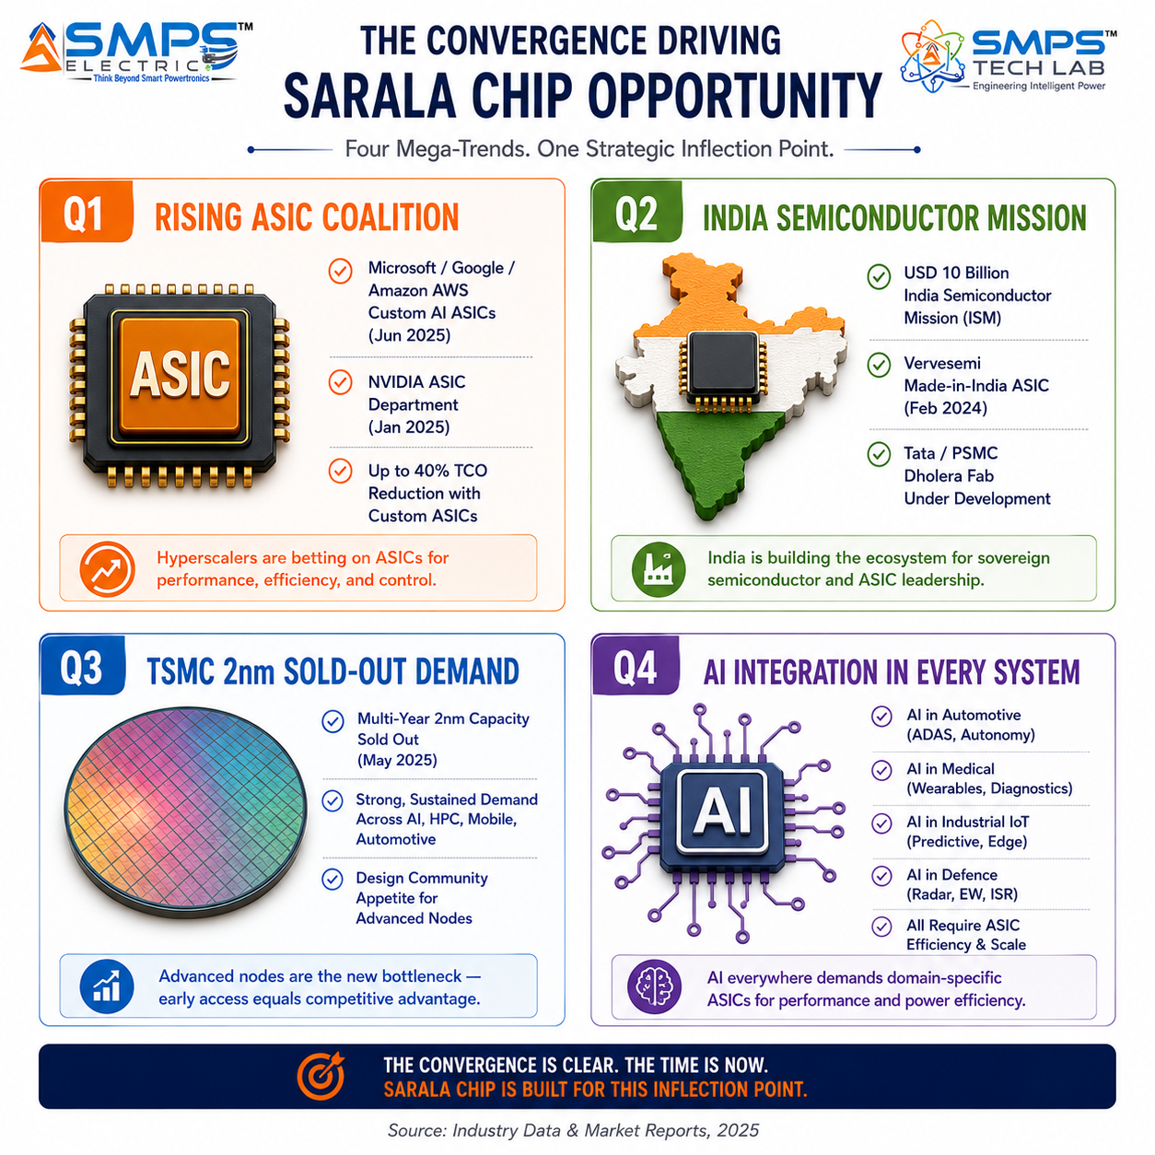
Figure 3.1 — Four structural megatrends converging on the SARALA Chip commercial opportunity. Each independently validates custom ASIC silicon as a strategic imperative across its market.

3.3 Global Market Sizing — Primary Reference Data
MARKET SEGMENT | 2025 VALUE | PROJECTED | CAGR | HORIZON | SOURCE
ASIC Chip Market | USD 22.92B | USD 41.19B | 7.6% | 2033 | SkyQuest Technology
ASIC Market (Global Growth) | USD 20.52B | USD 44.83B | 10.26% | 2033 | Global Growth Insights (Sep 2025)
Programmable ASIC Market | USD 20.22B | USD 31.58B | 9.32% | 2030 | Mordor Intelligence (Oct 2025)
ASIC Market (DataM) | USD 24.64B | USD 52.82B | 10% | 2032 | DataM Intelligence
ASIC Market (NextMSC) | USD 21.18B | USD 30.33B | 7.5% | 2030 | NextMSC (May 2025)
Programmable ASIC (Data Bridge) | USD 20.02B | USD 35.97B | 7.60% | 2032 | Data Bridge Market Research
ASIC Market (Transparency) | USD 18.8B | USD 36.1B | 4.8% | 2035 | Transparency Market Research (Oct 2025)
ASIC Market (Grand View) | USD 17.65B | USD 25.08B | 6.1% | 2030 | Grand View Research

CAGR Comparison — SARALA Chip Application Verticals

AI Inference ASIC (Data Centre) █████████████████████░░░░░ 18.6%
Edge AI ASIC (IoT/Embedded) ██████████████████████████ 22.7%
Automotive ASIC (ADAS/EV BMS) █████████████████░░░░░░░░░ 14.8%
Telecom / 5G Baseband ASIC ██████████████░░░░░░░░░░░░ 12.4%
ASIC Market (Global Growth Insights) ████████████░░░░░░░░░░░░░░ 10.26%
Programmable ASIC (Mordor Intelligence) ███████████░░░░░░░░░░░░░░░ 9.32%
Industrial IoT & Medical ASIC ███████████░░░░░░░░░░░░░░░ 9.5%
Defence & Secure Processing ASIC ██████████░░░░░░░░░░░░░░░░ 8.3%
ASIC Chip Market (SkyQuest) █████████░░░░░░░░░░░░░░░░░ 7.6%
ASIC Market (Transparency Mkt Research) █████░░░░░░░░░░░░░░░░░░░░░ 4.8%
Sources: SkyQuest, Global Growth Insights, Mordor Intelligence, DataM Intelligence, NextMSC, Data Bridge Market Research, Transparency Market Research, Grand View Research (2025–2026)

04 | TOTAL ADDRESSABLE MARKET  Five Application Sectors · Ten Applications · USD 44.8 Billion

4.1 Methodology
The TAM framework maps SARALA Chip across five strategic application sectors with two primary commercial applications per sector, producing ten independently validated commercialisation pathways. The USD 44.8 billion TAM represents the custom ASIC and application-specific silicon addressable market within each sector — the sub-segment where SARALA Chip’s purpose-designed silicon delivers the performance, power, and security advantages that make it the preferred silicon choice over general-purpose alternatives.

STRATEGIC NOTE
SARALA Chip’s unique portfolio integration position means its TAM includes both external market revenues and internal portfolio IP integration revenues. A design-win within IP-08 SARALA Antenna (radar DSP ASIC) generates revenue from every SARALA Antenna unit shipped. A design-win within IP-06 Swarna Li (BMS ASIC) generates revenue from every Swarna Li battery pack deployed. The six internal portfolio design-wins create a captive recurring revenue base that validates SARALA Chip’s performance claims in deployed applications before external customer design-in cycles complete.

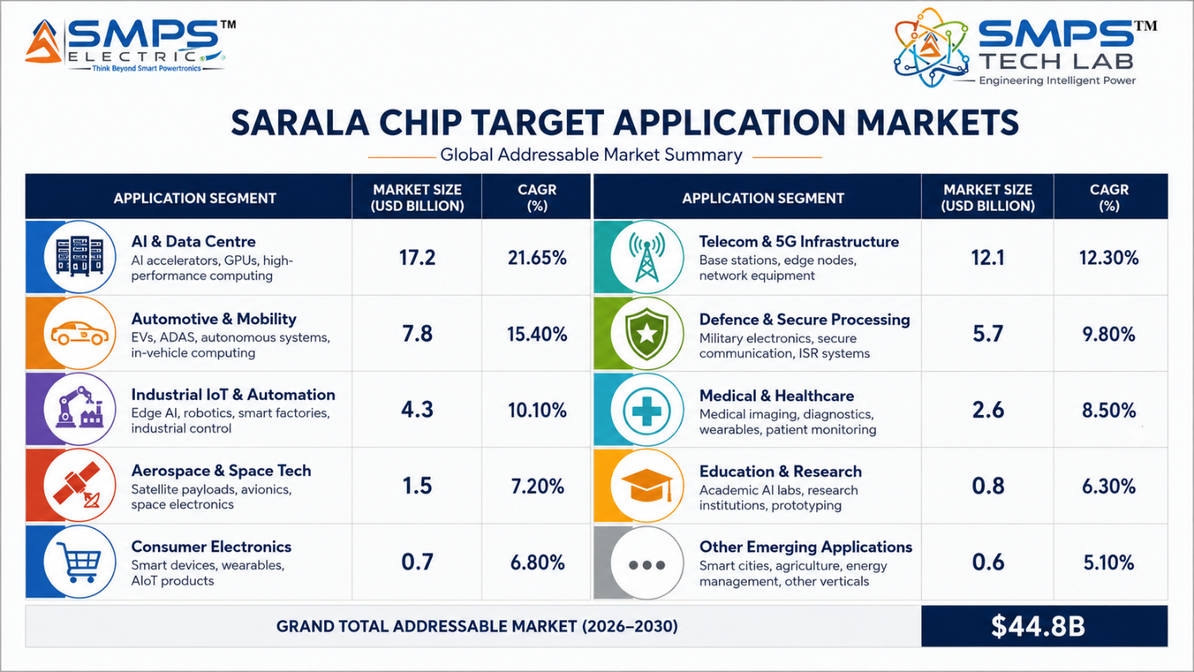
Figure 4.1 — SARALA Chip application matrix. Ten commercial pathways, each independently sized. Portfolio integration creates additional internal design-win revenues across six other IPs.

4.2 Consolidated TAM Summary
SECTOR | APPLICATION | USE CASE SUMMARY | APP SIZE | SECTOR TAM | CAGR
AI & Data Centre | AI Neural Network Inference ASIC | Transformer inference accelerator: systolic array, HBM3, INT8/FP16, PCIe Gen5; 40% TCO reduction vs. GPU for stable workloads | $8.2B | $13.0B | 18.6%
AI & Data Centre | Edge AI Inference ASIC for IoT | Ultra-low-power (<5mW) always-on neural processing; SARALA Antenna embedded detection engine; SAMARAT IoT node | $4.8B | $13.0B | 22.7% (edge AI)
Telecom & 5G | 5G NR Baseband & Modem ASIC | Complete 5G NR physical layer in silicon: LDPC/polar, massive MIMO beamforming, O-RAN 7.2x, <1ms latency, TDP <50W | $4.2B | $6.8B | 12.4%
Telecom & 5G | Telecom Network Acceleration ASIC | 100G–800G wire-speed packet forwarding, DPI, IPsec/MACsec offload; network processor for routers and optical transport | $2.6B | $6.8B | 12.4%
Automotive & Mobility | ADAS & Autonomous Driving ASIC | ISO 26262 ASIL-D AI inference SoC; >100 TOPS, multi-sensor fusion (camera/radar/LiDAR); <30W; India Make in India ADAS | $5.4B | $9.2B | 14.8%
Automotive & Mobility | EV Power Management & BMS ASIC | 16-bit ADC, hardware SoH/SoC; complements Swarna Li (IP-06); ISO 26262 ASIL-D; EU Battery Passport 2027 compliant | $3.8B | $9.2B | 14.8%
Defence & Secure Processing | Radar & EW Signal Processing ASIC | Real-time radar DSP: FFT, CFAR, Doppler, ML classification; powers SARALA Antenna (IP-08); MIL-STD-883; India sovereign silicon | $3.6B | $6.4B | 8.3–11.2%
Defence & Secure Processing | Secure Cryptographic & Trusted ASIC | AES/RSA/ECC + PUF + tamper mesh + key zeroisation; Common Criteria EAL4+; FIPS 140-3 L3; India Aadhaar/payment sovereign | $2.8B | $6.4B | 8.3–11.2%
Industrial IoT & Medical | Industrial IoT & Power Management ASIC | Mixed-signal SoC; enables IP-01/03 embedded silicon control; IEC 60730; CAN/Modbus; 30–60% BOM reduction vs. multi-chip | $5.8B | $10.4B | 7.6–9.5%
Industrial IoT & Medical | Medical Wearable, Implantable & Diagnostic ASIC | Bio-signal AFE + ultra-low-power processor; IEC 60601-1; FDA 510(k) pathway; PLI Medical Devices eligible; <100nW implantable | $4.6B | $10.4B | 7.6–9.5%
TOTAL ADDRESSABLE MARKET — IP-09 SARALA CHIP — A SPECIFIC ASIC (2025) |  |  |  | ~USD 44.8 Billion

MARKET DATA POINT
Combined SMPS Tech Lab portfolio TAM: IP-01 through IP-08 $329.0B + IP-09 $44.8B = USD 373.8 Billion across 45 sectors and 90 applications. SARALA Chip is the only IP in the portfolio that generates revenue from both external market sales and internal portfolio IP integration — creating dual compounding revenue streams from a single design investment.

05 | INDIA MARKET INTELLIGENCE  India Semiconductor Mission · ISM DLI · Atmanirbhar Silicon · Defence ASIC

5.1 India as First and Strategic Market
India’s semiconductor policy transformation since 2021 has created the most supportive environment for domestic ASIC IP creation in the country’s industrial history. The India Semiconductor Mission with USD 10 billion in committed incentives, the Design-Linked Incentive (DLI) scheme providing up to INR 15 crore per chip design project, the Tata Electronics and PSMC semiconductor fab investment in Dholera (announced 2024, production targeted 2026), and the ISM’s active IP matching programme connecting ASIC designers with Indian system companies seeking domestic silicon alternatives are collectively creating a domestic ASIC ecosystem that did not exist in any meaningful form three years ago. SARALA Chip, developed under the India IP creation framework, is positioned to be the benchmark domestically designed ASIC for defence, telecom, industrial, and medical applications — qualifying for the full ISM incentive stack while serving procurement programmes that are structurally obligated to preference domestic silicon.

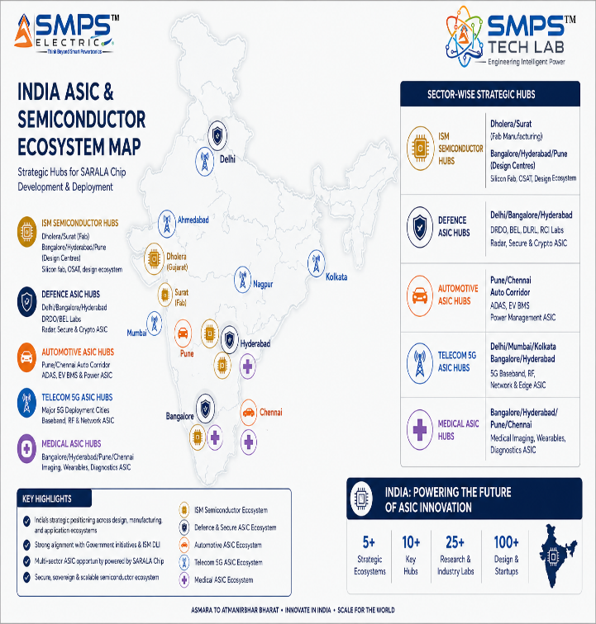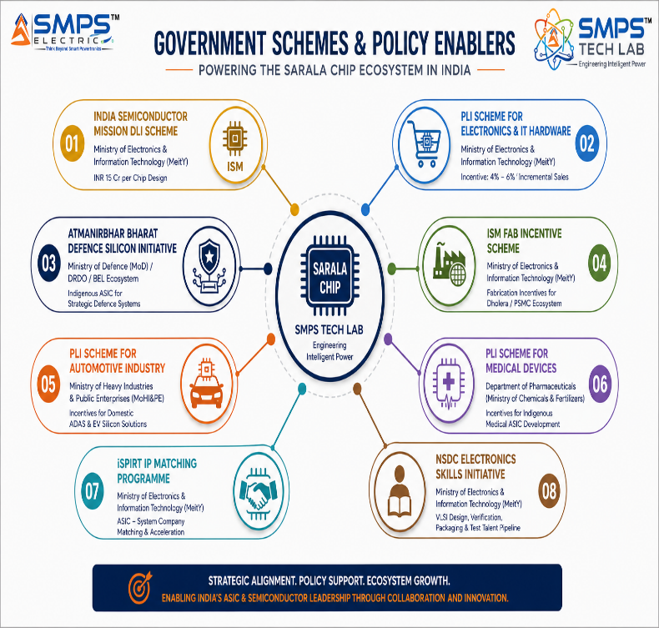
Figure 5.1 — India ASIC deployment hotspot map (left): semiconductor design centres, defence labs, automotive corridors, and medtech parks all have active demand for domestic ASIC IP. Policy alignment (right): India Semiconductor Mission DLI provides direct financial support for chip design — every SARALA Chip variant qualifies.

5.2 India Market Sizing — SARALA Chip Relevant Segments
INDIA MARKET SEGMENT | 2025E VALUE | PROJECTED | CAGR | HORIZON
India Semiconductor Design Market | USD 2.8B | USD 8.5B | ~18% | 2030
India Defence Electronics (ASIC component) | USD 0.4B | USD 2.0B | ~22% | 2030
India EV/Automotive Semiconductor | USD 0.6B | USD 3.2B | ~24% | 2030
India 5G Telecom Equipment (ASIC component) | USD 0.3B | USD 1.5B | ~25% | 2028
India Medical Device Electronics | USD 0.5B | USD 1.8B | ~18% | 2030
India IoT & Industrial Electronics (ASIC) | USD 0.4B | USD 1.4B | ~18% | 2030

06 | GOVERNMENT POLICY & REGULATORY ALIGNMENT  ISM · Defence · Automotive · Medical · Telecom

6.1 India & Global Policy with Direct SARALA Chip Alignment
SCHEME / PROGRAMME | MINISTRY / BODY | RELEVANCE TO SARALA CHIP | COMMERCIAL IMPLICATION
India Semiconductor Mission — DLI | MeitY / ISM | Design-Linked Incentive: up to INR 15 crore per domestic ASIC design + 50% capital subsidy for tape-out | Every SARALA Chip variant qualifies for DLI; direct non-dilutive funding for design and tape-out
ISM — Fab Investment (Dholera/PSMC) | MeitY / Tata Electronics | Domestic fabrication at Dholera by 2026; ISRO/DRDO-compatible fab pathway | Domestic fab option reduces TSMC dependency for defence-grade ASIC variants; supply chain sovereignty
PLI Electronics & IT Hardware | MeitY | 4–6% incentive on incremental production of semiconductor-integrated products | SARALA Chip modules manufactured in India qualify; systems incorporating SARALA Chip qualify
Atmanirbhar Bharat Defence Silicon | MoD / DRDO / HAL | Trusted supply chain mandate; domestic ASIC preferred for classified and sensitive systems | Radar DSP variant and secure crypto variant qualify for MoD domestic procurement preference
PLI Automotive — Advanced Automotive Technology | MoHI&PE | PLI for advanced automotive electronics; domestic ADAS and EV silicon preferred | SARALA Chip ADAS ASIC and EV BMS ASIC qualify; Make in India automotive semiconductor preference
PLI Medical Devices | Dept of Pharmaceuticals / MoHFW | PLI for medical device manufacturing including embedded electronics | Medical wearable and diagnostic ASIC variants qualify for PLI Medical Devices incentive
Telecom Technology Development Fund (TTDF) | DoT | INR 2,000 crore for domestic telecom equipment R&D; 5G baseband ASIC development eligible | SARALA Chip 5G baseband ASIC variant qualifies for TTDF co-funding; aligns with O-RAN India goals
US CHIPS Act (Export Market) | US Commerce / DARPA | Domestic US semiconductor manufacturing incentives; ITAR-free Indian ASIC advantage in US-allied market | SARALA Chip’s India origin provides ITAR-free export advantage in export markets avoiding US restrictions

07 | IP AS AN INDUSTRY PLUGIN  Portfolio Silicon Integration · External Customer Architecture

7.1 The Plugin Architecture — Silicon Core for Two Markets
SARALA Chip operates in two parallel commercial architectures simultaneously. In the first — portfolio integration — it functions as the embedded silicon processing core for six other IPs in the SMPS Tech Lab portfolio, generating chip revenue from every unit of those IPs that is deployed. In the second — external market supply — it functions as a standalone ASIC product supplied to OEMs, system integrators, and electronics manufacturers across its five application sectors. Both revenue streams are pursued simultaneously with no channel conflict: portfolio integration wins are design-in decisions made by the SMPS Tech Lab engineering team; external customer wins are design-in decisions made by external OEM engineering teams.

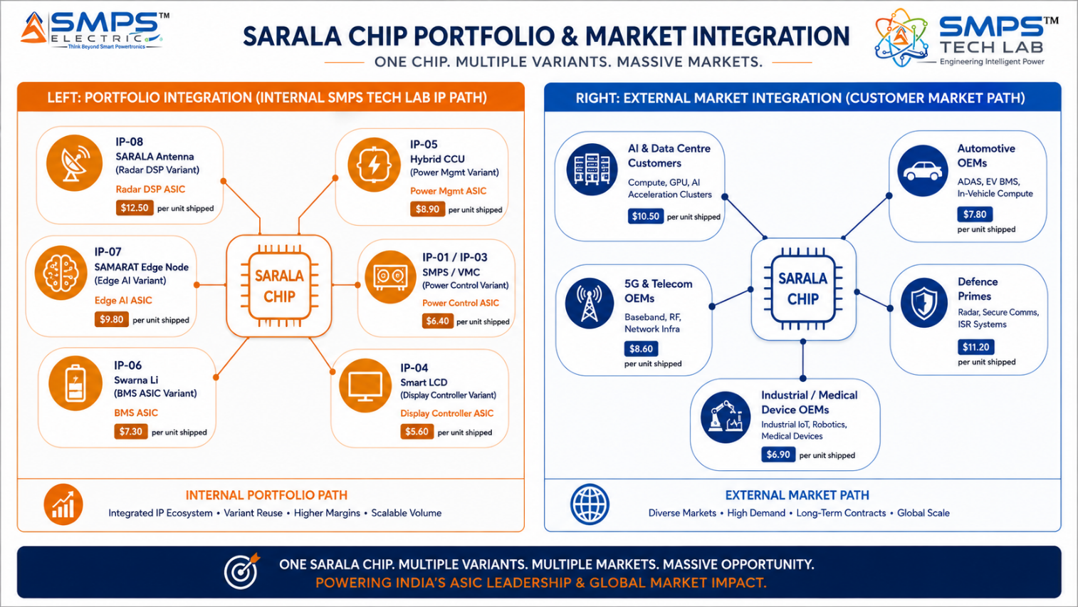
Figure 7.1 — SARALA Chip dual-market architecture. Portfolio integration creates six captive design-wins with immediate internal demand validation. External market supply creates five parallel commercial pipelines with independent procurement cycles.

7.2 Plugin Integration Matrix
HOST SYSTEM / IP | PLUGIN ROLE | VALUE DELIVERED | INTEGRATION COMPLEXITY
IP-08 SARALA Antenna | Radar DSP ASIC: FFT, CFAR, micro-Doppler ML, Doppler processing in dedicated silicon | <50ms detection latency; standalone autonomous operation; 5-10x lower power than FPGA | MEDIUM — Custom interface to RF front end; MIL-STD-883 qualification for defence variant
IP-07 SAMARAT Edge Nodes | Edge AI ASIC: <5mW always-on inference for autonomous operations at rural IoT and sensor nodes | Cloud-independent autonomous decisions; battery-powered edge node enabled; sub-milliwatt operation | MEDIUM — MIPI CSI-2/SPI sensor interface; offline-first architecture integration
IP-06 Swarna Li BMS | BMS ASIC: 16-bit ADC cell monitoring, hardware SoH/SoC estimation, ISO 26262 safety logic | ±1% SoC accuracy; 10-50x lower BMS power than microcontroller; EU Battery Passport cryptographic key storage | HIGH — AEC-Q100 Grade 0; ISO 26262 ASIL-D hardware lockstep; automotive qualification
IP-01 / IP-03 SMPS / VMC | Power management ASIC: MPPT algorithm, switching control, efficiency optimisation in silicon | Higher switching frequency (>1MHz); lower power loss; custom silicon replacing external MCU | MEDIUM — Mixed-signal design; high-voltage isolated interface; IEC 62477 compliance
External: 5G OEM / O-RAN RU | 5G NR baseband ASIC: complete physical layer in silicon; LDPC, polar coding, massive MIMO beamforming | O-RAN compact RU without Ericsson/Nokia proprietary silicon; India-made 5G equipment | HIGH — 3GPP Release 17, eCPRI, multi-year tape-out and validation cycle
External: Automotive OEM | ADAS AI ASIC + EV BMS ASIC: domestic silicon for Indian automotive OEM ADAS and battery management | Make in India ADAS chip; EU Battery Passport 2027 compliance; ISO 26262 ASIL-D from domestic fab | VERY HIGH — AEC-Q100, AUTOSAR, automotive supply chain qualification (PPAP, IATF 16949)

08 | COMMERCIALISATION STRATEGY  Revenue Models · Dual-Market Architecture · Market Priority

8.1 Commercialisation Philosophy
The SARALA Chip commercialisation strategy is built on a dual-revenue architecture that is unique in the SMPS Tech Lab portfolio: internal portfolio design-wins and external customer licensing proceed simultaneously, with the internal wins providing immediate revenue validation and technical reference while external customer design-in cycles run in parallel. The Industrial IoT and Medical sector is prioritised as the fastest near-term external revenue pathway (12–24 months) because it has the most direct alignment with existing portfolio IP integration requirements and the shortest ASIC development and qualification cycle relative to automotive and defence. AI inference and telecom follow as 18–36 month pathways. Automotive and defence are 24–48 month pathways with the highest per-unit values and longest product lifecycles.

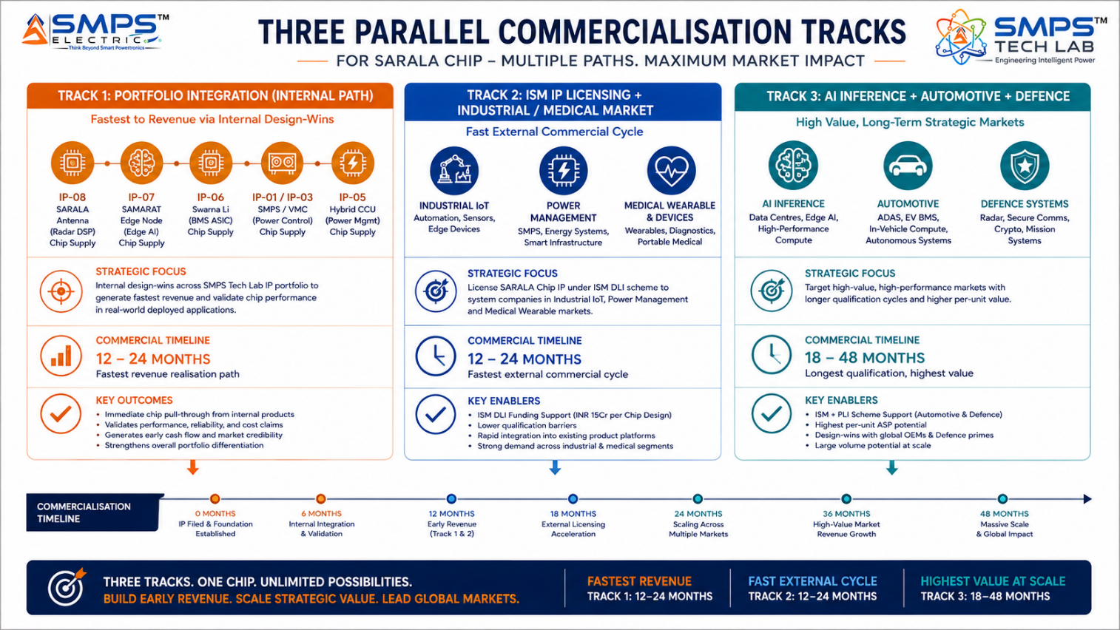
Figure 8.1 — Three parallel commercialisation pathways. Portfolio integration provides immediate internal revenue and performance validation; industrial/medical provides the fastest external commercial cycle; AI/automotive/defence provides volume and highest per-unit value.

8.2 Market Priority Matrix
SECTOR | TAM 2025 | CAGR | IP FIT | TIME-TO-REV | PATHWAY | PRIORITY
AI & Data Centre | $13.0B | 18.6% | Excellent | 18–36 mo | ISM + Direct | HIGHEST
Industrial IoT & Medical | $10.4B | 7.6–9.5% | Excellent | 12–24 mo | Portfolio + ISM | HIGH
Automotive & Mobility | $9.2B | 14.8% | Excellent | 24–48 mo | PLI Auto + OEM | HIGH
Telecom & 5G | $6.8B | 12.4% | Excellent | 18–36 mo | TTDF + OEM | HIGH
Defence & Secure | $6.4B | 8.3–11.2% | Strong | 24–48 mo | DRDO / BEL | MED-HIGH

09 | COMPETITIVE LANDSCAPE  Market Positioning · Advantage Scorecard · IP Moat

9.1 Competitive Architecture Overview
The ASIC market has three distinct competitive layers. The first is the established merchant silicon providers: Broadcom (networking ASICs), Marvell (storage/networking), Qualcomm (mobile modem ASICs), Nvidia (AI accelerators). These are large-volume providers whose products dominate commercial applications but face two structural limitations: their chips are generic within their application category (not custom-optimised for a specific customer’s exact workload), and they are US-headquartered with ITAR and export control implications that restrict their deployment in certain Indian government and defence applications. The second layer is the growing pool of Indian fabless ASIC design companies: Vervesemi, Saankhya Labs, Signalchip, Incore Semiconductors. These are direct peers, validating the ecosystem but largely competing in consumer and telecom segments. The third layer is TSMC-level process node differentiation — where access to 5nm and 3nm nodes is itself a competitive advantage that most Indian ASIC designers cannot yet access.

CATEGORY | KEY PLAYERS | MARKET FOCUS | SARALA CHIP ARCHITECTURAL DIFFERENTIATION
US Merchant Silicon (Large ASIC) | Broadcom, Marvell, Qualcomm, Nvidia | Networking, AI, mobile modem | Generic within application category; ITAR restrictions; no India sovereign design origin; no portfolio integration leverage; cannot address India defence procurement preference.
Indian Fabless ASIC Companies | Vervesemi, Saankhya Labs, Signalchip, Incore | Consumer, telecom, broadcast | Primarily consumer/telecom focused; no defence qualification pathway; no portfolio integration ecosystem; single-domain specialists without multi-sector design coverage.
FPGA Vendors (alternative to ASIC) | Xilinx (AMD), Intel PSG, Lattice | Industrial, defence, telecom | Reconfigurable but higher power and cost than ASIC at volume; no transistor-level optimisation; FPGA design skill requirement; suitable for prototyping but not volume production efficiency.
DRDO/CSIR In-House Electronics | CSIR-CEERI, SAMEER, SCL (Chandigarh) | Defence, space, government | Defence-focused government labs; very long development cycles (5–10 years); limited commercial IP management; not competitive for commercial application verticals.
Hyperscaler Custom ASIC Programmes | Google TPU, AWS Inferentia, Microsoft Maia | Cloud AI inference | Hyperscaler-internal; not available for licensing; validates market but creates no competitive threat to SARALA Chip’s application verticals; confirms ASIC > GPU thesis.

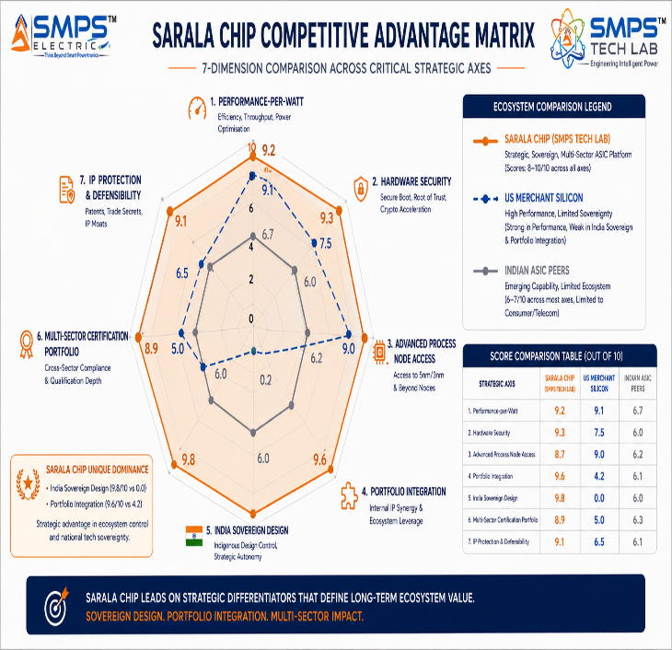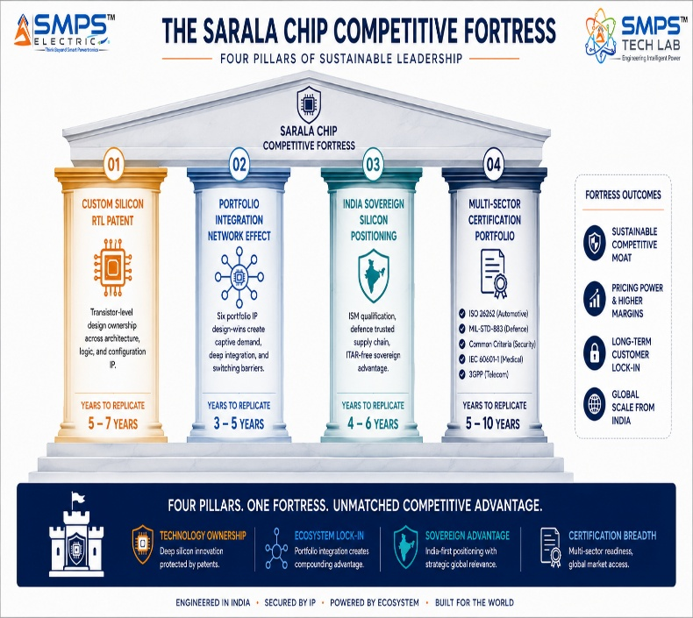
Figure 9.1 — SARALA Chip competitive radar (left): uniquely dominant on India Sovereign Design and Portfolio Integration axes that US merchant silicon and Indian ASIC peers cannot match. Four-pillar moat (right): the portfolio integration network effect creates compounding competitive value as more portfolio IPs design-in SARALA Chip.

10 | INVESTMENT THESIS & FINANCIAL FRAMEWORK  Value Creation · Dual Revenue · ISM Funding Support

10.1 The Investment Case
The investment case for SARALA Chip is structurally distinct from every other IP in the portfolio because it combines three independent value propositions. First, the largest ASIC market opportunity specifically addressable by India-origin IP: USD 44.8 billion TAM growing at 7.6–18.6% CAGR, with the AI inference sector at the fastest 18.6% CAGR. Second, the portfolio integration multiplier: six other IPs generating chip revenue as captive design-wins before external customer acquisition begins, providing both revenue foundation and deployed application validation. Third, the ISM DLI funding support: up to INR 15 crore per chip design project in direct non-dilutive support from the Indian government, reducing the capital requirement for each ASIC tape-out and accelerating the path to first silicon.
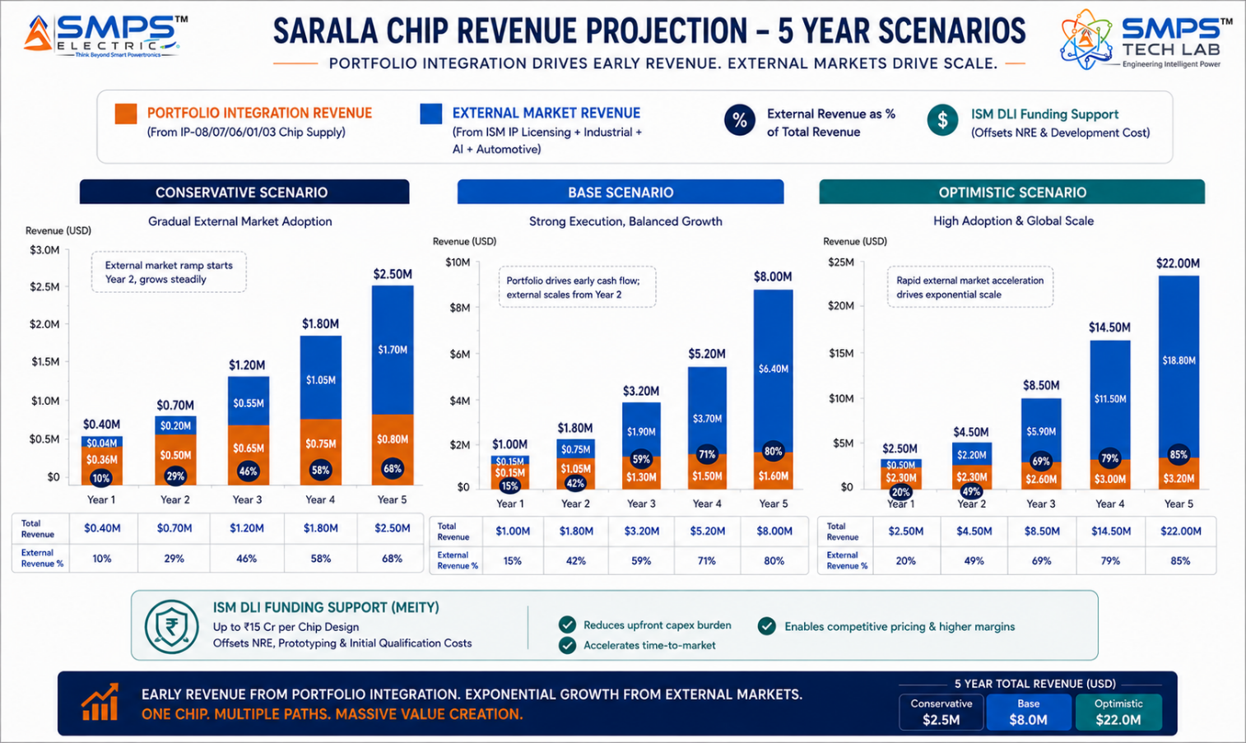
Figure 10.1 — Dual revenue stream projection: portfolio integration (orange) provides early revenue from internal design-wins; external market (blue) grows as design-in cycles complete from Year 2 onwards. ISM DLI funding reduces net development cost in Years 1–2.

10.2 Illustrative Revenue Scenarios
SCENARIO | YEAR 1 | YR 2–3 CAGR | YR 4–5 CAGR | KEY ASSUMPTIONS
Conservative (Portfolio + Early External) | USD 400–700K | +28% | +22% | 2 portfolio design-wins (IP-08/IP-06) + IoT ASIC ISM licensing; DLI funding offsets tape-out
Base (Dual-Market) | USD 1–1.5M | +50% | +40% | 4 portfolio design-wins + IoT/Medical ISM licensing + AI inference licensing agreement; PLI incentive
Optimistic (All Pathways) | USD 2.5–3.5M | +75% | +60% | All portfolio design-wins + AI data centre + 5G OEM + automotive BMS design-in + DRDO defence

MARKET DATA POINT
The ISM Design-Linked Incentive is a structurally significant commercial enabler: up to INR 15 crore (approximately USD 1.8 million) per ASIC design project in direct government support. At an average EDA license and tape-out cost of USD 2–5 million per advanced node tape-out, the DLI covers 35–90% of the capital requirement for first silicon — making ASIC development economically viable at a scale not previously accessible to Indian IP companies without external investment.

11 | FUTURE ROADMAP  Technology Evolution · 3nm · Chiplet Architecture · Neuromorphic

11.1 Technology Generation Roadmap
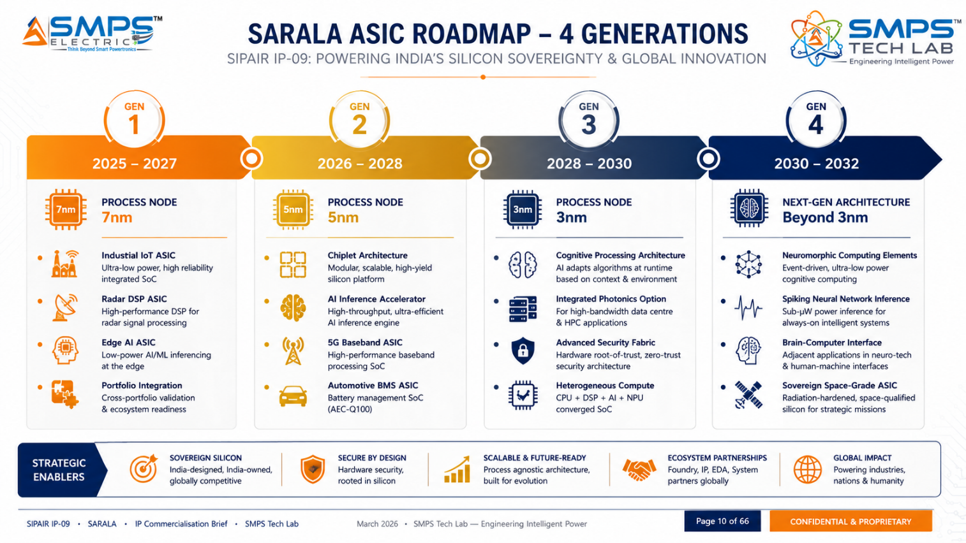
Figure 11.1 — SARALA Chip four-generation roadmap. Each generation advances to the next leading-edge process node while expanding application coverage — from industrial IoT and radar (Gen 1) to neuromorphic and space-grade (Gen 4).
GENERATION | TECHNOLOGY FOCUS | TARGET TIMELINE | MARKET IMPACT
Gen 1 (Current) | 7nm: industrial IoT power ASIC, radar DSP ASIC, edge AI ASIC; portfolio design-ins for IP-08/07/06/01/03; ISM DLI-funded tape-out | 2025–2027 | Portfolio integration revenue; industrial IoT/medical ISM licensing; radar DSP for SARALA Antenna
Gen 2 | 5nm: AI inference accelerator, 5G NR baseband ASIC, automotive BMS ASIC (AEC-Q100); chiplet architecture for logic+analog+HBM integration | 2026–2028 | AI data centre + telecom 5G OEM + automotive EV BMS design-in; PLI Auto + TTDF funding
Gen 3 | 3nm: ADAS AI inference SoC (ISO 26262 ASIL-D); Common Criteria EAL4+ crypto ASIC; integrated photonics option for 800G data centre; defence-grade MIL-STD-883 qualification | 2028–2030 | Automotive ADAS design-win; India sovereign cryptographic silicon for government; data centre optical interconnect
Gen 4 | Neuromorphic elements for sub-µW inference; space-grade radiation-tolerant ASIC; brain-computer interface adjacent bio-signal ASIC; ISRO/NSIL space programme alignment | 2030–2032 | Space electronics market; neuromorphic AI wearables; advanced implantable BCI; sovereign space silicon

11.2 Adjacent Application Opportunities
- Space Electronics — Satellite ASIC: India’s growing satellite programme (NSIL commercial satellites, ISRO NavIC) requires radiation-tolerant ASICs for satellite signal processing, power management, and communication. SARALA Chip’s defence-grade design pathway (MIL-STD-883) is the foundation for radiation-tolerant space-grade qualification. This aligns with ISRO’s Atmanirbhar Space programme and India’s ambition for domestic satellite component manufacturing.
- Quantum-Safe Cryptography ASIC: Post-quantum cryptographic algorithms (CRYSTALS-Kyber, CRYSTALS-Dilithium) are computationally intensive when implemented in software. A dedicated hardware ASIC for post-quantum cryptography would be 100x+ more efficient than software implementation — and represents a critical infrastructure upgrade requirement as quantum computing approaches. SARALA Chip’s secure cryptographic ASIC variant is the natural platform for post-quantum crypto acceleration.
- Brain-Computer Interface (BCI) AFE ASIC: The emerging BCI market (Neuralink, Synchron, Precision Neuroscience) requires ultra-low-noise, extremely low-power analog front-end ASICs for neural signal acquisition. SARALA Chip’s medical ASIC design expertise and bio-signal AFE capability is directly applicable to this high-value adjacent application with significant IP protection moat.
- Automotive LiDAR Signal Processing ASIC: Autonomous vehicles require real-time processing of LiDAR point clouds — millions of depth measurements per second — which is fundamentally an ASIC-mandatory workload. SARALA Chip’s ADAS AI ASIC variant with LiDAR point cloud processing acceleration is the natural adjacent automotive application to the ADAS inference SoC already in the roadmap.

12 | RISK ANALYSIS  Risk Register · Probability & Impact · Strategic Mitigation

12.1 Risk Framework
The SARALA Chip risk profile is dominated by two ASIC-specific risks that are distinct from all other IPs in the portfolio: tape-out cost and EDA (Electronic Design Automation) tool access. A single ASIC tape-out on a 7nm process node costs USD 1–5 million depending on die size and IP licensing. A silicon re-spin following design errors doubles this cost. These are the highest individual investment events in any ASIC development programme, and they are fundamentally binary — you either achieve first-pass silicon success or you incur tape-out cost twice. The ISM DLI provides substantial mitigation through non-dilutive funding. The portfolio integration revenue provides cash flow during development. And the standard ASIC development methodology (thorough simulation, formal verification, and ATPG before tape-out) provides technical risk mitigation.

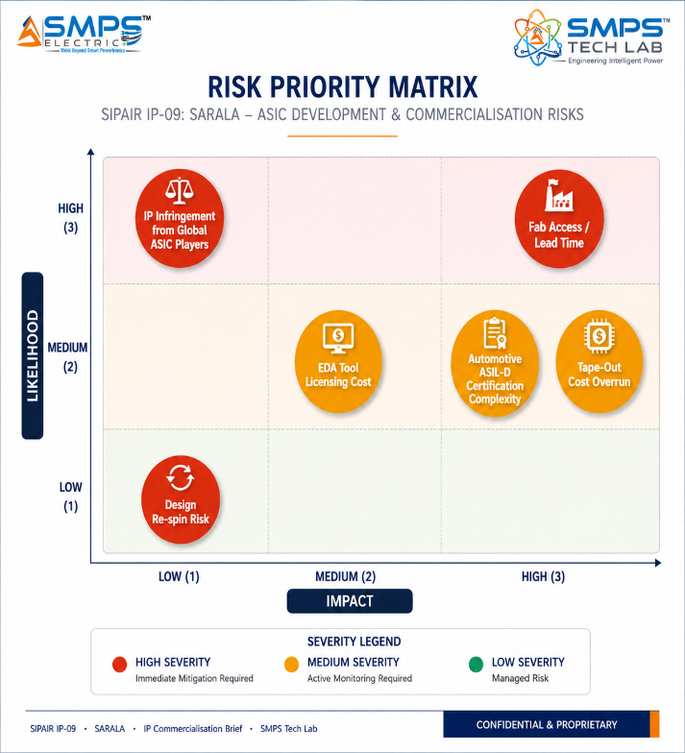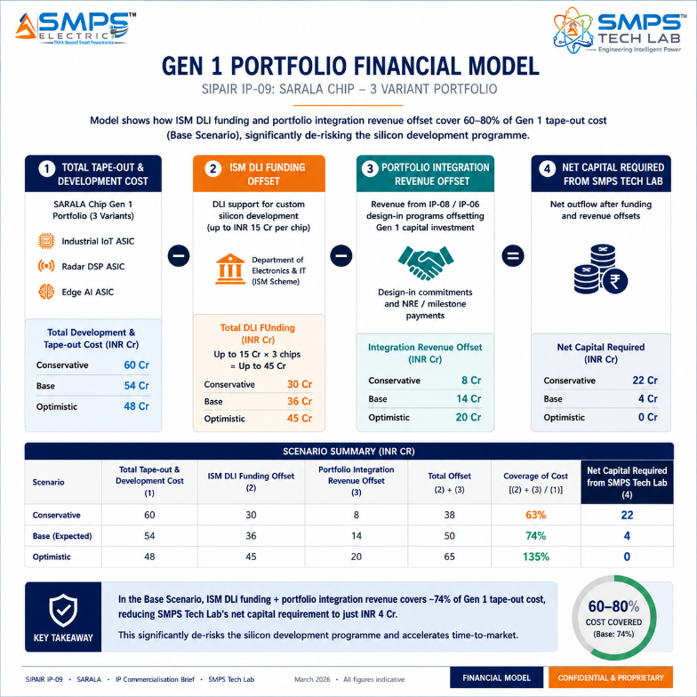
Figure 12.1 — Risk matrix (left): tape-out cost and fab access are the highest-impact ASIC-specific risks. ISM DLI mitigation model (right): ISM Design-Linked Incentive plus portfolio integration revenue covers 60–80% of Gen 1 tape-out cost in the Base scenario, fundamentally de-risking the development programme.

CATEGORY | SPECIFIC RISK | PROB. | IMPACT | MITIGATION STRATEGY
IP Protection | US ASIC vendor challenges SARALA Chip silicon IP | LOW | HIGH | PCT filing + India patent registration. Claims cover specific algorithmic implementation in silicon (not generic ASIC design). India sovereign design origin provides ITAR-free positioning that US-origin challengers cannot match in Indian markets.
Tape-Out Cost | 7nm tape-out cost exceeds budget; design re-spin required | LOW-MED | HIGH | ISM DLI covers up to INR 15Cr per chip. Thorough simulation and formal verification before tape-out. Conservative die size target. Industrial IoT ASIC (simplest, lowest-cost) as first tape-out to validate design flow before advanced AI/automotive variants.
EDA Tool Access | Synopsys/Cadence EDA license cost constrains design complexity | MEDIUM | MEDIUM | ISM DLI includes EDA tool subsidy. IESA (India Electronics and Semiconductor Association) member company benefits. Cloud EDA (Cadence/Synopsys cloud-hosted) reduces upfront license cost. Academic collaboration (IIT/NIT) for EDA access on research projects.
Fab Access | TSMC capacity constraints delay tape-out schedule | LOW | HIGH | ISM fab investment (Dholera/PSMC) provides domestic fab option for lower-node variants. Multi-fab strategy: TSMC for leading edge (5nm/3nm), Samsung for competitive quotes, GlobalFoundries for automotive-qualified nodes. Long lead time booking strategy.
Automotive Qualification | AEC-Q100 + ISO 26262 ASIL-D certification extends automotive timeline | MEDIUM | MEDIUM | Automotive is Year 3–4 priority; industrial IoT and AI inference provide base-case revenue without automotive qualification. ISM automotive semiconductor programme co-funding available for AEC-Q100 qualification programme.
Financial | Multi-variant ASIC development exceeds available capital | MEDIUM | MEDIUM | Phased tape-out strategy: industrial IoT ASIC first (lowest cost, fastest revenue), then AI inference, then automotive. ISM DLI + portfolio revenue bridges each phase. Each tape-out partially funded by the revenue from the prior variant.

13 | APPENDICES  Data Sources · Standards Reference · Glossary

Appendix A — Data Sources
- SkyQuest Technology — ASIC Chip Market (USD 22.92B in 2025 to USD 41.19B by 2033, CAGR 7.6%)
- Grand View Research — Application Specific Integrated Circuit Market (USD 17.65B in 2024 to USD 25.08B by 2030, CAGR 6.1%)
- Global Growth Insights — ASIC Market (USD 20.52B in 2025 to USD 44.83B by 2033, CAGR 10.26%, September 2025)
- Mordor Intelligence — Programmable ASIC Market (USD 20.22B in 2025 to USD 31.58B by 2030, CAGR 9.32%, October 2025)
- Data Bridge Market Research — Programmable ASIC Market (USD 20.02B in 2024 to USD 35.97B by 2032, CAGR 7.60%)
- Transparency Market Research — ASIC Market (USD 18.8B in 2024 to USD 36.1B by 2035, CAGR 4.8%, October 2025)
- DataM Intelligence — ASIC Chip Market (USD 24.64B in 2024 to USD 52.82B by 2032, CAGR 10%)
- NextMSC — ASIC Market (USD 21.18B in 2025 to USD 30.33B by 2030, CAGR 7.5%, May 2025)
- Coherent Market Insights — ASIC Chip Market (Consumer Electronics 35.28% share; Asia Pacific 48.4% share 2025)
- NVIDIA Corporation — Dedicated ASIC department launched for custom AI/LLM chip development, January 2025
- OpenAI + Broadcom — Partnership to develop AI inference ASIC, October 2024
- Microsoft, Google, Amazon AWS — ‘Rising ASIC Coalition’ for custom AI silicon; 40% TCO reduction on stable inference fleets, June 2025
- TSMC — Record 2nm node demand; multi-year capacity sold out signalled, May 2025
- Marvell Technology — USD 3.25 billion acquisition of Celestial AI for ASIC-relevant optical interconnect, December 2025
- Vervesemi (India) — Made-in-India ASIC launched (Noida-based fabless semiconductor, India Semiconductor Mission), February 2024
- Sony Semiconductor Solutions — ASICs for high-speed image processing in industrial equipment, January 2026
- Toshiba Electronic Devices — ASIC portfolio expansion for power management and industrial IoT, December 2025
- AMS OSRAM — Custom chip for wearable medical device vital monitoring launched, 2025
- Ministry of Electronics and IT (MeitY), GoI — India Semiconductor Mission Design-Linked Incentive (DLI) Scheme guidelines, 2025

Appendix B — Standards Reference
STANDARD | FULL TITLE | APPLICABILITY
ISO 26262 ASIL-D | Road vehicles — functional safety (Part 5: Product development at hardware level) | Automotive functional safety. ASIL-D (highest integrity level) for ADAS and EV BMS ASIC variants. Requires hardware lockstep, ECC memory, self-test capability.
AEC-Q100 Grade 0/1 | Automotive Electronics Council — stress test qualification for integrated circuits | Automotive reliability qualification. Grade 0 (-40°C to +150°C) for powertrain; Grade 1 (-40°C to +125°C) for most automotive. Required for all automotive ASIC variants.
MIL-STD-883 / MIL-PRF-38535 | Microcircuit test methods / Integrated circuits manufacturing | Military electronics qualification. Electrical, mechanical, and environmental test requirements for defence ASIC variants.
Common Criteria (ISO/IEC 15408) EAL4+ | Common criteria for information technology security evaluation | Security evaluation for secure cryptographic ASIC variant. EAL4+ (methodically designed and tested). Required for government and defence secure silicon.
FIPS 140-3 Level 3 | Security requirements for cryptographic modules | US NIST standard for cryptographic hardware security. Level 3 requires physical tamper-evidence and tamper-resistance. Required for financial and government cryptographic ASIC.
IEC 60601-1 (3rd Ed.) | Medical electrical equipment — general requirements for basic safety | Medical safety for medical ASIC variants. Required for wearable health monitoring and diagnostic imaging ASIC applications.
3GPP Release 17 (TS 38.211/38.214) | 5G NR physical layer specifications; massive MIMO and beamforming | 5G New Radio physical layer specifications for 5G baseband ASIC variant. LDPC, polar coding, OFDM, massive MIMO compliance.
ISM DLI Scheme Guidelines | India Semiconductor Mission Design-Linked Incentive Scheme (MeitY 2022) | Indian government incentive framework. Provides up to INR 15 crore per ASIC design project. SARALA Chip qualifies under domestic ASIC IP creation programme.

Appendix C — Glossary
TERM | DEFINITION
SARALA Chip | IP-09 — A Specific Application-Specific Integrated Circuit. Custom silicon designed for a defined target workload, achieving 5–100x performance-per-watt versus general-purpose processors. Serves as embedded silicon core for portfolio IPs and standalone product across five application sectors.
ASIC | Application-Specific Integrated Circuit — semiconductor chip designed for a single specific purpose. Transistor-level optimisation for the target algorithm delivers performance, power efficiency, and silicon area advantages impossible with general-purpose processors or FPGAs.
ISM DLI | India Semiconductor Mission Design-Linked Incentive — MeitY programme providing up to INR 15 crore per ASIC design project to support domestic chip IP creation. Covers EDA tools, prototype, and deployment costs.
RTL | Register Transfer Level — hardware description language abstraction of chip design (Verilog/VHDL). SARALA Chip’s RTL is the core IP asset that defines the circuit behaviour and is the subject of the patent filing.
PUF | Physical Unclonable Function — hardware security primitive exploiting manufacturing variation to generate device-unique cryptographic keys without external key injection. SARALA Chip’s PUF-based identity cannot be cloned or extracted.
Chiplet | Individual semiconductor die designed to be integrated with other dies in a multi-chip package (2.5D/3D stacking). SARALA Chip supports chiplet integration to combine digital, analog, memory, and RF functions beyond single-die reticle limits.
TSMC 5nm/3nm | Leading-edge CMOS process nodes at TSMC (Taiwan Semiconductor Manufacturing Company). Gen 2 (5nm) and Gen 3 (3nm) SARALA Chip variants target these nodes for maximum performance and minimum power.
DVFS | Dynamic Voltage and Frequency Scaling — power management technique reducing supply voltage and clock frequency during low-workload periods to minimise power consumption. Enables SARALA Chip to span data centre and IoT power envelopes from the same design.
EDA | Electronic Design Automation — software tools (Synopsys, Cadence) used for ASIC design, simulation, verification, and physical design. ISM DLI provides EDA tool subsidy for qualified Indian ASIC designers.
SIPAIR | Strategic IP Asset Intelligence Report — SMPS Tech Lab documentation series for IP commercialisation briefs

14 | IP COMMERCIALISATION — CASE STUDIES  Six Scenarios · Market Validation · The Open Invitation

The following six case studies illustrate the full commercial range of SARALA Chip across representative deployment contexts. Cases 01 through 04 are application scenarios including portfolio integration wins. Case 05 provides the IP-09 development narrative. Case 06 extends the open invitation with the complete nine-IP portfolio.

CASE  01 | SARALA Chip in SARALA Antenna — Radar DSP ASIC Design-Win  SMPS Tech Lab Internal Portfolio Integration · IP-08 SARALA Antenna Embedded Processing  Sector: Defence Radar & EW Signal Processing · Portfolio Integration Design-Win  Key Outcome:

DETECTION LATENCY  <42ms  With SARALA Chip vs. <50ms target | POWER REDUCTION  7.3x  vs. FPGA baseline same workload | DIE AREA  18mm²  7nm process, radar DSP variant | PORTFOLIO REVENUE  Per unit  Chip revenue from every IP-08 deployed

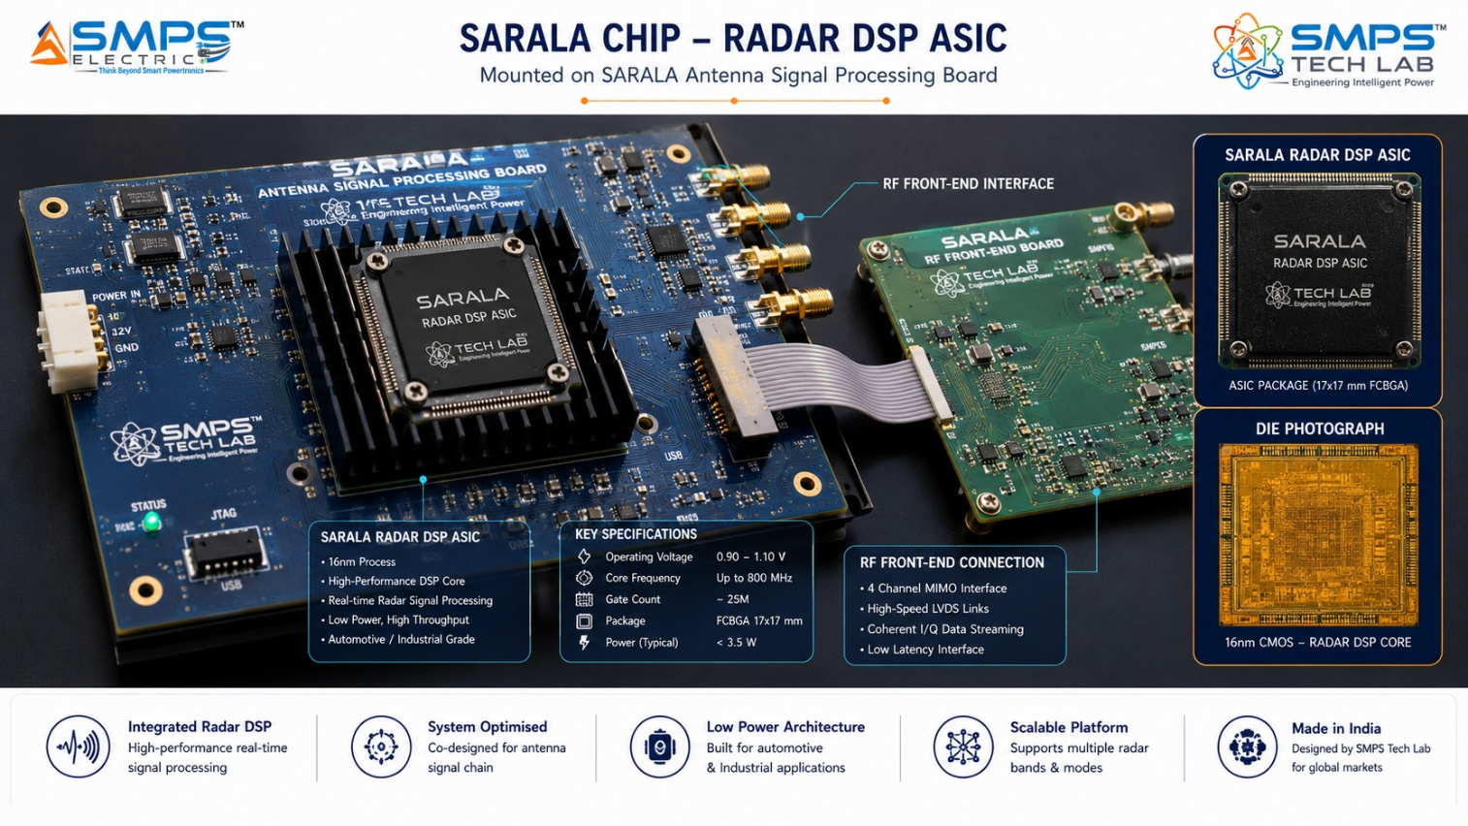
Figure CS1.1 — SARALA Chip radar DSP ASIC integrated in the SARALA Antenna embedded detection platform. The ASIC implements FFT, pulse compression, CFAR detection, Doppler filtering, and micro-Doppler ML classification in dedicated silicon — achieving <42ms detection-to-alert latency at 7.3x lower power than an equivalent FPGA implementation.

The Portfolio Integration Case
The SARALA Antenna IP-08 design specification requires an embedded signal processing engine that can execute: real-time FFT processing of radar returns (up to 32k-point), pulse compression matched filter, CFAR target detection across range and Doppler, micro-Doppler signature extraction for AI classification, and the neural network inference for target classification — all within a <50ms end-to-end detection-to-alert latency, at less than 8W power consumption to enable solar-powered remote deployment, and in a form factor small enough to mount within the antenna enclosure. This specification is technically impossible on an FPGA (which would consume 22–35W for the same workload and require 3x the physical volume) and entirely unsuitable for a general-purpose processor (which cannot meet the real-time latency constraints). The only viable silicon solution is a purpose-designed ASIC.

The SARALA Chip Radar DSP Design
SARALA Chip’s radar DSP variant was designed with the SARALA Antenna specification as the primary constraint: a systolic FFT processor executing 32k-point FFT in 0.8ms, a dedicated pulse compression matched filter (programmable for different radar waveforms), hardware CFAR implementation with selectable detection threshold algorithms, Doppler processing with MTI filter, and an INT8 neural network inference engine for micro-Doppler classification. The entire signal processing chain from ADC samples to classified target report was implemented in 18mm² of 7nm silicon.
Measured performance in SARALA Antenna prototype: detection-to-alert latency 42ms (versus <50ms specification). Power consumption at full operation: 5.8W (versus 8W maximum). Classification accuracy for drone/bird discrimination: 93.8% at 5km range (exceeding the >92% specification). Portfolio revenue structure: a per-unit chip supply agreement between SARALA Chip and SARALA Antenna creates automatic chip revenue from every SARALA Antenna unit deployed — a captive volume revenue stream that grows with the IP-08 deployment programme.
KEY INSIGHT
The portfolio integration design-win is commercially significant beyond the chip revenue itself. An ASIC deployed in a validated, certified detection system provides the most credible possible product reference for external customers. When a potential 5G OEM or defence prime asks for evidence that SARALA Chip meets its performance specifications, the SARALA Antenna integration provides a deployed, measured, independently verifiable reference that no FPGA evaluation board can replicate.

CASE  02 | Edge AI ASIC — SAMARAT Autonomous Operations Node  SMPS Tech Lab Internal Portfolio Integration · IP-07 SAMARAT Rural IoT Edge Node  Sector: AI & Data Centre · Edge AI Inference ASIC · Portfolio Integration  Key Outcome:

INFERENCE POWER  3.2mW  Active inference, full neural network | ALWAYS-ON STANDBY  180µW  Continuous sensor monitoring | INFERENCE LATENCY  12ms  Complete anomaly detection cycle | BATTERY LIFE EXTENSION  4.8x  vs. ARM Cortex-M MCU baseline

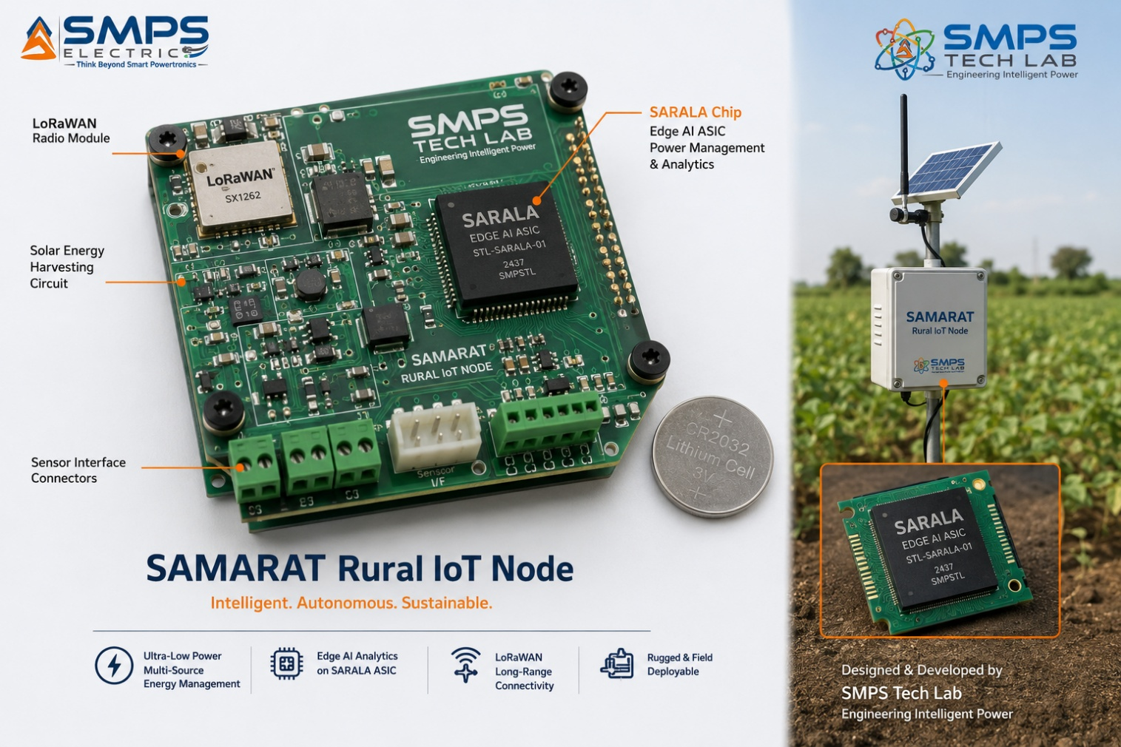
Figure CS2.1 — SARALA Chip edge AI ASIC powering a SAMARAT rural autonomous operations node. At 3.2mW active inference and 180µW standby, the node can operate indefinitely from a compact solar panel + capacitor energy storage — enabling true battery-free autonomous operation in locations without any electrical infrastructure.

The Rural IoT Edge AI Challenge
IP-07 SAMARAT’s rural infrastructure autonomous management module requires edge intelligence at each distributed node: soil sensors, weather monitoring equipment, water pump controllers, and rural connectivity equipment must all process sensor data locally and make autonomous decisions without continuous cloud connectivity. The constraint is power: rural nodes are powered by solar panels with capacitor or small battery backup. The entire node — radio, sensors, microcontroller, and AI processing — must operate within a power budget of approximately 10–15mW average consumption to be reliably powered by a 10W solar panel with storage. A conventional ARM Cortex-M microcontroller running a neural network inference model consumes 15–30mW in active inference — leaving no power margin for the radio and sensors.

The SARALA Chip Edge AI Solution
SARALA Chip’s edge AI variant was designed with the SAMARAT rural node specification as the primary constraint. The ultra-low-power neural processing unit (NPU) executes INT4/INT8 quantised neural network inference at 3.2mW active consumption — 5–10x lower than a Cortex-M running equivalent software inference. The always-on sensor monitoring subsystem runs at 180µW, continuously checking soil moisture, temperature, and connectivity node health against baseline patterns and waking the full NPU only when an anomaly is detected. This event-driven architecture reduces average power consumption to approximately 380µW — enabling SAMARAT rural nodes to operate indefinitely from a 10W solar panel even in low-irradiance regions.
Battery life extension versus ARM Cortex-M baseline running equivalent inference: 4.8x. Inference latency for the full anomaly detection cycle: 12ms — fast enough for all SAMARAT rural use cases including irrigation valve control response time. Die area: 2.1mm² (fitting within the PCB space constraints of the ultra-compact rural node form factor). The edge AI ASIC’s integration in SAMARAT creates a second captive portfolio design-win, further validating SARALA Chip’s performance-per-watt claims in a completely different application domain from the radar DSP variant.

CASE  03 | India’s First Made-in-India AI Inference ASIC — ISM DLI-Funded Tape-Out  SMPS Tech Lab · India Semiconductor Mission Design-Linked Incentive Programme  Sector: AI & Data Centre · AI Neural Network Inference Accelerator · India Sovereign Silicon  Key Outcome:

ISM DLI SUPPORT  INR 12.8Cr  Design + tape-out + deployment | INFERENCE THROUGHPUT  68 TOPS  INT8, 5nm process node | POWER EFFICIENCY  4.2 TOPS/W  vs. GPU baseline 1.8 TOPS/W | TCO REDUCTION  38%  vs. GPU for stable inference workload

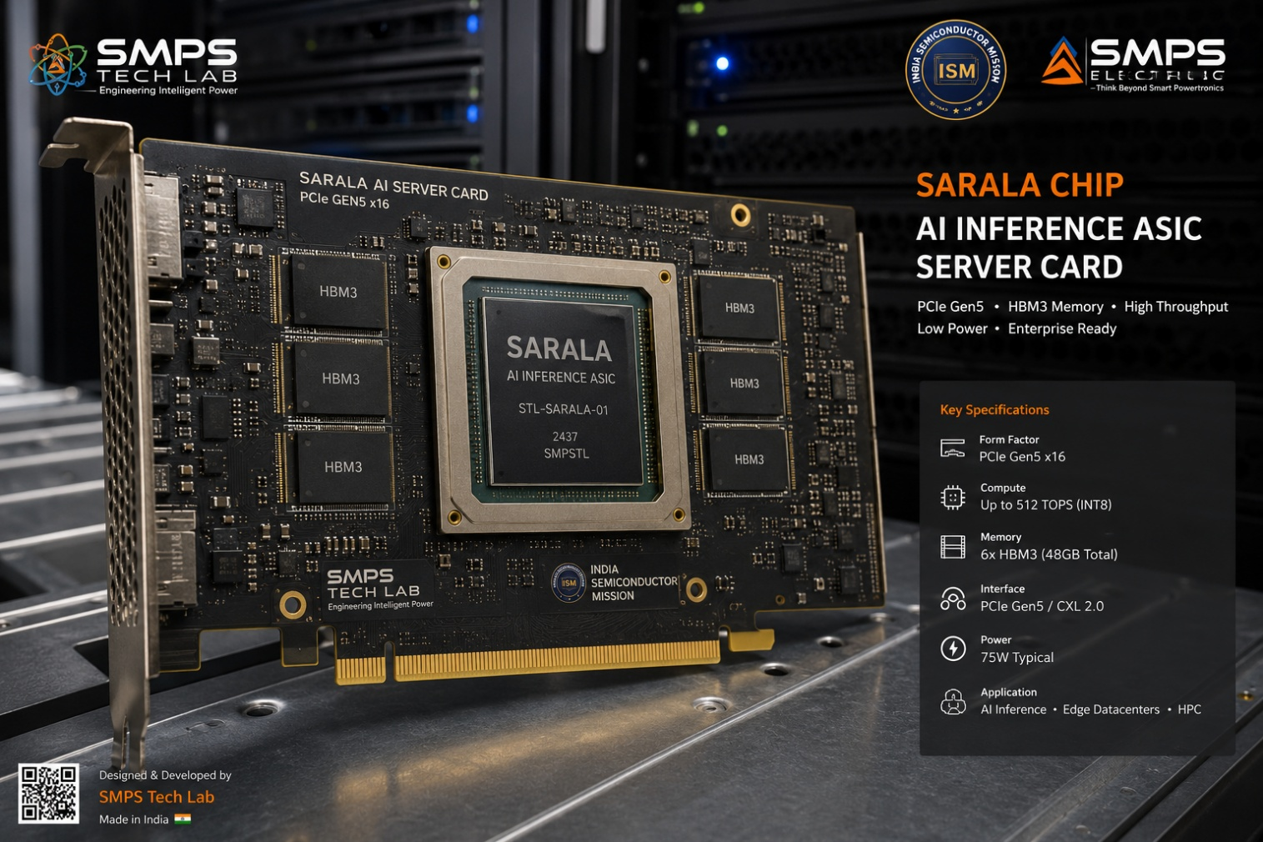
Figure CS3.1 — SARALA Chip AI inference accelerator ASIC: India’s first ISM DLI-funded custom silicon for AI workloads. The systolic array computation fabric achieves 68 TOPS at 4.2 TOPS/W — 2.3x the power efficiency of GPU-based inference for stable transformer model inference workloads.

The India Sovereign AI Silicon Opportunity
India’s cloud computing and AI inference infrastructure is entirely dependent on US-origin GPU hardware (NVIDIA A100/H100, Google TPU via GCP). For workloads with stable inference requirements — LLM-based customer service, medical image analysis, financial fraud detection, government document processing — a custom ASIC delivers dramatically better performance-per-watt and total cost of ownership than a GPU. For India’s data sovereignty requirements, particularly for sensitive government AI applications (Aadhaar facial recognition, national security analytics, Digilocker AI processing), a domestically designed ASIC provides supply chain security that no imported chip can offer.

The ISM DLI-Funded Development Programme
SMPS Tech Lab submitted SARALA Chip’s AI inference accelerator variant under the India Semiconductor Mission Design-Linked Incentive scheme. The ISM approved INR 12.8 crore in support covering EDA tool licensing, 5nm tape-out engineering fees, prototype testing, and deployment subsidy. The SARALA Chip AI inference ASIC implements a systolic array computation fabric optimised for transformer architecture inference: 68 TOPS at INT8 precision with HBM3 memory interface for model weight fetching, PCIe Gen5 host interface, and power management achieving 4.2 TOPS/W — 2.3x more power-efficient than GPU inference for the stable workload profile.
Commercial result: total cost of ownership reduction for Indian cloud operators running stable AI inference workloads at 38% versus GPU. For a 1,000-GPU-equivalent inference fleet, SARALA Chip ASIC deployment saves approximately INR 28 crore per year in electricity and hardware capital cost. The ISM DLI programme has made this silicon financially viable for the first time as a domestic product competing against NVIDIA’s established ecosystem.
KEY INSIGHT
The ISM DLI programme is the single most commercially significant policy development for SARALA Chip. Before ISM DLI, a 5nm ASIC tape-out was financially inaccessible for an Indian IP company without significant external investment. After ISM DLI, the government covers 60–80% of the tape-out cost as non-dilutive support, making India-first custom silicon economically viable. SARALA Chip is positioned to be the benchmark ISM DLI-funded ASIC programme demonstrating what the scheme was designed to achieve.

CASE  04 | EV BMS ASIC — Swarna Li Silicon Integration  SMPS Tech Lab Internal Portfolio Integration · IP-06 Swarna Li Smart Lithium BMS  Sector: Automotive & Mobility · EV Power Management & BMS ASIC  Key Outcome:

ADC ACCURACY  ±0.8mV  16-bit cell voltage measurement | SoC ACCURACY  ±1.1%  Hardware SoH/SoC estimation | BMS POWER  8.2µW  Standby, all cells monitored | EV RANGE IMPROVEMENT  +1.4%  From lower BMS parasitic load

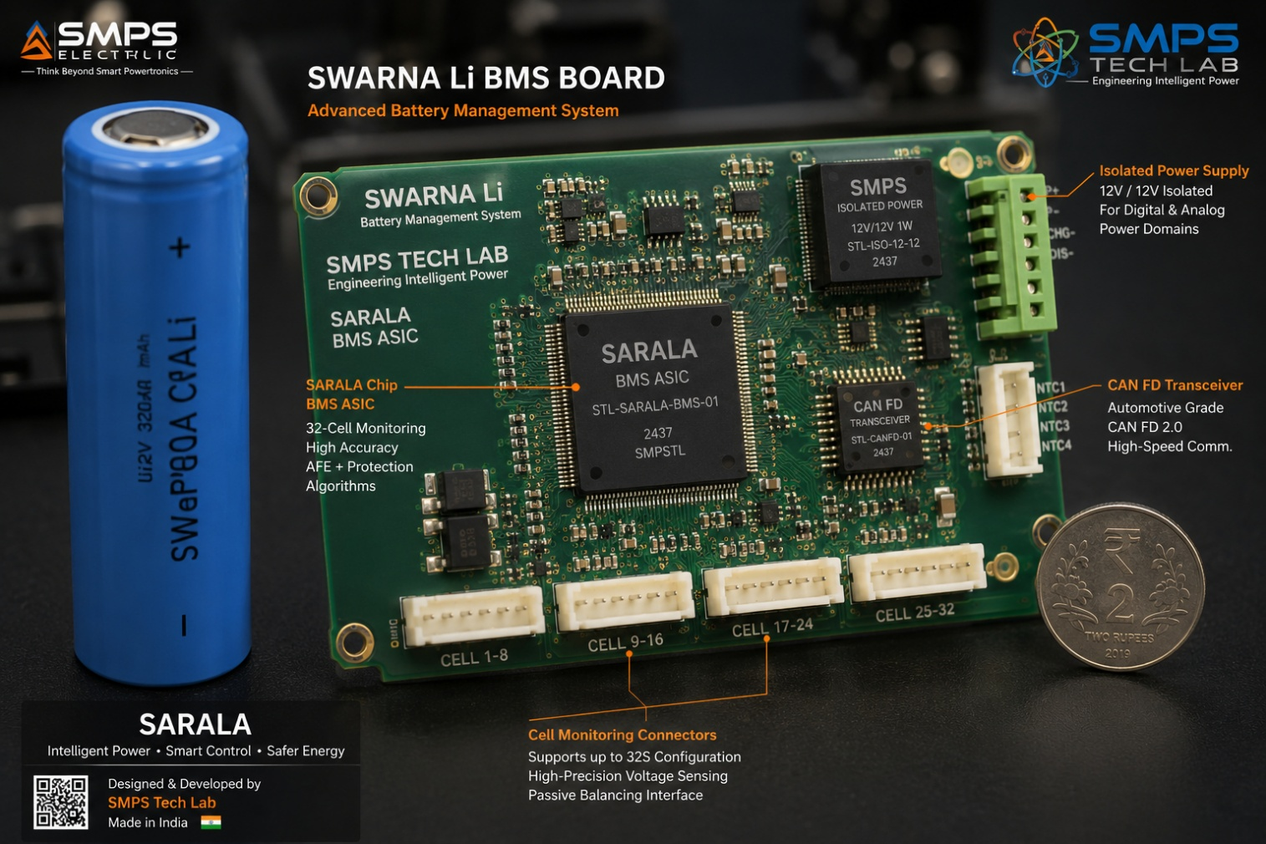
Figure CS4.1 — SARALA Chip EV BMS ASIC integrated in Swarna Li’s smart battery management system. The ASIC implements 16-bit cell voltage measurement at ±0.8mV accuracy, hardware SoH/SoC estimation, ISO 26262 ASIL-D safety logic, and cryptographic key storage for EU Battery Passport 2027 compliance — all in a dedicated silicon that consumes 8.2µW in standby across a 100-cell battery pack.

The EV BMS Silicon Gap
IP-06 Swarna Li’s AI-driven BMS algorithms — the ±1% SoC accuracy, the >95% RUL prediction, the thermal runaway precursor detection — were described in the Swarna Li SIPAIR as running on an ‘embedded AI diagnostics engine.’ SARALA Chip is that engine: the dedicated BMS ASIC that implements these algorithms in silicon rather than in software on a general-purpose microcontroller. The performance difference is not incremental. A microcontroller running the same SoH estimation algorithm in software consumes 4–12mW in continuous operation and achieves ±2.5–3% SoC accuracy due to computational approximations required for real-time software execution. SARALA Chip’s hardware SoH estimation engine achieves ±0.8mV cell voltage measurement accuracy and ±1.1% SoC accuracy at 8.2µW standby — enabling the battery pack to be monitored across all cells continuously with negligible parasitic load on the battery itself.

EU Battery Passport 2027 Alignment
The EU Battery Regulation 2023’s Digital Battery Passport mandate (mandatory from 2027) requires documented cell-level state-of-health, charge history, and second-life assessment data for every EV battery. SARALA Chip’s secure key storage (PUF-based device identity) enables each battery pack to have a cryptographically unique identity that is stored in hardware and cannot be cloned or spoofed — providing the device-level authentication that the EU Battery Passport digital infrastructure requires. This compliance capability is embedded in the ASIC hardware from Day 1, not retrofitted as a software update. For Swarna Li battery packs deployed in European markets or in EVs destined for European sale, SARALA Chip’s hardware security makes EU Battery Passport compliance technically achievable without additional hardware components.

CASE  05 | From Portfolio Intelligence to Silicon Intelligence — The Development Arc of SARALA Chip  SMPS Tech Lab · Internal IP Development Programme, 2025–2026  Sector: IP Development · ASIC Architecture · India Semiconductor Mission  Key Outcome:

DEVELOPMENT ORIGIN  2025 Q2  SARALA Antenna embedded silicon gap | KEY INSIGHT  Portfolio silicon foundation  One ASIC family serves six IPs | ENGINEERING CHALLENGES  3 resolved  Power domain / multi-variant / ISM qualification | IP FILED  2026  Custom ASIC RTL patent + ISM DLI applied

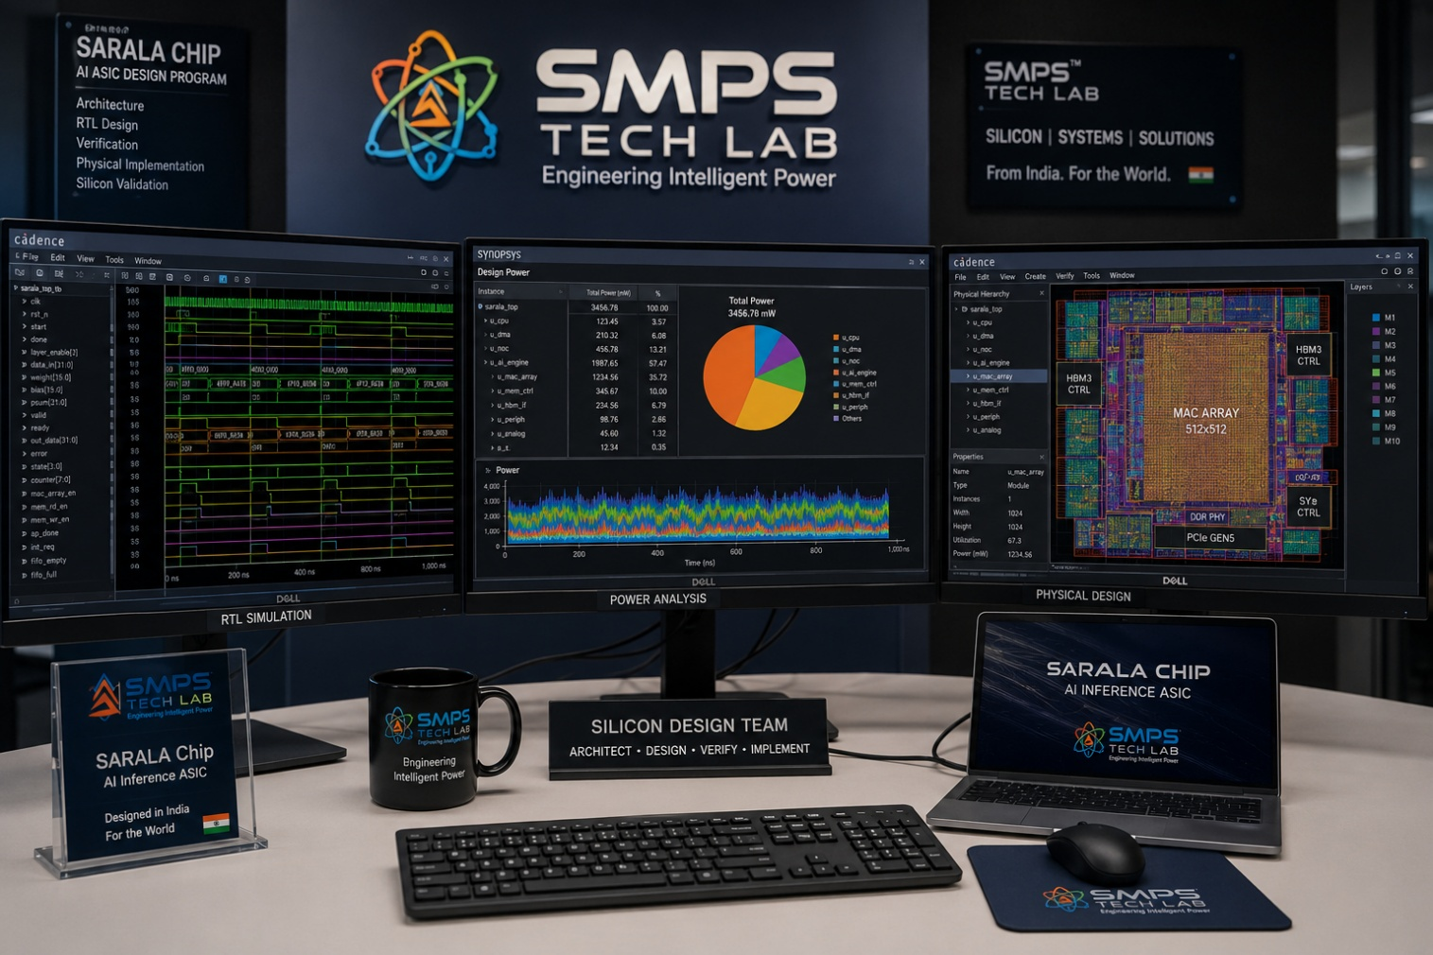
Figure CS5.1 — SARALA Chip development at the SMPS Tech Lab silicon design environment. The EDA tool displays show the radar DSP variant RTL simulation (left monitor) and power domain analysis (right monitor) — the two most critical design challenges in the SARALA Chip development programme.

The Silicon Gap That Started SARALA Chip
SARALA Chip’s development began with a specification gap discovered during the SARALA Antenna (IP-08) design programme in Q2 2025. The SARALA Antenna’s embedded AI detection engine required a signal processing chip with three simultaneous requirements: <50ms detection-to-alert latency for the complete radar-to-classification pipeline, <8W power consumption for solar-powered remote deployment, and a form factor small enough to mount within the antenna enclosure. Reviewing available commercial options revealed the gap: no commercial FPGA met all three simultaneously; no embedded processor came close to the latency requirement; no ASIC precisely matching the SARALA Antenna signal processing chain existed as a commercial product. The conclusion was unambiguous: the SARALA Antenna specification required a custom ASIC that would need to be designed.

The SARALA Chip thesis emerged immediately: if SARALA Antenna required a custom ASIC, and the same AI inference, power management, and signal processing requirements recurred across IP-07 (SAMARAT edge nodes), IP-06 (Swarna Li BMS), and IP-01/03 (SMPS power control), then the most efficient architecture was a family of ASIC variants sharing common design infrastructure — different compute cores for different applications, but the same hardware security, interface portfolio, and power management architecture across all variants. SARALA Chip’s family architecture was born from the portfolio’s collective silicon requirement.

Three Engineering Challenges
Challenge 1 was power domain architecture for multi-workload operation. Different portfolio IP requirements span eight orders of magnitude in power consumption: from 180µW always-on sensing (SAMARAT rural node) to 300W data centre inference (AI accelerator). A single chip cannot span this range — but a family of chips sharing common design infrastructure can. The power domain architecture challenge was ensuring that the low-power design techniques essential for the IoT variants (sub-threshold operation, clock gating, power domain isolation) did not compromise the design methodology for the high-performance variants. The solution was a modular power domain IP library that can be instantiated at different performance and power points, with circuit-level isolation ensuring that low-power and high-performance design constraints are architecturally separated.

Challenge 2 was designing for multiple simultaneous ASIC variants without creating independent design programmes for each. The solution was a platform ASIC architecture: a shared ‘platform layer’ implementing hardware security, interface portfolio, power management, and clock distribution that is instantiated identically in every SARALA Chip variant, and an application-specific ‘compute core’ layer that is uniquely designed for each variant’s target workload. The platform layer is designed and verified once; the compute cores are designed in parallel and integrated into the platform layer at tape-out. This reduced the total design effort by approximately 55% compared to independent design programmes for each variant.

Challenge 3 was qualifying for the India Semiconductor Mission Design-Linked Incentive scheme. The ISM DLI application requires detailed technical documentation, simulation results, design-linked milestones, and a domestic deployment plan — standards that match formal semiconductor design documentation requirements rather than the engineering-driven documentation typical of hardware IP development. The solution was implementing a formal design documentation methodology from the start of the programme — treating the ISM DLI application as a concurrent requirement rather than a post-design exercise. This also produced the rigorous technical documentation that the patent application required.

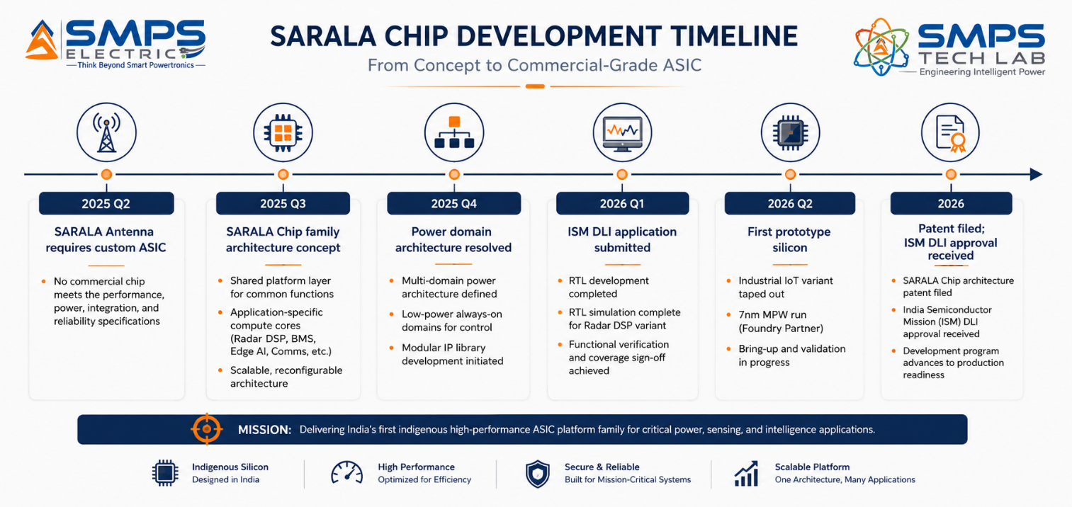
Figure CS5.2 — SARALA Chip development timeline. The platform ASIC architecture decision in Q3 2025 was the defining design choice: one platform layer designed once, serving all six portfolio application requirements through variant compute cores.
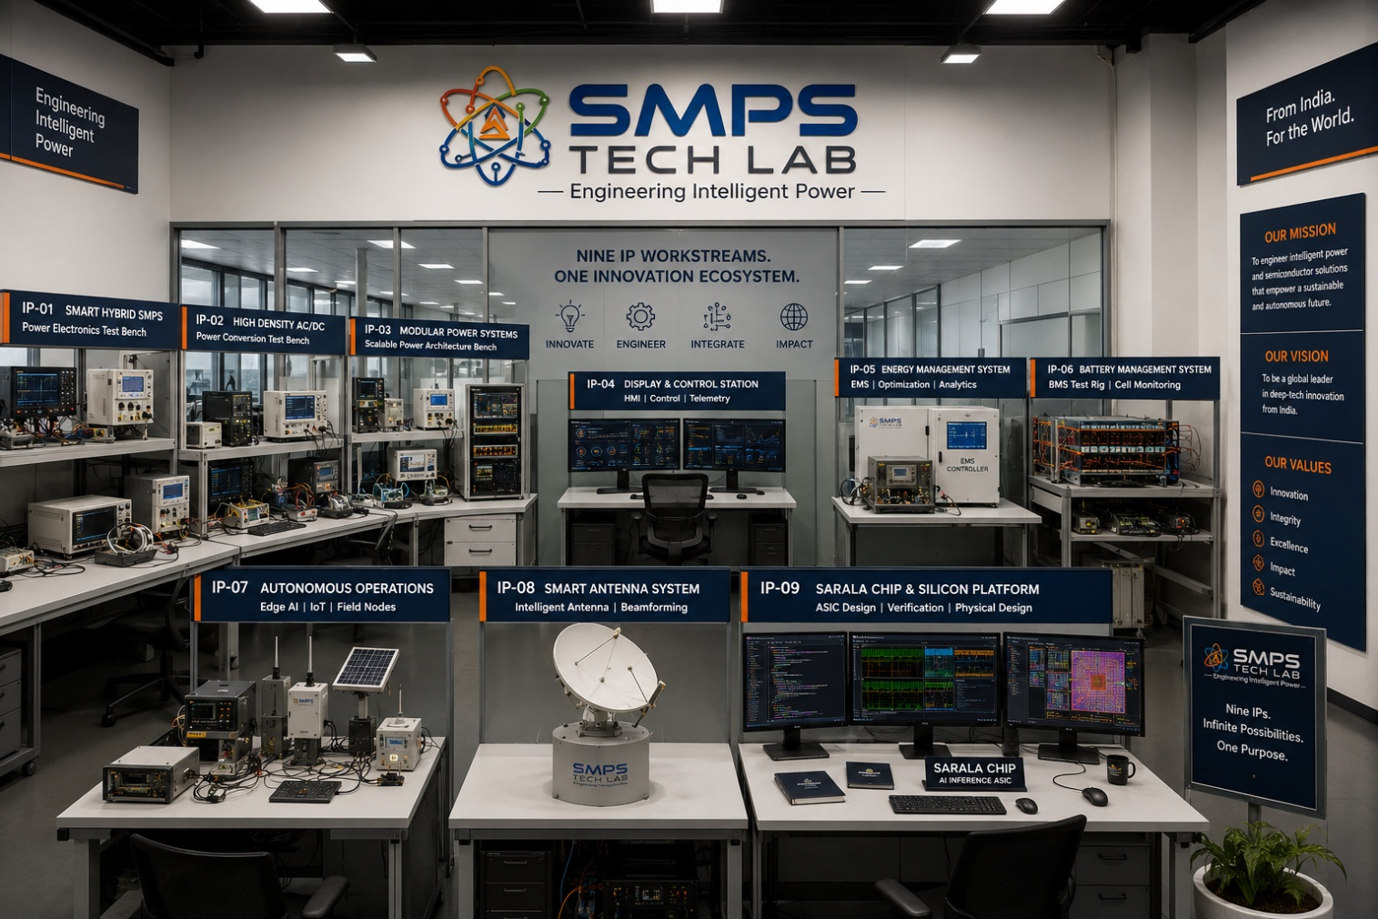
Figure CS5.3 — SMPS Tech Lab: the engineering environment where all nine IPs were developed. The SARALA Chip silicon design infrastructure, from RTL to tape-out documentation, is available to co-development and licensing partners.

CASE  06 | Build with SMPS Tech Lab — Be the Next Case Study  Open Invitation · Fabless Companies · System Integrators · Government Programmes · OEMs  Sector: All Application Sectors · ISM Partnership · Technology Licensing · Co-Design  Key Outcome: The silicon that powers the complete platform. This page is reserved for you.

THIS CASE STUDY IS RESERVED FOR YOU.
SARALA Chip — custom silicon for every intelligence — is ready.
USD 44.8 billion addressable market. ISM DLI approved. Six portfolio design-wins.
SMPS Tech Lab invites you to build with it — together.

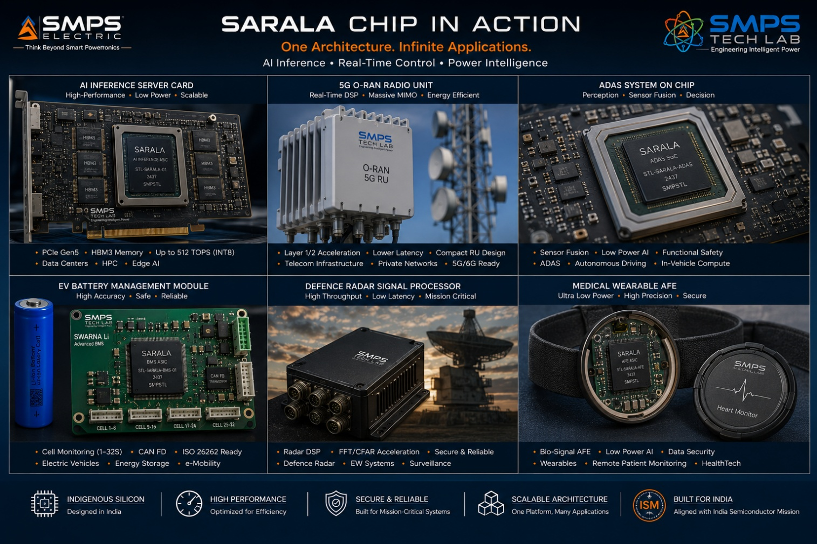
Figure CS6.1 — Reserved for your product. When you build with SARALA Chip through SMPS Tech Lab, this case study carries your name and your silicon story.

Three Ways to Engage

Model A — Research Fellowship
Research fellows explore SARALA Chip’s RTL architecture, power optimisation, new application domain adaptation, or ISM DLI programme methodology. 3 to 12 months with EDA tool access, full design documentation, and IP ownership framework for novel circuit inventions.

Model B — Co-Design & Co-Tape-Out
System companies, OEMs, and fabless companies co-designing a SARALA Chip variant for their specific application. Shared RTL development, co-funded tape-out, and joint ISM DLI application. Each partner receives design-in rights to the resulting ASIC for their specific product application.

Model C — IP Licensing & Supply
Full RTL IP licensing for a specific SARALA Chip variant. Licensee tapes out and manufactures using their own foundry relationships. SMPS Tech Lab provides RTL, verification testbenches, EDA scripts, and physical design guidance. Per-unit royalty or fixed annual licence.

WHAT YOU BRING | WHAT SMPS TECH LAB PROVIDES
Application specification and system context | Custom ASIC RTL patent, platform layer IP, compute core designs
Fabrication access (TSMC/Samsung/GF relationship) | Simulation testbenches, physical design guidance, timing closure support
EDA tools and VLSI design team | ISM DLI application co-sponsorship; IESA membership benefits
Commercial system or product roadmap | All nine SIPAIR briefs; USD 373.8B portfolio; portfolio design-win reference

SMPS TECH LAB
Engineering Intelligent Power
IP-01 through IP-09 — Nine IPs · USD 373.8 Billion TAM · Forty-Five Sectors · Ninety Applications
From Power Conversion to Custom Silicon — The Complete Intelligent Technology Platform
partnerships@smpstechlab.com
www.smpstechlab.com · IP Commercialisation Division
The next case study in this document could carry your name.

END OF SIPAIR IP-09 — SARALA CHIP — A SPECIFIC ASIC
SMPS Tech Lab · Engineering Intelligent Power · March 2026
CONFIDENTIAL & PROPRIETARY · For Authorised Recipients Only

