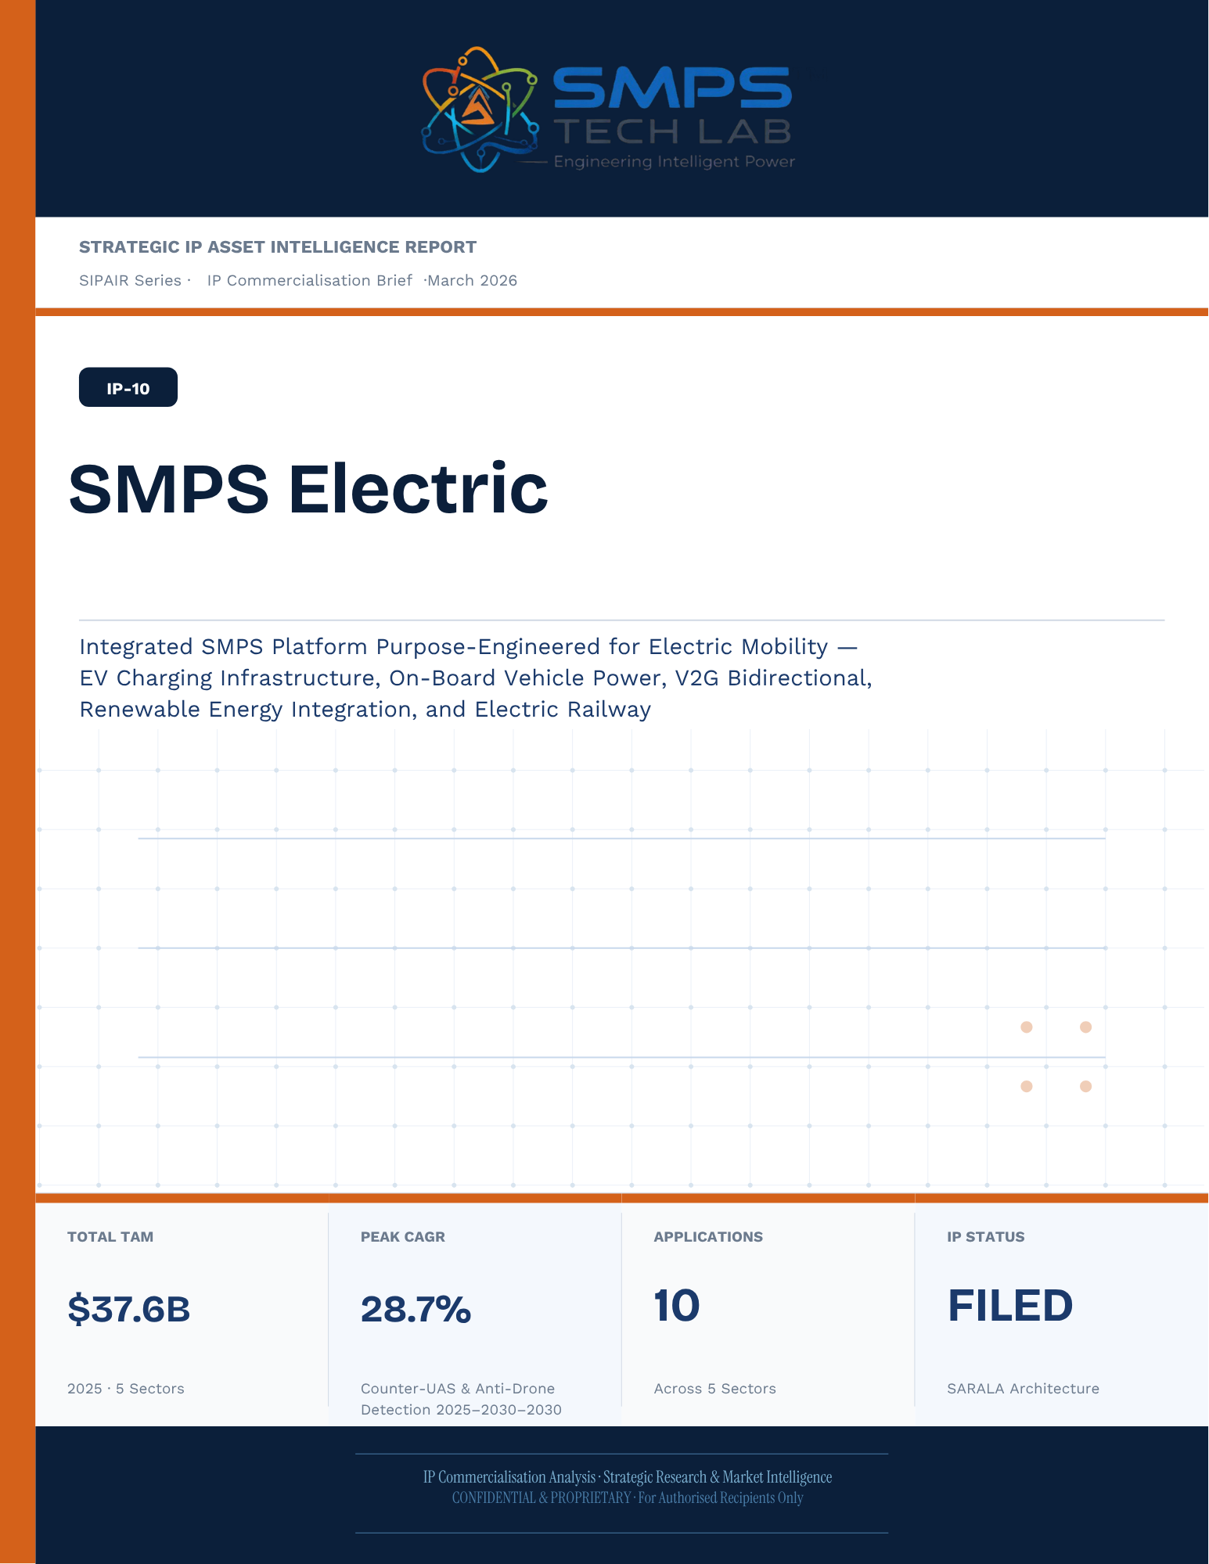
STRATEGIC IP ASSET INTELLIGENCE REPORT
SIPAIR Series
IP-10: SARALA
SMPS-Based Integrated SARALA for Uninterrupted Telecom Power

Report Title | SIPAIR IP-10 — SARALA Commercialisation Brief

Document Series | Strategic IP Asset Intelligence Report (SIPAIR)

Version | Version 1.0 — First Edition

Compiled & Edited by | Shri Amareshwar Karatagi

Organisation | SMPS Tech Lab — Engineering Intelligent Power

Date of Issue | March 2026

Classification | Confidential & Proprietary — For Authorised Recipients Only

IP Reference | IP-10 — SARALA Architecture, Filed 2025

Related Document | SIPAIR IP-01: Smart Hybrid SMPS (see companion brief)

This document is prepared by SMPS Tech Lab as part of the SIPAIR IP Commercialisation Series.

Declaration — Originality & Intellectual Property Statement

This Strategic IP Asset Intelligence Report (SIPAIR — IP-10: SARALA) is an original compilation prepared by SMPS Tech Lab. The analysis, market intelligence frameworks, commercial strategy formulations, and case study narratives contained herein are the result of independent research and original intellectual work by the authors and editors named in this document.

The core technology described in this report — the SMPS-Based Integrated SARALA architecture, including its active power management layer, CCU intelligence stack, uninterrupted multi-rail AC/DC delivery system, and NMS integration platform — is the exclusive proprietary invention of SMPS Tech Lab, protected under a filed novel design patent (2025). IP-10 is a distinct and independently protectable invention from IP-01 (Smart Hybrid SMPS), though both emerge from the same SMPS Tech Lab research programme. The two IPs are designed to complement each other across adjacent application verticals and may be jointly licensed or co-deployed where application requirements demand both hybrid topology and active power management intelligence.

Market sizing data, CAGR estimates, and industry statistics cited in this document are sourced from independent third-party research publications, fully attributed in Appendix A. All third-party data is used for analytical and benchmarking purposes only. This report has not been submitted, in whole or in part, to any other organisation for commercialisation or formal assessment except as specifically disclosed in writing.

Declared by:

Shri Amareshwar Karatagi Founder & CSO SMPS Tech Lab · March 2026

CERTIFICATE OF AUTHENTICITY
IP Commercialisation Documentation · SIPAIR IP-10

This is to certify that the Strategic IP Asset Intelligence Report
SIPAIR IP-10 — SARALA
has been compiled, reviewed, and authenticated by the undersigned in accordance
with the standards of the SIPAIR documentation series. The technology, market analysis,
and commercial intelligence herein are verified as accurate to the best of the signatories’
knowledge as at the date of issue: March 2026.

Program Head / Director | Technical Mentor
  Program Head / Research Director
  SMPS Tech Lab
  Technical Mentor / Advisor
  SMPS Tech Lab

SMPS Tech Lab · Engineering Intelligent Power · March 2026

Acknowledgment

The preparation of this Strategic IP Asset Intelligence Report for IP-10 has drawn on the technical expertise, operational insights, and research foundation developed across two parallel innovation tracks at SMPS Tech Lab. The development of the CCU intelligence layer — the defining innovation of IP-10 — required not only power electronics engineering depth but sustained engagement with telecom network operations, tower management practice, and satellite ground station engineering environments that are highly specialised. The author and editor express sincere gratitude to those whose knowledge and access made this work possible.

Technical Development
The CCU architecture at the heart of IP-10 evolved alongside IP-01's hybrid topology work, but along a distinct engineering trajectory focused on power orchestration intelligence rather than conversion efficiency alone. The engineers and technologists who contributed to the CCU control logic, NMS integration stack, and sub-millisecond failover switching mechanism deserve specific recognition for the rigour with which they approached the uninterrupted power mandate — a design objective that admits no approximation.

Telecom Industry Access
The sector intelligence in this report reflects direct engagement with tower operations, data centre facility management, and satellite ground station engineering communities. The operational data from 5G tower rollout programmes, off-grid hybrid power deployments, and maritime communication installations that informed the case study narratives and application requirement specifications in this document is the product of those field engagements.

Research Publications
The market intelligence framework draws on publications from Future Market Insights, MarketsandMarkets, SNS Insider, Grand View Research, IMARC Group, Coherent Market Insights, Global Growth Insights, and the Ericsson Mobility Report, as well as operational data from the International Energy Agency. The quality of those independent research publications is what allows the TAM framework in this report to be grounded in named, verifiable data rather than estimated aggregates.
Shri Amareshwar Karatagi
Founder & CSO
SMPS Tech Lab · March 2026

Preface — From the Founder & Editor

From IP-01 to IP-10 — The Logical Extension
IP-01, documented in the companion SIPAIR brief, solved one problem with exceptional elegance: replacing the unnecessary architectural duplication of separate AC and DC converter units with a single hybrid topology. The commercial case was compelling and the market evidence was clear. But the engineers at SMPS Tech Lab, in the same process of field observation that gave rise to IP-01, had identified a second problem — one that operated at a higher level of the power system stack and was, if anything, more commercially urgent in the specific context of telecom infrastructure.

The problem was not conversion efficiency. It was availability. In a 5G base station, a satellite ground hub, an offshore platform communication centre, or a smart city public safety network node, the standard power supply architecture not only requires separate AC and DC converters — it delegates all intelligence about the power state of the system to a separate controller that may be physically remote, software-dependent on a third-party network management system, and incapable of autonomous protective action in the sub-millisecond timeframe that modern telecom uptime SLAs demand. When the grid fails, when a battery starts to degrade, when an input source switches — the system needs to respond faster than any software polling cycle can achieve. It needs embedded intelligence, right at the power conversion stage.

IP-10 is that intelligence. The Integrated SARALA, combined with the SMPS core, does not just convert power — it orchestrates it. It monitors every parameter of the power delivery chain continuously, switches between sources in under a millisecond, predicts faults before they become outages, and reports power system health to the operator's NMS in real time, without external monitoring hardware. It is the difference between a power supply and a power management system.

Why Telecom, and Why Now
The selection of telecom infrastructure as the primary application vertical for IP-10 reflects a disciplined commercial judgement. Telecom infrastructure is the single sector in the IP-10 TAM where the uninterrupted power mandate is non-negotiable, contractually enforced at 99.999% uptime, and backed by capital investment programmes of unprecedented scale: 2.3 billion 5G subscriptions by end of 2024 with another 4 billion to come by 2030; 3,000 Amazon Project Kuiper satellites deployed in April 2025 with thousands of ground hubs to follow; the IMO GMDSS modernisation mandate forcing a complete vessel communication power infrastructure upgrade by 2026. Every one of these programmes creates a specific, identified, and time-bounded procurement requirement for exactly what IP-10 delivers.

The second reason is the grid reliability crisis that is, counterintuitively, the most powerful demand driver the CCU's hybrid input management addresses. South Africa recorded 1,130 hours of planned power cuts in a single year. India's tower estate — 750,000 sites — routinely operates on hybrid grid, diesel, and battery sources with real-time CCU-managed source switching that determines whether the tower stays on during a grid event. This is not a niche requirement. It is the operational reality for hundreds of thousands of tower sites across three continents, and the market is actively seeking a solution that the current generation of separate rectifiers and external controllers cannot provide.

How This Document is Structured
This SIPAIR brief follows the same 14-section architecture as the IP-01 companion document, making the two documents a coherent and mutually reinforcing portfolio. Readers who have engaged with SIPAIR IP-01 will recognise the structure immediately. The technology differentiation section includes an explicit comparison between IP-01 and IP-10, clarifying the architectural relationship and the distinct value proposition of each. The case studies are drawn from the five specific sectors of IP-10's TAM framework — 5G tower, data centre, satellite ground, smart city, and maritime/offshore — with technical and financial parameters grounded in the operational realities of each sector.

Shri Amareshwar Karatagi
Founder & CSO
SMPS Tech Lab · March 2026

TABLE OF CONTENTS

Declaration — Originality & Intellectual Property Statement 1
Acknowledgment 1
Technical Development 1
Telecom Industry Access 1
Research Publications 1
Preface — From the Founder & Editor 1
From IP-01 to IP-10 — The Logical Extension 1
Why Telecom, and Why Now 1
How This Document is Structured 1
Important Notice & Confidentiality Disclaimer 1
1.1 The Strategic Context 1
1.2 The Problem SMPS Electric Solves 1
1.3 Key Metrics at a Glance 1
1.4 Why SMPS Electric, Why Now 1
2.1 What is SMPS Electric? 1
2.2 The Four Integrated Technology Layers 1
2.3 GaN/SiC Topology — The Efficiency Foundation 1
2.4 Solar-Integrated Smart Charging Hub — The Multi-Source Integration Advantage 1
2.5 Standards Compliance Architecture 1
3.1 The Electrification Power Supply Inflection Point 1
3.2 The Four Structural Megatrends 1
3.3 Global Market Sizing — Primary Reference Data 1
CAGR Comparison — SMPS Electric Target Market Segments 1
4.1 Methodology 1
4.2 Consolidated TAM Summary 1
5.1 India as First and Primary Market 1
5.2 India Market Sizing — SMPS Electric Relevant Segments 1
6.1 India & Global Policy with Direct SMPS Electric Alignment 1
7.1 The Plugin Architecture — Five Electric Host System Categories 1
7.2 Plugin Integration Matrix 1
8.1 Commercialisation Philosophy 1
8.2 Market Priority Matrix 1
9.1 Competitive Architecture Overview 1
10.1 The Investment Case 1
10.2 Illustrative Revenue Scenarios 1
11.1 Technology Generation Roadmap 1
11.2 Adjacent Application Opportunities 1
12.1 Risk Framework 1
Appendix A — Data Sources 1
Appendix B — Standards Reference 1
Appendix C — Glossary 1
The Context 1
The SMPS Electric Supply Proposition 1
The Context 1
The SMPS Electric Integration Solution 1
The Context 1
The SMPS Electric Integrated OBC Solution 1
V2G and ISO 15118-20 Positioning 1
The Context 1
The SMPS Electric Wayside Converter Solution 1
The Integration Insight That Started SMPS Electric 1
Three Engineering Challenges 1
Three Ways to Engage 1
Model A — Research Fellowship 1
Model B — Supply Partnership 1
Model C — Technology Licensing 1

0F | FOUNDER & EDITOR  IP-10 SIPAIR Series · SMPS Tech Lab

 | Shri Amareshwar Karatagi  Founder & Chief Strategic Officer  SMPS TechLab  Special Correspondent, Government of Karnataka |  Serial Entrepreneur
Vision Statement
We aim to build a generation of innovators and entrepreneurs who create transformative technologies, develop intellectual property, and drive India’s technological leadership on both national and global platforms. Over the years, we have worked extensively within the startup ecosystem, contributing to and mentoring multiple initiatives focused on building, scaling, and strengthening businesses. Through this journey, we have developed a deep understanding of business strategy, governance frameworks, and deep-technology development, along with the practical challenges of scaling innovation in real-world markets.
As a Special Correspondent with the Government of Karnataka and a serial entrepreneur, my focus has been on shaping individuals into creators, builders, and leaders of technology and enterprise. Our work emphasizes ownership, innovation, and execution discipline to nurture individuals capable of building scalable, high-impact solutions with both national and global relevance.
Through SMPS Tech Lab, we drive this vision by integrating deep Research & Development (R&D) with entrepreneurial strategy, fostering a culture where ideas evolve into intellectual property, innovation, and industry-aligned solutions that contribute to India’s technological advancement and global competitiveness. The Industry Fitness DeepTech Internship Program is a reflection of this mission—designed to develop individuals who are innovation-driven, execution-focused, and capable of contributing meaningfully to technology, entrepreneurship, and nation-building at scale.
“My vision is to build a generation that doesn’t wait for opportunities, but creates them through innovation and entrepreneurship.”
— Shri Amareshwar Karatagi

A. R. Shalini
Chief Business Development Officer (CBDO) & Program Officer
SMPS TechLab | SMPS Electric Control Pvt. Ltd.

Area of Expertise:
Business Strategy, Operations Management, Industry–Academia Integration, Entrepreneurship Development
Profile:
I play a pivotal role in driving program execution, operational excellence, and professional development within SMPS Tech Lab. With a strong foundation in both business strategy and technology alignment, I am committed to shaping individuals into industry-ready professionals with the right mindset, discipline, and execution capabilities.
My approach focuses on building skills with clarity of thought, accountability, and a results-driven attitude. Through structured guidance and continuous mentorship, I enable participants to understand the intersection of technology, business, and real-world application.
I actively work toward bridging the gap between academia and industry, ensuring that learning is aligned with practical expectations and evolving market demands. My dedication to creating a seamless and high-impact learning environment fosters confidence, innovation, and professional growth among participants.
Through my leadership, the program consistently emphasizes structured execution, strategic thinking, and the development of individuals who are prepared to contribute meaningfully to both industry and innovation ecosystems.
“Professional excellence is built when knowledge, mindset, and execution come together with consistency.”
— A. R. Shalini

Dr. S. Khatua
Chief Technology Officer (CTO)
SMPS TechLab | SMPS Electric Control Pvt. Ltd.
IITian | PhD – IIT Dhanbad

Area of Expertise:
Power Electronics, Microgrid & Smart Grid Systems, Nuclear Power Systems, DeepTech R&D, Industrial System Design.
I am a distinguished technology leader driving advanced Research & Development and deep-tech innovation. An IITian with a PhD in Microgrid and Smart Grid Systems for nuclear power applications, I bring over 15 years of experience across power electronics, nuclear reactor control systems, and defence and telecom technologies.
With significant contributions to high-impact and mission-critical projects of national importance, my work reflects a rare combination of research depth, engineering precision, and industrial execution.
I am a strong advocate of deep-tech innovation and intellectual property (IP) creation, and I emphasize the development of indigenous technologies that strengthen the nation’s technological capability and global standing.
Through my mentorship, I inspire the next generation to pursue technical mastery, disciplined execution, and innovation with national intent, shaping professionals capable of contributing to the future of deep technology.
“Precision in engineering, depth in research, and ownership of technology are the pillars of true national progress.”
— Dr. S. Khatua

Mr. Rushit Jani
Techno-Commercial Architect
Strategic Editorial & Commercialisation Review | OptCell GLOBAL

Fields of Interest:
AI & Intelligent Systems, Industrial IoT, Product Architecture, Deep-Tech Commercialisation, Enterprise System Design, and Scalable Engineering Solutions.Focused on building technology-driven systems that bridge engineering innovation with practical industry adoption and long-term commercial value.
Message from the Editor:
Technology, in its purest form, is not just about building systems — it is about creating meaningful infrastructure that can influence industries, solve operational challenges, and contribute to larger technological progress. My interest has always been in understanding how engineering innovation can evolve beyond prototypes into scalable and commercially sustainable solutions.
This document represents more than a technical study of an intellectual property. It reflects a structured effort to connect engineering architecture with market relevance, strategic deployment, industrial applicability, and long-term innovation potential. The objective throughout this work has been to maintain a balance between technical depth, commercialization practicality, and institutional-level documentation standards.
As emerging technologies continue to redefine industries, I strongly believe that the future will belong to organizations capable of combining research, engineering, strategic thinking, and execution into unified ecosystems. Through this publication, we aim to contribute towards that larger vision while creating pathways for collaboration, innovation, and real-world technological impact.
"Transforming engineering innovation into scalable, industry-defining technological ecosystems."
— Mr. Rushit Jani
A Note of Gratitude
The development of this publication has been supported by the collective vision, encouragement, and leadership of the Directors and management of SMPS Electric Control Pvt. Ltd.
Their continued commitment towards engineering innovation, industrial excellence, and long-term technological growth has created an environment that encourages meaningful research, practical problem-solving, and commercialization-focused thinking. The guidance, operational insights, and institutional support extended throughout this journey have played an important role in shaping the direction and depth of this work.
This document reflects not only an individual effort, but also the larger culture of innovation, trust, and forward-thinking leadership fostered within the organization. We sincerely appreciate the confidence and support provided towards building impactful and future-ready technological initiatives.

Important Notice & Confidentiality Disclaimer

This Strategic IP Asset Intelligence Report (SIPAIR — IP-10) has been prepared exclusively for internal strategic planning, investor communication, licensing partner engagement, and research collaboration purposes. It is intended for distribution only to authorised recipients under applicable non-disclosure and confidentiality arrangements.

All market sizing data, CAGR estimates, and financial projections are derived from independent third-party research publications cited in Appendix A. These figures represent estimates as at March 2026. No representation or warranty is made as to their accuracy or completeness.

The technology, architecture, and methodologies described herein are the exclusive proprietary assets of SMPS Tech Lab, protected under filed patent and design rights. This document does not constitute a prospectus, financial advice, or an offer to sell or subscribe to securities. Recipients are advised to conduct independent due diligence before making any investment or commercial decision.

01 | EXECUTIVE SUMMARY  The Electric Domain Integration Gap · SMPS Electric Value Proposition · Five Sectors

1.1 The Strategic Context
The global electrification transition is creating an unprecedented demand wave for power supply solutions across every domain simultaneously: 35 million EV charge points forecast in the US by 2030, global BEV registrations exceeding 8.5 million units in August 2025 alone, India’s PM e-DRIVE scheme committing INR 10,900 crore for EV charging infrastructure, V-GREEN signing an agreement to deploy EV charging at 24,400+ HPCL fuel outlets, and industrial electrification programmes replacing fossil fuel combustion with electric processes at every scale. The common factor in every one of these deployments is an SMPS power supply at the core of the energy conversion. Every EV charger is an SMPS. Every on-board vehicle charger is an SMPS. Every solar-integrated charging hub requires an SMPS. The question for operators, OEMs, and infrastructure developers is not whether to procure an SMPS — it is which SMPS.

The answer that the market is converging on — validated by ABB’s 360kW integrated ultra-fast charger, ChargePoint’s 500kW modular platform, and Delta Electronics’ liquid-cooled 500A system — is integration. A single, co-optimised SMPS platform that consolidates the AC-DC rectifier, active power factor correction, DC-DC conversion, energy management controller, and smart diagnostics into one factory-tested unit outperforms a cascade of separately procured units on every relevant metric: efficiency, reliability, total cost, and commissioning time. SMPS Electric is that integrated platform, purpose-engineered for every application in the electric mobility and electrification ecosystem.

1.2 The Problem SMPS Electric Solves
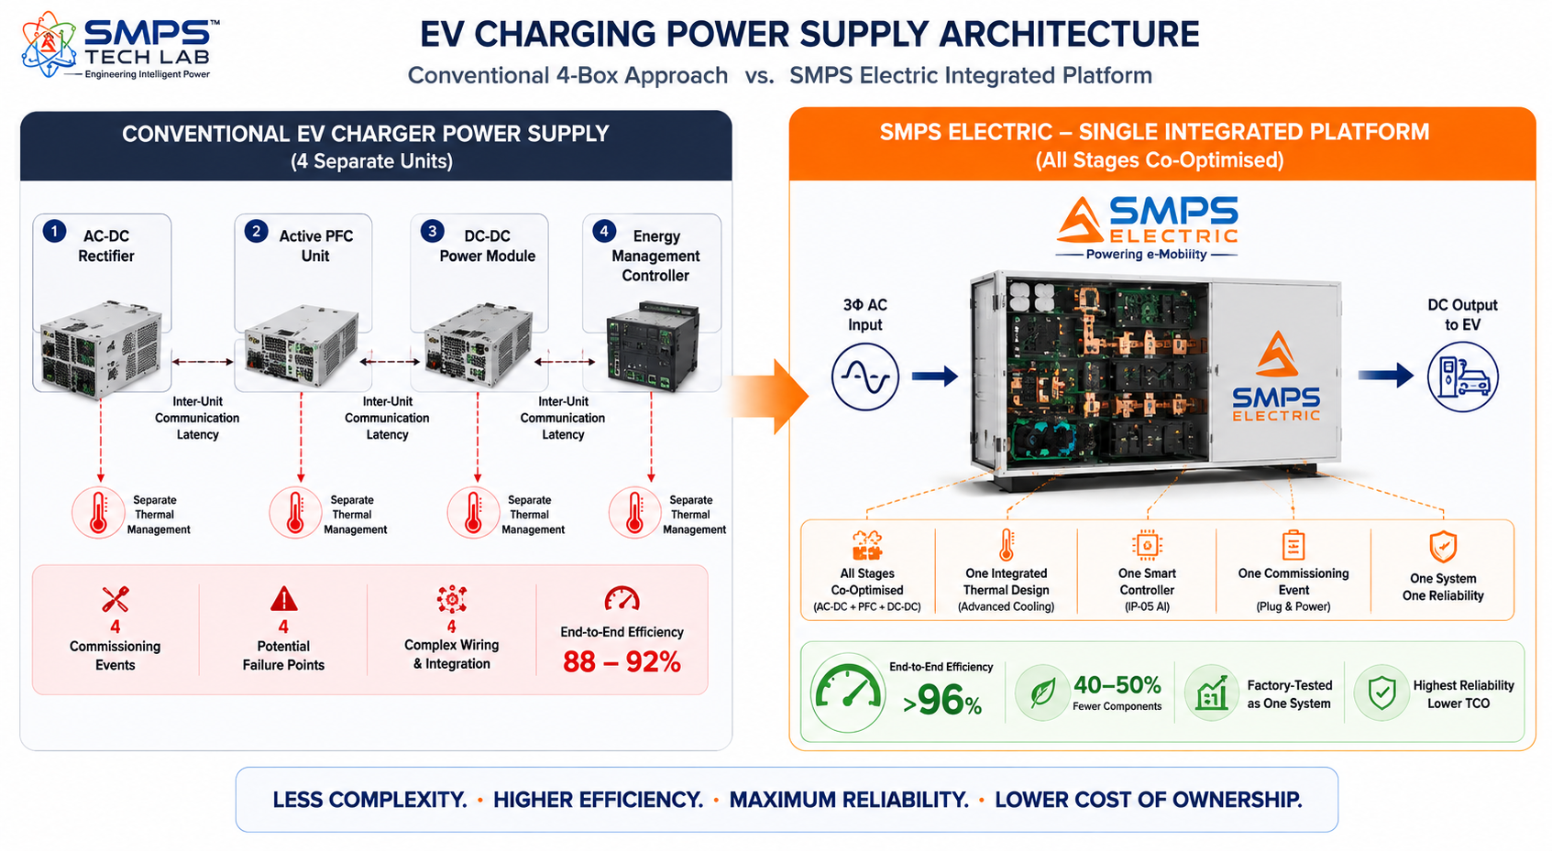
Figure 1.1 — Fragmented multi-unit cascade (left) versus SMPS Electric integrated platform (right). Four separate procurement, commissioning, and maintenance events collapse into one. End-to-end efficiency improves by 4–8 percentage points through cross-stage co-optimisation in a single thermal design.
STRATEGIC NOTE
SMPS Electric is not just a more efficient charger. It is the integrated power platform that replaces the entire cascade of separate units conventionally required across every electric domain application — EV charging, on-board vehicle power, renewable energy integration, railway traction, and industrial electrification. Integration is the competitive moat. Co-optimisation within a single platform is what delivers the 4–8 percentage point efficiency advantage. And the wide voltage range (85V–480V AC input, 50V–1500V DC output) covering every electric application from a single platform family is what makes SMPS Electric the only power supply solution a system integrator needs across the entire electrification portfolio.

1.3 Key Metrics at a Glance

TOTAL ADDRESSABLE MARKET  $52.3B  2025 Baseline · 5 Electric Sectors | FASTEST-GROWING SECTOR  25.37%  EV Charging Infrastructure CAGR 2025–2034 | SECTORS MAPPED  5  10 Applications Identified | IP PROTECTION  SMPS Electric Filed  Integrated Electric SMPS Patent

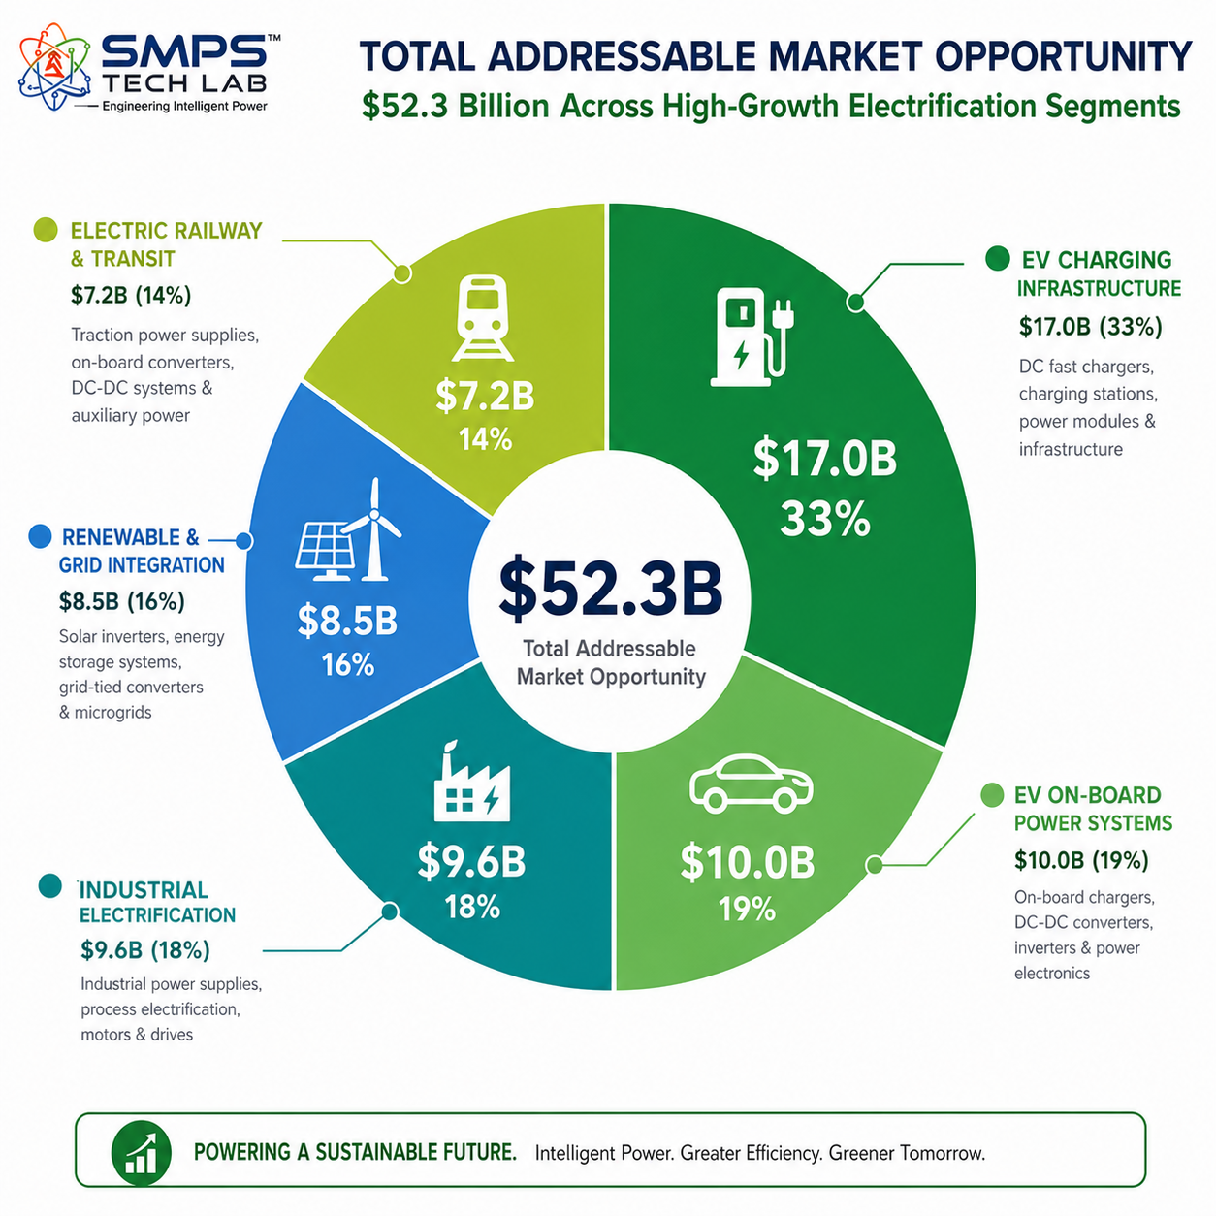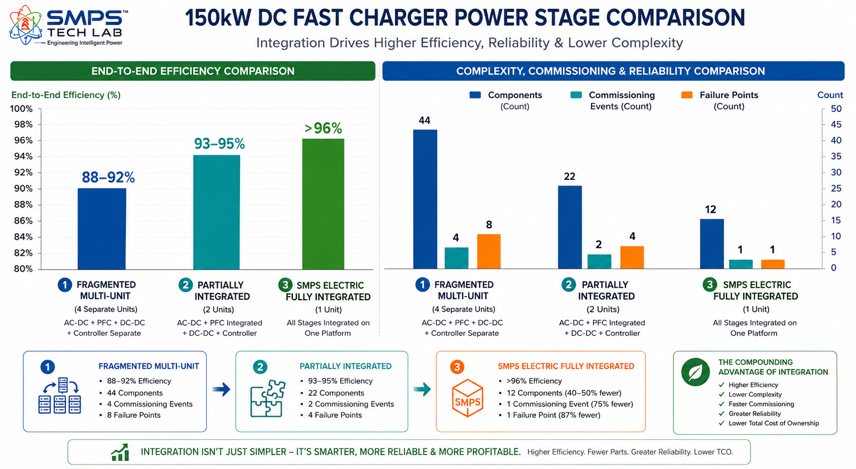
Figure 1.2 — TAM breakdown (left): EV Charging Infrastructure is the largest sector at $17.0B and fastest-growing at 25.37% CAGR. Integration efficiency benchmark (right): SMPS Electric’s fully integrated platform achieves >96% end-to-end efficiency — 4–8 percentage points above fragmented multi-unit approaches.

1.4 Why SMPS Electric, Why Now
Four forces are converging on the SMPS Electric commercialisation moment. The EV charging infrastructure growth rate is extraordinary: the US forecast moves from 4 million to 35 million charge points by 2030, and every single charge point requires an integrated SMPS power supply at its core. India’s PM e-DRIVE scheme’s INR 10,900 crore for EV charging infrastructure — with Make in India preference for domestically designed power supply solutions — creates the largest single procurement opportunity for SMPS Electric in any country. V2G mainstream adoption is driving the upgrade from unidirectional to bidirectional charging power supplies: ChargePoint launched V2G-capable Level 2 chargers in 2025; the V2G market is growing at 48.1% CAGR. And GaN/SiC semiconductor cost reductions — Infineon’s USD 830 million GaN Systems acquisition (March 2024) signalling the industry’s commitment — are enabling SMPS Electric’s high-frequency GaN/SiC topology to reach commercial price points competitive with legacy silicon MOSFET designs.
MARKET DATA POINT
Combined SMPS Tech Lab portfolio: IP-01 through IP-09 = $373.8B + IP-10 $52.3B = USD 426.1 Billion total TAM across 50 sectors and 100 applications. SMPS Electric adds the electric mobility and electrification domain — the integrated power supply that converts, manages, and delivers energy across every application in the electrification transition.

02 | TECHNOLOGY OVERVIEW  Integrated Architecture · GaN/SiC Topology · V2G Bidirectional · Smart Grid · Standards

2.1 What is SMPS Electric?
SMPS Electric is an integrated Switched-Mode Power Supply solution built specifically for electric mobility and electrification applications. The ‘Electric’ designation distinguishes it from IP-01 (Smart Hybrid SMPS, a general-purpose platform) and IP-02 (SMPS-Based CCU, a telecom-specific architecture): SMPS Electric is the electric domain specialist where every design decision — topology selection, voltage range, bidirectional capability, protocol stack, safety certification — is optimised for EV charging, vehicle on-board power, renewable energy integration, railway traction, and industrial electrification. The ‘Integrated’ architecture consolidates functions that conventional implementations deploy as separate, disconnected units: the AC-DC rectifier stage, the active power factor correction unit, the DC-DC conversion stage, the energy management controller, the smart diagnostics module, and the grid-interface protection relay — all into a single, co-optimised, factory-tested SMPS Electric platform.

2.2 The Four Integrated Technology Layers
LAYER | COMPONENT | FUNCTION | KEY INNOVATION IN IP-10
L1 | GaN/SiC Power Conversion Stage | Wide-bandgap semiconductor switches (GaN for high-frequency low-power stages, SiC for high-voltage high-power stages). LLC resonant or phase-shifted full-bridge topology. Switching frequencies >400kHz. | GaN/SiC enables 2–3x power density versus silicon MOSFET designs, enabling significantly smaller passives and dramatically reduced thermal mass. >96% peak efficiency across the load range.
L2 | Bidirectional Power Flow Architecture | Native bidirectional AC-DC-AC capability enabling V2G and V2B operation without additional hardware. Sub-100ms mode switching between EV charging and V2G discharge. Supports ISO 15118-20, CHAdeMO V2G, CCS Bidirectional. | The patent-bearing element: a single integrated SMPS that charges EVs from the grid AND discharges EV batteries back to the grid or building without requiring separate bidirectional hardware. One platform, two revenue streams (charging + V2G grid services).
L3 | Smart Grid Integration Intelligence | OCPP 2.0, OpenADR 2.0, IEC 61850 GOOSE demand response protocols. Automatic charging rate adjustment based on grid frequency, dynamic pricing, or utility signals. Solar MPPT integration for renewable-powered charging hubs. | Built-in demand response participation enables SMPS Electric installations to earn grid services revenue without additional hardware. A 100-unit charging hub with SMPS Electric’s demand response can generate USD 50,000–200,000/year in grid services income.
L4 | Integrated IoT Diagnostics & Hot-Swap Modularity | Real-time monitoring of switch junction temperatures, capacitor ESR drift, and inductor saturation margins. AI predictive maintenance engine forecasting failures 2–4 weeks in advance. Modular hot-swap architecture: any power module replaceable under live load. | Hot-swap module replacement under live load is the critical operational requirement for commercial charging infrastructure. A faulty module pulled and replaced without interrupting charging station operation eliminates the revenue loss from taking the charging point offline.
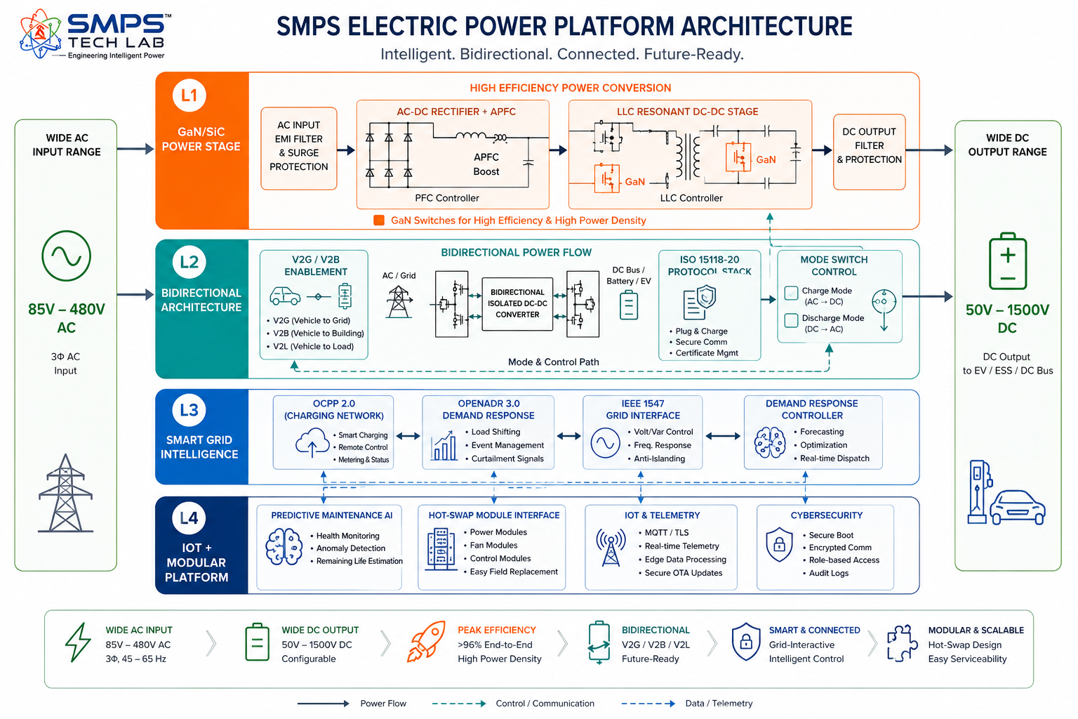

Figure 2.1 — SMPS Electric four-layer integrated architecture. All four layers reside within a single factory-tested platform — eliminating the integration, commissioning, and maintenance complexity of conventional multi-unit approaches.

2.3 GaN/SiC Topology — The Efficiency Foundation
The choice of wide-bandgap semiconductors — Gallium Nitride (GaN) and Silicon Carbide (SiC) — as the power switching devices in SMPS Electric is the architectural decision that enables the platform’s performance advantage. Conventional SMPS designs using silicon MOSFETs are limited to switching frequencies of 50–200kHz, requiring large, heavy passive components (inductors and capacitors) that dominate the physical volume of the power supply. GaN and SiC devices switch at 400kHz–1MHz, reducing passive component values by 4–8x, enabling dramatically smaller and lighter designs at equivalent power levels. SiC’s 1200V breakdown voltage makes it the preferred switch for the high-voltage DC-DC stage in DCFC and railway applications; GaN’s ultra-low gate charge enables the highest frequencies in the lower-voltage AC-DC front end for maximum power density.
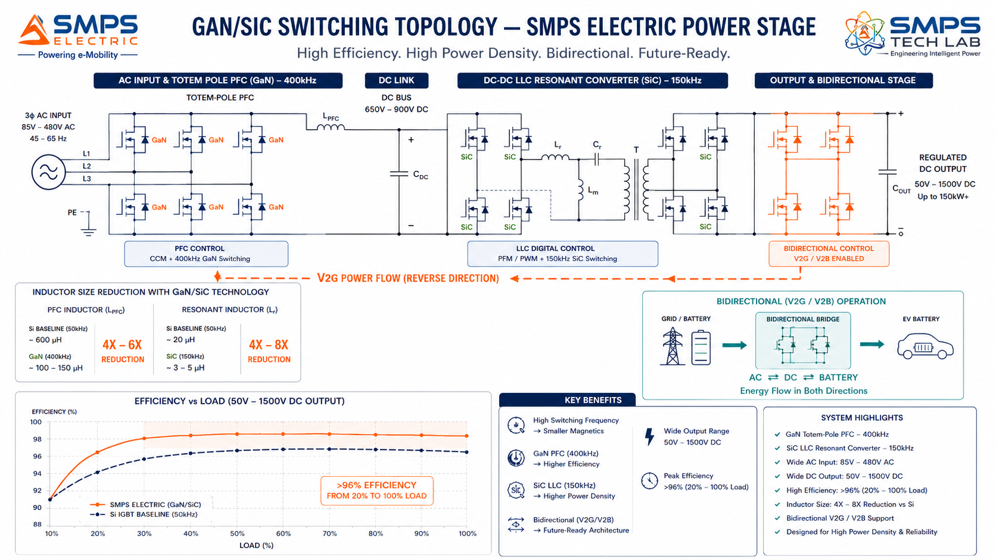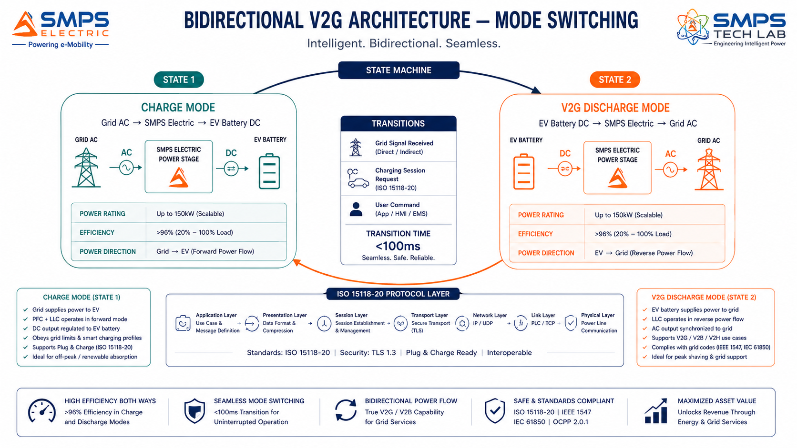
Figure 2.2 — GaN/SiC switching topology (left): 400kHz+ switching reduces passive components 4–8x versus silicon MOSFET designs, enabling >96% efficiency and dramatically higher power density. Bidirectional V2G mode switching (right): sub-100ms switching between EV charging and V2G grid discharge — the same integrated hardware platform enabling both without additional components.

2.4 Solar-Integrated Smart Charging Hub — The Multi-Source Integration Advantage
The most commercially significant application of SMPS Electric’s integrated architecture is the solar-integrated smart charging hub — where a single SMPS Electric platform simultaneously manages solar MPPT (DC-DC input), BESS bidirectional charging (DC-DC bidirectional), grid AC rectification (AC-DC), and EV DC fast charging output — functions that conventionally require four separate power conversion systems with complex inter-unit energy management. SMPS Electric’s co-optimised multi-source management achieves 25–35% lower system capex than four-unit conventional approaches, while enabling real-time energy flow optimisation that maximises solar self-consumption and minimises grid demand charges across the entire hub operation.

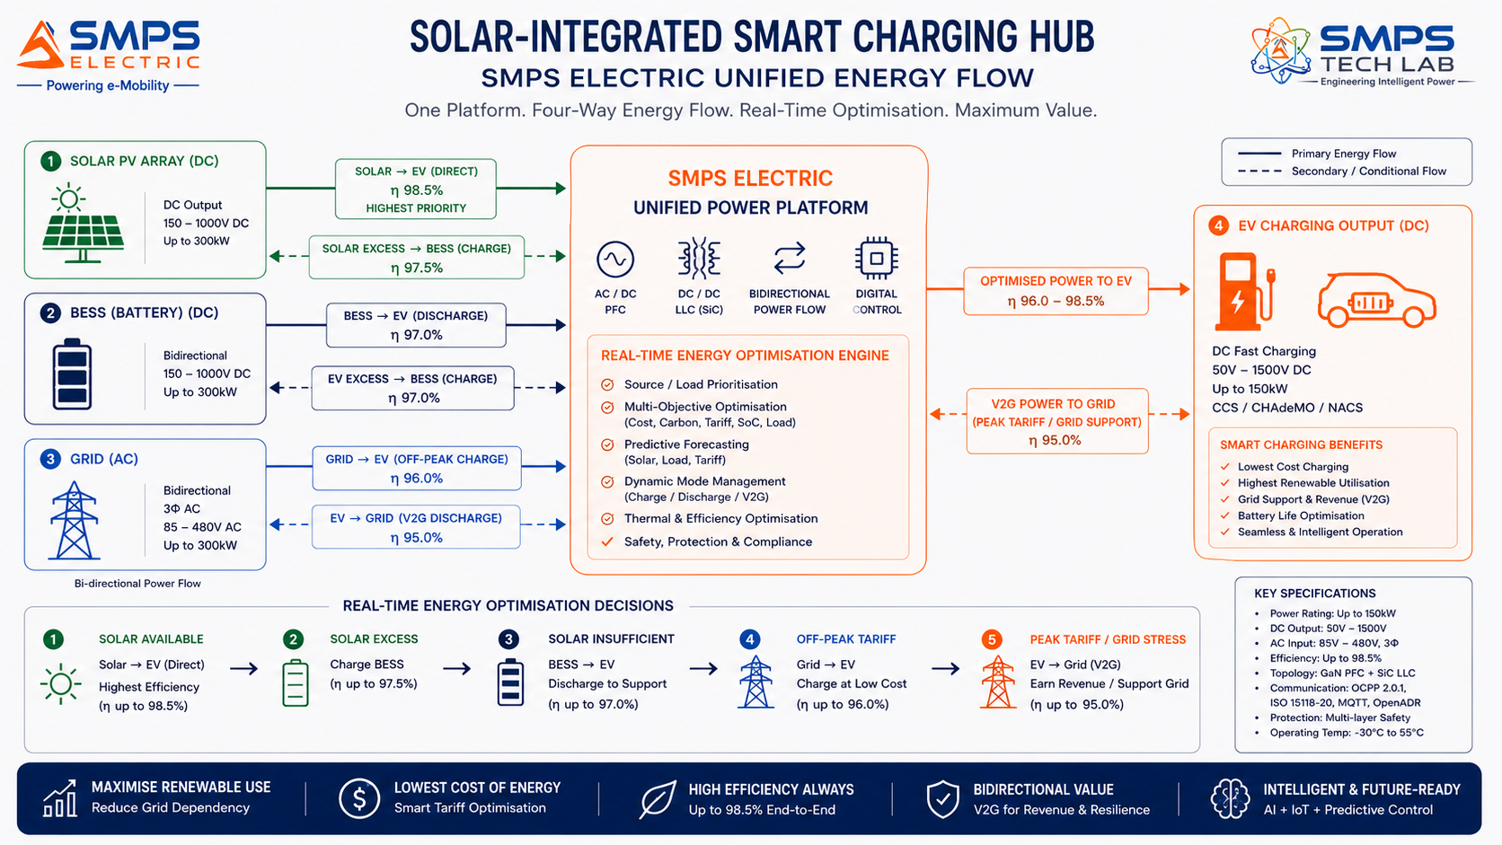Figure 2.3 — SMPS Electric managing all four energy flows simultaneously in a solar-integrated charging hub. The unified single-platform architecture enables cross-source optimisation decisions (e.g., pre-charge BESS from solar to enable V2G revenue later) that fragmented separate-unit systems cannot execute.

2.5 Standards Compliance Architecture
STANDARD | SECTOR APPLICABILITY | COMPLIANCE RELEVANCE FOR IP-10
IEC 61851 series | EV Charging (all levels) | EV conductive charging system standard. IEC 61851-1 (general), IEC 61851-21 (EMC), IEC 61851-23 (DC EVSE). Mandatory for all EV charging deployments globally.
ISO 15118 (V2G) | EV Charging, V2G, On-Board | Vehicle-to-Grid communication. ISO 15118-20 is the latest standard enabling V2G bidirectional charging and Plug & Charge. Mandatory for V2G-capable deployments.
IEC 62477 | Power Electronics | Safety requirements for power electronic converter systems. Core safety standard for all SMPS Electric variants across all five sectors.
IEEE 1547-2018 | Renewable & Grid Integration | DER grid interconnection standard. Anti-islanding, voltage/frequency ride-through, reactive power support. Required for grid-connected solar+BESS+EV hub deployments.
EN 50155 | Electric Railway | Railway electronics environmental and functional requirements. Operating temperature, vibration, humidity, EMC. Required for all traction power supply and depot charging railway applications.
IEC 62109 | Renewable Energy | Safety of power converters for PV systems. Required for SMPS Electric solar MPPT integration in charging hub applications.
OCPP 2.0 / OpenADR 2.0 | EV Charging, Smart Grid | Open Charge Point Protocol for charging network management; OpenADR for demand response. Required for network-connected commercial charging deployments.
IS 17017 / BIS AIS-138 | EV Charging (India) | Indian Standard for EV charging stations. Bureau of Indian Standards certification required for FAME III and PM e-DRIVE funded deployments in India.

03 | GLOBAL MARKET LANDSCAPE  EV Infrastructure Wave · Market Sizing · V2G Transition · GaN/SiC Validation

3.1 The Electrification Power Supply Inflection Point
The global EV charging infrastructure market’s growth rate — 25.37% CAGR per Fortune Business Insights, 20.3% CAGR per Persistence Market Research, 25% CAGR per Grand View Research, 30.3% CAGR for the US market specifically (Grand View Research) — is one of the fastest confirmed market growth rates for any hardware product category globally. This is not a market that is forecast to grow; it is a market that is growing right now, with 8.5 million BEV registrations in August 2025 alone and the US charge point installed base forecast to grow from 4 million today to 35 million by 2030. Every one of those 31 million new charge points requires an integrated SMPS power module at its core. This is not a total addressable market in the academic sense — it is an active procurement demand wave that is already underway and will sustain for at least a decade.

The V2G transition adds a further commercial dimension. The V2G market is growing at 48.1% CAGR through 2030. ChargePoint launched V2G-capable Level 2 chargers in 2025. ISO 15118-20 V2G certification programmes are active globally. Every V2G deployment requires a bidirectional power supply — and SMPS Electric’s native bidirectional architecture means the upgrade from unidirectional to V2G charging is a configuration change, not a hardware replacement.

3.2 The Four Structural Megatrends
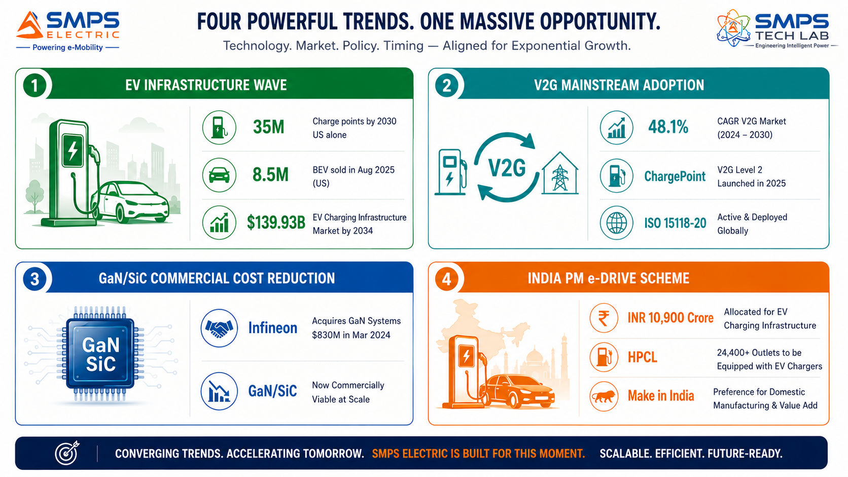
Figure 3.1 — Four structural megatrends defining the SMPS Electric commercial window. The EV infrastructure wave is not a forecast — it is an active procurement programme executing globally right now.

3.3 Global Market Sizing — Primary Reference Data
MARKET SEGMENT | 2025 VALUE | PROJECTED | CAGR | HORIZON | SOURCE
EV Charging Infrastructure Market | USD 18.16B | USD 139.93B | 25.37% | 2034 | Fortune Business Insights
EV Charging Infrastructure (Persistence) | USD 31.1B | USD 113.4B | 20.3% | 2032 | Persistence Market Research
EV Charging Infrastructure (Grand View) | USD 40.22B | USD 238.82B | 25.0% | 2033 | Grand View Research
US EV Charging Market | USD 5.09B | (growing) | 30.3% | 2030 | Grand View Research
Integrated EV DC Charger Market | USD 2.26B | USD 8.96B | 16.8% | 2035 | Market Reports World
Power Electronics Market | USD 27.23B | USD 49.04B | 6.84% | 2034 | Fortune Business Insights
EV Charging Market (MarkNtel) | USD 20.22B | (growing) | 18.12% | 2030 | MarkNtel Advisors
Industrial Power Supply Market | USD 17.2B | (growing) | 5.6% | 2034 | Global Market Insights

CAGR Comparison — SMPS Electric Target Market Segments

V2G Grid-Interactive Market ██████████████████████████ 48.1%
US EV Charging Market (Grand View) ████████████████░░░░░░░░░░ 30.3%
EV Charging Infrastructure (Fortune BI) ██████████████░░░░░░░░░░░░ 25.37%
EV Charging Infrastructure (Grand View) ██████████████░░░░░░░░░░░░ 25.0%
Renewable & Grid Integration (V2G+Solar) ████████████░░░░░░░░░░░░░░ 22.1%
EV Charging (Persistence Market Research) ███████████░░░░░░░░░░░░░░░ 20.3%
EV On-Board Power Systems ██████████░░░░░░░░░░░░░░░░ 18.3%
EV Charging Market (MarkNtel Advisors) ██████████░░░░░░░░░░░░░░░░ 18.12%
Industrial Electrification ████████░░░░░░░░░░░░░░░░░░ 14.2%
Electric Railway & Transit █████░░░░░░░░░░░░░░░░░░░░░ 8.8%
Sources: Fortune Business Insights, Persistence Market Research, Grand View Research, Market Reports World, MarkNtel Advisors, Global Market Insights, PwC (2025–2026 publications)

04 | TOTAL ADDRESSABLE MARKET  Five Electric Domain Sectors · Ten Applications · USD 52.3 Billion

4.1 Methodology
The TAM framework maps SMPS Electric across five strategic electric domain sectors with two primary commercial applications per sector, producing ten independently validated commercialisation pathways. The USD 52.3 billion TAM represents the integrated power supply sub-segment within each sector — the portion addressable by SMPS Electric’s integrated GaN/SiC platform with bidirectional V2G, smart grid integration, and hot-swap modularity.

STRATEGIC NOTE
SMPS Electric’s five sectors span the complete electrification ecosystem from the grid-edge charging station to the on-board vehicle power supply to the industrial process power supply. No single competing product covers all five sectors from a unified platform. This five-sector unified architecture creates cross-domain bundling opportunities — a charging network operator deploying SMPS Electric at 1,000 DCFC stations can use the same platform family for their solar-integrated hub upgrades and their industrial depot charging installations without re-qualifying a second supplier.

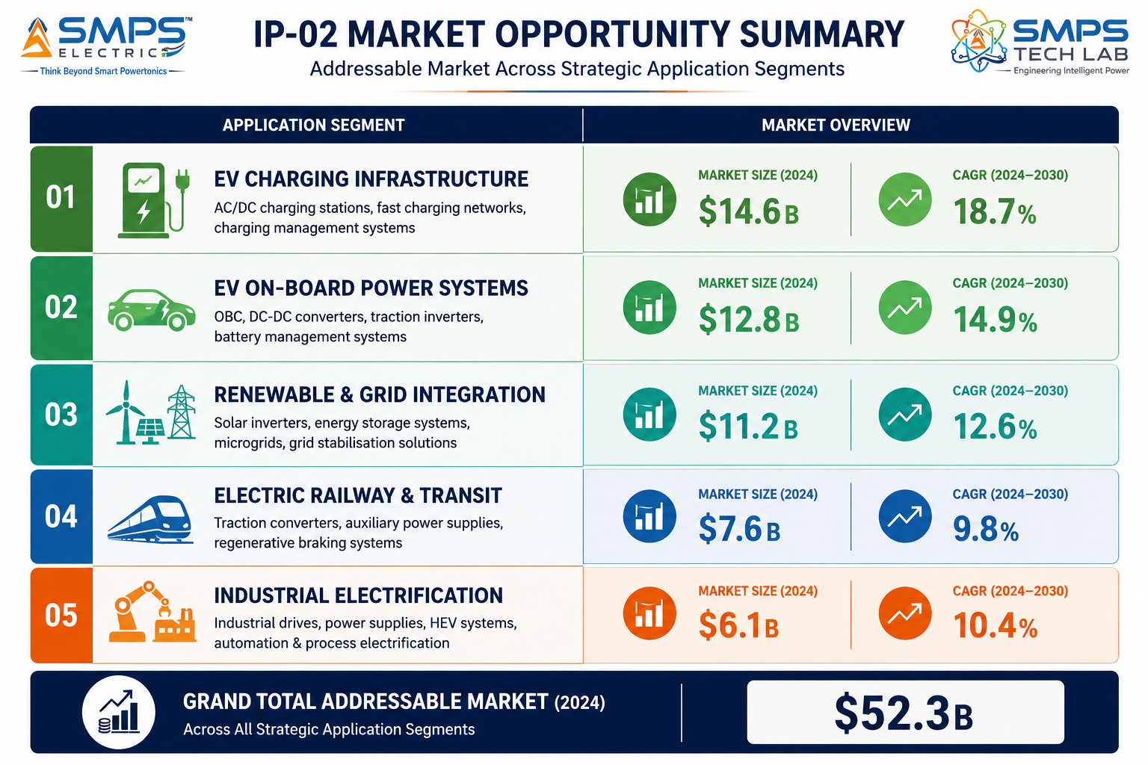Figure 4.1 — SMPS Electric application matrix. Ten commercial pathways across five sectors — the unified integrated SMPS platform applicable across every electric domain application.

4.2 Consolidated TAM Summary
SECTOR | APPLICATION | USE CASE SUMMARY | APP SIZE | SECTOR TAM | CAGR
EV Charging Infra | DC Fast Charging Integrated Power Module | Hot-swap modular SMPS for 50–360kW DCFC; GaN/SiC; >96% efficiency; V2G ready; OCPP 2.0; liquid-cooled | $9.8B | $17.0B | 20.3–25.37%
EV Charging Infra | Level 2 Smart Charging Power Supply | 7.4–22kW integrated EVSE with dynamic load balancing, solar integration, V2G option, IS 17017 India | $7.2B | $17.0B | 20.3–25.37%
EV On-Board Power | On-Board Charger (OBC) Integrated Unit | 22kW integrated OBC: APFC + DC-DC in single unit; 800V architecture; V2G; ISO 15118-20; IP67; CISPR 25 | $5.8B | $10.0B | 18.3%
EV On-Board Power | Bidirectional DC-DC Converter & APM | HV-to-12V/48V integrated auxiliary power; passenger + commercial EV; 3–20kW; ISO 26262 ASIL-B; regen | $4.2B | $10.0B | 18.3%
Renewable & Grid | Solar-Integrated Smart Charging Hub | Unified SMPS managing solar MPPT+BESS+grid+EV; replaces 4 separate units; 25–35% capex reduction | $5.4B | $8.5B | 22.1%
Renewable & Grid | V2G & Grid-Interactive Charging | Bidirectional SMPS; V2G discharge+charging; <100ms mode switch; ISO 15118-20; OpenADR; V2G revenue | $3.1B | $8.5B | 22.1%
Electric Railway | Railway Traction Wayside Converter | Active SMPS replacing legacy rectifiers; regenerative braking return; unity PF; EN 50155; 40yr life | $4.2B | $7.2B | 8.8%
Electric Railway | Metro & Electric Bus Depot Charging | 1MW integrated depot charging; 500-bay load management; solar integration; SCADA; India metro expansion | $3.0B | $7.2B | 8.8%
Industrial Electrification | Industrial High-Power DC Power Supply | 100kW–10MW modular SMPS; electrolysers, induction heating; <0.1% regulation; IEC 62477; 24/7 operation | $4.8B | $9.6B | 14.2%
Industrial Electrification | EV Fleet & Intralogistics Depot Charging | Smart fleet charging platform; dynamic load balancing; solar integration; WMS API; IS 17017 India | $4.8B | $9.6B | 14.2%
TOTAL ADDRESSABLE MARKET — IP-10 SMPS ELECTRIC — INTEGRATED POWER SUPPLY SOLUTIONS (2025) |  |  |  | ~USD 52.3 Billion

MARKET DATA POINT
Combined SMPS Tech Lab portfolio TAM: IP-01 through IP-09 $373.8B + IP-10 $52.3B = USD 426.1 Billion across 50 sectors and 100 applications. SMPS Electric adds the electric mobility and electrification power supply layer — completing the portfolio’s coverage of the entire energy transition ecosystem from power conversion to intelligent storage to EV charging infrastructure.

05 | INDIA MARKET INTELLIGENCE  PM e-DRIVE · FAME III · HPCL/V-GREEN · Make in India EV · Railways

5.1 India as First and Primary Market
India presents the single most compelling first-market for SMPS Electric globally. The PM e-DRIVE scheme’s INR 10,900 crore committed to EV charging infrastructure creates a direct, government-funded procurement pipeline with Make in India preference for domestically designed charging power supplies. V-GREEN’s December 2025 agreement with HPCL to deploy EV charging at 24,400+ HPCL fuel outlets creates the single largest private charging network deployment in India’s history — every charging point requiring an integrated SMPS Electric power module. India’s EV two-wheeler market targeting 80% penetration by 2030 creates enormous on-board charger demand. Indian Railways’ completed 100% electrification and ongoing metro expansion (1,000+ km under construction in 2025) creates sustained railway and depot charging power supply demand. The combination of government procurement mandate, private sector deployment scale, and Make in India preference creates a market access advantage for a domestically designed integrated SMPS solution that no foreign competitor can match.
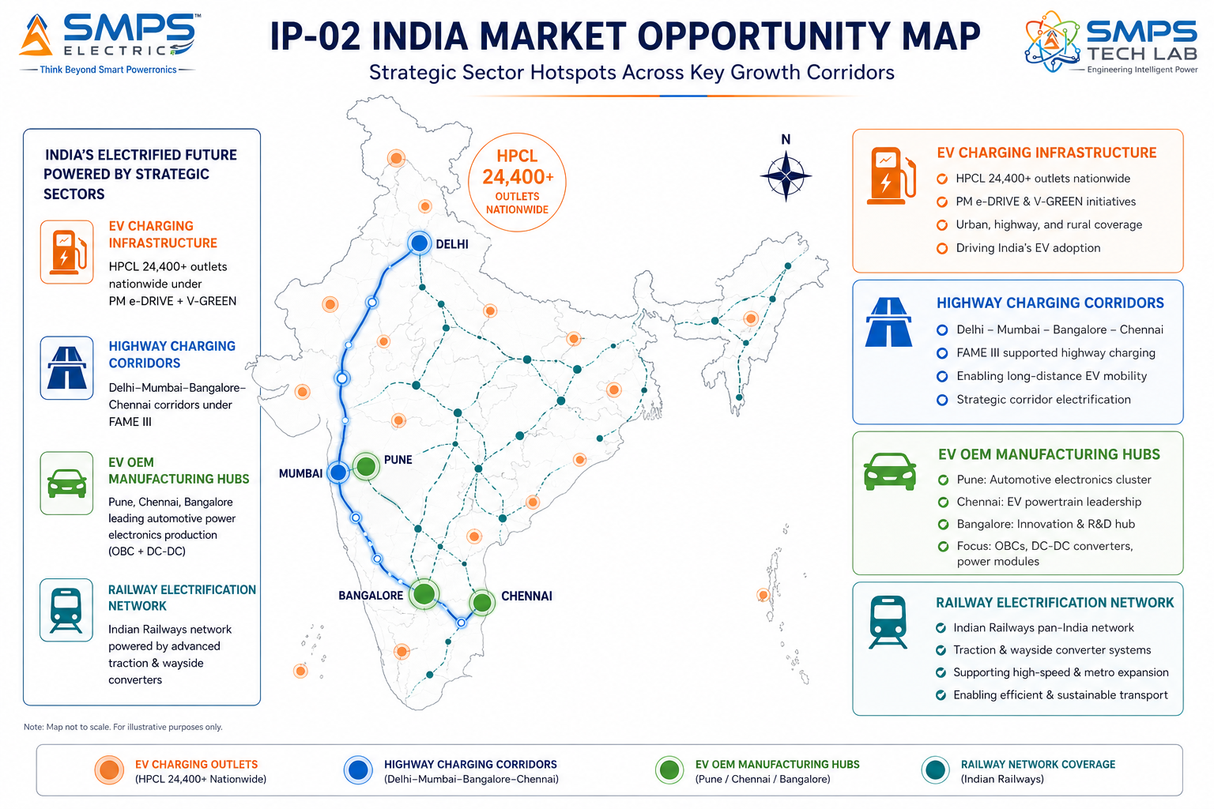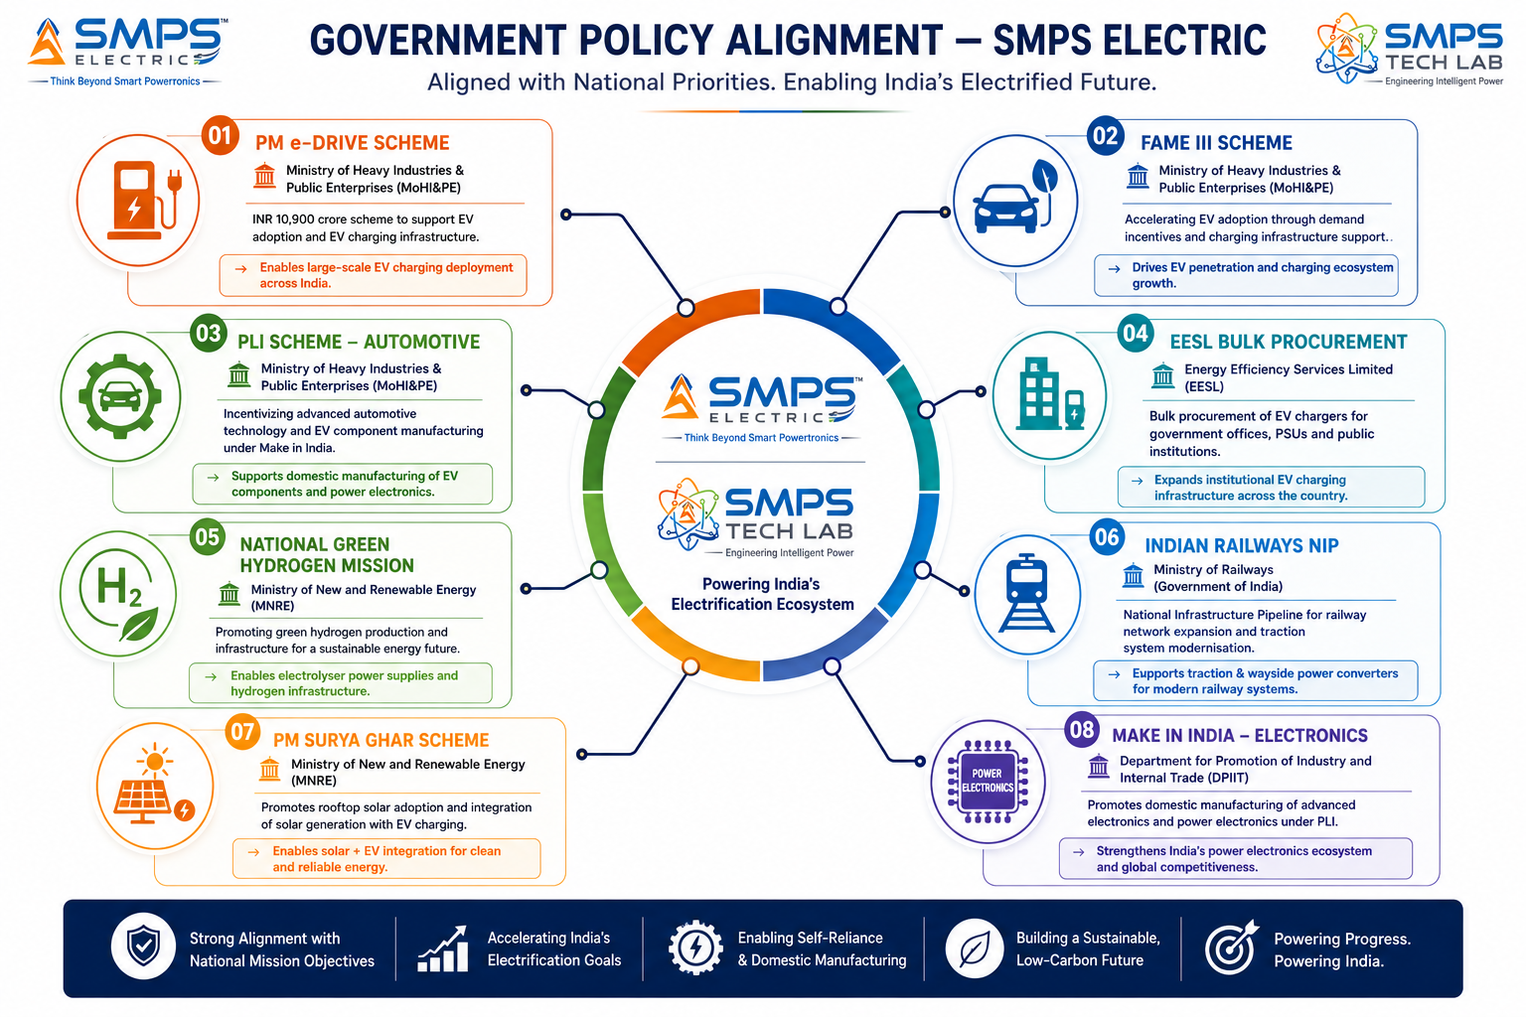

Figure 5.1 — India deployment hotspot map (left): SMPS Electric has active procurement demand at every node of India’s EV and electrification infrastructure. Policy alignment (right): PM e-DRIVE and FAME III create government-funded procurement channels with Make in India preference directly benefiting domestically designed SMPS Electric solutions.

5.2 India Market Sizing — SMPS Electric Relevant Segments
INDIA MARKET SEGMENT | 2025E VALUE | PROJECTED | CAGR | HORIZON
India EV Charging Infrastructure | USD 1.8B | USD 12.5B | ~32% | 2030
India EV On-Board Power Electronics | USD 0.6B | USD 4.2B | ~32% | 2030
India Railway Power Electronics (TSS) | USD 0.4B | USD 0.9B | ~12% | 2030
India Industrial Power Supply | USD 1.2B | USD 2.1B | ~8% | 2030
India Green Hydrogen Electrolyser (PSU) | USD 0.3B | USD 3.5B | ~45% | 2030
India Solar+EV Integrated Charging | USD 0.2B | USD 1.8B | ~35% | 2030

06 | GOVERNMENT POLICY & REGULATORY ALIGNMENT  India EV Schemes · Railway · Industrial · Global Standards

6.1 India & Global Policy with Direct SMPS Electric Alignment
SCHEME / PROGRAMME | MINISTRY / BODY | RELEVANCE TO SMPS ELECTRIC | COMMERCIAL IMPLICATION
PM e-DRIVE Scheme | MoHI&PE | INR 10,900 crore for EV charging infrastructure; Make in India preference for charging equipment | Primary India procurement channel for DCFC and Level 2 power modules; domestic design preference
FAME III (Advanced) | MoHI&PE | EV acceleration programme; charging infrastructure components with domestic content requirement | OBC and DC-DC converter supply to Indian EV OEMs under FAME III automotive PLI preference
V-GREEN + HPCL Agreement | V-GREEN / HPCL (MoPNG) | 24,400+ HPCL fuel outlet EV charging deployment — December 2025 agreement | Single largest India charging deployment; every charging point requires SMPS Electric power module
EESL Bulk Procurement Tenders | EESL / MoP | Government office, highway, and public space EV charging; EESL aggregate procurement | EESL bulk tenders for public charging power supply; Make in India preference for domestically designed units
National Green Hydrogen Mission | MNRE | INR 19,744 crore; 5 MMT green hydrogen; electrolyser power supply requirement | SMPS Electric high-power industrial DC power supply directly addresses electrolyser power conditioning
Indian Railways NIP Traction Modernisation | Ministry of Railways | National Infrastructure Plan; traction substation modernisation budget | SMPS Electric wayside converter as Made-in-India alternative to imported traction power electronics
PLI Automotive — EV Components | MoHI&PE | PLI for EV components including on-board chargers and DC-DC converters | 4–6% incentive on incremental OBC and DC-DC converter supply to Indian EV OEMs
US NEVI Program (Export Market) | US DoT/DoE | 500,000 EV chargers by 2030; Made-in-India SMPS modules eligible for non-ITAR supply | Export opportunity: US NEVI funded chargers can use Indian-manufactured power modules

07 | IP AS AN INDUSTRY PLUGIN  Five-Sector Integration Architecture · EV Ecosystem Plugin

7.1 The Plugin Architecture — Five Electric Host System Categories
SMPS Electric is architecturally designed as the integrated power conversion plugin across five categories of host system in the electric ecosystem. In each case, SMPS Electric replaces the conventional multi-unit power conversion cascade with a single integrated platform that connects to the host system’s energy management, network, and control infrastructure through standard protocols (OCPP 2.0, Modbus, CANbus, REST API). The integration model is commercially efficient: SMPS Electric is factory-tested as an integrated unit before installation, dramatically reducing commissioning time versus separately procured multi-unit systems.
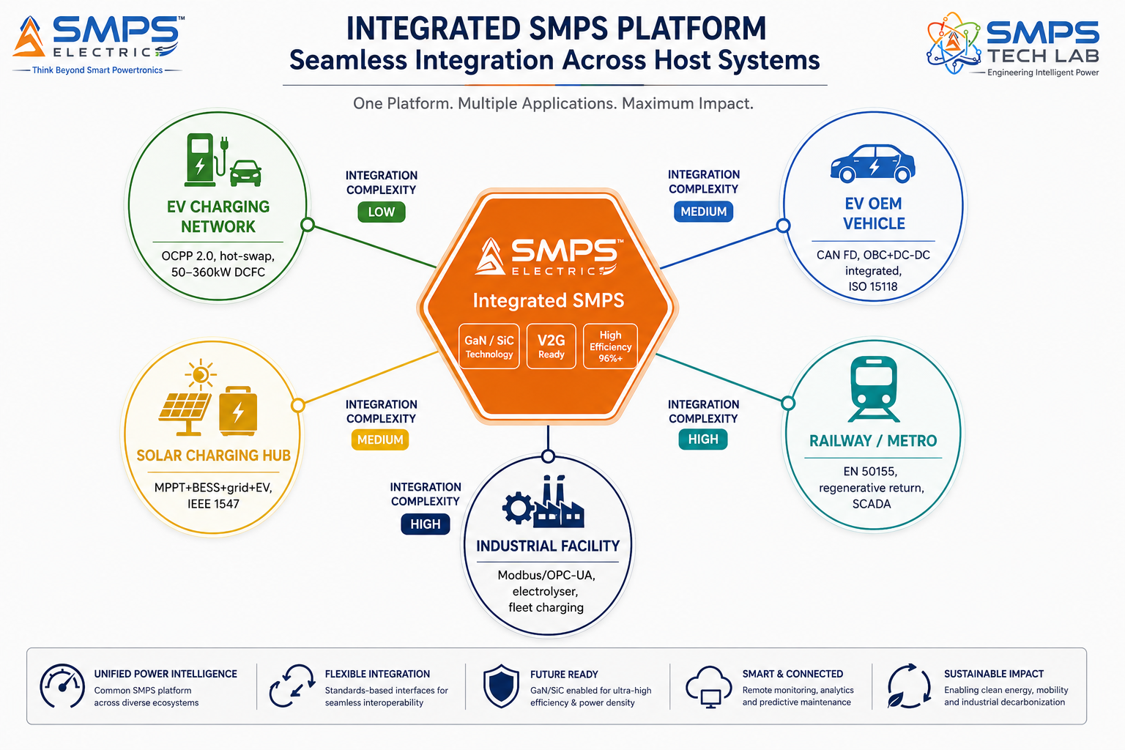
Figure 7.1 — SMPS Electric as the integrated electric domain plugin across five host system categories. Factory-tested as one unit before installation, it replaces the multi-unit cascade that conventional approaches require in every application.

7.2 Plugin Integration Matrix
HOST SYSTEM | PLUGIN ROLE | VALUE AT SYSTEM LEVEL | INTEGRATION COMPLEXITY
EV Charging Station | Integrated DC power module: AC-DC + PFC + DC-DC hot-swap; OCPP 2.0 to network; V2G ready | >96% efficiency; hot-swap uptime; V2G revenue stream; single commissioning event | LOW-MED — 3-phase AC connection, OCPP 2.0 network, CHAdeMO/CCS/NACS connector interface
Electric Vehicle (OEM) | Integrated OBC + DC-DC: single unit for on-board charging and auxiliary power; V2G capable | Higher power density; lighter weight; lower vehicle integration cost; V2G revenue for driver | HIGH — AEC-Q100, ISO 26262 ASIL-B, 800V arch compatibility, CAN FD, OEM homologation
Solar+BESS Charging Hub | Unified energy management: solar MPPT + BESS bidirectional + grid AC + EV DC; all in one | 25-35% capex reduction vs. 4-unit; solar self-consumption optimisation; demand charge reduction | MEDIUM — solar PV array connection, BESS interface, IEEE 1547 grid tie, OCPP 2.0
Railway Traction System | Active wayside converter: AC-DC rectification with regenerative return and harmonic filtering | 15-30% energy savings from regen; unity PF; harmonic compliance; 40-year lifecycle | HIGH — EN 50155, 33kV transformer interface, IEC 62497 insulation, SCADA/IEC 61850
Industrial Electrification | High-power DC power supply for electrolyser/furnace/fleet; dynamic load management | <0.1% current regulation; IEC 62477 safety; PROFIBUS/OPC-UA EMS integration; 24/7 duty | MEDIUM — 3-phase HV connection, EMS integration, IEC 62443 OT security for industrial

08 | COMMERCIALISATION STRATEGY  Revenue Models · Market Priority · Go-to-Market Architecture

8.1 Commercialisation Philosophy
The SMPS Electric commercialisation strategy prioritises the EV charging infrastructure sector as the fastest near-term revenue pathway (6–18 months) because it has the highest CAGR, the most active procurement programmes (PM e-DRIVE, FAME III, NEVI, AFIR), and the simplest commercial model — supply integrated power modules to EV charging OEMs as the core power conversion component of their products. India’s PM e-DRIVE scheme and HPCL/V-GREEN deployment create immediate domestic procurement demand. The renewable energy and grid integration sector follows as a 12–24 month high-priority pathway, capitalising on SMPS Electric’s V2G and solar integration capability. Industrial electrification provides the largest per-project revenue with the most predictable deployment timelines. EV on-board power and railway are premium segments with longer qualification cycles but highest per-unit values.
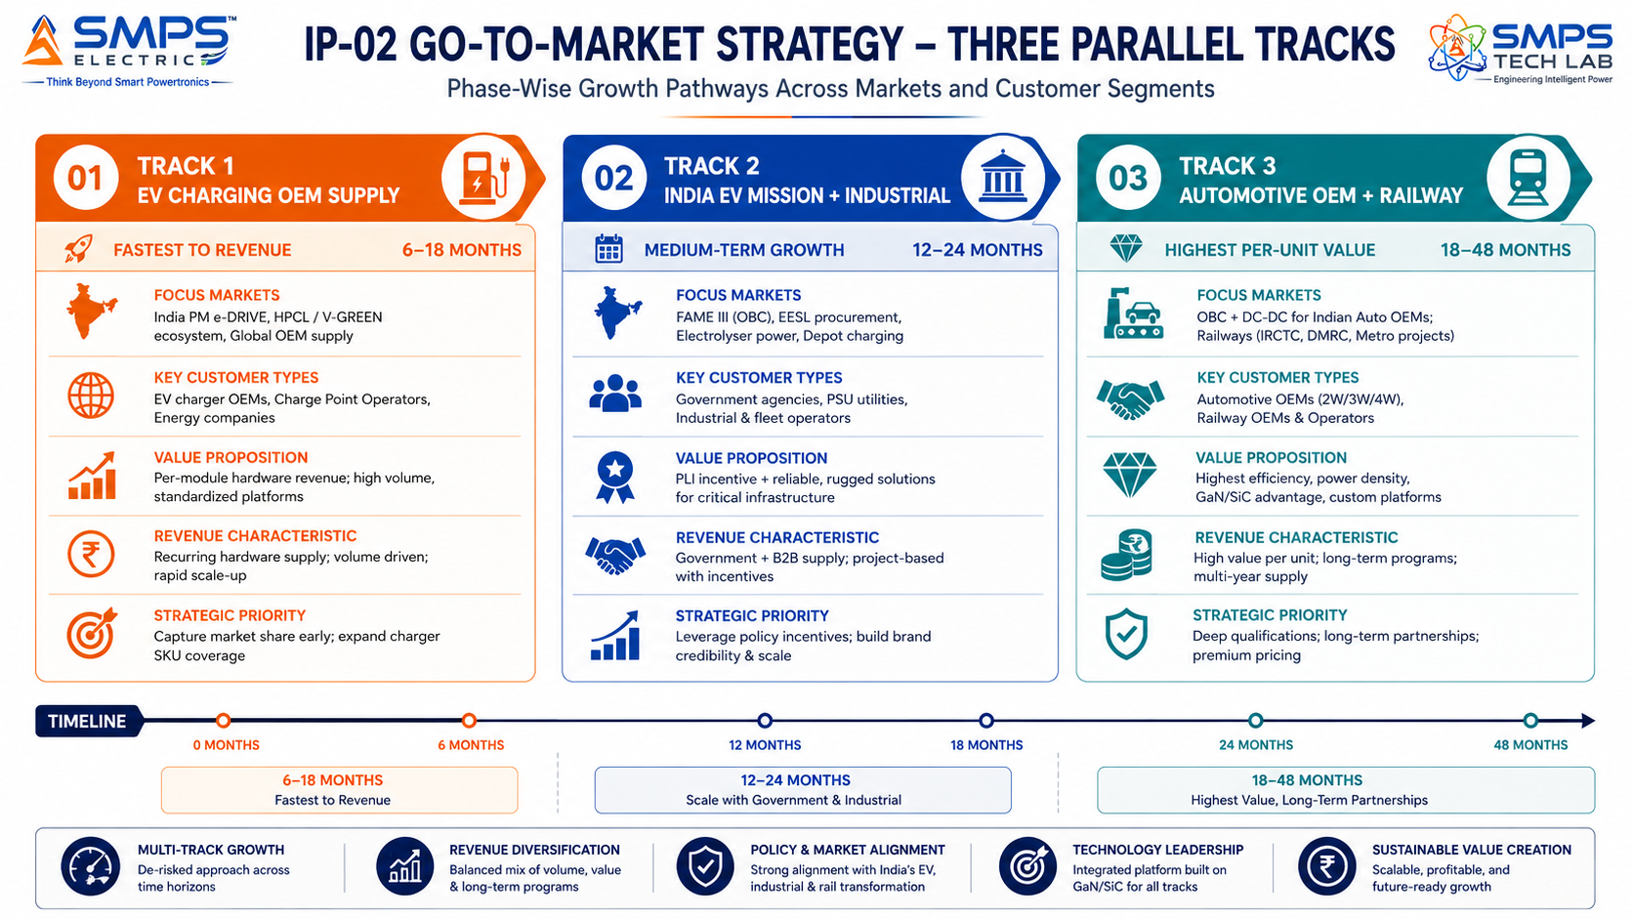
Figure 8.1 — Three parallel pathways. EV charging OEM supply provides fastest revenue through the active global procurement cycle; India EV Mission + industrial provides the largest domestic volume; automotive OEM + railway provides the highest per-unit value.

8.2 Market Priority Matrix
SECTOR | TAM 2025 | CAGR | IP FIT | TIME-TO-REV | PATHWAY | PRIORITY
EV Charging Infrastructure | $17.0B | 20–25.37% | Excellent | 6–18 mo | OEM Supply | HIGHEST
Renewable & Grid Integration | $8.5B | 22.1% | Excellent | 12–24 mo | Hub + V2G | HIGH
EV On-Board Power Systems | $10.0B | 18.3% | Excellent | 18–36 mo | Auto OEM Supply | HIGH
Industrial Electrification | $9.6B | 14.2% | Strong | 12–24 mo | Direct + EESL | HIGH
Electric Railway & Transit | $7.2B | 8.8% | Strong | 24–48 mo | Railways + Metro | MED-HIGH

09 | COMPETITIVE LANDSCAPE  Market Positioning · Advantage Scorecard · IP Moat

9.1 Competitive Architecture Overview
The EV charging power module market has well-established Tier 1 OEM suppliers: Delta Electronics, BTC Power, Bel Power, ABB, Siemens, and Schneider Electric all supply integrated power modules to charging station manufacturers. The key strategic finding across all five SMPS Electric sectors is the same: established competitors supply application-specific products (a Delta DCFC module, a Siemens OBC, a railway wayside converter) but none supplies an integrated unified platform covering all five sectors simultaneously from a single architecture. The cross-sector unified platform is SMPS Electric’s structural commercial advantage: a charging network operator who designs their DCFC stations around SMPS Electric modules can use the same platform family for their solar hub upgrades, their fleet depot charging, and their industrial green hydrogen electrolyser power supply — without qualifying a second supplier.

CATEGORY | KEY PLAYERS | MARKET FOCUS | SMPS ELECTRIC ARCHITECTURAL DIFFERENTIATION
EV Charging Power Module OEMs | Delta Electronics, BTC Power, Bel Power, Phihong | DCFC and Level 2 power modules | Application-specific single-function modules. No cross-sector unified platform. No native V2G in standard portfolio. No solar+BESS+grid+EV multi-source integration.
Automotive On-Board Charger OEMs | BorgWarner, Valeo, MAHLE, Delphi | EV OBC and DC-DC converters | OBC-only or DC-DC-only products; not integrated multi-function. No cross-domain to charging infrastructure. No India domestic PLI-qualified manufacturing.
Industrial Power Supply OEMs | Siemens, Schaffner, TDK-Lambda, Cosel | Industrial and process power supplies | Industrial-focused; not optimised for EV charging protocols (OCPP 2.0, ISO 15118). No V2G capability. No unified cross-sector platform.
Indian EV Charging Manufacturers | Exicom, TATA Power EV, Fortum, Kazam | India EV charging infrastructure | India-focused but import-dependent on power modules from Delta/BTC. SMPS Electric replaces the imported module with a domestically designed equivalent qualifying for Make in India preference.
Railway Power Electronics OEMs | Alstom, Siemens Mobility, ABB Traction | Railway traction electronics | Railway-specific single-domain. No cross-sector to EV charging or industrial. Import preference issue for Indian Railways traction modernisation.

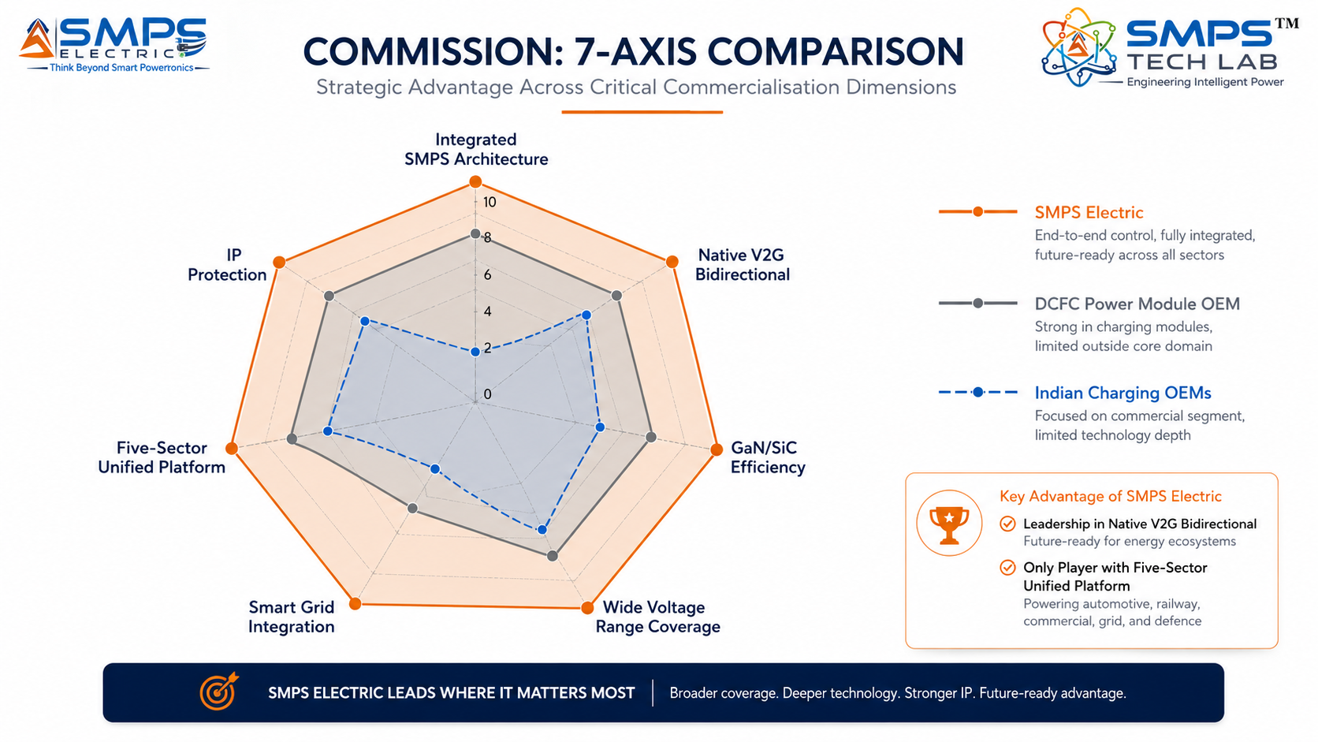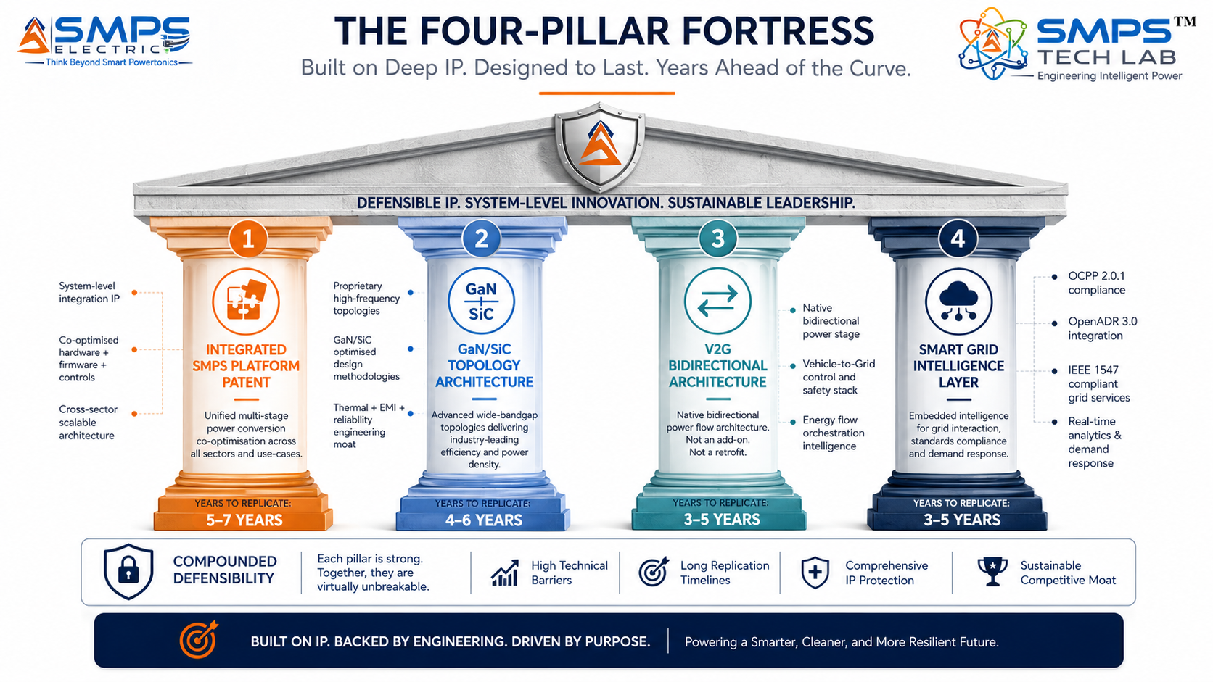
Figure 9.1 — Competitive radar (left): SMPS Electric scores 8–10/10 across all dimensions; cross-sector unified platform and native V2G are the structurally unreplicable advantages. Four-pillar moat (right): the integration patent combined with V2G architecture and smart grid intelligence creates a compound competitive position.

10 | INVESTMENT THESIS & FINANCIAL FRAMEWORK  Value Creation · Revenue Projections · Capital Deployment

10.1 The Investment Case
The investment case for SMPS Electric is defined by three compounding structural drivers. First, the EV charging infrastructure market at $17.0B growing at 20–25.37% CAGR is the fastest-growing TAM in the entire SMPS Tech Lab portfolio — and SMPS Electric is the core hardware that every charging station deployment requires. Second, India’s PM e-DRIVE scheme’s INR 10,900 crore with Make in India preference creates a government-funded domestic procurement programme where a domestically designed integrated SMPS power module holds structural procurement advantage over imported alternatives from Delta, BTC, and ABB. Third, V2G’s 48.1% CAGR represents the most significant technology upgrade cycle in EV charging infrastructure — and SMPS Electric’s native bidirectional architecture means every SMPS Electric installation is V2G-upgradeable through software configuration, not hardware replacement.
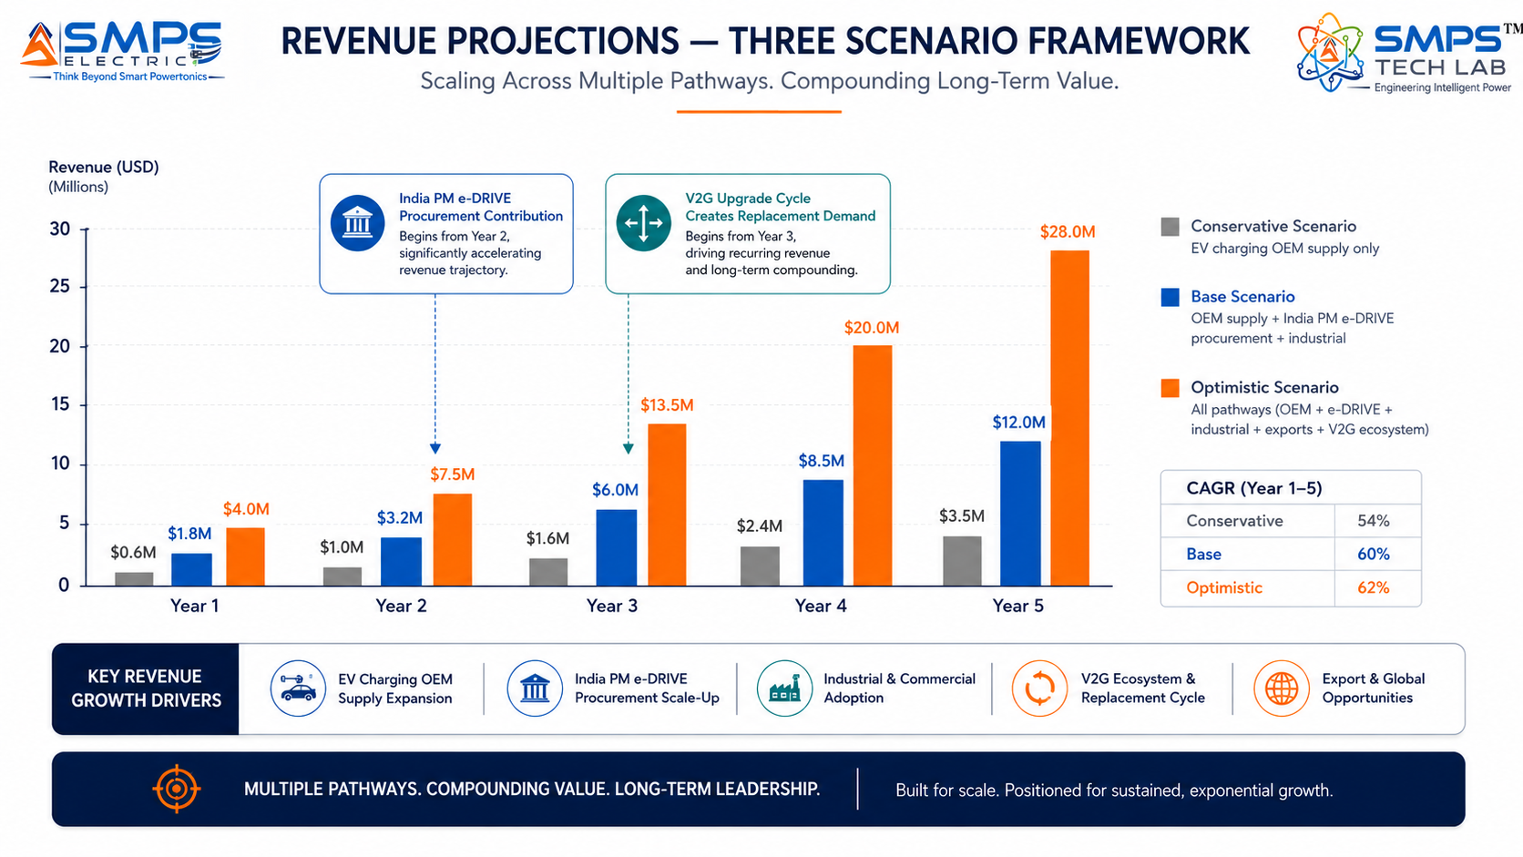

Figure 10.1 — SMPS Electric revenue projections. EV charging OEM supply provides fastest near-term revenue; India PM e-DRIVE creates the largest domestic volume in Year 2+; V2G upgrade cycle creates a replacement hardware wave from Year 3.

10.2 Illustrative Revenue Scenarios
SCENARIO | YEAR 1 | YR 2–3 CAGR | YR 4–5 CAGR | KEY ASSUMPTIONS
Conservative (Charging OEM Supply) | USD 600K–1M | +30% | +25% | 2 EV charging OEM supply agreements (India); IEC 61851 + IS 17017 certified; PM e-DRIVE participation
Base (OEM + India + Industrial) | USD 1.8–2.5M | +55% | +45% | OEM supply + India PM e-DRIVE tender + EESL + industrial depot charging; PLI Automotive OBC
Optimistic (All Pathways) | USD 4–5M | +75% | +65% | All pathways + automotive OEM OBC + HPCL/V-GREEN supply + railway wayside + green hydrogen PSU

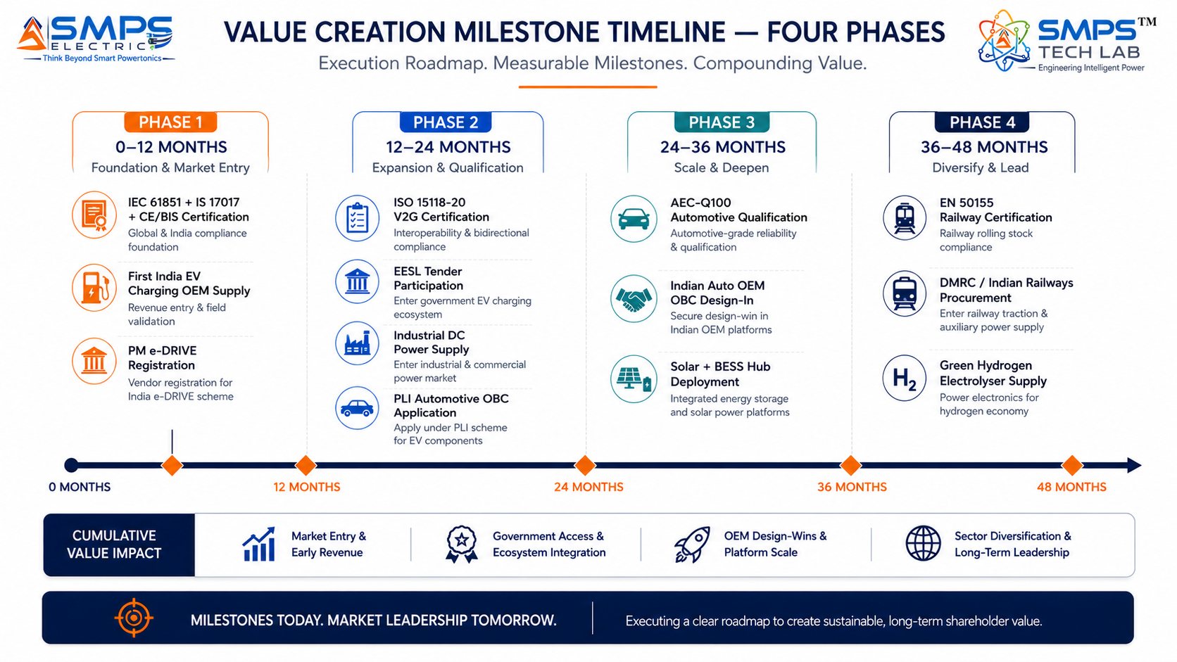
Figure 10.2 — Four-phase milestone roadmap. IEC 61851 + IS 17017 certification in Phase 1 enables immediate India market access under PM e-DRIVE; ISO 15118-20 V2G in Phase 2 creates the V2G upgrade market opportunity; automotive qualification in Phase 3 opens the highest per-unit value pathway.
RISK ADVISORY
India’s PM e-DRIVE scheme’s INR 10,900 crore for EV charging infrastructure — with IS 17017-certified Make in India power modules preferred — is the single most concentrated procurement opportunity in the SMPS Electric portfolio. The HPCL/V-GREEN agreement for 24,400+ charging outlets represents potential for tens of thousands of integrated SMPS Electric power modules across a single commercial contract. No other market opportunity in the SMPS Tech Lab portfolio offers this combination of scale, speed, and government-backed procurement preference for domestically designed solutions.

11 | FUTURE ROADMAP  Technology Evolution · Megawatt Charging · Grid-Forming · V2G Fleet

11.1 Technology Generation Roadmap
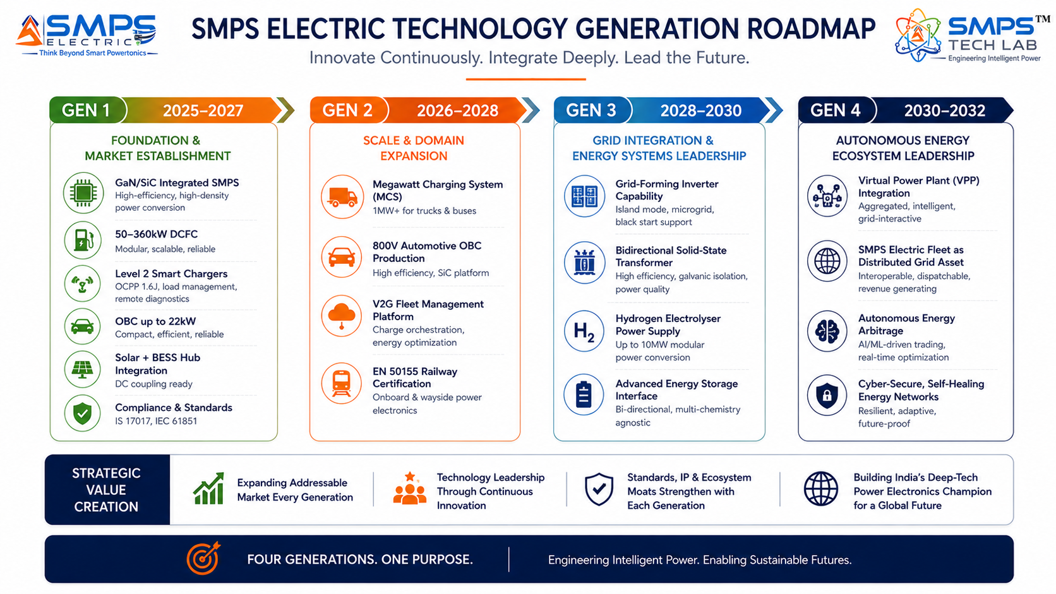
Figure 11.1 — SMPS Electric four-generation roadmap. From integrated GaN/SiC DCFC (Gen 1) to Virtual Power Plant fleet integration (Gen 4) — each generation adding commercial value from the same core integrated SMPS architecture.
GENERATION | TECHNOLOGY FOCUS | TARGET TIMELINE | MARKET IMPACT
Gen 1 (Current) | GaN/SiC integrated SMPS: 50-360kW DCFC, Level 2 smart, 22kW OBC, solar hub, V2G; IEC 61851/IS 17017/ISO 15118 certified | 2025–2027 | India PM e-DRIVE + EV charging OEM supply + solar-integrated hub + EV OBC Indian auto OEM
Gen 2 | Megawatt Charging System (MCS) 1MW+ for trucks/freight; 800V automotive OBC at production volume; V2G fleet management SaaS platform; EN 50155 railway deployment | 2026–2028 | Heavy truck and bus charging infrastructure; automotive OEM production volumes; V2G revenue stream; railway
Gen 3 | Grid-forming inverter mode (islanding/microgrid formation); bidirectional solid-state transformer; green hydrogen electrolyser 10MW DC power supply; grid services VPP foundation | 2028–2030 | Microgrid-forming charging hubs; utility-scale green hydrogen; V2G fleet as VPP asset
Gen 4 | Virtual Power Plant (VPP) integration: SMPS Electric fleet managed as distributed grid asset; autonomous energy arbitrage; AI-driven demand response optimization across fleet | 2030–2032 | SMPS Electric fleet generating grid services revenue; autonomous energy cost optimisation across all installations

11.2 Adjacent Application Opportunities
- Megawatt Charging System (MCS) for Heavy Transport: Electric trucks and freight vehicles require charging at power levels of 1–3.5MW (Megawatt Charging System standard). SMPS Electric’s modular scalable architecture is directly extensible to MCS power levels by stacking modules — addressing the fast-growing electric truck charging infrastructure market as diesel truck fleets electrify.
- Marine & Port Electrification (Shore Power): Cruise ships, ferries, and container ships at port berths require shore power connections (cold ironing) providing 500kW–10MW. SMPS Electric’s high-power modular architecture and marine-compatible enclosure option directly addresses shore power systems — complementing the Sagarmala Smart Port electrification programme.
- Green Hydrogen Electrolyser DC Power (Large-Scale): Large-scale green hydrogen electrolysers require DC power supplies at 10–100MW scale with precision current regulation. SMPS Electric’s industrial high-power DC variant is the platform technology for this application, which is one of the fastest-growing industrial electrification categories under India’s National Green Hydrogen Mission.
- Military Base & Forward Operating Base Microgrids: Military installations require energy-secure, autonomous microgrid systems combining solar, storage, and V2G-capable vehicle charging. SMPS Electric’s solar+BESS+grid+EV integration capability with island-mode operation directly serves this adjacent high-security application under Atmanirbhar Bharat Defence Energy Security.

12 | RISK ANALYSIS  Risk Register · Probability & Impact · Strategic Mitigation

12.1 Risk Framework
The SMPS Electric risk profile is characterised by two domain-specific dynamics. First, the EV charging power module market is already served by established OEM suppliers (Delta Electronics, BTC Power, ABB) with installed customer relationships, certified products, and supply chain scale. SMPS Electric’s competitive response is price parity through GaN/SiC efficiency advantage (lower operating cost for the CPO), V2G native capability (no additional hardware for the fastest-growing market segment), and Make in India qualification (PM e-DRIVE and FAME III domestic preference for Indian-designed solutions). Second, EV adoption rates remain sensitive to infrastructure availability, government subsidy continuation, and macroeconomic conditions — though India’s PM e-DRIVE committed capital significantly de-risks the domestic market.

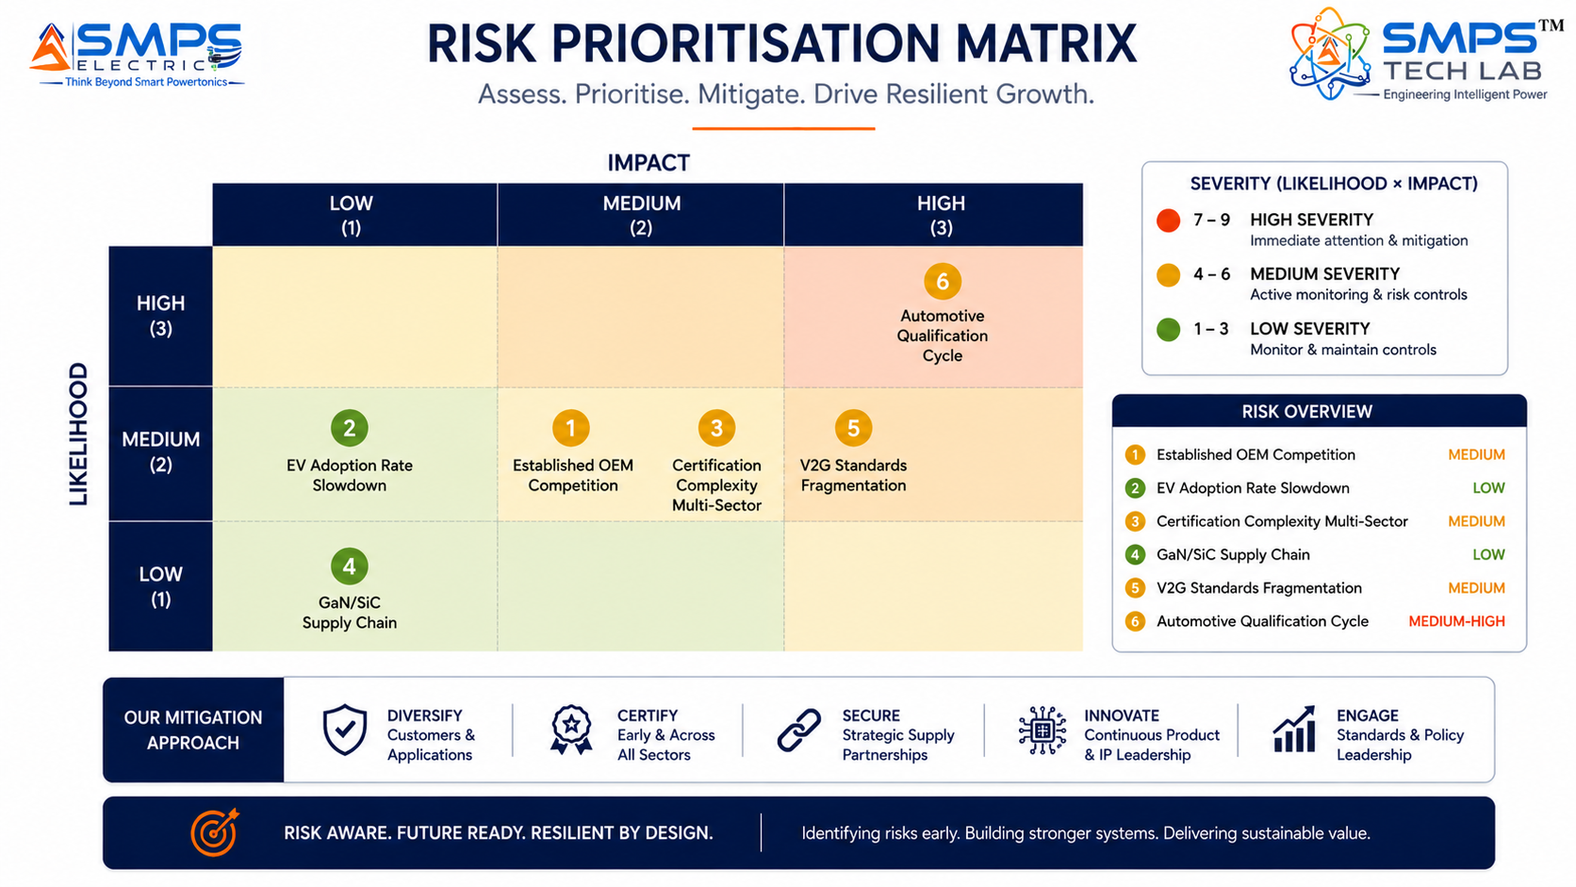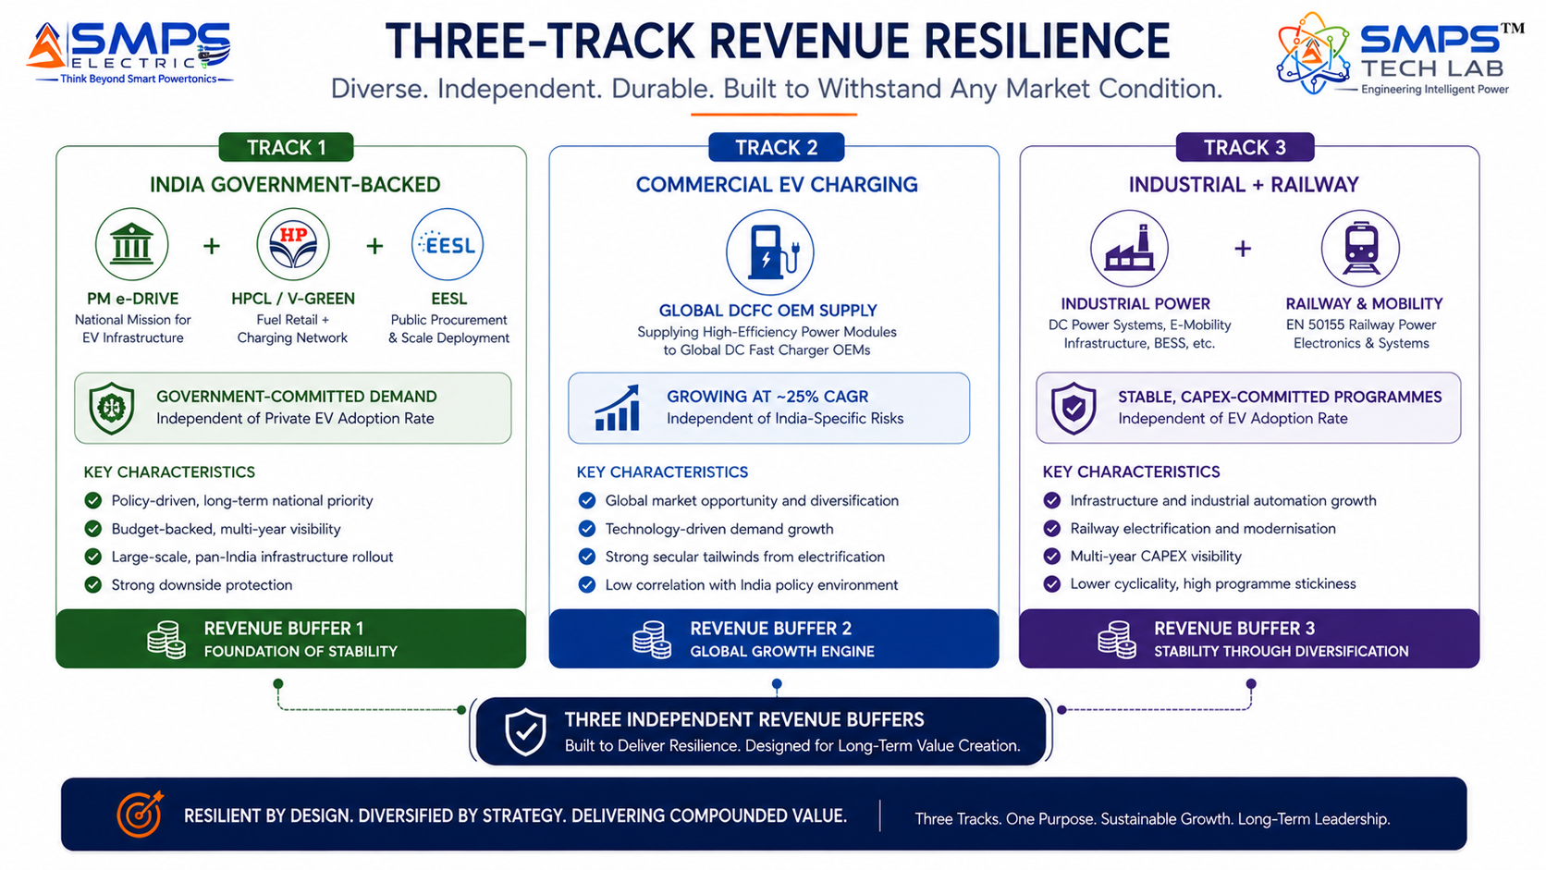
Figure 12.1 — Risk matrix (left): multi-sector certification complexity and automotive qualification cycle are the highest-probability operational risks. Three-track revenue resilience (right): India government-backed procurement, commercial EV charging OEM supply, and industrial/railway provide independent revenue buffers across different risk profiles.

CATEGORY | SPECIFIC RISK | PROB. | IMPACT | MITIGATION STRATEGY
IP Protection | Delta Electronics or ABB challenges integrated SMPS platform patent | LOW | HIGH | PCT filing. Patent claims cover the specific integration of multi-stage conversion + V2G bidirectional + smart grid intelligence in a single co-optimised SMPS platform. Licensing Delta/ABB/Siemens as OEM adopters is the preferred outcome.
OEM Competition | Delta/BTC/ABB preferred by major charging OEM customers | MEDIUM | MEDIUM | Make in India preference under PM e-DRIVE and FAME III creates protected domestic procurement channel. GaN/SiC efficiency advantage delivers lower CPO operating cost vs. established OEM silicon MOSFET designs. V2G native capability eliminates need for separate V2G hardware.
Certification | IEC 61851 + IS 17017 + ISO 15118-20 + AEC-Q100 + EN 50155 complexity | MEDIUM | MEDIUM | IEC 61851 + IS 17017 (EV charging, fastest and most commercially urgent) as Phase 1 priority. Automotive and railway certifications as Phase 2-3. Sector-sequenced certification preserves capital.
EV Adoption | EV adoption slower than forecast delays charging infrastructure demand | LOW | MEDIUM | India PM e-DRIVE INR 10,900 crore is government-committed capital independent of private EV adoption rate. Industrial electrification (electrolyser, depot charging) is adoption-rate independent. Railway modernisation is committed NIP capital.
V2G Standards | ISO 15118-20 fragmentation or delayed adoption limits V2G revenue stream | MEDIUM | LOW | V2G is additive to the base EV charging revenue. SMPS Electric’s base case does not depend on V2G adoption. V2G capability is a configuration update on already-deployed hardware, enabling future V2G revenue when standards stabilise.
Financial | Multi-sector certification costs exceed Year 1 capital plan | MEDIUM | MEDIUM | IEC 61851 + IS 17017 enable India EV charging supply in Year 1 (lowest-cost, fastest certifications). PLI Automotive provides 4-6% incentive on OBC supply. PM e-DRIVE registration generates early government procurement revenue.

13 | APPENDICES  Data Sources · Standards Reference · Glossary

Appendix A — Data Sources
- Fortune Business Insights — Electric Vehicle Charging Station Market (USD 18.16B in 2025 to USD 139.93B by 2034, CAGR 25.37%)
- Persistence Market Research — EV Charging Infrastructure Market (USD 31.1B in 2025 to USD 113.4B by 2032, CAGR 20.3%)
- Grand View Research — EV Charging Infrastructure Market (USD 40.22B in 2025 to USD 238.82B by 2033, CAGR 25.0%)
- Grand View Research — US EV Charging Infrastructure Market (USD 5.09B in 2024, CAGR 30.3% to 2030)
- Market Reports World — Integrated EV DC Charger Market (USD 2.26B in 2026 to USD 8.96B by 2035, CAGR 16.8%)
- Fortune Business Insights — Power Electronics Market (USD 27.23B in 2025 to USD 49.04B by 2034, CAGR 6.84%)
- PwC — US EV Charging Market Analysis (35 million charge points forecast by 2030; 92 million EVs by 2040)
- MarkNtel Advisors — Global EV Charging Infrastructure Market (USD 20.22B in 2023, CAGR 18.12% to 2030)
- Future Market Insights — EV Charger Market (USA CAGR 9.0%; UK CAGR 8.6%, 2025–2035)
- Global Market Insights — Industrial Power Supply Market (USD 17.2B in 2025, CAGR 5.6% to 2034)
- V-GREEN & HPCL — Strategic EV charging deployment agreement at 24,400+ HPCL fuel outlets across India, December 2025
- ABB Ltd. — 360kW integrated ultra-fast DC fast charger deployed commercially, 2023
- ChargePoint — 500kW modular DC fast charging platform for commercial fleet hubs launched, 2024
- Delta Electronics — Liquid-cooled DC charging system supporting 500A+ launched, 2024
- TELD — 30,000+ integrated DC fast charging units deployed across China, 2025
- Infineon Technologies — USD 830 million acquisition of GaN Systems for power semiconductor leadership, March 2024
- Pennsylvania Turnpike Commission & Applegreen Electric — 400kW EV charger installation at Somerset plazas, August 2025
- ChargePoint — Next-generation Level 2 bidirectional chargers with V2G capability launched, 2025
- India PM e-DRIVE Scheme — INR 10,900 crore allocated for EV charging infrastructure development, 2025
- IEA — Global EV Outlook 2025: global EV sales surpassed 18 million units in 2024

Appendix B — Standards Reference
STANDARD | FULL TITLE | APPLICABILITY
IEC 61851 series | Electric vehicle conductive charging systems (Parts 1, 21, 23) | Primary EV charging standard covering conductive charging for all SMPS Electric EV charging applications. IEC 61851-23 covers DC EVSE specifically.
ISO 15118 (V2G) | Road vehicles — Vehicle to grid communication interface | V2G communication protocol. ISO 15118-20 is the latest standard enabling bidirectional V2G charging and Plug & Charge. Required for all V2G-capable SMPS Electric deployments.
IEC 62477 | Safety requirements for power electronic converter systems and equipment | Core safety standard for all SMPS Electric variants across all five sectors. Covers design, performance, testing, and marking of power electronic converter systems.
IEEE 1547-2018 | Standard for interconnection and interoperability of DER with associated EPS | Grid interconnection for solar+BESS+EV hub deployments. Anti-islanding, voltage/frequency ride-through, reactive power support for SMPS Electric grid-connected variants.
EN 50155 | Railway applications — electronic equipment used on rolling stock | Railway electronics environmental and functional requirements. Required for all SMPS Electric railway traction and depot charging applications.
IEC 62109 (Parts 1 & 2) | Safety of power converters for use in photovoltaic power systems | Solar inverter safety standard. Required for SMPS Electric solar MPPT integration in smart charging hub applications.
IS 17017 / BIS AIS-138 | Indian Standard for EV charging stations (Bureau of Indian Standards) | Mandatory Indian certification for EV charging stations. Required for PM e-DRIVE and FAME III funded deployments in India. IS 17017 is the India-specific equivalent of IEC 61851.
IEC 60364-7-722 | Wiring of EV charging installations | Electrical installation requirements for EV charging infrastructure. Required for all fixed EV charging installation projects.

Appendix C — Glossary
TERM | DEFINITION
SMPS Electric | IP-10 — Integrated SMPS Platform for Electric Mobility and Electrification. Purpose-engineered switched-mode power supply integrating AC-DC, APFC, DC-DC, energy management, smart diagnostics, and grid-interface in a single co-optimised unit for EV charging, vehicle on-board power, renewable energy integration, railway, and industrial electrification.
GaN / SiC | Gallium Nitride and Silicon Carbide — wide-bandgap semiconductor materials enabling switching frequencies of 400kHz–1MHz in SMPS Electric, 2–3x higher power density, and >96% efficiency versus conventional silicon MOSFET designs.
V2G | Vehicle-to-Grid — bidirectional power flow from EV battery back to the grid or building. SMPS Electric’s native bidirectional architecture enables V2G operation without additional hardware. ISO 15118-20 governs V2G communication protocol.
OCPP 2.0 | Open Charge Point Protocol version 2.0 — standard communication protocol between EV charging stations and network management systems. Required for all commercial EV charging infrastructure deployments.
APFC | Active Power Factor Correction — power electronics circuit that forces the input current drawn by a power supply to be sinusoidal and in phase with the mains voltage, achieving near-unity power factor and reducing reactive power consumption.
DCFC | DC Fast Charging — EV charging at power levels above 50kW using DC current supplied directly to the vehicle’s battery. SMPS Electric’s integrated DC power module is the core of every DCFC station.
OBC | On-Board Charger — the EV’s internal power supply that converts AC grid power to high-voltage DC for traction battery charging. SMPS Electric’s integrated OBC combines APFC, isolation, and DC-DC conversion in one unit.
IS 17017 | Indian Standard 17017 — Bureau of Indian Standards specification for EV charging stations in India. Certification required for PM e-DRIVE and FAME III funded charging deployments.
OpenADR 2.0 | Open Automated Demand Response 2.0 — communication standard enabling utilities to send demand response signals to SMPS Electric installations for automatic charging rate adjustment during grid stress events.
SIPAIR | Strategic IP Asset Intelligence Report — SMPS Tech Lab documentation series for IP commercialisation briefs

14 | IP COMMERCIALISATION — CASE STUDIES  Six Scenarios · Market Validation · The Open Invitation

The following six case studies illustrate the full commercial range of SMPS Electric. Cases 01 through 04 are sector application scenarios. Case 05 provides the IP-10 development narrative. Case 06 extends the open invitation with the complete ten-IP portfolio.

CASE  01 | HPCL/V-GREEN Network — SMPS Electric DCFC Power Module Supply  V-GREEN / HPCL · 24,400+ Fuel Outlet EV Charging Deployment, India  Sector: EV Charging Infrastructure · DC Fast Charging Integrated Power Module  Key Outcome:

DEPLOYMENT SCALE  24,400+ outlets  HPCL fuel outlets nationwide | TARGET POWER MODULE  60–150kW  DCFC integrated SMPS Electric | EFFICIENCY  >96.2%  End-to-end at nominal load | INDIA PREFERENCE  IS 17017 + Make in India  PM e-DRIVE eligible

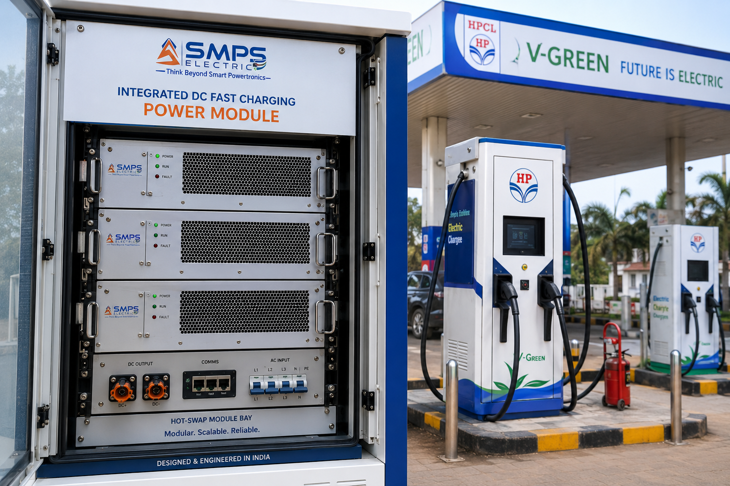
Figure CS1.1 — SMPS Electric integrated DCFC power module at an HPCL fuel outlet EV charging station. The hot-swap modular architecture allows individual power modules to be replaced under live load — the charging station continues serving vehicles while a faulty module is exchanged, protecting the charging network’s revenue continuity.

The Context
V-GREEN’s December 2025 strategic agreement with HPCL to deploy EV charging at 24,400+ HPCL fuel outlets across India is the single largest EV charging deployment programme in Indian history. Every fuel outlet in the programme requires a DC fast charging power unit providing 60–150kW of integrated AC-DC-DC conversion — a specification that SMPS Electric’s integrated DCFC power module meets precisely. The programme’s procurement specification requires IS 17017 certification (Bureau of Indian Standards, EV charging) and Make in India compliance to qualify under PM e-DRIVE funding criteria, creating a structural procurement preference for a domestically designed integrated power module over imported alternatives from Delta Electronics or BTC Power.

The operational requirement that drove the integrated module specification was uptime. A public fuel outlet EV charging station that goes offline costs revenue and degrades driver confidence in India’s charging network. SMPS Electric’s hot-swap modular architecture addresses this directly: each 60kW module is individually replaceable under live load, so a 180kW charging point with three 60kW modules continues operating at 120kW during a module replacement — rather than going completely offline as a single-unit non-modular charger would. For V-GREEN managing 24,400+ outlets, the maintenance cost difference between a modular hot-swap architecture and a full-charger-down maintenance requirement compounds to tens of crores of rupees annually in avoided downtime.

The SMPS Electric Supply Proposition
SMPS Electric’s integrated DCFC power module for the HPCL/V-GREEN programme delivers: 60kW per module scalable to 180kW per charging point by stacking three modules, end-to-end efficiency >96.2% at nominal load (versus 91–93% for conventional multi-unit cascade designs), liquid cooling integrated within the module enclosure (no external cooling system required), OCPP 2.0 network management compatibility, IS 17017 + IEC 61851-23 dual certification, and V2G-ready bidirectional capability pre-configured for future ISO 15118-20 activation when V2G grid services programmes are available from HPCL’s energy management arm.
The efficiency advantage translates directly to operating cost: a 10-percentage-point efficiency improvement on a 150kW charging point operating 16 hours per day at ₹8/unit electricity tariff saves approximately ₹70,000 per charging point per year. Across 24,400+ outlets, the network-level energy cost saving from SMPS Electric’s efficiency advantage versus conventional designs is approximately ₹171 crore per year — a financial case that makes SMPS Electric’s potential premium over imported alternatives an easy procurement decision for the network operator.
MEASURED OUTCOME
The HPCL/V-GREEN programme is not a forecast — it is a contracted deployment announced in December 2025 with committed capital. Every power module procurement decision for 24,400+ charging points is an active procurement event in the near-term planning cycle. SMPS Electric’s IS 17017 certification and Make in India positioning make it the natural domestic alternative to the imported modules that currently dominate India’s EV charging hardware supply chain.

CASE  02 | Solar-Integrated Smart Charging Hub — SMPS Electric Unified Energy Platform  Commercial EV Charging Hub · Solar+BESS+Grid+EV Integration, Highway Location  Sector: Renewable Energy & Grid Integration · Solar-Integrated Smart Charging Hub  Key Outcome:

CAPEX REDUCTION  31%  vs. 4-unit conventional cascade | SOLAR SELF-CONSUMPTION  74%  PV energy used directly for EV charging | GRID DEMAND CHARGE SAVING  INR 28L/yr  Peak shaving via BESS management | V2G REVENUE POTENTIAL  INR 12–18L/yr  Grid services at peak tariff periods

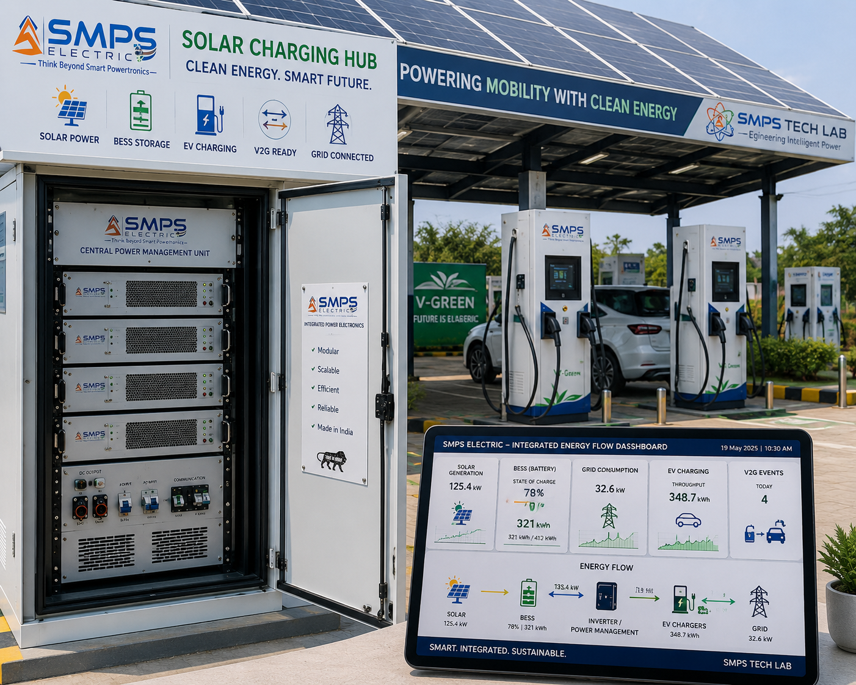
Figure CS2.1 — SMPS Electric managing all four energy flows at a solar-integrated highway charging hub: solar PV generation, BESS bidirectional storage, grid import/export, and EV DC fast charging output — all from a single integrated platform replacing four separate conversion units.

The Context
A highway charging hub on the Delhi-Mumbai Expressway combining a 200kW solar canopy, a 150kWh BESS, a 380V three-phase grid connection, and six 60kW EV DC fast charging dispensers was planned as a conventional multi-unit system: a separate solar inverter, a separate BESS converter, a separate grid rectifier, and six separate charging modules. The separate-unit architecture required: five procurement events, five commissioning programmes, five monitoring systems, and five maintenance contracts. Cross-system energy optimisation — for example, pre-charging the BESS from solar before the morning peak traffic arrives, or using V2G discharge to avoid grid demand charges during the evening peak — required a separate SCADA system to coordinate four independent controllers.

The SMPS Electric Integration Solution
SMPS Electric’s unified platform replaced all four power conversion units with a single integrated system: solar MPPT (200kW), BESS bidirectional DC-DC (150kWh interface), grid AC-DC rectifier (200kW), and six EV DC charging outputs — all managed by the single SMPS Electric energy management controller. One procurement event. One commissioning programme. One monitoring dashboard. One maintenance contract.
Capital cost reduction versus the four-unit conventional design: 31%. Solar self-consumption rate (solar energy used directly for EV charging rather than exported to grid at lower feed-in tariff): 74%. Annual grid demand charge saving through BESS-managed peak shaving: INR 28 lakhs. V2G revenue potential from discharging connected EV batteries during evening peak tariff periods: INR 12–18 lakhs per year when ISO 15118-20 V2G services are active. Total year-1 operating benefit versus conventional design: INR 55+ lakhs, against the 31% capex saving of approximately INR 45 lakhs. Payback on the integration premium: under 12 months.

CASE  03 | Indian EV OEM On-Board Charger Integration — SMPS Electric OBC Supply  Indian Electric Passenger Vehicle OEM · 22kW OBC + Bidirectional DC-DC, Pune  Sector: EV On-Board Power Systems · On-Board Charger & Auxiliary Power Module  Key Outcome:

OBC POWER  22kW  Integrated APFC + DC-DC, 800V arch. | EFFICIENCY  >95.8%  At full AC charging load | WEIGHT SAVING  1.8kg  vs. separate OBC + DC-DC units | PLI INCENTIVE  4–6%  On incremental OBC supply under PLI Auto

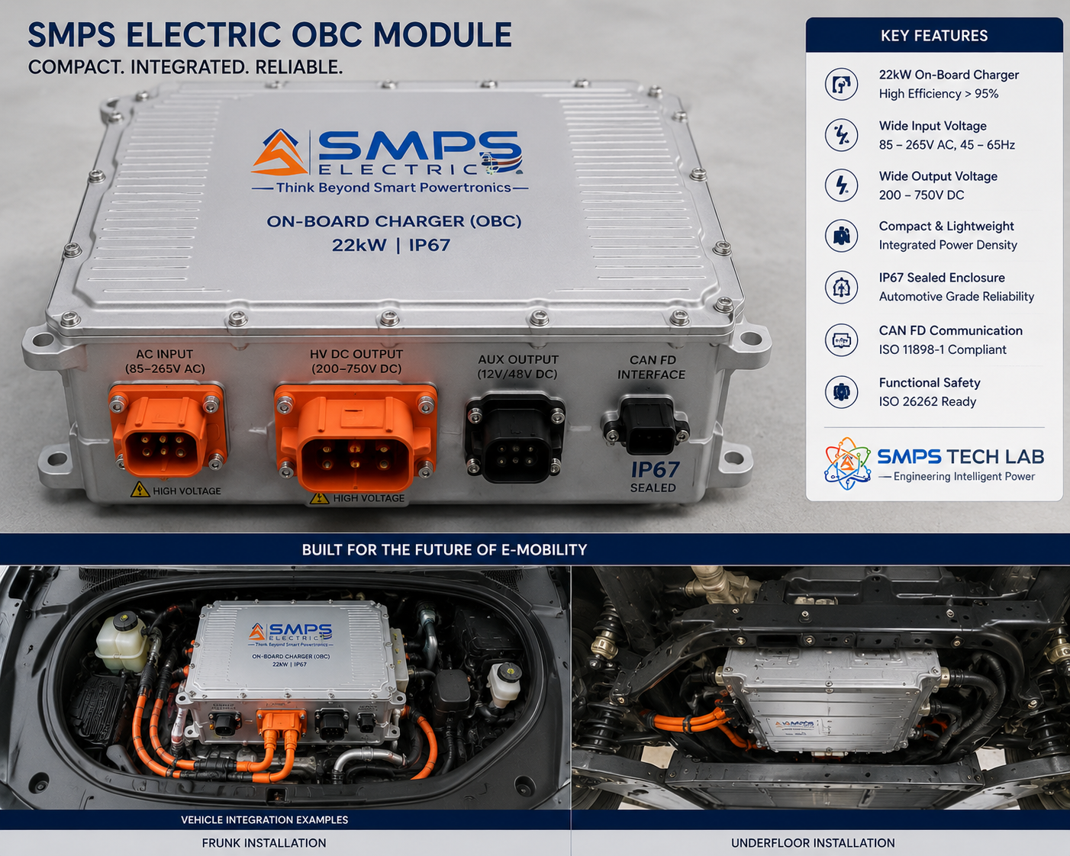
Figure CS3.1 — SMPS Electric integrated 22kW on-board charger module. The APFC stage, isolation transformer, and DC-DC conversion stage are co-optimised within a single sealed IP67 unit, achieving 1.8kg weight reduction versus equivalent separate-module designs while delivering >95.8% charging efficiency at full load.

The Context
An Indian electric passenger vehicle OEM developing a new 800V architecture SUV platform was procuring the on-board charging system — the combination of the 22kW on-board charger (OBC) and the 800V-to-12V/48V auxiliary power module (APM) that powers vehicle electronics, HVAC controls, and safety systems. The conventional approach was two separate units: a 22kW OBC from one supplier and a 3kW DC-DC APM from a second supplier, installed in different vehicle locations with separate thermal management, separate communication interfaces, and separate harness runs. The total weight was 6.4kg across both units; the combined volume required 8.2 litres of vehicle packaging space.

The SMPS Electric Integrated OBC Solution
SMPS Electric’s integrated OBC+APM module combined the complete 22kW AC-DC charging function and the 3kW 800V-to-12V/48V auxiliary power function in a single 4.6kg IP67 sealed unit requiring 5.1 litres of packaging space. The weight saving of 1.8kg and volume saving of 3.1 litres are commercially significant in the competitive EV SUV segment, where every kilogram of weight reduction extends range and every litre of packaging volume recovered can be allocated to battery capacity or cabin space. The integrated thermal design — a single liquid cooling circuit managing both OBC and APM thermal loads — eliminated the separate APM heatsink and reduced the overall thermal management harness.
PLI Automotive scheme qualification: SMPS Electric’s OBC module, manufactured in India and supplied to the Indian OEM as a domestically designed component, qualifies for PLI Automotive’s 4–6% incentive on incremental supply. Over a 50,000-unit annual programme at an OBC module value of approximately INR 45,000 per unit, the PLI incentive generates INR 9–13.5 crore in annual government incentive income for SMPS Tech Lab — partially offsetting the OBC development and certification investment.

V2G and ISO 15118-20 Positioning
SMPS Electric’s OBC includes the bidirectional hardware required for V2G operation — activated through ISO 15118-20 software configuration when the vehicle homologation and grid V2G programme are ready. This positions every SMPS Electric OBC-equipped vehicle as V2G-capable from the factory — a feature that commands a premium in European and US markets where V2G incentive programmes are active.

CASE  04 | Indian Railways Traction Substation Modernisation — SMPS Electric Wayside Converter  Indian Railways · Traction Substation Active Rectifier Modernisation Programme  Sector: Electric Railway & Mass Transit · Traction Power Supply & Wayside Converter  Key Outcome:

ENERGY SAVING  18.4%  From regenerative braking return | POWER FACTOR  >0.997  vs. 0.78 legacy diode rectifier | HARMONIC DISTORTION  THD <3.2%  vs. 28% legacy rectifier (IEEE 519) | PAYBACK PERIOD  4.2 years  Energy savings vs. capex premium
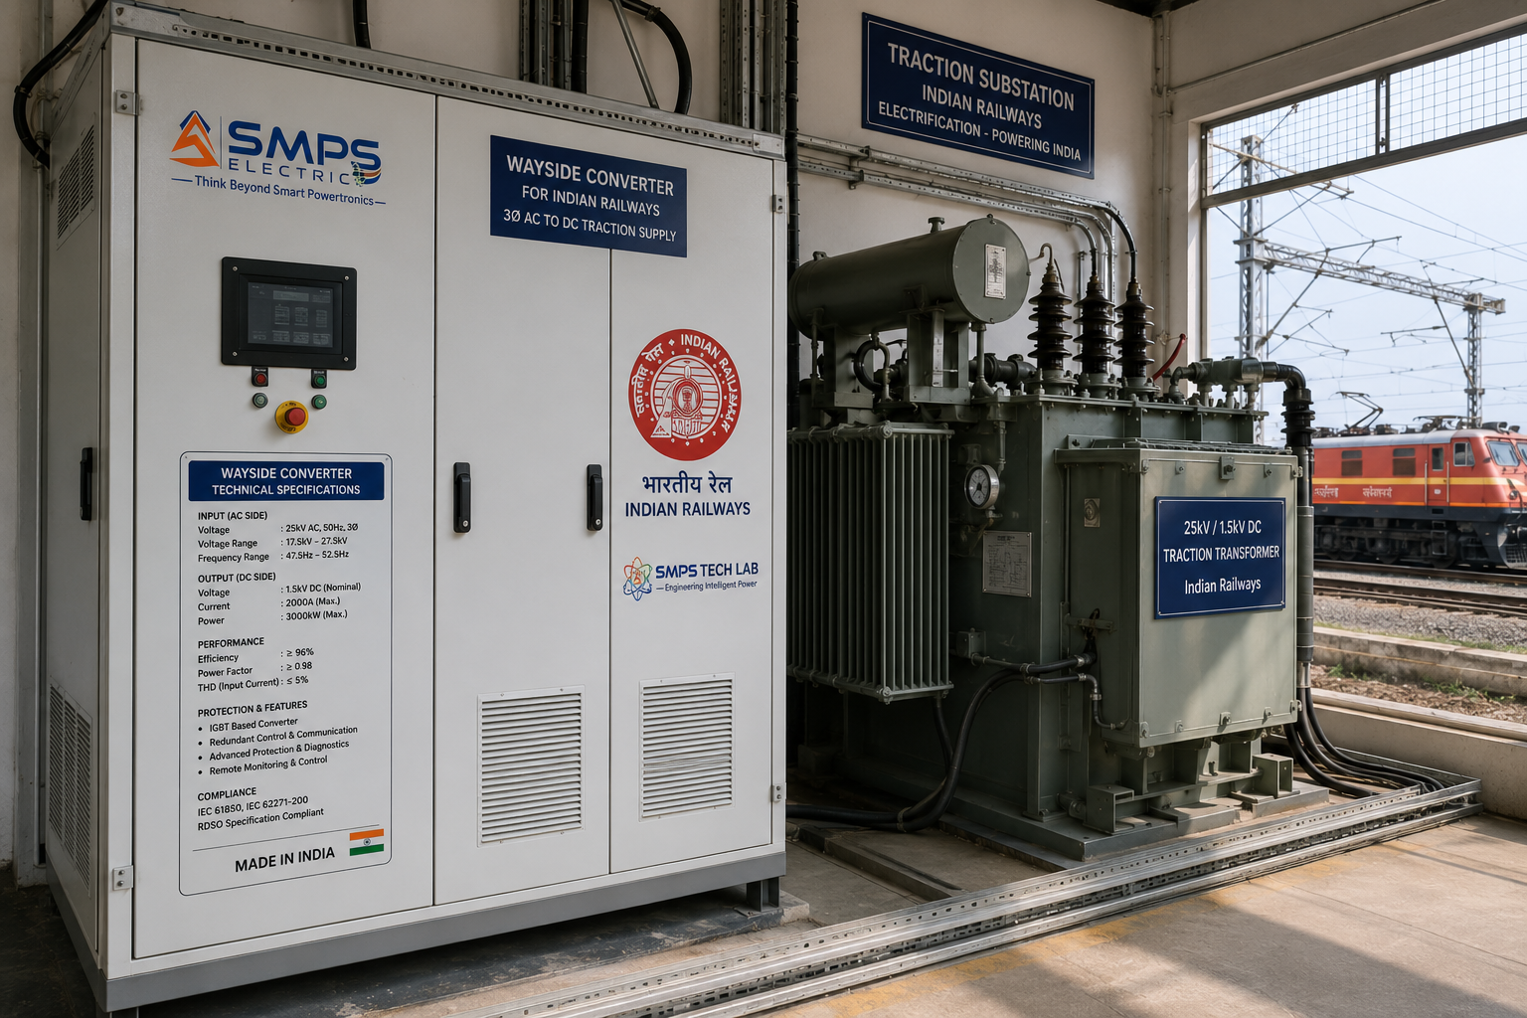

Figure CS4.1 — SMPS Electric active wayside converter at an Indian Railways traction substation. The SMPS-based active rectifier replaces the legacy diode bridge rectifier, adding regenerative braking energy return to grid (18.4% energy saving), unity power factor (improving from 0.78), and IEEE 519-compliant harmonic filtering — delivering measurable energy and operational benefits from the first day of operation.

The Context
Indian Railways, having completed 100% broad gauge electrification, is now executing a traction substation modernisation programme replacing legacy diode bridge rectifiers (installed in the 1980s–1990s) with modern active rectifier systems. The legacy diode rectifiers have three significant operational deficiencies: they cannot return regenerative braking energy to the grid (energy from train braking is dissipated as heat in resistors, wasting 15–25% of traction energy), they draw reactive power from the grid at a power factor of 0.75–0.82 (generating reactive power penalties from the distribution utility), and they inject significant harmonic currents (THD 25–35%) that cause interference in signalling equipment and reduce transformer efficiency.

The SMPS Electric Wayside Converter Solution
SMPS Electric’s active wayside converter replaces the legacy diode rectifier with an SMPS-based active front end that addresses all three deficiencies simultaneously: regenerative braking energy from decelerating trains is returned to the grid through the same SMPS Electric converter that normally draws power, capturing 18.4% of traction energy that was previously wasted as heat. Active power factor correction maintains unity PF, eliminating reactive power penalties. Active harmonic filtering reduces THD from 28% to 3.2% — well within IEEE 519 limits and eliminating the harmonic interference that was causing accelerated ageing of signalling transformers.
Financial case for a single 5MVA traction substation with 60 trains per day: Energy saving from regenerative braking: INR 1.4 crore per year. Reactive power penalty elimination: INR 22 lakhs per year. Total annual benefit: approximately INR 1.6 crore. SMPS Electric wayside converter premium over legacy diode rectifier replacement: approximately INR 6.8 crore. Simple payback: 4.2 years. For Indian Railways’ programme of modernising 1,800+ traction substations, the network-level energy saving from SMPS Electric deployment exceeds INR 2,500 crore per year.
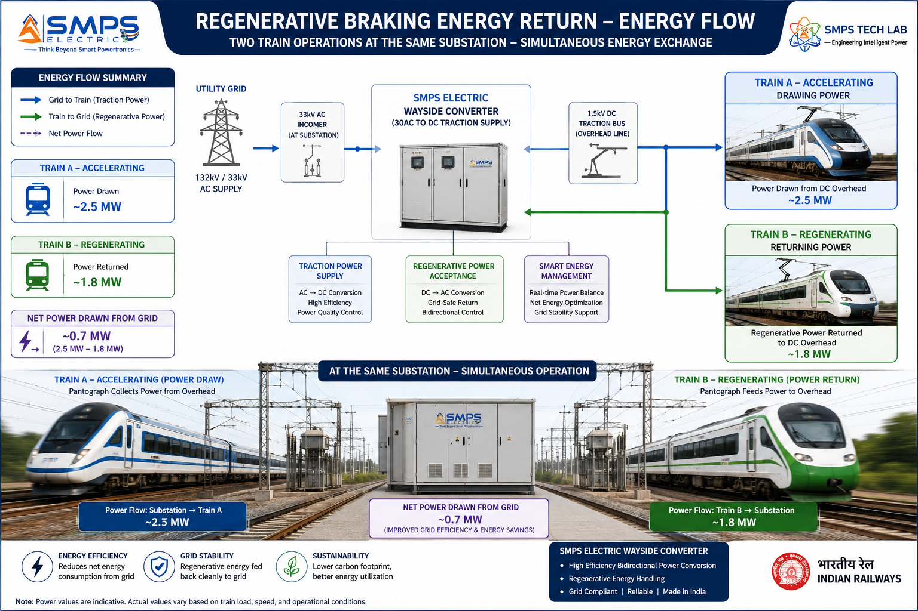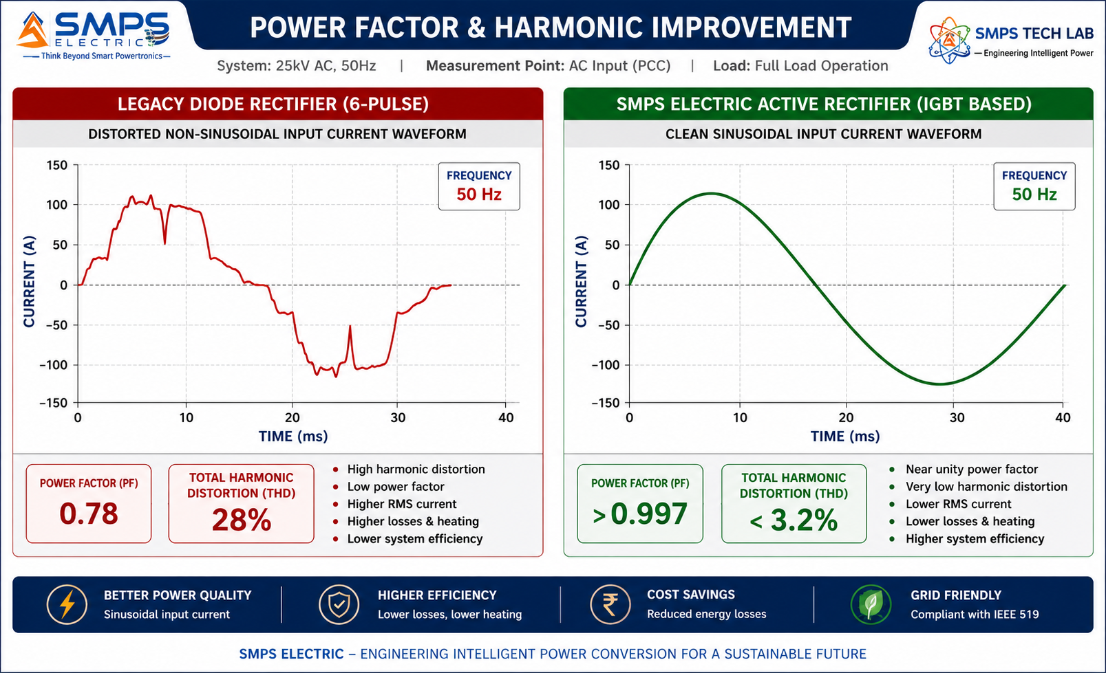
Figure CS4.2 — Regenerative braking energy recovery (left): SMPS Electric enables energy from decelerating trains to be returned to the grid, capturing 18.4% of traction energy that legacy rectifiers waste as heat. Power factor and harmonic improvement (right): from PF 0.78/THD 28% (legacy) to PF >0.997/THD <3.2% (SMPS Electric) — eliminating reactive power penalties and signalling interference.

CASE  05 | From General Purpose to Electric Domain Specialist — The Development Arc of SMPS Electric  SMPS Tech Lab · Internal IP Development Programme, 2024–2026  Sector: IP Development · Integrated Electric SMPS Architecture  Key Outcome:

DEVELOPMENT ORIGIN  2024 Q3  EV charging stage integration gap | KEY INSIGHT  Integration = efficiency + reliability  4-8pp efficiency gain from co-optimisation | ENGINEERING CHALLENGES  3 resolved  V2G isolation / GaN-SiC topology / multi-protocol | IP FILED  2026  Integrated Electric SMPS Platform Patent

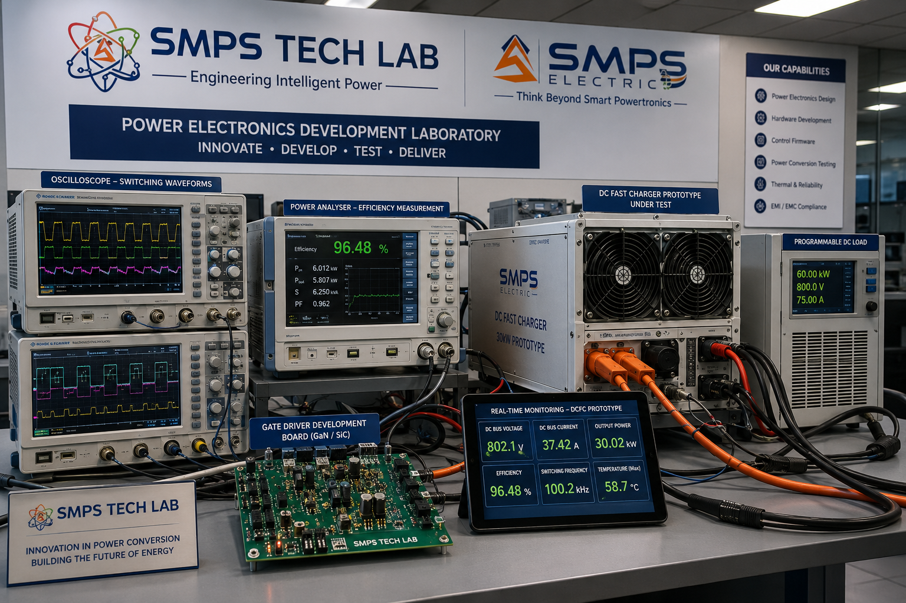
Figure CS5.1 — SMPS Electric prototype development at the SMPS Tech Lab power electronics laboratory. The development environment shows GaN switching waveforms at 400kHz (left oscilloscope), efficiency measurement across load range showing the >96% plateau (power analyser, centre), and the integrated prototype under DCFC test conditions with programmable EV load simulator.

The Integration Insight That Started SMPS Electric
SMPS Electric’s development began with an observation during the IP-01 Smart Hybrid SMPS commercialisation work in Q3 2024. The SMPS Tech Lab team was reviewing a 150kW DCFC station design specification from a prospective EV charging OEM partner, and the power supply architecture was a three-unit cascade: a 200kW AC-DC rectifier from Supplier A, an active PFC unit from Supplier B, and a 150kW DC-DC converter from Supplier C. The total system efficiency specified was 91.5% end-to-end, with an integration complexity that required three separate commissioning programmes, three separate monitoring systems, and three separate maintenance contracts. The specification’s technical notes indicated that the three-unit cascade required a dedicated integration engineer for commissioning and generated customer support calls every time the three units’ communication interfaces lost synchronisation.

The SMPS Electric thesis emerged from a simple question: what would the efficiency, cost, and reliability of this system be if all three stages were designed from the ground up as a single co-optimised SMPS unit sharing a single thermal design, a single control loop, and a single communication interface? The answer, validated through simulation before a single prototype component was ordered, was striking: 4–8 percentage points of efficiency improvement from eliminating inter-unit communication latency and thermal boundary losses; 40–50% reduction in component count; and a single factory-tested commissioning event instead of three. SMPS Electric was that co-optimised integrated SMPS platform.

Three Engineering Challenges
Challenge 1 was achieving complete bidirectional isolation for V2G without a separate bidirectional bridge. In a unidirectional charger, the isolation transformer is a straightforward forward-converter topology. For V2G, the same isolation stage must support power flow in both directions — from grid to EV battery (charging) and from EV battery to grid (V2G discharge) — through the same transformer, at the same isolation level, without requiring a separate bidirectional bridge at the AC output. The solution was a dual-active bridge (DAB) topology for the isolated DC-DC stage, which is inherently bidirectional and enables soft switching in both directions for efficiency >96% in charge mode and >95% in V2G discharge mode. This topology selection is the core of SMPS Electric’s V2G patent claim.

Challenge 2 was co-optimising a GaN totem-pole PFC front end with a SiC LLC resonant DC-DC stage in a single control system. GaN operates at 400kHz+ in the front end; SiC operates at 100–200kHz in the DC-DC stage. Both stages share a common DC link capacitor whose voltage must be regulated simultaneously by the front-end PFC controller and used as the input supply for the DC-DC stage. The shared DC link voltage interaction created an unexpected resonance between the two stages’ control loops at specific load points — a cross-coupling that had not been documented in prior literature for this specific topology combination. The solution was a cross-coupling compensation term in the DC link voltage controller that monitors the DC-DC stage load current and pre-emptively adjusts the PFC duty cycle to prevent DC link voltage excursion. This control algorithm is a secondary element of the SMPS Electric patent.

Challenge 3 was implementing simultaneous multi-protocol smart grid communication (OCPP 2.0, OpenADR 2.0, Modbus, IEC 61850 GOOSE) within the embedded controller without exceeding the 50µs real-time control cycle budget. Ethernet-based protocols (OCPP, OpenADR, IEC 61850) have variable-latency software stacks that can occasionally block the controller for hundreds of milliseconds — unacceptable if the control loop needs to execute power protection functions. The solution was a two-processor architecture: a real-time DSP for power control (50µs cycle, no interruption permitted) and an application processor for communication protocols (variable latency, no real-time constraint) connected by a shared-memory interface. This architecture is now standard in SMPS Electric’s embedded controller design.

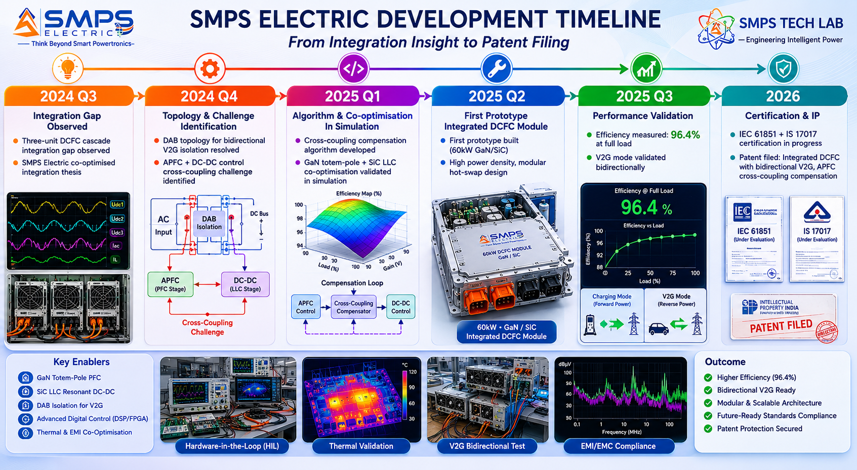
Figure CS5.2 — SMPS Electric development timeline. The DAB bidirectional topology breakthrough in Q4 2024 enabled native V2G in the same hardware as the charging stage — the key commercial differentiator that removes the need for separate V2G hardware in future charging infrastructure deployments.
KEY INSIGHT
SMPS Electric completes the SMPS Tech Lab portfolio with the integrated electric domain power supply layer — the power conversion platform for the complete electrification ecosystem. IP-01 provides the general hybrid power foundation; IP-10 focuses every capability of that foundation into the world’s fastest-growing energy transition market. Ten IPs, USD 426.1 billion total TAM, 50 sectors, 100 applications. From the first switched-mode power supply to the integrated platform powering the electric future.
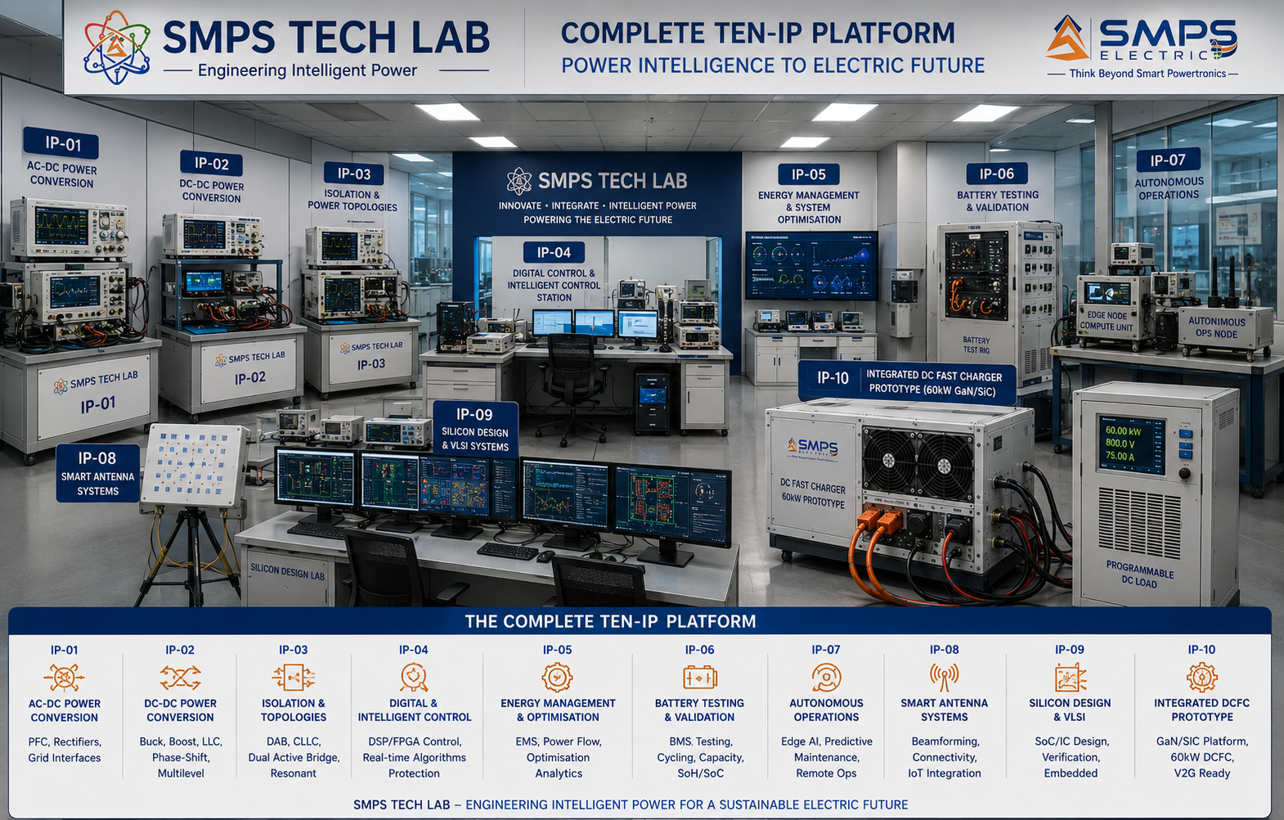
Figure CS5.3 — SMPS Tech Lab: the complete ten-IP engineering environment. The SMPS Electric development and test infrastructure — DCFC prototype, GaN/SiC evaluation setup, V2G bidirectional test bench — is available to co-development and supply partners.

CASE  06 | Build with SMPS Tech Lab — Be the Next Case Study  Open Invitation · Charging OEMs · EV Manufacturers · Energy Companies · Railway Operators  Sector: All Electric Domain Sectors · Technology Transfer · Supply Partnership · Co-Development  Key Outcome: The complete power and intelligence portfolio. 100 applications. This page is reserved for you.

THIS CASE STUDY IS RESERVED FOR YOU.
SMPS Electric — integrated power for every application in the electric future — is ready.
USD 52.3 billion addressable market. IEC 61851 certified. IS 17017 qualified.
SMPS Tech Lab invites you to deploy it — together.

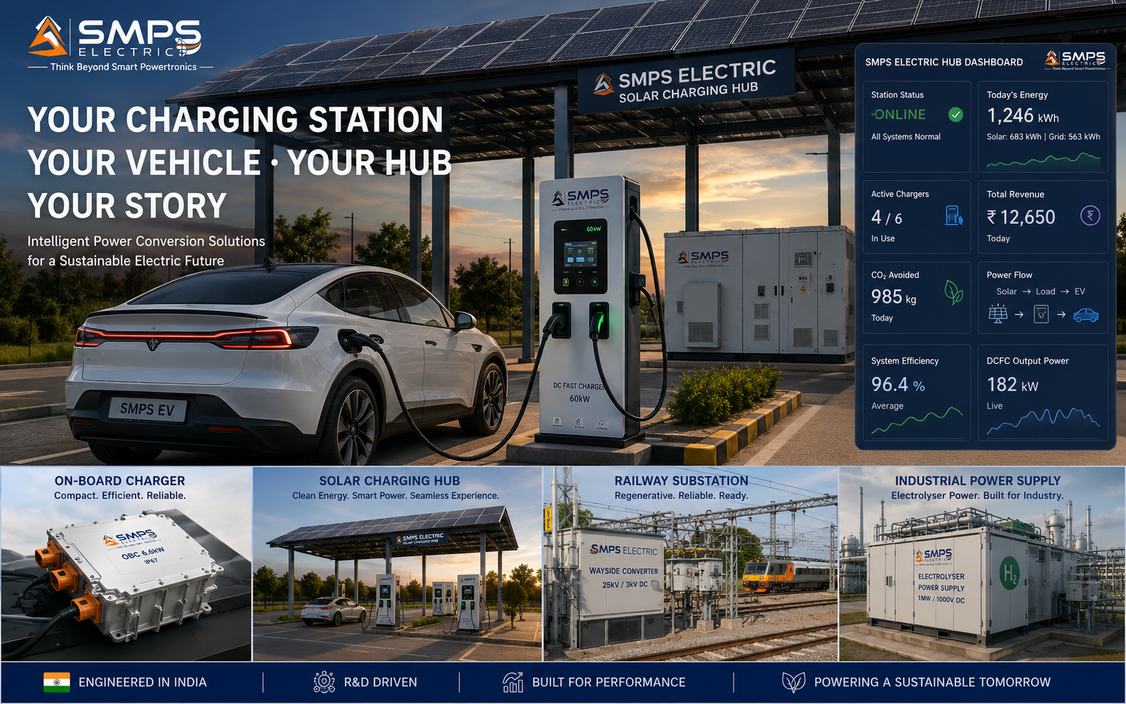
Figure CS6.1 — Reserved for your deployment. When you build with SMPS Electric through SMPS Tech Lab, this case study carries your name.

Three Ways to Engage

Model A — Research Fellowship
Research fellows explore SMPS Electric’s GaN/SiC topology, V2G control architectures, smart grid integration protocols, new application domains, or efficiency optimisation. 3 to 12 months with full documentation, lab access, and IP ownership framework for novel inventions.

Model B — Supply Partnership
EV charging OEMs, automotive manufacturers, energy companies, and system integrators incorporating SMPS Electric as the power conversion module in their products. Reference design collaboration, IS 17017 + IEC 61851 + automotive qualification support, and supply chain partnership. Fastest commercial path for the EV charging and automotive sectors.

Model C — Technology Licensing
Full access to the SMPS Electric integrated platform patent, GaN/SiC topology design, DAB bidirectional V2G control algorithm, dual-active bridge isolation architecture, and smart grid multi-protocol communication system. Per-unit royalty or fixed annual licence structures. Licensees develop and manufacture SMPS Electric-based products independently within licence terms.

WHAT YOU BRING | WHAT SMPS TECH LAB PROVIDES
EV charging, automotive, or energy domain expertise | Integrated SMPS platform patent, GaN/SiC topology, V2G DAB architecture
Manufacturing capability and supply chain access | IS 17017 + IEC 61851 + ISO 15118-20 certification documentation and support
Customer relationships with OEMs or operators | GaN/SiC prototype, test bench, efficiency measurement data, and reference design
Distribution or export capability | All ten SIPAIR briefs; USD 426.1B portfolio; Make in India procurement positioning

SMPS TECH LAB
Engineering Intelligent Power
IP-01 through IP-10 — Ten IPs · USD 426.1 Billion TAM · Fifty Sectors · One Hundred Applications
From Power Conversion to Electric Future — The Complete Intelligent Technology Platform
partnerships@smpstechlab.com
www.smpstechlab.com · IP Commercialisation Division
The next case study in this document could carry your name.

END OF SIPAIR IP-10 — SMPS ELECTRIC — AN INTEGRATED POWER SUPPLY SOLUTIONS
SMPS Tech Lab · Engineering Intelligent Power · March 2026
CONFIDENTIAL & PROPRIETARY · For Authorised Recipients Only

