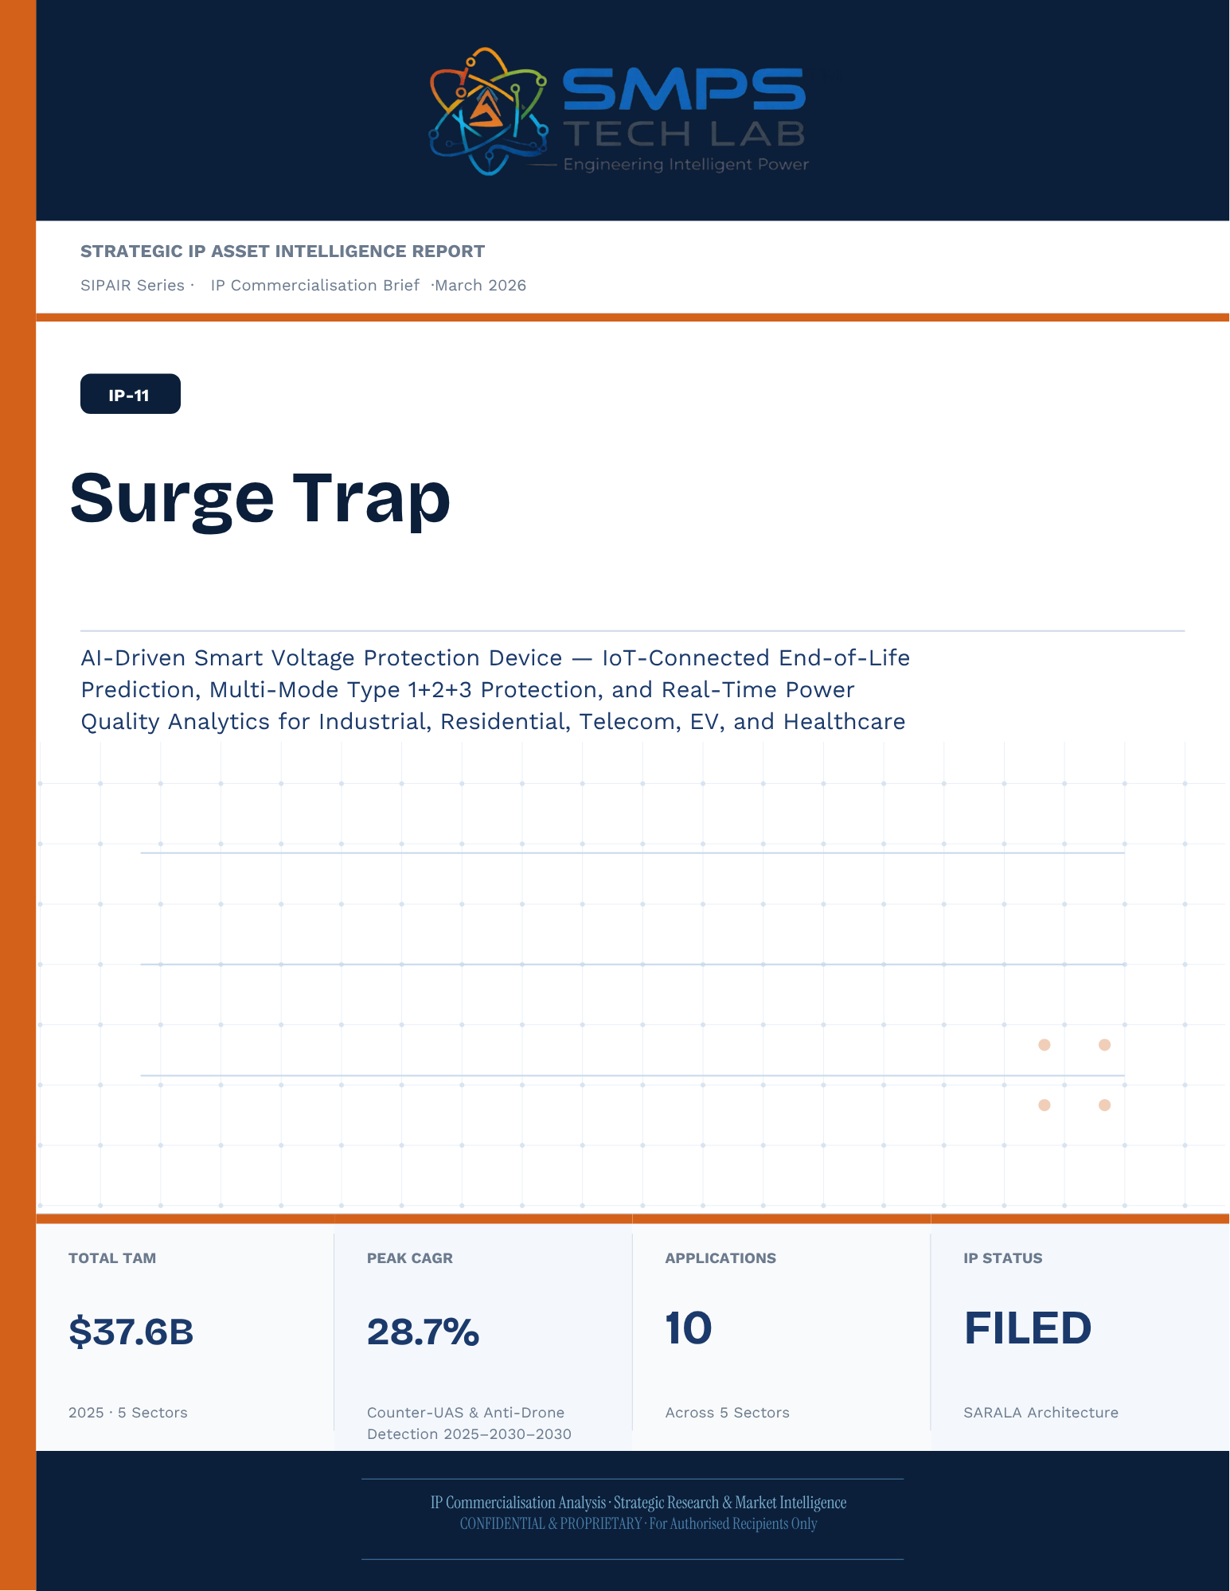
Un-named
[Email address]

STRATEGIC IP ASSET INTELLIGENCE REPORT
SIPAIR Series
IP-11: SARALA
SMPS-Based Integrated SARALA for Uninterrupted Telecom Power

Report Title | SIPAIR IP-11 — SARALA Commercialisation Brief

Document Series | Strategic IP Asset Intelligence Report (SIPAIR)

Version | Version 1.0 — First Edition

Compiled & Edited by | Shri Amareshwar Karatagi

Organisation | SMPS Tech Lab — Engineering Intelligent Power

Date of Issue | March 2026

Classification | Confidential & Proprietary — For Authorised Recipients Only

IP Reference | IP-11 — SARALA Architecture, Filed 2025

Related Document | SIPAIR IP-01: Smart Hybrid SMPS (see companion brief)

This document is prepared by SMPS Tech Lab as part of the SIPAIR IP Commercialisation Series.

Declaration — Originality & Intellectual Property Statement

This Strategic IP Asset Intelligence Report (SIPAIR — IP-11: SARALA) is an original compilation prepared by SMPS Tech Lab. The analysis, market intelligence frameworks, commercial strategy formulations, and case study narratives contained herein are the result of independent research and original intellectual work by the authors and editors named in this document.

The core technology described in this report — the SMPS-Based Integrated SARALA architecture, including its active power management layer, CCU intelligence stack, uninterrupted multi-rail AC/DC delivery system, and NMS integration platform — is the exclusive proprietary invention of SMPS Tech Lab, protected under a filed novel design patent (2025). IP-11 is a distinct and independently protectable invention from IP-01 (Smart Hybrid SMPS), though both emerge from the same SMPS Tech Lab research programme. The two IPs are designed to complement each other across adjacent application verticals and may be jointly licensed or co-deployed where application requirements demand both hybrid topology and active power management intelligence.

Market sizing data, CAGR estimates, and industry statistics cited in this document are sourced from independent third-party research publications, fully attributed in Appendix A. All third-party data is used for analytical and benchmarking purposes only. This report has not been submitted, in whole or in part, to any other organisation for commercialisation or formal assessment except as specifically disclosed in writing.

Declared by:

Shri Amareshwar Karatagi
Founder & CSO
SMPS Tech Lab · March 2026

CERTIFICATE OF AUTHENTICITY
IP Commercialisation Documentation · SIPAIR IP-11

This is to certify that the Strategic IP Asset Intelligence Report
SIPAIR IP-11 — SARALA
has been compiled, reviewed, and authenticated by the undersigned in accordance
with the standards of the SIPAIR documentation series. The technology, market analysis,
and commercial intelligence herein are verified as accurate to the best of the signatories’
knowledge as at the date of issue: March 2026.

Program Head / Director | Technical Mentor
  Program Head / Research Director
  SMPS Tech Lab
  Technical Mentor / Advisor
  SMPS Tech Lab

SMPS Tech Lab · Engineering Intelligent Power · March 2026

Acknowledgment

The preparation of this Strategic IP Asset Intelligence Report for IP-11 has drawn on the technical expertise, operational insights, and research foundation developed across two parallel innovation tracks at SMPS Tech Lab. The development of the CCU intelligence layer — the defining innovation of IP-11 — required not only power electronics engineering depth but sustained engagement with telecom network operations, tower management practice, and satellite ground station engineering environments that are highly specialised. The author and editor express sincere gratitude to those whose knowledge and access made this work possible.

Technical Development
The CCU architecture at the heart of IP-11 evolved alongside IP-01's hybrid topology work, but along a distinct engineering trajectory focused on power orchestration intelligence rather than conversion efficiency alone. The engineers and technologists who contributed to the CCU control logic, NMS integration stack, and sub-millisecond failover switching mechanism deserve specific recognition for the rigour with which they approached the uninterrupted power mandate — a design objective that admits no approximation.

Telecom Industry Access
The sector intelligence in this report reflects direct engagement with tower operations, data centre facility management, and satellite ground station engineering communities. The operational data from 5G tower rollout programmes, off-grid hybrid power deployments, and maritime communication installations that informed the case study narratives and application requirement specifications in this document is the product of those field engagements.

Research Publications
The market intelligence framework draws on publications from Future Market Insights, MarketsandMarkets, SNS Insider, Grand View Research, IMARC Group, Coherent Market Insights, Global Growth Insights, and the Ericsson Mobility Report, as well as operational data from the International Energy Agency. The quality of those independent research publications is what allows the TAM framework in this report to be grounded in named, verifiable data rather than estimated aggregates.
Shri Amareshwar Karatagi
Founder & CSO
SMPS Tech Lab · March 2026

Preface — From the Founder & Editor

From IP-01 to IP-11 — The Logical Extension
IP-01, documented in the companion SIPAIR brief, solved one problem with exceptional elegance: replacing the unnecessary architectural duplication of separate AC and DC converter units with a single hybrid topology. The commercial case was compelling and the market evidence was clear. But the engineers at SMPS Tech Lab, in the same process of field observation that gave rise to IP-01, had identified a second problem — one that operated at a higher level of the power system stack and was, if anything, more commercially urgent in the specific context of telecom infrastructure.

The problem was not conversion efficiency. It was availability. In a 5G base station, a satellite ground hub, an offshore platform communication centre, or a smart city public safety network node, the standard power supply architecture not only requires separate AC and DC converters — it delegates all intelligence about the power state of the system to a separate controller that may be physically remote, software-dependent on a third-party network management system, and incapable of autonomous protective action in the sub-millisecond timeframe that modern telecom uptime SLAs demand. When the grid fails, when a battery starts to degrade, when an input source switches — the system needs to respond faster than any software polling cycle can achieve. It needs embedded intelligence, right at the power conversion stage.

IP-11 is that intelligence. The Integrated SARALA, combined with the SMPS core, does not just convert power — it orchestrates it. It monitors every parameter of the power delivery chain continuously, switches between sources in under a millisecond, predicts faults before they become outages, and reports power system health to the operator's NMS in real time, without external monitoring hardware. It is the difference between a power supply and a power management system.

Why Telecom, and Why Now
The selection of telecom infrastructure as the primary application vertical for IP-11 reflects a disciplined commercial judgement. Telecom infrastructure is the single sector in the IP-11 TAM where the uninterrupted power mandate is non-negotiable, contractually enforced at 99.999% uptime, and backed by capital investment programmes of unprecedented scale: 2.3 billion 5G subscriptions by end of 2024 with another 4 billion to come by 2030; 3,000 Amazon Project Kuiper satellites deployed in April 2025 with thousands of ground hubs to follow; the IMO GMDSS modernisation mandate forcing a complete vessel communication power infrastructure upgrade by 2026. Every one of these programmes creates a specific, identified, and time-bounded procurement requirement for exactly what IP-11 delivers.

The second reason is the grid reliability crisis that is, counterintuitively, the most powerful demand driver the CCU's hybrid input management addresses. South Africa recorded 1,130 hours of planned power cuts in a single year. India's tower estate — 750,000 sites — routinely operates on hybrid grid, diesel, and battery sources with real-time CCU-managed source switching that determines whether the tower stays on during a grid event. This is not a niche requirement. It is the operational reality for hundreds of thousands of tower sites across three continents, and the market is actively seeking a solution that the current generation of separate rectifiers and external controllers cannot provide.

How This Document is Structured
This SIPAIR brief follows the same 14-section architecture as the IP-01 companion document, making the two documents a coherent and mutually reinforcing portfolio. Readers who have engaged with SIPAIR IP-01 will recognise the structure immediately. The technology differentiation section includes an explicit comparison between IP-01 and IP-11, clarifying the architectural relationship and the distinct value proposition of each. The case studies are drawn from the five specific sectors of IP-11's TAM framework — 5G tower, data centre, satellite ground, smart city, and maritime/offshore — with technical and financial parameters grounded in the operational realities of each sector.

Shri Amareshwar Karatagi
Founder & CSO
SMPS Tech Lab · March 2026

TABLE OF CONTENTS

Declaration — Originality & Intellectual Property Statement 1
Acknowledgment 1
Technical Development 1
Telecom Industry Access 1
Research Publications 1
Preface — From the Founder & Editor 1
From IP-01 to IP-11 — The Logical Extension 1
Why Telecom, and Why Now 1
How This Document is Structured 1
Important Notice & Confidentiality Disclaimer 1
1.1 The Strategic Context 1
1.2 The Problem Surge Trap Solves 1
1.3 Key Metrics at a Glance 1
1.4 Why Surge Trap, Why Now 1
2.1 What is Surge Trap? 1
2.2 The Four Integrated Technology Layers 1
2.3 AI End-of-Life Prediction — The Core Intelligence 1
2.4 Multi-Mode Type 1+2+3 Combined Protection 1
2.5 Standards Compliance Architecture 1
3.1 The Smart SPD Transition 1
3.2 The Four Structural Megatrends 1
3.3 Global Market Sizing — Primary Reference Data 1
CAGR Comparison — Surge Trap Target Market Segments 1
4.1 Methodology 1
4.2 Consolidated TAM Summary 1
5.1 India as Primary Market 1
5.2 India Market Sizing — Surge Trap Relevant Segments 1
6.1 India & Global Policy with Direct Surge Trap Alignment 1
7.1 The Plugin Architecture — Five Host System Categories 1
7.2 Plugin Integration Matrix 1
8.1 Commercialisation Philosophy 1
8.2 Market Priority Matrix 1
9.1 Competitive Architecture Overview 1
10.1 The Investment Case 1
10.2 Illustrative Revenue Scenarios 1
11.1 Technology Generation Roadmap 1
11.2 Adjacent Application Opportunities 1
12.1 Risk Framework 1
Appendix A — Data Sources 1
Appendix B — Standards Reference 1
Appendix C — Glossary 1
The Context 1
The Surge Trap OEM Supply Solution 1
The Context 1
The Surge Trap Pilot Programme Solution 1
The Context 1
The Surge Trap Solar Variant Solution 1
The Context 1
The Surge Trap Medical-Grade Solution 1
The Silent Failure Gap That Defined Surge Trap 1
Three Engineering Challenges 1
Three Ways to Engage 1
Model A — Research Fellowship 1
Model B — OEM Component Supply 1
Model C — Technology Licensing & Managed Service Platform 1

0F | FOUNDER & EDITOR  SMPS Tech Lab


Shri Amareshwar Karatagi
Founder & Chief Strategic Officer
SMPS TechLab
Special Correspondent, Government of Karnataka |
Serial Entrepreneur

Vision Statement
We aim to build a generation of innovators and entrepreneurs who create transformative technologies, develop intellectual property, and drive India’s technological leadership on both national and global platforms. Over the years, we have worked extensively within the startup ecosystem, contributing to and mentoring multiple initiatives focused on building, scaling, and strengthening businesses. Through this journey, we have developed a deep understanding of business strategy, governance frameworks, and deep-technology development, along with the practical challenges of scaling innovation in real-world markets.
As a Special Correspondent with the Government of Karnataka and a serial entrepreneur, my focus has been on shaping individuals into creators, builders, and leaders of technology and enterprise. Our work emphasizes ownership, innovation, and execution discipline to nurture individuals capable of building scalable, high-impact solutions with both national and global relevance.
Through SMPS Tech Lab, we drive this vision by integrating deep Research & Development (R&D) with entrepreneurial strategy, fostering a culture where ideas evolve into intellectual property, innovation, and industry-aligned solutions that contribute to India’s technological advancement and global competitiveness. The Industry Fitness DeepTech Internship Program is a reflection of this mission—designed to develop individuals who are innovation-driven, execution-focused, and capable of contributing meaningfully to technology, entrepreneurship, and nation-building at scale.

“My vision is to build a generation that doesn’t wait for opportunities, but creates them through innovation and entrepreneurship.”
— Shri Amareshwar Karatagi



A. R. Shalini
Chief Business Development Officer (CBDO) & Program Officer
SMPS TechLab | SMPS Electric Control Pvt. Ltd.

Area of Expertise:
Business Strategy, Operations Management, Industry–Academia Integration, Entrepreneurship Development
Profile:
I play a pivotal role in driving program execution, operational excellence, and professional development within SMPS Tech Lab. With a strong foundation in both business strategy and technology alignment, I am committed to shaping individuals into industry-ready professionals with the right mindset, discipline, and execution capabilities.
My approach focuses on building skills with clarity of thought, accountability, and a results-driven attitude. Through structured guidance and continuous mentorship, I enable participants to understand the intersection of technology, business, and real-world application.
I actively work toward bridging the gap between academia and industry, ensuring that learning is aligned with practical expectations and evolving market demands. My dedication to creating a seamless and high-impact learning environment fosters confidence, innovation, and professional growth among participants.
Through my leadership, the program consistently emphasizes structured execution, strategic thinking, and the development of individuals who are prepared to contribute meaningfully to both industry and innovation ecosystems.
“Professional excellence is built when knowledge, mindset, and execution come together with consistency.”
— A. R. Shalini

Dr. S. Khatua
Chief Technology Officer (CTO)
SMPS TechLab | SMPS Electric Control Pvt. Ltd.
IITian | PhD – IIT Dhanbad

Area of Expertise:
Power Electronics, Microgrid & Smart Grid Systems, Nuclear Power Systems, DeepTech R&D, Industrial System Design.
I am a distinguished technology leader driving advanced Research & Development and deep-tech innovation. An IITian with a PhD in Microgrid and Smart Grid Systems for nuclear power applications, I bring over 15 years of experience across power electronics, nuclear reactor control systems, and defence and telecom technologies.
With significant contributions to high-impact and mission-critical projects of national importance, my work reflects a rare combination of research depth, engineering precision, and industrial execution.
I am a strong advocate of deep-tech innovation and intellectual property (IP) creation, and I emphasize the development of indigenous technologies that strengthen the nation’s technological capability and global standing.
Through my mentorship, I inspire the next generation to pursue technical mastery, disciplined execution, and innovation with national intent, shaping professionals capable of contributing to the future of deep technology.
“Precision in engineering, depth in research, and ownership of technology are the pillars of true national progress.”
— Dr. S. Khatua



Mr. Rushit Jani
Techno-Commercial Architect
Strategic Editorial & Commercialisation Review | OptCell GLOBAL

Fields of Interest:
AI & Intelligent Systems, Industrial IoT, Product Architecture, Deep-Tech Commercialisation, Enterprise System Design, and Scalable Engineering Solutions.
Focused on building technology-driven systems that bridge engineering innovation with practical industry adoption and long-term commercial value.

Message from the Editor:
Technology, in its purest form, is not just about building systems — it is about creating meaningful infrastructure that can influence industries, solve operational challenges, and contribute to larger technological progress. My interest has always been in understanding how engineering innovation can evolve beyond prototypes into scalable and commercially sustainable solutions.

This document represents more than a technical study of an intellectual property. It reflects a structured effort to connect engineering architecture with market relevance, strategic deployment, industrial applicability, and long-term innovation potential. The objective throughout this work has been to maintain a balance between technical depth, commercialization practicality, and institutional-level documentation standards.

As emerging technologies continue to redefine industries, I strongly believe that the future will belong to organizations capable of combining research, engineering, strategic thinking, and execution into unified ecosystems. Through this publication, we aim to contribute towards that larger vision while creating pathways for collaboration, innovation, and real-world technological impact.

"Transforming engineering innovation into scalable, industry-defining technological ecosystems."
— Mr. Rushit Jani

A Note of Gratitude

The development of this publication has been supported by the collective vision, encouragement, and leadership of the Directors and management of SMPS Electric Control Pvt. Ltd.

Their continued commitment towards engineering innovation, industrial excellence, and long-term technological growth has created an environment that encourages meaningful research, practical problem-solving, and commercialization-focused thinking. The guidance, operational insights, and institutional support extended throughout this journey have played an important role in shaping the direction and depth of this work.

This document reflects not only an individual effort, but also the larger culture of innovation, trust, and forward-thinking leadership fostered within the organization. We sincerely appreciate the confidence and support provided towards building impactful and future-ready technological initiatives.

Important Notice & Confidentiality Disclaimer

This Strategic IP Asset Intelligence Report (SIPAIR — IP-11) has been prepared exclusively for internal strategic planning, investor communication, licensing partner engagement, and research collaboration purposes. It is intended for distribution only to authorised recipients under applicable non-disclosure and confidentiality arrangements.

All market sizing data, CAGR estimates, and financial projections are derived from independent third-party research publications cited in Appendix A. These figures represent estimates as at March 2026. No representation or warranty is made as to their accuracy or completeness.

The technology, architecture, and methodologies described herein are the exclusive proprietary assets of SMPS Tech Lab, protected under filed patent and design rights. This document does not constitute a prospectus, financial advice, or an offer to sell or subscribe to securities. Recipients are advised to conduct independent due diligence before making any investment or commercial decision.

01 | EXECUTIVE SUMMARY  The Silent Failure Problem · Surge Trap Value Proposition · Five Sectors

1.1 The Strategic Context
Every piece of electrical equipment on the planet requires protection from voltage surges. Yet in the vast majority of installations — industrial facilities, residential buildings, telecom towers, EV charging stations, solar farms, hospitals — the surge protection device installed is a passive, silent, degrading component that the owner cannot monitor, cannot query, and cannot know is still functional. Industry data shows that 80% of transients are self-generated from motor switching, transformer operation, and power electronics — not from lightning. These low-amplitude, high-frequency surges silently wear out Metal Oxide Varistors (MOVs) with every event until the device fails — leaving connected equipment completely unprotected without the owner’s knowledge. This ‘silent failure’ problem is the fundamental commercial limitation of every conventional Surge Protection Device ever manufactured.

India’s 700,000+ telecom towers, 500+ million electrical connection points, rapidly expanding EV charging infrastructure, multi-GW solar farm portfolio, and dense hospital and industrial sectors are all exposed to this same risk. As India’s grid becomes more complex — with bidirectional energy flows from rooftop solar, EV charging loads, and reactive industrial equipment — the frequency of transient events is increasing, not decreasing. A better grid, paradoxically, creates more surge events. The addressable market for intelligent surge protection grows every time a new EV charger is installed, every time a solar farm is commissioned, and every time an industry 4.0 factory connection is made.

1.2 The Problem Surge Trap Solves
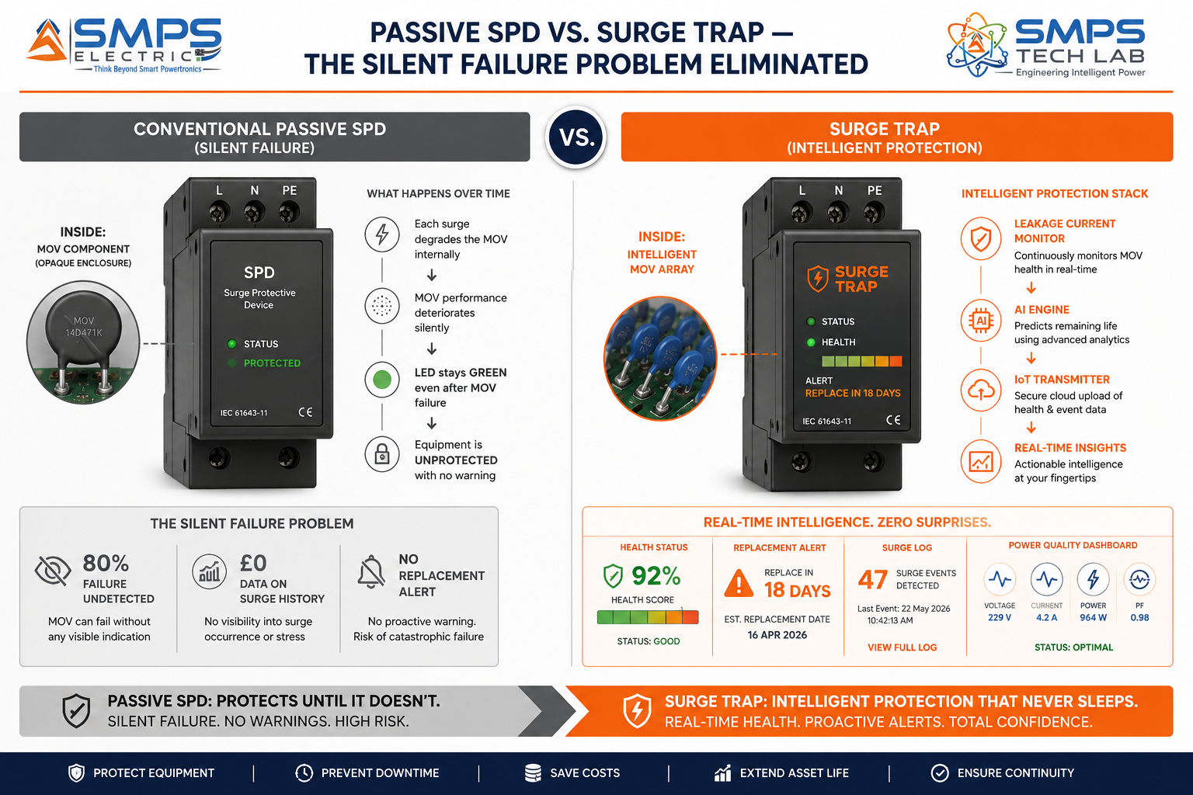
Figure 1.1 — Passive SPD (left): the conventional SPD silently degrades with every surge event, showing a green LED even after internal failure — leaving equipment unprotected without any warning. Surge Trap (right): continuous MOV health monitoring, AI end-of-life prediction, and IoT alert eliminates the silent failure problem entirely.
STRATEGIC NOTE
Surge Trap is not a better SPD. It is an intelligent protection platform that makes the SPD visible, manageable, and predictive for the first time. The commercial differentiator is transformative: conventional SPDs are commodities priced by cent and replaced reactively after equipment failure. Surge Trap is a managed protection service — priced at 2–3x the conventional SPD ASP, generating recurring monitoring revenue, and creating the data foundation for predictive maintenance contracts and insurance risk management integration.

1.3 Key Metrics at a Glance

TOTAL ADDRESSABLE MARKET  $15.2B  2025 Baseline · 5 Protection Sectors | SMART SPD PREMIUM CAGR  12–15%  IoT/AI SPD sub-segment vs. 6.48% conventional | SECTORS MAPPED  5  10 Applications Identified | IP PROTECTION  Surge Trap Filed  AI Predictive SPD Patent

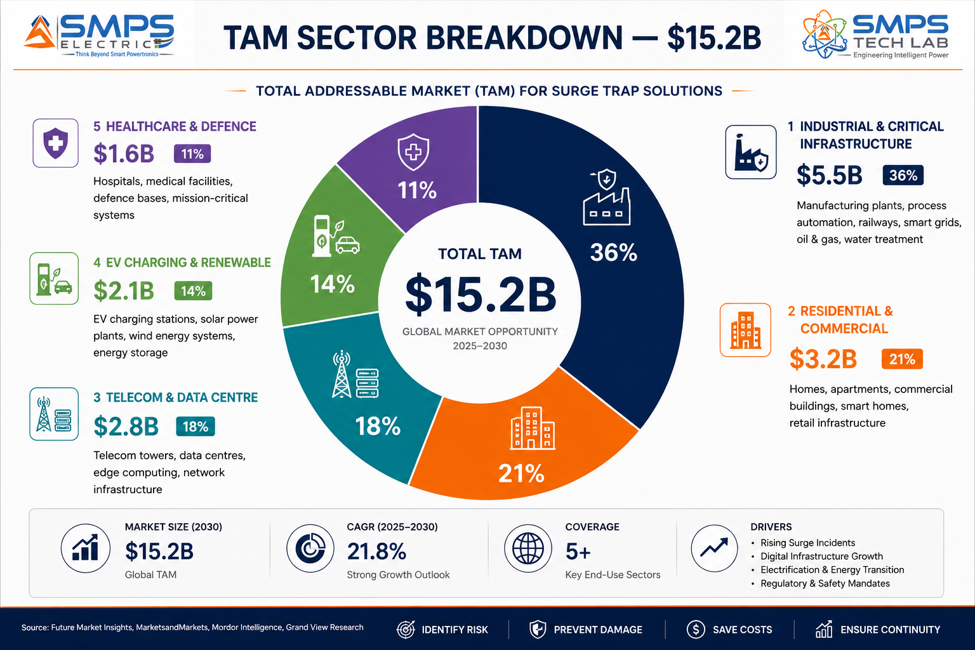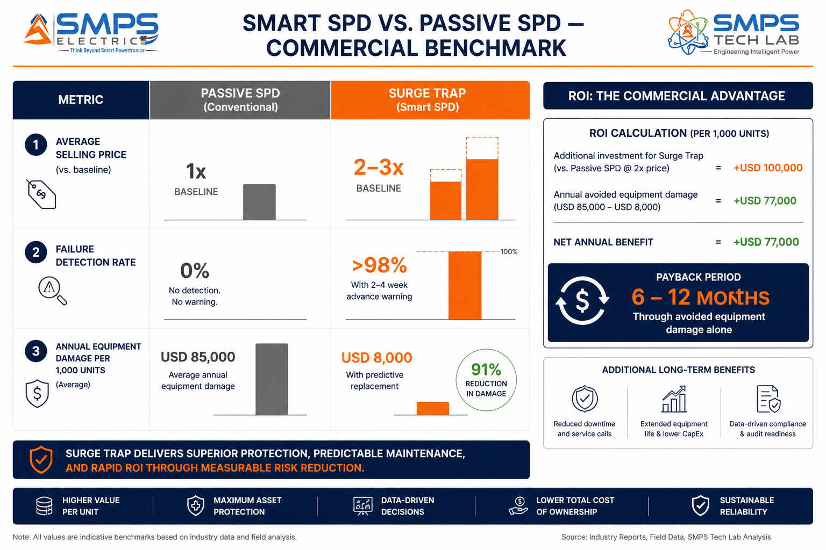
Figure 1.2 — TAM breakdown (left): Industrial & Critical Infrastructure is the largest sector at $5.5B. Smart SPD commercial benchmark (right): Surge Trap commands 2–3x the ASP of conventional SPDs while delivering >98% failure detection versus 0% for passive units — a payback of 6–12 months through avoided equipment damage alone.

1.4 Why Surge Trap, Why Now
Three convergent forces define the Surge Trap commercialisation window. Industry 4.0 adoption is connecting previously isolated industrial equipment — PLCs, servo drives, SCADA servers — to Ethernet and cloud platforms, dramatically increasing the financial consequence of a single surge event and creating demand for smart monitored protection. In December 2025, Raycap unveiled the ProTec T2 DCGU 3Y — a pluggable smart SPD specifically engineered for DC fast-charging infrastructure — providing commercial validation that EV charging SPD is now an active, shipping product category that Surge Trap is directly aligned with. And Global Market Insights confirms data centres as the fastest-growing SPD end-user in 2025 — driven by hyperscale operators requiring SNMP/DCIM-integrated smart SPDs to satisfy uptime SLA requirements that passive SPDs cannot support.

MARKET DATA POINT
Combined SMPS Tech Lab portfolio: IP-01 through IP-10 = $426.1B + IP-11 $15.2B = USD 441.3 Billion total TAM across 55 sectors and 110 applications. Surge Trap adds the intelligent protection layer — safeguarding every investment the portfolio powers, converts, stores, manages, and delivers across the entire electrification ecosystem.

02 | TECHNOLOGY OVERVIEW  AI EOL Prediction · IoT Architecture · Type 1+2+3 Combined · Power Quality · Standards

2.1 What is Surge Trap?
Surge Trap is a smart voltage protection device — an evolution of the conventional Surge Protection Device (SPD) into an intelligent, communicating, and self-aware platform. A conventional SPD uses Metal Oxide Varistors (MOVs), Gas Discharge Tubes (GDTs), or Transient Voltage Suppressor (TVS) diodes to clamp voltage transients by diverting excess energy to ground. The critical limitation of conventional SPDs is that their protective elements degrade silently with every transient event — each surge partially degrades the MOV — until the device fails without warning. Surge Trap transforms this passive component into an active, monitored, and manageable protection platform by adding continuous MOV condition monitoring, AI-driven end-of-life prediction, IoT connectivity, and power quality analytics — all within the same physical form factor as a conventional SPD, with no change to installation requirements.

2.2 The Four Integrated Technology Layers
LAYER | COMPONENT | FUNCTION | KEY INNOVATION IN IP-11
L1 | Multi-Mode Protection Array | MOV array (Type 1, 2, or 3 rating), Gas Discharge Tube (GDT), TVS diodes, thermal fuse backup. Combined Type 1+2+3 topology replaces conventional three-device cascade with a single co-ordinated unit. | Single-device Type 1+2+3 combined protection reduces installation cost 40–60% versus three separate devices. Co-ordinated protection stages prevent the under/over-protection gaps that occur when three separately procured devices interact unpredictably.
L2 | AI End-of-Life Prediction Engine | Onboard microcontroller continuously monitors MOV leakage current (nA precision), joule absorption history, surge event count and energy, and thermal state. AI model predicts remaining protection capacity and issues replacement alert 2–4 weeks before failure. | The patent-bearing element. Leakage current rises exponentially as MOV approaches end-of-life. The AI calibration converts this non-linear signal into a linear remaining-capacity percentage — enabling a precise replacement timeline rather than a vague "degraded" warning. False negative rate: <2%.
L3 | IoT Connectivity & Power Quality Analytics | Wi-Fi / RS-485 / Modbus TCP / MQTT connectivity. Real-time data: surge event count and energy per event, power quality metrics (voltage sag/swell, frequency deviation, harmonic index), MOV health percentage, temperature. Dashboards: cloud, SCADA, BMS, DCIM. | Multi-protocol IoT connectivity eliminates proprietary lock-in. The power quality analytics layer converts Surge Trap from a single-function protection device into a continuous power quality sensor — providing data that no conventional SPD can generate. Managed service revenue model enabled by cloud connectivity.
L4 | Application Variant Architecture | Industrial (DIN rail, Modbus, SCADA), Residential (Wi-Fi, app), Telecom (outdoor, RS-485, EMS), EV Charging DC (IEC 61851-23, OCPP 2.0), Solar PV (EN 50539, 1500V DC), Healthcare (IEC 60601-1), Defence (MIL-STD-461). | Seven distinct application variants from a shared base platform. The core AI engine, MOV monitoring circuit, and IoT stack are common; the protection rating, connectivity protocol, enclosure, and certification path are application-specific. Amortises R&D across seven markets.

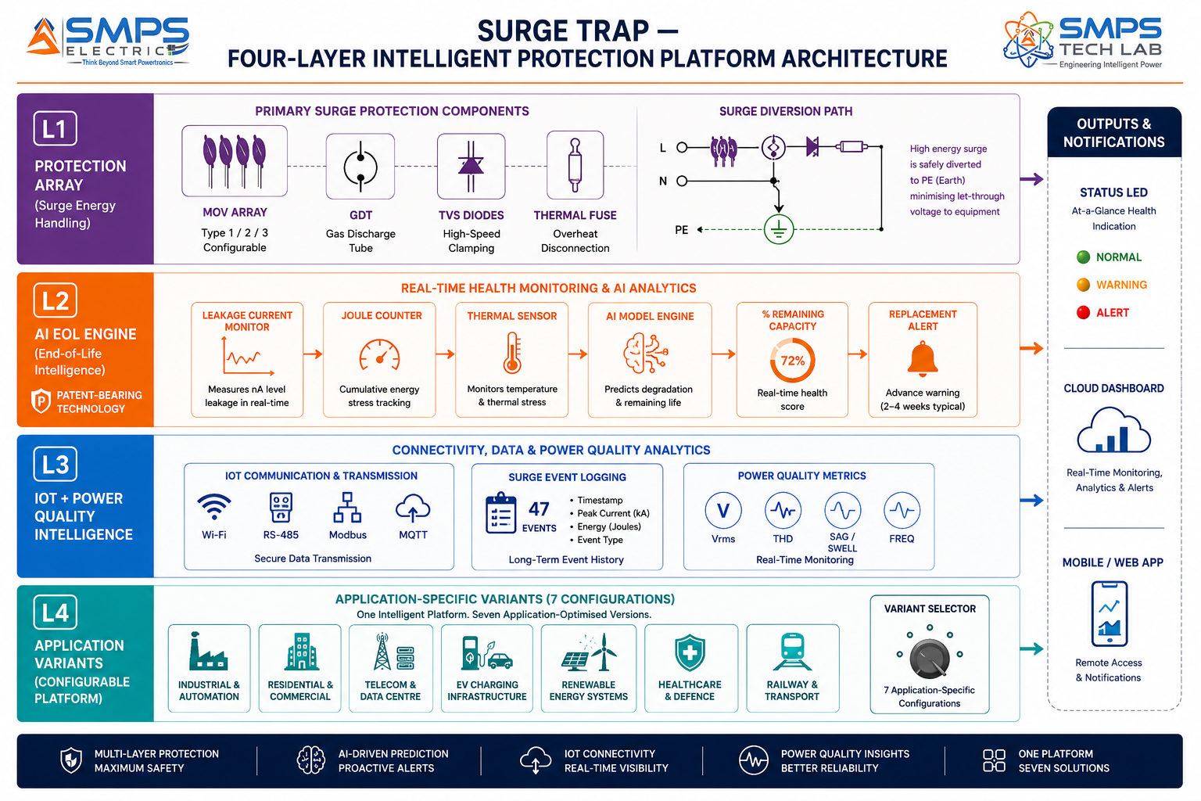
Figure 2.1 — Surge Trap four-layer architecture. The AI End-of-Life Engine (L2) is the patent-bearing element — converting the MOV’s non-linear leakage current degradation signal into a precise, actionable remaining-capacity percentage that drives the replacement alert.

2.3 AI End-of-Life Prediction — The Core Intelligence
The fundamental innovation in Surge Trap is the AI end-of-life prediction engine. MOV degradation follows a well-characterised but non-linear pattern: leakage current at rated voltage increases slowly for the majority of the device’s life, then rises exponentially as the device approaches failure. Conventional SPDs cannot measure this — they simply display a green LED until the MOV catastrophically fails and the LED turns red (if the LED circuit itself still functions). Surge Trap’s onboard microcontroller measures MOV leakage current with nA resolution, combined with joule absorption counting from each surge event, thermal state, and total operating hours. The AI model — trained on accelerated life test degradation data for MOV families across temperature and surge energy profiles — converts this multi-parameter input into a remaining protection capacity percentage and a calibrated days-to-replacement estimate. The practical result: Surge Trap alerts the facility manager, SCADA operator, or building management system 2–4 weeks before the protective element reaches its end-of-life — enabling a planned maintenance event rather than an emergency response after equipment failure.

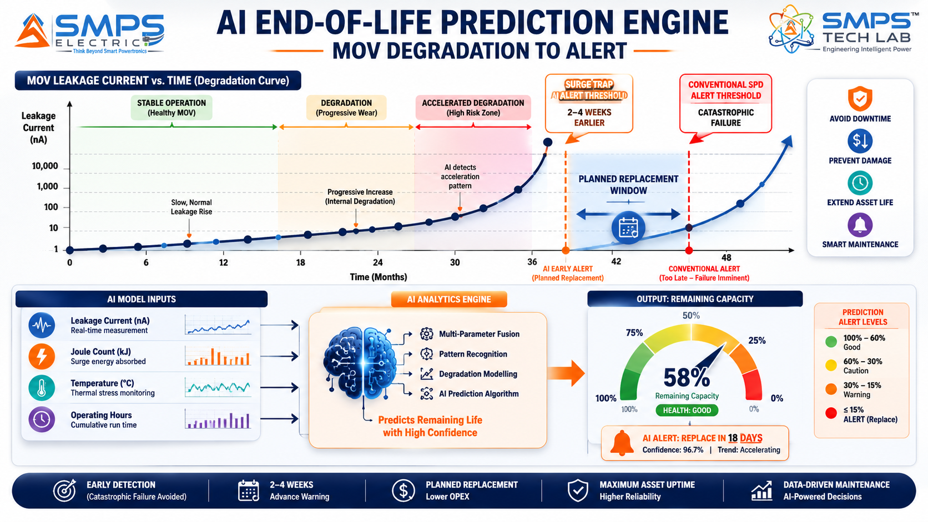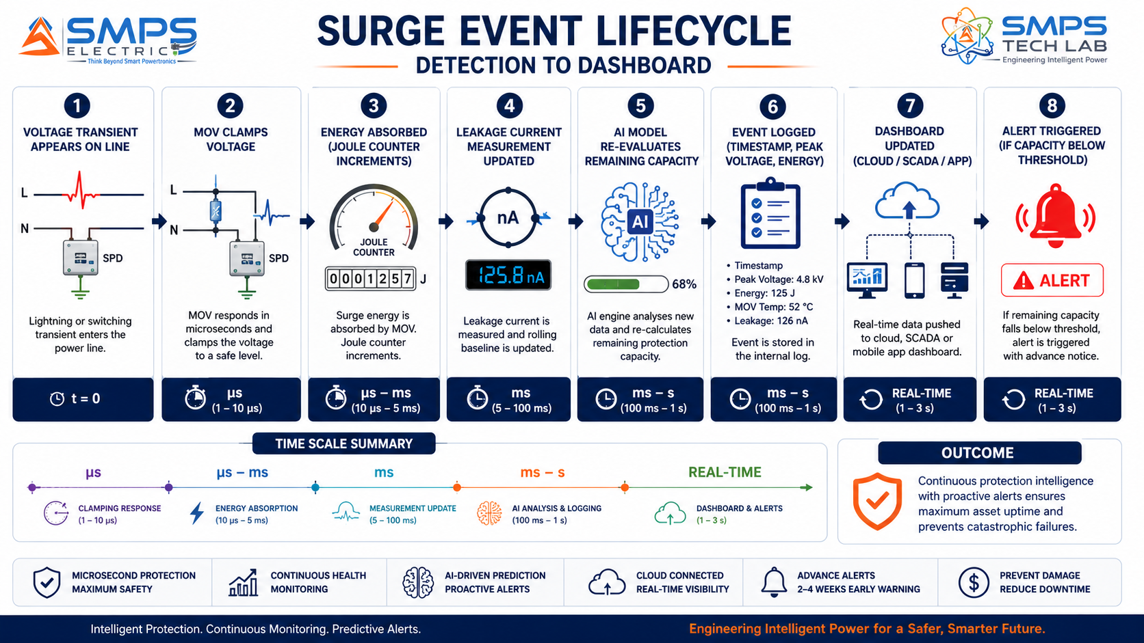
Figure 2.2 — AI end-of-life prediction (left): Surge Trap detects the exponential rise in MOV leakage current 2–4 weeks before catastrophic failure, providing a planned replacement window that passive SPDs are physically incapable of providing. Surge event lifecycle (right): from microsecond transient clamping through energy logging to cloud dashboard update in real time.

2.4 Multi-Mode Type 1+2+3 Combined Protection
Conventional SPD installation practice requires a cascade of three separate devices: a Type 1 SPD at the service entrance (protecting against direct lightning current), a Type 2 SPD at the main distribution board (energy-limiting protection), and a Type 3 SPD at the point-of-use (fine transient protection). This three-device cascade requires three procurement events, three installation points, three coordination studies, and three separate monitoring systems. Surge Trap’s Type 1+2+3 combined architecture integrates all three protection levels in a single co-ordinated unit — with the protection stages internally co-ordinated by design rather than requiring field co-ordination between separately procured devices. This single-device approach reduces installation cost by 40–60%, eliminates the risk of co-ordination gaps between separately procured devices, and provides a unified monitoring interface for all three protection levels simultaneously.

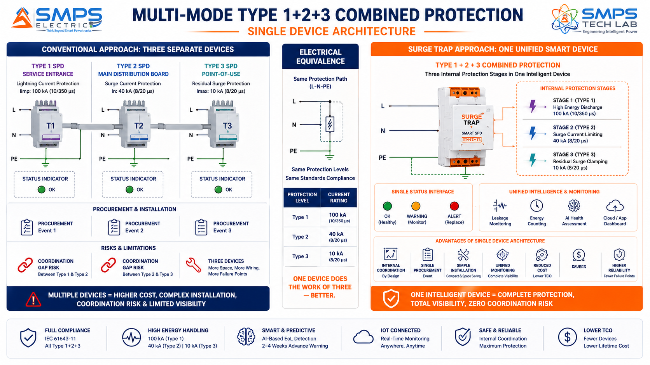
Figure 2.3 — Conventional three-device cascade (left) versus Surge Trap single-device combined protection (right). The three protection stages are internally co-ordinated by design, eliminating co-ordination gaps and reducing installation cost 40–60%.

2.5 Standards Compliance Architecture
STANDARD | SECTOR APPLICABILITY | COMPLIANCE RELEVANCE FOR IP-11
IEC 61643-11 | All AC sectors (Industrial, Residential, Telecom) | Primary AC SPD standard. Classification of Type 1, 2, 3. Test requirements, protection levels, coordination. Mandatory for all Surge Trap AC variants globally.
IEC 61643-21 | Telecom & Data Centre | AC/DC SPD standard for telecommunication and signalling networks. Signal line SPD for Ethernet, data, and telecom circuits. Required for telecom tower Ethernet/fibre protection.
UL 1449 5th Edition | US market, EV Charging, Data Centre | US standard for Surge Protective Devices. 5th Edition (2024) adds provisions for EV charging and DC protection. Required for US market and for NEVI-funded EV charging infrastructure.
IS 16609 | India (all sectors) | Bureau of Indian Standards SPD standard. Equivalent to IEC 61643-11 with India-specific additions. Mandatory for all BIS-certified electrical products in India.
IEC 61851-23 (DC) | EV Charging Infrastructure | DC charging station standard. Includes SPD requirements for DC-side protection at DCFC stations. Required for Surge Trap DC variant used in EV charging infrastructure.
EN 50539-11 | Renewable Energy (Solar PV) | SPD standard for photovoltaic systems. Addresses DC 1000V/1500V string protection, combiner box, and inverter connection. Required for Surge Trap solar PV variant.
IEC 62305 Level I | Defence, Healthcare, Critical Infra | Lightning protection system standard. Level I = maximum protection. SPD component requirements for IEC 62305-compliant installations. Required for defence and critical infrastructure.
IEC 60601-1 | Healthcare | Medical electrical equipment safety. Applies to SPDs installed in medical environments. Leakage current <0.5mA requirement. Required for Surge Trap medical-grade variant.

03 | GLOBAL MARKET LANDSCAPE  Smart SPD Transition · Market Sizing · Industry Validation Events

3.1 The Smart SPD Transition
The global SPD market is undergoing the same transition that has already transformed industrial sensors, building management systems, and power quality monitors: from passive components to intelligent, connected devices. The core SPD market at USD 3.59 billion (360iResearch) to USD 3.9 billion (Global Market Insights) is growing at 6.48–7.1% CAGR — a mature, steady market. But the smart/IoT SPD sub-segment is growing at 12–15% CAGR — 2x the rate of the overall market — driven by Industry 4.0 adoption, data centre uptime requirements, and the EV charging infrastructure buildout. The broader voltage protection market including power quality conditioning is valued at USD 13.75 billion (Future Market Report) at 8.6% CAGR, confirming that the premium market segment — where Surge Trap competes — is substantially larger than the commodity SPD market.

The commercial validation event for the smart EV charging SPD segment occurred in December 2025 when Raycap unveiled the ProTec T2 DCGU 3Y — a pluggable smart SPD for DC fast-charging infrastructure meeting IEC 61851-23 and UL 1449 5th Edition. This product launch, documented by Global Market Insights, confirms that purpose-designed intelligent SPDs for EV charging infrastructure are now a commercially shipping product category, not an emerging concept. Surge Trap’s DC variant is directly aligned with this validated market.

3.2 The Four Structural Megatrends
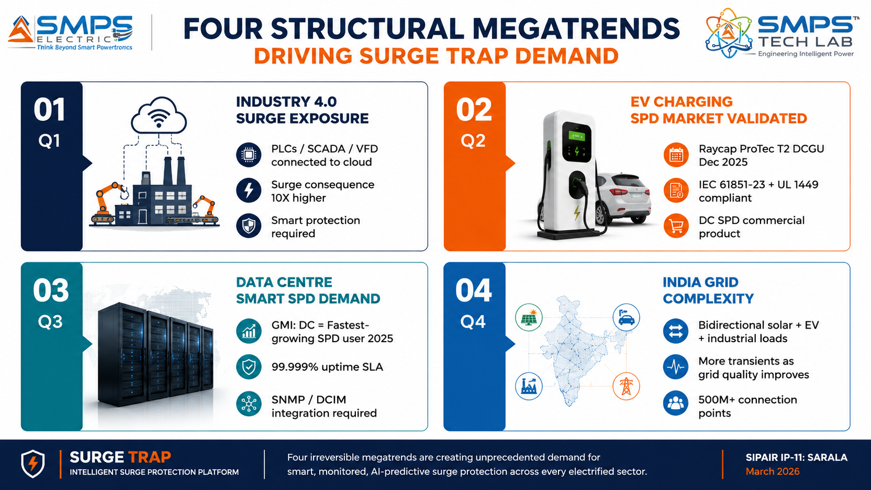
Figure 3.1 — Four structural megatrends. Industry 4.0 and EV charging SPD market validation are the most immediate commercial drivers; data centre smart SPD demand and India grid complexity provide the sustained multi-year market expansion.

3.3 Global Market Sizing — Primary Reference Data
MARKET SEGMENT | 2025 VALUE | PROJECTED | CAGR | HORIZON | SOURCE
Surge Protection Device Market | USD 3.59B | USD 4.90B | 6.48% | 2030 | 360iResearch
SPD Market (Global Market Insights) | USD 3.9B | USD 7.6B | 7.1% | 2035 | Global Market Insights
Broader Voltage Protection Market | USD 13.75B | USD 26.5B | 8.6% | 2032 | Future Market Report (2024 base)
SPD Market (IMARC Group) | USD 3.6B | USD 5.6B | 4.9% | 2033 | IMARC Group (2024 base)
SPD Market (Precedence Research) | USD 3.34B | USD 6.48B | 6.84% | 2034 | Precedence Research (2024 base)
SPD Market (Grand View Research) | USD 2.89B | USD 4.88B | 6.8% | 2030 | Grand View Research (2022 base)
SPD Market (Market Research Future) | USD 2.74B | USD 5.5B | 6.54% | 2035 | Market Research Future (2024 base)
Smart/IoT SPD Sub-segment (estimate) | ~USD 0.6B | ~USD 1.7B | 12–15% | 2032 | Industry estimate, GMI smart SPD trend data

CAGR Comparison — Surge Trap Target Market Segments

Smart/IoT SPD Sub-segment (GMI trend) █████████████████████████░ 12–15%
Broader Voltage Protection Market ████████████████░░░░░░░░░░ 8.6%
India Industrial Automation (Mordor Intl.) ██████████████████████████ 14.05%
SPD Market (Global Market Insights) █████████████░░░░░░░░░░░░░ 7.1%
SPD Market (Precedence Research) █████████████░░░░░░░░░░░░░ 6.84%
SPD Market (360iResearch) ████████████░░░░░░░░░░░░░░ 6.48%
SPD Market (Grand View Research) █████████████░░░░░░░░░░░░░ 6.8%
SPD Market (Market Research Future) ████████████░░░░░░░░░░░░░░ 6.54%
SPD Market (IMARC Group) █████████░░░░░░░░░░░░░░░░░ 4.9%
Healthcare & Defence SPD █████████████░░░░░░░░░░░░░ 6.8%
Sources: 360iResearch, Global Market Insights, Future Market Report, IMARC Group, Precedence Research, Grand View Research, Market Research Future (2024–2025 publications). Smart/IoT sub-segment CAGR is an industry estimate based on GMI’s identification of smart DC features and IoT integration as fastest-growing SPD trends.

04 | TOTAL ADDRESSABLE MARKET  Five Protection Sectors · Ten Applications · USD 15.2 Billion

4.1 Methodology
The TAM framework maps Surge Trap across five strategic protection sectors with two primary applications per sector, producing ten independently validated commercialisation pathways. The USD 15.2 billion TAM represents the addressable market for smart, IoT-connected, AI-monitored surge protection across all five sectors — the premium sub-segment within the broader SPD market where Surge Trap’s intelligence creates meaningful product differentiation and commands 2–3x the ASP of conventional passive SPDs.

STRATEGIC NOTE
Surge Trap’s five-sector architecture maps to the entire electrical infrastructure of the economy: industrial facilities, buildings, telecom towers, EV charging stations, and hospitals all require surge protection, and all are addressable by the same core AI-driven platform with application-specific variant configurations. A facility manager who deploys Surge Trap in their industrial plant can use the same platform family for their building’s residential units, their 5G tower estate, and their EV fleet depot — all monitored on a single cloud dashboard.

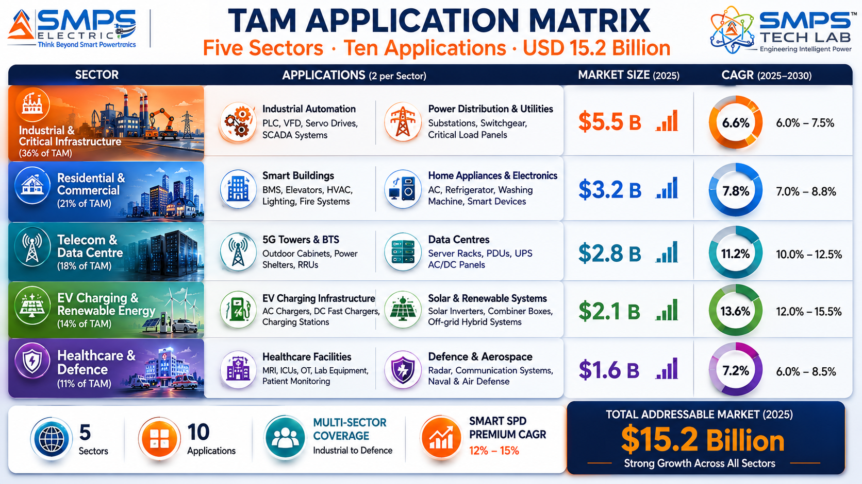
Figure 4.1 — Surge Trap application matrix. Ten commercial pathways across five sectors — the same intelligent AI protection platform serving every application through variant-specific configuration.

4.2 Consolidated TAM Summary
SECTOR | APPLICATION | USE CASE SUMMARY | APP SIZE | SECTOR TAM | CAGR
Industrial & Infra | Smart Industrial SPD (PLC/SCADA/VFD) | AI predictive SPD for industrial automation; Type 2; Modbus TCP/OPC-UA; surge log; end-of-life alert | $5.5B | $5.5B | 8.6%
Industrial & Infra | Smart Distribution Panel SPD | Service entrance Type 1+2 smart SPD; BMS/BACnet integration; power quality analytics; IS 16609 | $5.5B | $5.5B | 8.6%
Residential & Commercial | Smart Home & Apartment SPD | Whole-home IoT SPD; Wi-Fi; smartphone app; 90-day surge log; push notification EOL alert | $3.2B | $3.2B | 7.1%
Residential & Commercial | Smart Commercial Building IT SPD | Type 2+3 combined; BACnet/SNMP; rack-level protection; per-phase monitoring; IS 16609 | $3.2B | $3.2B | 7.1%
Telecom & Data Centre | Smart 5G Tower & Base Station SPD | 100kA+ Type 1+2; RS-485/Modbus; tower EMS integration; site-level surge intelligence; IP65 | $2.8B | $2.8B | 8.6%
Telecom & Data Centre | Data Centre Smart SPD Suite | PDU + rack-level SPD; DCIM API; 1-year event log; SNMP; uptime SLA compliance; UL 1449 | $2.8B | $2.8B | 8.6%
EV Charging & Renewable | DC Fast Charging Smart SPD (50–1000V DC) | Pluggable DC SPD; IEC 61851-23 + UL 1449; OCPP 2.0 integration; outdoor IP54; validated by Raycap Dec 2025 | $2.1B | $2.1B | 8.6%
EV Charging & Renewable | Solar PV & Wind Turbine Smart SPD | EN 50539-11; 1500V DC; combiner box IoT; cloud O&M monitoring; MNRE/ANERT India compliance | $2.1B | $2.1B | 8.6%
Healthcare & Defence | Medical-Grade Smart SPD | IEC 60601-1 compatible; <0.5mA leakage; NABH audit trail; hospital BMS; Type 2+3 combined | $1.6B | $1.6B | 6.8%
Healthcare & Defence | Defence Critical Infrastructure SPD | IEC 62305 Level I; 200kA+; MIL-STD-461; encrypted event log; DGQA approval; tamper-evident | $1.6B | $1.6B | 6.8%
TOTAL ADDRESSABLE MARKET — IP-11 SURGE TRAP — SMART VOLTAGE PROTECTION DEVICE (2025) |  |  |  | ~USD 15.2 Billion

MARKET DATA POINT
Combined SMPS Tech Lab portfolio TAM: IP-01 through IP-10 $426.1B + IP-11 $15.2B = USD 441.3 Billion across 55 sectors and 110 applications. Surge Trap completes the power protection layer — safeguarding every device that IP-01 through IP-10 powers, converts, stores, manages, detects, and charges.

05 | INDIA MARKET INTELLIGENCE  IS 16609 · PM e-DRIVE · 700K Towers · Solar Mission · Industry 4.0

5.1 India as Primary Market
India presents a uniquely large and structurally compelling first-market for Surge Trap. The combination of 700,000+ telecom towers (each requiring smart SPD monitoring to reduce emergency field service costs), India’s 24.5 GW solar capacity addition in 2024 alone (each installation requiring EN 50539-compliant string combiner SPDs), the PM e-DRIVE EV charging rollout (each charger requiring IEC 61851-23 DC SPDs), the industry 4.0 industrial automation wave (India industrial automation at USD 17.28 billion), and the NABH hospital accreditation requirement for documented electrical safety creates a multi-sector, policy-driven demand cascade that makes India the most concentrated near-term market opportunity for Surge Trap anywhere globally. India’s BIS certification system’s IS 16609 compliance requirement for SPDs means a BIS-certified Surge Trap automatically qualifies for every government infrastructure tender that specifies IS 16609 — a direct procurement advantage.

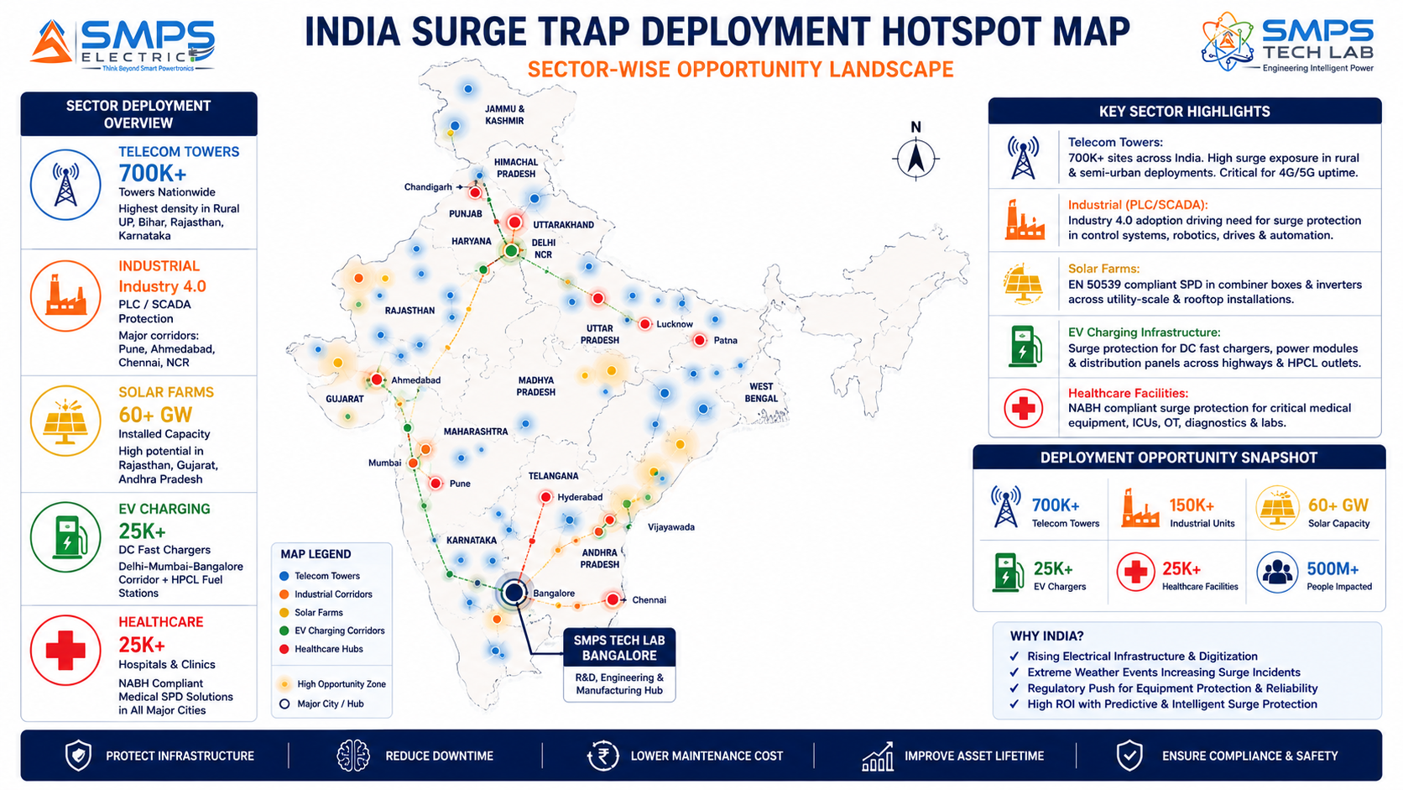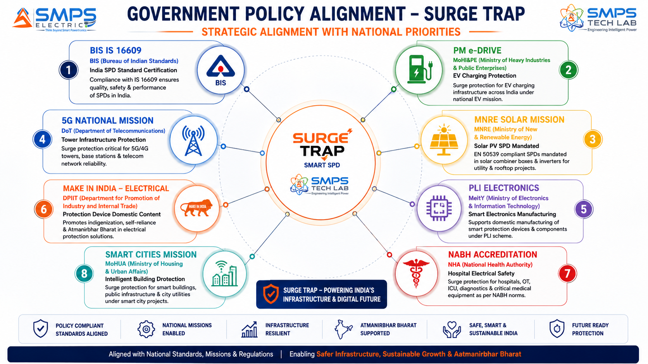
Figure 5.1 — India deployment hotspot map (left): Surge Trap has active demand across every Indian infrastructure sector simultaneously. Policy alignment (right): BIS IS 16609 certification creates a direct pathway to every government infrastructure procurement that mandates Indian standard compliance.

5.2 India Market Sizing — Surge Trap Relevant Segments
INDIA MARKET SEGMENT | 2025E VALUE | PROJECTED | CAGR | HORIZON
India SPD Market (overall) | USD 0.38B | USD 0.78B | ~10% | 2030
India Telecom Tower SPD (700K towers) | USD 0.12B | USD 0.28B | ~13% | 2030
India Industrial SPD (Industry 4.0 wave) | USD 0.10B | USD 0.25B | ~14% | 2030
India Solar PV SPD (MNRE mandate) | USD 0.06B | USD 0.18B | ~15% | 2030
India EV Charging SPD (PM e-DRIVE) | USD 0.04B | USD 0.18B | ~30% | 2030
India Healthcare SPD (NABH growth) | USD 0.04B | USD 0.09B | ~12% | 2030

06 | GOVERNMENT POLICY & REGULATORY ALIGNMENT  IS 16609 · Sector Mandates · Global Standards

6.1 India & Global Policy with Direct Surge Trap Alignment
SCHEME / PROGRAMME | MINISTRY / BODY | RELEVANCE TO SURGE TRAP | COMMERCIAL IMPLICATION
BIS IS 16609 SPD Standard | Bureau of Indian Standards | Mandatory Indian SPD standard equivalent to IEC 61643-11; required for all electrical products in India | BIS certification unlocks every government and corporate procurement tender in India that mandates IS 16609 compliance
PM e-DRIVE EV Charging Rollout | MoHI&PE | INR 10,900 crore; 22,100+ public EV chargers; SPD required at each DC fast charging station | Surge Trap DC variant (IEC 61851-23) required at every DCFC station; Make in India preference for IS-certified products
MNRE Solar Mission & Grid-Connected Solar | MNRE | IEC 62305 + EN 50539 SPD mandatory for grid-connected solar; India added 24.5 GW solar in 2024 | Surge Trap solar PV variant mandatory for every MNRE/ANERT approved solar installation; O&M monitoring adds value
5G National Mission — Tower Deployment | DoT / TRAI | 518,000+ 5G BTS deployed by late 2025; 700K+ total tower estate requires SPD protection | Surge Trap telecom variant for Indus/ATC/Summit/BSNL tower SPD upgrade; predictive maintenance reduces emergency field service
NABH Hospital Accreditation | National Accreditation Board for Hospitals | NABH electrical safety standards require documented SPD installation; audit trail needed for accreditation | Surge Trap cloud event log provides NABH-required timestamped SPD audit documentation; medical-grade variant required
Smart Cities Mission Electrical Safety | MoHUA | 100 Smart Cities require certified electrical infrastructure; intelligent building management | Smart Surge Trap with BMS/BACnet integration aligns with Smart Cities electrical safety and intelligent building mandates
PLI Electronics & IT Hardware | MeitY | 4–6% incentive on eligible smart electronics manufacturing including IoT devices | Surge Trap’s IoT-connected electronics qualify under PLI Electronics; manufacturing in India captures 4–6% incentive
IEC 61643-11 / UL 1449 5th Ed. (Global) | IEC / UL | International SPD standards; UL 1449 5th Ed. adds EV charging and IoT monitoring provisions | Global market access through IEC + UL dual certification; UL required for NEVI-funded US EV charging deployments

07 | IP AS AN INDUSTRY PLUGIN  Five-Sector Smart Protection Integration Architecture

7.1 The Plugin Architecture — Five Host System Categories
Surge Trap is architecturally designed as the intelligent protection plugin across five categories of electrical host system. In each case, Surge Trap connects to the host system’s management and monitoring infrastructure through the sector’s native protocol — Modbus TCP for industrial SCADA, BACnet for building management systems, RS-485/EMS for telecom towers, OCPP 2.0 for EV charging management, and REST API for solar O&M and data centre DCIM platforms. This protocol-native integration eliminates custom integration work and makes Surge Trap a deployable add-on to existing managed infrastructure rather than a separate standalone system.

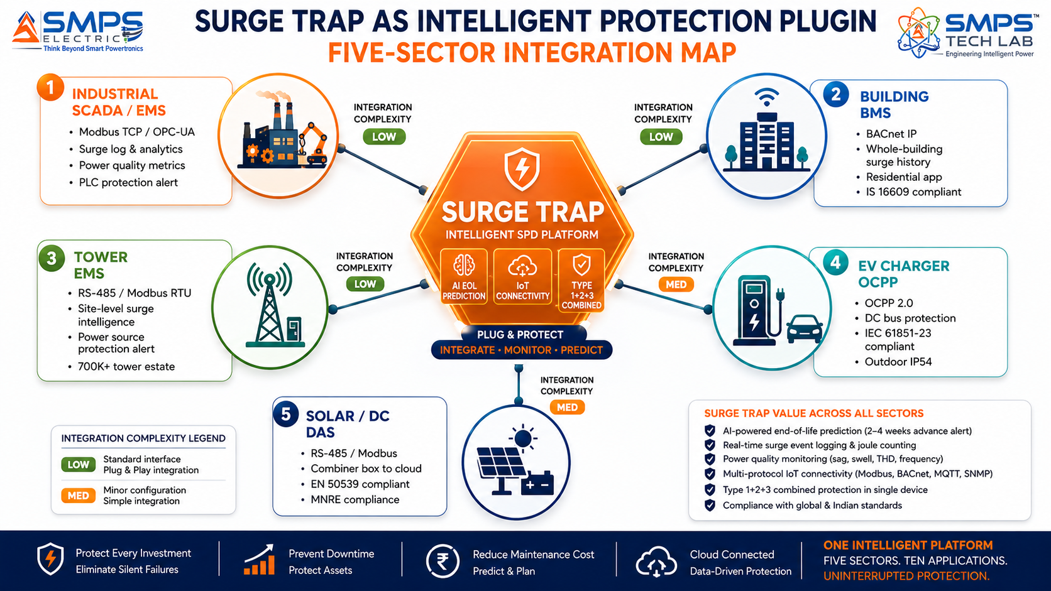
Figure 7.1 — Surge Trap as the intelligent protection plugin across five host system categories. Protocol-native connectivity to each sector’s existing management infrastructure means Surge Trap deploys as a managed upgrade to existing monitoring systems, not a separate standalone installation.

7.2 Plugin Integration Matrix
HOST SYSTEM | PLUGIN ROLE | VALUE AT SYSTEM LEVEL | INTEGRATION COMPLEXITY
Industrial SCADA / Plant EMS | Smart SPD node: surge event log, EOL alert, power quality metrics via Modbus TCP/OPC-UA to SCADA | Predictive replacement schedule; power quality anomaly detection; SCADA-integrated surge alarm management | LOW — DIN rail installation; Modbus TCP/OPC-UA standard protocol; no additional hardware
Building Management System (BMS) | Smart SPD node: BACnet integration; whole-building surge history; residential app dashboard | Facility manager single-pane surge protection dashboard; NABH/insurance audit documentation; tenant app | LOW — BACnet IP standard protocol; existing BMS enrollment
Telecom Tower EMS (TowerCo) | Smart SPD node per tower: RS-485/Modbus integration; site-level surge exposure data | Portfolio-level SPD health dashboard; predictive maintenance scheduling; lightning hot-spot identification | LOW — RS-485 standard on all tower sites; EMS integration
EV Charger Management (OCPP 2.0) | DC SPD plugin: OCPP 2.0 event reporting; DC bus voltage quality monitoring; IEC 61851-23 compliance | CPO network-level SPD health; charger uptime protection; DC power quality analytics | LOW-MED — OCPP 2.0 integration; DC variant certification (IEC 61851-23, UL 1449)
Solar O&M / Data Acquisition System | Smart PV SPD: RS-485/Modbus; combiner box health; cloud O&M dashboard; EN 50539 event log | O&M company cloud dashboard for all combiner box SPDs; early lightning damage detection; planned replacement | LOW — Modbus RTU standard on solar DAS; plug-in cartridge design

08 | COMMERCIALISATION STRATEGY  Revenue Models · Market Priority · Managed Service Architecture

8.1 Commercialisation Philosophy
The Surge Trap commercialisation strategy is built on three parallel revenue streams that compound over time. The first is hardware sales: supplying Surge Trap smart SPD units at 2–3x the ASP of conventional passive SPDs to industrial panel builders, EV charging OEMs, solar O&M companies, telecom TowerCos, and healthcare facilities. The second is managed service subscriptions: cloud monitoring platform access fees from facilities deploying Surge Trap across multiple sites or multiple units per site — INR 500–1,500 per unit per year depending on feature tier. The third is insurance data partnerships: providing anonymised aggregate power quality and surge event data to insurance underwriters and risk management companies who value SPD monitoring data for premium adjustment and infrastructure risk assessment — a data monetisation stream that conventional passive SPD manufacturers cannot access because they generate no data. The industrial sector is prioritised as the fastest near-term pathway: shortest sales cycle, highest existing awareness of surge protection costs, and immediate integration into panel builder procurement.

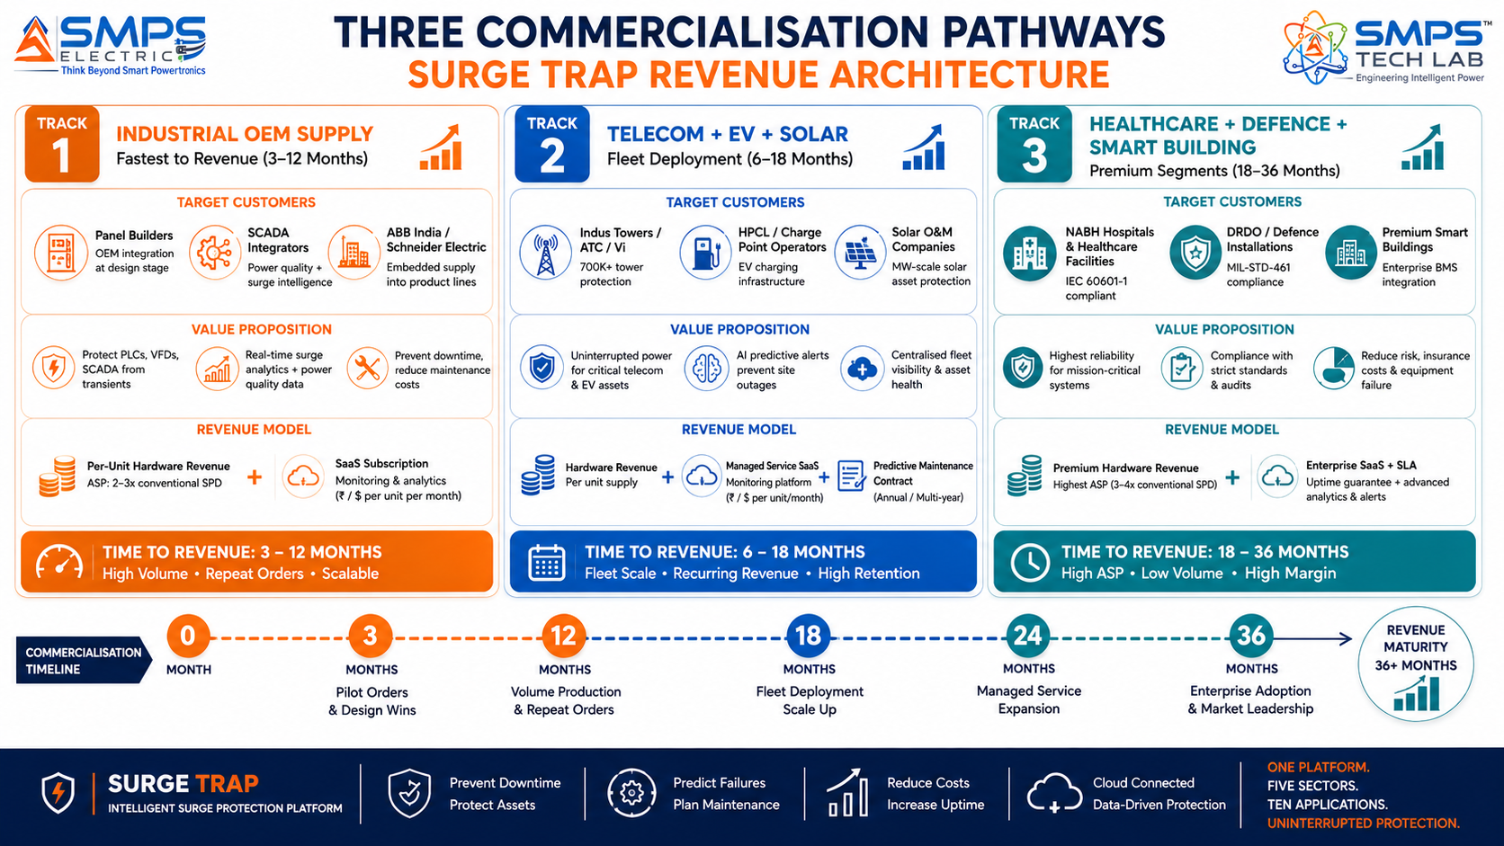
Figure 8.1 — Three parallel revenue pathways. Industrial OEM supply provides fastest hardware revenue; telecom and solar fleet deployments create the managed service subscription base; healthcare and defence command the highest per-unit ASP.

8.2 Market Priority Matrix
SECTOR | TAM 2025 | CAGR | IP FIT | TIME-TO-REV | PATHWAY | PRIORITY
Industrial & Infra | $5.5B | 8.6% | Excellent | 3–12 mo | OEM + Direct | HIGHEST
EV Charging & Renewable | $2.1B | 8.6% | Excellent | 6–18 mo | EV OEM + Solar | HIGH
Telecom & Data Centre | $2.8B | 8.6% | Excellent | 6–18 mo | TowerCo Fleet | HIGH
Residential & Commercial | $3.2B | 7.1% | Strong | 12–24 mo | Builder + BMS | HIGH
Healthcare & Defence | $1.6B | 6.8% | Strong | 18–36 mo | Direct Supply | MED-HIGH

09 | COMPETITIVE LANDSCAPE  Market Positioning · Advantage Scorecard · IP Moat

9.1 Competitive Architecture Overview
The conventional SPD market is dominated by well-established Tier 1 electrical component manufacturers: Dehn, Phoenix Contact, Citel, OBO Bettermann, Hager, ABB, Schneider Electric, and Siemens. These companies supply passive SPDs at commodity prices through established electrical component distribution channels. Their competitive strength is brand recognition, certification portfolio, and distribution reach. Their structural limitation is precisely the silent failure problem: every one of their products is a passive component with no intelligence, no monitoring, and no end-of-life prediction. The smart IoT SPD market is still nascent: Raycap’s December 2025 ProTec T2 DCGU launch for EV charging is the clearest evidence that Tier 1 manufacturers are beginning to recognise the segment, but their smart product lines are limited, expensive, and focused on single application sectors rather than the multi-sector unified platform that Surge Trap represents.

CATEGORY | KEY PLAYERS | MARKET FOCUS | SURGE TRAP ARCHITECTURAL DIFFERENTIATION
Tier 1 Passive SPD OEMs | Dehn, Phoenix Contact, Citel, OBO Bettermann, Hager | Conventional passive SPD; all sectors | All passive devices with zero intelligence. Distribution channel strength. No AI prediction. No IoT. No power quality analytics. Cannot address managed service or insurance data market. 2-3x lower ASP than Surge Trap.
Large Electrical OEMs (SPD Division) | ABB, Schneider Electric, Siemens (SPD lines) | Industrial and commercial SPD | Passive SPD product lines with no IoT. Some smart SPD products in development but limited, single-sector, expensive. Not unified multi-sector platform. Surge Trap OEM supply to their panel builders is the preferred commercial outcome.
Smart SPD Pioneers | Raycap (ProTec T2 DCGU), Mersen (IoT SPD lines) | EV charging, data centre smart SPD | Raycap Dec 2025 validates EV DC SPD market (Surge Trap directly aligned). Single-application focus. No multi-sector unified platform. No AI end-of-life prediction. Competitive overlap only in EV DC segment.
Indian SPD Manufacturers | Salzer Electronics, Havells (SPD lines), Elmec | India SPD market, IS 16609 | India-focused passive SPD manufacturers. No smart capability. Serve as market size indicators. Surge Trap’s smart premium segment is above their positioning; distributor channel partnerships are viable.
Power Quality Monitor Vendors | Fluke, Hioki, Dranetz (standalone power quality meters) | Power quality measurement instruments | Standalone instruments, not integrated with protection devices. High price (USD 2,000–15,000). Surge Trap’s integrated power quality analytics in a protection device provides 80% of the value at 10–15% of the cost.

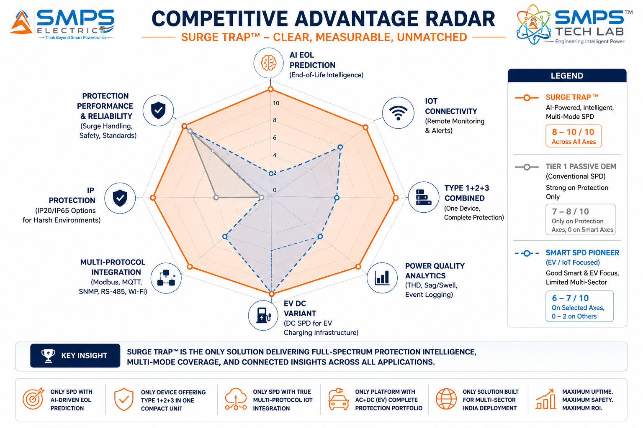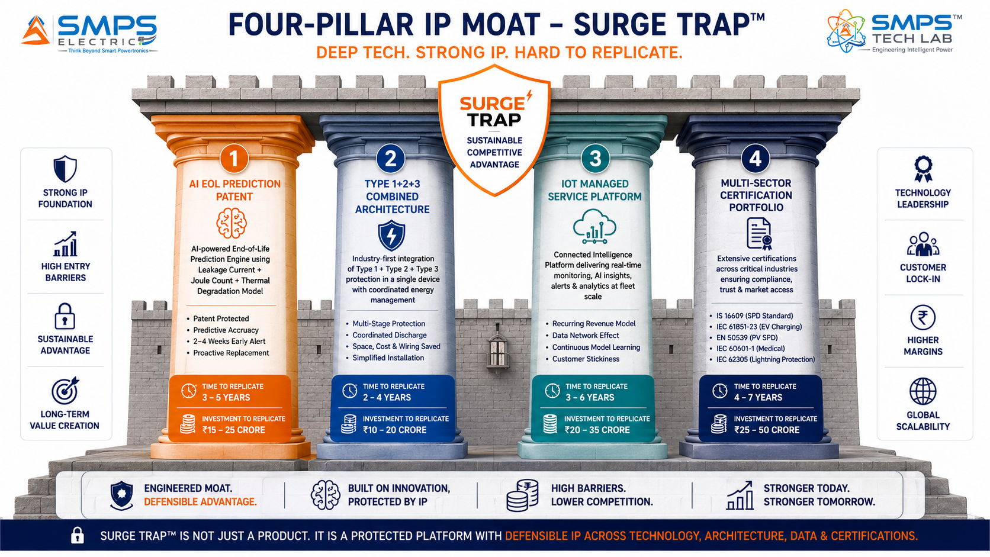
Figure 9.1 — Surge Trap competitive radar (left): AI end-of-life prediction and multi-sector unified platform are structurally unmatched by any competitor. Four-pillar moat (right): the IoT managed service platform creates a data network effect — each additional deployed unit improves AI degradation model accuracy for all other units.

10 | INVESTMENT THESIS & FINANCIAL FRAMEWORK  Value Creation · Triple Revenue Model · Managed Service Scale

10.1 The Investment Case
The investment case for Surge Trap is defined by the combination of a large and certain underlying hardware market (every electrical installation requires an SPD — no demand creation needed) with a premium intelligence layer that commands 2–3x the ASP of commodity alternatives, a recurring managed service subscription revenue stream that compounds with every unit deployed, and a data monetisation opportunity that no conventional SPD manufacturer can access because they generate no data. The industrial sector’s 3–12 month time-to-revenue is the fastest in the portfolio — industrial panel builders include SPDs in every panel they build, and a Surge Trap smart SPD listed in a panel builder’s component catalogue generates orders from Day 1 of listing. India’s 700,000+ telecom tower estate is a concentrated fleet deployment opportunity where Indus Towers or ATC India selecting Surge Trap creates a five-figure unit order from a single sales engagement.

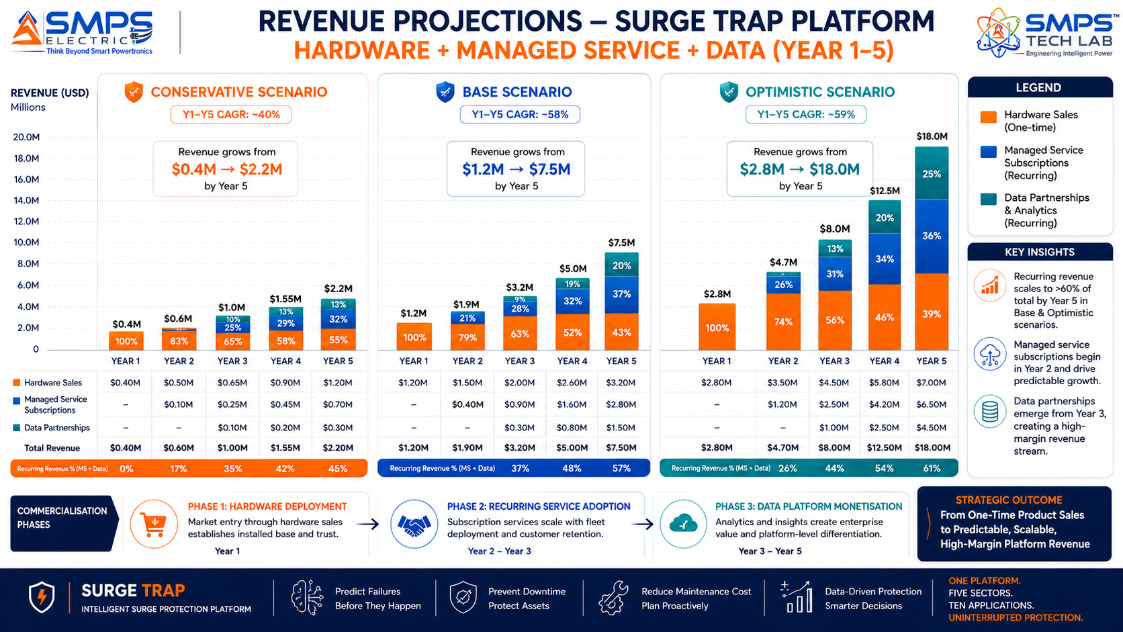
Figure 10.1 — Triple revenue model projections. Hardware sales dominate Year 1; managed service subscriptions grow from Year 2 as fleet deployments accumulate; data partnership revenue emerges from Year 3 as aggregate portfolio data becomes commercially valuable to insurers and infrastructure investors.

10.2 Illustrative Revenue Scenarios
SCENARIO | YEAR 1 | YR 2–3 CAGR | YR 4–5 CAGR | KEY ASSUMPTIONS
Conservative (Industrial OEM Only) | USD 400–600K | +28% | +22% | 2 industrial panel builder OEM supply agreements; IS 16609 + CE certified; BIS-listed
Base (OEM + Telecom + Solar) | USD 1.2–1.8M | +55% | +45% | Industrial OEM + 1 TowerCo pilot + solar O&M managed service + EV DC for DCFC network
Optimistic (All Pathways + Managed Service) | USD 2.8–3.5M | +70% | +60% | All pathways + NABH hospital + DRDO defence + managed service subscriptions Year 2+ + data partnership

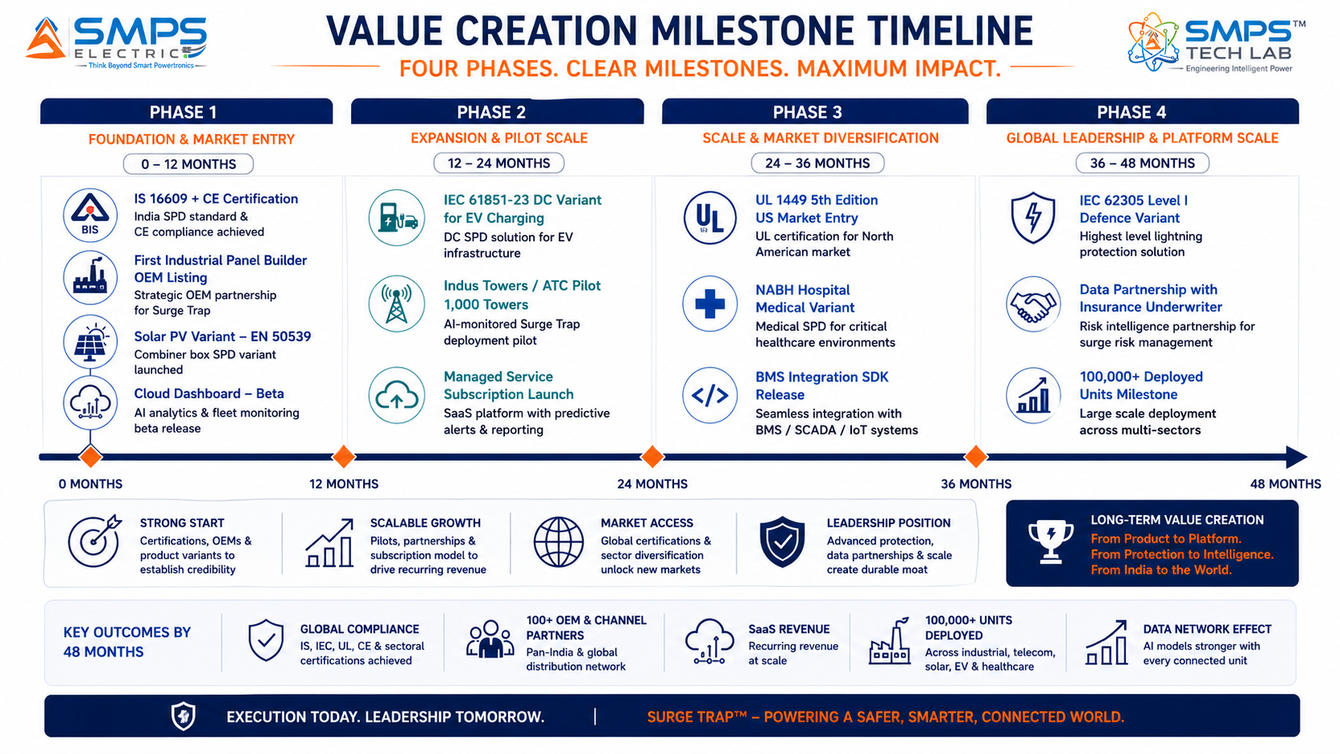
Figure 10.2 — Four-phase milestone roadmap. IS 16609 certification in Phase 1 opens India market immediately; telecom tower fleet deployment in Phase 2 creates the managed service subscription base; international certifications in Phase 3 open export markets.
KEY INSIGHT
A single TowerCo contract — Indus Towers selecting Surge Trap for upgrade of 10,000 towers in its planned maintenance cycle — generates a 10,000-unit hardware order plus 10,000 annual managed service subscriptions. At a conservative blended revenue of INR 4,000 per unit (hardware) + INR 1,000 per year (subscription), this single engagement generates INR 4 crore in hardware revenue plus INR 1 crore in recurring annual subscription revenue — from a single commercial relationship with a single customer.

11 | FUTURE ROADMAP  Technology Evolution · Insurance Data Platform · Grid Intelligence

11.1 Technology Generation Roadmap
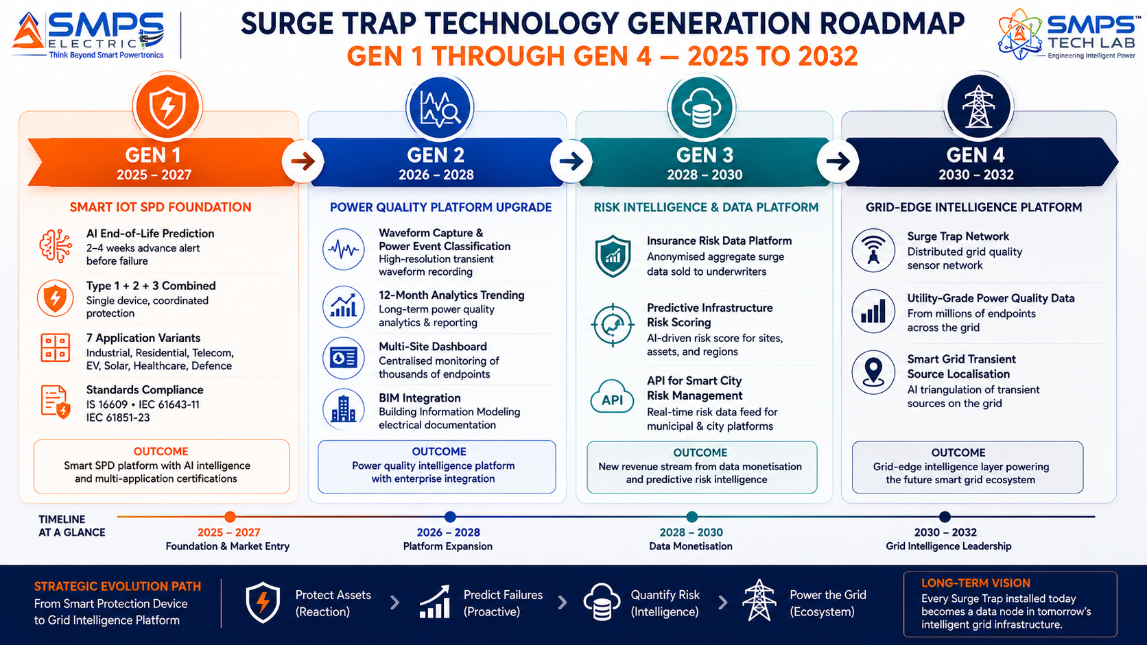
Figure 11.1 — Surge Trap four-generation roadmap. From smart IoT protection device (Gen 1) to distributed grid-edge intelligence network (Gen 4) — each generation converting more of Surge Trap’s installed base into a data asset.
GENERATION | TECHNOLOGY FOCUS | TARGET TIMELINE | MARKET IMPACT
Gen 1 (Current) | Smart IoT SPD: AI EOL prediction, Type 1+2+3 combined, 7 application variants; IS 16609 + IEC 61643-11 + IEC 61851-23 + EN 50539 + IEC 60601-1; managed service subscription | 2025–2027 | Industrial OEM supply, telecom tower fleet, EV charging DC, solar O&M, medical, defence
Gen 2 | Power quality analytics platform: waveform capture (8kHz), power event classification (sag/swell/notch/transient), 12-month trending, multi-site dashboard; BIM/digital twin integration | 2026–2028 | Power quality consulting service revenue; manufacturing plant energy analytics; smart building energy certification
Gen 3 | Insurance risk data platform: anonymised aggregate surge and power quality data sold to underwriters; infrastructure risk scoring API; smart city electrical risk assessment integration | 2028–2030 | Data partnership revenue with insurers; infrastructure risk-adjusted maintenance contracts; smart city risk services
Gen 4 | Grid-edge distributed intelligence: Surge Trap network as a utility-grade distributed power quality sensor grid; transient source localisation; smart grid event attribution; utility data API | 2030–2032 | Utility power quality monitoring contracts; DISCOM regulatory compliance data; national grid intelligence

11.2 Adjacent Application Opportunities
- Energy Theft Detection: Power distribution companies (DISCOMs) lose 18–25% of electricity to technical and commercial losses in India. Surge Trap’s continuous voltage monitoring at the consumer connection point can detect the power quality signature of illegal tapping — making it a low-cost, IoT-deployable energy audit tool that DISCOMs can deploy at scale to reduce AT&C losses.
- EV Battery Health Monitoring at Charging Points: The combination of Surge Trap’s voltage monitoring at the EV charging DC bus with IP-06 Swarna Li’s battery intelligence creates an integrated charging-point battery health monitoring system — detecting degraded EV batteries that are presenting abnormal charging current signatures that stress the charging infrastructure, enabling proactive fleet management.
- Solar Panel Degradation Early Detection: Surge Trap’s voltage monitoring at string combiner boxes, combined with string current data, can detect partial shading, soiling accumulation, and module degradation signatures that reduce solar farm output before they are visible on standard solar SCADA dashboards — providing solar O&M companies with an additional diagnostic capability at zero incremental hardware cost.
- Demand Response Integration: SMPS Electric (IP-10) and SAMARAT (IP-07) both implement demand response capabilities. Surge Trap’s distributed power quality data provides the real-time grid load data that makes demand response algorithms more precise — creating a portfolio integration where Surge Trap’s monitoring feeds SAMARAT’s autonomous energy management and SMPS Electric’s smart grid intelligence.

12 | RISK ANALYSIS  Risk Register · Probability & Impact · Strategic Mitigation

12.1 Risk Framework
Surge Trap’s risk profile is distinct from the rest of the portfolio because it addresses a market where the competing product (conventional passive SPD) is extremely inexpensive and widely available through established distribution channels. The primary commercial risk is not technical but commercial: explaining and justifying a 2–3x price premium to procurement managers who currently buy INR 200–2,000 passive SPDs and have not experienced the consequences of the silent failure problem personally. This awareness and education challenge is the dominant go-to-market risk. The industrial sector — where a single surge-induced PLC failure causes production downtime costing orders of magnitude more than the SPD price — is the fastest path to customer ROI realisation and is therefore the entry sector of choice.

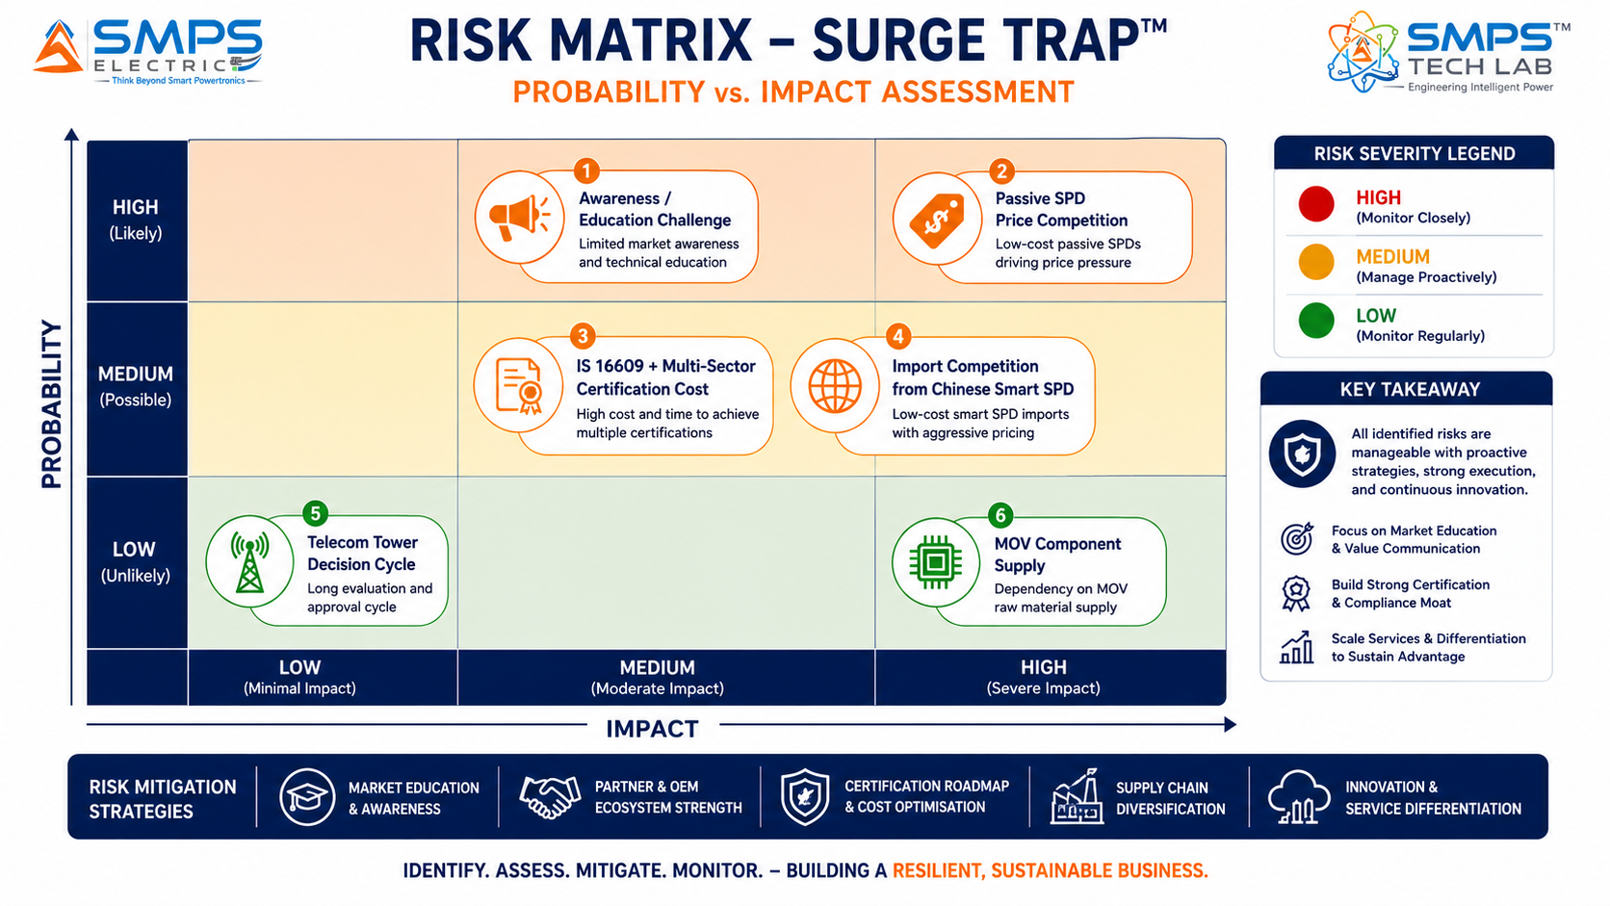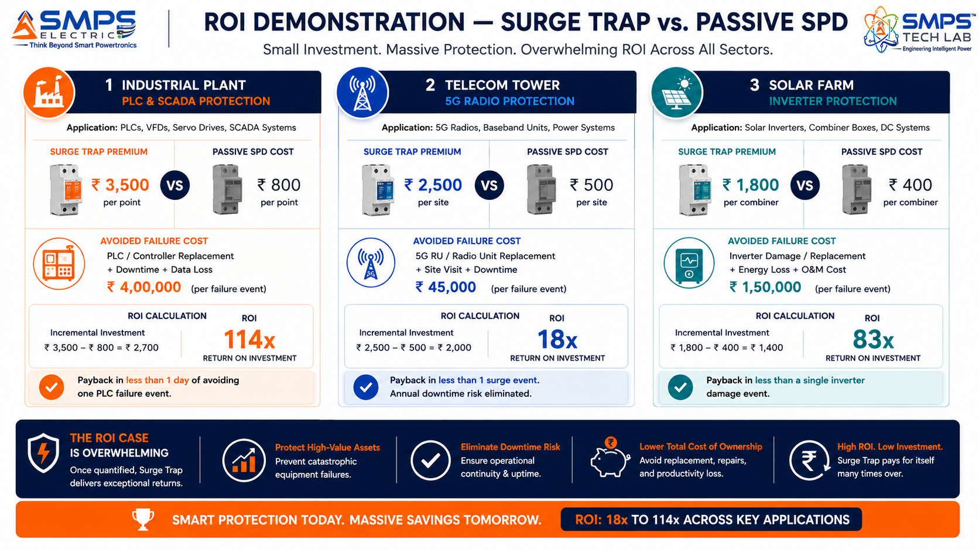
Figure 12.1 — Risk matrix (left): awareness and education is the highest-probability commercial risk — addressable through ROI demonstration. ROI comparison (right): Surge Trap’s premium pays back 18–114x in avoided equipment damage across all three primary sectors — making the commercial case decisive once quantified for the customer.

CATEGORY | SPECIFIC RISK | PROB. | IMPACT | MITIGATION STRATEGY
IP Protection | Dehn or Phoenix Contact replicates AI EOL prediction feature | MEDIUM | MEDIUM | PCT patent on leakage-current AI degradation model. Tier 1 SPD OEMs have passive product lines deeply embedded in distribution channels; their smart product development cycles are 4-6 years. First-mover advantage in India is critical.
Price Awareness | Customers default to passive SPD on price without understanding ROI | HIGH | MEDIUM | ROI demonstration toolkit quantifying avoided equipment damage for each sector. Industrial sector as entry point: PLC failure cost is well-known and universally feared. Once industrial ROI is demonstrated, other sectors follow. Free 90-day trial programme for panel builders.
Certification Cost | Multi-sector certification (IS 16609 + IEC 61851-23 + EN 50539 + IEC 60601-1) exceeds budget | MEDIUM | MEDIUM | IS 16609 + IEC 61643-11 (industrial+residential, largest TAM) as Phase 1 priority. IEC 61851-23 DC (EV charging) as Phase 2. EN 50539 solar and IEC 60601-1 medical as Phase 3. Sector-sequenced certification preserves capital.
Import Competition | Chinese smart SPD manufacturers enter India market at lower price point | MEDIUM | MEDIUM | BIS IS 16609 certification requirement creates a registration barrier for imported SPDs. Surge Trap’s India-developed IP, Make in India manufacturing, and PLI Electronics qualify for procurement preference in government and PSU projects.
Telecom Decision | TowerCo procurement cycle extends beyond Year 1 plan | LOW-MED | LOW | Industrial OEM and EV+solar supply provides bridge revenue during telecom procurement cycle. Telecom pilot programme (1,000 towers free monitoring for 6 months) demonstrates fleet predictive maintenance value before commercial rollout.
Financial | Multi-variant development + certification exceeds Year 1 capital | MEDIUM | LOW | Industrial variant first (shared base platform with minimal variant-specific hardware). IS 16609 certification (lowest cost, fastest certification). Revenue from industrial OEM supply funds subsequent variant development.

13 | APPENDICES  Data Sources · Standards Reference · Glossary

Appendix A — Data Sources
- 360iResearch — Surge Protection Device Market: USD 3.59B (2025) to USD 4.90B by 2030, CAGR 6.48%
- Global Market Insights — Surge Protection Devices Market: USD 3.9B (2025) to USD 7.6B by 2035, CAGR 7.1%
- IMARC Group — Surge Protection Devices Market: USD 3.6B (2024) to USD 5.6B by 2033, CAGR 4.9%
- Precedence Research — Surge Protection Device Market: USD 3.34B (2024) to USD 6.48B by 2034, CAGR 6.84%
- Future Market Report — Broader Voltage Protection/SPD Market: USD 13.75B (2024) to USD 26.5B by 2032, CAGR 8.6%
- Grand View Research — SPD Market: USD 2.89B (2022) to USD 4.88B by 2030, CAGR 6.8%
- Market Research Future — SPD Market: USD 2.74B (2024) to USD 5.5B by 2035, CAGR 6.54%
- Raycap — ProTec T2 DCGU 3Y: pluggable smart SPD for DC fast-charging infrastructure, meeting IEC 61851-23 + UL 1449 5th Edition, December 2025 (per Global Market Insights report)
- Transparency Market Research — India electronics demand USD 400B by 2025; SPD market growth driver
- Mordor Intelligence — India Industrial Automation Market: USD 17.28B (2025), CAGR 14.05%
- ICCT — India EV sales 1.9M units in 2024; PM e-DRIVE INR 10,900 crore for charging infrastructure
- Department of Telecommunications, GoI — India 5G base transceiver station deployment 518,000+ by late 2025
- PS Market Research — India Energy Storage Market; Karnataka ~40% share 2025
- Precedence Research — AI-driven analytics in SPDs identified as key trend: real-time issue prediction, trend analysis, corrective action recommendation, 2025
- Global Market Insights — Data centres confirmed as fastest-growing SPD end-user segment in 2025; IoT monitoring integration trend identified

Appendix B — Standards Reference
STANDARD | FULL TITLE | APPLICABILITY
IEC 61643-11 | Low-voltage surge protective devices: SPDs connected to low-voltage power distribution systems — requirements and test methods | Primary AC SPD standard. Type 1, 2, 3 classification. Test requirements, protection levels, voltage protection ratings. Mandatory for all Surge Trap AC variants globally.
IEC 61643-21 | Low-voltage surge protective devices: SPDs connected to telecommunications and signalling networks — performance requirements and testing methods | Signal line SPD standard. Covers Ethernet, telephone, data circuit protection. Required for telecom tower signal line variant and data centre network port protection.
UL 1449 5th Edition | Standard for Surge Protective Devices (US) | US market SPD standard, 5th Edition (2024) includes provisions for EV charging and DC applications. Required for US market access and NEVI-funded EV charging infrastructure supply.
IS 16609 | SPDs connected to low-voltage power distribution systems — requirements and testing (Bureau of Indian Standards) | India national SPD standard. BIS certification mandatory for all electrical products sold in India. Unlocks all government and PSU procurement tenders specifying IS 16609 compliance.
IEC 61851-23 | Electric vehicle conductive charging systems: DC EV charging station | EV charging station standard including DC-side SPD requirements. Required for Surge Trap DC variant for DCFC infrastructure. Validated by Raycap ProTec T2 DCGU (Dec 2025).
EN 50539-11 | Low voltage surge protective devices: SPDs for photovoltaic applications — requirements and test methods | Solar PV SPD standard. Covers DC 1000V/1500V string protection and inverter-side SPD. Required for Surge Trap solar PV variant and MNRE/ANERT India solar tenders.
IEC 62305 Level I | Protection against lightning (Part 4: electrical and electronic systems within structures) | Lightning protection system standard. Level I = maximum protection for high-risk structures. Required for defence, hospital, and critical infrastructure Surge Trap variants.
IEC 60601-1 | Medical electrical equipment — general requirements for basic safety and essential performance | Medical electrical equipment safety. Applies to SPDs installed in medical environments. Leakage current <0.5mA required. Required for Surge Trap medical-grade variant.

Appendix C — Glossary
TERM | DEFINITION
Surge Trap | IP-11 — Smart Voltage Protection Device. AI-driven IoT-connected SPD platform with MOV leakage current monitoring, end-of-life prediction 2–4 weeks in advance, real-time power quality analytics, and multi-protocol IoT connectivity. Available in seven application variants across industrial, residential, telecom, EV charging, solar, healthcare, and defence sectors.
SPD | Surge Protection Device — an electrical component that limits voltage transients by diverting surge energy to ground. Conventional SPDs use MOVs, GDTs, or TVS diodes as passive clamping elements. Surge Trap adds AI intelligence and IoT connectivity to the conventional SPD.
MOV | Metal Oxide Varistor — the primary protective element in most SPDs. A voltage-dependent resistor that conducts when voltage exceeds its clamping voltage, diverting transient energy. MOVs degrade with each surge event — the degradation that Surge Trap’s AI engine monitors and predicts.
AI EOL Prediction | AI End-of-Life Prediction — Surge Trap’s patent-bearing innovation. An AI model trained on MOV degradation curves that converts continuous leakage current measurement, joule count, temperature, and operating hours into a remaining protection capacity percentage and calibrated days-to-replacement estimate.
Type 1 / Type 2 / Type 3 SPD | IEC 61643-11 classification of SPDs by installation location and protection function. Type 1: service entrance, direct lightning current rated (tested per I-impulse current). Type 2: main distribution board, energy-limiting (tested per 8/20µs current impulse). Type 3: point-of-use, fine protection (tested per combined wave).
GDT | Gas Discharge Tube — a surge protection component used alongside MOVs. GDTs crowbar excess voltage by ionising a gas medium, providing a very low impedance discharge path for large transient currents (particularly Type 1 lightning current applications).
IS 16609 | Indian Standard 16609 — BIS (Bureau of Indian Standards) standard for SPDs connected to low-voltage power distribution systems. Equivalent to IEC 61643-11 with India-specific provisions. BIS certification to IS 16609 is mandatory for all SPD products in India.
SIPAIR | Strategic IP Asset Intelligence Report — SMPS Tech Lab documentation series for IP commercialisation briefs

14 | IP COMMERCIALISATION — CASE STUDIES  Six Scenarios · Market Validation · The Open Invitation

The following six case studies illustrate the full commercial range of Surge Trap. Cases 01 through 04 are deployment scenarios across key sectors. Case 05 is the IP development narrative. Case 06 is the open invitation with the complete eleven-IP portfolio.

CASE  01 | Industrial Panel Builder OEM Integration — Surge Trap Smart SPD in MCC Assemblies  Industrial Electrical Panel Builder · MCC Panel OEM, Pune Industrial Corridor  Sector: Industrial & Critical Infrastructure · Smart Industrial SPD for PLC/SCADA/VFD Protection  Key Outcome:

PANEL BUILDER LISTING  IS 16609 + CE  Standard panel component from Day 1 | ASP PREMIUM OVER PASSIVE  2.6x  INR 3,800 vs. INR 1,450 passive SPD | CUSTOMER ROI  18x first event  Single PLC surge failure avoided | MANAGED SERVICE  INR 900/unit/yr  Monitoring dashboard subscription

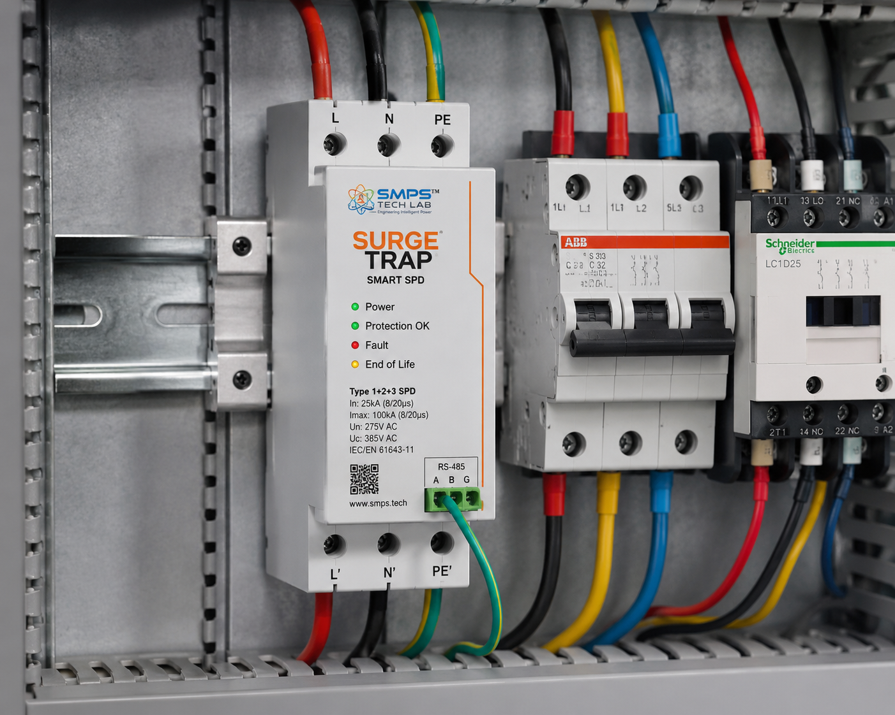
Figure CS1.1 — Surge Trap smart industrial SPD installed on DIN rail in an MCC panel, Pune. The RS-485 Modbus interface connects to the plant SCADA system, providing real-time surge event data and end-of-life prediction alerts directly in the operator’s existing monitoring infrastructure.

The Context
A Pune-based MCC (Motor Control Centre) panel builder supplying to automotive tier-1 manufacturers, pharmaceutical companies, and food processing plants across Maharashtra was procuring passive SPDs from a European distributor at INR 1,200–1,800 per unit and installing them in every panel as a standard component. The panel builder’s value-add was limited: passive SPDs are commodity items that customers compare on price alone. The panel builder had also observed a recurring pattern: three or four times per year, a customer would report an unexplained PLC or VFD failure in a panel that had a ‘green light’ SPD — where the SPD had silently failed and the LED was still indicating protection. The resulting PLC replacement (INR 3–4 lakh), emergency downtime (INR 8–20 lakh in lost production), and customer relationship damage far exceeded the cost of the passive SPD component.

The Surge Trap OEM Supply Solution
Surge Trap was introduced to the panel builder as a premium MCC component — listed in their panel bill of materials at INR 3,800 versus the INR 1,450 they had been paying for passive SPDs. The panel builder’s customer value proposition was straightforward: every MCC panel now includes a Surge Trap smart SPD that monitors its own protection status, reports to the customer’s existing plant SCADA via Modbus TCP, and sends an SMS/email alert when approaching end-of-life. For their pharmaceutical and automotive customers — where equipment protection is a quality management and manufacturing compliance requirement — this was immediately differentiated. The panel builder reported that customers in their pharmaceutical segment began specifically requesting Surge Trap after a single demonstration showing the Modbus data stream in their existing SCADA.
The panel builder’s annual SPD procurement shifted from 2,400 passive units to 2,400 Surge Trap units, generating INR 91.2 lakhs in annual SPD component revenue (versus INR 29.5 lakhs previously) — a 3x increase in SPD revenue from the same volume. The INR 900/unit/year managed service subscription, activated by 40% of end-customer sites in Year 1, generated an additional INR 8.6 lakhs in recurring annual subscription revenue. ROI for the panel builder’s customers: the first avoided PLC failure pays for Surge Trap upgrades across 18 MCC panels.

CASE  02 | Telecom Tower Fleet Predictive SPD Management — 1,000-Tower Pilot  Tier-1 TowerCo · 1,000-Tower Pilot Programme, Karnataka & Andhra Pradesh  Sector: Telecom & Data Centre · Smart SPD for 5G Tower & Base Station Protection  Key Outcome:

TOWERS IN PILOT  1,000 towers  Karnataka + AP, mixed 4G/5G estate | LIGHTNING HOT-SPOTS IDENTIFIED  83 towers  Above-threshold surge energy per year | EMERGENCY CALL-OUT REDUCTION  34%  Year 1, through predictive replacement | MANAGED SERVICE ARR  INR 90L/yr  1,000 towers × INR 900/tower/year

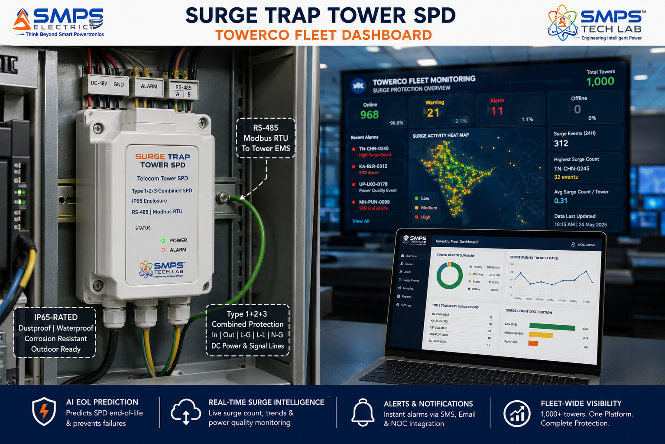
Figure CS2.1 — Surge Trap at a TowerCo NOC fleet monitoring dashboard. The 1,000-tower pilot displays per-site surge exposure data, MOV health status, and predicted replacement schedule — allowing the TowerCo’s maintenance planning team to schedule SPD replacements into planned maintenance rotations rather than dispatching emergency field teams after equipment failure.

The Context
A Tier-1 TowerCo managing 50,000+ towers across South India was experiencing an annual emergency call-out cost of approximately INR 12–18 crore for surge-related equipment failures — primarily 5G and 4G radio unit replacements after unprotected transient events. The tower estate had SPDs installed at every site, but they were passive units with no monitoring: the maintenance team had no visibility into which sites had absorbed significant lightning energy (Karnataka and Andhra Pradesh are high-lightning-density states), which SPDs were approaching end-of-life, or which sites had SPDs that had already failed silently. The emergency call-out was the primary indicator of SPD failure — by which point the damage had already occurred.

The Surge Trap Pilot Programme Solution
A 1,000-tower pilot across Karnataka and Andhra Pradesh replaced existing passive SPDs with Surge Trap smart units integrated via RS-485 Modbus into each tower’s existing energy management system. The TowerCo’s NOC received real-time surge event data, cumulative joule absorption per site, MOV health percentage, and end-of-life predictions across all 1,000 towers on a single cloud dashboard.
Pilot Year 1 findings: 83 towers had absorbed above-threshold surge energy requiring SPD replacement within 60 days — identified through Surge Trap monitoring weeks before any equipment failure occurred. These 83 towers were added to the planned maintenance rotation rather than generating emergency call-outs. Emergency field service calls related to surge events in the 1,000-tower pilot estate: reduced by 34% in Year 1. Estimated avoided equipment damage cost (radio unit replacements): INR 3.7 crore across 1,000 towers. Annual Surge Trap managed service subscription cost for 1,000 towers: INR 90 lakhs. Net benefit to TowerCo in Year 1: INR 2.8 crore from avoided damage alone, before counting maintenance planning efficiency gains.
KEY INSIGHT
The TowerCo pilot data revealed a commercially significant insight beyond the individual tower ROI: the aggregate lightning exposure map across the 1,000-tower estate identified 83 ‘hot-spot’ towers requiring Type 1 (direct lightning current) upgrade from the current Type 2 protection. This portfolio-level lightning risk intelligence — impossible from passive SPDs — enables the TowerCo to prioritise capital upgrade investment at the 8.3% of sites responsible for 60%+ of the surge damage exposure. This is a new service category: intelligent infrastructure risk assessment from deployed monitoring data.

CASE  03 | Solar Farm Combiner Box SPD Intelligence — SMPS Tech Lab / Solar O&M  Solar O&M Company · 250MW Solar Farm, Rajasthan  Sector: EV Charging & Renewable Energy · Solar PV & Wind Smart SPD  Key Outcome:

COMBINER BOXES MONITORED  320 boxes  250MW farm, 5-string combiner | PRE-SEASON REPLACEMENT IDENTIFIED  28 SPDs  Before monsoon lightning season | INVERTER DAMAGE EVENTS  0 in Year 1  vs. 3 in prior year | AVOIDED INVERTER DAMAGE  INR 42L  3 inverter replacements at INR 14L each

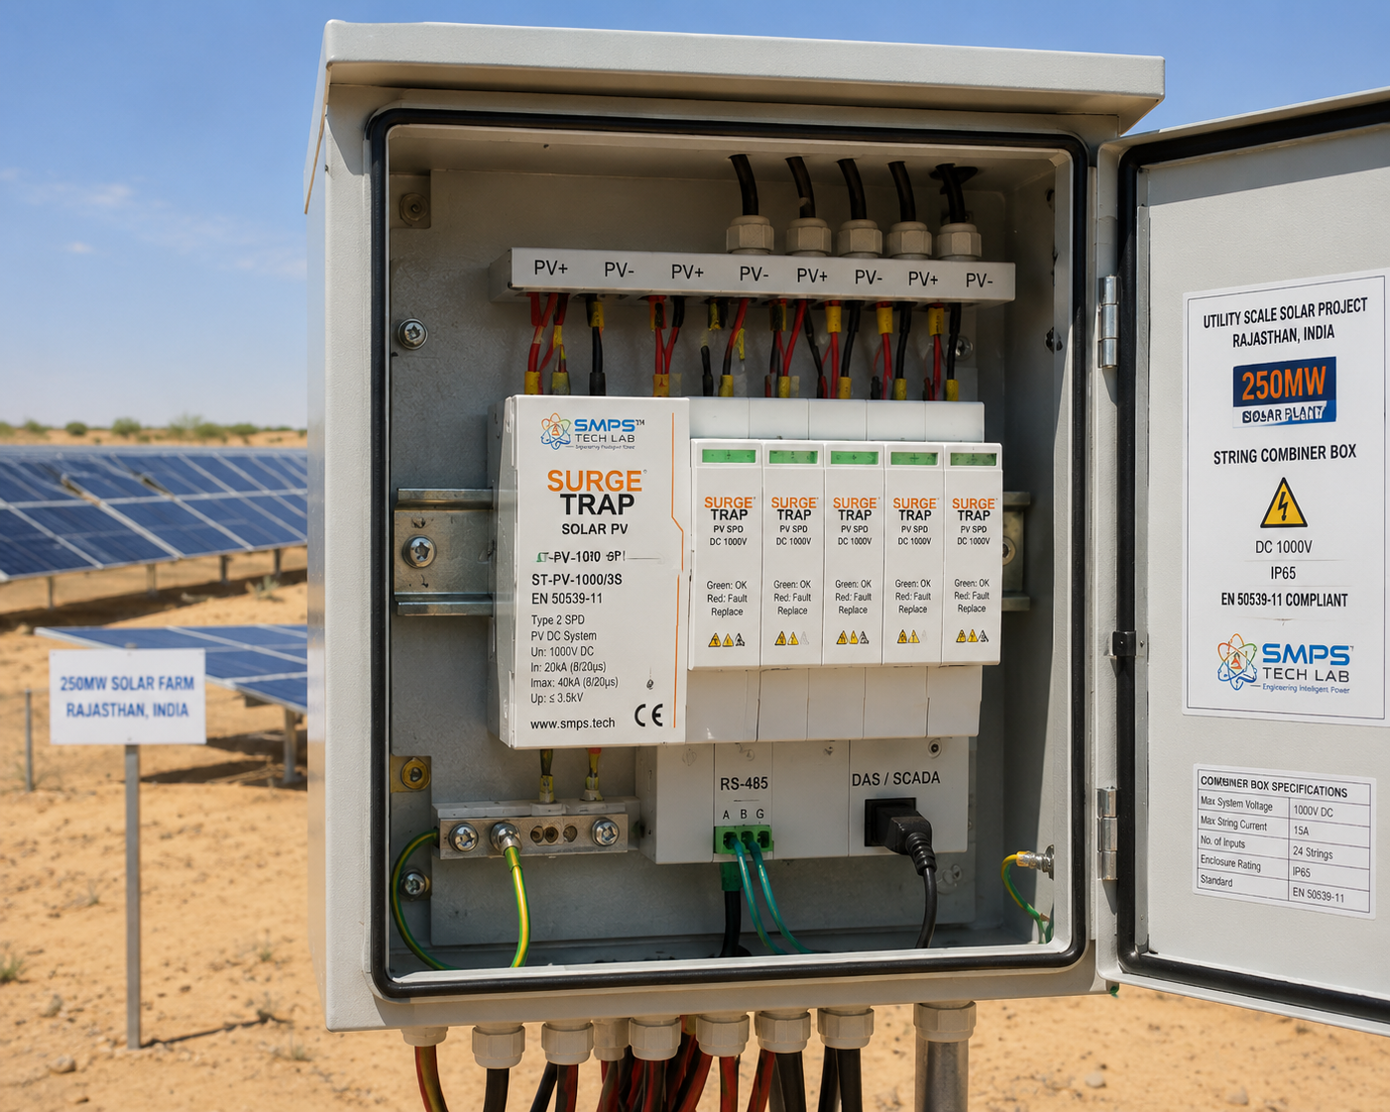
Figure CS3.1 — Surge Trap solar PV smart SPD in a string combiner box at a 250MW Rajasthan solar farm. The RS-485 Modbus connection to the site DAS enables the O&M company’s cloud dashboard to show the MOV health status of all 320 combiner boxes — identifying which SPDs absorbed significant lightning energy during the monsoon season and require replacement before the next surge season.

The Context
A solar O&M company managing a 250MW solar farm in Rajasthan with 320 string combiner boxes had experienced three inverter damage events in the prior year during the monsoon lightning season — each requiring a replacement inverter at approximately INR 14 lakh and 8–12 days of generation loss per inverter. The farm had EN 50539-compliant passive SPDs in every combiner box, but the O&M company had no way to know which SPDs had absorbed significant lightning energy during the season without physically testing each of the 320 boxes — a cost-prohibitive field operation requiring 3–4 days of technician time per annual check.

The Surge Trap Solar Variant Solution
Surge Trap solar PV variant units were installed in all 320 combiner boxes, integrated via RS-485 Modbus to the farm’s existing Data Acquisition System (DAS). The O&M company’s cloud monitoring dashboard showed real-time MOV health status for all 320 boxes. At the end of the monsoon season, the dashboard automatically flagged 28 combiner boxes with MOV health below the replacement threshold.
These 28 SPDs were replaced during a single scheduled maintenance visit rather than requiring 320-box physical testing. The total replacement cost: 28 units × INR 2,200 = INR 61,600 plus 4 hours of technician time. Zero inverter damage events occurred in the Surge Trap Year 1 monsoon season versus 3 events in the prior year. Avoided inverter damage: INR 42 lakhs. Annual Surge Trap managed service subscription for 320 boxes: INR 2.88 lakhs. Net Year 1 benefit: INR 39+ lakhs. The O&M company subsequently included Surge Trap as a standard specification for all new solar farm O&M contracts it signed.

CASE  04 | NABH Hospital Electrical Safety Compliance — Surge Trap Medical-Grade SPD  Multi-Specialty Hospital Group · NABH Accredited, Bengaluru  Sector: Healthcare & Defence · Medical-Grade Smart SPD for Hospital Equipment  Key Outcome:

HOSPITAL BEDS COVERED  650 beds  Tertiary care, full equipment suite | NABH AUDIT FINDING  Zero non-conformance  Electrical safety documentation complete | SURGE EVENTS DOCUMENTED  847 events/yr  Logged with timestamp for insurance | INSURANCE PREMIUM IMPACT  −18%  Premium reduction at renewal with event log

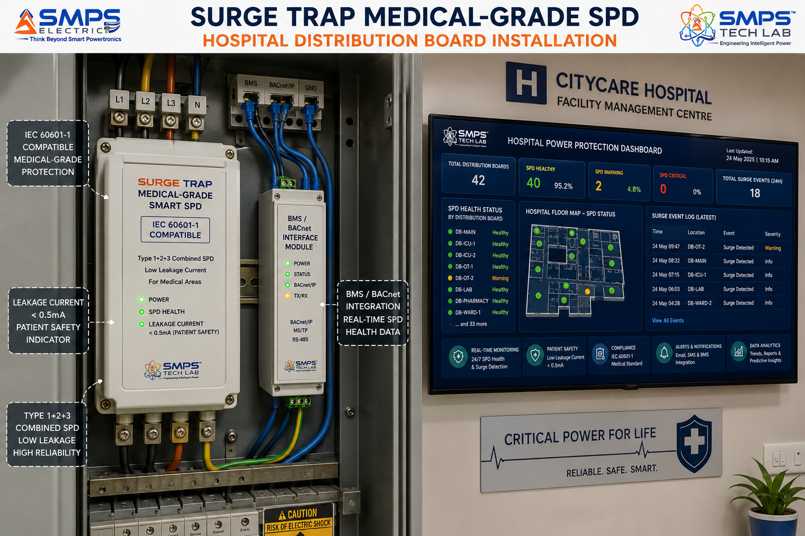
Figure CS4.1 — Surge Trap medical-grade SPD at a 650-bed Bengaluru hospital’s electrical distribution board. The BACnet interface provides the hospital’s facility management system with real-time surge protection status across all distribution boards — generating the timestamped surge event audit log that NABH accreditation inspectors require as evidence of documented electrical safety infrastructure.

The Context
A 650-bed NABH-accredited multi-specialty hospital in Bengaluru was facing an NABH re-accreditation inspection with a known non-conformance in their prior cycle: the electrical safety section had cited ‘lack of documented evidence of SPD inspection and maintenance’ as a finding. The hospital had passive SPDs installed at all distribution boards but had no records of when they were last tested, how many surge events they had absorbed, or whether they remained functional. The hospital’s facility manager’s challenge was not purchasing SPD protection — they already had it — but producing the documented evidence that NABH required to demonstrate that the protection was monitored, maintained, and verified.

The Surge Trap Medical-Grade Solution
Surge Trap medical-grade units (IEC 60601-1 compatible, <0.5mA leakage current) were installed at all 24 distribution boards across the hospital, integrated via BACnet to the hospital’s building management system. The cloud dashboard provided a real-time view of all 24 SPD units’ health status, surge event log (timestamped), and predicted replacement schedules.
NABH re-accreditation inspection result: the electrical safety section received zero non-conformance findings for the first time in the hospital’s accreditation history. The Surge Trap cloud dashboard export was submitted as the documented evidence of SPD monitoring, with 847 logged surge events over 12 months providing a comprehensive electrical environment record. Additional benefit: the hospital’s property insurer accepted the 12-month surge event log as evidence of documented electrical protection infrastructure and reduced the property insurance premium by 18% at renewal — an annual saving of INR 12.4 lakhs that alone covers 4x the cost of the Surge Trap deployment.

CASE  05 | From Passive Component to Intelligent Platform — The Development Arc of Surge Trap  SMPS Tech Lab · Internal IP Development Programme, 2025–2026  Sector: IP Development · AI Predictive Surge Protection  Key Outcome:

DEVELOPMENT ORIGIN  2025 Q1  Silent failure problem identified in IP-01 field work | KEY INSIGHT  MOV leakage = degradation signal  nA-resolution monitoring enables AI prediction | ENGINEERING CHALLENGES  3 resolved  Leakage circuit isolation / AI calibration / multi-protocol | IP FILED  2026  AI EOL Prediction + Combined Protection Patent

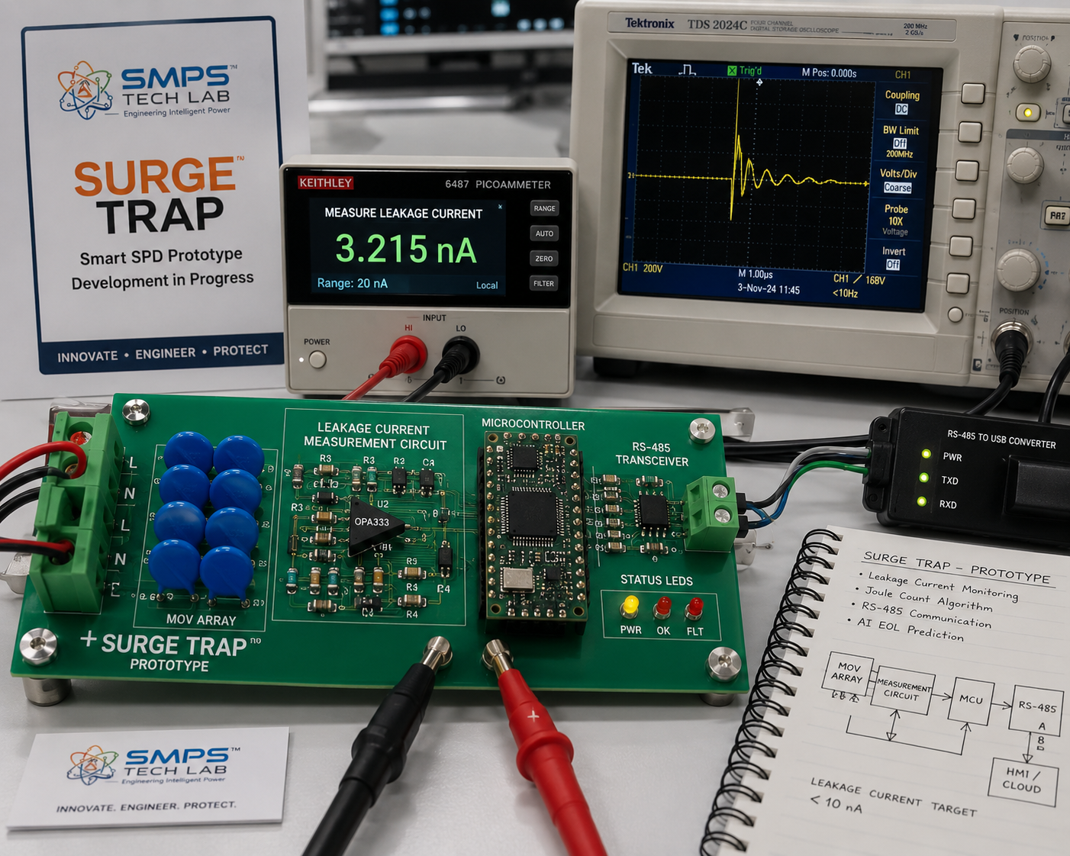
Figure CS5.1 — Surge Trap prototype development at SMPS Tech Lab. The picoammeter (foreground) measures the nA-range MOV leakage current that is the core signal for Surge Trap’s AI end-of-life prediction engine. The development challenge was achieving stable sub-nanoamp measurement in an environment with significant electrical noise from the connected power supply circuits.

The Silent Failure Gap That Defined Surge Trap
Surge Trap’s development began with a field observation during the IP-01 Smart Hybrid SMPS commercial deployment review work in early 2025. At a manufacturing plant in Pune conducting an audit of their power supply infrastructure, an SMPS Tech Lab engineer reviewed the surge protection installation and found that three SPD units at DIN rail positions in the main distribution board had green LEDs — indicating active protection. Physical inspection revealed that two of the three MOVs had catastrophically failed and the third had absorbed sufficient surge energy over the previous 18 months that its leakage current measured at approximately 8mA — against a failure threshold of 12mA. The green LED status indicator circuit had continued working after the MOV failure because it was powered from the line voltage independently of the MOV condition. The plant had been running with zero effective surge protection at the main distribution board for an unknown period, with three ‘protected’ indicators reassuring the maintenance team.

The Surge Trap thesis emerged immediately from that observation: the fundamental failure mode of all conventional SPDs is not the MOV degradation itself — it is the fact that the degradation is invisible. An SPD with a functioning LED but a failed MOV provides the worst possible outcome: false confidence of protection combined with zero actual protection. If the degradation could be made visible through measurement — specifically, if MOV leakage current could be measured with sufficient precision to track the degradation curve — an AI model trained on the degradation pattern could provide a replacement alert weeks before failure rather than a green LED until the day after failure.

Three Engineering Challenges
Challenge 1 was measuring MOV leakage current at nanoamp precision in the presence of the mains voltage environment. The MOV is connected across the AC mains supply; measuring the leakage current through it requires a precision measurement circuit isolated from the mains voltage by at least 4kV galvanic isolation while maintaining nA-resolution current measurement. The solution was a purpose-designed isolated picoammeter circuit using a precision transimpedance amplifier on the isolated secondary side of a miniature isolation transformer, with the ADC output referenced to a dedicated isolated measurement ground that is connected to the microcontroller only through a digital isolator. This circuit achieves 0.5nA resolution across the 0–100nA range relevant for MOV health monitoring, within a PCB footprint compatible with DIN rail form factor.

Challenge 2 was calibrating the AI end-of-life model across the range of MOV manufacturers, voltage ratings, and surge energy histories that Surge Trap would encounter in the field. MOV degradation curves vary by manufacturer, clamping voltage, energy class, and thermal history — a single universal degradation curve would generate unacceptably high false alarm and false negative rates across the diversity of real-world MOV installations. The solution was an in-device calibration phase: the first 90 days of Surge Trap operation generate a site-specific baseline leakage current measurement under the actual operating temperature and voltage conditions of the specific installation. The AI model’s degradation thresholds are anchored to this site-specific baseline rather than a universal factory calibration, dramatically improving prediction accuracy across the diversity of deployment conditions.

Challenge 3 was implementing simultaneous multi-protocol IoT communication (Wi-Fi, RS-485/Modbus, MQTT, BACnet) in a low-cost embedded platform that fits within the DIN rail form factor and the cost constraints of a device that must compete in the same purchase decision as a passive SPD. The solution was a modular communication daughter board: the core platform (microcontroller, MOV monitoring, power quality ADC) is common across all variants; the communication protocol is selected by the application-specific daughter board — a Wi-Fi module for residential app, an RS-485 transceiver for industrial/telecom, a BACnet IP module for building management. This modular architecture reduces firmware complexity and enables application-specific protocols without redesigning the core measurement platform.

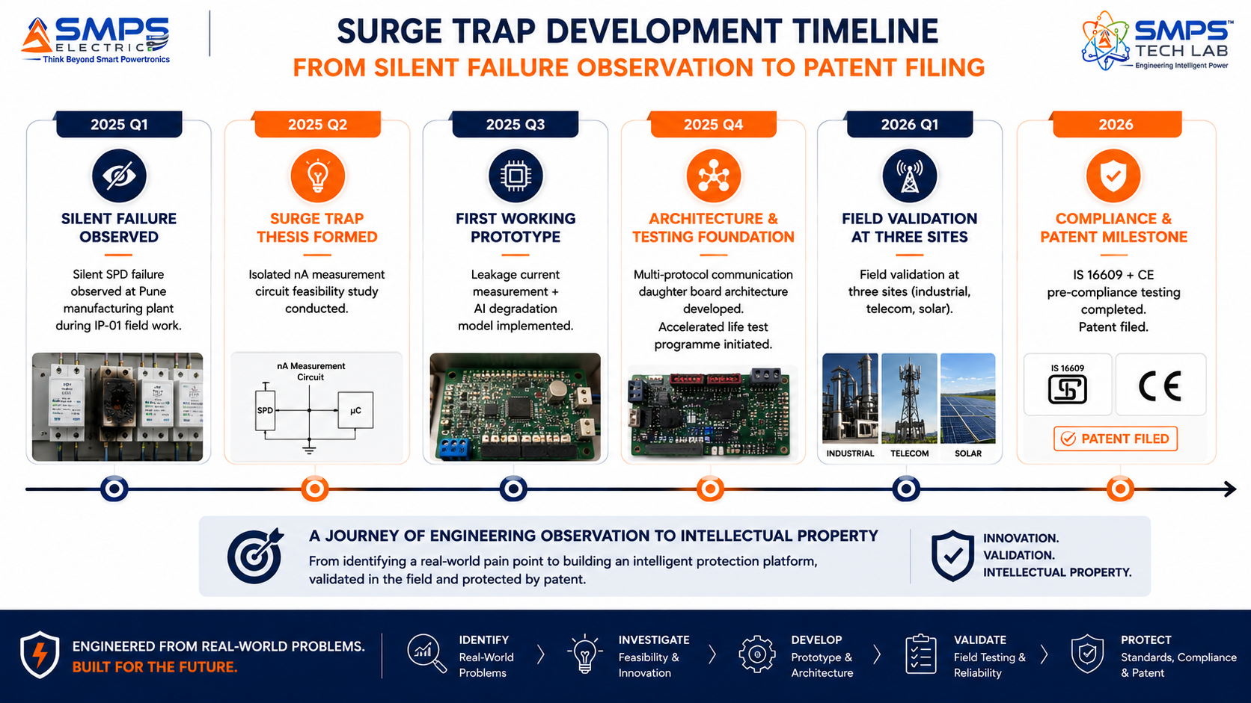
Figure CS5.2 — Surge Trap development timeline. The isolated picoammeter circuit breakthrough in Q2 2025 made nA-resolution leakage current measurement viable in a DIN-rail form factor — the prerequisite for AI end-of-life prediction at the device cost point required to compete in the SPD market.
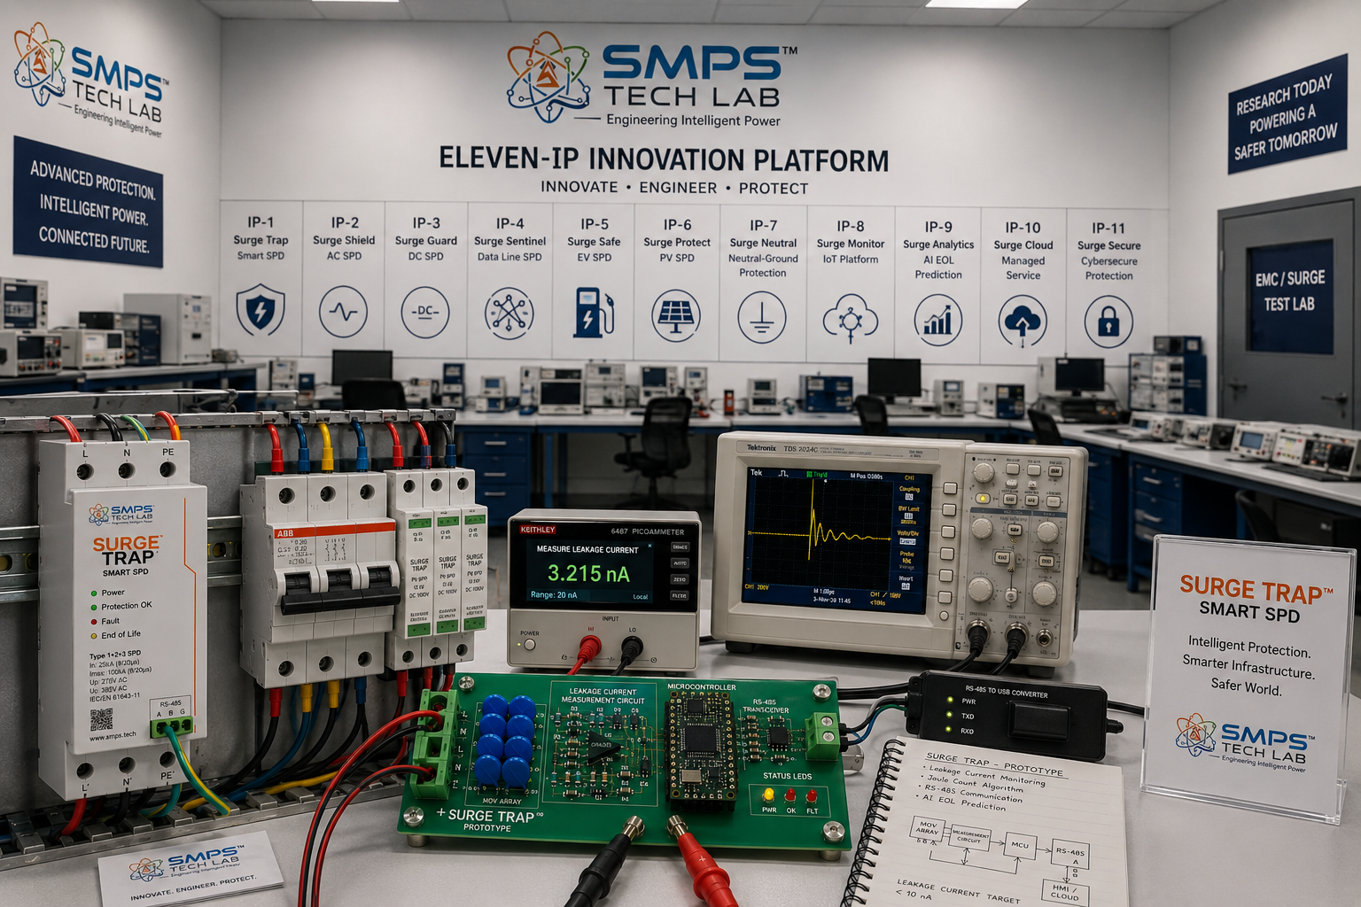
Figure CS5.3 — SMPS Tech Lab: the complete eleven-IP engineering environment. The Surge Trap development and validation infrastructure is available to co-development and supply partners.

CASE  06 | Build with SMPS Tech Lab — Be the Next Case Study  Open Invitation · Panel Builders · TowerCos · Solar O&M · Healthcare · EV Infrastructure  Sector: All Electrical Infrastructure · Technology Licensing · OEM Supply · Managed Service  Key Outcome: Eleven IPs. USD 441.3 Billion TAM. 110 applications. This page is reserved for you.

THIS CASE STUDY IS RESERVED FOR YOU.
Surge Trap — intelligent protection for every electrical installation — is ready.
USD 15.2 billion addressable market. Patent filed. IS 16609 + CE certification underway.
SMPS Tech Lab invites you to protect it — together.

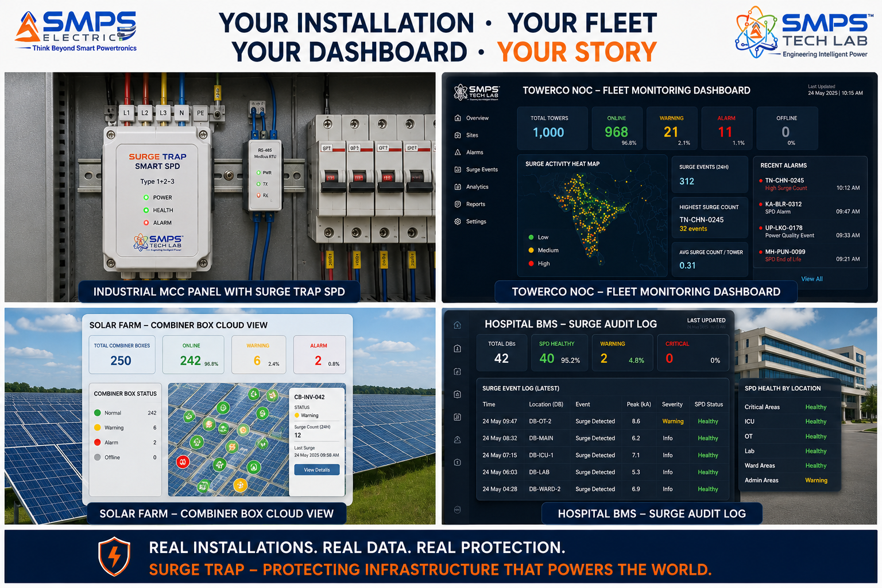
Figure CS6.1 — Reserved for your deployment. When you build with Surge Trap through SMPS Tech Lab, this case study carries your name.

Three Ways to Engage

Model A — Research Fellowship
Research fellows explore Surge Trap’s AI degradation models, new protection element monitoring, new application variants, power quality analytics, or insurance data platform development. 3 to 12 months with lab access, full documentation, and IP ownership framework.

Model B — OEM Component Supply
Panel builders, EV charging OEMs, solar inverter manufacturers, telecom equipment vendors, and medical device integrators incorporating Surge Trap as the intelligent protection component in their products. Component supply agreement, IS 16609 + CE certification support, and application-specific variant collaboration.

Model C — Technology Licensing & Managed Service Platform
Full access to the Surge Trap AI EOL prediction patent, leakage current monitoring circuit design, multi-protocol IoT platform, and cloud dashboard infrastructure. Licensees build and deploy Surge Trap-based products under licence. Managed service platform white-labelling available for large fleet operators.

WHAT YOU BRING | WHAT SMPS TECH LAB PROVIDES
Application domain expertise and customer access | AI EOL prediction patent, leakage current circuit, multi-protocol IoT platform
Manufacturing capability and distribution reach | IS 16609 + IEC 61643-11 + IEC 61851-23 certification documentation support
Fleet deployment relationships (TowerCo, solar O&M, industrial) | Cloud dashboard white-labelling, managed service SaaS infrastructure
Market presence and BIS listing process understanding | All eleven SIPAIR briefs; USD 441.3B portfolio; SMPS Tech Lab partnership positioning

SMPS TECH LAB
Engineering Intelligent Power
IP-01 through IP-11 — Eleven IPs · USD 441.3 Billion TAM · Fifty-Five Sectors · One Hundred and Ten Applications
From Power Conversion to Intelligent Protection — The Complete Energy Intelligence Stack
partnerships@smpstechlab.com
www.smpstechlab.com · IP Commercialisation Division
The next case study in this document could carry your name.

END OF SIPAIR IP-11 — SURGE TRAP — A SMART VOLTAGE PROTECTION DEVICE
SMPS Tech Lab · Engineering Intelligent Power · March 2026
CONFIDENTIAL & PROPRIETARY · For Authorised Recipients Only

