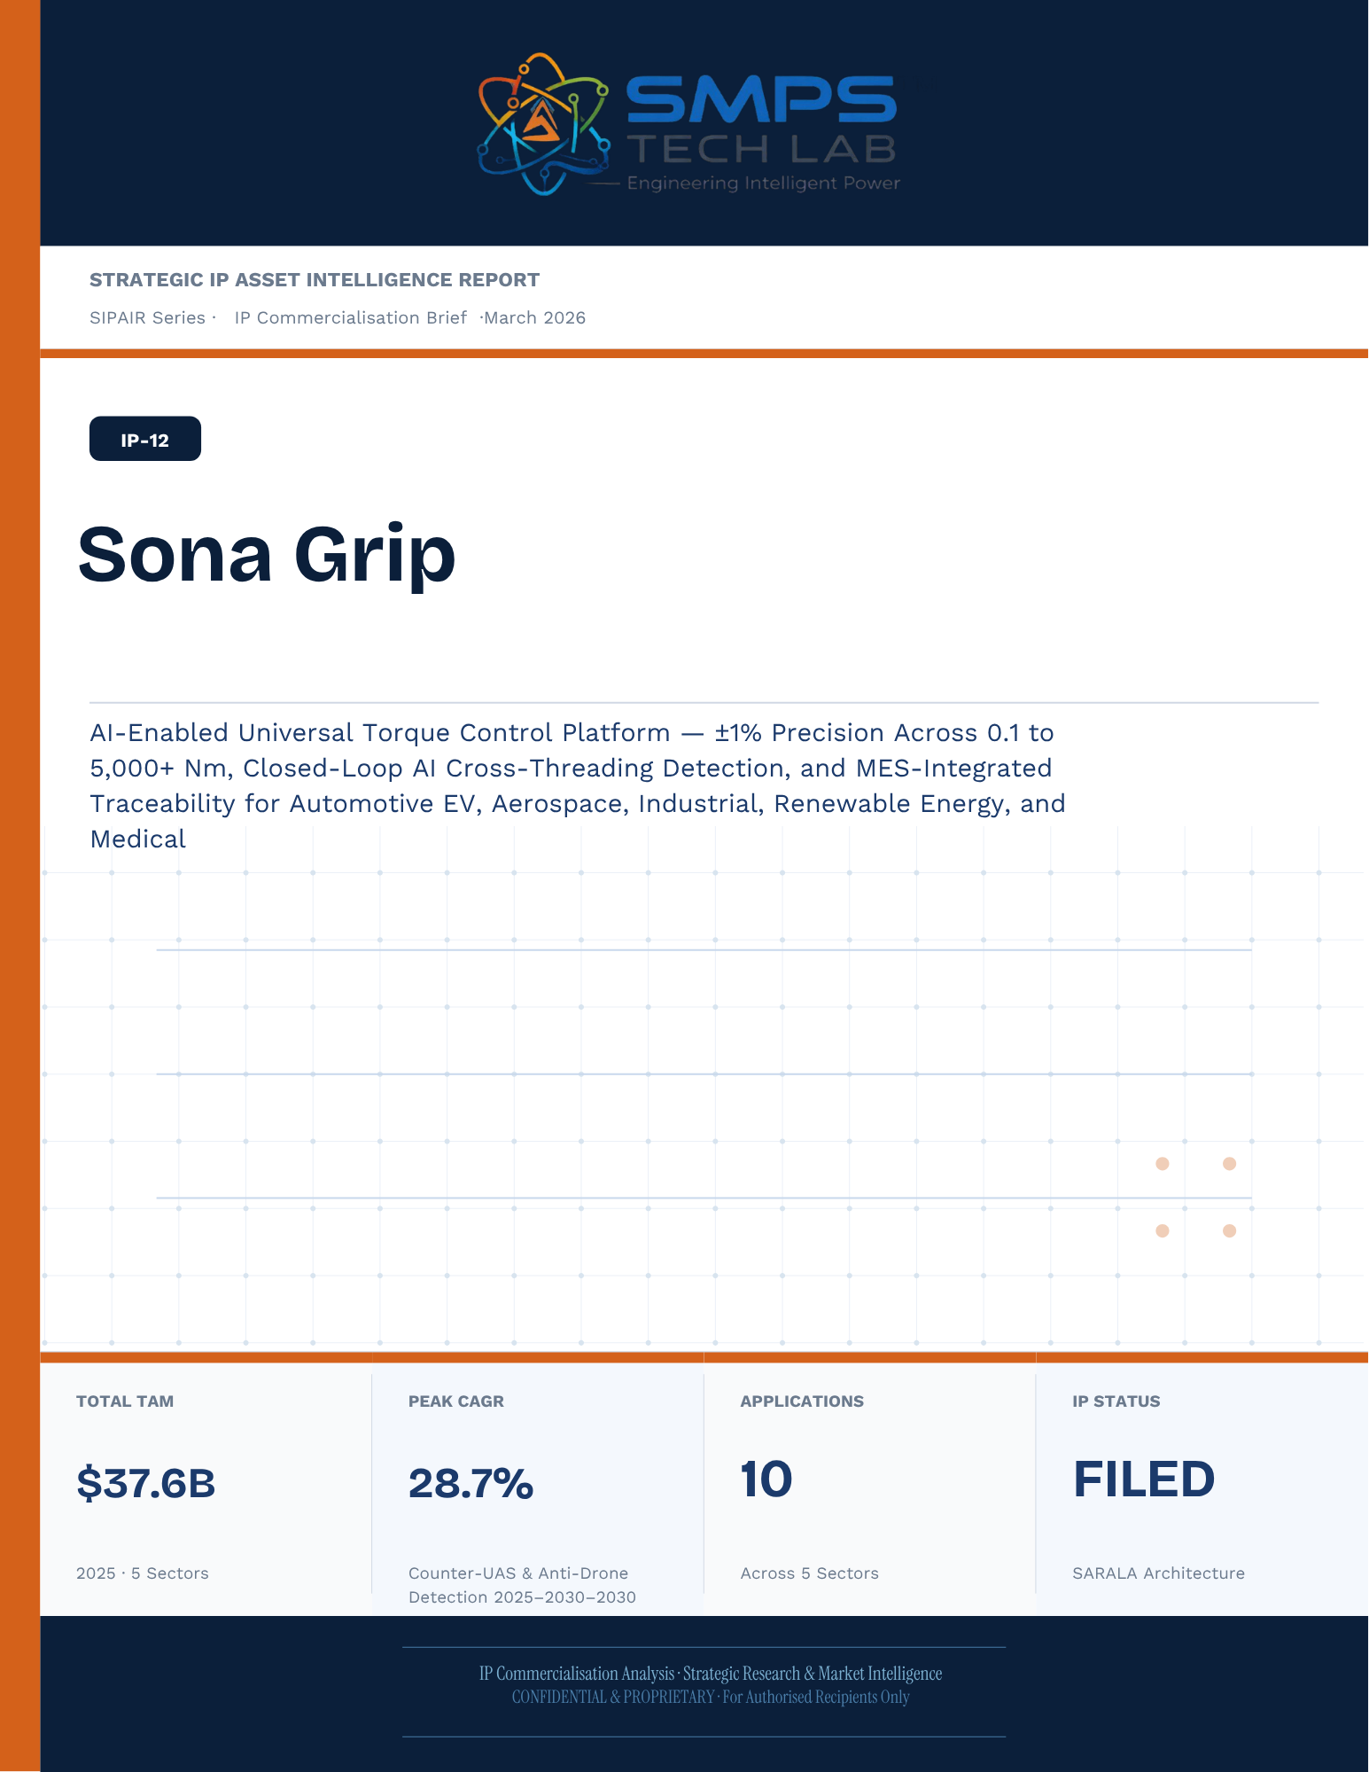
Un-named
[Email address]
Abstract
[Draw your reader in with an engaging abstract. It is typically a short summary of the document.
When you’re ready to add your content, just click here and start typing.]
STRATEGIC IP ASSET INTELLIGENCE REPORT
SIPAIR Series
IP-12: SARALA
SMPS-Based Integrated SARALA for Uninterrupted Telecom Power

Report Title | SIPAIR IP-12 — SARALA Commercialisation Brief

Document Series | Strategic IP Asset Intelligence Report (SIPAIR)

Version | Version 1.0 — First Edition

Compiled & Edited by | Shri Amareshwar Karatagi

Organisation | SMPS Tech Lab — Engineering Intelligent Power

Date of Issue | March 2026

Classification | Confidential & Proprietary — For Authorised Recipients Only

IP Reference | IP-12 — SARALA Architecture, Filed 2025

Related Document | SIPAIR IP-01: Smart Hybrid SMPS (see companion brief)

This document is prepared by SMPS Tech Lab as part of the SIPAIR IP Commercialisation Series.

Declaration — Originality & Intellectual Property Statement

This Strategic IP Asset Intelligence Report (SIPAIR — IP-12: SARALA) is an original compilation prepared by SMPS Tech Lab. The analysis, market intelligence frameworks, commercial strategy formulations, and case study narratives contained herein are the result of independent research and original intellectual work by the authors and editors named in this document.

The core technology described in this report — the SMPS-Based Integrated SARALA architecture, including its active power management layer, CCU intelligence stack, uninterrupted multi-rail AC/DC delivery system, and NMS integration platform — is the exclusive proprietary invention of SMPS Tech Lab, protected under a filed novel design patent (2025). IP-12 is a distinct and independently protectable invention from IP-01 (Smart Hybrid SMPS), though both emerge from the same SMPS Tech Lab research programme. The two IPs are designed to complement each other across adjacent application verticals and may be jointly licensed or co-deployed where application requirements demand both hybrid topology and active power management intelligence.

Market sizing data, CAGR estimates, and industry statistics cited in this document are sourced from independent third-party research publications, fully attributed in Appendix A. All third-party data is used for analytical and benchmarking purposes only. This report has not been submitted, in whole or in part, to any other organisation for commercialisation or formal assessment except as specifically disclosed in writing.

Declared by:

Shri Amareshwar Karatagi
Founder & CSO SMPS Tech Lab · March 2026

CERTIFICATE OF AUTHENTICITY
IP Commercialisation Documentation · SIPAIR IP-12

This is to certify that the Strategic IP Asset Intelligence Report
SIPAIR IP-12 — SARALA
has been compiled, reviewed, and authenticated by the undersigned in accordance
with the standards of the SIPAIR documentation series. The technology, market analysis,
and commercial intelligence herein are verified as accurate to the best of the signatories’
knowledge as at the date of issue: March 2026.

Program Head / Director | Technical Mentor
  Program Head / Research Director
  SMPS Tech Lab
  Technical Mentor / Advisor
  SMPS Tech Lab

SMPS Tech Lab · Engineering Intelligent Power · March 2026

Acknowledgment

The preparation of this Strategic IP Asset Intelligence Report for IP-12 has drawn on the technical expertise, operational insights, and research foundation developed across two parallel innovation tracks at SMPS Tech Lab. The development of the CCU intelligence layer — the defining innovation of IP-12 — required not only power electronics engineering depth but sustained engagement with telecom network operations, tower management practice, and satellite ground station engineering environments that are highly specialised. The author and editor express sincere gratitude to those whose knowledge and access made this work possible.

Technical Development
The CCU architecture at the heart of IP-12 evolved alongside IP-01's hybrid topology work, but along a distinct engineering trajectory focused on power orchestration intelligence rather than conversion efficiency alone. The engineers and technologists who contributed to the CCU control logic, NMS integration stack, and sub-millisecond failover switching mechanism deserve specific recognition for the rigour with which they approached the uninterrupted power mandate — a design objective that admits no approximation.

Telecom Industry Access
The sector intelligence in this report reflects direct engagement with tower operations, data centre facility management, and satellite ground station engineering communities. The operational data from 5G tower rollout programmes, off-grid hybrid power deployments, and maritime communication installations that informed the case study narratives and application requirement specifications in this document is the product of those field engagements.

Research Publications
The market intelligence framework draws on publications from Future Market Insights, MarketsandMarkets, SNS Insider, Grand View Research, IMARC Group, Coherent Market Insights, Global Growth Insights, and the Ericsson Mobility Report, as well as operational data from the International Energy Agency. The quality of those independent research publications is what allows the TAM framework in this report to be grounded in named, verifiable data rather than estimated aggregates.
Shri Amareshwar Karatagi
Founder & CSO
SMPS Tech Lab · March 2026

Preface — From the Founder & Editor

From IP-01 to IP-12 — The Logical Extension
IP-01, documented in the companion SIPAIR brief, solved one problem with exceptional elegance: replacing the unnecessary architectural duplication of separate AC and DC converter units with a single hybrid topology. The commercial case was compelling and the market evidence was clear. But the engineers at SMPS Tech Lab, in the same process of field observation that gave rise to IP-01, had identified a second problem — one that operated at a higher level of the power system stack and was, if anything, more commercially urgent in the specific context of telecom infrastructure.

The problem was not conversion efficiency. It was availability. In a 5G base station, a satellite ground hub, an offshore platform communication centre, or a smart city public safety network node, the standard power supply architecture not only requires separate AC and DC converters — it delegates all intelligence about the power state of the system to a separate controller that may be physically remote, software-dependent on a third-party network management system, and incapable of autonomous protective action in the sub-millisecond timeframe that modern telecom uptime SLAs demand. When the grid fails, when a battery starts to degrade, when an input source switches — the system needs to respond faster than any software polling cycle can achieve. It needs embedded intelligence, right at the power conversion stage.

IP-12 is that intelligence. The Integrated SARALA, combined with the SMPS core, does not just convert power — it orchestrates it. It monitors every parameter of the power delivery chain continuously, switches between sources in under a millisecond, predicts faults before they become outages, and reports power system health to the operator's NMS in real time, without external monitoring hardware. It is the difference between a power supply and a power management system.

Why Telecom, and Why Now
The selection of telecom infrastructure as the primary application vertical for IP-12 reflects a disciplined commercial judgement. Telecom infrastructure is the single sector in the IP-12 TAM where the uninterrupted power mandate is non-negotiable, contractually enforced at 99.999% uptime, and backed by capital investment programmes of unprecedented scale: 2.3 billion 5G subscriptions by end of 2024 with another 4 billion to come by 2030; 3,000 Amazon Project Kuiper satellites deployed in April 2025 with thousands of ground hubs to follow; the IMO GMDSS modernisation mandate forcing a complete vessel communication power infrastructure upgrade by 2026. Every one of these programmes creates a specific, identified, and time-bounded procurement requirement for exactly what IP-12 delivers.

The second reason is the grid reliability crisis that is, counterintuitively, the most powerful demand driver the CCU's hybrid input management addresses. South Africa recorded 1,130 hours of planned power cuts in a single year. India's tower estate — 750,000 sites — routinely operates on hybrid grid, diesel, and battery sources with real-time CCU-managed source switching that determines whether the tower stays on during a grid event. This is not a niche requirement. It is the operational reality for hundreds of thousands of tower sites across three continents, and the market is actively seeking a solution that the current generation of separate rectifiers and external controllers cannot provide.

How This Document is Structured
This SIPAIR brief follows the same 14-section architecture as the IP-01 companion document, making the two documents a coherent and mutually reinforcing portfolio. Readers who have engaged with SIPAIR IP-01 will recognise the structure immediately. The technology differentiation section includes an explicit comparison between IP-01 and IP-12, clarifying the architectural relationship and the distinct value proposition of each. The case studies are drawn from the five specific sectors of IP-12's TAM framework — 5G tower, data centre, satellite ground, smart city, and maritime/offshore — with technical and financial parameters grounded in the operational realities of each sector.

Shri Amareshwar Karatagi
Founder & CSO
SMPS Tech Lab · March 2026

TABLE OF CONTENTS

Declaration — Originality & Intellectual Property Statement 1
Acknowledgment 1
Technical Development 1
Telecom Industry Access 1
Research Publications 1
Preface — From the Founder & Editor 1
From IP-01 to IP-12 — The Logical Extension 1
Why Telecom, and Why Now 1
How This Document is Structured 1
Important Notice & Confidentiality Disclaimer 1
1.1 The Strategic Context 1
1.2 The Problem Sona Grip Solves 1
1.3 Key Metrics at a Glance 1
1.4 Why Sona Grip, Why Now 1
2.1 What is Sona Grip? 1
2.2 The Four Integrated Technology Layers 1
2.3 AI Torque-Angle Engine — Pre-Fault Detection 1
2.4 MES Integration — The Traceability Infrastructure 1
2.5 Standards Compliance Architecture 1
3.1 The Digital Torque Transition 1
3.2 The Four Structural Megatrends 1
3.3 Global Market Sizing — Primary Reference Data 1
CAGR Comparison — Sona Grip Target Market Segments 1
4.1 Methodology 1
4.2 Consolidated TAM Summary 1
5.1 India as Primary and Strategic Market 1
5.2 India Market Sizing — Sona Grip Relevant Segments 1
6.1 India & Global Policy with Direct Sona Grip Alignment 1
7.1 The Plugin Architecture — Five Quality System Categories 1
7.2 Plugin Integration Matrix 1
8.1 Commercialisation Philosophy 1
8.2 Market Priority Matrix 1
9.1 Competitive Architecture Overview 1
10.1 The Investment Case 1
10.2 Illustrative Revenue Scenarios 1
11.1 Technology Generation Roadmap 1
11.2 Adjacent Application Opportunities 1
12.1 Risk Framework 1
Appendix A — Data Sources 1
Appendix B — Standards Reference 1
Appendix C — Glossary 1
The Context 1
The Sona Grip EV Battery Assembly Solution 1
The Context 1
The Sona Grip Aerospace Documentation Solution 1
The Context 1
The Sona Grip PLI Industry 4.0 Solution 1
The Context 1
The Sona Grip Wind Turbine Documentation Solution 1
The Customer Pain That Defined Sona Grip 1
Three Engineering Challenges 1
Three Ways to Engage 1
Model A — Research Fellowship 1
Model B — OEM Tool Supply 1
Model C — Technology Licensing 1

0F | FOUNDER & EDITOR  IP-12 SIPAIR Series · SMPS Tech Lab


Shri Amareshwar Karatagi
Founder & Chief Strategic Officer
SMPS TechLab
Special Correspondent, Government of Karnataka |
Serial Entrepreneur

Vision Statement
We aim to build a generation of innovators and entrepreneurs who create transformative technologies, develop intellectual property, and drive India’s technological leadership on both national and global platforms. Over the years, we have worked extensively within the startup ecosystem, contributing to and mentoring multiple initiatives focused on building, scaling, and strengthening businesses. Through this journey, we have developed a deep understanding of business strategy, governance frameworks, and deep-technology development, along with the practical challenges of scaling innovation in real-world markets.
As a Special Correspondent with the Government of Karnataka and a serial entrepreneur, my focus has been on shaping individuals into creators, builders, and leaders of technology and enterprise. Our work emphasizes ownership, innovation, and execution discipline to nurture individuals capable of building scalable, high-impact solutions with both national and global relevance.
Through SMPS Tech Lab, we drive this vision by integrating deep Research & Development (R&D) with entrepreneurial strategy, fostering a culture where ideas evolve into intellectual property, innovation, and industry-aligned solutions that contribute to India’s technological advancement and global competitiveness. The Industry Fitness DeepTech Internship Program is a reflection of this mission—designed to develop individuals who are innovation-driven, execution-focused, and capable of contributing meaningfully to technology, entrepreneurship, and nation-building at scale.

“My vision is to build a generation that doesn’t wait for opportunities, but creates them through innovation and entrepreneurship.”
— Shri Amareshwar Karatagi


A. R. Shalini
Chief Business Development Officer (CBDO) & Program Officer
SMPS TechLab | SMPS Electric Control Pvt. Ltd.

Area of Expertise:
Business Strategy, Operations Management, Industry–Academia Integration, Entrepreneurship Development
Profile:
I play a pivotal role in driving program execution, operational excellence, and professional development within SMPS Tech Lab. With a strong foundation in both business strategy and technology alignment, I am committed to shaping individuals into industry-ready professionals with the right mindset, discipline, and execution capabilities.
My approach focuses on building skills with clarity of thought, accountability, and a results-driven attitude. Through structured guidance and continuous mentorship, I enable participants to understand the intersection of technology, business, and real-world application.
I actively work toward bridging the gap between academia and industry, ensuring that learning is aligned with practical expectations and evolving market demands. My dedication to creating a seamless and high-impact learning environment fosters confidence, innovation, and professional growth among participants.
Through my leadership, the program consistently emphasizes structured execution, strategic thinking, and the development of individuals who are prepared to contribute meaningfully to both industry and innovation ecosystems.
“Professional excellence is built when knowledge, mindset, and execution come together with consistency.”
— A. R. Shalini

Dr. S. Khatua
Chief Technology Officer (CTO)
SMPS TechLab | SMPS Electric Control Pvt. Ltd.
IITian | PhD – IIT Dhanbad

Area of Expertise:
Power Electronics, Microgrid & Smart Grid Systems, Nuclear Power Systems, DeepTech R&D, Industrial System Design.
I am a distinguished technology leader driving advanced Research & Development and deep-tech innovation. An IITian with a PhD in Microgrid and Smart Grid Systems for nuclear power applications, I bring over 15 years of experience across power electronics, nuclear reactor control systems, and defence and telecom technologies.
With significant contributions to high-impact and mission-critical projects of national importance, my work reflects a rare combination of research depth, engineering precision, and industrial execution.
I am a strong advocate of deep-tech innovation and intellectual property (IP) creation, and I emphasize the development of indigenous technologies that strengthen the nation’s technological capability and global standing.
Through my mentorship, I inspire the next generation to pursue technical mastery, disciplined execution, and innovation with national intent, shaping professionals capable of contributing to the future of deep technology.
“Precision in engineering, depth in research, and ownership of technology are the pillars of true national progress.”
— Dr. S. Khatua

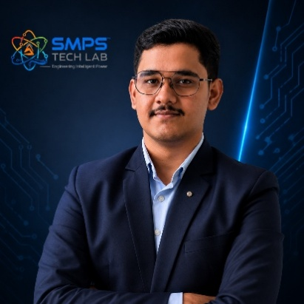

Mr. Rushit Jani
Techno-Commercial Architect
Strategic Editorial & Commercialisation Review | OptCell GLOBAL

Fields of Interest:
AI & Intelligent Systems, Industrial IoT, Product Architecture, Deep-Tech Commercialisation, Enterprise System Design, and Scalable Engineering Solutions.
Focused on building technology-driven systems that bridge engineering innovation with practical industry adoption and long-term commercial value.

Message from the Editor:
Technology, in its purest form, is not just about building systems — it is about creating meaningful infrastructure that can influence industries, solve operational challenges, and contribute to larger technological progress. My interest has always been in understanding how engineering innovation can evolve beyond prototypes into scalable and commercially sustainable solutions.

This document represents more than a technical study of an intellectual property. It reflects a structured effort to connect engineering architecture with market relevance, strategic deployment, industrial applicability, and long-term innovation potential. The objective throughout this work has been to maintain a balance between technical depth, commercialization practicality, and institutional-level documentation standards.

As emerging technologies continue to redefine industries, I strongly believe that the future will belong to organizations capable of combining research, engineering, strategic thinking, and execution into unified ecosystems. Through this publication, we aim to contribute towards that larger vision while creating pathways for collaboration, innovation, and real-world technological impact.

"Transforming engineering innovation into scalable, industry-defining technological ecosystems."
— Mr. Rushit Jani

A Note of Gratitude

The development of this publication has been supported by the collective vision, encouragement, and leadership of the Directors and management of SMPS Electric Control Pvt. Ltd.

Their continued commitment towards engineering innovation, industrial excellence, and long-term technological growth has created an environment that encourages meaningful research, practical problem-solving, and commercialization-focused thinking. The guidance, operational insights, and institutional support extended throughout this journey have played an important role in shaping the direction and depth of this work.

This document reflects not only an individual effort, but also the larger culture of innovation, trust, and forward-thinking leadership fostered within the organization. We sincerely appreciate the confidence and support provided towards building impactful and future-ready technological initiatives.

Important Notice & Confidentiality Disclaimer

This Strategic IP Asset Intelligence Report (SIPAIR — IP-12) has been prepared exclusively for internal strategic planning, investor communication, licensing partner engagement, and research collaboration purposes. It is intended for distribution only to authorised recipients under applicable non-disclosure and confidentiality arrangements.

All market sizing data, CAGR estimates, and financial projections are derived from independent third-party research publications cited in Appendix A. These figures represent estimates as at March 2026. No representation or warranty is made as to their accuracy or completeness.

The technology, architecture, and methodologies described herein are the exclusive proprietary assets of SMPS Tech Lab, protected under filed patent and design rights. This document does not constitute a prospectus, financial advice, or an offer to sell or subscribe to securities. Recipients are advised to conduct independent due diligence before making any investment or commercial decision.

01 | EXECUTIVE SUMMARY  The Fastening Quality Gap · Sona Grip Value Proposition · The Gold Standard

1.1 The Strategic Context
Incorrect fastener torque is the single most pervasive quality failure in modern manufacturing. It is invisible at time of assembly, catastrophic in consequence, and almost entirely preventable. An under-torqued bolt in an EV battery cell module creates poor electrical contact — a fire risk discovered under load. An over-torqued aerospace fastener strips the thread — a structural failure discovered at 35,000 feet. A cross-threaded screw in a surgical instrument causes sterility failure discovered during a procedure. In every case, the failure was detectable at the point of assembly by a tool that could measure, compare, and record the torque being applied. The industry has known this for decades. But the tools that deliver this capability — precision digital torque tools with closed-loop control, AI error detection, and MES-integrated traceability — have historically been expensive, application-specific, and proprietary. A factory needed different tools for different fastener types, different torque ranges, and different industry certifications. The fragmentation was the barrier.

Over 68% of global OEMs now employ automated fastening with digital torque wrenches (Industry Research Biz, 2025). Tesla Gigafactories use smart torque tools specifically for EV battery module fastening to prevent thermal runaway. Volkswagen reports 15–20% assembly defect reduction after adopting IoT-enabled torque wrenches. Lockheed Martin’s F-35 production line uses Bluetooth-enabled wrenches that auto-upload torque values to central QA systems. The market has validated the technology. What it has not had is a universal platform — one tool, one certification, one MES integration, across all fastener types, all torque ranges, and all industry standards simultaneously.

1.2 The Problem Sona Grip Solves

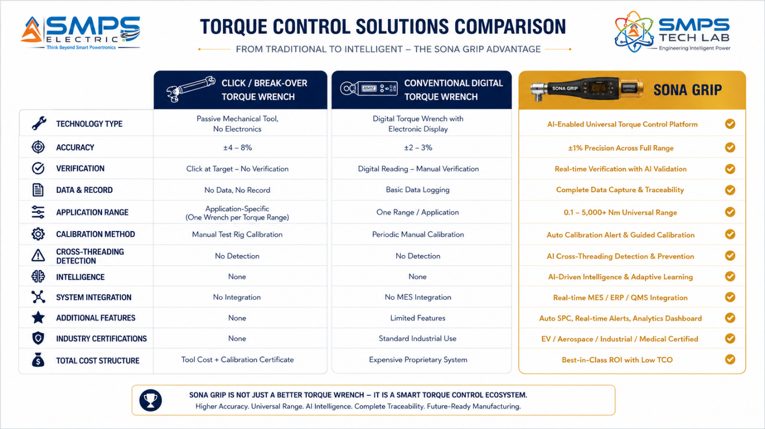
Figure 1.1 — Three levels of torque control capability. Sona Grip’s universal platform achieves what no conventional tool provides: ±1% accuracy across the full range, AI pre-fault detection, and automatic MES-integrated traceability — replacing a fragmented inventory of application-specific tools with a single certified universal platform.
STRATEGIC NOTE
The Sanskrit and Hindi meaning of Sona is Gold. Sona Grip is positioned as the gold standard of torque control: the single, universal, intelligent fastening platform that replaces the fragmented collection of application-specific torque tools that every precision manufacturer must stock, certify, calibrate, and maintain. One tool. One certification. One MES integration. Every fastener type. Every torque range. Every industry.

1.3 Key Metrics at a Glance

TOTAL ADDRESSABLE MARKET  $26.4B  2025 Baseline · 5 Manufacturing Sectors | FASTEST GROWING SEGMENT  9.6%  Smart Power Tools CAGR 2025–2033 (Grand View) | SECTORS MAPPED  5  10 Applications Identified | IP PROTECTION  Sona Grip Filed  Universal Torque Control Patent

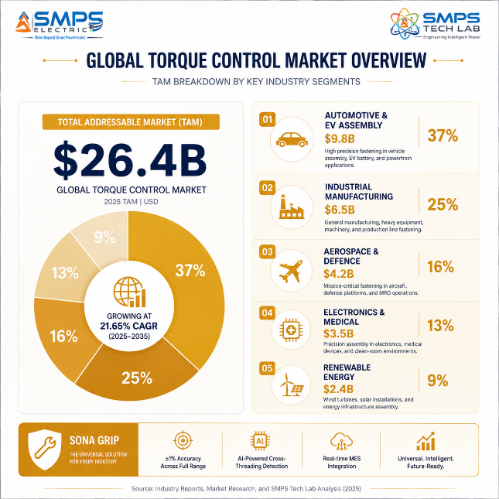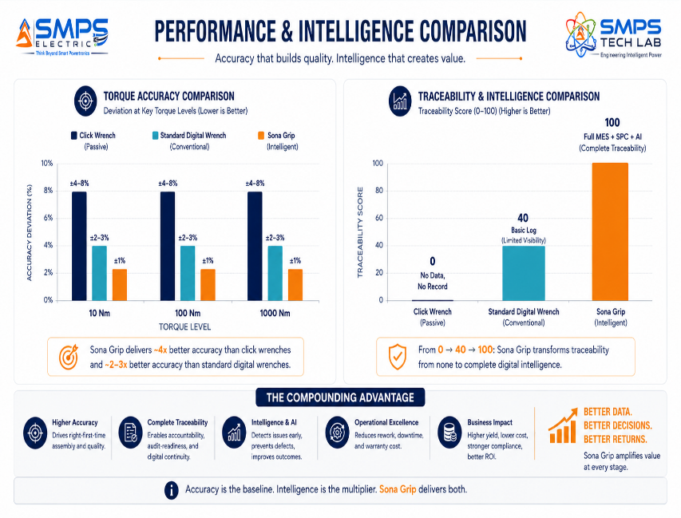
Figure 1.2 — TAM breakdown (left): Automotive & EV Assembly is the largest sector at $9.8B driven by EV battery pack fastening safety requirements. Precision benchmark (right): Sona Grip achieves ±1% accuracy versus ±4–8% for click wrenches and provides full MES-integrated traceability that no passive tool can generate.

1.4 Why Sona Grip, Why Now
Four forces are defining the Sona Grip commercialisation moment. EV battery assembly is the highest-criticality, fastest-growing torque application in manufacturing history — every EV battery cell requires documented, AI-verified torque, and India EV production is scaling from 2 million to tens of millions of units. The 68% OEM digital torque adoption rate means the market has crossed the majority adoption threshold globally, with India’s manufacturing sector at the beginning of the same curve. PLI scheme Industry 4.0 compliance requirements are creating a direct procurement mandate for MES-integrated fastening documentation among PLI beneficiaries. And the emergence of AI-driven torque tools — Bosch investing in AI torque optimisation, Tesla’s smart battery assembly validation — confirms that AI cross-threading detection is transitioning from experimental to procurement-standard.

MARKET DATA POINT
Combined SMPS Tech Lab portfolio: IP-01 through IP-11 = $441.3B + IP-12 $26.4B = USD 467.7 Billion total TAM across 60 sectors and 120 applications. Sona Grip adds the precision manufacturing quality layer — ensuring every fastener in every product that the portfolio’s technology powers, charges, manages, and protects is assembled with the gold standard of torque control.

02 | TECHNOLOGY OVERVIEW  Universal Range · AI Torque Engine · MES Integration · Universal Head · Standards

2.1 What is Sona Grip?
Sona Grip is a universal torque controlled device where every word in the name carries precise technical meaning. ‘Universal’ means a single platform covering 0.1 Nm (micro-screw in electronics assembly) to 5,000+ Nm (structural bolts in wind turbine flanges) through a modular head system — the entire 50,000:1 torque range from a single certified controller. ‘Torque Controlled’ means closed-loop digital control: unlike a passive click wrench that provides only a signal at target torque, Sona Grip continuously measures torque at 10,000 samples per second and actively modulates the drive in real time. ‘Device’ means an intelligent platform — not just a tool but a connected quality system node that delivers MES-integrated fastening records, AI error prevention, and statistical process control output. The combination is the IP: no competitor offers a certified universal platform with AI closed-loop control and full MES integration across the complete manufacturing torque range.

2.2 The Four Integrated Technology Layers
LAYER | COMPONENT | FUNCTION | KEY INNOVATION IN IP-12
L1 | Universal Modular Head System | Patented universal head adapter accepting hex, square drive, TORX, spline, and custom fastener heads. Auto-detection of head type via RFID tag in each head. Torque specification automatically pulled from MES database on head change. | Single Sona Grip controller drives any fastener type. When the operator changes heads, the tool automatically downloads the correct torque specification from the MES — no manual parameter entry, no wrong-spec risk. Eliminates the need to stock, calibrate, and certify separate tools for each fastener type.
L2 | AI Closed-Loop Torque Engine | Strain gauge or reaction torque sensor measuring at 10,000 samples/second. AI algorithm monitoring the torque-angle signature in real time. Pre-fault detection: cross-threading identified in first 5° of rotation; non-conforming fastener identified before damage; yield-point detection for stretch bolts. | The patent-bearing element. The AI does not log failures — it prevents them. Cross-threading detected before the fastener is damaged, non-conforming fasteners identified before stripped threads occur, over-torque stopped before structural failure. Prevention, not documentation of failure.
L3 | MES/ERP Integration Platform | OPC-UA, Modbus TCP, REST API, and PROFINET connectivity. Every fastening result automatically uploaded: torque value, angle, date-time, operator ID (from login badge scan), tool ID, head ID, fastener ID, VIN/work order, SPC statistics. Supported: Siemens Opcenter, SAP ME, Oracle MES, FDA 21 CFR Part 11 DHR. | Auto-logged fastening records with zero manual entry. The MES integration layer is the commercial differentiator for customers supplying global automotive Tier 1, aerospace, and medical export markets where electronic traceability records are a contractual and regulatory requirement.
L4 | Application Variant Intelligence | Seven distinct application variants sharing the common AI engine and MES integration: Automotive EV Battery (UN 38.3), Automotive Assembly (IATF 16949), Aerospace (AS9100D), Defence MRO (MIL-STD-810), Smart Factory (ISO 9001), Electronics (IPC-A-610), Medical (FDA 21 CFR Part 11). | Same hardware platform, different intelligence modules. Variant selection changes the torque strategy, safety interlocks, certification outputs, and MES data schema appropriate for the application — without requiring a different physical tool or a new calibration certificate.

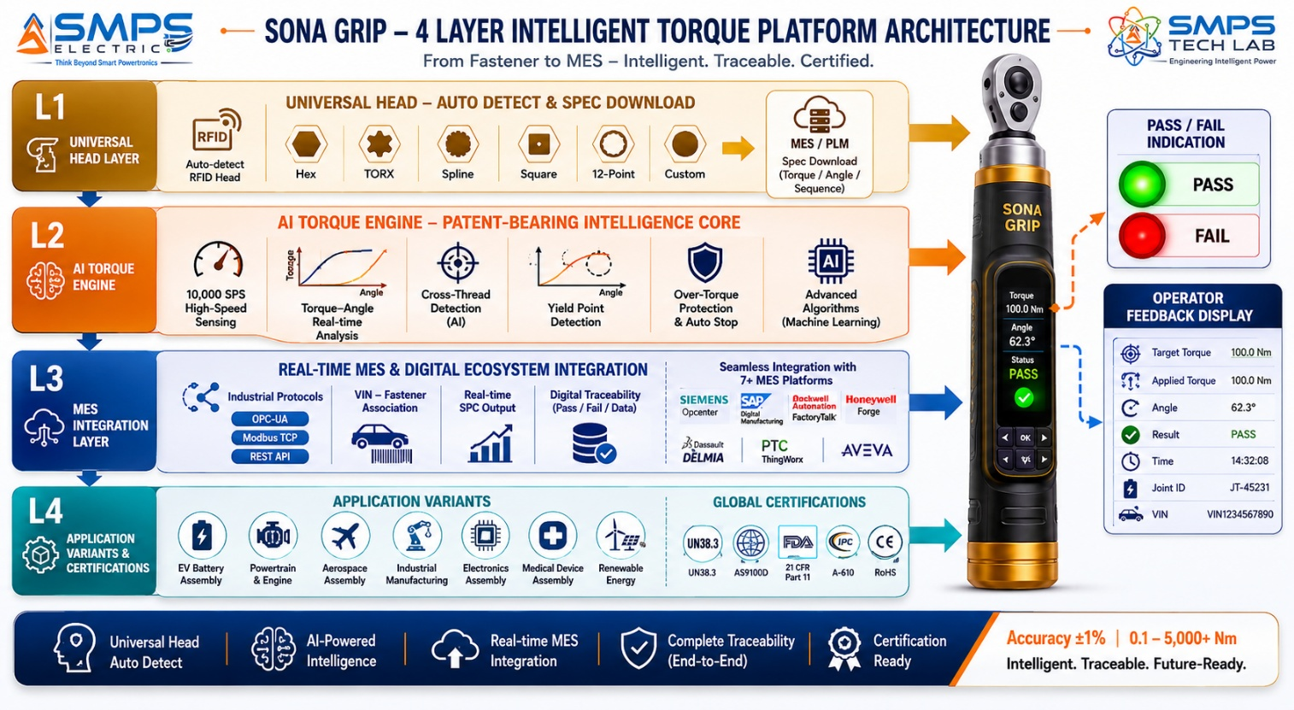
Figure 2.1 — Sona Grip four-layer architecture. The AI Closed-Loop Torque Engine (L2) is the patent-bearing element — 10,000 samples per second enabling cross-threading detection in the first 5° of rotation, preventing fastener damage before it occurs rather than logging it after the fact.

2.3 AI Torque-Angle Engine — Pre-Fault Detection
The fundamental innovation in Sona Grip is the transition from torque ‘measurement’ to torque ‘control’. A conventional digital torque tool measures the torque applied and records it. Sona Grip’s AI engine monitors the real-time torque-angle curve against the expected signature for the specific fastener and application, and intervenes before a defect occurs. Cross-threading — where the screw enters the hole on the wrong thread — produces a characteristic abnormal torque rise in the first 5° of rotation that is unmistakeable in the 10,000 sps data stream. Sona Grip stops the drive, sounds an alert, and logs the event as a ‘CROSS-THREAD DETECTED — REWORK REQUIRED’ record in the MES before the fastener or component is damaged. A click wrench applying incorrect technique cannot distinguish a cross-threaded fastener from a correctly engaged one until it produces the click signal — at which point the damage is done and the component requires rework or scrap.

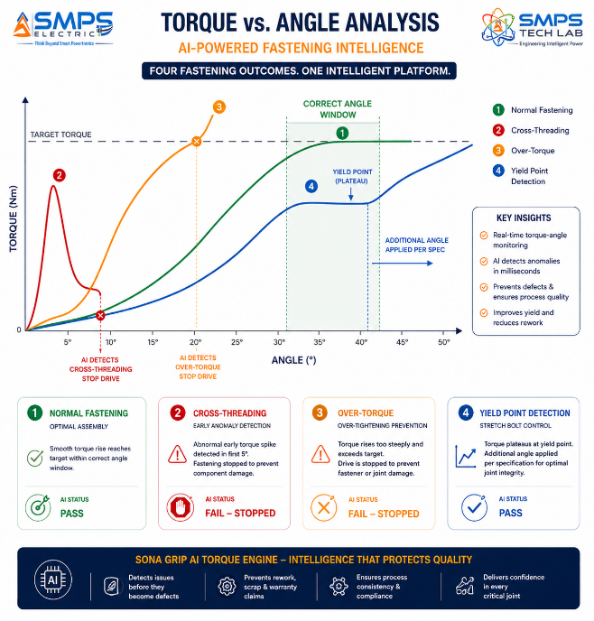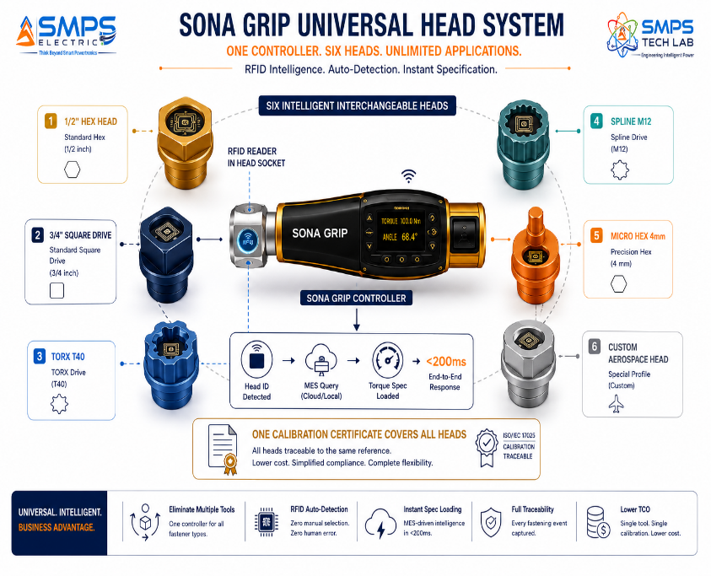
Figure 2.2 — AI torque-angle signature analysis (left): Sona Grip detects cross-threading in the first 5° of rotation — stopping the drive before thread damage occurs. Conventional tools cannot make this distinction until the target torque is reached and the damage is already done. Universal head auto-detection (right): any head type instantly detected, correct torque specification automatically loaded, single calibration certificate covers all heads.

2.4 MES Integration — The Traceability Infrastructure
For automotive Tier 1 suppliers, aerospace manufacturers, and medical device companies, fastening traceability is not a nice-to-have — it is a contractual requirement enforced through annual QMS audits. Sona Grip’s MES integration eliminates the manual data entry, paper-based torque records, and post-hoc data reconciliation that characterise conventional digital torque tool deployments. Every Sona Grip fastening operation automatically generates a tamper-proof digital record in the connected MES system within 200ms of completion — with the operator’s identity (badge scan or biometric login), the exact torque and angle values, the tool calibration status at time of use, and the work order or VIN/serial number the fastening belongs to. For a medical device manufacturer’s Device History Record or an EV battery manufacturer’s UN 38.3 compliance package, this automatic digital trail is the regulatory compliance documentation.

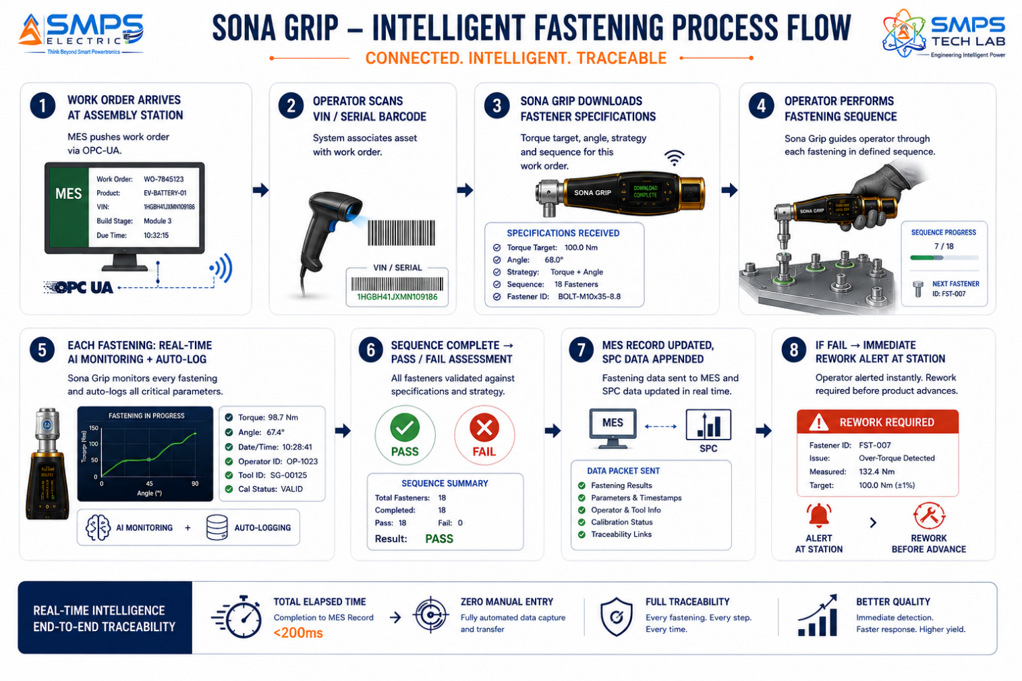
Figure 2.3 — Sona Grip MES integration flow. From work order receipt to quality record creation in <200ms per fastening operation — with zero manual data entry, zero paper records, and automatic sequence enforcement preventing product from advancing until all fasteners are confirmed in-specification.

2.5 Standards Compliance Architecture
STANDARD | SECTOR APPLICABILITY | COMPLIANCE RELEVANCE FOR IP-12
IATF 16949 / ISO/TS 16949 | Automotive | Automotive quality management standard. Requires documented torque traceability for critical fasteners. Sona Grip’s automatic MES-integrated records satisfy IATF 16949 customer audit requirements.
AS9100D / EN 9100 | Aerospace & Defence | Aerospace quality management standard. ±1% accuracy requirement for critical fasteners. Calibration traceability to NIST/NPL. Sona Grip’s calibration management system satisfies AS9100D audit requirements.
FDA 21 CFR Part 11 | Medical Devices & Electronics | Electronic records and electronic signatures regulation. Requires audit trails for all manufacturing records. Sona Grip’s encrypted tamper-proof fastening records with operator electronic signature satisfy 21 CFR Part 11.
ISO 5393 | Industrial & Automotive Rotary Tools | Test methods and performance of rotary tools for threaded fasteners. Accuracy, repeatability, calibration. Required for IATF 16949 and AS9100D compliance.
ISO 6789 | Hand Torque Tools | Test methods for hand torque tools. Calibration requirements and accuracy classes. Sona Grip’s calibration management system satisfies ISO 6789 calibration interval and traceability requirements.
IS 7344 / IS 1370 | India (all sectors) | Bureau of Indian Standards hand tools and power tools standards. Required for BIS certification and government/PSU procurement in India. IS 7344 covers hand torque tools specifically.
IEC 61340-5-1 (ESD) | Electronics Assembly | Electrostatic discharge protection in electronics environments. ESD-safe construction required for Sona Grip electronics and medical variants used in sensitive assembly environments.
ISO 16047 / EN 14399-4 | Renewable Energy, Infrastructure | Torque/clamp force testing for fasteners; structural bolt tightening. Required for wind turbine and infrastructure bolting documentation under engineering standards.

03 | GLOBAL MARKET LANDSCAPE  Digital Torque Transition · Market Sizing · EV Validation

3.1 The Digital Torque Transition
The global torque tool market is undergoing a structural transition from passive click/break-over tools to digital, connected, MES-integrated precision torque systems. The DC torque tool market at USD 15.73 billion (Market Research Future) and the smart power tools sub-segment at USD 3.48 billion growing at 9.6% CAGR (Grand View Research) tell the same story from two angles: the overall market is large and stable, but the connected premium sub-segment is growing at nearly 2x the rate of the broader market. The EV revolution is the primary accelerant: each EV battery pack requires 200–400 documented fastening operations to UN 38.3 battery safety standards, and global EV production is scaling from 17 million units (2024) toward 40+ million by 2030. At the same time, 68% of OEMs have already adopted automated fastening with digital torque tools — meaning the market has crossed majority adoption and is now in the expansion phase where late adopters and emerging market manufacturers are entering the digital torque ecosystem.

India represents the most significant single-country growth opportunity. India is the world’s 3rd largest automobile market, the 2nd largest two-wheeler market, and is scaling rapidly in aerospace, electronics, and medical device manufacturing. Yet the majority of Indian manufacturing plants still rely on manual click torque wrenches or minimally certified digital tools — a gap that PLI scheme Industry 4.0 compliance requirements, EV battery safety mandates, and global customer audit requirements are simultaneously closing.

3.2 The Four Structural Megatrends
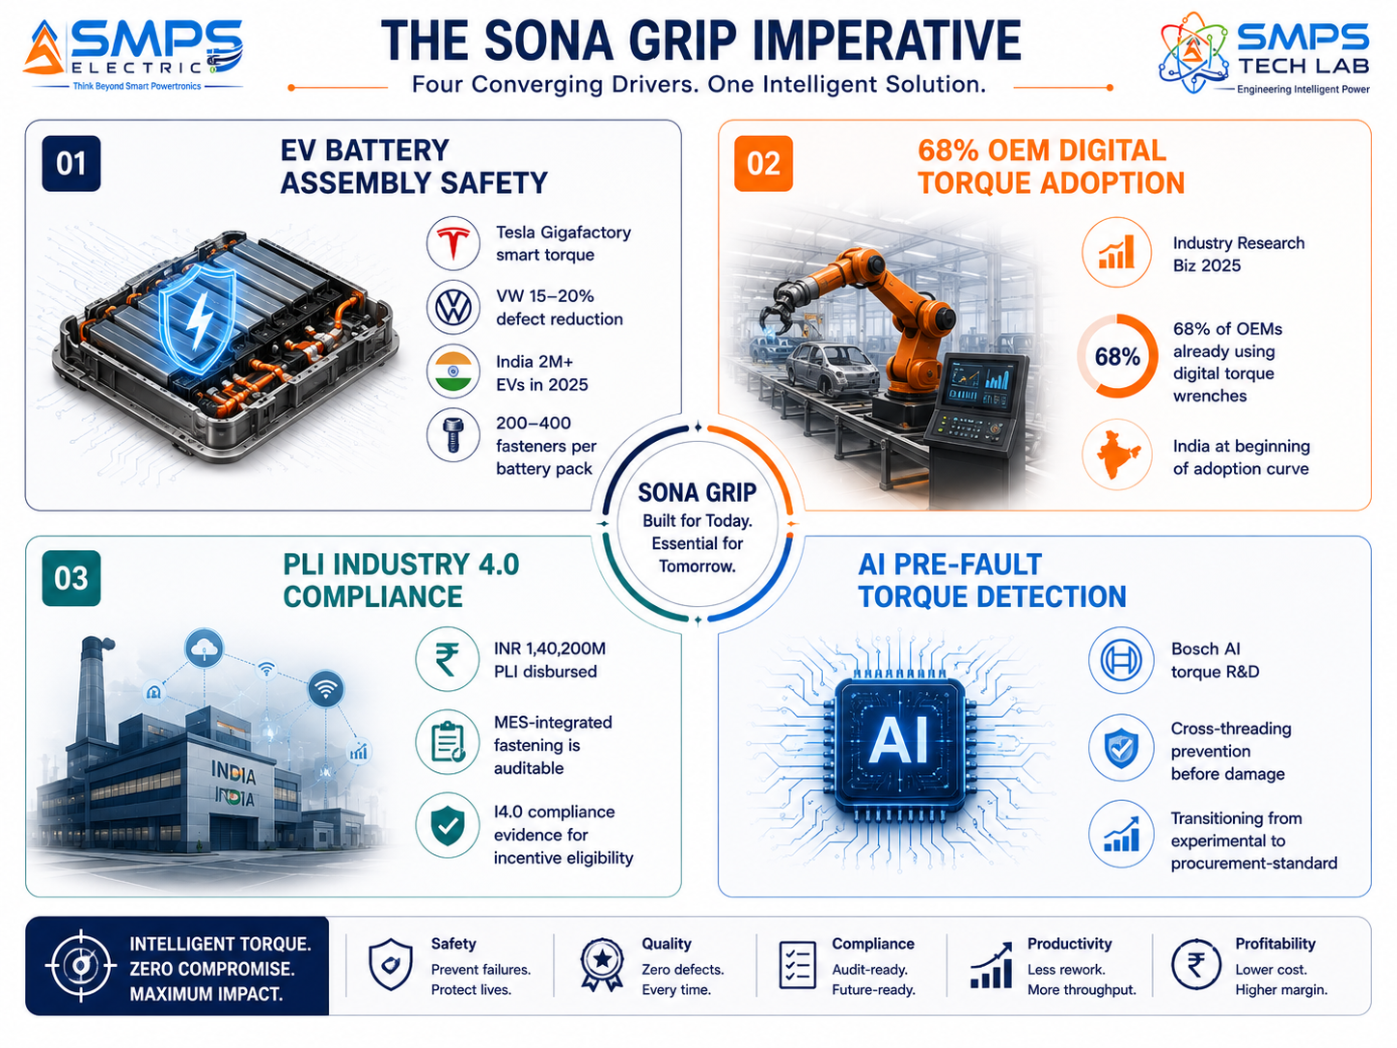
Figure 3.1 — Four structural megatrends converging on the Sona Grip market window. EV battery safety requirements are the most immediate commercial driver; PLI Industry 4.0 compliance creates a direct procurement mandate; 68% OEM adoption confirms market mainstream readiness.

3.3 Global Market Sizing — Primary Reference Data
MARKET SEGMENT | 2025 VALUE | PROJECTED | CAGR | HORIZON | SOURCE
DC Torque Tool Market | USD 15.73B | USD 25.87B | 5.7% | 2034 | Market Research Future
Smart Power Tools (Connected Sub-Seg.) | USD 3.48B | USD 7.94B | 9.6% | 2033 | Grand View Research (2024 base)
Assembly Fastening Tools | USD 3.8B | USD 5.8B | 4.4% | 2035 | Future Market Insights
DC Torque Tool Market (CMI) | USD 3.77B | USD 5.63B | 6.0% | 2032 | Custom Market Insights (2022 base)
Digital Torque Wrench Market | USD 2.5B | USD 4.5B | 6.2% | 2033 | DataHorizzon Research (2024 base)
Fastening Power Tools | USD 4.0B | USD 6.4B | 7.1% | 2032 | Industry estimate
DC Torque Tool (MarketsandMarkets) | USD 3.76B | USD 4.36B | 3.7% | 2029 | MarketsandMarkets
Automotive Torque Tool Market (Emergen) | USD 1.84B | USD 2.67B | 3.8% | 2034 | Emergen Research (2024 base)

CAGR Comparison — Sona Grip Target Market Segments

Smart Power Tools (Grand View Research) ██████████████████░░░░░░░░ 9.6%
India Industrial Automation (Mordor Intl) ██████████████████████████ 14.05%
Fastening Power Tools █████████████░░░░░░░░░░░░░ 7.1%
Aerospace & Defence Tools █████████████░░░░░░░░░░░░░ 6.8%
Digital Torque Wrenches (DataHorizzon) ███████████░░░░░░░░░░░░░░░ 6.2%
DC Torque Tool Market (CMI) ███████████░░░░░░░░░░░░░░░ 6.0%
DC Torque Tool Market (MRF) ███████████░░░░░░░░░░░░░░░ 5.7%
Electronics Assembly Tools ██████████████████░░░░░░░░ 9.6%
Automotive Torque Tools (Emergen) ███████░░░░░░░░░░░░░░░░░░░ 3.8%
DC Torque Tool (MarketsandMarkets) ███████░░░░░░░░░░░░░░░░░░░ 3.7%
Sources: Market Research Future, Grand View Research, Future Market Insights, Custom Market Insights, DataHorizzon Research, MarketsandMarkets, Emergen Research, Mordor Intelligence (2024–2026 publications)

04 | TOTAL ADDRESSABLE MARKET  Five Manufacturing Sectors · Ten Applications · USD 26.4 Billion

4.1 Methodology
The TAM framework maps Sona Grip across five strategic manufacturing sectors with two primary applications per sector, producing ten independently validated commercialisation pathways. The USD 26.4 billion TAM represents the addressable market for AI-enabled, MES-integrated universal torque control platforms within each sector — the premium sub-segment where Sona Grip’s universal range, AI pre-fault detection, and automatic traceability create meaningful differentiation from conventional passive tools.

STRATEGIC NOTE
Sona Grip’s universal architecture means that a single commercial relationship with an automotive OEM procurement team can generate tool supply across five different applications — EV battery assembly, chassis assembly, engine assembly, body assembly, and interior trim assembly — from a single certified platform. No competitor can offer this cross-application coverage from one tool family.

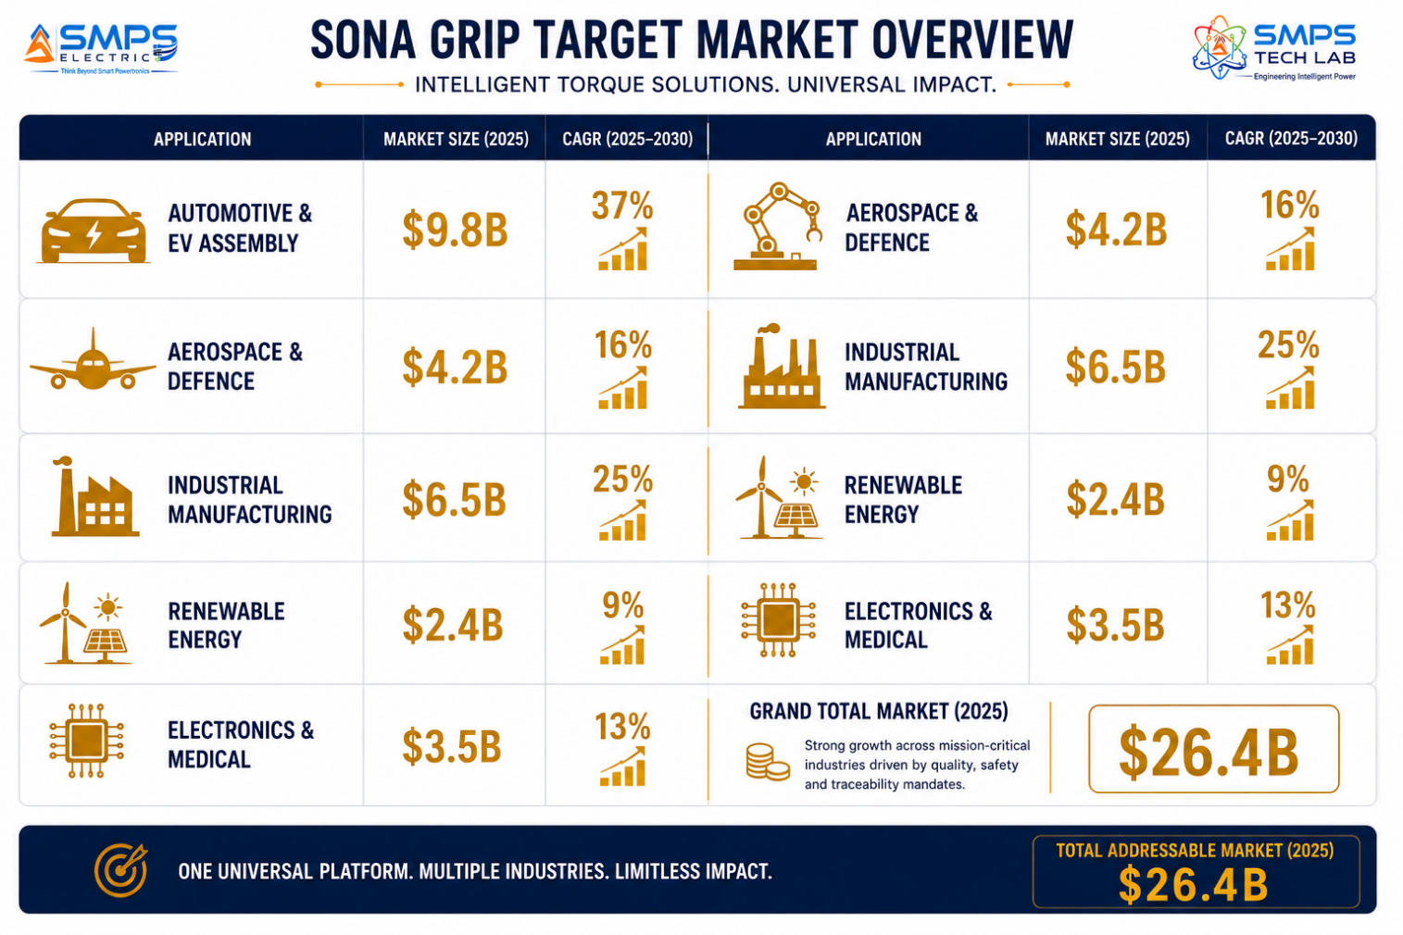
Figure 4.1 — Sona Grip application matrix. Ten commercial pathways across five manufacturing sectors, all served by a single universal tool platform with application-specific variant intelligence.

4.2 Consolidated TAM Summary
SECTOR | APPLICATION | USE CASE SUMMARY | APP SIZE | SECTOR TAM | CAGR
Automotive & EV | EV Battery Pack Assembly Torque Controller | AI torque-angle control; UN 38.3 traceability; thermal runaway prevention; MES-linked; ESD-safe | $9.8B | $9.8B | 5.7%
Automotive & EV | Automotive Assembly NutRunner & Screwdriver | IATF 16949 MES-integrated torque station; VIN-fastener association; SPC output; 15–20% defect reduction | $9.8B | $9.8B | 5.7%
Aerospace & Defence | Aircraft Airframe & Engine Torque Documentation | AS9100D ±1% encrypted DGCA/FAA-compliant fastening records; calibration management; NPL-traceable | $4.2B | $4.2B | 6.8%
Aerospace & Defence | Defence Platform MRO Torque Management | IP65 MIL-STD-810 rugged; offline-capable; DGQA pathway; 72hr battery; satellite sync option | $4.2B | $4.2B | 6.8%
Industrial Manufacturing | Smart Factory MES-Integrated Torque Station | OPC-UA/REST; PLI Industry 4.0 compliance; SPC dashboard; sequence control; ISO 9001/IATF | $6.5B | $6.5B | 5.7%
Industrial Manufacturing | Heavy Equipment Hydraulic Torque System | 500–50,000 Nm digital bolting; ISO 16047; bridges, pressure vessels, industrial plant documentation | $6.5B | $6.5B | 5.7%
Renewable Energy | Wind Turbine Flange Bolting Documentation | 200–10,000 Nm; three-pass ISO torque; GPS per bolt; commissioning record; turbine OEM warranty | $2.4B | $2.4B | 7.1%
Renewable Energy | Solar Farm & Infrastructure Structural Bolting | 5–500 Nm; GPS location tagging; EPC civil certification; MNRE compliance; 12-hour cordless runtime | $2.4B | $2.4B | 7.1%
Electronics & Medical | Micro-Torque for Electronics & PCB Assembly | 0.01–10 Nm ESD-safe; sequence-controlled; IPC-A-610 aligned; NABL calibration; MES-integrated | $3.5B | $3.5B | 9.6%
Electronics & Medical | Medical Device Assembly FDA 21 CFR Part 11 | 0.05–50 Nm; FDA DHR integration; ISO 13485; CDSCO compliance; cleanroom-compatible; audit trail | $3.5B | $3.5B | 9.6%
TOTAL ADDRESSABLE MARKET — IP-12 SONA GRIP — UNIVERSAL TORQUE CONTROLLED DEVICE (2025) |  |  |  | ~USD 26.4 Billion

MARKET DATA POINT
Combined SMPS Tech Lab portfolio TAM: IP-01 through IP-11 $441.3B + IP-12 $26.4B = USD 467.7 Billion across 60 sectors and 120 applications. Sona Grip adds the precision manufacturing quality layer — ensuring every fastener in every product built, powered, managed, or protected by the portfolio is assembled with the gold standard of torque control.

05 | INDIA MARKET INTELLIGENCE  PLI Industry 4.0 · EV Manufacturing · Aerospace Bengaluru · Make in India

5.1 India as Primary and Strategic Market
India’s manufacturing transformation creates a uniquely compelling market for Sona Grip. Three structural forces converge. PLI scheme Industry 4.0 compliance requirements are creating a direct, government-backed procurement mandate for MES-integrated fastening documentation among PLI beneficiaries across automotive components, electronics, and industrial manufacturing — the most auditable Industry 4.0 compliance evidence is a digital, MES-linked fastening record. India’s EV industry is scaling from 2 million to tens of millions of units — with every EV battery pack requiring UN 38.3-documented torque at 200–400 fastening operations. And Bengaluru is India’s #1 defence and aerospace hub: HAL, BEL, DRDO, Collins Aerospace, Airbus Helicopters, and Safran all operate precision assembly operations in Bengaluru requiring DGCA/AS9100D-compliant fastening documentation — a market served by expensive imported European tools that Sona Grip can address with a Made-in-India alternative at a competitive price point.

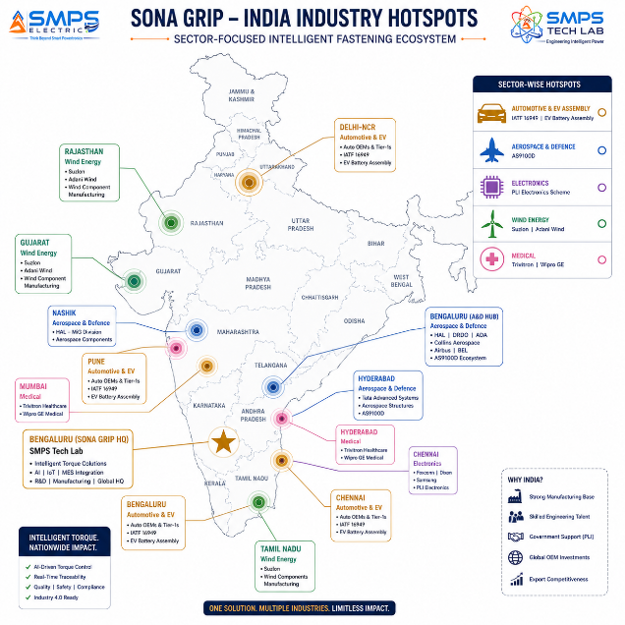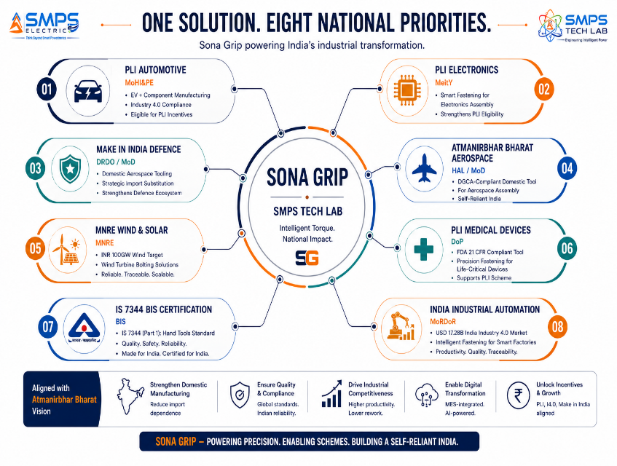
Figure 5.1 — India deployment hotspot map (left): Sona Grip has active demand across every precision manufacturing sector simultaneously — Bengaluru alone hosts aerospace, automotive, electronics, and defence assembly operations requiring certified torque traceability. Policy alignment (right): PLI Industry 4.0 compliance creates a direct procurement mandate across multiple schemes.

5.2 India Market Sizing — Sona Grip Relevant Segments
INDIA MARKET SEGMENT | 2025E VALUE | PROJECTED | CAGR | HORIZON
India Power & Precision Tools Market | USD 0.9B | USD 1.8B | ~10% | 2030
India Automotive Assembly Tools | USD 0.18B | USD 0.38B | ~12% | 2030
India Aerospace & Defence MRO Tools | USD 0.08B | USD 0.18B | ~13% | 2030
India Electronics Assembly Tools (PLI) | USD 0.12B | USD 0.35B | ~15% | 2030
India Wind & Renewable Installation | USD 0.06B | USD 0.16B | ~15% | 2030
India Medical Device Assembly Tools | USD 0.04B | USD 0.12B | ~18% | 2030

06 | GOVERNMENT POLICY & REGULATORY ALIGNMENT  PLI I4.0 · Automotive · Aerospace · Medical · Renewable

6.1 India & Global Policy with Direct Sona Grip Alignment
SCHEME / PROGRAMME | MINISTRY / BODY | RELEVANCE TO SONA GRIP | COMMERCIAL IMPLICATION
PLI Automotive — Advanced Auto Technology | MoHI&PE | PLI for EV components; Industry 4.0 documented quality; MES-integrated manufacturing preferred | EV battery assembly Sona Grip supply to Indian auto OEMs under PLI compliance; digital fastening = I4.0 evidence
PLI Electronics & IT Hardware | MeitY | PLI for electronics manufacturing; documented quality for global brand OEM supply | Sona Grip micro-torque for Dixon/Foxconn/Samsung India assembly lines; IPC-A-610 quality evidence for PLI audit
Make in India Defence — Aerospace | MoD / DRDO | Domestic content preference for aerospace tools; DGCA-compliant calibration management | Sona Grip Made-in-India AS9100D tool vs. imported Snap-on/Norbar; HAL/BEL DGCA-compliant fastening records
MNRE 100 GW Wind Target | MNRE | 100 GW wind by 2030 requires structural bolt documentation for turbine commissioning | Sona Grip wind turbine variant for Suzlon/Adani/ReNew EPC operations; ISO 16047 commissioning record
PLI Medical Devices | DoP / MoHFW | PLI for medical device manufacturing; FDA 21 CFR Part 11 required for US export | Sona Grip medical variant for Trivitron/Wipro GE/Hindustan Syringes FDA-compliant DHR records
BIS IS 7344 Certification | Bureau of Indian Standards | Hand tools standard; BIS certification enables government and PSU procurement | IS 7344 BIS certification unlocks government, PSU, and defence procurement channel
IATF 16949 Customer Audit Requirements (Global) | IATF / Global Auto OEMs | Automotive quality standard; digital torque traceability required for supplier qualification | Indian Tier 1/2 suppliers of Bosch, Mahle, Faurecia must provide IATF 16949 fastening records — Sona Grip provides
AS9100D / DGCA Compliance (Global) | DGCA / FAA / EASA / IAQG | Aerospace quality; ±1% torque accuracy and calibration traceability mandatory | Sona Grip is the only Indian-designed AS9100D-compliant torque system; direct procurement advantage at HAL/BEL

07 | IP AS AN INDUSTRY PLUGIN  Five-Sector Quality Integration Architecture

7.1 The Plugin Architecture — Five Quality System Categories
Sona Grip is architecturally designed as the precision fastening quality node within each sector’s existing quality management infrastructure. It does not replace the MES, QMS, or calibration management system — it connects to them, enriching them with tamper-proof fastening data that they currently receive from paper records or basic digital logs. The integration is bidirectional: the quality system pushes fastener specifications to Sona Grip (torque target, angle, strategy, sequence); Sona Grip pushes fastening results back (actuals, SPC data, AI fault detections). No manual data transfer. No paper records. No reconciliation.
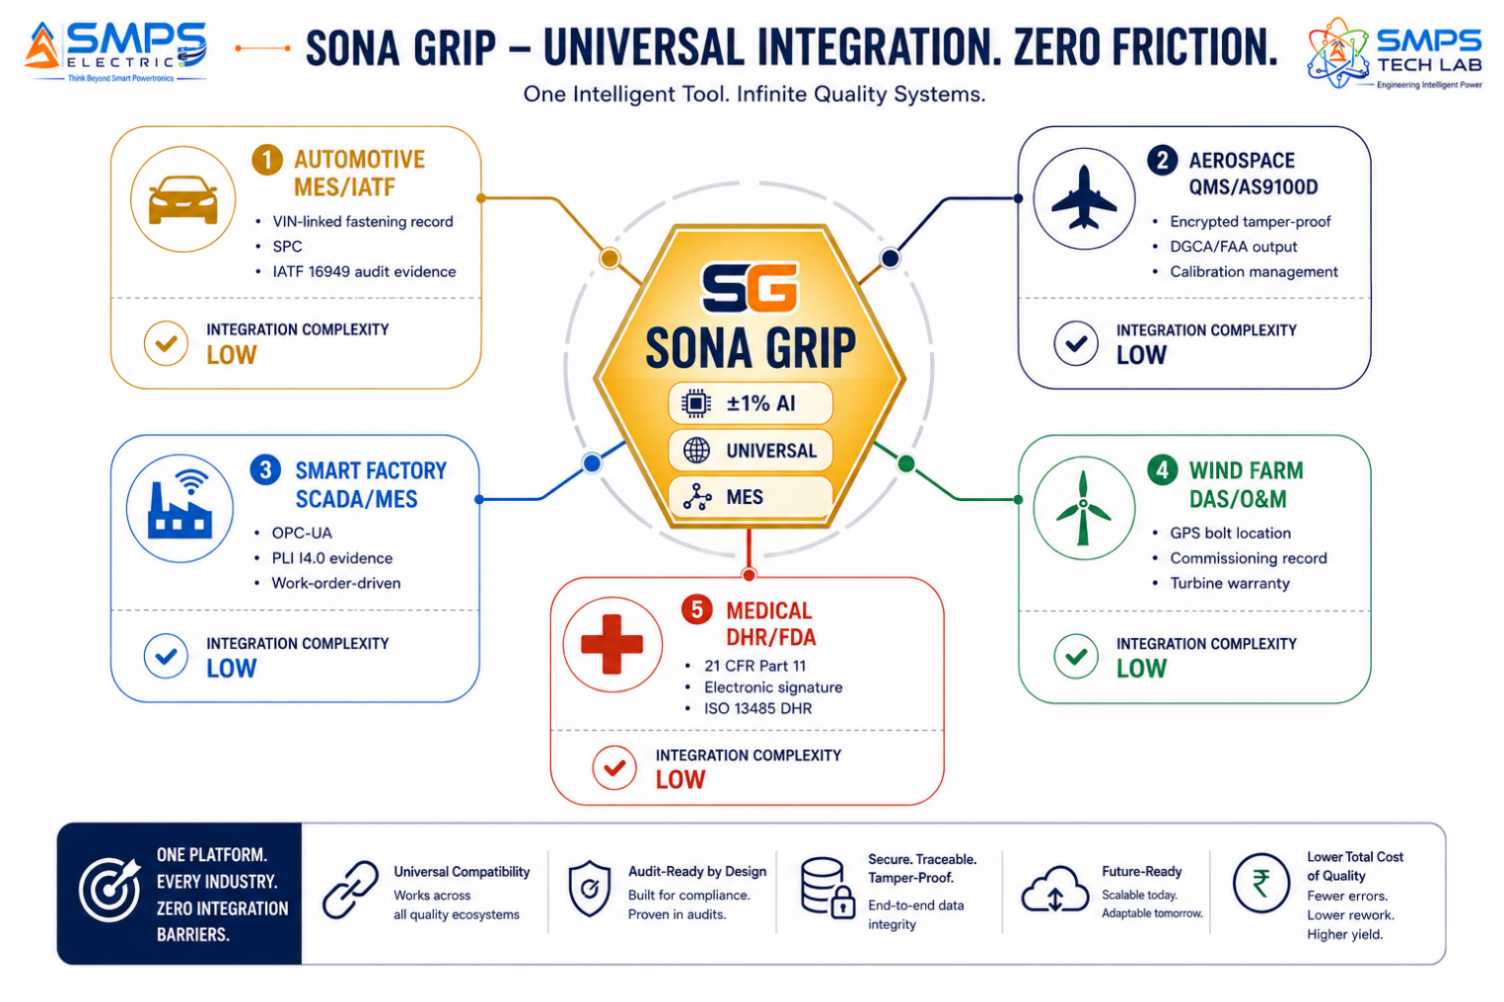
Figure 7.1 — Sona Grip as the universal precision fastening quality plugin. The same physical tool provides different quality system integration profiles for each sector through application variant intelligence — automotive MES integration, aerospace encrypted records, medical FDA audit trails, all from one universal device.

7.2 Plugin Integration Matrix
HOST SYSTEM | PLUGIN ROLE | VALUE AT SYSTEM LEVEL | INTEGRATION COMPLEXITY
Automotive MES (SAP ME / Siemens Opcenter) | VIN-fastener association; work-order-driven spec download; SPC data push; IATF audit export | Zero manual data entry; IATF 16949 audit evidence auto-generated; 15–20% defect reduction | LOW — OPC-UA/REST standard; VIN barcode scan; Wi-Fi connectivity to plant network
Aerospace QMS (AS9100D / CAMP / Traxxall) | Encrypted tamper-proof fastening record per Aircraft Tech Log; calibration status check before each use; DGCA/FAA data format output | Aircraft Certificate of Release to Service fastening documentation; zero paper torque records; audit-ready | MEDIUM — Bluetooth upload; encrypted record format; QMS API integration
Industrial ERP/MES (SAP / Oracle) | Work-order-driven torque spec; SPC output per batch; ISO 9001 quality evidence; sequence enforcement | PLI Industry 4.0 compliance evidence; global Tier 1 supplier audit qualification; zero paper records | LOW — REST API; OPC-UA; barcode scan for work order association
Wind Farm DAS / Commissioning Database | GPS-tagged bolt tightening record; three-pass documentation; turbine OEM commissioning upload | Turbine warranty compliance documentation; structural certification evidence for civil authority | LOW-MED — Bluetooth; GPS; 4G cloud sync; commissioning database API
Medical QMS (MasterControl / Veeva Vault) | FDA 21 CFR Part 11 electronic records; operator e-signature; DHR auto-population; calibration management | Device History Record auto-populated; FDA 510(k) / CDSCO export registration documentation | MEDIUM — FDA 21 CFR Part 11 compliant API; electronic signature; QMS integration

08 | COMMERCIALISATION STRATEGY  Revenue Models · Market Priority · Go-to-Market Architecture

8.1 Commercialisation Philosophy
The Sona Grip commercialisation strategy prioritises the automotive and EV assembly sector as the fastest near-term revenue pathway (6–18 months), driven by India’s EV production scale-up, PLI automotive compliance requirements, and the established market fact that 68% of global OEMs already use digital torque tools — making the conversation with an Indian automotive procurement manager one of ‘which digital torque platform’ rather than ‘why digital torque.’ Industrial manufacturing follows as a parallel pathway with equal time-to-revenue through PLI Industry 4.0 compliance demand. Aerospace and medical are 12–24 month pathways with the highest per-unit ASP and the most durable, multi-year supply relationships. Revenue model: hardware sales (tool + head sets) plus calibration service subscriptions (annual calibration management + NPL-traceable calibration service) plus MES integration professional services.

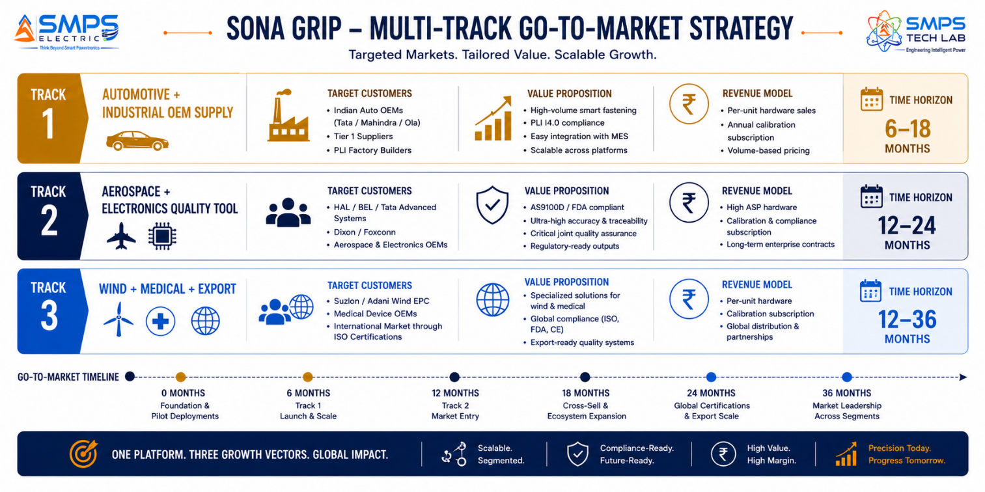
Figure 8.1 — Three parallel commercialisation pathways. Automotive and industrial OEM supply provides fastest revenue through established PLI demand; aerospace and electronics premium provides highest per-unit ASP; wind turbine and medical supply builds the global export foundation.

8.2 Market Priority Matrix
SECTOR | TAM 2025 | CAGR | IP FIT | TIME-TO-REV | PATHWAY | PRIORITY
Automotive & EV Assembly | $9.8B | 5.7% | Excellent | 6–18 mo | OEM Direct | HIGHEST
Industrial Manufacturing | $6.5B | 5.7% | Excellent | 6–18 mo | PLI I4.0 + OEM | HIGH
Aerospace & Defence | $4.2B | 6.8% | Excellent | 12–24 mo | HAL/BEL Direct | HIGH
Electronics & Medical | $3.5B | 9.6% | Excellent | 12–24 mo | PLI + Export | HIGH
Renewable Energy | $2.4B | 7.1% | Strong | 12‒24 mo | Wind EPC Direct | MED-HIGH

09 | COMPETITIVE LANDSCAPE  Market Positioning · Advantage Scorecard · IP Moat

9.1 Competitive Architecture Overview
The precision torque tool market has well-established international Tier 1 suppliers: Atlas Copco (Tensor/PowerFocus range), Snap-on Industrial (CDtech, Technofriction), Norbar Instruments, Stanley Engineered Fastening, and Desoutter Tools dominate the premium digital torque segment globally. Their competitive strength is certification portfolio, global service network, and established OEM customer relationships. Their structural limitation — and Sona Grip’s structural opportunity — is price, universality, and India market positioning. Atlas Copco and Snap-on industrial torque systems are priced at USD 2,000–20,000 per unit, with replacement heads and calibration services priced accordingly. Indian manufacturing’s price sensitivity and PLI scheme constraints make a fully certified, Indian-designed universal torque platform at 40–60% of the imported price point a commercially compelling alternative.

CATEGORY | KEY PLAYERS | MARKET FOCUS | SONA GRIP ARCHITECTURAL DIFFERENTIATION
International Precision Torque OEMs | Atlas Copco, Snap-on Industrial, Norbar, Desoutter, Stanley Engineered Fastening | Premium digital torque, automotive, aerospace | Expensive (USD 2,000-20,000); non-universal (separate tools per application); limited India support; not Make in India eligible for procurement preference. Sona Grip OEM supply to their Indian customers is the preferred outcome.
German/Japanese Precision Tool OEMs | Wera, Gedore, Stahlwille, Tone (Japan) | Manual and digital hand torque tools | Quality hand tools; no AI control; no MES integration; no universal range. Address maintenance and manual assembly; not smart factory assembly. No cross-threading detection. No automatic traceability.
Indian Tool Manufacturers | Jhalani, Eastman, Groz, Trust | Mass market Indian hand tools | Passive click wrenches, no digital capability. India manufactured but no precision digital technology. Distribution channel strength. Sona Grip is the premium digital segment above their market positioning.
Integrated NutRunner Systems | Bosch Rexroth (Tightening Technology), Cleco | Automotive assembly line NutRunners | High-quality automotive systems; not universal across all sectors; not universal range; high price. Sona Grip’s universal architecture and India price point are the differentiators in the Indian OEM market.
EV Battery Assembly Specialists | Cleco Assembly Technologies, AIMCO Tools | EV battery and electronics fastening | Specialist single-application tools. Sona Grip’s universal architecture covers EV battery plus all other applications in the same plant from one certified platform.

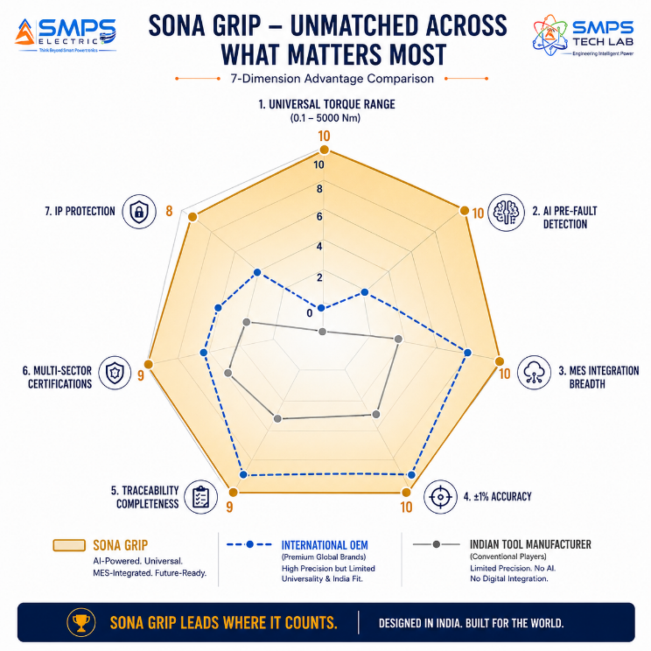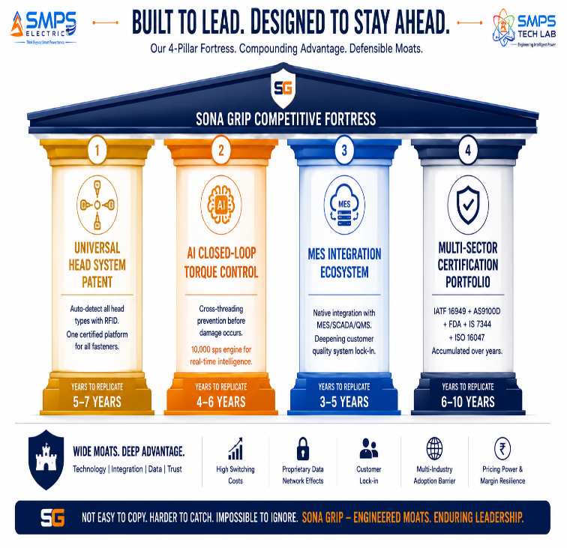
Figure 9.1 — Sona Grip competitive radar (left): Universal Range and AI Pre-fault Detection are the structurally unreplicable advantages — no single competitor offers both simultaneously. Four-pillar moat (right): the MES integration ecosystem creates customer quality system lock-in that deepens with every data point generated.

10 | INVESTMENT THESIS & FINANCIAL FRAMEWORK  Value Creation · Revenue Projections · Market Scale

10.1 The Investment Case
The investment case for Sona Grip is built on three independent and compounding revenue streams. Hardware sales: a universal tool platform priced at 40–60% of imported European alternatives, covering every application from a single certified device. Calibration service subscriptions: every precision torque tool requires annual calibration recertification; Sona Grip’s calibration management service provides NPL-traceable recertification with automatic quarantine alerts, generating a recurring revenue stream equal to 20–35% of the tool’s original price per year. MES integration professional services: each new customer deployment requires MES integration configuration; Sona Grip’s professional services team delivers this as a one-time engagement that creates durable customer relationships and deepens quality system lock-in. The automotive sector’s 6–18 month time-to-revenue combined with India’s EV production scale-up makes Sona Grip the precision manufacturing tool with the clearest, most immediate commercial pathway in the SMPS Tech Lab portfolio.

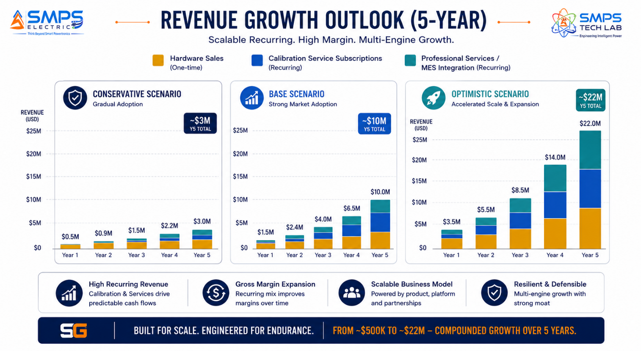
Figure 10.1 — Triple revenue model. Hardware sales provide immediate Year 1 revenue; calibration service subscriptions compound from Year 2 as the installed fleet grows; professional services create durable customer relationships that expand tool deployment across each customer’s additional assembly lines.

10.2 Illustrative Revenue Scenarios
SCENARIO | YEAR 1 | YR 2–3 CAGR | YR 4–5 CAGR | KEY ASSUMPTIONS
Conservative (Auto + Industrial OEM) | USD 500K–800K | +28% | +22% | IS 7344 + CE + IATF 16949 tool certification; 2 automotive OEM pilot supply agreements; PLI factory
Base (Multi-Sector OEM Supply) | USD 1.5–2M | +55% | +45% | Auto OEM + HAL aerospace + PLI electronics + wind turbine EPC; calibration service Year 2
Optimistic (All Pathways + Export) | USD 3.5–4.5M | +70% | +60% | All pathways + FDA medical export + international EV OEM + calibration service scale + professional services

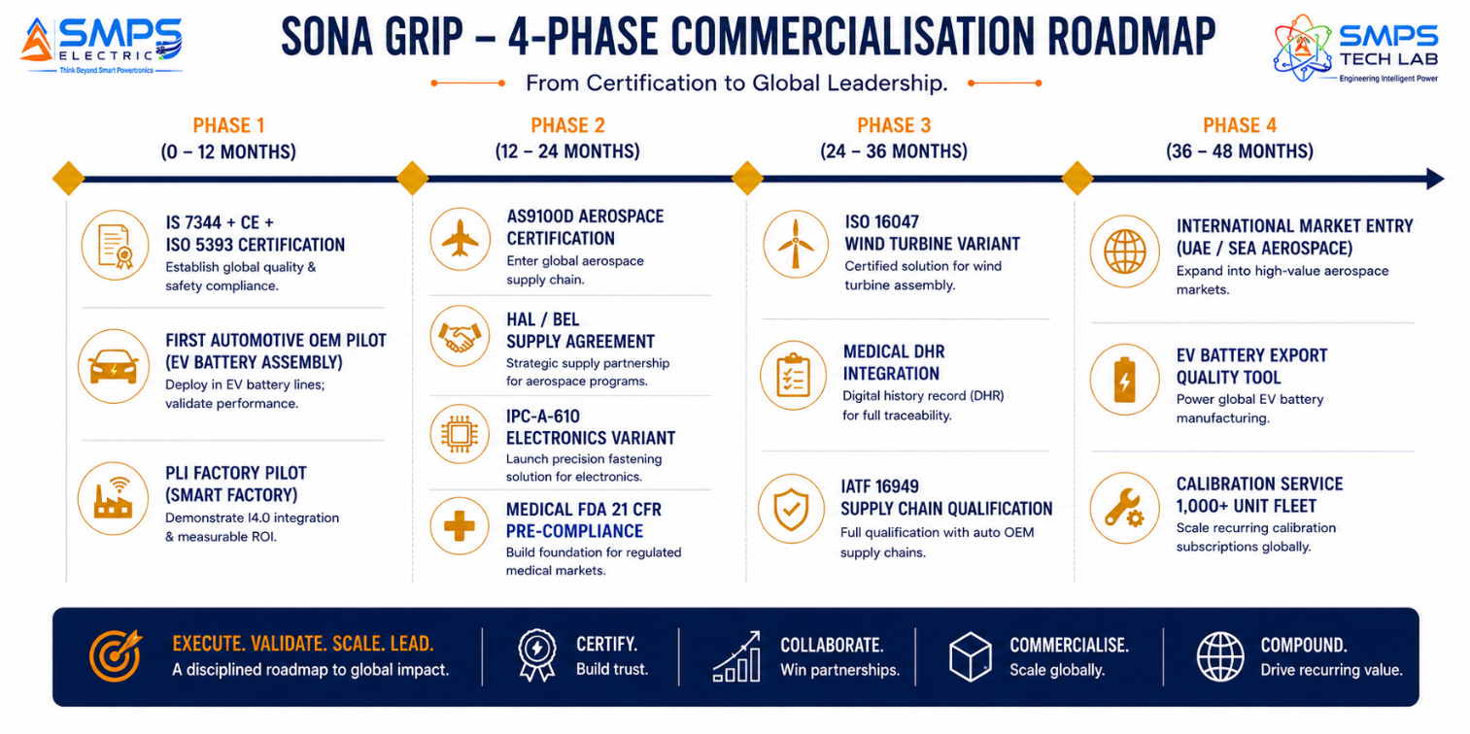
Figure 10.2 — Four-phase milestone roadmap. IS 7344 + CE + IATF certification in Phase 1 opens automotive and industrial markets; AS9100D in Phase 2 opens the highest-value aerospace and defence channel; international markets from Phase 4.
KEY INSIGHT
A single EV OEM production contract — Tata Motors selecting Sona Grip for their Pune EV battery assembly line at 200 tools per line and 3 production lines — generates 600 units of hardware revenue plus 600 annual calibration service subscriptions. At INR 45,000 per tool + INR 9,000 per year calibration service, this single engagement generates INR 2.7 crore in Year 1 hardware revenue plus INR 54 lakh in recurring annual calibration service. And this is before the expansion to other assembly lines at Tata’s other EV plants.

11 | FUTURE ROADMAP  Technology Evolution · Digital Twin Assembly · Autonomous Fastening

11.1 Technology Generation Roadmap
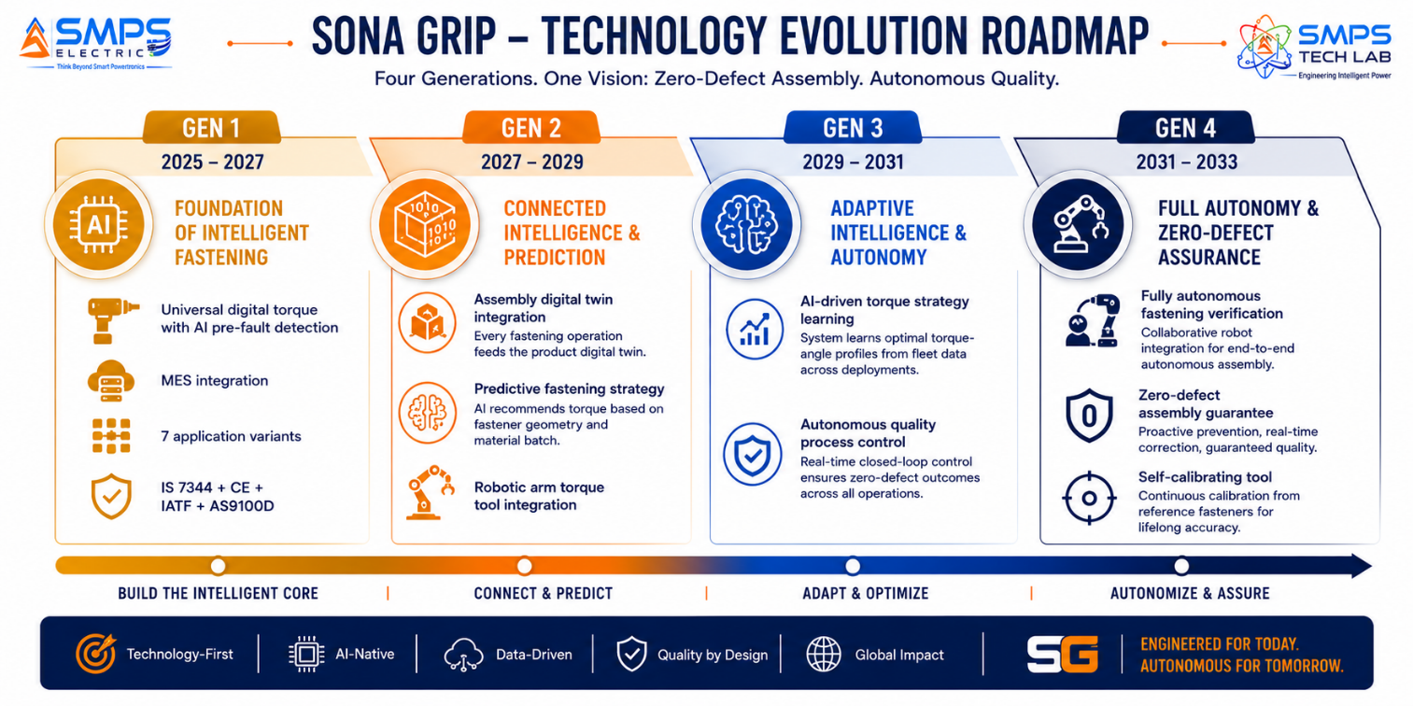
Figure 11.1 — Sona Grip four-generation roadmap. From universal AI torque with MES integration (Gen 1) to fully autonomous zero-defect assembly verification (Gen 4) — each generation converting Sona Grip from a precision tool into an autonomous quality intelligence platform.
GENERATION | TECHNOLOGY FOCUS | TARGET TIMELINE | MARKET IMPACT
Gen 1 (Current) | Universal digital torque: AI pre-fault detection, MES integration, ±1% accuracy, 7 variants; IS 7344+CE+IATF+AS9100D; 0.1–5,000Nm range | 2025–2027 | Automotive OEM, PLI factories, aerospace HAL/BEL, wind turbine EPC, medical export
Gen 2 | Digital twin assembly integration: every Sona Grip fastening updates the product’s digital twin in real time; predictive torque strategy from AI; collaborative robot (cobot) torque arm integration | 2027–2029 | Smart factory digital twin adoption; EV battery pack digital trace from cell fastening to commissioning; cobot-integrated assembly
Gen 3 | Federated AI learning across Sona Grip fleet: optimal torque strategies shared across deployments; AI flags batch-level fastener non-conformance before line shutdown; autonomous quality control | 2029–2031 | Zero-PPM quality target for automotive suppliers; AI-driven supplier fastener quality management; autonomous warranty analysis
Gen 4 | Fully autonomous fastening verification: cobot integration with Sona Grip as end-effector; self-calibrating sensor; zero-defect assembly certification; AI-guaranteed quality evidence | 2031–2033 | Autonomous precision assembly; quality guarantee contracts; insurance-backed zero-defect manufacturing certification

11.2 Adjacent Application Opportunities
- Semiconductor Fab Equipment Assembly: Semiconductor manufacturing equipment (lithography systems, plasma etch chambers, CVD reactors) requires ultra-precision fastening at sub-Nm torques in cleanroom conditions. Sona Grip’s micro-torque electronics variant, extended to Class 3 cleanroom compatibility, addresses the emerging India semiconductor equipment manufacturing market under the ISM fab investments.
- Railway Rolling Stock Maintenance: Indian Railways’ ongoing electrification and high-speed rail programmes require precision torque documentation for wheel-axle assembly, bogie fasteners, and pantograph mounting — safety-critical applications currently served by manual tools without digital traceability. Sona Grip’s heavy-duty variant with IS 1370-compliant calibration addresses this large, stable, government-funded market.
- Oil & Gas Pressure Vessel and Pipeline Flanges: Offshore and onshore oil & gas installations require documented bolting for pressure boundary flanges (ASME B16.5, ISO 15649). Sona Grip’s ATEX/IS-classified heavy torque variant addresses this premium market where fastening documentation is a pressure system safety regulation requirement.
- EV Charging Station Manufacturing Quality: EV charging station manufacturers (Exicom, Tata Power EV, ChargePoint India) require precision fastening for internal power module assembly — the same application context as IP-10 SMPS Electric. Sona Grip as the quality tool for EV charging station manufacturing creates a portfolio integration: SMPS Electric powers the charger; Sona Grip ensures every fastener in the charger is assembled to specification.

12 | RISK ANALYSIS  Risk Register · Probability & Impact · Strategic Mitigation

12.1 Risk Framework
Sona Grip’s risk profile is shaped by two domain-specific factors. First, the precision torque market has entrenched international incumbents (Atlas Copco, Snap-on, Norbar) with deep customer relationships, established calibration service networks, and multi-year tool supply contracts. Displacing these incumbents in existing global OEM supply relationships is challenging. The primary market entry strategy addresses this: India’s manufacturing scale-up is creating new plants, new assembly lines, and new procurement decisions where Sona Grip has no incumbent disadvantage — a greenfield opportunity every time a new PLI factory, new EV plant, or new aerospace facility is commissioned. Second, precision torque tools require calibration certification traceable to national metrology standards (NPL India / NABL-accredited labs). Establishing the calibration service infrastructure is a prerequisite for market entry, not a Phase 2 exercise.

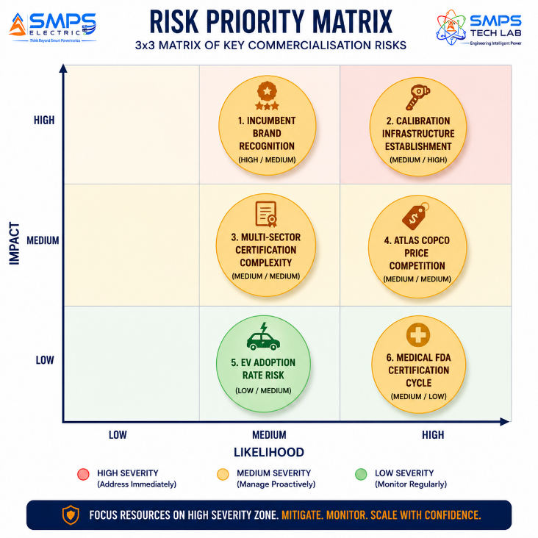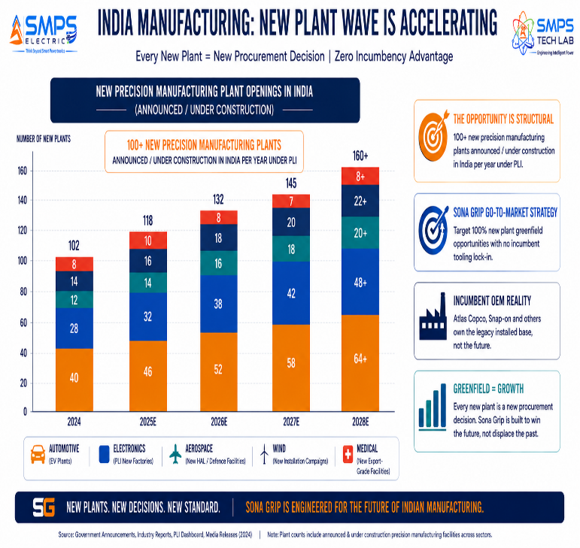
Figure 12.1 — Risk matrix (left): incumbent brand recognition is the highest-probability commercial challenge. Greenfield strategy (right): India’s manufacturing scale-up is creating 100+ new plants per year with no incumbent torque tool relationships — Sona Grip targets these greenfield decisions rather than displacement of existing Atlas Copco or Snap-on installations.

CATEGORY | SPECIFIC RISK | PROB. | IMPACT | MITIGATION STRATEGY
IP Protection | Atlas Copco or Snap-on challenges universal head or AI control patent | LOW | HIGH | PCT filing + India patent. Claims cover the specific combination of universal auto-detect head system and AI closed-loop torque-angle control with MES integration. Licensing these OEMs as India market distributors is the preferred commercial outcome.
Brand Recognition | Indian OEMs default to Atlas Copco / Snap-on brand familiarity | HIGH | MEDIUM | Greenfield strategy: target new plants with no incumbent. Pilot programme: 6-month free trial at one assembly station demonstrating defect reduction data vs. click wrench baseline. Sona Grip ROI quantification: one avoided rework event pays for the tool purchase.
Calibration Infrastructure | NPL-traceable calibration service not established at market launch | MEDIUM | HIGH | NABL-accredited lab partnership agreement before market launch. SMPS Tech Lab Bengaluru lab equipped for in-house calibration of IS 7344-range torque tools. Partnership with established NABL labs for aerospace and medical calibration ranges.
Certification Complexity | IATF + AS9100D + FDA 21 CFR + IS 7344 multi-sector timeline | MEDIUM | MEDIUM | IS 7344 + CE + ISO 5393 (industrial/automotive, lowest cost, fastest) as Phase 1. AS9100D aerospace as Phase 2. FDA 21 CFR medical as Phase 3. Sector-sequenced certification preserves capital; automotive revenue funds aerospace certification.
EV Adoption | India EV manufacturing scale slower than forecast | LOW | LOW | Industrial manufacturing and PLI general factory market is adoption-rate independent. Aerospace is government-funded procurement independent of EV market. EV is the upside accelerator, not the baseline case.
Financial | Multi-sector development + certification exceeds Year 1 capital | MEDIUM | LOW | Automotive/industrial variant first (lowest certification cost, fastest revenue). Revenue from Year 1 automotive supply funds aerospace and medical certification. Calibration service subscription from Year 2 provides recurring revenue foundation.

13 | APPENDICES  Data Sources · Standards Reference · Glossary

Appendix A — Data Sources
- Market Research Future — DC Torque Tool Market: USD 15.73B (2025) to USD 25.87B by 2034, CAGR 5.7%
- Grand View Research — Smart Power Tools Market: USD 3.48B (2024) to USD 7.94B by 2033, CAGR 9.6%
- Grand View Research — Electric Torque Tools Market: USD 639.6M (2024) to USD 1.01B by 2033, CAGR 5.2%
- DataHorizzon Research — Digital Torque Wrenches Market: USD 2.5B (2024) to USD 4.5B by 2033, CAGR 6.2%
- Future Market Insights — Assembly Fastening Tools Market: USD 3.8B (2025) to USD 5.8B by 2035, CAGR 4.4%
- Custom Market Insights — DC Torque Tool Market: USD 3.77B (2022) to USD 5.63B by 2032, CAGR 6%
- MarketsandMarkets — DC Torque Tool Market: USD 3.76B (2025) to USD 4.36B by 2029, CAGR 3.7%
- Emergen Research — Automotive Torque Tool Market: USD 1.84B (2024) to USD 2.67B by 2034, CAGR 3.8%
- ReAnin — Digital Torque Wrench Market: USD 1.90B (2025) to USD 2.58B by 2032, CAGR 4.5%
- PW Consulting — Smart Digital Torque Wrenches: Tesla Gigafactories using smart torque for EV battery assembly; VW reports 15–20% defect reduction with IoT torque wrenches
- Industry Research Biz — Automotive Tools Market: USD 50.8B (2025); 68% of OEMs employ automated fastening with digital torque wrenches (2025)
- Future Market Insights — India Power Tools Market: Karnataka as fast-growing precision tool market; Bengaluru adopting smart devices in precision engineering
- Mordor Intelligence — India Industrial Automation Market: USD 17.28B (2025), CAGR 14.05%
- Expert Market Research — India Aerospace & Defence Market: USD 28.68B (2024), CAGR 7.1%; Bengaluru as India’s No. 1 defence hub
- IEA — Global EV Sales: 14 million units in 2023, growing to 17M+ in 2024; EV battery assembly torque demand driver
- India Ministry of Finance — PLI scheme: INR 1,40,200 million disbursed to discrete industries requiring Industry 4.0 compliance, 2025

Appendix B — Standards Reference
STANDARD | FULL TITLE | APPLICABILITY
IATF 16949 (ISO/TS 16949) | Quality management systems: particular requirements for the application of ISO 9001 for automotive production and relevant service part organisations | Automotive quality management standard. Requires documented torque traceability for critical fasteners. Sona Grip MES-integrated records satisfy IATF 16949 fastening evidence requirements.
AS9100D / EN 9100:2018 | Quality management systems: requirements for aviation, space and defence organisations | Aerospace quality management. ±1% accuracy and NIST/NPL-traceable calibration. Sona Grip’s AS9100D-compatible calibration management satisfies aerospace customer audit requirements.
FDA 21 CFR Part 11 | Electronic records; electronic signatures | Electronic records and signatures for FDA-regulated manufacturing. Sona Grip’s encrypted tamper-proof records with operator electronic signature satisfy 21 CFR Part 11 requirements for Device History Records.
ISO 5393:2020 | Rotary tools for threaded fasteners: test methods for evaluation of performance | Performance and accuracy testing for rotary torque tools. Required for IATF 16949 and AS9100D tool qualification. Sona Grip certified per ISO 5393 accuracy and repeatability requirements.
ISO 6789:2017 | Assembly tools for screws and nuts: hand torque tools: requirements and test methods | Hand torque tool calibration standard. Defines accuracy classes, calibration intervals, and traceability requirements. Sona Grip calibration management satisfies ISO 6789 intervals and documentation.
IS 7344 (BIS) | Hand torques wrenches — specification (Bureau of Indian Standards) | India national hand torque tool standard. BIS certification mandatory for government and PSU procurement. Required for all Sona Grip variants sold in India.
IEC 61340-5-1 | Electrostatics: protection of electronic devices from electrostatic phenomena | ESD protection in electronics environments. Required for Sona Grip electronics and medical assembly variants used in ESD-sensitive environments.
ISO 16047 / EN 14399-4 | Fasteners: torque/clamp force testing; structural bolt assemblies | Structural bolt tightening documentation standard. Required for wind turbine, bridge, and infrastructure bolting documentation under engineering certification requirements.

Appendix C — Glossary
TERM | DEFINITION
Sona Grip | IP-12 — Universal Torque Controlled Device. Sanskrit/Hindi: Sona = Gold — the gold standard of torque control. AI-enabled, IoT-connected universal precision fastening platform with ±1% accuracy from 0.1–5,000+ Nm, closed-loop AI torque control, MES-integrated traceability, and seven application variants across automotive, aerospace, industrial, renewable energy, electronics, and medical sectors.
Torque | Rotational force applied to a fastener. Measured in Newton-metres (Nm) or foot-pounds (ft-lb). Critical for ensuring fasteners are neither under-tightened (loose — vibration failure risk) nor over-tightened (stripped threads, component damage, structural failure).
Torque-Angle Strategy | The most accurate fastening method: the fastener is first tightened to a specified torque (snug), then rotated a specified additional angle. Required for EV battery cell fasteners, stretch bolts, and yield-point-controlled fasteners. Sona Grip enforces torque-angle windows automatically.
AI Pre-Fault Detection | Sona Grip’s real-time monitoring of the torque-angle signature at 10,000 samples/second, detecting cross-threading (abnormal torque rise in first 5°) and non-conforming fasteners before they are damaged. Stops the drive and alerts the operator before a defect is created.
MES | Manufacturing Execution System — the plant-level software that manages production orders, quality records, work-in-process tracking, and operator instructions. Sona Grip integrates with MES via OPC-UA, REST API, and Modbus TCP to automatically upload fastening records.
IS 7344 | Bureau of Indian Standards specification for hand torque wrenches. BIS certification to IS 7344 is mandatory for Sona Grip products sold in India, enabling procurement by government departments, defence agencies, and PSUs.
DHR | Device History Record (FDA 21 CFR Part 820) — the complete production record for each manufactured medical device, including all manufacturing operations, quality inspections, and test results. Sona Grip’s FDA 21 CFR Part 11-compliant fastening records auto-populate the DHR.
SIPAIR | Strategic IP Asset Intelligence Report — SMPS Tech Lab documentation series for IP commercialisation briefs

14 | IP COMMERCIALISATION — CASE STUDIES  Six Scenarios · Market Validation · The Open Invitation

The following six case studies illustrate the full commercial range of Sona Grip. Cases 01 through 04 are deployment scenarios. Case 05 is the IP development narrative. Case 06 is the open invitation with the complete twelve-IP portfolio.

CASE  01 | EV Battery Pack Assembly — Sona Grip at Indian EV OEM Production Line  Indian Electric Vehicle OEM · Battery Pack Assembly, Pune  Sector: Automotive & EV Battery Assembly · Universal Torque Controller  Key Outcome:

BATTERY FASTENING OPS/DAY  14,400  200 operations per pack × 72 packs/day | CROSS-THREAD DETECTIONS  23/month  Prevented before damage; zero scrap events | DEFECT ESCAPE RATE  0 ppm  vs. 12 ppm with previous click wrenches | UN 38.3 COMPLIANCE  100% documented  Every fastening in MES battery record

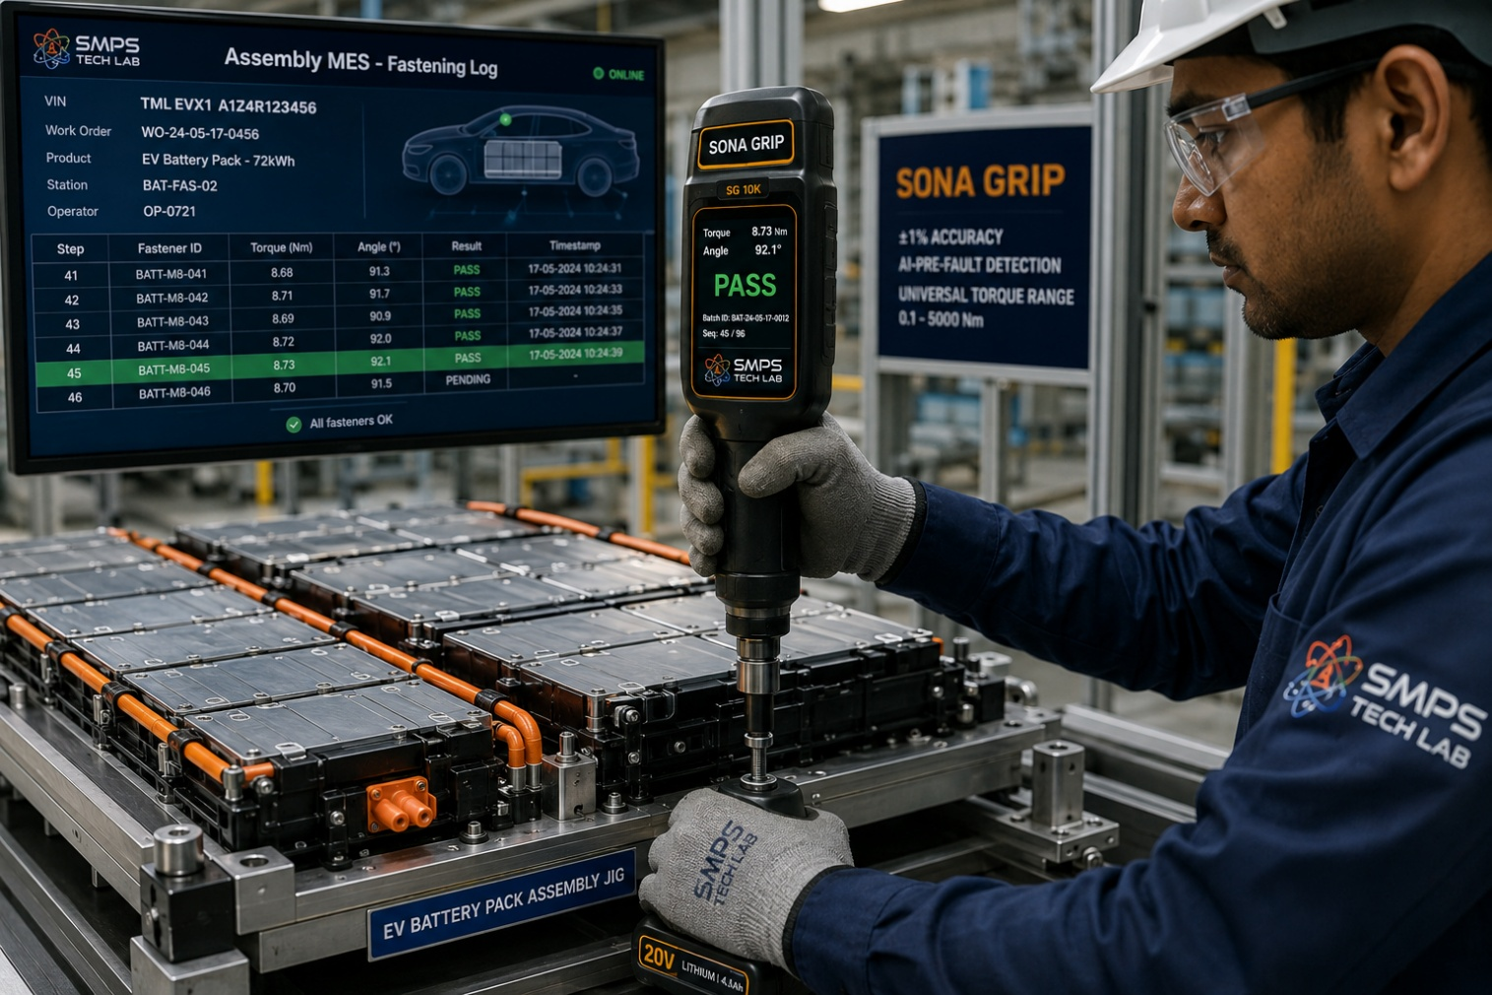
Figure CS1.1 — Sona Grip at an EV battery pack assembly station. The operator fastens cell module connectors at the required UN 38.3 torque-angle specification; each fastening operation is automatically logged with the battery pack serial number, operator ID, and tool calibration status in the OEM’s MES system. The AI cross-threading detection stops the drive within 5° of rotation if an anomalous torque signature is detected — preventing cell module damage before it occurs.

The Context
An Indian EV OEM scaling battery pack production from 30 to 72 packs per day at their Pune facility was using a combination of click torque wrenches (calibrated quarterly) and one imported Atlas Copco NutRunner (allocated to the highest-torque structural fasteners only) for their battery assembly line. Their quality team had identified 12 ppm defect escape rate at the battery fastening station attributable to three failure modes: occasional over-torque events from operator fatigue during end-of-shift production, cross-threaded fasteners not detected until electrical testing, and missing torque records when the paper log sheet was completed incorrectly or retroactively.

For UN 38.3 battery safety compliance and for their warranty and insurance documentation requirements, the OEM needed a fully documented digital fastening record for every cell module fastener. The imported Atlas Copco system was priced at approximately INR 85,000 per unit and would have required 12 units for full line coverage — a INR 10.2 lakh investment that the procurement team deferred due to budget constraints. Sona Grip’s combination of universal range (covering all torque specifications on the battery line from 5 Nm to 45 Nm in a single tool) and 40% lower price point made the full-line deployment commercially viable.

The Sona Grip EV Battery Assembly Solution
12 Sona Grip units were deployed across the battery pack assembly line, integrated via Wi-Fi to the OEM’s MES system (OPC-UA interface). The EV Battery variant’s torque-angle strategy was programmed with the cell module fastener specifications; the UN 38.3 battery safety compliance mode was activated, generating a structured fastening record for every operation automatically linked to the battery pack serial number. The AI pre-fault detection engine monitored every fastening operation in real time.
Month 1 results: 23 cross-thread detection events (operator alerted, rework performed before cell module damage). Zero over-torque events. Zero missing fastening records. Defect escape rate: 0 ppm at the fastening station. UN 38.3 compliance documentation: 100% complete from Day 1. The OEM’s quality manager reported that the shift from paper torque records to automatic MES-integrated digital records eliminated approximately 2 hours per shift of quality clerk time previously spent transcribing and filing torque log sheets.
MEASURED OUTCOME
The 23 cross-thread detections in the first month alone quantify Sona Grip’s ROI. Each cross-threaded EV battery cell module connector, if not detected, results in either a rework requiring battery pack disassembly (INR 15,000–25,000 in labour) or a field failure causing warranty replacement or recall. 23 prevented events at INR 15,000 each = INR 3.45 lakh in avoided rework cost in Month 1 alone — against a total Sona Grip deployment cost of approximately INR 6.4 lakh. Payback: under 2 months.

CASE  02 | HAL Tejas Assembly — Sona Grip Aerospace Torque Documentation  Hindustan Aeronautics Limited · Tejas Production, Bengaluru  Sector: Aerospace & Defence · Aircraft Airframe & Engine Torque Documentation  Key Outcome:

FASTENING OPERATIONS DOCUMENTED  1,200/aircraft  Critical fasteners per aircraft | PAPER TORQUE RECORDS ELIMINATED  100%  All replaced by digital MES records | CALIBRATION MANAGEMENT  Auto-quarantine  Tool locked if calibration overdue | DGCA AUDIT OUTCOME  Zero NCs  Fastening documentation section

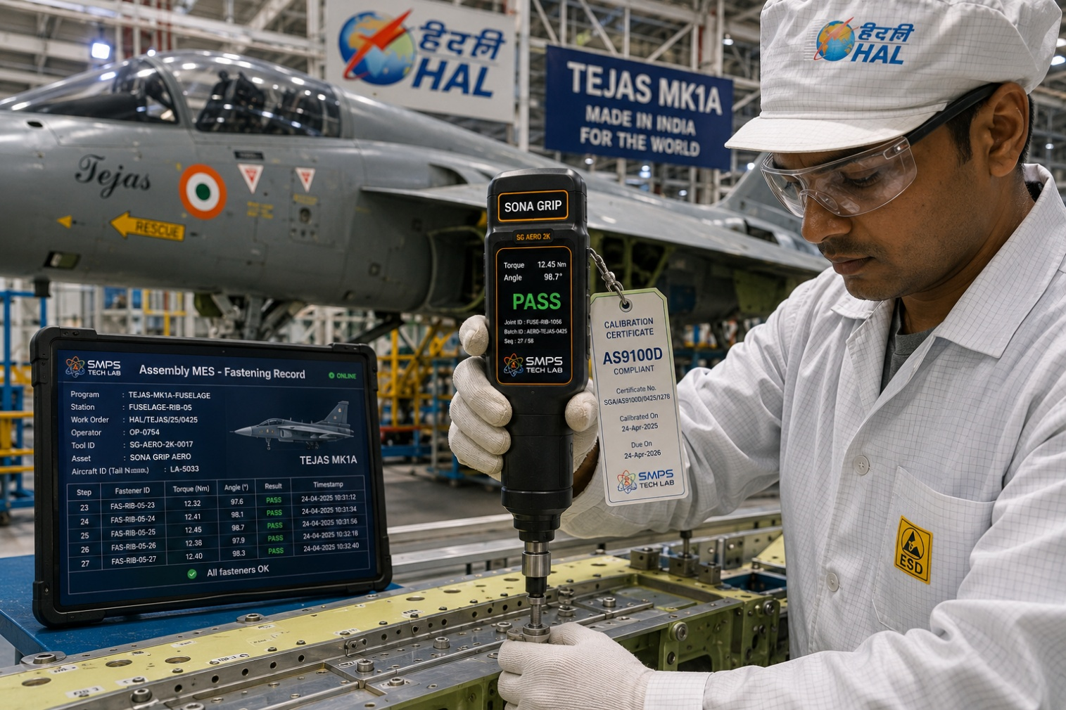
Figure CS2.1 — Sona Grip aerospace variant at HAL’s Tejas production facility, Bengaluru. Every critical fastener — airframe, engine bay, hydraulic system, control surface mounting — generates an automatic encrypted digital record in HAL’s MES system, with the technician’s badge-scanned electronic signature, the tool’s current calibration status, and the torque and angle values. This is the DGCA Certificate of Release to Service fastening documentation that previously required manual paper records.

The Context
HAL’s Tejas Light Combat Aircraft production at Bengaluru requires approximately 1,200 documented torque fastening operations per aircraft for critical fasteners — airframe structural joints, engine bay mounting bolts, landing gear attachment, hydraulic line fittings, and avionics rack mounting. The DGCA’s AS9100D audit requirements mandate that each critical fastener tightening operation be documented with the technician’s identity, the torque specification, the actual torque applied, and the tool’s calibration status at time of use. Prior to Sona Grip, this documentation was maintained through a combination of hand-completed paper torque records (stamped with the technician’s personal stamp after each operation) and periodic digital entry into the aircraft’s Technical Log system. The manual process generated recurring DGCA audit findings related to illegible records, missing entries, and calibration status not verifiable at point of use.

The Sona Grip Aerospace Documentation Solution
Sona Grip’s aerospace variant with AS9100D calibration management was deployed at HAL’s Tejas assembly stations. Each technician logs in via badge scan at the beginning of the shift; the tool’s calibration status is verified against the calibration management database automatically before the first operation; if the tool’s calibration is overdue, it is automatically quarantined and a replacement tool is flagged. Every fastening operation generates an encrypted record transmitted via Bluetooth to the aircraft’s Technical Log system: technician ID, torque value, angle, date/time, tool ID, and calibration certificate serial number. The record is digitally signed by the technician’s biometric profile via the tool’s fingerprint reader.
DGCA audit outcome: zero non-conformances in the fastening documentation section for the first time in three audit cycles. Paper torque records: eliminated entirely across the Tejas line. Calibration events missed by tools in service: zero (automatic quarantine before use if calibration overdue). HAL’s quality manager estimated that the elimination of paper torque record filing reduced quality administration workload by approximately 3 hours per aircraft build, equivalent to INR 12–15 lakh in annual quality clerk time across the Tejas production schedule.

CASE  03 | PLI Smart Factory — Sona Grip Industry 4.0 Fastening Documentation  Auto Component Tier 1 Manufacturer · PLI Recipient, Pune Industrial Corridor  Sector: Industrial Manufacturing · Smart Factory MES-Integrated Torque Station  Key Outcome:

FASTENING STATIONS  18 stations  Across 3 assembly lines | SPC Cpk IMPROVEMENT  0.92 → 1.68  Process capability index | PLI AUDIT EVIDENCE  Digital trace  Every fastening = I4.0 compliance record | CUSTOMER AUDIT OUTCOME  Tier 1 approved  Bosch India supplier audit passed

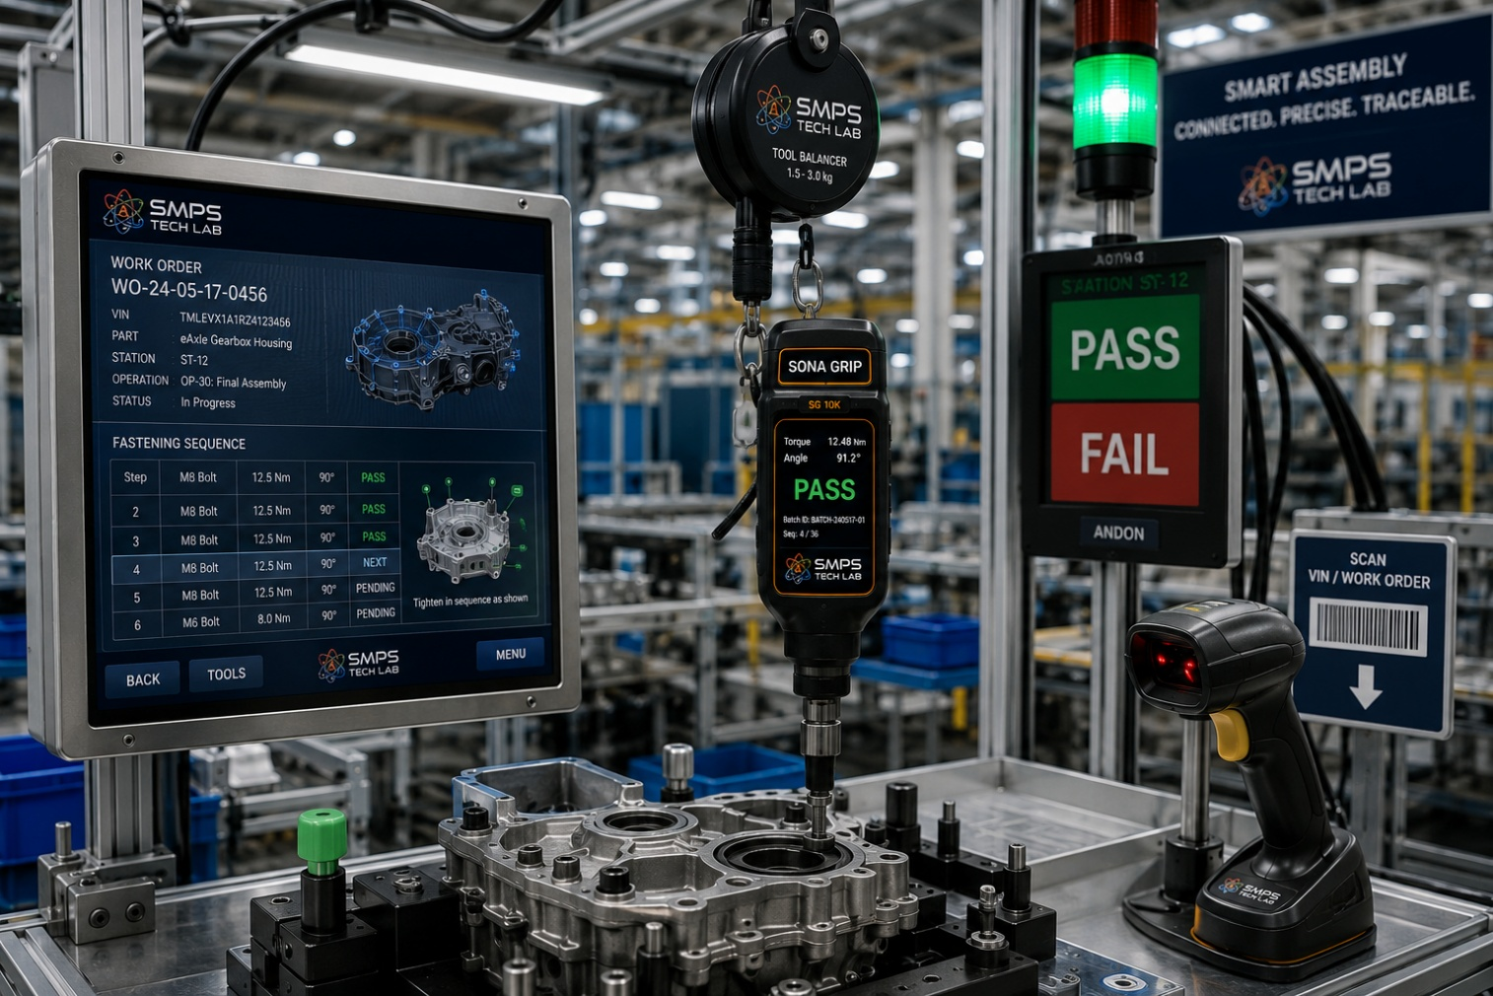
Figure CS3.1 — Sona Grip smart factory assembly station, Pune. The MES work order arrives at the station (left screen), the operator scans the component barcode to associate the fastening record, Sona Grip guides the operator through the fastening sequence, and every result is automatically logged. If any fastening is out-of-specification, the station’s green light does not illuminate and the component cannot advance to the next station.

The Context
A PLI scheme recipient Tier 1 automotive component manufacturer in Pune supplying to Bosch India and KPIT was under both PLI compliance pressure and Bosch supplier audit pressure to demonstrate documented Industry 4.0 quality practices. Their existing assembly process used click torque wrenches with manual paper log sheets — compliant with ISO 9001 technically but below the digital documentation standard that Bosch’s supplier quality audit required for supplier qualification upgrade from Tier 2 to Tier 1 status. The factory’s Cpk for their critical torque fastening process (measured during the Bosch audit) was 0.92 — below the Cpk ≥ 1.33 minimum required for Tier 1 supplier qualification.

The Sona Grip PLI Industry 4.0 Solution
18 Sona Grip units were deployed across 3 assembly lines, integrated via OPC-UA to the plant’s Siemens Opcenter MES. Work-order-driven torque specification download eliminated manual parameter entry errors. The SPC data stream from 18 stations provided the production quality team with real-time Cp/Cpk per fastening batch — enabling immediate corrective action before a batch of non-conforming components was built. The sequence enforcement feature (component cannot advance to next station until all fasteners are confirmed in-specification) eliminated the ‘green light but missing torque’ failure mode.
Cpk improvement at the critical torque station: 0.92 to 1.68 in 3 months — above the Bosch Tier 1 minimum. Bosch supplier audit result: Tier 1 supplier status approved, unlocking INR 4.2 crore per year in incremental contract value. PLI audit evidence: 18 MES-integrated torque stations documented as Industry 4.0 compliance evidence. Annual PLI disbursement unlocked through Industry 4.0 documentation: INR 8.5 crore.

CASE  04 | Wind Turbine Commissioning — Sona Grip Flange Bolting Documentation  Wind Farm EPC Contractor · 150 MW Wind Farm, Rajasthan  Sector: Renewable Energy · Wind Turbine Flange & Foundation Bolting Documentation  Key Outcome:

STRUCTURAL BOLTS DOCUMENTED  225,000 bolts  150 turbines × 1,500 bolts each | COMMISSIONING RECORD  100% GPS-tagged  Every bolt location traceable | THREE-PASS COMPLIANCE  ISO 16047 certified  Turbine OEM warranty requirement met | PAPERWORK ELIMINATION  3,600 pages  Per turbine manual bolt record replaced

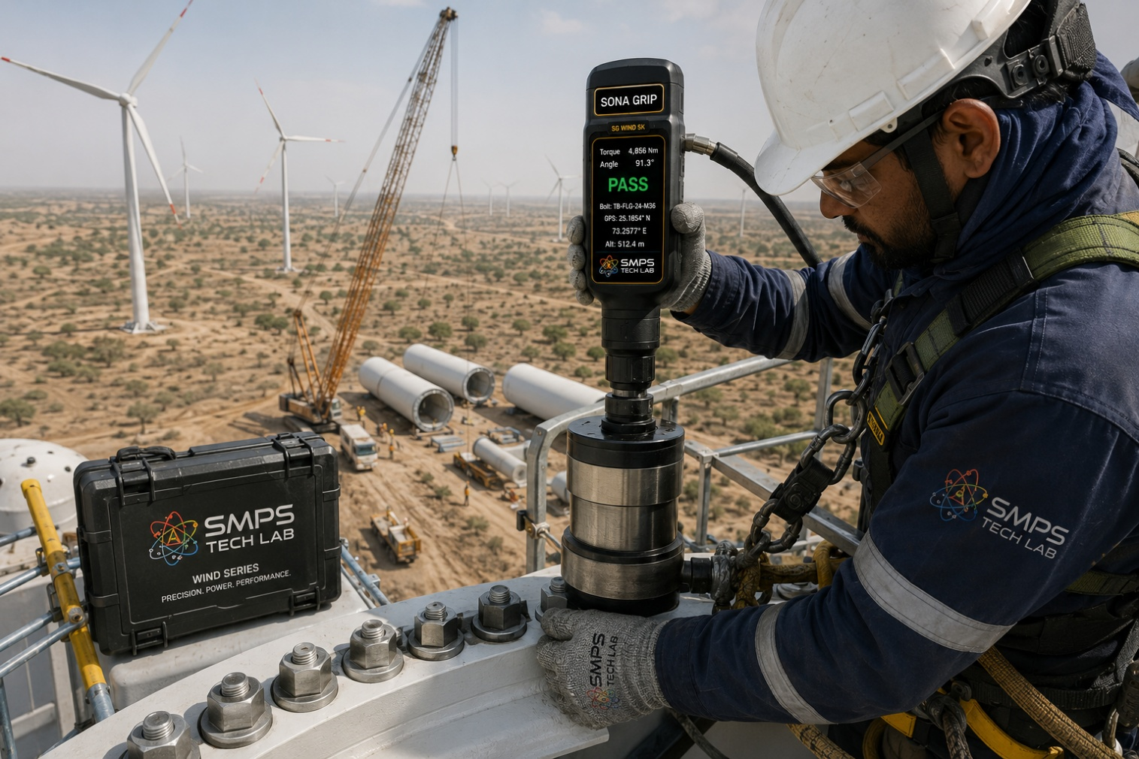
Figure CS4.1 — Sona Grip wind turbine variant at a Rajasthan wind farm tower section flange. Each of the 1,500 structural bolts is documented with GPS location, three-pass torque and angle values per ISO 16047, and turbine serial number association. The complete commissioning record — all 225,000 bolts across 150 turbines — is uploaded to the turbine OEM’s commissioning database automatically via 4G connection, satisfying the structural certification requirement for turbine warranty activation.

The Context
A wind farm EPC contractor commissioned with installing 150 wind turbines (150 MW total) in Rajasthan for a major renewable energy developer was facing a commissioning documentation challenge: the turbine OEM’s warranty conditions required a complete three-pass bolt tightening record for all 1,500 structural bolts per turbine (225,000 bolts total) in a specific digital format for the commissioning database. The OEM’s requirement was explicit: manual torque wrenches without calibrated digital output did not satisfy the warranty documentation requirement. The contractor’s previous approach — hired hydraulic torque wrench operators recording torque values on paper and manually entering them into spreadsheets — had resulted in warranty disputes on two previous projects where documentation gaps led the turbine OEM to decline warranty claims for early-life gearbox failures.

The Sona Grip Wind Turbine Documentation Solution
Sona Grip wind turbine variants (high-torque, outdoor IP67, GPS-enabled) were deployed for the entire 150-turbine commissioning campaign. The three-pass tightening protocol (snug, 50% target, 100% target per ISO 16047) was programmed into the tool’s commissioning mode; each pass was automatically logged with the bolt position reference (scanned from the flange marking), GPS coordinates, torque and angle values, and the commissioning technician’s identity. The tool’s 4G module uploaded each bolt’s record to the contractor’s cloud commissioning database in real time, which auto-populated the turbine OEM’s commissioning portal format.
225,000 bolts documented across 150 turbines. Zero documentation gaps. Turbine OEM commissioning acceptance: 100% — no documentation disputes. Manual data entry eliminated: 3,600 pages of paper bolt records per turbine replaced by automatic digital records. EPC contractor’s commissioning documentation labour: reduced by approximately 60% compared to the previous paper-based approach. The renewable energy developer accepted the Sona Grip digital commissioning record as the structural certification evidence for the wind farm’s civil insurance policy.

CASE  05 | From Gold Standard Ambition to Universal Platform — The Development Arc of Sona Grip  SMPS Tech Lab · Internal IP Development Programme, 2025–2026  Sector: IP Development · Universal Torque Control Architecture  Key Outcome:

DEVELOPMENT ORIGIN  2025 Q1  EV battery assembly quality gap identified | KEY INSIGHT  Universal = one platform, all applications  Fragmented tool inventory is the customer’s pain | ENGINEERING CHALLENGES  3 resolved  Universal head / AI cross-threading / MES integration | IP FILED  2026  Universal head system + AI torque control patent

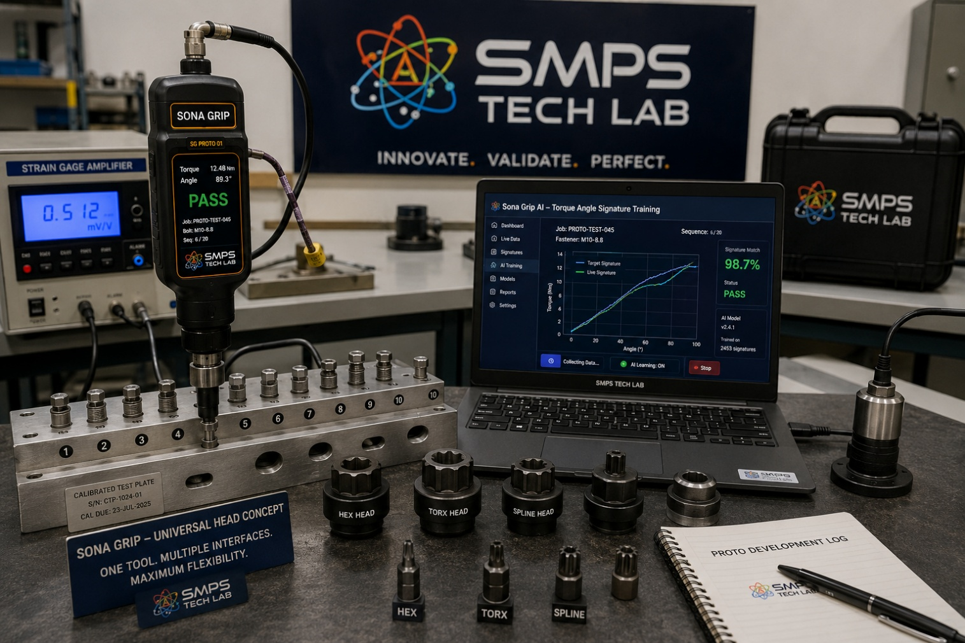
Figure CS5.1 — Sona Grip prototype development at SMPS Tech Lab. The calibration test plate (foreground) provides NPL-traceable reference torque values for AI model training across the complete torque range. The multiple head types (right) demonstrate the universal head system prototype — the same Sona Grip controller driving hex, TORX, and spline fasteners with automatic spec download for each head change.

The Customer Pain That Defined Sona Grip
Sona Grip’s development began with a quality audit observation during an SMPS Tech Lab field engagement at a Pune-based auto components manufacturer in early 2025. The facility’s tool crib — the room where precision tools are stored, calibrated, and issued to assembly operators — contained 47 different torque tools: 12 click torque wrenches (calibrated annually, various ranges), 8 torque screwdrivers, 3 digital torque wrenches, 2 imported Atlas Copco NutRunners (the plant’s most expensive tools, used only for the highest-criticality assembly station), and 22 assorted manual wrenches. The tool controller reported that they spent approximately 3 full working days per month managing tool calibration scheduling, recall notifications, and replacement tool sourcing when tools went out-of-calibration or were damaged. Each calibration event required sending the tool to an external NABL lab, a 2-week turnaround, and a cost of INR 2,500–8,000 per tool.

The conversation that defined Sona Grip: "What would it take for you to replace all 47 of those tools with one?" The tool controller’s answer was immediate and precise: "It would need to cover all our torque ranges, have the accuracy of the Atlas Copco, cost less than the imported digital tools, have one calibration certificate instead of 47, and connect to our SAP system automatically." That specification became the Sona Grip product brief, and the development programme that followed was an engineering exercise in making every element of that specification simultaneously achievable.

Three Engineering Challenges
Challenge 1 was the universal head system. Achieving ±1% torque accuracy requires that the torque sensor measure the torque applied to the fastener — not the torque at the drive shaft — because friction losses in the head adapter reduce the torque transmitted to the fastener by an unpredictable amount. The solution was a reaction torque sensor architecture: the strain gauge measures torque at the fastener-side of the head interface, after all friction losses, in real time during the tightening operation. Each head is characterised individually (friction coefficient, stiffness, inertia) during the factory calibration of the Sona Grip-head pair — and the AI model applies the head-specific compensation function to maintain ±1% accuracy at the fastener regardless of which head is in use. The RFID chip in each head carries the head’s calibration data, which is read automatically when the head is attached.

Challenge 2 was cross-threading detection at 0.1–10 Nm micro-torque for electronics assembly. At low torques, the signal-to-noise ratio of the torque sensor is challenging: a 0.1 Nm cross-thread signature is 10–20 millinewton-metres above the nominal tightening curve — a difference that a strain gauge bridge circuit must resolve reliably in the presence of electrical noise from the battery-powered motor drive. The solution was a differential sampling architecture with a 24-bit ADC and a digital low-pass filter tuned to the torque-angle signature frequency content of M1.6–M8 fasteners — achieving the signal-to-noise ratio required for reliable cross-threading detection at the lowest torque range of Sona Grip’s universal specification.

Challenge 3 was MES integration across the heterogeneous set of MES platforms found in Indian manufacturing: SAP ME, Siemens Opcenter, Oracle MES, custom-built MES, and paper-based quality systems at smaller facilities. A proprietary MES integration requiring custom programming at each customer site would make Sona Grip’s fastest-to-revenue advantage — the industrial sector — into the slowest, because every new customer would require a custom integration project. The solution was a universal MES integration layer: a configurable OPC-UA server running in the Sona Grip docking station that maps any MES’s work order and fastening data schema to Sona Grip’s internal data model through a no-code configuration tool. Any MES that supports OPC-UA client can receive Sona Grip fastening data without custom programming. Non-OPC-UA systems receive data through a REST API endpoint. Configuration time for a new MES integration: 4–8 hours, not 4–8 weeks.

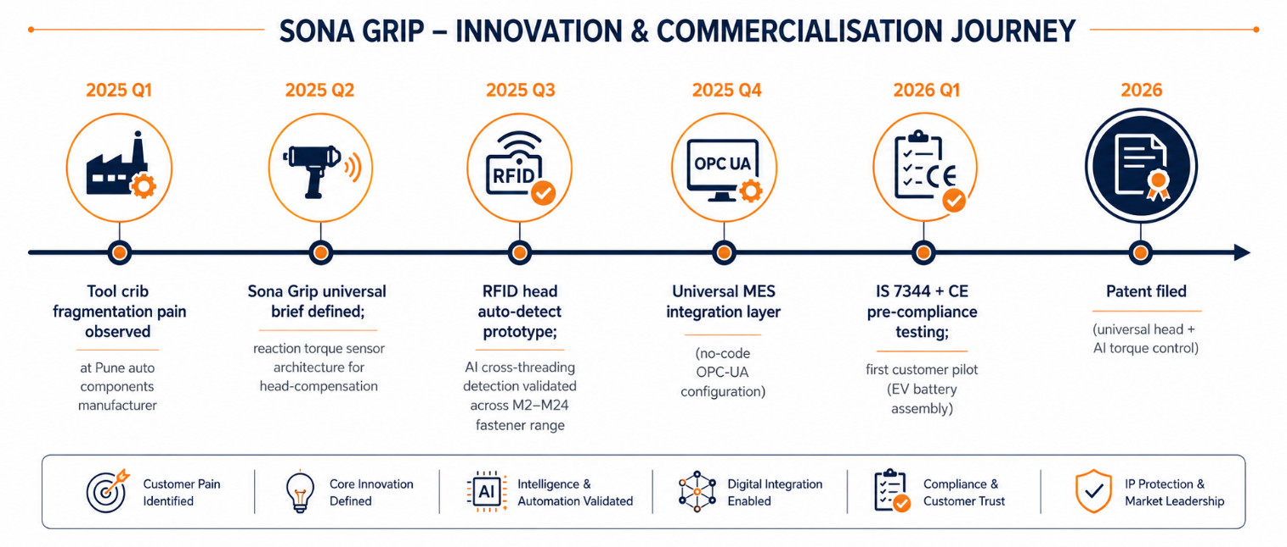
Figure CS5.2 — Sona Grip development timeline. The reaction torque sensor breakthrough in Q2 2025 enabled ±1% accuracy across all head types from a single calibration certificate — making the "replace 47 tools with one" specification technically achievable.
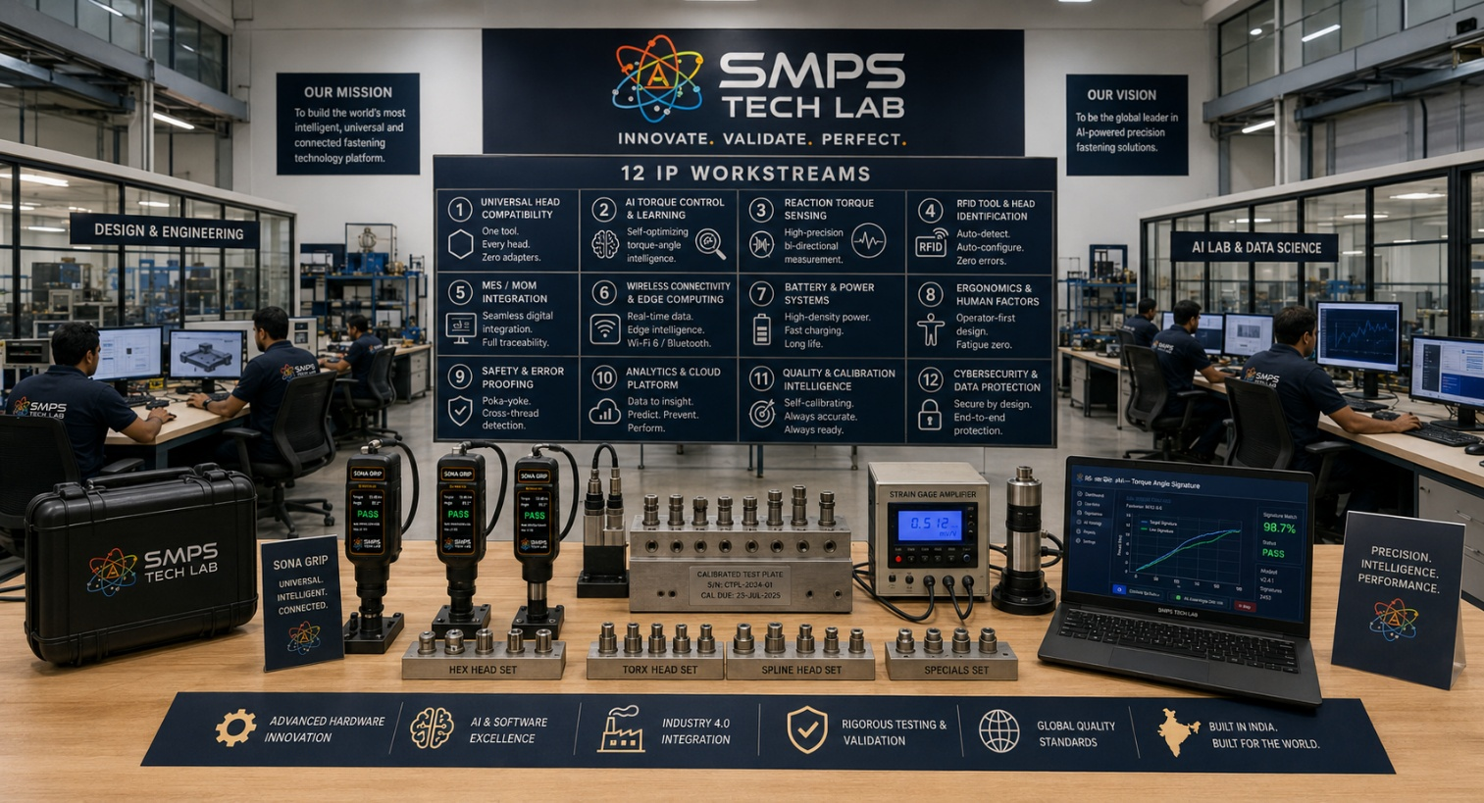
Figure CS5.3 — SMPS Tech Lab: the complete twelve-IP engineering environment. The Sona Grip precision assembly tool development and calibration infrastructure is available to co-development, licensing, and OEM supply partners.

CASE  06 | Build with SMPS Tech Lab — Be the Next Case Study  Open Invitation · Auto OEMs · Aerospace · Industrial Builders · Renewable EPC · Medical  Sector: All Precision Manufacturing Sectors · OEM Supply · Technology Licensing · Calibration Service  Key Outcome: Twelve IPs. USD 467.7 Billion TAM. 120 applications. This page is reserved for you.

THIS CASE STUDY IS RESERVED FOR YOU.
Sona Grip — the gold standard of precision assembly — is ready.
USD 26.4 billion addressable market. Patent filed. IS 7344 + CE certification underway.
SMPS Tech Lab invites you to assemble it — together.

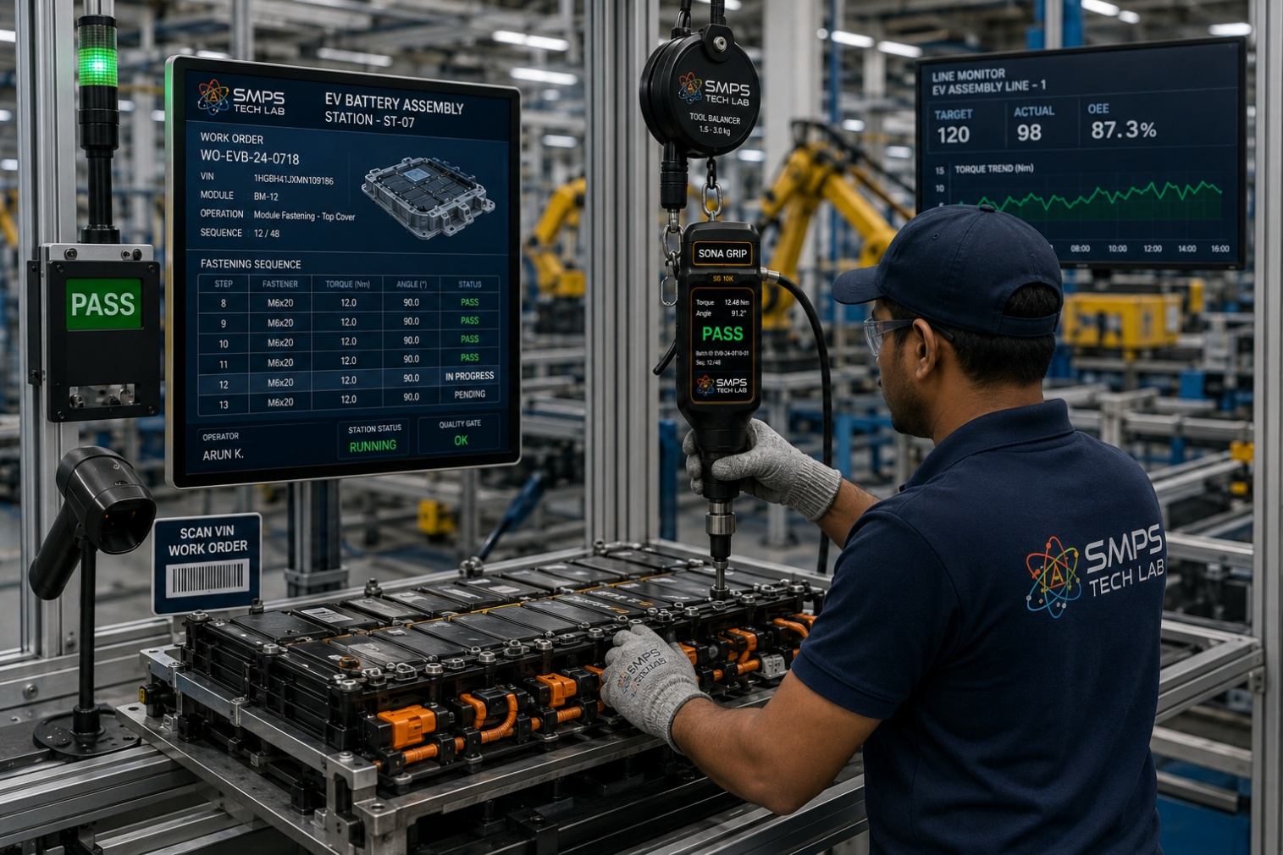
Figure CS6.1 — Reserved for your deployment. When you build with Sona Grip through SMPS Tech Lab, this case study carries your name.

Three Ways to Engage

Model A — Research Fellowship
Research fellows explore Sona Grip’s AI torque algorithms, new application variant development, calibration methodology, new sector certifications, or MES integration architecture. 3 to 12 months with lab and calibration equipment access, full documentation, and IP ownership framework.

Model B — OEM Tool Supply
Automotive OEMs, Tier 1 suppliers, aerospace manufacturers, industrial builders, and renewable energy EPC contractors deploying Sona Grip as their production or commissioning torque tool. IS 7344 + CE certified supply, NABL-traceable calibration service, MES integration support. Volume supply with annual calibration service subscription.

Model C — Technology Licensing
Full access to the Sona Grip universal head system patent, AI torque-angle control algorithm, reaction torque sensor architecture, and universal MES integration layer. Licensees manufacture and supply Sona Grip-based tools in their own market under their own brand. Per-unit royalty or fixed annual licence structures.

WHAT YOU BRING | WHAT SMPS TECH LAB PROVIDES
Precision manufacturing domain expertise and customer access | Universal head system patent, AI torque control algorithm, reaction torque sensor architecture
Manufacturing capability and distribution reach | IS 7344 + CE + ISO 5393 certification documentation and support
OEM relationships in automotive, aerospace, or industrial | NABL-traceable calibration service infrastructure, MES integration no-code layer
Market presence in target sector | All twelve SIPAIR briefs; USD 467.7B portfolio; Sona Grip gold standard positioning

SMPS TECH LAB
Engineering Intelligent Power
IP-01 through IP-12 — Twelve IPs · USD 467.7 Billion TAM · Sixty Sectors · One Hundred and Twenty Applications
From Power Conversion to Precision Assembly — The Complete Intelligent Manufacturing Stack
partnerships@smpstechlab.com
www.smpstechlab.com · IP Commercialisation Division
The next case study in this document could carry your name.

END OF SIPAIR IP-12 — SONA GRIP — UNIVERSAL TORQUE CONTROLLED DEVICE
SMPS Tech Lab · Engineering Intelligent Power · March 2026
CONFIDENTIAL & PROPRIETARY · For Authorised Recipients Only

