**SDM – software development model**

**AGILE**

**Agile tell us how to do not what to do.**

Agile have Values 4 and principles 12

Values

1. Individuals and interactions (people and their collaboration) – це то шо тіпа люди топ і над взяємодіяти з людьми
2. Working software more important than thorough documentation
3. Customer Collaboration
4. Quiclkly Responding to change

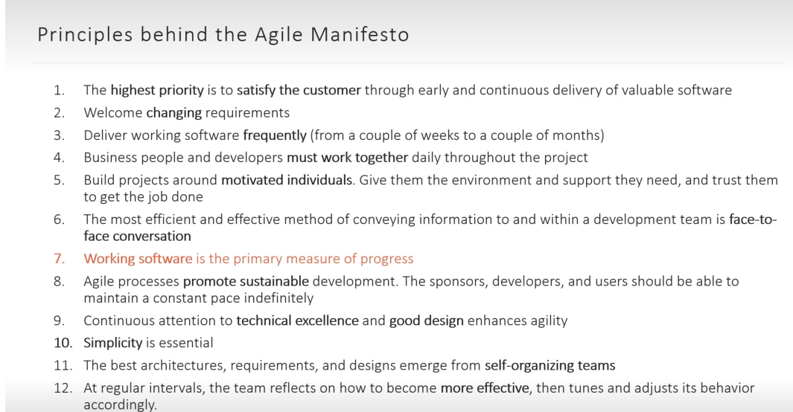

SCRUM – побудований на Agile metodologi

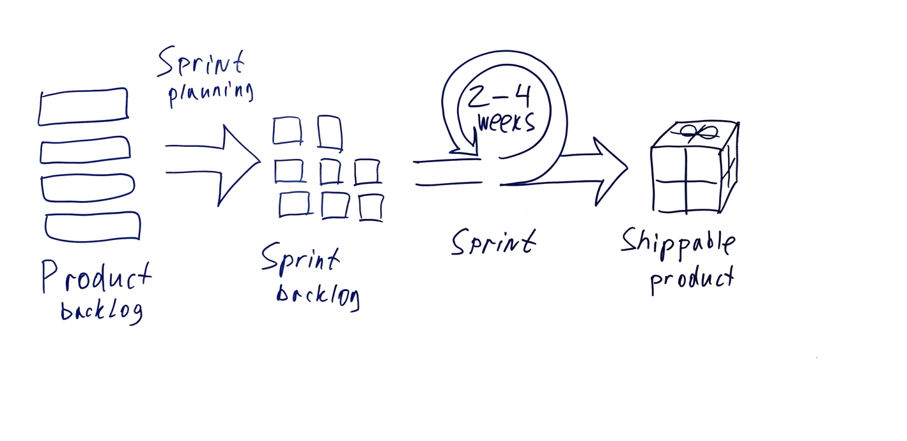

Scrum roles – product owner, scrum master, delelop team.

Test-driven development

Cспочатку робимо тест – потім робимо код через який пройде цей тест.

Behavipir-driven development

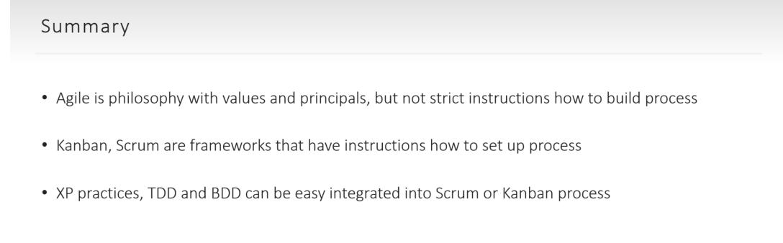

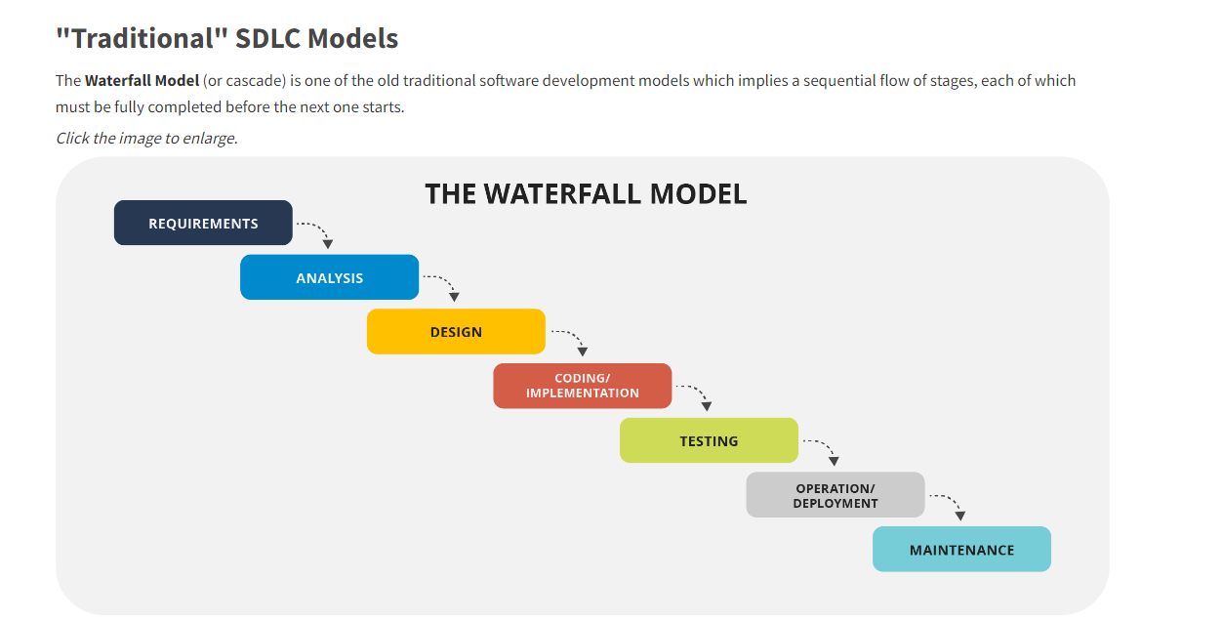

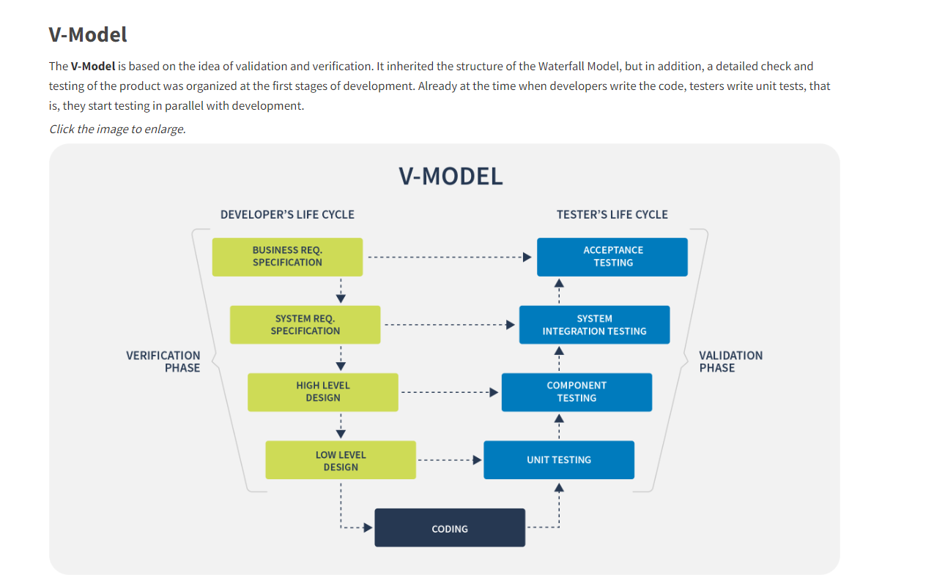

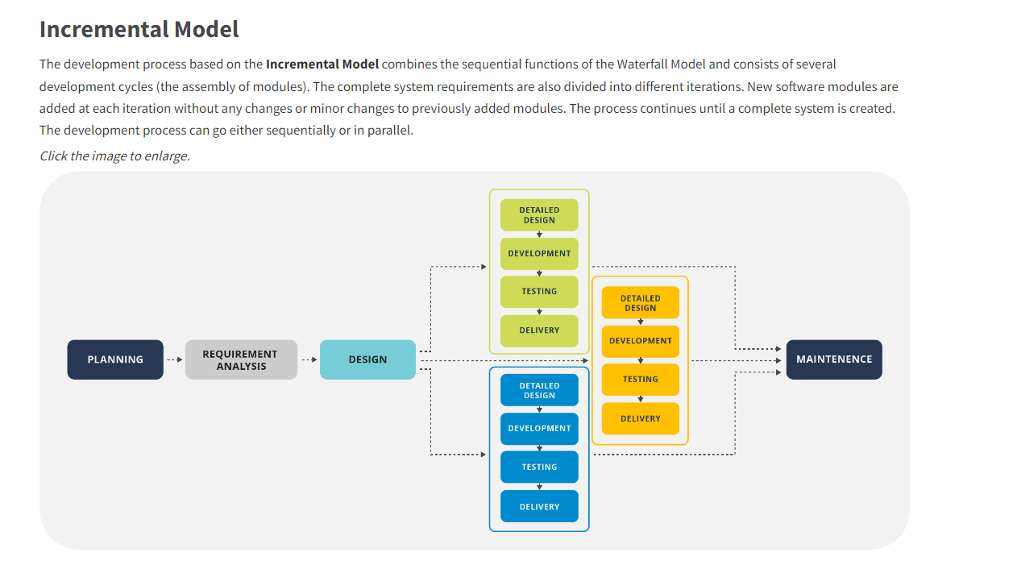

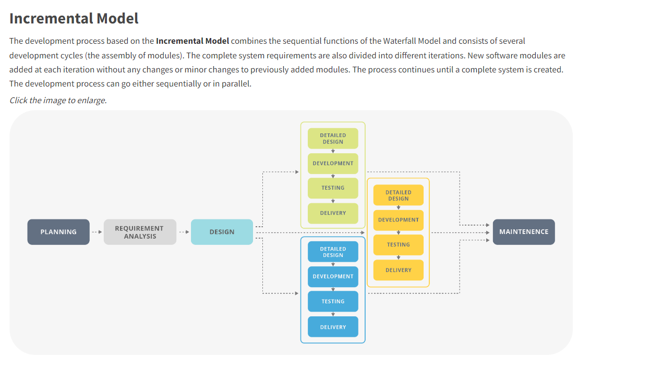

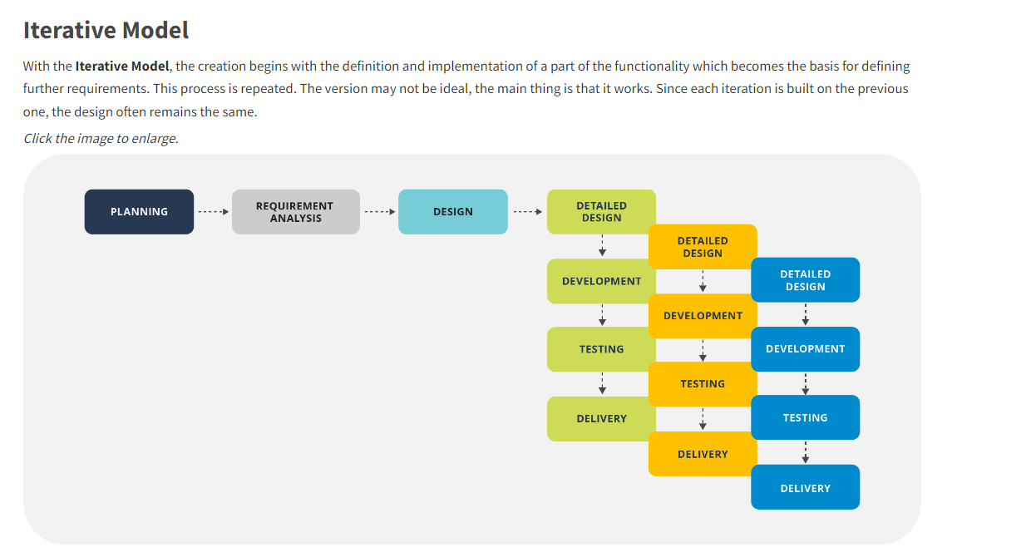

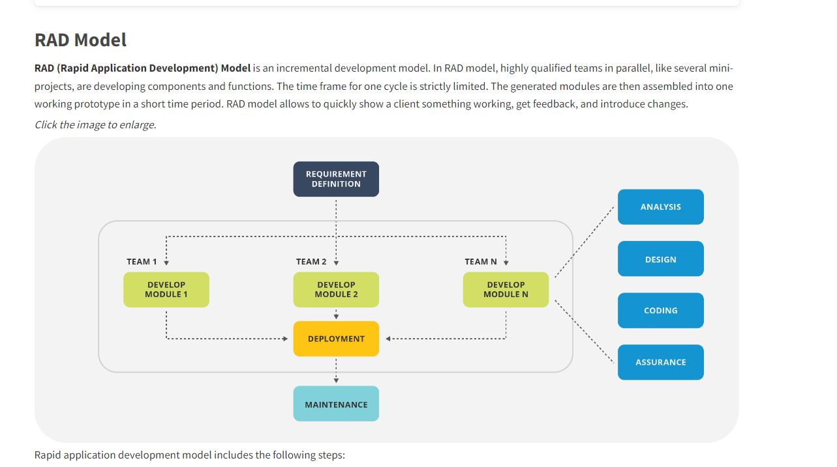

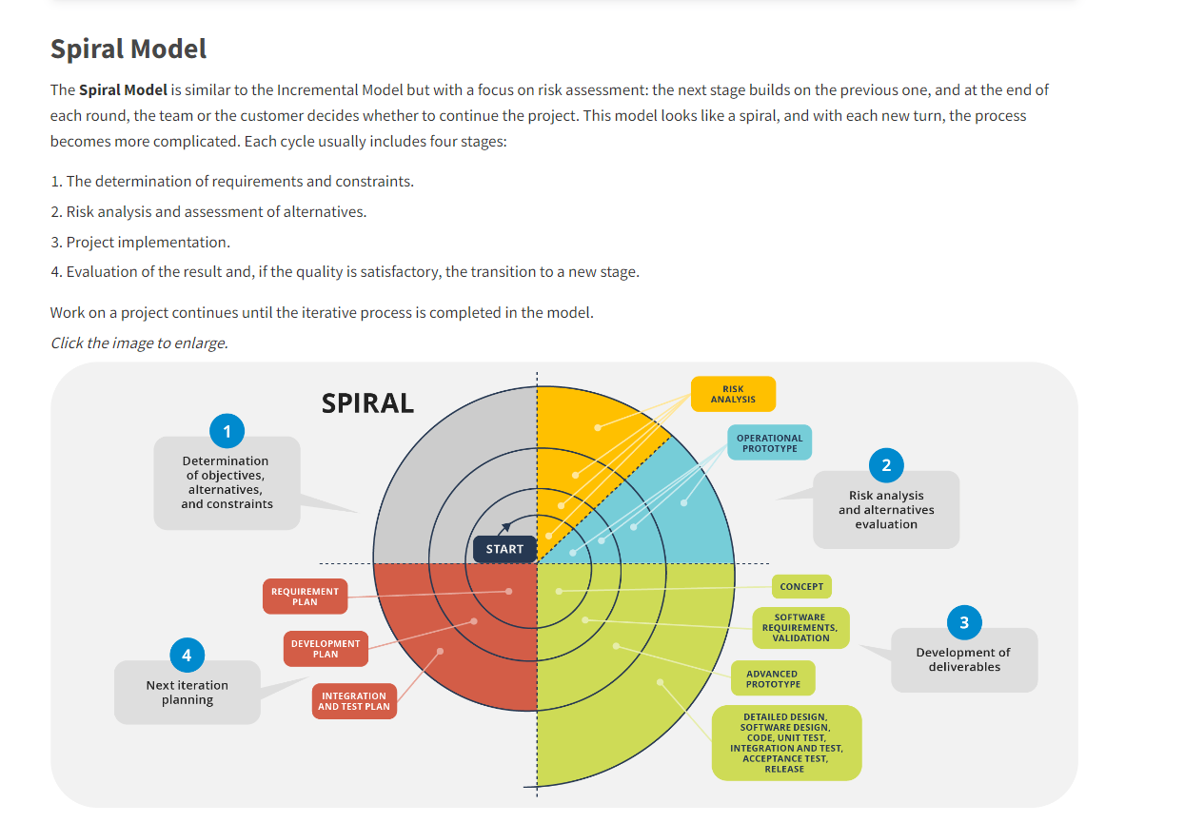

**s**