Apache GitHub Activity Analytics with PySpark
Final Project Report
Student | Sai Mani Raj Chanda (008735877)
Course | CSE 6320 - BIG DATA MANAGEMENT
Professor / Date | Dr. Said Ngobi | 15/05/2026
This project implements an end-to-end ELT pipeline for Apache GitHub data using Python, Databricks, PySpark, and Spark SQL. Raw JSON data is loaded into Bronze, standardized in Silver, and aggregated in Gold for repository activity, language distribution, contributor behavior, and popularity analysis.
The scope was intentionally controlled to keep the work practical. Repository metadata was collected for 200 active Apache repositories, while commit and contributor analysis focused on Airflow, Spark, Iceberg, Kafka, and Flink over a 30-day window. This satisfies the course requirement for ingestion, storage, transformation, querying, and meaningful outputs without making the workload too large for Databricks Free Edition.
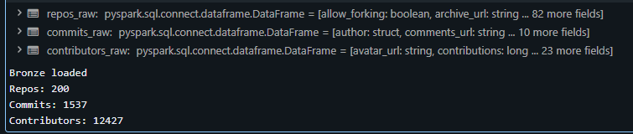
Figure 1. Bronze-layer ingestion summary for repositories, commits, and contributor snapshots.

Architecture and Processing
A Bronze-Silver-Gold lakehouse structure was used because GitHub API responses are semi-structured JSON. ELT is the better fit: raw data can be landed first without flattening, then parsed and typed in Spark where joins and aggregations scale better. The Silver layer cleans timestamps and identifiers, removes duplicate commits, and joins repository context into the commit and contributor datasets.

Results
The final activity results show that Airflow was the most active repository in the 30-day deep-dive with 776 commits, followed by Spark with 335. Iceberg, Kafka, and Flink showed smaller but still meaningful development activity. This confirms that the pipeline is capturing current repository behavior rather than only static project metadata.
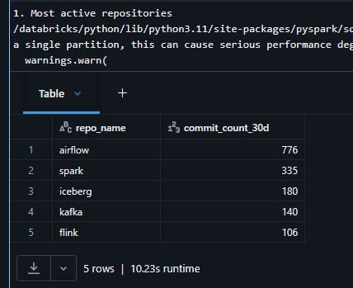
Figure 2. Most active deep-dive repositories by 30-day commit volume.
Across the 200-repository metadata slice, Java dominated with 95 repositories. HTML and Python followed at much lower counts, which reflects the strong Java presence in the Apache ecosystem. Contributor snapshot counts were also highest for Airflow and Spark, aligning with their recent activity levels.
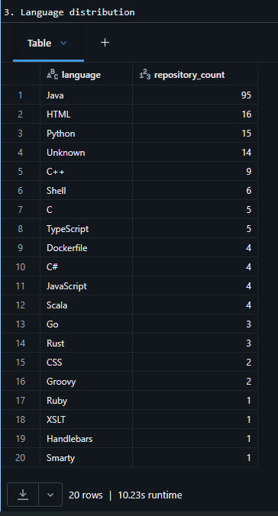
Figure 3. Language distribution across the selected Apache repository metadata set.
The advanced analytical component studied contributor behavior over time using Spark window functions. Each contributor's first active week was identified, contributors were classified as new or returning, and per-repository contribution ranks were computed. This adds a stronger analytical layer than simple counts because it shows how work is distributed across contributors over time.
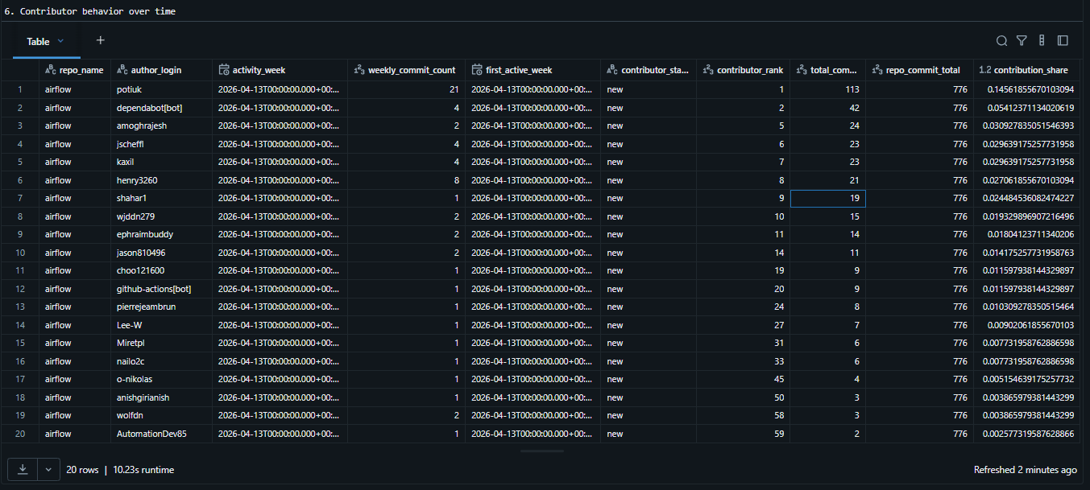
Figure 4. Contributor behavior over time using weekly activity and repository ranking windows.

Validation, Tradeoffs, and Conclusion
The final run produced 200 repositories, 1,537 commits, and 12,099 contributor rows after Silver-layer cleanup. Validation checks confirmed zero duplicate commits and zero null commit timestamps, which indicates that the main transformation logic behaved correctly. The Gold layer also produced weekly and monthly trends, contributor counts, and popularity-versus-activity comparisons in addition to the outputs shown in this report.
A key tradeoff is that commit-history analysis was limited to five repositories instead of the entire Apache organization. This keeps the project manageable in Databricks Free Edition while still demonstrating real data engineering work with API ingestion, JSON handling, joins, and time-based Spark analysis.
Overall, the project meets the course objective of building a simplified but realistic end-to-end big data pipeline. It demonstrates practical ingestion from a real source, structured transformation in Spark, and interpretable analytical outputs that connect repository popularity, activity, and contributor behavior.

