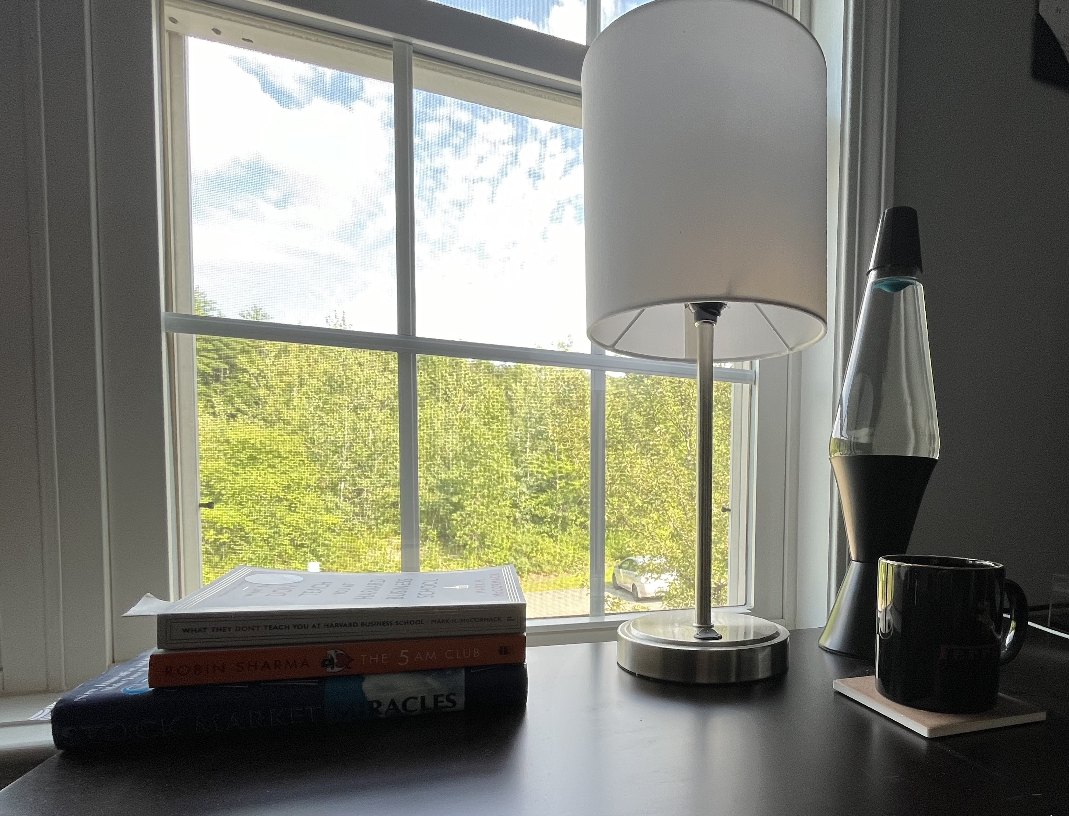

For this project I selected my four objects as a stack of books, a lamp, a lava lamp, and a cup on a coaster. Although I did not do it intentionally three of the the objects are made from the same object just in different orientations: the stack of books is just different boxes, the lamp is different sized cylinders, and the lava lamp is different sized tapered cylinders with one being flipped upside down. The coaster and cup was my complex object as it required a box for the coaster, cylinder for the mug, and a torus for the handle. As the scene backs up against my window I used that as a light source, projecting from the back left of the scene. To meet the project requirements I added a second light coming from the lamp and made it a red color. I changed the color of the table to a brighter wood color since I had quite a few darker materials between the cup, lava lamp, and books so I thought it would brighten the scene better.

When navigating the scene the you can the WASD keys to move forward, left, backward, and right like in most computer based controls. You can also use the Q key to move the camera upward and the E key to move downward. The movement of the mouse is what controls the orientation of the camera, and all movement is based on this orientation so if the camera angle is face up and you press W to move forward the camera will move upward as well. I set the initial camera view so that the entire scene can be seen when the program is first run, and the scroll on the mouse will change the speed to your computers speed. In the reading it had the multiple of the computers frame rate a 2.5, I found this would make my computer grind to a halt, so I set it to 100 as this was still slower but much more usable. Unfortunately I tried to make it so you could flip between orthographic and perspective views by pressing R but I could not get that functionality to work. My attempt is in the in the same keyboardInput function which has the camera movement controls, but pressing R does not change the view.

When writing my code I made sure to comment what specific lines or groups of lines did. For example I made sure to comment where each of objects were rendered, so that it was easy to find each one. Also certain materials were similar so I was able to reuse certain them across different objects, like using the metal material shader for the steel of the lamp as well as the black metal of the cup and lava lamp.