UNIT 1:

INTRODUCTION TO COMPUTER SYSTEMS

José Gaspar Sánchez García.

Index:
1. Computer Architecture. 4
1.1. The Turing Machine. 5
1.2. Hardvard Architecture 7
1.3. Von Neumann's Architecture 8
1.3.1. Boolean Algebra. 9
1.3.2. Logic Gates 11
1.3.3. Analysis and synthesis of digital circuits 11
2. Introduction to information systems 12
2.1. Computer Science and Information Systems 12
2.2. Classification of computer systems 15
2.2.1. Computer systems according to their use 15
2.2.2. Computer systems according to their performance 15
2.3. Computers History 18
2.4. Computers Generations. 23
2.4.1. 1st Generation (1940-1956): Vacuum Valves 23
2.4.2. 2nd Generation (1956-1963): Transistor 25
2.4.3. 3rd Generation (1964-1971): integrated circuit (Chip) 26
2.4.4. 4th Generation (1971-1981): Microprocessor - Scale Integration LSI 27
2.4.5. 5th Generation (1982-1991): VLSI Integration Scale 27
2.4.6. 6th Generation (1992- present): Scale Integration ULSI and GLSI 28
3. Representation of information. 28
3.1. Convert binary values to decimal. 29
3.2. Binary to decimal with decimals. 29
3.3. Convert decimal values to binary. 29
3.4. Decimal to binary with decimals. 30
3.5. Octal number system. 31
3.6. Convert octal values to decimal. 31
3.7. Convert decimal values to octal. 31
3.8. Hexadecimal number system. 32
It is clear that the change from hexadecimal to binary is just as simple. 32
4. Convertir valores de hexadecimal a decimal 33
5. Hardware de un ordenador. Componentes físicos. 33
6. Periféricos. Adaptadores para la conexión de dispositivos. 33
7. Proceso de puesta en marcha. Chequeo y diagnóstico. Resolución de averías. 34
8. Herramientas de monitorización. 34
9. Normas de seguridad y prevención de riesgos laborales. 34
10. Components of a computer system. Hardware. Software. 34
11. Computer hardware. Physical components. 34
12. Peripherals. Adapters for connecting devices. 34
13. Start-up process. Checkup and diagnosis. Troubleshooting. 34
14. Monitoring tools. 34
15. Occupational risk prevention and safety regulations. 34

Computer Architecture.
A computer is a machine or device that performs processes, calculations and operations based on instructions provided by a software or hardware program. It has the ability to accept data (input), process it, and then produce outputs.
Computers can also store data for later uses in appropriate storage devices, and retrieve whenever it is necessary.
Modern computers are electronic devices used for a variety of purposes ranging from browsing the web, writing documents, editing videos, creating applications, playing video games, etc.
They are designed to execute applications and provide a variety of solutions by combining integrated hardware and software components.
A computer is an electronic machine that can store and arrange large amounts of information.
Therefore, we can say that it is a device with the following basic functions:
- Transmit information. The components of a computer that perform this task are called input/output (I/O) devices and have a dual mission: on the one hand, they communicate the computer with the outside and, on the other, they are responsible for encoding the input information in a format that the computer understands and the output information, in a format that is understood on the outside. Among them, we have keyboards, mice, monitors, etc.
- Store information. This function is performed in so-called storage devices, of which the computer has a great variety, depending on their nature and their specific purpose (RAM, hard disk, etc.).
- Process information. The main component that performs this function is the processor that, fundamentally, is responsible for reading from the RAM a series of instructions, encoded so that it can understand them, and execute them in a preset order.
A computer transforms the input data into an output containing the required information. Data are sets of symbols used to represent a numerical value, an object or an idea in the form suitable for processing. The representation of the data is made based on a certain code that gives it its meaning. Thus, for example, decimal digits are usually used to represent numbers, although many other codes or forms of representation will be studied.
Computer architecture is the conceptual design and fundamental operational structure of a computer system. That is, it is a model and functional description of the design requirements and implementations for various parts of a computer, with special interest in the way the central processing unit (CPU) works internally and accesses memory addresses.

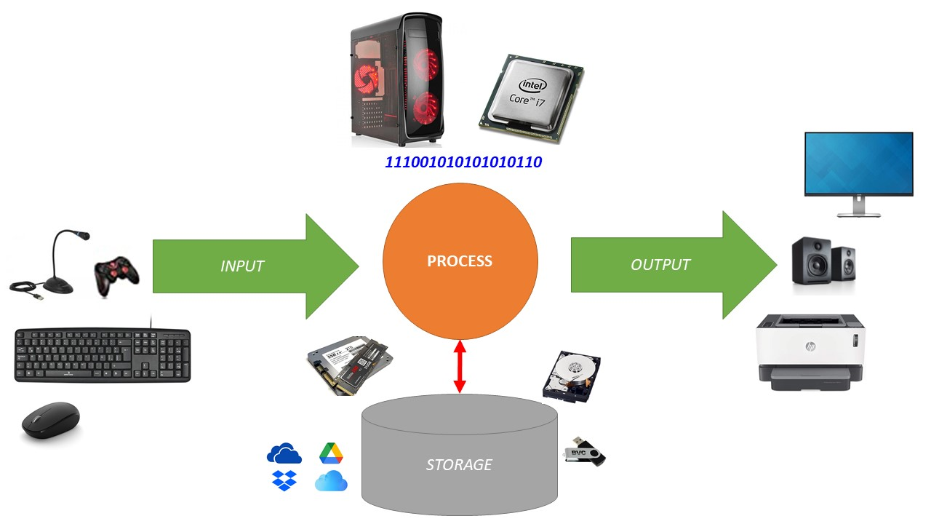
Figure 1. Schematic representation of the operation of a computer.

The Turing Machine.
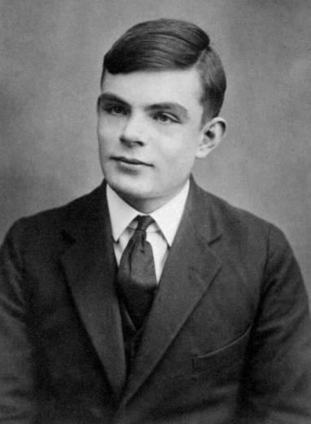
Alan Mathison Turing, English mathematician and scientist developed between 1935 reads 1945 a model a hypothetical computational model that allowed in theory to solve any mathematical problem as long as it is reduced to an algorithm.
Figure 2. Alan Turing - (King's College Cambridge, 2022) (Public Domain)
In this way it will be possible to calculate given functions from the simplest possible generations and even if it is a very complex algorithm, it will be possible to decompose it in a greater number of steps until it is solved.
This model that was originally called the Logical Computing Machine, but in honor of its inspector ended up being called the Turing machine, is considered the precursor of modern digital computing despite its simplicity. According to the Church-Turing thesis it is shown that a problem is computable if you can build a Turing machine capable of carrying out the procedure to solve it, and that any other alternative machine can create an equivalent Turing machine capable of solving any computational problem that is performed on the other machine. (Raya Cabrera, Raya González, & Zurdo, 2014).
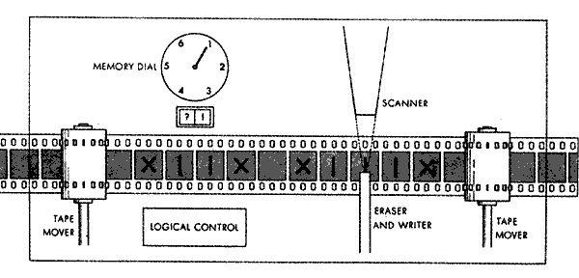
This photo by Unknown Author is licensed under CC BY-SA-NC
Figure 3. Turing Machine Schematic
The components of the Turing machine are:
- Memory: this is an infinite ribbon divided into square comma cells each of which has a symbol and a code (for example, a 1 or a 0, so the tape occupies a bil). This set of symbols or codes is what is known as the machine alphabet. This memory allows the storage of both the information entered and the output data to solve the algorithm or the intermediate steps that have been completed to solve the algorithm, which allows to track the entire process. Due to the multiple use that is given to the memory and the impossibility of knowing the number of intermediate steps that the machine will need, it forces that the size of the tape must be unlimited. It is precisely this detail of endless memory that attaches so much importance to the Turing machine.
- Read-write pitch: it is a device capable of performing four operations: move one position to the right with respect to the current cell, move one position to the left, read the contents of the cell in which it is located and write a symbol different from the one that has previously been read by the head or write again the one that was in the cell.
- Status log: which stores the state of the Turing machine, one of the finite states. There is a special initial state with which the status record starts. Turing writes that these states replace the "state of mind" that a person would ordinarily be performing calculations in.
- A table of instructions (occasionally called as an action table or transition function). It contains the actions that the machine performs at each instant of time. This last part of the processor is responsible for deciding what the new state will be, the symbol to be written on the tape and the direction that the head will take depending on the character that has just been read and the current internal state (that is, this part will contain the entire program that governs the operation of the machine).

Hardvard Architecture
It is characterized by having the data memory separated from the program memory and these in turn are attached to the CPU through independent buses (then they can have different contents in the same direction) and allows the CPU to simultaneously access the two memories.
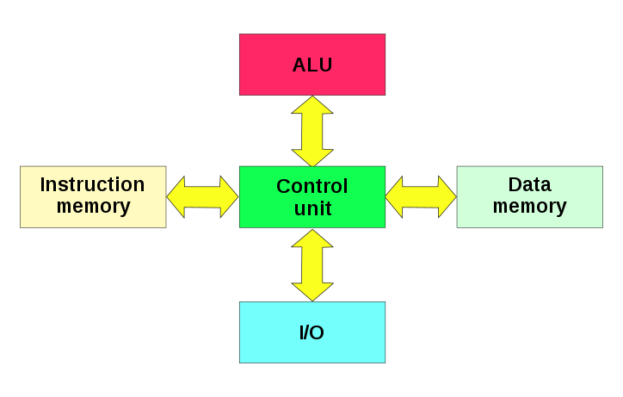
This photo by Unknown Author is licensed under CC BY-SA

Figure 4. Schematic representation of Hardvard architecture.
Therefore, it uses physically separate storage devices for instructions and for data as opposed to the von Neumann architecture.
Instructions and data are stored in separate caches to improve performance, but it has the drawback of having to split the cache amount between the two so it works best only when the reading frequency of the instructions and data is about the same.
The term comes from the Harvard Mark I. comma computer that stored instructions on perforated tapes and data on switches.
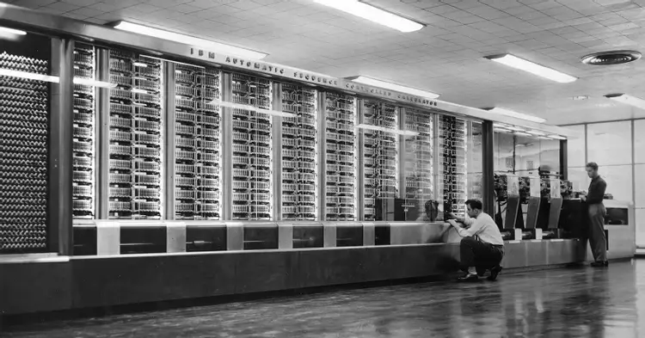
Figure 5. Harvard Mark I Computer
This architecture is commonly used in digital signal processors, commonly used in products for audio and video processing. (Raya Cabrera, Raya González, & Zurdo, 2014)

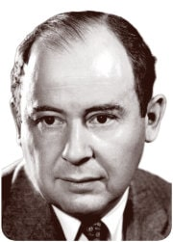
Von Neumann's Architecture
This photo of Unknown Author is under license CC BY-SA
In 1945, the Hungarian-born American mathematician John Von Neumann proposed a new model of computer architecture that featured a program stored in an electrical memory. This model was used in the construction of the EVIDAC (Electronic Discrete Variable Automatic Computer) and although with slight modifications, it is still used by manufacturers for the construction of current computers.
Figure 6. John von Neumann.
The concept of a stored program is a very important concept. Unlike early computers, von Newman proposed that both the program and the data be stored in the computer's memory along with the data. In this way, it not only simplifies the programming work by not having to rewrite and restructure and / or redesign or rewire the computer when it was desired to change its operation. The hardware design becomes independent of any problems and approach to the control and execution of the program.

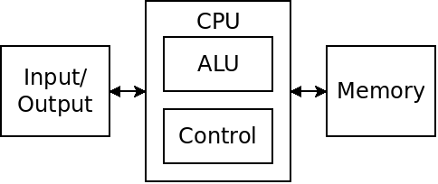
Figure 7. Outline of the Von Neumann Architecture
According to von Newmann's architecture, a computer consists of:
- Central Processing Unit (CPU). It is the "brain" of the computer. It is the part of a computer in which the elements that serve to process data are located. Its components are:
  - An Arithmetic-Logical Unit (ALU) or execution unit, which performs calculations and comparisons and makes logical decisions determines whether a statement is true or false using rules of Boolean Algebra.
  - Control Unit (UC). Its function is to search for the instructions in the main memory, decode them (interpretation) and execute them, using the arithmetic-logical unit. There are two types of control units: wired ones, generally used in simple machines, and microprogrammed ones, typical of more complex machines.
  - Memory Unit. Formed by cells of equal size intended to store information. In memory are stored both the instructions that make up the programs and the data that are used by these programs for their operation.
- Input/Output Unit. They are electronic circuits that allow the exchange of information between the CPU of the exchange of information with the outside. Peripheral devices are connected to this unit.
- Buses. Communication channels that allow information to be exchanged between the different functional units. There are three types of buses.
  - Data bus. Used to transfer both instructions and data from the memory unit to the rest of the computer components and vice versa.
  - Control bus. The CPU transmits the commands (microorders) to the rest of the units. And it receives signals from them indicating their status.
  - Address bus. This is the set of power lines needed to select memory addresses. The capacity of the memory that can be addressed depends on the number of bits that make up the address bus, with 2n being the maximum size in bits of the memory bank that can be addressed with n lines.

Boolean Algebra.
Boolean algebra, also called Boolean algebra, in digital electronics, computer science, and mathematics is an algebraic structure that schematizes logical operations.
It is named after George Boole (2 November 1815 – 8 December 1864), a self-taught English mathematician, who was the first to define it as part of a logical system, initially in a small pamphlet, The Mathematical Analysis of Logic, published in 1847.
Boolean algebra was an attempt to use algebraic techniques to deal with expressions of propositional logic. It was later extended as a more important book known as An Investigation of the Laws of Thought, published in 1854.
The respective interpretations of symbols 0 and 1 in the logic system are Nothing and Universe.
Today, Boolean algebra is widely applied in the field of electronic design. Claude Shannon was the first to apply it in the design of bistable electrical switching circuits, in 1948. This logic can be applied to two fields:
- To the analysis, because it is a concrete way of describing how the circuits work.
- To the design, since having a function applies that algebra to be able to develop an implementation of the function.
A Boolean algebra is an algebraic structure called a complementary and distributive lattice$(B, +, .)$, for which the following axioms are met.
- Associative:
$$∀a, b, c ∈B$$
$$\left(a+b\right)+c=a+\left(b+c\right)$$
$$\left(a·b\right)·c=a·\left(b·c\right)$$

- Absorption:
$$∀a, b ∈B$$
$$a·\left(a+b\right)=a+a·b=a$$
$$a+\left(a·b\right)=\left(a+a\right)·\left(a+b\right)=a·\left(a+b\right)=a$$

- Commutative:
$$∀a, b ∈B$$
$$a+b=b+a$$
$$a·b=b·a$$

- Idempotencia:
$$∀a ∈B$$
$$a+a=a$$
$$a·a=a$$
- Complementation:
$$∃0, 1∈B; ∀a ∈B ∃\overline{a}∈B$$
$$a+\overline{a}=1$$
$$a·\overline{a}=0$$
- Distributive:
$$∀a, b, c ∈B$$
$$a·\left(b+c\right)=a·b+a·c$$
$$a+\left(b·c\right)=\left(a+b\right)·(a+c)$$

A Binary or Bivalent Boolean Algebra is a Boolean Algebra in which there are only two elements: $B=\{0, 1\}$.
$$∀a∈B a=0 ∨a=1$$
0+0=0 | 0·0=0
0+1=1 | 0·1=0
1+0=1 | 1·0=0
1+1=1 | 1·1=1

Logic Gates
A logic gate is an electronic device with a Boolean-type function. They make up switching circuits integrated into a chip.
The implementation of Boolean functions is based on the technological capacity to build electronic devices (logic gates) that execute the operations of Boolean Algebra.

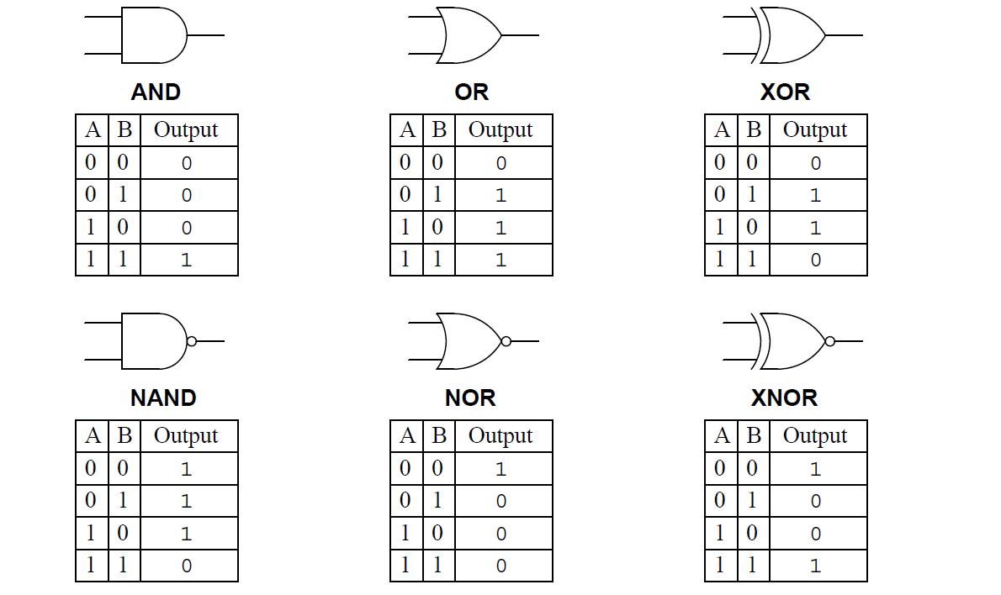
Figure 8. Summary of Logic Gates.

Analysis and synthesis of digital circuits
Analysis: Determine the behavior and functionality of a digital circuit.
Synthesis: Design the digital circuit from the description of a behavior or functionality.
The stages to design a logic circuit are:
- Identify the variables involved in the problem.
- Group the identified variables into input variables (independent) and output variables (dependent).
- Interpret the logical dependency relationships between inputs and outputs and express the functions they represent in a truth table.
- Obtain the minimum algebraic expressions of the logical functions that represent the output variables.
- Implement with logic gates the functions that solve the problem.
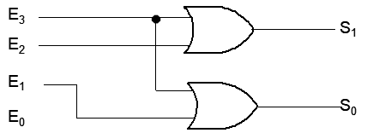
Figure 9. Digital circuit.

Introduction to information systems

Computer Science and Information Systems
Computer Science
The theory, experimentation, and engineering that form the basis for the design and use of computers. It involves the study of algorithms that process, store, and communicate digital information. A computer scientist specializes in the theory of computation and the design of computational systems
An information system is a computer system within a company or organization for sharing information:
We live surrounded by systems, being part of many of them. Sometimes we do it unconsciously and sometimes we do not (examples such as financial systems, political systems, health systems are clear examples of them).
In its most general meaning, we call system that ordered set of elements that relate to each other and contribute to a certain objective.
At present, due to the rise of computer networks and the evolution of new technologies, the term computer system has displaced in the professional field, not in the domestic or popular, to other terms such as computer or computer.
Today, the popular definition of a computer as a machine for the automated or automatic processing of information, used only a few decades ago in specific sectors such as the military or the scientific, has given way to large computer systems used in almost all areas and with which an excessive dependence is created. There are computer systems in sectors as diverse as industrial development, medicine, education or business management without forgetting the home itself.
A computer system is a set of devices, with at least one CPU or central processing unit, that will be physically and logically connected to each other through channels, which is called local mode, or will communicate by means of various devices or means of transport, in the so-called remote mode. These elements are integrated by means of a series of logical components or software with which one or more external agents, including man, can interact.
Every computer system must have two basic elements: a physical system or hardware and a logical system or software, to which we must add a third that, without belonging intrinsically, cannot be thought of working without it: human resources.
Traditionally, the elements that make up an information system are:
- Hardware. Formed by those physical elements of the computer systems, being hardware elements the terminal element, the channels and the supports of the information. It is constituted by electronic and electromechanical devices that provide information capture, calculation and information presentation capacity through devices such as sensors, processing and storage units, monitors, etc.
- Software. Those elements of the system that do not have a physical nature and that are used for the processing of information. They are computer programs that usually handle data structures, among which databases stand out, understood as organized collections of information that support the system.
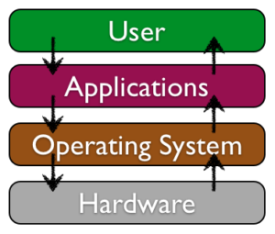
Figure 10. Overview of a standard software system. (Information Systems for Business and Beyond, 2019)
- Data. You can think of data as a collection of facts. For example, your address (street, city-state, zip code), your phone number, and your social media account are all data. Like software, data is also intangible, unable to be seen in its native state. Unrelated data is not very useful. But aggregated, indexed and organized together in a database, data can become a powerful tool for businesses. Organizations collect all kinds of data and use it to make decisions that can then be analyzed as to its effectiveness. Data analysis is used to improve the performance of the organization.
- Communication networks. In addition to the technological components (hardware, software and data) that have long been considered the core technology of information systems, another component has been added: communication. An information system can exist without the ability to communicate: the first personal computers were independent machines that did not access the Internet. However, in today's hyper-connected world, it's an extremely rare computer that doesn't connect to another device or an electronic network. Technically, the network communication component is made up of hardware and software, but it is such a central feature of today's information systems that it has become its own category.
- People. When thinking about information systems, it's easy to focus on the technological components and forget to look beyond these tools to fully understand their integration into an organization. A focus on the people involved in information systems is the next step. From frontline user support staff, to systems analysts, to developers, to the chief information officer (CIO), the people involved with information systems are an essential element.
- Process. It is a series of steps undertaken to achieve a desired outcome or goal. Information systems are becoming increasingly integrated with organizational processes, bringing greater productivity and better control to those processes. But simply automating activities using technology isn't enough: companies looking to use information systems need to do more. The ultimate goal is to improve processes both internally and externally, improving interfaces with suppliers and customers. Technology buzzwords like "business process reengineering," "business process management," and "enterprise resource planning" have to do with the continuous improvement of these business procedures and the integration of technology with them. Companies hoping to gain a competitive advantage over their competitors are very focused on this component of information systems. (Information Systems for Business and Beyond, 2019)
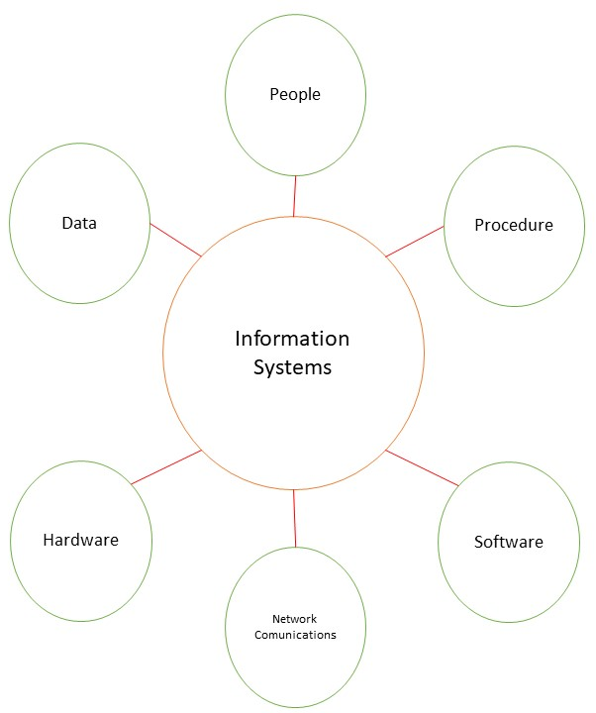
Figure 10. Elements of Information Systems
Every system, and of course a computer system, can be seen from two aspects: its physical description (how it is physically, analyzing the components that constitute it, as well as the elements of interconnection) and its functional description (functions of its components, how they interact with each other, rules or norms of communication, etc.)
Throughout this unit, along with the following, we will see in more detail the functional and physical characteristics of an IS understood by:
- Functional structure of the information systems. That associated with the physical support or hardware that is responsible for studying the architectures of organization and operation of the various components of the same. We will see the traditional or classic architecture of a personal computer or PC, which takes as its starting point the historical Architecture of Von Neumann.
- Physical structure of the information system. Also associated with the hardware. In this case we will study what is commonly called commercial hardware. We will see how they are physically, what they are for and what characteristics the different current components that make up a PC have, integrated from the motherboard and collected within a chassis, communicating with different input, output or input-output devices.

Classification of computer systems
Computer systems can be classified according to various criteria, such as according to their use or performance.

Computer systems according to their use
- General purpose computer systems, which are those used for various types of applications (this is the case of personal computers).
- Computer systems of specific use, which are those that are characterized by running one or a few programs (this is the case of industrial robots, hospital systems, or video games).
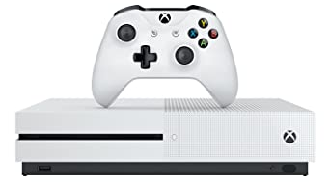 | 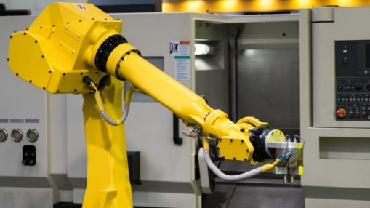
Figure 11. Computer systems for specific use.

Computer systems according to their performance
- Supercomputers. They are equipment with great calculation capacity. They are used in the technical-scientific environment and in the realization of simulations, for example, Sequoia built by IBM in California is used to improve nuclear safety, as well as to face the fight against terrorism, and for scientific purposes such as astronomy, the study of the human genome and climate change. It is capable of performing 16,235 trillion calculations per second (16,325 petaFLOPS). It has 1,572,864 processors and the same amount of GB of RAM, a custom interconnect system and a consumption of 7,890 kilowatts. In Spain there are supercomputers such as the MareNostrum in Barcelona, the Magerit, or Tirant in Valencia.
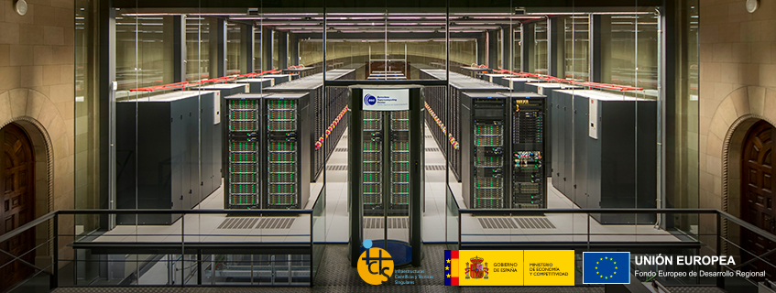
Figure 12. Morenostrum. https://www.bsc.es/marenostrum/marenostrum
We can find a report list of the 500 most powerful computer systems installed.in http://top500.org/. The list is updated twice a year: in June and November. In addition, they have also drawn up a ranking of the best supercomputers according to their energy efficiency: Green 500.

Figure 13. TOP 500 The List
- Mainframes: They are very powerful computers, used to process large amounts of data. They are usually found in large companies such as banks, insurance companies, etc. In addition to standing out for their calculation speed, they also tend to do so for their large storage capacity. They typically perform simpler calculations than a supercomputer, but involving large volumes of data. In many cases, companies do not acquire the computer, but rent a certain calculation capacity to the manufacturer. The latter will be responsible for offering the service uninterruptedly, being able to make repairs without turning off the computer or offering replacement computers while the problem is corrected. (SomeBooks.es, 2022)
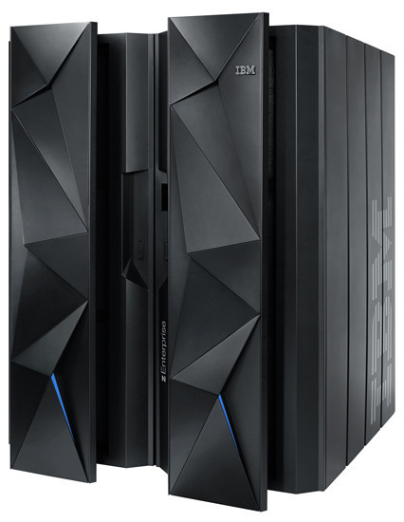
Figure 14. Mainframe IBM zEnterprise BC12
- Medium systems or minicomputers. They are equipment with the capacity to support hundreds of users with a cost and performance lower than large systems or mainframes. They are also known as servers, with network operating systems. For example, we can find domain servers, files, printing, DNS, DHCP, updates, etc. We can find them in tower, rack or blade format.
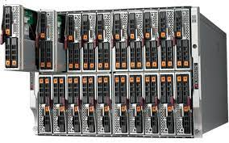 | 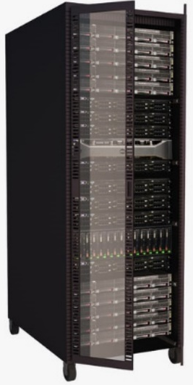 | 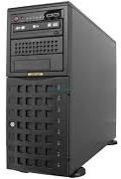
Figure 15. Medium systems / Servers
- Workstations. They are very powerful and specialized single-user equipment, with desktop operating systems, some with RISC technology, which allow to achieve an increase in performance (for example, for design and CAD). Following the performance trends of computers in general, today's microcomputers are more powerful than the best workstations of previous generations. As a result, the workstation market is becoming increasingly specialized, as many complex operations that previously required high-performance systems can now be performed by general-purpose computers. However, the workstations are optimized for high-performance, high-reliability situations where a microcomputer might stop responding.
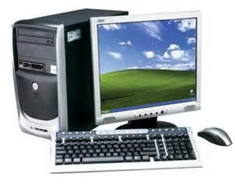
Figure 16. Workstation
- Microcomputers. They are less powerful single-user computers than workstations, and with desktop operating systems. Among them are: professional and personal computers, office and home computers, and desktop computers, laptops, tablets and even mobiles.
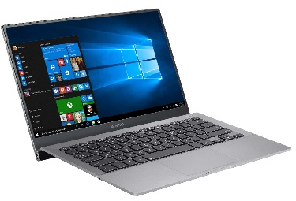 | 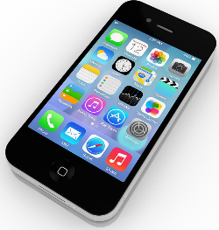 | 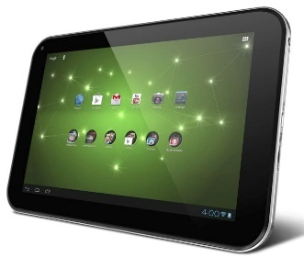 | 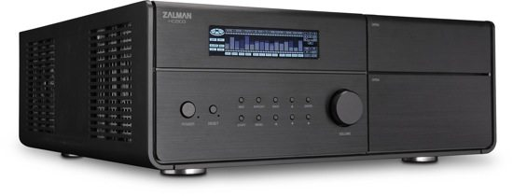
Figure 17. Microcomputers

Computers History
Computers, understood as machines to process data, are not a recent invention by any means, but have behind them a long history and an interesting evolutionary process where a group of people, many fallen into anonymity or oblivion, have contributed by contributing some kind of advancement or improvement.
Man has always sought to have instruments at the beginning, and devices later, capable of making precise and fast calculations. Let's do a brief review of how we got to today's computer systems.
More than 3,000 years ago.C., and the Chinese, and later other cultures, developed the abacus, an object created from a number of beads set on rods that represent numerical figures and that allows simple calculations and arithmetic operations.
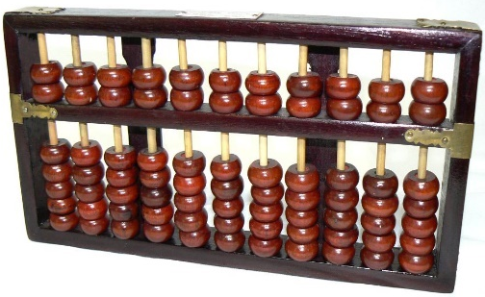
Figure 18. Abacus.
It tends to think that the origin of the abacus is in China, where the use of this instrument is still remarkable as in Japan, although other experts say that it was born in the Sahara, where these instruments have also been found and are still used both to perform arithmetic calculations and to play various traditional intelligence games. In the Canary Islands they are also very abundant.
The abacus is still in force today by storekeepers in Asia and Chinatowns in the United States. In addition, it is taught in Asian schools, to learn simple mathematics to children, but also in more advanced courses.
In Europe, around the seventeenth century, the growing interest in new sciences such as astronomy and navigation drove the development of what were called mechanical calculators.
In 1614, John Napier invented logarithmic tables that allowed complex multiplications to be performed as simple additions.
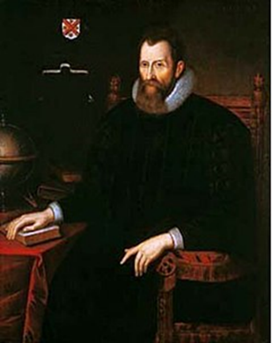 | 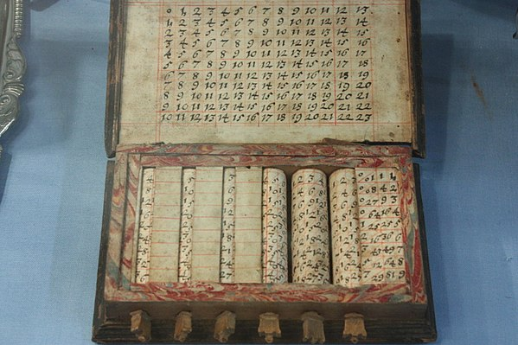
Figure 19. John Napier (CC BY-SA).
Blaise Pascal, at age 19, in 1642 creates a mechanical machine to help his father who was a tax collector. He was able to add and subtract 2 numbers directly, and do multiplication and division by repetition. He used a system of toothed wheels that he called the Pascaline. A high-level programming language was named after Pascal in his honor.
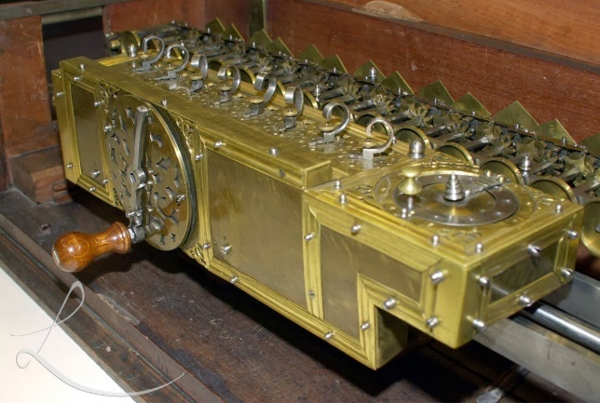
Figure 20. Pascaline (CC BY-SA-NC).
Later, Gottfried Wilhelm Leibnitz, in 1671, invented a machine very similar to the Pascaline, called "Stepped Reckoner" a device that, as well as performing additions and subtractions, could multiply, divide and take square roots through a series of addition steps. However, the "Stepped Reckoner" was unreliable due to mechanical parts that tended to bind and fail.
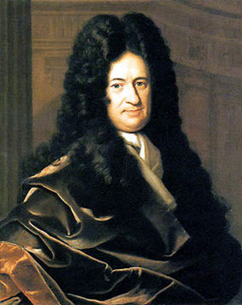 | 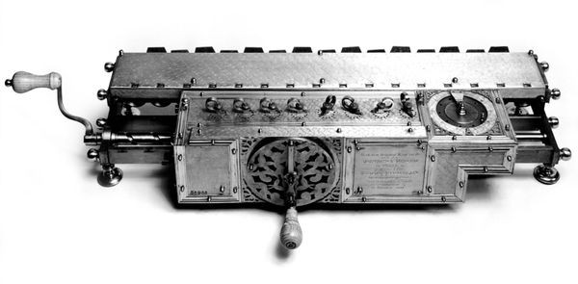
Figure 21. Gottfried Wilhelm Leibnitz - Stepped Reckoner (CC BY-SA).
In 1804, Frenchman Joseph Jacquard invented a loom that used punch cards to control the creation of complex textile designs. A replica of the loom can be seen in the science museum in London.
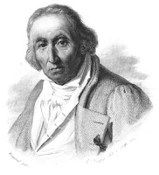 | 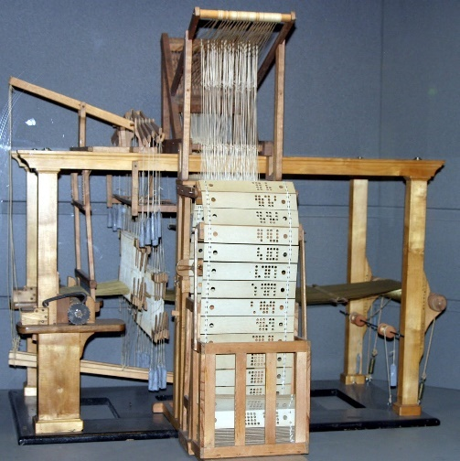
Figure 22. Joseph Marie Jacquard - Jacquard’s Loom (CC BY-SA).
A punched card is a paper, cardboard or plastic surface with perforations distributed in a way that represents information (in binary for computers).
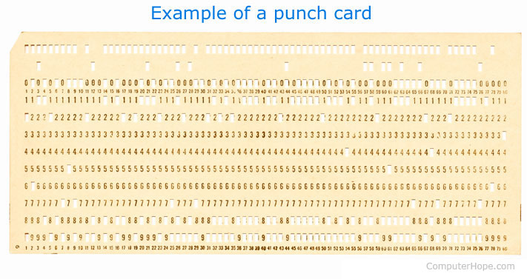
Figure 23. Example of a punch card. (CC BY-NC)
The first calculator with commercial possibilities was the "arithmometer". It was developed by Frenchman Charles Xavier Thomas, known as Carlos de Colmar, and won a gold medal at the London International Exhibition in 1862. The machine could add, subtract, multiply, divide, and calculate square roots with precision.
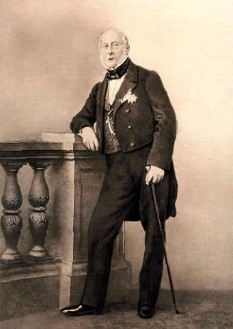 | 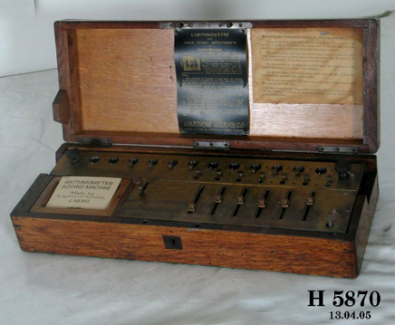
Figure 24. Charles Xavier Thomas de Colormar - Arithmometer. (CC BY-NC-ND)
It was already in the 19th century when a new evolutionary push was given by Charles Babbage who designed and built the first general-purpose computer, called "Difference Engine”. This machine can be seen in the science museum in London.
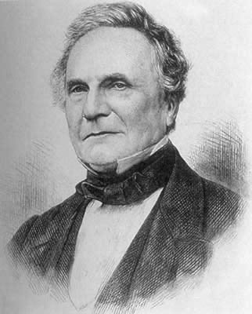 | 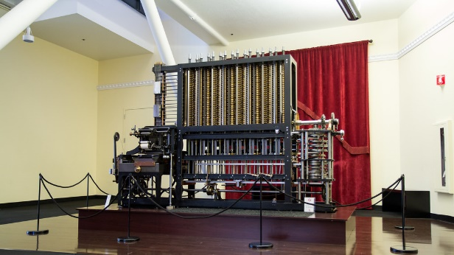
Figure 25. Charles Babbage – Difference Engine. (CC BY-SA)
Later he worked all his life on a new, called "Analytical Engine", designed to use punched cards to enter data similar to Jacquard cards. This device would have been a completely modern computer with a recognizable cycle of Input, Process, Output and Storage. Unfortunately, the technology of the time could not create the parts needed to complete the Analytical Engine. The end of Babbage's story is not a very happy one: he went bankrupt trying to build the Analytical Engine. A functional analytical engine was built according to Babbage's plans in 1991 and is housed at the Charles Babbage Institute in Minnesota. Charles Babbage is known as "the father of computing".
Augusta Ada Byron, daughter of the poet Lord Byron, is considered the first woman programmer in the world, she collaborated in the programming of the analytical engine (Bernoulli's number calculation algorithm). Babbage called her "the enchantress of numbers". The US Department of Defense named a programming language ADA in his memory.
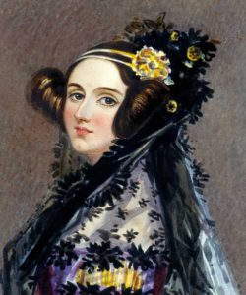
Figure 26. Ada Lovelace (CC BY-NC-ND)
Already in the 1880s, advances in data processing reached a new level with the emergence of punch card programs, an idea that was born from the need to process the data that would be obtained in the United States population census. of 1890. This system created by the American statistician Herman Hollerith, used a series of perforated cards, which passed through a system with electrical contacts. Invented Hollerith's Tabulating Machine
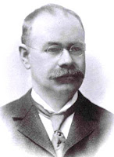 | 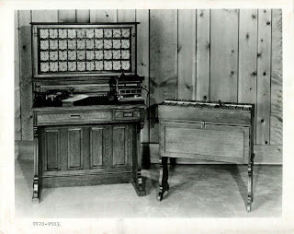
Figure 27. Herman Hollerith - Tabulating Machine. Used for the US Census, 1890 (CC BY-SA).
Based on the results obtained, Hollerith, in 1896, founded a company called TMC – Tabulation Machine Company, coming to associate, in 1914, with two other small companies, forming the Computing Tabulation Recording Company which was to become, in 1924, in the well-known IBM, International Business Machines.
 | 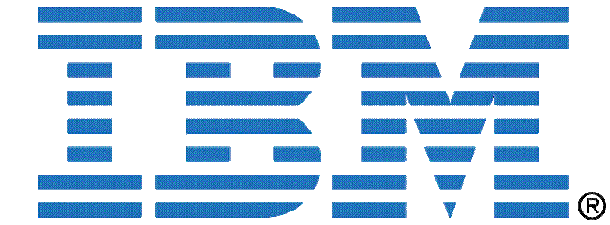
Figure 28. Logos International Business Machines (IBM)
By the year 1936, what is now known as a computer or computer was already being given shape and meaning, thanks to the manufacture of Konrad Zuse's Z1, which for many is the first programmable computer in history, despite to be recognized as a binary mechanical calculator.
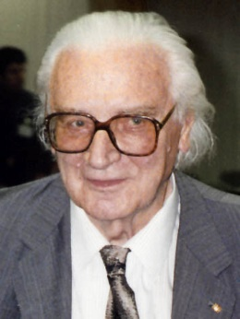 | 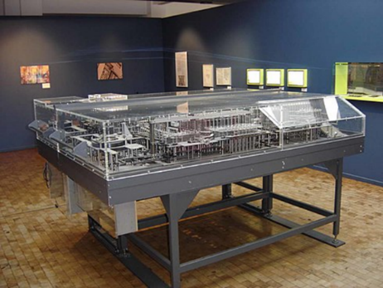
Figure 29. Konrad Zuse - Z1 Binary Mechanical Calculator, 1936. (CC BY-SA).
During World War II (1939-1945), a group of scientists and mathematicians working at Bletchley Park created the first digital computer. This system was designed by Tommy Flowers and had the participation of mathematicians Marian Rejewski and Alan Turing, who through the Colossus Mark I systems managed to decipher the messages transmitted by the German troops. Fact that favored the side of the allies (England, United States, USSR and France).
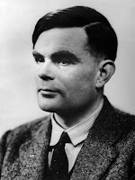 | 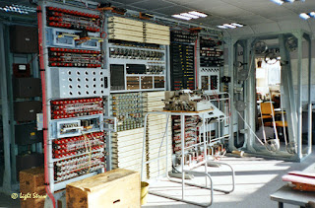
Figure 30. Alan Turing - Colossus Mark. Digital Computer, February 1944. (CC BY-SA).
During the war several prototypes of the Colossus were created, such as the Colossus Mark I and Mark II (1944). Around the same time, Konrad Zuse's Z3 and Z4 computers were created, and the Harvard Mark I (1944), built by Harvard University (Howard Aiken), was the first electromechanical computer built. Quite different from today's computers, the Mark I was 18 meters long, two meters wide and weighed 70 tons. Possessing gigantic dimensions, Colossus worked through valves, processing about 5 thousand characters per second. It was invented by the English mathematician Alan Turing.
The Z3 computer, built by the Germans, had as its main function the encryption of messages. However, it was destroyed in Berlin leaving us very little information about this computer.
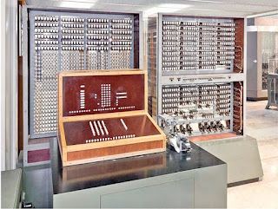 | 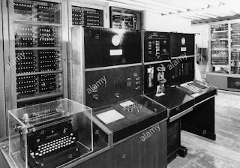
Figure 31. Z3 - Z4. Digital Computer, 1944. (CC BY-SA).

The Harvard Mark II was an electromechanical computer and was built at Harvard University under the direction of Howard Aiken and was completed in 1947. This machine was financed by the US Navy. At Harvard they produced from the Mark I to the Mark IV.
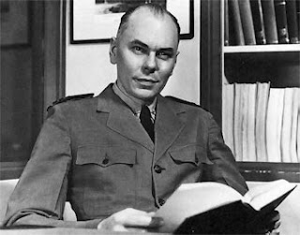 | 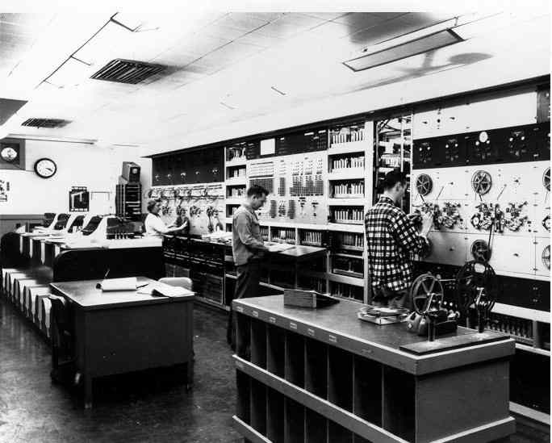
Figure 32. Howard Aiken - Mark III. Electromechanical and Electrical Computer, 1947. (CC BY-SA).
In 1939, at Iowa State University, John Atanasoff designed and built the first digital computer while working with Clifford Berry, a graduate student. Later, Atanasoff and Berry went to work on an operational model called the ABC, the "Atanasoff-Berry Computer". This computer, completed in 1942, used binary logic circuits and had regenerative memory. (Torres Yaguana, 2022)
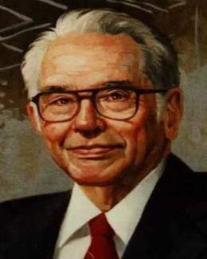 | 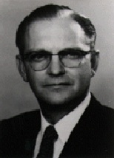 | 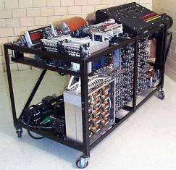
Figure 33. John Vincent Atanasoff & Clifford Berry. Replica of the ABC built by Iowa State University, 1995. (EcuRed, s.f.)

Computers Generations.

1st Generation (1940-1956): Vacuum Valves
It comprises the first large computers, and emerge a vital instrument to be considered a weapon during World War necessity. (Bailén Canales, 2018)
Its main features are:
- Using the technology based on vacuum tube technology which replaced electromechanical switches, to support the bistable.
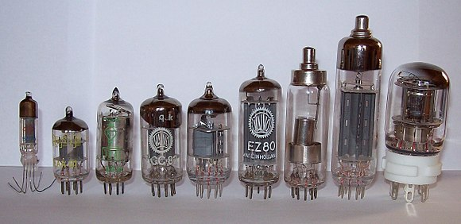
Figure 34. Vacuum tubes (CC BY-SA).
- Use of computers for military and scientific purposes.
- Very large and heavy machines, very slow in its processes, so that some programs involving long days of waiting. Even so, they could get to make about five thousand calculations per second. Used to enter data punch cards and programs.
- Using programming languages; such as, low-level machine code, and then the assembler.
Computer ABC (Atanasoff-Berry Computer), designed by a teacher and a student in Iowa in 1942 and considered the first electronic and digital computer above (now attributed to the Z1 Suze). 280 binary and vacuum valves.
During World War II, IBM began research in the field of computer science. In 1944 he finished building computer Automatic Sequence Controlled Calculator (ASCC), also known as Mark I (Harvard Mark I), first mainframe. Able to run complex calculations automatically (3-5 seconds per calculation), based on electromechanical switches. It had 4200 vacuum tubes and 800 kilometres of cable. It is based on the analytical engine of Charles Babbage.
Computing Grace Hooper, creator Cobol, a programming language, discovers a moth in the Mark II machine melting several vacuum valves, it first documented failure with the term bug (system failure).
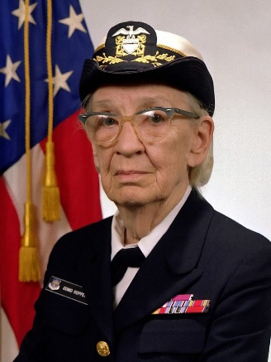 | 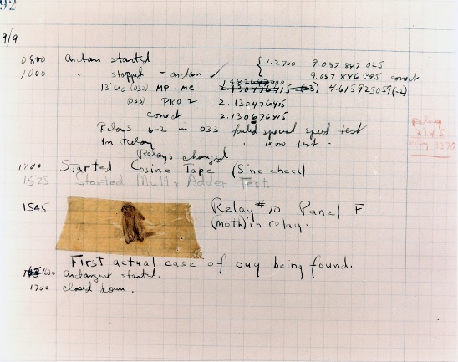
Figure 35. Grace Hooper. Origin of the legend about the first known computer bug. (Public Domain).
In this generation, we must talk about Alan Turing (1912-1954), father of Artificial Intelligence. Mathematician, computer scientist and English cryptographer, also one of the fathers of the Theory of Science. He formulated the Theory of Computing, and helped fight the Germans in World War II helping decrypts its powerful machine Enigma (machine Lorenz), with the design of machines Colossus Mark I and Colossus Mark II (1944). The Colossus Mark II machine had 2400 vacuum tubes and was in secret until a few years ago and should be considered as one of the first electronic machines. He created the first computer chess program.
I stand at this time machines as ENIAC (1946), designed with the ideas of the ABC with 17,468 vacuum valves, or EDSAC (1946) (enhanced ENIAC incorporating the use of binary and the program version stored proposed by John Von Neumann).
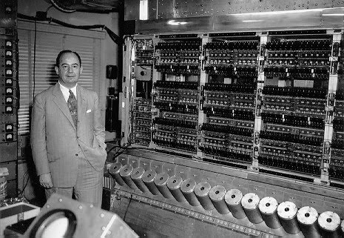
Figure 36. John Von Neumann with ENIAC.
In 1952, IBM created the IBM 701, the first large computer based on vacuum tube technology that replaced the electromechanical switches. In 1954 IBM introduced the 650.
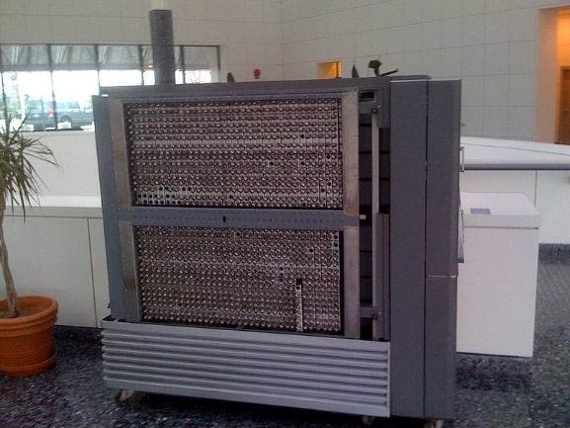 | 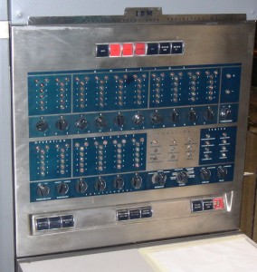
Figure 37. IBM 701 & IBM 650 (CC BY SA)

2nd Generation (1956-1963): Transistor
This stage coincides with the appearance of the transistor (1956). Transistor functions are similar to the vacuum valves, but with significant savings in size and power consumption.
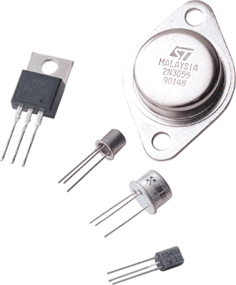
Figure 38. Transistors (CC BY).
Its main features are:
- Technology based on transistors with smaller machines and lower energy consumption.
- The scientific field remains the largest application but commercial computers arise.
- the UNIVAC series, first commercial computer appears.
- In 1956 IBM creates the first hard drive, and begin to use the first peripheral (keyboard).
- the first programming languages high-level FORTRAN (IBM), and the famous batch systems or batch processing, allowing the execution of a program without the control or supervision of the user (in front of interactive systems that require appear the control or user presence).
- In 1962 the first game, Spacewar, and the first drawing program Sketchpad developed.
- the concept of supercomputer appears as one computer with capabilities far superior to common calculation according to the season.
Supercomputers were introduced in the sixties and designed primarily by Seymour Cray in the company Control Data Corporation (CDC). For example, the CDC 6600.
Current supercomputers are used for tasks intensive, such as problems involving quantum physics, weather forecasting, climate change research, modeling of molecules, physical simulations such as simulation of airplanes or cars in the wind, simulation of the detonation calculations nuclear weapons and nuclear fusion research.

3rd Generation (1964-1971): integrated circuit (Chip)
It is characterized by the appearance of integrated circuits. It is integrated into a single chip all analog transistors and circuits that perform the basic operations of a computer. This discovery caused great changes in the size of computers in speed, compatibility, etc.
This generation is characterized by:
- Using technology based on a small-scale integration (SSI), with tens of transistors, and then move to a medium scale integration (MSI) with hundreds of transistors on each chip.
- Invention by Douglas Engelbart mouse. new storage and interaction such as magnetic floppy disks created by IBM or monitor appear.
- New techniques and programming languages.
- Minicomputer concepts (server), intermediate multiuser computer performance compared to large mainframe systems or before, and the concept of computer workstation or high performance for certain specific tasks appear. The first server in the market was the PDP-8 IBM (the PDP-1 the first server)
- Non-specific languages high level programming languages general purpose (C, Pascal, Basic, etc.) are used for the first time.
In the mid-60 IBM released System / 360 (S / 360), the first computer architecture that allowed exchange programs and peripheral devices between different components of architecture, unlike what exists above. The development was so expensive that almost bankrupted IBM, but was so successful to jump into the market to new entrants and leadership that IBM got over their competitors made it right to them of all charges. This success prompted an investigation by the company monopoly. He had a trial, which began in 1969, in which he was accused of trying to monopolize the market for business computers, which lasted until 1983.

4th Generation (1971-1981): Microprocessor - Scale Integration LSI
It is characterized by the implementation of microprocessor (programmable integrated circuit containing some or all elements of the CPU), and reducing space consumption. Invented by Ted Hoff, an engineer at Intel, it was the 4004.
Its main features are:
- Technology large scale integration (LSI) which employed thousands of transistors (up 10,000), can integrate more circuits into a single pill.
- In 1971 Kenback I, the first personal computer ($ 750) is released.
- In 1974 first workstation (WorkStation) appears the Xerox Alto, with mouse.
- Proliferate programming languages high-level and applications of all kinds.
- With the microprocessor appears personal or home computer (microcomputer). Many families have models of microcomputers as the Apple I and II, Commodore, Atari, Amstrad or Spectrum.
- Apple Disk II is the first commercial FDD, and IBM launches Winchister (standard disc) hard drives.
- In 1981, IBM PC, and the first laptop (Osborne I) is released.

5th Generation (1982-1991): VLSI Integration Scale
The microprocessor continues to evolve reducing its size and allowing many more operations and functions. Their characteristics are:
- VLSI technology or very large-scale integration (10,000 to 100,000 transistors).
- specific use microprocessors appear.
- rapid evolution of technology, which was called Moore's Law.
- Development and expansion of multimedia technology. Apple Lisa, the first microcomputer with GUI (1982).
- At this stage the company Apple invented open architecture, which will add to modernize and change its components and the graphical user interface or GUI, which uses a set of images and graphic objects to represent information and actions, which are based the operating systems today.
- Computers lowered their prices and began to be used in increasingly diverse fields.
- microprocessors working in parallel appear, and extends the widespread use of networks.
Moore's Law (empirical law), based on the observation made by the co-founder of Intel, Gordon Moore in 1965 which states that about every 18 months the number of transistors doubles in an integrated circuit. For some decades now applied on personal computers.

6th Generation (1992- present): Scale Integration ULSI and GLSI
Higher integration technologies such as ULSI (Ultra Large-Scale Integration) employing between 100,000 and 1 million transistors and GLSI (Giga Large Scale Integration) with more than one million are used.
Currently producing computers, it is based on multiple microprocessors that work simultaneously so that some machines can get to make more than one trillion arithmetic operations per second.
Furthermore, it extended connectivity of computers by using networks and increasingly using supported by the network itself as Internet applications grows.
As supposedly the sixth generation of computers is running since the nineties, we outline the characteristics required of this generation computers. Also, we mention some of the technological advances of the last decade of the twentieth century and what is expected to achieve in the XXI century:
- Computers of this generation feature-vector parallel architecture combined type employing hundreds of vector microprocessors working simultaneously so that they have created computers capable of performing more than one million million arithmetic floating-point operations per second (petaflops).
- Global area networks or WANs have been developed, but will continue to grow exorbitantly using media such as optical fibre and satellite, with impressive band widths.
- This generation technologies have already been developed or are in the process. Some of the most important are the so-called distributed artificial intelligence, the use of chaos theory, use of fuzzy systems, holography, optical transistors, nanotechnology, etc.

Representation of information.
Computer systems internally use the binary numbering system, which is based on only two digits (0 and 1). While people use the decimal numbering system which, as its name suggests, is based on the use of ten digits (from 0 to 9).
A number system is a set of rules and symbols that allow us to represent numerical values.
This means that a certain value will be represented differently depending on the numbering system we are using. Or on the contrary, the same representation can be equivalent to different values when we use different numbering systems.
Let's look at an example:
Number System
Decimal | Binary
2₁₀ | 10₂
10₁₀ | 1010₂
220₁₀ | 11011100₂
When we mix values represented in different numbering systems, we can indicate the system to which each number belongs by adding to its right a subscript with the number of symbols that system uses.
All positional numbering systems are governed by the Fundamental Theorem of Numbering, which establishes that the value of a number is given by the sum of each of its digits multiplied by its base raised to the position occupied by said digit. , taking into account that the units occupy position 0.
$$N=\sum_{i=-d}^{i=n}{{digit}_{i} x {base}^{i}}$$
Following this idea, we could represent the 245₁₀ number, using its positional expression, as follows:
$${245}_{10}=2×{10}^{2}+4×{10}^{1}+5×{10}^{0}$$

Convert binary values to decimal.
In Computer Science, the Fundamental Theorem of Numeration has immediate use, since it allows us to convert a number represented in binary to decimal in a very simple way.
The trick is to write the positional expression of the binary number in decimal. In this way, when solving it, we will obtain the result in decimal.
Let's look at an example:
$${11011100}_{2}=1×2^{7}+1×2^{6}+0×2^{5}+1×2^{4}+1×2^{3}+1×2^{2}+0×2^{1}+0×2^{0}=128+64+16+8+4={220}_{10}$$

Binary to decimal with decimals.
Actually, there is no difference in converting a number from binary to decimal with or without decimal part. To achieve this, it is enough to apply the Fundamental Theorem of Numbering in the way we have seen above.
We will verify it supposing that the previous number had a decimal part. For example: 11011100,01101₂
To convert it to a decimal, we would perform the following operations:
$${11011100,01101}_{2}=1×2^{7}+1×2^{6}+0×2^{5}+1×2^{4}+1×2^{3}+1×2^{2}+0×2^{1}+0×2^{0}+0×2^{-1}+1×2^{-2}+1×2^{-3}+0×2^{-4}+1×2^{-5}=128+64+16+8+4+0,25+0,125+0,03125={220,40625}_{10}$$

Convert decimal values to binary.
When we need to convert in the opposite direction, we can apply the method of successive divisions.
Basically, this method consists of performing an integer division (that is, without obtaining decimals) of the number in decimal by the base to which we are going to convert. Once the division is complete, we take the quotient and divide it by two again. We continue like this until we obtain a quotient less than the base. At this point, we take the remainders of all the divisions in the reverse order in which they have appeared (that is, the last quotient will be the first).
Dividend | Divider (Base) | Quotient | Remainders
220₁₀ | 2 | 110 | 0
110₁₀ | 2 | 55 | 0
55₁₀ | 2 | 27 | 1
27₁₀ | 2 | 13 | 1
13₁₀ | 2 | 6 | 1
6₁₀ | 2 | 3 | 0
3₁₀ | 2 | 1 | 1
Binary number: |  | 11011100₂

Decimal to binary with decimals.
Sometimes the base 10 number that we want to convert to binary has a decimal part.
In these cases, we will convert the integer part using the explanation above, and then convert the decimal part using the following guidelines:
- We multiply the decimal part by 2.
- We separate the integer part of the result.
- With the resulting decimal part, we return to the first step.
- We repeat the process until we have no decimal part left.
At the end, the decimal part will be formed by the integers that we have been obtaining in each operation, placed in the same order that they have appeared.
To understand it, let's take the previous case as an example: Convert to binary in decimal number 220,40625₁₀.
We would start by getting the integer part and, as we have seen above, the result would be:
$${220}_{10}={11011100}_{2}$$
Next, we focus on the decimal part (0,40625₁₀) and apply the above process:
Step | Number | x 2
1 | 0,40625 | 0,8125 | 0
2 | 0,8125 | 1,625 | 1
3 | 0,625 | 1,25 | 1
4 | 0,25 | 0,5 | 0
5 | 0,5 | 1 | 1
Decimal part: |  | 01101₂
Therefore, the decimal part would be 0,01101₂. And adding the integer part with the decimal part: 11011100,01101_{2.}

Octal number system.
As its name indicates, the octal number system uses eight digits (0 to 7) to represent values.
The advantage that octal represents over decimal is that it uses a base that is a power of 2 (2³ = 8). In short, this characteristic is going to allow us that every three binary characters can be represented, directly, with an octal character.
To understand it, let's look at the following table that shows us values in octal and binary:
Number Systems
Binary | Octal
000₂ | 0₈
001₂ | 1₈
010₂ | 2₈
011₂ | 3₈
100₂ | 4₈
101₂ | 5₈
110₂ | 6₈
111₂ | 7₈
In this way, to convert a number written in binary to the octal system, it would suffice to take the bits grouped three by three, starting on the right and completing the necessary zeros on the left:
100 110 101₂
Next, we look up each group of three digits in the table above and replace them with their corresponding digit in the table:
$${100 110 101}_{2} ={465}_{8}$$
It is clear that the change from octal to binary is just as simple.

Convert octal values to decimal.
The easiest way to convert an octal value to a decimal value is to apply the Fundamental Theorem of Numbering as we have already done with binary. As the positional expression of the number in octal we write it in decimal, when solving it, we will obtain the result in decimal.
Let's look at an example:
$${465}_{8}=4×8^{2}+6×8^{1}+5×8^{0}=4×64+6×8+5×1=256+48+5={309}_{10}$$

Convert decimal values to octal.
To convert from a decimal to an octal value, we can apply the method of successive divisions that we already used with the binary system. That is, we will carry out the integer division (without obtaining decimals) of the number in decimal by eight (the base to which we are going to convert). Once the division is complete, we take the quotient and divide it again by eight. This process will continue until we obtain a quotient equal to zero.
At this point, we take the remainders of all the divisions in the reverse order in which they have appeared (that is, the last remainder will be the first).
As an example, let's see the same conversion as in the previous point, but in the opposite direction:
Dividend | Divider (Base) | Quotient | Remainders
309₁₀ | 8 | 38 | 5
38₁₀ | 8 | 4 | 6
Octal number: |  | 465₈

Hexadecimal number system.
The hexadecimal number system uses sixteen digits to represent values. As we only use the digits from 0 to 9, and they are not enough, in this case the letters A to F are added to represent the missing digits. Therefore, the digits we use to represent values in hexadecimal are:
$$Hex=\{0, 1, 2, 3, 4, 5, 6, 7, 8, 9, A, B, C, D, E,F\}$$
We have already commented above that, as was the case with the octal system, the advantage that hexadecimal represents over decimal is that it uses a base that is a power of 2 (2⁴ = 16). In a similar way to what happened in octal, this feature will allow us that every four characters in binary can be directly represented with a character in hexadecimal.
To check it, we start from the table that shows us values in hexadecimal and in binary:
Number Systems
Decimal | Binary | Hexadecimal
0₁₀ | 0000₂ | 0₁₆
1₁₀ | 0001₂ | 1₁₆
2₁₀ | 0010₂ | 2₁₆
3₁₀ | 0011₂ | 3₁₆
4₁₀ | 0100₂ | 4₁₆
5₁₀ | 0101₂ | 5₁₆
6₁₀ | 0110₂ | 6₁₆
7₁₀ | 0111₂ | 7₁₆
8₁₀ | 1000₂ | 8₁₆
9₁₀ | 1001₂ | 9₁₆
10₁₀ | 1010₂ | A₁₆
11₁₀ | 1011₂ | B₁₆
12₁₀ | 1100₂ | C₁₆
13₁₀ | 1101₂ | D₁₆
14₁₀ | 1110₂ | E₁₆
15₁₀ | 1111₂ | F₁₆
In this way, to convert a number written in binary to the hexadecimal system, it would suffice to take the bits grouped four by four, starting from the right and completing the necessary zeros on the left:
1 0011 0101₂
Next, we look up each group of three digits in the table above and replace them with their corresponding digit in the table:
$${0001 0011 0101}_{2} ={135}_{16}$$
It is clear that the change from hexadecimal to binary is just as simple.
Another binary to hexadecimal conversion example is:
$${220}_{10}={11011100}_{2}={DC}_{16}$$

Convert hexadecimal values to decimal.
We reapply the Fundamental Number Theorem as we did before. Let's see the resolution of the previous examples.
$${135}_{16}=1×{16}^{2}+3×{16}^{1}+5×{16}^{0}=1×256+3×16+5×1=256+48+5={309}_{10}$$
$${DC}_{16}=D×{16}^{1}+C×{16}^{0}=13×16+12×1=208+12={220}_{10}$$

Start-up process. Checkup and diagnosis. Troubleshooting.
We will study the essential steps to get a newly assembled computer up and running. Once the hardware assembly operations of a device have been completed, it must be configured and equipped with the essential software applications to make it fully operational.
First of all, we will perform the first boot of the computer, the BIOS will carry out a series of initial checks to find out if all the hardware components have been mounted correctly.

Initial checks:
Once the assembly of the PC is finished, we have to do an initial study to avoid the appearance of problems. We must check:
- If the motherboard is well connected to the case and is receiving power from the power supply.
- Whether the microprocessor, heatsink, and fan are securely attached and connected, and powered by the power supply.
- Whether the memory modules are secure and in the proper position.
- If the cards are well inserted in their slot and fastened by the screws.
- If the connectors of hard drives, DVD, CD and floppy drive are well connected to the power supply and motherboard.
- If the connectors on the front of the box are well connected to the position indicated on the motherboard.
- Once this first check has been made, and before plugging in the computer, we will check:
  - That the external connections, such as keyboard, mouse and monitor, are correctly in their connector.
  - That the power supply reaches the PC power supply and the monitor.
  - After carrying out these checks, we can now plug in the PC. We will then examine if all the fans are spinning, if the front panel LEDs are on, and if the various drives are also on.
  - If all went well, a single beep will be heard and typical BIOS messages will appear on the screen.

Computer boot options:
Initializing a computer is a multi-step process. From the time the power is turned on until the system goes to sleep with the command line prompt or graphical desktop, a sequence of steps occurs that checks the system and prepares it for operation. These are the steps:
- Power on, the power button is pressed.
- The bootstrap, the instructions stored in ROM memory are executed.
- Power-On Self-Test-POST, system and individual component diagnostics.
- Localization of the Operating System.
- Operating System Load.
- Establishment of the environment.

BIOS and POST
The Basic Input-Output System, known simply as BIOS, is a special memory on the motherboard that contains an application that starts when a computer is turned on or restarted. That application is called BIOS and has ended up naming the memory that contains it.
The functions of the BIOS (as an application) are:
- First, check the system hardware (POST).
- To then look for the unit that will load the operating system (BOOT).
These two actions are executed strictly in this order, so that if there is a failure in the system test, the loading of the operating system will not be possible.
The POST (Power-On-Self-Test), as we have seen, is a part of the BIOS application that is responsible for verifying the connected hardware. The variety of models and BIOS versions means that there is a wide range of POSTs. The order in which the POST check sequence is performed may vary depending on the make and model of BIOS.
In any case, POST adapts to the capabilities of the board it is running on and will not test a component that is not contained on the board.
The following tables show the POST check sequence for the Award and AMI BIOS.

POST sequence in an AWARD BIOS (AWARDBIOS)
- Microprocessor status test and system clock.
- Test the keyboard driver to verify that it is available.
- Starts the chipset activity to carry out the tests of the equipment devices.
- The graphics card driver is checked and activated to later display information on the screen.
- CMOS chip status test (BIOS).
- DMA (direct access) memory test.
- Test of the lower part of the RAM memory (the first 64 kB)
- Graphics card memory test.
- Test at the base of the plate stack.
- System memory capacity test.
- RAM memory status test.
- Extended memory test.
- The floppy drive is initialized (floppy disk, if any).
- Serial and parallel ports are detected.
- Hard drives (if any) are initialized.

POST sequence in an AMI BIOS (AMIBIOS)
- Test the keyboard driver to verify that it is available.
- Starts the chipset activity to carry out the tests of the equipment devices.
- CMOS chip status test (BIOS).
- DMA (direct access) memory test.
- The graphics card driver is checked to later display information on the screen.
- Test of the lower part of the RAM memory (the first 64 kB)
- Graphics card memory test.
- Motherboard battery test.
- System memory capacity test.
- RAM memory status test.
- Extended memory test.
- The floppy drive is initialized (floppy disk, if any).
- Serial and parallel ports are detected.
- Hard drives (if any) are initialized.

If a fault is detected, the POST will notify you by beeping or on-screen error messages. Depending on the BIOS model used, the way to communicate errors varies.
MError  Messages | Screen error messages | Error description
MError  Messages | BIOS ROM checksum error – System halted | Corrupt BIOS
MError  Messages | CMOS battery failed | Board battery failure (exhausted)
MError  Messages | CMOS battery state low | Battery about to run out.
MError  Messages | CMOS checksum error – Defauls loaded | Error loading BIOS settings
MError  Messages | Fllopy disk(s) fail | Floppy drive failure
MError  Messages | Hard disk install failure | Error on hard drive connection
MError  Messages | Hard disk(s) diagnosis fail | Hard drive diagnostic failure.
MError  Messages | Keyboard error or no present | Keyboard error or keyboard not connected.
MError  Messages | Memory test fail | Memory test failed.
MError  Messages | Parity error | RAM parity error
MError  Messages | Primary/Secondary master hard disk fail | Master IDE drive 1/2 failed.
MError  Messages | Primary/Secondary slave hard disk fail | IDE slave drive 1/2 failed.
MError  Messages | Insert booteable media. | Bootable drive not found.
MError  Messages | Primary boot device not found. | Initial boot drive not found.
MError  Messages | System halted. | System interrupted due to unknown fault.
MError  Messages | I/O Card parity error at xxxx | Expansion card failure.

Depending on the type of error, the POST will allow us to continue with the loading of the system or will force us to solve the failure before continuing.
If more than one error occurs, we may not know until the next POST, depending on the influence it has on the stability of the system.

The POST diagnostic card.
When a piece of equipment is "dead" it is very difficult to diagnose it without the proper instruments.
In addition to beeps and error messages, POST has additional information called diagnostic codes. The POST code is specific to each model and BIOS version, so you have to refer to the manufacturer's manual.
A POST diagnostic card is used to display POST codes. This card includes an operation manual and the most common BIOS code tables.
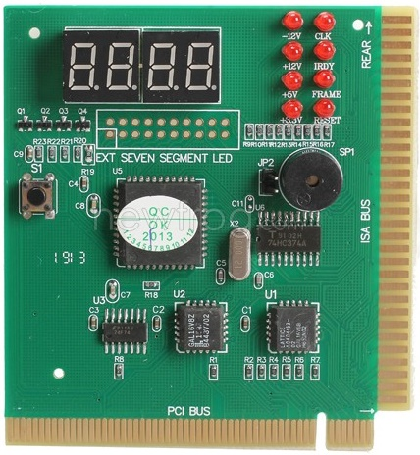
Figure 39. POST diagnostic card.(CC BY-SA)
In some boards the slot to place this card is at the bottom and the display could not be seen, there is an additional display that connects with an IDE type cable to the card, allowing us to place it in a visible place to the time to run the test.
It may also notify you of the error by beeping. In this case, if the board does not have a connection to the computer's internal speaker, it will use the buzzer that comes with the POST card itself.
If the combination that remains fixed is "00" or "FF", it means that the POST has successfully completed all the tests and that the device is ready to start the BOOT.

BIOS boot sequence
The boot sequence of the BIOS of a computer decides the search order of the drives for the system boot. Sometimes we want to vary this sequence, such as to install another operating system on our hard drive or to scan the drive for viruses. In this case, it will be necessary to enter the BIOS setup program. Normally, during the boot process, a message appears at the bottom of the screen telling us how to enter the BIOS. A typical message is "Press DEL to enter SETUP". We must consult the motherboard manual to find out what combination of keys allow us to enter.

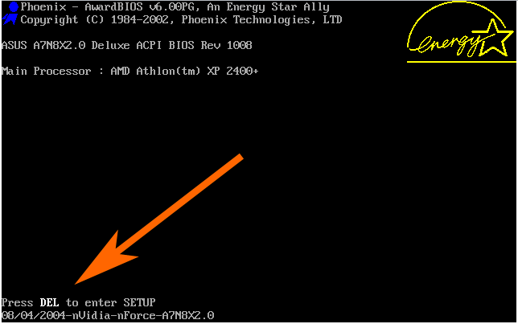 | 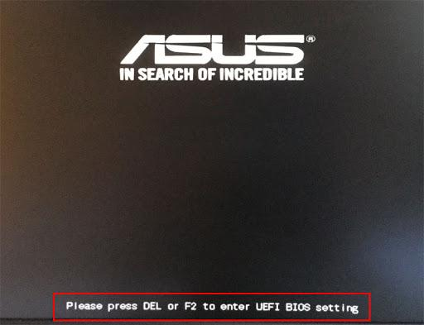
Figure 40. Press DEL to enter SETUP.
We turn on the computer and press the Delete key to enter the BIOS. A series of menu options are displayed. We select with the cursor arrows the option that allows us to change the boot sequence of the computer; Boot sequence and press the Enter key. A screen similar to these will appear:
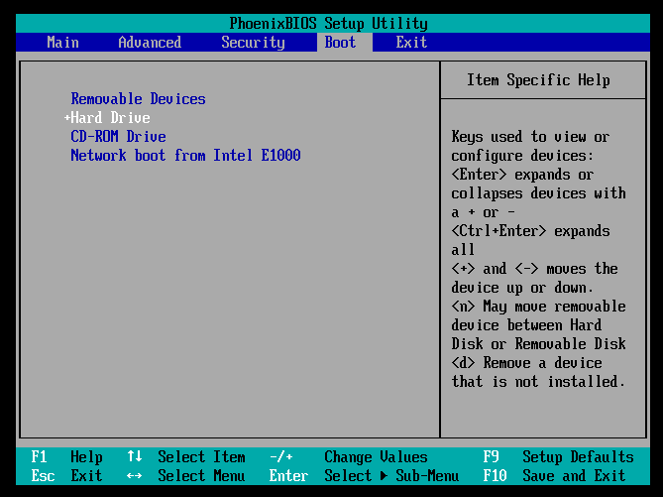
Figure 41. Phoenix BIOS Setup Utility.

In this way it is possible to establish the order in which the storage devices connected to the computer will be read to find the active partition of the operating system or the self-booting image for installation.
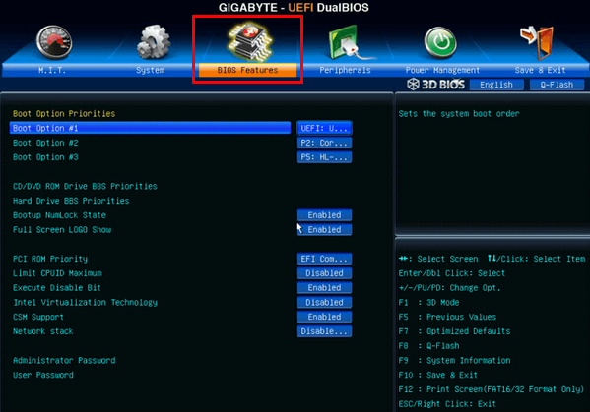
Figure 42. UEFI DualBIOS
Once you have made changes to the BIOS settings, it is very important to save the changes before exiting so that they are stored permanently.
In the event that the changes introduced in the BIOS or the configuration of the chosen boot sequence is not the desired one and the correct boot and start-up of the equipment cannot be completed, it will be necessary to proceed to restore the factory values.

Occupational risk prevention and safety regulations.
Ergonomic risks are those that can lead to musculoskeletal disorders (MSDs) in the worker and are derived from forced postures, continuous application of forces, repetitive movements and manual handling of loads in the workplace. They may be present, for example, in parcel and delivery companies, moving companies, office cleaning services or stevedoring operations in commercial seaports.
On the other hand, musculoskeletal disorders (MSDs) are alterations suffered by body structures such as muscles, tendons, joints, bones, nerves and the circulatory system, due to work or the environment in which it is developed.
The risks are regulated in the development regulations of the Law on Prevention of Occupational Risks:
- Royal Decree 488/1997 regarding risks in work with display screens. Precepts for the design of workstations and provisions on what the table, chair or screen should be like are included.
- Royal Decree 486/1997 on workplaces, which indicates the environmental conditions, dimensions and adequate lighting that the workstations must have for the development of work activity in ergonomic conditions, in its Annexes I, III and IV.

General recommendations for risk prevention in the office.
A series of general recommendations will be given to fear when working with computer systems in an office: (Raya Cabrera, Raya González, & Zurdo, 2014).
- I tried to keep the cables as collected as possible to avoid falls. The installation of nets should be by walls and ceilings always avoiding the floor.
- Data cables should not be in contact with electrical cables.
- Electrical installations should always be in good condition and checked by competent personnel.
- Avoid overloading plugs by using multiple adapters and regattas. I tried to spread the load among the plugs that are available. In many cases, overloads produce fires.
- Turn off equipment (screens, speakers, printers) when you leave the office, as they overheat and consume electricity.
- Separate equipment from the wall to prevent overheating.
- Try to ground plugs and appliances. Install groundings and differential current switches.
- It is desirable to have an adequate firefighting system. Fire extinguishers and fire exits must be properly marked and operational.
- Air conditioning in the office is always important. Avoid placing air conditioning outlets next to radiators. An average temperature of 22º in winter and 24º in summer is usually the most appropriate with humidity between 30% and 70% (if there is a risk of static energy it should be below 50%).
- Noises make it difficult to concentrate. These should not exceed 55 decibels. Try to make the office a non-noisy place (both internal and external noises). If necessary, enable an exclusive room for the equipment that makes the most noise.
- The psychosocial factor in the office is very important. We must try to ensure that the working procedures are clear and the organization is adequate. We must encourage interpersonal relationships and avoid mobbing and bournout.
  Figure 43. Burnout syndrome. (CC-BY) |   Figure 44. Moobing at workplace (CC-BY)

- Employees working on the assembly and repair of computer equipment should follow the manufacturers' instructions.
- Use natural light whenever possible. If artificial light is used, it must be taken into account that it should produce glare or reflections. The tubes must be covered and not directly affect the table or equipment. The light intensity must be adequate.
- Workstations must be close to the windows preventing light from falling directly on the screen and causing reflection to the worker. It is necessary to use screens, curtains or other elements that prevent reflections.
- The ceilings should be white and the walls should be painted in medium tones. It is recommended to introduce stimulating colors into the environment.
- The vibrations of air conditioning, machines, printers, traffic, ... they are disturbing elements and should be reduced or eliminated as far as possible.
- In offices that have a lot of electrostatic charge, this can be reduced by increasing the humidity of the air or using antistatic products.

Specific advice for users of computer equipment.
At this point, a series of specific tips will be given for people who spend a lot of time in front of the computer (generally, more than 20 hours a week). There are many jobs that require a lot of dedication in front of the computer. We usually find computer scientists, administrative staff, accountants, writers, data recorders, draughtsmen, etc. in this situation.
When you spend a lot of time in front of the computer screen, it can occur:
- Musculoskeletal disorders: especially in the back, neck, shoulders, hands and arms. In general, adopting an incorrect or static posture for a long time leads to problems of this type.
- Visual problems: especially irritation and redness of the eyes, blurred vision... Generally, they can be caused by the effort of looking at the screen and at the documents with which you are working. Sometimes, if there is a big difference in brightness between the screen and the documents with which you are working, the adaptation that the eyes make to these differences produces visual fatigue. Lack of or incorrect lighting can also cause these symptoms.
- Mental fatigue: when repetitive or monotonous tasks are carried out or even when the work pace is excessive, mental fatigue can occur.
The following tips try to minimize these types of problems:
- The distance between the screen and the worker's eye must be greater than 40 cm.
- The worker must stand in front of the screen. The angle between the line of sight and the horizontal must be at least 60º.
- Do not use very small screens as they cause visual fatigue since the size of the characters in the texts is smaller.
- Correctly adjust the contrast and brightness between the screen and the rest of the workplace to be as similar as possible.
- Do not work in semi-darkness. Try to make the brightness between the screen and the rest of the workplace as similar as possible.
- Avoid older monitors (such as CRTs) if possible. Newer displays have lower reflection and better contrast capabilities making them more suitable.
- The position, inclination and height of the keyboard must be adequate when we are working on it, so that the hands are as relaxed as possible. No need to force postures. Try to choose the most comfortable keyboard for the worker.
- Choose a comfortable mouse. This should not be too big or too small. In the event that prolonged use of the mouse can lead to injuries such as carpal tunnel syndrome.
- The position to adopt in front of the computer is the one that can be seen in the following figure. The most important thing is that the spine should remain straight against the back of the chair and the other parts of the body should adopt a relaxed position and as natural as possible.

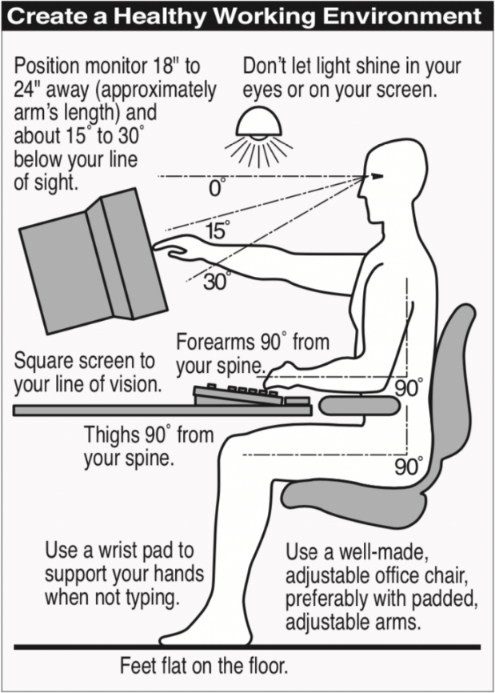
Figure 45. Ergonomic body position in front of the computer (CC BY-SA)
- The furniture (chair, table) must be as comfortable as possible, it must be adjustable and have a suitable finish (no sharp edges, no reflections, etc).
- The chairs are very important. The use of an adjustable and comfortable chair for the worker is recommended.

Learning Outcomes and Assessment Criteria
Contents
1. Exploitation of microcomputer systems:
- Computer architecture.
- Introduction to microcomputer systems.
- Components of a computer system. Hardware. Software.
- Representation of information.
- Computer hardware. Physical components.
- Peripherals. Adapters for connecting devices.
- Start-up process. Checkup and diagnosis. Troubleshooting.
- Monitoring tools.
- Occupational risk prevention and safety regulations.
Learning outcomes | Evaluation criteria
LR 1. Evaluates computer systems identifying their components and characteristics. | a) The physical components of a computer system and its interconnection mechanisms have been recognized.  b) The start-up process of a piece of equipment has been verified.

References:
Bailén Canales, E. C. (2018). FOUNDATIONS OF HARDWARE. COMPUTER SYSTEMS: FUNCTIONAL STRUCTURE. Almoradí, Alicante, España: I.E.S. Antonio Sequeros.
Beas Arcos, J. (2020). Sistemas Informáticos. España: Síntesis.
Comesaña, J. L. (s.f.). https://www.sitiolibre.com/. Recuperado el 17 de Marzo de 2022, de https://www.sitiolibre.com/
EcuRed. (s.f.). Recuperado el 3 de Agosto de 2022, de EcuRed: Enciclopedia cubana: https://www.ecured.cu/
Huertas Gassó, I. (2021). Sistemas Informáticos. Torrazza Piemonte, Italia: Amazon Italia Logistica S.r.l.
Information Systems for Business and Beyond. (2019). Recuperado el 17 de Marzo de 2022, de Chapter 1: What Is an Information System?: https://opentextbook.site/informationsystems2019/chapter/chapter-1-what-is-an-information-system-information-systems-introduction/
Jiménez Cumbreras, I. M. (2017). Sistemas Informáticos. Ibergaceta Publicaciones S.L.
King's College Cambridge. (17 de Marzo de 2022). The Turing Digital Archive. Obtenido de https://turingarchive.kings.cam.ac.uk/
Raya Cabrera, J., Raya González, L., & Zurdo, J. S. (2014). Sistemas Informáticos. Madrid: RAMA - Editorial.
SomeBooks.es. (2022). Conceptos basicos sobre sistemas operativos. Obtenido de SomeBooks.es: http://somebooks.es/conceptos-basicos-sobre-sistemas-operativos/
Torres Yaguana, J. (3 de Agosto de 2022). Blog Lic. Jaime Torres Y. Obtenido de Historia de las computadoras: https://jaimetorresy.blogspot.com/p/historia-de-las-computadoras.html

