# Back-up SOP for the QC database

An SOP for backing up the NGSQC database using the application MySQL Workbench.

Instructions are for Windows 10 using the application MySQL Workbench 6.3 CE, backing up a MySQL database v.5.6 using the Inorb storage engine.

## Logging in

After opening the application, click on the log-in for the relevant database (yellow box in the screenshot below). In this case this is the Local Instance MySQL56 database.

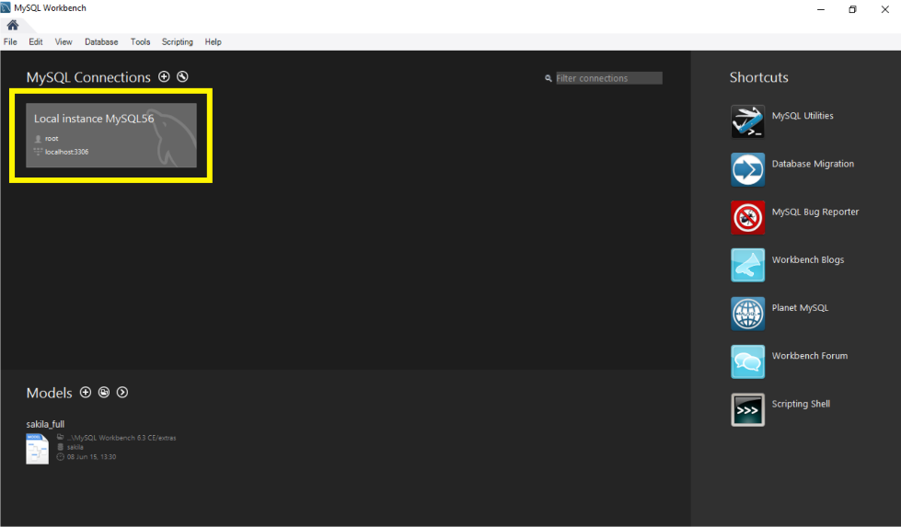

Enter the password for the root user at the prompt (see screenshot below). If you do not have the password and require it, ask Sara.

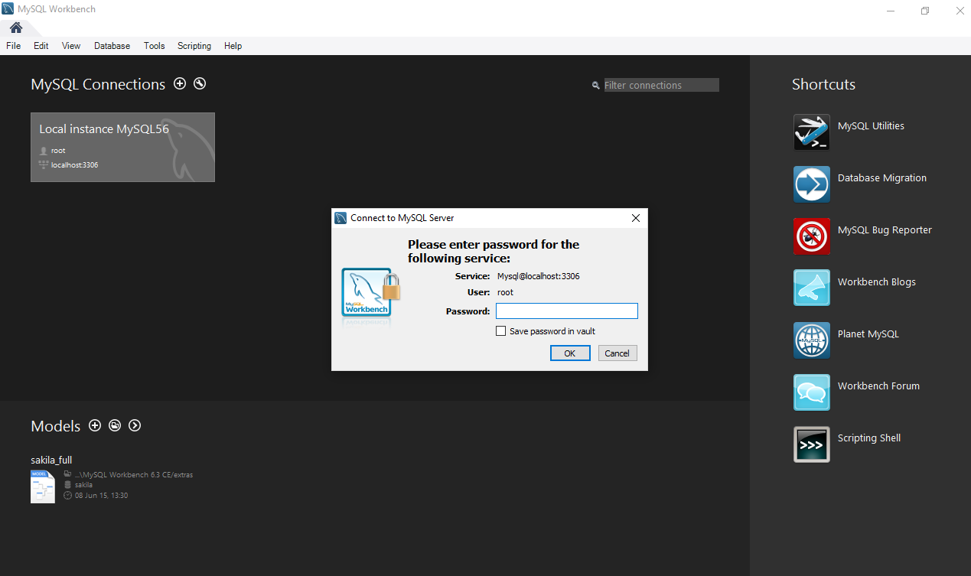

## Backing up data

Ensure that the correct database is selected. This should be “ngsqc” (see black box in screenshot below).

Then select ‘Server’ from the drop-down menu at the top of the screen and select Data Export and click (see black arrow in screenshot below).

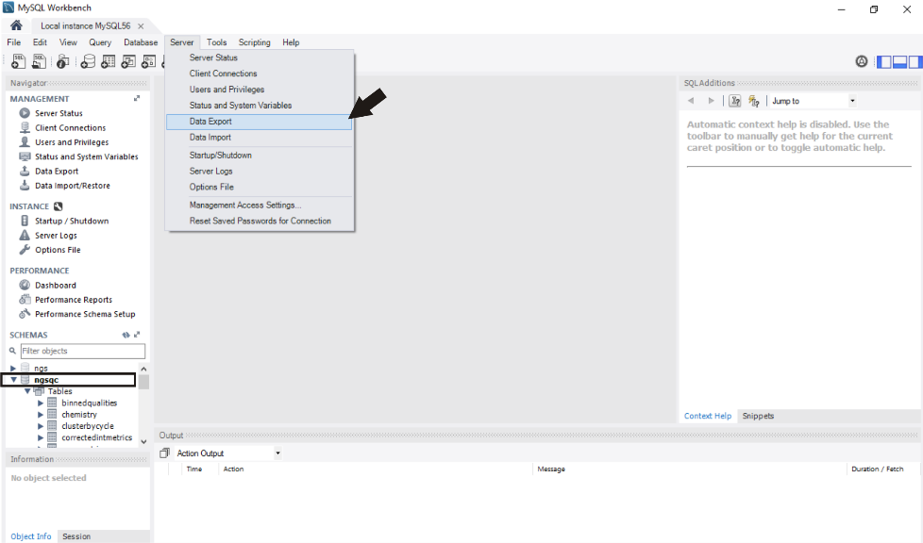

In the Object selection pane, tick the box next to the database to back up (here “ngsqc”) (see black arrow in screenshot below).

Ensure that the drop-down menu next to the purple arrow in the screenshot below has the “Dump Structure and Data” option selected.

Select the option to Export to Self-Contained File (yellow box in screenshot below) and ensure that there is a tick in the box below that stating “Create Dump in a Single Transaction (self-contained file only)”.

Select the intended storage location for the database dump file (blue box in screenshot below). The default location is in the user’s Documents folder in a sub-folder called “dumps”.

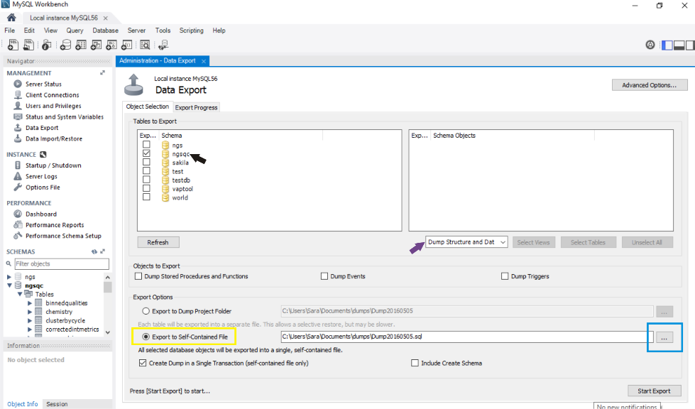

After double-checking that all the selected options are correct, click on the Start Export button (yellow box in screenshot below).

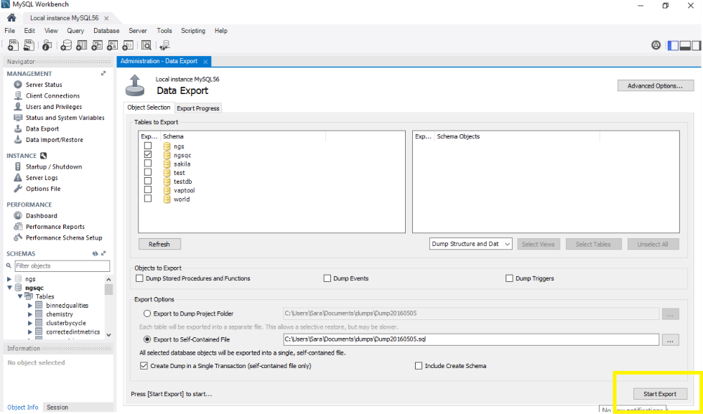

The following screen should appear automatically. If it does not, click on the ‘Export Progress’ tab to navigate to this screen (see black arrow on screenshot below).

If you need to stop the backup then click the ‘Stop’ button (see yellow box in screenshot below).

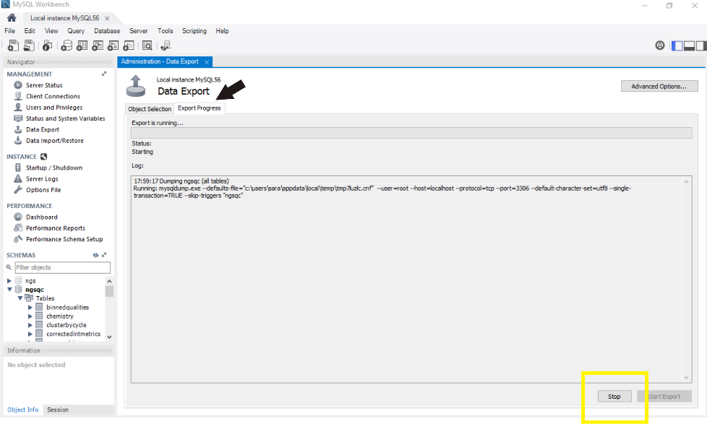

On successful completion of data export, the screen should appear with the green progress bar filled as in the screenshot below.

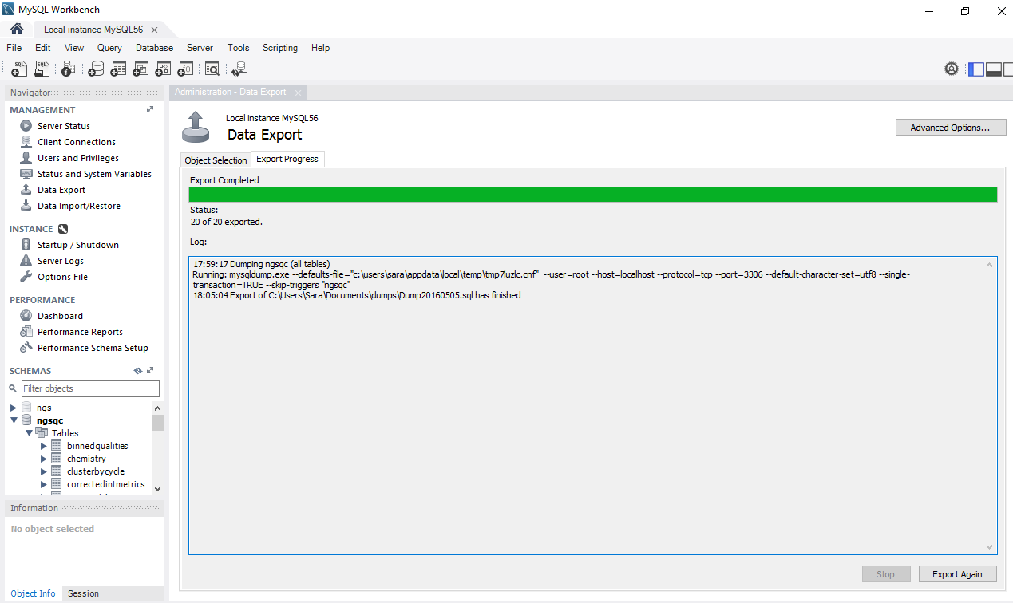

Exit the application by clicking the cross in the right hand top corner.