Instructions to run ConferenceTrackManagement:

1) System Requirements:

-Ubuntu 16.0
-64-bit O.S
-ruby 2.3.1
-Rails 4.2.6

2) Unzip the ConferenceTrackManagement folder.

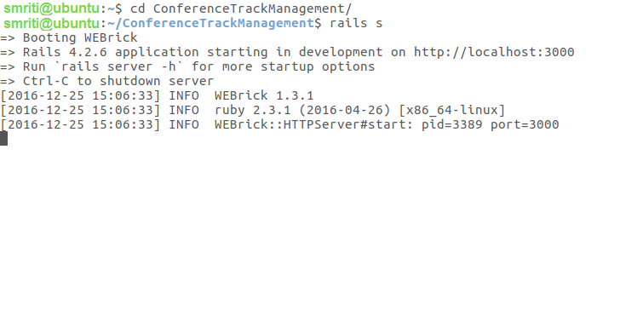
3) From Terminal, go to ConferenceTrackManagement directory.

4) Type rails s
To start the server.

5) Go to http://localhost:3000/index from your browser.

6) The below window should appear

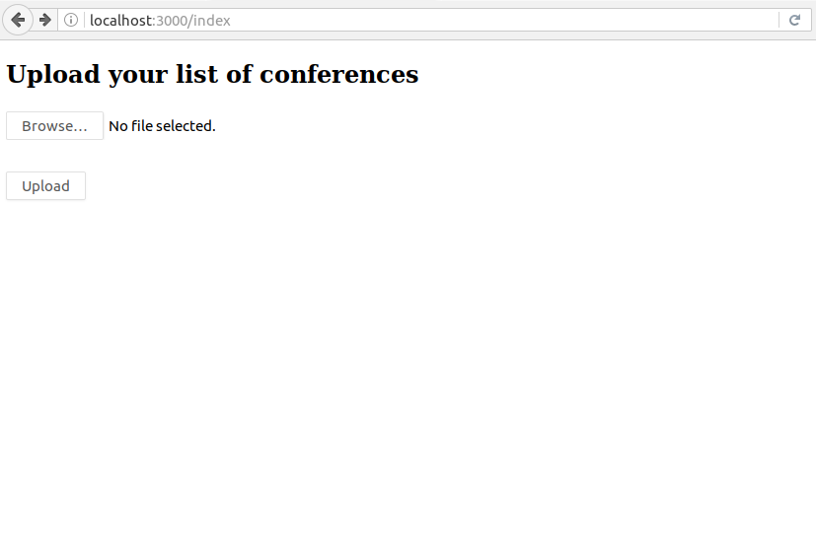

7) Browse the /ConferenceTrackManagement/public/Test_Input1.txt and upload.
TestInput1.txt contains the Test Input given in the problem statement.
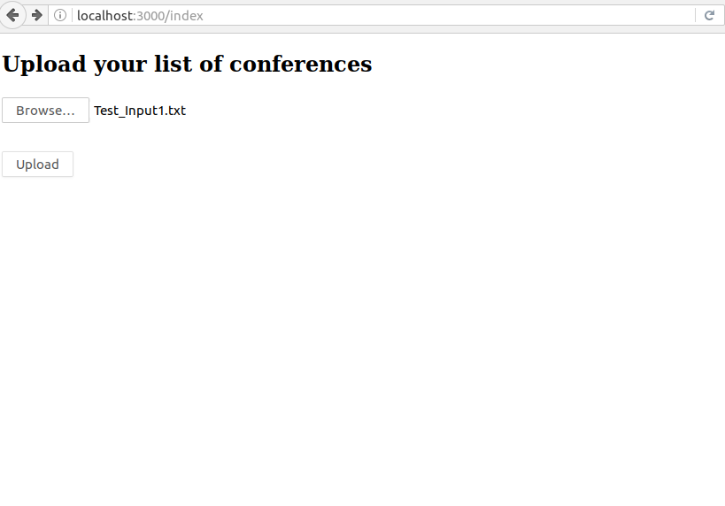

8) Click on Upload

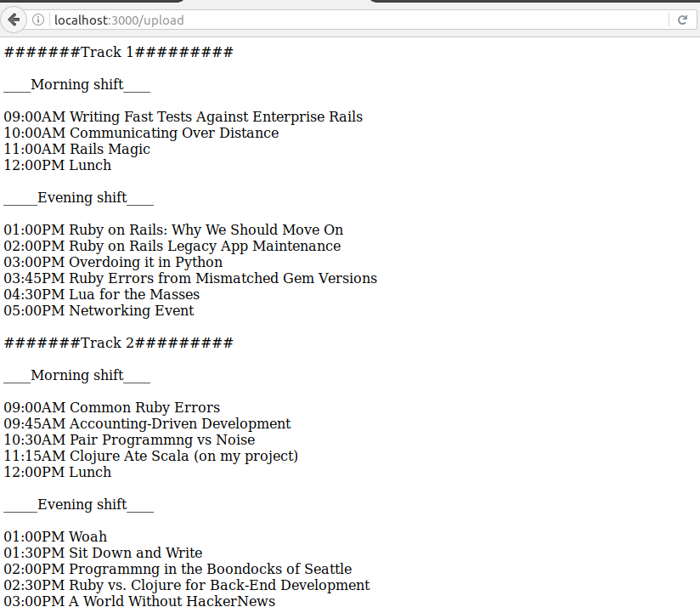

9) To upload any other list of conferences, Again go to http://localhost:3000/index.
Browse the /ConferenceTrackManagement/public/Test_Input2.txt

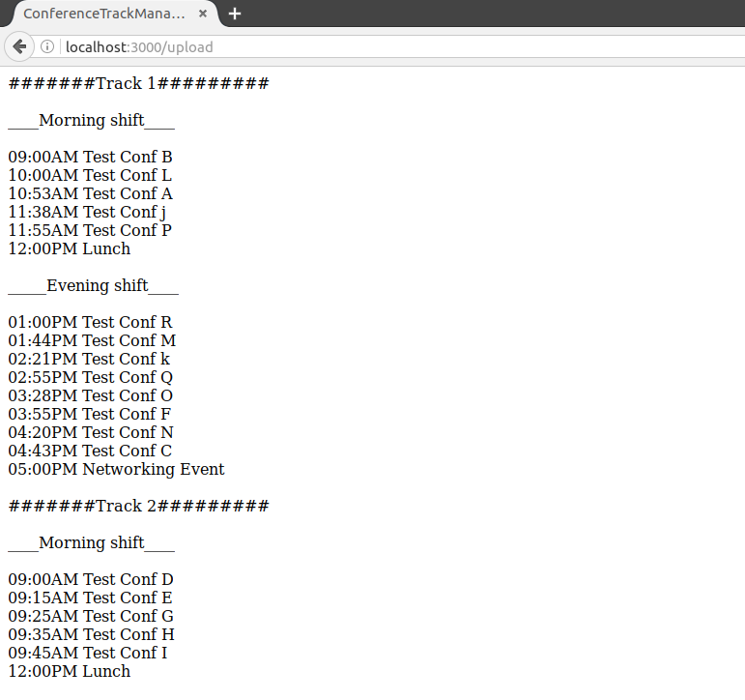

10) To run Rspec, go to ConferenceTrackManagement directory, type rspec

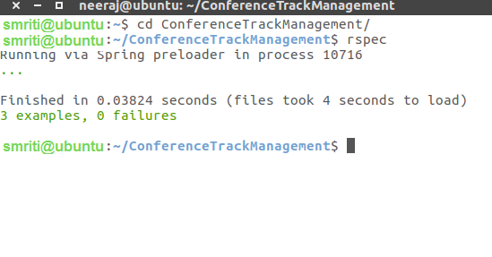

Scenarios Considered while designing the ConferenceTrackManagement: -

1) Test input should be the below format:

<Name of the conference> <duration in minutes>

<Name of the conference> should consist only alphabets or string, numbers are not considered in the current scope.

<duration in minutes> should be in minutes only, hours not accepted. Format is 60min, 30min etc.

Example:
Ruby on Rails 60min
C++ 30min
java 30min

2) UI part is not considered much in the current scope.

3) Only .txt files are supported in the current scope.

Architecture considered while designing the ConferenceTrackManagement:

1) Created two library files:
a) conference_slot_scheduler
b) conference_time_scheduler

2) conference_slot_scheduler: Divide the hash into two slots morning & evening
Morning <= 180 min
Evening <= 240 min

conference_time_scheduler: Ruby Time object is being used, minutes added according in each divided slots.

3) One controller file conference_tracker_controller.rb
Consists of two actions:
upload_list_of_conferences (Get method ) to get the page for uploading test input.
get_conferences_schedules(Post method) to get the schedule.

4) Written Rspec for controller conference_tracker_controller.rb with 100% coverage.

5) The given input file with data is coverted into hash_of_conferences, with
key as Title of conference
value as duration of conference
After that controller actions are carried out

